DEVELOPMENT OF A DEEP LEARNING NEURAL NETWORK MODEL FOR TRANSIENT AND SMALL SIGNAL STABILITY ASSESSMENT

ONYEMENAM, JOHN OBIAJULU (20PGBD000145)

A THESIS SUBMITTED TO THE DEPARTMENT OF ELECTRICAL AND INFORMATION ENGINEERING, COLLEGE OF ENGINEERING, LANDMARK UNIVERSITY, OMU-ARAN, KWARA STATE

IN PARTIAL FULFILMENT OF THE REQUIREMENTS FOR THE AWARD OF MASTER OF ENGINEERING (M.ENG) DEGREE IN ELECTRICAL AND INFORMATION ENGINEERING, LANDMARK UNIVERSITY, OMU-ARAN, KWARA STATE

OCTOBER, 2022

DECLARATION

I, JOHN OBIAJULU ONYEMENAM, a Master of Engineering, from the Department of Electrical and Information Engineering, Landmark University, Omu-Aran, hereby certify that the thesis I submitted, "Development of a Deep Learning Neural Network for Transient and Small Signal Stability Assessment" is based entirely on my own original research. All information from other sources and any work produced by other people or organizations has been properly acknowledged.

…………................................……………………………….

STUDENT NAME AND MATRICULATION NUMBER

……………………………………………….
SIGNATURE AND DATE

CERTIFICATION

This is to certify that the thesis has been read and approved as meeting the requirements of the Department of Electrical and Information Engineering, Landmark University, Omu-Aran, Nigeria for the award of Masters in Engineering.

..................................... .……………………….

Supervisor Signature and Date

………………………… ………………………..

Head of Department Signature and Date

………………………… ……….………………..
External Examiner Signature and Date

DEDICATION

I dedicate the work to Almighty God, the founder and refiner of my faith, in gratitude for the grace and strength He has given me. In equal measure, I dedicate this work to my parents, Mr. and Mrs. Onyemenam.

ACKNOWLEDGEMENT

Glory to Almighty God for endowing me with the skills and talent necessary to complete this job. I also extend my sincere appreciation to mine abide and competent supervisor Engr. Dr. Paul Kehinde Olulope in the Department of Electrical and Information Engineering for his support mentorship and advice given to me during the course of the project. My gratitude also goes to Engr. Prof. Francis Ibikunle for his advice and support given to me during the tenure of my project.
I also want to thank the Departmental staff for their outstanding efforts in making this research project a success. In addition, I want to thank two of my postgraduate classmates, Odetoye Oyinlolu and Okeke Uchenna, for their support in both my academic and general lives. I wish to publicly thank Dr. Michael Arowolo for his contributions to this project in providing technical advice in the area of coding and modeling. I want to convey my gratitude to Dr. O.J.K. Oghorada and Dr. B.B. Adetokun in particular for their support during my time at Landmark University. I also want to thank Dr. G. O. Igbionsa for his guidance and support about my academic career, for which I have the utmost respect.
My sincere gratitude is also extended to Mr. & Mrs. Onyemenam, my loving and supportive parents, for their financial support and parental guidance during my Masters study in the Department of Electrical and Information Engineering.
My heartfelt gratitude is extended to my beloved family, my siblings, and the sweet soul Glory Abuka for her support and prayers she offered for me.
I also want to thank my longtime friend, Ejenam Victor, from United Kingdom for his contribution during my modelling and simulation, may God almighty continue to uplift you brother.

TABLES OF CONTENTS

DECLARATION ii
CERTIFICATION iii
DEDICATION iv
ACKNOWLEDGEMENT v
TABLES OF CONTENTS vi
LIST OF FIGURES x
LIST OF TABLES xi
LIST OF ABBREVIATION xii
ABSTRACT xiv
CHAPTER ONE 1
INTRODUCTION 1
  - Background to the Problem 1
  - Statement of the Problem 2
  - Justification for the Study 2
  - Aim and Objectives 3
  - Research Questions 3
  - Scope of the Study 4
  - Significance of the Study 4
CHAPTER TWO 5
REVIEW OF RELATED LITERATURE 5
  - Introduction 5
  - Power System Stability 6
    - Transient Stability 7
    - Small Signal Stability 7
  - Artificial Intelligence 9
  - Machine Learning 10
    - Supervised Learning 11
    - Unsupervised Learning 12
    - Reinforcement Learning 12
  - Deep Learning 13
  - Shallow Learning 14
  - Neural Network (NN) 14
    - Types of Neural Network (NN) 14
      - Artificial Neural Network (ANN) 14
      - Convolutional Neural Network 15
      - Recurrent Neural Networks 16
        - Long Short Term Memory (LSTM) 18
  - Relief-F algorithm 21
  - Review of Methodological Approaches 22
CHAPTER THREE 30
METHODOLOGY 30
  - Research Design 30
  - Data gathering 32
  - Network modeling 33
  - Data Gathering for DLNN 36
  - DLNN model 37
  - Performance Evaluation 38
  - Modeling of IEEE 9 Bus system for comparison 44
  - Research Instrument 47
CHAPTER FOUR 48
RESULTS AND DISCUSSIONS OF FINDINGS 48
  - Results and Discussions 48
  - Findings 51
    - The Results of TSA and SSA for Nigeria 28 bus system 51
    - The Results of TSA and SSA for IEEE 9 bus test system 54
    - Comparison with other results from literature 57
CHAPTER FIVE 59
SUMMARY, CONCLUSION AND RECOMMENDATION 59
  - Summary 59
  - Conclusion 59
  - Recommendation 60
  - Contribution to Knowledge 60
REFERENCES 61
APPENDIX OF NIGERIA 28-BUS SYSTEM AND IEEE 9-BUS SYSTEM 69

LIST OF FIGURES

Figure 2.1: Classification of power system stability Nikos et al., (2020) 6

........................................................................................................................................9

Figure 2.2: Machine Learning Techniques (Khraisat et al., 2019) 11

Figure 2.3: Model of an Artificial Neuron Network(Source: Mohammed et al., 2021) 15
Figure 2.4: Convolutional Neural Network Diagram (Source: Hoo-chang et al., 2016) 16
Figure 2.5: Recurrent Neural Network Diagram (Source: Zia & Zahid, 2019) 17

Figure 2.6: Long Short-Term Memory Network Diagram (Source: Zia & Zahid, 2019) 21
Figure 2.7: The flow chart of the Relief-F algorithm(Source: Bao Li et al., 2020) .22 Figure 3.1: Methodology 30
Figure 3.2: Schematic design model of TSA and SSA 31

Figure 3.3: The Nigerian 28 bus power system 34

......................................................................................................................................35

Figure 3.4: Modelling of Nigerian 28-Bus System in DIgSILENT 35

Figure 3.5: Proposed workflow chart 41

Figure 3.6: IEEE 9 bus system (Source: Noor et al., 2008) 44

Figure 4.2: Confusion Matrix for the TSA Developed Model 52

Figure 4.4: Modelling of IEEE 9 Bus System in DIgSILENT 55

......................................................................................................................................56

LIST OF TABLES
Table 2. 1: Summary of Related Works 28
Table 3.1: NETWORK DATA OF THE NIGERIAN 28 BUS POWER SYSTEM
…………………………………………………………………………32
Table 3.2: Confusion Matrix 38
Table 3.3: Loaded data for IEEE 9 bus system 45
Table 4.1: Loaded data for Nigeria 28 bus system 48
Figure 4.1: ANN Fitting view for the data 50
Table 4.2 Deep learning Neural Network Data and Structure of TSA & SSA 51
Table 4.3: Evaluation Performance for TSA 52
Table 4.5: Sample Target and Predicted values for TSA 53
Table 4.6: Sample Target and Predicted values for SSA 54
Figure 4.5: Confusion matrix for the TSA IEEE 9 bus system 56
Table 4.7: Evaluation Performance for TSA of IEEE 9 bus system 56
Table 4.8: Comparison of performance with TSA and SSA methods 58

LIST OF ABBREVIATION
AdaBOOST - Adaptive Boosting Algorithm

ANN - Artificial Neural Network’

ATAN - Adaboost Tree Augmented Naive Bayesian

AVC - Automatic Voltage Controller

CAIM - Class-Attribute Interdependence Maximization

CCT - Critical Clearing Time

CNN - Convolutional Neural Network

CPSS - Conventional Power System Stabilizer
CV-RMSE - Cumulative Variation of Root Mean Square Error DAEs - Differential Algebraic Equations

DL - Deep Learning
DMTSA - Direct Method-Based Transient Stability Analysis DNN - Deep Neural Network
DLNN - Deep Learning Neural Network

DT - Decision Tree

FACTs - Flexible Alternating Current Transmission

FEL - Feedback Error Learning

GAN - Generative Adversarial Network

GRU - Gated Recurrent Unit

LSTM - Long Short Term Memory

MAPE - Mean Absolute Percentage Error

ML - Machine Learning

NESs - Non-Synchronous Energy Sources

NN - Neural Network

PMUs - Phasor Measurement Units

PSS - Power System Stabilizer

RF - Random Forest

RL - Reinforcement Learning

RNN - Recurrent Neural Network

SGDR - Stochastic Gradient Descent Restart

SSA - Small-signal Stability Assessment

STLF - Short Term Load Forecasting

SVM - Support Vector Machine

TAN - Tree Augmented Naive Bayesian

TD - Damping Torque

TS - Synchronizing Torque

TSA - Transient Stability Assessment

VSA - Voltage Stability Analysis

VSC - Voltage Source Converter

VSI - Voltage Stability Index

WECC - Western Electricity Coordinating Council

ABSTRACT

This study's objective is to assess the degree of instability that existing power systems are subject to as a result of incorporating novel elements such power electronics, electric vehicles, and renewable energy production. The development of renewable energy sources is currently having an impact on the reliability and security of the electrical network. Due to the potential for disastrous power outages, a wide range of stakeholders are paying attention to transient stability and tiny signal stability issues. With the help of a feature selection and DLNN technique, the aim of this research is to evaluate the numerous stability issues relating to the electricity system. Data contingencies for the Nigerian 28 bus system and IEEE 9 bus system were produced using DIgSILENT. When the line on DIgSILENT was removed, the fault was applied and cleared. A data processing pipeline for feature selection is built using the Relief-F feature selection approach. A DLNN model was created in the Python environment to train and anticipate the power system's transient stability and tiny signal stability. The prediction model will advise the power system operator on how low frequency local and inter-area oscillations will be suppressed while a system is transiently stable. In order to implement the necessary control mechanisms, the DLNN approach also gives information on the system's transient stability and oscillatory dynamic response. The DIgSILENT/Python application, which utilizes an Intel Pentium core i5 2GHz CPU, is used to carry out this analysis. The Nigeria 28 bus system and the IEEE 9 bus system are used to test the increased performance of the suggested model. The results demonstrate evaluation performance metrics for accuracy, precision, sensitivity, f1-score, specificity, mean squared error, and root mean square error for the Nigeria 28 bus system and the IEEE 9 bus system. The Nigeria 28 bus system and the IEEE 9 bus system's evaluation metrics were compared to other works in the related literature. This study shows how the DLNN technique can be used to evaluate transient stability and tiny signal stability in real-time, online.

CHAPTER ONE

INTRODUCTION

Background to the Problem

To ensure the reliability and safety of power systems, transient stability assessment (TSA) and small signal stability assessment (SSA) have traditionally been used. As new components like power electronics, electric vehicles, and renewable energy sources are integrated, the dynamic features of power networks are becoming more complex, raising severe concerns about TSA and SSA. Data-driven TSA is becoming more popular in both academics and business because traditional time-domain simulations and direct methods cannot adequately handle the needs of power systems in the real world. The SSA is a time-consuming process that requires the computation of eigenvalues, linearization at the operational point, and load flow for large networks (Zhang et al., 2021). The direct technique, time-domain simulation methodology, and data-driven artificial intelligence (AI) method are some of the TSA methodologies now in use. Before a power system can function normally, it must be consistently stable for small signals; otherwise, running a power grid in this way will ultimately lead to minor disruptions since unstable systems cannot operate in real-time (Lim et al., 2017). In the literature, it has been found that intelligent models such as the decision tree (DT), deep learning, and support vector machine (SVM) are efficient at analyzing transient stability evaluation (Kuo and Huang, 2018). For TSA and SSA, computational intelligence (CI)-based techniques are widely employed. Because CI techniques only rely on a small amount of data, they do not require knowledge of the entire system. Neural Network (NN), Neuro Fuzzy Method (NF), and Random Forest are appropriate CI methods for SSA. This study suggests an evaluation of transient and tiny signal stability using a deep learning neural network (DLNN) technique and the Relief-F features selection algorithm.
.

Statement of the Problem

The theoretical techniques of handling stability assessment of most power stations including the injection substations are mostly responsible for inaccurate reports of stabilities results, as well as the delay in reporting.
The degree of non-linear equations is increasing in a modern power network which will be difficult for traditional technique to handle. However, the introduction of fast learning algorithm has been able to address the problems and handle stability problem. Most of these algorithms lack the ability to memorize and handle complex network in addition to stability analysis. The introduction of deep learning algorithm will handle the complexity of the network and predict system stability for transient and small signal stability.

Justification for the Study

Unlike earlier research, which only examined transient stability, our method evaluated both tiny signal stability and stability to transients (Bin and Xue, 2019). In this study, deep learning techniques will be used to regulate network complexity and anticipate system stability. Highly nonlinear differential algebraic equations (DAE), which also explain the behavior of synchronous generators, loads, renewable energy generation, and flexible alternating current transmission networks, control the dynamic response of a power system (FACT). To quantitatively resolve each situation, time domain simulations are required as an alternative. To achieve these objectives, the prediction model is trained using a deep learning method and a data set for a range of operational scenarios.
The long short term memory technique (LSTM), which has been trained to remember the oscillatory response of a projected stable system, eventually manages to record the primary weekly damped low frequency oscillation. The TSA, SSA, and LSTM all feature progressively less complex computational architectures that boost prediction accuracy. The suggested model's enhanced performance is demonstrated using the Nigeria 28 bus system, and its support by the IEEE 9 bus system is provided.
.

Aim and Objectives

The aim of this research is to develop a deep learning neural network model for transient stability assessment and small signal stability assessment in power stations.
The specific objectives are to:

- model Nigeria 28 bus system.

- develop a DLNN model for the TSA and SSA of Nigeria 28-Bus System

- evaluate the performance of the developed models using Nigeria 28 bussystem network and IEEE 9 bus system.
- compare results with other related works.

Research Questions

The high penetration of renewable energy sources and the decommissioning of traditional power plants both reduce the inertia of the power system. This loss affects the stability of weak signals and power system transients.
- How will the Nigeria 28 bus system be modelled?

- How do we generate, pre-process data, and build an improved model for TSA and SSA in power system?
- How does the performance of the developed model generate an efficient and promising results?
- Which related work is the result compared with?

Scope of the Study

The Nigeria 28 bus system and IEEE 9-Bus System are the topic of this study, which uses a deep learning neural network approach to anticipate power system transient stability and small signal stability concerns. The Nigeria 28 bus system and IEEE 9-bus system are the focus of this paper's deep learning neural network technique to predicting power system transient stability and micro signal stability concerns.

Significance of the Study

The study's findings will benefit researchers by improving their understanding of LSTM evaluation of transient and small signal stability.
.

CHAPTER TWO

REVIEW OF RELATED LITERATURE

Introduction

Regulations related to global warming, market forces, and technological advancement are all having a big impact on the way that power is produced today. Transient stability and small signal stability can be linked to major and minor outages, which are frequently accompanied by significant economic losses (Sarajcev et al., 2022). Due to the integration of RESs (such as wind and photovoltaic power plants), modern power networks are susceptible to instability today, creating a system that is near to the stability margin. As a result, the system's inertia value is lower than it would be for a normal power system. The problem of decreased system inertia will get worse as the proportion of RES in the producing mix increases.
A power system's stability refers to its ability to quickly recover from an interruption and carry on in a reasonably balanced manner. The instability problem has long been associated with rotor angle instability brought on by synchronism loss. Depending on the magnitude of the disturbance, the two main types of rotor angle stability are small-signal stability and large-signal (transient) stability. Therefore, small-signal and transient stability are connected to a power system's capacity to maintain synchronism in the face of both minor and major interruptions. A set of highly nonlinear differential and algebraic equations governs how synchronous generators interact with their associated control systems, loads, renewable energy output, flexible AC transmission devices (FACTs), and the transmission network (DAE) (Li et al., 2021). The DAE model can be linearized all the way around the equilibrium point in a power system that experiences only minimal modifications. Stabilizing damping torque components are crucial for small-signal performance. A synchronous generator's rotor angle may occasionally drift and oscillate due to insufficient synchronizing and damping torque (Li et al., 2021).
In actual power systems, insufficient oscillation damping is the main factor contributing to the issue of minuscule signal stability. However, as the DAE model cannot be linearized around an operational point, it must be numerically solved for each situation using time domain simulations when a generator's considerable rotor angle excursions are caused by a power system's transient stability to a significant disturbance.
Transient stability has already resulted in catastrophic power outages and can reduce a power system's overall performance (Nikolaev et al., 2021).

Power System Stability

Power system stability is the ability of an electric power system to restore a state of operating balance after an interruption (Nikos et al., 2020). Figure 2.1 depicts the classification of the different power system stability types, such as rotor angle stability, frequency stability, and voltage stability. Different categories of system stability are discussed in the following sub sections.

Transient stability
Small signal stability
Rotor angle stability
Voltage stability
Power System Stability
Frequency Stability

Figure 2.1: Classification of power system stability Nikos et al., (2021)
Large disturbance voltage
Small disturbance voltage

Transient Stability

Rotor angle stability is the capacity of synchronous machines in a power system to sustain synchronism following a substantial disruption. Some generators may experience increased load as a result of adaptive operation and may slow down, whereas other generators may accelerate up to maintain grid frequency because power system disturbances may not always have the same effects on generation.
The rotor angle continuously both accelerates and slows to maintain balance between the input mechanical torque and the output electrical torque. This characteristic decreases the generator's capacity to generate power, which also affects the generator, prime mover, and transformers (Bin and Xue, 2019). The dynamic response of a power system to disturbances is governed by a series of algebraic and differential equations, and their compact form is known as this:
x and y, is the state and algebraic variables. H and G also serve as representations for the vectors of the accompanying differential and algebraic equations. Time-varying trajectories are created by solving for the state variables x, such as rotor angles and frequencies, and the algebraic variables y, such as bus voltages and active power injections. This is accomplished by discretizing the set of differential equations using numerical methods, such as the trapezoidal approach (2.1). The created algebraic equations and the remaining algebraic issues are resolved using Newton's approach at each time step (2.2) (Bin and Xue, 2019).

Small Signal Stability

Small signal stability refers to synchronous devices' capacity to keep their synchronization in the face of even the smallest disturbance in a power system. Limited signal stability can be detected by insufficient oscillation damping in frequency, rotor angle, or voltage stability signals. Small signal stability problems could have a local or regional impact. Local mode oscillations are smaller disturbances caused by a single generating station as opposed to interarea mode oscillations, which are larger disturbances caused by groups of producing stations. The power system stabilizer (PSS) and flexible alternating current transmission system (FACTS) controllers are two machine power systems that are widely used in SSA to boost system oscillation stability. These devices lessen damping by generating additional signals to cancel oscillations in generator excitation systems. Electrical torque has a major impact on how synchronous machines react to oscillations. Electrical torque is made up of the damping torque (Td), which is in phase with the speed deviation components during an oscillation event, and the synchronization torque (Ts), which is in phase with the rotor angle deviation during an oscillation event. The set of algebraic and differential equations stated in (2.1) - (2.2) can be linearized around an equilibrium point for minor perturbations, as shown in (2.3) - (2.4). (2.4).

This is accomplished by Lyapunov technique, which is all about determining the eigenvalue characteristic equations as follows (Liu et al., 2011).

Responses can either be oscillatory or non-oscillatory depending on the predicted real or complex eigenvalues.

Artificial Intelligence

Artificial intelligence (AI) is the process of making computers do intelligent tasks that humans are unable to complete (Huang et al., 2019). The advancement of AI has increased national development competitiveness and preserved security in numerous countries around the world. Researchers in the fields of science, engineering, and technology are concentrating on AI, and major firms like IBM, Google, and Microsoft are utilizing AI in a range of fields (Huang et al., 2019). Data prepping, model creation, model training, model deployment, and model management are the traditional five processes that make up an AI model's life cycle. Standardization of the dataset is frequently needed as the following step in the workflow for many machine learning models. The data are scaled to a unit variance once the mean has been removed from the calculation. Centering and scaling are carried out independently for each feature by computing statistics using only the training set samples. Power system databases contain tens of thousands of features. Numerous conventional machine learning algorithms are difficult due to the enormous dimensionality of the feature space. Dimensional analysis is thus a critical phase in the data processing process.

Machine Learning

Machine learning is a subfield of artificial intelligence that focuses on using statistical techniques to build intelligent computer systems that can learn from existing databases. Making systems that can learn from the data they receive or perform better is the goal of machine learning. Li et al. used a variety of alternative machine learning methods to address the TSA problem, including the support vector machine (SVM), random forest (RF), gradient boosting, and multilayer perceptron. Kernel regression was employed by Liu et al., although Pannell et al. suggested using naive Bayes as well (Kaliappan et al., 2021) Figure 2.2 illustrates the elements of machine learning approaches for supervised learning, unsupervised learning, and reinforcement learning.

MACHINE LEARNING
REINFORCEMENT LEARNING
UNSUPERVISED LEARNING
SUPERVISED LEARNING

CLASSIFICATION  k | REGRESSION | CLUSTERING
Support Vector Machines | Linear Regression, GLM | K-Means, Fuzzy C-Means
Discriminant Analysis | SVR, GPR | Hierarchical
Naïve Bayes | Ensemble Methods | Gaussian Mixture
Nearest Neighbor | Decision Trees | Hidden Markov Model
Neural Networks | Neural Networks | Neural Networks

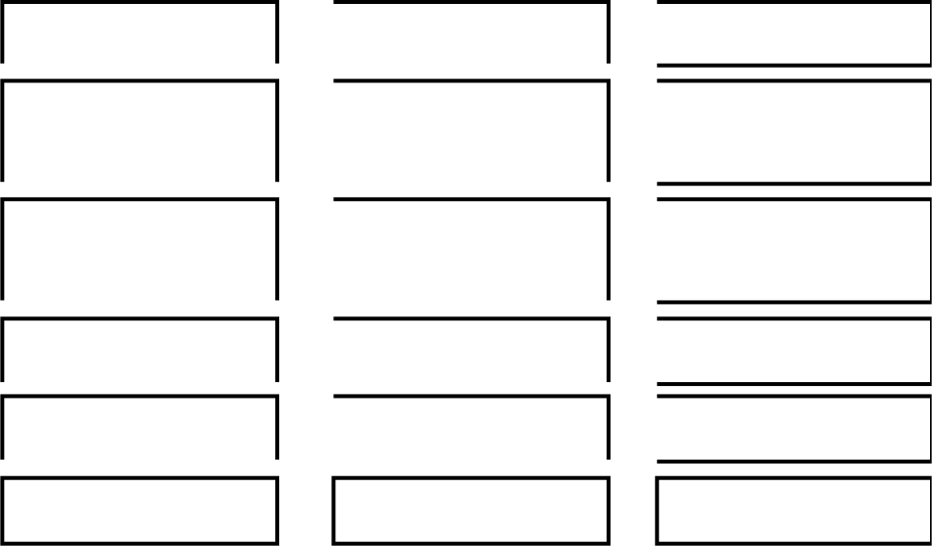
Figure 2.2: Machine Learning Techniques (Khraisat et al., 2019)

Supervised Learning

A instructor is necessary for this learning, and objectives are given. This example's algorithm is built using labeled data. Despite the fact that this approach is strongly dependent on precise data labeling, supervised learning has the potential to be quite powerful in the proper situation. In supervised learning, the approach is given a small quantity of transfer learning to work with. The algorithm can learn about the issue, the remedy, and the additional data that needs to be processed using this test data. The training dataset's features are quite similar to the testing outcome, and it gives the algorithm the annotated variables it needs to address the issue (Van Engelen and Hoos, 2020).

Unsupervised Learning

No teacher is necessary for this learning, and no objectives are given. Unsupervised machine learning creates models from scratch using raw data. The algorithm can now handle significantly larger datasets because there was no need for manual or human involvement. An algorithm trained on a set of linked samples can only pinpoint the precise reason for any grouping with the aid of these labels. Unsupervised learning, however, results in the creation of hidden processes when labels are not present. Without any user input, the system can identify correlations between different data sets. Rather than presenting a predetermined solution, unsupervised learning algorithms can adapt to the data on this aspect, by changing local features as they change over time (Janiesch et al., 2021).

Reinforcement Learning

Although a teacher is necessary for this learning and specific goals are given, the anticipated results are not present. People must comprehend the knowledge they learn in their daily lives in order to learn through reinforcement. It uses a trial-and-error mechanism to gradually learn from new situations and adjust to them. Positive results are strongly emphasized, while negative outcomes are strongly emphasized. According to a theory of conditioning, for instance, a work atmosphere with translators and rewards is optimal for reinforcing learning. The interpreter gets an output from an algorithm and determines whether or not it is useful. By paying the algorithm when it determines the right response, the translator confirms the algorithm's accuracy. If the outcome is unsatisfactory, the algorithm is instructed to repeat the procedure; it will do so until the desired result is obtained. In the vast majority of instances, the success of the solution is directly related to the reward system (Darling-Hammond et al., 2020).

In ordinary reinforcement learning applications, such plotting a route between two points, an exact number cannot be calculated.
. As a result, it is given an efficacy score that is estimated based on its age. When this percentage value is higher, the algorithm receives more points. Because of this, the software is constantly being improved in order to provide the best possible solution (Maia et al., 2009).

Deep Learning

Deep learning is a popular approach that still shows a lot of promise and offers new research opportunities to address the power system TSA and SSA problem. Deep learning includes the design and training of multi-layered artificial neural networks. However, when training complicated deep learning neural network designs, issues with suitable layer initialization, activation function selection, scheduling training data, convergence, disappearing gradients, forgetting, dead axons, and other issues arise (Kaliappan et al., 2021). When applied to the power system TSA and SSA problem, deep learning does not need a features engineering stage, in contrast to conventional ML models. The application of feature learning, specifically with these DLNNs, enables a model to both learn new features and apply them to a classification assignment. Deep learning is challenging to comprehend. There are numerous uses for deep learning. Sequential data must be used to tackle deep learning challenges. A subtype of machine learning algorithms called "deep learning" sets itself apart by being more complicated. Some examples of deep learning include convolutional neural networks, recurrent neural networks, generative adversarial networks, and long short-term memories (Janiesch et al., 2021).

Shallow Learning

The performance ceiling of "shallow learning" machine learning systems is reached as more instances and training data are added to the network (Janiesch et al., 2021). Shallow learning refers to machine learning techniques that are not deep. Decision trees, support vector machines, k-nearest neighbors, and shallow autoencoders are examples of shallow machine learning algorithms (Janiesch et al., 2021).

Neural Network (NN)

An artificial intelligence called a neural network instructs computers on how to analyze data in a manner similar to the human brain. In a neural network, parallel components (neurons) work together to complete a certain goal. Numerous innovative methods for tackling pattern recognition problems are provided by neural networks. The process includes the processes of recognition, data analysis, and control. Fast processing rates and the ability to learn a problem's solution through a succession of examples are only two of their distinctive qualities (Janiesch et al., 2021). Because NNs excel at extracting meaning from difficult or erroneous data, they can be used to spot patterns and trends that are difficult for humans or other computer systems to detect.

Types of Neural Network (NN)

Artificial neural networks, recurrent neural networks, generative adversarial networks, transfer learning, autoencoders, and gated recurrent unit layers are among the several forms of neural networks.

Artificial Neural Network (ANN)

ANNs are computers with biological inspiration algorithms that replicate how the biological brain processes information. Finding patterns and connections in data is how

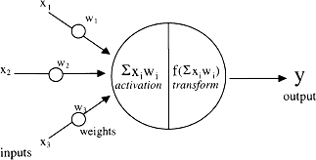
ANNs learn (or are taught). They do not receive programming based instruction or training. An ANN, also known as artificial neurons or processing elements, is composed of thousands of single units. The neural structure is created by layering the weights that connect these units (Mohammed et al., 2021). Figure 2.3 shows the model of an artificial neuron network. Each processing element consists of a transfer function, a weighted input, and a single output. A neural network's behavior depends on its architecture, learning algorithm, and transfer functions of the neurons. A neural network is a parameterized system since the variables that can be altered are the weights. Once the activation signal has been transmitted via a transfer function, a single neuron generates an output. The network becomes nonlinear due to the transfer function (Mohammed et al., 2021).

Figure 2.3: Model of an Artificial Neuron Network(Source: Mohammed et al., 2021)

Convolutional Neural Network

Convolutional neural network (CNN) is an artificial neural network designed primarily to evaluate pixel input and is used for image processing and recognition. A subset of deep learning is CNN. In 1988, under the name Le Net, Yann established the first CNN. With enough training data, CNNs can learn picture features in a data-driven, highly representational manner (Hoo-chang et al., 2016). Its primary function at the time was to decode characters like ZIP codes and integers. CNNs, usually referred to as Conv Nets, are multilayer structures frequently used in object identification and image processing. Figure 2.4 shows the Convolutional Neural
Network diagram.
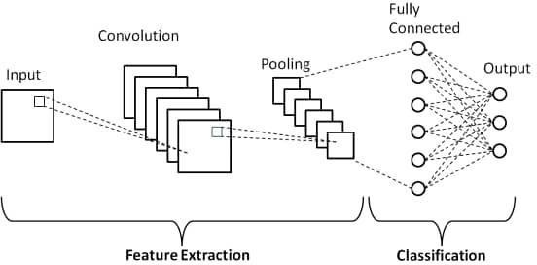

Figure 2.4: Convolutional Neural Network Diagram (Source: Hoo-chang et al., 2016)

Recurrent Neural Networks

Recurrent neural networks are a common type of artificial neural network used in speech recognition and natural language processing. Recurrent neural networks find patterns in the input and utilize them to identify sequential qualities that will likely appear in the output. The outputs from the LSTM can be used as inputs in the current phase since RNNs have connections that result in directed cycles. Because of its built-in memory, the LSTM can keep track of prior inputs, and its output serves as an input for the current phase (Zia & Zahid, 2019). Common uses of RNNs include natural language processing, time-series analysis, handwriting recognition, machine translation, and photo captioning. The completely unfolded Recurrent Neural Network diagram is shown in Figure 2.5.

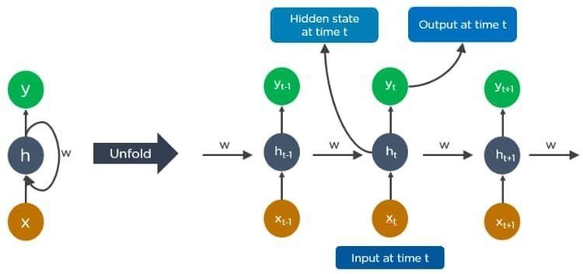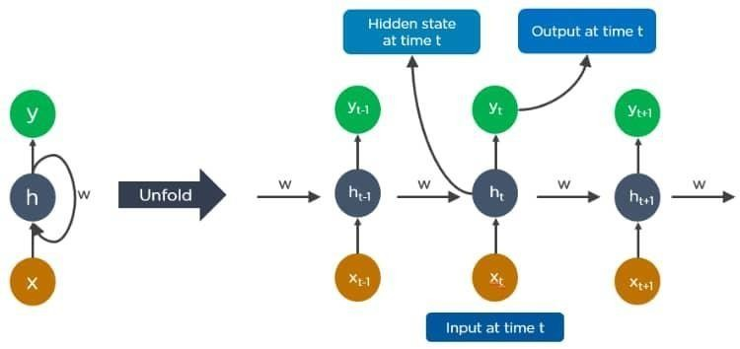

Figure 2.5: Recurrent Neural Network Diagram (Source: Zia & Zahid, 2019)

The parameters used each time are shared by all RNNs, which scan the full dataset from left to right. However, it also has a drawback in addition to its advantages. It does not use data from later in the series when making predictions; instead, it solely considers data from earlier in the sequence (Hamad & Abdulrahman, 2022).
Working with consecutive data is the main tenet of RNN. A typical neural network's input and output are independent of one another. However, we first need to understand the information (words) that came before a sentence or a paragraph so that we can decode it. RNN records its past data for use in calculations in the future. Because it performs the same processes for each member of the series and bases its decisions on earlier calculations, this operation is known as recurrent. Although they are only able to use a small number of the previous steps as references, they can theoretically recall data for long sequences (Zhou et al., 2020).
In recent years, tasks including handwriting recognition, language translation, and image captioning have demonstrated the efficiency of bidirectional and LSTM designs (Chien et al., 2019). There are different types of recurrent neural namely, long short term memory and gated recurrent unit.

Long Short Term Memory (LSTM)

The problem of long-term reliance, which is mostly focused on recurrent neural networks, is solved by a type of recurrent neural network called long short-term memory. To recall prior knowledge over a long length of time, LSTM is also a standard. Data is tracked over time using LSTMs. They are useful in time-series prediction because they can recall previous inputs. In Figure 2.6, a representation of the long short term memory network, four interacting layers of LSTMs are seen. To solve the vanishing gradient problem that recurrent networks had previously experienced, Hochreiter & Schmidhuber created LSTM in 1997. (Shewalkar et al., 2019). In contrast to bursting or dissipating, backpropagated errors in LSTM will continue to flow through an unlimited number of layers. The LSTM can handle scenarios needing memories of distant encounters because of its memory unit (Mikolov et al., 2015). Equation 2.7 displays the mathematical formulations of the LSTM equations;

(2.7)

where ct is the current state of the LSTM cell, Wi, Wc, and Wo denote its weights, and the operator denotes pointwise multiplication of two vectors (Mikolov et al., 2015). Theoretically, the LSTM cell shown in equation 2.8 can be defined as follows based on the connection:

(2.8)

The forget gate determines which information from the cell state will be deleted. When the forget gate, ft, is set to 1, the data is stored; when it is set to 0, the data is completely destroyed. However, Schmidhuber, Wierstra, Gagliolo, and Gomez (2007) assert that occasionally, combining evolutionary algorithms with additional methods can result in LSTM training that is superior to gradient descent alone. It is made up of LSTM layers that are piled on top of one another. A series of LSTMs are used to enter the data at predefined intervals.

The Advantages of LSTM Over Other Deep Learning Algorithms Include:
- Long-term storage of information is possible with LSTM.

- There is no finer control over how much of the past should be forgotten and how much of the content should be carried forward.
- A number of different variables, such as data for training, input and output biases, are available from LSTMs. there is no requirement for small modifications.
- With LSTMs, updating each weight has a complexity of zero

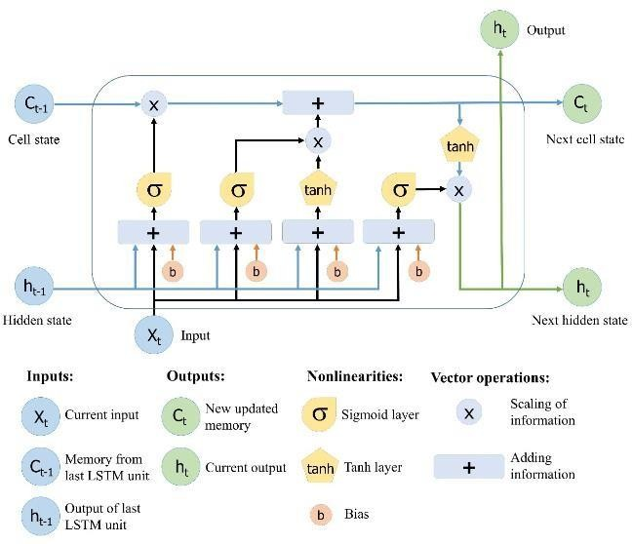

Figure 2.6: Long Short-Term Memory Network Diagram (Source: Zia & Zahid,2019).

Relief-F algorithm

Kononeill first proposed the Relief-F algorithm in 1994. A multiclass issue expansion of the Relief method is the Relief-F algorithm. Relief-F, created by Kira and Rendell in 1992, is a feature selection algorithm that employs a filter-method approach and is highly sensitive to feature interaction (Bao Li et al., 2020). Start by acquiring the data sample, which is split into two groups in figure 2.7. The samples that are closest to the random sample are then determined by selecting a sample at random from these data. A Near-hit is used to describe the closest sample within the same class, whereas a Near- miss is used to describe the closest sample inside a different class. The weight vector is then updated using the Near-hit and Near-miss weight update rule. then repeat the preceding steps a total of T times. The final weight vector is then divided by T to determine the average weight vector. Based on it and a predefined threshold, which is often an exact value, the characteristic is chosen. Characteristics that are above the threshold will be seen as relevant and picked, while those that are below the threshold will be seen as unimportant and ignored (Bao Li et al., 2020).
.
Start
Select Random
Samples
Feature > threshold
No
Update W
Find Near-Miss and Near-Hit

Figure 2.7: The flow chart of the Relief-F algorithm (Source: Bao Li et al., 2020)
Select features
End
Yes

Review of Methodological Approaches

The NN based classification method for small signal stability assessment was proposed by Teeuwsen et al., (2003). For estimating the eigenvalues of important stability modes in power systems, a new kind of neural network-based approach is

introduced. Particularly interesting are inter-area oscillations. Existing approaches for computing eigenvalues take a long time and need the usage of a comprehensive system model, which contains a lot of accurate state conditions for the power system after decreasing the input space for the neural network and correctly training it. This research led to the creation of new 16-machine dynamic test system. The results of this method for classifying the stability of power systems reveal low mistakes and high accuracy.
Small signal stability assessment for large power system using computational intelligence was performed by Teeuwseen et al., (2005). The quick prediction of the main inter-area oscillation modes is particularly important. The new proposed online oscillatory assessment techniques rely on artificial intelligence, including neural networks, neural fuzzy algorithms, and decision trees, as opposed to computing eigenvalues using the full power system model. Only a small set of system data are required to use computational intelligence as a quick online assessment tool. An overview of the stability status is provided through the classification of system states. The TSO will require more specific information in the event of inadequate damping, though. The estimated damping of the power supply may provide this information. It gives the TSO thorough and precise information about the number, position, and dominating eigenvalues within the complex plain without depending on any predetermined regions.
An approach was suggested using a feedforward artificial neural network with

increased feature selection for power system transient stability assessment by Sawhney and Jeyasurya, (2006). To predict the electrical system's stability status, an artificial neural network is deployed. This trustworthy and effective method for online transient stability monitoring of the power system combines the benefits of artificial neural networks and time-domain integration approaches. The transient stability index, a neural network output, was calculated using the extended equal area criterion approach. To find the input variables most suited for training, two feature selection strategies were applied. The suggested method reliably and without any false alarms forecasts the transient stability index. The neural network's output, the transient stability index, also aids in the implementation of potential control measures. The outcomes show that neural networks have the potential to be used in any dynamic security evaluation tool available online.
The purpose of implementation of transient stability assessment using artificial neural networks is to test the accuracy of artificial neural networks in assessing the transient stability of a single machine infinite bus system by Eltigani et al., (2013). The results of the ANN derived fault critical clearance time are compared to those of the traditional equal area criteria technique. While the supervised learning method is used to train the ANN, the back propagation technique is used to reduce training error. The system's stability is then verified. Therefore, we discover that, unless the ANN is well-trained, it forecasts the necessary clearing time for the same input data sets with a little lower accuracy than conventional techniques.
Assessment of power electronics based power systems small signal stability via impedance and eigenvalue methods was recently been proposed by Amin and Molinas,

(2017). The stability analysis methods were compared based on impedance and eigenvalues. Analytical connections between the eigenvalues' poles and zeros and their defining equation have been demonstrated. It is demonstrated that the system's stability can be determined using both stability analysis techniques. The impedance- based method can be used to determine whether the system is prone to harmonic oscillations by looking for a low phase margin in the minor loop gain's Nyquist plot. Because the impedance technique depends on the specification of local source load subsystems, it is essential to consider the stability of various subsystems. In these areas, the approach is reviewed in significant detail, and the study explains how a passive component or controller gain affects stability.
The assessment of power systems post-disturbance transient stability in order to achieve the best accuracy speed tradeoff was proposed by Ren et al., (2018). Real time post disturbance transient stability evaluation is now possible because to recent improvements in the phasor measuring approach. Fast TSA with adequate precision is essential since temporary instability may manifest itself after a perturbation very soon. In this study, an ideal self-adaptive TSA technique is then put forth for achieving the best possible accuracy-speed balance in post disturbance TSA. The results of the simulation demonstrate that the proposed strategy functions effectively with a New England 10-machine, 39-bus system.
Power system transient stability prediction algorithm based on relief-f and LSTM, was proposed by Bo et al., (2019). The health of the national economy depends on the stability of the electrical system, and a sudden failure would cause considerable

losses. This study provides a technique for predicting the power system's transient stability using the relief-f and LSTM networks. The relief-f algorithm filter is used to firstly select the most important properties before generating the optional LSTM neural network settings. The transient behavior of the power network is then predicted using the trained NN.
A unified online deep learning prediction model for small signal and transient stability, was proposed by Syafiq et al., (2020). In contrast to past work that largely focused on transient stability, this provides a holistic prediction technique for integrating small signal and transient angle stability. In this study, an online prediction model for rotor angle stability is trained using system-wide voltage phasor observations. The New-England 10-machine, 39-bus, IEEE 16-machine, 68-bus, 5-area, and IEEE 50-machine, 145-bus test systems, as well as time domain simulation, are used to evaluate the improved performance of the proposed model.
Artificial neural networks improve small signal stability in power systems feedback error learning (FEL) was proposed based on feedback errors by Sedat et al., (2021). Because of system flaws, load conditions, and disturbances from outside sources, electrical power systems are vulnerable to instability. The performance of the suggested FEL system and the traditional CPSS controller are compared using Python simulations. A FEL controller can be used in place of a stabilizer to increase the stability of the small signals in the power system.

Table 2. 1: Summary of Related Works

S/No | Authors | Title of article | Observation | Method | Limitation
1. | Teeuwseen et al.,2005 | SSA for large Power System using Computational Intelligence (CI) | A technique for evaluating oscillating stability online in a big, linked power system was  developed. | Neuro fuzzy | Neuro fuzzy are completely dependent on human expertise
2. | Ren et al., 2018 | Post- disturbance TSA of power systems towards optimal accuracy-speed  tradeoff. | Accuracy-speed tradeoff with optimal self- adaptive TSA approach. | Extreme learning machine (ELM) based ensemble model | Pre- disturbance was not considered
3. | Bo et al., 2019 | Power system transient stability prediction algorithm base on ReliefF and  LSTM | An algorithm for transient stability based on the ReliefFand LSTM networks | ReliefF & LSTM method | Issues of overfitting occurs regularly
4. | Shi et al., 2020 | CNN based power system transient stability assessment and instability mode  prediction. | Convolutional neural networks to analyze power system transient stability and predict instability  modes | CNN method | It takes CNN a longer time to train compared to other types of neural  network

5. | Syafiq et  al., 2020 | A unified online  deep Learning for small signal and transient stability | Using deep  learning methods, an online model is created for forecasting rotor angle stability. | CNN &  LSTM Model | CNN cannot  give a good performance with a large set of data
6. | Adhikari & Barnawal, 2021 | ANN based Approach for Voltage Stability Analysis of for Sustained Operation of  Power System. | Online voltage stability prediction | ANN method | ANN  requires processor with parallel processing power

CHAPTER THREE

METHODOLOGY

Research Design
Developing a DLNN model for TSA and SSA prediction is the aim of this study. To assess both transient and small signal stability, the prediction model uses an LSTM network. The step by step ways of carrying out the research is as follows in the block diagram in Figure 3.1.
Data Gathering for Network Modelling
Network Modeling Nigeria 28 Bus System

Pre-process Data

DLNN
Model
Performance Evaluation of Trained Model
Compare Test Results

Figure 3.1: Methodology

The sequence in Figure 3.1 is explained below:

- Data gathering: From the National Control Center (NCC), Oshogbo, appropriate data is gathered for the modeling of the 28-bus Nigeria network. The following data were gathered the network data of the Nigeria 28 bus system and IEEE 9 bus system.
- Network modeling: Using DIgSLIENT, the Nigeria 28 bus system was modeled.

- Data gathering for DLNN: In order to extract useful data, redundant data is filtered using the Relief-F method.
- DLNN model: Based on the provided data, a DLNN based on LSTM is modelled, trained, tested, and validated to perform the necessary TSA and SSA evaluation.
- Performance evaluation: The effectiveness of the LSTM model is then evaluated using the metrics listed below. Precision, accuracy, and Root Mean Square (RMS).

- Compare results: The outcomes are contrasted with those of the IEEE 9 bus system.
The flowchart approach for evaluating transient and tiny signal stability is shown in Figure 3.2. It is composed of two distinct models. The first model, for TSA, has four inputs: voltage, rotor angle, active and reactive power. The second model takes the same input as the TSA model and is for SSA. Where, respectively, X₁ and Y₁ stand for active power, X₂ and Y₂ for reactive power, X₃ and Y₃ for rotor angles, and X₄ and Y₄ for voltage. The binary classification output result for both TSA and SSA is also shown in this picture. The output result is either stable or unstable; stability is expressed by 1 and instability by 0.

X1
TSA

X2
Stable/unstable
X3

X4

Input Features

Y1
SSA

Y2

Y3

Y4 Bias = 1

Stable/unstable

Figure 3.2: Schematic design model of TSA and SSA

Data gathering

From the National Control Center (NCC), Oshogbo, appropriate data is obtained for the modeling of the 28-bus Nigerian network. The 330KV, 28 bus Nigerian network that served as the case study's bus and transmission line data was provided by the NCC. The bus data and transmission line are shown in Table 3.1. The DIgSILENT power factory is where the modeling is done. The information below was acquired;

Table 3.1: NETWORK DATA OF THE NIGERIAN 28 BUS POWER SYSTEM

Bus Identification |  | Bus Loads |  | Transmission Lines Data
NO | Name | MW | MVAR | Bus |  | Resistance R(pu) | Reactance X(pu)
1 | Egbin | 68.90 | 51.70 | FROM | TO
2 | Delta | 0.00 | 0.00 | 1 | 3 | 0.0006 | 0.0044
3 | Aja | 274.40 | 205.80 | 4 | 5 | 0.0007 | 0.0050
4 | Akangba | 244.70 | 258.50 | 1 | 5 | 0.0023 | 0.0176
5 | Ikeja-West | 633.20 | 474.90 | 5 | 8 | 0.0110 | 0.0828
6 | Ajaokuta | 13.80 | 10.30 | 5 | 9 | 0.0054 | 0.0405
7 | Aladja | 96.50 | 72.40 | 5 | 10 | 0.0099 | 0.0745
8 | Benin | 383.30 | 287.50 | 6 | 8 | 0.0077 | 0.0576
9 | Ayede | 275.80 | 206.8 | 2 | 8 | 0.0043 | 0.0317
10 | Osogbo | 201.20 | 150.90 | 2 | 7 | 0.0012 | 0.0089
11 | Afani | 52.50 | 39.40 | 7 | 24 | 0.0025 | 0.0186
12 | Alaoji | 427.00 | 320.20 | 8 | 14 | 0.0054 | 0.0405
13 | New-Heaven | 177.90 | 133.40 | 8 | 10 | 0.0098 | 0.0742
14 | Onitsha | 184.60 | 138.40 | 8 | 24 | 0.0020 | 0.0148
15 | B/Kebbi | 114.50 | 85.90 | 9 | 10 | 0.0045 | 0.0340
16 | Gombe | 130.60 | 97.90 | 15 | 21 | 0.0122 | 0.0916

17 | Jebba | 11.00 | 8.20 | 10 | 17 | 0.0061 | 0.0461
18 | Jebba G | 0.00 | 0.00 | 11 | 12 | 0.0010 | 0.0074
19 | Jos | 70.30 | 52.70 | 12 | 14 | 0.0060 | 0.0455
20 | Kaduna | 193.00 | 144.70 | 13 | 14 | 0.0036 | 0.0272
21 | Kanji | 7.00 | 5.20 | 16 | 19 | 0.0118 | 0.0887
22 | Kano | 220.60 | 142.90 | 17 | 18 | 0.0002 | 0.0020
23 | Shiroro | 70.30 | 36.10 | 17 | 23 | 0.0095 | 0.0271
24 | Sapele | 20.60 | 15.40 | 17 | 21 | 0.0032 | 0.0239
25 | Abuja | 110.00 | 89.00 | 19 | 20 | 0.0081 | 0.0609
26 | Makurdi | 290.10 | 145.00 | 20 | 22 | 0.0090 | 0.0680
27 | Mambila | 0.00 | 0.00 | 20 | 23 | 0.0038 | 0.0284
28 | Papalanto | 0.00 | 0.00 | 23 | 25 | 0.0038 | 0.0284
 |  |  |  | 12 | 26 | 0.0071 | 0.0532
 |  |  |  | 19 | 26 | 0.0059 | 0.0443
 |  |  |  | 26 | 27 | 0.0079 | 0.0591
 |  |  |  | 5 | 28 | 0.0016 | 0.0118

Network modeling

The network consists of Nigeria 28 bus system which is modelled using DIgSLIENT. Figure 3.3 shows the 28 buses, 9 generation stations, and 52 transmission lines that make up Nigeria's 28 bus power network. The modeling of the Nigeria 28 bus on DIgSILENT is shown in Figure 3.4. According to where the load and generator were located, the bus bars were either modelled as PV or PQ when it came to the transmission lines. The loads were PQ data-based lumped loads. The generators were accurately modeled using the appropriate data and synchronous generator characteristics. It also includes AVR and PSS. The automatic voltage regulator is used so as

to maintain constant voltage level to electrical equipment on same load and the power system stabilizer is also used to enhance oscillation stability.
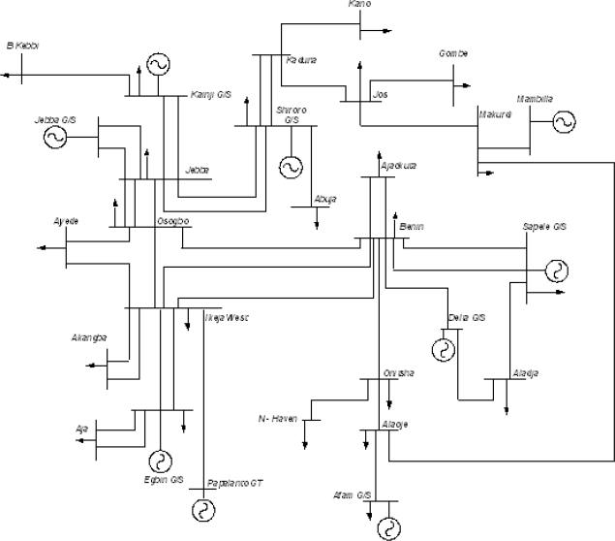

Figure 3.3: The Nigerian 28 bus power system

(Source: National Control Center (NCC), Power Holding Company of Nigerian,2012)

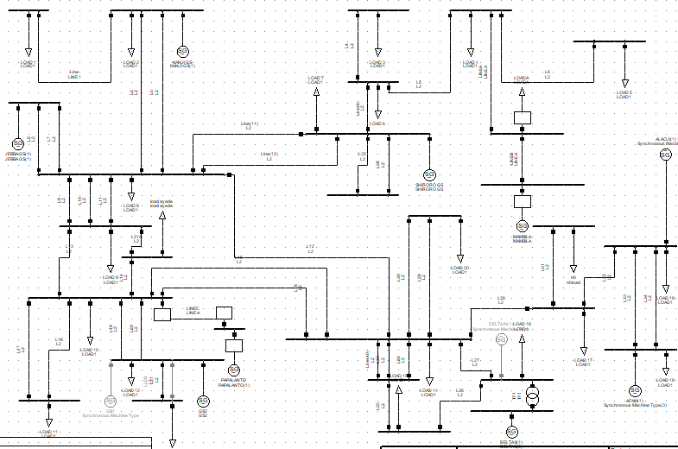

Figure 3.4: Modelling of Nigerian 28-Bus System in DIgSILENT

Data Gathering for DLNN

The following transient stability assessment input data are gathered for the Nigeria 28 bus system which includes, terminal voltage, active power, reactive power and rotor angles. The data was gathered from DIgSILENT and the simulation was run for 20 seconds with integration time step of 0.01 second. Data for the training and testing of the proposed DLNN was gathered from the network when it is subjected to different contingencies, such as three phase fault, load increment and shutdown etc. The faults were applied by removing the lines. The faults were applied on all available lines in the network as single contingencies and also double contingencies so as capture the situation of the operated network. The load was also increase gradually and sequentially. The generators were also shut down and data were taken at each of these scenario to indicate the system situation. Each sample is chosen based on how the generator rotor angle behaves. The generator's real output is kept constant at 100kW, and its reactive power is kept constant at 80KVAR. Each time a fault is applied, it is cleared or disconnected by cutting the line. There are 81,802 records collected for each input. The relief-f method is used for feature selection. In order to extract important data, redundant data is filtered using the Relief- F method. For small signal stability assessment same process is followed as transient stability assessment. The data gathered for each input is also 81,802. The relief-f algorithm is then applied as the feature selection. The output assessment of transient and small signal stability is either stable or unstable. This is denoted as 1 for stability and 0 for instability. For transient stability assessment when a system is stable is at the range of 0⁰ to 120⁰ for multi-machines and when the range is greater than 120⁰ the system is unstable. Meanwhile for small signal stability the system is stable or oscillatory free when the real part of the eigenvalue is negative and the damping ratio is positive and the system

is unstable when the real part of eigenvalue is positive.

DLNN model

Based on the provided data, a DLNN based on LSTM is modelled, trained, tested, and validated to perform the necessary TSA and SSA evaluation. Initializing a sequential model was the first step in the development of the LSTM, and then the LSTM layer was added. Then, a dense (completely connected) output layer and a batch normalizing layer were included. It is these that distinguish it as an LSTM neural network. The LSTM was created to be able to forecast transient and tiny signal stability in the python environment. As long as the network is adequately described and trained, employing LSTM allows for a quick computation of the eigenvalues. The LSTM is used to capture the dynamic evolution of a substantially damped low frequency oscillation step by step after being taught to discover an anticipated stable system's oscillatory response.
Pseudocode for ANN-LSTM (Source: Nakisa et al., 2018)

Define the size of the population NP, D dimension of problem, crossover rate cr, Scalefactor F.
Initialization: Initialize the population

While the termination criteria is not met
For each individual, target vector, in the population NP
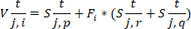
Mutation: Select three individual from the population randomly and generate a donor vector using the following mutation

Crossover: Compute the trial vector for the ith target vector
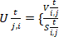 if ri ≤ cr or j = Jrand
otherwise

Selection: Apply LSTM classifier as fitness function f and evaluate
If Else
End for End While

Performance Evaluation

Following that, the confusion matrix, root mean squared (RMS), specificity, accuracy, and precision metrics are used to evaluate the effectiveness of the LSTM model.
Confusion matrix: is a popular technique for showing how well a categorization model works. The matrix (table) displays the percentage of cases in the test data that were correctly and wrongly recognized, together with the actual outcomes (target value). The matrix has dimensions of n by n, where n is the total number of classes. Positive/negative, yes/no, and male/female are the only two classes in binary classifiers, which are the simplest. A confusion matrix, which divides observed and predicted cases into four categories, summaries a binary classifier's performance.
True Positive (TP): Predicting a label with accuracy (predicted "yes," and it was "yes"). True Negative (TN): Predicting the opposing label with accuracy (predicted "no," and it was "no").
A false positive (FP) is a label prediction that is incorrect (for example, expecting "yes," but receiving "no" instead.
Missing and arriving labels constitute a False Negative (FN) (we predicted "no," but it turns out to be "yes").

Table 3.2: Confusion Matrix

Prediction | Observed true | Observed false
Predicted true | TP | FP
Predicted false | FN | TN

The evaluation metrics also used in this research includes mean squared error, root mean squared error, accuracy, precision and sensitivity.
Mean Squared Error (MSE): Is the average squared difference between the target value and the predicted value.
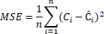

Where Ĉi is the predicted values, Ci is the target values, i is a variable and n is the number of data points.
Root Mean Square Error (RMSE): is the square root of the prediction errors.

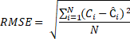
Where Ĉi is the predicted values, Ci is the target values, i is a variable and N is the number of non-missing data points.
Accuracy: The percentage of correctly classified units is known as accuracy.

Sensitivity: Identifies the percentage of mistakenly anticipated problematic code units, which are frequently files, modules, or packages.

Precision: is the percentage of anticipated faulty code that actually was faulty. When test sets are unbalanced, recall and precision are both crucial, but there is a trade-off between the two measures.

Specificity: is calculated as the number of correct negative predictions divided by the total number of negatives.

F1 score: is a weighted average of precision and recall.

Where TP is denoted as true positive, TN is true negative, FP is false positive and FN is false negative. These metrics are used from confusion matrix.
Summarily, in figure 3.5 shows the proposed flowchart to carry out the research work is as stated below.

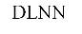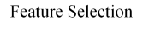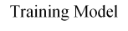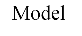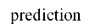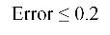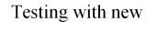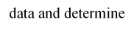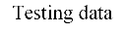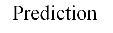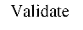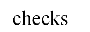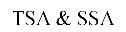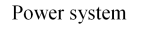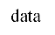

Figure 3.5: Proposed workflow chart

Step 1:
Appropriate data was gathered from National control center (NCC), Oshogbo on the

Nigeria 28 bus system and the modeling will be carried out.

Step 2:
Data for the training and testing of the proposed DLNN was gathered from the network when it is subjected to different contingencies.

Step 3:
Using the Relief-F algorithm, features are filtered to identify the most relevant ones, which are then used to support the subsequent classification process.
Step 3-1:

Then, for the N labeled sample data randomly select one sample R. Then, from the same sample set of R, get the K nearest neighbors Hj (j = 1,2…., k) of R, and from each separate class of sample set, find the K nearest neighbors Mj (C).
The formula is as follows:

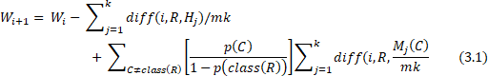

Where Wi + 1 is the new input weight. Wi is the input weight, R is the random sample selected, K is the nearest neighbors, Hj is the nearest hit, Mj is the nearest miss, C is the class of sample.

Step 4:
To create the final correlation vector for the feature set, steps 1-3 are repeated T times so as to obtain the defined threshold or selected features. The defined threshold is then used to filter the feature that is most important.

Step 5:
Find the forward value of each neuron's output. The stages decide the forgetting gate

(Ft), candidate

Step 5-1:
The activation function can be used to implement the forgetting gate.

where is the weight between the input layer and the hidden layer of the forgetting gate, bf is the forgotten gate offset, and is the forgotten gate weight matrix. The letter "f" in this instance stands for the word "forget first
Step 5-2:
The candidate gate, which is in charge of input data and past memory data, is then computed.

Step 5-3:

The output gate is calculated

Step 5-4:

The output (St) is calculated and these parameters is used to construct the LSTM unit.

Step 6:

On the basis of gradient guidance of the loss function, the network weight parameter is modified.

Step 7:

Repeat steps 5 and 6 until the network is below the error, then return to Step 1.

Step 8:

By this time, a model has been developed that complies with industry standards and is been used to assess the transient and small signal stability of fresh data from the power network.

Modeling of IEEE 9 Bus system for comparison

The results are compared with results from IEEE 9 bus system. The DLNN technique, which is used to assess transient stability and small signal stability, is validated using the IEEE 9 bus system. The IEEE 9 bus system is implemented on DIgSILENT/Python environment. Three (3) synchronous generators are shown in figure 3.6 as part of the system, which is connected via a 230KV transmission network. Three generators, rated at 16.5KV/230MVA, 18KV/230MVA, and 13.8KV/230MVA, are included in the system. To increase the voltage of each generator to 230 kV, the system contains three
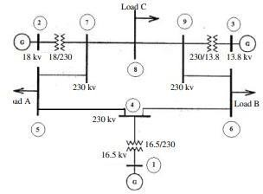
(3) transformers. It consists of three loads connected to buses 5, 6, and 8. The system's basic frequency is 60 Hz.

Figure 3.6: IEEE 9 bus system (Source: Noor et al., 2008)

The loaded data for the IEEE 9 bus system, which was created and used for training and testing and contains 62,500 target values, is shown in Table 3.3. This is because large amounts of data are required to train neural networks. With the proper target values, recovered samples for the IEEE 9-Bus system contained 43,750 training samples and 18,750 testing samples. This system displays oscillations with eigenvalues appropriate for both inter-area and local modes. The SSA simulation revealed substantial eigenvalue errors.

Table 3.3: Loaded data for IEEE 9 bus system

V (p.u) | P (KW) | Q (KVAR) | δ(ϴ) | Target for  TSA | Target for  SSA
0.17958 | -123.513 | 171.9536 | -121.034 | 0 | 1
0.541271 | 191.1149 | -377.243 | 26.03689 | 0 | 1
0.21862 | 312.9513 | 61.45572 | 172.7484 | 0 | 0
0.437684 | -202.49 | -101.296 | -40.9198 | 0 | 0.982346655
0.441616 | 528.1544 | -257.218 | 105.0707 | 0 | 0.982346655
0.210953 | -162.216 | 160.9706 | -109.329 | 0 | 0.10730671
0.542129 | 238.5471 | -392.568 | 35.91947 | 0 | 0.10730671
0.194307 | 277.8757 | 75.5049 | -179.199 | 0 | -0.085283166
0.459572 | -195.994 | -154.359 | -34.6968 | 0 | -0.085283166
0.428978 | 542.6657 | -250.911 | 109.4685 | 0 | 0
0.228289 | -186.864 | 148.0511 | -106.753 | 0 | 0
0.534469 | 254.3771 | -375.392 | 36.6825 | 0 | 0
0.198982 | 272.5964 | 83.33363 | 179.7563 | 0 | 0
0.441242 | -197.513 | -114.59 | -37.5489 | 0 | 0
0.445292 | 530.6067 | -272.797 | 104.8101 | 0 | 0

0.194562 | -150.778 | 160.4638 | -113.223 | 0 | 0
0.542532 | 191.7196 | -392.29 | 28.39765 | 0 | 0
0.227462 | 338.5404 | 33.06602 | 169.661 | 0 | 0.982346655
0.418274 | -235.976 | -78.9364 | -49.4565 | 0 | 0.982346655
0.468614 | 509.4048 | -308.579 | 91.10054 | 0 | 0.10730671
0.157332 | -66.9781 | 175.4959 | -128.727 | 0 | 0.10730671
0.522165 | 70.40726 | -316.896 | 11.09665 | 0 | -0.085283166
0.302283 | 439.3 | -54.8439 | 150.5735 | 0 | -0.085283166
0.624853 | -9.64501 | -129.177 | -8.05784 | 1 | 0.665289483
0.227101 | -52.6998 | 80.03403 | -153.935 | 1 | 0.665289483
0.56338 | 153.7332 | -97.2337 | 59.75763 | 1 | 1
0.469375 | -144.999 | -19.156 | -87.0155 | 1 | 0.982346655
0.340243 | 144.8405 | 25.90654 | 125.809 | 1 | 0.982346655
0.618135 | -37.9999 | -124.809 | -21.8297 | 1 | 0.10730671
0.19964 | -15.4921 | 84.51697 | -169.886 | 1 | 0.10730671
0.58878 | 124.0379 | -112.592 | 41.62661 | 1 | -0.085283166
0.393766 | -128.53 | 23.54144 | -107.31 | 1 | -0.085283166
0.424704 | 166.4318 | -13.3347 | 103.3437 | 1 | 1
0.566972 | -92.0308 | -81.178 | -46.4654 | 1 | 0.1357123
0.223781 | 66.61872 | 72.06836 | 163.309 | 1 | 0.1357123
0.622595 | 50.8213 | -134.97 | 12.6332 | 1 | 0.136845029
0.266696 | -81.6125 | 68.15128 | -138.483 | 1 | 0.136845029
0.537384 | 169.9684 | -86.7075 | 69.97655 | 1 | 0.137707869
0.477451 | -135.93 | -24.5208 | -82.0215 | 1 | 0.137707869
0.343173 | 149.2903 | 19.08701 | 125.5704 | 1 | 1

Research Instrument

This study is conducted using a Windows 10 PC with an Intel Pentium Core i5 2GHz processor, 4GB RAM, and the Google Colaboratory Python tool (64bit). These are the software and hardware requirements for implementing the system:

Hardware Requirements

The hardware configuration for the implementation of this study is as follow: An Intel Pentium Core i5 CPU or its equivalence, a minimum of 2.0 GHz processor speed and a minimum of 4 GB of Random Access Memory.

Software Requirements

The following software configuration is needed for the implementation of this study: DIgSILENT power factory, Colaboratory Python, Windows 8 Operating system or its equivalence and above with a Web browser.

CHAPTER FOUR

RESULTS AND DISCUSSIONS OF FINDINGS

Results and Discussions

This section shows the results of the research works. The explanation is in this sequence;
- The results of transient stability and small signal stability assessment for Nigeria28 bus system.
- The results of TSA and SSA for IEEE 9 bus system.

- Comparison with other results from literature.

The user in this study has access to the dataset using the Python graphical user interface (GUI), which allows them to apply the relief-f feature selection method to filter out the pertinent data from the vast amount of data. It assists in the preprocessing of the data required for testing and training.

Table 4.1: Loaded data for Nigeria 28 bus system

V (p.u) | P (KW) | Q (KVAR) | δ(degree) | Target for TSA | Target for SSA
0.388583 | -271.618 | 0.454232 | -63.3957 | 0 | 1
0.469965 | 563.2468 | -306.641 | 97.48929 | 0 | 1
0.255932 | -209.335 | 151.7141 | -102.012 | 0 | 1
0.533196 | 409.5992 | -385.232 | 58.1159 | 0 | 1
0.147646 | 19.65125 | 190.0627 | -142.138 | 0 | 1
0.540542 | 127.6128 | -338.973 | 17.22918 | 0 | 1
0.220532 | 318.4933 | 72.08323 | 176.2186 | 0 | 1
0.484492 | -151.327 | -180.955 | -25.1795 | 0 | 1
0.370508 | 535.4349 | -148.529 | 133.0507 | 0 | 1
0.366197 | -274.478 | 26.74668 | -69.1091 | 0 | 1

0.489727 | 539.7334 | -341.938 | 88.36538 | 0 | 1
0.209501 | -156.153 | 174.4907 | -114.545 | 0 | 1
0.543035 | 309.6819 | -389.185 | 42.17829 | 0 | 1
0.154649 | 150.4527 | 153.4337 | -161.475 | 0 | 1
0.514599 | -27.5849 | -260.075 | -5.50633 | 0 | 1
0.310105 | 458.6298 | -49.8561 | 150.0938 | 0 | 1
0.403731 | -252.811 | -30.6135 | -54.6958 | 0 | 1
0.465345 | 553.8266 | -304.05 | 100.1514 | 0 | 1
0.233219 | -197.255 | 154.0606 | -105.39 | 0 | 0.1357123
0.54455 | 350.7548 | -412.666 | 48.70475 | 0 | 0.1357123
0.261644 | -207.228 | 163.5346 | -100.006 | 1 | 1
0.533944 | 476.4872 | -393.262 | 69.36015 | 1 | 1
0.18805 | -114.21 | 196.6741 | -121.668 | 1 | 1
0.558244 | 357.5287 | -423.106 | 46.91436 | 1 | 1
0.143834 | 28.34095 | 192.7953 | -144.893 | 1 | 1
0.557052 | 193.1078 | -381.217 | 22.91489 | 1 | 1
0.174444 | 207.5377 | 142.6571 | -169.663 | 1 | 1
0.529761 | 5.899559 | -279.595 | -2.62709 | 1 | 1
0.262632 | 390.804 | 33.29464 | 164.024 | 1 | 1
0.478254 | -163.078 | -149.175 | -29.7162 | 1 | 1
0.363884 | 531.1055 | -122.907 | 136.1584 | 1 | 1
0.403087 | -264.254 | -12.8995 | -58.3608 | 1 | 1
0.453271 | 580.6472 | -277.746 | 106.7376 | 1 | 1
0.305046 | -256.283 | 111.7104 | -88.555 | 1 | 1

The loaded data is displayed in Table 4.1 and consists of 81,802 instances over 6 columns. Voltage, active power, reactive power, and rotor angles are the four inputs listed in the columns. The objectives for TSA and SSA were obtained, and each input consists of 81,802 data. The loaded data is next preprocessed on the Python side with Relief-F. The DLNN is then given the 81,089 selected features that were retrieved. Figure 4.1 displays the feedforward propagation ANN fitting view for the data. 4 inputs, 6 hidden layers, and 1 output make up the ANN. Without looping, all signals are linked into each layer, resulting in a feedforward propagation.

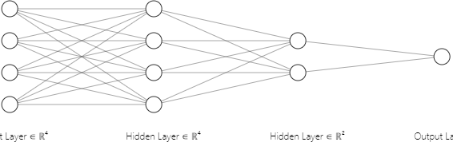
X1

X2
Y
X3

X4

Figure 4.1: ANN Fitting view for the data

There are two types of TSA and SSA outputs: stable and unstable. For TSA, a stable system has a range of 00 to 1200 for many machines, whereas an unstable system has a range bigger than 1200. When the damping ratio is positive and the real part of the eigenvalue is negative, the SSA system is stable or oscillatory free; however, if the real part of the eigenvalue is positive, the system is unstable. An overview of the deep learning neural network data and structure for TSA and SSA is given in Table 4.2.

Table 4.2 Deep learning Neural Network Data and Structure of TSA & SSA

FEATURE AND STRUCTURE OF LSTM | TSA AND SSA
Number of inputs Number of hidden layer Output  Training data Testing data Validation data Training algorithm Epoch Architecture Transfer function | 4  6  1 (for each)  66560  8256  6273  LSTM 31  DIgSILENT/Python  Relu and Sigmoid

Findings

The Results of TSA and SSA for Nigeria 28 bus system

Figure 4.2 and 4.3 shows the results of the neural network model as indicated as a confusion matrix. It shows the model's effectiveness as measured by accuracy, sensitivity, specificity, and precision using LSTM. The results of the TSA's confusion matrix are as follows: TP=14335, TN=275, FP=225, and FN=1526. After 31 epochs, the system converges, and the model accuracy gained is 90% for TSA and 100% for SSA. Table 4.3 displays the performance of the approach's TSA model evaluation. The confusion matrix of SSA model is provided as TP=7251, TN=9110, FP=0, FN=0. Table 4.4 displays the performance evaluation strategy for the SSA model.

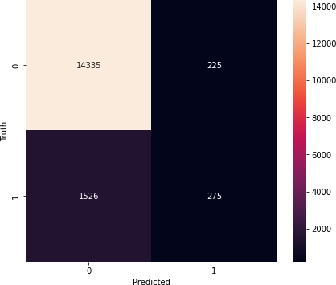

Figure 4.2: Confusion Matrix for the TSA Developed Model

Table 4.3: Evaluation Performance for TSA

Measure | Evaluation (%) | Derivations
Sensitivity | 90.38 | SET = TP / (TP + FN)
Specificity | 55.00 | SPC = TN / (FP + TN)
Precision | 98.45 | PPV = TP / (TP + FP)
Accuracy | 90.16 | ACC = (TP + TN) / (P + N)
F1 Score | 94.24 | F1 = 2TP / (2TP + FP + FN)

Table 4.5 and 4.6 show the target value of TSA and SSA obtained which was then compared with the predicted value after applying LSTM. The LSTM is trained so as to get a predicted value for both TSA and SSA. The predicted value obtained for TSA and SSA are either stable or unstable. For TSA, if the rotor angle is at the range of 0⁰ to 120⁰ for multimachines the system is stable but when the rotor angle is more than 120⁰ the system is unstable. In contrast, the SSA system is stable if the real part is negative, but unstable if the real part is positive. For both stability assessments, the system's expected values for stable and unstable are denoted as 1 and 0, respectively.
.

Table 4.5: Sample Target and Predicted values for TSA

S/N Target for TSA Predicted value
16341 0 0
16342 0 0
16343 0 0
16344 0 0
16345 0 0
16346 0 0
16347 0 0
16348 0 0
16349 0 0
16350 0 0
16351 0 0
16352 0 0
16353 0 0
16354 0 0
16355 0 0
16356 0 0

Table 4.6: Sample Target and Predicted values for SSA

S/N Target for SSA Predicted value
18511 0.1357123 0
18512 1 0
18513 0.10730671 0
18514 0.10730671 0
18515 1 1
18516 1 0
18517 1 0
18518 1 0
18519 1 1
18520 1 0
18521 1 0
18522 1 0
18523 -0.085283166 1
18524 -0.085283166 1
18525 1 0
18526 1 0
18527 1 0
18528 1 0

The Results of TSA and SSA for IEEE 9 bus test system

In order to verify the findings of the TSA and SSA evaluations, this part also depicts the modeling of the IEEE 9 bus system in the DIgSILENT power factory. The transmission lines were modeled as either PV or PQ depending on the location of the generator and load, and the bus bars were modeled as a network. The loads were lumped loads based on PQ data. Using the required information and synchronous generator characteristics, the generators were accurately modeled.
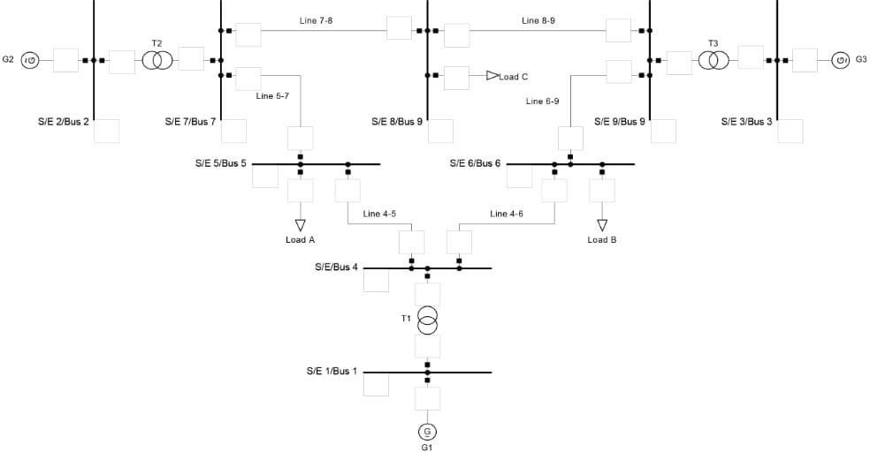

Figure 4.4: Modelling of IEEE 9 Bus System in DIgSILENT

The evaluation performance of the developed model, including accuracy and precision, was calculated using the DLNN technique, as shown in Figure 4.5, using the TSA model confusion matrix. The results of the confusion matrix are as follows; TP = 2300, TN = 5900, FP = 4000, FN = 370. The number of epochs for the TSA is 100 and an early stopping of 82 epochs so as to avoid overfitting. As a result of this the model accuracy obtained was 65 percent. Table 4.8 below shows the evaluation performance for TSA of IEEE 9 bus system.

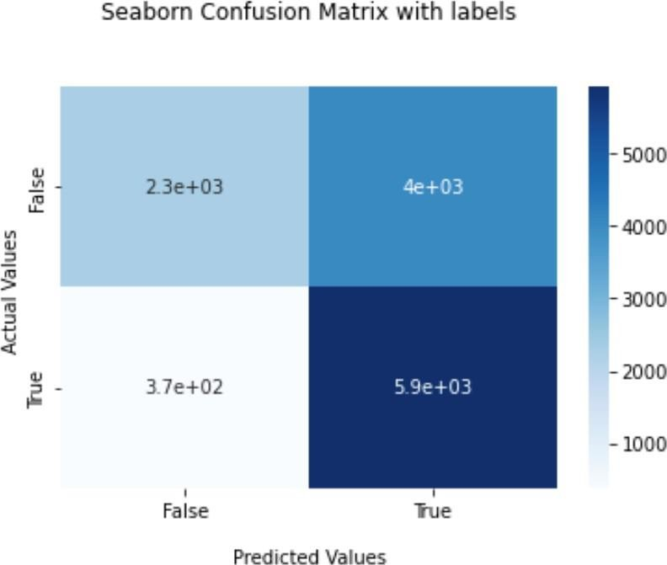

Figure 4.5: Confusion matrix for the TSA IEEE 9 bus system Table 4.7: Evaluation Performance for TSA of IEEE 9 bus system

Measure | Evaluation (%) | Derivations
Sensitivity | 94 | SET = TP / (TP + FN)
Precision | 86 | PPV = TP / (TP + FP)
Accuracy | 65 | ACC = (TP + TN) / (P + N)
F1 Score | 73 | F1 = 2TP / (2TP + FP + FN)

The number of epochs for the SSA is 100 and an early stopping of 40 epochs so as to monitor the generalization error of the model. This resulting to a MSE of 0.183 and RMSE of 0.428.

print (‘MSE: ‘ + str(mse) )

print (‘MSE: ‘ + str(rmse) )
print (‘Epochs: ‘ + str(5) )MSE: 0.183
RMSE: 0.428

Comparison with other results from literature
The effectiveness of several approaches in forecasting TSA and SSA is compared in Table 4.8 below. To predict TSA and SSA, the suggested technique is compared with CNN and LSTM, two networks. The main comparative metrics are MSE, RMSE, sensitivity, accuracy, and precision. The TSA and SSA accuracy, sensitivity, and precision of the Nigeria 28 bus system have good assessment metrics performance. However, when employing the IEEE 9 bus system, the evaluation performance for accuracy was only 65%; the high number of floats in the input data was to blame for the TSA's poor accuracy. In this situation, the TSA accuracy can be increased by extending the training period and applying random search hyperparameter tuning. When utilizing SSA, the MSE can be increased by modifying the random search hyperparameters and increasing the LSTM layers to determine whether the model will overfit the data.

Table 4.8: Comparison of performance with TSA and SSA methods

Related works (TSA and SSA) | Method | Accuracy (%) | Sensitivity (%) | Precision (%) | MSE | RMSE
Nigeria 28 Bus System (proposed work) | LSTM | 90.16 | 90.8 | 98.45 | - | -
IEEE 9 Bus  System (proposed work) | LSTM | 65 | 94 | 86 | 0.183 | 0.428
IEEE 50 Bus  System (Syafiq et.,al 2020) | CNN  and LSTM | 96.4 | - | - | 0.00000016 | 0.0004
New England 39 Bus System (Syafiq et.,al 2020) | CNN  and LSTM | 94.5 | - | - | 0.000010 | 0.0032
IEEE 68 Bus  System (Syafiq et.,al 2020) | CNN  and LSTM | 97.22 | - | - | 0.000017 | 0.0041

CHAPTER FIVE

SUMMARY, CONCLUSION AND RECOMMENDATION

Summary

This study demonstrated a DLNN technique in assessing the power system stabilities by utilizing DIgSILENT/Python to replicate the Nigeria 28 bus system, which was designed expressly for that purpose and significantly expanded in versatility by the use of custom frames and object-oriented programming. The data were chosen using the filtered selection technique after being adequately assessed to reflect unbalanced data and the statistical distribution of fault types. Several machine learning methods for TSA and SSA analysis, such as feature selection, can be tested using this dataset (relief- f and deep learning). The stability of the power system is examined in this study using deep learning. Real data from the Nigerian electricity grid backs up the claim. In this study, a deep learning technique is used to analyze the stability of small and transient signals. According to the research, which was done on a Nigerian 28 Bus system with 9 generators, 28 bus systems, and 52 transmission lines, the suggested method may be used to assess the TSA with SSA and has good accuracy in determining the minimal damping ratio at different operating levels. The case study illustrates how the method outlined in this study may be used to increase the stability and minimal damping ratio of a weakly damped system. The suggested model's effectiveness is confirmed by the minimal prediction error when used to predict the corrected damping ratio using the trained model.

Conclusion

It is now simpler to upgrade the current power systems to a new generation of power systems with a high penetration of renewable energy sources thanks to the combination of power electronics technology and renewable energy. The evaluation of the electrical networks' transient and tiny signal stability is made extremely challenging by this modification. To maintain safe and dependable operation of electricity networks, transient stability and tiny signal stability must be maintained. In order to evaluate micro signal stability and transient stability, feature-based deep learning algorithms (LSTM) are created in this study. The study's conclusions will benefit researchers by improving their understanding of how to assess transient and tiny signal stability using LSTM.

Recommendation

Future research will therefore concentrate on increasing the dataset size through new simulations, increasing the class imbalance through new contingencies, stress-testing the models with different noise and measurement errors, utilizing more deep learning for feature extraction from time-domain signals, experimenting with engineering new artificial features, and comparing various ensemble methods. Utilizing machine learning methods like dimensionality reduction and clustering for this project may also be advised. This paper suggests an online deep learning method for evaluating the stability of transients and small signals.

Contribution to Knowledge
For the Nigeria 28 bus power system, this research effort established a deep learning neural network model for efficient and prompt assessment of transient stability and small signal stability.

REFERENCES

Amin, M., & Molinas, M. (2017). Small-Signal Stability Assessment of Power Electronics Based Power Systems: A Discussion of Impedance- and Eigenvalue- Based Methods. IEEE Transactions on Industry Applications, 53(5), 5014–5030.https://doi.org/10.1109/TIA.2017.2712692
Baoquin Li, J. Wu, L. Hao, M. Shao, R. Zhang & W. Zhao (2020). Anti-jiter and Refined Power System Transient Stability Assessment Based on Long-short Term Memory Network Vol. No 5655, 3-5. DOI: 10.1109/ACCESS.2020.2974915, IEEE ACCESS
Boinee, P., Angelis, A. De, & Foresti, G. L. (2008). Meta Random Forests. World Academy of Science, Engineering and Technology, 18(6), 1148–1157.
Che, Y., Lv, Z., Xu, J., Jia, J., & Li, M. (2020). Direct Method-Based TransientStability Analysis for Power Electronics-Dominated Power Systems.
Mathematical Problems in Engineering, Vol No. 4295, 1-9. https://doi.org/10.1155/2020/4295094
Chien, J.-T. (2019). Deep Neural Network. In Source Separation and Machine Learning (pp. 259–320). Elsevier. https://doi.org/10.1016/B978-0-12-804566- 4.00019-X
Darling-Hammond, L., Flook, L., Cook-Harvey, C., Barron, B., & Osher, D. (2020). Implications for educational practice of the science of learning and development. Applied Developmental Science, 24(2), 97–140. https://doi.org/10.1080/10888691.2018.1537791

Dasu, B., Mangipudi, S., & Rayapudi, S. (2021). Small signal stability enhancement of a large scale power system using a bio-inspired whale optimization algorithm. Protection and Control of Modern Power Systems, 6(1), 35. https://doi.org/10.1186/s41601-021-00215-w
Eltigani, D. M., Ramadan, K., & Zakaria, E. (2013). Implementation of transient stability assessment using artificial neural networks. 2013 international conference on computing, electrical and electronic engineering (icceee), Vol. No. 659–662. https://doi.org/10.1109/ICCEEE.2013.6634018
Hamad, Z., & Abdulrahman, I. (2022). Deep learning-based load forecasting considering data reshaping using PYTHON\Simulink. International Journal of Energy and Environmental Engineering, 13(2), 853–869. https://doi.org/10.1007/s40095-022-00480-x
He, T., Li, S., Wu, S., & Li, K. (2021). Small-Signal Stability Analysis for Power System Frequency Regulation with Renewable Energy Participation. Mathematical Problems in Engineering, 2021, 1–13. https://doi.org/10.1155/2021/5556062
Hoo-Chang Shin, Holger R. Roth, Mingchen Gao, Le Lu, Ziyue Xu, Isabella Nogues & Jianhua Yao (2016). Deep convolutional neural networks for computer-aided detection: CNN Architectures, Dataset Characteristics and Transfer Learning. DOI: 10.1109/TMI.2016.2528162
Janiesch, C., Zschech, P., & Heinrich, K. (2021). Machine learning and deep learning

Electronic Markets, 31(3), 685–695. https://doi.org/10.1007/s12525-021-

00475-2

Jia, Y., Wu, Z., Xu, Y., Ke, D., & Su, K. (2017). Long Short-Term Memory Projection Recurrent Neural Network Architectures for Piano’s Continuous Note

Recognition. Journal of Robotics, 2017, 1–7. https://doi.org/10.1155/2017/2061827
Kaliappan, J., Srinivasan, K., Mian Qaisar, S., Sundararajan, K., Chang, C. Y., & Suganthan, C. (2021). Performance Evaluation of Regression Models for the Prediction of the COVID-19 Reproduction Rate. Frontiers in Public Health, 9. https://doi.org/10.3389/fpubh.2021.729795
Khraisat, A., Gondal, I., Vamplew, P., & Kamruzzaman, J. (2019). Survey of intrusion detection systems: techniques, datasets and challenges. Cybersecurity,2(1), 20. https://doi.org/10.1186/s42400-019-0038-7
Krishna, S., & Padiyar, K. R. (n.d.). Transient stability assessment using artificial neural networks. Proceedings of IEEE International Conference on Industrial Technology 2000 (IEEE Cat. No.00TH8482), 2, 627–632.
https://doi.org/10.1109/ICIT.2000.854241

Krištof, V., & Mešter, M. (2017). Loss of excitation of synchronous generator.

Journal of Electrical Engineering, 68(1), 54–60. https://doi.org/10.1515/jee- 2017-

0007

Kuo, P.-H., & Huang, C.-J. (2018). A High Precision Artificial Neural NetworksModel for Short-Term Energy Load Forecasting. Energies, 11(1), 213. https://doi.org/10.3390/en11010213
Li, Y., Zhao, C., Jiang, H., Zhang, Y., & Muljadi, E. (2021). Introduction. In New Technologies for Power System Operation and Analysis (pp. 1–21). Elsevier. https://doi.org/10.1016/B978-0-12-820168-8.00001-8
Maia, T. V. (2009). Reinforcement learning, conditioning, and the brain: Successes and challenges. Cognitive, Affective, & Behavioral Neuroscience, 9(4), 343–364. https://doi.org/10.3758/CABN.9.4.343
Mikolov, T., Joulin, A., Chopra, S., Mathieu, M., & Ranzato, M. ’A. (2015). Learning longer memory in recurrent neural networks. 3rd International Conference on Learning Representations, ICLR 2015 - Workshop Track Proceedings.
M. Mohammadi, G. B. Gharehpetian & T. Niknam(2010). On-line Small-signal Stability Asssessment of Power Systems Using Ball Vector Machines, Electric Power Componentsand Systems, 38:13, 1427-1445, DOI: 10.1080/15325001003735150

Mohammed, I. J. (2021). The artificial neural network for estimation transient stability by relative unstable equilibrium point method (RUEP). 080010. https://doi.org/10.1063/5.0071021
Nakisa, B., Rastgoo, M. N., Rakotonirainy, A., Maire, F., & Chandran, V. (2018).Long short term memory hyperparameter optimization for a neural network based emotion recognition framework. IEEE Access, 6, 49325–49338. https://doi.org/10.1109/ACCESS.2018.2868361
Nikos, H., J. V. Milanovi, C. Rahmann & V. Ajjarapu (2020). Stability definitions band

characterization of dynamic behavior in systems with high penetration of power electronics interfaced technologies, IEEE Power and Energy Society, Tech . Rep. PES -TR77, May 2020. [Online].
Prasertwong, K., Mithulananthan, N., & Thakur, D. (2010). Understanding Low- Frequency Oscillation in Power Systems. The International Journal of Electrical Engineering & Education, 47(3), 248–262. https://doi.org/10.7227/IJEEE.47.3.2
Ren, C., Xu, Y., & Zhang, Y. (2018). Post-disturbance transient stability assessment of power systems towards optimal accuracy-speed tradeoff. Protection and Control of Modern Power Systems, 3(1), 19. https://doi.org/10.1186/s41601- 018-0091-3
Sarajcev, P., Kunac, A., Petrovic, G., & Despalatovic, M. (2022). Artificial Intelligence Techniques for Power System Transient Stability Assessment.Energies, 15(2), 507. https://doi.org/10.3390/en15020507
Sawhney, H., & Jeyasurya, B. (2006). A feed-forward artificial neural network with enhanced feature selection for power system transient stability assessment.

Electric Power Systems Research, 76(12), 1047–1054. https://doi.org/10.1016/j.epsr.2005.12.026
Shewalkar, A., Nyavanandi, D., & Ludwig, S. A. (2019). Performance Evaluation of Deep Neural Networks Applied to Speech Recognition: RNN, LSTM and GRU. Journal of Artificial Intelligence and Soft Computing Research, 9(4), 235–245. https://doi.org/10.2478/jaiscr-2019-0006
Syafiq, K. A., Younes,J. I., Mohamed, S. El., Khaled, E. (2020). A Unified Online Deep Learning Prediction Model for Small Signal and Transient Stability. IEE Transactions on Power Systems, 35(6).
Van Engelen, J. E., & Hoos, H. H. (2020). A survey on semi-supervised learning.

Machine Learning, 109(2), 373–440. https://doi.org/10.1007/s10994-019-05855-6 Venkata, S. S. mani, Eremia, M., & Toma, L. (2013). Background of Power System
Zhang, S., Zhu, Z., & Li, Y. (2021). A Critical Review of Data-Driven Transient Stability Assessment of Power Systems: Principles, Prospects and Challenges. Energies, 14(21), 7238. https://doi.org/10.3390/en14217238

