DYNAMIC MODELLING AND ASSESSMENT OF MULTI-SOURCE RENEWABLE ENERGY-BASED MICROGRID SYSTEM DURING UNCERTAINTY

ODETOYE, OYINLOLU AYOMIDOTUN
(20PGBD000143)

A THESIS SUBMITTED TO THE DEPARTMENT OF ELECTRICAL AND INFORMATION ENGINEERING, COLLEGE OF ENGINEERING, LANDMARK UNIVERSITY, OMU-ARAN, KWARA STATE

IN PARTIAL FULFILMENT OF THE REQUIREMENTS FOR THE AWARD OF MASTER OF ENGINEERING (M.ENG) DEGREE IN ELECTRICAL AND INFORMATION ENGINEERING, LANDMARK UNIVERSITY, OMU-ARAN, KWARA STATE

AUGUST 2022

DECLARATION
I, Oyinlolu Ayomidotun ODETOYE, a M.Eng. student in the Department of Electrical and Information Engineering, Landmark University, Omu-Aran, hereby declare that this thesis entitled “DYNAMIC MODELLING AND ASSESSMENT OF MULTI-SOURCE RENEWABLE ENERGY-BASED MICROGRID SYSTEM DURING UNCERTAINTY”, submitted by me is based on my original work. Any material(s) obtained from other sources or work done by any other persons or institutions have been duly acknowledged.

ODETOYE, Oyinlolu Ayomidotun
20PGBD000143
----------------------------------------
Student’s Full Name and Matriculation number

----------------------
Signature & Date

CERTIFICATION
This is to certify that this thesis has been read and approved as meeting the requirements of the Department of Electrical and Information Engineering, Landmark University, Omu-Aran, Nigeria, for the Award of Master of Engineering (M.Eng.).

------------------------------------ -----------------------------------
Supervisor Signature and Date

------------------------------------ ---------------------------------
Head of Department Signature and Date

----------------------------------- ---------------------------------
External Examiner Signature and Date

DEDICATION
This work is dedicated to God Almighty, the giver of knowledge and essence of all that is intelligent. This work is also dedicated to all families who are kind and supportive, and to all those who are genuinely trying to make the world a better place through their daily activities.
This work is also dedicated to all young people who recognise that one who, in the meantime, legitimately depends on their own family for support, is more honourable than one whose ‘financial independence’ fully depends on defrauding others’ families.

ACKNOWLEDGEMENTS
I acknowledge the Rock of Ages, without which I, this work, and everyone else here acknowledged, would not exist. He has been my strength, shield, and facilitator throughout the studies that culminated in this work.
Words cannot express how blessed I am to have Engr. Dr. P.K. Olulope as my M.Eng thesis supervisor. His devotion to my excellence, not only in this work but in other aspects of my academic training, transcends the call of duty and is reflected in numerous sacrifices he made on my behalf in and even before the course of this work. His encouragement, advice, thoroughness of instruction, extensive resourcefulness, work ethic, and emotional support, have made a work of this quality possible within the relatively short time in which he had to supervise me.
I cannot describe how much I owe to the paternal interest, sagely encouragement and inspiring mentorship of Engr. Prof F.A. Ibikunle, which have been very illuminating and helpful in providing a rewarding experience throughout the entire duration of my studies at Landmark University. I am also grateful to the entire staff of the EIE department, especially of the SDG 7 Research Group, for the supportive atmosphere afforded for my studies. I am especially grateful to Dr O.J.K Oghorada and Dr B.B. Adetokun of Nile University, Abuja, for the roles they have played in my LMU journey and my ongoing evolution as a researcher, for which I can hardly provide a befitting summary, and Dr G. O Igbinosa for his golden nuggets of advice.
I must acknowledge the impact of my adjunct lecturers who came primarily from my alma mater, the University of Ilorin. Prof. M.F Akorede’s delivery of the Research Methods course and the Renewable Energy course has been directly relevant to this work, as have Dr A.Y Abdulrahman’s MATLAB demonstrations and Dr I.O.A Omeiza’s eye-opening lectures. My closest M.Eng study colleagues, John Onyemenam and Nnaemeka Okeke, have been mutually supportive and very encouraging and helped me out several times and I have learnt a lot from them not only about academics but about life in general, for which I am very grateful. Engr. Egbune, Engr. Kareem and Mr Alabi were very helpful on several occasions.
Dr B.S Fakinle helped me find my feet at LMU at a very critical time, and he and Dr O. Oyewole of the Chemical Engineering department have been full of encouragement, advice, and support for me at all times. I am also very grateful to Prof O. Awodele for constant motivation, Dr Gbadamosi, Dr Nwonuma, Mr Ayooluwa Ayoola, Pastor Adekunle, Mrs Boluwape Olarewaju, I.K Anyim for highly valuable interactions and crucial kind gestures, and those who were, simply inspiring lights every time I was around them, such as F.F Olasehinde and E.M. Ibitogbe. I appreciate Bishop D.O Oyedepo for the vision for Landmark University that gave me the opportunity for this study. Climatic data were obtained from the NASA Langley Research Center (LaRC) POWER Project funded through the NASA Earth Science/Applied Science Program.
I appreciate SDA Church, Igangu, Omu-Aran under the leadership of Pastor Solademi for being a support system and for several kind gestures I enjoyed. I have been happy in the church’s youth and choir groups, in which I found both a service opportunity and joyful comradeship. I am especially indebted to the family of Elder Engr. Samuel Aremu and Dr. Mrs. Adepeju Aremu. There is no appropriate way of expressing the ramifications of their love which I have enjoyed, I have to settle for saying that they have been my family in Omu-Aran. Not only did they consistently see to my physical welfare, but Engr Aremu, as a power engineer himself, was very helpful in my work, including but not limited to facilitating the access to required data for which I am grateful to the Transmission Company of Nigeria.
I am very grateful to my uncle, Mr Adeyemi Adebayo, for his constant interest in my electrical professional education and for being more than willing to help whenever I needed a field personnel’s experienced advice, especially when it came to the Arandun power system. I am also very grateful to another uncle of mine, Mr Sunday Folayan, for his time, effort, and invaluable assistance in facilitating my stream-gauging efforts. Having him with me was a real blessing.
I acknowledge the support and especially prayers of my home church family, the SDA Church, Gaa-Akanbi in Ilorin, under the leadership of Pastor Dr Olaofe. My brother and friend, Prince Adefila Emmanuel, who was studying for his own Master’s degree at the same time in a different but similar setting to mine was always encouraging with his mature approach to our respective academic situations. Furthermore, our mummy, Deaconess Adefila was always checking on me over the phone. In this regard, I am also very grateful to Dr Dunmade for always keeping me in mind.
I am immensely grateful to my parents, Arc. Dr. Adeola S. Odetoye (FNIA) and Engr. Dr Mrs Temitope E. Odetoye (FNSE) for all they have done for me up till now, including, in this case, their tireless support and enablement of my academic endeavours. I thank my sisters and big brother (in-law), Dr and Mrs Oyinlola Oluwasegun-Yahaya, Oyinlade Odetoye, Oyinlayo Odetoye, and my niece and nephew, Modesoyinoluwa and Moyosoyinoluwa Oluwasegun-Yahaya for being an inexhaustible source of moral (and other forms of) support to me in the course of this research, and for the little things and big things they did to make my Master’s studies as painless as possible. If I had hired people to support and assist me in the course of my programme, they could not possibly have done it with the dedication and impact that my family have. I acknowledge everyone who has played a role in my success in this study, and whose work has made it possible.

TABLE OF CONTENTS
DECLARATION ii
CERTIFICATION iii
DEDICATION iv
ACKNOWLEDGEMENTS v
TABLE OF CONTENTS viii
LIST OF TABLES xiii
LIST OF FIGURES xv
ABSTRACT xviii
CHAPTER ONE 1
INTRODUCTION 1
1.1 BACKGROUND TO THE PROBLEM 1
1.2 STATEMENT OF THE PROBLEM 7
1.3 JUSTIFICATION FOR THE STUDY 8
1.4 AIM OF THE RESEARCH 9
1.5 SPECIFIC OBJECTIVES OF THE RESEARCH 9
1.6 SCOPE OF THE RESEARCH 10
1.7 SIGNIFICANCE OF THE STUDY 10
CHAPTER TWO 12
REVIEW OF RELATED LITERATURE 12
2.1 THE EMERGING STRUCTURE OF POWER SYSTEMS 12
2.2 THE CONCEPT OF DISTRIBUTED GENERATION 12
2.3 MICROGRID CONCEPT 17
2.4 CLASSIFICATIONS OF MICROGRIDS BY PURPOSE 19
2.5 STABILITY IN MODERN POWER SYSTEMS 24
2.6 UNCERTAINTY IN POWER SYSTEMS 26
2.7 QUASI-DYNAMIC SIMULATION 28
2.8 FUZZY LOGIC FOR SOCIAL ACCEPTABILITY ANALYSIS 30
2.9 GAP IDENTIFIED IN THE LITERATURE 42
CHAPTER THREE 43
METHODOLOGY 43
3.1 RESEARCH DESIGN/MODEL SPECIFICATION 43
3.1.1 Description of Study Area 43
3.1.2 Research Workstation 44
3.2 RESEARCH DESIGN LAYOUT 44
3.2.1 SOCIAL ACCEPTABILITY ANALYSIS 48
3.2.1.1 Fuzzy Logic Structure 48
3.2.2 TECHNO-ECONOMIC FEASIBILITY ASSESSMENT 55
3.2.2.1 Renewable Microgrid Scenario with Energy Storage. 56
3.2.2.2 Dispatch Strategy for the Renewable Microgrid. 57
3.2.2.3 Diesel Microgrid Scenario 58
3.3 DYNAMIC MODELLING OF SYSTEM COMPONENTS 61
3.3.1 Wind Generator (Doubly-Fed Induction Generator) 61
3.3.2 Quasi-Dynamic Mathematical Formulations for Synchronous Generators 63
3.3.3 Micro-Hydro Turbine Modelling 65
3.3.4 Concentrated Solar Power Modelling 66
3.3.5 Photovoltaic, Inverter, and Battery Storage Model 68
3.4 PROBABILISTIC TECHNIQUES IN THE STUDY. 70
3.4.1 Weibull Distribution 70
3.4.2 Normal Distribution 71
3.4.3 Gumbel (Extreme-Value Type - 1) Distribution 71
3.5 VOLTAGE PROFILE STABILITY: VOLTAGE DEVIATION INDEX (IVD) 73
3.6 QUASI-DYNAMIC SIMULATION OF THE MICROGRID 75
3.6.1 Single-Power-Point Microgrid Scenario 76
3.6.2 Multiple-Power-Point Microgrid Scenario 77
3.7 SOURCES OF DATA COLLECTION 78
3.7.1 Load Data 78
3.7.2 Renewable Energy Data 79
3.7.3 Economic Data and Cost Information 84
3.8 RESEARCH INSTRUMENTS/TOOLS 85
3.9 DATA ANALYSIS TECHNIQUES 86
3.10 BRIEF PRESENTATION AND EXPLANATION OF LOAD AND STREAMFLOW DATA. 87
CHAPTER FOUR 95
RESULTS AND DISCUSSION OF FINDINGS 95
4.1 SOCIAL ACCEPTABILITY ANALYSIS 95
4.2 TECHNO-ECONOMIC ANALYSIS 96
4.2.1 Load Computations for HOMER 96
4.2.2 Optimal Solutions for the Renewable Microgrid. 103
4.2.3 Net Present Cost and Levelized Cost of Energy 104
4.2.4 Battery Energy Storage System (BESS) 106
4.2.5 System Converter (Bidirectional) 108
4.2.6 Micro-Hydro Turbine 109
4.2.7 Effect of Removing the Battery Energy Storage 111
4.2.8 Optimal Solutions for Diesel Scenario. 113
4.2.9 Total Net Present Cost (NPC) for Diesel Microgrid 114
4.2.10 Levelized Cost of Energy (COE) for the Diesel Microgrid 114
4.2.11 Annual Operating Cost 115
4.2.12 Electrical Summary of the Diesel Microgrid 115
4.2.13 Emissions of the Diesel Microgrid 117
4.3 PROBABILITY DISTRIBUTIONS FITTED 118
4.4 QUASI-DYNAMIC SIMULATION RESULTS OF THE MICROGRID 120
4.4.1 Results of the IVD Analysis for First Scenario (Single Power Point) 120
4.4.2 Line loading in the Microgrid for The First Scenario 132
4.4.3 Voltages obtained in the Microgrid for the First Scenario. 133
4.4.4 Transformer Loading on the Microgrid 134
4.4.5 Results of the IVD Analysis for the Second Scenario (Dual Power Point). 135
Graphical Comparison of First and Second Scenarios 148
4.4.6 Voltages obtained in the Microgrid for the Second Scenario. 149
4.4.7 Transformer Loading on the Microgrid 150
CHAPTER FIVE 152
SUMMARY, CONCLUSION, AND RECOMMENDATION 152
5.1 SUMMARY 152
5.2 CONCLUSION 154
5.3 RECOMMENDATIONS 154
5.4 CONTRIBUTION TO KNOWLEDGE 155
REFERENCES 156
APPENDICES 178
APPENDIX I: RESEARCH TIMELINE 178
APPENDIX II: ESTIMATED BUDGET 178
APPENDIX III – MATLAB CODE FOR PROBABILISTIC MODELLING 179
APPENDIX IV – DIGSILENT MODEL SPECIFICATION 191
APPENDIX V – PLOTS OF PROBABILITY DISTRIBUTIONS 191
APPENDIX VI – MATLAB CODE FOR FUZZY LOGIC SYSTEM 197
APPENDIX VII – MONTHLY PRECIPITATION DATA 199
APPENDIX VIII – IMAGES OF WORK IN ACTION 201

LIST OF TABLES
Table 2.1 | Selection of Reviewed Methodological Approaches | 33
Table 3.1 | Cost Information of Generating sets with final selections in bold | 60
Table 3.2 | Official Exchange rate at research time in April 2022 | 61
Table 3.3 | Average Monthly DNI for Arandun | 67
Table 3.4 | Sample of the hourly load data | 89
Table 3.5 | Sample of Hourly Measurements for a Selected Week | 90
Table 3.6 | Monthly Average Hydropower Data | 91
Table 3.7 | Extract of Daily Solar Influx Data for January 2021 for Arandun Coordinates | 93
Table 4.1 | Architecture of the Chosen Optimal Renewable Microgrid | 105
Table 4.2 | Net Present Costs Breakdown of the Renewable Microgrid | 105
Table 4.3 | Design Properties of the Battery Energy Storage System | 106
Table 4.4 | Electrical Summary of the Bidirectional Converter | 109
Table 4.5 | Statistics and Capacity of the Hydropower Turbine | 110
Table 4.6 | Electrical Summary of the Diesel Microgrid Results for the First and Last Years | 116
Table 4.7 | Emission Levels of Pollutants in the First Year of Diesel Microgrid | 118
Table 4.8 | Probability Distributions for Characterizing Uncertainty in the Renewable Resources and Load in Arandun | 119
Table 4.9 | Average IVD as experienced at the loads for each month for the first three buses – First Scenario | 131
Table 4.10 | Average IVD as experienced at the loads for each month for the last three buses – First Scenario | 132
Table 4.11 | Average loading (in %) of distribution Lines in the microgrid for each month of the year for the First Scenario | 133
Table 4.12 | Average voltage on buses in the microgrid for each month of the year for the first Scenario | 133
Table 4.13 | Average loading (in %) of Transformers in the microgrid for each month of the year for the first Scenario | 134
Table 4.14 | Average IVD (in %) as experienced at the loads for each month for the first three buses in the Second Scenario | 135
Table 4.15 | Average IVD (in %) as experienced at the loads for each month for the last three buses in the Second Scenario | 136
Table 4.16 | Average voltage on buses in the microgrid for each month of the year for the first Scenario | 149
Table 4.17 | Average loading (in %) of Transformers in the microgrid for each month of the year for the first Scenario | 150

LIST OF FIGURES
Figure 2.1 | Centralised Generation visually contrasted with DG | 15
Figure 3.1 | Breakdown of Objective 1 | 46
Figure 3.2 | Breakdown of Objective 2 | 46
Figure 3.3 | Summary of Objective 3 | 47
Figure 3.4 | Breakdown of Objective 4 | 47
Figure 3.5 | Structure of the Fuzzy Inference System | 50
Figure 3.6 | Linguistic Variable and Membership Functions for Land Use | 51
Figure 3.7 | Linguistic Variable and Membership Functions for Acoustic Noise | 52
Figure 3.8 | Linguistic Variable and Membership Functions for Impact on Air Quality | 53
Figure 3.9 | Linguistic Variable and Membership Functions for Visual Impact | 53
Figure 3.10 | Linguistic Variable and Membership Functions for Impact on Water Resources | 54
Figure 3.11 | Schematic of Multi-Energy Renewable Energy with Chemical Storage in HOMER | 57
Figure 3.12 | Schematic of Diesel Microgrid in HOMER | 59
Figure 3.13 | DFIG and its Connections | 62
Figure 3.14 | Power Conversion and Control in the Microgrid | 69
Figure 3.15 | Representation of the first scenario of the microgrid in PowerFactory | 77
Figure 3.16 | Representation of the Second Scenario of the Microgrid in PowerFactory | 78
Figure 3.17 | Hose Level Method Used in Head Estimation in the Study | 83
Figure 4.1 | Defuzzification of Rule Base for Computation of Acceptability Index | 95
Figure 4.2 | Box-and-Whisker Plot Showing the Monthly Average Load Profile | 97
Figure 4.3 | Histogram Showing Load distribution by Frequency of Incidence | 98
Figure 4.4 | Cumulative Distribution of Load Pattern by Frequency of Incidence | 98
Figure 4.5 | Load Curve for the First Year of the Simulation | 99
Figure 4.6 | Average Hourly Load Profile for Selected Days in May | 100
Figure 4.7 | Average Hourly Load Profile for Selected Days in November and December | 100
Figure 4.8 | Monthly Peak Load for 2020 and 2021 | 101
Figure 4.9 | Monthly Energy Consumption in 2021 and 2021 | 102
Figure 4.10 | Average Hourly Load Profiles for each Month as Estimated by HOMER Pro | 103
Figure 4.11 | Box-and-Whisker Plot of the BESS Input Power in Year 1 | 107
Figure 4.12 | Box-and-Whisker Plot of the BESS State of Charge in Year 1 | 108
Figure 4.13 | Hydropower Output Annual Curve as estimated for the Osin River in Arandun | 111
Figure 4.14 | AC Primary Load Curve of the Renewable-Based Microgrid | 112
Figure 4.15 | Complementarity Curve of the Renewable-Based Microgrid | 113
Figure 4.16 | Growth of Emissions in tandem with load growth over the Project Lifetime | 117
Figure 4.17 | Average IVD in the microgrid in January (Scenario 1) | 121
Figure 4.18 | Average IVD in the microgrid in February (Scenario 1) | 122
Figure 4.19 | Average IVD in the microgrid in March (Scenario 1) | 123
Figure 4.20 | Average IVD in the microgrid in April (Scenario 1) | 124
Figure 4.21 | Average IVD in the microgrid in May (Scenario 1) | 125
Figure 4.22 | Average IVD in the microgrid in June (Scenario 1) | 126
Figure 4.23 | Average IVD in the microgrid in July (Scenario 1) | 126
Figure 4.24 | Average IVD in the microgrid in August (Scenario 1) | 127
Figure 4.25 | Average IVD in the microgrid in September (Scenario 1) | 128
Figure 4.26 | Average IVD in the microgrid in October (Scenario 1) | 129
Figure 4.27 | Average IVD in the microgrid in November (Scenario 1) | 129
Figure 4.28 | Average IVD in the microgrid in December (Scenario 1) | 131
Figure 4.29 | Average IVD in the microgrid in January (Scenario 2) | 138
Figure 4.30 | Average IVD in the microgrid in February (Scenario 2) | 139
Figure 4.31 | Average IVD in the microgrid in March (Scenario 2) | 140
Figure 4.32 | Average IVD in the microgrid in April (Scenario 2) | 141
Figure 4.33 | Average IVD in the microgrid in May (Scenario 2) | 142
Figure 4.34 | Average IVD in the microgrid in June (Scenario 2) | 142
Figure 4.35 | Average IVD in the microgrid in July (Scenario 2) | 143
Figure 4.36 | Average IVD in the microgrid in August (Scenario 2) | 144
Figure 4.37 | Average IVD in the microgrid in September (Scenario 2) | 145
Figure 4.38 | Average IVD in the microgrid in October (Scenario 2) | 146
Figure 4.39 | Average IVD in the microgrid in November (Scenario 2) | 147
Figure 4.40 | Average IVD in the microgrid in December (Scenario 2) | 148
Figure 4.41 | Average Bus 6 IVD in the microgrid for both scenarios | 149

ABSTRACT
Due to environmental concerns, the case for the development of renewable-based electricity infrastructure has grown stronger. The electrical energy access in Arandun Town, Kwara State, Nigeria, is inadequate and in need of improvement. Most intermittent renewable sources of energy have inherent uncertainty in their availability, which could impact the utilization negatively while also affecting the stability of power systems incorporating them. This study assessed the economic and dynamic performance of a proposed multi-source standalone renewable community microgrid under uncertainty in the local renewable resources.
The load data and fine-grained climactic data for Arandun were obtained and the major river in the community (Osin River), was gauged. Cost information for equipment was gathered; a techno-economic feasibility study and design optimization in HOMER Pro software was conducted and compared with a diesel alternative on an economic basis. A Social acceptability analysis of the microgrid using a Fuzzy Inference System (FIS) with 5 inputs was conducted. Probability distributions to characterize the uncertainty in the wind, micro-hydropower, load, and solar resource in each month of the year were developed using MATLAB, with the Weibull, Gumbel, and Lognormal distributions respectively. The microgrid was modelled and simulated in DigSILENT PowerFactory and the voltage stability in each month of the year due to renewable uncertainty was assessed using the Index of Voltage Deviation (IVD).
Based on the results of the study, a mixture of Concentrated Solar Power (CSP), Photovoltaics (PV), and micro-hydro with energy storage which will be cheaper than a diesel microgrid of equal capacity for the location was found to be reasonably viable, except for wind energy. The three-source (CSP-PV-Hydro), battery-equipped renewable microgrid had a Net Present Cost of $55.7 million compared to $408 million for an equivalent diesel microgrid. Also, the renewable microgrid saved 7,450 metric tons of CO₂ per year in emissions for a 25-year simulated project lifetime. The obtained climatic data for each month were found to be representative of the 48 different respective probability distributions as developed in MATLAB, which were then sampled for 12 different Quasi-dynamic simulations based on 14 variables (for each month of the year). The Index of Voltage Deviation (IVD) was used to assess the performance of the renewable microgrid for each month in two scenarios and it was found that the microgrid stability was most at risk in December and January.
The results of the feasibility study showed that the renewable microgrid based on the combination of PV, CSP, micro-hydro, and a Battery Energy Storage System is economically and ecologically competitive compared to relying on fossil fuels to meet the electricity demand over time. However, the investment in wind energy in Arandun or similar locations does not look promising. Furthermore, some of the buses on the microgrid tend to experience voltage stability problems during the holiday seasons due to population flux and higher stochasticity of the load. Thus, measures to enhance the stability of the weak points in the microgrid in such periods need to be considered. Based on the results of the study, the proposed renewable microgrid in Arandun is a promising prospect.

CHAPTER ONE

INTRODUCTION

1.1 BACKGROUND TO THE PROBLEM
Energy is nature’s currency for all activities (Mihajlović & Trajković, 2018). From the motions and metamorphoses of the galaxies in space and time to the reactions that take place within the smallest cells of the human body to create and sustain life, energy is involved in all physical processes. Economical activities rely on the timely and adequate provision of energy with which to carry them out (Melnyk et al., 2019). Of the different forms in which energy is harnessed and utilized by man, electricity presents the most versatile (Herath & Varathan, 2018). Electrical energy continues to garner a rapidly-increasing number of available applications, and much of modern technology relies on it. For these reasons, there is a well-known correlation between electricity access and productivity in twenty-first-century economies (Adebimpe et al., 2021; Akhator et al., 2019).
Due to several factors such as global warming, climate change, political transitions, and technological trends among other ones, the use of renewable resources in the energy mix has gained importance and priority in the international community (A. K. Aliyu et al., 2018; Elum & Momodu, 2017). Most traditional ways of generation of electricity on commercially-viable scales involve the emission of not only greenhouse gases which contribute to global warming but also chemical pollutants that are directly hazardous to the health of humans and other living creatures, while it is not so with most renewable energy-based methods (Akuru et al., 2013; Kopas et al., 2020). In addition, transportation costs for fuel and reliance on other countries for the supply of a critical resource such as energy have become a sensitive scene in the light of international relations in recent times (A. S. Aliyu et al., 2015; Ates et al., 2016).
In the light of the aforementioned factors, development and research toward power systems that integrate high proportions of renewable energy resources have drawn increasing attention in the past and recent years (Adedoyin et al., 2020; Batel, 2020; Carbajo & Cabeza, 2019; Jurasz et al., 2020; Zafar et al., 2019). Many renewable energy technologies have fewer separate physical stages of energy conversion between raw material and the power generator compared to fossil-fuel plants (Dawood, 2020). Most renewable sources also have a lower environmental impact compared to non-renewable energy sources and can be implemented economically on a wide range of scales, from a few watts to several megawatts of power (Sumathi et al., 2015).
Heating, cooling, ventilation, illumination, and mechanical systems in modern commercial, industrial, recreational, and residential buildings have relied on electricity as the major source of energy input for decades (Ahmad et al., 2018; Amasyali & El-Gohary, 2018; Cai et al., 2019; Tian et al., 2018). Transportation, however, has been a sector relying mainly on fossil fuel combustion for its energy. Nevertheless, recently, the trends in the electric transport industry have produced disruptive technologies such as electric trains, electric vehicles, and even aircraft and seacrafts that do not rely on combustion engines but electric engines (Anderson et al., 2018; Hu et al., 2020; Moaveni et al., 2020; Pintér et al., 2021).
These trends show that, increasingly, electricity is the form of energy being used in consumer applications. In other words, hypothetically, if enough electricity is provided at all points of use and on time as needed, given the current level of human technological advancement, the only use of fossil fuels will be at the electric power plants themselves. Thus, one of the most effective measures in making for a smooth transition to clean energy, in general, is the provision of high amounts of secure and adequate renewable-based electrical energy to human communities on demand.
However, the use of renewable sources in the existing electricity grids presents a myriad of engineering challenges (Aziz & Ketjoy, 2017; Basit et al., 2020; Duong et al., 2017; Pinto et al., 2016). This is due, firstly, to the fact that there are different technologies used for energy conversion for different forms of renewable energy, each with its own physical and electrical properties, which all have to be synergized for stable operation of the power systems (Kenyon et al., 2020). Many renewable technologies, with the notable example of solar photovoltaic (PV), rely on inverters, sometimes in tandem with storage batteries, for conversion into the AC form that is used on existing grids (Masters, 2013). Electrical power systems are complex, and the inclusion of new inverter-based sources in a plug-and-play manner has the potential to destabilize the system if added without careful planning (Hirsch et al., 2018). These challenges have been approached by researchers, and while advances have been made, the development of systems that allow for robust operation of the power system with plug-and-play inclusion of inverter-based resources remains an open area of research (Aganah et al., 2019).
Equally concerning is that, even for the renewable sources that have been successfully integrated into grids by designing for compatibility, such integration is accompanied by several economic and technical challenges that make it difficult to achieve security of energy supply. Mainly, unlike conventional generation where the amount of fuel can be predetermined and controlled on-site, some renewable energy resources are intermittent and not amenable to control. This introduces undesirable uncertainty into the planning and operation of renewable-based systems that are based on intermittent resources such as wind, solar irradiation, and river or stream flow. Hydropower that is based on impoundment (such as dammed rivers and lakes) is more stable but still relatively subject to variation while solar and wind are highly variable and subject to uncertainty (Fathabad et al., 2020). The effect of this uncertainty is more critical when the system has a high penetration of renewable-based sources (Duong et al., 2017). This frequently poses a major challenge to the use of renewable technology in power systems which urgently demands if adequate studies are not carried out at the right time. This precipitates the need for current research on the performance of renewable energy-based power systems under uncertainty in the natural energy resources.
Uncertainty in the planning and operation of power systems arises from many factors in different contexts and on different timescales (from years, months, days, down to milliseconds) which could not only be physical but could also be economic, political, behavioural or technological (Blanco, 2019). However, when focusing on the physical characteristics of power systems, the major source of uncertainty is the connection/ high penetration of renewable-based generation. In non-renewable-based systems, many parameters can safely be treated as having deterministic states, but in systems with high penetration of renewable energy, the parameters depend on factors that are not under the control of the power system operator (Zobaa & Aleem, 2021).
For example, the supply of energy in the form of solar insolation at a location is neither constant nor uninterrupted. This means that a solar farm is susceptible to periods of producing below its capacity on cloudy days or during eclipses. In addition, the temperature also affects the amount of electricity that can be harvested from a solar array. In the case of wind turbines, the power in the wind is not constant but varies as the wind gusts hasten and slow over time. In the event of potentially destructive wind speeds, the average wind turbine is designed to ‘cut out’ to avoid damage, and there is also no power generation. These extreme cases illustrate the uncertainty that arises in intermittent renewable-based systems. If this uncertainty is not accounted for, a standalone system such as a microgrid that is built to depend on such technologies may be severely inadequate.
A microgrid is a power system that contains its own sources and loads within a small area, with the ability to operate in standalone mode, or while connected to the larger power system or macrogrid (Shayeghi & Younesi, 2020). Microgrids usually integrate multiple alternative energy sources such as solar photovoltaic, wind turbines, and energy storage systems, sometimes with conventional sources such as diesel generators, to serve local loads (Akinyele et al., 2020; Hirsch et al., 2018). A standalone microgrid exists without depending on any external sources or supplying any loads that are external to the system. Microgrids also sometimes exchange power with the macrogrid or other microgrids, in which case they are known as grid-connected microgrids. The effects of renewable-based uncertainty are more critical in standalone microgrids because they have no external system on which to fall back in case of internal inadequacies in the generation of electric power.
Standalone microgrids enable complete independence from the grid. They are usually a favourable option wherever power utility infrastructure is unavailable, nonexistent, or inadequate. Whenever a standalone microgrid is used, energy storage is needed to maintain continuity of supply. In many Nigerian communities, there is the well-known problem of electricity supply being unable to meet up with the demand (Adebimpe et al., 2021; Ebhota & Tabakov, 2018). This is not only concerning real and reactive power quantity, but also the quality of power. In many cases, the grid power supply from a centralized power system is unable to keep up with the evolution in electricity demand due to the local developments of a community as it grows economically, and the feeders from the utility are overloaded, which results in problems such as poor voltage profile.
Grid-connected microgrids are not independent of the larger grid but are connected to it in such a way as to enable the sharing of power with it. For this reason, energy storage systems are usually not needed. However, this applies only when the power supply from the larger grid is reliable. If the power supply from the larger grid is not reliable or rarely available, the microgrid may still need to be equipped with energy storage systems. These energy storage systems may be batteries, supercapacitors, or flywheel energy storage systems. The decision to stay on or off the grid depends on factors such as the size of the technology (how much power is to be generated), the price of the technology (which varies from place to place and across time), and the local tariffs and feed-in-tariff policies (Khalilpour & Vassallo, 2016).
The uncertainty in the primary energy sources and the unavailability of the energy resources in the power system poses a great threat to the stability of the power system. The stability of a power system concerns its tendency to operate in its desired equilibrium conditions even when subjected to physical disturbances. However, due to the multidimensionality of power systems, stability is classified for system analysis, usually by focusing on one power system variable at a time. The voltage stability of the grid is the ability of the power system to maintain desired voltage levels on all buses in the system under reasonable operating conditions and after its subjection to disturbance (Youssef et al., 2018). If there is inadequate voltage stability on the microgrid, the loads connected could operate undesirably or be damaged.
The use of load shedding for stability control of power systems means that the quality of service is not favourable for economic activities. This forces many people to rely on “I-pass-my-neighbour” mini-generators (Aganah et al., 2019) which are comparatively expensive to run, producing noise and toxic fumes, while also having unused capacity at times, making them rather inefficient when considered in massive numbers with each house having its own. For this reason, a standalone microgrid would be a more communal and economical alternative. It can run partially or completely on renewable resources depending on demand, it can save space and fuel, and reduce noise. Also, maintenance is easier as it is one system, and it can take advantage of the existing distribution networks.
In the light of the presented facts, a community microgrid operating the standalone form must meet the requirements of being able to provide energy at a competitive cost as needed by consumers (availability). If it is a renewable microgrid, it must be able to meet the energy demands, even when subjected to renewable resource uncertainty, as well as possible. Also, the system must not only provide energy to consumers but also do so while remaining stable.

1.2 STATEMENT OF THE PROBLEM
The grid electricity access in many locations, including the selected study location in Nigeria, is found to be mostly insufficient and sometimes unavailable. In Arandun with a load demand of up to 2MW (and growing) but sporadic power supply of 0.9 MW on average, insufficient and inadequate supply leads to issues such as poor voltage profile. Wherever such a situation exists, access to safe, clean, and affordable energy is not secured. This forces individuals to either endure sporadic, nonexistent, insecure, or low-quality access to electricity or invest in expensive, noisy, and fume-emitting generating sets despite the abundance of locally-harnessable renewable energy.
There is an unmet need for modelling and assessment of a standalone microgrid system to provide reliable, secure, safe, and affordable energy for the community in Nigeria at the selected location. This is because the use of intermittent renewables tends to negatively impact voltage stability in some cases.

1.3 JUSTIFICATION FOR THE STUDY
Several researchers have noted that the impacts of integrating renewable energy sources into the grid are not always completely positive (Duong et al., 2017; Impram et al., 2020). As the global paradigm shift from centralized generation to distributed generation continues, the proliferation of smaller inverter-based resources is on the rise (Bajaj & Singh, 2020). Existing power system management strategies for the control of important quantities such as voltage and frequency are usually best suited for power systems whose sources are rotating electrical machines. Therefore, these strategies are proving increasingly ill-suited for coping with the large numbers of smaller generating units which do not always fit this criterion (Felder, 2014).
There have been cases of significant and very costly damage to power systems spanning wide areas due to unanticipated interactions between the electrical and mechanical quantities in parts of the power system (Tran et al., 2019; X. Xie et al., 2017). The fact that these events were unanticipated is partially due to the limited understanding of the dynamics of some of the renewable subsystems that were integrated into them (Meegahapola et al., 2021). Thus, the importance of prior investigations into the expected behaviour of power systems even before they are constructed cannot be overstated.
Considering that standalone microgrids operate in a self-reliant mode, with no external power sources to fall back on, it is doubly important to ensure that the power system can operate stably under uncertainty in the energy sources and to be able to anticipate the critical aspects of the operation of such. An effective way to do this is using models, which can be used to carry out extensive investigations whose results are only surpassed in reliability by real-world data. Hence, there is a need for studies involving the modelling and simulation of renewable-based microgrids under uncertainty.

1.4 AIM OF THE RESEARCH
The aim of this study is to model a standalone multi-source-type renewable energy microgrid to meet the Arandun community’s present and near-future electrical load demand considering the uncertainty of selected and identified renewable energy resources.

1.5 SPECIFIC OBJECTIVES OF THE RESEARCH
The specific objectives of this study are to:
- determine the technical feasibility and economic optimum of different renewable energy technologies in the Arandun community.
- model a feasible combination of solar PV, wind energy, concentrated solar power (CSP), micro-hydro, and energy storage based on the results of the feasibility study.
- mathematically model the uncertainty in the natural energy resources using probabilistic techniques.
- simulate the microgrid (load flow) and evaluate the quasi-dynamic voltage profile stability of the microgrid under uncertainty.

1.6 SCOPE OF THE RESEARCH
The current research was conducted using the town of Arandun, Kwara State, in Nigeria as a case study. The voltage profile stability of the proposed microgrid system under renewable resource uncertainty was the focus of the investigation. The system was a low-voltage system with all voltages to be considered at the distribution level (hence, transmission line faults and protection are not directly applicable) and all buses and distribution lines to be considered are at 11kV and below and investigated by quasi-dynamic simulation.

1.7 SIGNIFICANCE OF THE STUDY
The current research gives useful insights into the potential impact of uncertainty in the natural energy resources on isolated power systems (microgrids) with high renewable energy penetration. The information that has been obtained will be helpful to power system planners in effecting seamless integration of renewable technology into grid systems, which is currently a challenge being faced in the electricity industry globally.
Potential beneficiaries will include not only other academic researchers but also the policy and decision-makers, prospective investors, power system managers, financial analysts, and sustainability experts. The work to be carried out in this study is capable of guiding the planning and execution of projects involving renewable energy generating units. It is intended that research results will be disseminated, as far as possible, in outlets not limited to scientific journals and conferences, and that this will be a springboard for future works.
The work carried out in this study is of direct relevance to ensuring access to affordable, reliable, sustainable and modern energy for all (United Nations Sustainable Development Goal 7), building resilient infrastructure, promoting inclusive and sustainable industrialization and fostering innovation (UN SDG 9), making cities and human settlements inclusive, safe, resilient and sustainable (UN SDG 11), and ensuring sustainable consumption and production patterns (UN SDG 12).

CHAPTER TWO

REVIEW OF RELATED LITERATURE

2.1 THE EMERGING STRUCTURE OF POWER SYSTEMS
The traditional structure of power systems consists of clearly defined and physically separate generation, transmission and distribution/consumption regions. This power system paradigm has centralized generation, with large alternating current (AC) power plants being built in few numbers. However, in the twenty-first century, the means of generating electricity on a large scale have become more varied, and the technologies are diverse. For example, photovoltaic (PV) generation directly generates direct current (DC), which can be converted to AC using power electronics such as voltage source converters.
These changes mean that electricity is now generated on various scales, in various forms, and in a wider variety of locations than was possible in the early days of community electrification technology. One of the major impacts of this relatively recent variety has been the decentralization of electricity generation from a paradigm with centralized large power plants (vertical structure) to a paradigm with both centralized large power plants and many smaller generating stations (horizontal structure) that have a wider geographical spread. This horizontal structure has spurred the rise of a concept known as distributed generation (Olulope, 2014).

2.2 THE CONCEPT OF DISTRIBUTED GENERATION
In the twenty-first century, the means of generating electricity has continued to shift gradually from fossil fuel to renewable energy-based sources (Adelaja, 2020; Adewuyi, 2020; Akorede et al., 2016; A. K. Aliyu et al., 2018; Elum & Momodu, 2017; Emodi & Boo, 2015; Olujobi et al., 2021). In the traditional power system, favourable locations for power plants would be identified (ideally away from densely-populated settlements) and each power plant would be constructed to have as large a capacity as could be developed in a single location to maximize its output. This also meant that, frequently, systems containing as few power plants as necessary for robust operation and energy security were preferred. The power would then be transmitted over long distances to the distribution networks and end users (Ogbonnaya et al., 2019). This system prevailed because the economics of building and running fossil-fuel power plants favoured this kind of centralized paradigm.
Renewable energy is the energy that is harnessed from resources that are perennial enough to be considered practically inexhaustible (Badal et al., 2019). Solar, wind, hydropower, biomass, and tidal energy are examples of renewable energy because no matter how intensely they are used, they are replenished by the forces of nature (Masters, 2013). Renewable energy is usually clean energy and green energy, and the definitions of those terms usually overlap significantly. In the light of global warming, there have been concerted efforts to reduce carbon footprints by stepping down the combustion of fossil fuels for electricity generation and transportation (Adetokun et al., 2020). As a result of this, renewable energy has gained more research, investment and development priority over non-renewable energy in the past few decades.
However, renewable energy is not available in nature on an on-demand basis, but rather on an as-available basis which can be highly intermittent (as in the case of solar) (Tavakoli et al., 2018), variable in a way that is difficult to predict (as in the case of wind energy) (Ab-Belkhair et al., 2020), highly location-specific (as in the case of geothermal and hydro) (Okolie et al., 2019), subject to seasonal variations, such as biomass and hydro, (A. K. Aliyu et al., 2018) or spread thinly across a wide area as in the case of wind and solar (Mas’Ud et al., 2017). To effectively harness these sources of energy, a decentralized approach to the deployment of the generating units is warranted. In addition, renewable energy has a lower impact on its immediate environment (Akhator et al., 2019). Furthermore, the cost of renewable energy equipment has been falling, to the point where it has achieved a significant level of market competitiveness (Felder, 2014).
As a result of these factors, Distributed Generation (DG), which is a decentralized electricity generation paradigm, emerged and continues to gain favour in the power industry with increased penetration of renewable energy on the world’s grids. Distributed Generation is not limited to renewable energy, as non-renewable energy can also be implemented in DG systems. Conversely, renewable energy is also not limited to DG, as it can be implemented in a centralized or long-distance fashion such as in the large impoundment-type hydroelectric dams which the world has already had for decades (Zobaa & Aleem, 2021). However, it so happens that renewable energy is highly amenable to implementation in DG-type systems.
Distributed generation can be defined as the integration of small-scale generating units, which may be renewable or non-renewable, into a conventional distribution system so that they can supply electrical power at or in proximity to the consumer load points (Bansal, 2017). In essence, the long-transmission lines are bypassed: generation, by small-scale units, and consumption, by the load, occurs on the distribution network. This defies the traditional tripartite structure of the power system: generation, transmission, and distribution networks. Because renewable energy can usually be generated close to the site of usage and with a spread of small-scale units, it is frequently harnessed in DG systems. Figure 2.1 shows the difference between Distributed Generation and Centralized Generation paradigms.
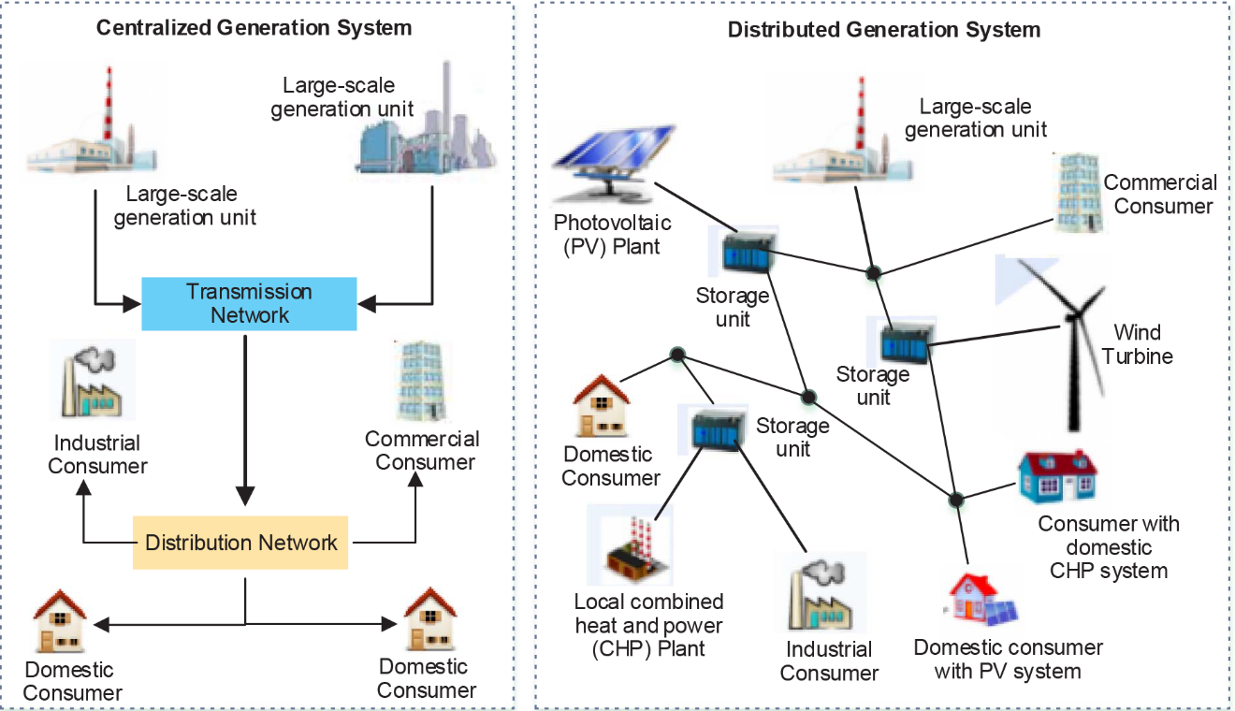
Figure 2.1 - Centralised Generation visually contrasted with DG(Ehsan & Yang, 2018).
A wide variety of renewable and non-renewable technologies are used in DG systems such as gas-fired reciprocating engines, diesel-fired reciprocating engines, gas turbines, wind energy conversion systems/turbines, solar photovoltaic systems/arrays, mini- and micro-hydro, biomass-fired turbines/engines, and fuel-cells (Indrawan et al., 2020). When the more small-scale compatible fossil fuels such as natural gas are used, the heat generated from their combustion is sometimes used in multiple stages: first for electricity generation and then for heating and cooling purposes (using the refrigeration principle in the latter case). This kind of arrangement, known as Combined Heat and Power (CHP) generation enhances overall energy utilization (Ou et al., 2021).
Distributed generation, when integrated into radial distribution networks, affects the power flow, reliability, overall power loss, and the voltage profiles that the end users experience, which are due to the direct injection of real and reactive power into the distribution networks (Abu-Mouti & El-Hawary, 2012; Martín García & Gil Mena, 2013; Yammani et al., 2012). Hence, the DG units must be optimally located in the radial networks to obtain desirable power flow and voltage profiles. In addition to this, in the event of line faults leading to an outage in the power system, buses connected closer to the substation side of the line are supplied while the consumers connected farther away are cut off from the power supply. On the other hand, a line fault that is very close to the substation causes an outage for most of the consumers in that distribution network (Jamian et al., 2015; Rama Prabha et al., 2015; Rama Prabha & Jayabarathi, 2016). This means that the reliability of the DG system in a radial network is sensitive to the location of any line faults on it.
Another concern with DG is the potentially hazardous issue that may occur in DG systems. Due to the proliferation of sources in the system, in case of faults, assurance of isolation of specific parts of the system may be difficult to ensure (Baghbanzadeh et al., 2021). This is because so many sources and paths exist for energizing a bus, and a bus that has been disconnected from all substations may still be found to be energized by an unaccounted-for generation unit connected directly to it. However, this can be mitigated by adequate communication and implementation of multiple safety measures to protect power system personnel while they work even on energized buses (Senthil Kumar et al., 2021).

2.3 MICROGRID CONCEPT
A microgrid is a Distributed Generation system which is designed to be capable of self-sufficient and autonomous operation either in isolation or while being able to connect and disconnect freely from a larger power system that incorporates it. A microgrid that consistently operates in isolation is known as a standalone microgrid while one that is connected to or disconnected from the larger grid is said to be grid-connected or islanded respectively (Shayeghi & Younesi, 2020). A crucial addition to power systems that has made renewable-based microgrids possible is the element of energy storage(Muñoz-Cruzado-Alba et al., 2016).
The intermittency of renewable resources ordinarily means that sometimes, more instantaneous power is available than is demanded, while at times, the power generated in the microgrid is not enough to meet the demand. For example, a microgrid that relies heavily on solar power without energy storage would be stranded at night, as there is no significant energy harnessed by solar panels at night even during a full moon (McNutt et al., 2018). However, with the inclusion of storage technology on the microgrid, the excess energy harnessed at times when demand is lower than generation can be utilized when demand is higher than generation.
A microgrid is a power system that contains its own sources and loads within a small area, with the ability to operate in standalone mode, or while connected to the larger power system or macrogrid (Shayeghi & Younesi, 2020). Microgrids usually integrate multiple alternative energy sources such as solar photovoltaic, wind turbines, and energy storage systems, sometimes with conventional sources such as diesel generators, to serve local loads (Akinyele et al., 2020; Hirsch et al., 2018). They also sometimes exchange power with the macrogrid or other microgrids. The sources that are connected to a microgrid are known as Distributed Generation Units (DGUs) (De Souza & Castilla, 2019). Decentralization of electricity generation, when properly designed, can enhance system overall reliability because the power system has more generators, and the failure of a DGU is, in theory, not as catastrophic as the failure of a big generator in a traditional system.
However, in practice, the interactions of the many various sources and loads in the system are more likely to lead to some destabilizing event in the microgrid, potentially hurting the quality of service (X. Xie et al., 2017). Thus, the presence of many generation nodes (powered by intermittent resources) on a grid, with the potential for disconnection and reconnection to other power systems presents a complex grid structure in which special care must be taken to ensure stability of the system. This engineering problem has been widely identified in research as requiring the design of novel control strategies and power dispatch methods to allow for seamless integration and utilization of energy storage systems, especially when the renewable penetration level in the microgrid is very high(Aziz & Ketjoy, 2017; Bajaj & Singh, 2020; Bansal, 2017; Chettibi et al., 2021; Wen et al., 2019; Youssef et al., 2018; Zhang et al., 2021).
In most microgrids, the primary source of energy is not one massive synchronous generator, but usually asynchronous machines and semiconductor-based electricity generation technologies. As such, traditional droop control as used for machine-only power systems is mostly found to be inadequate(De Carne et al., 2018; Naderipour et al., 2018; Rawat & Sathans, 2018). The control strategies that are developed to operate these kinds of hybrid power systems frequently contribute to stability issues faced in microgrids, which has attracted significant research investigations into their effects on power system stability(Londono et al., 2021; Taghavifar & Taghavifar, 2021).
It is important to note that microgrids can be AC-based like traditional power systems(Roy & Das, 2021), or they can be DC-based depending on the known nature of the loads to be used on them(Ardriani et al., 2018, 2021). This is possible because long-distance transmission which usually calls for voltage level transformation (which is the main advantage of AC) is not always needed in microgrids. Also, where DC voltage transformation is needed, due to the smaller scale of the grid, power electronic converters of sufficient capacity are more likely to be furnishable as opposed to when the volume of power to be handled is very large, such as a national grid.
Furthermore, a single microgrid can have both AC and DC buses and sections (S. Li et al., 2020; Wen et al., 2018). The choice of any of these configurations tends to depend on local requirements, constraints, and existing infrastructure. However, it is worth noting that distributed generation is not always the optimal way of deploying renewable resources, as there are cases in which the abundance of the renewable resource to be harnessed is found at significantly long distances from the load centres (Sun et al., 2017). For example, offshore renewable energy such as that captured by offshore wind turbines needs to be transmitted to the load centres, possibly over long distances.

2.4 CLASSIFICATIONS OF MICROGRIDS BY PURPOSE
The purposes for which microgrids are developed vary. Military microgrids are built to cater to the requirements of military bases, boost energy supply for power-intensive military operations and eliminate dependence on the grid (Kashem et al., 2018). Military microgrids are also made to be physically and digitally immune to attacks that may put down the civilian grids (Jiang et al., 2020). Renewable-based military microgrids eliminate the reliance on external fuel supply which could be a vulnerable link in the chain of operations. This is because transportation equipment could be attacked at any point on a long supply route, and fuel transport is always inherently risky (Shabshab et al., 2020).
Commercial microgrids, on the other hand, are developed to help in optimizing the financial profitability of an enterprise and usually operate in grid-connected mode (Kinnon et al., 2021). The establishment of this kind of microgrid is to optimize demand and costs. For example, the microgrid may be designed to use external power when energy is cheap while switching to low-cost internal generation in an optimal manner as the price of energy rises (Zachar & Daoutidis, 2018). Commercial microgrids also alleviate the risks that could be incurred due to power outages from large-scale utilities. An advantage of commercial microgrids is that they can be constructed faster than new power plants in situations where grid access is not yet well-established or problematic (Tavakoli et al., 2018).
Community microgrids are different from commercial microgrids in that they are established to shore up the quality of service and complement the functioning of electric utility companies in already-existing localities (Shayeghi & Younesi, 2020). A community microgrid may be an aggregation of houses, some of which have solar photovoltaic arrays installed on their roofs, using the energy for their own purposes, and sending the excess to the grid to be used by other houses, or to the utility (Masters, 2013). The excess energy could also be stored for the night. There may also be electric vehicle charging functions in the microgrid (Warneryd et al., 2020). This kind of microgrid is a community enterprise and thus can be very complex to optimize in any particular way. Determination of the optimum mix of storage and generation infrastructure in community microgrids is highly location-specific (Hossain et al., 2019; Liu et al., 2019).
Campus microgrids are developed in institutions such as universities, industries, medical establishments, and technology hubs (Kinnon et al., 2021). They are usually established due to elevated requirements for an uninterruptible power supply and special loads (Shayeghi & Younesi, 2020). Unlike community microgrids, these can be designed with fewer uncertainties to consider and a centralized layer of control is also easier to implement on campus microgrids (W. Liang et al., 2022). They can help the institutions to optimize their energy costs (Husein & Chung, 2018). Also, campus microgrids provide good study and test locations for novel designs and academic research on power systems to any educational institution that has them.
Remote microgrids are mostly operated off-grid (in standalone/islanded mode) in locations where utility access is unavailable or unprofitable for local reasons such as a disproportionately high cost of building and maintaining the transmission lines (Lu & Wang, 2017). Usually, where remote microgrids are found, the alternatives are diesel and propane generators (Almeshqab & Ustun, 2019). In Nigeria, however, gasoline generators are also very common. Establishing microgrids in these areas enables the incorporation of renewable resources as opposed to relying totally on fossil-fuel generators. This not only aims to reduce the carbon footprint of such power systems but also cut down on fuel-related running costs.
Usually, there is a choice of relying completely on renewable energy in an islanded microgrid, but this will require a considerable amount of energy storage capacity for there to be any dispatchability (capacity to vary power supply according to demand) of power on the microgrid. However, this kind of system would have no running costs associated with fueling. It would also be lacking in rotational inertia (except for hydropower) and its stability could be more complex to design for, especially given a high proportion of inverter-sourced power (Lasseter et al., 2020). The use of hybrid technology on a microgrid, especially Doubly Fed Induction Generator (DFIG-based) wind turbines can negatively impact the stability of the system (P. K. Olulope et al., 2013).
On the other hand, a system with a high proportion of dispatchable fossil-fuel generators running on diesel or propane would need less or no energy storage but would have significant fuel costs and emissions. Such a system is also likely to be more robust than a purely renewable-based system without needing complex arrangements for its stability (Denholm et al., 2020). This presents a common optimization problem that project financiers and engineers face in standalone microgrid development. The optimal solution to this kind of problem depends on factors such as renewable energy resources, environmental impact, local regulations, financial constraints, project scale, and government policies. Also, it is usually more costly to develop and operate a self-sufficient standalone system than a grid-reliant system (Khalilpour & Vassallo, 2016).
Microgrids are small-scale, localized power systems. As such, they are not physically constrained to have only renewable generation connected. Rather, purely fossil-fuel-based microgrids also exist. Coal-based generation is largely unacceptable for development in populated areas due to its high and visible impact on its immediate environment, as well as the fact that it is less resource-efficient on the scales likely to be found in a microgrid (Molyneaux et al., 2016). However, diesel and natural gas are less obtrusive in their application, and microgrids based on them exist (R. Wang et al., 2020). However, the microgrid concept is to localize not only power distribution but also its generation and transmission(Zachar & Daoutidis, 2018).
For the most part, fuels such as diesel and natural gas have to be transported from locations far away from the microgrid (Kashem et al., 2018). In many cases, these fuels need to be imported from other countries. In examples like this, even if generation is done locally, there are long distances in the energy supply chain that transcend the area serviced by the power system. This can be said to defeat one of the main purposes of microgrids: shortening the energy supply chain. However, when renewable sources are used on a microgrid system, such a system relies on local natural energy resources which are self-replenishing (i.e free of cost and transportation) and also mostly nonpolluting (Kashem et al., 2018). This is why the benefits of the microgrid are most effectively expressed in a system that integrates renewable generation, and why research on microgrids has mostly explored this kind of system.
The installed capacity of a microgrid can be a few kilowatts, up to a few megawatts (Sechilariu & Locment, 2016). Apart from providing dispatchability of power, the combustion-based generators provide mechanical inertia in concert with any hydropower generators in the system which boosts its stability (Hirsch et al., 2018). For reason of the complexity of control and stability concerns, it is not always desired to have a system completely composed of inverter-based sources (Kenyon et al., 2020). As a result of this, it is quite common to find diesel and natural gas generators incorporated as DGUs in otherwise renewable-based microgrids. However, solar photovoltaic (PV) and wind energy conversion systems (WECS) are the predominant renewable technologies used for generation in microgrids (J. Li et al., 2021).

2.5 STABILITY IN MODERN POWER SYSTEMS
Power system stability is the ability of a power system to return to its equilibrium state after experiencing a physical disturbance (Machowski et al., 2020). The three main quantities that are relevant to the stable operation of a power system are the power angles and load angles (which are the angles of the node voltages in the system), the frequency at which the system is operating (which is usually designed to be 50 or 60Hz), as well as the magnitudes of the nodal voltages. For this reason, the three main divisions of power system stability are voltage stability, frequency stability, and rotor angle stability (Machowski et al., 2020). In a system where the sources are all rotating machines, the stability is mainly dependent on the electromechanical interactions in the system. However, in systems with solid-state electronics involved in the generation, the stability becomes more complex (Bajaj & Singh, 2020).
Voltage Stability is also classified according to the disturbance severity to help delineate the systems’ ability to respond correctively to disturbances of different types (Venkata et al., 2013). The Large-Disturbance Voltage Stability is the ability of the power system to maintain acceptable levels of steady-state voltage after being subjected to relatively-large disturbances such as system faults or transmission line disconnection, or disconnection of a synchronous generator. On the other hand, Small-Disturbance Voltage Stability refers to the ability of a system to maintain the desired voltage level while subjected to small changes such as minute changes in load demand over time (Venkata et al., 2013).
Du et al. (2015) conducted investigations by modelling that showed that the small-signal angle stability of a grid composed of synchronous generators is affected by the connection of a large-scale wind farm. They discovered that this is a composite of two separate effects. The first contribution was from the dynamic interactions of the synchronous generators with the newly-added wind farm, while the second contribution was noted to be due to the change in load condition viz-a-viz system configuration. As with many cases in which small-signal angular stability is studied, the increase in levels of the interconnectedness of the power system was found to quickly lead to high levels of numerical complexity. Doubly Fed Induction Generator (DFIG) turbines were used in the study (Du et al., 2015).
Modarresi et al. (2016) carried out a review of commonly-used voltage stability indices in two categories: line voltage stability indices and bus voltage stability indices. Notable among the indices presented were the Fast Voltage Stability Index (FVSI) for lines and the Voltage Collapse Prediction Index (VCPI) for buses. Aien et al. (2016) reviewed the uncertainty modelling techniques in power systems, presenting the numerical approaches such as Sequential Monte Carlo simulation, Non-sequential Monte Carlo Simulation and Pseudo-Sequential Monte Carlo Simulation. There were also analytical approaches, possibilistic methods, and risk-averse and risk-seeking methods using Information Gap Decision Theory reviewed in the work (Aien et al., 2016).
Suvorov et al. (2020) conducted a study in which the effectiveness of a simulator-based reference model for the transient stability analysis of power systems was investigated. The study showed that mathematical formulations of this nature of problem tend to present stiff differential equations that cannot be solved analytically, and for which standard numerical methods frequently give results whose reliability is not as high as desired. Field data is not always available for simulation validation. However, Suvorov et al. (2020) found that the substitution of a reference model based on a hardware-software simulator could facilitate this validation and improve the accuracy of results.
Li et al. (2021) carried out a study on improving the utilization of intermittent renewable energy sources. The study examined the People’s Republic of China as a case study, and the authors determined that large-scale pumped-storage hydropower stations would be of great impact in increasing the utilization of power harnessed from renewable resources. Also, the establishment of multi-energy microgrids was recommended. This shows that if properly planned, the introduction of DG in the right locations will bolster the macrogrid as a whole rather than be detrimental to it (Li et al., 2021).
Niu et al. (2022) proposed and demonstrated a method for qualitative evaluation of how the rate of penetration of renewable energy impacts transient voltage stability, based on input-to-state stability (ISS) theory. Several case studies were then performed virtually in MATLAB/Simulink. The study found that external disturbances to power flow negatively impacted the stability and security indices of the system with the increasing renewable energy penetration rate (Niu et al., 2022).

2.6 UNCERTAINTY IN POWER SYSTEMS
Uncertainty in the planning and operation of power systems arises from many factors, ranging from international politics to electric vehicle adoption rates, and the renewable penetration of the grid. Power system development involves probabilistic or deterministic analysis (Przygrodzki & Kubek, 2020). In the case of renewable-based microgrids, the probabilistic approach is more reliable because the renewable resources are especially subject to uncertainties and their availability is not deterministic. Simulation methods for the probabilistic approach include Latin Hypercube Sampling (Guo et al., 2020; Ma et al., 2021) and Two-point Estimation Method algorithms (Emrani-Rahaghi et al., 2021) which were used to reduce the time taken for computations while still giving satisfactory outcomes when tested on the Polish grid (Przygrodzki & Kubek, 2020).
In some situations, there is a highly variable load, which also contributes to the uncertainty of such systems. The power system engineer sometimes develops a model based on techniques such as random forest regression, weighted averaging, or machine learning models such as multilayer perceptron (Dudek, 2020), to forecast the load for very-short periods which could be a few seconds (Kwon et al., 2020; Y. Liang et al., 2019; Parol et al., 2021). Industrial loads with big dynamics are relevant to this kind of scenario, as highly-variable loads of such nature could make or break the stability of a power system, and this becomes even more complicated when the power generation is made up of intermittent renewables (Parol et al., 2019).
The forecasting of the available power from renewable sources in a location has been researched in recent years. Day-ahead wind power forecasting using Auto-Regressive Moving Averages (ARMA) techniques has been investigated (Bochenek et al., 2021). Support Vector Machine (SVM) and K-Nearest-Neighbour (KNN) techniques have also been applied to similar problems in forecasting approaches for wind and solar power (Ahmad et al., 2021; Rodríguez et al., 2021).
Sometimes, the uncertainty is modelled in form of cost functions such that the effect on the power system can be reasonably approximated (Reyes et al., 2020). The uncertainty costs were considered due to overestimation and underestimation that is due to the discrepancies between available power and scheduled power. For modelling the uncertainty in wind power generation, variants of the Weibull modelling, especially the Rayleigh formulation, are frequently used (Al-Mhairat & Al-Quraan, 2022; Chiodo et al., 2022). For modelling of PV, the lognormal and normal distributions have become established modelling methods while for micro-hydro generation, Gumbel-based distributions were found to be preferred in the literature due to their higher effectiveness and more accurate results (Ayalew, 2021; Osei et al., 2021; Rawa et al., 2021).

2.7 QUASI-DYNAMIC SIMULATION

2.7.1 COMPARISON OF DYNAMIC AND QUASI-DYNAMIC SIMULATION
Dynamic modelling is the use of computer software to model the time-variant characteristics of a dynamical system (Pampillón et al., 2018). Power systems (or any electromechanical systems) with rotating machines or any kind of system with energy storage fall into the category of dynamic systems, hence the need for and relevance of dynamic modelling (Walz et al., 1995). However, in traditional dynamic modelling and simulation, such as that which is usually performed in MATLAB’s SIMULINK, both the transient and steady-state characteristics are modelled (Markova et al., 2021).
An investigation of the stability of a system by fully-dynamic modelling would consider the transient phenomenon on both fast and slow timescales (Lee, 2006). This kind of simulation tends to be computationally expensive, however, it gives fuller information about the system, especially on the short-term scales. In some studies, however, the long-term behaviour of the system assuming short-term stability is of higher priority. In such situations, quasi-dynamic simulations are preferred (Gaitan et al., 2018). This is because quasi-dynamic simulations enable simulations of long periods in feasible computational time while giving the needed long-term behaviour at the expense of not capturing information about short-term behaviour (Yao et al., 2016).

2.7.2 JUSTIFICATION OF QUASI-DYNAMIC ANALYSIS APPROACH
Quasi-dynamic analysis is an approach in which the length of the time steps used in the analysis is sufficient for the settling of fast transients but allows the steady state analysis of the dynamic system under consideration at different points in time. The quasi-dynamic type of simulation tends to have time constants ranging from tens of seconds to hours (Gaitán et al., 2019). The quasi-dynamic model of a power system is used to observe its behaviour when subjected to medium or long-term variations in the inputs such as load variation or variations in the generated power (Starcevic et al., 2021). The quasi-dynamic approach to modelling is not restricted to power systems and has been applied to earthquake analysis and refrigeration technology, all phenomena that rely on time-dependent processes but in which long-term behaviour is of interest compared to short-term behaviour and in which it would be computationally impractical to simulate the short term behaviour of the system over a long time (Mahmoudian & Yousefi, 2016).
For example, the simulation of 10 seconds of the behaviour of a dynamic system in MATLAB using default settings could take more than a minute if short-term behaviours such as transients are computed in the model using very short timesteps or continuous numerical integration. However, in a program like DigSILENT Powerfactory with a built-in quasi-dynamic simulation toolbox, such a simulation for over a year could be run much faster (in a few seconds) due to the ability of the software to work according to the time resolution of the available data and take time steps that are just long enough, preserving computational accuracy while not spending precious computational time simulating the short-term behaviour of the system (Gaitan et al., 2018).

2.8 FUZZY LOGIC FOR SOCIAL ACCEPTABILITY ANALYSIS
Fuzzy logic is logic that does not deal exclusively with crisply definable variables but considers degrees of truth on a continuum (Yousuf et al., 2021). The word “fuzzy” implies working with concepts that are not clearly or uniquely defined. For example, the statement that someone is tall is not straightforward to classify as true or false, because there is no universal threshold for tallness even when the height of such a person is known. Hence, instead of speaking of being either “tall” or “not tall”, a scale for the degree of tallness might be introduced. This way, the person’s degree of tallness could be defined by a number determined by a set of rules for calculating how well they fall into the “tall” category (Yokoyama & Zhu, 2000).
Fuzzy logic systems are used for decision-making in a wide variety of applications in which the variables in question are not crisply defined. For example, whether a microgrid is acceptable is not a crisply defined variable. The degree of truth of the statement “the microgrid is acceptable” can be determined by a number representing the degree of the acceptableness of such a microgrid. The system that calculates the degree of truth of the various fuzzy criteria and computes the degree of truth of a certain outcome is known as a fuzzy inference system (Pedrycz et al., 2016). In literature, the social acceptability of technical projects (such as a microgrid) is considered in terms of various combinations of important factors (Lakioti et al., 2018). No universal rule base is specified in literature as this is recognized as being location and situation-dependent (Lakioti et al., 2018; Wu, Zhang, et al., 2019). However, the important criteria that are examined by fuzzy systems used in methodologies for microgrid acceptability assessment are the impact on land use, water resources, air quality, acoustic impact, and visual impact (De Souza & Castilla, 2019).

In search of a method for social acceptability analysis suitable for a study of this size, it was found that most feasibility study articles in literature written from an electrical power systems research perspective do not have a specific algorithm or model for assessing the social acceptability of proposed renewable energy technologies, but rather refer to several qualitative factors. For example, wind turbines are known to be comparatively noisy. As far as health and toxicity concerns go, renewable energy is generally safer than conventional energy, especially when deployed on relatively small scales. Health and safety are at less risk compared to conventional power generation systems. However, local concerns could mean that certain stresses on the lives of those living in such communities may be exacerbated, threatening the comfort of people in an area, which is why the analysis is labelled as a social acceptability analysis as opposed to an environmental impact assessment (De Souza & Castilla, 2019).
Since such a study is qualitative, yet seeks to quantify social acceptability based on important factors, a fuzzy-logic-based acceptability inference system is developed and used in this study. For social opinion-related surveys, questionnaire methods are mostly used (Almaiah, 2018; Almaiah et al., 2019; Salloum et al., 2019). However, the weaknesses of questionnaire studies for preliminary surveys in an area tend to be pronounced where the large proportion of the population has neither previously experienced what they are being questioned about nor has enough technical knowledge to develop informed opinions of the expected impact of a major project in their environment, introducing large amounts of interpretation bias (X. Wang & Cheng, 2020).
In other words, mass administration of questionnaires, according to the literature on research methods, is not suitable where the population in question are largely not equipped (or educated) enough to develop and give informed opinions on a prospect, such as in a preliminary feasibility survey (Einola & Alvesson, 2020). Hence, the recommendation from surveyed literature on research methods is that the social acceptability analysis in such multivariable engineering projects is best constrained to informed stakeholders and the technical personnel involved (Ikart, 2019). For these reasons, the mass questionnaire method is passed over in this study in favour of the analysis of a smaller sample of informed parties’ opinions using a five-variable fuzzy-inference-based index developed specifically for the social-acceptability evaluation of renewable microgrid projects by De Souza & Castilla (2019).
A survey of precedents in literature, across several environment-related studies such as water resources assessments and site selection studies, shows that the use of fuzzy logic systems for decision making concerning technical science-, medical- or engineering-heavy projects (as opposed to political/religious studies) is a well-established method in similar situations(Ahanbakhsh & Iahkalroudi, 2016; Akbari et al., 2019; Çolak & Kaya, 2017; Lakioti et al., 2018; Mohamed et al., 2019; Wu, Li, et al., 2019; Yousuf et al., 2021). It is prominently used where the average member of the community cannot be feasibly informed enough about the intended project to make a representative decision within reasonable resources and time. Hence, the researcher designs the fuzzy system using domain knowledge based on a physical survey of the location.
Table 2.1 – Selection of Reviewed Methodological Approaches

AUTHOR/YEAR | TITLE OF ARTICLE | METHOD | OBSERVATION | LIMITATIONS
Du et al. (2015) | Impact of Grid Connection of Large-Scale Wind Farms on Power System Small-Signal Angular Stability | Modal analysis with a linearized model is used to separately investigate the effects of the addition of wind units using superposition. | The dynamics of the power system consisting of synchronous generators before and after the connection of a DFIG wind farm was successfully separated in analysis. | The scope of the study is limited to small-signal angle stability and pays little attention to the voltage.
Suvorov et al.(2020) | Comprehensive Validation of Transient Stability Calculations in Electric Power Systems and Hardware-Software Tool for Its Implementation | A hardware-software reference model (HRTSim) was used to simulate the response of the system to disturbances. | The intensity of disturbance was found to be critical in determining the error in calculations. | The simulations did not account for uncertainties due to renewable energy penetration.
Niu et al. (2022) | Impact of renewable energy penetration rate on power system transient voltage stability | Input-to-state stability (ISS) theory is used to construct security and stability indices for the evaluation of system transient stability. | The relationship between the renewable energy penetration rate and the system stability for the modified IEEE 14-bus system is simulated and ISS is found to be accurate for nonlinear modellings. | The ISS technique relies on estimations which are not always straightforward for practical systems.
Przygrodzki and Kubek (2020) | The Polish Practice of Probabilistic Approach in Power System Development Planning | Probabilistic simulations of power flow simulation were carried out on Poland’s power system viz-a-viz technical standards that are in force in Poland. | The study successfully linked the technical analysis with the economic analysis. | The study was computationally intensive as to require the use of machine clusters or supercomputers which makes the methodology unsuitable for general applications.
Guo et al. (2020) | Security risk assessment of power system based on Latin hypercube sampling and daily peak load forecasting | A risk assessment algorithm using Latin hypercube sampling in conjunction with peak load forecasting is proposed. Markov modelling and Recurrent Neural Networks are also used. | The Latin-hypercube-based method is found to be more efficient than the Monte Carlo simulation for the dataset considered in the study. | This method is not able to identify the weak links in the power system.
Ma et al. (2021) | Risk-adjustable stochastic schedule based on Sobol augmented Latin hypercube sampling considering the correlation of wind power uncertainties | The Sobol-sequence method was used to augment the Latin Hypercube Sampling to handle the higher dimensionality of the wind forecast problem. | The copula method is also incorporated into the method proposed in this work and tested on the IEEE 118-bus system with promising results. | The proposed method requires generating a large number of stochastic scenarios.  The proposed method is limited to generation adequacy indices.
Emrani-Rahaghi et al. (2021) | Optimal stochastic operation of residential energy hubs based on plug-in hybrid electric vehicle uncertainties using two-point estimation method. | The two-point estimation method is used for the optimization of the residential energy hubs incorporating plug-in hybrid electric vehicles. | The solutions were better when the uncertainty of the electric vehicles was implemented in the optimization based on the developed model. | The interactions of different aspects of uncertainty such as the electricity price were not considered, it was focused on the electric vehicles.
Dudek (2020) | Multilayer perceptron for short-term load forecasting: from global to local approach. | Multilayer perceptron network with Levenberg-Marquardt algorithm using Bayesian regularization is applied to the load forecasting | Splitting the problem into subproblems to be handled by separate multilayer perceptrons improved the accuracy of forecasting. | The model relies on splitting the problem into sub-problems and separate training of several neural networks.
Kwon et al. (2020) | Short-Term Load Forecasting Based on Deep Neural Networks Using LSTM Layer. | Periodicity of load variation according to daily, weekly, and monthly patterns is made to reflect in the training algorithm. | Identification and incorporation of factors influencing the load into training the deep neural network improved the results of training. | Fluctuation in the load due to the availability of renewable energy resources is not accounted for in the study.
Liang et al. (2019) | Short-term load forecasting based on feature extraction and improved general regression neural network model. | Empirical mode decomposition is applied in combination with multiple computational intelligence approaches as well as regression to accomplish short-term load forecasting. | The hybrid model thus developed was found to outperform the individual methods. | The study focused on load forecasting but not on its relationship and effectiveness toward power system stability.
Parol et al. (2019) | Very short-term forecasting of power demand of big dynamics objects. | The effectiveness of the naïve method is contrasted with weighted moving average-based models. | Auto-Regression Moving Average (ARMA) and Multi-Layer Perceptron are considered in the study and give comparable quality results that are better than the naïve method | The study focused on load forecasting but not power system stability.
Parol et al. (2021) | Forecasting of 10-Second Power Demand of Highly Variable Loads for Microgrid Operation Control. | Fifteen forecasting methods are used to verify the efficiency of 10-second power demand forecasting on various values of hyperparameters. | Ensemble methods proposed for load forecasting in power systems under uncertainty were found to be promising. | The study focused on load forecasting but not on generation forecasting.
Bochenek et al., (2021) | Day-Ahead Wind Power Forecasting in Poland Based on Numerical Weather Prediction. | The extreme Gradient Boosting method and two years of training were used to train the prediction model. | 24-hour forecasting of available wind power was attempted in this work using weather data. | Training of the model takes years.
Reyes et al. (2020) | Marginal Uncertainty Cost Functions for Solar Photovoltaic, Wind Energy, Hydro Generators, and Plug-In Electric Vehicles. | The uncertainty due to demand-supply mismatch is analytically modelled in terms of cost functions. | The derived results were found to be in accordance with pre-existent modelling methods. | The effects of the cost functions on power system stability were not mentioned.
Al-Mhairat and Al-Quraan (2022) | Assessment of Wind Energy Resources in Jordan Using Different Optimization Techniques. | Weibull, Gamma, and Rayleigh distributions were used for modelling, while Particle Swarm Optimization, Grey Wolf Algorithm, and Whale Optimization were used to optimize the parameters for the distribution models. | Particle Swarm Optimization was found to outperform the other computational intelligence methods in the study. | The study did not consider the impact of the connection of wind energy to the grid on stability based on the results of the analysis.
Rawa et al. (2021) | Economical-technical-environmental operation of power networks with wind-solar-hydropower generation using analytic hierarchy process and improved grey wolf algorithm. | Improved Grey Wolf Optimization algorithm and other metaheuristic techniques were compared on the IEEE 30-bus system with renewable penetration. | The Improved Grey Wolf Optimization algorithm was found to be superior to others such as the moth-flame and salp swarm algorithm. | The study sought to optimize three variables considering the penetration of renewable resources. However, voltage stability was not one of them.
Chiodo et al. (2022) | The Compound Inverse Rayleigh as an Extreme Wind Speed Distribution and Its Bayes Estimation | The Compound Inverse Rayleigh distribution was proposed for characterizing extreme wind speed values in power system uncertainty planning. | Locations in Greece were used to validate the effectiveness of this distribution which gave different qualities of results in different locations. | There were cases in which the approximation was found unsuitable, which may be critical for power system stability.
Starcevic et al. (2021) | PV System Integration Assessment by Automated Monte Carlo Simulation in DIgSILENT PowerFactory | Monte Carlo simulation was used with PowerFactory to investigate the impact of integrating PV generation into the medium voltage distribution network, specifically the IEEE 33-bus system. | It was shown that the quasi-dynamic simulation results were satisfactory for long-term system investigation. | Only PV integration was considered in the study.
Gaitan et al. (2018) | Simulation of a 14 Node IEEE System with Distributed Generation Using Quasi-dynamic Analysis | A set of load curves based on Colombian electricity profiles was used with Particle Swarm Optimisation to optimize the power dispatch on the IEEE 14-bus system. | The quasi-dynamic simulation results were found to be representative of the system behaviour. | Only 24-hour periods were considered in the simulation.
Rey et al. (2019) | Design and Optimal Sizing of Microgrids | A set of concepts and methodologies for analyzing and sizing microgrids are presented and classified | Social acceptability analysis for microgrids using fuzzy logic with selected factors is proposed. | The precise structure of fuzzy rules and membership functions in the study was not made available.

2.9 GAP IDENTIFIED IN THE LITERATURE
A review of the works of literature on microgrids reflects that most of these studies have been performed based on the factors that prevail in parts of the Asian continent, and some in America and Europe. However, literature shows a paucity of research efforts in this direction in Africa. Also, previous studies and several methodologies have been used based on other power systems in regions of various countries, on the large national grid systems (including the Nigerian national grid), and the IEEE benchmark microgrids. However, little work has been done on community microgrids with a focus on Nigerian local communities. Additionally, while some of the works in the literature considered power system stability and some others considered renewable resource uncertainty, they did not unite the two concepts in the context of a renewable-based system. Moreso, quasi-dynamic simulation, as carried out in this study, has not been commonly used in literature for microgrid modelling and simulation.

CHAPTER THREE

METHODOLOGY

3.1 RESEARCH DESIGN/MODEL SPECIFICATION

3.1.1 Description of Study Area
The research data is based on Arandun in Irepodun Local Government Area, Kwara State, Nigeria. The coordinates of the town are 8° 4' 59" N and 4° 57' 0" E, about 64 km distance from Ilorin, the state capital, within a few kilometres of the Osun-Kwara border. The town has a growing population of about 15,000 which peaks during the holiday periods and ebbs at other times of the year, and a significant amount of land which is neither farmed nor built-on. The activities in the town are majorly agricultural and artisanal, such as metal, wood, and textile works, (which reflects latent demand for electricity). Furthermore, while it is a rural community, modern facilities have sprung up in recent years. Yet, the electricity supply continues to be a major challenge.
Arandun has a number of rivers flowing through it, as well as other hydrological features, some of which are seasonal and some of which are perennial. It lies in the tropical savannah of Nigeria and is possessed mineral resources such as tantalite, an ore of tantalum which is used in some alloys (Saliu, 2003). Thus, Arandun is a prospective mining community. For these reasons, the Arandun community was chosen for this study. Renewable resources available in Arandun include its solar irradiance, wind resource, vegetation (for biomass), and hydropower from rivers and streams. Of these, biomass, due to its associated environmental impact, is not considered in this study. The loads in Arandun are mostly residential and commercial, with a higher incidence of commercial loads than most rural communities. However, if reliable electricity supply is realised in the community, industrial loads can also be expected, and the expected load growth is also considered in the study.

3.1.2 Research Workstation
The modelling and simulation were done on a Windows PC. The Windows 10 PC with 8GB RAM, and CPU specifications Intel Core i7-9750H (a 64-bit CPU) with 512 GB of secondary drive memory, existing in notebook form factor, was earmarked by the researcher for this purpose. The specified computer system was selected to meet the hardware and operating system requirements of the software application to be used in the study. This is worth mentioning because this computing power proved barely enough for the study, with the system crashing due to an overload of system resources (especially memory) in the early stages of the simulations in the HOMER software, despite the computer system being of above-average specifications. However, the models were adjusted and rescaled in complexity as appropriate and the simulations were successfully completed, although they did take several hours in some cases.

3.2 RESEARCH DESIGN LAYOUT
Figures 3.1 through 3.4 show the four objectives of the study. The climatic data were used for the feasibility study. The data on the location’s wind speeds, temperature, precipitation, and solar irradiance over several years was used for this purpose, with data samples ranging from 2001 to 2021 for the given location. The load profile data (peak load and average load on hourly, daily, and monthly timescales as measured by the electricity company in 2020 and 2021) was also used in the research. Load data predating the Coronavirus pandemic was only selectively available and also found to be unsuitable for this study due to major changes and interruptions in the power system and metering arrangements. Typical costs for both diesel generating sets (gen-sets) and renewable generation equipment adjusted for capacity were obtained from vendors and used to perform technical and economic analyses in the HOMER software, which was also critical for determining the size of the battery energy storage system to be recommended. Molten-Salt/Hot Water-based Concentrated Solar Power is not available as a built-in option in HOMER, with Concentrated Photovoltaic (CPV) being the closest alternative, therefore, the student had to creatively rescale and readjust the Direct Normal Irradiance as well as several parameters, to enable the CPV system to be representative of the CSP, for this purpose to be used in the feasibility analysis in HOMER.
A five-variable fuzzy-logic inference system was developed based on existing literature as standard practice for quantifying multiple environmental-based variables into a single acceptability index for the microgrid. The variables considered were the project’s impact on land use, impact on water resources, impact on air resources, visual impact, and acoustic impact. A rule base and membership functions were developed using human languages based on environmental considerations investigated by interviewing a selection of educated stakeholders in the Arandun community, and their concerns were translated into fuzzy logic. It was found that a mass questionnaire was not suitable for this purpose as it concerns a prospect about which the average member of the community would not be in a position to provide informed opinions. It was found that such situations were not recommended for questionnaire usage in literature, hence the choice of going with the more-rigorous fuzzy-inference approach as detailed in Chapter 4.
The load data was used to develop a low-voltage model in PowerFactory software to represent the distribution network of the Arandun community in a standalone microgrid scenario. The design was based on the load data and information gathered on-site about the distribution network. The model design and simulation method was also refined to ensure that it is representative of low-voltage distributed generation characteristics, as compared to traditional grid characteristics which PowerFactory is mostly used for.
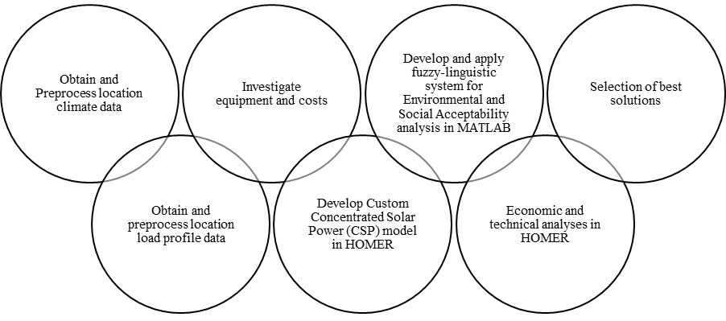
Figure 3.1 – Breakdown of Objective 1
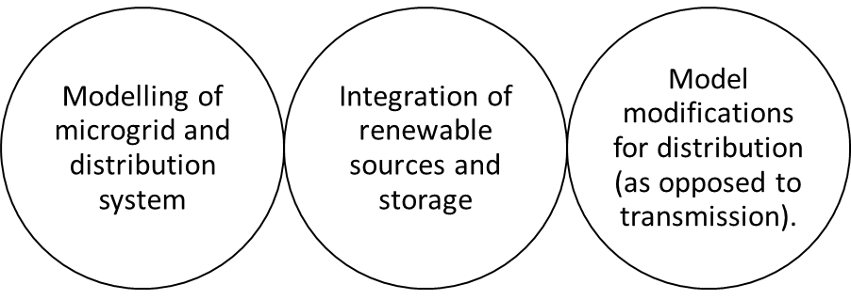
Figure 3.2 – Breakdown of Objective 2

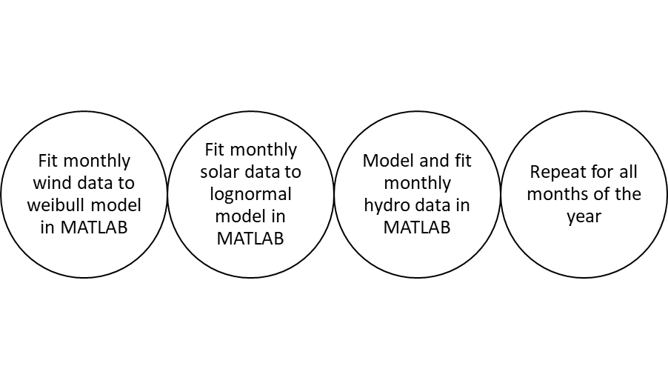
Figure 3.3 – Summary of Objective 3

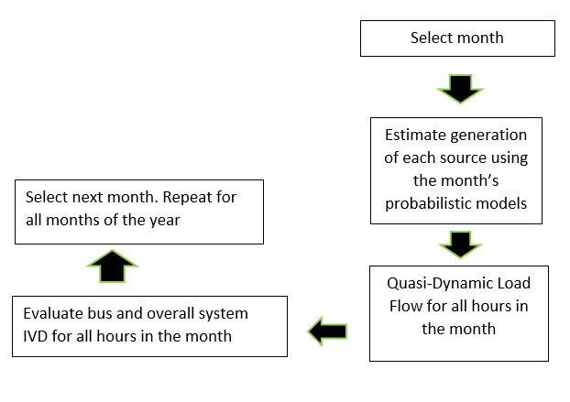
Figure 3.4 –Breakdown of Objective 4
Based on the reviewed literature, using MATLAB capabilities, Weibull/Rayleigh-based distribution was used for fitting the wind data to a probability distribution, the lognormal distribution was used for the solar photovoltaic, load uncertainty was fitted with the Gaussian/normal distribution, while the extreme value distribution was to be used for the hydropower aspects of the project. The year was subdivided into twelve months, with twelve separate probability distributions being formulated per resource for solar, wind, and hydro, making 48 different models to encompass the stochastic generation in the study. This is to make the results as realistic as possible.

3.2.1 SOCIAL ACCEPTABILITY ANALYSIS
The five variables considered in the analysis are:
- Land use.
- Visual impact.
- Air pollution/Impact on air resources.
- Acoustic impact.
- Impact on water resources.
In this study, a fuzzy system established in the literature for purposes such as the one in this study has been used.

3.2.1.1 Fuzzy Logic Structure
Fuzzy logic is a type of logic that is not strictly exclusive, such that there may be multiple levels of truth for the variables in the system. In Boolean logic, variables are either true or false. However, in fuzzy logic, truth or falsehood is expressed as points on a continuum. Fuzzy logic is designed to represent or assess systems in which certain parameters or information cannot be crisply defined but are expressed in vague terms. Fuzzy logic is used in control theory and artificial intelligence. There are various types of fuzzy logic paradigms, majorly the Mamdani-type and the Sugeno-type. The Mamdani type is more intuitive for humans to work with, while the Sugeno type is more efficient in computation, especially where the algorithm is to be used continuously such as an embedded system controller. However, it is used once for assessment in this study, and a Mamdani-type fuzzy system was sufficient for the study.
The crisp inputs were taken from the average of the opinion survey carried out by the researcher on the five acceptability/environmental variables considered. It had five inputs, one output, and three inference rules in its rule base. “Minimum AND”, “Maximum OR”, and “Minimum Implication were used for the system while the aggregation parameter was configured to use the maximum option. The reason for this is that a Mamdani-type system is used. If a Sugeno system had been used, the aggregation would have been based on the sum method. Aggregation is the process by which the fuzzy sets that represent the outputs of each rule are combined into a single fuzzy set. However, Mamdani systems are easier to interpret and write by humans and are perfectly satisfactory for decision-making outside embedded systems applications. This is why the Mamdani fuzzy system was used for this study and preferred over the Sugeno type. The structure of the Fuzzy system is shown in Figure 3.5.
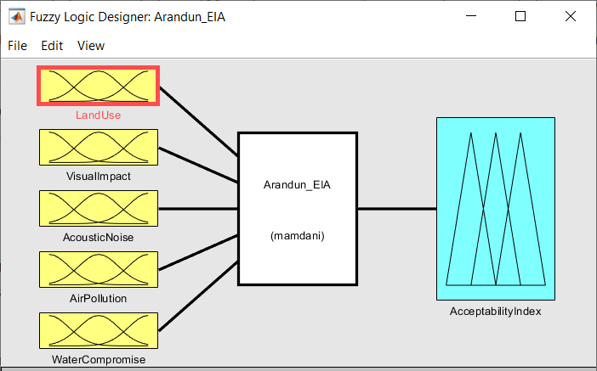
Figure 3.5 – Structure of the Fuzzy Inference System
Land use was characterized using three fuzzy-linguistic variables: ‘limited’, ‘moderate’, and ‘extensive’, with Z-shaped, Gaussian, and a second Z-shaped membership functions respectively. Considering that the size of the land area available to the community is finite, the acceptability of the amount of land to be used by the project was an important question. For fuzzification, the question was expressed in three sub-questions for the knowledgeable stakeholder who had both the knowledge of the nature of the project and the community (including the researcher). The membership functions were chosen based on previous applications of fuzzy logic in literature:
- On a scale of 1-10, how limited would the land use be considered to be for the microgrid project?
- On a scale of 1-10, how moderate would the land use be considered to be for the microgrid project?
- On a scale of 1-10, how extensive would the land use be considered to be for the microgrid project?
The results were then normalized by dividing by 10 to express them on a [0 1] interval. The described pattern illustrates how a crisp variable is carefully fuzzified for use in a fuzzy inference system. Figure 3.6 shows the linguistic variables and membership functions used for analyzing the land use input.
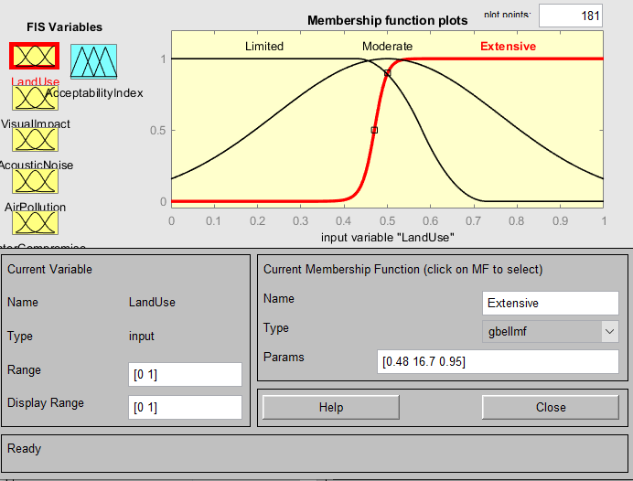
Figure 3.6 – Linguistic Variable and Membership Functions for Land Use.
The same method was repeated for all five input variables using membership functions as shown in figures 3.7 to 3.10 for acoustic impact, air pollution, visual impact, and water resource impact respectively. In the case of air pollution, the stakeholders had to decide how polluting they considered the microgrid was, which was then used to compute both fuzzy sets for “good” and “bad” membership functions. For acoustic impact, membership functions concerning expected noise levels were for fuzzy sets “good”, “moderate”, and “unbearable”. For air pollution, membership functions were for fuzzy sets “low” for low toxicity and “toxic” to represent how toxic the respondent considered the expected microgrid. Visual impact fuzzy sets were “good”, “moderate”, and “bad” while water impact fuzzy sets were negligible, low, and severe.
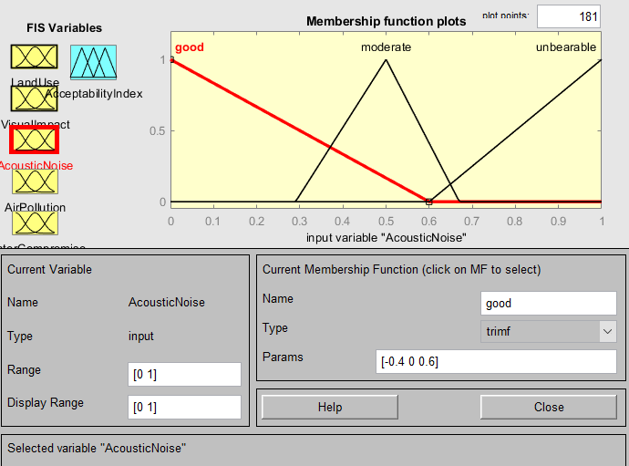
Figure 3.7 – Linguistic Variable and Membership Functions for Acoustic Noise.
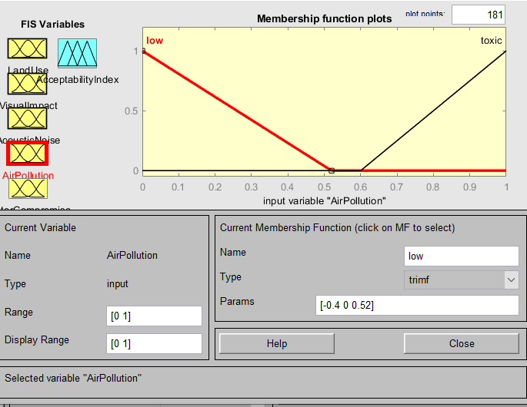
Figure 3.8 – Linguistic Variable and Membership Functions for Impact on Air Quality.
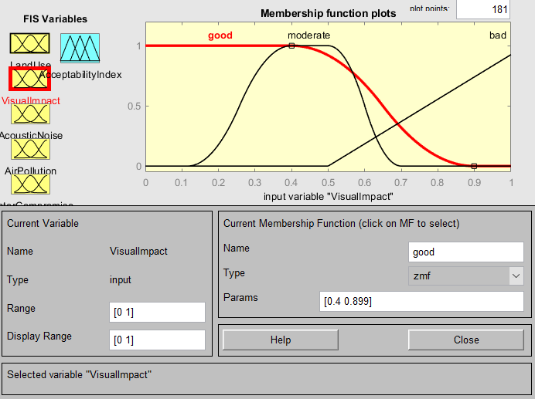
Figure 3.9 – Linguistic Variable and Membership Functions for Visual Impact.

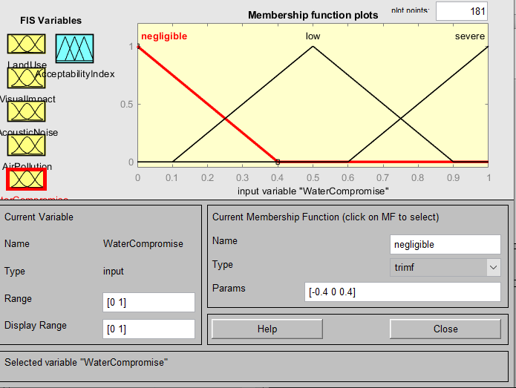
Figure 3.10 – Linguistic Variable and Membership Functions for Impact on Water Resources
The rule base for the fuzzy inference system is given as follows:
- If (LandUse is Limited) or (VisualImpact is good) or (AcousticNoise is good) or (AirPollution is low) or (WaterCompromise is negligible) then (AcceptabilityIndex is high) (1)
- If (AirPollution is low) and (WaterCompromise is not severe) then (AcceptabilityIndex is high) (1)
If (AcousticNoise is unbearable) and (AirPollution is low) and (WaterCompromise is not severe) then (AcceptabilityIndex is moderate) (1).
For interpretation of the Social Acceptability (SA) index on a scale of 0 to 1 (higher is better), the following rules are used:
- If SA < 0.2, the microgrid is completely unacceptable
- If 0.2 < SA < 0.4, the microgrid is strongly unacceptable
- If 0.4 < SA < 0.6, the microgrid is marginally acceptable
- If 0.6 < SA < 0.8, the microgrid is strongly acceptable
- If SA > 0.8, the microgrid is completely acceptable

3.2.2 TECHNO-ECONOMIC FEASIBILITY ASSESSMENT
The technical and economic analysis of a renewable-based microgrid system was conducted in the HOMER Pro software on a multi-year basis for 25 years. The renewable microgrid with energy storage is the main system under investigation. However, for validation and comparison purposes, a diesel-only microgrid and a renewable microgrid without energy storage were also modelled and assessed in the same software, as in the standard practice in previous studies using HOMER.
However, unlike most studies, this one is also considered a purely-renewable system, especially without energy storage. This presented an unconventional level of constraints on the optimisations performed in the software and required several iterations and model customisations over time before feasible solutions could be obtained. Thus, this is the first study, known to the researcher, to successfully present quantitative results for a microgrid with 100% renewable generation without any macrogrid connection. Furthermore, the presentation of results for a 100% renewable microgrid with no energy storage is also a notable aspect of the results.
HOMER performed simulations on the model, which took multiple hours due to the complexity of the intended system and the number of sensitivity factors considered, as a follow-up to the Hybrid modelling, which used energy components and prices, load demand data, and weather data. HOMER classified each system combination objectively based on net present cost, annual operating cost, initial capital, the cost of energy, renewable proportion, and fuel utilization during these simulations. Carbon emissions were also taken into consideration in this study and formed part of the factors considered by HOMER in its simulations. It then chose the system combinations with the lowest electricity cost and net present cost as its best solution.
Upon getting feasible solutions for a single-year scenario, the multiyear analysis considering component degradation over time was also carried out. This added more complexity to the simulations by increasing the computational time by several factors. In addition, it was found that many systems that seemed to be feasible for the first year did not fulfil multi-year constraints. A conservative inflation rate based on Nigerian trends was also included in the model to estimate the effects of economic fluctuations for a more realistic cost analysis. The cost analysis was carried out in US Dollars due to its benchmark status as well as its relative stability, as well as the fact that the equipment and system components are imported and prices are mostly marked up in dollars.

Renewable Microgrid Scenario with Energy Storage.
The combination of renewables in the presence of chemical energy storage was investigated with solar PV, CSP, wind turbines, small hydro, and Lithium battery storage being considered. Due to the number of sensitivity variables originally considered, the system took over 3 hours to simulate after the selective removal of several sensitivity variables. Hydro head based on physical survey and literature survey was estimated at 3m and a case of zero discount and 10% nominal discount rate were also considered. 10kW turbines were used as the base for wind, and 100kW nominal ratings for hydropower were used as a base (initial conditions and search space gradation). The PV panel used was generic flat-plate PV, with costs for component installation and maintenance being chosen based on surveys of existing projects such as the Gbamugbamu photovoltaic-based microgrid in Ogun state which has a capacity of over 80kW peak. As with the diesel system, inflation of 10% was considered for the economic aspect. Figure 3.11 shows the representative schematic of the multi-energy renewable microgrid with chemical storage in the HOMER software.
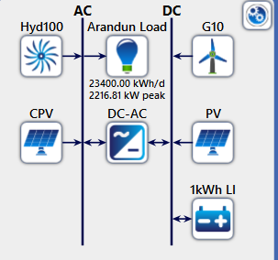
Figure 3.11– Schematic of Multi-Energy Renewable Energy with Chemical Storage in HOMER.

Dispatch Strategy for the Renewable Microgrid.
Dispatch strategies are rules which are used to determine how the generator and storage batteries behave when the renewable energy available is not enough to supply the load. HOMER has three dispatch strategies which are cycle charging, load following, and combined dispatch strategy which implements both depending on instantaneous system conditions and criteria. When the system operates on cycle charging, the generation supplies full power whenever the system is serving the primary load on the microgrid. Excess electrical production in this period is then used to service the lower-priority functions such as serving the deferrable loads, recharging the battery energy storage system, or serving the electrolyzer in a fuel-cell-based system. When the system operates on the load-following dispatch strategy, it only produces enough power to meet the primary load while leaving the recharging of the batteries to instantaneous renewable generation. The dispatch strategies come into play when there is a capacity shortage and when both renewable and non-renewable generation are combined. In this case, however, the microgrid is purely supplied by renewable energy, and correspondingly, the selected dispatch strategies were found to not affect the performance of the microgrid.

3.2.2.3 Diesel Microgrid Scenario
The diesel microgrid scenario is used as a basis for comparison and cross-validation with the pure-renewable microgrid. Figure 3.12 shows the condensed schematic in HOMER for the diesel microgrid scenario. It can be seen from the figure that HOMER recognizes the absence of renewable resources in the considered scenario and advises the designer/researcher to include one in it. To preserve the realistic outlook of the analysis, the flexible sizing option using both diesel and renewable sources (which is a common scenario in literature) was not considered. Rather, to improve the quality of this analysis, various discrete sizes of diesel generators with known prices either in Naira or Dollars were catalogued. Prices of diesel generating sets were obtained from online marketplaces, and where necessary, by direct correspondence with distributors and manufacturers.
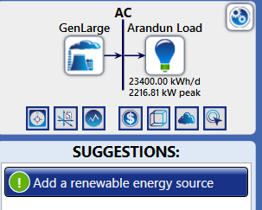
Figure 3.12 – Schematic of Diesel Microgrid in HOMER.
Table 3.1 shows a selection of surveyed diesel generating sets and their obtained prices, with the calculation of cost prices in dollars per kilowatt. Prices per kilowatt were also obtained for smaller gasoline/diesel generating sets and used in the analysis. Table 3.2 shows the exchange rate as obtained in April 2022 and used in the project.
The cost of diesel as obtained around the same time by the market survey was ₦700, corresponding to about $1.69. Being a general-purpose microgrid, a power factor of 0.8 lagging was used for conversion between kVA and kW, as HOMER works only with the latter (HOMER works with energy and its time derivatives such as power). Large diesel gen-sets are a dispatchable resource, and this was also implemented in HOMER, hence, there was no need to consider energy storage in the diesel microgrid case. An inflation rate of 10% annually was used in the study. Prices were used as obtained without the assumption of discount since the generating sets are discrete and there is rarely an obtainable discount rate for fossil fuels in Nigeria apart from the general effects of inflation.
Ultimately, after several iterations and exploration of HOMER capabilities and available computing resources, the 80kW and 400kW generating sets (Mikano 100 and 500 kVA) were mainly focused on in the final selected diesel scenario. Considering this, direct quotes from the manufacturers for the prices (and specifications) of these generating sets were obtained in Naira and converted to dollars.
Table 3.1 - Cost Information of Generating sets with final selections in bold.
Name | Capacity (kW) for 0.8pf | Cost in Dollars | Cost in Naira | Cost per kW (Naira) | Cost per kW (US$)
Perkins Generator (Yaoota) | 40 | 12,480.00 | 5,200,000.00 | 130,000.00 | 312.00
Cummins (Alibaba) | 40 | 4,500.00 | 1,870,740.00 | 46,768.50 | 112.24
Sumec Firman (Zit) | 4 | 1,608.00 | 670,000.00 | 167,500.00 | 402.00
Lutian (zit) | 4.8 | 1,728.00 | 720,000.00 | 150,000.00 | 360.00
Perkins (Jumia) | 40 | 10,932.00 | 4,555,000 | 113,875.00 | 273.30
Perkins (Jii) | 32 | 8,880.00 | 3,700,000 | 115,625.00 | 277.50
Perkins (Jiji) | 12 | 6,480.00 | 2,700,000 | 225,000.00 | 540.00
Perkins (Jiji) | 24 | 7,440.00 | 3,100,000 | 129,166.67 | 310.00
Perkins (Jiji) | 280 | 34,800.00 | 14,500,000 | 51,785.71 | 124.29
Perkins (Jiji) | 8 | 5,760.00 | 2,400,000 | 300,000.00 | 720.00
Kemage (Jiji) | 8 | 2,016.00 | 840,000 | 105,000.00 | 252.00
Sumec Firman (Jiji) | 8 | 750,000.00 | 750,000 | 93,750.00 | 225.00
Mikano (direct quote) | 80 | 25,973.68 | 10,822,366.00 | 135,279.58 | 324.67
Mikano (direct quote) | 400 | 81238.224 | 33,849,260 | 84,623.15 | 203.10

Table 3.2 – Official Exchange rate at research time in April 2022
Dollar to Naira | Naira to Dollar
1 | 1
415.72 | 0.0024

3.3 DYNAMIC MODELLING OF SYSTEM COMPONENTS

3.3.1 Wind Generator (Doubly-Fed Induction Generator)
The Doubly-Fed Inductor Generator (DFIG) is a common choice for use in wind turbines due to its robust construction and the ease with which its operation can be controlled (Adetokun & Muriithi, 2021). The DFIG is a type of wound-rotor induction generator in which a voltage source converter is connected to the rotor’s slip rings. The interaction of the DFIG with the power system happens through the rotor and stator terminals. The induction generator’s stator terminals are directly grid-connected while the rotor terminals are connected to an AC-DC-AC converter (which is a variable frequency converter) as shown in Figure 3.13.
Figure 3.13 – DFIG and its connections (Olulope, 2014).
In modelling the DFIG, the rotor speed is controlled by the quadrature (q) component of the injected voltage. The direct-axis (d) component of the rotor-side voltage converter voltage is used to compensate for the generator’s magnetizing reactive power. A DFIG equipped with four-quadrant AC-to-AC converters tends to be more stable on the grid than Squirrel Cage Induction Generators (SCIG). The modelling of voltage in the DFIG is given:
$V_{ds}= -R_{s}i_{ds}-ω_{s}ψ_{qs}+\frac{dψ_{ds}}{dt}$ (3.1)
$V_{qs}= -R_{s}i_{qs}+ω_{s}ψ_{ds}+\frac{dψ_{qs}}{dt}$ (3.2)
$V_{dr}= -R_{r}i_{dr}-sω_{s}ψ_{qr}+\frac{dψ_{dr}}{dt}$ (3.3)
$V_{qr}= -R_{r}i_{qr}+sω_{s}ψ_{dr}+\frac{dψ_{qr}}{dt}$ (3.4)
Where s is the slip of the induction machine, v is the voltage, i is the current, R is resistance, ψ is the flux, and ω_{s} is the stator field synchronous speed. Subscripts d and q, where they appear, represent the direct and quadrature components of the quantities. Subscripts r and s where they appear represent the rotor and stator quantities.
From the above voltage equations for the DFIG, the real and reactive power which are of direct importance to the microgrid are modelled as follows:
$P_{s}=V_{ds}i_{ds}+V_{qs}i_{qs}$ (3.5)
$Q_{s}=V_{qs}i_{ds}-V_{ds}i_{qs}$ (3.6)
$P_{r}=V_{dr}i_{dr}+V_{qr}i_{qr}$ (3.7)
$Q_{r}=V_{qr}i_{dr}-V_{dr}i_{qr}$ (3.8)
The total DFIG power is given as follows:
$P=P_{s}+P_{r}$ (3.9)
$Q=Q_{s}+Q_{r}$ (3.10)
$P=V_{ds}i_{ds}+V_{qs}i_{qs}+V_{dr}i_{dr}+V_{qr}i_{qr}$ (3.11)
$Q=V_{qs}i_{ds}-V_{ds}i_{qs}+V_{qr}i_{dr}-V_{dr}i_{qr}$ (3.12)

3.3.2 Quasi-Dynamic Mathematical Formulations for Synchronous Generators
For the purpose of providing the mathematical background to quasi-dynamic modelling, the differential and algebraic equations customarily used for representing the power systems in the mathematical form are presented, followed by the synchronous generator model (i.e for hydro) in quasi-dynamic form (Q. Wang, 2001).
$\dot{x}= f(x,y,z_{c},z_{d},λ)$ (3.13)
$0= g(x,y,z_{c},z_{d},λ)$ (3.14)
$z_{D}\left(k^{+}\right)=h_{D}(x\left(k^{-}\right),y(k^{-}),z_{c}(k^{-}),z_{D}(k^{-}),λ(k))$ (3.15)
$\dot{\dot{z_{C}}=h_{C}(x,y,z_{c},z_{D},λ)}$ (3.16)
In equations 3.13 to 3.16, x represents the transient state variables in the system, y includes the algebraic variables, f and g are network-specific functions, Z_{C} refers to load state variables, Z_{D} refers to control and protection functions on the power system, k represents any constant of interest in the system, while λ represents load demand coefficients and load-generation dynamics in the operation of the system. In a system with n buses and m generators, assumed to be identical in terms of their excitation control mechanism, the rotor angle of the m-th generator can be chosen as the system reference. When stator transients are
ignored, the direct-and-quadrature axis model describing the synchronous machine dynamics are:
${\dot{δ}}_{i}=\left(ω_{i}-ω_{m}\right)ω_{0}, where i=1,…, m-1$ (3.17)
${\dot{ω}}_{i}=M_{i}^{-1}\left[P_{mi}-D_{i}\left(ω_{i}-ω_{m}\right)-\left(E_{qi}^{'}-X_{di}^{'}I_{di}\right)I_{qi}-\left(E_{di}^{'}+X_{qi}^{'}I_{qi}\right)I_{di}\right], i=1 to m$
(3.18)
$\dot{E_{qi}^{'}}=T_{d0i}^{-1}\left[E_{fdi}-E_{qi}^{'}-\left(X_{di}-X_{di}^{'}\right)I_{di}\right] i=1,…,m$ (3.19)
$E_{di}^{'}=T_{q0i}^{-1}[-E_{di}^{'}+\left(X_{qi}-X_{qi}^{'}\right)I_{qi}, i=1,…,m$ (3.20)
In equations 3.17 to 3.20, the ω_{m} is the system frequency, ω_{i} is the generator/machine frequency, and the ω₀ is the system’s rated frequency in radians per second. The q and d represent quadrature and direct axes quantities.
The real and reactive power outputs from generators are formulated as:
$P_{gi}=I_{di}V_{i}\sin\left(δ_{i}-θ_{i}\right)+I_{qi}V_{i}\cos\left(δ_{i}-θ_{i}\right) i=1,…,m$ (3.21)
$Q_{gi}=I_{di}V_{i}\cos\left(δ_{i}-θ_{i}\right)-I_{qi}V_{i}\sin\left(δ_{i}-θ_{i}\right) i=1,…,m$ (3.22)
Equations 3.21 and 3.22 have θ and δ representing the power angle and the voltage angle respectively.

3.3.3 Micro-Hydro Turbine Modelling
The micro-hydro turbines for low-head sites such as the Osin river site are usually based on the Kaplan designs. For a site such as the one in consideration, the following assumptions are in order: that the hydraulic resistance is negligible, that the penstock pipe is not elastic, that hydraulic flow is incompressible, that the speed of water varies directly with gate opening and the square root of the net head, and that the turbine’s mechanical output is proportional to the product of the head and the volume flow.
The mechanical hydropower available is given as:
$P_{mech}=ηρgh_{w}A_{w}v_{w}$ (3.23)
In Equation 3.13, P_{mech} is the mechanical power, η is the turbine mechanical efficiency, ρ is the density of water, g is the acceleration due to gravity, h_{w} is the effective head across the diameter of the turbine, A_{w} is the effective pipe area, and v_{w} is the velocity of the water. The area A_{w} is evaluated as being the cross-section of the river which is the product of its width and its depth at the time being considered. The electrical modelling is also represented by equations 3.1 to 3.22.

3.3.4 Concentrated Solar Power Modelling
In HOMER, the Concentrated Photovoltaics (CPV) model was adapted to approximate the CSP generator for quantitative purposes. Qualitatively/dynamically, however, the CSP is based on rotating synchronous generators, similar to hydropower and wind turbines. The molten-salt CSP power plant has intrinsic thermal storage in its working fluid. This means that it can generate power both during the day and during the night, though the night generation may be less than the day generation. A CSP power plant is complex to model, however, unlike solar PV, it can be modelled as having little and predictable variation, and it tends to add more stability to the grid. CSP’s ability to generate power at night makes it valuable. In this work, the CSP was modelled as a synchronous generator with electrical output varying during the day according to the monthly average Direct Normal Irradiation presented in Table 3.3. The CSP plant in the study is designed with a nominal efficiency of 15% from its nameplate output in HOMER, while most cutting-edge and more expensive plants in literature may have up to 30% efficiency.
For informational purposes, the mathematical model of a typical parabolic trough-type CSP plant is presented in equations 3.24 to.
$Q_{u}=F_{R}A_{a}\left[\frac{S-A_{r}}{A_{a}U_{L}(T_{i}-T_{a)}}\right]$ (3.24)
In equation 3.24, Q_{U} is the useful heat gain for a concentrated collector, F_{R} is the collector heat removal factor, A_{a} is the area of the aperture of the solar concentrator, A_{r} is the area of the receiver, and S is the solar radiation absorbed, while U_{L} is the heat loss coefficient, T_{i} is the fluid inlet temperature, and T_{a} is the ambient temperature at the solar power plant location.
Furthermore, the temperature obtained is given by:
$T_{o}=T_{i}+\frac{Q_{u}}{mC_{p}}$ (3.25)
In equation 3.25, T_{o} is the temperature of the working fluid at the outlet, m is the mass flow rate of the working (heat transfer) fluid, and C_{p} is the specific heat capacity of the heat transfer fluid.
The dynamic modelling for active and reactive power from CSP is similar to that of DFIG except that it relies on the synchronous machine instead of the induction machine. Therefore, the slip s coefficient in equations 3.1 to 3.4 is zero for CSP and micro hydro. However, equations 3.5 to 3.12 still apply.
Table 3.3 – Average Monthly DNI for Arandun.
Month | DNI (kWh/m²/day)
January | 4.22
February | 3.48
March | 3.47
April | 3.63
May | 3.54
June | 2.53
July | 1.96
August | 2.12
September | 2.00
October | 3.77
November | 4.94
December | 5.52

3.3.5 Photovoltaic, Inverter, and Battery Storage Model
The Solar PV and Battery Energy Storage Systems (BESS) are connected using back-to-back voltage source converters (VSCs). These consist of cascading DC-DC converters (which perform the maximum power point tracking (MPPT) function and the DC-AC inverter (which controls the grid interface). Being a static DC generator, the PV panel has no defined causal impact on the dynamic performance of the microgrid, except to provide DC power to the inverter and recharge the battery when needed. The PV system uses a unidirectional converter while the BESS has a bidirectional converter.
The equation used to calculate the output of the PV array is given:
$P_{PV}=Y_{PV}f_{PV}\left(\frac{{\overline{G}}_{T}}{{\overline{G}}_{T,STC }}\right)\left(1+ α_{P}\left(T_{c}-T_{c, STC}\right)\right)$ (3.26)
Where:
Y_{PV} is the array’s rated capacity under standard testing conditions (STC) in kilowatts;
f_{PV} is the photovoltaic array’s percentage de-rating factor;
G_{T} is the current timestep's value of incident solar irradiance in kW/m²;
G_{T, STC} is the incident solar irradiance at STC;
α_{P} is the temperature coefficient of power in %/°C
T_{C} is the PV cell temperature in the current time step in °C
Finally, T_{c, STC} is the cell temperature of the modules at STC.
PV system inverters are not usually configured to output reactive power, especially if, as in this case, it is used in a standalone microgrid configuration, however, some can do so when the voltage and reference frequency is used to control two loops giving direct and quadrature components of current. PowerFactory, like real-world controllers, can implement this type of droop control, whose analysis is beyond the scope of this work. Figure 3.14 shows a typical inverter control system with proportional-integral and proportional-integral-derivative control being implemented in the outer loop while pulse-width modulation and phase-locked loop are applied in the inner grid.
The batteries are lithium-ion batteries with a minimum acceptable State-of-Charge (SOC) of 20% and 3000 kWh of throughput, as well as a design lifetime of 20 years, a string size of 50 6V batteries were used for the modelling.
Figure 3.14 – Power Conversion Control in the Microgrid.
The dynamic model of the BESS is presented:
$Q_{1,end}=Q_{1}e^{-kΔt}+\frac{\left(Qkc-P\right)\left(1-e^{-kΔt}\right)}{k}+\frac{Pc\left(kΔt-1+e^{-kΔt}\right)}{k}$ (3.27)
$Q_{2,end}=Q_{2}e^{-kΔt}+Q\left(1-c\right)(1-e^{-ekΔt})+\frac{P(1-c)\left(kΔt-1+e^{-kΔt}\right)}{k}$ (3.28)
Where:
c is the capacity ratio of the battery;
Q₁ is the number of available energy units (kWh) in the BESS at the start of a timestep;
Q₂ is the number of bound energy units (kWh) in the BESS at the start of a timestep;
Q_{1, end} is the available energy in the BESS at the end of the timestep (kWh);
Q_{2, end} is the bound energy in the BESS at the end of the timestep (kWh);
P is the net flow of power into the BESS in kW, which is positive for inflow and negative for outflow;
Δt is the duration of a time step.

For the wind turbine mechanical output, the equation is presented:
$P{}_{WTG}=\left(\frac{ρ}{ρ_{0}}\right).P_{WTG,STP }$ (3.29)
Where:
P_{WTG} is the wind turbine power output (kW)
P_{WTG, STP} is the wind turbine power output at standard temperature and pressure [STP] (kW)
ρ is the true air density in (kg/m³)
ρ₀ is the air density at STP (1.225 kg/m³)

3.4 PROBABILISTIC TECHNIQUES IN THE STUDY.

3.4.1 Weibull Distribution
Available power in the wind is known to be highly variable, being related to wind speed (Zobaa & Aleem, 2021). The wind speed was modelled using the Weibull distribution which is well-established in literature for this purpose. The equation for this is given in Equation 3.26
$r={\left(\frac{σ}{V_{mean}}\right)}^{-1.086}, c= \frac{V_{mean}}{Γ\left(1+\frac{1}{r}\right)}$ (3.26)
Where the parameters V_{mean} and σ are the mean and standard deviations of the wind speed and r and c are the Weibull parameters as obtained from wind data. The probability distribution function (PDF) is given as
$f\left(V\right)=\frac{r}{c}{\left(\frac{V}{c}\right)}^{r-1} exp⁡(-{\left(\frac{V}{c}\right)}^{r}$ (3.27)

3.4.2 Normal Distribution
The available solar power is known to vary with the irradiance which is taken to follow a normal distribution.
$f\left(G_{ing}, T_{r}\right)=\frac{1}{\sqrt{2π}×σ}\exp\left(-\left(\frac{\left(G_{ing}, T_{r}\right)-μ^{2}}{2×σ^{2}}\right)\right)$ (3.28)
Where G_{ing} is irradiation and T_{r} is the air temperature, with µ and σ being the mean and standard deviation of the irradiation as obtained from solar data (Zobaa & Aleem, 2021).

3.4.3 Gumbel (Extreme-Value Type - 1) Distribution
The hydrological flow of water bodies fluctuates with the seasons during the year. It was modelled using the Gumbel distribution which is given.
$f_{X}\left(x\right)=a{e^{-e}}^{-a(x-b)}e^{-a\left(x-b\right)}, -∞<x<∞, a>0$ (3.29)
Where a and b are the scale and position parameters as obtained by the Matlab fit, and x is the variable (hydro flow) being considered (Osei et al., 2021).
The Statistics and Machine Learning Toolbox as well as the Curve Fitting Toolbox of MATLAB R2020a were used to perform the distribution fitting tasks for the dynamic modelling of the microgrid using the Maximum-Likelihood Estimation (MLE) method. HOMER, on the other hand, for the feasibility study, accepted the climatic data in time series format. The data was obtained from the National Aeronautics and Space Administration (NASA) Langley Research Center (LaRC) Prediction of Worldwide Energy Resource (POWER) Project funded through the NASA Earth Science/Applied Science Program (NASA, 2022). However, much data cleaning was required in Microsoft excel to make the data amenable to HOMER use. The weather and hydrological data used in HOMER were scaled according to procedures detailed in the HOMER documentation.
Using data-handling functions in MATLAB to process the contiguous time-series data from the NASA website, 48 different probability functions were developed. This was done in MATLAB. For each month of the year, the load, the solar irradiance, the wind speeds, and the expected streamflow were modelled using the Gaussian, Lognormal, Weibull, and Gumbel distributions respectively. This involved writing codes to extract and organize the data according to months of the year and then fit the appropriate distributions to each data subset for each of the variables in question. The data used was hourly data from 1981 to 2021, with over 184,000 hourly values for each variable over that period, hence the dataset size is adequate for the task, which would have been infeasible to extract and process by manual means. Outliers and missing values were also removed from the data before use for this purpose, which was also done programmatically. In addition, the probability distributions were sampled to derive the values of the renewable resources for each timestep.
Using the dynamic models presented earlier, the values of the electrical parameters for each system component (i.e active and reactive power, or in some cases, apparent power) were computed for each timestep, which was done programmatically in MATLAB but had to be meticulously entered (defined, selected, copied, pasted, and reformatted) in 168 separate batches in Powerfactory, to prepare for the Quasi-Dynamic simulation for each month of the year. A Digsilent Language Script may have been able to speed up this task, however, the time for the development of the script would have exceeded the timeline for this work itself. In addition, the version and restricted license of Powerfactory available for the research had limitations in terms of scripting abilities.

3.5 VOLTAGE PROFILE STABILITY: VOLTAGE DEVIATION INDEX (IVD)
The voltage profile stability (which is the focus of the final objective) in the multi-energy standalone low-voltage microgrid with renewable-energy components, which is more of a distribution network than a transmission network, is measured in this work using the Index of Voltage Deviation, abbreviated as IVD or VDI (Gonzalez-Longatt & Rueda, 2014; Yang et al., 2012). This refers to a measure of the maximum obtained deviation of the network voltages between the network’s buses that takes into account the impact of the renewable sources.
There are a number of voltage stability metrics that have been reviewed, however, the IVD index is specifically designed for microgrids with renewable penetration and the coding involved is only of moderate difficulty where it is used in literature (Bhatt et al., 2018; Roy & Das, 2021; Vidyasagar et al., 2016).
$VDI= \sum_{i}^{NB}{\frac{\left|V_{rated}-V_{i}\right|}{V_{rated}}}$ (3.30)
Where V_{rated} would be 1 per unit of system voltage and V_{i} would be the voltage at the ith bus in per-unit. NB is the number of buses.
The IVD as used in DG systems exists in both an absolute formulation and a relative formulation(Gonzalez-Longatt & Rueda, 2014; Roy & Das, 2021). In the absolute formulation, the normalized deviation of the relevant nodes from their nominal voltage is considered. However, in the relative formulation, which was used in this study, the renewable and diesel-based scenarios are inherently compared.
In both formulations, IVD of 10% or less is considered satisfactory in the surveyed literature (Gonzalez-Longatt & Rueda, 2014). An IVD of zero would mean, for example, that the voltage stability of the system under renewable generation and conventional generation are identical and there is no instability introduced by using renewable sources. The lower the value of the IVD, the more stable the system is, and an IVD of 10% or more is considered unstable. IVD is mostly computed for an entire system of buses, however, it can be computed for individual buses as well to localize problems on the grid.
For the computation of IVD, the voltage profile assuming that the generation is strictly from constant renewable sources is computed, with rated and minimum levels being recorded as V⁰_{max} and ^{V0}_{min}.
Then, the voltage profile with the renewable components is computed similarly and recorded as V_{max} and V_{min}. The IVD is using per unit voltages is then computed according to the relative formulation replacing the numerator in equation 3.30 with:
$IVD=|\left(V_{max}^{o}-V_{min}^{o}\right)-(V_{max}-V_{min⁡})$| (3.31)
Thus, the system had to be modelled and simulated both with diesel generation and with its standalone renewable generators to compute the voltage profile stability. The voltage deviation index was evaluated for each month of the year and critical months were identified. This is because both load and energy resource availability vary during the year.

QUASI-DYNAMIC SIMULATION OF THE MICROGRID
Quasi-Dynamic simulation is a simulation paradigm in PowerFactory that solves the load flow problem for a time series of data. This is good for inspecting the behaviour of the system over a long time as done in this study. The traditional power flow assumes a set of static constraints and parameters and solves the power flow equation. However, quasi-dynamic simulation in PowerFactory solves the power flow equation for each timestep within a period. The period considered in this study was hypothetically January 1st to December 31st of the year 2021, which contained 8760 hours. A timestep size of one hour (3600 seconds) was used for the study to match the time resolution of the data used in the uncertainty modelling. Two scenarios were considered for the microgrid using CSP, PV, battery storage bank with an inverter, and the hydropower plant.
In the first scenario, the generators were all connected to bus 1 which served as the power injection point (feeder) for the entire microgrid, with its localized droop control. In this kind of system, the sources are harmonized together and controlled as a composite power source for the grid. This way, although the microgrid is still connected in a ring topology with respect to the loads, the power flow goes from one bus having all the sources, to the other buses. A system of this nature could be selected for the relative ease of control.
In the second scenario, the microgrid had the CSP generator connected at a different bus from the hydro and PV generation. The CSP is the single largest generator set among all the sources, so it was the best candidate for isolating and moving to another end of the grid. This way, with the ability of the power to be supplied from more than one bus as one of the major advantages of distributed generation, the performance of the microgrid in this configuration was also investigated. This kind of system would need more sophisticated frequency control than the first scenario. However, assuming that such control is achieved, its performance in simulation is also presented in subsequent sections.

3.6.1 Single-Power-Point Microgrid Scenario
A 6-bus, 51-lumped loads (eventually model-reduced into 5 loads on bus aggregation basis for computational reasons), 4-transformer, 4-line distribution network was used in the study after investigation of the load and according to the results of the feasibility study in HOMER and visual inspection of the community. The nominal voltages in the system were 11KV and 415V three-phase for source and consumer characteristics respectively. The generators were modelled according to the architecture presented in Table 4.1 with a model reduction being performed on the network in order to reduce the computational complexity. There were three generating components (PV, CSP, and Hydro) as well as one BESS in the microgrid connected to a bus (Bus 1) and run with droop control with the battery-and-inverter system acting as the slack bus for the load flows. The lines were all 500m long with Aluminum 400mm² cables. The relatively-big size of the cable is because the entire system with a capacity of several megawatts has been constrained to distribution level voltages. However, considering that these are not extremely-long transmission lines, the costs are not exactly prohibitive in this case compared to the rest of the system. The use of cables of this size also reduced reactive losses in the system and enabled the study to focus on the impact of renewable uncertainty in the microgrid.
Using quasi-dynamic simulation, each hour of a full non-leap year (for which the 2021 calendar was used) was simulated, month by month, and the Index of Voltage Deviation (IVD) was computed with each time step as the average of the voltage deviations on each bus in percentage for that unique time step. Figure 3.15 shows a representation of the simplified grid for the first scenario in PowerFactory.
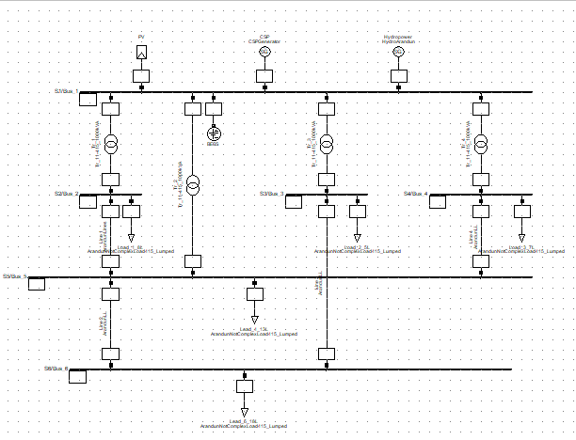
BESS
PV
CSP
Hydro
T1
T4
T3
T2
Line 4
Line 3
Line 1
Line 2
Bus 4
Bus 3
Bus 2
Bus 1
Bus 5
Bus 6
Figure 3.15 – Representation of the first scenario of the microgrid in PowerFactory.

3.6.2 Multiple-Power-Point Microgrid Scenario
Figure 3.16 shows the schematic of the second scenario of the microgrid with the CSP plant now connected through an additional 2 MVA transformer with tap changing enabled, with power being injected to the microgrid on bus 6, which was the weak point of the first scenario. The two microgrid configurations are identical except for the change of location of the CSP point-of-coupling from bus 1 in the first scenario to bus 6 in the second scenario.
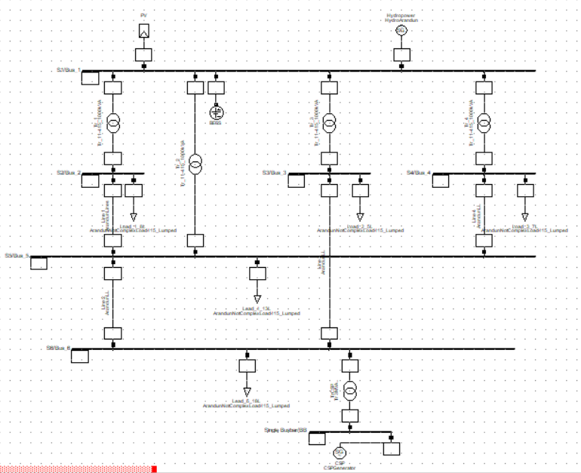
CSP
Bus 4
Bus 3
Bus 2
Bus 5
Bus 1
Bus 6
Hydro
PV
Figure 3.16 – Representation of the Second Scenario of the Microgrid in PowerFactory.

3.7 SOURCES OF DATA COLLECTION

3.7.1 Load Data
Most studies that are conducted with HOMER Pro software tend to use the prepackaged load profile in the software while external data is used only for energy resources (Adebanji et al., 2020; Jain & Sawle, 2021; Khan et al., 2020; Mostafaeipour et al., 2019). However, in this study, the average load profile of the selected location was computed and a data-based model was developed in Microsoft excel. The qualitative data and expected patterns were gathered both by visual inspection and observation to determine the nature and capacity of the power system on which the community currently relies, the migration pattern of the Arandun community influencing their population and electricity demand at various times of the year, as well as the transformers and their ratings.
The quantitative data used in developing the load profile were gathered from the records of the injection substation which is in charge of the feeders supplying Arandun with electricity. The data gathered were the peak load and monthly megawatt usage of the area, which were adjusted for the size of the population and also adjusted using the qualitative information gathered directly by observation and are presented in detail in Figures 4.2 to 4.10.
The diurnal load profile, as well as the seasonal load profile, were analysed using data from the utility company, compiled and scaled in excel before being inputted in HOMER. HOMER has a default load profile which is used in many studies in the literature. However, for this study, location-specific load data was used to give more accurate results than the default load profile in the HOMER software. The obtained load data was calculated on a monthly resolution and average-based interpolation was used to fill in missing values in the available data.

3.7.2 Renewable Energy Data
The wind, precipitation, temperature, humidity, and insolation data for Arandun were harvested from the POWER dataset and preprocessed in Microsoft Excel, which involved sorting the necessary columns and rows and reorganizing the data according to the parameters to be used in the study. The data were averaged across the years before being used in the HOMER Pro software, except in the case of outliers and missing data where the averages had to be customized to use only the available data.
The POWER dataset is specially curated to be used by renewable energy researchers globally, and its data has been validated in previous studies and is internationally trusted by researchers in the field of renewable energy systems. For the extensiveness, level of timestep precision and long lifetime of the project, for preliminary assessment, the average Root Mean Square Error of 0.14 for solar, when compared to ground-based weather stations as declared by NASA on the website shows that the dataset is well-validated and difficult to outperform within reasonable resource expense. It is also established by NASA that the dataset is more accurate the closer the location is to the equator.
At research time, the POWER dataset can be assessed at https://power.larc.nasa.gov. Because this extensive dataset is curated by climate experts, metrologists, and renewable energy experts using state-of-the-art measurement technologies and methods, the use of this well-established dataset is a justifiable and more reliable alternative to primary data in the context of this study.
Furthermore, some of the data, such as the Direct Normal Irradiation (DNI) were only available for a temporal resolution of one month. However, this nature of study requires a full year of hourly data, prompting the use of the centroid method in Microsoft excel software to synthesize an hourly model of 8760 unique time-steps per year from 12 monthly measurements. Incidentally, this also completely solved the issue of modelling the nightly generation characteristic due to the intrinsic energy storage capacity of the Concentrated Solar Power plant (CSP) in HOMER, by using the simple centroid average model rather than the sophisticated Graham’s model that would have been used if the same unavailability of data had applied to the GHI data that was to be used for modelling the Photovoltaic energy input.
This is because the CSP plant, unlike the photovoltaic (PV), can store thermal energy and continues to generate at night. The centroid model has a comparatively little variation between night and day energy input. Therefore, using the centroid model only for DNI synthesis and taking the energy output as a scaled version of the energy input, the model has the effect of preserving the total daily energy in DNI but spreading it across both day and into the night, which is exactly how a molten salt CSP plant operates. It is important to note that, during the feasibility study design, it was realized that modelling CSP in HOMER would have otherwise been the most complex aspect of the feasibility modelling and increased the computational complexity of the optimizations by at least an order of magnitude, such that a personal computer would not have been enough to handle the simulation. Those, an inadvertent model simplification which proved to be very important was carried out by using the simple centroid modelling rather than the standard Graham’s model.
The data for hydropower potential modelling was gathered by using simple improvised stream gauging techniques. In a testament to its hydrological potential, Arandun is known to have several rivers and streams flowing through it. Some of them are listed by name in following: Osin, Odun Alaro, Ale, Otewu, Afogbangba, Ajiwese, Ileti, and Odo-Agbo.
Of these, The Osin River (which has previously appeared in Nigerian geographical literature as being 170km long) which flows through Arandun is known to be the major river in the area and was selected for the hydropower measurement, being a year-round river (Adediji et al., 2011). The major obstruction to river flow at the location was the natural vegetation and presence of large trees in the river which negatively impacted the depth and speed at many points and complicated the stream gauging efforts. Despite this, the river was found to be feasible for measurement at some points, and it is worth noting that the potential of the river for electricity generation at the given location will be greatly improved by controlling the vegetation in the river as well as some dredging at the points at which debris has accumulated due to the numerous obstructions on it, which factors into the costs of establishing such a plant and are also accounted for in the study. Because of the aforementioned factors, the potential determined based on the measurements in this study is unavoidably bound to be an underestimation of the Osin River’s true potential at the Arandun location for hydropower generation.
The measurements were taken at two points along the course of the Osin River about 1km apart. To measure the streamflow velocity, a light floating object (specifically a corked empty bottle) was placed on the surface of the water. The distance and time taken to cover a stretch of river without many obstructions were measured and the speed and depth of the river at that point were determined.
Per basic stream gauging works of literature such as (Mdee et al., 2018; Wali, U.G., 2013), a hose level was used for estimation of the river head at the selected location. The unavailability of a pressure gauge for use with the hose necessitated relying on the basic hose-level method for low-head rivers as recorded in (Mdee et al., 2018), in which the hose was submerged except for its ends. Both ends were raised and the height difference between the water columns in each hose was noted. Several trials were needed for this particular exercise and it was performed with a ten-yard hose with a partner at the river at both locations. In the process of entering the river, it was discovered that the bottom of the river was not of hard rock but of mud which suggests that dredging will be an economically-feasible project where necessary. Figure 3.17 shows the illustration of the head estimation method used at the river with hose and metric measuring instruments.
Figure 3.17 – Hose-Level Method Used in Head Estimation in the Study(Mdee et al., 2018).
The measurements at the river were taken in February 2022, well within the dry/harmattan season. On one hand, this made the river tame enough to be safely interacted with, and on the other hand, the measurements thus obtained are not representative of the yearly cycle of the river. However, with the aid of assistants at the river, the extent of the Osin River when in flood was established and also accounted for by developing a heuristic model of its yearly flow. By consulting (Ayalew, 2021; Osei et al., 2021; M. Xie et al., 2021), a pattern for the estimation of the river flow uncertainty using the precipitation data of the location was developed which enabled the monthly volume variation of the river to be established with a reasonable level of accuracy as the measurements were taken based on the topography of the river bank and observing the health of the reeds along the river to show the relative presence of water along the river bank.
By combining the multiple various observations from the river location, including those who spend much time around the river, by analyzing the precipitation data, and interpolating from the results of models used in hydrological studies such as (Ayalew, 2021), the monthly river flow to represent an entire yearly cycle was estimated heuristically and speed variations were also introduced by numerical modelling, knowing that the depth of the river and its speed of flow were related. The width of the river was measured at points where it was narrow enough to be directly measured, by attaching a floating object to the end of the tape and casting the tape with a slight upstream inclination to compensate for the downstream drift. At most points, the river could not be measured directly due to its significant depth, thus the maximum obtained depth for safety purposes was used. This implies that the river is at least as deep as the recorded measurements at both points where it was gauged.

3.7.3 Economic Data and Cost Information
Certain information, such as the cost of fuels such as diesel at the time of study is common knowledge and has been gathered directly in the locality and used without citation, especially since it is not fixed. However, the prices used are representative of a realistic range of costs. The prices of generating sets of various sizes/capacities were gathered by a market survey. For capacities which are not common, direct quotations of price from manufacturing companies had to be obtained where possible. An inflation rate of 10%, which is both conservative and optimistic, is used in the economic analysis as the inflation rate is not constant in Nigeria. US Dollars were used for the economic computations and expression of prices and costs, as the dollar is a well-known benchmark currency used in such studies even by previous Nigerian research efforts.
The climactic and meteorological data for Arandun, (excluding hydrological data) to be used in the study were sourced from the extensive dataset curated by the Prediction of Worldwide Energy Resources (POWER) project which is under the aegis of the National Aeronautics and Space Administration (NASA).

3.8 RESEARCH INSTRUMENTS/TOOLS
For the feasibility study of the proposed microgrid, HOMER software was used. HOMER stands for Hybrid Optimization of Multiple Energy Resources. It is used to optimize the design of systems which include multiple energy resources, such as microgrids. HOMER has found application in the design and evaluation of renewable energy systems, including the economic analysis. HOMER takes input about the location of the project, and the cost of components to be used, and helps in speeding up the solution of optimal design problems for microgrids. For the stream gauging effort, a stopwatch, a set of floating objects, a human assistant, a 10-yard hose, and a measuring tape were involved. A depth gauge was improvised from straight rods.
For the modelling and simulation, DigSILENT’s PowerFactory software was used. PowerFactory has been used by several researchers and industry professionals to design, model, and simulate power systems ranging from load flow analysis, contingency analysis, and electromagnetic transient analysis, to network model management, and it has the appropriate feature set to execute this study. PowerFactory has suitable inbuilt packages for modelling and simulation of distributed generation, being built for the modelling and simulation of a wide variety of power system network types such as generation, transmission, distribution, and in this case, distributed generation. PowerFactory is well-suited for studies involving wind power, solar power, and hydroelectric generation. It is user-friendly and while it is graphical for modelling and design, it has a built-in scripting language which will give flexibility to the simulations to be conducted.
MATLAB is a proprietary multidisciplinary software suite for numerical computing which has a built-in high-performance programming language, which makes it flexible for research applications. It is a highly-preferred numerical computing environment and programming language among electrical engineers, having a number of specialized toolboxes and functions for electrical and electronic system design and analysis. It was used in this work because has a fuzzy logic toolbox which provides functions that can be used for the design, analysis, and simulation of fuzzy inference systems within time frames much shorter than those obtainable for generic programming languages such as C and C++. Also, the type of modelling carried out in power systems lends itself readily to matrix manipulation, which makes MATLAB a strong choice for use in this study.

3.9 DATA ANALYSIS TECHNIQUES
For the techno-economic analyses, the proprietary analysis and optimisation algorithms in the HOMER software are trusted by power system researchers and renewable energy project managers and have been relied on. In addition, a fuzzy logic algorithm was used in MATLAB for the environmental impact and acceptability analysis. MATLAB was also used for data analysis and for fitting the data to the probability distributions. For the rest of the study, the data was used both for the development of power system models and for simulation of the developed model in DIgSILENT PowerFactory, after which the voltage profile stability was determined.

BRIEF PRESENTATION AND EXPLANATION OF LOAD AND STREAMFLOW DATA.
The data gathered are partially presented in following. Samples of month-by-month load data are presented in Table 3.4. Table 3.5 shows the hourly load measurements in Megawatts for selected days, as gotten directly from the utility. Due to the difficulty of technical difficulties of obtaining large contiguous chunks of highly-detailed representative hourly load data (due to blackouts and for other data-use reasons), the months of May, November, and December 2021 with relatively low blackout rates were chosen to represent the harmattan and rainy season load profiles respectively. This selection is justified by the fact that in 2020 the community experienced an average of 4.88mm/day of precipitation in May compared to 0.12 (which is approximately 0) mm/day in December. However, the monthly summary for each month for the years 2020 and 2021 was graciously furnished by the power company. To get the target community’s load, the figures in the table are divided by a factor of 3 to account for the utility’s measurement arrangements with respect to its feeders. Hydro data was partly measured (where possible) and partly estimated based on visual, on-site observations and readily-obtainable precipitation data, for the months in which river measurements were not directly obtainable as elaborated in Appendix VII. Topographical examination of the location helped estimate how the level of water changed with the amount of rainfall. The estimations relied on the reasonable assumption that 95% of the rainfall in the community seeps into the ground while 5% seeps into the Osin River. However, even for such months, the usual boundaries of the river were established. Hence, the appropriateness of the Gumbel (extreme value) distribution for characterizing it. The data as used in the study is presented in Table 3.6. Table 3.7 represents some of the weather data that was gathered. Where data points were found missing, other points were averaged and interpolated for quantitative operations. Further information and codes on the methodology are available in the appendices.
Table 3.4 – Sample of the hourly load data (Provided by TCN).
Date | Month Covered | MWh (2019) | Max MW (2019) | MWh(2020) | Max MW (2020) | MWh (2021) | Max MW (2021)
1st February | January |  |  | 862.00 | 2.17 | 764.00 | 1.97
1st March | February |  |  | 733.33 | 2.20 | 727.67 | 2.10
1st April | March |  |  | 732.00 | Missing | 785.33 | 2.03
1st May | April |  |  | 666.67 | 2.07 | 659.33 | 2.00
1st June | May |  |  | 754.33 | 2.00 | 639.67 | 2.00
1st July | June |  |  | 728.00 | 1.93 | 576.00 | 2.00
1st August | July |  |  | 729.00 | 1.93 | 703.67 | 2.07
1st September | August |  |  | 779.00 | 2.00 | 663.00 | 1.93
1st October | September | 602.00 | 1.90 | 653.67 | 2.00 | 652.67 | 2.00
1st November | October | 627.67 | 2.00 | 683.00 | 2.03 | 633.33 | 2.10
1st December | November | 716.33 | 2.00 | 772.00 | 2.10 | 800.33 | 2.10
1st January | December | 756.67 | 2.20 | 741.00 | 2.07 | 800.33 | 2.10

Table 3.5 – Sample of Hourly Load Measurements in MW for a Selected Week (provided by TCN).
Hours | 12/05/2021 | 13/05/2021 | 14/05/2021 | 15/05/2021 | 16/05/2021 | 17/05/2021 | 18/05/2021 | 19/05/2021
0 | 2.3 | 3.2 | 2.9 | 3 | 3.25 | 3.25 | 3 | 2.9
1 | 2.2 | 3 | 2.9 | 3.2 | 3.25 | 3.25 | 2.6 | 2.9
2 | 2.2 | 3 | 2.9 | 3.2 | 3.25 | 3.25 | 2.6 | 2.9
3 | 2.2 | 3.5 | 2.9 | 3.2 | 3.25 | 3.25 | 2.8 | 3.1
4 | 2.4 | 3.7 | 2.9 | 3.2 | 3.25 | 3.25 | 2.9 | 3.7
5 | 2.6 | 4.2 | 3.9 | 3.2 | 3.25 | 3.25 | 2.95 | 4.1
6 | 3.3 | 4.5 | 4.5 | 3.2 | 3.25 | 3.25 | 3.05 | 5.1
7 | 3.4 | 5 | 4.6 | 3.2 | 3.25 | 3.25 | 3 | 4.2
8 | 3.3 | 5.2 | 4.3 | 3.3 | 3.25 | 3.25 | 3.1 | 3.3
9 | 3 | 4.6 | 3.7 | 3.2 | 3.25 | 3.25 | 3.1 | 3.1
10 | 3.2 | 3.6 | 3.4 | 3.3 | 3.25 | 3.25 | 3.25 | 2.8
11 | 3.2 | 3.6 | 2.9 | 3 | 3.25 | 3.25 | 3.25 | 2.8
12 | 3.25 | 3.6 | 3 | 3 | 3.25 | 3.25 | 3.4 | 2.9
13 | 3.3 | 3.7 | 3 | 3 | 3.25 | 3.25 | 3.45 | 2.9
14 | 3.2 | 3.6 | 3.1 | 3 | 3.25 | 3.25 | 3.5 | 2.8
15 | 4.2 | 3.5 | 3.2 | 3 | 3.25 | 3.25 | 3.5 | 2.8
16 | 4.3 | 3.7 | 3.4 | 3 | 3.25 | 3.6 | 3.6 | 3
17 | 4.3 | 3.7 | 3.6 | 3 | 3.25 | 4.05 | 3.8 | 3.3
18 | 4.4 | 3.5 | 4.1 | 3 | 3.25 | 4.5 | 4 | 4.2
19 | 5 | 4.3 | 4.5 | 3 | 3.25 | 5 | 5.3 | 5.3
20 | 5.2 | 5.1 | 5.8 | 3 | 3.25 | 5 | 4.9 | 5.6
21 | 4.7 | 4.5 | 5.4 | 3 | 3.25 | 4.6 | 4.2 | 4.5
22 | 4.2 | 3.6 | 3.7 | 3 | 3.25 | 3.4 | 3.6 | 3.4
23 | 3.8 | 3.1 | 3.2 | 3 | 3.25 | 3.1 | 3.1 | 3.3
24 | 3.2 | 2.9 | 3 | 3 | 3.25 | 3 | 2.9 | 2.7

Table 3.6 - Monthly Average Hydropower Data (Measured directly and/or Estimated using precipitation data).
Month | Streamflow in Litres/s
January | 250
February | 255 (measured)
March | 1834
April | 5239
May | 8153
June | 27789 (measured)
July | 15906
August | 16695
September | 4966
October | 1936
November | 545
December | 261

Table 3.7 Extract of Daily Solar Influx Data for January 2021 for Arandun Coordinates (Used with Permission of NASA POWER Langley Research Centre).
YEAR | MO | DY | ALLSKY_SFC_SW_DWN | CLRSKY_SFC_SW_DWN | ALLSKY_KT | ALLSKY_SFC_LW_DWN
2021 | 1 | 1 | 5.6 | 5.68 | 0.63 | 362.96
2021 | 1 | 2 | 5.27 | 5.62 | 0.59 | 388.27
2021 | 1 | 3 | 4.87 | 5.57 | 0.55 | 401.62
2021 | 1 | 4 | 5.59 | 5.83 | 0.63 | 380.82
2021 | 1 | 5 | 5.72 | 5.95 | 0.64 | 370.19
2021 | 1 | 6 | 5.41 | 5.57 | 0.61 | 392.1
2021 | 1 | 7 | 5.39 | 5.82 | 0.6 | 388.24
2021 | 1 | 8 | 5.46 | 5.83 | 0.61 | 388.34
2021 | 1 | 9 | 5.99 | 6.05 | 0.67 | 382.74
2021 | 1 | 10 | 5.58 | 5.91 | 0.62 | 382.7
2021 | 1 | 11 | 5.76 | 5.87 | 0.64 | 388.99
2021 | 1 | 12 | 5.77 | 5.85 | 0.64 | 375.21
2021 | 1 | 13 | 6.05 | 6.06 | 0.67 | 368.99
2021 | 1 | 14 | 6.1 | 6.1 | 0.67 | 365.58
2021 | 1 | 15 | 5.65 | 5.79 | 0.62 | 363.66
2021 | 1 | 16 | 5.54 | 5.57 | 0.61 | 368.23
2021 | 1 | 17 | 5.42 | 5.52 | 0.59 | 387.44
2021 | 1 | 18 | 5.51 | 5.56 | 0.61 | 397.32
2021 | 1 | 19 | 6 | 6.18 | 0.66 | 363.82
2021 | 1 | 20 | 5.17 | 5.39 | 0.56 | 363.6
2021 | 1 | 21 | 5.54 | 5.64 | 0.6 | 357.35
2021 | 1 | 22 | 4.8 | 5.15 | 0.52 | 375.26
2021 | 1 | 23 | 4.63 | 4.91 | 0.5 | 371.35
2021 | 1 | 24 | 5.26 | 5.43 | 0.57 | 362.2
2021 | 1 | 25 | 5.47 | 5.46 | 0.59 | 361.12
2021 | 1 | 26 | 5.76 | 5.74 | 0.62 | 372.27
2021 | 1 | 27 | 5.77 | 5.77 | 0.62 | 365.96
2021 | 1 | 28 | 5.58 | 5.63 | 0.6 | 387.87
2021 | 1 | 29 | 5.91 | 5.96 | 0.63 | 373.35
2021 | 1 | 30 | 5.17 | 5.27 | 0.55 | 373.28
2021 | 1 | 31 | 4.83 | 5.02 | 0.52 | 399.65

ALLSKY_SFC_SW_DWN is CERES SYN1deg All Sky Surface Shortwave Downward Irradiance (kW-hr/m^2/day)
CLRSKY_SFC_SW_DWN is CERES SYN1deg Clear Sky Surface Shortwave Downward Irradiance (kW-hr/m^2/day)
ALLSKY_KT is CERES SYN1deg All Sky Insolation Clearness Index (dimensionless)
ALLSKY_SFC_LW_DWN is CERES SYN1deg All Sky Surface Longwave Downward Irradiance (W/m^2)
ALLSKY_SFC_PAR_TOT is CERES SYN1deg All Sky Surface PAR Total (W/m^2)
CLRSKY_SFC_PAR_TOT is CERES SYN1deg Clear Sky Surface PAR Total (W/m^2)
ALLSKY_SFC_UVA is CERES SYN1deg All Sky Surface UVA Irradiance (W/m^2)
ALLSKY_SFC_UVB is CERES SYN1deg All Sky Surface UVB Irradiance (W/m^2)
ALLSKY_SFC_UV_INDEX is CERES SYN1deg All Sky Surface UV Index (dimensionless)

CHAPTER FOUR

RESULTS AND DISCUSSION OF FINDINGS

4.1 SOCIAL ACCEPTABILITY ANALYSIS
Due to the number of inputs involved (5), the output could not be represented in a three-dimensional surface plot as is usually done for bivariable fuzzy systems. However, as shown in Figure 4.1 after the fuzzification of responses, the average was taken, membership functions evaluated, and output was defuzzified using the centroid method, the Social Acceptability index (SA) was obtained as 0.7 on a scale of 0 to 1. This result, when interpreted according to the rule base, signifies that the microgrid is strongly acceptable to the community and will not disrupt their comfort in terms of the five criteria of land use, visual impact, acoustic impact, water impact, and air impact.
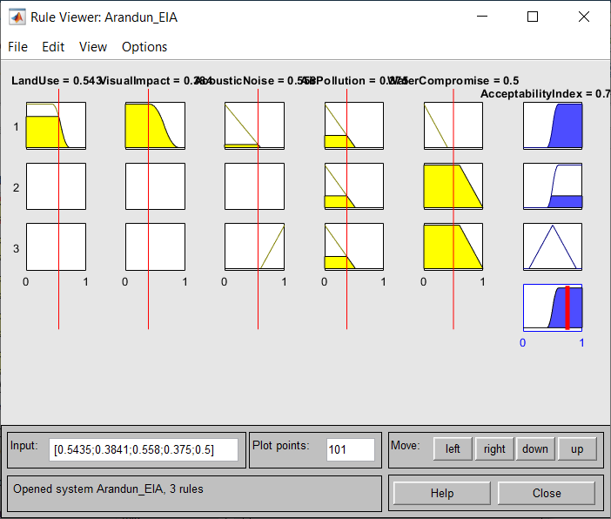
Figure 4.1 – Defuzzification of Rule Base for Computation of Acceptability Index

4.2 TECHNO-ECONOMIC ANALYSIS

4.2.1 Load Computations for HOMER
The average load for the community as evaluated after all interpolations and approximations were carried out was 975 kW, with an absolute annual peak demand of 2216.8 kW. The HOMER-estimated daily energy usage for the year 2021 was 23,400 kWh per day while the real average daily consumption for the community was calculated as 23,028 kWh per day, which validates the model closely enough and shows an outstanding accuracy with 98.3% agreement between the software prediction based on given data and built-in algorithms, and real-world calculations for 2021, considering the quality and relatively low quantity of data available. This also justifies why HOMER is suitable for this study. A box-and-whisker plot of the monthly energy usage profile as estimated by HOMER is provided in Figure 4.2. For an annual overview of load patterns, a histogram showing the relative frequency of various energy usage levels is also provided in Figure 4.3. A cumulative frequency distribution is also presented in Figure 4.4.
An annual load curve was also generated using the HOMER software. Figure 4.5 presents the shape of the load curve illustrating the stochasticity of load over an entire year, with the load varying every timestep. Due to computational complexity, the models were simulated at a resolution of 60 minutes which is customary for HOMER models in the literature. Furthermore, this presents 8760 data input steps per simulation per year, which is already more resolution than can be represented by a normal-sized plot, hence the points and peaks are visually exaggerated for visibility. The load factor of the community is calculated to be 0.44 or 44% as follows:
Load factor = average demand/peak demand = 975 kW / 2216.8 kW = 0.44.
The variability in the load that enables the use of realistic load profiles based on user-based data is controlled by the random variability parameters in HOMER. For this study, the day-to-day variability is set to 10% while the timestep variability is set to 20%. This is the combination of settings recommended by HOMER which also gave >98% agreement in annual energy consumption during manual validation of the selected calculations.
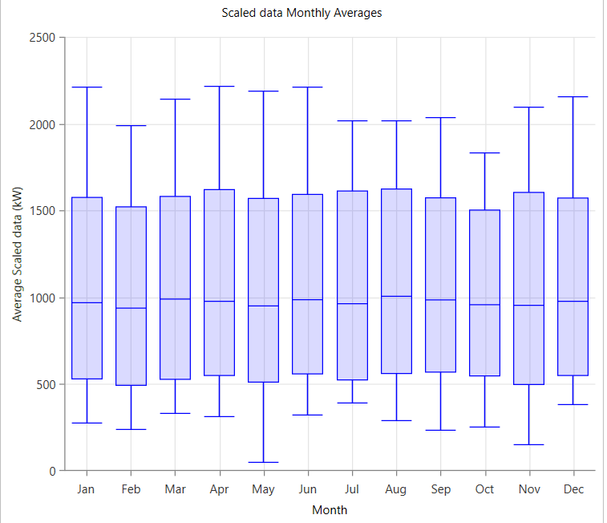
Figure 4.2 – Box-and-Whisker Plot Showing the Monthly Average Load Profile.
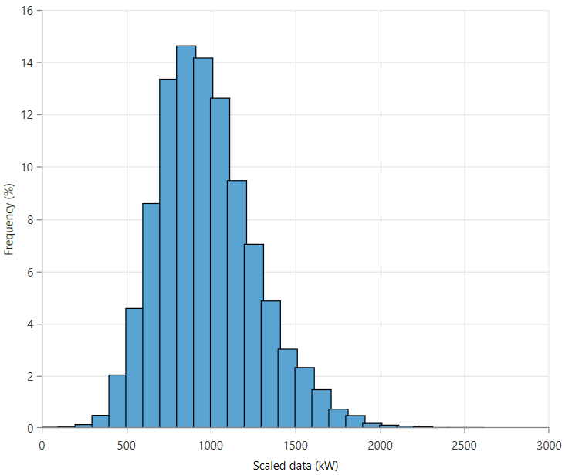
Figure 4.3 – Histogram Showing Load distribution by Frequency of Incidence.
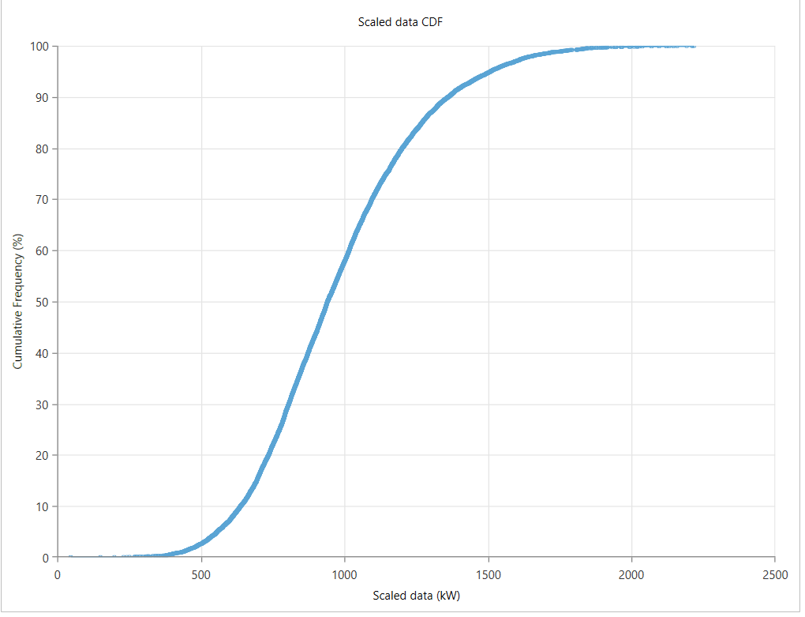
Figure 4.4 – Cumulative Distribution of Load Pattern by Frequency of Incidence.

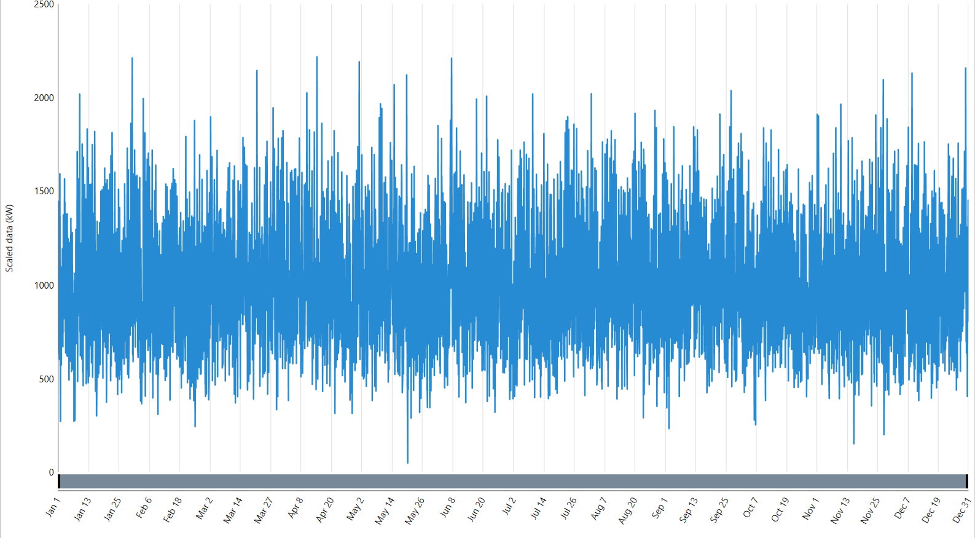
Figure 4.5 – Hourly Load Time Series for the First Year of the Simulation
Also, weeks with a low number of outage hours were selected for a better representation of the energy usage pattern of the community. A selection of 26 days, designed to include all days of the week, towards the middle of the year (May) and towards the end of the year (November and December) were selected for an hour-by-hour study to develop the diurnal (hourly) load profile for the rainy season and dry season which were both considered in developing the HOMER model. The chosen days were selected to include both holidays, weekend days, and regular work days. Figure 4.6 shows a histogram showing the average daily load profile for selected days in May and Figure 4.7 for selected days in November and December which were chosen based on criteria described in the previous chapter.
The standard deviation for the hourly demand in May is found to be 162.456 MW while that of the November-December data is found to be 242.224 MW. The mean for the May load data shows an average of 1.157 MW being consumed while in November-December, the mean load consumption was 1.248 MW. This shows that the peak demand towards the end of the year tends to be higher than that towards the middle of the year. Also, the variation in the load profile is higher in the November-December periods compared to May. Hence, in HOMER, priority was given to the November-December profile in the modelling because the one with more variance and that more accurately depicts the peak would give more accurate results.
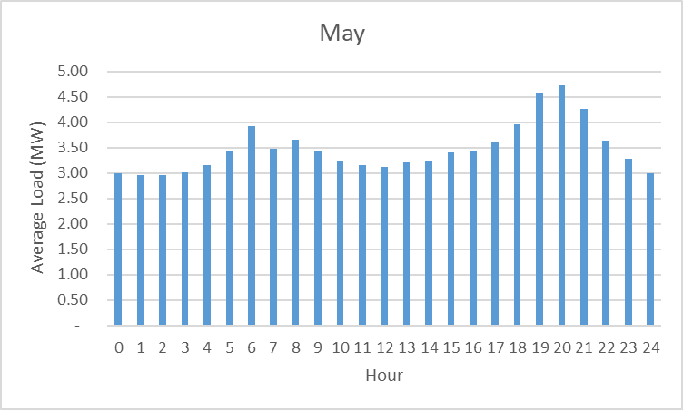
Figure 4.6 – Average Hourly Load Profile for Selected Days in May.
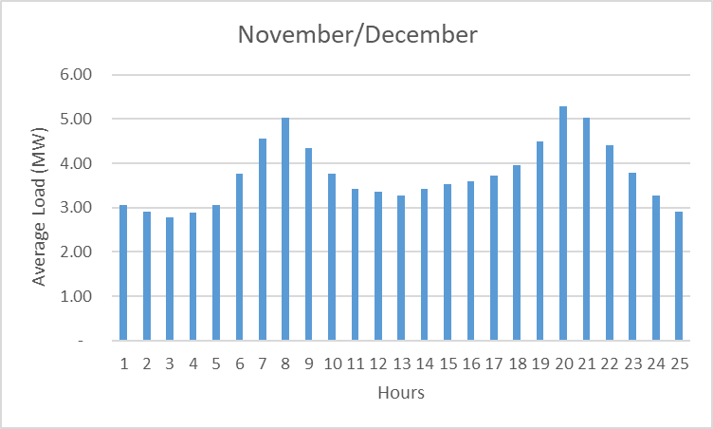
Figure 4.7 – Average Hourly Load Profile for Selected Days in November and December.
In addition, an annual load profile for the Arandun community was also developed using the monthly measurement data from the utility company. Both the maximum monthly demand in MW (instantaneous) and the energy usage of the community in MWh (cumulative) were compiled and used in the calculation. It was found that the peak load varied more than the total energy consumption. However, both monthly quantities were found to be higher towards the end or at the beginning of the year than mid-year. Furthermore, January was found to be the peak month for consumption both when measured by MWh and by peak MW demand. Figure 4.8 shows the graph of the month-by-month statistics for the years 2020 and 2021 for Arandun peak load and Figure 4.9 shows the total cumulative energy consumption in those periods.
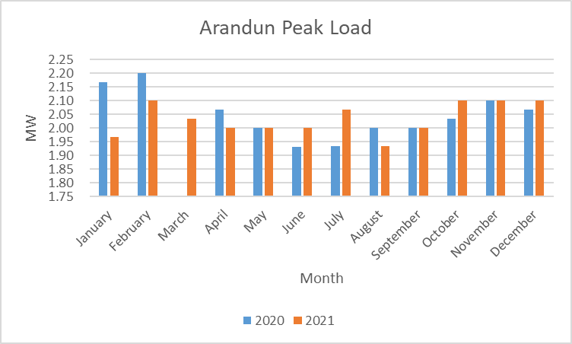
Figure 4.8 – Monthly Peak Load for 2020 and 2021.

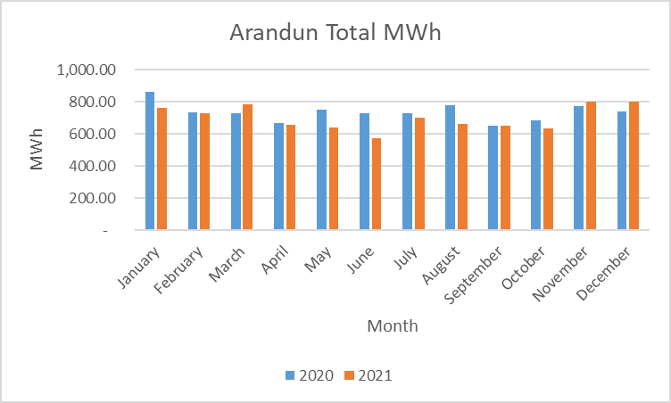
Figure 4.9 – Monthly Energy Consumption in 2021 and 2021.
Figure 4.10 shows the variance of the load profile estimated by HOMER based on given data over time, showing that the data selection enabled HOMER to develop unique load profiles for each month, as opposed to having identical profiles for each month as is frequently obtained in literature, thereby making the study as non-deterministic as possible. The various average monthly profile is seen presenting various permutations of Arandun’s “two-humped” load profile pattern.
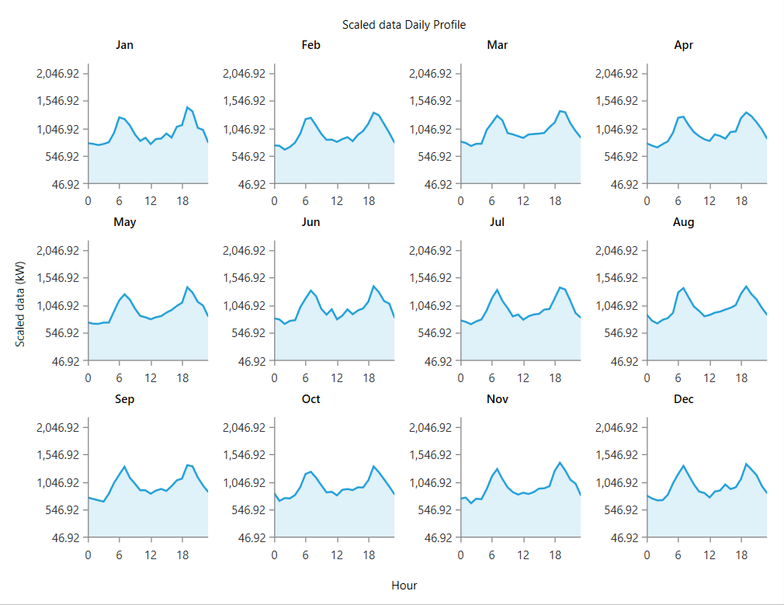
Figure 4.10 – Average Hourly Load Profiles for each Month as Estimated by HOMER Pro.

4.2.2 Optimal Solutions for the Renewable Microgrid.
Over 5 million solutions were simulated for this particular case. However, due to the unusual constraint faced by HOMER that the system was to be 100% renewable, over 60% of the simulated solutions were found to be infeasible either due to capacity shortage constraints or failing the multiyear adequacy test. It was generally found that wind energy installation was not recommendable in the chosen location due to the relatively low availability of wind resource which meant that an unreasonably high number of turbines would have been needed. The chosen solution meets the demand completely while having a very competitive Net Present Cost compared to other solutions. CSP showed high viability due to its intrinsic thermal inertia as well. As expected in a tropical location relatively close to the equator, it was more highly recommended than solar PV according to the results of the simulation. An optimal combination is presented. Net Present Cost of $55.7 million compared to the diesel NPC of $408 million over 25 years shows the difference between using renewable energy and using fossil fuels in a microgrid of this size.

Net Present Cost and Levelized Cost of Energy
The total NPC for the renewable microgrid with battery storage was calculated as $55,724,760.00 while the Levelized COE was calculated as $0.26 for each unit of electricity generated. Compared to the diesel microgrid, this is much more cost-effective. The chosen optimal system has a system architecture and capacities for each technology as shown in Table 4.1. Wind energy in the location was found to be suboptimal, hence the results of the feasibility survey discourage the use of wind turbines in the microgrid project unless cost is not assumed to be a priority. Even in such a scenario, the amount of space that would be taken up by any significant wind installations makes land use a hard constraint against the en-masse installation of wind turbines in the area. Table 4.2 shows a breakdown of the total NPC for the renewable microgrid.
The photovoltaic array consists of 3000 kW of photovoltaic generation capacity, a 9MW capacity concentrating solar plant, as well as 200 strings of 50 6V batteries of 1kWh each (or 167 Ah). This is how HOMER sizes its batteries. However, the battery and solar equipment batteries were obtained from battery vendors, PV array statistics, and CSP statistics from literature respectively, and levelized so that the cost of batteries in the simulation was realistic. $144/kWh of Li-ion storage was used in the study.

Table 4.1 – Architecture of the Chosen Optimal Renewable Microgrid
Component | Name | Size | Unit
PV #1 | Generic flat plate PV | 3,000 | kW
CSP | Concentrating Solar Power | 9,000 | kW
Storage | Generic 1kWh Li-Ion | 200 | Strings
System converter | System Converter | 2,500 | kW
Hydroelectric | Generic Hydro 100kW | 23.5 | kW

Table 4.2 – Net Present Costs Breakdown of the Renewable Microgrid
Name | Capital | Operating | Replacement | Salvage | Resource | Total
Concentrating PV | $31.5M | $2.25M | $27.0M | -$20.3M | $0.00 | $40.5M
Generic 1kWh Li-Ion | $1.80M | $2.50M | $1.44M | -$1.08M | $0.00 | $4.66M
Generic flat plate PV | $9.00M | $750,000 | $0.00 | $0.00 | $0.00 | $9.75M
Generic Hydro 100kW | $459,845 | $344,875 | $0.00 | -$114,962 | $0.00 | $689,759
System Converter | $75,000 | $0.00 | $75,000 | -$25,000 | $0.00 | $125,000
System | $42.8M | $5.84M | $28.5M | -$21.5M | $0.00 | $55.7M

Battery Energy Storage System (BESS)
The battery energy storage as designed is based on Lithium-ion technology. Lithium batteries are less vulnerable to degradation over time, and they tend to charge faster than lead-acid batteries. The search space for the battery capacity to be put in the microgrid includes 0, 200, and 500. The search space was originally more fine-grained. However, the complexity of simulations made it necessary to selectively eliminate some entries in the search space which had already proved themselves to be invisible. For this reason, the simulation had to be repeated with various search spaces. Because there are 10000 batteries needed, space considerations are also important. Table 4.3 presents information on the battery energy storage system recommended after the optimization.
Table 4.3 – Design Properties of the Battery Energy Storage System
Quantity | Value | Units
Batteries | 10,000 | qty.
String Size | 50.0 | batteries
Strings in Parallel | 200 | strings
Bus Voltage | 300 | V
Average Energy Cost | 0 | $/kWh
Energy In | 222,624 | kWh/yr
Energy Out | 199,413 | kWh/yr
Storage Depletion | -1,000 | kWh/yr
Losses | 22,211 | kWh/yr
Autonomy | 8.21 | hr
Storage Wear Cost | 0.0506 | $/kWh
Nominal Capacity | 10,000 | kWh
Usable Nominal Capacity | 8,000 | kWh
The battery input power over the year is shown in form of a box-and-whisker plot in Figure 4.11. From the figure, it can be seen that the Harmattan months such as January and December show less power flow involving the battery. November, December, and January in particular show very little utilization of the batteries. However, the rainy months of June, July, August, September, and October show massive exchanges of energy between the BESS and the rest of the microgrid. The box-and-whisker plot of the State-of-Charge (SOC) in Figure 4.12 corroborates this narrative, as it is shown that, in the first year, the State of Charge is at its lowest value of 55% in September. The median, shown as the central line on the September box, however, shows that the dip in SOC is a fringe phenomenon. However, as degradation of batteries occurs, the SOC dips as low as 20% in year 20, but no lower. This is not coincidental, as 20 years is the lifespan of the BESS as estimated by HOMER. HOMER recommends the overhauling of the battery system after this time.
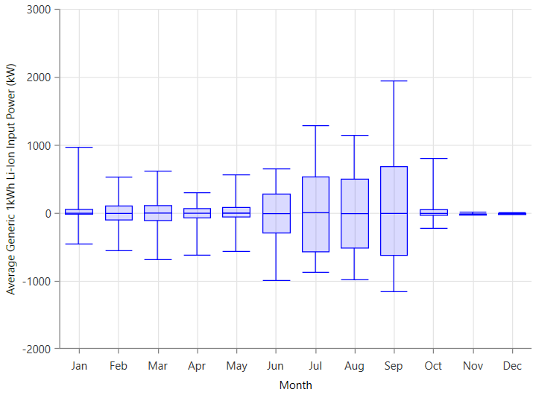
Figure 4.11 – Box-and-Whisker Plot of the BESS Input Power in Year 1.
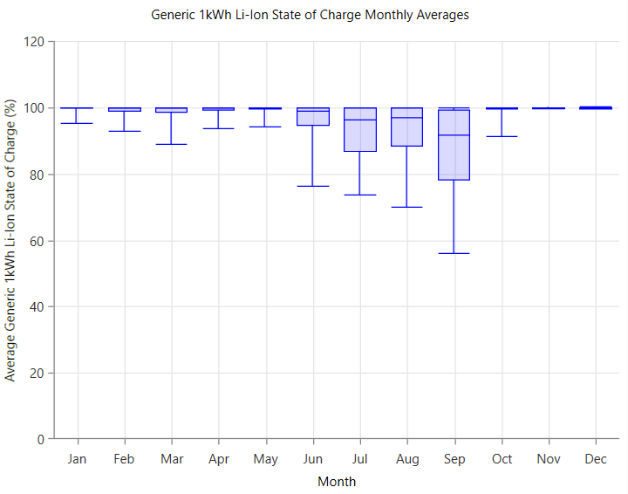
Figure 4.12 – Box-and-Whisker Plot of the BESS State of Charge in Year 1.

4.2.5 System Converter (Bidirectional)
HOMER allows the modelling of the energy balance between AC and DC parts of the microgrid network. After a market survey for large-scale grid inverters, a value of $15,000 for a 500 kW inverter was determined to be appropriate. The search space for inverter ranged from 0 to 5000 in steps of 2500. There were originally more values in the search space but they had to be whittled down into three entries. The optimization determined an optimum size of 2500 kW for the converter in the network. The bidirectional AC-DC converter was estimated with an efficiency of 95%, with an effective lifespan of 15 years before needing overhauling or total replacement. Table 4.4 shows the summary of information concerning the converter operation involved in HOMER simulations.

Table 4.4 – Electrical Summary of the Bidirectional Converter.
Quantity | Value | Units
Hours of Operation | 1,170 | hrs/yr
Energy Out | 273,393 | kWh/yr
Energy In | 287,782 | kWh/yr
Losses | 14,389 | kWh/yr
Capacity | 2,500 | kW
Mean Output | 31.2 | kW
Minimum Output | 0 | kW
Maximum Output | 1,100 | kW
Capacity Factor | 1.25 | %

Micro-Hydro Turbine
The hydropower potential of the Osin river as measured during the stream gauging was used in HOMER and it was found that a turbine with up to 200kW capacity would be appropriate for the location. The hydrological flow varies significantly in Arandun. Being a small project, extensive damming would not be recommended. However, a weir could be constructed, and dredging and installation of the turbine at an artificially-lowered height would ensure a consistent head of 3m at the location year round, although the flow rate of water itself would vary highly during the year. A capital cost of $459,845.00 was estimated for the hydropower of 200kW capacity based on scaling from similar projects. Yearly operation and maintenance costs were estimated at $13,795.00 per year. Table 4.5 shows the summary of the capacity and performance of the hydropower turbine.

Table 4.5 – Statistics and Capacity of the Hydropower Turbine
Quantity | Value | Units
Nominal Capacity | 23.5 | kW
Mean output | 89.5 | kW
Capacity factor | 380 | %
Total Production | 784,108 | kWh/yr
Minimum output | 4.99 | kW
Maximum output | 200 | kW
Hydro penetration | 9.18 | %
Hours of operation | 8,760 | hrs/yr
Levelized Cost | 0.0352 | $/kWh

Osin streamflow data, unlike most of the other data which were made available in the POWER dataset, had to be measured and some estimated for each month based on observations at the location, not on an hourly/daily basis. Hence, the plot in Figure 4.13 shows the hydropower output based on the estimated streamflow for each month as used in the HOMER software. As expected, the rainier months have more hydropower output, while the dry season severely impacts the available power from the turbine.
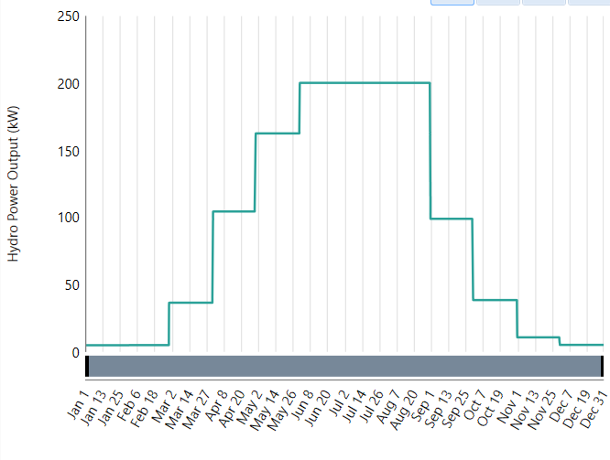
Figure 4.13 – Hydropower Output Annual Curve as estimated for the Osin River in Arandun.

4.2.7 Effect of Removing the Battery Energy Storage
The system was simulated without the BESS, and the results were observed. Notably, the generation had to be increased to compensate for the lack of storage. Even though the Concentrated Solar Power has intrinsic storage capacity, 9MW capacity of solar power was no longer enough to meet the load demand, with a new NPC of $67,314,760.00 being incurred (compared to $55.7 million with batteries) and still having an unmet electric load of 1.92% in the first year and a capacity shortage of 44% while wasting about a third of the generated electricity. Hence, the impact of the BESS on the system performance and economics is established.
The primary load and complementarity curves of the microgrid are shown in Figures 4.14 and Figure 4.15. The highest and concave curve represents the Concentrated Solar Power (CSP) output in kW which decreases during the middle months of the year (when precipitation interferes with the DNI component of solar radiation). The convex curve represents the output of the micro-hydro turbine over the year in kW. The hydropower component produces its maximum of 200kW from early June to late August, at which point it drops gradually until the next rainy season. The highly-erratic curve sandwiched between the CSP and the hydro represents the output of the inverter which is a combination of battery and PV system. The output of the inverter is used instead of the direct DC power output of the PV because it is a more accurate representation of the functioning of the system over time. Also, the direct output of the PV makes it difficult to see other curves on the graph properly. From the inverter output curve, it can be seen that the battery and PV power is used more during the rainy season when the CSP output has reduced and the hydro is not enough to supply the demand. Hence, the renewable-based microgrid with energy storage is complementary.
Figure 4.14 – AC Primary Load Curve of the Renewable-Based Microgrid.
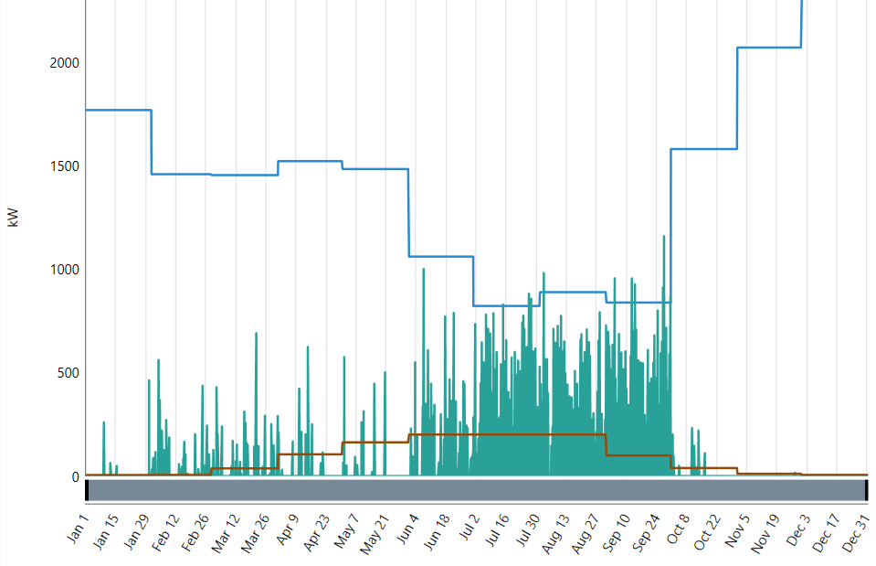
PV-BESS
Hydro
CSP
Figure 4.15 – Complementarity Curve of the Renewable-Based Microgrid.

4.2.8 Optimal Solutions for Diesel Scenario.
For the diesel operating scenario, ultimately, 328 solutions were simulated in the final multiyear scenario run (for a 25-year lifetime project) after the search space was refined iteratively. 316 of the solutions were feasible while 12 were infeasible due to capacity shortage constraints. In the optimal solutions, 4000 kW of installed capacity was recommended by HOMER to meet up the load demand at all points during the microgrid lifetime. This corresponded to a Net Present Cost (NPC) of $408 million despite having a capital cost of less than $1 million initially. Further investigations showed that the effects of compounding inflation and fueling and maintenance expenses in an economic environment with dwindling relief of fossil fuel projects are responsible for the high ratio of running costs to initial costs. Illuminatingly, it is found that if the effects of inflation are removed and a discount rate of 20% on all products is introduced, the net present cost would only be $40.9 million, a tenth of its nominal NPC of $408 million under realistic economic conditions. This shows how much inflation and fueling costs greatly multiply the overall cost of the microgrid.

4.2.9 Total Net Present Cost (NPC) for Diesel Microgrid
The Total Net Present Cost for a power generating station is the total of its life-cycle costs. It corresponds to the present value of all expenditures for installing and operating the system components over the lifespan of the project (in this case, 25 years for the purpose of the study), less the present value of all revenues earned during that time. The net present cost for the diesel microgrid scenario in Arandun based on the information used in the study under a no-discount, 10% inflation rate for the microgrid was calculated to be $408,109,800.00. For comparative purposes, the system was also simulated with an assumption of zero inflation for the entire 25 years, with a discount of 20% on all expenses, which reduced the NPC to $40,911,500.00. This represents almost 10% of the original value under realistic conditions, due to the time value of money. This difference is due to the compounding of inflation (which HOMER represents by using a real discount rate instead of a nominal discount rate) in running costs over a period of 25 years while still giving the same results with less computational complexity.

4.2.10 Levelized Cost of Energy (COE) for the Diesel Microgrid
The levelized COE for a power generating station is the average cost of generating 1 kWh of useful energy (i.e not counting losses) in the system over its lifetime. It is used to compare various options for electricity generation especially when viewed from the consumer perspective (it is scaled) while the Net Present Cost views the same phenomena from the investors’ perspective (i.e it is an absolute value). The levelized COE for the diesel microgrid over the lifetime of the project was calculated as being $1.01.

4.2.11 Annual Operating Cost
This is the annualized magnitude of the total costs and revenue other than the starting costs (initial capital). The annual operating cost for the diesel microgrid was calculated as $16,296,270.00 per year.

4.2.12 Electrical Summary of the Diesel Microgrid
After going through the simulation, HOMER recommended 4000kW of installed capacity of diesel generation i.e 10 500kVA generating sets to consistently economically meet the load for 25 years, considering maintenance schedules and load variations. The search space for the installed capacity also included smaller options such as 2000kW, 3000kW, and 3500kW options. However, the HOMER’s proprietary algorithms deduced that the 4000kW option, which would consist of 10 units of 400kW (500 kVA), would be the best for the community based on stochastic calculations considering maintenance schedules and the probability of a breakdown and optimizing the fuel efficiency and maintaining the reliability of the system. This is because HOMER not only prioritises initial cost, but also running costs, maintenance schedules, maintenance costs, unit dispatch strategy, and most importantly, generation adequacy with respect to load demand growth.
Hence, when all of the aforementioned factors are considered, over the lifetime of the project, the bigger system proved more economical than the others, especially when considering that the load is projected to grow by an average of ~5% every year assuming that constant electricity in the location can be guaranteed, leading to mean consumption of 3.034 kW by the end of the 25th year and leading to 3.73% unmet load by this time. By the twenty-fifth year, the unmet load can be supplemented, either by isolation of point loads for separate small generating units, or by procurement of more generating units. However, the 4000kW diesel capacity represents the optimal balance of performance and net present cost.
In the first year of the project, an excess of 11.5% in terms of annual electrical energy generation is expected. However, this value drops to 0.015% by the end of the twenty-fifth year of the project due to the growing load. However, if the power factor is improved (beyond 0.8), the microgrid can be equipped to supply all expected loads for the lifetime of the project. Table 4.6 shows the electrical summary of the microgrid in the diesel case for year 1 and year 25 respectively, assuming a growth of 5% per annum in the load demand.
Table 4.6– Electrical Summary of the Diesel Microgrid Results for the First and Last Years.
Quantity | Value in Year 1 | Value in Year 25 | Units
Electrical Production | 9,636,755 | 26,521,943 | kWh/yr
Mean Electrical Output | 1,102 | 3,034 | kW
Minimum Electrical Output | 1,000 | 1,000 | kW
Maximum Electrical Output | 2,217 | 4,000 | kW
Fuel Consumption | 2,840,976 | 6,960,962 | L
Specific Fuel Consumption | 0.295 | 0.262 | L/kWh
Fuel Energy Input | 27,955,207 | 68,495,868 | kWh/yr
Mean Electrical Efficiency | 34.5 | 38.7 | %
Hours of Operation | 8,743 | 8,743 | hrs/yr
Number of Starts | 18.0 | 18.0 | starts/yr
Operational Life | 1.72 | 1.72 | yr
Capacity Factor | 27.5 | 75.7 | %
Fixed Generation Cost | 142 | 352 | $/hr
Marginal Generation Cost | 0.412 | 1.33 | $/kWh

4.2.13 Emissions of the Diesel Microgrid
The diesel microgrid, being based on fossil fuel combustion, gives off emissions which increase with the amount of power needed from the microgrid. Hence, the microgrid will give off increasing amounts of diesel every year. Table 4.7 shows the annual emissions of various greenhouse by-products and pollutants in the first year while the plot in Figure 4.16 shows the growth pattern of the emissions relative to the first year which is considered as 100%. As seen from the plot, by the end of the project lifetime, the emissions grow with the load and reach more than double the initial levels. This poses a high risk to the people of the Arandun community if implemented in addition to contributing to ozone depletion and global warming. Further, such a power plant is liable to become a shutdown target of future attempts of the government to cut down on carbon emissions. This is also a reason why the renewable microgrid is chosen in this study.
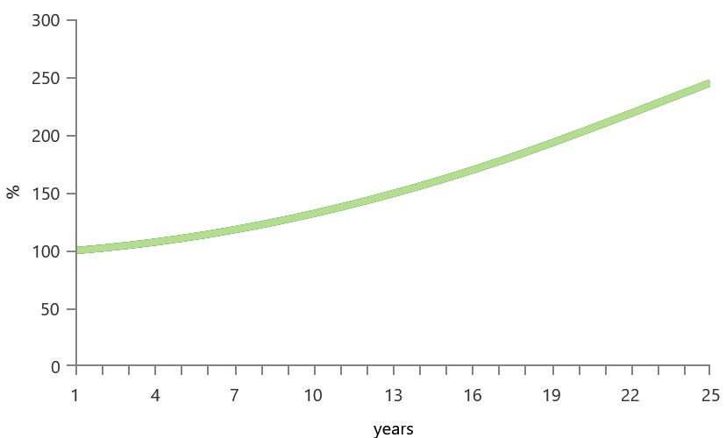
Figure 4.16– Growth of Emissions in tandem with load growth over the Project Lifetime.

Table 4.7 – Emission Levels of Pollutants in the First Year of Diesel Microgrid.
Pollutant | Quantity | Unit
Carbon Dioxide | 7,449,680 | kg/yr
Carbon Monoxide | 38,541 | kg/yr
Unburned Hydrocarbons | 2,046 | kg/yr
Particulate Matter | 330 | kg/yr
Sulfur Dioxide | 18,210 | kg/yr
Nitrogen Oxides | 7,387 | kg/yr

For this reason, the renewable energy microgrid with PV, CSP, hydro, and lithium batteries is adjudged as being the feasible option even compared to diesel generation.

PROBABILITY DISTRIBUTIONS FITTED
The Probability distributions fitted are presented in Table 4.8 showing the parameters of each distribution for each month of the year. Wind speed is measured in m/s, Irradiance is measured in kW/m², stream flow is measured in Litres/s, and the load is measured in MW.

Table 4.8 – Probability Distributions for Characterizing Uncertainty in the Renewable Resources and Load in Arandun
Month | Wind speed Weibull Scale Parameter  (A) | Wind speed Weibull Shape Parameter (B) | Irradiance Lognormal (mu) | Irradiance Lognormal (sigma) | Streamflow Gumbel Distribution Location Parameter (mu) | Streamflow Gumbel Distribution Scale Parameter (sigma) | Load Gaussian  Mean (mu) | Load Gaussian Standard Deviation (sigma)
January | 4.24 | 2.30 | -15.20 | 20.86 | 261.71 | 25.32 | 1.09 | 0.52
February | 4.52 | 2.51 | -15.18 | 20.88 | 265.69 | 21.89 | 1.09 | 0.54
March | 5.04 | 2.80 | -15.14 | 20.91 | 1889.37 | 188.18 | 1.02 | 0.51
April | 5.30 | 3.39 | -13.56 | 20.73 | 5454.53 | 541.46 | 0.92 | 0.51
May | 4.87 | 3.40 | -13.54 | 20.72 | 8565.49 | 789.45 | 0.94 | 0.50
June | 4.88 | 3.26 | -13.57 | 20.69 | 29396.35 | 2972.20 | 0.91 | 0.49
July | 5.23 | 3.61 | -13.64 | 20.63 | 16546.25 | 1292.38 | 0.96 | 0.50
August | 5.37 | 3.65 | -13.69 | 20.58 | 17408.78 | 1543.09 | 0.97 | 0.49
September | 4.19 | 2.64 | -13.66 | 20.62 | 5167.38 | 530.44 | 0.91 | 0.50
October | 3.67 | 2.47 | -13.68 | 20.65 | 2051.71 | 240.34 | 0.88 | 0.52
November | 3.44 | 2.33 | -15.39 | 20.89 | 576.97 | 63.85 | 1.09 | 0.53
December | 3.69 | 2.26 | -15.23 | 20.85 | 276.81 | 21.78 | 1.04 | 0.52

QUASI-DYNAMIC SIMULATION RESULTS OF THE MICROGRID
Two scenarios of the microgrid were considered based on Figures 3.15 and Figure 3.16 respectively. In the first scenario, there was a single power-injection bus, while the second scenario had both bus 1 and bus 6 as power injection points, with the CSP being connected closer to bus 6. In both cases, the instantaneous IVD for each hour for each bus for each hour was computed (to highlight potential problematic buses), and then the average instantaneous IVD for all buses was computed for each hour (the true IVD according to the mathematical formulation). Monthly, for summary purposes, the average monthly IVDs for the buses and for the entire system (for all buses) were also computed. As mentioned in Chapter 3, the threshold for acceptable IVD is 10%, with smaller IVDs indicating more stable voltage profiles.

4.4.1 Results of the IVD Analysis for First Scenario (Single Power Point)
Results of the IVD analysis for the first scenario, with CSP sharing the power injection bus with PV and hydro, show the average IVD for each month as shown in Tables 4.9 and 4.10. The results show that the voltage profile for each month is decent on average. The month of January experiences the least stability of voltage by this metric, while October experiences more stability. However, Bus 6 is responsible for the bulk of the contribution to the average IVD for all buses. This is because, as shown in Table 4.10, the IVD for bus 6 ranges between 5 and 10%, which shows that the voltage is marginally stable on that particular bus. This trend would be different if the configuration of the microgrid were to be different. This is because the distribution of heavier loads on the farthest part of the microgrid from the injection bus leads to worse performance on that bus (which is bus 6) and high levels of voltage instability over the course of the year, especially in January. To correct for this, special cabling arrangements may have to be made, or the addition of a transformer. However, the latter option has the potential to introduce radiality into this distribution network, which, has until now been avoided. The figures from Figure 4.17 to Figure 4.28 show the quasi-dynamic results of the average IVD for each hour of each month, from January to December. In January, the average IVD mostly stayed under 5% but went up to 5.22% occasionally. However, Bus 6 experienced unacceptable voltage levels with up to 23% IVD which exceeds the tolerance of 10%. In this regard, January proved to be the month with the least stability.
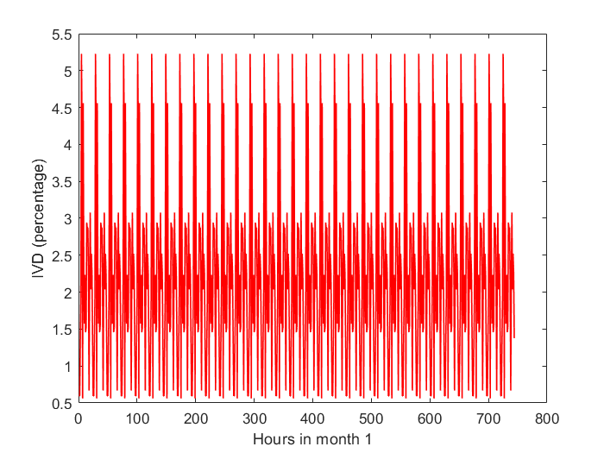
Figure 4.17 – Average IVD in the microgrid in January (Scenario 1).
February results showed more stability than January. However, Bus 6 experienced up to 15.9 % IVD which is also not acceptable for that particular bus. However, the average IVD for the bus mostly remained within 3.56% at all times, which means that the voltage stability on most of the buses is acceptable even at this time except for bus 6 which suffers from voltage stability problems due in part to the losses along the paths from the source to the bus. This is a potential challenge with operating a standalone microgrid as the infinite-busbar assumption no longer holds in this particular simulation, as it would be in real life. The frequency has been preserved at the expense of the voltage in this particular scenario. However, this challenge is not one of generation adequacy but of the distribution network characteristics.
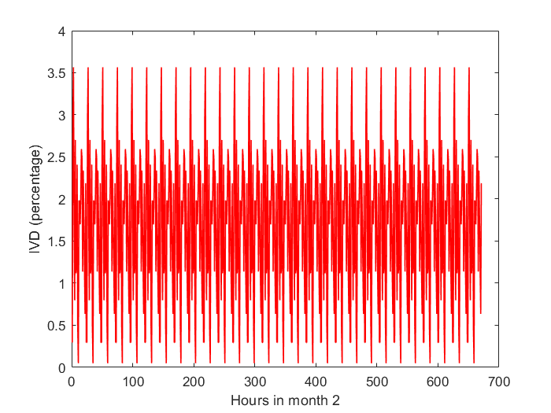
Figure 4.18 – Average IVD in the microgrid in February (Scenario 1).
The month of March showed more improvement in the voltage stability characteristics, as the average IVD for all buses stayed within a range of 3.15% compared to 3.56 in February. The maximum instantaneous IVD recorded during this month was 14.57% also on Bus 6. This is closer to the 10% range which is considered acceptable in this kind of system. Also, this is still the only bus on the system that shows this exceeded-limit characteristic, while all other buses show acceptable voltage ranges consistently.
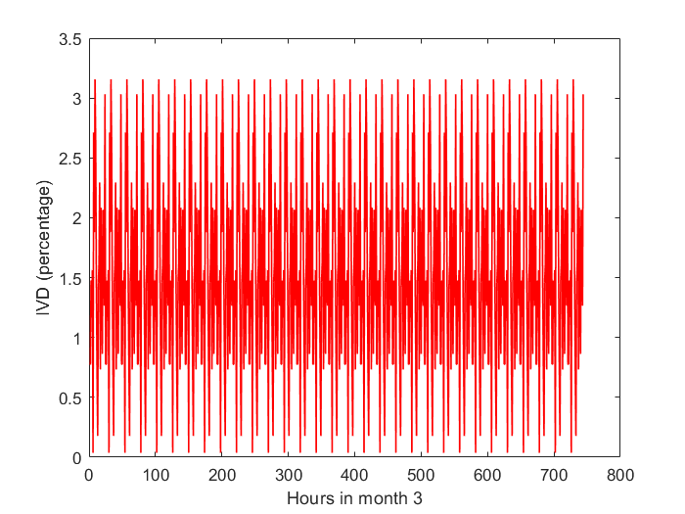
Figure 4.19 – Average IVD in the microgrid in March (Scenario 1).
In the month of April, the voltage stability characteristic did not show any major improvement over the month of March. The overall profile stayed nearly the same, except that the range of deviation increased to 3.48% in April compared to 3.15% in March. The decrease in stability may also be attributed to an increased load variation compared to the previous month. This can be deduced because the battery storage system in April is seen to not be stressed, meaning that generation adequacy is not the issue. As in previous months, Bus 6 was the only month which exceeded the voltage profile stability limits during some hours of operation of the microgrid with 15.6% being the maximum instantaneous IVD recorded during April. For comparison, the least stable bus after Bus 6 was Bus 5, which had only 2.26% IVD, showing that in the first third of the year, Bus 6 distinguished itself as a bus with voltage stability problems unlike the other buses on the microgrid.
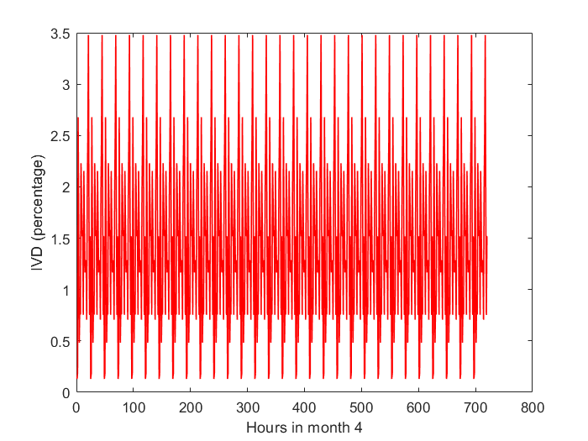
Figure 4.20 – Average IVD in the microgrid in April (Scenario 1).
In May, there was an improvement in the voltage stability of the bus. This is probably attributable to the increase in baseline hydropower generation as well as a relatively benign load profile compared to previous months. The voltage on buses 1 to 5 were all within very stable ranges with IVD of 2.014% being the maximum IVD obtained on Bus 5. However, the sixth bus continued to show occasions of exceeding the tolerable IVD range, with up to 13.89% IVD which is still better than that of all previous months. The average IVD of 3.12% on all buses shows that the microgrid is comparatively stable in May compared to other months. Even so, analysis of the results showed that Bus 6 was stable 87% of the time during this period.
In June, the stability of the microgrid continued to improve such that the average IVD on all buses stayed within the range of 3.01%. By this time, the hydropower generation had peaked at 200kW and the CSP generation had started to drop. However, the PV, in conjunction with the battery and inverter system fully took up the slack in this period. The voltages on buses 1 to 5 were highly stable as usual, with 1.94% being the worst case obtained on Bus 5 during June. The sixth bus continued to show IVD in the range of 13.38%. Analysis of the results showed that Bus 6 was within acceptable IVD limits 88% of the time.
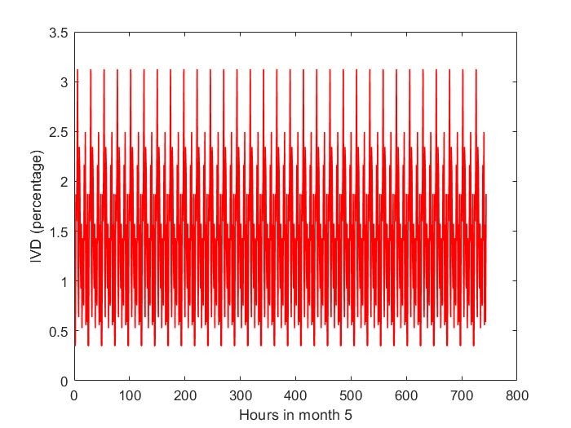
Figure 4.21 – Average IVD in the microgrid in May (Scenario 1).
July showed more improvements in the IVD ranges of the microgrid as the average IVD stayed consistently within the range of 2.79%. In terms of absolute limits, this showed a stability improvement for the microgrid in general. Bus 6 also showed its closest approach to being within tolerable (10%) limits than all months in the first half of the year. The worst IVD obtained on the system outside of bus 6 was 1.8%. However, bus 6 showed the worst instantaneous IVD of 12.37%, continuing its streak of tolerance exceedance into the second half of the year but being closer to consistent stability than previously. The analysis of results showed that the bus 6 IVD was within limits 83% of the time compared to 87% in May. However, it exceeded the limits with only 1 or 2% most of the time during this month.
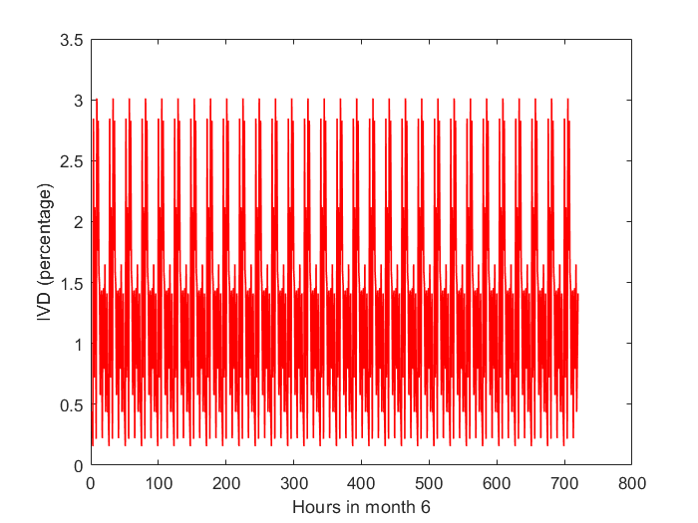
Figure 4.22 – Average IVD in the microgrid in June (Scenario 1).
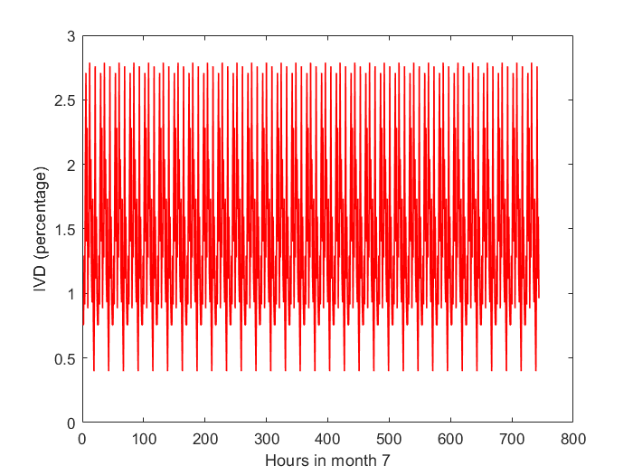
Figure 4.23 – Average IVD in the microgrid in July (Scenario 1).
In August, the microgrid showed a slight decline in the dynamic performance of the microgrid due to load stochasticity in this period. The CSP generation reduced significantly by this time, but the battery and PV systems were able to take the slack. Around this time, the BESS began to be tasked more heavily but was not exceeded. This is because although the precipitation is well increased in this period, the optimally-sized hydro turbine peaks at 200kW and cannot ramp up any further. The IVD of all buses except bus 6 were stable as usual with the worst instantaneous IVD excluding bus 6 being 2.25%. Bus 6 showed IVD as high as 15.8% on occasion, however, its IVD was within limits 88% of the time.
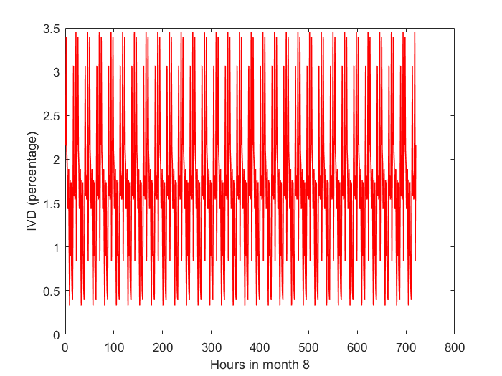
Figure 4.24 – Average IVD in the microgrid in August (Scenario 1).
In the ninth month of the year, the average IVD obtained on all buses stayed within the range of 3.68%. The CSP generation was at its annual lowest at this time, while the hydropower had started to ebb gradually away from its 200kW peak. The battery-inverter system and PV array, during this period, were heavily tasked. However, as deduced by HOMER, they were able to take up the slack comfortably with a lot of bidirectional power flow in the energy storage system that month, and the lowest State-of-Charge obtained in the BESS system under non-emergency operation of about 50%, well above the minimum permissible level for any serviceable lithium-ion batteries. The IVDs obtained on the buses in September were all within the acceptable range except for bus 6 which had a 16.6% IVD as its worst value during the month. The IVD on bus 6 was within limits 87% of the time. However, the other buses performed excellently with an IVD of 2.28 or less.
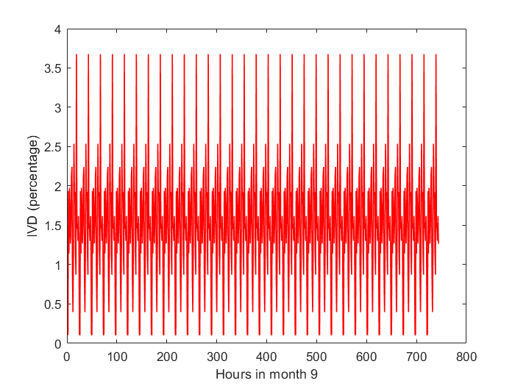
Figure 4.25 – Average IVD in the microgrid in September (Scenario 1).
In the month of October of the simulated year, the microgrid showed its most stable operation of all the twelve months. This could potentially be attributed to the increase in CSP generation with the departure of the rains, which tends to inherently boost system stability due to its low variability. In addition, the load profile in this period is quite benign and less stochastic. This combination of factors makes the microgrid have a stable voltage profile as assessed by VDI in this period. Indeed, the average VDI during the month of October remains consistently under 3%, which would be far less were it not for the contribution of the worst-performing bus 6, which gave a comparatively better performance than usual of 12.67% as its worst IVD. Also, bus 6 was within the acceptable IVD tolerance range 96% of the time during this month, which is the best performance of all twelve months.
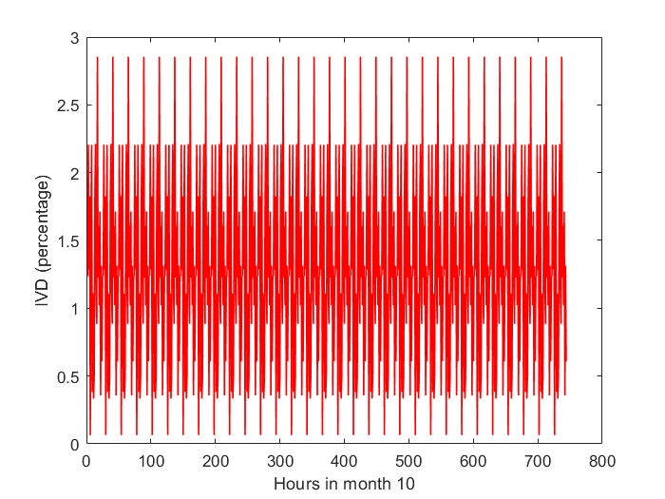
Figure 4.26 – Average IVD in the microgrid in October (Scenario 1).
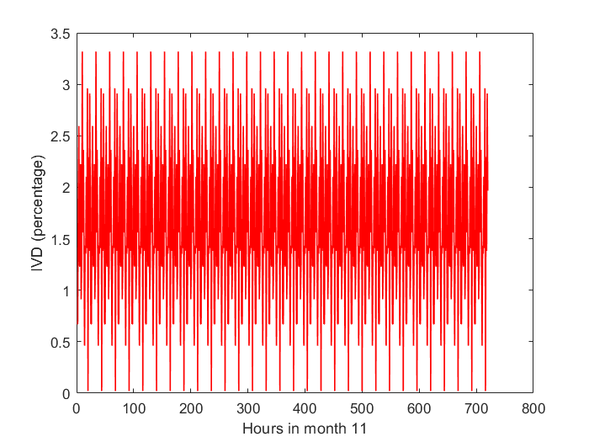
Figure 4.27 – Average IVD in the microgrid in November (Scenario 1).

In November in the simulated year, the average IVD of all buses was within the range of 3.31 or less, which was a decline in performance from October but still a well-performing microgrid except for bus 6 which gave a maximum instantaneous IVD of 14.94% for the month. However, other buses gave stable values of IVD with 2.06% being the worst IVD outside the sixth bus on the microgrid. Furthermore, the bus 6 IVD was within acceptable limits 75% of the time. This decline from October can be attributed to the load stochasticity within this period, as the load curve suggests that the load profile became more erratic towards the end of the year, reflecting changing consumption patterns and economic activity schedules towards the end of the year.
In December, a similar scenario to November was obtained with the IVD on all buses except bus 6 being 2% or less while bus 6 was within stable limits 21% of the time and gave a worst IVD of 13.01%. The months of November and December were this way despite the consistent CSP generation and nearly uninterrupted cycling of the PV and BESS. Notably, the batteries were less-used in December compared to September and October. However, the load stochasticity in this period due to the holidays impacted the microgrid performance. Because Bus 1 was not directly loaded but rather the injection bus for the renewable generators, the IVD of 0 (meaning perfect voltage) was recorded consistently on Bus 1.
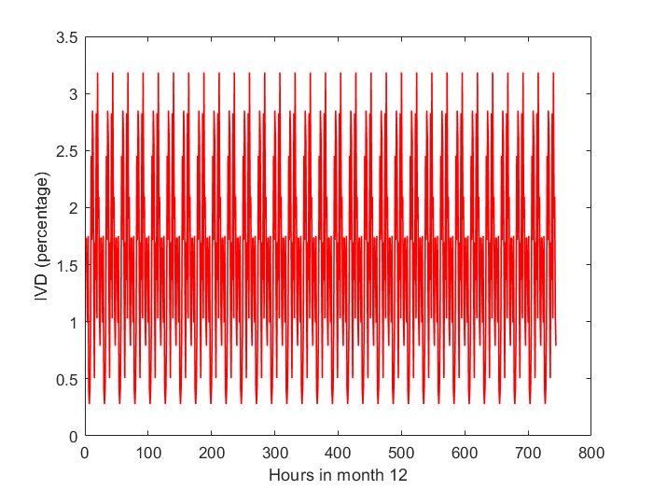
Figure 4.28 – Average IVD in the microgrid in December (Scenario 1).

Table 4.9 – Average IVD (in %) as experienced at the loads for each month for the first three buses for First Scenario.
Month | System Average | Bus 1 | Bus 2 | Bus 3
January | 2.2107 | 0 | 0.5373 | 1.0064
February | 1.6541 | 0 | 0.4127 | 0.7509
March | 1.5459 | 0 | 0.0592 | 0.7301
April | 1.4506 | 0 | 0.3646 | 0.6639
May | 1.3984 | 0 | 0.3534 | 0.6337
June | 1.2868 | 0 | 0.3249 | 0.5833
July | 1.4549 | 0 | 0.3681 | 0.6593
August | 1.6503 | 0 | 0.4131 | 0.7488
September | 1.4928 | 0 | 0.3346 | 0.7038
October | 1.2784 | 0 | 0.3246 | 0.5790
November | 1.6541 | 0 | 0.3685 | 0.7799
December | 1.5422 | 0 | 0.3617 | 0.6443

Table 4.10 – Average IVD (in %) as experienced at the loads for each month for the last three buses for First Scenario.
Month | System Average | Bus 4 | Bus 5 | Bus 6
January | 2.2107 | 0.4753 | 1.4282 | 9.8166
February | 1.6541 | 0.3649 | 1.0779 | 7.3182
March | 1.5459 | 0.3548 | 1.0214 | 7.1100
April | 1.4506 | 0.3224 | 0.9470 | 6.4056
May | 1.3984 | 0.3125 | 0.9150 | 6.1753
June | 1.2868 | 0.2872 | 0.8417 | 5.6838
July | 1.4549 | 0.3254 | 0.9524 | 6.4243
August | 1.6503 | 0.3653 | 1.0765 | 7.2980
September | 1.4928 | 0.2970 | 0.9441 | 6.6776
October | 1.2784 | 0.2870 | 0.8378 | 5.6417
November | 1.6541 | 0.3271 | 1.0441 | 7.4048
December | 1.5422 | 0.9738 | 0.9841 | 6.2892

4.4.2 Line loading in the Microgrid for The First Scenario
The average monthly line loading for the four main distribution lines in the microgrid is shown in Table 4.11 which shows that on average the lines in the microgrid are not excessively loaded. However, the loading varies hour by hour and the lines are therefore not as underutilised as the figures may present. In addition, the use of such lines is necessary to minimise copper losses and maintain thermal stability of conductors in the microgrid, as some of the lines reached loading of over 90% on occasion (where 100% represents full load) but no line maintained overloaded state for long periods and loading was generally low on the lines. It is seen that if 100mm square conductors had been used, the line loading would be quadrupled for each line and lines 2 and 3 would consistently be overloaded. Lines 1 and 4 are lightly loaded under normal operation but in case of outage of one line or damage to a transformer, the loading is similar to that of lines 2 and 3, as the network is a ring instead of radial, for higher reliability. In addition, lines of robust capacity have deliberately been used in this simulation so that the effects of line losses will not overshadow the relevant long-term dynamics in the microgrid.
Table 4.11 – Average loading (in %) of distribution Lines in the microgrid for each month of the year for the First Scenario.
Month | Line 1 | Line 2 | Line 3 | Line 4
January | 3.26 | 24.01 | 25.37 | 3.52
February | 2.45 | 17.86 | 18.92 | 2.65
March | 3.04 | 17.45 | 18.41 | 2.51
April | 2.15 | 15.65 | 16.58 | 2.33
May | 2.08 | 15.09 | 16.00 | 2.25
June | 1.91 | 13.89 | 14.73 | 2.07
July | 2.16 | 15.69 | 16.65 | 2.34
August | 2.45 | 17.83 | 18.89 | 2.65
September | 2.09 | 15.90 | 16.64 | 2.25
October | 1.9 | 13.78 | 14.62 | 2.06
November | 2.31 | 17.64 | 18.45 | 2.49
December | 2.25 | 15.21 | 16.30 | 1.70

Voltages obtained in the Microgrid for the First Scenario.
Table 4.12 shows the average RMS voltages obtained on each of the buses in the microgrid for each month, with the nominal voltage being 11kV 3-phase for the single power injection bus and 415/240V for the load buses. From the voltage profiles as provided, it is seen that the voltages obtained on bus 6 reflect the voltage stability issues experienced on that bus. Bus 1 is shown as three-phase while for other buses, single-phase voltage is considered relevant.
Table 4.12 – Average voltage on buses in the microgrid for each month of the year for the first Scenario.
Month | Bus 1  (kV) |  | Bus 2  (V) | Bus 3  (V) | Bus 4  (V) | Bus 5  (V) | Bus 6  (V)
January |  | 11 | 238.3 | 237.1 | 238.4 | 236.1 | 216.0
February |  | 11 | 238.6 | 237.8 | 238.7 | 237.0 | 222.0
March |  | 11 | 239.4 | 237.8 | 238.7 | 237.1 | 222.5
April |  | 11 | 238.7 | 238.0 | 238.8 | 237.3 | 224.2
May |  | 11 | 238.7 | 238.0 | 238.8 | 237.4 | 224.8
June |  | 11 | 238.8 | 238.2 | 238.9 | 237.5 | 225.9
July |  | 11 | 238.7 | 238.0 | 238.8 | 237.3 | 224.2
August |  | 11 | 238.6 | 237.8 | 238.7 | 237.0 | 222.1
September |  | 11 | 238.7 | 237.9 | 238.8 | 237.3 | 223.6
October |  | 11 | 238.8 | 238.2 | 238.9 | 237.5 | 226.0
November |  | 11 | 238.7 | 237.7 | 238.8 | 237.0 | 221.8
December |  | 11 | 238.7 | 238.0 | 237.2 | 237.2 | 224.5

Transformer Loading on the Microgrid
Table 4.13 shows the average loading percentages for the transformers on the microgrid. As the transformers were sized with the load distribution in mind (each being 1MVA), it is not surprising that the transformers, on average, are used at healthy loading levels. However, due to the stochasticity of the load, the transformers would sometimes have higher loadings than that reflected in the aforementioned table, however, the table information is representative of the long-term loading of the transformer. Also, the loadings of the transformers justify the use of multiple distribution lines even while it may appear that the distribution lines are being underutilized at first, which is due to the improved non-radial structure of the microgrid.
Table 4.13 – Average loading (in %) of Transformers in the microgrid for each month of the year for the first Scenario.
Month | Transformer 1 | Transformer 2 | Transformer 3 | Transformer 4
January | 32.09 | 71.28 | 53.89 | 28.95
February | 24.66 | 54.14 | 40.62 | 22.23
March | 20.72 | 51.92 | 39.61 | 21.65
April | 21.83 | 47.74 | 36.05 | 19.68
May | 21.16 | 46.19 | 34.54 | 19.08
June | 19.45 | 42.48 | 31.77 | 17.54
July | 22.04 | 48.09 | 35.95 | 19.87
August | 24.71 | 54.17 | 40.61 | 22.28
September | 19.79 | 44.71 | 34.47 | 17.87
October | 19.44 | 42.36 | 31.63 | 17.53
November | 21.78 | 49.37 | 38.13 | 19.68
December | 21.65 | 48.71 | 35.11 | 35.79

4.4.5 Results of the IVD Analysis for the Second Scenario (Dual Power Point).
Results of the IVD analysis show the average IVD for each month in Tables 4.14 and 4.15. The second scenario with the CSP power plant connected to a different bus than the other sources shows a major improvement in the voltage stability of the system. The average yearly IVD reduced from 1.5516 in the first scenario to 0.3511 in the second scenario which suggests that, on average, the system stability by IVD metric improved by 342% when the CSP was connected to the weak point in the first scenario. Qualitatively, the major observation was that, while the first scenario was prone only to undesirable voltage sags, the second scenario featured both voltage swell and voltage sags. However, on average, the magnitude of swelling and sagging in the second case was less severe on the voltage stability than the magnitude of sagging alone in the first case.
In the second scenario, it was discovered that all buses on the microgrid exhibited individual IVD components that were always within the tolerance range of 10%, with the maximum individual IVD component recorded throughout the year being 1.93%, which was recorded on bus 4 in December. However, even though all the buses performed excellently enough, bus 5 was the least stable bus on the system based on its performance throughout the year.
Table 4.14 – Average IVD (in %) as experienced at the loads for each month for the first three buses in the Second Scenario.
Month | System Average | Bus 1 | Bus 2 | Bus 3
January | 0.4830 | 0 | 0.5529 | 0.5788
February | 0.3840 | 0 | 0.4295 | 0.4682
March | 0.3208 | 0 | 0.0817 | 0.4936
April | 0.3732 | 0 | 0.3894 | 0.4773
May | 0.2536 | 0 | 0.3279 | 0.1330
June | 0.2484 | 0 | 0.3092 | 0.1727
July | 0.2682 | 0 | 0.3448 | 0.1586
August | 0.2953 | 0 | 0.3819 | 0.1506
September | 0.2586 | 0 | 0.3079 | 0.1677
October | 0.3861 | 0 | 0.3783 | 0.6340
November | 0.4132 | 0 | 0.4096 | 0.6578
December | 0.5296 | 0 | 0.4139 | 0.6547

Table 4.15 – Average IVD (in %) as experienced at the loads for each month for the last three buses in the Second Scenario.
Month | System Average | Bus 4 | Bus 5 | Bus 6
January | 0.4830 | 0.4909 | 0.9798 | 0.2954
February | 0.3840 | 0.3818 | 0.7705 | 0.2539
March | 0.3208 | 0.3773 | 0.7516 | 0.2204
April | 0.3732 | 0.4379 | 0.7311 | 0.2033
May | 0.2536 | 0.2869 | 0.4636 | 0.3101
June | 0.2484 | 0.2715 | 0.4630 | 0.2738
July | 0.2682 | 0.3021 | 0.4974 | 0.3062
August | 0.2953 | 0.3341 | 0.5379 | 0.3673
September | 0.2586 | 0.2703 | 0.4601 | 0.3454
October | 0.3861 | 0.3406 | 0.8051 | 0.1584
November | 0.4132 | 0.3682 | 0.8575 | 0.1860
December | 0.5296 | 1.0263 | 0.9100 | 0.1725

Numerical analysis of simulation results in MATLAB showed that bus 5 had its instantaneous IVD exceeding 1% for 7 months of the year. This means that for the other 5 months, the IVD for this worst-performing bus never crossed 1%, which is still very satisfactory. Furthermore, the relative worse performance of this bus is not unexplainable, as the tap changing for voltage control on bus 6 (which has only one transformer and generator directly connected to it) immediately made it competitive, while bus 5 has two lines and two transformers connected to it, combined with ripple effects from other transformers’ actions.
On the other hand, bus 1 remained the most stable bus in this scenario with IVD of 0% at all times due to being unloaded and droop-controlled, while among the loaded buses, bus 3 emerged at 0.75% or less at all times, while bus 6 came a close second and had the least yearly variation in its IVD than bus 3 while having higher peak values of IVD, which can be attributed to the tap changing of the transformer.
The figures from Figure 4.29 to Figure 4.40 show the quasi-dynamic results of the average IVD for each hour of each month, from January to December for this scenario. In January, the average (considering all buses) hourly (i.e instantaneous in quasi-dynamic simulation) IVD of the system mostly stayed under 0.6% but went up to 0.8137% occasionally. For the first scenario, Bus 6 in January showed the worst IVD recorded with up to 23% being obtained. However, in this scenario, the worst individual bus instantaneous IVD recorded in January was 1.5% which was on bus 5. Compared to the tolerable range of 10% and the desirable range of 5%, this IVD is excellent for the microgrid and the magnitude of the improvement can be seen. Also, January became the second least voltage-stable month in the year after December, which supports the deduction that the voltage stability of a standalone microgrid is impacted by the holiday season and first-month-of-the-year activities in the community. The average monthly system IVD was 0.4830% for 744 hours.
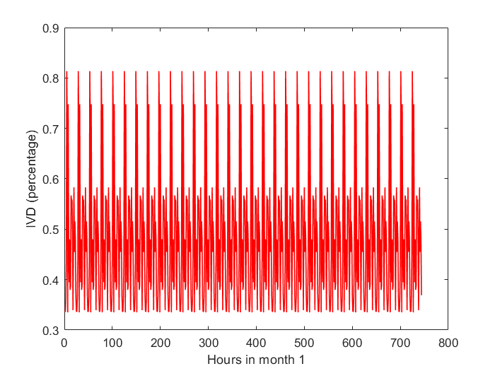
Figure 4.29 – Average IVD in the microgrid in January (Scenario 2).
In February, the performance of the microgrid improved from January, with the maximum instantaneous individual bus IVD of 1.14% being recorded on bus 5. The system average (considering all 6 buses) hourly (instantaneous) IVDs stayed under 0.5% for the most part, however, they occasionally rose to 0.6104% while going as low as 0.27%. The average monthly system IVD for 672 hours was 0.3840%.
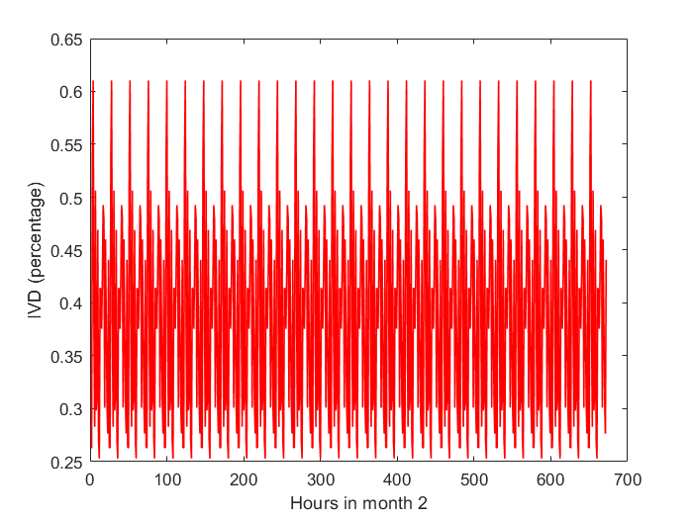
Figure 4.30 – Average IVD in the microgrid in February (Scenario 2).
In March, the performance of the microgrid improved from February, with the maximum instantaneous individual bus IVD of 1.05% being recorded on bus 5. The system average (considering all 6 buses) hourly (instantaneous) IVDs stayed under 0.4% for the most part, however, they occasionally rose up to 0.4616% while going as low as 0.26%. The average monthly system IVD for March’s 744 hours was 0.3028%.
In April, the voltage stability of the microgrid decreased slightly from March, with the maximum instantaneous individual bus IVD of 1.15% being recorded on bus 5. The system average (considering all 6 buses) hourly (instantaneous) IVDs stayed under 0.55% for the most part, however, they occasionally rose up to 0.6076% while also going as low as 0.27%. The average monthly system IVD for the 720 considered hours of April was 0.3732%.

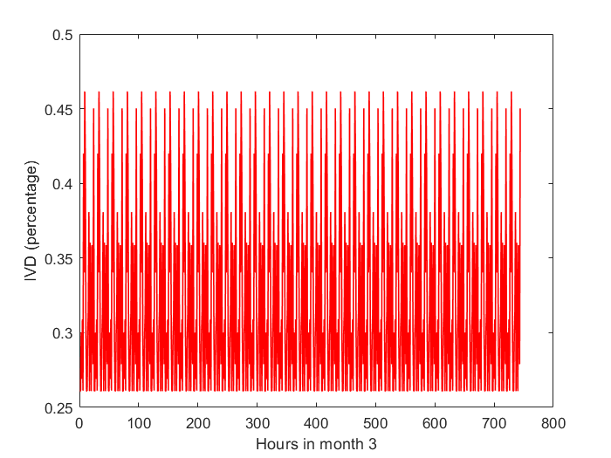
Figure 4.31 – Average IVD in the microgrid in March (Scenario 2).
In May, the voltage stability of the microgrid improved significantly from April except for bus 6 which showed worse performance than April, due to the increasing uncertainty of the connected CSP as the rainy season crept in, with the maximum instantaneous individual bus IVD of 0.8279 % being recorded on bus 5. Still, bus 6 was close behind with up to 0.8166% being recorded on it. The system average (considering all 6 buses) hourly (instantaneous) IVDs stayed under 0.41% for the most part, however, they occasionally rose up to 0.4904% while also going as low as 0.11%. The average monthly system IVD for the 744 considered hours of May was 0.2536%.
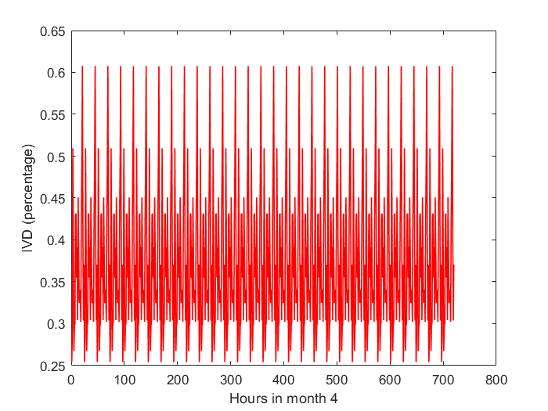
Figure 4.32 – Average IVD in the microgrid in April (Scenario 2).
In June, the voltage stability of the microgrid improved slightly from May except for bus 3 which showed worse performance than May due to increased loading and load variations, with the maximum instantaneous individual bus IVD of 0.8268% being recorded on bus 5. Still, bus 6 was close behind with up to 0.7554% being recorded on it. The system average (considering all 6 buses) hourly (instantaneous) IVDs stayed under 0.3% for the most part, however, they occasionally rose up to 0.4812% while also going as low as 0.12%. The average monthly system IVD for the 720 considered hours of June was 0.2484%. June emerged as the month with the best voltage stability in this regard, which can be attributed to the peaking of the hydropower generation and the effect of the battery bank as well as the loading conditions for the month of June.
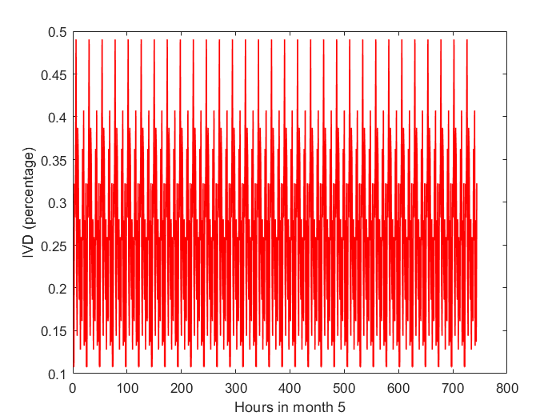
Figure 4.33 – Average IVD in the microgrid in May (Scenario 2).

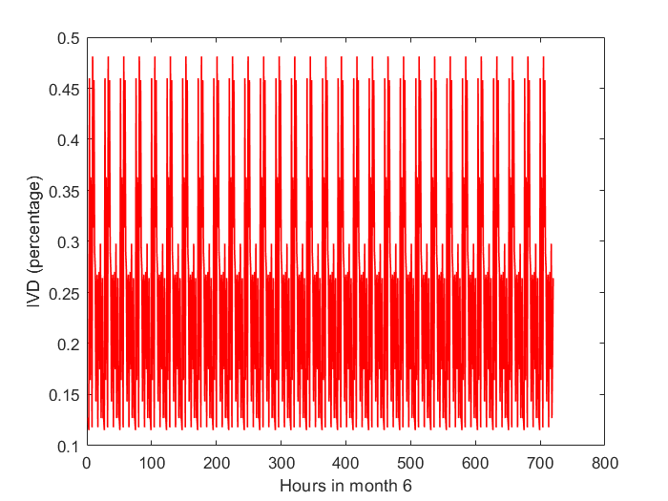
Figure 4.34 – Average IVD in the microgrid in June (Scenario 2).
July showed a slight decline in the voltage stability of the microgrid from June, with the maximum instantaneous individual bus IVD of 0.7795% being recorded on bus 5. The system average (considering all 6 buses) hourly (instantaneous) IVDs stayed under 0.4% for the most part, however, they occasionally rose up to 0.4520% while also going as low as 0.13%. The average monthly system IVD for the 744 considered hours of July was 0.2682%.
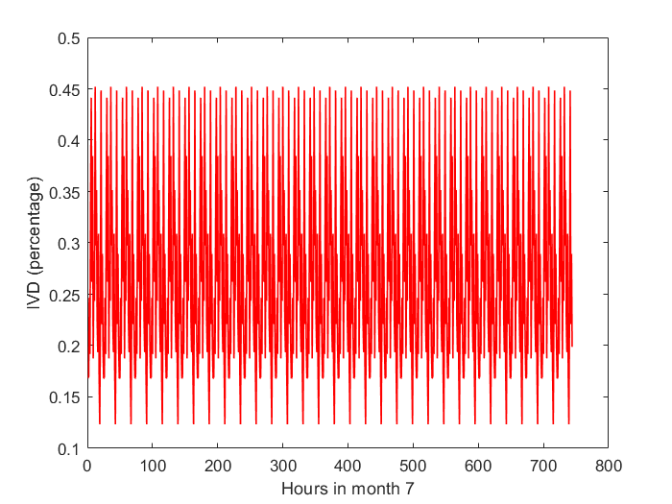
Figure 4.35 – Average IVD in the microgrid in July (Scenario 2).
August continued the trend of July, showing a slight decline in the voltage stability of the microgrid that started in June, with the maximum instantaneous individual bus IVD of 0.9108% being recorded on bus 5. The system average (considering all 6 buses) hourly (instantaneous) IVDs stayed under 0.5% for the most part, however, they occasionally rose up to 0.5369% while also going as low as 0.13%. The average monthly system IVD for the 744 considered hours of August was 0.2953%. At this time of the year, the rainy season is in full flow, yet, due to the low hydro capacity of 200kVA, the hydro peaking cannot fully compensate for the shortfall from CSP and PV, which forces the reliance on the batteries and inverter system for significant periods, which contributes to lowering stability of the system.
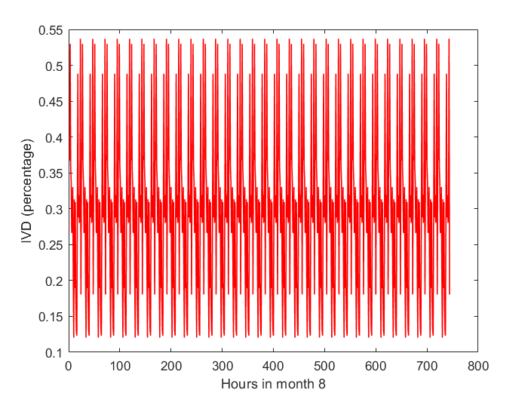
Figure 4.36 – Average IVD in the microgrid in August (Scenario 2).
By September, the incipient abatement of the rainy season enables more PV generation. However, the CSP generation had yet to rise, which lead to continued reliance on battery energy storage, PV, and hydro, to take the slack of the load. Nevertheless, there was a slight improvement from August, with the maximum instantaneous individual bus IVD of 0.9512% being recorded on bus 6, due to the relatively less abundance of CSP generation. The system average (considering all 6 buses) hourly (instantaneous) IVDs stayed under 0.4% for the most part, however, they occasionally rose up to 0.5238% while also going as low as 0.11%. The average monthly system IVD for the 720 considered hours of September was 0.2586%.
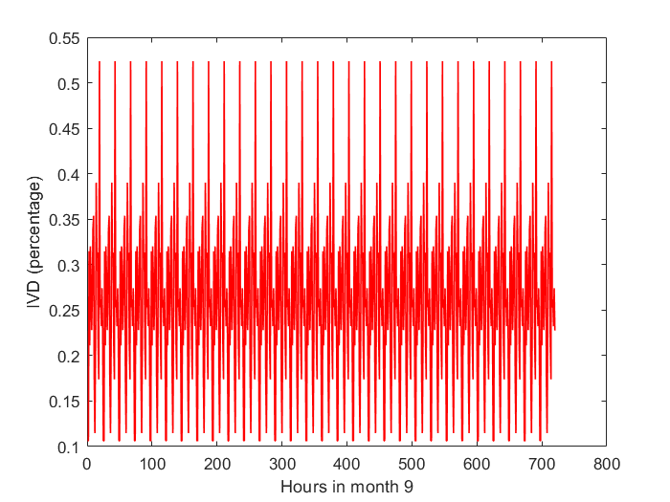
Figure 4.37 – Average IVD in the microgrid in September (Scenario 2).
In October, the loaded buses all showed marginally increasing IVD compared to September except bus 6. The different behaviour of bus 6 can be attributed to the rise in CSP generation at this time of the year. The maximum instantaneous individual bus IVD of 1.1123% was recorded on bus 5. The system average (considering all 6 buses) hourly (instantaneous) IVDs stayed under 0.55% for the most part, however, they occasionally rose up to 0.5573% while also going as low as 0.32%. The average monthly system IVD for the 744 considered hours of October was 0.3861%.
It is noteworthy that in the first scenario, October produced the best average IVD chiefly for the reason that bus 6 (which was the weak spot dragging down the rest of the system) was relatively stronger in that month, and in this scenario as well, bus 6 is the only bus that has an improved IVD relative to the September operating state, which shows that not only the increase in generation but also the loading conditions in October play a role in the improved performance in that period.
In November, the system continued to show a slight increase in IVD on all buses, with the maximum instantaneous individual bus IVD of 1.1351% being recorded on bus 5. The system average (considering all 6 buses) hourly (instantaneous) IVDs stayed under 0.47% for the most part, however, they occasionally rose up to 0.5872% while also going as low as 0.33%. The average monthly system IVD for the 720 considered hours of November was 0.4132%.
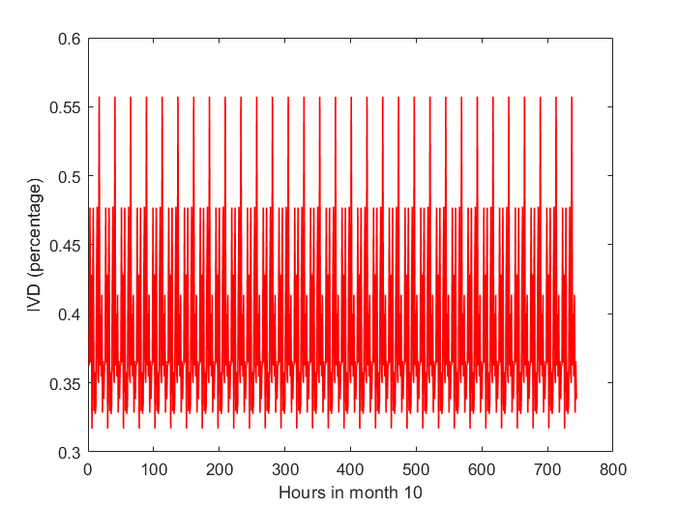
Figure 4.38 – Average IVD in the microgrid in October (Scenario 2).
In December, the microgrid voltage stability had its worst average performance compared to other months. However, this was also excellent performance as it stayed firmly in the desirable 5% IVD range for all buses during this time. The maximum instantaneous individual bus IVD of 1.9255%, which was the worst value seen on any bus at any time of the year in this second scenario, was recorded on bus 4. This does not follow the usual trend in which bus 5 is the least stable bus on the microgrid, and this is explained by increased load stochasticity in December such that the load conditions on bus 4 caused this uncharacteristic behaviour. Such unexpected results are a reflection of the fact that uncertainty has been factored into the simulation. This is also evident when it is seen that bus 5 also had a relatively large maximum instantaneous IVD of 1.2565% in December. The system average (considering all 6 buses) hourly (instantaneous) IVDs stayed under 0.7% for the most part, however, they occasionally rose up to 0.8106% while also going as low as 0.36%. The average monthly system IVD for the 720 considered hours of November was 0.5296%. Thus, December emerged as the month with the least voltage stability on the microgrid, even after shifting the CSP plant to bus 6, and this is explained by increased load stochasticity in this period.
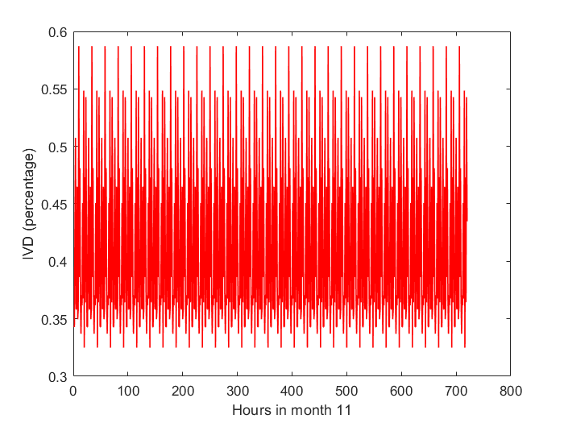
Figure 4.39 – Average IVD in the microgrid in November (Scenario 2).
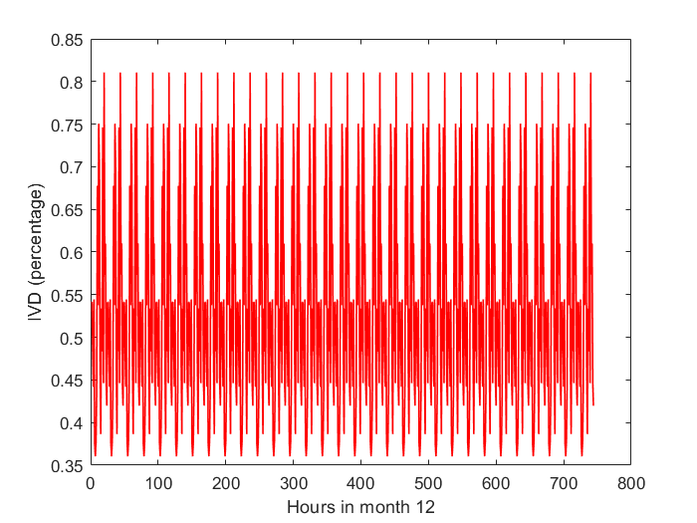
Figure 4.40 – Average IVD in the microgrid in December (Scenario 2).

Graphical Comparison of First and Second Scenarios
Figure 4.44 shows the average monthly IVD on bus 6 in the first scenario and the second scenario. Bus 6 represents the bus with the most susceptibility to voltage stability issues in the microgrid in the first scenario, hence the focus on it. Figure 4.46 reveals that the connection of one of the generators to bus 6 with a tap-changing transformer vastly lessens the IVD of the bus, showing a major improvement in the voltage stability of the bus by several orders of magnitude, which represents an improvement to the system in its entirety. In all months of the year, the second scenario is shown to have bus 6 being at least 10 times as stable as in the first scenario, with less variation in stability between months.
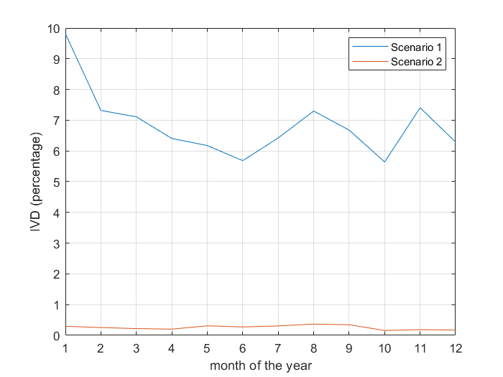
Figure 4.41 – Average Bus 6 IVD in the microgrid for both scenarios.

4.4.6 Voltages obtained in the Microgrid for the Second Scenario.
Table 4.16 shows the average RMS voltages obtained on each of the buses in the microgrid for each month, with the nominal voltage being 11kV 3-phase for the single power injection bus and 415/240V for the load buses. From the voltage profiles as provided, it is seen that the voltages on all buses are within a decent range of the nominal load voltage, notably bus 6 which now has all voltages less than 2V away from 240, which is well within the +/- 5% range of voltage sag/swell accepted in Nigeria. Bus 1 is shown as three-phase while for other buses, single-phase voltage is considered relevant.
Table 4.16 – Average voltage on buses in the microgrid for each month of the year for the first Scenario.
Month | Bus 1  (kV) |  | Bus 2  (V) | Bus 3  (V) | Bus 4  (V) | Bus 5  (V) | Bus 6  (V)
January |  | 11 | 238.3 | 238.2 | 238.4 | 237.2 | 239.1
February |  | 11 | 238.6 | 238.5 | 238.7 | 237.8 | 239.2
March |  | 11 | 239.4 | 238.4 | 238.7 | 237.8 | 239.3
April |  | 11 | 238.7 | 238.5 | 238.6 | 237.9 | 239.4
May |  | 11 | 238.8 | 239.2 | 238.9 | 238.5 | 238.9
June |  | 11 | 238.9 | 239.2 | 239.0 | 238.5 | 239.0
July |  | 11 | 238.7 | 239.2 | 238.9 | 238.4 | 238.9
August |  | 11 | 238.7 | 239.2 | 238.8 | 238.3 | 238.7
September |  | 11 | 238.9 | 239.2 | 238.9 | 238.5 | 238.8
October |  | 11 | 238.7 | 238.1 | 238.8 | 238.7 | 239.7
November |  | 11 | 238.6 | 238.0 | 238.7 | 237.5 | 239.4
December |  | 11 | 238.6 | 238.0 | 237.1 | 237.4 | 239.6

Transformer Loading on the Microgrid
Table 4.17 shows the average loading percentages for the transformers on the microgrid. As the transformers were sized with the load distribution in mind (each being 1MVA except the CSP transformer for which 3MVA was used in simulation, while 2MVA is finally recommended), it is not surprising that the transformers, on average, are used at healthy loading levels. However, due to the stochasticity of the load, the transformers would sometimes have higher loadings than that reflected in the aforementioned table, nevertheless, the table information is representative of the long-term loading of the transformer. Also, the loadings of the transformers justify the use of multiple distribution lines even while it may appear that the distribution lines are being underutilized at first, which is due to the improved non-radial structure of the microgrid. It is seen that the loadings of the transformers improve relative to the first scenario.
Table 4.17 – Average loading (in %) of Transformers in the microgrid for each month of the year for the first Scenario.
Month | Transformer 1 | Transformer 2 | Transformer 3 | Transformer 4 | CSP Transformer
January | 29.24 | 42.14 | 25.79 | 26.09 | 29.99
February | 22.69 | 34.20 | 21.41 | 20.26 | 24.16
March | 17.96 | 31.86 | 21.47 | 19.76 | 24.58
April | 20.18 | 30.66 | 21.31 | 19.97 | 23.20
May | 19.26 | 29.98 | 17.09 | 17.18 | 14.14
June | 17.74 | 27.69 | 16.32 | 15.82 | 14.27
July | 20.05 | 30.21 | 16.01 | 17.88 | 14.60
August | 22.46 | 35.09 | 19.86 | 20.03 | 16.30
September | 17.76 | 27.44 | 15.00 | 15.85 | 15.27
October | 18.30 | 31.34 | 27.92 | 16.39 | 28.26
November | 20.05 | 32.64 | 28.00 | 17.94 | 29.46
December | 20.22 | 34.89 | 28.38 | 36.20 | 29.47

CHAPTER FIVE

SUMMARY, CONCLUSION, AND RECOMMENDATION

SUMMARY
On one hand, the importance of renewable energy in the global context cannot be overemphasized. There are enormous environmental, economical, and aesthetic reasons why renewable energy-based electricity as a flagship for clean and affordable energy needs to be implemented. On the other hand, the electricity demand-supply mismatch in Arandun is an urgent problem that needs to be tackled. The present study shows the potential of a renewable energy microgrid in the community given existing resources at the location. The four renewable energy sources of wind, hydropower, solar-generated electricity, and solar thermal (Concentrated Solar Power) were examined in the study.
Data was obtained both by direct measurement, estimation, and from the trusted Prediction of Worldwide Energy Resources (POWER) dataset and pre-processed, cleaned, and fed into the HOMER Pro software for optimal selection of microgrid configuration. This exercise also involved economic information such as discount rate, inflation rate, as well as costs of equipment and time value of money. The degradation of the equipment was also considered. The CSP did not have a direct model in HOMER, however, a suitable approximation was used which was the CPV since they are both DNI-dependent generation technology.
Renewable energy was compared with the diesel microgrid for the selected location and the renewable option was found to have a lower net present cost of $55.7 million compared to $408 million for the diesel microgrid, for 25 years. Microgrid fulfilling zero unmet load in the simulations while being cost-effective was a mixture of CSP, PV, and Micro-hydro in order of decreasing contribution. The hydropower resource selected was the Osin River which is notable enough to have appeared in the literature previously. In addition to this, the emissions of the diesel microgrid were found to be astronomical compared to the clean alternative of the PV-CSP-Hydro-BESS renewable microgrid that was selected as the optimal solution. Wind energy was found to be economically infeasible due to low wind resource in the Arandun location. The complementarity of the various sources on the microgrid was also confirmed.
MATLAB was used to develop 48 separate probability distribution functions for the load uncertainty (using Gaussian Distribution), solar irradiance uncertainty (using Lognormal distribution), hydropower uncertainty (using the Gumbel/Extreme Value Distribution), and the wind uncertainty (using the Weibull distribution) at the location, which could be useful for future studies. Using these models, the annual dynamic performance (in terms of voltage profile stability) of the buses in the proposed microgrid was modelled in DIgSILENT PowerFactory, simulated, and summarized. The index used was the Index of Voltage Deviation (IVD) to measure the difference between the stability using conventional generation (i.e grid supplied system) and the standalone microgrid voltage performance under uncertainty in the renewable resources, and also the load. The microgrid was found to be most prone to voltage instability in December and January and most stable between June and October in single-bus power injection and multi-bus power injection scenarios.
This work has involved carrying out and presenting a review of recent literature on the development of distributed generation and microgrid technology. Before this work, the prospects of a standalone renewable community microgrid in Arandun, Kwara State, Nigeria, had not been researched. However, this work presents the results, findings, and conclusions of the feasibility study, techno-economic analysis, social acceptability, and expected dynamic performance of a standalone renewable-based microgrid in the community under uncertainty in the energy resources, based on locally-obtained data and real physical surveys. This work will be useful for town planners and potential investors.

CONCLUSION
Wind energy was not found to be feasible on a large scale in Arandun in comparison to other renewable and non-renewable alternatives. Apart from the cost of the installations of wind that would be required, the number of wind turbines required to supply the demand would be infeasible to install in the amount of land available.
It emerged that Concentrated Solar Power is a promising option for generating solar power in the tropics as exemplified by the Arandun community. The proximity to the equator of Nigeria means that in areas with a long-enough dry season, the thermal storage ability of CSP may make it more viable than even solar PV in some instances.
The microgrid was predicted, after simulations to be most prone to voltage instability in January due to the combination of high load demand and load stochasticity around that period. This is potentially due to the high fluxion of traffic during the festive seasons. However, it is expected that a microgrid providing reliable and affordable electricity will introduce stability into the population flux and the IVD may be improved by this.

5.3 RECOMMENDATIONS
Further studies on the potentials of a renewable microgrid in Arandun are required, especially considering the potentials of other energy sources (such as biomass) not considered in the study. Load profile uncertainty models for Nigerian power systems should be investigated further. The use of other methods of fitting probability distributions apart from maximum likelihood methods is a potential area of research. The use of fuzzy logic for Social Acceptability analysis has been adopted in this study. The adaptation of such a paradigm using the Fuzzy-Neural model would be a good investigation. This would require the synchronisation of data from various microgrid projects. The results of increasing the resolution of the sensitivity variables in HOMER (which would require as much as 1 Terabyte of RAM) should be investigated. This would require a high-end workstation. The prediction of simulation time for dynamic and quasi-dynamic models should be evaluated and improved as such models take a lot of time to simulate.

5.4 CONTRIBUTION TO KNOWLEDGE
The following major contributions have been made in this work:
- The preliminary feasibility and techno-economic analyses as well as the expected annual performance of a standalone renewable-based microgrid under renewable resource uncertainty in Arandun were presented.
- The long-term economic and ecological benefits of developing solar photovoltaic, concentrated solar power, in Nigeria’s middle belt, and micro-hydro electricity on the Osin River, were presented.
- The long-term quasi-dynamic stability modelling, simulation, and results of a proposed renewable microgrid network for the Arandun community were presented.

REFERENCES
Ab-Belkhair, A., Rahebi, J., & Abdulhamed-Mohamed-Nureddin, A. (2020). A study of deep neural network controller-based power quality improvement of hybrid PV/Wind systems by using smart inverter. International Journal of Photoenergy, 2020. https://doi.org/10.1155/2020/8891469
Abu-Mouti, F. S., & El-Hawary, M. E. (2012). Optimal dynamic economic dispatch including renewable energy source using artificial bee colony algorithm. SysCon 2012 - 2012 IEEE International Systems Conference, Proceedings, 304–309. https://doi.org/10.1109/SYSCON.2012.6189540
Adebanji, B., Adepoju, G. A., Olulope, P., Fasina, T., & Adetan, O. (2020). Feasibility and optimal design of a hybrid power system for rural electrification for a small village. Undefined, 10(6), 6214–6224. https://doi.org/10.11591/IJECE.V10I6.PP6214-6224
Adebimpe, O. A., Oladokun, V. O., & Edem, I. E. (2021). Towards the Application of Pumped-Hydro Storage in Nigeria. Proceedings of the 11th Annual International Conference on Industrial Engineering and Operations Management, July 2016, 2528–2537.
Adediji, A., Adewumi, J. A., & Ologunorisa, T. E. (2011). Effects of irrigation on the physico-chemical quality of water in irrigated areas: The Upper Osin Catchment, Kwara State, Nigeria. Progress in Physical Geography, 35(6), 707–719. https://doi.org/10.1177/0309133311407655
Adedoyin, F. F., Bekun, F. V., & Alola, A. A. (2020). Growth impact of transition from non-renewable to renewable energy in the EU: The role of research and development expenditure. Renewable Energy, 159, 1139–1145. https://doi.org/10.1016/J.RENENE.2020.06.015
Adelaja, A. O. (2020). Barriers to national renewable energy policy adoption: Insights from a case study of Nigeria. Energy Strategy Reviews, 30, 100519. https://doi.org/10.1016/j.esr.2020.100519
Adetokun, B. B., & Muriithi, C. M. (2021). Impact of integrating large-scale DFIG-based wind energy conversion system on the voltage stability of weak national grids: A case study of the Nigerian power grid. Energy Reports, 7(January), 654–666. https://doi.org/10.1016/j.egyr.2021.01.025
Adetokun, B. B., Muriithi, C. M., & Ojo, J. O. (2020). Voltage Stability Analysis and Improvement of Power System with Increased SCIG-based Wind System Integration. 2020 IEEE PES/IAS PowerAfrica, PowerAfrica 2020. https://doi.org/10.1109/PowerAfrica49420.2020.9219803
Adewuyi, A. (2020). Challenges and prospects of renewable energy in Nigeria: A case of bioethanol and biodiesel production. Energy Reports, 6, 77–88. https://doi.org/10.1016/J.EGYR.2019.12.002
Aganah, K., Chukwuma, J., & Ndoye, M. (2019). A Review of Off-Grid Plug-and-Play Solar Power Systems: Toward a New" I Better Pass My Neighbour" Generator. 2019 IEEE PES/IAS PowerAfrica, 182–186.
Ahanbakhsh, H. J., & Iahkalroudi, M. L. S. (2016). A Comparative Study on Energy Management Approaches in Theories and Patterns of Contemporary Urbanism 3 . Selected Urban Development Theories in Energy Management. 1049–1062.
Ahmad, T., Chen, H., Guo, Y., & Wang, J. (2018). A comprehensive overview on the data driven and large scale based approaches for forecasting of building energy demand: A review. Energy and Buildings, 165, 301–320. https://doi.org/10.1016/J.ENBUILD.2018.01.017
Ahmad, T., Manzoor, S., & Zhang, D. (2021). Forecasting high penetration of solar and wind power in the smart grid environment using robust ensemble learning approach for large-dimensional data. Sustainable Cities and Society, 75, 103269. https://doi.org/10.1016/J.SCS.2021.103269
Aien, M., Hajebrahimi, A., & Fellow, M. F. (2016). A comprehensive review on uncertainty modeling techniques in power system studies. Renewable and Sustainable Energy Reviews, 57, 1077–1089. https://doi.org/10.1016/j.rser.2015.12.070
Akbari, M., Neamatollahi, E., & Neamatollahi, P. (2019). Evaluating land suitability for spatial planning in arid regions of eastern Iran using fuzzy logic and multi-criteria analysis. Ecological Indicators, 98, 587–598. https://doi.org/10.1016/j.ecolind.2018.11.035
Akhator, P. E., Obanor, A. I., & Sadjere, E. G. (2019). Electricity situation and potential development in Nigeria using off-grid green energy solutions. Journal of Applied Sciences and Environmental Management, 23(3), 527–537. https://doi.org/10.4314/jasem.v23i3.24
Akinyele, D., Olabode, E., & Amole, A. (2020). Review of Fuel Cell Technologies and Applications for Sustainable Microgrid Systems. Inventions, 5(3), 1–35. https://doi.org/10.3390/inventions5030042
Akorede, M., Ibrahim, O., Amuda, S., Otuoze, A., & Olufeagba, B. (2016). Current Status and Outlook of Renewable Energy Development in Nigeria. Nigerian Journal of Technology, 36(1), 196–212. https://doi.org/10.4314/njt.v36i1.25
Akuru, U. B., Okoro, O. I., & Chikuni, E. (2013). Impact of renewable energy deployment on climate change in Nigeria. IEEE AFRICON Conference, 26(3), 125–134. https://doi.org/10.1109/AFRCON.2013.6757649
Al-Mhairat, B., & Al-Quraan, A. (2022). Assessment of Wind Energy Resources in Jordan Using Different Optimization Techniques. Processes, 10(1), 105. https://doi.org/10.3390/PR10010105
Aliyu, A. K., Modu, B., & Tan, C. W. (2018). A review of renewable energy development in Africa: A focus in South Africa, Egypt and Nigeria. Renewable and Sustainable Energy Reviews, 81(February 2016), 2502–2518. https://doi.org/10.1016/j.rser.2017.06.055
Aliyu, A. S., Dada, J. O., & Adam, I. K. (2015). Current status and future prospects of renewable energy in Nigeria. Renewable and Sustainable Energy Reviews, 48, 336–346. https://doi.org/10.1016/j.rser.2015.03.098
Almaiah, M. A. (2018). Acceptance and usage of a mobile information system services in University of Jordan. Education and Information Technologies, 23(5), 1873–1895. https://doi.org/10.1007/S10639-018-9694-6
Almaiah, M. A., Alamri, M. M., & Al-Rahmi, W. (2019). Applying the UTAUT Model to Explain the Students’ Acceptance of Mobile Learning System in Higher Education. IEEE Access, 7, 174673–174686. https://doi.org/10.1109/ACCESS.2019.2957206
Almeshqab, F., & Ustun, T. S. (2019). Lessons learned from rural electrification initiatives in developing countries: Insights for technical, social, financial and public policy aspects. Renewable and Sustainable Energy Reviews, 102(November 2018), 35–53. https://doi.org/10.1016/j.rser.2018.11.035
Amasyali, K., & El-Gohary, N. M. (2018). A review of data-driven building energy consumption prediction studies. Renewable and Sustainable Energy Reviews, 81, 1192–1205. https://doi.org/10.1016/J.RSER.2017.04.095
Anderson, A. D., Renner, N. J., Wang, Y., Agrawal, S., Sirimanna, S., Lee, D., Banerjee, A., Haran, K., Starr, M. J., & Felder, J. L. (2018). System Weight Comparison of Electric Machine Topologies for Electric Aircraft Propulsion. 2018 AIAA/IEEE Electric Aircraft Technologies Symposium (EATS), 1–16.
Ardriani, T., Dahono, P. A., Rizqiawan, A., Garnia, E., Sastya, P. D., Arofat, A. H., & Ridwan, M. (2021). A dc microgrid system for powering remote areas. Energies, 14(2). https://doi.org/10.3390/en14020493
Ardriani, T., Sastya, P. D., Husnan Arofat, A., & Dahono, P. A. (2018). A novel power conditioner system for isolated DC microgrid system. 4th IEEE Conference on Power Engineering and Renewable Energy, ICPERE 2018 - Proceedings, 1–5. https://doi.org/10.1109/ICPERE.2018.8739686
Ates, Y., Boynuegri, A. R., Uzunoglu, M., Nadar, A., Yumurtacı, R., Erdinc, O., Paterakis, N. G., & Catalão, J. P. S. (2016). Adaptive protection scheme for a distribution system considering grid-connected and islanded modes of operation. Energies, 9(5). https://doi.org/10.3390/en9050378
Ayalew, A. T. (2021). Assessment of Power Compeers Prospective of Gobecho Micro Hydropower Plant on Ganga River, Genale Dawa River Basin, Ethiopia. American Journal of Electrical Power and Energy Systems, 10(2), 25. https://doi.org/10.11648/j.epes.20211002.12
Aziz, T., & Ketjoy, N. (2017). PV Penetration Limits in Low Voltage Networks and Voltage Variations. IEEE Access, 5, 16784–16792. https://doi.org/10.1109/ACCESS.2017.2747086
Badal, F. R., Das, P., Sarker, S. K., & Das, S. K. (2019). A survey on control issues in renewable energy integration and microgrid. Protection and Control of Modern Power Systems, 4(1). https://doi.org/10.1186/s41601-019-0122-8
Baghbanzadeh, D., Salehi, J., Gazijahani, F. S., Shafie-khah, M., & Catalão, J. P. S. (2021). Resilience improvement of multi-microgrid distribution networks using distributed generation. Sustainable Energy, Grids and Networks, 27, 100503. https://doi.org/10.1016/j.segan.2021.100503
Bajaj, M., & Singh, A. K. (2020). Grid integrated renewable DG systems: A review of power quality challenges and state-of-the-art mitigation techniques. International Journal of Energy Research, 44(1), 26–69. https://doi.org/10.1002/er.4847
Bansal, R. (2017). Handbook of Distributed Generation. In Handbook of Distributed Generation. https://doi.org/10.1007/978-3-319-51343-0
Basit, M. A., Dilshad, S., Badar, R., & Sami ur Rehman, S. M. (2020). Limitations, challenges, and solution approaches in grid-connected renewable energy systems. International Journal of Energy Research, 44(6), 4132–4162. https://doi.org/10.1002/er.5033
Batel, S. (2020). Research on the social acceptance of renewable energy technologies: Past, present and future. Energy Research & Social Science, 68, 101544. https://doi.org/10.1016/J.ERSS.2020.101544
Bhatt, D. V., Bhatt, Y. H., & Pakka, V. H. (2018). Loss Sensitivity and Voltage Deviation Index Based Intelligent Technique for Optimal Placement and Operation of Distributed Generators. 2018 IEEE 7th International Conference on Power and Energy, PECon 2018, 310–315. https://doi.org/10.1109/PECON.2018.8684177
Blanco, I. (2019). Decision-making Under Uncertainty for the Operation of Integrated Energy Systems Ignacio Blanco. Technical University of Denmark.
Bochenek, B., Jurasz, J., Jaczewski, A., Stachura, G., Sekuła, P., Strzyżewski, T., Wdowikowski, M., & Figurski, M. (2021). Day-Ahead Wind Power Forecasting in Poland Based on Numerical Weather Prediction. Energies 2021, Vol. 14, Page 2164, 14(8), 2164. https://doi.org/10.3390/EN14082164
Cai, M., Pipattanasomporn, M., & Rahman, S. (2019). Day-ahead building-level load forecasts using deep learning vs. traditional time-series techniques. Applied Energy, 236, 1078–1088. https://doi.org/10.1016/J.APENERGY.2018.12.042
Carbajo, R., & Cabeza, L. F. (2019). Sustainability and social justice dimension indicators for applied renewable energy research: A responsible approach proposal. Applied Energy, 252, 113429. https://doi.org/10.1016/J.APENERGY.2019.113429
Chettibi, N., Massi Pavan, A., Mellit, A., Forsyth, A. J., & Todd, R. (2021). Real-time prediction of grid voltage and frequency using artificial neural networks: An experimental validation. Sustainable Energy, Grids and Networks, 27, 100502. https://doi.org/10.1016/j.segan.2021.100502
Chiodo, E., Fantauzzi, M., & Mazzanti, G. (2022). The Compound Inverse Rayleigh as an Extreme Wind Speed Distribution and Its Bayes Estimation. Energies 2022, Vol. 15, Page 861, 15(3), 861. https://doi.org/10.3390/EN15030861
Çolak, M., & Kaya, İ. (2017). Prioritization of renewable energy alternatives by using an integrated fuzzy MCDM model: a real case application for Turkey. Renew Sust Energ Rev, 80, 840–853. https://doi.org/10.1016/j.rser.2017.05.194
Dawood, K. (2020). An overview of renewable energy and challenges of integrating renewable energy in a smart grid system in Turkey. 2020 International Conference on Electrical Engineering, ICEE 2020. https://doi.org/10.1109/ICEE49691.2020.9249780
De Carne, G., Buticchi, G., Zou, Z., & Liserre, M. (2018). Reverse Power Flow Control in a ST-Fed Distribution Grid. IEEE Transactions on Smart Grid, 9(4), 3811–3819. https://doi.org/10.1109/TSG.2017.2651147
De Souza, A. C. Z., & Castilla, M. (2019). Microgrids Design and Implementation. In Microgrids Design and Implementation. https://doi.org/10.1007/978-3-319-98687-6_4
Denholm, P., Mai, T., Kenyon, R. W., Kroposki, B., & Malley, M. O. (2020). Inertia and the Power Grid : A Guide Without the Spin. National Renewable Energy Laboratory, May, 48. https://www.nrel.gov/docs/fy20osti/73856.pdf
Du, W., Bi, J., Wang, T., Wang, H., & Member, S. (2015). Impact of Grid Connection of Large-Scale Wind Farms on Power System Small-Signal Angular Stability. 1(2), 83–89.
Dudek, G. (2020). Multilayer perceptron for short-term load forecasting: from global to local approach. Neural Computing and Applications, 32(8), 3695–3707. https://doi.org/10.1007/S00521-019-04130-Y/TABLES/9
Duong, M. Q., Tran, N. T. N., Sava, G. N., & Scripcariu, M. (2017). The impacts of distributed generation penetration into the power system. 2017 11th International Conference on Electromechanical and Power Systems, SIELMEN 2017 - Proceedings, 2017-Janua, 295–301. https://doi.org/10.1109/SIELMEN.2017.8123336
Ebhota, W. S., & Tabakov, P. Y. (2018). Power Inadequacy, the Thorn in Economic Growth of Nigeria. International Journal of Applied Engineering Research, 13(16), 12602–12610. http://www.ripublication.com12602
Ehsan, A., & Yang, Q. (2018). Optimal integration and planning of renewable distributed generation in the power distribution networks: A review of analytical techniques. Applied Energy, 210, 44–59. https://doi.org/https://doi.org/10.1016/j.apenergy.2017.10.106
Einola, K., & Alvesson, M. (2020). Behind the Numbers: Questioning Questionnaires: Https://Doi.Org/10.1177/1056492620938139, 30(1), 102–114. https://doi.org/10.1177/1056492620938139
Elum, Z. A., & Momodu, A. S. (2017). Climate change mitigation and renewable energy for sustainable development in Nigeria: A discourse approach. Renewable and Sustainable Energy Reviews, 76(February), 72–80. https://doi.org/10.1016/j.rser.2017.03.040
Emodi, N. V., & Boo, K. J. (2015). Sustainable energy development in Nigeria: Current status and policy options. Renewable and Sustainable Energy Reviews, 51, 356–381. https://doi.org/10.1016/j.rser.2015.06.016
Emrani-Rahaghi, P., Hashemi-Dezaki, H., & Hasankhani, A. (2021). Optimal stochastic operation of residential energy hubs based on plug-in hybrid electric vehicle uncertainties using two-point estimation method. Sustainable Cities and Society, 72, 103059. https://doi.org/10.1016/J.SCS.2021.103059
Fathabad, A. M., Cheng, J., Pan, K., & Qiu, F. (2020). Data-Driven Planning for Renewable Distributed Generation Integration. IEEE Transactions on Power Systems, 35(6), 4357–4368. https://doi.org/10.1109/TPWRS.2020.3001235
Felder, F. A. (2014). What Future for the Grid Operator? In Distributed Generation and its Implications for the Utility Industry (pp. 399–415). Elsevier Inc. https://doi.org/10.1016/B978-0-12-800240-7.00020-5
Gaitán, L. F., David Gómez, J., Rivas-Trujillo, E., Gaitán, L. F., Gómez, J. D., & Rivas-Trujillo, E. (2019). Quasi-Dynamic Analysis of a Local Distribution System with Distributed Generation. Study Case: The IEEE 13 Node System. TecnoLógicas, 22(46), 195–212. https://doi.org/10.22430/22565337.1489
Gaitan, L. F., Gómez, J. D., & Trujillo, E. R. (2018). Simulation of a 14 Node IEEE System with Distributed Generation Using Quasi-dynamic Analysis BT - Applied Computer Sciences in Engineering (J. C. Figueroa-García, E. R. López-Santana, & J. I. Rodriguez-Molano (eds.); pp. 497–508). Springer International Publishing.
Gonzalez-Longatt, F., & Rueda, J. (2014). PowerFactory Applications for Power System Analysis. In Power Systems.
Guo, J., Feng, T., Cai, Z., Yu, Z., Gu, Y., Qian, T., Huang, K., & Tang, W. (2020). Security risk assessment of power system based on latin hypercube sampling and daily peak load forecasting. 2020 IEEE 4th Conference on Energy Internet and Energy System Integration: Connecting the Grids Towards a Low-Carbon High-Efficiency Energy System, EI2 2020, 2787–2792. https://doi.org/10.1109/EI250167.2020.9347328
Herath, H., & Varathan, N. (2018). Statistical modelling of monthly electricity sales in Colombo: ARIMA approach.
Hirsch, A., Parag, Y., & Guerrero, J. (2018). Microgrids: A review of technologies, key drivers, and outstanding issues. Renewable and Sustainable Energy Reviews, 90, 402–411. https://doi.org/10.1016/j.rser.2018.03.040
Hossain, M. A., Pota, H. R., Squartini, S., Zaman, F., & Muttaqi, K. M. (2019). Energy management of community microgrids considering degradation cost of battery. Journal of Energy Storage, 22, 257–269. https://doi.org/10.1016/J.EST.2018.12.021
Hu, Y., Wang, Z., & Li, X. (2020). Impact of policies on electric vehicle diffusion: An evolutionary game of small world network analysis. Journal of Cleaner Production, 265, 121703. https://doi.org/10.1016/J.JCLEPRO.2020.121703
Husein, M., & Chung, I. Y. (2018). Optimal design and financial feasibility of a university campus microgrid considering renewable energy incentives. Applied Energy, 225, 273–289. https://doi.org/10.1016/J.APENERGY.2018.05.036
Ikart, E. M. (2019). Survey Questionnaire Survey Pretesting Method: An Evaluation of Survey Questionnaire via Expert Reviews Technique. Asian Journal of Social Science Studies, 4(2), 1. https://doi.org/10.20849/AJSSS.V4I2.565
Impram, S., Varbak Nese, S., & Oral, B. (2020). Challenges of renewable energy penetration on power system flexibility: A survey. Energy Strategy Reviews, 31(April), 100539. https://doi.org/10.1016/j.esr.2020.100539
Indrawan, N., Kumar, A., Moliere, M., Sallam, K. A., & Huhnke, R. L. (2020). Distributed power generation via gasification of biomass and municipal solid waste: A review. Journal of the Energy Institute, 93(6), 2293–2313. https://doi.org/https://doi.org/10.1016/j.joei.2020.07.001
Jain, S., & Sawle, Y. (2021). Optimization and Comparative Economic Analysis of Standalone and Grid-Connected Hybrid Renewable Energy System for Remote Location. Frontiers in Energy Research, 9, 518. https://www.frontiersin.org/article/10.3389/fenrg.2021.724162
Jamian, J. J., Mustafa, M. W., & Mokhlis, H. (2015). Optimal multiple distributed generation output through rank evolutionary particle swarm optimization. Neurocomputing, 152, 190–198. https://doi.org/10.1016/J.NEUCOM.2014.11.001
Jiang, P., Huang, S., & Zhang, T. (2020). Asymmetric information in military microgrid confrontations-evaluation metric and influence analysis. Energies, 13(8). https://doi.org/10.3390/en13081954
Jurasz, J., Canales, F. A., Kies, A., Guezgouz, M., & Beluco, A. (2020). A review on the complementarity of renewable energy sources: Concept, metrics, application and future research directions. Solar Energy, 195, 703–724. https://doi.org/10.1016/J.SOLENER.2019.11.087
Kashem, S. B. A., De Souza, S., Iqbal, A., & Ahmed, J. (2018). Microgrid in military applications. Proceedings - 2018 IEEE 12th International Conference on Compatibility, Power Electronics and Power Engineering, CPE-POWERENG 2018, 1–5. https://doi.org/10.1109/CPE.2018.8372506
Kenyon, R. W., Bossart, M., Marković, M., Doubleday, K., Matsuda-Dunn, R., Mitova, S., Julien, S. A., Hale, E. T., & Hodge, B. M. (2020). Stability and control of power systems with high penetrations of inverter-based resources: An accessible review of current knowledge and open questions. Solar Energy, 210(April), 149–168. https://doi.org/10.1016/j.solener.2020.05.053
Khalilpour, K. R., & Vassallo, A. (2016). Community Energy Networks With Storage. http://link.springer.com/10.1007/978-981-287-652-2
Khan, M. R. B., Pasupuleti, J., & Jidin, R. (2020). Technical and Economic Analysis of Floating PV System for Putra Mosque in Malaysia. 2020 IEEE Student Conference on Research and Development, SCOReD 2020, 39–44. https://doi.org/10.1109/SCORED50371.2020.9250936
Kinnon, M. Mac, Razeghi, G., & Samuelsen, S. (ORCID:0000000204203951). (2021). The role of fuel cells in port microgrids to support sustainable goods movement. Renewable and Sustainable Energy Reviews, 147(April), 111226. https://doi.org/10.1016/j.rser.2021.111226
Kopas, J., York, E., Jin, X., Harish, S. P., Kennedy, R., Shen, S. V., & Urpelainen, J. (2020). Environmental justice in India: Incidence of air pollution from coal-fired power plants. Ecological Economics, 176, 106711.
Kwon, B. S., Park, R. J., & Song, K. Bin. (2020). Short-Term Load Forecasting Based on Deep Neural Networks Using LSTM Layer. Journal of Electrical Engineering & Technology 2020 15:4, 15(4), 1501–1509. https://doi.org/10.1007/S42835-020-00424-7
Lakioti, E., Samaras, P., Kokkinos, K., Lakioti, E., & Karayannis, V. (2018). Evaluation of public perception on key sustainability indicators for drinking water quality by fuzzy logic methodologies. Fifth International Conference on Small and Decentralized Water and Wastewater Treatment Plants, 26–29. https://doi.org/10.5004/dwt.2019.24642
Lasseter, R. H., Chen, Z., & Pattabiraman, D. (2020). Grid-Forming Inverters: A Critical Asset for the Power Grid. IEEE Journal of Emerging and Selected Topics in Power Electronics, 8(2), 925–935. https://doi.org/10.1109/JESTPE.2019.2959271
Lee, K. Y. (2006). The effect of DG using fuel cell under deregulated electricity energy markets. 2006 IEEE Power Engineering Society General Meeting, PES, 1–8. https://doi.org/10.1109/pes.2006.1709637
Li, J., Chen, S., Wu, Y., Wang, Q., Liu, X., Qi, L., Lu, X., & Gao, L. (2021). How to make better use of intermittent and variable energy? A review of wind and photovoltaic power consumption in China. Renewable and Sustainable Energy Reviews, 137(November 2020), 110626. https://doi.org/10.1016/j.rser.2020.110626
Li, S., Li, Y., Chen, X., Li, T., & Zhang, W. (2020). A novel flexible power support control with voltage fluctuation suppression for islanded hybrid AC/DC microgrid involving distributed energy storage units. International Journal of Electrical Power and Energy Systems, 123(June), 106265. https://doi.org/10.1016/j.ijepes.2020.106265
Liang, W., Lin, S., Lei, S., Xie, Y., Tang, Z., & Liu, M. (2022). Distributionally robust optimal dispatch of CCHP campus microgrids considering the time-delay of pipelines and the uncertainty of renewable energy. Energy, 239, 122200. https://doi.org/10.1016/J.ENERGY.2021.122200
Liang, Y., Niu, D., & Hong, W. C. (2019). Short term load forecasting based on feature extraction and improved general regression neural network model. Energy, 166, 653–663. https://doi.org/10.1016/J.ENERGY.2018.10.119
Liu, G., Jiang, T., Ollis, T. B., Zhang, X., & Tomsovic, K. (2019). Distributed energy management for community microgrids considering network operational constraints and building thermal dynamics. Applied Energy, 239, 83–95. https://doi.org/10.1016/J.APENERGY.2019.01.210
Londono, J. E. V., Mazza, A., Pons, E., Lok, H., & Bompard, E. (2021). Modelling and control of a grid-connected RES-hydrogen hybrid microgrid. Energies, 14(6), 1–25. https://doi.org/10.3390/en14061540
Lu, X., & Wang, J. (2017). A game changer: Electrifying remote communities by using isolated microgrids. IEEE Electrification Magazine, 5(2), 56–63. https://doi.org/10.1109/MELE.2017.2685958
Ma, Z., Gao, J., Hu, W., & Dinavahi, V. (2021). Risk-adjustable stochastic schedule based on Sobol augmented Latin hypercube sampling considering correlation of wind power uncertainties. IET Renewable Power Generation, 15(11), 2356–2367. https://doi.org/10.1049/RPG2.12169
Machowski, J., Lubosny, Z., Bialek, J. W., & Bumby, J. R. (2020). Power System Dynamics: Stability and Control (3rd ed.). John Wiley & Sons, Ltd.
Mahmoudian, M., & Yousefi, G. (2016). Real Time Congestion Management in Power Systems Considering Quasi-Dynamic Thermal Rating and Congestion Clearing Time. IEEE Transactions on Industrial Informatics, 12(2), 745–754. https://doi.org/10.1109/TII.2016.2530402
Markova, A. A., Kopyrin, V. A., Deneko, M. V, Khamitov, R. N., & Logunov, A. V. (2021). Investigation of transients in a submersible electric motor with a downhole compensator. Journal of Physics: Conference Series, 1901(1), 12074.
Martín García, J. A., & Gil Mena, A. J. (2013). Optimal distributed generation location and size using a modified teaching–learning based optimization algorithm. International Journal of Electrical Power & Energy Systems, 50(1), 65–75. https://doi.org/10.1016/J.IJEPES.2013.02.023
Mas’Ud, A. A., Wirba, A. V., Ardila-Rey, J. A., Albarracín, R., Muhammad-Sukki, F., Jaramillo Duque, Á., Bani, N. A., & Munir, A. B. (2017). Wind Power Potentials in Cameroon and Nigeria: Lessons from South Africa. Energies, 10(4), 443. https://doi.org/10.3390/en10040443
Masters, G. M. (2013). Renewable and efficient electric power systems (2nd ed.). John Wiley & Sons.
McNutt, P., Sekulic, W. R., & Dreifuerst, G. (2018). Solar/Photovoltaic DC Systems: Basics and Safety. IEEE IAS Electrical Safety Workshop, 2018-Janua. https://doi.org/10.1109/ESW41044.2018.9063869
Mdee, O. J., Kimambo, C. Z., Nielsen, T. K., & Kihedu, J. (2018). Measurement methods for hydropower resources : a review. 21–38.
Meegahapola, L. G., Bu, S., Wadduwage, D. P., Chung, C. Y., & Yu, X. (2021). Review on Oscillatory Stability in Power Grids with Renewable Energy Sources: Monitoring, Analysis, and Control Using Synchrophasor Technology. IEEE Transactions on Industrial Electronics, 68(1), 519–531. https://doi.org/10.1109/TIE.2020.2965455
Melnyk, L., Kubatko, O., Dehtyarova, I., Matsenko, O., & Rozhko, O. (2019). The Effect of Industrial Revolutions On The Transformation of Social and Economic Systems. Problems and Perspectives in Management, 17(4), 381–391. https://doi.org/10.21511/ppm.17(4).2019.31
Mihajlović, L. S., & Trajković, S. (2018). The Importance of Energy For The Economy, Sustainable Development and Environmental Protection- An Economic Aspect. Journal of Process Management and New Technologies, 6(1), 20–26. https://doi.org/10.5937/JOUPROMAN6-16221
Moaveni, B., Fathabadi, F. R., & Molavi, A. (2020). Supervisory predictive control for wheel slip prevention and tracking of desired speed profile in electric trains. ISA Transactions, 101, 102–115. https://doi.org/10.1016/J.ISATRA.2020.01.011
Modarresi, J., Gholipour, E., & Khodabakhshian, A. (2016). A comprehensive review of the voltage stability indices. Renewable and Sustainable Energy Reviews, 63, 1–12. https://doi.org/10.1016/j.rser.2016.05.010
Mohamed, A. K., Dan, L., Kai, S., Mohamed, M. A. A., Aldaw, E., & Elubid, B. A. (2019). Hydrochemical Analysis and Fuzzy Logic Method for Evaluation of Groundwater Quality in the North Chengdu Plain, China. International Journal of Environmental Research and Public Health 2019, Vol. 16, Page 302, 16(3), 302. https://doi.org/10.3390/IJERPH16030302
Molyneaux, L., Wagner, L., & Foster, J. (2016). Rural electrification in India: Galilee Basin coal versus decentralised renewable energy micro grids. Renewable Energy, 89, 422–436. https://doi.org/10.1016/J.RENENE.2015.12.002
Mostafaeipour, A., Rezaei, M., Jahangiri, M., & Qolipour, M. (2019). Feasibility analysis of a new tree-shaped wind turbine for urban application: A case study: Https://Doi.Org/10.1177/0958305X19888878, 31(7), 1230–1256. https://doi.org/10.1177/0958305X19888878
Muñoz-Cruzado-Alba, J., Rojas, C. A., Kouro, S., & Díez, E. G. (2016). Power production losses study by frequency regulation in weak-grid-connected utility-scale photovoltaic plants. Energies, 9(5), 1–21. https://doi.org/10.3390/en9050317
Naderipour, A., Abdul-Malek, Z., Abohamzeh, E., Ramachandaramurthy, V. K., & Miveh, M. R. (2018). Control strategy of Grid-Connected PV Inverters in Microgrid with Nonlinear Operating Conditions. 2018 IEEE 7th International Conference on Power and Energy, PECon 2018, 45–49. https://doi.org/10.1109/PECON.2018.8684119
NASA. (2022). Prediction of Worldwide Energy Resources (POWER). https://power.larc.nasa.gov/data-access-viewer/
Niu, S., Zhang, Z., Ke, X., Zhang, G., Huo, C., & Qin, B. (2022). Impact of renewable energy penetration rate on power system transient voltage stability. Energy Reports, 8, 487–492. https://doi.org/10.1016/j.egyr.2021.11.160
Ogbonnaya, C., Abeykoon, C., Damo, U. M., & Turan, A. (2019). The current and emerging renewable energy technologies for power generation in Nigeria: A review. Thermal Science and Engineering Progress, 13, 100390. https://doi.org/10.1016/J.TSEP.2019.100390
Okolie, S. T. A., Ozuor, O., Fakehinde, O., Ongbali, S. O., Fayomi, O. S. I., & Agu, F. A. (2019). Study of Nigeria geothermal energy resources’ viability, brief production techniques and transportation. Energy Procedia, 157, 1475–1485. https://doi.org/10.1016/j.egypro.2018.11.312
Olujobi, O. M. J., Ufua, D. E., Olokundun, M., & Olujobi, O. M. J. (2021). Conversion of organic wastes to electricity in Nigeria: legal perspective on the challenges and prospects. International Journal of Environmental Science and Technology. https://doi.org/10.1007/s13762-020-03059-3
Olulope, P. (2014). Transient Stability Assessment of Hybrid Distributed Generation Using Computational Intelligence Approaches. University of Cape Town.
Olulope, P. K., Folly, K. A., & Venayagamoorthy, G. K. (2013). Modeling and simulation of hybrid distributed generation and its impact on transient stability of power system. Proceedings of the IEEE International Conference on Industrial Technology, 1757–1762. https://doi.org/10.1109/ICIT.2013.6505941
Osei, M. A., Amekudzi, L. K., Omari-Sasu, A. Y., Yamba, E. I., Quansah, E., Aryee, J. N. A., & Preko, K. (2021). Estimation of the return periods of maxima rainfall and floods at the Pra River Catchment, Ghana, West Africa using the Gumbel extreme value theory. Heliyon, 7(5), e06980. https://doi.org/10.1016/J.HELIYON.2021.E06980
Ou, K., Yuan, W.-W., & Kim, Y.-B. (2021). Development of optimal energy management for a residential fuel cell hybrid power system with heat recovery. Energy, 219, 119499. https://doi.org/https://doi.org/10.1016/j.energy.2020.119499
Pampillón, P., Santillán, D., Mosquera, J. C., & Cueto-Felgueroso, L. (2018). Dynamic and Quasi-Dynamic Modeling of Injection-Induced Earthquakes in Poroelastic Media. Journal of Geophysical Research: Solid Earth, 123(7), 5730–5759. https://doi.org/10.1029/2018JB015533
Parol, M., Piotrowski, P., Kapler, P., & Piotrowski, M. (2021). Forecasting of 10-Second Power Demand of Highly Variable Loads for Microgrid Operation Control. Energies 2021, Vol. 14, Page 1290, 14(5), 1290. https://doi.org/10.3390/EN14051290
Parol, M., Piotrowski, P., & Piotrowski, M. (2019). Very short-term forecasting of power demand of big dynamics objects. E3S Web of Conferences, 84, 01007. https://doi.org/10.1051/E3SCONF/20198401007
Pedrycz, W., Sillitti, A., & Succi, G. (2016). Computational intelligence: An introduction. In Studies in Computational Intelligence (Vol. 617, pp. 13–31). https://doi.org/10.1007/978-3-319-25964-2_2
Pintér, G., Vincze, A., Baranyai, N. H., & Zsiborács, H. (2021). Boat-to-Grid Electrical Energy Storage Potentials around the Largest Lake in Central Europe. Applied Sciences 2021, Vol. 11, Page 7178, 11(16), 7178. https://doi.org/10.3390/APP11167178
Pinto, R., Mariano, S., Calado, M. D. R., & De Souza, J. F. (2016). Impact of rural grid-connected photovoltaic generation systems on power quality. Energies, 9(9), 1–15. https://doi.org/10.3390/en9090739
Przygrodzki, M., & Kubek, P. (2020). The Polish Practice of Probabilistic Approach in Power System Development Planning. Energies 2021, Vol. 14, Page 161, 14(1), 161. https://doi.org/10.3390/EN14010161
Rama Prabha, D., & Jayabarathi, T. (2016). Optimal placement and sizing of multiple distributed generating units in distribution networks by invasive weed optimization algorithm. Ain Shams Engineering Journal, 7(2), 683–694. https://doi.org/10.1016/J.ASEJ.2015.05.014
Rama Prabha, D., Jayabarathi, T., Umamageswari, R., & Saranya, S. (2015). Optimal location and sizing of distributed generation unit using intelligent water drop algorithm. Sustainable Energy Technologies and Assessments, 11, 106–113. https://doi.org/10.1016/J.SETA.2015.07.003
Rawa, M., Abusorrah, A., Bassi, H., Mekhilef, S., Ali, Z. M., Abdel Aleem, S. H. E., Hasanien, H. M., & Omar, A. I. (2021). Economical-technical-environmental operation of power networks with wind-solar-hydropower generation using analytic hierarchy process and improved grey wolf algorithm. Ain Shams Engineering Journal, 12(3), 2717–2734. https://doi.org/10.1016/J.ASEJ.2021.02.004
Rawat, G. S., & Sathans. (2018). Survey on DC microgrid architecture, power quality issues and control strategies. Proceedings of the 2nd International Conference on Inventive Systems and Control, ICISC 2018, Icisc, 500–505. https://doi.org/10.1109/ICISC.2018.8399123
Rey, J. M., Vergara, P. P., Solano, J., & Ordóñez, G. (2019). Design and Optimal Sizing of Microgrids. Microgrids Design and Implementation, 337–367. https://doi.org/10.1007/978-3-319-98687-6_13
Reyes, E. D., Bretas, A. S., & Rivera, S. (2020). Marginal Uncertainty Cost Functions for Solar Photovoltaic, Wind Energy, Hydro Generators, and Plug-In Electric Vehicles. Energies 2020, Vol. 13, Page 6375, 13(23), 6375. https://doi.org/10.3390/EN13236375
Rodríguez, F., Martín, F., Fontán, L., & Galarza, A. (2021). Ensemble of machine learning and spatiotemporal parameters to forecast very short-term solar irradiation to compute photovoltaic generators’ output power. Energy, 229, 120647. https://doi.org/10.1016/J.ENERGY.2021.120647
Roy, N. B., & Das, D. (2021). Optimal allocation of active and reactive power of dispatchable distributed generators in a droop controlled islanded microgrid considering renewable generation and load demand uncertainties. Sustainable Energy, Grids and Networks, 27, 100482. https://doi.org/10.1016/j.segan.2021.100482
Saliu, M. A. (2003). DESIGN OF OPTIMUM MINING METHOD FOR TANTALITE DEPOSIT IN ARANDUN–KWARA STATE, NIGERIA. FEDERAL UNIVERSITY OF TECHNOLOGY, AKURE.
Salloum, S. A., Qasim Mohammad Alhamad, A., Al-Emran, M., Abdel Monem, A., & Shaalan, K. (2019). Exploring students’ acceptance of e-learning through the development of a comprehensive technology acceptance model. IEEE Access, 7, 128445–128462. https://doi.org/10.1109/ACCESS.2019.2939467
Sechilariu, M., & Locment, F. (2016). Connecting and Integrating Variable Renewable Electricity in Utility Grid. In Urban DC Microgrid: Intelligent Control and Power Flow Optimization (pp. 1–33). Butterworth-Heinemann. https://doi.org/10.1016/B978-0-12-803736-2.00001-3
Senthil Kumar, J., Prem, P., & Jagabar Sathik, M. (2021). Evaluation of DG impacts on distribution networks. In Uncertainties in Modern Power Systems (pp. 195–209). Academic Press. https://doi.org/10.1016/B978-0-12-820491-7.00007-4
Shabshab, S. C., Lindahl, P. A., Nowocin, J. K., Donnal, J., Blum, D., Norford, L., & Leeb, S. B. (2020). Demand Smoothing in Military Microgrids through Coordinated Direct Load Control. IEEE Transactions on Smart Grid, 11(3), 1917–1927. https://doi.org/10.1109/TSG.2019.2945278
Shayeghi, H., & Younesi, A. (2020). Microgrid Architectures, Control and Protection Methods. In Power Systems (Issue January). http://link.springer.com/10.1007/978-3-030-23723-3_24
Starcevic, V., Zeljkovic, C., Kitic, N., Mrsic, P., Erceg, B., & Jovanovic, V. (2021, March 17). PV System Integration Assessment by Automated Monte Carlo Simulation in DIgSILENT PowerFactory. 2021 20th International Symposium INFOTEH-JAHORINA, INFOTEH 2021 - Proceedings. https://doi.org/10.1109/INFOTEH51037.2021.9400525
Sumathi, S., Ashok Kumar, L., & Surekha, P. (2015). Solar PV and Wind Energy Conversion Systems. In Green Energy and Technology. http://link.springer.com/10.1007/978-3-319-14941-7
Sun, J., Li, M., Zhang, Z., Xu, T., He, J., Wang, H., & Li, G. (2017). Renewable energy transmission by HVDC across the continent: system challenges and opportunities. CSEE Journal of Power and Energy Systems, 3(4), 353–364. https://doi.org/10.17775/cseejpes.2017.01200
Suvorov, A. A., Diab, A. A. Z., Gusev, A. S., Andreev, M. V, Ruban, N. Y. U., Askarov, A. B., Bay, Y. D., Rudnik, V. E., Aboelsaud, R., Ibrahim, A., & Al-sumaiti, A. S. (2020). Comprehensive Validation of Transient Stability Calculations in Electric Power Systems and Hardware-Software Tool for Its Implementation. 8, 136071–136091. https://doi.org/10.1109/ACCESS.2020.3011207
Taghavifar, H., & Taghavifar, H. (2021). Adaptive robust control-based energy management of hybrid PV-Battery systems with improved transient performance. International Journal of Hydrogen Energy, 46(10), 7442–7453. https://doi.org/https://doi.org/10.1016/j.ijhydene.2020.11.243
Tavakoli, M., Shokridehaki, F., Funsho Akorede, M., Marzband, M., Vechiu, I., & Pouresmaeil, E. (2018). CVaR-based energy management scheme for optimal resilience and operational cost in commercial building microgrids. International Journal of Electrical Power & Energy Systems, 100, 1–9. https://doi.org/10.1016/J.IJEPES.2018.02.022
Tian, W., Heo, Y., de Wilde, P., Li, Z., Yan, D., Park, C. S., Feng, X., & Augenbroe, G. (2018). A review of uncertainty analysis in building energy assessment. Renewable and Sustainable Energy Reviews, 93, 285–301. https://doi.org/10.1016/J.RSER.2018.05.029
Tran, M. Q., Dinh, M. C., Lee, S. J., Lee, J. I., Park, M., Lee, C. H., & Yoon, J. S. (2019). Analysis and mitigation of subsynchronous resonance in a Korean power network with the first TCSC installation. Energies, 12(15). https://doi.org/10.3390/en12152847
Venkata, M., Eremia, M., & Toma, L. (2013). Background of Power System Stability. In M. Shahidehpour (Ed.), Handbook of Electrical Power System Dynamics: Modelling, Stability, and Control (pp. 451–475). Wiley-IEEE Press.
Vidyasagar, S., Vijayakumar, K., Sattianadan, D., & George Fernandez, S. (2016). Optimal placement of DG based on voltage stability index and voltage deviation index. Indian Journal of Science and Technology, 9(38). https://doi.org/10.17485/ijst/2016/v9i38/101930
Wali, U.G. (2013). Estimating hydropower potential of an ungaged stream. International Journal of Emerging Technology and Advanced Engineering, 3(11), 592–600.
Walz, D., Caplan, S. R., Scriven, D. R. L., & Mikulecky, D. C. (1995). Methods of mathematical modelling. In Bioelectrochemistry: General Introduction. https://doi.org/10.1007/978-3-0348-7318-5_2
Wang, Q. (2001). A novel continuation-based quasi-steady-state analysis approach to mitigate long-term voltage instability. Iowa State University.
Wang, R., Hsu, S. C., Zheng, S., Chen, J. H., & Li, X. I. (2020). Renewable energy microgrids: Economic evaluation and decision making for government policies to contribute to affordable and clean energy. Applied Energy, 274, 115287. https://doi.org/10.1016/j.apenergy.2020.115287
Wang, X., & Cheng, Z. (2020). Cross-Sectional Studies: Strengths, Weaknesses, and Recommendations. Chest, 158(1), S65–S71. https://doi.org/10.1016/J.CHEST.2020.03.012
Warneryd, M., Håkansson, M., & Karltorp, K. (2020). Unpacking the complexity of community microgrids: A review of institutions’ roles for development of microgrids. Renewable and Sustainable Energy Reviews, 121, 109690. https://doi.org/10.1016/J.RSER.2019.109690
Wen, Y., Chung, C. Y., Liu, X., & Che, L. (2019). Microgrid dispatch with frequency-aware islanding constraints. IEEE Transactions on Power Systems, 34(3), 2465–2468. https://doi.org/10.1109/TPWRS.2019.2895573
Wen, Y., Chung, C. Y., & Ye, X. (2018). Enhancing Frequency Stability of Asynchronous Grids Interconnected with HVDC Links. IEEE Transactions on Power Systems, 33(2), 1800–1810. https://doi.org/10.1109/TPWRS.2017.2726444
Wu, Y., Li, L., Song, Z., & Lin, X. (2019). Risk assessment on offshore photovoltaic power generation projects in China based on a fuzzy analysis framework. Journal of Cleaner Production, 215, 46–62. https://doi.org/10.1016/J.JCLEPRO.2019.01.024
Wu, Y., Zhang, T., Xu, C., Zhang, B., Li, L., Ke, Y., Yan, Y., & Xu, R. (2019). Optimal location selection for offshore wind-PV-seawater pumped storage power plant using a hybrid MCDM approach: A two-stage framework. Energy Conversion and Management, 199, 112066. https://doi.org/10.1016/J.ENCONMAN.2019.112066
Xie, M., Cheng, X., Cai, H., Wang, J., Liu, S., Chen, Q., & Liu, X. (2021). A hydropower scheduling model to analyze the impacts from integrated wind and solar powers. Sustainable Energy, Grids and Networks, 27, 100499. https://doi.org/10.1016/j.segan.2021.100499
Xie, X., Zhang, X., Liu, H., Liu, H., Li, Y., & Zhang, C. (2017). Characteristic analysis of subsynchronous resonance in practical wind farms connected to series-compensated transmissions. IEEE Transactions on Energy Conversion, 32(3), 1117–1126.
Yammani, C., Maheswarapu, S., & Matam, S. (2012). Multiobjective Optimization for Optimal Placement and Size of DG using Shuffled Frog Leaping Algorithm. Energy Procedia, 14, 990–995. https://doi.org/10.1016/J.EGYPRO.2011.12.1044
Yang, C. F., Lai, G. G., Lee, C. H., Su, C. T., & Chang, G. W. (2012). Optimal setting of reactive compensation devices with an improved voltage stability index for voltage stability enhancement. International Journal of Electrical Power and Energy Systems, 37(1), 50–57. https://doi.org/10.1016/j.ijepes.2011.12.003
Yao, R., Huang, S., Sun, K., Liu, F., Zhang, X., & Mei, S. (2016). A Multi-Timescale Quasi-Dynamic Model for Simulation of Cascading Outages. IEEE Transactions on Power Systems, 31(4), 3189–3201. https://doi.org/10.1109/TPWRS.2015.2466116
Yokoyama, R., & Zhu, J. (2000). Tutorial on Fuzzy Logic Applications in Power Systems. Control, 87.
Youssef, E., Sharaf, A., Amin, A., & El Samhey, A. (2018). Wind Energy FACTS Applications and Stabilization Schemes. In Advances in Renewable Energies and Power Technologies (Vol. 1). Elsevier Inc. https://doi.org/10.1016/B978-0-12-812959-3.00014-9
Yousuf, H., Zainal, A. Y., Alshurideh, M., & Salloum, S. A. (2021). Artificial intelligence models in power system analysis. Studies in Computational Intelligence, 912, 231–242. https://doi.org/10.1007/978-3-030-51920-9_12
Zachar, M., & Daoutidis, P. (2018). Energy management and load shaping for commercial microgrids coupled with flexible building environment control. Journal of Energy Storage, 16, 61–75. https://doi.org/10.1016/J.EST.2017.12.017
Zafar, M. W., Shahbaz, M., Hou, F., & Sinha, A. (2019). From nonrenewable to renewable energy and its impact on economic growth: The role of research & development expenditures in Asia-Pacific Economic Cooperation countries. Journal of Cleaner Production, 212, 1166–1178. https://doi.org/10.1016/J.JCLEPRO.2018.12.081
Zhang, G., Hu, W., Cao, D., Liu, W., Huang, R., Huang, Q., Chen, Z., & Blaabjerg, F. (2021). Data-driven optimal energy management for a wind-solar-diesel-battery-reverse osmosis hybrid energy system using a deep reinforcement learning approach. Energy Conversion and Management, 227, 113608. https://doi.org/https://doi.org/10.1016/j.enconman.2020.113608
Zobaa, A. F., & Aleem, S. H. E. A. (2021). Uncertainties in Modern Power Systems. Academic Press. https://doi.org/10.1016/B978-0-12-820491-7.01001-X

APPENDICES

APPENDIX I: RESEARCH TIMELINE
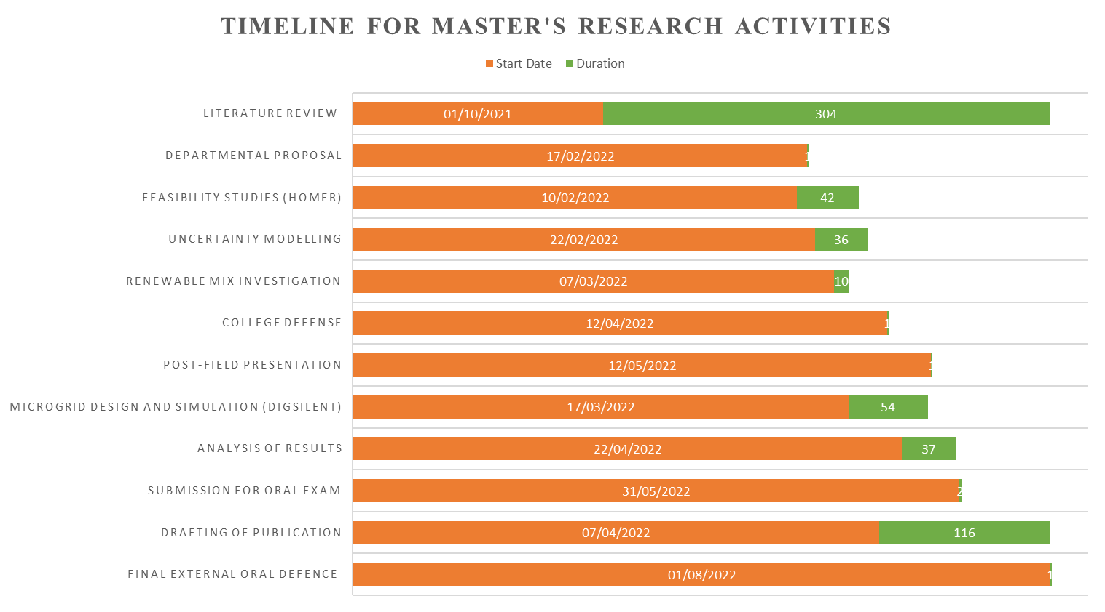

APPENDIX II: ESTIMATED BUDGET
S/N | Item Description | Estimated Cost (₦)
1. | Literature Review | 5,000
2. | Transportation | 15,000
3. | Streamgauging materials | 15,000
4. | Stationery and Printing | 30,000
5. | Report Compilation | 15,000
6. | Running Costs (Electricity and Bandwidth Access) | 20,000
 | TOTAL | 100,000

APPENDIX III – MATLAB CODE FOR PROBABILISTIC MODELLING
The MATLAB code written by the student for probabilistic modelling is presented. The code was developed in MATLAB R2020a and is not guaranteed to run in earlier versions. The code also refers to a data files that the student prepared using the data gathered during the research. The code starts after this sentence:
%% *Loading my Data.*
% First, we load 'Windspeeds.mat' and create the timetable for the Arandun hourly
% data with columns for datetime (from 1st January 2001 to 31st December 2021)
% and then six more columns for:
%
% Hourly windspeed at 50m (in m/s), Wind direction ($\left.\circ \right)$, Temperature
% ($\circ$C), Precipitation(mm/hour), All Sky Surface Shortwave Downward Irradiance
% (Wh/m^2), and Albedo(dimensionless).
%
% We also load the 'hydrodata' as an array which it already is, since it was
% not sourced from NASA like the other data.
%
% We also load the load data as a table containing mu and sigma as per month
% from loadmonthly.mat
%
% We also load the monthsTable.mat to supply month names and lengths in days
% and hours when needed during the simulations.
%
% We also load the data for the DNI from

tic
load('Windspeeds.mat');
load("hydrodata.mat");
hourlyData = wind_arandun;
load('loadmonthly.mat');
loadmusgima = table2array(FeederMonthlyMeasurements);
load monthsTable.mat;
load DNImonthly.mat;
montharray = monthsTable.monthName;
%%
% Next, we extract the data for each month. 12 tables are created from the original
% table with extraction and grouping of rows sharing common months. A cell array,
% monthCell, holds each month's timetable.

monthCell = cell(1,12);
%%
% Populating the cell array and splitting the data by months,

for f = 1:length(monthCell)
TR = (month(hourlyData.VarName7) == f);
monthCell{f} = hourlyData(TR,:);
end
%%
% Now, we create the probability functions for each month and store each one
% in a cell array as well. To do this, we declare four cell arrays for four sets
% of pdfs for wind, irradiation, hydro streamflow, load demand, and DNI simultaneously
% using "deal".

[windPdfs,solarPdfs,hydroPdfs,loadPdfs,DniPdfs] = deal(cell(1,12));
%%
% Next, we get all 12 wind pdfs with a for loop

for m = 1:length(windPdfs)
x = monthCell{m}.windspeed;
windPdfs{m} = fitdist(x,"Weibull");
pdw = windPdfs{m};
xpdfw = linspace(0.05,max(x),1000);
ypdfw = pdf(pdw,xpdfw);
figure
histogram(x,'Normalization',"pdf")
line(xpdfw,ypdfw,'Color','red','Linewidth',1)
titlestrg = ['Wind pdf ', num2str(m)];
xlabel('Windspeeds in '+ montharray(m)+' (m/s)')
ylabel('Probability distribution')
%title(titlestrg)
end
%%
% And then we do the same for all solar pdfs

for m = 1:length(solarPdfs)
xs = monthCell{m}.Irradiance;
xs(xs==0) = eps;
solarPdfs{m} = fitdist(xs,"Lognormal");
pds = solarPdfs{m};
xpdfs = linspace(1,max(xs),1000);
ypdfs = pdf(pds,xpdfs);
figure
histogram(xs,'Normalization',"pdf")
line(xpdfs,ypdfs,'Color','red','Linewidth',1)
titlestrg = ['Irradiance pdf ', num2str(m)];
xlabel('All-Sky Irradiation in '+montharray(m)+' (Wh/m^2)')
ylabel('Probability distribution')
%title(titlestrg)
end
%%
% Now, we fit the hydro flow to the extreme-value distribution as follows

for m = 1:length(hydroPdfs)
monthflow = hydrodatabig(m,:)';
hydroPdfs{m} = fitdist(monthflow,"ExtremeValue");
pdh = hydroPdfs{m};
xpdfh = linspace(min(monthflow),max(monthflow),1000);
ypdfh = pdf(pdh,xpdfh);
figure
histogram(monthflow,'Normalization',"pdf")
line(xpdfh,ypdfh,'Color','red','Linewidth',1)
titlestrg = ['Streamflow pdf ', num2str(m)];
xlabel('Streamflow (Litre/s) in '+montharray(m))
ylabel('Probability distribution')
%title(titlestrg)
end
%%
% We also develop a pdf for the DNI since it is on a month-by-month basis. For
% this, a Gaussian Distribution is used.

% for m = 1:length(DniPdfs)
% meann = (DNI(m)/24*0.25); sdev = ((DNI(m)/rand/24*0.25));
% DniPdfs{m} = makedist('Normal',"mu",meann,"sigma",sdev);
% pdd = DniPdfs{m};
% xpdfd = linspace(0,(4*sdev),1000);
% ypdfd = pdf(pdd,xpdfd);
% figure
% line(xpdfd,ypdfd,'Color','red','Linewidth',1)
% xlabel('Estimated Average CSP output in kW/m^2 for '+montharray(m))
% ylabel('Probabilityy Distribution')
% end
%%
% Now, having dealt with the renewable resources, we model the load uncertainty
% too with a pdf object on a nonth-by-month basis. For this a Gaussian/Normal
% Distribution is used.

for m = 1:length(loadPdfs)
meann = loadmusgima(m,1); sdev = loadmusgima(m,2);
loadPdfs{m} = makedist('Normal','mu',meann,'sigma',sdev);
pdl = loadPdfs{m};
xpdfl = linspace(0,(4*sdev),1000);
ypdfl = pdf(pdl,xpdfl);
figure
line(xpdfl,ypdfl,'Color','red','Linewidth',1)
xlabel('Load (MW) in '+montharray(m))
ylabel('Probability Distribution')
end
%%
% *NOW, we move to Sampling the Probability distributions for our dynamic modelling
% parameters.*
%
% We can generate 12 rectangular array of loads for each month, 24 rows for
% hours, columns according to number of days based on monthsTable. The loads will
% be sampled randomly from each load pdf. But instead of doing it this way, because
% of the ways the data will be used, we will instead generate a single column
% vector of random samples for each hour in the month.

loadSamplesCell = cell(1,12);
for m = 1:length(loadSamplesCell)
specpdfl = loadPdfs{m};
daysl = monthsTable.monthHours(m);
loadSamplesCell{m} = abs(random(specpdfl,daysl,1));
end
%%
% Next up is the sampling of windspeeds

windSamplesCell = cell(1,12);
for m = 1:length(windSamplesCell)
specpdfw = windPdfs{m};
daysw = monthsTable.monthHours(m);
windSamplesCell{m} = abs(random(specpdfw,daysw,1));
end
%%
% Next up is the sampling of solar irradiances

solarSamplesCell = cell(1,12);
for m = 1:length(solarSamplesCell)
specpdfs = solarPdfs{m};
dayss = monthsTable.monthHours(m);
solarSamplesCell{m} = abs(random(specpdfs,dayss,1));
end
%%
% And finally, the sample of streamflows

hydroSamplesCell = cell(1,12);
for m = 1:length(hydroSamplesCell)
specpdfh = hydroPdfs{m};
daysh = monthsTable.monthHours(m);
hydroSamplesCell{m} = abs(random(specpdfh,daysh,1));
end
%% Compiling Results
% First, we compile the summary of monthly probability parameters for each of
% the four distributions into a table (with a view to putting in the thesis or
% even xlswrite it out). The columns' parameters in order are:
%
% months|weibull scale(a)|weibull shape(b)|lognormalMu|lognormalSigma|evdLocationMu|evdScaleSigma|gaussianMu|gaussianSigma
%
% Initialising the table:

sz = [12 9];
varTypes = ["string","double","double","double","double","double","double","double","double"];
varNames = ["monthm", "WblScaleA","WblShapeB","LognMu","LognSigma","EvdLocationMu","EvdScaleSigma","GaussianMu","GaussianSigma"];
monthlyPdfSummary = table('Size',sz,'VariableTypes',varTypes,'VariableNames',varNames);
%%
% Next, we populate the months

monthlyPdfSummary.monthm = montharray;
%%
% Next, we compile the parameters, row by row.

for m = 1:height(monthlyPdfSummary)
monthlyPdfSummary.WblScaleA(m) = windPdfs{m}.A;
monthlyPdfSummary.WblShapeB(m) = windPdfs{m}.B;
monthlyPdfSummary.LognMu(m) = solarPdfs{m}.mu;
monthlyPdfSummary.LognSigma(m) = solarPdfs{m}.sigma;
monthlyPdfSummary.EvdLocationMu(m) = hydroPdfs{m}.mu;
monthlyPdfSummary.EvdScaleSigma(m) = hydroPdfs{m}.sigma;
monthlyPdfSummary.GaussianMu(m) = loadPdfs{m}.mu;
monthlyPdfSummary.GaussianSigma(m) = loadPdfs{m}.sigma;
end
monthlyPdfSummary
%%
% Now, we writetable, optionally, to a file named 'monthlyPdfSummary.xls'

writetable(monthlyPdfSummary,'monthlyPdfSummary.xls');
%%
% We create another set of 12 tables to show for each month the hours,MW in
% the hour, MVAR in the hour (0.8pf), irradiance in the hour, streamflow in the
% hour.

monthInputs = cell(1,12);
for m = 1:length(monthInputs)
sz = [monthsTable.monthHours(m) 22];
varTypes = ["int16","double","double","double","double","double","double","double","double","double","double", "double","double","double","double","double","double","double","double","double","double","double"];
varNames = ["Hourr", "LoadP","LoadQ","LoadPSMall","LoadQSmall","Irradiance", "PV instPower", "Streamflow","HydroP","HydroQ","CSPpower","batteryuse","load1_8LP","load2_5lP","load3_7lP","load4_13lP","load5_18lP","load1_8LQ","load2_5lQ","load3_7lQ","load4_13lQ","load5_18lQ"];
monthInputs{m} = table('Size',sz,'VariableTypes',varTypes,'VariableNames',varNames);
end
%%

for m = 1:length(monthInputs)
monthInputs{m}.Hourr = (1:monthsTable.monthHours(m))';
monthInputs{m}.LoadP = loadSamplesCell{m};
monthInputs{m}.LoadQ = (loadSamplesCell{m}).*0.75;
monthInputs{m}.LoadPSMall = (monthInputs{m}.LoadP)./51;
monthInputs{m}.LoadQSmall = (monthInputs{m}.LoadQ)./51;
monthInputs{m}.Irradiance = solarSamplesCell{m};
monthInputs{m}.("PV instPower") = (0.13.*60702*1e-6.*solarSamplesCell{m});
monthInputs{m}.("PV instPower")(monthInputs{m}.("PV instPower")>3) = 3;
monthInputs{m}.Streamflow = hydroSamplesCell{m};
monthInputs{m}.HydroP = (monthInputs{m}.Streamflow).*0.8*0.85*3*9.81*3/1e6;
monthInputs{m}.HydroQ = (monthInputs{m}.HydroP)*0.75;
if ismember (m,[5,6,7,8,9])
monthInputs{m}.CSPpower = zeros(height(monthInputs{m}),1) + 0.3 + 0.07*rand;
elseif ismember(m,[2,3,4])
monthInputs{m}.CSPpower = zeros(height(monthInputs{m}),1) + 0.8 + 0.07*rand;
else
monthInputs{m}.CSPpower = zeros(height(monthInputs{m}),1) + 1 + 0.1*rand;
end
monthInputs{m}.load1_8LP = (8/51).*monthInputs{m}.LoadP;
monthInputs{m}.load2_5lP = (5/51).*monthInputs{m}.LoadP;
monthInputs{m}.load3_7lP = (7/51).*monthInputs{m}.LoadP;
monthInputs{m}.load4_13lP = (13/51).*monthInputs{m}.LoadP;
monthInputs{m}.load5_18lP = (18/51).*monthInputs{m}.LoadP;
monthInputs{m}.load1_8LQ = (8/51).*monthInputs{m}.LoadQ;
monthInputs{m}.load2_5lQ = (5/51).*monthInputs{m}.LoadQ;
monthInputs{m}.load3_7lQ = (7/51).*monthInputs{m}.LoadQ;
monthInputs{m}.load4_13lQ = (13/51).*monthInputs{m}.LoadQ;
monthInputs{m}.load5_18lQ = (18/51).*monthInputs{m}.LoadQ;

monthInputs{m}.batteryuse = (monthInputs{m}.LoadP - (monthInputs{m}.HydroP + monthInputs{m}.CSPpower + monthInputs{m}.("PV instPower")))
writetable(monthInputs{m},[montharray(m) + 'hours.Table.xls'])
end
toc

APPENDIX IV – DIGSILENT MODEL SPECIFICATION
An example showing the configuration of transformers as used in the Project is shown. In this case, the 1000kVA transformer with Dyn11 is shown. Dyn11 (Delta-Star Neutral 11-o,clock is shown).
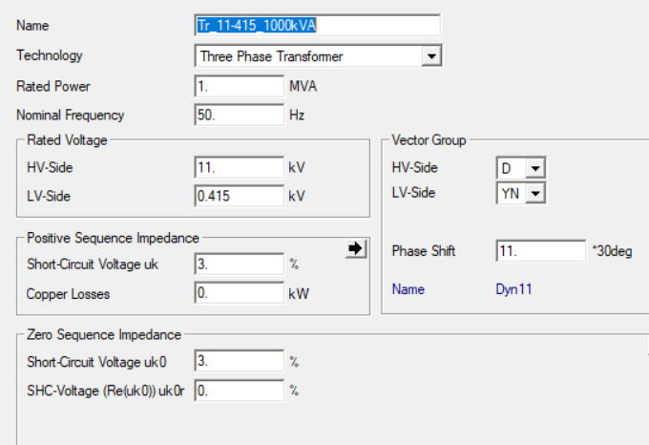

APPENDIX V – PLOTS OF PROBABILITY DISTRIBUTIONS
A set of self-captioned plots are provided for visual validation of the probabilistic models developed. Histograms based on real data fom 2001 to 2021 are superimposed onto function plots calculated using the methodology described in Chapter 3. For brevity, only windspeeds have been provided.
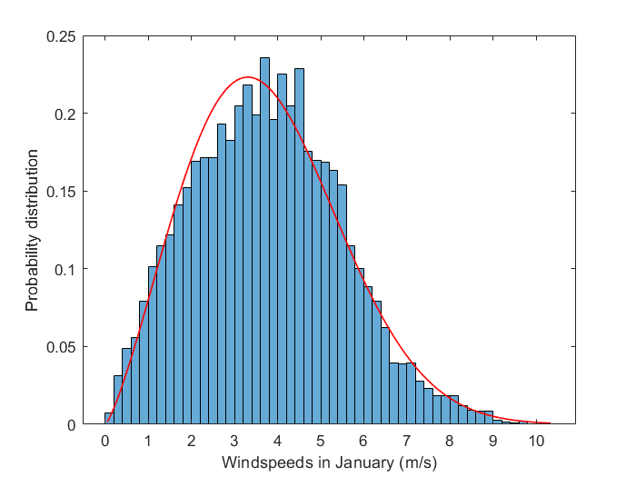
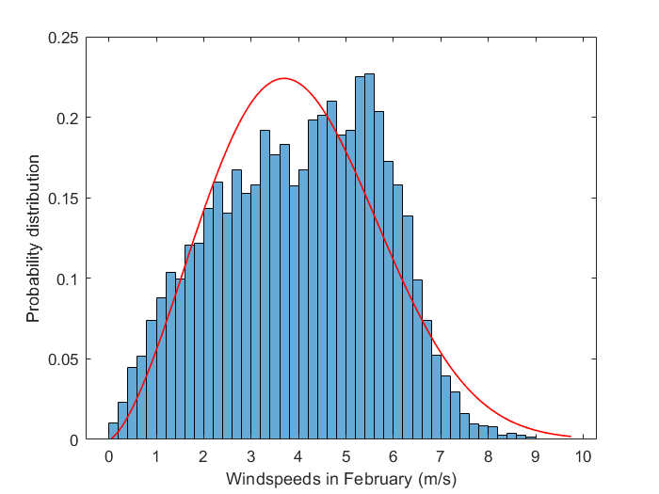
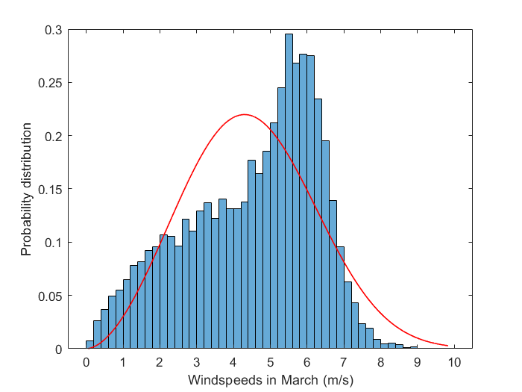
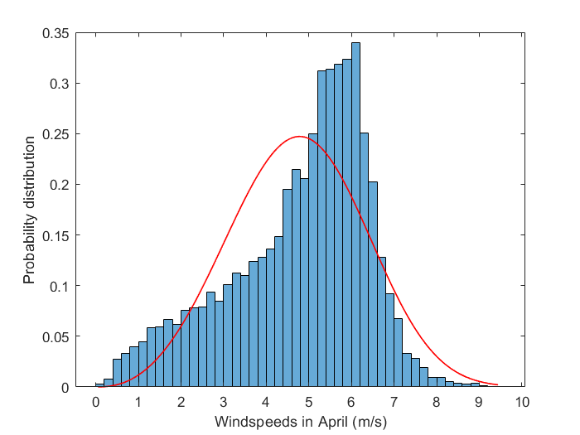
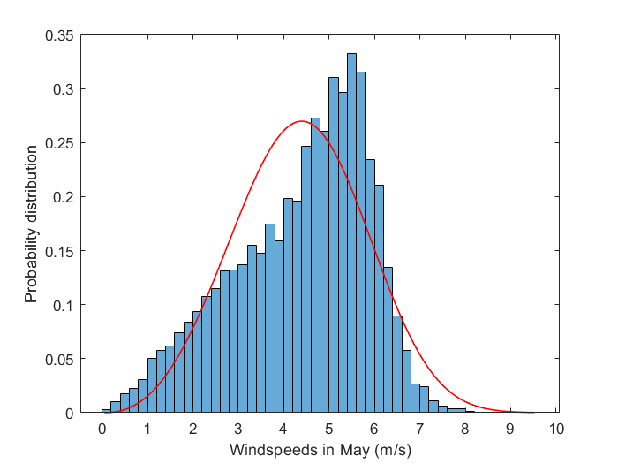
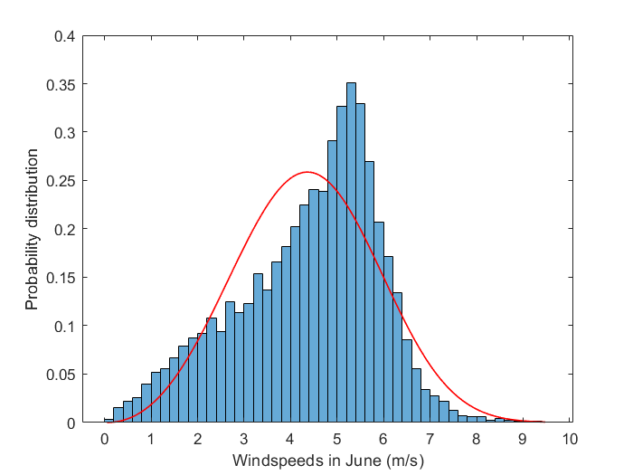
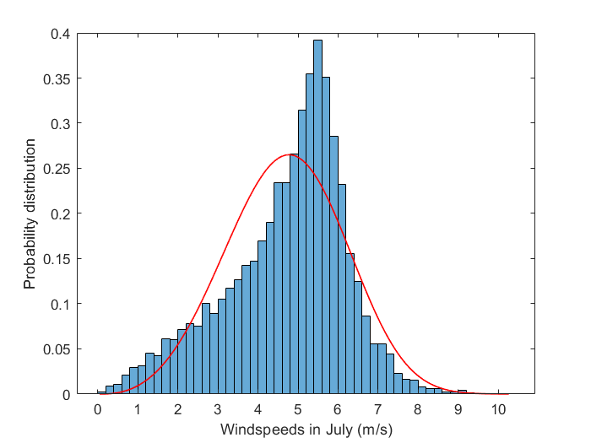
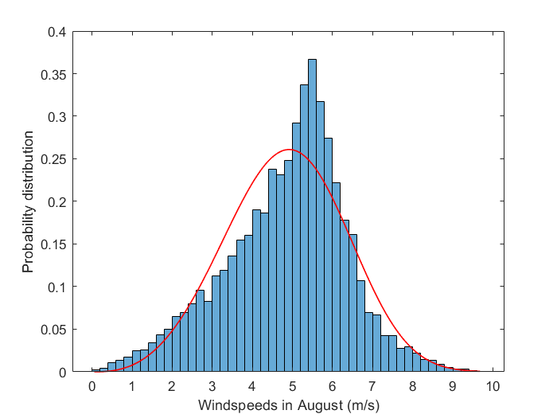
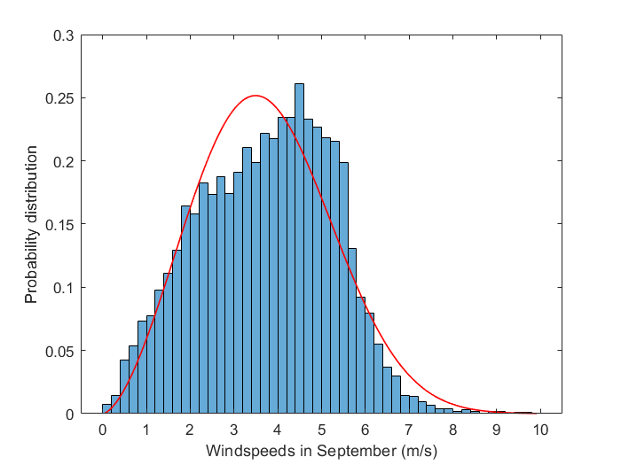
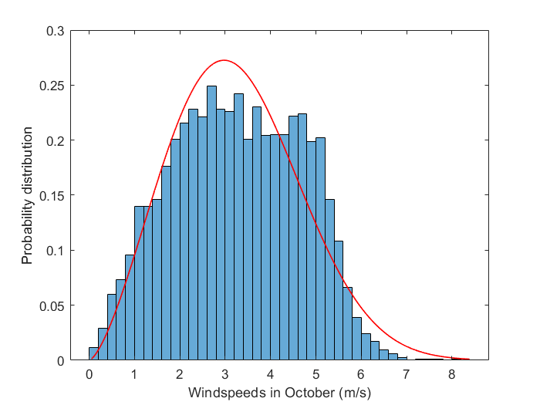
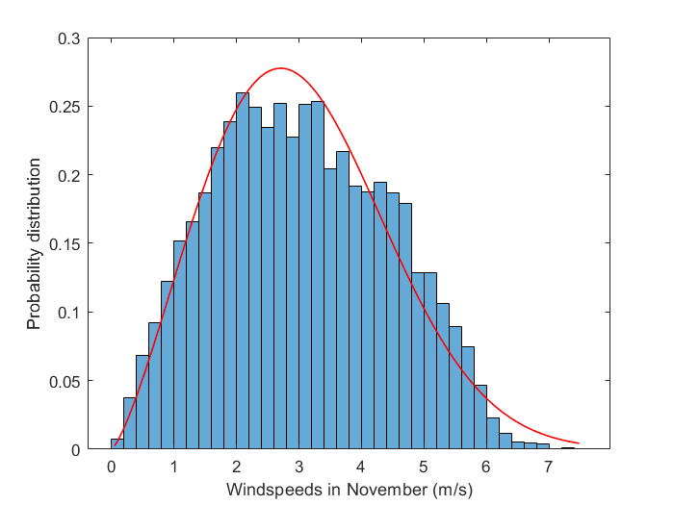
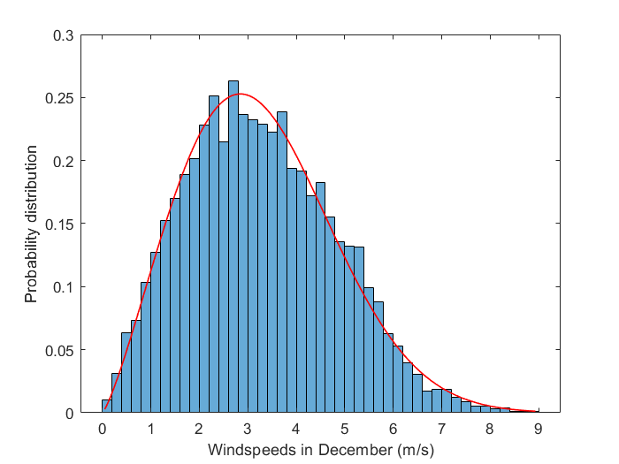

APPENDIX VI – MATLAB CODE FOR FUZZY LOGIC SYSTEM
For transparency purposes the code that was used to implement the fuzzy logic system used in the study is expressed in form of MATLAB codes as follows:
[System]
Name='Arandun_EIA'
Type='mamdani'
Version=2.0
NumInputs=5
NumOutputs=1
NumRules=3
AndMethod='min'
OrMethod='max'
ImpMethod='min'
AggMethod='max'
DefuzzMethod='centroid'

[Input1]
Name='LandUse'
Range=[0 1]
NumMFs=3
MF1='Extensive':'gbellmf',[0.48 16.7 0.95]
MF2='Moderate':'gaussmf',[0.26 0.5]
MF3='Limited':'zmf',[0.43 0.73]

[Input2]
Name='VisualImpact'
Range=[0 1]
NumMFs=3
MF1='good':'zmf',[0.4 0.899]
MF2='moderate':'pimf',[0.115 0.4 0.5 0.7]
MF3='bad':'trimf',[0.5 1.04 1.44]

[Input3]
Name='AcousticNoise'
Range=[0 1]
NumMFs=3
MF1='good':'trimf',[-0.4 0 0.6]
MF2='moderate':'trimf',[0.29 0.5 0.67]
MF3='unbearable':'trimf',[0.6 1 1.4]

[Input4]
Name='AirPollution'
Range=[0 1]
NumMFs=2
MF1='low':'trimf',[-0.4 0 0.52]
MF2='toxic':'trimf',[0.6 1 1.4]

[Input5]
Name='WaterCompromise'
Range=[0 1]
NumMFs=3
MF1='negligible':'trimf',[-0.4 0 0.4]
MF2='low':'trimf',[0.1 0.5 0.9]
MF3='severe':'trimf',[0.6 1 1.4]

[Output1]
Name='AcceptabilityIndex'
Range=[0 1]
NumMFs=3
MF1='low':'trimf',[-0.4 0 0.4]
MF2='moderate':'trimf',[0.1 0.5 0.9]
MF3='high':'smf',[0.4 0.6]

[Rules]
3 1 1 1 1, 3 (1) : 2
0 0 0 1 -3, 3 (1) : 1
0 0 3 1 -3, 2 (1) : 1

APPENDIX VII – MONTHLY PRECIPITATION DATA
The precipitation data and how it is used to compute streamflow is presented in following:
Month | Total Precipitation in mm² | Speed multiplier | River Width (m)
January | 2.15 | 1 | 7
February | 2.83 | 1 | 7
March | 48.64 | 3 | 7
April | 117.37 | 4 | 8
May | 133.06 | 5 | 9
June | 247.89 | 6 | 15
July | 190.25 | 5 | 13
August | 220.43 | 4 | 15
September | 135.56 | 3 | 9
October | 78.9 | 2 | 8
November | 31.39 | 1 | 8
December | 3.66 | 1 | 7

The streamflow is extrapolated with the following equation:
$$S=V_{b}×{(D}_{b}+D_{a})*1000\frac{M_{v}W}{8}$$
$$D_{a}=P/50$$
Where:
S = Streamflow in Litres/s;
V_{b} =Minimum River Speed which is 0.444m/s as measured
D_{b} = Minimum Depth which is 0.6m
P = Total Monthly Precipitation in mm
M_{v} = River speed multiplier (dimensionless)
W = River width in m
The multipliers were chosen after numerical comparisons in similar studies.

APPENDIX VIII – IMAGES OF WORK IN ACTION
