**INFLUENCE OF PARENTAL DEATH ON ACADEMIC PERFORMANCE AMONG STUDENTS IN SELECTED SECONDARY SCHOOLS IN OMU-ARAN, KWARA STATE, NIGERIA**

By

**FALEKE, Michael Olaoye**

**MATRIC NUMBER: 20PGED000131**

A DISSERTATION SUBMITTED TO THE DEPARTMENT OF SOCIOLOGY, COLLEGE OF BUSINESS AND SOCIAL SCIENCES IN PARTIAL FULFILLMENT OF THE REQUIREMENTS FOR AWARD OF THE DEGREE OF

MASTER OF SCIENCE (M.SC.) OF THE LANDMARK UNIVERSITY

SUPERVISORS:

**DR RASAK, Bamidele**

**DR (MRS) IWELUMOR, Oluwakemi Shade**

AUGUST, 2022.

**ABSTRACT**

Several studies have employed secondary data to investigate the consequences of parental death on orphans. But these studies that have involved directly the unit of analysis and important key informants are very limited. This study investigated the influence of parental death on the academic performance of students in selected secondary students in Omu-Aran, Kwara State through the lived experience of the respondents. The two Secondary Schools and the students were purposively selected; the sample for the study was twenty respondents consisting of ten orphaned students, five School teachers, and five parents. The study was guided by the structural-functionalist and phenomenologist theories. Five themes emerged from the data analysis: (a) distinctive maternal death influences; (b) distinctive paternal death influences; (c) external initiatives and motivations; (d) personal initiatives and motivations; and (e) supportive roles. Data was collected using in-depth and key informant interviews. Qualitative data was analysed using the interpretative phenomenological approach aided by use of NVivo 12 software. The findings of the study revealed that parental death across the board affects the academic performance of orphans negatively; maternal orphans perform more poorly when compared with their paternal counterparts across the board, that the main coping strategies are "personal initiatives" and motivations such as bracing up, studying harder, and so on (that is, academic initiatives), and non-academic initiatives such as opening up to friends, speaking to relatives, not thinking about their late parent(s), focusing on the future, resolve to make their parents, guardians, or sponsors proud, farming, trading, and so on are the most adopted coping strategies by orphans. Other strategies from others are secondary; they make up the "external initiatives". Finally, the support systems are vital as they provide essential financial, social, academic, emotional, and social roles. Conclusively, from the interpretative analysis of the data collected, self-determination is the most important factor in determining academic performance irrespective of the nature of orphanhood; some orphans do better academically after the death of their parent(s). The study recommended that School management should enlighten parents as regards ways to assist orphans to cope with their peculiarities while the government should give scholarships to orphans.

**Keywords: Orphans, Academic Performance, Parental Death, Coping Strategies**

**Word Count: 350**

**ACKNOWLEDGEMENT**

To the One who alone can raise the poor from the dust and lift the beggar from the ash heap to set them among princes, I bow in awe of You Abba. You gave the prompting to commence the programme and You backed me up all through the journey, I thank You, Lord. All acknowledgements go to the Almighty God the Helper of the helpless. My thanksgiving goes to all the people who God has used to bring about the accomplishment of this programme in various ways. My supervisors, Dr. Peter Bolade Ogunlade and Dr. (Mrs.) O.S. Iwelumor. Baba Ogunlade, you have greatly impacted my life. Thank you, Sir, for painstakingly reading through my work, and for taking me as a son, I will eternally be grateful Sir. Dr. (Mrs.) Iwelumor, every constructive input, untiring commitment to this work, and push to make me give my best is greatly appreciated Ma. I appreciate both of you greatly. I am also grateful to Dr. Ben-Caleb Egbide (Dean, College of Business and Social Sciences [CBS]), thank you Sir for your timely and strategic input in the work. To the Director of the Centre for Learning Resources, Dr. Ayooluwa Aregbesola and other staff in the library, thank you for the tutelage, corrections and guidance.

My special acknowledgement goes to all the members of the Department of Sociology. The current Head of Department, Dr. Arisukwu Ogadimma, your reassuring and ceaseless motivating words were priceless all through the programme, I celebrate and appreciate you, Sir. The immediate past HOD of the Department, Dr. Rasak Bamidele, thanks for always being there to allay my fears and answer my unending questions, Sir. Dr. (Mrs) Igbolekwu Chisaa, thank you Ma for the tutelage and more importantly for encouraging me to start the programme. To Mr Oye Joseph, Mr. Oyekola, Mr Oyeyipo, and Mr. Ooye Bukoye, all the PhD programme students, especially my dear sister, Miss Mkperedem Abigail, Mr. Ilesanmi Daniel, Mr. Akinola Festus, and Mr. Seun, I acknowledge your priceless contributions to this work. God bless you all Sirs and Ma

My sincere gratitude goes to my beloved wife, Barr (Mrs.) Mercy Fikayo Leke, thanks for the encouragement to proceed with this programme and thanks much more “SH” for the counsel and support to the end. To my beloved children; Grace, Emmanuel, and Vaniel, thank you for understanding and for allowing me to be away even at very important times. Daddy loves and appreciates you greatly. My profound appreciation goes to the entire Faleke and Asaju dynasties, especially my siblings; Dr.(Mrs.) Folashade Ayodele, Dr.(Mrs.) Olayinka Apeabu, Pastor (Engr.) Babalola Olorunleke, Engr. Olarewaju Faleke, and Hon. Olaoluwa Faleke. Special acknowledgement goes to Pastor (Dr.) Ahmed Ayodele and his family, for their support and for hosting me all through the programme; Favour, Peculiar, Purpose, and Samuel Ayodele, I say a big thank you for the love and understanding. I appreciate the uncommon love and unflinching support of my parents-in-law, The Rt Rev. (Prof.) Dapo and Barr (Mrs.) Dapo Harriet Asaju, Baba & Mama Ilesha, words will fail me if I attempt to express my gratitude. Thank you, Sir and Ma.

Indeed, this programme could not have been a success if not for the immense contributions and support of the non-academic staff in the Department of Sociology, College of Business and Social Sciences, Landmark University. The Lecturers in the Department of Sociology especially and other faculty from other departments made their remarkable contributions to the work starting from the beginning stage of proposal defence to pre-field and post-field defence.

I am deeply indebted to my immediate past HOD at work, Dr. Kabir Durowade, who encouraged me to continue the programme, the Grandfather of our Department, and the present HOD, Dr. Olusegun Elegbede, and all my senior colleagues, especially Drs Ipinnimo, Adeosun, Olaseinde, Asake, and Omotoso you all have been wonderfully used by God. God will perfect everything that concerns you.

Finally, and very importantly, I want to appreciate Prophet Jacob Babalola, Prof. Olufemi Adebesin, Apostle Joseph & Rev. (Mrs) Comfort Ifepariola, Pastor Bayo Olorunfemi, Dr. Whenayon Ajisegiri, Dr. (Mrs) ‘Kemi Adebola, Dr. (Mrs.) Folashade Daniel, Prof. Olufemi Idowu, Dr. Adebanji Ayeni, Dr. Chinomso Chinyere, Mr. Ikponmwosa Evbuomwan, Dr. Ogunkayode Stephen and last but not the least the entire School of Post graduate staff, especially our amiable Dean, Prof. (Mrs.) Charity Aremu, Dr. (Mrs.) Folashade Dada and Mr. John Ojeka. For the strategic roles you all individually played in this journey, I say a big thank you. God bless you all greatly.

**DEDICATION**

I dedicate this work to the glory of the Almighty God, the One who makes a way where there seems to be no way. Thank You, Abba for teaching me to profit and for consistently leading me on the way to go (Isaiah 48:17). To the memory of Olori Margret Aduke Faleke, my beloved mother who translated while I was only four (4) years old, I love you, Mum. To the memory of my late father, HRH Oba S.A. Faleke, thank you for being a father indeed. And finally to all the Angels that played (and are still playing) the role of a mother in my life; Dr. (Mrs.) G.F. Ayodele, Dr. (Mrs.) S.O. Apeabu, Olori Mary Faleke, Mrs E.B. Aronimoh, Deaconess Grace Faleke, Deaconess Janet Faleke, and Mrs Victoria Olorunfemi. Thanks so much for all your input in my life.

**CERTIFICATION**

This is to certify that this research work was carried out by FALEKE, OLAOYE MICHAEL (Matric No. 20PGED000131). This dissertation has been read and approved as meeting the requirements for the award of a Master of Science degree in the Department of Sociology, College of Business and Social Science, Landmark University, Nigeria.

Sign …………………………………. …………………………….

Name: Dr. Bamidele Rasak Date

(Supervisor)

Sign ………………………………… ……………………………..

Name: Dr. (Mrs.) O.S. Iwelumor Date

(Co-Supervisor)

Sign ………………………………… ….....………………………

Name: Dr. Arisukwu Ogadimma Date

(Head of Department)

Sign ………………………………… ……………………………..

Name: Dr Ben-Caleb Egbide Date

(Dean, College of Business and Social Sciences)

Sign ………………………………… ……………………………….

Name: ______________________ Date

(External Examiner)

**TABLE OF CONTENTS**

TITLE PAGE----------------------------------------------------------------------------------------------- i

ABSTRACT------------------------------------------------------------------------------------------------ ii

ACKNOWLEDGEMENT------------------------------------------------------------------------------- iii

DEDICATION--------------------------------------------------------------------------------------------- v

CERTIFICATION----------------------------------------------------------------------------------------- vi

TABLE OF CONTENTS--------------------------------------------------------------------------------- vii

LIST OF APPENDICES--------------------------------------------------------------------------------- x

LIST OF TABLES---------------------------------------------------------------------------------------- xi

LIST OF FIGURES--------------------------------------------------------------------------------------- xii

LIST OF ABBREVIATIONS---------------------------------------------------------------------------- xiii

CHAPTER ONE------------------------------------------------------------------------------------------- 1

INTRODUCTION

1.1 Background of the Study --------------------------------------------------------------------------- 1

1.2 Statement of the Problem--------------------------------------------------------------------------- 2

1.3 Research Questions---------------------------------------------------------------------------------- 3

1.4 Research Objectives--------------------------------------------------------------------------------- 3

1.5 Significance of the Study--------------------------------------------------------------------------- 4

1.6 Scope of the Study----------------------------------------------------------------------------------- 4

1.7 Operational Definitions of Terms----------------------------------------------------------------- 4

CHAPTER TWO----------------------------------------------------------------------------------------- 6

REVIEW OF LITERATURE AND THEORETICAL FRAMEWORK

2.1 Introduction ------------------------------------------------------------------------------------- 6

2.2 Parental Death and Academic Performance --------------------------------------------------- 6

2.2.1 Maternal Death and Academic Performance ------------------------------------------- 6

2.2.2 Paternal Death and Academic Performance -------------------------------------------- 7

2.3 Parents’ Academic Role ------------------------------------------------------------------- 8

2.4 Grief in the Early Stage of Life ----------------------------------------------------------------- 8

2.5 Coping Strategies after Parental Death--------------------------------------------------------- 10

2.6 Role of Supportive Systems after Parental Death--------------------------------------------- 10

2.7 Theoretical Framework-------------------------------------------------------------------------- 12

2.7.1 The Phenomenological Theory -------------------------------------------------- 12

2.7.2 The Structural Functionalist Theory--------------------------------------------- 13

2.8 Gap identified in the Literature ----------------------------------------------------------------- 14

2.9 Conceptual Framework--------------------------------------------------------------------------- 14

3. CHAPTER 3 –METHODOLOGY ----------------------------------------------------------------- 16

3.1 Introduction ---------------------------------------------------------------------------------------- 16

3.2 Research Design ----------------------------------------------------------------------------------- 16

3.3 Study Location ------------------------------------------------------------------------------------- 16 3.4 Population of the Study -------------------------------------------------------------------------- 16 3.5 Method of Data Collection----------------------------------------------------------------------- 17

3.6 Sample Size and Sampling Techniques --------------------------------------------------------- 17 3.7 Research Instrument-------------------------------------------------------------------------------- 18

3.8 Method of Data Analysis-------------------------------------------------------------------------- 18

3.9Validity and Reliability of the Research Instrument-------------------------------------------- 20

3.10 Ethical Consideration ----------------------------------------------------------------------------- 21

3.11 Limitations of the Study --------------------------------------------------------------------------- 21

CHAPTER FOUR

DATA PRESENTATION AND ANALYSIS---------------------------------------------------------- 23

4.1 Introduction------------------------------------------------------------------------------------------- 23

4.2 Socio-Demographic Characteristics of the Respondents ---------------------------------------- 28

4.3 Parental Death and Students’ Academic Performance ----------------------------------------- 28

4.3.1 Maternal Death and Students’ Academic Performance-------------------------------------- 28

4.3.2 Paternal Death and Students’ Academic Performance------------------------------------- 32

4.3.3 Paternal Death with Weightier Influence on Academic Performance-------------------- 33

4.4 The Coping Strategies after Parental Death---------------------------------------------------------- 34

4.4.1 External Initiatives and Motivation--------------------------------------------------------------- 34

4.4.2 Personal Initiatives and Motivation---------------------------------------------------------------- 35

4.5 Roles of Support Systems after Parental Death--------------------------------------------------- 36

4.5.1 Academic Roles ------------------------------------------------------------------------------- 36

4.5.2 Emotional Roles ------------------------------------------------------------------------------- 36

4.5.3 Financial Roles--------------------------------------------------------------------------------- 36

4.5.4 Physical Roles---------------------------------------------------------------------------------- 37

4.5.5 Social Roles------------------------------------------------------------------------------------- 37

4.5.6 Other Findings --------------------------------------------------------------------------------- 37

4.6 Discussions of the Major Findings---------------------------------------------------------------- 39

4.7 Integration of Findings with Theories--------------------------------------------------------------- 46

CHAPTER FIVE--------------------------------------------------------------------------------------- 50

5.1 Introduction------------------------------------------------------------------------------------------- 50

5.2 Summary---------------------------------------------------------------------------------------------- 50

5.3 Conclusion-------------------------------------------------------------------------------------------- 51

5.4 Recommendations----------------------------------------------------------------------------------- 53

5.4.1 Policy Recommendations for the Government-------------------------------------------- 53

5.4.2 Policy Recommendations for the Non-Governmental Agencies (NGOs) ------------- 53

5.4.3 Policy Recommendations for the Schools and Teachers-------------------------------- 53

5.4.4 Policy Recommendations for the Ministry of Women and Child Development------- 54

5.5 Contribution to Knowledge ------------------------------------------------------------------------ 54

5.6 Prospect for Further Study ------------------------------------------------------------------------- 54

REFERENCES---------------------------------------------------------------------------------------- 56

APPENDICES: Introductory letter, Ethical Clearance, Instruments, Charts, Word Cloud,

Diagram Map ------------------------------------------------------------------------------------------ 63

**LIST OF APPENDICES**

Appendix 1: Interview Guide for the Students in Selected Secondary Schools

Appendix 2: Interview Guide for the Teachers

Appendix 3: Interview Guide for the Parents

Appendix 4: Introductory Letter

Appendix 5: Permission Letter 1

Appendix 6: Permission Letter 2

Appendix 7: Informed Consent

Appendix A: Table of Themes and Sub-Nodes

Appendix B: Hierarchical chart (H C) Addressing Influences of Maternal and Paternal Deaths

Appendix C: H C Depicts Distinctive Paternal Death Influences

Appendix D: H C Depicts Distinctive Maternal Death Influences

Appendix E: Table Showing Themes and Sub-Themes Addressing Research Question One

Appendix F: H C Summarizes Coping Strategies

Appendix G: Table showing the Themes and Sub-Themes of Coping Strategies.

Appendix H: H C for Sub-Themes of the Negative Outcome

Appendix I: Word Cloud for Codes on Coping Strategies

Appendix J: Diagram Map Connecting Two-Parent Respondents; P2 and P4

Appendix K: Word Cloud for Codes on Support Systems

Appendix L: H.C Showing the Sub-Themes of Support Systems

Appendix M: H.C Summarizing the Respondents’ Recommendations

Appendix N: H.C Shows the Summary of the Entire Study at a Glance

Appendix O: Map Tree Addressing Research Question One (1) Codes

Appendix P: Cluster Analysis Diagrams provide a Graphical Representation of Nodes to make it easy to see similarities and differences.

**LIST OF TABLES**

Table 4.2.1: Characteristics of Students Interviewed ------------------------------------------------------ 24

Table 4.2.2: Characteristics of Teachers Interviewed ----------------------------------------------------- 24

Table 4.2.3: Characteristics of Parents Interviewed -------------------------------------------------------- 25

**LIST OF FIGURES**

**Figure 1:** Relationship Between the Variables of the Study --------------------------------------- 16

**Figure 2:** Diagram Summarizing the Findings from the Study ----------------------------------- 42

**Figure 3:** Diagram Explaining the Application of the Phenomenology Theory ---------------- 46

**Figure 4:** The Theories and the Variables ----------------------------------------------------------- 47

**LIST OF ABBREVIATIONS**

**HOD**: Head of Department

**CBS**: College of Business and Social Sciences

**WHO:** World Health Organisation

**IDI:** In-Depth Interview

**KII:** Key Informant Interview

**CHEW:** Community Health Extension Worker

**PTA**: Parent-Teacher Association

**NPC**: National Population Commission

**LGEA**: Local Government Educational Authority

**S.S.S.:** Senior Secondary School

**WAEC:** West Africa Examination Council

**NECO:** National Examination Council

**H.C:** Hierarchical Chart

**CHAPTER ONE**

**INTRODUCTION**

**1.1 Background of the study**

The death of one or both parents is one of the most traumatic incidents that can occur in childhood which may affect a child's life course in many ways. Experts from several fields ranging from sociologists, psychologists, educationists, and public health scientists are passionate about understanding how family settings, and more precisely, parental absence, affects the well-being of children. According to Gimenez *et al*. (2013), there are roughly 153 million children worldwide who have lost one or both parents. It's also been reported that twenty-five percent of children grows up without parents and that 22.1 million children were living with only one parent as of 2014. Of the 22.1million, approximately 13.4 million children resided with custodial mothers (Grall, 2016). Hunter and Williamson (2000) found that one out of every ten African children under the age of 15 had lost one or both parents, according to their research.

Parental loss poses a great challenge to the entirety of the child's normal growth and development; one of the worst-hit however is his academics (Amato & Anthony 2014; Prix & Erola 2017). Previous research on children's academic performance suggests that when both parents are actively involved in their children's education, their academic achievement improves. (Fadeiye, 1985; Nyarko, 2007; Nyarko & Vorgelegt, 2007) The authors discovered, for example, that parental participation is linked to students' academic achievement in school.The consequences of parental loss especially on the academics of their children have attracted serious concerns even on the global stage intending to proffer prompt and corresponding solutions (World Bank, 1999; Copson, 2002). Especially now that the number of children facing the absence or loss of a parent has increased due to road traffic accidents, societal instability, conflicts, and the HIV/AIDS epidemic (Chen *et al.,* 2009; Gimenez *et al*. 2013; Gbadamosi, 2015). Furthermore, a series of high-mortality natural disasters have resulted in unexpected increases in the number of children without parents in recent years, drawing media attention and humanitarian concerns to their predicament.

The goal of the study is to obtain a deeper knowledge of people's beliefs, attitudes, and behaviours, as well as to develop a holistic view of particular scenarios such as when a student has lost either mother, father or both, and he or she is left with no other option than to live with relatives from where he or she goes to school. This study explored the experiences of students' loss of (a) parent(s), as related by their surviving parents or relatives, their teachers, and also the orphans themselves. It utilized the qualitative approach in contrast with the majority of previous studies along this line that utilized the quantitative approach which relies often on historical and secondary data with their attendant drawbacks (Case & Ardington, 2006; Rosenbaum-Feldbrugge, 2019; Burrel *et al*., 2020). Summarily, this present study is designed to explore the influence of parental death on the academic performance of secondary students in Omu-Aran, Kwara State.

**1.2 Statement of the Problem**

There are alarming and worrisome statistics to corroborateescalating orphanhood as a result of parental deaths from road traffic accidents, societal instability, conflicts, the HIV/AIDS epidemic, et cetera (Chen, Chen & Liu 2009; Gbadamosi, 2015; Gimenez *et al*. 2013). Orphaned children are more affected especially as it concerns their academic performance; bereaved children have lower expectations and aspirations for their future education and careers than children who have not lost a parent, according to studies (Brent *et al*., 2012; Berg, *et al*., 2014; Thyden *et al*., 2020; Liu *et. al.,* 2022).A few researchers have also found lower educational scores, attainment and success among orphaned children (Amato & Keith, 1991; Pong, *et.al*, 2003). A lot of research has looked into the psychological effects of early parental mortality due to various causes of death. (Cerel *et al* 1999; Lin *et al*. 2004; Pfeffer *et al*. 2000; Liu *et. al.,* 2022), however, not much attention has been paid to education: Only a few researchers have looked into parental death and the educational performance of their children (Chen *et al*., 2009; Berg *et al.,* 2014; Prix & Erola, 2016).

Similarly, there is a paucity of studies that have addressed the roles played by the family and other support systems like the community, government, et cetera, in abating the effects of parental death on the academic performance of students in Secondary Schools. The demise of one or both parents is known to come as a rude shock to these adolescents. This study also explored the coping strategies adopted by this cohort of students. More importantly, there are very limited studies that have had direct engagement with the orphans. This research work is, therefore, directed towards addressing the aforementioned problems.

**1.3 Research Questions**

1. What distinctive influences do maternal deaths have on students’ academic performance in selected secondary schools in Omu-Aran, Kwara State?
2. What distinctive influences do paternal deaths have on students’ academic performance in selected secondary schools in Omu-Aran, Kwara State?
3. What coping strategies for schooling do orphans adopt in selected secondary schools in Omu-Aran, Kwara State?
4. What are the roles of the family and the community in mitigating the negative influences of parental death on the academic performance of selected secondary students in Omu-Aran, Kwara State?

**1.4 Objectives of the Study:**

This general objective of the study is to examine the influence of parental death on the academic performance of students in selected schools in Omu-Aran, Kwara State**.** While the specific objectives are to:

1. Examine the distinctive influences of maternal deaths on students’ academic performance in selected secondary schools in Omu-Aran, Kwara State.

2. Examine the distinctive influences of paternal deaths on students’ academic performance in selected secondary schools in Omu-Aran, Kwara State.

3. Examine the coping strategies geared towards stability and good academic performance adopted by orphans in selected secondary schools in Omu-Aran, Kwara State.

4. Assess the roles of the family and the community in mitigating negative influences of parental death on the academic performance of students in selected secondary schools in Omu-Aran, Kwara State.

**1.5 Significance of the Study**

Firstly, the study will contribute to knowledge on the existing Literatures and Theoretical Framework on the subject under investigation. Secondly, findings from this study from the surviving parents or relatives, teachers and the orphans themselves will be beneficial in providing key stakeholders and policymakers, especially in the educational and health sectors with relevant data which will help to review and improve policy implementation and responses to the challenges of orphans. Also, at the local levels, teachers, counsellors, as well as Educational instructors would benefit greatly from the knowledge this research work will provide.

**1.6 Scope of the Study**

The study will focus mainly on the influences of parental death on students in selected Secondary Schools in Omu-Aran and their academic performance, the coping strategies they adopt, and the mitigating roles of the family and the community against negative influences will also be explored in line with the objectives of the study. The qualitative research design employed was the phenomenology design. Only qualified participants based on the inclusion criteria were interviewed.

**1.7 Operational Definitions of Terms**

**A Parent** is a student’s father or mother who is responsible for his or her conception, delivery, and upbringing.

**Academic Performance:** refers subjectively to how well a student does in his or her studies.

**A Single Orphan** is a child (under the age of eighteen) whose mother or father has died.

**A Paternal Orphan** is a child (under the age of eighteen) whose father has died.

**A Maternal Orphan** is a child (under the age of eighteen) whose mother has died.

**A Full Orphan/Double Orphan** is a child (under the age of eighteen) whose parents have both died.

**Parental Death** is the loss of the physical life of a father, mother or both by a student.

**Lived Experience** is the firsthand observation of or participation in events as a source of knowledge.

**A Secondary School** is an institution that provides post-basic formal education, an intermediate between elementary school and tertiary institution.

**Coping Strategies** are the behavioural and cognitive tactics employed by students to manage the effect of the loss of their parents.

**A Support System** is the network of people who provide orphaned students with all the support needed to reduce the effect of the death of their parents.

**Grief** in this study refers to the response of students to the death of any or both of their parents.

**CHAPTER TWO**

**REVIEW OF LITERATURE AND THEORETICAL FRAMEWORK**

**2.1 Introduction**

Studies have shown mixed outcomes as it pertains to the effect of early parental death on children’s educational performance. Some have been negative (Steele *et al*., 2009; Prix & Erola, 2017), very limited work have shown positive outcomes (Apelian and Nesteruk, 2017), while a few others have been neutral (Francesconi *et al.,* 2010; Amato & Anthony 2014; Berg *et al*., 2014; Burrell *et al.,* 2020). Parental mortality has been linked to an increased incidence of sadness, self-harm, and suicide in children, demonstrating the seriousness of the situation (Berg *et al*., 2016). In addition, Shor *et al*. (2012) also discovered some similar challenges especially anxiety in the surviving parents. Aftermaths of parental death in childhood have also been noted to include: anxiety, sadness, anger, sleep issues, attention-seeking, withdrawn behaviour, bed wetting, jealousy, guilt, and other behaviours –all of which can affect school children (Giovaanola, 2005 & Bolton *et al*., 2016).

**2.2 Parental Death and Academic Performance**

What is certain is the fact that all parents will die at one time or the other but the untimely death of a parent during one's childhood is associated with untoward outcomes especially in terms of academic performance among others (Steele *et al.,* 2009; Amato & Anthony, 2014; Prix & Erola, 2017).

**2.2.1 Maternal Death and Academic Performance**

Family structures come in a variety of shapes and sizes. Whether both parents are participating in their children's training or only one parent is involved determines the structure. The importance of the mother and father in most societies and communities cannot be overstated. Mothers play a very pivotal role in the well-being of their children especially as it relates to their academic performance. A few studies have conjectured that mothers play a more dominant role in the academic outcome of their children than the fathers thereby implying that maternal orphans do more poorly academically following the demise of their mothers with or without the fathers being present (Case & Ardington, 2006; Maxine, 2014). The mother is the most essential environmental force for character formation at a young age. Case and Ardington (2006) discovered a considerable disparity between the impact of the deaths of mothers and fathers. They claimed that, depending on age, maternal orphans are far less likely to be enrolled in school and to have completed significantly fewer years of education than children whose mothers are still alive. Several studies have echoed Case and Ardington (2006) in finding maternal orphans more disadvantaged in their academic performance and pursuit (Evans & Miguel, 2007; Chen *et al*., 2009). However, Gertler *et al*. (2004) using household data from Indonesia discovered that the negative aftermath on academic performance in orphaned children is irrespective of the gender of the parent who died.

**2.2.2 Paternal Death and Academic Performance**

Fathers on their end are seen as "the provider", the breadwinners of the family and by this natural role they occupy, the responsibility is on them to make adequate provision for the financial, physical, material, social, and even the spiritual needs of the family. A few studies have tried to probe into the effect of the presence or absence of fathers (especially owing to death as it relates to this context) (Case & Ardington, 2006; Berg, *et al*., 2014; Kailaheimo-Lönnqvist & Kotimäki, 2020; Liu *et al*., 2022).. Case and Ardington (2006) find that paternal death does not affect academic performance. Since paternal death is a strong predictor of subsequent socioeconomic level, they contend that, to the extent that such impacts do exist, they probably function through socioeconomic status. However, some studies concluded that paternal orphans are worse off (Berg, *et al*., 2014; Kailaheimo-Lönnqvist & Kotimäki, 2020; Liu *et al*., 2022).

**2.3 Parents’ Academic Role**

Parents bear a significant amount of responsibility for their children's educational and professional development (Salami & Alawode, 2000). In other words, before a child enters school, the family establishes the framework for education, and the home influences the personality that the youngster brings to school. According to studies on child academic accomplishment, academic achievement improves when both parents are involved in their children's education (Nyarko, 2007; Nyarko and Vorgelegt, 2007).

Abankwa (2013) also found that children from two-parent homes are more likely to have their parents’ active in their education than children from single-parent homes. Children with only one parent alive may not have enough attention because the single parent is usually overstressed. Children from single-parent families are said to be more likely than children from two-parent families not to finish high school, even when they are academically equal (Zimiles *et al*., 1991).

**2.4 Grief in the Early Stage of Life**

Worden (1996) evaluated the impact of parental loss on preteens (6–11 years old) and adolescents (12–18 years old) using data from the Childhood Bereavement Study and discovered clear differences between the two. The realization of the parent's impending death by the teenager is one of the key differences between preteens and adolescents. Adolescents were also more likely to have attended the burial, to have seen the parent's body, to have remembered what was said at the funeral than preteens were. Worden discovered that male adolescents were more likely than female adolescents to hear messages about developing and growing up after their death. Worden also discovered that, in comparison to preteens, teenagers who had experienced parental death showed lower levels of self-esteem.

Worden (1996) also compared parentally bereaved adolescents to non-bereaved adolescents and found noticeable differences. Within the first year of the death, bereaved adolescents were more likely to report health and sleep problems. Bereaved adolescents reported more fighting within the family and reported more changes during dinnertime.

When compared to peers who had not experienced a loss, grieving teenagers perceived themselves as less academic and had more unfavourable opinions of themselves. Adolescents who had lost a parent by the second anniversary still exhibited lower levels of self-esteem than their peers who had not experienced a loss. Teenagers who have experienced a loss are also more likely to be reclusive, to have more anxiety and depression, and to worry more about their families. Adolescents who had lost a parent showed differences in their sense of identity, saying that they felt different from their friends and that they performed less well in school than they should have (Worden, 1996).

Eleven (11) teenagers; six (6) boys and five (5) girls, between the ages of (thirteen) 13 and (eighteen) 18 who had experienced parental death were evaluated and interviewed for Harris's (1991) descriptive study. According to Harris, every participant expressed sadness and crying following the death and particularly during the funeral. Additionally, participants reported poor concentration, reductions in academic performance, and sleep difficulties. Participants identified their primary sources of distraction as daydreams, memories, and worry for the surviving parent. This researcher discovered common experiences later in the grieving process, such as sadness, alcoholism, criminality, and possibly educational failure (Harris, 1991). The study's findings concur with those mentioned by Worden.

**2.5 Coping Strategies after Parental Death**

The death of a parent is the most devastating loss a kid can suffer. Children are thought to be incapable of comprehending death and grieving. According to psychological research such as Maxine's (2014), an adolescent's ability to cope with the death of a parent is influenced by his or her age. Maxine hypothesized that losing a parent before reaching adulthood has a lasting impact on a person's life. A common practice is to shield children from the knowledge about the death of a loved one, this has been noticed to rob them of the opportunity to grieve and, eventually, heal (Patterson, 2009).

A few researchers have identified some coping strategies; one of the commonest being voracious eating in other words when traumatic experiences strip bereaved children of their capacity to control their emotions and stability in life, they may be unable to control their eating choices (Beam *et al*., 2004). For some others, participating in sports or becoming absorbed in homework are two examples of coping mechanisms. Spirituality has also been linked to a reduction in mourning reactions following the death of a parent (Lawrence-Webb & Okundaye, 2006). In a study carried out by Ajiboye and Ajokpaniovo (2019) among in-school adolescents faced with parental loss in Ilorin, Nigeria, The respondents used poor coping mechanisms, which could explain their strong mourning reactions..

**2.6 Roles of Supportive Systems after Parental Death**

In previous studies, the prevalence of orphan-caring extended family and community networks was connected to the lack of a persistent detrimental effect of parent death on African children (Foster, *et al*., 1995; Ntozi, 1997; Foster & Williamson 2000). Especially in the African setting, in the absence of both or any of the parents' close relatives such as uncles, aunts, grandparents or neighbours are poised to take responsibility for establishing a suitable home environment in which their children can learn effectively (Ogbemudia & Aiasa, 2013). Studies have shown that Extended family members can provide "practical aid, company, and a sense of security and solidarity, which can assist the family in adjusting to the loss" of bereaved children and teenagers (Greeff & Human, 2004). Grandparents, cousins, aunts, and uncles may provide a haven for grieving children, making it easier for them to cope with the loss of a parent (Greeff & Human, 2004; Eppler, 2008). According to Walsh and McGoldrick (2004), families without such a supporting extended network have a harder time coping with the death of a loved one. Does the level of integration among relatives in the immediate and extended family of origin available to the children play a compensatory or masking role in the expected impact of the parental loss on the academic outcomes of these bereaved children or do they, on the contrary, encourage lethargy and complacency in their academic pursuit? This is another germane variable that is worth reviewing in this inductive adventure.

Support groups are a huge benefit to children who have lost a parent. Sixteen (16) children between the ages of seven and eleven who had lost a close family member participated in an eight-week children's grieving group, and Lambert and Tonkins (1996) investigated its efficacy. Families with Mormon, Catholic, Christian and Jewish religious backgrounds were included in the study. Children's grief support groups, according to the researchers, offer a well-organized framework for working with children who have lost a parent. Children who attend the support groups, according to the authors, exhibit fewer grieving symptoms like sadness, anger, withdrawal, and guilt. As a result, the supportive services provided to kids who attended grief support groups after losing a loved one were extremely beneficial to them (Lambert & Tonkins, 1996). Healy-Romanello (1993) asserts that a child can receive the necessary amount of outside assistance by participating in a children's grief support group. Children who participate in the program can work on forming new friendships with peers to whom they can relate on a personal level.

Research has indicated that having additional support networks outside of the home has a favourable effect on the child (ren). It has been demonstrated that children who receive support from classmates, friends, and/or support groups are less likely to have negative consequences after a parent passes away. Making linkages between support networks and lifelong impacts of childhood parental bereavement is crucial to the current study and can reveal more details about the mourning process of the child (Healy-Romanello, 1993; Lambert & Tonkins, 1996).

**2.7 Theoretical Framework**

In a bid to give theoretical backing to this study, two theories were adopted to provide insight into how parental death affects academic performance. They are; the phenomenological theory and the structural-functionalist theory

**2.7.1 The Phenomenological Theory**

Phenomenology is the study of conscious experience from a subjective or first-person perspective, and it has guided academics in their investigations of young people's lived experiences concerning parental loss, grieving, and adaptability over the years (Creswell, 2013; Daly, 2007). There are several variations and interpretations of the phenomenon. Descriptive phenomenology and interpretive phenomenology are the two primary schools of philosophy (hermeneutics).

Edmund Husserl founded descriptive phenomenology (Abalos *et al*., 2016). Husserl was a mathematician and philosopher who lived from 1859 to 1958. He was able to rigorously study the meaning of a person's "lived experience" which is defined simply as an understanding of the world acquired by an individual by direct, first-hand participation in everyday occurrences rather than through representations created by others (Abalos *et al*., 2016).

Descriptive phenomenology comprises four key ideas: bracketing, inferring, analyzing, and describing (Hamill & Sinclair, 2010). The process of detecting and holding in abeyance preexisting notions and attitudes regarding the topic under research is referred to as bracketing. To address the evidence in its purest form, researchers work to bracket away presuppositions. In their efforts to bracket, phenomenological researchers (as well as other qualitative researchers) frequently keep a reflexive journal. The second stage of descriptive phenomenology, intuition, happens when researchers are receptive to the meanings that others who have experienced the phenomenon have assigned to it. Then, researchers who study phenomena do an analysis (i.e., extracting significant statements, categorizing, and making sense of essential meanings). The descriptive phase, on the other hand, is when researchers finally comprehend and define the phenomenon (Hamill & Sinclair, 2010).

**2.7.2 The Structural Functionalist Theory**

According to functionalism, each element of society contributes to overall stability and that society is greater than the sum of its parts. Emile Durkheim, one of the most notable proponents of this theory, saw society as an organism in which each component performs an essential purpose but cannot function independently. The remaining components of the system must change to fill the void when one component fails. According to functionalist theory, social institutions—each of which is created to meet a specific need—are what make up the various facets of society.

In many countries, the government pays for the education of the children, who then pay taxes to support the government. The family anticipates that the school will assist its students in locating acceptable employment so they can support and raise their own families. Through this system, the young develop into law-abiding, tax-paying citizens who assist the government. The functionalist perspective contends that when society's components function properly, order, stability, and production result. In the event that things don't go as planned, society's members will have to adapt and create new forms of stability, order, and production.

Societal consensus, order, social stability, and accepted public values are all highly valued by functionalism. According to this viewpoint, change occurs as a result of systemic disorder, such as deviant behavior, because social elements must adjust in order to achieve stability.

Societal consensus, order, social stability, and accepted public values are all highly valued by functionalism. According to this viewpoint, change occurs as a result of systemic disorder, such as deviant behavior, because social elements must adjust in order to achieve stability. The entire system suffers when one component of it fails, leading to societal issues and driving social change. Other notable exponents of the structural-functionalist theory include Herbert Spencer, Robert Merton and Talcott Parsons. When various social patterns are combined, each plays a specific role in the structure; they enable society to run in a balanced and stable way. Furthermore, social systems adapt to society's changing needs; if any part of the structure fails, the entire society may collapse.

**2.8 Gap Identified in the Literature**

A lot of research has looked into the psychological effects of early parental mortality due to various causes of death. (Cerel *et al*. 1999; Pfeffer *et al*. 2000; Lin *et al*. 2004) however, education has received little attention: Only a few researchers have looked into parental death and the educational performance of their children. (Chen *et al*., 2009; Berg *et al.,* 2014; Prix & Erola, 2016) and also, more importantly, there are very limited studies that have had direct engagement with children. If these children are not given the right attention they may constitute a nuisance to their immediate environment and liabilities to their families. This research work is, therefore, directed towards improving existing knowledge about the influence of parental death on academic performance with the intent of proffering solutions and recommendations.

**2.9 Conceptual Framework**

A conceptual framework is described as a group of overarching concepts and guiding ideas drawn from relevant academic fields that are used to structure a presentation in the future (Reichel & Ramey, 1987). As with any social world studies, the framework itself is part of the agenda for negotiation and will be tested, reviewed, and changed as a result of the study (UKEssays, 2018).

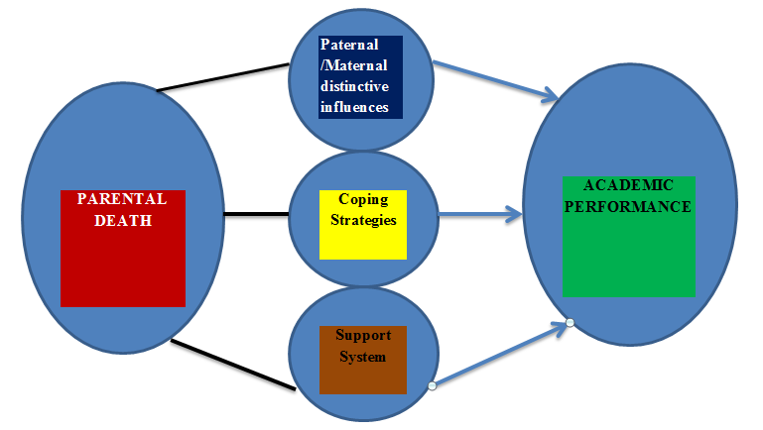

**©Source –Faleke, 2022**

**Figure 1**: Relationship between the independent variable (parental death), the intervening variables (paternal/maternal distinctive influences, coping strategies, support systems), and the dependent variable (academic performance).

**Conceptual Clarification**

The framework for this study (presented in figure 1) is a graphical representation based on the interactions between the independent variable, which is “parental death” and the intervening variables (paternal/maternal distinctive influences, coping strategies, support systems), and how these interactions can result in varying outcomes in form of the academic performance of the orphaned students.

**CHAPTER THREE**

**RESEARCH METHODOLOGY**

**3.1 Introduction**

The concepts and processes by which the research was conducted will be examined in this portion of the study. The procedure is explained under the following sections; the research design, study location, population of the study, method of data collection, research instrument, sampling technique and sample size, method of data analysis, validity and reliability of the research instrument, and ethical consideration.

**3.2 Research Design**

A phenomenological research design was used. To get thorough descriptions that serve as the foundation for a reflective structural analysis that captures the substance of the experience, Moustakas (1994) claims that "the empirical phenomenological approach entails a return to experience" (p. 13).

**3.3 Study Location**

The study was conducted in selected schools in Omu-Aran which doubles as the headquarters of Irepodun Local Government Area (LGA) one of the sixteen LGAs domiciled in Kwara state, the North-central geopolitical enclave of Nigeria. Omu-Aran was established almost 500 years ago and is located at approximately 8'08'00'N and 5'06'00'E. Omu-Aran people were predominantly farmers due to the area's vegetation. They were also well-known for their handicrafts, such as basket making and blacksmithing. It’s fast becoming a rural-urban township following its hosting of notable two (2) universities, and a couple of institutions of learning. The estimated population is 147,333 inhabitants (as of 2016) with the vast majority of the area's dwellers being members of the Igbomina ethnic group. The Igbomina dialect of the Yoruba Language is widely spoken in Omu-Aran with the religions of Christianity and Islam popularly practiced in the area (National Population Commission [NPC], 2009).

**3.4 Study Population**

The study populations were students within the selected secondary schools in Omu-Aran, Kwara State, their teachers and parents/relatives. The two secondary schools selected were; Government Secondary School, Omu-Aran, and Federal Government Girls College, Omu-Aran. The rationale for selection includes: the diversity of the population (the socioeconomic classes will be inclusive, cuts across all works of life), public schools are known to have students from all works of life, gender equality (addresses age as a co-founder), the number of enrollees in both schools are in their hundreds, and finally is a boarding school and the other a day school.

**3.5 Method of Data Collection**

The study used the semi-structured interview as the tool for data collection.Data was collected for the study through both In-Depth Interviews (IDI) (from the students) and Key Informant Interviews (KII) (from the parents and teachers). The informed consent form and permission to record the interviews were obtained from all participants. All participants filled out the demographic information sheet.

**In-Depth Interview**

To gain a deeper understanding of the effect of parental death on academic performance, the orphans’ point of view, experiences, feelings, and perspectives are of profound importance especially as it pertains to events after the death of their parents. IDI allows for the broad process of experiences and information.

**Key Informant Interview**

The goal of key informant interviews is to gather data from a variety of persons who have firsthand experience with the subject. Teachers and parents/relatives will be interviewed in this instance.

**3.6 Sample Size and Sampling Technique**

The first stage involved a purposive selection of the two (2) public secondary schools in Omu-Aran; thereafter twenty (20) respondents were recruited purposively. The 20 respondents comprised ten (10) orphaned students, five (5) teachers and five (5) parents. The emphasis however was on "data saturation" as richness and depth are vital in this study. Respondents were assigned a number for identification purposes.

**Inclusion Criteria**:

Inclusion criteria for students:

1. Must be within the 12-18 years age bracket.
2. Must presently be in school.
3. Must be in any of the three (3) senior classes

Inclusion criteria for teachers:

1. Must have a minimum of 10 years of experience.
2. Must have been involved in the teaching of orphans in the past.

Inclusion criteria for parents/relatives:

1. Must have students currently in school.

**3.7 Research Instrument**

The instrument for this study consisted mainly of interview guides (Appendices 1-3). The appendices varied depending on the category of the respondents and they were structured in line with the objectives of the study. Field notes with observations about interview sessions were also taken.

**Instrument validity**

The researcher created the instruments, which his supervisors then examined. A few lecturers in the college also submitted them to peer assessment. The tools were also pretested among a small group of orphaned students at the Federal Science and Technical College, Usi-Ekiti, Ekiti State, South-Western Nigeria, in order to determine their validity.

**3.8 Method of data analysis**

The Interpretative Phenomenological Analysis (IPA) was used by this researcher. IPA records participants' lived experiences and is intended to help comprehend their personal experiences related to a significant life event, encounter, or scenario (Smith *et al.,* 2009). According to Smith *et al.* (2009), the IPA Steps theoretically include:

1. Reading over and again.

2. Initially Coding,

3. Creating Emergent Themes,

4. Searching for Connections Across Emergent Themes

5. Moving on to the subsequent case, while attempting to bracket earlier themes and keeping an open mind to properly account for each new example's uniqueness,

6. Searching for trends throughout cases, and lastly

7. Deepening interpretations

The study's data was analyzed throughout the research. The researcher took notes and made observations during and after the interviews. After conducting the interviews, the researcher listened to and transcribed all twenty (20) of them. *To begin*, all personally identifiable information was removed from the transcription and replaced with pseudonyms. *Second*, the researcher had to take on Epoche's point of view. Simply expressed, "epoche" is becoming aware of and putting aside one's personal biases about the subject under investigation –in a way bracketing the researcher's subjective feelings. During data processing, the researcher in alignment with phenomenology tried to put any preconceived notions and/or beliefs aside and appreciate the subjectivity of each participant's individual experience. Phenomenology also encourages researchers to look at the world through the eyes of participants to gain a better knowledge of their lives and circumstances (Creswell, 2013).

Furthermore, the researcher listened, transcribed, took notes, and made comments for each interview during the *third* stage of data immersion. *Fourthly*, the data was uploaded into Nvivo software where cases were created for each respondent. The *fifth* step involved data reorganization in which data was arranged using the categories created before the fieldwork by the researcher based on common variables and attributes. *Sixthly,* *coding* relevant information in the data concerning the research questions and objectives, the researcher painstakingly read through the transcript line by line looking for expressions that align, suggest, or are in tandem with the objectives of the study. This step initially produces sub-codes. Further evaluation and cross-examinations of similarities and differences among the sub-codes produced the sub-themes (emergent themes, or more recently –experiential statements) which finally led to the parent themes (superordinate themes, or more recently –personal experiential themes) to address the research questions.

Penultimately, the researcher made use of the latest improvements in the NVivo software to *display data* and create some visual, pictorial, and graphical representations (see Appendices C-P) to help prospective readers understand and appreciate in clearer terms the findings of the study. This also further gives credence and credibility to a relative abstract work. Some of these include; map trees, word clouds, cluster analysis, hierarchical charts, and diagram maps to mention but a few. *Finally*, *data verification* was done by a senior data analyst at the University.

**3.9 Validity and Reliability of the Research Instrument**

The four components of Lincoln and Guba's Trustworthiness in a Research Study vis-à-vis; Credibility, transferability, dependability, and confirmability were adhered to in this research (Lincoln & Guba, 1985). A minimal initial time frame of thirty minutes was established with each participant to promote sustained engagement, the first stage in creating trustworthiness. This amount of time was adequate to obtain all the necessary data. There was no need for more meetings. In keeping with this, it was crucial to give each participant ample time to say all they know as regards parental death and its influence on academic performance. Additionally, the participant's verbal intonation, word choice, and any extra details they provided needed to be carefully observed by the researcher. The constant observation that Lincoln & Guba (1985) mention as their next stage for creating credibility was made possible by these procedures.

Utilizing a method known as member checking as the next and final stage in building credibility; in member checking, participants are contacted and informed of the findings of the data analysis by the researcher(s). To ascertain whether the participants in this study concur with the findings, the researcher contacted two participants who had been informed of this beforehand and had consented to it.

Another aspect of Lincoln & Guba's (1985) procedure for determining trustworthiness is transferability. The researcher must be as specific as possible when using this technique. Conversations with the respondents yielded that information. To get a thorough explanation of the phenomenon, the researcher gave each participant enough time to narrate their whole tale while also urging them to elaborate when appropriate. Dependability is another feature that Lincoln & Guba (1985) feel it necessary to prove rigour. Dependability was ensured by allowing a few other lecturers outside the department to review all aspects of the study at intervals for accuracy. The final technique, according to Lincoln & Guba (1985) is confirmability. This last stage of confirmability involves Reflexivity. The researcher tried as much as possible to be transparent throughout the research, he also reported each of the steps that was taken in the study and what the findings were to the supervisors, conclusively, the researcher as much as possible ensured self-reflexivity.

**3.10 Ethical Consideration**

Ethical clearance was obtained from the Irepodun Local Government Educational Authority (LGEA). Also, each respondent was assured absolute confidentiality and anonymity. Study objectives, benefits and the right to refuse to be interviewed were explained to the potential respondents. Only relevant information to the study was requested and informed consent was taken before each interview, they were duly informed that the interview will be audio recorded. Risks such as bringing back bad memories were explained to the respondents and they were free to seek explanation at any time during the interview. They were also told that if they felt uncomfortable during the interview, they could stop it and withdraw without punishment. The transcript was stripped of all names and identifying characteristics, ensuring that none of the responders can be identified. De-identification, in which responders were assigned code numbers was done will help to ensure confidentiality and the data obtained were stored in a secure electronic file.

**3.11 Limitations of the Study**

One of the major challenges that emanated from the study itself was the administrative bottlenecks that delayed permission by the Local Government Educational Authority (LGEA) and also at the schools. Also, getting the most conducive place for interviewing the students was a major challenge. Finally, was the challenge of making the widows/widower interviewed to see the need for the study as some of them were initially reluctant but eventually gave their consent after due explanation. Conclusively, this study, like most other qualitative work, had common limitations which had to do with sampling and generalization of the findings. The results cannot be applied to all grades or secondary schools outside of Omu-Aran.

**CHAPTER FOUR**

**DATA PRESENTATION AND ANALYSIS**

**4.1 Introduction**

This chapter presents the research findings of the study which sought to investigate the influence of parental death on academic performance. Data was obtained from the school teachers, parents, and orphaned students.

**4.2. Socio-Economic and Demographic Characteristics of the Respondents**

Each one of the participants was assigned a pseudonym to preserve their identity. Pseudonyms for students, teachers, and parents were S1, S2, S3, S4, S5, S6, S7, S8, S9, and S10, T1, T2, T3, T4, and P1, P2, P3, P4, and P5 respectively. Tables 4.2.1, 4.2.2, and 4.2.3, reflect the students', teachers', and parents' details respectively

**Table 4.2.1: Characteristics of Students interviewed**

|  |  |  |  |  |  |  |  |
| --- | --- | --- | --- | --- | --- | --- | --- |
| **Student** | **Gender** | **Religion** | **Age (Years)** | **Orphan-Type** | **Age at Death** | **Number of Siblings** | **Family Type** |
| **S1** | Male | Christianity | 17 | Maternal | 15 | 2 | Monogamous |
| **S2** | Male | Islam | 17 | Maternal | 14 | 6 | Monogamous |
| **S3** | Male | Islam | 16 | Paternal | 14 | 8 | Polygamous |
| **S4** | Male | Christianity | 17 | Maternal | 13 | Nil | Monogamous |
| **S5** | Male | Christianity | 17 | Paternal | 12 | 4 | Monogamous |
| **S6** | Male | Christianity | 18 | Maternal | 12 | 6 | Polygamous |
| **S7** | Female | Christianity | 15 | Maternal | 12 | 5 | Monogamous |
| **S8** | Female | Christianity | 16 | Paternal | 10 | 3 | Monogamous |
| **S9** | Female | Christianity | 15 | Maternal | 09 | 5 | Monogamous |
| **S10** | Female | Christianity | 18 | Paternal | 13 | 4 | Monogamous |

***Source: Filed Data (2022)***

**Table 4.2.2: Characteristics of Teachers interviewed**

|  |  |  |  |  |
| --- | --- | --- | --- | --- |
| **Teacher** | **Age group** | **Gender** | **Length of Service** | **Religion** |
| **T1** | 30-39 years | Male | 13 years | Christianity |
| **T2** | > 50 years | Female | 19 years | Christianity |
| **T3** | 40-49 years | Female | 11 years | Christianity |
| **T4** | 40-49 years | Female | 12 years | Christianity |
| **T5** | 40-49years | Female | 15 years | Christianity |

***Source: Filed Data (2022)***

**Table 4.2.3: Characteristics of Parents interviewed**

|  |  |  |  |  |  |  |  |  |  |  |
| --- | --- | --- | --- | --- | --- | --- | --- | --- | --- | --- |
|  | **AGE (in Years)** | **INCOME** | **QUALIFICATION** | **GENDER** | **RELIGION** | **# OF CHILDREN** | **WORK** | **LATE PARTNER’S WORK** | **YEARS AGO THAT PARTNER DIED** | **STATUS(NOW)** |
| **P 1** | 30-39 | N50,000-N100,000 | Diploma | Female | Christianity | 2 | CHEW | Timber Contractor | 2 | Single |
| **P 2** | 40-49 | >N100,000 | B.Sc. | Female | Christianity | 3 | Public Servant | Public Servant | 4 | Single |
| **P 3** | 40-49 | N50,000-N100,000 | Diploma | Female | Christianity | 3 | Nurse | Teacher | 4 | Single |
| **P 4** | 40-49 | >N100,000 | B.Sc. | Male | Christianity | 3 | Records Officer | Trader | 15 | Re-married |
| **P5** | 30-39 | N50,000-N100,000 | Diploma | Female | Christianity | 3 | Public Servant | Public Servant | 4 | Single |

***Source: Filed Data (2022)***

**4.2.1 Description of Participants**

**STUDENTS**

**S1:** He is a seventeen (17) year old student in S.S.2, from a monogamous setting-has two (2) siblings, he lost his mother two (2) years ago, a Christian, lives with his Grandmother at present, assists her in the market to sell charcoal. His aunty is responsible for the payment of his school fees.

**S2:** He is a seventeen (17) year old student in S.S.2; he has a peculiar hereditary health challenge which qualified him for a scholarship covering mainly tuition from a Good Samaritan. He is from a monogamous setting –has six (6) siblings, his father too is on a sick bed at home, and a Muslim lives with his father. He lost his mother three (3) years ago.

**S3:** He is a sixteen (16) year old student in S.S.2 who lost his father that was a truck driver two (2) years ago on the day he started his exams. He practices Islam, and has eight (8) siblings (second child of the mother) –from a polygamous setting (his father had four (4) wives), he lives with his mother, who is a photographer, and she is responsible for the payment of his school fees.

**S4:** He is a seventeen (17) year old student in S.S.3, he lost his mother four (4) years ago, the only child of his parents, from a monogamous background, and he is a Christian, his mother was nurse and he promised her to become an Engineer in the future.

**S5:** A seventeen (17) year old male student who is in S.S.3, has four (4) siblings and is from a monogamous setting. He lost his father five (5) years ago. He is almost entirely responsible for his well-being and sells fruits and snails to make ends meet. At present, he lives with his brother.

**S6:** He is an eighteen (18) year old maternal orphaned in S.S.3, she was a teacher who died six (6) years ago in a ghastly road traffic accident. He is the last of six (siblings) from a polygamous family, he practices Christianity. His uncle is responsible for his accommodation and school fees.

**S7:** She is a fifteen (15) year old Christian, at present in S.S.3, lost her mother three (3) years ago, from a monogamous setting, her father remarried and she is happy with her step-mother who according to her; "treats me well", lives with her father and her five (5) other siblings. They are Christians.

**S8:** An eighteen (18) year old paternal orphan in S.S.3, whose father died six (6) years ago. From a monogamous setting with three (3) siblings, she is a Christian. Lives with her mother, who also pays her school fees.

**S9:** A fifteen (15) year old S.S.1 student who lost her mother six (6) years ago, she is from a monogamous setting, a Christian, lives with her Aunty while her school fees are being paid by Good Samaritan since she almost dropped out of school. She sells yam for her Aunty whenever she is at home. She is the second child in a family of five (5), and her three younger brothers have dropped out of school on financial grounds. She promised her late mother that she will become a medical doctor.

**S10:** She is an eighteen-year-old S.S.3 paternal orphan; he died five (5) years ago, they are Christians from a monogamous setting, and she is from a family of four (4). Her mother (who is a teacher) and her eldest brother pay her school fees.

**TEACHERS**

**T1:** He is a 37-year-old Christian with 13 years of teaching experience, he was also an orphan while in secondary school, lost his father in S.S.1, and his mother had to run away because of widows' rite, especially when his uncle wanted to marry her forcefully. He almost dropped out of school if not for his principal who paid for his West Africa Examination Council (WAEC) and National Examination Council (NECO) examinations; today he is now a graduate.

**T2:** She is a 52-year-old PhD holder, a Christian with 19 years of teaching experience. She has taught several orphans, and at a point had to "rescue" one of her students, a paternal orphan whose uncle insisted on marrying her off to his creditor to whom he owed N30, 000, she had to take her away for some time even though he would not marry off one of his daughters for the same purpose.

**T3:** She is a 45-year-old PhD holder, a Christian with 11 years of teaching experience, and is very passionate about the well-being of her students.

**T4:** She is a 47-year-old graduate, who began her teaching career about 12 years ago; she has vast experience based on her years of relating with orphans both in school and outside the school environment.

**T5**: She is a 48-year-old graduate, who has been teaching across several secondary schools for the past one and half decades, she practices Christianity. Her love for her job and especially her students made her adopt one of them who lost her father some years ago and was about to drop out of school since the mother is also financially incapacitated.

**PARENTS**

**P1:** She is a 34-year-old widow, a Community Health Extension Worker (CHEW) who lost her husband who was a Timber contractor two (2) years ago to a road traffic accident; she holds a diploma certificate, practices Christianity, earns #75,000 monthly with which she takes care of her two (2) children.

**P2:** She is a 43-year-old mother of three (3) who lost her husband (who was a public servant) four (4) years ago and single-handedly takes care of her children with the #120,000 she earns as a public servant and the additional income from her businesses. She is a graduate and practices Christianity.

P3: A 47-year-old widow who lost her husband four (4) years ago when he was shot by armed robbers at home in the presence of one of their children (a girl), she has been battling since then with trying to bring her out of the shock until lately that after withdrawing her from boarding school, she is now much stable emotionally. She is a nurse and earns about #90,000. Her late husband was a teacher and she practices Christianity.

**P4:** He is a 49-year-old graduate, works as a record officer, and father of three (3) whose wife (a trader) died 15 years ago, he remarried two (2) years after her demise. His children are doing well academically, two (2) of them have won awards both at the class and state levels. He practices Christianity and earns about #120,000 monthly.

P5: She is a 39-year-old graduate who lost her husband four (4) years ago, and a mother of three (3) children, just like her late husband, she is a public servant, has a diploma certificate and earns about #70, 000 monthly

**4.3 Parental Death and Students’ Academic Performance**

Findings from the qualitative analysis (see Appendices B & E) portray the clear significance and peculiarity of the roles of both parents in ensuring sound academic performance for their wards. Worthy of note however is the fact that for both parents, some of these roles can easily be played by others –especially relatives, however, most of the influences raised are best made by the parents themselves and as such foster parents can merely try their best in filling in the gap created, more like round pegs in square holes.

* + 1. **Maternal Death and Students’ Academic Performance**

The participants' accounts clustered around two sub-themes: **Inadequacies Related to Maternal Death** and **Maternal Absence-Related Influences** both of which have three and seven sub-codes respectively. For those that border on **Inadequacies Related to Maternal Death,** they capture roles or influences that others aside from the biological mothers can attempt to play or make but will still not be comparable or adequate if compared to being done by the actual mothers. They include; inadequate academic support, inadequate care –poor outlook, and inadequate follow-up. While for those that border on maternal **Absence-Related Influences**, they capture roles or influences that only the mothers of the orphaned students can make and as such the students’ academic performance is greatly influenced by their absence. They include; absent motherly companionship, absent motherly spiritual roles, challenges of absent parenting, challenges of stepmothers, lack of motherly motivation, lack of motherly protective nature, and lack of motherly sacrificial nature as depicted in Appendix D

**Inadequacies Related to Maternal Death**

Respondents reported that major challenges that orphans are affected by are the *inadequacy of academic support* owing to the death of their mothers. For instance, one of the students, a 17-year-old Senior Secondary School (S.S.3) male student reported in this manner:

"She was the one always encouraging me to read, she would explain things I don't understand to me, she would wake me up in the night to read my book, especially during exam period but since she died, nobody has been playing that role and it has affected my performance in school. I am not as serious as before…It affected me a lot, it has not been easy, and nobody encouraged me that much. When she was alive she'd be the one to assist me when I don't understand classwork, I'll take it home, and she will explain it to me. Many times, she will wake me up at night to read"*–*S4.

Also, one of the teachers, a female with 11 years’ experience remarked:

“…fathers usually don’t have time doing revisions for children…but mothers can still have time to do that, the mothers can easily take the children through lessons that were taught in school…” ***-*T3**

Another distinctive influence of maternal death deduced from the data was *inadequate care –poor outlook*. Some of the respondents implied that maternal orphans are conspicuously not well catered for physically. A 15-year-old S.S.1 student remarked:

“I miss how she used to dress for me, how she used to advise me, I used to sit on her legs and she would say “I shouldn’t break her legs” –**T9**

A male teacher with 13 years’ experience corroborated the point above, in his words:

“…mothers are more caring, more active at home…they take care of the children and look after them. They prefer to be stressed, uncomfortable, at the expense of their children…” **-T1**

**Maternal Absence-Related Influences**

The respondents further highlight factors that relate to the outright absence of a mother and the influence on the academics of students. The first was the *inadequate follow-up,* according to T1:

“Fathers hardly have time for the children, the money may be there but who does the cooking, caring, etc. most times it’s as if the child has lost nothing if they lost just fathers” –**T1**

Absent motherly companionship was another sub code deduced from the respondents, according to S6, the 18-year-old male student respondent:

"I miss her companionship, counselling, and prayers for me. Being the last born, we were very close." –**S6**

T1, the male teacher in support of the mother's companionship absence and its influence also attested:

"The influence of a mother is very huge on the child; the mother carried the child for nine (9) months till birth, she's very close to the child, she always wants to do things that are best for the child, she doesn't want to do anything detrimental to the child" ***-*T1**

S6, an 18-year-old male student who lost his mother 6 years ago has this to say about missing his mother's spiritual roles:

“I miss her …prayers for me. Being the last born, we were very close."-**S6**

T5, one of the teachers with 15 years of experience in her forties when discussing the distinctive maternal influences raised the challenge of absent parenting when only the father is alive, in her words:

“…fathers hardly have time for all of these (assignments, preparing them for their exams, revisions et cetera) since…they are busying making money to take care of the family…” ***-*T5**

When asked if she would have fared better academically if it was her mother that died, S8, a 16-year-old female S.S.3 student expressed her fears concerning stepmothers, her:

“No. If it was my mum that died, he would have remarried and there are chances that she might have maltreated us.”**–S8**

T3 also added her voice:

"…unlike the mother who can stay alone as a widow and be taking care of the children…If the father remarries, it might be difficult for the children to cope because the new wife will take good care of her children more than those of the late wife…" ***–*T3**

25% of the respondents attested to the fact that nothing compares to the *motivations that only mothers can give*; they affirmed that such motivations are second to none. 17-year-old S4, in S.S.3, said concerning her late mother:

“She used to help me with my academic work; she encouraged me to read my book and will always tell me that I will be someone great in the future.” ***–*S4**

S7, the youngest respondent, a 15-year-old female student in S.S.3, also aired her experience of what motherly motivations do:

***“***I believe that her encouragement especially before exams is special. It had a way of giving me a push to go the extra mile." ***-*S7**

Mothers are believed to be specialists in protecting their children from insults, attacks, shame, and all manner of reproach. A maternal orphan lacks this motherly protective nature and hence suffers the consequences, especially at home. 17-year-old male S.S.2 student, S1, emphasized this point concerning his late mother:

“…she doesn’t want anything to happen to me at all…She cared so much about me and doesn’t want anything to happen to me at all…” ***–*S1**

The love mothers have for their children is palpable, and this makes them go to any length even at the risk of their lives to ensure that their children are comfortable. Maternal orphans, unfortunately, lack this motherly sacrificial nature that only their mothers can express. T1 expressed his thoughts on this:

“They take care of the children and look after them. They prefer to be stressed, uncomfortable, at the expense of their children” ***–*T1**

S1 also affirmed this statement of his:

“…She doesn’t want me to get hungry, goes all the way to meet my needs…” ***–S1***

**4.3.2 Paternal Deaths and Students’ Academic Performance**

The responses from the informants in response to questions that addressed this caption centre around two sub-themes: **Inadequacies Related to paternal death** and **paternal absence related influences** both of which have two and four sub-codes respectively, namely; 'Divided attention', 'Inadequate provision of essentials', **and** ‘Absent fatherly companionship’, ‘Absent fatherly inspiration’, ‘Absent fatherly unique love’, and ‘Lack of fatherly sacrificial nature’ respectively as depicted in **Appendix C**

**Inadequacies Related to Paternal Death.**

As regards divided attention, one of the respondents,S5, a 17-year-old student in SS3 who has to sell fruits and farm to support himself has this to say:

“His absence has divided my attention, if I’m reading, I will be thinking of money”–**S5**

Regarding inadequate provision of essentials, 6 out of the twenty respondents spoke in support of this point. They inferred that fathers are the natural breadwinners of every family by their wiring so one of the influences their absence will cause which will certainly affect the academic performance of students is inadequate provision of essentials like food, clothing, good accommodation, books, et cetera. S5, who lost his father while in Junior Secondary School (J.S.S.) 2, recalled his experience:

“It was difficult to start because I was like where do I start from? How do I get money for books, school fees, and exam fees?...” ***-***S1

Another student respondent asserted further:

“He was the one paying my school fees, purchase of clothes and any other thing that I need.” **(S3, Male, 16)**

**Paternal Absence-Related Influences**

The respondents further highlight factors that relate to the outright absence of fathers and the influence on the academics of students. The first was *absent fatherly companionship*, a 16-year-old female student respondent remarked:

"I felt scared because he was the breadwinner of the family. I wasn't happy because he was also closer to us than our mum" –**S8**

Regarding 'absent fatherly inspiration', the majority of the respondents spoke in support, one of them who lost his father in J.S.S.2 recalled his thoughts when his father died:

'…the words of my father always ring in my heart, many times while walking to or from school, I cry in my mind but whenever I remember my Dad's words like, "life is full of challenges when you meet the challenges, face them"' **(S1.Male)**

Some of the respondents reported that there is a special love that only fathers can express. This absent fatherly unique love according to them affects students.19-year-old S10, a female in S.S.3 remarked about her late father:

“His love, kindness, gentle to speak, he corrected us in love, and he's calm." –**S10**

* 1. **Parental Death with Weightier Influence on Academic Performance**

The majority of the teachers (80%) affirmed that across the board paternal orphans fare better than maternal orphans. They emphasized that mothers aside from their domestic roles are also committedly involved in the academic engagements of their children such as preparing for exams, and review of daily school work and assignments. These are the responses of a few of the teachers when asked, “From your experience as a teacher, what category of orphans does more poorly in school – Paternal or Maternal?”

**T2**: “Orphans who have lost their mothers perform more poorly. The influence of a mother is very huge on the child; the mother carried the child for nine (9) months till birth, she's very close to the child, she always wants to do things that are best for the child, and she doesn't want to do anything detrimental to the child unlike a father, a father doesn't have time, that's why you hear the father say to them when he comes back from work, ‘go and meet your mother’ so a child that loses the mother is affected the most.”

And according to **T1**;

“It's those who have lost their mothers because mothers are more caring, more active at home. They take care of the children and look after them. They prefer to be stressed, and uncomfortable, at the expense of their children. The fathers are always out looking for money. Fathers hardly have time for the children, the money may be there but who does the cooking, caring, etc. most times it's as if the child has lost nothing if they lost just their fathers. In some circumstances (though very rare) it appears as if fathers are more caring. So summarily, those who have lost their mothers perform more poorly than those who have lost their fathers.”

**4.5 Coping Strategies after Parental Death**

The participants’ accounts clustered around two themes: **External Initiatives and** **Motivations** and **Personal Initiatives and Motivation.** The external initiatives and motivations are initiatives that are not directly triggered or initiated by the students, they could be academic (directly relating to school work), or non-academic. The reverse is true for personal initiatives and motivation, that is, they are related to initiatives which the students are solely responsible for (SEE Appendices F, G, & I).

**4.5.1** **External initiatives and** **motivations**

Regarding the external academic, one of the female teachers T5, who personally had to adopt one of her students, when asked how the orphaned students cope with grief, remarked:

“I have one with me now as a result of the loss of the father and the mother is not capable but since I know that she’s brilliant, I took up the responsibility and she’s residing with me …some of them enjoy support from their peers that extend the hand of love to them. Some in few cases also share with them their money and belongings.” –**T5**

A student respondent also responded thus:

“Since my guardians, i.e. my uncle and his wife are teachers; they have helped me not to miss the roles my mum played in my education before she died" **(S6.Male)**

For the external non-academic, P1, a widow, a Community Health Extension Worker (CHEW) with two children, in her thirties who lost her husband 2 years ago said:

“…I as the mother however have to be strong for them in handling some of these challenges; I try my best to reduce the influence of his absence” –**P1.** Also, **P4**, who lost his first wife 15 years ago remarked:

"I engaged myself much more than I would have done if their mother was alive. I have had to sit with them and counseled them.”

A student **S6** said:

“Since my guardians, i.e. my uncle and his wife are teachers; they have helped me not to miss the roles my mum played in my education before she died.”

**4.5.2** **Personal Initiatives and Motivation**

The majority of the respondents spoke in favour of personal initiatives and motivation; they inferred that it's the most effective. Listen to S1's account of his *personal academic initiatives and motivation:*

"…so I'm compelled to wake up at night or early in the morning to read and in some cases, I plead with her (his grandma) to excuse me so I can read my books" **–S1**

Some respondents also spoke in favour of the *personal non-academic* strategies that orphaned students engage in. S5 who lost his father 5 years ago, now in S.S.3 lamented:

“…We would go to the farm plucking fruits to sell in the market to get some money for our fees…” –**S5**

The study has shown that it is the coping strategies adopted by the student in question which particularly resorts to self-determination, drive, resolve, decidedness, or resoluteness to succeed academically (Appendix I).

Quotations from some of the students to buttress this assertion: “… I read my books a lot while in school…", "…I’m determined to make her (his late mum) proud”, and "I had to sit up and put things behind me…", "…I give my academics more attention and as much as possible, I try not to recall things that bring back her memory…", "…I work harder, I burn the midnight candle, and I also pay attention to what am being taught in class…", “…When I think that even though I don’t have a mum, I shouldn’t be discouraged. Since I have someone to sponsor me who has promised to see me through university…” and “…It got to a point that I had to speak to myself, I had to advise myself. I will try to make him proud of me wherever he is…”

**4.6 Roles of Support Systems after Parental Death**

From the qualitative analysis, five sub-themes were identified that summarize the roles of support systems as revealed from the lived experiences of the participants, they include; academic, emotional, financial, physical, and social (See Appendices K & L).

**4.6.1 Academic Roles**

For *academic roles*, S4, a 17-year-old student who lost his mother who was a nurse four years ago and at present lives with his grandfather remarked:

“My Grandfather encourages me to read a lot. When he sees I’m watching television too much, he stops me and asks me to go and read my books.” **–S4**

4**.6.2 Emotional Roles**

Five of the respondents attested to the place of *emotional support* that support systems give orphans, one of the students, S1, shared his experience:

“…my academic performance started getting better especially because many of my relatives came to encourage me, some promising to sponsor me as far as to University level…” **–S1**

**4.6.3 Financial Roles**

Most of the respondents (13 out of 20) emphasized the place of financial support; 15-year-old S9 shared her experience (with teary eyes):

“…at a point, I was almost dropped to 'day school' because my dad could not afford my school fees. Mr. ….who is a PTA chairman started paying my (and my sister's) school fees.” **-S9**

When P5, a widow-public servant with three children, who lost her husband 4 years ago replied when asked if she has got any form of support:

“Yes. I got some assistance from a member of my community for example one of my children got a form of a near-full scholarship in school which covers a portion of the school fees” –**P5**

**4.6.4 Physical Roles**

Concerning the physical roles that relatives play in his life, one of the students, S6, who lives with his Uncle remarked: "Yes some of them apart from my uncle send me books and other materials, shoes, clothes, and they encourage me to come to spend the holidays with them"

**4.6.5 Social Roles**

In touching social roles, fifty per cent of the students live with their relatives, one of them has this to say; "*If it’s a short break, I stay with my cousins in Omu-Aran, but if it’s a long vacation, I travel to Lagos where I stay with my father.”*

**4.7 Other Findings**

The researcher also made three main discoveries in this study:

1. The alarming proportion of respondents who believed that the death of the parent has brought about positive (and in some cases better) outcomes in terms of academic performance of the students. Appendix H, in comparing the outcomes vis-à-vis; negative (immediate, intermediate, and long term) and positive, showed that items coded for “positive outcome" were greater than that of “long term negative”. This is backed up by a few quotes from the respondents that support this claim, listen to a few of them; **S6**:

"It's possible that because of the love my mother had for me, I might have become over pampered and spoilt in the process because most likely, I would have been living with her. But staying with my uncle has motivated me to sit up and study hard to make my father and guardians proud…my performance is now much better than before she died because I am now more determined to pass all my exams than before she died…"

**P2** a mother of 3 children remarked: “I can say they are even more serious; they are reading harder than when he was alive and are coming out with better grades” finally, **P4**, a graduate, record officer, and father of three whose wife (a trader) died 15 years ago shared this good news;

“I thank God my children are performing excellently; they have refused to allow the issue of being motherless to affect their academic performance. One of them even won the state's spelling B competition while she was in primary school while the other also was the best science student in the last exams. So they are doing well.”

Apelian and Nesteruk (2017) revealed one of the few research that found benefits of parental death in a study on improved academic performance and attentiveness. The results of his study showed an increase in resilience in a subgroup of teens, which was consistent with how the study's participants regarded loss as fostering both personal growth and resilience. One adolescent said, "Experiencing suffering makes you learn a lot about life, about yourself, about others, and everything—it makes you grow" (p. 92). Another person added, "In my perspective if you're alone for a couple of weeks and you're feeling horrible, it builds character" (Apelian & Nesteruk, 2017).

2. No government support for the orphans based on the remarks from the respondents, even though the majority of them expected and recommended that the government should be at the forefront of catering for the wellbeing of orphans. This depicts the level of awareness by the respondents and enforcement on the side of the government (See Appendix M)

3. The researcher noticed that there was not a single double orphan within the cohorts of students that were available for the interview. This could be suggestive of a high dropout rate among the double or full orphans.

Conclusively, the chapter presented the findings of the study based on the objectives of the study. It began with the Socio-Economic and Demographic characteristics of the respondents. The findings revealed that parental death depending on the gender of the parent has distinctive influences on the academic performance of the student. Maternal orphans are more affected as it pertains to *inadequate academic support* –since mothers are said to be more involved with the homework, and preparation for exams, among others. Secondly, *inadequate care results in poor outlook* –the respondent teachers particularly noted that maternal orphans are easy to pick out in school merely looking at their appearance, *and lack of motherly motivation –*the majority of the respondents emphasized the very important effect of counsel from mothers, *challenges of absent parenting* –since their fathers are hardly at home, and *challenges of stepmothers*. Paternal orphans on the other hand suffer from mainly *inadequate provisions of essentials*, *divided attention* in their attempt to make ends meet, and *absent fatherly companionship and inspiration are the other two major themes mostly emphasized*. The chapter also presented that copying strategies towards good academic performance could be either *personally or externally motivated* –both of which could be either *academic or non-academic* since several factors come to play in ensuring a competent learner with some students having to farm and sell fruits to raise their school fees. Finally, the findings showed that orphans get support from relatives –mostly the surviving parent, friends, and the community. The categories of support are summarized into; *academic, emotional, financial, physical, and social*. The next section discusses the key findings of the study.

**4.8 Discussions of the Findings**

This study was intended to find explanations for the research objectives which include; firstly examining the distinctive influences of maternal deaths on students' academic performance in selected secondary schools in Omu-Aran, Kwara State. Secondly, to examine the distinctive influences of paternal deaths on students' academic performance in selected secondary schools in Omu-Aran, Kwara State, and thirdly, to examine the coping strategies geared towards stability and good academic performance adopted by orphans in selected secondary schools in Omu-Aran, Kwara State, and fourthly, to assess the roles of the family and the community in mitigating the negative influences of parental death on academic performance of students in selected secondary schools in Omu-Aran, Kwara State.

**4.8.1 Socio-Economic and Demographic Characteristics of the Respondents**

**4.8.1.1 Gender Characteristics**

The study revealed that the proportion of female respondents was higher than for males in all the cohorts interviewed; female respondents were 60%, 80%, and 80% among the students, teachers, and parents respectively. Making a total of 40% for males and 60% for females, Even though the purposive sampling technique was adopted, all attempts to prevent skewing along gender line and matching to prevent gender being a co-founder was futile based on the limited available potential and qualified male respondents. The demographic characteristics of the Nigerian population census have sometimes shown in the past that women were more than men (National Population Commission, 2009). What are the factors for female dominance in this study especially for the teachers and parents? Firstly, occupation-wise, females tend to be more involved in the teaching sector than males, which often than not, gives them time for their domestic responsibilities. Also, according to [www.macrotrends.net/countries/NGA/nigeria/life- expectancy](http://www.macrotrends.net/countries/NGA/nigeria/life-%20expectancy)' (n.d), mothers (with a life expectancy of 63) usually outlive their husbands (with a life expectancy of 59), who are more exposed to the risk of road traffic accidents (responsible for the demise of two of the respondents' fathers) as they are more active, spend more time on the road, combine jobs, et cetera, in their quest to make their families comfortable as dutiful breadwinners.

**4.8.1.2 Age Characteristics**

The modal age of student respondents was approximately 17 years, it accounted for about 50% of the students interviewed. Since majorities (60%) of the students too were in the senior terminal class (S.S.3), it, therefore, suggests that based on WHO classification, most young people graduate from Secondary school as late adolescents. According to Oosterhoff *et al.* (2018) "youths are most likely to first experience a sudden loss of a loved one during middle adolescence and this often co-occurs with other traumatic events with associated lower school functioning. This study alludes to their findings. As depicted in Table 4.2.1, virtually all the students lost their parents during their middle adolescence.

**4.8.1.3 Marital Status of Parents**

The studies found that the majority (80%) of the parents are still single (widows) while 20% (coincidentally the only male) have remarried, this he did barely two years after the death of his late wife. This further corroborates the fact that most widows hardly remarry, probably because of the relative scarcity of marriageable men or owing to cultural implications attributable to widowhood. This also explains why paternal orphans fare better than their maternal counterparts who usually get undivided attention from their mothers.

**4.8.1.4 Educational Characteristics of the Teachers and Parents**

For the parents, the least qualification was a Diploma (60%), while a few of them were graduates (40%). This could explain why they are keen on ensuring that their children are educated since they understand and value the importance of education. For the teachers, the least qualification is a degree, with two (2) of them being PhD holders. This also depicts the exposure and mental soundness of the teachers involved in this study.

**4.8.1.5 Length of service**

The average number of teaching experience of the teachers expressed in years is fourteen (14) years. This further deepens the richness of the study since it portrays the vast experience of the teachers interviewed.

**4.8.1.6 Income Characteristics of the Parent-Respondents**

This study found that all the parents interviewed earned above #50,000, with 40% of them earning above #100,000. The income per respondent is in pro rata with their level of education (Table 4.2.3). This further supports the assertion that the level of education directly relates to the level of income.

**4.8.2 Parental Death and Academic performance**

Over the years, several studies have made attempts at understanding and explaining the varying outcomes of academic performance of orphans based on several variables of interest, some have opined that maternal orphans do more poorly, and some asserted that there is no significant difference in the academic performance among the different categories of orphans while a few concluded that paternal orphans are worse off (Case & Ardington, 2006; Berg, *et al*., 2014; Kailaheimo-Lönnqvist & Kotimäki, 2020; Liu *et al*., 2022).

This study has however shown that of the three main intervening variables captured by this study (of which influence of parental death is one of them), each has a great role in affecting the outcome, that is, the academic performance of a particular orphaned student in question; whether he or she is a maternal or paternal orphan, whether there are sufficient support systems vis-à-vis friends or relatives to support, well-meaning individuals or the government to give scholarship or not. The most important intervening variable is not the type of orphan in question rather it is the coping strategies adopted (see figure 2 below). And more specifically, the "personal initiatives and motivation" and succinctly put, the self-motivation of the orphaned student (See Appendix I).

Therefore, the explanation for studies that posit that paternal orphans do more poorly than their maternal contemporaries most often than not is that mothers by their nature and wiring feed "the engine" better since they are more available to the students, they are more engaged both in counselling, encouraging, and assisting their wards all of which spurs their self-motivation and resolve to attain academic excellence. This cannot be said of most maternal or double orphans, even though the presence of a father or relative who can give equivalent influence, presence, and support as the mother would have done will result in a similar outcome.

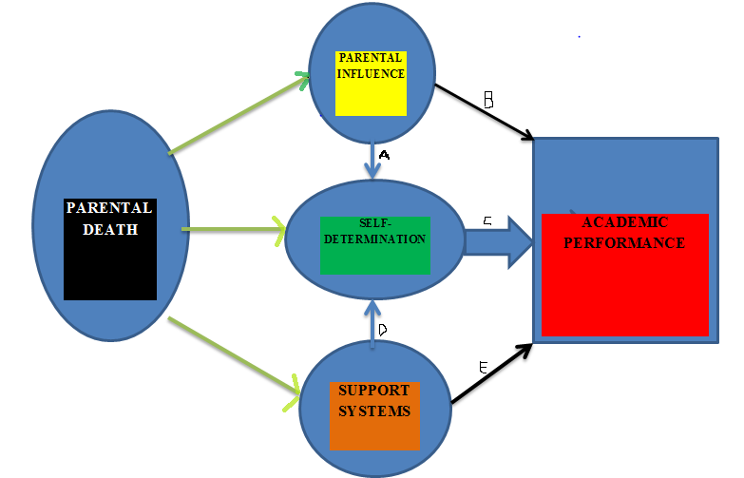

**Figure 2: Diagram Summarizing the Findings from the Study**

**©Source –Faleke, 2022**

Figure 2, firstly depicts the pathways to academic performance. The legitimate path(thick blue arrow C) has at its root, self-determination expressed through sacrifice, focus and hard work among others, Somebody may say but "I have seen undetermined students excel academically", that kind of "good" academic performance is best tagged QUASI-Good Academic Performance. For instance when parents use their influence to secure good grades or when support systems like teachers or school structures, adopt the “let him/her go”–sympathy approach. The two black arrows (C and E) explain this second pathway, it shows the relationship between the intervening variables; both "support systems" and "parental influence" are expected to fuel/aid the determination of the student to achieve good academic performance.

Therefore, this study has been able to find the missing link between the varying outcomes of previous studies **(**Case & Ardington, 2006; Berg, *et al*., 2014; Apelian & Nesteruk, 2017; Kailaheimo-Lönnqvist & Kotimäki, 2020; Liu *et al*., 2022). In other words, the academic outcome of orphans or bereaved students is not primarily a function of the gender of the deceased parent, the support systems available to the student, and by extrapolation is not essentially a product of the cause of death.

**4.8.3 The Coping Strategies Geared Towards Stability and Good Academic Performance**

The findings from the study reveal that most orphans cope with the influences of parental death on their academics by taking personal responsibilities and initiatives, in other words, they are usually more self-motivated. Lesser percentage relies on external initiatives and motivation (See Appendix F). Parental death has been linked to psychological issues, which may explain why it has such a poor impact on school achievement (Berg *et al.,* 2014). According to Oosterhoff *et al.* (2018) youths are most likely to first experience a sudden loss of a loved one during middle adolescence and this often co-occurs with other traumatic events with associated lower school functioning hence the need for coping strategies to enable them to stabilize emotionally and excel academically. Jazmin (2019) reported that the coping strategy used by students was mostly getting support from loved ones; this also aligns with the majority of the respondents' point of view as regards non-personal strategies.

This study has shown that for any orphaned student, among the three intervening variables, what is most essential is the coping strategies adopted by the student, and also that the "powerhouse" of this most vital intervening variable, that is, the coping strategies, is self-determination (see figure 2 above) and what powers or fuels this engine (self-determination) can be any other factor/variable like paternal or maternal influence, support systems, et cetera.

In other words, self-determination is the *constant factor* of any good academic performance equation. From the positivist point of view, this can also be explained empirically by the following equations:

PD +/- MI +/- PI +/- SS **+ K = GAP ----- (1)**

PD +/- MI +/- PI +/- SS **- K = BAP ------ (2)**

**Where PD =Parental Death**

**MI =Maternal Influence**

**PI = Paternal Influence**

**SS =Support Systems**

**K = Self-Determination**

**GAP =Good Academic Performance**

**BAP = Bad Academic Performance**

**+/- = Plus or minus (with or without)**

In agreement with this current study of home and school-based initiatives as regards engaging the copying strategies, School-based involvement and home-based involvement are the two main categories of involvement, according to Serum (2019). She went on to say, "Home-based participation might include scheduled schoolwork and downtime, as well as keeping an eye on the child's academic progress. School-based involvement includes things like volunteering for extracurricular activities, attending school events, and communicating with parents and teachers. Both sorts of involvement can result in beneficial effects for children, such as improved grades, increased participation in advanced coursework, decreased dropout rates, increased drive to complete schoolwork and a greater overall value placed on education."

**4.8.4 The Roles of the Family and the Community in Mitigating Negative Influences**

The importance of support structures in mitigating untoward consequences of parental death on the academic performance of students can never be sidelined or overemphasized. Its essence is captured in findings from this study which Case and Ardington (2006) also affirmed. The authors discovered that children orphans are behind in school when compared to non-orphans with whom they reside. They are less likely to be enrolled than other children, and they spend much less on school-related expenses. One of the student-respondents, **S9** also corroborated this claim, when she revealed that she almost dropped out of school on account of being unable to pay for her school fees (to join three of her brothers who have already dropped out of school) but for the intervention and support of a good Samaritan who came to her rescue.

Furthermore, the findings from this study as depicted in figure 2 also explain the reason for the cases of positive outcomes, that is, good academic performance despite the loss of either father or mother in the study. The account of P4 whose children became award-winning students even at the State level despite the loss of their mother buttresses this point, he claimed that he engaged himself much more than he would have done if their mother was alive. He had to sit with them and counseled them, gave them attention, I also motivated them to believe that nothing is impossible for them if they can only believe in themselves and aspire. This account shows the place of support systems in "fueling" self-determination of orphaned students as depicted in "arrow D" of figure 2.

The roles however from this study are summarized and stratified into financial, academic, emotional, social, and physical. It was discovered from the study that a lot is connected to academic excellence or performance; the student must be socially, emotionally, physically, and financially balanced, for them to be academically fit to get good performance. In addendum, the study found that specifically, financial support is the most essential based on the responses of the participants (As depicted by Appendix L). The reason for this is not far-fetched, money is essential for payment of school fees, buying of uniforms, textbooks, notebooks and other stationeries, buying of food, transportation to school, and several others. So like the popular saying, ‘money indeed answers all things’.

**4.8.5 Integration of Findings with Theories**

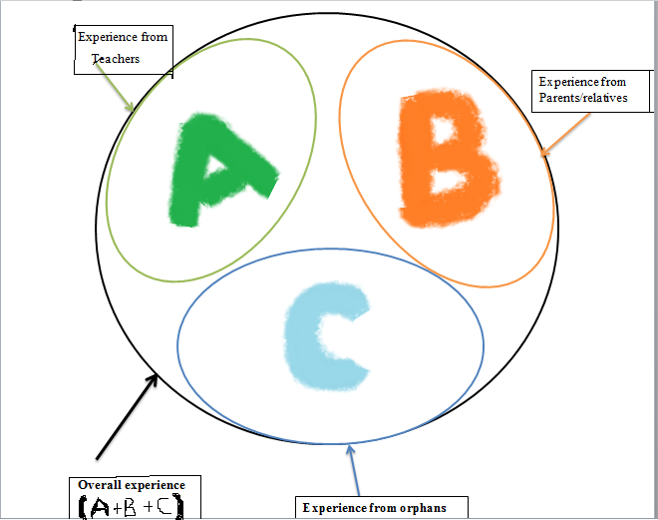

**©Source –Faleke, 2022**

**Figure 3: Diagram Explaining the Application of the Phenomenology Theory in the Study**

Phenomenology is one of the theories adopted for this study, from figure 3 above, the study relied on the lived experiences of the three (3) cohorts of respondents, that is, the students, teachers, and the parents represented in figure 3 as lenses C, A, & B respectively while the overall or summation of all the experiences is the overarching lens represented by (A+B+C) which provided for a comprehensive, rich and multi-cohort based viewpoints with which the researcher was able to carry out an Interpretative Phenomenological Analysis (IPA) which culminated in a most robust the findings of the study.

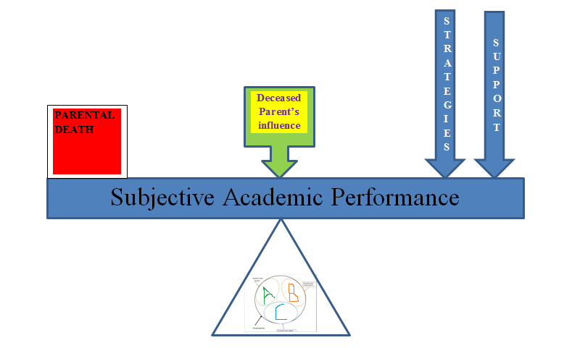

**©Source –Faleke, 2022**

**Figure 4: The Theories and the Variables**

**1.** The fixed **fulcrum** is represented by the concerted **lived experiences** of the respondents.

**2.** The **load** is represented by the **parental death, and**

**3.** The **“Effort” is** captured by the **copying strategies** and **support systems.**

**4.** A variable represented by the **“deceased parent’s distinctive influence”** is included**.**

Figure 4 harmonizes the theories adopted for this study, that is, the structural-functionalist and the phenomenology theories represented by the content of the inferior triangle and every other component of the figure respectively. Functionalism is excellent at explaining social stability. The stability is viewed from the standpoint (using the “analytic lenses” akin to glasses of the three groups of respondents) of the three cohorts interviewed.

In integrating the structural-functionalist theory to the influence of parental death on academic performance in the study, with the background understanding of the structural functionalists’ viewpoint, that disorganization in the system, such as deviant behaviour or in the case of this study –loss of a parent, leads to change which social components must adjust to achieve stability the researcher discovered that attaining and maintaining a level or state of academic stability interpretable as "good academic performance" within the context of this study involves the many "parts" working together to ensure that the particular orphan in question "succeeds". The study showed that despite the death of one or both parents –a kind of intrusion to bring about loss of balance and equilibrium which structural-functionalism upholds (social stability), restoration and/or maintenance of academic balance is feasible when sufficient relevant forces, stakeholders -such as the right coping strategies, adequate and timely support from surviving parent (if available), siblings, extended family members –uncles, aunties, grandparents, and even step-parents come to the fore. Therefore, for this cohort of students to enjoy a state of academic "equilibrium" all stakeholders vis-à-vis relatives, teachers, parents, the community at large, and the government must work together to contribute their" individual" quota.

On a wider scope, according to functionalists like Talcott Parsons, the family is the cornerstone of society and the most important factor in maintaining its efficiency and order. Additionally, they hold the opinion that the nuclear family is more mobile and economically viable than the traditional extended family because it has fewer members, making it best suited for a sophisticated industrial society. In their eyes, a nuclear family consists of a "breadwinner" husband (instrumental superior), a dependent wife (expressive superior), and children, in other words, the fathers are the breadwinner who is more instrumental with power to make practical decisions while the mothers are the expressive charismatic leaders who take care of the family (UKEssays. November 2018). Although mothers can play dependent roles, in the event of the loss of their husbands, they as well play dual roles of instrumental and expressive superior.

Functionalists like Emile Durkheim hold the view that every institution helps to ensure the smooth operation of society, with the family serving the most important role in preventing "society from anarchy" by creating social actors who are "socialized stable individuals." (UKEssays. November 2018). This is the more reason why all hands must be on deck to ensure that orphans get the needed attention to become “stable adults”.

In integrating the phenomenological theory to the influence of parental death on academic performance in the study, the researcher discovered that the lived experiences of the three (3) categories of participants though varying, was unique and provided very essential perspectives needed to understand the phenomenon of the aftermath of parental death on the academic performance of students that were studied. Worthy of note is the fact that speaking from a standpoint of directly lived experience gave meaning and “life” to the study. It also helped to understand and appreciate variables that would have been lost if other approaches were employed. The respondents were free to express themselves without any shred of fear or misgivings and the researcher also was able to “bracket” himself as expected and respectfully respond accordingly during emotional zeniths during the interviews shrouded with the outburst of tears and other personal expressions of burden. For the students, it was also a time of "un-bottling" repressed emotions which have been suppressed for years since in our clime; such matters are rarely discussed with children.

**CHAPTER FIVE**

**SUMMARY, CONCLUSION AND RECOMMENDATIONS**

**5.1 Introduction**

The main thrust of the study was to investigate the influences of parental death on the academic performance of students in selected schools in Omu-Aran, Kwara State. From the findings, several important issues were established. This section is organized into the summary of findings, conclusion and recommendations from the empirical views of the respondents that were interviewed in the study. This was made up of ten (10) orphaned students from the two selected secondary schools, five (5) teachers, and five (5) parents.

**5.2 Summary**

The general objective of this study was to examine the influences of parental death on the academic performance of students in selected schools in Omu-Aran, Kwara State**,** while thespecific objectives were to examine the distinctive influences between maternal and paternal deaths on students’ academic performance in selected secondary schools in Omu-Aran, Kwara State, to examine the coping strategies geared towards stability and good academic performance adopted by orphans in selected secondary schools in Omu-Aran, Kwara State and finally to assess the roles of the family and the community in mitigating negative influences of parental death on academic performance of students in selected secondary schools in Omu-Aran, Kwara State

The study employed a phenomenological research design to look into the influence of parental death on students' academic performance in selected secondary schools in Omu-Aran, Kwara State. A total of twenty (20) respondents took part in the study. Purposive sampling was used to choose all of them. Five (5) school teachers, five (5) parents, and ten (10) orphaned students from two randomly selected secondary schools made up the sample. In-depth and key informant interviews, interview guides, and a recorder were all used to collect data. Data were analyzed qualitatively using Nvivo12 software, which assisted in coding the data, and multiple sub-themes were generated from the data which resulted in the generation of five parent themes which were; 'Distinctive maternal death influences', 'Distinctive paternal death influences', 'External initiatives and motivations', Personal initiatives and motivations', and 'Supportive roles'. Ethical concerns were also strongly supported. This study made the following discoveries; firstly, mothers are the gatekeepers of their children's education, and when they are absent, no other caregiver is as attentive in ensuring that children attend a school or that money for school fees and uniforms is available, most cases of maternal influences are more felt by maternal orphans in secondary and as such, they are likely to do more poorly academically. Allowance must however be made for a few exceptions such as pertains to the educational background of the father, the innate ability of the student, variation in personal experiences, and other variables.

Furthermore, the study also found the coping strategies orphaned students adopt are broadly divided into two vis-à-vis; personal and external initiatives. The personal initiatives such as bracing up, studying harder, discussing with friends, going for lessons, et cetera (i.e. academic initiatives), and the non-academic initiatives such as opening up to friends, speaking to relatives, not thinking about their late parent(s), focusing on the future, resolve to make their parents, guardians, or sponsors proud, farming, trading, et cetera to make ends meet. The external initiatives are the other inputs from friends, relatives, well-meaning individuals, and teachers. Thirdly, the study identified the need for solid support for this cohort of students if their academic pursuit will continue and prosper, the most important in descending order are; financial, social, academic, emotional, and physical. Three serendipitous findings were discovered in the course of the research; the prevalence of positive academic outcomes from orphans in secondary school, the outright lack of any direct support from the government towards orphans, and the relative absence of double orphans from the experience of the respondents interviewed.

**5.3 Conclusion**

From the interviews and subsequent analysis done, it is concluded that even though the death of one or both parents to a child or an adolescent is a grievous, pathetic, and quality of life-defining occurrence, attaining and maintaining excellent academic performance is an achievable goal with self-determination irrespective of the nature of orphanhood (maternal or paternal). The reality from the study however is that majority of the victims of early parental death are adversely affected academically; most are forced to drop out, many lose years at home, and very few of those eventually continue to maintain good academic performance.

Also, the consensus was reached from integrating the respondents’ responses and analysis of data retrieved that mothers are the backbones of their children's education, and when mothers are absent, no other caregiver is as attentive as the mothers would have done in ensuring that children attend a school or that money for school fees and uniforms are available, it was, therefore, alluded that most cases of maternal influences are more felt by maternal orphans in secondary schools and as such, they are likely to do more poorly academically. Allowance must however be made for a few exceptions such as pertains to the educational background of the father, the innate ability of the student, variation in personal experiences, and other variables.

The findings from the study revealed that personal initiatives such as bracing up, studying harder, discussing with friends, going to lessons, and so on (i.e. academic initiatives), and non-academic initiatives such as opening up to friends, speaking to relatives, not thinking about their late parent(s), focusing on the future, resolve to make their parents, guardians, or sponsors proud, farming, trading, and so on constitute the bulk of the coping strategies adopted by orphans. Other inputs from friends, families, well-meaning folks and teachers make up the external initiatives. It can be inferred therefore that self-determination irrespective of the nature of orphanhood (maternal or paternal) is the most important factor in ensuring excellent academic performance

Finally, the support system in the persons of family members, friends, teachers, and well-meaning individuals is very vital. They provide topmost on the list is financial support in terms of school fees, money for books, clothes, and "pocket money" for the daily upkeep of these students. Next is social support, a good number of the students live with their relatives who provide shelter, security, provision of discipline and stand-in for them whenever there is a need for the other social roles expected by their parents to be met. The teachers and guardians also play major roles in the academic well-being of the students. Very essential is their emotional needs; approachable guardians and teachers with listening ears, sensitive hearts, and warm hands. These roles are mainly executed by their relatives with whom the majority live and their teachers. Lastly is the physical needs, among others including; the provision of medical care when they are sick, protection from harm, and provision of basic needs. The home and by direct extension the relatives create the platforms for survival and stability even though the students personally have to engage and adopt whatever strategy is at their disposal per time. The cooperation and engagement of these two stakeholders coupled with an understanding and sensitive teacher will make for a complete, encouraged, and promising child.

**5.4 Recommendations**

**5.4.1 Policy Recommendations for the Government**

The study has revealed that generally that there is no awareness and execution of policies that cater for the welfare of orphans in schools in Nigeria. Because of this, the government should:

* + - 1. Create more awareness in conjunction with the Ministry of Women And Child Development as to the privileges available to orphans.
      2. Work towards having a veritable database of Nigerians as a whole and especially orphans. This will help access, assist, and keep a track of their academic progress.
      3. Set up a committee to ensure routine visits and on-the-ground monitoring and assessment of the school –the facilities, teachers, activities, and welfare of the registered orphaned students.
      4. Scholarship programmes for the confirmed orphans up to the tertiary level.

**5.4.2 Policy Recommendations for the Non-Governmental Agencies (NGOs)**

1. NGOs should prioritize orphans and orphan-focused projects in their budgets and programmes.

2. They can serve as intermediaries to well-meaning individuals who will be willing to assist the orphans.

3. Donation of free materials that will help the orphaned students in school

**5.4.3 Policy Recommendations for the Schools and Teachers**

1. The school management should have records of the essential details of all the orphans for proper tracking; this should include home address and contact of Guardian(s).

2. The school management should schedule routine meetings with the Guardians to get feedback from them and to exchange thoughts as to how best to care for the orphans.

3. Occasional unscheduled visits should be made to the homes of the orphans for an on-ground assessment of how they are faring.

4. Training and re-training of teachers as it pertains to teaching and mentoring skills.

5. The Parent-Teacher Association (PTA) Platform should be used as an opportunity to enlighten and counsel parents/guardians as regards ways to assist orphans to cope with their peculiarities.

6. Teachers should have minimum exposure to guidance and counselling pieces of training.

7. Teachers should be friendlier, more approachable, and more sensitive to the needs of the individual student.

**5.4.4 Policy Recommendations for the Ministry of Women and Child Development**

1. Widows should be empowered through skills acquisition programmes, this will enable them to be financially buoyant to take care of their children.

2. Women generally and especially should be encouraged to embrace the adult education programme since only educated mothers can appreciate and encourage their wards to be educated.

3. Focus should be placed more on the girl-child –who is the mother of tomorrow.

**5.5 Contributions to Knowledge**

**5.5.1 The Study Makes the following Contributions to Knowledge:**

1. Following the inability of the researcher to see any double orphan in both schools selected, the study has raised a red flag by creating awareness as to the need to investigate and track the dropout rates in recent times amongst double or full orphans.

2. This study also contributes to the existing body of knowledge by revealing that self-determination is the most important motivational factor that an orphan needs to perform well academically.

3. The study adds to knowledge by revealing surprisingly several stories of students and even of their parents doing better than they were before they lost one of their parents. Thus, revealing the chances of few positive outcomes despite the parental loss.

* 1. **Prospect for Further Study**

The study identified the following areas for further study:

* + - 1. To ascertain the dropout rates of double orphans who were conspicuously absent from both selected schools, a quantitative study is needed to investigate the prevalence in the same study location.
      2. This study only focused on two selected schools in the North Central Geo-Political Zone of Nigeria, further studies are encouraged in the remaining five (5) zones preferably using the same methodology and objectives for the sake of comparison of findings.
      3. The issues around “step-mothers” and their influence on maternal orphans’ education that sprung up in the study portray a good variable for investigation.
      4. With the striking finding as regards positive academic outcomes in orphans sequel to parental death, another qualitative study with the adult age group as the unit of analysis to examine the same independent variable but now compared with educational or professional attainment is advocated.

**References**

Abalos, E., Rivera, R., Locsin, R., & Schoenhofer, S. (2016). Husserlian Phenomenology and Colaizzi’s Method of Data Analysis: Exemplary in Qualitative Nursing Inquiry Using Nursing As CaringTheory. *InternationalJournalOfHuman Caring*, *20*(1), 19-23. https://doi.org/10.20467/1091-5710.20.1.19

Abankwa .A. (2013) “Relationship between Single Parenting and Academic Performance of Adolescents in Senior High Schools: A case study of Afigya Sekyere District in Ashanti Region achievement in single- versus two-parent families*. Journal of Marriage and Family,*

Ainsworth, M., K. Beegle, & G. Koda. (2005). “The Impact of Adult Mortality and Parental Deaths on Primary Schooling in Northwestern Tanzania.” Journal of Development Studies 41:412–39.

Ajiboye, S., & Ajokpaniovo, M. (2019). Grief Reactions and Coping Strategies to Parental Loss among in-School Adolescents in Kwara State, Nigeria. *Anatolian Journal Of Education*, *4*(1). <https://doi.org/10.29333/aje.2019.418a>

Amato, P. R., & Keith, B. (1991). Parental divorce and adult well-being: A meta-analysis.

and resource compensation after paternal death in Finland’, Social ScienceResearch 64(1): 171–83. doi:10.1016/j.ssresearch.2016.10.012

Amato, P. & Anthony, C. (2014). Estimating the Effects of Parental Divorce and Death with Fixed Effects Models. *Journal of Marriage and Family* 76(2): 370–386.

Apelian, E., & Nesteruk, O. (2017). Reflections of young adults on the loss of a parent in adolescence. International Journal of Child, Youth Family Studies, 8(3/4), 79–100.

Beam, M. R., Servaty-Seib, H. L., & Mathews, L. (2004). Parental loss and eating-related cognitions and behaviors in college-age women. Journal of Loss and Trauma, 9(3), 247-255

Berg, L., Rostila, M., Saarela, J., & Hjern, A. (2014). Parental death during childhood and subsequent school performance. Pediatrics, 133(4), 682–689. <https://doi.org/10.1542/peds.2013-2771>

Bergman, A., Axberg, U., & Hanson, E. (2017). When a parent dies – a systematic review of the effects of support programs for parentally bereaved children and their caregivers. *BMC Palliative Care*, *16*(1). https://doi.org/10.1186/s12904-017-0223-y

Bernardi, F. and Boertien, D. (2017). Explaining conflicting results in research on the heterogeneous effects of parental separation on children’s educational attainment according to social background. *European Journal of Population* 33(2): 243–266. Doi:10.1007/s10680-017-9417-5.

Bolton, J., Au, W., Chateau, D., Walld, R., Leslie, W., Enns, J. . . . Sareen, J. (2016). Bereavement after sibling death: A population-based longitudinal case control study, *World Psychiatry*, 15, 59-66.

Brent D, Melhem NM, Masten AS, Porta G, & Payne MW (2012) Longitudinal effects of parental bereavement on adolescent developmental competence. J Clin Child Adolesc Psychol 41(6):778–791. https ://doi.org/10.1080/15374 416.2012.71787

Burrell, L., Mehlum, L., & Qin, P. (2020). Educational attainment in offspring bereaved by sudden parental death from external causes: a national cohort study from birth and throughout adulthood. *Social Psychiatry And Psychiatric Epidemiology*, *55*(6), 779-788. <https://doi.org/10.1007/s00127-020-01846-4>

Bussemakers, C., Kraaykamp, G., & Tolsma, J. (2022). Variation in the educational consequences of parental death and divorce: The role of family and country characteristics. *Demographic Research*, *46*, 581-618. https://doi.org/10.4054/demres.2022.46.20

Case, A., & Ardington, C. (2006). The impact of parental death on school outcomes: Longitudinal evidence from South Africa. *Demography*, *43*(3), 401-420. https://doi.org/10.1353/dem.2006.0022 [Accessed 2 March 2022].

Cerel, J., Fristad, M. A., Weller, E. B., & Weller, R. A. (1999). Suicide‐bereaved children and adolescents: A controlled longitudinal examination. *Journal of the American Academy of Child & Adolescent Psychiatry* 38(6): 672–679.

Charlick, S., Pincombe, J., McKellar, L., & Fielder, A. (2016). Making sense of participant experiences: Inter-pretative phenomenological analysis in midwifery research. *International Journal of Doctoral Studies, 11,* 205-216. Retrieved from http://www.informingscience.org/Publications/3486

Chen, S., Chen, Y-C. & Liu, J-T (2009). The impact of unexpected maternal death on education: first evidence from three national administrative data links. *The American Economic Review* 99(2): 149–153. Coliazzi’s method of data analysis’ exemplar in Qualitative Nursing Inquiry using

Cohen, D. & Crabtree, B. (2006). *Qualitative Research Guidelines Project, Robert Wood*

*Johnson Foundation*, <http://www> +.qualres.org/Home-Prol-3690.html

Copson, Raymond W. (2002) “AIDS in Africa,” CRS Issue Brief for Congress, IB10050, Washington, DC: Congressional Research Service, Library of Congress Corwin Press.

Cresswell, J. (2013). *Qualitative Inquiry and Research Design*, Sage Publications: Thousand Oaks, CA

Daly, K. J. (2007). *Qualitative methods for family studies and human development.*

Doi: 10.2046711091-5710-20.1.1 Economics and Statistics 86, 211-225.Educational outcomes in Norway. Demography 46(3):553–574*Estimate and Recommendations for Intervention,* Washington,DC.

Eppler, C. (2008). Exploring themes of resiliency in children after the death of a parent. *Professional School Counseling*, *11*(3), 189–196.

Fadeiye, J. D. (1985). *A text of social studies; socialization and political culture*,International Organization for NCE and Undergraduate. Etori, Ibadan.

Francesconi, M., Jenkins, S. P., & Siedler, T. (2010). Childhood family structure and schooling outcomes: evidence for Germany. *Journal of Population Economics*, *23*(3), 1201–1231. <http://www.jstor.org/stable/20730787>

Gbadamosi, K. T., (2015), “Spatial Trend and Management of Road Traffic Fatalities in Nigeria. *AcademicJournal Of Interdisciplinary Studies*. https://doi.org/10.5901/mjss.2015.v4n1p25

Gertler, P., Levine, D. I., & Ames, M. (2004). Schooling and Parental Death. *The Review of Economics and Statistics*, *86*(1), 211–225. [https: //www.jstor.org/stable/3211668](http://www.jstor.org/stable/3211668)

Gimenez, L., Chou, S., & Liu, J.-T., & Liu, J.-L. (2013). Parental loss and children’s well-being. *Journal of Human Resources, 48*(4), 1035–1071. doi:10.3368/jhr.48.4.1035

Giorgi, A. (1985). Phenomenology and psychological research. Pittsburgh, PA: Duquesne University Press.

Giorgi, A. (2005). The phenomenological movement and research in the human sciences. Nurse Science Quarterly, 18(1), 75- 82.

Giovanola, J. (2005). Sibling involvement at the end of life, *Journal of Pediatric Oncology*, 22, 222-226.

Grall, T. (2016). A look at custodial parents and child support in the U.S. Retrieved from Weekes-Shackelford V.A. (eds) Encyclopedia of Evolutionary Psychological Science. Springer, Cham. https://doi.org/10.1007/978-3-319-19650-3_2019

Healy-Romanello, M. A. (1993). The invisible griever: Support groups for bereaved children. *Special Services in The Schools*, *8*(1), 67-89. doi:10.1300/J008v08n01_04

Hill, R. (1958). Generic features of families under stress. *Social Casework, 49*(2-3), 139–150.

*Hospice & Palliative Nursing*, *10*(1), 14-16. doi:10.1097/01.njh.0000306709.20045.8f

[https: //www.census.gov/newsroom/blogs/random-samplings/2016/01/a-look-at-custodialparents- and-child-support-in-the-u-s.html](https://www.census.gov/newsroom/blogs/random-samplings/2016/01/a-look-at-custodialparents-%20%20and-child-support-in-the-u-s.html).

Greeff, P. A., & Human, B. (2004). Resilience in families in which a parent has died. *The American Journal of Family Therapy, 32*(1), 27–42. doi:10.1080/01926180490255765

Hunter, Susan, and John Williamson (2000).*Children on the Brink 2000: Updated*

*international organization for NCE- and Undergraduates*. Ibadan: Etori.

*Journal of Marriage and the Family, 53*(1), 43-58

Jazmin Joy E. Dizon (2019). Death of a Parent: Its Effects on Students’ Psychological Well-Being and Academic Resilience Don Bosco Technical Institute-Tarlac, The Phillipines. *Journal of Clinical Child and Adolescent Psychology* 33(4): 673–683.

Kailaheimo-Lönnqvist, S., & Kotimäki, S. (2020). Cause of parental death and child's health and education: The role of parental resources. *SSM - Population Health*, *11*, 100632. <https://doi.org/10.1016/j.ssmph.2020.100632>

Kailaheimo-Lönnqvist, S., & Erola, J. (2020). Child’s age at parental death and university education. *European Societies*, *22*(4), 433-455. <https://doi.org/10.1080/14616696.2020.1719179>

King, N. (1994). The qualitative research interview. In C. Cassell & G. Symon (Eds.), Qualitative methods in organizational research: A practical guide (pp.14-36). Thousand Oaks: Sage.

Lawrence-Webb, C. & Okundaye, J. N. (2006). African American intergender relationship: A theoretical exploration of roles, patriarchy, and love. Journal of Black Studies, 34 (5): 623-639.

Lin, K. K., Sandler, I. N., Ayers, T. S., Wolchik, S. A., & Luecken, L. J. (2004). Resilience in parentally bereaved children and adolescents seeking preventive services. *Journal of Clinical Child and Adolescent Psychology* 33(4): 673–683.

Lincoln, Y. & Guba, E. (1985). Naturalistic Inquiry, Sage Publications, Newbury Park, CA.

Liu, C., Grotta, A., Hiyoshi, A., Berg, L., & Rostila, M. (2022). School Outcomes Among Children FollowingDeathofaParent. *JAMANetworkOpen*, *5*(4),e223842. https://doi.org/10.1001/jamanetworkopen.2022.3842

Maxine, H. (2014). The loss that is forever: The lifelong impact of the early death of a  Mother or Father. *Psychiatric Services*, *48*(4), 553-554. https://doi.org/10.1176/ps.48.4.553

McCubbin, I. H., & Patterson, M. J. (1983). Family transitions: Adaptation to stress. In H. I. McCubbin & C. R. Figley (Eds.), *Stress and the family* (pp. 5–25). New York, NY: Brunner/Mazel mother or father (4th Ed). Washington, Plume Books

Munhall, P. (2012). *Nursing Research, A qualitative perspective*, Jones & Bartlett

Nursing as Caring Theory*, International Journal for Human Caring*, 20, 19-23.

Moustakas, C. (1994). Phenomenological research methods. Thousand Oaks, CA: Sage Publications, Inc.

National Population Commission (2009) 2006 Population and Housing Census of the Federal Republic of Nigeria: Priority Tables, Vol. 1, pgs. 5 & 17, Abuja, Nigeria.

National Population Commission (2009) The Sentinel Survey of National Population Commission, Baseline Report, 2007, Abuja, Lagos, Nigeria.

Nyako, K., & Vorgelegt, V. (2007). *Parental involvement: A sine qua non in adolescents’ educational achievement*. Unpublished Doctoral Dissertation, Ludwig-Maximilians University. Retrieved from <http://edoc.ub.uni-muenchen.de/8384/1/Nyarko_Kingsley.pdf>

Nyarko, K. (2007).*Parental Involvement: A Sine Qua Non in Adolescents’ Educational Achievement*. Unpublished Doctor of Philosophy Thesis, Ludwig-Maximilians-Universität, München.

Ogbemudia, M. I. & Aiasa, M. V. (2013). Influence of home environment on the academic performance of primary five pupils’ in English Language in Orhionmwon Local Government Area of Edo State. Merit Res. J. of Ed. and Rev., 1 (5), 120 – 125

Oosterhoff, B., Kaplow, J., & Layne, C. (2018). Links between bereavement due to sudden death and academic functioning: Results from a nationally representative sample of adolescents. *School Psychology Quarterly*, *33*(3), 372-380. https://doi.org/10.1037/spq0000254

Owens, D. (2008). Recognizing the needs of bereaved children in palliative care. *Journal of*

ParentinginAmerica.(2015).Retrievedfrom <https://www.pewsocialtrends.org/2015/12/17/parenting-in-america/>

Pfeffer, C. R., Karus, D., Siegel, K., & Jiang, H. (2000). Child survivors of parental death from cancer or suicide: depressive and behavioral outcomes. *Psycho*‐*Oncology* 9(1): 1–10. *Phenomenology and psychological research,* University Press: Pittsburgh, PA

Pong, S., Dronkers, J., & Thompson, G. H. (2003). Family policies and children’s school Achievement in Single- Versus Two-Parent Families *Journal of Clinical Child and Adolescent Psychology* 33(4): 713–753.

Prix, I. & Erola, J. (2017) ‘Does death really make us equal? Educational attainment

progress. Developmental Psychology, 27(2), 314-320. (ERIC Journal No. EJ431669)

review of the effects of support programs for parentally bereaved children and their caregivers. *BMC Palliative Care*, *16*(1), 39.

Reichel, M., & Ramey, M. (1987). Conceptual frameworks for bibliographic education theory into practice. *Libraries Unlimited*, 5-7. Retrieved 31 May 2022.

Rollè L, Gullotta G, Trombetta T. (2019). Father involvement and cognitive development in early and middle childhood: a systematic review. *Front Psychol*;10:2405. doi:10.3389/fpsyg.2019.02405

Rosenbaum-Feldbrügge, M. (2019). The Impact of Parental Death in Childhood on Sons’ and Daughters’ Status Attainment in Young Adulthood in the Netherlands, 1850–1952. *Demography*, *56*(5), 1827-1854. https://doi.org/10.1007/s13524-019-00808-z

Salami, S.O. & Alawode, E.A. (2000). “Influence of Single Parenting on Academic Achievement of Adolescents in Secondary School: Implication for Counselling”. University of Ibadan, Ibadan Nigeria. Schooling outcomes: evidence for Germany. *Journal of Population Economics*

Serum, M. (2019). "The Effects of Parental Involvement on Student Achievement: Implications for Students with Absent Parents" Counselor Education Capstones. 106.https://openriver.winona.edu/counseloreducationcapstones/106

Shor, E., Roelfs, D. J., Curreli, M., Clemow, L., Burg, M. M., & Schwartz, J. E. (2012). Widowhood and mortality: A meta-analysis and meta-regression. Demography, 49(2), 575–606. <https://doi.org/10.1007/s13524-012-0096-x>

Smith, J. A., Flowers, P., & Larkin, M. (2009). *Interpretative phenomenological analysis: Theory, method and research*. London: Sage Publications Ltd.

Steele F, Sigle-Rushton W, & Kravdal O (2009) Consequences of family disruption on children’s Synergy Project, executive summary (2000)..

Thyden, N., Schmidt, N., & Osypuk, T. (2020). The unequal distribution of sibling and parent deaths by race and its effect on attaining a college degree. *Annals Of Epidemiology*, *45*, 76-82.e1. <https://doi.org/10.1016/j.annepidem.2020.03.002>

Tonkins, S.A.M., Lambert, M.J. (1996) A treatment outcome study of bereavement groups for children. *Child Adolesc Soc Work J* 13, 3–21. https://doi.org/10.1007/BF01876592

Toynbee, A.K. (1996) Parental Care and Children Roles. Clark University, Mosby C.V.

Triventi, M. (2011). Stratification in higher education and its relationship with social inequality: A comparative study of 11 European countries. European Sociological Review, 29(3), 489–502. <https://doi.org/10.1093/esr/jcr092>

UKEssays.(November 2018). Conceptual Framework For Research Sociology Essay. Retrieved from <https://www.ukessays.com/essays/sociology/conceptual-framework-for-research-sociology-essay.php?vref=1>

UKEssays.(November 2018). Examine functionalism explanations of socialisation. Retrieved from <https://www.ukessays.com/essays/sociology/examine-functionalism-explanations-of-socialisation.php?vref=1>

Wertz, F. J. (2005). Phenomenological research methods for counseling psychology. Journal of Counseling Psychology 52(2), 167 – 177.

Willis, C. A. (2002). The Grieving Process in Children: Strategies for Understanding, Educating, and Reconciling Children's Perceptions of Death. *Early Childhood* *Education Journal*, *29*(4), 221-26.

Worden, J. (2009). Grief counseling and grief therapy: A handbook for the mental health practitioner - (4th ed). New York, NY: Springer Publishing Co.

Worden, J., Davies, B. & McCown, D. (1999). Comparing parent loss with sibling, *Death Studies*, 23-1-15.

World Bank, Confronting AIDS: Public Priorities in a Global Epidemic, revised ed. (New York: Oxford University Press, 1999).

[Www.macrotrends.net/countries/NGA/nigeria/](http://Www.macrotrends.net/countries/NGA/nigeria/) (n.d) life-expectancy'>Nigeria Life Expectancy 1950-2022</a>. www.macrotrends.net. Retrieved 2022-07-02

Zimiles, Herbert, & Lee, Valerie E. (1991). Adolescent family structure and educational progress *School Psychology Quarterly*, *33*(3), 372-380. https://doi.org/10.1037/spq0000254

**APPENDICES**

**APPENDIX 1**

**IN-DEPTH INTERVIEW GUIDE FOR STUDENTS FROM SELECTED SECONDARY SCHOOL IN OMU ARA, KWARA STATE**

**INTRODUCTION**

Goof Afternoon Sir/Ma, Thank you for taking out time to talk to me today. My name is Faleke Olaoye Enoch. I am doing a research on the influence of parental death on the academic performance of students in selected secondary schools in Kwara State for my M.Sc. dissertation. I will be recording and taking notes on what appear to be the most essential subjects that we address, and everything will be kept completely confidential.

**QUESTIONS**

Date and Time ------------------------------

Number---------------------------------------

S1. The oral consent script has been read and consent given? (a) Yes (b) No

S2. Gender is: (a) Male (b) Female

S3. How old are you? --------------------

S4. Religion? -----------------------------

S5. What class are you? -----------------

S6. How many years ago did you lose your parent(s)? ----------------

S7. How many are you in the family? -----------

S8. Family type (monogamous or polygamous)? ------------

S9. Do you miss him/her/them?

Prompts: what about him/her do you miss the most?

S10. Has his/her absence affected your scores in exams?

Prompts: How exactly?

S11. How have you been coping in your academics since his/her/their death?

S12. Who pays your school fees?

S13. When is it usually paid?

S14. Who do you live with?

Prompts: do you have time to read at home?

S15. Have your relatives or anyone been supporting you?

S16. How have you been coping with going to school and passing your exams?

S17. Do you think you would have done better academically than you are doing now if it was the other way round i.e. if it was your mother/father that died?

S18. Suggestions to government, community, relatives, and teachers in assisting orphans in secondary schools?

S19. Any difference in your academic performance before and after your parent(s) death?

**APPENDIX 2**

**KEY INFORMANT INTERVIEW GUIDE FOR TEACHERS OF STUDENTS FROM SELECTED SECONDARY SCHOOL IN OMU ARA, KWARA STATE.**

**INTRODUCTION**

Good Afternoon Sir/Ma, Thank you for taking out time to talk to me today. My name is Faleke Olaoye Enoch. I am doing a research on the influence of parental death on the academic performance of students in selected secondary schools in Kwara State for my M.Sc. dissertation. I will be recording and taking notes on what appear to be the most essential subjects that we address, and everything will be kept completely confidential.

**QUESTIONS**

Date and Time ------------------------------

Number---------------------------------------

T1. The oral consent script has been read and consent given? (a) Yes (b) No

T2. Gender is: (a) Male (b) Female

T3. Age? -----------years

T4. Religion? -------------------

T5. Length of service? -----------------years

T6. From your experience as a teacher, what category of orphans does more poorly in school - Paternal or Maternal?

T7. What, in terms of academic performance are the reasons from your point of view that could be responsible for this?

T8. From your experience as a teacher, in what ways has the death of a parent affected the attitude to schooling and academic performance of students?

T9. What are your suggestions to enhance their academic performance?

T10. Have you noted some symptoms of grief in your bereaved students?

T11. If yes, can you list a few of them and state how they cope?

T12. In what way do orphans differ in school from those with both parents alive?

**APPENDIX 3**

**KEY INFORMANT INTERVIEW GUIDE FOR PARENTS OF STUDENTS FROM SELECTED SECONDARY SCHOOL IN OMU ARA, KWARA STATE.**

**INTRODUCTION**

Good Afternoon Sir/Ma, Thank you for taking out time to talk to me today. My name is Faleke Olaoye Enoch. I am doing a research on the influence of parental death on the academic performance of students in selected secondary schools in Kwara State for my M.Sc. dissertation. I will be recording and taking notes on what appear to be the most essential subjects that we address, and everything will be kept completely confidential.

**QUESTIONS**

Date and Time ------------------------------

Number---------------------------------------

P1. The oral consent script has been read and consent given? (a) Yes (b) No

P2. Gender is: (a) Male (b) Female

P3. Age? -----------------

P4. Religion? --------------------------

P5. Highest level of education ----------------------------------

P6. Occupation? ------------------------------

P7. Occupation of late spouse/relatives? -----------------------------------------

P8. Average monthly income? ----------------------------

P9. Number of children? --------------------------------

P10. Number of years since loss of parent(s) -------------------

P11. What are the main challenges your child has faced in school since he/she lost his/her mother/father?

P12. How has your ward(s) been able to cope with these challenges?

P13. Has he/she got any form of assistance to support his/her schooling after the loss of his/her parent(s)?

P14. If yes, do you think the support has made his/her/their academics better?

P15. Have you noticed changes in your ward(s) attitude to schooling and performance in school generally?

P16. If yes/no, can you give likely reasons for this/these?

P17. Any suggestion to government, well-meaning individuals, teachers, and community at large?

**APPENDIX A**

**Summarizes the Relationship Between the Research Questions, Anchor Codes, Sub Codes, Sub Themes, and Final Themes.**

|  |  |  |  |  |
| --- | --- | --- | --- | --- |
| **Research question** | **Anchor codes** | **Sub codes** | **Sub themes** | **Themes** |
| 1. | Influences | 1ai. Inadequate academic support  1aii. Inadequate care –poor outlook  1aiii. Inadequate follow up.  1bi. Absent motherly companionship.  1bii. Absent motherly spiritual roles.  1biii. Challenges of absent parenting  1biv. Challenges of stepmothers  1bv. Lack of motherly motivation  1bvi. Lack of motherly protective nature.  1bvii. Lack of motherly sacrificial nature.  2ai. Divided attention  2aii. Inadequate provision of basic essentials.  2bi. Absent fatherly companionship  2bii. Absent fatherly inspiration  2biii. Absent fatherly unique love.  2biv. Lack of fatherly sacrificial nature. | 1a.Inadequacies related to  maternal death.  1b.Maternal  Absence related influences.  2a. Inadequacies related to paternal death.  2b. Paternal absence related influences | 1. Distinctive maternal death influences.   2. Distinctive paternal death influences. |
| 2. | Activities |  | 1a. External –Academic  1b. External –Non-Academic.  2a. Personal – Academic  2b. Personal –Non-academic | 1. 1. External Initiatives and Motivations. 2. 2. Personal Initiatives and Motivation. |
| 3. | Support systems |  | 1. Academic. 2. Emotional. 3. Financial. 4. Physical 5. Social. | Supportive Roles |

***Source: Filed Data (2022)***

**APPENDIX B Hierarchy Chart showing the themes and sub themes addressing distinctive influences between maternal and paternal deaths on students’ academic performance in selected secondary schools in Omu-Aran, Kwara State. Coding references (*cr*) for distinctive maternal influence was 55 aggregated, items coded (*ic*) was 13 aggregated as against 19 and 7 of distinctive paternal influence respectively**. Succinctly put, the respondents at 55 different points made comments related to the distinctive influences of maternal death as against the 19 times of paternal. Majority of the respondents (13 out of 20) spoke in favour of the fact that the deaths of mothers have more distinctive influence on the academic performance of students than those of fathers. Also, the most prevalent maternal and paternal factor was that of inadequate academic support and absent fatherly inspiration respectively.

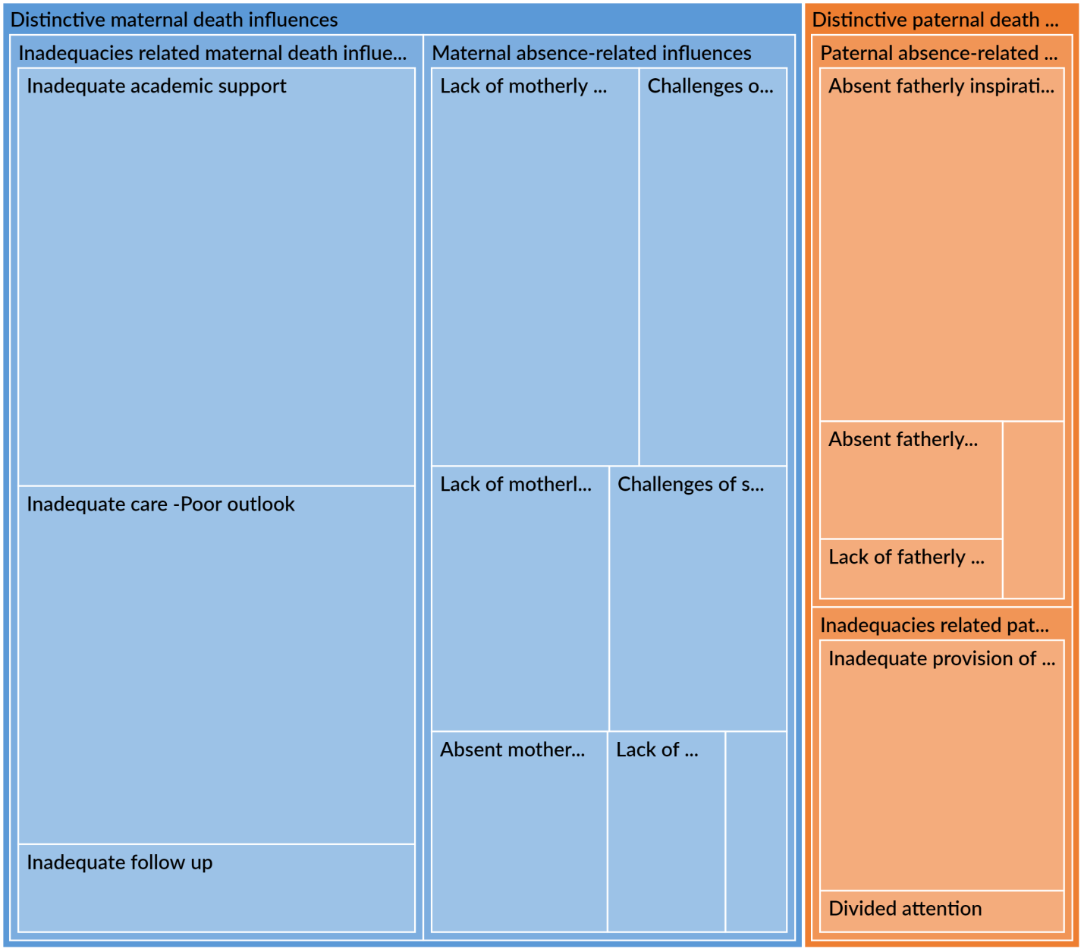

***Source: Filed Data (2022)***

**APPENDIX C**

**Distinctive Paternal Death Influence: Themes and Sub themes. *Cr* in descending order as depicted by the figure is 8, 6, 4, 2, 1, 1, and 1 aggregate for absent fatherly inspiration, provision of basic essentials, lack of fatherly motivation, absent fatherly unique love, lack of fatherly sacrificial nature, absent fatherly companionship, and divided attention respectively.**

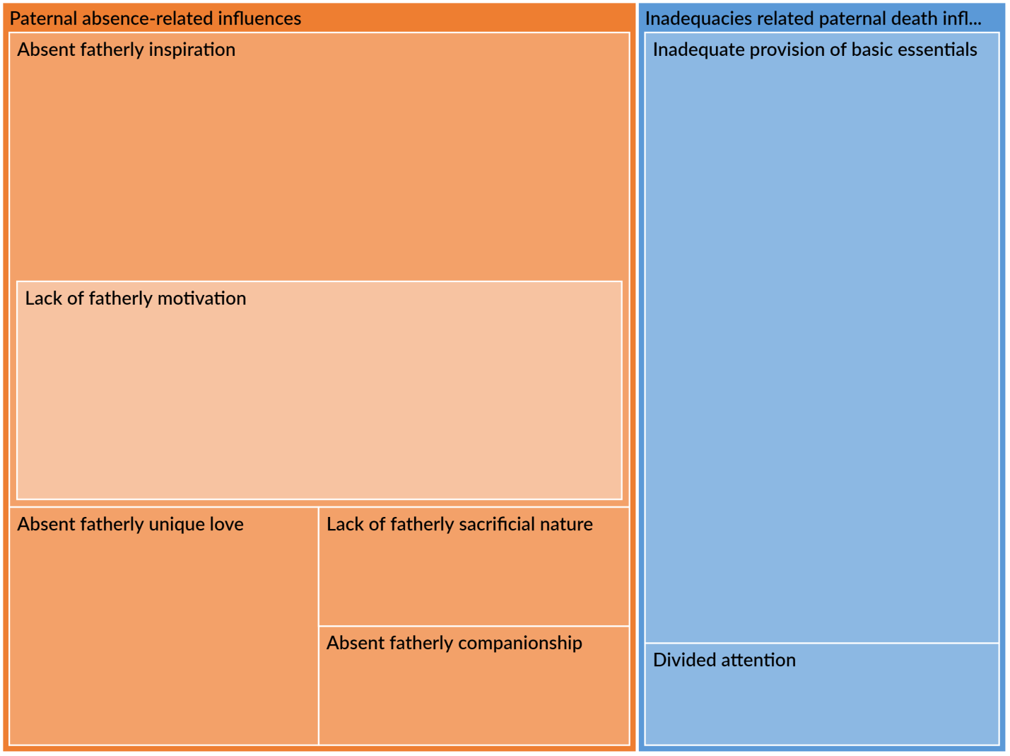

***Source: Filed Data (2022)***

**APPENDIX D**

**Direct Codes Capturing Distinctive Maternal Death Influence on Academic Performance. Inadequate academic support (with *cr* of 14 aggregated and *ic* of 7 aggregated) tops the list while absent motherly spiritual roles (with *cr* 1 aggregated and *ic* 1 aggregated) was the least influence mentioned.**

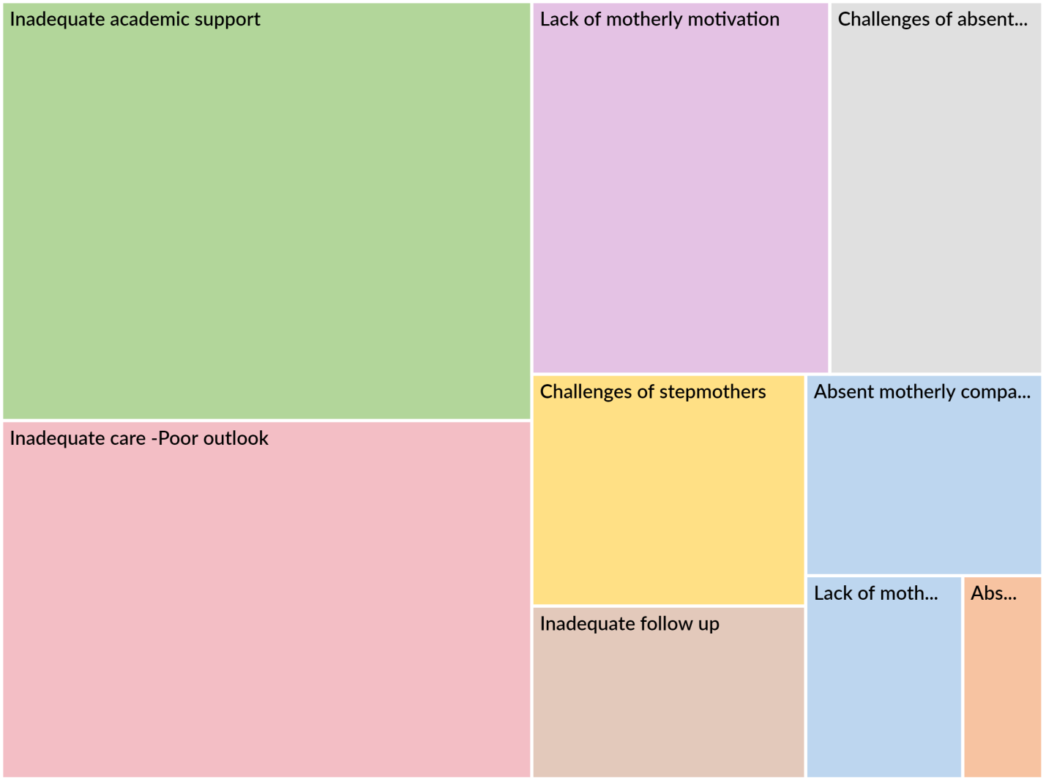

***Source: Filed Data (2022)***

**APPENDIX E**

**Shows the Themes and Sub Themes Addressing Distinctive Influences between Maternal and Paternal Deaths on Students’ Academic Performance and the number of files and references implicated**

| Name | Description | Files | References |
| --- | --- | --- | --- |
| 1. **DISTINCTIVE MATERNAL DEATH INFLUENCES** |  |  | 55 |
| 1. **Inadequacies related maternal death influences** | **These are influences that can still be made by others such as fathers, relatives, friends but are usually the sole responsibilities of the mothers** |  |  |
| Inadequate academic support |  | 7 | 14 |
| Inadequate care -Poor outlook |  | 5 | 12 |
| Inadequate follow up |  | 2 | 3 |
| 1. **Maternal absence-related influences** | **These are influences that are principally made by mothers which others can rarely make in their absence**. |  |  |
| Absent motherly companionship |  | 3 | 3 |
| Absent motherly spiritual roles |  | 1 | 1 |
| Challenges of absent parenting |  | 3 | 5 |
| Challenges of stepmothers |  | 2 | 4 |
| Lack of motherly motivation |  | 5 | 7 |
| Lack of motherly protective nature |  | 1 | 2 |
| Lack of motherly sacrificial nature |  | 4 | 4 |
| 1. **DISTINCTIVE PATERNAL DEATH INFLUENCES** |  |  |  |
| 1. **Inadequacies related paternal death influences** | **These are influences that can still be made by others such as mothers, relatives, friends but are usually the sole responsibilities of the fathers** |  |  |
| Divided attention |  | 1 | 1 |
| Inadequate provision of basic essentials |  | 6 | 6 |
| 1. **Paternal absence-related influences** | **These are influences that are principally made by fathers, which others can rarely make in their absence**. |  |  |
| Absent fatherly companionship |  | 1 | 1 |

***Source: Filed Data (2022)***

**APPENDIX F**

**Hierarchy Chart Comparing Themes and Sub Themes Representing Coping Strategies Adopted by Orphans. Coding references (*cr*) for personal initiatives and motivations was 28 aggregated, items coded (*ic*) was 10 aggregated as against 23 and 9 of external initiatives and motivation respectively.** This simply implies that most orphans cope with the influences of parental death on their academics by taking personal responsibilities and initiatives, in other words they are usually more self-motivated. Lesser percentage relies on external initiatives and motivation.

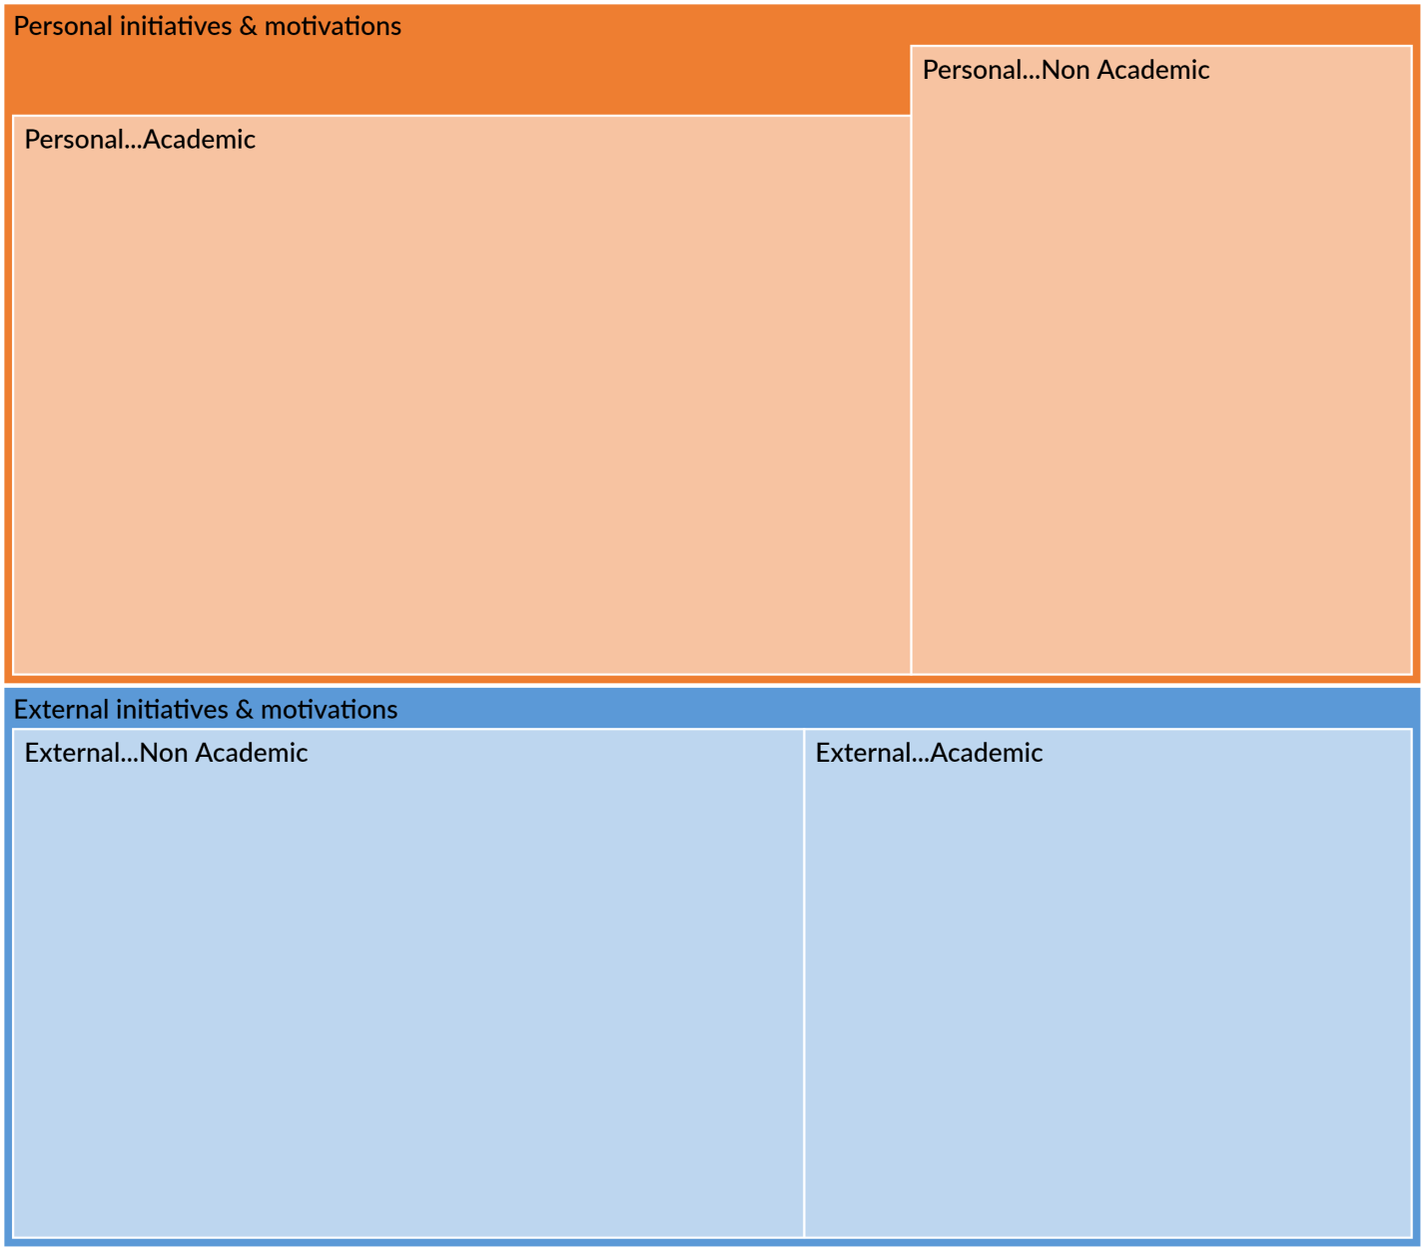

***Source: Filed Data (2022)***

**APPENDIX G**

**Table** **showing the themes and sub themes addressing copying strategies adopted by orphans vis-à-vis external versus personal initiatives and the number of files and references implicated.**

**vis-à-vis external versus personal initiatives and the number of files and references implicated.**

|  |  |  |  |
| --- | --- | --- | --- |
| NAME | DESCRIPTION | FILES | REFERENCES |
| **STRATEGIES -INITIATIVES AND MOTIVATIONS** |  |  |  |
| 1. **External initiatives & motivations** |  |  |  |
| External...Academic |  | 5 | 10 |
| External...Non Academic |  | 7 | 13 |
| 1. **Personal initiatives & motivations** |  |  |  |
| Personal...Academic |  | 8 | 18 |
| Personal...Non Academic |  | 7 | 10 |

***Source: Filed Data (2022)***

**APPENDIX H**

**Hierarchical Chart Showing the Sub Themes of Negative outcome of parental loss juxtaposed with that of positive outcome.** It’s worthy of note that intermediate-negative outcomes has the highest number of codes with *cr* of 38 aggregated and *ic* of 13 aggregated while immediate-negative outcome is next with *cr* 27 aggregated and *ic* 14 aggregated. Another very striking revelation from the chart is the fact that positive outcome (with *cr* 10 aggregated and *ic* 8 aggregated) had more items coded than long term-negative outcome (with *cr* 10 aggregated and *ic* 5 aggregated).

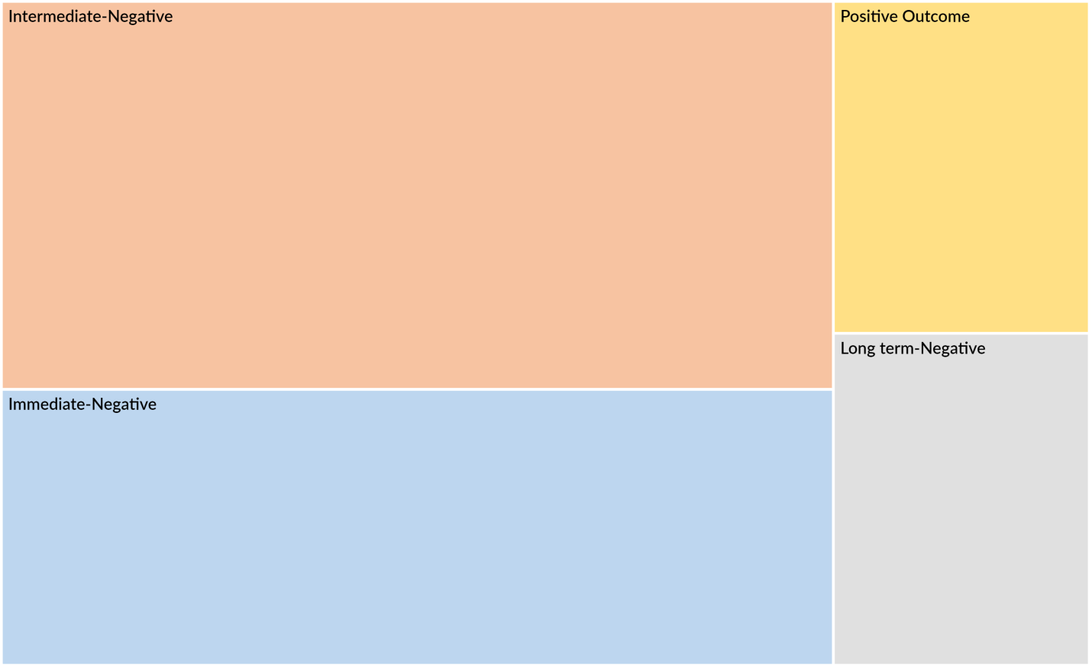

***Source: Filed data (2022)***

**APPENDIX I**

**Word Cloud for Codes on Coping Strategies.** The central and most striking and reoccurring are the words; motivated, motivation, and read. This unveils the essential and very critical role of motivation as a copying strategy.

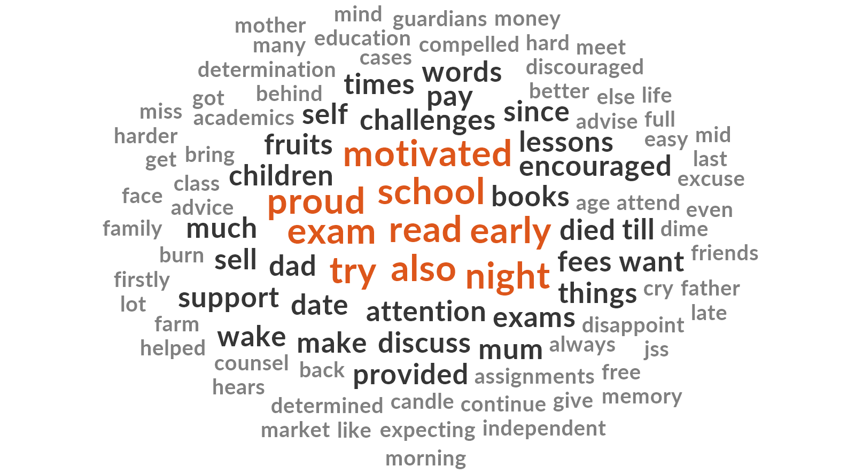

***Source: Filed Data (2022)***

**APPENDIX J**

**Diagram Map Showing the points of Agreement and Dissension in views between Two Parents (P2 and P4), both are Christians, degree holders, have three children each, the former is a widow of three years (still single), while the latter was a widower of 15 years (now remarried).** Both of them believe that the death of their partners have made their children’s academic performance better (positive outcome), they are solely responsible for the upkeep and training of their children (surviving parent), they both affirmed that the copying strategies are mainly from their encouragements at home (Home-passive) even though P2 also said that her children also engage actively at home and in school (Both BHS -Active), and passively at home and in school (Both BHS -Passive). She believes that the influence of parental death has more negative long term implications. P4 in the contrary believes that the influence has more negative immediate implications and being a Records Officer, he recommended that government should “provide other essentials”. In his words; “***I would have advised government to have a genuine database through which they can know the number of orphans, single parents, et cetera in the population. With which appropriate support can be extended to the right quarters***.” government should provide other essentials like. Both of them recommended that well-meaning individuals and government (through giving of scholarships, and financial aids) should help orphans and surviving parents.

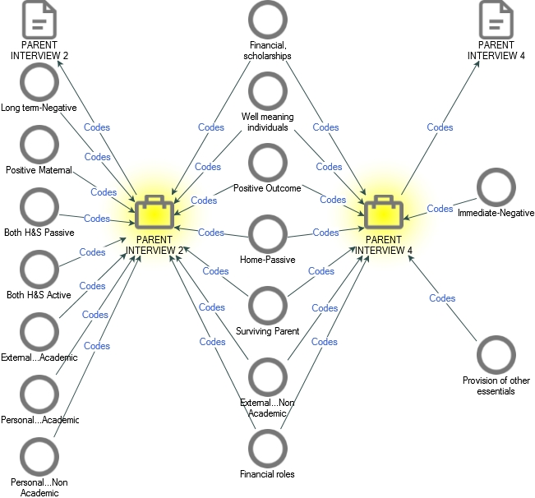

***Source: Filed Data (2022)***

**APPENDIX K**

**Word Cloud for Coded Data Addressing Support Systems.** One of the central and by interpretation one of the most emphasized and frequently used expressions vis-à-vis support systems is “school fees” portraying and corroborating the fact that financial support is fundamental, germane, and very paramount to/ in supporting bereaved children.

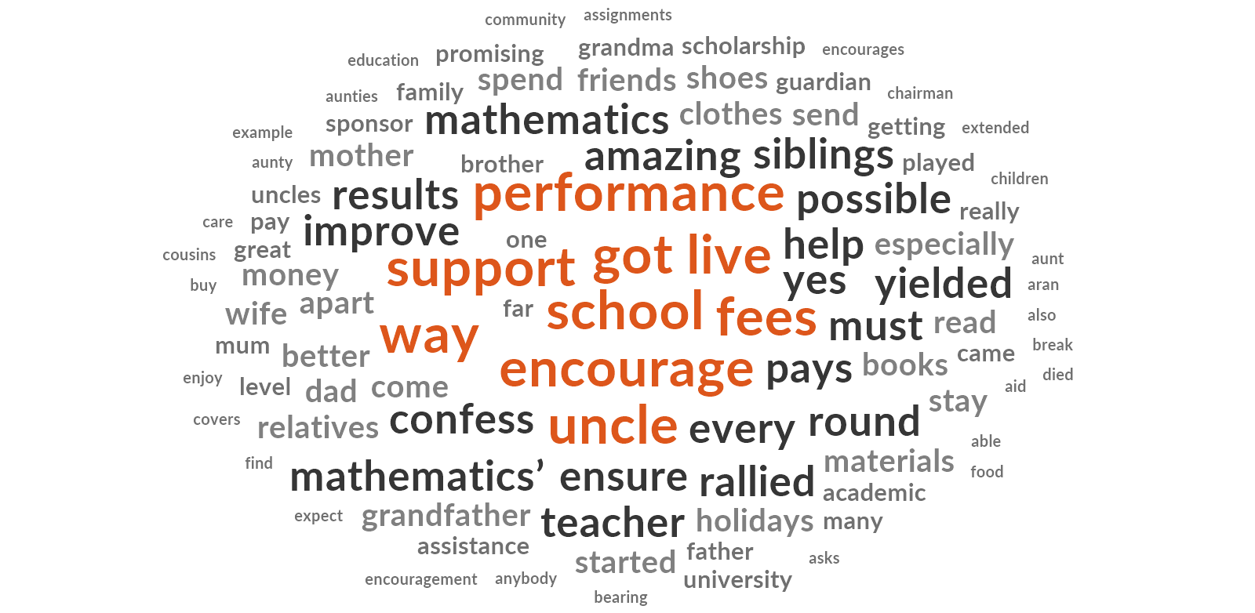

***Source: Filed Data (2022)***

**APPENDIX L**

**Hierarchical Chart Showing the Sub Themes of Supportive Systems. Financial roles being the most prominent followed by social support.**

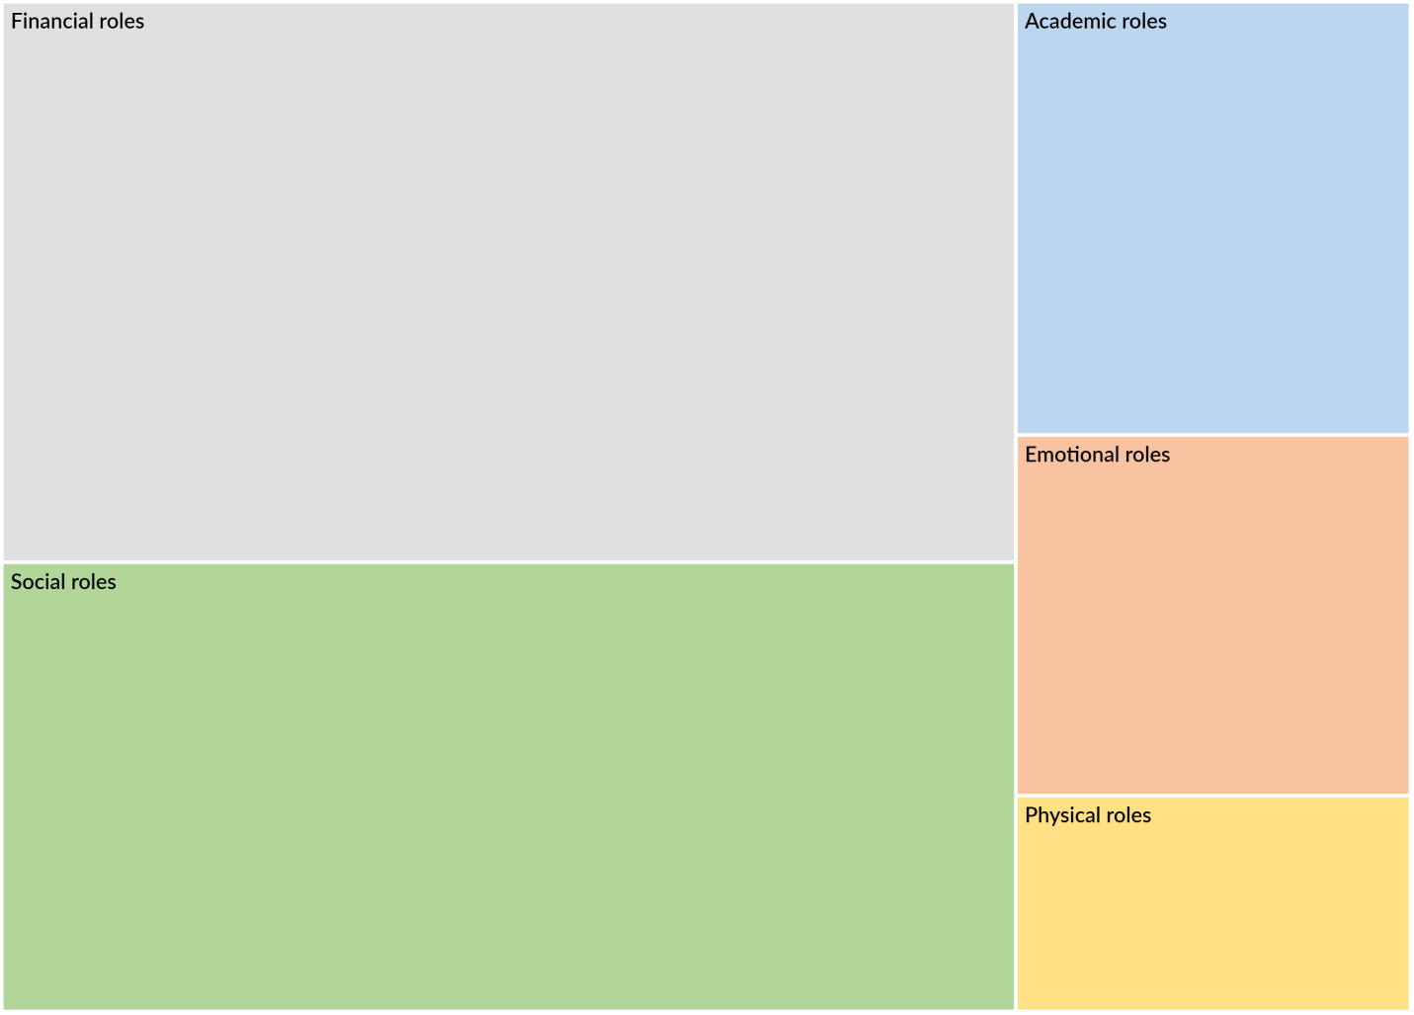***Source: Filed Data (2022)***

**APPENDIX M**

**Hierarchical Chart Summarizing the Respondents’ Recommendations as to Categories of Support Structures that can help the orphaned-students and how they can intervene; top on the list is the government (financial aids, provision of other essentials), followed by well-meaning individuals, teachers, and finally relatives**

**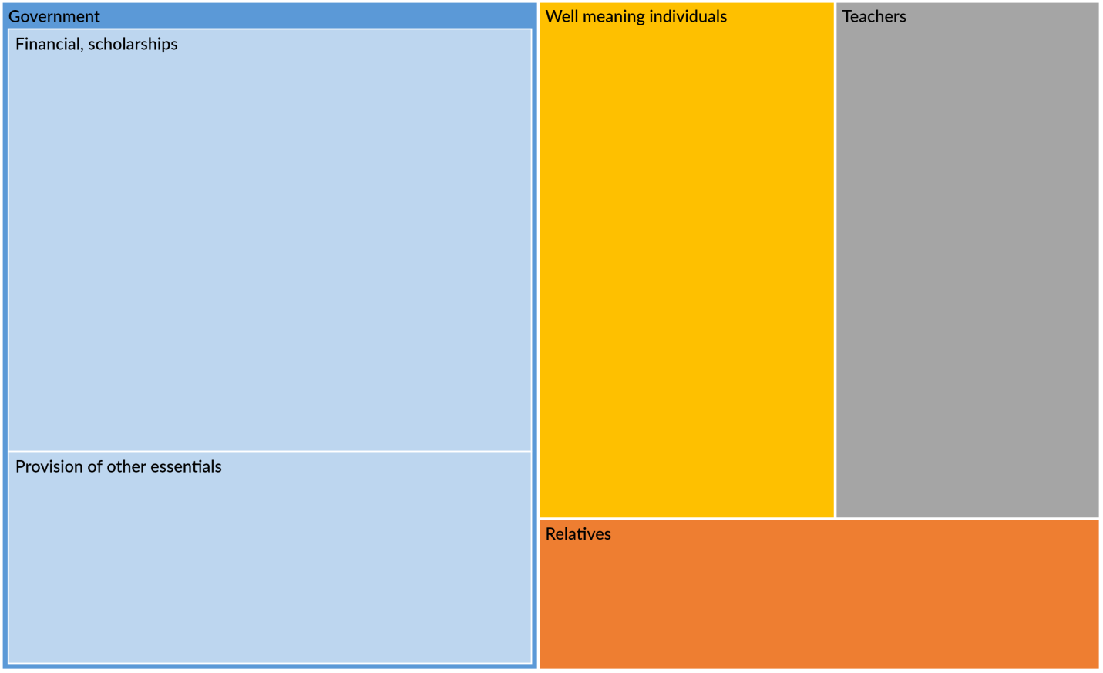*Source: Filed Data (2022)***

**APPENDIX N**

**Hierarchical Chart Showing the Summary of the Entire Study at a Glance.** This is a major advantage of the NVivo 12 software.

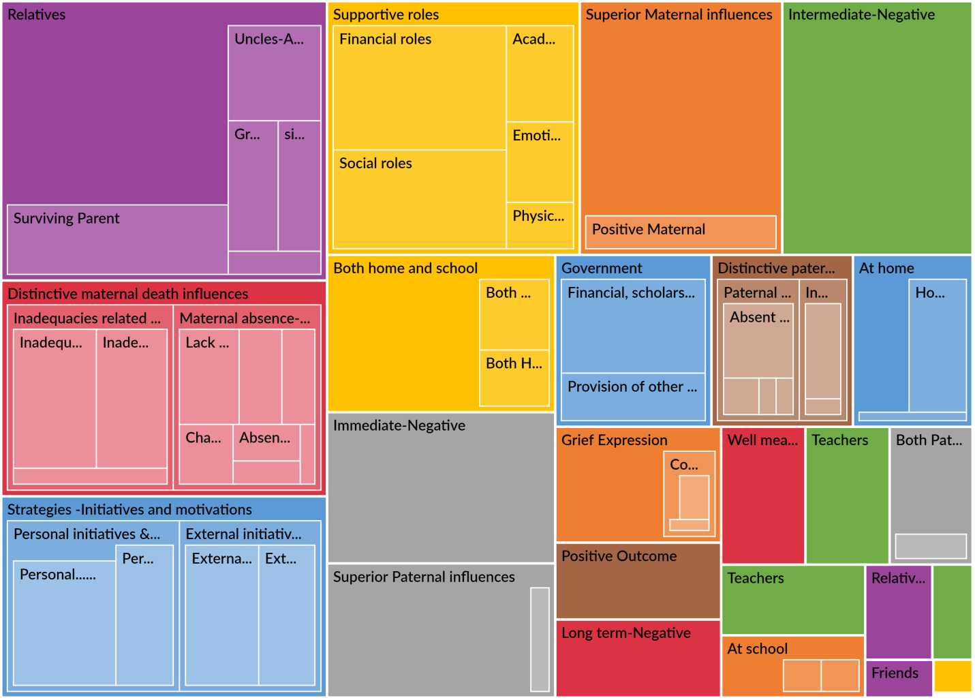***Source: Filed Data (2022)***

Figure 1

**APPENDIX O: Map Tree Addressing Research Question One (1) Codes: It at a glance depicts the most frequently used words that were coded from the answers that addressed research question one (1). From the map tree, words like school, dad, affected, children, absence, father, and fathers were the most frequently used.**

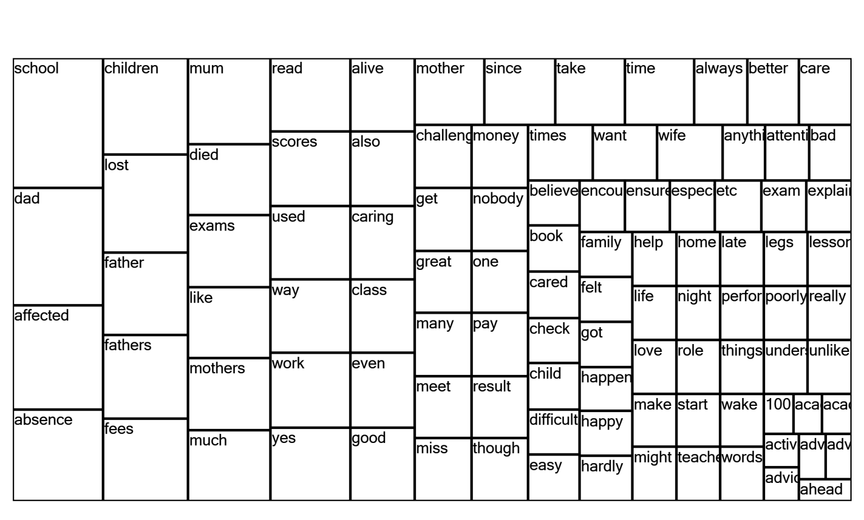 ***Source: Filed Data (2022)***

**APPENDIX P: Cluster Analysis Diagrams Providing a Graphical Representation of Nodes to make it easy to see Similarities and Differences. Cluster diagrams that appear close together are more similar than those that are far apart**.

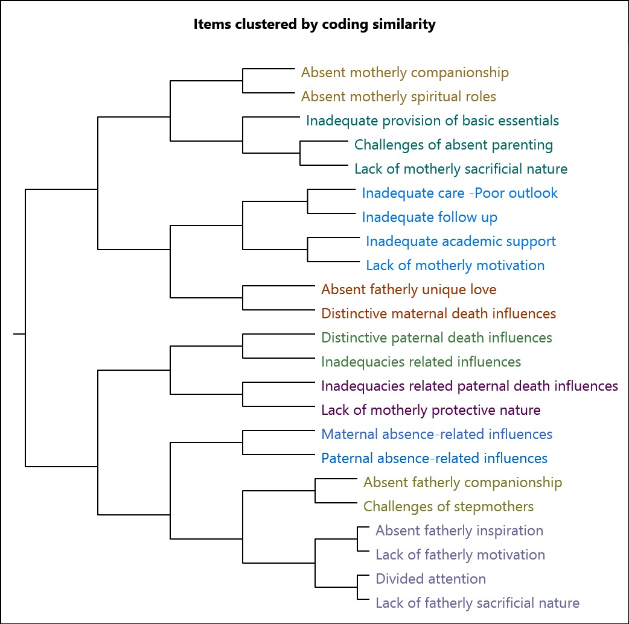

***Source: Filed Data (2022)***