**THE FERMENTATION AND AMINO ACIDS PROFILING OF PROCESSED COWHIDE (*PONMO*)**

**DAODU GLADYS OPEYEMI**

**(14CC003402)**

**IN PARTIAL FULFILMENT OF THE M. Sc. DEGREE FROM TH DEPARTMENT OF FOOD SCIENCE AND MICROBIOLOGY**

**AUGUST, 2022**

# **DECLARATION**

I, (GLADYS, OPEYEMI DAODU), an (**M. Sc.**) student in (**Food Science and Microbiology**), Landmark University, Omu-Aran, hereby declare that this thesis entitled “**The Fermentation and Amino Acids Profiling of Processed Cowhide (*Ponmo*)**”, submitted by me is based on my original work. Any material(s) obtained from other sources or work done by any other persons or institutions have been duly acknowledged.

----------------------------------------

Student’s Full Name and Matriculation number

----------------------

Signature & Date

# **CERTIFICATION**

This is to certify that this thesis has been read and approved as meeting the requirements of the Department of (**Food Science and Microbiology**), Landmark University, Omu-Aran, Nigeria, for the Award of (**M. Sc.**).

|  |  |
| --- | --- |
| ___________________ | _______________ |
| **Dr. Ndako J.** | Date |
| (Supervisor) |  |
| _____________________ | ________________ |
| **Prof. Owa S. O.** | Date |
| (Co-Supervisor) if applicable |  |
| **_______________________**  **Dr. Ndako J.** | Date |
| (Head of Department) |  |
| **__________________________**  **Name** | Date |
| (External Examiner) |  |
|  |  |

# **ABSTRACT**

Cowhide is a delicacy relished by Nigerians especially the Yoruba that’s a by-product of the meat. It involves the skinning of the cow, dehairing, boiling, and soaking (fermentation). The skin has collagen protein that makes it suitable as a fermentation substrate. Fermentation improves food quality in terms of nutrition and sensory and involves the use of microorganisms to act on its amino acid are required for protein synthesis, and modulating homeostasis among other functions. Sulphur amino acids consisting of methionine, cysteine, cysteine, and taurine are also important in the production of glutathione. Spontaneous fermentation was carried out on the cowhide and *Bacillus* isolated from it was then used as a starter culture for the fermentation of the hide also constructing the best environment for the starter culture. The fermentation was subjected to an acidic environment condition using hydrochloric acid (HCl) and sodium hydroxide (NaOH) to control the pH to the desired pH and a slightly alkaline condition using baking soda.

Proximate analysis results of some of the samples identified phosphorus, sodium, potassium, calcium, and magnesium for minerals crude protein, crude fat, moisture content, ash content, total carbohydrate, energy value, and dry matter. The amino acid analysis also detected 17 amino acids namely hydroxyproline, proline, histidine, glutamic acid, alanine, glycine, lysine, valine, serine, threonine, tyrosine, methionine, cysteine, arginine, leucine, isoleucine, and phenylalanine.

Sample with biochemical change of pH 6.0 at inoculum size 7 for 24 hours showed the highest moisture content amongst the other sample and it also had the highest number of amino acid with higher surface area as compared to other samples.

# **DEDICATION**

I dedicate this work to Almighty God for His mighty hand that upheld me through this work.

# **ACKNOWLEDGEMENT**

I like to acknowledge my parents Mr. and Mrs. Daodu for their support throughout this work. I also want to acknowledge my s, Dr. Daniel Dada,l Dada for always pulling through for me.

I also acknowledge my supervisors Dr. Ndako J., and Prof. Owa S. O. for their guidance throughout this work. I also want to acknowledge my friends, family, and the whole faculty and staff of Food Science and Microbiology for their constant guidance.

**TABLE OF CONTENTS**

**DECLARATION** ii

**CERTIFICATION** iii

**ABSTRACT** iv

**DEDICATION** v

**ACKNOWLEDGEMENT** vi

**CHAPTER ONE** 1

**1.0 INTRODUCTION** 1

**1.1 BACKGROUND** 1

**1.2 STATEMENT OF PROBLEM** 2

**1.3 JUSTIFICATION FOR THIS STUDY** 2

**1.4 AIM OF STUDY** 3

**1.5 OBJECTIVES** 3

**1.6 SCOPE OE STUDY** 3

**1.7 SIGNIFICANCE OF STUDY** 3

**CHAPTER TWO** 3

**2.0 LITERATURE REVIEW** 3

**2.1 SKIN HIDE** 3

**2.2 FERMENTATION** 4

**2.2.1 STARTER CULTURE** 5

**2.3 BAKING SODA** 6

**2.4 AMINO ACID** 7

**2.4.1 SULPHUR AMINO ACID** 9

**2.4.1.1 Methionine** 9

**2.4.1.1.1 Methionine Oxidation Reduction Cycle** 10

**2.4.1.1.2 SAM** 10

**2.4.1.2 Cysteine** 10

**2.4.1.2.1 GSH** 10

**2.4.1.2.2 H2S** 11

**2.4.1.3 Taurine** 11

**2.4.1.3 Cystine** 12

**2.4.2 Other Amino Acids** 12

**2.4.2.1 Threonine** 12

**2.4.2.2 Lysine** 12

**2.4.2.3 Phenylalanine** 12

**2.4.2.4 Histidine** 12

**2.4.2.5 Isoleucine** 13

**2.4.2.6 Leucine** 13

**2.4.2.7 Valine** 13

**2.4.2.8 Tyrosine** 13

**2.4.2.9 Arginine** 14

**2.4.2.10 Alanine** 14

**2.4.2.11 Aspartic acid** 14

**2.4.2.12 Glutamic acid** 14

**2.4.2.13 Glycine** 14

**2.4.2.14 Proline** 14

**2.4.2.15 Serine** 14

**CHAPTER THREE** 16

**3.0 METHODOLOGY** 16

**3.1 Sample collection** 17

**3.2 Sterilization of materials** 17

**3.3 Preparation of media** 17

**3.4.1 De-hairing by scalding** 17

**3.4.2 De-hairing by burning** 17

**3.5 Spontaneous fermentation** 17

**3.6 Isolation and identification** 18

**3.6.1 Isolation** 18

**3.6.2 Morphological characterization** 18

**3.6.3 Biochemical identification** 18

**3.6.3.1 Catalase Test** 18

**3.6.3.2 Starch Hydrolysis** 18

**3.6.3.3 Coagulase** 19

**3.6.3.4 Citrate utilization test** 19

**3.6.3.5 Reaction on mannitol salt agar** 19

**3.6.3.6 Indole test** 19

**3.6.3.7 Oxidase test** 19

**3.6.3.8 Methyl red** 19

**3.6.3.9 Voges Proskauer** 20

**3.6.3.10 Sugar fermentation** 20

**3.6.4 Identification of Isolates** 20

**3.7 Processing optimization** 20

**3.8 pH analysis** 20

**3.9 Proximate analysis** 21

**3.9.1 Ash Content Determination** 21

**3.9.2 Fat Content Determination** 21

**3.9.3 Crude Protein Determination** 21

**3.9.4 Determination of Moisture Contents** 22

**3.9.5 Crude Fiber Determination** 23

**3.9.6 Carbohydrate Content Determination** 23

**3.9.7 Mineral Analysis** 24

**3.9.8 Phosphorus Determination** 24

**3.10 Amino acid profiling** 24

**3.10.1 Extraction** 24

**3.10.2 Analysis** 24

**3.10.3 Calculation** 25

**CHAPTER FOUR** 26

**4.0 RESULTS AND DISCUSSION** 26

**4.1 Cultural and Morphology of Isolates** 26

**4.2 Screening for the isolated biochemical properties** 26

**4.3 Optimization of Ponmo Processing Method** 26

**4.4 Colony count** 38

**4.5 Proximate and Mineral Analysis** 38

**4.6 Amino Acid Analysis** 38

**4.6 DISCUSSION** 55

**CHAPTER FIVE** 58

**5.0 CONCLUSION AND RECOMMENDATION** 58

**5.1 CONCLUSION** 58

**5.2 RECOMMENDATION** 58

**REFERENCES** 59

# 

# **CHAPTER ONE**

## **1.0 INTRODUCTION**

### **1.1 Background**

*Ponmo* is beef hide and skin-fermented into soft semi-gelatinous food. *Ponmo* has relished meat among many Nigerians, and especially so among the Yoruba (Okiei *et al*., 2009; Olukibiti *et al*., 2017). *Ponmo* is prepared by skinning a slaughtered cow and other products of the skinning are cow head, cow tail, and cow foot. The skin may be roasted immediately or sun-dried into hide. The skin or hide is roasted to remove hair. The hair-free skin is then cut into pieces and boiled to soften it. After cooling it is soaked in water for further softening and microbial fermentation. It is then ready for sale and cooking. (Okiei *et al*., 2009). Slaughtered cow and other animals provides edible products apart from meat which is usually ingested by humans. Processed cowhide is commonly known as *Ponmo* or *Canda* in Nigeria, and *Wele* in Ghana. It is also one of the frequently soughted meat products in most parts of Africa especially the aforementioned countries. In Nigeria, meat attached to its skin is often consumed as delicacies in meals.

*Ponmo* is rich in collagen and keratin which are proteins commonly regarded as low quality. (Akwetey *et al*., 2013). Collagen can be extracted from the bovine (cow) hide is of type I, which can also be found in human dermis too. Bovine (cow) hide contains a large amount of collagen.

Fermentation is regarded as an inexpensive and old method of preserving foods. It also used to improve food quality. Fermentation technology involves the use of microorganisms or enzymes cultivated from them for production of compounds that have application within pharmaceutical industries, material, energy production, food and chemical industries. The types of fermentation process are solid state fermentation and submerged fermentation. Fermented foods are foods whose nutritional and sensory quality is improved through the fermentation process and they include bread, wine, cheese, meat and meat products (sausage among others).

Starter cultures such as Lactic acid bacteria (LAB), yeasts, Gram-positive cocci, or rods, are also used in the fermentation process. These organisms work on varieties of nutrients usually referred to as substrates which can be protein, starch, or lipids.

Sulphur is needed in various chemical and biological reactions. Methionine, taurine, and cysteine are called sulphur amino acids, because of the sulphur atom present in them. Animals provide more taurine, methionine, and cysteine than plants. These sulphur products are all beneficial to human health. Sulphur in the human body is the eighth most abundant element. Sulphur can be found in our skin, bones, muscles, hair, nails, cartilage and connective tissue is needed to build human structure. Sulphur amino acids play an important role in keeping the balance and scavenging of free radicals in the body. For example cysteine is used in the production of an antioxidant in the body called glutathione (Pizzorno, 2014). Cysteine also plays an important role in the formation of [di-sulfide](https://www.sciencedirect.com/topics/chemistry/disulfide) bond between proteins such as insulin. Studies have been carried to understand and establish sulphur antioxidant mechanisms.

### **1.2 Statement of Problem**

The nutritional quality of *ponmo* has been greatly misunderstood over the years and considered of no nutritional value (Akwetey *et al*., 2013). This is due to the presence of collagen which cannot be metabolize by humans though research has shown that it does have some nutritional value though of low quality compared to other protein-based and it contains approximately 1.23 to 3.58 % fat, 56.46 to 69.19 % protein and 1.33 to 1.94 % ash (Bwirhonde *et al*., 2018). But microorganisms have been known the possess collagenase so there is need to employ the use of microorganism to breakdown the collagen and also how they improve amino acids availability.

### **1.3 Justification for this Study**

Considering the health importance of S-nutrients derivable from ponmo, this study is to explore how to manipulate fermenting organism to optimize the conservation of S-nutrient in dietary ponmo. When achieved and the knowledge is disseminated among the populace it should improve public health to eat ponmo.

### **1.4 Aim of Study**

To ferment *ponmo* and the effect of fermentation on its amino acid profile.

### **1.5 Objectives**

1. Process cowhide into dietary *ponmo*.
2. Isolate from the processed *ponmo* through spontaneous fermentation and use as starter culture
3. Determine the optimal environment for fermentation *ponmo* and its effect on amino acids.
4. To compare the singed and scalded *ponmo* with respect to the fermentation environments and sulphur amino acids.

### **1.6 Scope of the Study**

This study comprises of Omu-Aran abbatoir and Landmark University Microbiology Laboratory.

### **1.7 Significance of the Study**

This study provides insight on how “ponmo” can be used as therapeutic and prophylaxis purposes for diseases.

# **CHAPTER TWO**

## **2.0 LITERATURE REVIEW**

### **2.1 Skin Hide**

Hide is the external surface layers of a mature animal of larger kinds (camel, cattle, etc.) (Adem, 2019). Water makes up 60–70% of the weight of a fresh and protein makes up 25% protein. The protein present makes it a good nutrient source for microorganism to grow. Meat is an essential source of nutrient to human and its short supply in Sub-Saharan Africa as encouraged the demand for meat products in which processed cowhide is one of them. Singed hides and skins are known as *Ganda* in Northern Nigeria, *Ponmo* in Southern Nigeria, and *Welle* in Ghana. ingeing ruminants proceed in West Africa with the application of fuel wood as a major fuel supplier and other alternatives such as; scrap tyres, liquefied petroleum gas, kerosene, hot water, dumped plastics, waste polythene leather bags, and refuse to singe. Cattles, sheeps, and goats are usually singed to rid it of its body hair after slaughteringSlaughtered ruminants such as goats, sheep, and cattle are normally singed to get rid of the body hair before consumption, and singeing is preferred because it maintains the hides and gives meat flavors that are highly desired by the consumers (Zungum *et al*., 2020)

National Agency for Food and Drugs Administration and Control, (26th July, 2019) issued cautionary advice regarding the consumption of hides and skin for possible chemical contaminations that can pose health threats to its consumers (Zungum *et al*., 2020).

Hides and skins are also used as raw materials in the tanning industry that are renewable and easily perishable resources (Juhar *et al*., 2015).

Animal source foods contribute significantly to the nutrients in our food supply and accounts for 60% of total protein intake. It is widely accepted that the nutritional quality of a protein depends on the content and availability of their essential amino acids. It has also been said that compared to plant products, animal skins have greater nutritional value. There are indications that pig, goat, cane rat and dog skins which are usually avoided by some people can contribute a useful amount of nutrients, mineral elements, and amino acids to the human diet (Ajayi and Akomolafe, 2016).

The collagen protein extraction from cowhide provides nutrients for bacteria to grow. This is due to the fact that collagen proteins contain important amino acids required for growth processes and are the source of nutrition for bacteria. (Said *et al*., 2020).

### **2.2 Fermentation**

Fermentation is one of the most inexpensive and oldest method. It is a simple method for preservation of meat and its products in food industry that helps improve nutritional value, flavour and extend the shelf life of foods with the use of microorganisms such as *Lactobacillus, Lactococcus, Streptococcus, Bifidobacterium,* etc. Fermentation is an energy-efficient microbial metabolism of organic substrates, in general, carbohydrates are not completely oxidized, and organic carbohydrates act as electron receptors. Fermented food is food that reacts with microorganisms or enzymes and causes desirable biochemical changes that cause significant changes in food. (Pavan, 2015).

For a long time meat has been preserved by fermentation process. The fermented meat became widely known during the World War II because of their preservation, and its health benefits. At present, 20-40% of the total processed meat products in European countries are fermented meat products majority of them being fermented sausages. Bacteria has been used in food processing to break down proteins like fish, meat, eggs, and milk.

Fermented meat products have their characteristics of aroma and enhanced nutritional value. Physical, microbial and biochemical changes are changes that occur during fermentation. Chemical changes also occur during fermentation and it involves organisms like micrococci and lactic acid bacteria breaking down sugar or reducing nitrites and nitrates to nitric oxide. And these changes are dependent on type of nutrient used as substrate such as proteins and lipids. Use of starter cultures plays a crucial role in fermented foods (Ashaolu *et al*., 2021)

### **2.2.1 Starter Culture**

Starter cultures are microorganisms used to conduct and promote fermentation of meat and its products. Bacteria, especially lactic acid bacteria (LAB) and coagulase negative staphylococci (CNS), molds and yeasts, are microorganisms usually used as starter cultures. They often times increase the food security of fermented meat by producing antimicrobial substances, such as bacteriocins or by rapid matrix acidification. Starters, which are deemed GRAS (Generally Regarded as Safe) by the US Food and Drug Administration (FDA), inhibits the growth of unwanted microorganisms, like spoilage and pathogenic microorganisms. Starters can also help shorten ripening times and also standardize product properties. At present, special attention is been cast on the use of cultures to produce meat products. They are often used in traditional products from places like Croatia, Turkey, Romania, Italy, Greece, Spain, Thailand, Portugal, and China. The use of starter cultures is an important and a sustainable method for preservation of some food and its products, with recognized technological advantages

For meat products, lactic acid bacteria (Gram-positive, catalase negative bacilli or cocci), Gram-positive, catalase positive cocci, mainly CNS, and *Micrococcaceae,* yeasts or molds are organisms mostly used as starter cultures, and they produce several antimicrobial compounds. These microorganisms may be used as singly or combined. They can also be competitive in naturre, out-competing the deteriorating autochthonous or spoiling microorganisms.

Before starter cultures can be selected certain things like the raw material, quality attributes, the properties of the strain(s), and food safety requirements should be taken into account. Lactic acid bacteria are usually used as starter cultures in fermenting meat and its products and include the genera *Leuconostoc, Lactobacillus, Enterococcus, Pediococcus,* and *Lactococcus* and are facultative anaerobes. The facultative anaerobes are the most used the species amongst the CNS, for fermentation of meat products and they include *Staphylococcus carnosus* and *S. xylosus*. In the fermentation of sausages the mostly used aerobes are organisms within the family *Micrococcaceae, Kocuria* spp. *Candida* spp. and *Debaryomyces* spp. are the most commonly used yeasts for fermenting meat and they exhibit a facultative anaerobic or an aerobic metabolism. Molds used starters, as obligate aerobes, are usually inoculated on the surface and belong to *Penicillium nalgiovense* and *P. gladioli.*

Fermented meat and meat products can be a source of biogenic amines (BAs), some amino acids are decarboxylated to form BAs which are potentially unsafe (Bartkiene *et al*.,2019). The formation of these Bas may be formed by microorganismme microorganisms may be responsible for their formation. Starters usually causes a fast pH decrease that inhibits the growth of microorganisms that can decarboxylate amino acid, and prevent the accumulation of BA in fermented meat products.

### **2.3 Baking Soda**

NaHCO3 (Baking Soda) is a white powder that dissolves easily into water and releases carbon dioxide (Hasimuna *et al*., 2020). Sodium Bicarbonate, which is sometimes called Soda Ash is usually used as a cleaning agent. It was first produced in 1791 by French chemist Nicolas Leblanc. In 1843, Alfred Bird refined Soda Ash to make the first version of baking powder. Since then, baking soda has been used as a cooking leavening agent, as a light disinfectant and odorant, as an anti-inflammatory agent, Skin balm for treating skin pain, toothpaste, cleaner and animal feed supplement. When consumed, inhaled, or injected into the skin for more than 30years, it is harmless. Baking soda, or sodium bicarbonate (NaHCO3), In the food industry, it is widely used for processing, pH control, flavor and texture development and up to 2% for leavening. As a cake-baking agent, bicarbonate releases carbon dioxide gas bubbles from baking dough during the roasting process. Besides this, baking soda also has the function to bind cake-forming components. Research has shown that baking soda can also be used for bio-control efficacy in fruit. In another case, baking soda can be used to absorb any odors, such as the bad odor that comes from soured milk (Nefasa *et al*., 2019). A regular intake of baking soda has been shown to support general body functions by regulating the blood’s natural pH levels (Suha *et al*., 2021). The human body can naturally synthesize sodium bicarbonate (baking soda). The stomach and pancreas protect the intestines, and kidneys pull salt, water, and carbon dioxide from the blood to naturally produce baking soda. Baking soda is supposed to provide relief from indigestion, and heartburn, protect the intestines and improve sports performance (Raman and Link, 2021).

### **2.4 Amino Acid**

Amino acids are small molecules present in many food matrices. Amino acids are commonly known for functioning as precursors for ribosomal protein synthesis. However, they are not only components of protein synthesis, but also play a variety of metabolic functions, including transmitters, mitochondrial functions, and modulating homeostasis (Violi *et al*., 2021)

Meat is a rich substrate providing amino acids, peptides, minerals, and vitamins. Collagen proteins contain the amino acids essential to the growth process and are a source of nutrition for bacteria. Meat proteins are very digestible, and the correct amino acid rating is 0.92. (Zhang *et al*., 2010; Lee *et al*., 2020).

Cattle hide has a dermis layer for most of its components and the layer contains collagen protein of about 70-85%. Collagen is a major type of structural protein produced from animal tissue. Until now, collagen has been widely used in the food industry as a gel agent, stabilizer, foam, and emulsifier. The development of collagen extracts is also aimed at reducing the use of chemical preservatives and incorporating natural antioxidants and texture agent as healthy foods. Collagen extracts have not yet been widely used as additives in functional foods.

Most amino acids were isolated and characterized in the late nineteenth and early twentieth century (Bergen, 2021). Amino acids are the main factors determining protein quality in foods.

Amino acids (AA) function as a cell signaling molecules, the protein phosphorylation cascade, and regulators of gene expression. Several amino acids have been known to support the intestinal endocrine function and the intestinal barrier function. The intestinal microbiome metabolizes amino acids and releases numerous metabolites, such as hydrogen sulphide, in the intestinal lumen via catabolic pathways, ammonia, branched-chain amino acids, phenolic, polyamines, and indolic compounds. Adequate dietary supply of amino acids proves gut health and functions (Beaumont and Blachier, 2020).

For example leucine can reduce the effects of dexamethasone on the accumulation of muscle proteins. Amino acid transporters also play a crucial role in thyroid function. Cysteine decreases the ghrelin level in mice while some other amino acids increases it in different species. Although branched-chain amino acids can increase leptin levels, restricting leucine in high-fat diets can increase the sensitivity of leptin. (Flynn *et al*., 2020).

Amino acids also help wound healing, acid-base balance, repair of the damaged skin; and water retention in cellular layers, such as stratum corneum, maintenance of skin microbiome and protection against sunlight damage (Solano, 2020).

Research as shown that L-arginine is in promotes vascular health through the production of nitric oxide. More recently, L-glutamine, L-cysteine, and L-tryptophan have also been shown to modulate vascular function through the formation metabolites, and gases. These amino acids and their metabolites maintain the balance of the vascular system by controlling some essential cell processes, which includes migration, proliferation, senescence, differentiation, contractility, and apoptosis. Furthermore, they show potency in the effect of inflammatory and antioxidants on the circulation and the initiation of lipid accumulation in the artery wall. They also mitigate known risk factors for cardiovascular disease, including diabetes, hypertension, obesity, and hyperlipidemia (Durante, 2020).

The essential amino acids include threonine, valine, lysine, phenylalanine, leucine, isoleucine, histidine and methionine while the non-essential includes aspartic acid, serine, glutamic acid, proline, glycine, alanine, cysteine, tyrosine and arginine (Maloy, 2013)

### **2.4.1 Sulphur Amino Acid**

Sulphur amino acids (SAAs) are amino acids consisting of sulfhydryl, and play an important role in immunity, protein structure, oxidation, and metabolism. Out of the four sulphur amino acids, methionine, and cysteine are considered as primary SAAs. Methionine is an essential amino acid for mammals because it is not synthesized int he required amount for growth Cysteine is also a semi-essential amino acid present in mammals, because L-methionine is a precursor in the trans-sulphuration pathway to produce cysteine. The contents of methionine and cysteine can be considered to determine the dietary requirement of sulphur amino acids for mammals. Their metabolites enables them to give function like glutathione (GSH), taurine, polyamines, and S-adenosylmethionine (SAM), (Bin *et al*., 2017).

According to Kim *et al*., 2020, based on In vitro experiments, amino acids containing sulphur have valuable antioxidant activities, including DPPH, ABTS, antioxidant activities, FRAP, the scavenging activity of hydrogen peroxide and metal chelation, with only cysteine showing a scavenging activity similar to that of standard antioxidants (ascorbic acid).

**2.4.1.1 Methionine**

Methionine is an essential amino acid, sulfur-containing, aliphatic, and a precursor of creatin,e succinyl-CoA, cysteine, homocysteine, and carnitine (Martinez *et al*., 2017). Methionine plays a crucial function in producing products that require single carbon transfers. S-adenosylmethionine is a product of methionine, which has a high energy that affects the formation of choline which is a metabolite intermediates that is of high-energy. Methionine play an important role in synthesis of choline and also in detoxification in the liver. The dietary intake required for methionine is 10.4 mg/kg per day.

### **2.4.1.1.1 Methionine Oxidation-Reduction Cycle**

Methionine residues are easily react to reactive oxygen species (ROS), and are bound to react with ROS to change methionine to methionine sulfoxide (MetO); making the ROS lose its function. MetO can further be reduced by the thioredoxin [Th(SH)2] to methionine through the enzyme methionine sulfoxide reductases A (MsrA) and B (MsrB). Each cycle of methionine residue will eradicate harmful substances such as hydroperoxide, lipid peroxide, hypochlorous, and ozone, and this may be an important natural elimination system of harmful substances.

### **2.4.1.1.2 SAM**

S-adenosylmethionine (SAM) is a product of methionine that occur during the catalysis by the enzyme methionine adenosyltransferase (MAT). It is considered a methyl donor for most of the methyltransferases that modifies RNA, DNA, and other proteins. SAM shows antioxidant ability by the following pathway: by increasing the activity of cystathionine *γ*-synthase (CBS) a primary enzyme in trans-sulfuration that contributes to the production of cysteine, and also increasing the glutathione (GSH) level. Studies has shown that the appliication of SAM restores the tissues and alleviates oxidant stress.

### **2.4.1.2 Cysteine**

Cysteine residues also undergo oxidation like methionine residues. Cysteine residues have redox regulation property because of a special characteristics that make it reacts easily with hydrogen peroxide (H2O2). It is one of the precursor for glutathione GSH, and also the limiting amino acid in glutathione synthesis through the trans-sulfuration pathway. Hydrogen sulfide (H2S), and taurine, are products of GSH and this reflects its antioxidant property.

### **2.4.1.2.1 Glutathione GSH**

GSH is produced through two enzymatic reactions that is ATP-dependent with cysteine, glycine, and glutamate as precursor: Cysteine and glutamate consume ATP by the catalyst *γ*-glutamylcysteine synthetase (GCS) to form *γ*-glutamylcysteine (*γ*-Glucys) and GSH synthetase catalyzes *γ*-Glucys and glycine to form GSH, which also uses ATP.

GSH plays a crucial role in animal as regards cellular anti-oxidation. Glutathione disulfide (GSSG) is produced by oxidization of glutathione by the free radicals and other ROS (such as lipid peroxide radicals, H2O2, and hydrogen radicals) released. Further catalysis of GSSG by glutathione reductase reduces it to GSH. This cycle helps the eradication of other reactive species and free radicals, and it also prevents biomolecules oxidation. GSH also plays an assisting role in the anti-lipid peroxidation of GSH-Px. Low levels of GSH has been believed to result in lipid peroxidation.

### **2.4.1.2.2 H2S**

H2S has been deemed a toxic gas produced by mammalian tissues in a considerable amounts, and recent research has revealed that it plays an important role as an anti-inflammatory, neuro-protective, and antioxidant agent and also perform various physiological functions. L-Cysteine is a major precursor used in production of about 70% of endogenous H2S by either cystathionine *γ*-lyase or cystathionine *β*-synthase. And recent research, observed a novel pathway that produces H2S from D-cysteine and may be more effective than using L-cysteine as precursor. H2S is thought to be a powerful lantioxidant, but it is only used to directly eliminate reactive oxygen and nitrogen species to protect tissues.

### **2.4.1.3 Taurine**

Taurine plays a major role in many physiological functions and it’s the most abundant free amino acid present in mammals, the physiological functions include neural development, visual development, anti-inflammatory, detoxification, anti-oxidation, and so on. The main precursors of taurine production in the mammals are metabolism of cysteine and absorption from diets. Synthesis of taurine is by three steps which are catalysis of cysteine by cysteine dioxygenase to give cysteine sulfinate; removal of carboxyl by cysteine sulfinate decarboxylase from cysteine sulfinate to form hypotaurine; then oxidation of hypotaurine to form taurine. Researches has shown increase intake of cysteine increases level of taurine in the body especially in HIV-infected person.

Taurine protects tissues and its antioxidant ability to ROS scavenging. It has also been reported that taurine inhibits the production of ROS by helping the mitochondria to absorb Ca2+.

### **2.4.1.3 Cystine**

The dietary intake required for cystine is 4 mg/kg per day. It can replace methionine and thus considered a semi-essential amino acid (Huang *et al*., 2017).

Deamination of an amino acid leads to the production of ammonium through non-enzymic hydrolysis and their carbon skeletons is s available for energy-yielding metabolism.

### **2.4.2 OTHER AMINO ACID**

### **2.4.2.1 Threonine**

Threonine is important in the synthesis of mucin and in maintenance of intestinal integrity. Threonine also help synthesis of glycine, immune functions, O-linked glycosylation, and protein phosphorylation. The dietary intake required for threonine is 15 mg/kg per day.

### **2.4.2.2 Lysine**

Lysine is an essential amino acid because mammals can’t synthesis it and its major role is in production of protein synthesis. Use of L-lysine as supplements enhances calcium absorption in the gut and filtered reabsorption of calcium in the kidney. The dietary intake required for lysine is about 30 mg/kg per day.

### **2.4.2.3 Phenylalanine**

Phenylalanine plays an essential role in the metabolic steps involved in dopamine synthesis with tyrosine its metabolite. Low level of phenylalanine results in high dopamine synthesis which as an adverse effects on mental health. It has also been reported that in visceral tissue, phenylalanine determines its protein synthesis. The dietary intake required for phenylalanine is 25 mg/kg per day.

### **2.4.2.4 Histidine**

It was observed in a research that persons fed with histidine free foods had adverse changes in their which proves histidine to be an essential amino acid. Histidine also plays a role modulating the oxidation degradation of DNA that affects different organisms and their physiological systems. Histamine is a metabolite of histidine and it functions as a possible neurotransmitter in brain, is a significant metabolite of histidine. The dietary intake required for histidine is 10 mg/kg per day.

### **2.4.2.5 Isoleucine**

Isoleucine is stored in large amounts in animals and humans even though they cannot synthesis it themselves. As an essential amino acid and should be consumed in diet. Isoleucine is a precursor to the synthesis of alanine and glutamine and also gives balance to branched-chain amino acid. The dietary intake required for isoleucine is 20 mg/kg per day.

### **2.4.2.6 Leucine**

Leucine is a branched-chain amino acid balance that forms muscle tissue and sterols in adipose. They function as a flavour enhancer and glutamate dehydrogenase activator. The dietary intake required for leucine is 39 mg/kg per day.  Leucine has also been shown to play important roles in the muscle primarily through the mTOR pathway like arginine, D-aspartate and glutamine though this effect of leucine does not cut across every population.

### **2.4.2.7 Valine**

The major function of valine and also like isoleucine is their function as a precursor for production of glutamine and alanine and giving balance to branched-chain amino acid. The dietary intake required for valine is 26 mg/kg per day.

### **2.4.2.8 Tyrosine**

The dietary intake required for tyrosine is 25 mg/kg per day. Tyrosine is as aromatic amino acids and a metabolite of phenylalanine. Sufficiency of tyrosine in the body is dependent on phenylalanine. Tyrosine can be synthesized so far the enzymes needed are present in the body and there is sufficient phenylalanine in the body and in the absence of the two becomes indispensable. The function of tyrosine is associated with sulfation, protein phosphorylation, and nitrosation. Tyrosine also serve as a precursor for the production of norepinephrine, dopamine, thyroid hormones, and epinephrine.

### **2.4.2.9 Arginine**

Arginine is essential only when there is a high anabolic activity, such as the tissue growth of childhood. Arginine also plays a crucial role in healing of injuries, regulation of blood pressure, the release of hormones, and immune function.

### **2.4.2.10 Alanine**

Alanine is a non-essential amino acid that can be produced in the body. Alanine inhibits hepatic autophagy and pyruvate kinase, gluconeogenesis, glucose–alanine cycle and transamination.

### **2.4.2.11 Aspartic acid**

Aspartic acid is present in invertebrates and vertebrates neuroendocrine tissues. Functionally, aspartic acid participates in the development of the human nervous system, visual activity, and has a role in neurotransmission.

### **2.4.2.12 Glutamic acid**

Glutamic acid is also one of the precursor needed for synthesis of proteins. It is a non-essential amino acid that can be produced in the human body. Glutamic acid functions in the nervous system of a vertebrate as an important neurotransmitter and a precursor for other neurotransmitter synthesis such as gamma-aminobutyric acid (GABA). Glutamic acid is a determinant of healthy brain function and development in humans.

### **2.4.2.13 Glycine**

Glycine is a neurotransmitter, one of the precursor for synthesis of proteins, and a biosynthetic intermediate. Research has reported that the quality of sleep can be improved by glycine.

### **2.4.2.14 Proline**

### Proline has the main function of maintaining collagen matrix and function, acting as a neuroprotective and osmoprotective agent.

### **2.4.2.15 Serine**

Serine is involved in the production of pyrimidines and purines. Serine is a precursor to some amino acids production such as cysteine and glycine. D-Serine is a signaling molecular in organs, peripheral tissues, and nervous system. It also perform a function in gustatory sensation.

# **CHAPTER THREE**

## **3.0 METHODOLOGY**

**Figure 3.1:** Research design layout

### **3.1 Sample collection**

Rawhide was obtained from the omu-aran abattoir.

### **3.2 Sterilization of materials**

All the materials used were sterilized using the hot air oven, autoclave, and 70% ethanol.

### **3.3 Preparation of media**

Nutrient agar, MacConkey agar, and Blood agar were prepared as described by the manufacturer’s instruction and sterilized in an autoclave for 121oC for 15 minutes. **3.4 Ponmo production**

Cowhides are often processed by skinning, dehairing, washing, boiling, cutting, soaking and cooling (Okiei *et al*., 2009).

### **3.4.1 De-hairing by scalding**

The cowhide was scalded using hot water and a blade used to scrape off the scalded hair, the de-haired skin was then rinsed properly to get rid of the hair particles, and soaked in hot water at 100oC for 60 minutes to give a tender skin.

### **3.4.2 De-hairing by burning**

A portion of the hide was placed on a gas burner and the hair was passed over an open flame of a gas burner to burn, then a knife was used to scrape off the singed hair. The de-haired hide was then boiled for 1 hour (Ademola *et al*., 2022).

### **3.5 Spontaneous fermentation**

A portion of hide de-haired by burning and boiling was subjected to a spontaneous fermentation in sterile water at room temperature, and a knife was used to test for the softness of the hide to establish fermentation time. The hide was fermented for 8 hours, 24 hours, and 48 hours and tested for its softness to confirm a method adopted from Ademola *et al*., (2022).

### **3.6 Isolation and identification**

### **3.6.1 Isolation**

Water samples from the fermented hide at 8, 24, and 48 hours were plated out on Blood agar and MacConkey agar and incubated at 37oC for 24 hours to isolate organisms likely to be responsible for the fermentation of the hide. A representative colony was then sub-cultured to obtain the pure culture of the isolates at 37oC for 24 hours.

### **3.6.2 Morphological characterization**

Purified isolates were screened with Gram dyes to determine morphology. A light suspension of a single colony was smeared with a sterile loop on a sterile slide, allowed to air-dry then heat fixed. The smear is flooded for 60 seconds with crystal violet, washed with water, and flooded for 60 seconds with Gram iodine. The iodine was washed off and the smear was decolourized with 95% acetone for 5 seconds and washed off immediately. The smear was then flooded with safranin as a counter stain for 60 seconds, rinsed with water, air-dried, and observed under the microscope using the oil immersion and X100 immersion oil objective.

### **3.6.3 Biochemical identification**

The pure isolates of some selected were subjected to some biochemical reactions namely catalase, coagulase, oxidase, indole, MRVP, citrate, mannitol salt agar, and sugar fermentation (glucose, sucrose, lactose, galactose, fructose, sorbitol, mannose, mannitol, maltose, and glycerol) to identify the isolates.

### **3.6.3.1 Catalase Test**

The pure culture of each isolate was sprayed onto the surface of a droplet of 3% hydrogen peroxide in a clean and sterile microscope. The presence of white precipitation is positive, while the absence of white precipitation is negative.

### **3.6.3.2 Starch Hydrolysis**

Starch added with agar agar was prepared and the isolates were cultured on it in a straight line and incubated for 24 hours at 37oC. After incubation the petri dish was flooded with Lugos iodine solution for 60 seconds and the iodine was decanted. Positive result shows a golden colour on the inoculated area while a negative result shows a blue black colouration

### **3.6.3.3 Coagulase**

A single colony from pure culture of the isolates was smeared on the surface of a drop of a blood plasma on a sterile microscope. Presence of agglutination shows a positive result while absence shows a negative result.

### **3.6.3.4 Citrate utilization test**

Fresh and pure cultures of the isolates were inoculated on Simmon citrate agar slantusing a sterile loop. The slants were incubated for 24 hours at 37oC. Utilization of the citrate after incubation changes the colour to blue.

### **3.6.3.5 Reaction on mannitol salt agar**

Pure culture of the isolates was inoculated on mannitol salt agar and incubated at 37oC for 24 hours. Positive results shows a change of colour to yellow on the petri dish.

### **3.6.3.6 Indole test**

Some of the isolates were inoculated into 10ml of peptone water and incubated at 37oC for 24 hours. The incubated sample was mixed using a vortex mixer and two drops of Kova’s reagent were added. The appearance of a pink ring form indicates a positive result while a yellow ring form indicates a negative result.

### **3.6.3.7 Oxidase test**

Some of the isolates were inoculated with 5 mL of peptone water and incubated for 24 hours at 37°C. After incubation, the oxidase test strip was then dipped into the broth culture and removed to stay for 30 seconds. The colouration of purple colour indicates a positive result.

### **3.6.3.8 Methyl red**

The pure culture of the isolate was inoculated into 5 ml of peptone water and incubated at 37oC for 48 hours. Two drops of methyl red were then added after incubation.

### **3.6.3.9 Voges Proskauer**

The pure culture of the isolate was inoculated into 5 ml of peptone water and incubated at 37oC for 48 hours. Two drops of 50% Naphthol followed by 2 drops of KOH (potassium hydroxide) were then added after incubation.

### **3.6.3.10 Sugar fermentation**

Ten sugars were used for the sugar fermentation namely sucrose, sorbitol, galactose, lactose, fructose, mannose, mannitol, maltose, glycerol, and glucose. 1% of each sugar was prepared into peptone water and 3 drops of phenol red as an indicator. Pure isolates were then inoculated into the sugars and incubated at 37oC for 24 hours and observed for colour change. A yellow colour indicates a positive result while no colour change indicates a negative result.

### **3.6.4 Identification of Isolates**

Bergey’s Manual of Systemic Bacteriology was applied in the identification of the isolates and were further sent for molecular identification

### **3.7 Processing optimization**

20 ml of sterile water was dispensed into various containers and the containers were divided into two groups containing different environment conditions. One group contain a controlled pH of different level which were 5.5, 6.0, and 6.5. While the other group contain addition of baking soda at different concentrations which were 0.2g, 0.5g, and 1g. 2g of ponmo de-haired by burning and by boiling were weighed and added respectively to the various environment conditions.

Serial dilution from a broth culture of *Bacilus* was carried out and 1 ml of power 7 and 9 was dispensed into 100ml of PBS (Phosphate Buffer Solution). 1ml of each PBS was then added to the various containers and allowed to ferment for hours of 24, 48, and 72.

**3.8 pH analysis**

The pH probe of a pH meter was dipped into each container to determine its pH after fermentation at interval of 24, 48, and 72 hours (Da Silva *et al*., 2019).

### **3.9 Proximate analysis**

### **3.9.1 Ash Content Determination**

Ash content was determined by using a furnace at 600°c. 2 g of the samples were weighed an ignited tarred crucible (W1). The crucible that contained the sample were placed on the hot plates inside the combustion tank to prevent the smoke from accumulating, the rest of the residues were transferred to a pre-heated muffler furnace for 6 hours, and the residues were transferred to the ash.. The crucible was then removed and placed in the desiccator, cooled and weighed (W2) and the ash content was evaluated using the formula below (Thiex *et al*., 2012):

% Ash (on dry basis) = W2-W1 x 100

2.0 g

### **3.9.2 Fat Content Determination**

Fat content was determined using the Soxhlet extraction method. 2 g of the samples were weighed into a thimble (W1), dried and the boiling flask was weighed after cooling, and then filled with petroleum ether of about 300 mL (W2), and then boiled at 60°c using the extraction thimble in soxhlet apparatus for 6 hours. The thimble was then removed carefully, while the extracted oil was dried in the oil ethyl cup for an hour, the oil was dried between 105-110°C. It was then placed in the desiccator from the oven, weighed, and evaluated as below (Janati *et al*., 2012)

% fat = W2-W1 x 100 Weight of sample (2.0 g)

### **3.9.3 Crude Protein Determination**

The crude protein was determined using micro–Kjeldahl method. 20mL of distill water was measured with 2 g of the sample and placed into a micro – Kjeldahl digestion flask. It was shaken carefully and allowed to stand for some time. 20 mL tetra oxo sulphate (VI) acids and one tablet of selenium catalyst were added. The flask was heated at 100°c for 4 hours on the digestion block until the digest became clear. The flask was removed, cooled, and transferred contents to 50mL volumetric flask and diluted with the to the calibration mark with water. 10 mL of the digest then, a 20 ml distilled water and a micro-kjeldahl distillator were transferred to another micro-kjeldahl glass and placed at the distillation outlet of themicro-kjeldahl distillation unit. Under the condenser's output, a conical container with a boric acid indicator of 20 mL was placed, and by opening the funnel stopcock, the contents of the Kjeldahl bottle were supplemented with a 20 mL sodium hydroxide solution. The distillation began and the heat supply was controlled to avoid sucking again. The distillate was collected with 4 % boric acid and stopped distilling. Nitrogen was determined by titrating the distillate with 0.014 M of H2SO4; the endpoint was obtained with the color change from green to pink.

Calculation;

% Crude protein = % N x 6.25 (conversion factor)

The nitrogen content of the sample is given by the formula below.

% N = TV x Na x 0.014 x V1 x 100 x G x V2

Where TV = Titre value of acid (cm3)

Na = Normality of acid

V1 = Volume of distilled water used for distilling the digest (50 mL).

V2 = Volume of aliquot used for distillation (10 mL)

G = Original weight of sample grams

### **3.9.4 Determination of Moisture Contents**

The moisture content was determined using the vacuum oven method. 2 g of the samples were weighed into a dried pre-weighed dish (W1) and weighed together with the dish (W2). The dried weight was 5 hours at constant pressure and the pressure was less than100 mmHg at 100°C. After drying, the dish was cooled in the desiccators and reweighed (W3) and the loss in weight was recorded (Ooi *et al*., 2012). The percentage moisture was calculated as below;

% moisture = W2-W1 x100

W3-W1

Where; W1 = Initial weight of the empty crucible

W2 = Weight of the crucible plus (+) the sample before drying

W3 = Final weight of crucible + sample after drying

% total solids (dry matter) = 100 % moisture.

### **3.9.5 Crude Fiber Determination**

The crude fiber content was determined using a non-enzymatic method. 2 g of the dried sample were for 30 minutes, defatted with petroleum ether, boiling 200 mL solution and 1.5 g H2SO4/100mL solution. The solution is filtered through the linen in the flute funnel and washed and washed, to reduce the acidity with boiling water. Subsequently, the residues were transferred to the bottle, and the solution containing NaOH free from carbonate 1,25g per 100 mL was boiled for 30 minutes. The residues were eventually filtered through a thin but closed, pad of washed asbestos in a porcelain circle and exploded. It was dried in electric ovens, weighed, burned, cooled and reweighed. After the burning off x 100 of the weight loss is calculated as percentage.

(%) of the crude fiber = Loss in weight (g) x 100

Original mass (2.0)

### **3.9.6 Carbohydrate Content Determination**

The total carbohydrate proportion was calculated using the percentage weight method by subtracting from 100% the % sum of food nutrients: (% crude fiber, % protein, % fat, and % ash) (Naeem *et al*., 2017).

Where, percentage (%) of carbohydrates (=) (CF + CP + F + A + M – 100 %) where; CF = Crude Fibre, CP= Crude Protein, M = Moisture, F = Fat and A = Ash.

### **3.9.7 Mineral Analysis**

The contents of calcium, sodium, potassium and magnesium were determined by three-step digestion. The samples were weighted with 2 g in a micro-jeldahl digestion container and added 24 mL of concentrated HNO3, H2SO4, and 60% HClO4 (9:2:1v/v). The flask is placed in the heating block, digested, cooled, transferred to the 50 mL volume flask and filled with water to reach the calibration mark.

### **3.9.8 Phosphorus Determination**

2 mL of the digested supernatant solution was placed into a 50 cm3 volumetric flask, 2 cm3 of ammonium molybdate solution was added to 2 mL of sample with distilled water to make up to 48 mL, the content was carefully mixed, add 1 mL of diluted stannous chloride solution and mix. Then add 1 mL of distilled water to complete the calibration mark, and leave it for 5 minutes. The % absorbance was determined on a spectrophotometer with wavelength 660 nm.

### **3.10 Amino acid profiling**

### **3.10.1 Extraction**

10 g of sample was measured into the amber bottle and to it was added 20mls of acetonitrile (acetonitrile or methanol as an organic solvent modifier) (Dembek, and Bocian, 2020), bottle were shaked vigorously for 30 minutes. After shaking, the end of the absorption was extracted, the end of the organic solvent was placed in a standard volume bottle of 25 mL and prepared to be calibrated, ready for analysis.

### **3.10.2 Analysis**

Standard form of the analytes profile were first inputed into the HPLC to create a chromatogram with a peak profile and a given peak area. They are used as the standard for HPLC to prepare for the runtime with test samples. Then, aliquots extracted from the test sample were also inputted into HPLC, and the chromatography obtained the corresponding peak profile and peak area. Then the sample's peak surface is compared to the standard's concentration to obtain the sample concentration.

### **3.10.3 Calculation**

Conc. of sample = peak area of sample X standard concentration

Peak area of the standard.

(Sharma *et al*., 2014)

# **CHAPTER FOUR**

## **4.0 RESULTS AND DISCUSSION**

### **4.1 Cultural and Morphology of Isolates**

After the spontaneous fermentation, at 8 hours of fermentation and all across the samples DWWP, NWWP, DWBP, and NWBP. There were mucoidal colonies, and buttoned colonies, but after 24 and 48 hours, the microbial growth showed white colonies (WC), cream drawing colonies (CDC), large flat transparent colonies (LFTC), and flat button colonies (FBC). And some of the colonies showed a sweeping growth of organisms.

Table 4.1 shows the morphology of the cell after observation under the microscope.

### **4.2 Screening for the isolated biochemical properties**

Seven isolates during the spontaneous fermentation were screened for indole, oxidase, citrate, MR/VP (Methyl Red/Voges Proskauer), catalase, starch hydrolysis, and sugar fermentation while the 16 other isolates were screened for coagulase and reaction on mannitol salt agar. All isolates were screened for blood hemolysis.

Table 4.1 shows all 7 isolates subjected to sugar fermentation were positive for glucose, lactose, fructose, sucrose, mannitol, maltose, mannose, galactose, sorbitol, and glycerol; 1 isolate was positive for indole test; 1 positive for oxidase, 2 positive for MR, all positive for catalase and all negative for starch hydrolysis and VP.

The table also shows 1 out of the 16 other isolates positive to coagulase test and 4 positive to reaction on mannitol salt agar.

### **4.3 Optimization of Ponmo Processing Method**

Figure 4.1, 4.2, and 4.3 shows the change in pH after fermentation and its possible effect on fermentation.

Figure 4.4, 4.5, and 4.6 shows the change in pH after fermentation in an alkaline environment and the possible effect of baking soda in different concentrations on fermentation.

Figure 4.7 and 4.8 shows the difference between pH after fermentation from pH before fermentation.

**Table 4.1:** Phenotypic identification of isolates



**Figure 4.1:** Graphical representation of initial pH at 5.5 and after fermentation

**KEYS:** 7A: Inoculum size 7 for scalded “ponmo”; 7B: Inoculum size 7 for singed “ponmo”; 9A: Inoculum size 9 for scalded “ponmo”; 9B: Inoculum size 9 for singed “ponmo”.



**Figure 4.2:** Graphical representation of initial pH at 6.0 and after fermentation

**KEYS:** 7A: Inoculum size 7 for scalded “ponmo”; 7B: Inoculum size 7 for singed “ponmo”; 9A: Inoculum size 9 for scalded “ponmo”; 9B: Inoculum size 9 for singed “ponmo”.



**Figure 4.3:** Graphical representation of initial pH at 6.5 and after fermentation

**KEYS:** 7A: Inoculum size 7 for scalded “ponmo”; 7B: Inoculum size 7 for singed “ponmo”; 9A: Inoculum size 9 for scalded “ponmo”; 9B: Inoculum size 9 for singed “ponmo”.



**Figure 4.4:** Graphical representation of initial pH and after fermentation of baking soda concentration of 0.2g

**KEYS:** 7A: Inoculum size 7 for scalded “ponmo”; 7B: Inoculum size 7 for singed “ponmo”; 9A: Inoculum size 9 for scalded “ponmo”; 9B: Inoculum size 9 for singed “ponmo”.



**Figure 4.5:** Graphical representation of initial pH and after fermentation of baking soda concentration of 0.5g

**KEYS:** 7A: Inoculum size 7 for scalded “ponmo”; 7B: Inoculum size 7 for singed “ponmo”; 9A: Inoculum size 9 for scalded “ponmo”; 9B: Inoculum size 9 for singed “ponmo”.



**Figure 4.6:** Graphical representation of initial pH and after fermentation of baking soda concentration of 1g

**KEYS:** 7A: Inoculum size 7 for scalded “ponmo”; 7B: Inoculum size 7 for singed “ponmo”; 9A: Inoculum size 9 for scalded “ponmo”; 9B: Inoculum size 9 for singed “ponmo”.



**Figure 4.7:** The difference between the initial pH before fermentation and the final pH after each fermentation time..

**KEYS:** 7A5.5: Inoculum size 7 for scalded “ponmo” at pH 5.5; 7B5.5: Inoculum size 7 for singed “ponmo” at pH 5.5; 7A6.0: Inoculum size 7 for scalded “ponmo” at pH 6.0; 7B6.0: Inoculum size 7 for singed “ponmo” at pH 6.0; 7A6.5: Inoculum size 7 for scalded “ponmo” at pH 6.5; 7B6.5: Inoculum size 7 for singed “ponmo” at pH 6.5; 9A5.5: Inoculum size 9 for scalded “ponmo” at pH 5.5; 9B5.5: Inoculum size 9 for singed “ponmo” at pH 5.5; 9A6.0: Inoculum size 9 for scalded “ponmo” at pH 6.0; 9B6.0: Inoculum size 9 for singed “ponmo” at pH 6.0; 9A6.5: Inoculum size 9 for scalded “ponmo” at pH 6.5; 9B6.5: Inoculum size 9 for singed “ponmo” at pH 6.5.



**Figure 4.8:** The difference between the initial pH before fermentation and the final pH after each fermentation time of samples treated with baking soda.

**KEYS:** 7A0.2: Inoculum size 7 for scalded “ponmo” with 0.2g baking soda; 7B0.2: Inoculum size 7 for singed “ponmo” with 0.2g baking soda; 7A0.5: Inoculum size 7 for scalded “ponmo” with 0.5g baking soda; 7B0.5: Inoculum size 7 for singed “ponmo” with 0.5g baking soda; 7A1: Inoculum size 7 for scalded “ponmo” with 1g baking soda; 7B1: Inoculum size 7 for singed “ponmo” with 1g baking soda; 9A0.2: Inoculum size 9 for scalded “ponmo” with 0.2g baking soda; 9B0.2: Inoculum size 9 for singed “ponmo” with 0.2g baking soda; 9A0.5: Inoculum size 9 for scalded “ponmo” with 0.5g baking soda; 9B0.5: Inoculum size 9 for singed “ponmo” with 0.5g baking soda; 9A1: Inoculum size 9 for scalded “ponmo” with 1g baking soda; 9B1: Inoculum size 9 for singed “ponmo” with 1g baking soda.

### **4.4 Colony count**

Figure 4.9, 4.10, 4.11, and 4.12 shows the microbial count of the starter culture after each fermentation time.

### **4.5 Proximate and Mineral Analysis**

Table 4.2 shows the proximate composition of four of the fermented ponmo (1g 107 A, 1g 107 B, 6.0 107 B, and 5.5 107 B) while table 3 shows its mineral composition. The moisture content, ash content, crude fat, crude protein, carbohydrates, energy value, and dry matter ranged between 58 - 68%, 1.2 - 1.7%, 3.2 – 3.8%, 11.9 – 19.5%, 8.8 – 23.8%, 135 – 180kj/cal, and 31 – 41 respectively, while the sodium, potassium, calcium, magnesium and phosphate ranged between 0.9 – 2.2, 0.046 – 0.067, 0.142 – 0.402, 0.119 – 0.274, and 207.3 – 257.3 respectively.

Phosphorus is high in each sample compared to other minerals.

### **4.6 Amino Acid Analysis**

Figure 4.13, 4.14, 4.15, and 4.16 shows the graphical representation of 17 amino acid profiling while table 4.4, 4.5, 4.6, and 4.7 shows the retention and surface area of the 17 amino acids. The four samples shows the same retention across the 17 amino acids but different surface area although two of the samples shows the same surface area.



**Figure 4.9:** Microbial count after fermentation with baking soda at concentration 0.2 g, 0.5 g, and 1 g.

**KEYS:** 7A0.2: Inoculum size 7 for scalded “ponmo” with 0.2 g baking soda; 7B0.2: Inoculum size 7 for singed “ponmo” with 0.2 g baking soda; 7A0.5: Inoculum size 7 for scalded “ponmo” with 0.5 g baking soda; 7B0.5: Inoculum size 7 for singed “ponmo” with 0.5 g baking soda; 7A1: Inoculum size 7 for scalded “ponmo” with 1 g baking soda; 7B1: Inoculum size 7 for singed “ponmo” with 1 g baking soda.



**Figure 4.10:** Microbial count after fermentation with baking soda at concentration 0.2 g, 0.5 g, and 1 g.

**KEYS:** 9A0.2: Inoculum size 9 for scalded “ponmo” with 0.2 g baking soda; 9B0.2: Inoculum size 9 for singed “ponmo” with 0.2 g baking soda; 9A0.5: Inoculum size 9 for scalded “ponmo” with 0.5 g baking soda; 9B0.5: Inoculum size 9 for singed “ponmo” with 0.5 g baking soda; 9A1: Inoculum size 9 for scalded “ponmo” with 1g baking soda; 9B1: Inoculum size 9 for singed “ponmo” with 1g baking soda.



**Figure 4.11:** Microbial count after fermentation at pH 5.5, 6.0, and 6.5 of 107

**KEYS:** 7A5.5: Inoculum size 7 for scalded “ponmo” at pH 5.5; 7B5.5: Inoculum size 7 for singed “ponmo” at pH 5.5; 7A6.0: Inoculum size 7 for scalded “ponmo” at pH 6.0; 7B6.0: Inoculum size 7 for singed “ponmo” at pH 6.0; 7A6.5: Inoculum size 7 for scalded “ponmo” at pH 6.5; 7B6.5: Inoculum size 7 for singed “ponmo” at pH 6.5.



**Figure 4.12:** Microbial count after fermentation for pH 5.5, 6.0, and 6.5 of 109

**KEYS:** 9A5.5: Inoculum size 9 for scalded “ponmo” at pH 5.5; 9B5.5: Inoculum size 9 for singed “ponmo” at pH 5.5; 9A6.0: Inoculum size 9 for scalded “ponmo” at pH 6.0; 9B6.0: Inoculum size 9 for singed “ponmo” at pH 6.0; 9A6.5: Inoculum size 9 for scalded “ponmo” at pH 6.5; 9B6.5: Inoculum size 9 for singed “ponmo” at pH 6.5.

**Table 4.2:** Proximate composition of some selected samples of the “ponmo”

|  |  |  |  |  |  |  |  |
| --- | --- | --- | --- | --- | --- | --- | --- |
| Sample code | % Moisture | % Ash | % Crude fat | % Crude protein | % Carbohydrate | Energy value | Dry matter |
| 1g 107 A | 58.0655 | 1.2825 | 3.6465 | 13.173 | 23.8325 | 180.8405 | 41.9345 |
| 1g 107 B | 60.605 | 1.452 | 3.7045 | 19.5515 | 14.687 | 170.2945 | 39.395 |
| 6.0 107 B | 68.6375 | 1.6195 | 3.24 | 11.9605 | 14.542 | 135.1695 | 31.3625 |
| 5.5 107 B | 66.41 | 1.74 | 3.89 | 19.0765 | 8.8835 | 146.8485 | 33.59 |

**Table 4.3:** Mineral composition of some selected samples of the “ponmo”

|  |  |  |  |  |  |
| --- | --- | --- | --- | --- | --- |
| Sample code | Sodium | Potassium | Calcium | Magnesium | Phosphorus |
| 1g 107 A | 0.985 | 0.062 | 0.37 | 0.1185 | 235.484 |
| 1g 107 B | 1.96 | 0.067 | 0.198 | 0.235 | 224.1935 |
| 6.0 107 B | 1.08 | 0.052 | 0.402 | 0.1295 | 257.258 |
| 5.5 107 B | 2.28 | 0.046 | 0.142 | 0.2735 | 207.2585 |

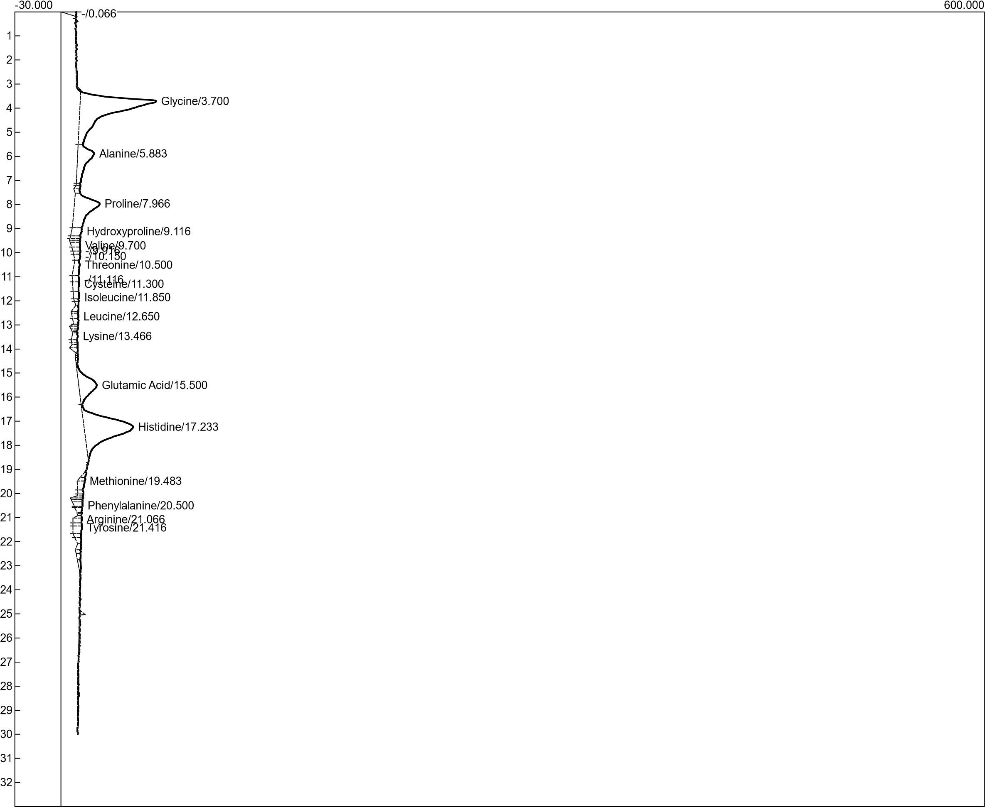

**Figure 4.13:** Graphical representation of amino acid profiling for 1g 107 B

**Table 4.4:** Amino acid profile for sample 1g 107 B

|  |  |  |
| --- | --- | --- |
| Component | Retention | % Area |
| Glycine | 3.700 | 2203.5010 |
| Alanine | 5.883 | 550.3230 |
| Proline | 7.966 | 826.0000 |
| Hydroxyproline | 9.116 | 126.5450 |
| Valine | 9.700 | 70.4100 |
| Threonine | 10.500 | 138.0160 |
| Cysteine | 11.300 | 92.4660 |
| Isoleucine | 11.850 | 64.9900 |
| Leucine | 12.650 | 51.9825 |
| Lysine | 13.466 | 59.6665 |
| Glutamic Acid | 15.500 | 560.6775 |
| Histidine | 17.233 | 1755.3485 |
| Methionine | 19.483 | 94.0000 |
| Phenylalanine | 20.500 | 64.6685 |
| Arginine | 21.066 | 68.3370 |
| Tyrosine | 21.416 | 108.2740 |

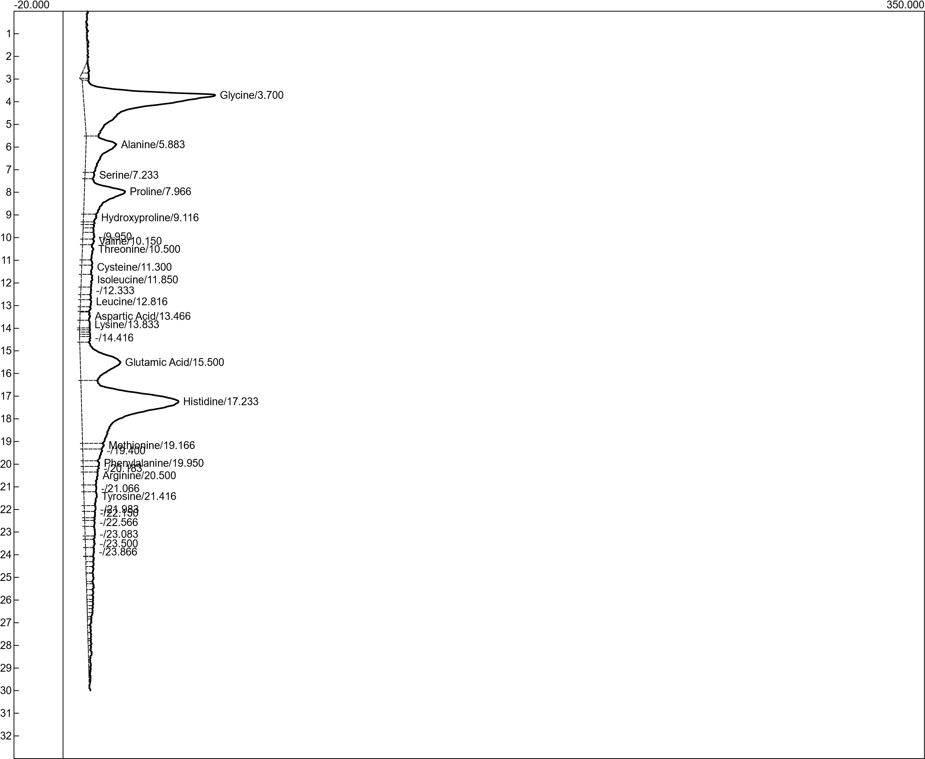

**Figure 4.14:** Graphical representation of amino acid profiling for 1g 107 A

**Table 4.5:** Amino acid profile for sample 1g 107 A

|  |  |  |
| --- | --- | --- |
| Component | Retention | % Area |
| Glycine | 3.700 | 2692.2740 |
| Alanine | 5.883 | 684.7230 |
| Proline | 7.233 | 61.1370 |
| Hydroxyproline | 7.966 | 839.7670 |
| Valine | 9.116 | 97.6350 |
| Threonine | 10.150 | 65.2645 |
| Cysteine | 10.500 | 160.0200 |
| Isoleucine | 11.300 | 97.3260 |
| Leucine | 11.850 | 143.6170 |
| Lysine | 12.816 | 79.9585 |
| Glutamic Acid | 13.466 | 84.1590 |
| Histidine | 13.833 | 80.6780 |
| Methionine | 15.500 | 1015.7835 |
| Phenylalanine | 17.233 | 3125.7795 |
| Arginine | 19.166 | 123.8050 |
| Tyrosine | 19.950 | 95.0600 |

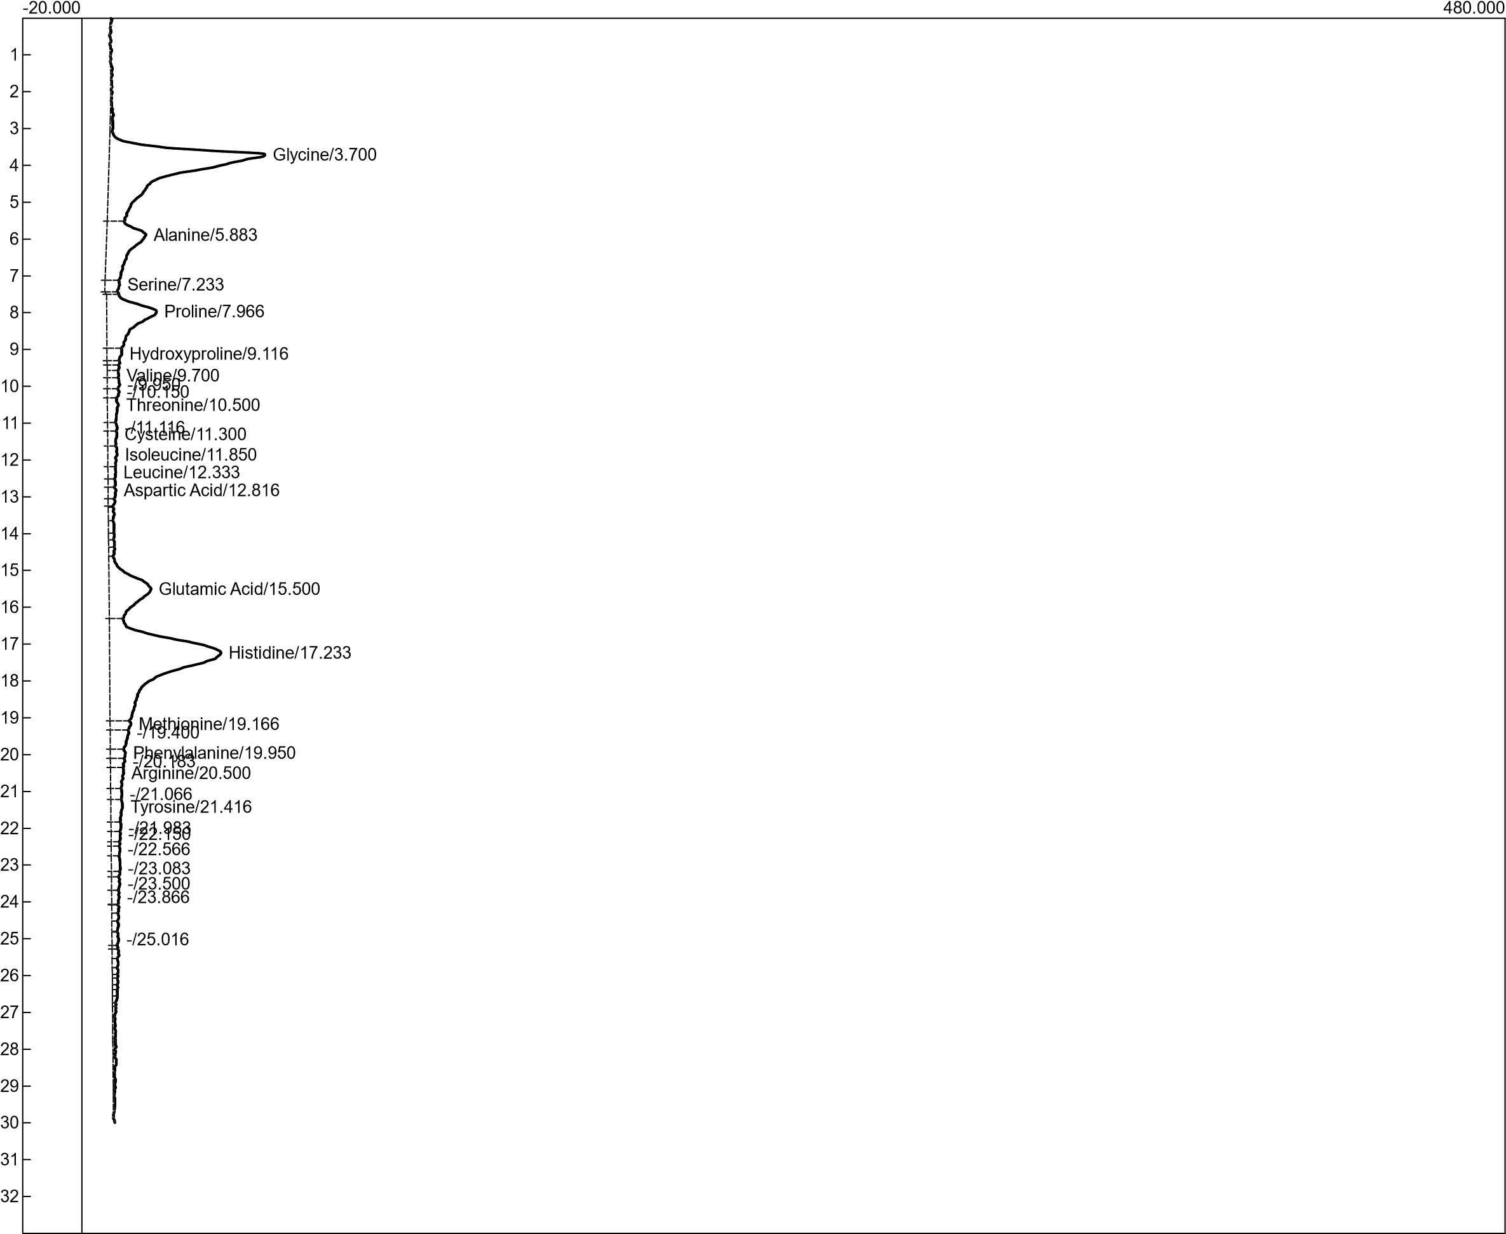

**Figure 4.15:** Graphical representation of amino acid profiling for 5.5 107 B

**Table 4.6:** Amino acid profile for sample 5.5 107 B

|  |  |  |
| --- | --- | --- |
| Component | Retention | % Area |
| Glycine | 3.700 | 2631.1690 |
| Alanine | 5.883 | 780.3390 |
| Proline | 7.233 | 87.6800 |
| Hydroxyproline | 7.966 | 836.7460 |
| Valine | 9.116 | 93.7850 |
| Threonine | 9.700 | 45.7320 |
| Cysteine | 10.500 | 126.1600 |
| Isoleucine | 11.300 | 69.0540 |
| Leucine | 11.850 | 96.4760 |
| Lysine | 12.333 | 50.0440 |
| Glutamic Acid | 12.816 | 45.4925 |
| Histidine | 15.500 | 797.3710 |
| Methionine | 17.233 | 2821.0045 |
| Phenylalanine | 19.166 | 99.8650 |
| Arginine | 19.950 | 72.8600 |
| Tyrosine | 20.500 | 137.0770 |

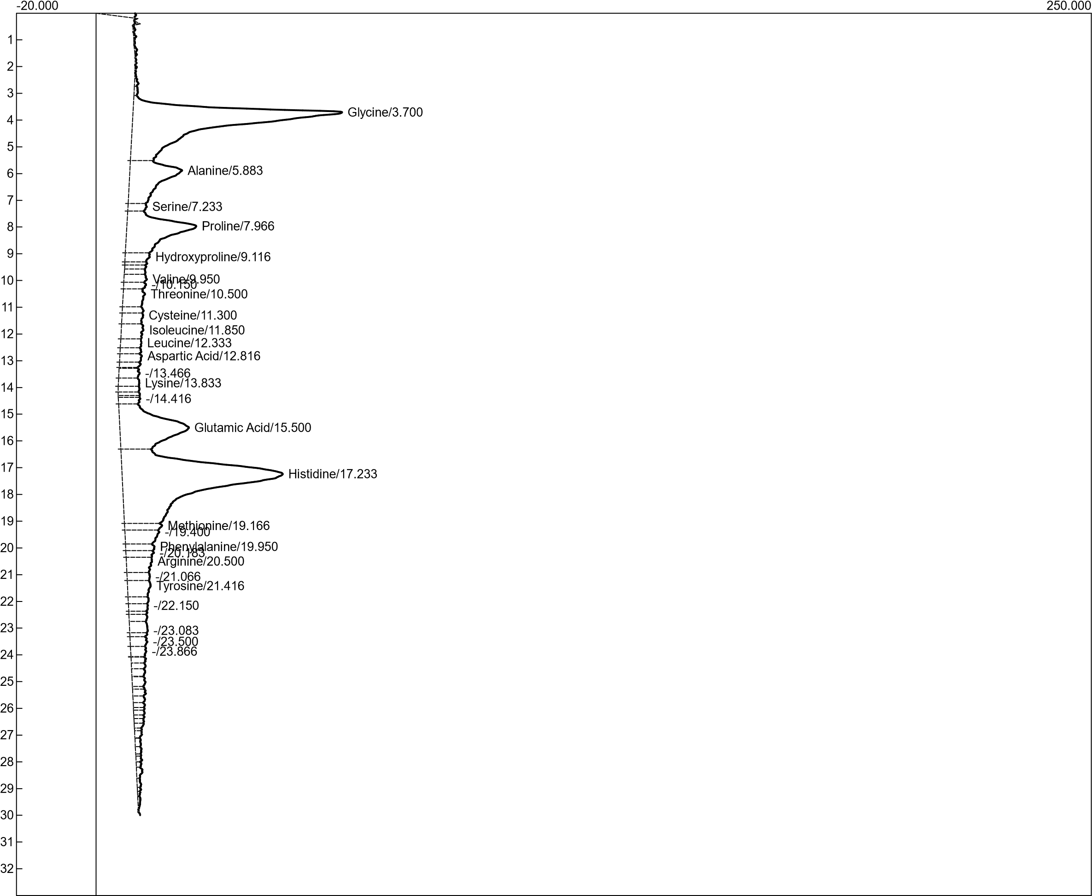

**Figure 4.16:** Graphical representation of amino acid profiling for 6.0 107 B

**Table 4.7:** Amino acid profile for sample 6.0 107 B

|  |  |  |
| --- | --- | --- |
| Component | Retention | % Area |
| Glycine | 3.700 | 2620.2190 |
| Alanine | 5.883 | 766.1790 |
| Proline | 7.233 | 76.1310 |
| Hydroxyproline | 7.966 | 925.7770 |
| Valine | 9.116 | 116.6250 |
| Threonine | 9.950 | 97.9270 |
| Cysteine | 10.500 | 200.2000 |
| Isoleucine | 11.300 | 122.0820 |
| Leucine | 11.850 | 179.2830 |
| Lysine | 12.333 | 102.9640 |
| Glutamic Acid | 12.816 | 100.5735 |
| Histidine | 13.833 | 92.5400 |
| Methionine | 15.500 | 1117.9450 |
| Phenylalanine | 17.233 | 3268.3140 |
| Arginine | 19.166 | 135.0025 |
| Tyrosine | 19.950 | 105.4400 |

**Table 4.8:** Comparison of each amino acid with the other in the four samples

|  |  |  |  |  |
| --- | --- | --- | --- | --- |
| Component | 1 g 107 B | 1 g 107 A | 5.5 107 B | 6.0 107 B |
| Glycine | 2203.5010 | 2692.2740 | 2631.1690 | 2620.2190 |
| Alanine | 550.3230 | 684.7230 | 780.3390 | 766.1790 |
| Proline | 826.0000 | 61.1370 | 87.6800 | 76.1310 |
| Hydroxyproline | 126.5450 | 839.7670 | 836.7460 | 925.7770 |
| Valine | 70.4100 | 97.6350 | 93.7850 | 116.6250 |
| Threonine | 138.0160 | 65.2645 | 45.7320 | 97.9270 |
| Cysteine | 92.4660 | 160.0200 | 126.1600 | 200.2000 |
| Isoleucine | 64.9900 | 97.3260 | 69.0540 | 122.0820 |
| Leucine | 51.9825 | 143.6170 | 96.4760 | 179.2830 |
| Lysine | 59.6665 | 79.9585 | 50.0440 | 102.9640 |
| Glutamic Acid | 560.6775 | 84.1590 | 45.4925 | 100.5735 |
| Histidine | 1755.3485 | 80.6780 | 797.3710 | 92.5400 |
| Methionine | 94.0000 | 1015.7835 | 2821.0045 | 1117.9450 |
| Phenylalanine | 64.6685 | 3125.7795 | 99.8650 | 3268.3140 |
| Arginine | 68.3370 | 123.8050 | 72.8600 | 135.0025 |
| Tyrosine | 108.2740 | 95.0600 | 137.0770 | 105.4400 |

Red: highest; Blue: second highest; Green: third highest; Purple: least.

## **4.6 DISCUSSION**

The research is aimed at developing a starter culture for the production of “ponmo” from cowhide and the effect of processing methods on the SAA present in “ponmo”. Previous literature reported the proximate of white scaled “ponmo” as 23.80% for moisture, 131.50% for energy, 30.75% for protein, 3.30% for total fat, and 1.48% for ash content while that of black singed “ponmo” was 67.02% for moisture, 6.80% for energy, 8.77% for protein, 0.42% for total fat, and 0.41% for ash. This report compared with the result of this research differs based on the factors that each hide had a predetermined environment in terms of pH with the addition of starter culture. The report by Ademola *et al*. (2022) indicates scalded “ponmo” has more proximate composition than singed “ponmo” but this research indicates singed “ponmo” has more proximate composition than that of scalded because of the form of fire it was subjected to and the cowhide to subjected to drying before singeing.

Also similar to Ajayi and Akomolafe (2016) report phosphorus is higher than all the other minerals. The low energy value as compared with the required value for adult as 590g also confirms cowhide as a low calorie food.

The ranges between the pH after the fermentation at 24 hours with each sample is wide whereas after 72 hours of fermentation the range was closer to each other and this can be a result of the *Bacillus* sp. no longer affecting the fermentation process. The difference between the initial and final pH at each hour shows sample 7B6.0 had a peak on the positive side while sample 7B5.5 was a peak on the negative side of the difference for samples that underwent the fermentation process with an adjusted pH. For a sample that underwent fermentation process with the addition of baking soda had sample7B1 as a peak on the positive side while sampling 7A1 had a peak on the negative side.

During the spontaneous fermentation, for the scalded “ponmo”, at 24 and 48 hours of fermentation, a growth of a distinct colony was observed which had a swarming growth on blood agar and also on marconkey agar both appeared to be in waves and reduced, while for the singed “ponmo”, the colonies that dominated/persisted were not having much effect on both agars. Although at 8 hours fermentation for the scalded “ponmo” to swarming effect was also noticed on blood agar but it wasn’t prominent.

The isolates were identified presumptively using the Bergey’s manual of systematic classification on the biochemical properties. The genera identified were *Bacilus*, and *Staphylococcus*. This is in agreement with Olukibiti *et al*. (2017) and Zungum *et al*. (2020). The presence of *Bacillus* which is a protein fermenter shows a likelihood of it fermenting the ponmo although some *Staphylococcus* sp. have been known to carry out fermentation (Lee *et al*., 2020).

In the production of ponmo, the *Bacillus* sp. used as starter culture was used singly on the different substrates and different environmental conditions. The result showed ponmo inoculated at pH 6.0 and 6.5 to ferment after 24 hours based on sensory and pH 6.0 performed best based on the high moisture content, low amount of crude protein as compared to the other samples, and low dry matter (Lee *et al*., 2020; ).

Similar to a report given by Sharma *et al*., (2014), 16 amino acids were analyzed for each of the 4 samples which are histidine ranging from 80-1755, valine ranging from 70-116, proline ranging from 61-826, phenylalanine ranging from 64-3268, alanine ranging from 550-780, tyrosine ranging from 95-137, arginine ranging from 68-135, threonine 45-138, hydroxyproline 126-925, cysteine 92-200, methionine 94-2821, glutamic acid 45-500, leucine 51-179, isoleucine 64-122, glycine 2203-2696, and lysine 50-102. Sample 6.0 107 B had 8 amino acids with the highest surface area compared to the other samples (hydroxyproline, valine, leucine, isoleucine, cysteine, lysine, phenylalanine, and arginine) of which five of the 8 amino acids are essential amino acids, sample 5.5 107 B had 3-methionine, tyrosine and alanine of which only methionine is an essential amino acid, sample 1g 107 A only had glycine as highest which is not an essential amino acid and sample 1g 107 B had 4 amino acids higher than the other samples which are proline, glutamic acid, threonine, and histidine of which only histidine and threonine is essential (Bhagavan and Ha, 2015).

The presence of hydroxyproline and proline may also suggest the breakdown of collagen which humans can’t digest because they lack collagenase.

Based on the sulphur amino acid, sample 5.5 107 B is ideal because of Pacheco *et al*., (2018) report that shows methionine is also a precursor for cysteine. But sample 6.0 107 B has the highest number of essential amino acid in high and highest number of high amino acids in general and can be considered better than sample 5.5 107 B has sample 6.0 107 B also had the second highest value for methionine.

The retention time is determined by the polarity of both the stationary phase and mobile phase, hence the four samples show the same retention time but varying surface area . The difference between the surface areas suggest the hydrophobicity of each amino acid with respect to the fermentation environment (Moret and Zebende, 2007; Apriyanto *et al*., 2017).

# **CHAPTER FIVE**

## **5.0 CONCLUSION AND RECOMMENDATION**

### **5.1 CONCLUSION**

This study as established that *Bacillus* isolated from *ponmo* may be responsible for its fermentation and can be used as starter culture for fermentation. This study has also been able to establish the best biochemical condition for fermentation of *ponmo* and also favour the amino acid nutrition, most especially sulphur amino acid is fermentation at pH 6.0 for 24 hours.

### **5.2 RECOMMENDATION**

It will be necessary despite the high surface area to carry out a bioaccesibility test using animal model to acertain the amount of these amino acids available after consumption so as to further encourage consumption of cowhide as a prophylaxis and/or therapeutic measure.

There is also need to carry out the sequencing process for the organisms isolated from this study.

# **REFERENCES**

Adem M., (2019). Production of hide and skin in Ethiopia; marketing opportunities and constraints: A review paper. *Cogent Food & Agriculture*, 5: 1565078. DOI:10.1080/23311932.2019.1565078.

Ademola A. S., Kayode B. I., Motolani A. M., Ajadi I. M., and Oluwaseun I. J. (2022). Consumers’ Perception, Nutritional and Mineral Composition of Processed Cowhide (Ponmo) as Affected by Different Processing Methods. *Al-Qadisiyah Journal for Agricultural science*, 12 (1). 65-69. DOI: 10.33794/qjas.2022.133171.1035 .

Ajayi O. B. and Akomolafe S. F. (2016). A Comparative Study on Nutritional Composition, Mineral Content and Amino Acid Profile of the Skin of Four Different Animals. *Journal of Food Science and Nutrition*, 2: 012. DOI: 10.24966/FSN-1076/100012.

Apriyanto M., Sutardi, Supriyanto, and Harmayani E. (2017). Amino acid analysis of cocoa fermented by High Performeance Liquid Chromatography (HPLC). *Asian Journal of Dairy and Food Research*, 36(2). 156-160. DOI: 10.18805/ajdfr.v36i02.7962.

Ashaolu T. J., Khalifa I., Mesak M. A., Lorenzo J. M., and Farag M. A. (2021). A comprehensive review of the role of microorganisms on texture change, flavor and biogenic amines formation in fermented meat with their action mechanisms and safety. *CRITICAL REVIEWS IN FOOD SCIENCE AND NUTRITION*, 1-18. DOI: 10.1080/10408398.2021.1929059.

Bartkiene E, Bartkevics V, Mozuriene E, Lele V, Zadeike D and Juodeikiene G. (2019). The Safety,Technological, Nutritional, and Sensory Challenges Associated With Lacto-Fermentation of Meat and Meat Products by Using Pure Lactic Acid Bacteria Strains and Plant-Lactic Acid Bacteria Bioproducts. *Frontiers in Microbiology*, 10:1036. DOI: 10.3389/fmicb.2019.01036.

Beaumont M. and Blachier F. (2020). Amino Acids in Intestinal Physiology and Health. *Amino Acids in Nutrition and Health*, 1265. 1-20. DOI: 10.1007/978-3-030-45328-2_1.

Bhagavan N. V., and Ha C. F. (2015). Amino Acids. *Essentials of Medical Biochemistry, Second edition*, 21-29. DOI: 10.1016/B978-0-12-416687-5.00003-8.

Bin P., Huang R., and Zhou X. (2017). Oxidation Resistance of the Sulfur Amino Acids: Methionine and Cysteine. *BioMed Research International*, 1-6. DOI: 10.1155/2017/9584932.

F., S. (2020). Metabolism and Functions of Amino Acids in the Skin. *Amino Acids in Nutrition and Health*, 187-199. DOI: 10.1007/978-3-030-45328-2_11.

Flynn N. E., Shaw M. H., and Becker J. t. (2020). Amino Acids in Health and Endocrine Function. *Amino Acids in Nutrition and Health*, 1265. 97-109. DOI: 10.1007/978-3-030-45328-2_6.

G., B. W. (2021). Amino Acids in Beef Cattle Nutrition and Production. *Amino Acids in Nutrition and Health*, 1285. 29–42. DOI: 10.1007/978-3-030-54462-1_3.

Gau M. R., Said M. I., Jamila and Yuliati F. N. (2021). Effect of differences in fermentation process methods of cattle hair waste on the properties of hair protein concentrate. *IOP Conference Series: Earth and Environmental Science*, 788 01215. DOI:10.1088/1755-1315/788/1/012153.

Hasimuna O. J., Monde C., Mweemba M., and Nsonga A. (2020). The anaesthetic effects of sodium bicarbonate (baking soda) on greenhead tilapia (Oreochromis macrochir, Boulenger 1912) broodstock. *The Egyptian Journal of Aquatic Research*, 46 (2). 195-199. DOI: 10.1016/j.ejar.2019.12.004.

Huang S., Wang L. M., Sivendiran T., and Bohrer B. M. (2017). Review: Amino acid concentration of high protein food products and an overview of the current methods used to determine protein quality. *Critical Reviews in Food Science and Nutrition*, 2673-2678. DOI: 10.1080/10408398.2017.1396202.

Impact of Nutritional and Environmental Factors on Inflammation, Oxidative Stress, and the Microbiome. (n.d.).

Juhar T., Teshager D., and Getachew T. (2015). Evaluation of hide and skin market chains in and around shashemene town. *Scientia Agriculturae*, 10 (3), 0000. DOI: 10.15192/PSCP.SA.2015.10.3.119-126.

Lee H. J., Yong H. I., Kim M.,Choi Y. S., and Jo C. (2020). Status of meat alternatives and their potential role in the future meat market — A review. *Asian-Australasian journal of animal sciences*, 33(10). 1533-1543. DOI:10.5713/ajas.20.0419.

M., A. (2019). Production of hide and skin in Ethiopia; marketing opportunities and constraints: A review paper. *Cogent Food & Agriculture*, 5: 1565078. DOI:10.1080/23311932.2019.1565078.

Martinez Y., Li X., Liu G., Bin P., Yan W., Mas D., Valdivie M., Hu C. A., Ren W., and Yin Y. (2017). The role of methionine on metabolism, oxidative stress, and diseases. *Amino Acids*, 49, pages2091–2098. DOI: 10.1007/s00726-017-2494-2.

Moret M. A. and Zebende G. F. (2007). Amino acid hydrophobicity and accessible surface area. *Physical Reviews E*.

Nefasa A. N., Christwardana M., Nurwantoro H., and Malyan S. (2019). Effect of Baking Soda Addition on the Characteristic of Ice Cream from Cow's Milk. *Scientific Study & Research Chemistry & Chemical Engineering, Biotechnology, Food Industry*, 20 (2). 151-165. .

Pacheco L. G., Sakomura N. K., Suzuki R. M., Dorigam J. C. P., Viana G. S. Milgen J. V., and Denadai J. C.,. (2018). Methionine to cystine ratio in the total sulfur amino acid metabolism using labelled amino acid approach for broilers. *BMC Veterinary Research*, 14:364. 1-11. DOI: 10.1186/s12917-018-1677-8.

Raman R. and Link R. (2021). 22 Benefits and Uses of Baking Soda. *Nutrition*.

S., M. (2013). Amino Acids. *Brenner's Encylopedia of Genetics 2nd edition*, 2(1). 54-56. DOI: 10.1016/B978-0-12-374984-0.00051-6.

Sharma G., Attri S. V., Behra B., Bhisikar S., Kumar P., Tageja M., Sharda S., Singhi P., and Singhi S. (2014). Analysis of 26 amino acids in human plasma by HPLC using AQC as derivatizing agent and its application in metabolic laboratory. *Amino Acids*, 46:1253-1263. DOI:10.1007/s00726-014-1682-6.

Suha M., Humaina A., Niyaz H. N., and Naila A. (2021). Sensory Properties of White Bread Enriched with Lemon Juice, Corn Flour and Baking Soda. *The Maldives National Journal of Research*, 9 (2). 38-47. .

Violi J. P., Bishop D. P., Padula M. P., Westerhausen M. T., and Rodgers K. J. (2021). Acetonitrile adduct analysis of underivatised amino acids offers improved sensitivity for hydrophilic interaction liquid chromatography tandem mass-spectrometry. *Journal of Chromatography A*, 462530. 0021-9673. DOI: 10.1016/j.chroma.2021.462530.

W., D. (2020). Amino Acids in Circulatory Function and Health. *Amino Acids in Nutrition and Health*, 1265. 39-56. DOI: 10.1007/978-3-030-45328-2_3.

Zhang W., Xiao S., Samaraweera H., Lee E. J., and Ahn D. U. (2010). Improving functional value of meat products. *Meat Science*, 86. 15–31. .

Zungum I. U., Imam T. S., Benjamin B., Moisule A., Daya M. G., Abubakar T., Bala Z. M., and Peter D. D. (2020). In Vitro Assay of Bacterial Load on Some Ruminant Hide and Skin from North Western Nigeria. *Journal of Applied Sciences and Environmental Management*, 24 (8). 1425-1432. DOI: 10.4314/jasem.v24i8.18.

Zungum I. U., Imam T. S., Benjamin B., Moisule A., Daya M. G., Abubakar T., Bala Z. M., and Peter D. D. (2020). In Vitro Assay of Bacterial Load on Some Ruminant Hide and Skin from North Western Nigeria. *Journal of Applied Sciences and Environmental Management*, 24 (8). 1425-1432. DOI: 10.4314/jasem.v24i8.18.