**TOURISM AND THE REBRANDING OF NIGERIA’S IMAGE (2015-2019)**

**AYANRINDE, Racheal Tijesunimi**

**(20PGEB000124)**

**B.Sc. (Ife)**

**A Dissertation in the Department of Political Science and International Relations**

**MASTER OF SCIENCE (M.Sc.)**

**of the**

**LANDMARK UNIVERSITY, OMU ARAN, KWARA STATE**

**Supervisor: Dr Ake Modupe**

**July, 2022**

**DECLARATION**

I, Racheal, Tijesunimi AYANRINDE, an (MSc) student in (Political Science and International Relations), Landmark University, Omu-Aran, hereby declare that this dissertation entitled “Tourism and the rebranding of Nigeria’s image”, submitted by me is based on my original work. Any material(s) obtained from other sources or work done by any other persons or institutions have been duly acknowledged.

**………………………………..**

**Student’s Full Name and**

**Matriculation number**

**………………………………….**

**Signature & Date**

**CERTIFICATION**

This is to certify that this dissertation has been read and approved as meeting the requirements of the Department of (Political Science and International Relations), Landmark University, Omu-Aran, Nigeria, for the Award of (M.Sc. in International Relations).

**___________________ _______________**

**Dr Mrs Modupe Ake Date**

**(Supervisor)**

**______________________ ________________**

**Dr Joseph Iseolorunkanmi Date**

**(Co-Supervisor)**

**_______________________ ________________**

**Dr Mrs Modupe Ake Date**

**(Head of Department)**

**_______________________ ________________**

**Name Date**

**(External Examiner)**

**ABSTRACT**

The image of a country is determined by the perception of the country in the international system, given that most decisions are dependent on perception, regulating such perception becomes critical to the nation's general well-being. Branding is the totality of people's perceptions of a product, person, place, or nation. However, Nigeria’s rebranding agenda in the Fourth Republic has been the use of slogans such as Heart of Africa, Good People, Great People, and change begin with me. This study, therefore, examines the use of tourism as a mechanism to rebrand Nigeria’s image.

This study adopts linkage theory, the theory assumes that there is a nexus between domestic politics and international politics. A two-stage sampling consisting of purposive and simple random techniques was used to select agencies and respondents respectively. This study adopts a qualitative method, primary and secondary data collection was utilized. Thirty-two key informants were interviewed from academia, tourists, and tourism agencies in the public sector and the private sector. This study used content analysis and thematic analytical techniques to analyze all the data collected via Nvivo 12 Software. The software generated word cloud diagrams, clustered word similarity diagrams, themes, and subthemes from the transcripts.

This study finds that Nigeria’s rebranding agenda have not been effective in rebranding its image and tourism can be used as a mechanism to rebrand Nigeria’s image. This study discovers that tourism has changed the perceptions of tourists to some extent because most of the tourists are willing to visit Nigeria again. This study identifies insecurity, paucity of funds, absence of functional amenities, lack of synergy, constitutional ambiguity, and corruption as the major impediments to tourism.

The study concludes that tourism is an excellent tool to rebrand Nigeria’s image, and the federal government should invest in the tourism sector. The study recommends that the government should invest in tourism by developing the attraction areas to international standards and maintaining them, the security agencies should ensure adequate security, and the Ministry of information and culture should advertise the attraction areas and festivals through media.

**Keywords:** Tourism, Nigeria’s image, Tourism agencies

**Word counts:** 349

**DEDICATION**

This research is dedicated to Almighty God for his provision, protection and guidance. I cannot neglect the support of my family as a whole for their financial, moral and spiritual support. I dedicate this research to Mr and Mrs Ayanrinde, Engineer Olumide Ayanrinde, Mr Olaoluwa Ayanrinde, Mrs Sanni Mary, Adewumi Raphael and Professor Okeyinka.

**ACKNOWLEDGEMENTS**

I am overwhelmed by all humbleness and sincere appreciation to all those who contributed to this research work. My heartfelt appreciation goes to the Head of the Department and my Supervisor in one, Dr Mrs Ake Modupe, who allowed me to work on the topic with moral support and counsel from every angle. I also want to express special appreciation to my amiable lecturers; Professor Omitola, Dr Aleyomi Mike, Dr Joseph Iseolorunkami, Dr Sola Olarenwaju, Dr Dele Rasak, Dr Ayeni, Mrs Edidiong Ayeni, Mr Nweke-love Henry and Mr Enoch Ogundele. Thank you all for your time and support in my academic endeavours. My appreciation goes to Professor Charity Aremu, the Vice-chancellor of Landmark University and the Dean of Postgraduate School as well as the entire staff of the School of Postgraduate for their support in the course of this research. Finally, I will like to appreciate my colleague at the Department of Political Science and International Relations; Oladapo Joy Oluwakemi.

**TABLE OF CONTENTS**

Contents Page

Declaration ii

Certification iii

Abstract iv

Dedication v

Acknowledgement vi

Table of Contents vii

List of Tables ix

List of Figures xi

List of Abbreviations xii

Chapter One: Introduction

1.1 Background of the Study 1

1.2 Statement of Problem 3

1.3 Research Questions 4

1.4 Research Objectives 4

1.5 Significance of Study 5

1.6 Scope of the Study 5

1.7 Limitation of the Study 6

1.8 Operational Definition of Terms 6

Chapter Two: Review of Literature and Theoretical Framework

2.0 Introduction 7

2.1 Conceptualization 7 2.1.1 Tourism 7

2.1.2 Tourism in Nigeria 9

2.1.3 Nigeria’s Image in perspective 11

2.1.4 Overview of the rebranding initiatives in Nigeria 16

2.2 Theoretical Framework 17

2.2.1 Linkage theory 17

2.2.2 Application of the theory to the study 18

Chapter Three: Methodology

3.1 Research Design 19 3.2 Instrument of Data Collection 19

3.2.1 Population 19

3.2.2 Sample Size and Sampling Techniques 20

3.2.3 Validity and Reliability of research instrument 20

3.3 Method of data analysis 21

3.3.1 Ethical consideration 21

Chapter Four: Data Analysis, Presentation of Results and Interpretation

4.1 Introduction 22

4.1.1 Data presentation 22

4.1.2 Demographic characteristics of respondents 22

4.1.3 Findings and discussion 23

4.2 Themes 70

Chapter Five: Summary, Conclusion and Recommendation

5.1 Introduction 78

5.1.1 Summary 78

5.2 Conclusion 79

5.3 Recommendation 81

5.4 Contribution to knowledge 82

References 84

APPENDIX 1 91

APPENDIX 2 92

APPENDIX 3 93

APPENDIX 4 94

**LIST OF TABLES**

Table 4.1 Informants’ view on the image of Nigeria

Table 4.2 Informants’ view on Nigeria’s rebranding agenda

Table 4.3 Informants’ view on the correlation between tourism and the rebranding of

Nigeria

Table 4.4 Informants’ view on tourism impact on Nigeria’s image

Table 4.5 Informants’ view on tourism as a tool to rebrand Nigeria’s image

Table 4.6 Informants’ view on the impediments that undermined the tourism sector in

rebranding Nigeria’s image

Table 4.8 Informants’ view on the measures in place by the tourism sector to rebrand

Nigeria’s image

Table 4.9 Informants’’ view on the prospects of tourism in rebranding Nigeria’s image

Table 4.10 Informants’ view on tourism as a tool to rebrand Nigeria’s image

Table 4.11 Informants’ view on the impediments that undermined the tourism sector in

rebranding Nigeria’s image

Table 4.12 Informants’ view on the measures in place by the tourism sector to rebrand

Nigeria’s image

Table 4.13 Informants’ view on Nigeria’s rebranding agenda

Table 4.14 Informants’ view on tourism as a tool to rebrand Nigeria’s image

Table 4.15 Informants’ view on the impediments that undermined the tourism sector in

rebranding Nigeria’s image

Table 4.16 Informants’ view on the measures in place by the tourism sector to rebrand

Nigeria’s image

Table 4.17 Informants’ experience with tourist

Table 4.18 Informants’ view on Nigeria’s image

Table 4.19 Informants’ view on Nigeria’s rebranding agenda

Table 4.20 Informants’ view on tourism as a tool to rebrand Nigeria’s image

Table 4.21 Informants’ view on the impediments undermined the tourism sector in

branding Nigeria’s image

Table 4.22 Informants’ view on the measures in place by the tourism sector to rebrand

Nigeria’s image

Table 4.23 Informants’’ view tourism as a tool to rebrand Nigeria’s image

Table 4.24 Informants’ view on the impediments that undermined the tourism sector in

branding Nigeria’s image

Table 4.25 Informants’ view on Lagos State tourism policy

Table 4.26 Informants’ view on the federal government tourism policy

Table 4.27 Informants’ view on the role of private sector tourism agencies in rebranding

Nigeria’s image

Table 4.28 Informants’ experience with tourists

Table 4.29 Informants’ view on acquiring Nigeria’s visa

Table 4.30 Informants’ view on the measures in place by the tourism sector to rebrand

Nigeria’s image

Table 4.31 Informants’ experience in Nigeria

Table 4.32 Informant’s perception of Nigeria

Table 4.33 Informant’s view of Nigeria

Table 4.34 Informant’s impression of Nigeria

**LIST OF FIGURES**

Figure 4.1 Items clustered by word similarities of Lagos State Polytechnic Academia

Figure 4.2 Word Cloud presentation of the respondents at the Lagos State Ministry of

Tourism, Arts and Culture

Figure 4.3 Items clustered by word similarities of the respondents at the Nigerian Institute

of International Affairs

Figure 4.4 Word Cloud presentation of the respondents at the Nigerian Tourism

Development Corporation

Figure 4.5 Word Cloud presents the respondents’ responses to the Private sector tourism

agencies.

Figure 4.6 Items clustered by word similarities of the International tourists

Figure 4.7 Items clustered by word similarities of all the respondents

Figure 4.8 The diagram above shows the major themes derived from the study

Figure 4.9 The diagram above presents the sub-themes of the major themes

**LIST OF ABBEVIATIONS**

COVID-19 Coronavirus Disease

**CHAPTER ONE**

**INTRODUCTION**

**1.1 Background of the Study**

In the modern world, the image of a country is a crucial symbol in diplomatic affairs, with a significant influence on nations' perceptions. Thus, the image of Nigeria is significant to its global stance and nation-building (Aleyomi, 2020). The image of a country is determined by the perception of the countries in the international system, the way it conducts its relations with other countries and most importantly, the character of its citizens at home and abroad (Zimako, 2009). Branding is the totality of people's perceptions of a product, person, place, or nation. Given that most decisions are dependent on perception, regulating such perception views becomes critical to the nation's general well-being (Ajeluorou, 2018). Ferguson (2001) opined that State just like a company requires a strong brand. This implies that a country is like a company that needs a good brand in the competitive global system.

According to World Tourism Organisation, one of the five export resources is tourism which constitutes 83 per cent of countries and it is the first revenue generator for 38 per cent of countries in the world (Obeta, 2013). Several countries of the world have leveraged tourism as a mechanism to rebrand their national image such as China, Dubai, Turkey, Iran, and Bangladesh among others.

According to the number of visitors from most countries, China is increasingly overtaking other countries as the most preferred tourism destination. Importantly, Beijing has been the world's top investor in foreign tourism since 2012 and the source of visitors with the quickest rate of growth in recent years. The China Tourism Academy estimates that Chinese tourists spent $130 billion in 2018. Therefore, it is not surprising that Beijing has tried to use outbound tourism as a political tool to enhance its influence and reputation in world affairs (Chaziza, 2019).

In Dubai, there is a conscientious effort by the state to produce a specific image and in turn, promote a particular type of consumption of that image by visitors and citizens alike. The Emirates of Dubai and Abu Dhabi's tourist branding strategies are critical components of the United Arab Emirates’ overall place brand. These strategies can be found in the United Arab Emirates’ national development plan (Vision 2021, 2015) as well as in the plans of each Emirate (Hatemi, 2015).

International engagement and cooperation on the African continent are made possible through tourism, which has been acknowledged as a crucial economic activity with considerable economic advantages in foreign exchange and infrastructure amenities. This has led to the inclusion of tourist development in the national development goals of numerous African countries. (Kimbu and Ngoasong 2013, Okupe, Ward, and Adeola, 2018, Novelli 2015).

As a result, United Nations World Tourism Organization discovered in 2018 that Africa became the second continent next to Europe which had the highest arrival of international tourists and it has retained its long-decade position as the second fastest developing tourism destination for tourists after East Asia and the Pacific. Tourism-driven countries in Africa are South Africa, Kenya, Algeria, and Morocco among others (Ngoasong, Adeola, Kimbu and Hinson, 2021).

Nigeria is a country endowed with natural resources; thus, the African giant is gifted with a plethora of people, materials, and natural resources that, if properly utilized, will rise to the occasion of repositioning the country. Many believe that if Nigeria's geographically dispersed natural riches are adequately harnessed for social and economic advantages, it can take the place of so many other nations as a popular tourism destination (Anikwe, 2007).

There are many eco-tourism centres in Nigeria such as Olumo rock in Ogun State, the Kainji National park in Kwara, Yankari Game Reserve, in Bauchi, The Agbokim Water Fall in Cross River state, Numerous Beaches like the Lekki, the Bar, Eko, Badagry coconut, Calabar beaches among others, Obudu Cattle Ranch, Museums such as War Museum in Abia State (Obeta, 2013), as well as several other attraction centres consist of arts and crafts, pottery, brass and bronze castings, painting, grass and clothe weavings, glass and metal works among others.

The tourism sector in Nigeria is affected by factors that undermined it from rebranding its national image. Infrastructural deficiency is one of the major factors, which is more severe in rural regions that are home to natural land formations and attractive tourist attractions (Briedenhann and Wickens, 2004). Oloidi (2019) also opined that weak tourism policy, poor implementation, inaccurate planning, lack of community participation, weak monitoring team, insecurity, insufficient funding, and lack of professional workforce and evaluation among others undermine Nigeria’s tourism sector.

A Series of rebranding has been conducted to project Nigeria’s good image from the period of military regimes such as Ethical Revolution, Mass Mobilisation for Self-Reliance, Social Justice, and Economic Recovery (MAMSER), War Against Indiscipline (WAI). These various actions are intended to combat corrupt inclinations in Nigerians, appeal to their consciences, and rectify the international community's negative perception of Nigeria as a corrupt and unreliable nation (Ademigbuji, 2015).

In 2016 the Federal Government launched the "Change Begins with Me" campaign which would entrench the virtues of accountability, honesty, and positive attitude change in Nigerians. The campaign has criticized that Patriotism cannot be legislated or imposed, making Nigerians love their country and want to die for it cannot be attained by propaganda. Change does not start from an average Nigeria but from the federal government that promised it (Adelakun, 2016). This connotes that Nigeria’s rebranding agenda is beyond sloganeering and this research work explores the area of tourism as a tool to rebrand Nigeria’s image.

Therefore, the Nigerian government can harness its tourism resources to rebrand its national image. Although Nigeria has been making headways in religious tourism in which people visit Nigeria from different parts of the world through the platform of religion camps such as Shiloh, Redemption camp, and Synagogue among others, there is a research gap in the aspect of exploring how tourism can be used as a tool to rebrand the image of Nigeria through tourism resources.

**1.2. Statement of the Problem**

The efforts of the federal government to rebrand Nigeria’s image have not been effective, thus numerous academic experts have written several articles denouncing the rebranding campaign's failure and expressing their concern about the future uncertainties (Aregbeshola 2009, Egwemi 2010, Nworah, 2006). According to Akinwunmi, the rebranding agenda in Nigeria was misinterpreted as an advertisement because of the rebranding strategy (Ademigbuji, 2015).

President Olusegun Obasanjo initiated the Heart of Africa in 2005, which was planned to make Nigeria the heartbeat of Africa (Uzuegbu, 2012). According to Dora Akuniyi, the Heart of Africa failed because it was initially launched abroad making it unfamiliar to Nigerians. She also launched a rebranding campaign in Nigeria through the ‘Good People, Great Nation’ Slogan (Akunyili, 2009a). The campaign drew widespread public criticism and resentment because the campaign came at a time when Nigerians had much apathy for the government (Ani, 2014).

As a result of this ineffectiveness of rebranding Nigeria’s image, this research intends to examine the use of tourism to rebrand Nigeria’s image, given Kerr's (2006) assertion that tourism is the most palpable part of a country's brand, the absence of tourism in rebranding strategy might be viewed as a major fault. Tourism has not been harnessed as a major factor to rebrand Nigeria’s image. Based on the above assertion, this study tends to answer the following research questions

**1.3. Research Questions**

1. To what extent has Nigeria’s rebranding agenda been effective?
2. To what extent has tourism changed the perception of tourists about Nigeria’s image?
3. What impediments have undermined the use of tourism to rebrand Nigeria’s image?
4. What are the measures in place by the tourism sector to rebrand Nigeria’s image?

**1.4. Objectives of the Study**

1. To examine the extent to which Nigeria’s rebranding agenda is effective.
2. To assess the extent to which tourism has changed the perception of tourists about Nigeria’s image.
3. To evaluate the impediments that have undermined tourism from rebranding the image of Nigeria.
4. To suggest effective ways tourism could be used to rebrand Nigeria’s image.

**1.5. Significance of the Study**

Nation branding is important in today's world order because it improves public diplomacy, global socio-economic competitiveness, and soft-power promotion (Jun and lee, 2008). The significance of this study lies in the fact that it examines the extent to which Nigeria’s rebranding agenda is effective. Therefore the study will be useful for Nigerian government agencies that are responsible for tourism and soft power diplomacy in making policies and implementing policies, government agencies such as the Nigeria Tourism Development Corporation (NTDC), Federal Ministry of Tourism, Arts and Culture, Federation of Tourism Association of Nigeria (FTAN), Hospitality and Tourism Management Association of Nigeria (HATMAN), National Association of Nigeria Travel Agencies (NANTA), National Commission for Museums and Monuments (NCMM).

Similarly, the study will be useful for Private tourism organizations to improve tourism promotion services, Organisations such as TIFA Travels and Tours, Sky land Travels and Tours Limited, and Wise-fares Travel and Tours. The study can also be beneficial to agencies in the tourism world in promoting world sustainable tourism development, World Organisation such as The United Nations World Tourism Organization.

This study is significant because the Nigerian government has not focused on tourism as a major factor to rebrand its image, despite the ecotourism centres in Nigeria that can attract tourists, and the previous rebranding agenda in Nigeria centred on the use of slogans which has not been able to rebrand its image effectively. Therefore, this study is meant to fill these gaps in the literature, and be of relevance to the academic community because it will enrich the body of knowledge for researchers and students of Political Science and International Relations. This study also will expand the frontier of knowledge by encouraging further future research.

**1.6. Scope of the Study**

The scope of the study is limited to President Muhammadu Buhari’s administration (2015-2019). President Muhammadu Buhari stated that his administration recognizes the tourism industry as one of the pillars of its diversification policy, and he is also substantially investing in infrastructure and human resource development to make Nigeria a preferred tourist destination (Akeregha and Onochie, 2018). The scope ends in 2019 because tourism was affected by the outbreak of COVID-19.

**1.7. Limitation of the Study**

The study is limited by the unwillingness of the respondents to give all the required information and the reduction in the number of respondents by the parastatals. As a result, thirty-two key informants' interview responses were gotten out of forty.

**1.8. Operational Definition of Terms**

**National Image**: can be defined as the internal and external public perception of a country. **Rebrand:** means to recreate the image of a country and project it in good light to the world **Tourism:** can be defined as the movement of people from a particular location to attraction areas in other locations within the country and outside the country.

**CHAPTER TWO**

**LITERATURE REVIEW AND THEORETICAL FRAMEWORK**

**2.0 Introduction**

This section reviews the literature on Nigeria’s rebranding agenda to examine if it has been effective, to examine the tourism potential in Nigeria and if it has changed the image perception of tourists as well as the factors that impede tourism from rebranding Nigeria’s image.

**2.1 Conceptualization**

**2.1.1 Tourism**

The emergence of beach resorts and spas in Europe marked the beginning of tourism, which is linked to spiritual and leisure pursuits including education, leisure, and attractions (Fadipe, 2007). However, modern tourism can be described as a social, cultural, and commercial phenomenon. It is the mobility of individuals to locations outside of their normal surroundings for personal, commercial, or professional reasons (United Nations World Tourism Organization, 2008). According to Fadipe (2007), the types of tourism are ecotourism, business tourism, and cultural tourism among others. Ecotourism is described as ecologically friendly tourism that preserves customs and culture, the natural environment, and wildlife habitat. Business tourism is primarily focused on business events and gatherings designed to foster collaboration among professional associations.

According to the United Nations World Tourism Organisation, the forms of tourism are domestic tourism, international tourism, outbound tourism and inbound tourism. Domestic tourism can be defined as a form of tourism in which people travel outside their place of residence to another location within the country. Inbound tourism can be defined as the travel by foreign visitors inside a given Country. Outbound tourism is the travel by non-nationals who are not citizens of the host country.

These forms of tourism can also be viewed from three different perspectives and they are internal tourism, national tourism and international tourism. Internal tourism is the combination of domestic tourism and inbound tourism, National tourism consists of domestic tourism and outbound tourism, and International tourism is the combination of inbound and outbound tourism (Fadipe, 2007).

China has been leveraging tourism to rebrand its image. In 2016, China initiated the search for “good Chinese tourists” campaign to amplify the stories of well-behaved outbound Chinese tourists and to enhance the external image of Chinese global travellers (China daily, 2022). Moreover, Wang Xiaofeng, deputy chairman of the China National Tourism Administration, claimed that the country's tourism sector, which has experienced fast expansion, has become a global influence. China has grown significantly in the development of the global tourism industry. The world's greatest tourist-generating state for outbound travel is China, which previously had the largest domestic tourism sector (Zhao and Liu, 2020).

Outbound tourism serves as a medium for symbolic relations between Chinese nationals and the globe, allowing Chinese nationals to get a better image of themselves and their nation while also expressing their national pride and prestige to the world (Yanga, Frencha, Leeb and Watabe, 2020). According to World Travel and Tourism Council in 2019, before the outbreak of COVID-19, China’s Travel and Tourism sector contributed CNY 11.5 Trillion to its Gross Domestic Product which is 11.6 per cent of the country’s economy.

Furthermore, United Arab Emirates has been leveraging tourism to rebrand its image. As a result, it has led to an influx of tourists in the country. Dubai's brand is evident in its tourism business, the city ranked fifth in the globe with 11.95 million tourists in 2014 and 13.34 million in 2016(Zeineddine, 2017). In addition to this, Dubai received approximately 6.17 million foreign tourists between January to May 2022 while 2 million were reported within the same period in 2021(Cabral,2022). Dubai attracts foreign tourists with a variety of attraction areas such as glitzy shopping malls, luxury resorts, beaches, cultural tourism and desert (Seraphim and Haq, 2020). According to the United Arab Emirates Tourism Council in 2021, its travel and tourism sector contributes AED 159.1 billion to its Gross Domestic Product which is 12.1 per cent of Gross Domestic Product.

In Africa, Kenya is one of the most popular tourist destinations in the world due to its natural attractive areas, distinct historical and archaeological sites, developing tourism infrastructures, and hospitable heritage (Mugo and Mwencha, 2017). As a result, the Kenya Tourism Board (KTB) has sustained its commitment to harnessing the influence of prominent local and foreign influencers to advertise Kenya as a desirable and secure tourism destination throughout the globe. (Johnson, 2022). In 2019, domestic and foreign visitor expenditure in Kenya contributed US$2.6 billion to Kenyan Gross Domestic Product and supported a total impact of US$7.9 billion. The Kenyan travel and tourism industry accounted for 8 per cent of the total Gross Domestic Product (Tourism economics, 2021).

**2.1.2 Tourism in Nigeria**

Tourism is a kind of cultural and economic engagement, and as such, it is the continuation of diplomacy, since tourists are both unofficial and official ambassadors that aim to convey and promote the interest of their country. Through cross-cultural communication, the Diplomatic mission abroad and tourist communication will enhance substantial and real-world impacts (Baranowski, Covert, Gordon, Jobs, Noack, Rosenbaum and Scott, 2019). Nigeria is endowed with tangible and intangible tourism resources in the six geopolitical zones. The tangible tourism resources are the material resources such as historical sites, museums, monuments, and arts and crafts among others. The intangible resources are the non-material resources such as festivals, culture, heritage, social practices, etc.

The attraction areas in the North Central are the followings; Esie Museum and Owu Waterfall in Kwara State, Farin Ruwa Waterfall and Keana salt village in Nasarawa State, Shere hills in Jos and Gurara Waterfalls in Niger State among others. In the North East, the attraction areas are Gashaki Gumpti National Park and Mambilla plateau in Taraba State, Sukur cultural landscape of Adamawa among others. In the North West, the attraction areas are Kaduna Matsirgu fall Kafanchan, Ancient Kano city walls, the Surame cultural landscape and the ancient Nok settlement in Kaduna State among others.

In the South East, the attraction areas are Ngwopine and Awhum Waterfall in Enugu, Arochukwu long juju slave route in Abia State, and Ogbunike cares in Anambra State among others. In the South-South, the attraction areas are the Nana living history Museum in Delta State, Ibeno beach in Akwa Ibom State, Obudu Mountain resort in Cross River State, the giant footprint of Ukhase oke in Edo State, Port Harcourt tourist beach, Alok Ikom Monoliths in Cross Rivers State, Isaac Boro Garden park in Port Harcourt among others.

In the South West, the attraction areas are Osun-Osogbo Grove, Idare hill in Ondo State, Freedom park, New Afrika Shrine, Lekki Conservation Centre, Coconut beach and Bar beach in Lagos State, Olumo rock in Ogun State, Ikogusi warm spring resort in Ekiti State, Erin Ijesha Waterfall in Osun State, Adoawaye mountains in Oyo State among others.

According to the Nigeria Bureau of Statistics, tourism contributes 34% to Nigeria’s Gross Domestic Product and generated 20% of employment in 2017(Agency Report, 2018). In addition to this, Kale (2018) stated that tourist operations in Nigeria have enormous potential and that the industry spans and influences various sub-sectors throughout the country's core production sectors. In his description of Nigeria as a travel destination that inspires, he made note of the fact that foreigners come to the nation to do business as well as to experience its natural beauty, culture, and experiences. He added that tourism activities also support the preservation of the country's national pride, unique heritage, and traditions, as well as environmental conservation.

The perception of foreign tourists about Nigeria has been negative and positive. For instance, during the 2019 Olojo and Osun festivals, a total of 232 international tourists completed a questionnaire. Overall, respondents had a good attitude toward their safety. Nonetheless, the majority of respondents felt unsafe while out at night and using public transportation (Badiora and Bako, 2020). In the same vein, research conducted by (Akinyoade, 2013) shows that 78% of the respondents signified interest and that Nigeria is home and they would love to visit. Awaritefe (2008) also discovered in his research that foreign tourists were motivated by adventure to visit Nigeria.

In addition to this, The French ambassador that visited the Esie museum in Kwara state said he was delighted that the museum was a fantastic discovery. Although he has never heard of it before, it is a world-class museum that deserves to be renowned all over the world(Azeez,2021). However, Infrastructural deficiency is a major factor that impedes the laundering of Nigeria’s image through tourism development. Nigeria has not fully realized its tourist potential since the government's commitment to creating a conducive atmosphere and necessary infrastructure is inadequate. These infrastructural deficiencies are more severe in rural regions, which are home to natural land formations and attractive tourist attractions.

Furthermore, attempts to construct infrastructure to facilitate tourism are few, and recent efforts by successive governments have been centred in metropolitan regions (Briedenhann and Wickens, 2004). In addition to this, Oloidi (2019) opined that weak tourism policy, poor implementation, inaccurate planning, lack of community participation, weak monitoring team, insecurity, insufficient funding, and lack of professional workforce and evaluation among others undermine Nigeria’s tourism sector.

**2.1.3 Nigeria’s Image in Perspective**

National image can be described as the sum of a nation's internal and external public perceptions of its people and institutions, systems, products, and so on (Akhimien, 2013). According to Wang (2008), National image is a collective opinion formed by the view and conclusion of a country by its overseas citizens. Nigeria’s image perception has fluctuated from extremely positive to severe negative since its independence. Thus, the attitudes of subsequent administrations to image cleansing are determined by which side of the extremes the pendulum swings (Uzuegbu, 2012).

However, Saliu (2002) painted a picture of Nigeria in the 1960s as having a positive image. The country's reputation was affected in certain ways by the country's civil war, which lasted from 1967 to 1970. Saliu (2002) also claimed that "the country's image soared high in the globe" after the Civil War, particularly under the administration of General Murtala Muhammed. Nigeria eloquently demonstrated the idea of Africa as the centrepiece of its foreign policy, and it also embraced the rightful role of African leaders (Saliu, 2002).

General Gowon's continuance policy on Pan-Africanism boosted the image of Nigeria in the global community, while his domestic policies of 'No Victor, No Vanquished' and 'Reconciliation, Rehabilitation, and Reconstruction' helped maintain Nigeria's positive image at the local and international level. Following that, throughout General Olusegun Obasanjo's regime and until Shagari's government, Nigeria maintained a favourable image both locally and internationally. Nigeria's image began to deteriorate dramatically during the first civilian administration of Shehu Shagari as a result of poor political and economic policies that led the country down the path of economic decline (Akhimien, 2013).

General Muhammadu Buhari and Tunde Idiagbon's administration's rebranding agenda between 1983 and 1985 is War Against Indiscipline (W.A.I.). The goal of this program was to eliminate indiscipline. The rebranding campaign was designed to rebrand Nigeria’s image and give Nigerians a new lease of life from the alleged widespread corruption of Shehu Shagari's civilian administration. (Uzuegbu,2012). General Ibrahim Badamasi Babangida launched a rebranding agenda called Mass Mobilization for Self-Reliance, Social Justice, and Economic Recovery in 1987(MAMSER). The goal was to reposition Nigeria's fortunes and image(Uzuegbu,2012).

Nigeria's image deteriorated during Babangida's regime, despite the efforts of MAMSER to rebrand the image of Nigeria. The leadership was accused of extensive corruption on the economic front. Corruption grew so open and ubiquitous to the extent that critics attributed it to the regime. Babangida's regime lacks domestic support due to its inability to implement measures to return the country to democratic rule (Akhimien, 2013).

During Babangida’s regime, Nigeria’s national and external image fell to the barest minimum. Consequently, the image of Nigeria maintained the same level during General Abacha’s regime because the regime had public relations problems, as a result of the killing of Ken Saro Wiwa in 1995 and the eight Ogoni companions (Akhimien, 2013).

In 1999, the emergence of a democratically elected administration led by President Olusegun Obasanjo signalled the beginning of a new era in Nigeria. Obasanjo inherited this image problem, he embarked on shuttle diplomacy to improve the country's image in which he had to make several abroad travels (Egwemi, 2003). President Obasanjo’s administration implemented re-branding initiatives that permit the president to travel to major cities across the globe and initiated the "Heart of Africa" project, which was planned to make Nigeria the heartbeat of Africa (Uzuegbu, 2012).

President Olusegun Obasanjo created an elite team entrusted with the supervision of project execution, promoting values, and encouraging Nigerians to be better citizens. He poured millions of dollars into worldwide media to promote Heart of Africa, establishing himself as the face of Nigeria. After his term expired, the initiative was finally abandoned (Adelakun, 2016). According to Dora Akunuyi, the former Minister of information in Nigeria, the project faced several major obstacles. Malawi was the first African country to utilize the phrase "Heart of Africa," and several other African countries, including Kenya, Libya, and Congo, have also claimed to be the Heart of Africa.

As a result, the slogan had to compete for approval. Second, the Heart of Africa was initially launched abroad making it unfamiliar to Nigerians. These and other factors reduced the chances of developing an authentically Nigerian brand even from the Heart of Africa project.

Moreover, Dora Akunyili launched the re-branding campaign for Nigeria in 2009, to provide Nigeria with a fresh image in the eyes and minds of the rest of the world (Olufuye, 2009). She launched Nigeria's rebranding campaign titled ‘Good People, Great Nation’ (Akunyili, 2009b). She realized the need to do something positive about Nigeria's dwindling image when she stated, “our image, especially in and outside this country, is highly battered. Outside this country, in particular, the perception of Nigeria and Nigerians is so bad that every Nigerian is regarded as a fraudster and criminal. Nigerians are never even given the benefit of the doubt” (Akunyili, 2009b).

The campaign eventually failed, since the campaign's commencement, there have been diverse reactions concerning it. Leftists believe that, in light of the country's downward trajectory in political and socioeconomic conditions, re-branding Nigeria is a waste of time and a misappropriation of priorities. They brought up issues such as environmental deterioration and pollution in the Niger Delta. As a result, the nation's unity is under threat.

The issue of Boko Haram in the northern region of the nation, unemployment, infrastructure ruin in the country, and so on, as being more urgent and pressing than the project of re-branding. The liberals are more worried about the approach of Dora Akunyili, to the rebranding of Nigeria’s initiative. They claim that the approach is based on sloganeering and has failed to address the domestic problems in Nigeria that would act as an incentive to motivate followers to constructive and exemplary behaviour (Aremu and Bamiduro, 2012).

During President Umar Musa Yar'Adua’s administration, he embraced the foreign policy thrust of citizen diplomacy to deal with issues Nigerian citizens faced both domestically and internationally (Osewolo, 2020). Also in 2007, the Minister of Foreign Affairs, Ojo Maduekwe, outlined the new direction of foreign policy. He advocated for "citizen-centred diplomacy," which aimed to put Nigerians' interests both at home and abroad at the centre of Nigeria's national interest (Ujara, 2014). However, Yar'Adua's citizen diplomacy tended to only be audible in official circles, and not all of its structures were tuned to recognize the urgency of the thrust (Saliu, 2010).

Corruption is one of the major factors that are affecting Nigeria’s image, although corruption exists in every polity, it is particularly pervasive in Nigeria and at alarming proportions, attracting worldwide attention (Alli, 2015; Aleyomi, 2017; Uddoh, 2016). Corruption has spread like a cankerworm, undermining the country's external image and national interest. According to the Transparency International corruption index, Nigeria has ranked the 154th corrupt country out of 180 countries in the year 2021.

Moreover, Some Nigerians who specialize in computer fraud, credit card fraud, money laundering, etc., have a dubious mentality that has contributed to Nigeria's unappealing and tarnished reputation (Raji, 2016). Drug trafficking has also tarnished Nigeria's reputation, with innocent Nigerians travelling abroad for legitimate reasons subjected to embarrassment, humiliation and dehumanizing inspections at major international airports under the premise that every Nigerian is a drug trafficker (Ukwayi, Okpa, Akwaji, 2019).

Terrorism has taken on new heights in Nigeria since 2009, when ethnic militancy gave way to suicide bombing, resulting in the announcement of a state of emergency in five States in the North (Olalekan, 2012). Boko Haram activities in Nigeria have elicited awful reactions from Multinational corporations and international positions have been littered with its events, resulting in the degradation of international relations (Tsokwa, 2012).

During Johnathan’s administration, Boko Haram’s abduction of 276 Chibok girls affected Nigeria’s image as it led to an international outcry. As a result, Michelle Obama, the first lady of America, participated in the global campaign "bring back our daughters" among many other famous people (Campbell, 2019). In addition to this, the present surge of abduction, banditry, and cybercrime (yahoo), among other things, in Nigeria has affected the country's image and socioeconomic progress (Makinde, 2019).

Furthermore, there are recent occurrences that necessitate the need to rebrand Nigeria’s image. For instance, some of the statements of President Muhammadu Buhari outside the country have tended to demarket Nigeria. Statements like "Nigeria is broke," "I inherited an empty treasury," "we cannot pay salaries," and others may have deeper meanings in the international system than the meaning that the President has given to it (Saliu, 2018). The openness with which President Buhari has been discussing the policy thrust of his administration with Nigerians abroad, as well as certain disclosures he has made in the process, serve as a basis for condemning the President for his style, which has implications for the country's standing in the world (Saliu, 2018).

As a result, some commentators have argued that the phrase made by, the former Prime Minister of Britain, David Cameron 2016 that Nigeria is a “fantastically corrupt nation” was a follow-up to the unrestrained manner with which those in government circles have been commenting on the incidence of corruption in Nigeria (Fayose, 2016). The President’s statement will affect the activities of Nigerian ambassadors because other countries have heard about the situation of Nigeria from the horse’s mouth (Saliu, 2018). In addition to this, the Nigerian ambassador was also embarrassed in Indonesia in 2021, this can be attributed to the image perception of Nigerians in Indonesia (Olayinka, 2021).

Nigeria’s image can be analyzed concerning linkage politics, linkage politics assumes that domestic politics influences the international environments and the international environments also influence domestic politics (Keke and Aniche, 2015). Independence among countries as a result of globalization has assaulted the wall that is separating domestic politics and the international environment (Saliu, 2018).

Therefore, domestic problems in Nigeria affect its external environment. Domestic problems such as insecurity, corruption, ethnic conflict, high crime rate, and deteriorating infrastructure affect Nigeria’s external image and global reputation. In addition to this, the High mortality rate, life expectancy is low and life below poverty increment affect Nigeria’s external environment because it is below the global ranking (Keke and Aniche, 2015). Nigeria's domestic human rights posture according to Eke (2009), is abject and does not adhere to any international legal norms.

**2.1.4 Overview of the Rebranding Initiatives in Nigeria**

The history of rebranding initiatives in Nigeria can be traced back to the period of the military regime of General Gowon. Past interventions include Ethical Revolution, Mass Mobilisation for Self-Reliance, Social Justice, and Economic Recovery (MAMSER), War against Indiscipline (WAI), and Heart of Africa. These various actions are intended to combat corrupt inclinations in Nigerians, appeal to their consciences, and rectify the international community's negative perception of Nigeria as a corrupt and unreliable nation (Ademigbuji, 2015).

The first rebranding agenda in the fourth republic in Nigeria was launched by former President Olusegun Obasanjo’s government in 2004, titled the Nigerian image project. In 2005, it was changed to the Heart of Africa project. The government contributed 600 million naira to it with the expectation that the private sector will contribute to it as part of its organizational social obligation (Agbese, 2009).

Despite the billions of naira invested, with Cable News Network (CNN) broadcast running it for months, the Heart of Africa initiative failed. The majority of Nigerians considered it a waste of taxpayers' money, a source of controversy, and a means for the administration in power to channel money into private pockets (Agbese, 2009). One of the reasons given for the failure of the Heart of Africa project was that it was marketed internationally initially, without regard for the domestic marketing process (Nworah, 2007and Ujiagbedion, 2008).

Subsequently, Late Professor Dora Akunyili, the former Minister of Information came up with a new re-branding campaign titled, “Nigeria: Good people, Great Nation”. She stated that she intends to stimulate a rebirth in the country's belief system, repackage Nigeria, and portray her to the world in a more acceptable manner (Akunyili, 2009a). Late President Yar'Adua believed that the campaign's goal of reorienting Nigerians toward believing in themselves and changing people's perceptions of the country, both locally and internationally, was genuine (Amadi and Nlemanya, 2017).

However, it eventually failed, as a result of the use of non-experts in different stages of the project conceptual framework, style, and execution, inappropriate measures, non-dedication and dishonesty of Nigeria’s political leaders, inadequate resources, and limiting the citizens from actively participating in various stages of image rebranding policies, as the Nigerian governments often plan for its citizens in the process of transformation and not with its citizens(Amadi and Nlemanya, 2017).

Moreover, in 2016 the Federal Government launched the "Change Begins with Me" campaign in the Federal Capital Territory, which would entrench the virtues of accountability, honesty, and positive attitude change in Nigerians. The campaign has criticized that Patriotism cannot be legislated or imposed, making Nigerians love their country and want to die for it cannot be attained by propaganda. Change does not start from an average Nigeria but from the federal government that promised it (Adelakun, 2016).

Furthermore, The Nigerian government has used various re-branding strategies, but none have produced the desired results. In this regard, the constant development of Nigeria's tourism sector will improve the image of the country to the level where it will override its shortcomings (Uzuegbu, 2012). Therefore, this research tends to bridge the gap in the literature to examine how tourism can be used as a tool to rebrand Nigeria’s image.

**2.2 Theoretical Framework**

**2.2.1 Linkage Theory**

Linkage theory originated from systems analysis (Frankel,1972). The theory was propounded in 1969 by James Rosenau, in his book titled “linkage politics”. The followers are Joseph Frankel, Michael. O’Leary, Susanne Lohmann, Morton Kaplan, and Arthur Stein among others. James Rosenau defined linkage as a sequence of state behaviour reacted to by another state. The terms "inputs" and "outputs" are used to describe the beginning and end stages of linkage.

Thus, the originating actor of a state is the output and its effect on another state is the input. The input and output connote a linkage between national politics and international politics. As a result, there is a nexus between the domestic environment and the international environment in which domestic politics is inseparable from international politics and international politics is inseparable from domestic politics (Rosenau, 1969).

There are three types of linkage and they are penetrative linkage, reactive linkage and emulative linkage. Penetrative linkage is a type of linkage where participants of a particular country involve in another country which can be for political, military and economic purposes. Reactive linkage is a type of linkage that is caused by cross-boundary reactions as a result of boundary sharing. Emulative linkage is a type of linkage in which what happens in a state affects another state directly (Adelusi, 2021). The forms of linkage are coerced linkage, threat produces linkage and mutual linkage (Stein, 1980).

**2.2.2 Application of the Theory to the Study**

The theory applies to this study because there is a nexus between Nigeria’s domestic environment and its international environment. This implies that Nigeria’s domestic problem such as corruption, insecurity, and cybercrime among others affects its international image in the international system. The international environment also shapes Nigeria’s domestic environment. In this regard, the international media projection of Nigeria’s domestic environment influences its external image.

However, Tourism can be used to influence the external image of Nigeria through cultural heritage, festivals, and attraction areas among others. Tourism can change the stereotypical perception of the outside world about Nigerians because when foreign tourists come to Nigeria, they will have practical life experience with Nigerians and its domestic environment, these experiences can influence Nigeria’s external environment through the feedback of the foreign tourists in their respective countries. Since they are representatives of their home countries. On the other hand, Nigeria’s external environment can influence its domestic environment because the good experience of foreign tourists in their countries can lead to the influx of foreign tourists to Nigeria.

**CHAPTER THREE**

**METHODOLOGY**

This contains the procedure for systematization (research design and layout) and the instrumentation that was used to collect and analyze data. Thus, this chapter covers the research design, instrument of data collection, population, sample size and sampling techniques, validity and reliability of research instrument, method of data analysis and ethical consideration.

**3.1 Research Design**

This study adopts a qualitative method, it aims to classify and construe ambiguous phenomena using non-numerical measurement techniques that centre on perspicacity and interpretation (Kakabasde and Steane, 2010). This study adopts both secondary and primary sources of data collection.

**3.2. Instrument of Data Collection**

The primary data in this study was gathered by using key informant interviews. The primary data collection was augmented by secondary data from government documents, textbooks, journal articles, newspapers, official statistical reports, newspapers and magazines, organization websites, and government websites to fulfil the objectives of the report. This study adopts a qualitative data collection instrument.

This research work used a semi-structured question format to generate relevant information from the respondents. The semi-structured interview procedure was conducted through a combination of face-to-face and telephone conversations. A semi-structured interview is a type of interview in which the researcher can ask questions outside the structured questions. Each interview was in the range of 30 minutes to 1 hour. The researcher collected, transcribed, and analyzed the data gathered via NVivo Software 12. **3.2.1. Population**

Polit and Hungler (1989), define a population as the total sum of all objects or members that conform to a designed set of specifications. The study targets employees employed in the Nigerian Institute of International Affairs (Level 10 and above), Ministry of Tourism, Arts and Culture in Lagos State (Level 10 and above), Nigeria tourism development corporation (Level 10 and above), Department of Leisure and Tourism in Lagos State Polytechnic (Senior lecturers and above), Tourists and Private sector tourism agencies (Management Staff and above).

**3.2.2. Sample Size and Sampling Techniques**

The researcher adopts purposive and randomly selected respondents for the study as shown in the table below.

**Table 1**

|  |  |  |  |  |
| --- | --- | --- | --- | --- |
| **S/N** | **Institutional Affiliation** | **No of Personnel**  **Interviewed** | **Age Group** | **Cadre** |
| A | Nigerian Institute of  International Affairs | 2 | Adult | Level 10 and above |
| B | Lagos State Ministry of  Tourism, Arts and Culture | 2 | Adult | Level 10 and above |
| C | Nigerian Tourism  Development Corporation | 2 | Adult | Level 10 and above |
| D | Academia | 10 | Adult | Senior lecturers and above |
| E | Tourists | 7 | Adult |  |
| F | Private sector tourism agencies | 9 | Adult | Management Staff and above |
|  | TOTAL | 32 |  |  |

The research intended to interview five respondents at the Nigerian Institute of International Affairs, Lagos State Ministry of Tourism, Arts and Culture and Nigerian Tourism Development Corporation, but the research was permitted to interview two respondents in each parastatal.

**3.2.3. Validity and Reliability of Research Instrument**

Validity is the degree to which the material that the test is supposed to assess reflects the set of tests. The validity of the information used in the analysis is a measure of the degree to which a specific domain or information of a specific definition reflects the data obtained using a particular instrument. Reliability refers to the precision of measurement and is also tested using the test-retest reliability technique. Reliability is enhanced by putting many similar items on a metric, assessing diverse samples of people, and using standardized testing methods.

**3.3. Method of Data Analysis**

This study used thematic and content analysis analytical techniques to analyze the collected data. The researcher transcribed all the voices that were recorded during the interview into text. The researcher edited all transcriptions by listening and re-listening to all the recorded interviews to ensure the accuracy of the key informants’ ideas and insights on the transcript. The researcher generated a word cloud diagram, clustered word similarity diagram, the themes, and the subthemes from the transcript by using the NVivo Software 12.

**3.3.1 Ethical consideration**

The researcher considers the study's sensitive nature. Some ethical questions were regarded concerning the persons involved. The freedom, reputation, honesty and protection of the research respondents were safeguarded. The researcher informed the respondents that the research is purely for academic purposes and not to examine any individual’s private problems, views, or political convictions. The researcher seeks the permission of the Managing Directors of the Organizations. The researcher omitted any variable that could classify the individuals involved. All data that are produced and audiotapes were stored where no member of the public will have access to them.

**CHAPTER FOUR**

**DATA ANALYSIS, PRESENTATION OF RESULTS AND INTERPRETATION**

**4.1 Introduction**

This chapter contains the findings from the key informant in-depth interview conducted for this study. Sequel to the completion of the in-depth interview of the (32) key informants, transcription was done to convert the voice responses to texts, and analysis followed with the use of NVivo 12 software.

**4.1.1 Data Presentation**

The data obtained from the key informants’ interview are presented with the use of table. A total of 32 key informants were interviewed from Lagos State Polytechnic, Ministry of Tourism, Arts and Culture, Nigerian Institution of International Affairs, Private sector tourism agencies and Tourists.

**4.1.2 Demographic Characteristics of Respondents**

The table below depicts the demographic characteristics of the key informants, showing their age, gender, cadre/level, nature of institution, and institution affiliation.

**Profile of key informants**

|  |  |  |  |  |
| --- | --- | --- | --- | --- |
| **Nature of Institution** | **Gender** | **Institution Affiliation** | **Age Grade** | **Cadre/level** |
| Government Ministry | Female | Nigerian Institute of International affairs | Adult | Level 10 and above |
| Government Ministry | Female | Nigerian Institute of International affairs | Adult | Level 10 and above |
| Government Ministry | Male | Lagos State Ministry of Tourism, Arts and Culture | Adult | Level 10 and above |
| Government Ministry | Male | Lagos State Ministry of Tourism, Arts and Culture | Adult | Level 10 and above |
| Government Ministry | Male | Nigerian Tourism Development Corporation | Adult | Level 10 and above |
| Government Ministry | Male | Nigerian Tourism Development Corporation | Adult | Level 10 and above |
| Academia | Female | Lagos State Polytechnic | Adult | Level 10 and above |
| Academia | Male | Lagos State Polytechnic | Adult | Level 10 and above |
| Academia | Male | Lagos State Polytechnic | Adult | Level 10 and above |
| Academia | Male | Lagos State Polytechnic | Adult | Level 10 and above |
| Academia | Male | Lagos State Polytechnic | Adult | Level 10 and above |
| Academia | Male | Lagos State Polytechnic | Adult | Level 10 and above |
| Academia | Male | Lagos State Polytechnic | Adult | Level 10 and above |
| Academia | Male | Lagos State Polytechnic | Adult | Level 10 and above |
| Academia | Male | Lagos State Polytechnic | Adult | Level 10 and above |
| Academia | Male | Lagos State Polytechnic | Adult | Level 10 and above |
| Private Sector | Male | Boomtrust Travels and Tours | Adult | Management staff and above |
| Private Sector | Female | Reliable Travels and Tours | Adult | Management staff and above |
| Private Sector | Male | Skyeland Travels and Tours Limited | Adult | Management staff and above |
| Private Sector | Male | Grosvenor Travels and Tours | Adult | Management staff and above |
| Private Sector | Female | Pearl Travels and Tours | Adult | Management staff and above |
| Private Sector | Male | Wisefares Travels and Tours | Adult | Management staff and above |
| Private Sector | Male | Nike art Gallery | Adult | Management staff and above |
| Private Sector | Male | Adesaq Travels Travels and Tours | Adult | Management staff and above |
| Private Sector | Male | TIFA Travels and Tours | Adult | Management staff and above |
| Tourist | Female |  | Adult |  |
| Tourist | Female |  | Adult |  |
| Tourist | Male |  | Adult |  |
| Tourist | Male |  | Adult |  |
| Tourist | Male |  | Adult |  |
| Tourist | Male |  | Adult |  |
| Tourist | Male |  | Adult |  |

**4.1.3 Findings and Discussion**

**Academia**

Selected respondents were selected in the academic environment for the assessment of their opinions on the related tourism discussion stated by the interviewer.

The tables below show the respondents' stance on Nigeria’s image.

**Table 4.1**

**Informants’ View on the Image of Nigeria**

|  |  |
| --- | --- |
| R1 | Other countries in the world are viewing Nigeria as a country full of negativity. |
| R2 | Nigeria’s image is bastardized in the world. Recently, the United State of America and the United Kingdom warned their citizens not to travel to the Northern part of Nigeria because it is not secured. |
| R3 | The external image of Nigeria has been tarnished with insecurity, cybercrime, strikes in government institutions, and lack of political structure |
| R4 | Nigeria’s image is dented because of insecurity and there are many write-ups on social media talking about Nigeria not being safe. |
| R5 | Nigeria’s image is affected by insecurity, the federal government is thriving to make sure that the country is peaceful for all, but some people are posing themselves as a threat to the Nigerian lives. |
| R6 | The image of Nigeria is negative because most of the things that the media project is negative, the world believes what is projected on the media |
| R7 | There is no country without a domestic problem, the image of Nigeria is affected by public figures speaking ill of the country because Nigeria lacks national value and Nigerians also accept ill statements about Nigeria |
| R8 | Fraudulent acts have affected the image of Nigeria. However, Nigeria's image is not totally bad, it’s like 80% negative because there are intelligent and well-educated Nigerians such as researchers, scholars, health workers (doctors, nurses), entertainers among others, for instance, Dr. Ngozi Okonjo-Iweala. The Director-General of the World Trade Organisation and Dr. Akinwumi A. Adesina, the President of African Development Bank. |
| R9 | Nigeria’s image to the outside world has been very bad because of the issue of terrorism such as Boko haram, the case of Umar Farouk Abdulmutallab that smuggled a bomb into the British airways. |
| R10 | Currently, the economic image of Nigeria is bad because of price hike on food and the issue of insecurity such as killing, kidnapping, banditry among others. |

From Table4.1, virtually all the key informants responded that Nigeria’s image is negative as a result of insecurity, strikes in government institutions and lack of political will, negative posts on social media and cybercrime. According to the Minister of Information and Culture, Lai Mohammed, the image problems Nigeria currently faces are mostly the result of the country's media's negative representation of the country (Sahara reporters, 2021).

However, Nigeria’s image is not bad because there are intelligent and well-educated Nigerians that project a positive image of Nigeria to the world such as researchers, scholars, health workers (doctors, nurses), and entertainers among others. Therefore, a good image will make Nigeria attract relations with other countries in the world and it will strengthen Nigeria's international relations. Fadipe (2007) also opined that good international relations are mechanism for quick tourism growth that international tourists take into consideration before visiting a destination.

**Effectiveness of Nigeria’s Rebranding Agenda**

**Table 4.2 Informants’ View on Nigeria’s Rebranding Agenda**

|  |  |
| --- | --- |
| R1 | Nigeria’s rebranding agenda have not been effective to give the desired result because professionals were not assigned to handle it |
| R2 | Nigeria’s rebranding agenda does not have any impact on Nigeria’s image because of insecurity, bandits have been attacking buses, train among others. |
| R3 | The past rebranding agenda have not been effective because there is no result to show to that effect. Security of lives and properties must be considered first before rebranding will take place. For instance, If a company wants to come up with the idea of rebranding, the security of the company, the company owner, and the company’s environment will be considered first. |
| R4 | The past Nigeria rebranding agenda tried to some extent to rebrand the image of Nigeria with the efforts of the past leaders in the 70s,80s, and 90s. The 21st-century Nigerian leaders have tried but they have not gotten there yet. |
| R5 | Nigeria’s rebranding agenda is not effective because slogans are mere words and Nigerians don’t believe in slogans. |
| R6 | The past rebranding agenda have not been effective because public figures are speaking ill of Nigeria, only few take cognizance of the rebranding agenda because negative things spread more than positive things. Slogan alone cannot be used to rebrand Nigeria and there is a need for national consciousness for Nigerians to say good things about Nigeria. |
| R7 | Dora Akunuyi’s Slogan is the most effective because she took significant steps to drive it in the entertainment industry, and the effect was seen in the music industry. ‘Change begins with me’ slogan did not have any impact. Hence, Slogan is not the thing that works but the driving and the implementation of it. |
| R8 | The government is trying to rebrand Nigeria’s image and at the same time, these governments are at the forefront of corruption. |
| R9 | Heart of Africa slogan was effective during Obasanjo’s administration because he embarked on shuttle diplomacy, paid Nigeria’s debt, and hired professionals that are Nigerians from abroad such as Dr. Nkojo Iweala. However, the use of slogans has not been working to rebrand the image of Nigeria because the people clamoring for power are not the people of integrity and Nigerian leaders don’t have the interest of the people at hand. |
| R10 | The past rebranding agenda have not been effective because it has been the use of slogan alone but it has to be practical, when Nigerians in diaspora live honestly and imbibe the culture of integrity, it will change their perception about what they have heard about Nigeria. |

Table 4.2 present the opinion of the key informants that Nigeria’s rebranding agenda is not effective to a large extent. According to respondent eight in Table 4.2:

‘The government is trying to rebrand Nigeria’s image and at the same time, these governments are at the forefront of corruption*.*

Corruption is one of the major factors that are affecting Nigeria’s image, although corruption exists in every polity, it is particularly pervasive in Nigeria and at alarming proportions, attracting worldwide attention (Alli, 2015; Aleyomi, 2017; Uddoh, 2016). Corruption has spread like a cankerworm, undermining the country's external image and national interest. According to the Transparency International corruption index, Nigeria has ranked the 149th corrupt country out of 180 countries in the year 2020.

Respondent six in Table 4.2 opined that: *‘*The past rebranding agenda have not been effective because of public figures are speaking ill of Nigeria’.This is evident in some of the statements of President Muhammadu Buhari outside the country. Statements like *"Nigeria is broke" "I inherited an empty treasury," "we cannot pay salaries,"* and others may have deeper meanings in the international system than the meaning that the President has given to it (Saliu, 2018). The respondents also affirmed that Insecurity, and lack of national consciousness, among others impede the rebranding agenda in Nigeria. Therefore, Nigeria’s rebranding agenda has been the use of mere slogans and it has not been able to rebrand Nigeria’s image.

**Correlation Between Tourism and Rebranding of Nigeria**

**Table 4.3 Informants’ View on the Correlation Between Tourism and the Rebranding of Nigeria**

|  |  |
| --- | --- |
| R1 | Yes, there is a correlation between tourism and rebranding Nigeria because we have a lot of attraction areas. |
| R2 | Yes, there is a correlation between tourism and the rebranding of Nigeria |
| R3 | Yes, Tourism can be used to rebrand Nigeria’s image when tourists come to Nigeria to places like Lagos, Port Harcourt, Ogun state, Oyo state, Eastern part of Nigeria, it will change their orientation about Nigeria but the far North is not safe |
| R4 | Of course, when it comes to tourism in Nigeria, what Nigeria sells most is cultural heritage compared to other countries that sell physical assets. Most importantly, it is the cultural image of the country that sells the country to the world. |
| R5 | Yes, if the tourism centers can be improved upon to attract more international tourists. Thus, the perception of tourists will change when they come to Nigeria. |
| R6 | Yes |
| R6 | Yes |
| R7 | Yes |
| R8 | Yes |
| R9 | Yes |
| R10 | Yes |

In Table 4.3 above, all the respondents agreed that there is a correlation between tourism and the rebranding of Nigeria. Nigerian government can sell tourism to the world through the instrumentality of cultural heritage and attraction areas.

**Impact of Tourism on Nigeria’s Image**

**Table 4.4 Informants’ View on Tourism Impact on Nigeria’s Image**

|  |  |
| --- | --- |
| R1 | Yes, to some extent because there are tourism activities in Nigeria that attract international tourists, festivals such as Osun Osogbo, Calabar carnival among others |
| R2 | Nigeria has a relatively good image before the emergence of insecurity, tourism contributed heavily to Nigeria’s Gross Domestic product but in the past eight years insecurity has affected tourism |
| R3 | Tourism has impacted Nigeria’s image a little because irrespective of the level of insecurity, tourists still attend Calabar festival to sightsee and enjoy themselves in Calabar. Although, tourism impact in Nigeria cannot be compared to other tourism-driven countries such as Dubai and Kenya, |
| R4 | In the past, tourism impacted Nigeria's economic image because when tourists come to Nigeria, they spend their money on cuisine, hotels, transportation among others. The service providers will pay tax to the government, but Nigeria's structure has to be put in order first before we talk about tourism |
| R5 | A little through cultural festivals |
| R6-10 | Nil |

The respondents in Table 4.4 opined that tourism has contributed to Nigeria’s Gross Domestic Product and impacted Nigeria’s image in the past. Although insecurity has affected tourism in the past eight years irrespective of the level of insecurity, tourists still attend Osun Osogbo and Calabar Carnival among others. In 2019, Hundreds of foreigners from Venezuela, Europe, the United Kingdom, the Republic of Benin, Brazil, Trinidad & Tobago, Cuba, and the Caribbean Islands ignored security concerns to join Osun worshippers (Tribune,2019). Therefore, tourism has impacted Nigeria’s image to some extent but the issue of insecurity must be resolved by the government so that Nigeria’s image can be rebranded through the influx of tourists.

**Tourism as a Tool for the Rebranding of Nigeria’s** **Image**

Table 4.5 presents the key informant’s response that tourism can be used as a tool to rebrand Nigeria’s image by promoting cultural heritage, developing attraction areas with historical affiliation, by using the entertainment industry.

**Table 4.5 Informants’ View on Tourism as a Tool to Rebrand Nigeria’s Image**

|  |  |
| --- | --- |
| R1 | Tourism can be used as a tool to rebrand our image if tourism assets are well developed, marketable, affordable and reliable to the world. In essence, tourism can be used to rebuild our image by ensuring that our cultural heritage is promoted and advertised to the world. Tourism can build Nigeria’s image by improving its economic standard. |
| R2 | Tourism can be used as a diplomatic tool to rebrand Nigeria's image but Nigeria needs to be restructured before tourism. Nigeria’s image is first while tourism is secondary but both are needed to function. |
| R3 | Tourism is a very vital tool to rebrand our image because when tourists come to Nigeria, they will have a practical experience and have a true perception of Nigerians |
| R4 | Tourism is an excellent tool to rebrand Nigeria’s image by using the entertainment industry to promote the attraction areas in music and movies because it will portray the image of Nigeria in a good light. |
| R5 | Yes, that is if there will be continuity. However, tourism cannot change the image of Nigeria rapidly, it is a gradual process. |
| R6 | Yes, if the government develops the attraction areas with historical affiliation, but Underlying problems in Nigeria must be resolved such as the issue of insecurity. |
| R7 | It boils down to the government and its policies, it will be difficult for tourism to flourish in Nigeria because of the level of insecurity, there are a lot of attractive areas in Nigeria but we have not explored them |
| R8-R10 | Nil |

According to Respondent 3 ‘Tourism is a very vital tool to rebrand our image because when tourists come to Nigeria, they will have a practical experience and have a true perception about Nigerians. Jacquie and Lugo-Ocando (2014) opined that tourism is a socially constructed reality that is culturally mediated by public relations to articulate symbolic systems of knowledge, experience, and satisfaction, which can only be understood in connection to expectations produced by the spread of ideas about the event-place.

However, it is difficult for tourism to rebrand the image of Nigeria with insecurity because insecurity is affecting its image. Therefore, Nigeria’s image building is first while tourism is secondary. Hence both are needed to function. Moreover, However, tourism is not something that can change the country’s image immediately, it will undergo a long process before it can rebrand its image, it is not something that will yield results rapidly, tourism can rebrand Nigeria’s image effectively if there will be continuity.

**Impediments that Undermined Tourism Sector in Rebranding Nigeria’s Image**

**Table 4.6 Informants’ View on the Impediments that Undermined the Tourism Sector in Rebranding Nigeria’s Image**

|  |  |
| --- | --- |
| R1 | Religious strive, insecurity, lack of finance from the government, lack of interest in the government, lack of competent experts in the tourism sector, and the private sector are not encouraging because they are not ready to invest in tourism. |
| R2 | Insecurity, tourists will not be willing to risk their lives to get to a dangerous destination |
| R3 | Insecurity impedes tourism because no tourist will want to visit a place where his/her life and property are not secured. Government focuses more on crude oil than tourism. As a result, the government is not making policies toward the development of the attraction areas, and tourism is hardly included in their budgetary plan. The Nigerian educational sector has little to do with promoting tourism education in the society and there are limited knowledgeable people in the field of tourism |
| R4 | Insecurity, Nigerians and journalists post a lot of negative things about Nigeria on social media as a result of lack of awareness and education of the citizens on the importance of protecting the country’s image. For instance, a lot of things happens in countries abroad such as America, but they don’t trend negative post on social media. |
| R5 | Insecurity and the world are still recovering from economic crisis due to the effect of covid-19, people spend on basic needs and not on tourism per se because tourism is an extra expense. |
| R6 | Some of our tourist centers are not well developed to international standard, there is no tour guide pamphlet and there is no good access road to majority of the attraction areas. |
| R7 | Attraction areas are underdeveloped and not well promoted, the poor road network. For example, the roads that lead to Owu fall are bad |
| R8 | The attraction areas are not given attention because the government did not know the importance of tourism, it has been deserted, unlike Dubai, one of their major source of income is tourism, but the government is not investing in it because it’s not going to yield quick cash like oil money. |
| R9 | Lack of continuity in the maintenance of the attraction areas by the government. For instance, former governor of Ogun State, Gbenga Daniel developed Olumo rock, once his tenure elapsed, his successor abandoned it because he believed that the success of the project will be attached to the past government. |
| R10 | Insecurity, lack of political will to explore attraction areas in the tourism sector, and corruption. |

Table 4.6 presents the factors that impede tourism in Nigeria, most of the key informants acknowledged that Religious strive, insecurity, lack of finance from the government, lack of interest in the government, corruption, poor electricity, and lack of competent experts in the tourism sector among others impede tourism. More so, the tourist centres are not well developed to international standard, there is no tour guide pamphlet, bad roads, a lack of awareness and education on the importance of protecting the country’s image, and Negative posts on social media by Nigerians and journalists, unfavourable government policy towards tourism, exclusion of tourism sector in government budgetary plan and so on impedes tourism in Nigeria.

In a corollary to the above, Oloidi (2019) opined that weak tourism policy, poor implementation, inaccurate planning, lack of community participation, weak monitoring team, insecurity, insufficient funding, and lack of professional workforce and evaluation among others undermine Nigeria’s tourism sector. Therefore, the impediments must be resolved by the government so that tourism can be used as a tool to rebrand Nigeria’s image.

**Efforts of the Government in Improving the Tourism Sector**

**Table 4.7 Informants’ View on the Effort of the Government to Improve the Tourism Sector**

|  |  |
| --- | --- |
| R1 | The federal government of Nigeria tried to improve tourism in the past, in which the Ministry of Tourism Arts and Culture established Nigerian Tourism Development Corporation to handle all tourism matters. However, President Obasanjo tried to some extent to revive the tourism sector but it has subsided. |
| R2 | Lagos state government is making efforts to improve tourism through the attraction areas, railway, and roads among others but the issue of insecurity must be tackled for tourism to flourish. The government is trying to tackle insecurity but the government is not capable of mitigating it because it has been politicized |
| R3 | Change in administration and government policy is another thing that is limiting the efforts of the government to improve tourism, this government will come with his policy, and his advisers by the time the tenure expires another government will come with his policy. |
| R4 | The government is trying its best but the negative things publicized about Nigeria are more than the positive things that the government is doing. |
| R5-R10 | Nil |

Table 4.7 presents the responses of the key informant concerning the efforts of the government to improve tourism in Nigeria. They opined that the federal government of Nigeria tried to improve tourism in the past, in which The Federal Ministry of Tourism Arts and culture established Nigerian Tourism Development Corporation to handle all tourism matters. However, President Obasanjo tried to some extent to revive the tourism sector but it has subsided because there is no continuity.

Lagos state government is making efforts to improve tourism through attraction areas, railways, roads among others but the issue of insecurity must be tackled for tourism to flourish. The government is trying to tackle the aspect of insecurity but the government is not capable of mitigating it, the negative things publicized about Nigeria are more than the positive things that the government is doing and the security issue in Nigeria has been politicized because some of the government officials finance it. According to the former Navy Commodore, Kunle Olawunmi, the government has been hesitant to confront the insurgency because some of the individuals supporting Boko Haram are now high-ranking government officials (ChannelsTV, 2021).

According to respondent three, Change in administration and government policy is another thing that is limiting the efforts of the government to improve tourism, this government will come with his policy and his advisers by the time the tenure expires another government will come with another policy. Therefore, the government needs to establish a permanent tourism policy so that it will enhance continuity in tourism development in subsequent administrations.

**Measures by the Tourism Sector in Rebranding Nigeria’s Image**

Table 4.8 presents the view of the key informants on the measure to put in place to rebrand Nigeria’s image through tourism. The following measures were recommended; Good leadership is important for tourism to thrive in Nigeria, there is a need for a change in Nigeria’s political structure, and the right set of people should be placed in the right place, i.e. tourism experts should be appointed to the tourism ministry.

Moreover, the government can package the unique festivals in Nigeria and sell them to the world to attract international tourists. The government should solve security problems and invest in the tourism sector by improving the transportation system, the government should also develop the attraction areas to make them more attractive, give proper advertisement and maintain the attraction areas. The government should link the rural attraction centres to the cities with good access roads. The government should make favourable policies toward the development of tourism as its focus is on crude oil. The citizens need to be educated on the importance of tourism.

**Table 4.8: Informants’ View on the** **Measures in Place by the Tourism Sector to Rebrand Nigeria’s Image**

|  |  |
| --- | --- |
| R1 | The government can package the unique festivals in Nigeria and sell them to the world to attract international tourists. |
| R2 | The government should solve security problems and invest in the tourism sector by improving the transportation system, the government should also develop the attraction areas to make them more attractive. |
| R3 | The government should make favourable policies toward the development of tourism as its focus is on crude oil. The citizens need to be educated on the importance of tourism. The issue of insecurity should be tackled. |
| R4 | The government can partner with foreign experts in the area of tourism to resuscitate tourism in Nigeria. The government should make a policy review and make policies that will promote tourism in Nigeria. |
| R5 | The government should tackle the issue of insecurity, the government should employ competent staff in the tourism field and the government can also do something to assist the private sector that promotes tourism. |
| R6 | Government should make a deliberate effort to develop tourism and the revenue derived will be used for the maintenance of the attraction centers. The government should also build good roads to the rural attraction areas and improve security. The government should partner with the private sector and make policies that will regulate the activities of private sector tourism. |
| R7 | Reduce corruption, eradicate corruption genuinely |
| R8 | The government should place the right set of people in the tourism sector and invest in the tourism sector. |
| R9 | The government should demonstrate good leadership, make the attraction areas more attractive, give proper advertisement, maintain the attraction areas, the government should employ more staff to maintain them, improve security and construct good roads. |
| R10 | The government needs to be deliberate about tourism development, the ministry of tourism, art and culture should be well funded, the government should create an enabling environment for private sector tourism promoters to thrive, the government should also ensure security because insecurity drives tourists away. |

The government can also partner with foreign experts in the aspect of tourism from developed tourism-driven countries so that they can resuscitate tourism in Nigeria. The government should partner with the private sector to promote tourism in Nigeria, the government should also create an enabling environment for private sector tourism promoters to thrive.

Moreover, Ekundayo (2014) opined that the government should make every effort to put in place adequate safety and security mechanisms in the country to combat all kinds of insecurity such as abduction, killing, armed robbery, and bombing. The government should invest funds in the tourist sector to upgrade necessary infrastructures such as Good roads, bridges, electricity, internet, and other facilities that should be built and improved to a world-class standard. Tourism potential in Nigeria should be promoted globally via Cable News Network, British Broadcasting Corporation, Al-Jazeera, and social media. Therefore, if the measures are put in place, tourism will develop and attract more international tourists. The flux of international tourists will rebrand Nigeria’s image because Nigeria will be a country where people in the world will be willing to visit for tourism purposes.

**Prospects of Tourism in Rebranding Nigeria’s Image**

**Table 4.9: Informants’ View on the Prospects of Tourism in Rebranding Nigeria’s Image**

|  |  |
| --- | --- |
| R1 | Nigeria will have huge patronage on tourism because Nigerians are hospitable and friendly. |
| R2 | Tourism has multiplier effects on the people in the environment, it will benefit the local communities, the marketers, the farmers, food vendors, petrol attendance, the banks, landowners among others. For instance, Badagry is benefiting hugely from tourism. There is a social benefit to promoting Nigeria’s culture. For instance, white tourists get married to Nigerians. |
| R3 | If the government can invest in tourism, it will develop tourism in Nigeria and generate revenue for the government. For instance, Calabar is known to the world since Governor Donald Duke developed Obudu Cattle Ranch, Calabar festival, and Monorail during his administration. |
| R4 | Tourism can increase the Gross Domestic Product of Nigeria if the government focuses on it just as it focused on crude oil. Tourism will improve the economic image of the country and attract foreign investors. |
| R5-R10 | Nil |

Table 4.9 represent the key informants' prospects of tourism as a rebranding tool in Nigeria, they predicted that Nigeria will have huge patronage on tourism because Nigerians are hospitable and friendly. Tourism has multiplier effects, the multiplier effect is on the people the environment is benefiting, and tourism will have an effect on the local communities, the marketers, the farmers, food vendors, petrol attendants, the banks, and landowners among others. For instance, Badagry is benefiting hugely from tourism, there is a social benefit as well such as white tourists getting married to Nigerians whereby we are promoting our culture as well to the white people.

Tourism can improve Nigeria’s economic image because it will increase its Gross Domestic Product. In addition to this, Tourism can provide skilled and unskilled employment because tourists will need the services of retailers, souvenir sellers, and food vendors among others. Tourism can improve the standard of living of Nigerians, it is like a capital flight whereby tourists will spend on cuisine, accommodation and transportation among others.

As a result, money will be in circulation and the economy of Nigeria will improve. Tourism can also preserve the cultural heritage with historical affiliations, tourism can improve infrastructure in Nigeria because new roads will be constructed, and parks will be improved. Hence, this will attract more tourism and rebrand Nigeria’s image. (Vanguard News, 2017). However, the solution to tourism development cannot be seen if the problem of insecurity is not resolved, because insecurity impedes tourism.

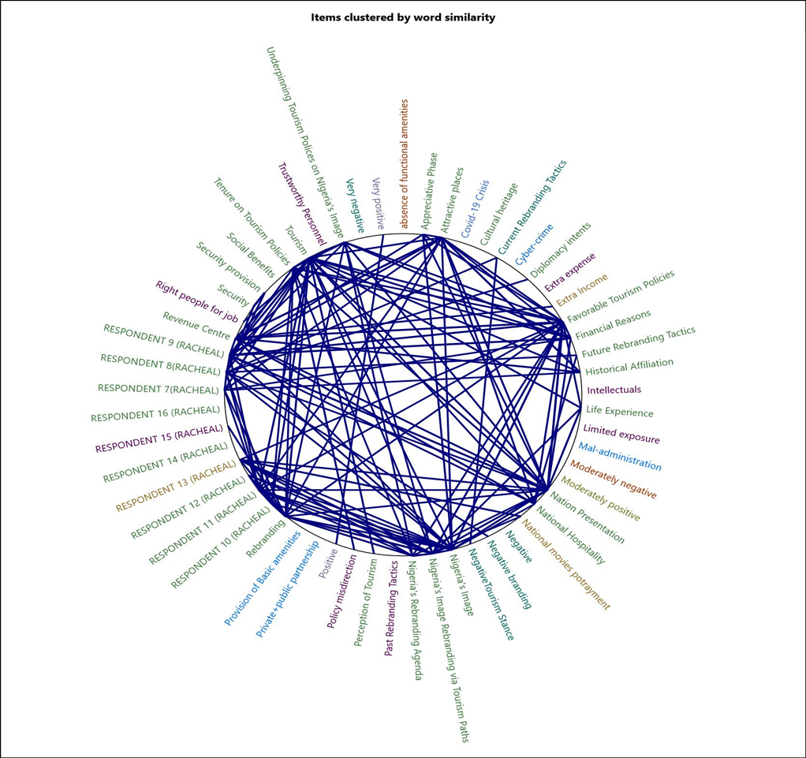

Figure 4.1 Items clustered by word similarities of Lagos State Polytechnic Academia

Prominent word similarities from figure 4.1 clustered diagram above show that ‘Nigeria’s rebranding agenda’ has not been effective as a result of inadequate ‘security’. According to Respondent 3:

‘The past rebranding agenda have not been effective because there is no result to show to that effect. Security of lives and properties must be considered first before rebranding will take place. For instance, if a company wants to come up with the idea of rebranding, the security of the company, the company owner, and the company’s environment will be considered first*.*

However, tourism can be used as a ‘diplomacy intent’ to rebrand Nigeria’s image because the perception of the tourists will be changed through public relations and attracts more tourists to Nigeria.

Respondent two opined that:

Tourism can be used as a diplomatic tool to rebrand Nigeria's image but Nigeria needs to be restructured before tourism. Nigeria’s image is first while tourism is secondary but both are needed to function*.*

This implies that tourism can be used as a diplomatic tool to rebrand Nigeria’s image but the issue of insecurity must be tackled because it tarnishes the image of Nigeria in the world. In corollary with the above, Respondent one explained ‘Nigeria’s image rebranding via tourism paths’ that:

*‘*Tourism can be used as a tool to rebrand our image if tourism assets are well developed, marketable, affordable and reliable to the world. In essence, tourism can be used to rebuild our image by ensuring that our cultural heritage is promoted and advertised to the world. Tourism can build Nigeria’s image by improving its economic standard’.

In addition to this, the government should develop the ‘attraction places’ with ‘historical affiliation’ so that it can attract more tourists. Moreover, Tourism in Nigeria is constrained by many factors and one of the dominant words is ‘financial reasons. According to Respondent:

Religious strive, insecurity, lack of finance from the government, lack of interest of the government, lack of competent experts in the tourism sector, the private sector is not encouraging because they are not ready to invest in tourism*.*

Furthermore, the key informant's dominant words connote that the constraints can be overcome by ‘security provision’, and ‘favourable tourism policies’, among others. This is embedded in the response of Respondent 3 that:

The government should make favourable policies towards the development of tourism as it focuses on crude oil. The citizens need to be educated on the importance of tourism and the issue of insecurity should be tackled.

The dominant words in the clustered diagram in blue print are; the right people for a job, trustworthy personnel, extra expense, intellectuals, limited exposure, past rebranding tactics, and policy misdirection. The ‘past rebranding tactics’ according to Respondent 9 is that the:

Heart of Africa' slogan was effective during Obasanjo’s administration because he embarked on shuttle diplomacy, he paid Nigeria’s debt, and he hired professionals that are Nigerians from abroad such as Dr Nkojo Iweala. However, the use of slogans has not been working to rebrand the image of Nigeria because the people clamouring for power are not people of integrity and Nigerian leaders don’t have the interest of the people at hand’*.*

This implies that slogan tactics have not successfully rebranded Nigeria’s image. However, ‘limited exposure’ of the citizens and ‘policy misdirection’ impedes tourism in Nigeria and this can be overcome by appointing the ‘right people that are tourism experts and ‘trustworthy personnel’ to the tourism sector.

The dominant words in the clustered diagram in brown print are; moderately negative, absence of functional amenities, national movies potrayment and extra income. Respondent 7opined that:

*‘*Dora Akunuyi’s Slogan is the most effective because she took significant steps to drive it in the entertainment industry, the effect was seen in the music industry. The ‘Change begins with me slogan did not have any impact. Hence, Slogan is not the thing that works but the driving and the implementation of it*.*

This connotes that Nigeria’s rebranding agenda is not effective but it is ‘moderately negative. The Respondents also agreed that Tourism can be used to rebrand Nigeria’s image but there is an ‘absence of functional amenities’ in the attraction areas. However, the image of Nigeria can be rebranded through tourism if the government can take significant steps to drive it in the entertainment industry and it will also serve as ‘extra income for the government.

**LAGOS STATE MINISTRY OF TOURISM, ARTS AND CULTURE**

**Tourism as a Tool for the Rebranding of Nigeria’s Image**

**Table 4.10 Informants’ view on Tourism as a Tool to Rebrand Nigeria’s Image**

|  |  |
| --- | --- |
| R1 | Tourism can be used to rebrand Nigeria’s image through festivals, culture, creative arts, etc. The Lagos state government is rebranding the major attraction areas and improving the transportation system such as railways and BRT to reduce traffic on major roads. Tourism can rebrand Nigeria’s economic image by generating revenue for the government through  tourists’ expenditure on hotels, cuisine, purchase of creative arts etc. However, the government needs to provide infrastructures to develop tourism, Nigerians need a reorientation to embrace domestic tourism so that it will attract tourists and rebrand Nigeria’s image. |
| R2 | Tourism can be used to rebrand Nigeria’s image, it depends on how we receive, treat, and respond to international tourists. For example, I have met with international tourists before, they were about three white people and five Americans, they were told that Nigeria is not a safe country but they were overwhelmed when they came to Nigeria. The way we were taking them around, nobody harasses them, we went to the nightclub, when we were ready to leave the club, the tourists were not ready to go because they were enjoying themselves. If it continues like that, many of them will want to visit Nigeria. |

From Table 4.10 above, the respondents opined that tourism can be used to rebrand Nigeria’s image through festivals, culture, creative arts, and hospitality to tourists among others. However, Nigeria as a country has battled for decades with its global image. Given the numerous variables that may be damaging its reputation that needs to be tackled, tourism appears to be the best way to improve it. As a result, the government should make concerted efforts to improve and control its foreign reputation (Vanguard News, 2018).

**Impediments that Undermined the Tourism Sector in Rebranding Nigeria’s Image**

Table 4.11 presents the key informants’ views on the factors that impede tourism in Nigeria. They opined that religious rigidity of the people, Lack of Infrastructural development, bad roads, lack of synergy between the federal government and the state government, lack synergy between the federal government and state government, epileptic power supply, insecurity, and lack of awareness about the importance of tourism impedes tourism in Nigeria.

**Table 4.11 Informants’ view on the Impediments that Undermined the Tourism Sector in Rebranding Nigeria’s Image**

|  |  |
| --- | --- |
| R1 | One of the major challenges is the religion rigidity of the people, Nigerian Christians and Muslims don’t want to participate in festivals because they see it as idol worship, the traditional worshipper also doesn’t want to upgrade their practices to be more appealing and attractive to attract more patronage from international tourists.  Infrastructural development is lacking, the roads are bad, and getting to some festivals and attraction areas becomes a difficult acromial task. There is no way to get to Agowa-Ikosi, it has to be by boat. Lack of proper information dissemination in terms of data collection of the attraction areas hinders international tourists from coming around.  Lack of synergy: there is the concurrent list, exclusive list, and residual list. The exclusive list of visa issuers is from the federal government. If the federal government does not have a synergy with the state government. The state government cannot issue visas, If the federal government did not issue visas to tourists, the tourist cannot come to Nigeria. There is a lack of synergy between the federal government and the state government. There is a lack of synergy within the ministry itself. Everybody is working on their own and it will make it difficult to drive international traffic. |
| R2 | The first impediment is infrastructure, no good road to where tourism sites and destinations are, epileptic power supply, and insecurity (kidnapping and the ransom request).  People are not fully aware of the importance and essence of tourism, they did not know that tourism is money, it is a way of life. There is a need to create more awareness, People travel abroad, struggle to buy a ticket and get a visa, do shopping, go to cinemas and their attraction areas, spend a lot of money outside the country but they don’t explore the attractions areas within Nigeria. How many places have they been to in Nigeria, that is why Lagos is trying to create community-based tourism? Some of the tourists also complained about obtaining Nigeria’s visa, they said the process of obtaining Nigeria’s visa is so cumbersome. |

In addition to this, Ezenagu (2018) opined that religion is a threat to tourism development in Nigeria, religion is a multidimensional phenomenon that pervades all aspects of human life because religious beliefs impact many parts of people's lives daily, it is reasonable to suggest that religion influences some of humanity's most important endeavours, such as commerce, migration, foreign investment, and tourism. In tourism, religion can affect destination selection, and restrict tourist mobility and involvement in tourism activities. Therefore, the government must resolve the impeding factors, Nigerians also need a reorientation to embrace domestic tourism and sell it to the world, by so doing it will attract more international tourists and Nigeria’s image will be rebranded.

**Measures by the Tourism Sector in Rebranding Nigeria’s Image**

**Table 4.12: Informants’ view on the Measures in Place by the Tourism Sector to Rebrand Nigeria’s Image**

|  |  |
| --- | --- |
| R1 | Lagos State Ministry of Tourism, Arts and Culture has a tourism master plan, one of the mission statements is to make Lagos the fifth tourist destination in Africa. Lagos is the first largest economy in Africa, people go to Cairo (Egypt), (Cape town, Jordan): South Africa. The master plan is like scratching the surface because of the paucity of funds however there are low-hanging fruits i.e the things that we can easily do that make us annex tourism is our culture and heritage. When we are talking about culture, we are talking about festivals.  In infrastructural renewals, the Lagos state is building on existing infrastructure such as roads and rails, BRT terminals, building tourist sites, and building monuments all over the place so that people can see the beauty in Lagos. Constructing paths and flowers all over the place so that it can be attractive to tourists to come around. When people come for a marathon race, and Lagos festivals, they will see the beauty of Lagos. The expected outcome is for Lagos to be the fifth tourism destination in Africa |
| R2 | In Lagos state there is a tourism master plan: it is the road map to developing tourism in Nigeria. This administration is doing everything humanly possible for the policy to thrive and succeed although there are infrastructural challenges.  The federal government should address the electricity issue, the federal government should improve security, the process of obtaining visas for tourists coming from outside the country should be easier, If the federal government can do all of these things, more tourists will come to Nigeria and have ache-free stay in Nigeria.  The expected end is that if the government can put all those things are simplified, it will attract more tourists to Nigeria, they will eat our food, sleep in our hotels, use our transportation system and buy our arts and crafts, it will generate more revenue for the country. Aside from that, when they go back to their country, they will market Nigeria in their country positively. If you go to Nigeria, processing the visa is very easy, Nigeria is very peaceful, beautiful, hospitable with fantastic cuisine, arts and crafts, so forget about the news you are hearing. |

Table 4.12 presents the view of the key informants about the measures to put in place to rebrand Nigeria’s image in Nigeria through tourism, they explained that the Lagos state government is making progress in tourism development. Respondent one replied that:

*‘*Lagos State Ministry of Tourism, Arts and Culture has a tourism master plan, one of the mission statements is to make Lagos the fifth tourist destination in Africa’*.*

Moreover, the Lagos state government in Lagos state is building on existing infrastructure such as roads and rails, BRT terminals, building tourist sites to beautify Lagos state. Lagos state government also engage in festival activities and marathon race to attract international tourists. According to the Lagos tourism master plan, the Lagos State government will promote tourism through cultural heritage with historical affiliation, through films, arts and entertainment because the third largest film industry in the world is in Lagos. Lagos State will also promote tourism through Access Bank Lagos Marathon, Lagos International squash classics, the junior and Cadet African fencing championship, and COPA Lagos.  Furthermore, Haven identified the role of the Lagos state government, respondent two also explained that the federal government should address electricity issues, improve security and make Nigeria’s visa processing application easier for tourists.

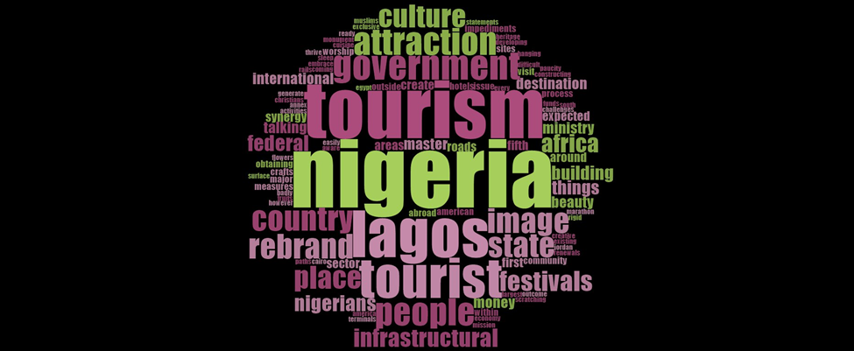

*Figure 4.2 Word Cloud presentation of the respondents at the Lagos State Ministry of Tourism, Arts and Culture*

From the figure 4.2 word-cloud diagram above, Respondent one opined that ‘culture’ and ‘festivals’ can be used to ‘rebrand’ Nigeria’s image through ‘tourism’. The Respondent also mentioned the need for government to provide ‘infrastructures’ to develop tourism in Nigeria so that it will attractive to tourists. Tourism is a vital tool to rebrand Nigeria’s image because tourists will have a practical experience of who Nigerians are.

However, ‘tourism’ in Nigeria is constrained by a lack of ‘infrastructural’ facilities, lack of good ‘roads’, lack of ‘synergy’ between the state government and the federal government, lack of ‘synergy’ with the Ministry of Tourism, Arts and Culture, a paucity of funds, religion ‘rigidity’ of Nigerians among others. Furthermore, the respondents opined that ‘Lagos State is making progress in tourism developments. This can be seen in Respondent one response: ‘Lagos State Ministry of Tourism, Arts and Culture have a tourism master plan, and one of the mission statements is to make Lagos the fifth tourist destination in Africa’.

Moreover, there is a need for a ‘synergy’ between the ‘Federal’ government and the State government, because it is only the ‘Federal’ government that can issue the visa to tourists according to the exclusive list. Therefore, the ‘Federal’ and state government should work together so that tourism can improve in Nigeria. There should also be a ‘synergy’ within the Ministry of Tourism, Arts and Culture. Respondent 2 also explained the roles of the federal government:

The federal government should address the electricity issue, the federal government should improve security, and the process of obtaining visas for tourists coming from outside the country should be easier, If the federal government can do all of these things, more tourists will come to Nigeria and have ache-free stay in Nigeria*.*

Therefore, the federal and the state government Tourism Ministries must work collectively toward tourism development so that it can serve as a mechanism for rebranding Nigeria’s image.

**Nigerian Institute of International Affairs**

**Effectiveness of Nigeria’s Rebranding Agenda**

Table 4.13 presents the view of the respondents at the Nigerian Institute of International Affairs on the past rebranding agenda in Nigeria. They admitted that Nigeria’s rebranding agenda was effective to a large extent during president Obasanjo’s administration because of the change in government administration and his engagement in shuttle diplomacy. The subsequent rebranding agenda has been the use of slogans without any significant impact. In addition to this, Respondent 2 opined that: Nigeria does not necessarily need a slogan to rebrand its image because the domestic situation of a country will determine the image of the country.

Insecurity is affecting Nigeria’s image and limiting its rebranding agenda. In addition to this, Poor finance, a lack of clarity of goal, and government insincerity have been mentioned as some of the reasons why previous initiatives to rebrand Nigeria failed (Thomsopon, 2017). Therefore, the government should deal with the fundamental problems in Nigeria before rebranding can take place.

**Table 4.13 Informants’ view on Nigeria’s Rebranding Agenda**

|  |  |
| --- | --- |
| **R1** | Initially, Nigeria’s external image was good outside Nigeria but based on the security challenges which we are facing now, we have issues of kidnapping, banditry, corruption, and agitation.  During the administration of President Olusegun Obasanjo, the rebranding agenda was having an impact, Obasanjo engaged in shuttle diplomacy. Under Buhari’s administration, rebranding is not having any impact. The challenge of insecurity is a limitation to Nigeria’s rebranding agenda, E.g. Kidnappings, train attach. The federal government needs to put the house in order and make sure that security challenges are resolved before we can talk about image building. |
| **R2** | Nigeria does not necessarily need a slogan to rebrand its image because the domestic situation of a country will determine the image of the country. The domestic situation has a negative impact on the image of Nigeria, It has also translated into our engagement in the international arena, in terms of deliberating with countries at the bilateral level and multilateral level, the situation of Nigeria has become very critical. There was a WhatsApp video of an international relations class of a school abroad, a Nigerian saw a lecturer using a large picture of President Buhari on the screen as an example of a bad leader to the students in the class. Students that have not been to Nigeria before will view Nigerians from a negative perspective because of so many things that the lecturer might have said in that class. If the federal government wants to rebrand Nigeria’s image it should start at the foundational level. The rebranding agenda has not been able to achieve anything, although president Obasanjo tried during his administration and engaged in shuttle diplomacy to a large extent, Nigeria's external image perception was positive because the Nigerian government changed to a democratic government and Obasanjo came up with positive agendas that affected our brand positively at the international level. |

**Tourism as a Tool for the Rebranding of Nigeria’s Image**

Table 4.14 above explained the opinion of the respondents on how tourism can be used to rebrand Nigeria’s image. They opined that Tourism is a very good tool to rebrand Nigeria’s image because if tourists are well treated, they will say good things about Nigeria in their home countries. Festivals and international exhibitions such as FESTAC (Festival of Black Arts and Culture) should be reintroduced. According to Professor Bolaji Akinyemi, the former Minister of External Affairs, the federal government of Nigeria should not bury the vision of FESTAC and it is necessary to add sport to it because sports is an instrument of soft power diplomacy. (Olawale,2022). However, Respondent two opined that:

‘In an ideal situation tourism can be used to rebrand a country’s image this implies that tourism can be used to rebrand Nigeria’s image but in a country where there is political violence, insecurity such as the train attack, it will be difficult for tourism to thrive because it will be difficult to attract tourists.

This implies that the government must tackle domestic problems in Nigeria so that tourism to flourish.

**Table 4.14: Informants’ view on Tourism as a Tool to Rebrand Nigeria’s Image**

|  |  |
| --- | --- |
| **R1** | Yes, Tourism is a very good tool for rebranding Nigeria’s image, when tourists come to Nigeria for vacation and they are well treated, they will spread the messages, e.g. People are always traveling to the Bahamas for vacation, people tell a lot of stories and I am looking forward to traveling there, e.g. in china, people travel there without facing security challenges.  Festac 1977, was the second world African black festival, arts, and culture, it was a major international festival held in Lagos Jan 15-12th february1977-1979. It was a carnival that people came to, some Americans came, and people that have not been to Nigeria. We should go back to that type of festival, art exhibitions. NUGA game that happened in Lagos was nice, a lot of people traveled from places to watch the game in UNILAG**.** |
| **R2** | In an ideal situation tourism can be used to rebrand a country’s image this implies that tourism can be used to rebrand Nigeria’s image but in a country where there is political violence, (train attack) insecurity, it will be difficult for tourism to thrive because it will be difficult to attract tourists. In a situation where there is peace, and stability at the domestic level then tourists can come in and see that oh it is a beautiful and peaceful country, then they can go back with a positive image of the country. |

**Impediments that Undermine the Tourism Sector in Rebranding Nigeria’s Image**

Table 4.15 presents the respondent’s opinions about the major impediments that are undermining tourism in Nigeria. The first respondent identifies the paucity of funds at the federal level as a major impediment. As a result, the attraction areas are not properly maintained and managed. While the second respondent opined that: *‘Nigeria* has a high percentage index in virtually all the bad things of the world, the corruption index is high, the poverty index is high, mortality rate index is high among others.

According to the Transparency International Corruption perception index in 2021, Nigeria ranked 154th out of 180 countries. Therefore, all the impediments must be resolved to enhance tourism development in Nigeria.

**Table 4.15 Informants’ view on the Impediments that Undermine the Tourism Sector in Rebranding Nigeria’s Image**

|  |  |
| --- | --- |
| **R1** | The major impediment is the paucity of funds at the federal government level, most of the tourist sites are undermined by the paucity of funds, they are not being maintained e.g. the Yankari game reserve some of the animals are dying. In my village, Owerri Ezukala café and waterfall, water comes from the rock which is misery, the government should take over such places and advertise it so that people will be coming. The government can make provision for shuttles for the attraction areas. |
| **R2** | Nigeria has a bad external image, it has a high percentage index in virtually all the bad things of the world, the corruption index is high, the poverty index is high, mortality rate index is high among others. Nigeria is leading in all the bad indexes, there is terrorism (Boko haram). There is the problem of bad leadership in the country, all these impediments must be resolved before we talk about tourism. |

**Measures by the Tourism Sector in Rebranding Nigeria’s Image**

Table 4.16presents the respondents’ views about the measures to put in place to rebrand Nigeria’s image. According to respondent one, the federal government should identify all the tourist sites, advertise them and design a tour guide for them. The government should also partner with the private and provide loans for them to develop their attraction areas. Collaboration between the public and private sectors is necessary because, even though they have a division of labour, there is a complementing point of elevation that will improve the tourism industry's sustainable goals (Olapade, 2022). However, respondent 2 opined: *‘Currently, we need to put our house in order before we talk about tourism in Nigeria because tourists will be afraid of being kidnapped.*

This implies that the security of lives and properties must be guaranteed by the government before tourism development. Bassey and Egon (2016) also opined that the government should also ensure adequate security and provide infrastructural facilities so that tourism can develop in Nigeria.

**Table 4.16: Informants’ view on the Measures in Place by the Tourism Sector to Rebrand Nigeria’s Image**

|  |  |
| --- | --- |
| **R1** | First of all, the federal government should identify all the tourist sites (Including the untapped attraction areas). Some of them are private and some are owned by the government. The government should invest in government-owned attraction areas and advertise them, the government should design a tour guide, and the government should make it available at the airport and give it to foreigners. The tour guide should include the phone number of people to contact if foreigners want to visit such places.  The government can give loans to the private sector which they can pay back to develop their attraction areas, the expected outcome if the government should put those measures in place, it will generate Funds for the government. For instance, if a tourist wants to visit any attraction area (both discovered and untapped attraction areas) yankari game reserve, ezukala waterfall, he or she will pay. It will generate funds for the federal government and the community. |
| **R2** | Currently, we need to put our house in order before we talk about tourism in Nigeria because tourists will be afraid of being kidnapped. |

**Tourists’ Comments on Nigeria**

**Table 4.17 Informants’ Experience with Tourist**

|  |  |
| --- | --- |
| R1 | Yes, they asked me things about Nigeria, they asked about more sites where they can go, some of the tourists were disappointed because they didn’t have a tour guide, they were doing the explorations by themselves. In terms of visiting the attraction areas, they were impressed, they were afraid of being kidnapped, and losing their money. |
| R2 | Nil |

The first respondent explained further about her personal experience with a tourist in the table above.

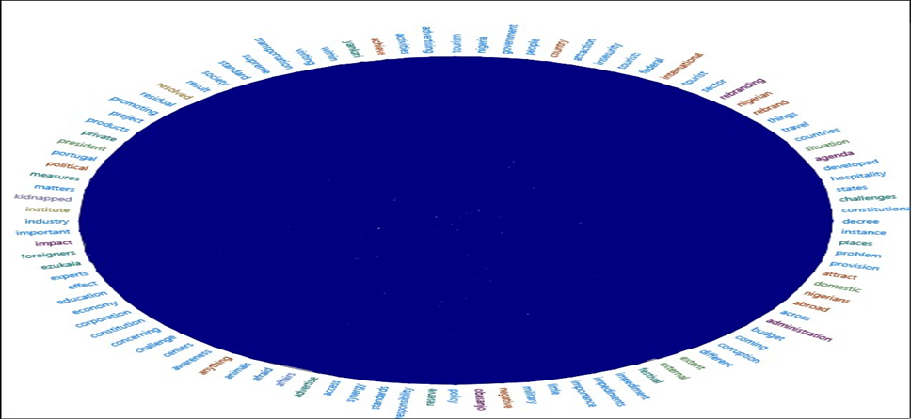*Figure 4.3 Items clustered by word similarities of the respondents at the Nigerian Institute of International Affairs*

The Prominent word similarities from figure 4.2 clustered diagram above show that Nigeria’s ‘rebranding’ ‘agenda’ has ‘little’ ‘impact on Nigeria’s image. Although, ‘President’ ‘Obasanjo’s administration’ ‘rebranding’ ‘agenda’ was impactful to some ‘extent’ but ‘domestic’ ‘problems’ in Nigeria debunk the use of mere slogans to ‘rebrand’ Nigeria’s image. However, ‘Tourism’ ‘attraction’ and ‘places’ can be used as a ‘centre’ of ‘attraction’ to ‘rebrand’ Nigeria’s image. ‘Tourists’ can visit places like the ‘Yankari’ game ‘reserve’, and ‘Ezekala’ waterfall.

Moreover, ‘insecurity’ is a major ‘challenge’ to ‘tourism’ in Nigeria. ‘Tourists’ that want to ‘visit’ ‘Nigeria’ will be ‘afraid’ of being ‘kidnapped’. Nigeria’s bad ‘external’ image in terms of the high ‘corruption’ index is an ‘impediment’ to ‘tourism’. More so, the ‘measures’ to put in ‘place’ is that the ‘federal’ ‘government’ should identify the ‘attraction’ ‘places’, ‘advertise’ it and invest in it. There should be a ‘synergy’ between the government-private sector tourism agencies in ‘promoting’ in Nigeria in terms of giving out loans to the private sector to develop the ‘attraction’ ‘places’. In addition to this, Respondent 1 also opined that:

‘FESTAC 1977, was the second world African black festival, arts, and culture, it was a major international festival held in Lagos Jan 15-12th february1977-1979. It was a carnival that people came to, some Americans came, and people that have not been to Nigeria’.

This implies that ‘international’ ‘festivals’ should be reintroduced.

**Nigerian Tourism Development Corporation**

Table 4.18 below presents the view of the respondents from Nigerians Tourism Development’s corporation on Nigeria’s image. Respondent two opined: ‘The international media projection about Nigeria’s image is full of negativity’.

This implies that journalists’ write-ups about Nigeria on media are full of negativity. Nigerian journalists overemphasize negative news while The United State of America's national interest is to protect the image of its country as number one in the world. According to Lai Mohammed, the Minister of Information in Nigeria, the image crisis that Nigeria is experiencing now is primarily attributable to the nation's media's "unflattering" representation of the country (Adegboyega, 2021).

**The Table Below Shows the Respondents’ Stance on Nigeria’s Image**  **Table 4.18 Informants’ view on Nigeria’s Image**

|  |  |
| --- | --- |
| **R1** | Journalists are pulling down the image of Nigeria which is a major impediment, although we are in the era of freedom of speech, Nigeria has not committed one-tenth of the crime committed by the United State or South Africa. Journalists in Nigeria overemphasize negative news. For instance, America has a target of building their image to be number one in the world, all activities will be channeled towards the target and whatsoever that will tarnish their image, or undermine their interest to protect their image, they will play it down, they will not display it on media. America doesn’t joke with anything that will jeopardize the image of their country. |
| **R2** | The international media projection of Nigeria’s image is full of negativity such as international news on BBC, CNN among others. |

Therefore, Nigerian journalists need to rebrand Nigeria’s image by posting good news about Nigeria and limiting the emphasis on bad news. The government should also find a way to limit the negative post from the International Media about Nigeria’s image.

**Effectiveness of Nigeria’s Rebranding Agenda**

**Table 4.19 Informants’ view on Nigeria’s Rebranding Agenda**

|  |  |
| --- | --- |
| **R1** | The past rebranding agenda has not been effective as a result of leadership problems. If you look at ‘Heart of Africa’, ‘Good People’, ‘Great Nation’ want people to know about Nigeria, what are the ingredients that you want people to know about Nigeria, the past rebranding agenda lacks the major ingredients. The past rebranding agenda did not pinpoint or emphasize the major area of focus that we want the outside world to know about Nigeria, people don’t know the content of the past rebranding agenda, and people don’t understand. Nigeria should include certain ingredients such as the Culture, cuisine and hospitality are the areas to capitalize on to rebrand Nigeria’s image. For instance, Ghana created the brand ‘Ghana Jollof’ for people to visit Ghana. Nowadays, hospitality is eroding as a result of the covid-19 policy. To maintain a park is capital intensive, and the beaches are at the stage of decadence. Although the image is easy to launder, for instance, if a goldsmith is using his hammer on a particular object continuously it will form the object he intends, rebranding Nigeria's agenda lacks consistency. |
| **R2** | The past rebranding agenda has been the handwork of the federal ministry of information, NTA, the voice of Nigeria among others, it was a catchphrase that embodies the Nigerians' spirit. Nigeria’s rebranding agenda have not been effective because there is no symbiosis between the rebranding agenda given mandate and the projection of Nigeria’s image in a positive way. |

Table 4.19 present the views of the respondents about Nigeria’s rebranding agenda. The two respondents admitted that Nigeria’s rebranding agenda have not been effective. Egwemi, 2010, Ademola, Talabi and Lamidi, 2012, and Endong (2018) also affirm that the several approaches to rebranding Nigeria have not been effective, despite the tremendous financial commitments and significant human efforts deployed during the rebranding campaign of Nigeria, Nigeria's worldwide perception remains dominantly negative. Respondent one opined that:

*‘*Nigeria’s rebranding agenda has not been effective as a result of leadership problem, Nigerians are not familiar with it and the rebranding agenda lacks major ingredients such as culture, cuisine and hospitality*.*

Culture, cuisine and hospitality are instruments of tourism that can be linked to the next question.

**Tourism as a Tool for the Rebranding of Nigeria’s Image**

**Table 4.20 Informants’ view on Tourism as a Tool to Rebrand Nigeria’s Image**

|  |  |
| --- | --- |
| R1 | This organization is the apex organization to consult when it comes to tourism in Nigeria, the tourism brand as far as this organization is concerned is ‘Tour Nigeria’, because when you tour Nigeria you will have the understanding and the experience of Nigerians.  Therefore, the corporation can rebrand Nigeria’s image through tourism in the area of culture, hospitality and cuisine, we have more than 250 ethnic groups, and Nigeria’s culture makes Nigeria unique in the world. In the area of hospitality, Nigerians are very hospitable. |
| R2 | Tourism is about the people, when you are talking about rebranding, you are talking about imaging and marketing. The image of a country can be determined by the international news media that has their agenda, tourism is a good tool to rebrand a country’s image, it is like selling the country to the rest of the world, tourism is about getting people interested in the country irrespective of the international media outlook through tourism products such as cultural, i.e. when we are talking about intangible things, it is the peculiarity of the life of the people. Another aspect of tourism is physical attractions that are unique. Irrespective of the negative news about Nigeria on international media, some tourists have an adventurous spirit. By the time the German man was visiting Nigeria before, the image of Nigeria was not as bad as it is currently being now. There is kidnapping, banditry, Fulani herdsmen, and money laundry, there was a notorious indigenous bank manager in Nigeria who defrauded a bank in Brazil and later became the major shareholder in one of the Nigerian banks. It was about ten to fifteen years ago; it was a major de marketing tool for Nigeria. The German man complained that getting a Nigerian visa is very difficult now compared to 10 or 15 years ago, the problem is bureaucratic from our foreign missions abroad. |

Table 4.20 above presents the key informant responses on tourism as a tool to rebrand the image of Nigeria. They agreed that tourism can be used as a tool to rebrand the image of Nigeria. Respondent one opined that ‘the corporation can rebrand Nigeria’s image through tourism in the area of culture, hospitality and cuisine’.

Corollary to this, Respondent two explained that culture is an intangible tourism product that sells Nigeria’s good image to the world. Tourism can be used to rebrand Nigeria’s image through hospitality, the destination centers and Nigerian culture should be showcased to tourists, they will return to their home countries with a reformed mind and pass the message across to others that Nigerians are different from what international and local media portrays (Vanguard News, 2018). Therefore, the issue of insecurity must be dealt with and the bureaucratic problem limiting tourists from getting Nigerian visas on foreign missions must be resolved.

**Impediments that Undermine the Tourism Sector in Rebranding Nigeria’s Image**

**Table 4.21 Informants’ view on the Impediments that Undermine the Tourism Sector in Rebranding Nigeria’s Image**

|  |  |
| --- | --- |
| R1 | Constitutional ambiguity: The Federal government only has control over tourism traffic, the federal government lacks cultural products and the states are the ones sharpening it.  Lack of authority over tourist sites, it is not possible for Nigeria Tourism Development Corporation to organize tourism activities. Although during the military regime, there are decrees with authority, under the democratic system of government in the fourth republic, the federal government gives power to every unit, and tourism is not seen as a thing of immediate concern. The decree written in a military tone on tourism was not amended  Insecurity: tourism does not flourish where there is fear, tourism flourish where there is freedom. Infrastructural deficiency, bad roads |
| R2 | Constitutional challenges: the corporation is over 50 years, NTDC was powerful during the military regime. The decree of 81 of 1992 is the major precursor for the NTDC, there were so many things in that decree that were not properly articulated. One of the key features of the decree is to encourage foreigners to visit Nigeria’s tourism destinations another key feature of the decree is that the NTDC was saddled with the responsibility of carrying out tourism research, the third key feature of the decree is for the corporation to develop tourism asset in the country in terms of physical assets, promoting Nigeria’s tourism abroad, providing tourism regulations and to other industries attached to tourism industry such as hotel, transportation. Tourism is a multi-sectional such as transportation, standard in hospitality, land, and finance. In the military era, NTDC has overall responsibility for tourism, although there were state tourism broads but NTDC was the one that gave the overall policy, and give directives to make sure that the policies were implemented. The constitutional provision limits the statutory power of the tourism sector to only immigration matters. In 1999, there was a key constitutional provision for tourism but the constitutional provision has a delayed effect of covering their statutory jurisdiction, at a point, NTDC took the Lagos government to the Supreme Court concerning the limitations of NTDC in regulations of hotels but the Supreme Court quoted the portion of the constitution that federal government only have responsibility for-tourist traffic, that is the movement of people alone and immigration matters. If it were to be a law it could have been easily amended, regulation of the hotel industry across the states, and enforcement of tourism hospitality standards across the states were categorized by the Supreme Court as residual list matters. The residual list is the aspect of government that the state has absolute power over, this can be found in section 4 part 60(d) of the 1999 Nigerian constitution. That is a major issue, the major effect is that the NTDC cannot ensure that standards are kept in hospitality which is a key component of the tourism industry because the state has the right to hospitality, it is a major problem because we will have 36 states and 36 different standards. The UNWTO has a global standard for hospitality, there was a time when Nigeria provided representation through the Nigerian Ambassador to Spain and NTDC representative to attend the UNWTO conference in Spain. Hospitality in Nigeria cannot be in line with global standards because of the constitutional provision that limits the responsibility of the federal government on tourism. The Nigerian constitution states that only the state has jurisdiction concerning hotel registration, hotel licensing, buildings and facilitation. It is a big problem, for instance, if a tourist comes to Nigeria with the mind of lodging in a big star hotel and many states, it is going to cause a serious problem because a five-star hotel in Lagos in terms of its luxuries will be different from a five-star hotel in another Abeokuta, in Ondo, he will find out that the quality is deteriorating. |

Table 4.21 below presents the responses of the key informant about the factors that are impeding tourism in Nigeria.

**Table 4.21: Informants’ view on the Impediments that Undermine the Tourism Sector in Rebranding Nigeria’s Image**

|  |  |
| --- | --- |
| R2 | Paucity of funds: the priority of the federal government is different; they don’t believe in investing money in the tourism sector. They don’t see tourism as a priority sector and they don’t fund it. Internationally tourism is recognized as a major laundering tool, for instance, Portugal over the last five years has consistently won the world tourism award as the most desirable tourism destination in the world. The award program is usually held in Dubai annually. Portugal is one of the smallest countries in Europe, how do they achieve this, their marketing budget alone in terms of internet advertising is half of their operating budget because they see the importance of image laundering. They have the result of a lot of people visiting Portugal, they put in marketing investment and they have been able to improve their economy as a result of it.  Before Nigeria used to involve in the international tourism market where different countries go to market their tourism products such as trade fairs, (ITB berlin) international tourism exhibition in Berlin Germany, the World travel market in London, FITUR Spain, and Dubai market. The tourism market attracts nationals of those countries to visit Nigeria. In the last 6 to7 years, NTDC has not been going to international exhibitions. How do we market the country when Nigeria is not involved in such exhibition activities again to market its tourism products?  Lack of tourism professionals or experts, it is only recently that the tertiary institutions see tourism as a course worth studying unlike a few years ago, so there is a lack of professionals. Perhaps if there are more tourism experts and people who have tourism educational backgrounds in policy positions, perhaps things will change. |

The respondents opined that constitutional ambiguity, lack of authority over tourist sites, insecurity, infrastructural deficiency, paucity of funds, lack of tourism experts, and non-participation in international exhibitions are the major factors that are undermining the operation of the Corporation in promoting tourism. Currently, the country's security condition is shattering tourism gains. For example, Canada, Australia, the United States, and the United Kingdom have issued travel warnings to their nationals who plan to visit Nigeria for tourism or business (Asabor, 2021). Therefore, constitutional ambiguity is the major problem of the corporation that limits its functions in handling all tourism matters. As a result, the corporation cannot function effectively if the constitution is not amended.

**Measures by the Tourism Sector in Rebranding Nigeria’s Image**

Table 4.22 below presents the measures put in place by the tourism sector to rebrand Nigeria’s image. The respondents admit that the government should amend the constitution to empower the Corporation to have full control over all aspects of tourism, the government should make a policy that will enhance the continuity of tourism promotion in Nigeria, and the government should construct roads and infrastructures. Nigeria’s foreign mission abroad should make tourism travel to Nigeria to be easier among others. Arogunmi (2019) also opined that the federal government should invest heavily in the tourism sector and sell tourism to the world. As a result, tourism will develop and increase the influx of international tourists to Nigeria. The influx of international tourists can rebrand Nigeria’s image because they will have a good impression of Nigeria.

**Table 4.22: Informants’ view on the Measures in Place by the Tourism Sector to Rebrand Nigeria’s Image**

|  |  |
| --- | --- |
| R1 | There has been the use of tourism slogans such as facilitating Nigeria, tourism is life. The current Director-General of NTDC discovered some lapses in tourism sectors and he said the corporation should start with domestic tourism. We should promote our culture, visit our tourist sites, should embrace what we have first before others. The new DG came up with TOUR Nigeria and Nigeria FLAVOUR. When we embrace what we have, we can talk about our culture, hospitality, and heritage. Tour Nigeria and Nigeria flavour has been effective but it was affected by covid-19 travel restrictions which have affected festivals such as Olojo festival, Osun Osogbo, new yam festival, Calabar festival among others. In the same vein, insecurity also affects tourism, there are insurgencies, we don’t embrace what we have, and in some countries, they celebrate Osun Osogbo.  Therefore, there is a need for a reorientation of Nigerians to define who we are as Nigerians, our goals as a country, and what we are aiming to achieve. We have not identified our goals and target as a country and what we intend to achieve.  Constitutional amendment; NTDC should have power over-tourism sites, Continuity in tourism promotion by the government, construction of roads and infrastructures and adequate security |
| R2 | ‘Tour Nigeria’ brand by the DG (Chief Folorunsho) of NTDC. Tour Nigeria is on social media such as Instagram, Twitter, it is the marketing tool of the corporation to promote tourism in Nigeria. Tour Nigeria is a short brand name that is easy to remember, we also have branded shirt called Tour Nigeria. It has been effective and has been able to attract tourists.  Nigeria’s foreign mission abroad should make tourism travel to Nigeria to be easier as possible.  The Nigerian government should make travel less cognitive for international people that want to visit Nigeria. Our foreign mission abroad should be properly trained on understanding the importance of tourism so that they can rebrand the country’s image because the focus has been on businessmen rather than a tourist. As a result, they made it easier for a foreigner that wants to come to Nigeria for business purposes rather than for tourism purposes. There was a proposition about 15 years that NTDC and Immigration officers should be embedded in diplomatic missions abroad to advise tourism travel less cognitive but nothing came of it, to make headways in that proposition, there is a need for symbioses and cooperation.  The federal government should invest heavily in the tourism sector, they need to study tourism progress in Portugal and see the importance of tourism as an image branding tool.  Concerning the constitutional problems, recently the members of the national assemble sat to vote on 68 constitutional amendments, they have been having that conversation since June 2021, and the NTDC has been pushing for the national assembly to look into the constitutional issue that is limiting the functionality of the NTDC, we made representations at the house of assembling and senate but when the final amendment was debated, NTDC constitutional limitations were not part of the amendments that were debated. everything has become so politicized. Other issues such as the power generation issue have been addressed, they have broken the monopoly of the federal government that state government can now generate their power. Security has to be improved  However, it is important to note that, tourists are not coming to Nigeria based on good roads, comfortable hotels, or good infrastructures, Tourists are coming to Nigeria based on an interest to experience our culture, they are coming because we have the tourism products that we don’t have in their country. The things that we consider as challenges, most of the tourists that come to Nigeria don’t see as challenges. There was a white man that traveled to Ikogusin in Ekiti state, he said that he doesn’t know that Nigeria has such an asset, he said that Nigerians are hospitable people. |

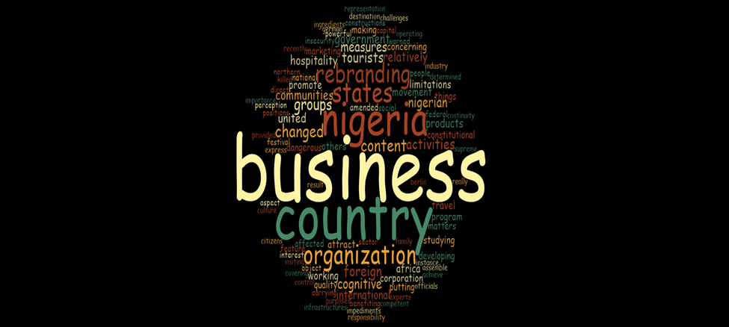*Figure 4.4 Word Cloud presentation of the respondents at the Nigerian Tourism Development Corporation.*

From figure 4.4 word-cloud diagram above, the respondents opined that Nigeria’s ‘rebranding’ agenda lacks the major ‘ingredients’ such as ‘culture’, ‘hospitality’, and cuisine. However, these ingredients are tourism products that can be used to ‘rebrand’ Nigeria’s image. Rebranding a country is like ‘marketing’ the country like a ‘business’ in the competitive world. ‘Festival’ ‘activities’ and physical attractions are ‘aspects’ of tourism that can be sued to ‘rebrand’ Nigeria’s image.

However, the respondents’ identified ‘constitutional’ ambiguity as a major ‘impediment’ that undermines the operation of the ‘corporation’. ‘Insecurity’ also impedes tourism in Nigeria, for instance, the ‘United’ ‘States’ of America instructed their ‘citizens’ not to ‘travel’ to the ‘Northern’ part of Nigeria. Respondent 2 opined that Nigeria’s foreign mission abroad permits more ‘foreigners’ to travel to Nigeria for ‘business’ ‘purposes’ than for tourism ‘purposes’.

Moreover, the ‘measures’ that the ‘government’ can put in place are to ‘amend’ the Nigerian constitution to favour the ‘operations’ of the ‘corporation’, the ‘federal’ ‘government’ foreign mission abroad should make ‘foreign’ ‘travel’ easier for tourism ‘purpose’, the ‘federal’ ‘government’ should consult ‘international’ ‘expert’ on tourism.

**PRIVATE SECTOR TOURISM AGENCIES Tourism as a Tool to Rebrand Nigeria’s Image**

**Table 4.23: Informants’ view on Tourism as a Tool to Rebrand Nigeria’s Image**

|  |  |
| --- | --- |
| R1 | Yes, there is no how we elevate our cultural heritage that tourists wouldn't come to visit because foreigners will want to experience new things outside their country. Tourism and hospitality go hand in hand, we can have food tourism, tourists can be served our traditional dishes, give the tourists local food to eat like Amala, roasted Corn, Boli if you go to La Campagne Tropicana Resort at Lekki, every food there is local, even the way the waitress will attend to you, they put on Oleku i.e. traditional attires to showcase our culture. |
| R2 | Yes, we have a lot of attraction areas in Nigeria such as Obudu cattle ranch, Olumo rock among others where people can come and visit. |
| R3 | Nigeria needs to be better before tourism can thrive |
| R4 | It is a good fit to rebrand Nigeria’s image if the Nigerian government can focus on the tourism sector |
| R5 | We can use tourism to rebrand Nigeria’s image, the first thing that the government can work on is security, when foreign don’t hear the news of people being kidnapped, people being killed and so many things around, with that we can attract more tourists, nowhere is safe, even for Nigerians and talk less of foreigners coming to the country. |
| R6 | Yes |
| R7 | Yes |
| R8 | Sure, if you go to western Europe tourism is boosting their economy but in Nigeria we didn't invest in tourism the way we should invest in it. |
| R9 | tourism will benefit our foreign relations as tourists come in but Nigeria is facing some challenges of lack of development of tourism locations, lack of infrastructure, insecurity in the country, travel policies restrictions, and corruption so when the government resolves those things and improve our attraction areas, it will improve foreign relations through tourism diplomacy, for instance, the government of Saudi Arabia has opened up to global tourism, they were closed up from the world because it is an Islamic country but now they have opened up to global tourism to improve their economy. It is also improving their GDP, they have reduced corruption, improve their security and develop their tourism sector. If the Nigerian government can do that, it will improve our foreign relations and increase our GDP. |

Table 4.23 presents the view of the respondents from private sector tourism agencies on how tourism can be used to rebrand Nigeria’s image. The respondents admitted tourism is an excellent tool to rebrand Nigeria’s image. Tourism can be used to rebrand Nigeria’s image through cultural heritage, hospitality, and attraction areas. Irrespective of Nigeria's tourism sector's potential, reoccurring security challenges will continue to impede the growth of the sector (Alade, 2021). According to respondent 9:

‘Nigeria is facing some challenges of lack of development of tourism locations, lack of infrastructure, insecurity in the country, travel policies restrictions, and corruption so when the government resolves those things and improve our attraction areas, it will improve foreign relations through tourism diplomacy’*.*

This implies that Tourism can flourish in Nigeria if these challenges are resolved.

**Impediments that Undermine the Tourism Sector in Rebranding Nigeria’s Image**

Table 4.23 presents the view of the respondents from private sector tourism agencies on how tourism can be used to rebrand Nigeria’s image. The respondents admitted tourism is an excellent tool to rebrand Nigeria’s image. Tourism can be used to rebrand Nigeria’s image through cultural heritage, hospitality, and attraction areas. Irrespective of Nigeria's tourism sector's potential, reoccurring security challenges will continue to impede the growth of the sector (Alade, 2021). According to respondent 9:

‘Nigeria is facing some challenges of lack of development of tourism locations, lack of infrastructure, insecurity in the country, travel policies restrictions, and corruption so when the government resolves those things and improve our attraction areas, it will improve foreign relations through tourism diplomacy’*.*

This implies that Tourism can flourish in Nigeria if these challenges are resolved.

**Table 4.24: Informants’ view on the Impediments that Undermined Tourism from Branding Nigeria’s Image**

|  |  |
| --- | --- |
| R1 | Insecurity, the economy of Nigeria is not favourable at all, there is over congestion at Osun Osogbo festival |
| R2 | The COVID-19 travel restrictions are a major challenge in which all travelers must be vaccinated before they travel |
| R3 | Insecurity, banditry and Boko Haram, people see what is posted online about Nigeria and it can restrict tourists from visiting Nigeria |
| R4 | Lack of maintenance in our tourist centers, the maintenance lacks continuity, once a government get there they do things right when another government get there they do otherwise, |
| R5 | Insecurity is the major challenge because everyone is scared of I can’t go by air, by road to come to your country where there is no safety, |
| R6 | Insecurity because tourists will want to know if they will be secured on the road, if the location that the organization is announcing to them is secured, especially in the post COVID era, they will want to know if the destination areas are safe health-wise also. This is part of the occurrences that we are experiencing as an organization, some of the tourists are scared that Nigeria will not be safe for them because of the crisis happening in the North-East, and they are looking at the quarantine procedure that are they going to be locked up in somewhere safe for the number of days for the quarantine period before they could go out and all of that. There are also secondary challenges that tourists consider, such as poor electricity, is the transportation good enough, and is there good infrastructure.  As an organization, we are prepared for these changes and we make sure that each of our packages that we are presenting to the public is good enough, in our service delivery we make sure that our tours are properly looked into and it is consumable for both the foreign and the local users. |
| R7 | Bad leadership by the old generation, in this current administration, Nigeria is indebted with foreign loans, this is the bad image we are projecting, our image abroad stinks, Nigeria is a good place, Nigerians are good people but our so-called leaders are terrible and rotten. The politicians will steal money and invest in other countries and keep it in foreign bank accounts, some of them are building houses promoting a foreign economy, why can’t they invest it here. There is corruption, a lot has been invested in electricity without any tangible result, and a Nigerian leader only caters for himself and his immediate family members, he doesn’t think about Nigerians. The leaders are killing the younger generation such as the end SARS protest and this is tarnishing Nigeria’s image. |
| R8 | it is money, private sector travel and tours lack money to promote domestic tourism |
| R9 | Insecurity, COVID 19 movement restriction policy. |

**Impediments that Undermine the Tourism Sector in Rebranding Nigeria’s Image**

**Table 4.24: Informants’ view on the Impediments that Undermined Tourism from Branding Nigeria’s Image**

|  |  |
| --- | --- |
| R1 | Insecurity, the economy of Nigeria is not favourable at all, there is over congestion at Osun Osogbo festival |
| R2 | The COVID-19 travel restrictions are a major challenge in which all travelers must be vaccinated before they travel |
| R3 | Insecurity, banditry and Boko Haram, people see what is posted online about Nigeria and it can restrict tourists from visiting Nigeria |
| R4 | Lack of maintenance in our tourist centers, the maintenance lacks continuity, once a government get there they do things right when another government get there they do otherwise, |
| R5 | Insecurity is the major challenge because everyone is scared of I can’t go by air, by road to come to your country where there is no safety, |
| R6 | Insecurity because tourists will want to know if they will be secured on the road, if the location that the organization is announcing to them is secured, especially in the post COVID era, they will want to know if the destination areas are safe health-wise also. This is part of the occurrences that we are experiencing as an organization, some of the tourists are scared that Nigeria will not be safe for them because of the crisis happening in the North-East, and they are looking at the quarantine procedure that are they going to be locked up in somewhere safe for the number of days for the quarantine period before they could go out and all of that. There are also secondary challenges that tourists consider, such as poor electricity, is the transportation good enough, and is there good infrastructure.  As an organization, we are prepared for these changes and we make sure that each of our packages that we are presenting to the public is good enough, in our service delivery we make sure that our tours are properly looked into and it is consumable for both the foreign and the local users. |
| R7 | Bad leadership by the old generation, In this current administration, Nigeria is indebted with foreign loans, this is the bad image we are projecting, our image abroad stinks, Nigeria is a good place, Nigerians are good people but our so-called leaders are terrible and rotten. The politicians will steal money and invest in other countries and keep it in foreign bank accounts, some of them are building houses promoting a foreign economy, why can’t they invest it here. There is corruption, a lot has been invested in electricity without any tangible result, and a Nigerian leader only caters for himself and his immediate family members, he doesn’t think about Nigerians. The leaders are killing the younger generation such as the end SARS protest and this is tarnishing Nigeria’s image. |
| R8 | it is money, private sector travel and tours lack money to promote domestic tourism |
| R9 | Insecurity, COVID 19 movement restriction policy. |

Table 4.24 shows the key informants' responses to the impediments that have undermined the tourism sector from rebranding Nigeria’s image. The respondents admitted that insecurity is a major impediment that is undermining the tourism sector because tourists will not want to go to a country that is not secure. According to tour operators, Nigeria's high incidence of insecurity is hindering the growth of the country's tourism sector. Stakeholders in the tourism sector also complained that the COVID-19 pandemic outbreak in 2020 had a devastating effect on the sector, emphasizing that the expense of the Polymerase Chain Reaction (PCR) test for outgoing and incoming travellers was an extra burden on tourists (Koiki,2021).

The other impediments are Covid-19 travel restrictions, congestion in the Osun Osogbo festival, and bad leadership, among others. According to Respondent 6: *‘There are also secondary challenges that tourists consider, such as electricity, is the transportation good enough, and is their good infrastructure.*

These secondary challenges can hinder tourists from coming to Nigeria. According to Onochie (2019), the absence of good roads developed tourism products and destinations, security, and inadequate power supply will make it difficult for Nigeria to have an influx of tourists. The implication is that it will be difficult for tourism to be used as a tool to rebrand Nigeria’s image because every tourist is an informal diplomat who can rebrand Nigeria’s image through practical tourism experiences.

**Lagos State Tourism Policy**

**Table 4.25: Informants’ view on Lagos State Tourism Policy**

|  |  |
| --- | --- |
| R1 | Lagos State master plan |
| R2 | Nil |
| R3 | Nil |
| R4 | No government has improved tourism as far as I’m concerned |
| R5 | Nil |
| R6 | Yes, Lagos state has been good so far, they make sure that they make use of every aspect of tourism like water tourism, land tourism, event tourism such as cultural events (eyo festivals), traditional events, sport event (marathon races)  They also partner with private sector tourism promoters, although the process is tedious with a good proposal we can get something viable |
| R7 | Nil |
| R8 | Nil |
| R9 | Nil |

Table 4.25 shows the respondents’ opinions about the Lagos State government’s policy on tourism. The majority of the respondents are not aware of Lagos State tourism policy while Respondent four opined that ‘*No government has improved tourism as far as I’m concerned*. However, Respondent one and Respondent two admitted that Lagos state government is making progress in tourism development Lagos State has a master plan on tourism, it involves water tourism, land tourism, and event tourism among others. Mrs. Uzamat Akinbile-Yussuf, Commissioner for Tourism, Arts, and Culture, stated that the Ministry has been directing its programs and policies in accordance with the Master Plan and Policy and that the implementation of the Master Plan will begin at the community level through Community-Based Tourism with adequate assistance in terms of all-important logistics that would contribute to the enhancement of the assigned duties (Olasunkanmi, 2021).

**Federal Government Tourism Policy**

**Table 4.26: Informants’ view on the Federal Government Tourism Policy**

|  |  |
| --- | --- |
| R1 | I know about NIHOTOUR (National Institute for Hospitality and Tourism)  Due to the pandemic, everywhere was locked down and it affected tourism, tourism is just picking up gradually this year, |
| R2 | the government has a lot to do to make the environment conducive for tourists and the people doing tourism business |
| R3 | Nil |
| R4 | Nil |
| R5 | Nil |
| R6 | Nil |
| R7 | Nil |
| R8 | Nil |
| R9 | Nil |

Table 4.26 shows the respondents’ opinions on the policy of the federal government. Most of the respondents are not aware of the federal government tourism policy. Respondent one opined that National Institute for Hospitality and Tourism makes favourable tourism policy but it is being undermined by the pandemic. According to Oloidi (2019), the Federal government has a National Tourism Policy. The objectives of the policy are the followings:

“to protect and promote Nigeria's cultural heritage as a resource for homegrown socio-economic development, to encourage community and public partnerships in tourism development, to generate foreign exchange, to enhance income redistribution, to alleviate poverty and create employment, to promote Nigeria as a desirable tourism destination within the context of Africa’s cultural renaissance, to promote geopolitical integration, healthy international cooperation and understanding and to ensure environmental sustainability in the development of tourism resources*”.*

Therefore, the government needs to implement the policy objectives so that tourism can develop in Nigeria.

**The Role of the Private Sector Tourism Agencies in Rebranding Nigeria’s Image**

**Table 4.27: Informants’ View On the Role of Private Sector Tourism Agencies in Rebranding Nigeria’s Image**

|  |  |
| --- | --- |
| R1 | To bring the tourism product to the doorstep of the tourists, a travel consultant, the travel consultant will process their visas and all that |
| R2 | They post adverts for people to see and tourists will want to come and experience it |
| R3 | The private sector should do more awareness on the social media platform |
| R4 | The private sector lack fund to promote tourism, they have good plans but there is no money to execute their good plans to promote tourism in Nigeria. |
| R5 | The private sector engages in domestic tourism activities so that it can be attractive to international tourist |
| R6 | We make sure that we rebrand Nigeria’s image by packaging these beautiful areas, very wonderful tours if it has to do with nature packs, we package very nice places, like Lekki conservation center, if we are talking about arts and crafts we have places like Nike art gallery and so on, there many places to have fun like beaches, we can go to other places like the waterfall in Taraba, Guara waterfall, Zuma rock in Abuja, Olumo rock in Ogun State among others, we try as much as possible to show to the world that there are many better places more than what they saw in Nigeria on the surface |
| R7 | They should be more creative in tourism promotion in Nigeria |
| R8 | this is being done by promoting tourism to attract tourists and Nigerians who travel outside the country to visit other people in the world can also promote tourism in Nigeria |
| R9 | The private sector promotes tourism through the media, just like the way our company does, we put out reputable adverts through media, projecting the appearance of the country as a good location, such that when foreigners see it, they will want to come around and experience it as well |

Table 4.27 represents the respondents’ opinions on the roles of the private sector in the tourism sector to rebrand Nigeria’s image. The role of the private sector is to bring tourism products to the doorstep of the tourists through awareness and advertisement on social media. According to Respondent six:

*‘*We make sure that we rebrand Nigeria’s image by packaging these beautiful areas, very wonderful tours if it has to do with nature packs, we package very nice places, like Lekki conservation centre, if we are talking about arts and crafts we have places like Nike art gallery and so on, there many places to have fun like beaches, we can go to other places like the waterfall in Taraba, Guara waterfall, Zuma rock in Abuja, Olumo rock in Ogun State among others*.*

This implies that the private sector packages beautiful destination areas to attract international tourists and rebrand Nigeria’s image. Respondent five also opined that the private sector engages in domestic tourism activities so that it can be attractive to international tourists, by so doing they invest in domestic tourism. This can be seen in the increasing number of private persons investing in the beaches and leisure business. Although it is capital intensive, a variety of private beaches and pool clubs have sprouted up, including Inagbe Resort, Ember Creek, and Ilashe Beach (Lagos state master plan 2018-2038).

**Tourists’ Comments on Nigeria’s Tourism**

**Table 4.28 Informants’ Experience with Tourists**

|  |  |
| --- | --- |
| R1 | Yes, a German, he said Nigeria is too dirty, he loves Nigeria’s weather, he came him after the ease of the COVID 19 locked down, he can breathe in peace, he wished to visit Nigeria again, he enjoyed all the attraction areas that he visited but his major problem is security, the road to some destination is very bad, like Owu waterfall, you have to trek like 3 and the half hours, there is no cab, there is no accommodation, even in delta state accommodation is far and we have to lodge at the park. The elevator in Olumo rock is not functioning again, you have to climb the three hundred and sixty-something steps before you can view the attractions there, then you have to trek down. Image an old man or woman that wishes to visit Olumo rock. The tourists have been complaining about the environment, the government needs to take care of the environment to be more attractive so that it can attract international tourists. |
| R2 | Yes, they come to Nigeria, we have to avoid some destinations due to insecurity, they enjoyed the destination areas,  The charges government imposes on people that want to come to Nigeria are much,  Insecurity and most of the destination areas are not developed |
| R3 | Yes, domestic tourist |
| R4 | Yes, some of them that are blood-related to Nigeria, come to trace their lineage and to know their origin, they tasted our food. They complained about the roads and the traffic, but they are always willing to come back |
| R5 | Yes, domestic tourist |
| R6 | Yes, Most of their perception before they come into Nigeria is that think, Nigeria is a jungle, it is just full of slums and all of that, so when they come to Nigeria, they will be amazed that we have many cultural diversities, very urban areas and even the natural walkways are very good, then they have a good notion about Nigeria, they complained about insecurity but they wish to visit Nigeria again. |
| R7 | Yes, before a tourist comes to Nigeria, they must have done their research, a tourist is coming to a tourist destination to break new ground, he wants to know about the host country and not what he or she is used to, the way they dance in that country, they sing, marry, the way they celebrate death, the way they settle quarrels among them if these are different from where he or she is coming from the tourists will want to learn new things and know the difference. Therefore, A tourist doesn’t have to tell you that, they can see what Nigerians are posting on social media and in print, television doesn’t tell much, what is written on social media is overwhelming, the kind of image we have now is that Nigeria is a place where they are killing people through book haram, herdsmen, banditry, train attack, Chibok girls up till now the government has not been able to find some of them. |
| R8 | Yes, the tourist appreciate Nigeria but we Nigerians don't appreciate our country, they enjoyed their visit and had a change of perception but they complained about insecurity |
| R9 | Yes, our team welcomed polish citizens recently, they wanted to tour Lagos, they had a nice time and it was fun for them, the hotel was good, they had good food, they visited Lekki conservation and other attraction areas in Lagos, they had a change of perception about insecurity in Nigeria, Nigeria is backward, people live in huts, people live in villages, there is no development in Nigeria when they came to their orientation changed. |

Table 4.28 presents the experience of the respondents with international tourists. International tourists have patronized the majority of the respondents. The tourists gave positive and negative fields back to the respondents. The tourists made good comments about Nigeria’s weather, cuisine, and some attraction areas among others, they had a change of perception about Nigeria. They also complained about Lagos traffic, insecurity, bad roads and lack of maintenance in the attraction areas among others. Respondent six asserts that:

‘Most of their perception before they come into Nigeria is that they think, Nigeria is a jungle, it is just full of slums and all of that, so when they come to Nigeria, they will be amazed that we have many cultural diversities, very urban areas and even the natural walkways are very good, then they have a good notion about Nigeria, they complained about insecurity but they wish to visit Nigeria again’.

However, Badiora and Bako (2020) affirmed that during the 2019 Olojo and Osun festivals, a total of 232 international tourists completed a questionnaire. Overall, respondents had a good attitude toward their safety. Nonetheless, the majority of respondents felt unsafe while out at night and using public transportation.

According to Respondent seven:

Before a tourist comes to Nigeria, they must have done their research, a tourist is coming to a tourist destination to break new ground, he wants to know about the host country and not what he or she is used to, the way they dance in that country, they sing, marry, the way they celebrate death, the way they settle quarrels among them if these are different from where he or she is coming from the tourists will want to learn new things and know the difference.

This implies that tourists are eager to learn new things irrespective of the negativity in Nigeria.

**Acquisition of Nigeria’s Visa**

**Table 4.29: Informants’ view on Acquiring Nigeria’s Visa**

|  |  |
| --- | --- |
| R1 | To travel to Nigeria from other countries is not difficult |
| R2 | No |
| R3 | It is easy |
| R4 | It is not difficult if they go through the right source |
| R5 | No |
| R6 | I have not heard of any challenge of tourists processing their visas, they need to go through the immigration processes, some countries are visa-free to Nigeria(ECOWAS Countries) |
| R7 | No |
| R8 | It is hard if the foreigner does not have the requirements if the requirements are met, it is easier, the Nigerian government is now issuing visas on arrival to some countries, and this has made it easier for people to come into Nigeria, the western countries made it difficult for Nigerians to travel to their country. |
| R9 | I learnt recently that Nigerian visa is not so easy to obtain, it is not as hard as Nigerians getting an international visa to certain countries, the Nigerian government needs to curb corruption, at times Nigerian visa is not really that hard but then the process is elongated much longer than it should be for some foreigners. |

Table 4.29 shows the respondents’ views about Nigeria’s visas. The majority of the respondents agreed that it is easy to get Nigerian Visa if the requirements are met. The Economic Community of West African States countries is also Visa-free to Nigeria. However, Respondent 9 had a contrary opinion that Nigeria’s Visa is not easy to get. According to Nigeria Immigration Service, The Nigerian government offers visas on arrival to nationals of all nations, except the Economic Community of West African States nationals that do not need a Visa to travel to Nigeria and those countries with whom Nigeria has visa-free agreements.

**Measures by the Tourism Sector in Rebranding Nigeria’s Image**

The above table shows the respondents’ opinions on measures put in place by the tourism sector to rebrand Nigeria’s image. The respondents acknowledged that the government should demonstrate good leadership, construct good roads, ensure security, ensure stable power supply, focus more on tourism as it focuses on the oil sector, and develop and maintain tourism centers among others. Respondent nine opined:

‘the government needs to curb corruption at the international airport, the government needs to work on its infrastructure i.e. tourism infrastructure, develop more tourism sites within the country and maintain it, develop better travel policy for international travellers and locals, ensure security, the government needs to encourage domestic tourism within its borders, the more they do that, the more it attracts more tourists to the country.

A group of tourism business owners from the private sector who work under the auspices of SKAL International in Abuja also urged the federal government of Nigeria to build infrastructure to boost the number of foreign tourists that will travel to Nigeria. Infrastructures such as excellent roads and a steady electricity supply among others (Onochie, 2019).

**Table 4.30: Informants’ view on the Measures in Place by the Tourism Sector to Rebrand Nigeria’s Image**

|  |  |
| --- | --- |
| R1 | The government should focus more on tourism just as they have 100 percent focus on crude oil. Hospitality, innovation, rehabilitation, attraction, accessibility, and accommodation are important in tourism promotion. |
| R2 | Government should improve the tourism centers. |
| R3 | Good roads, adequate power supply, security |
| R4 | We need good roads, security of life and properties, good roads and accessible facilities, and innovation in government tourist centers so that they can serve as a source of revenue for the government |
| R5 | The government should work on security and maintain the attraction areas, for instance in the Ibadan zoo, the animals look malnourished, they should maintain it because tourists might want to do a short video of it  It also starts from we Nigerians, we need to visit our attraction areas by that it will extend to the international space Nigerians should visit and promote our attraction areas instead of going outside the country, spending money on accommodation, tickets, food, and at their attraction areas, from there we will promote domestic tourism before we extend it to the international space. |
| R6 | Good infrastructures, good roads, electricity, and security |
| R7 | The young generation should take over the leadership of Nigeria |
| R8 | good leadership |
| R9 | The government needs to curb corruption at the international airport, the government needs to work on its infrastructure, travel and tourism infrastructure, develop more tourism sites within the country and maintain it develop better travel policy for international travelers and locals, ensure security, the government needs to encourage domestic tourism within its borders, the more they do that, the more it attracts more tourists to the country |

Therefore, the government needs to demonstrate good leadership for the measures to be put in place. Fadipe (2007) asserts that good governance is essential for long-term international relations and tourism because good international relations are a mechanism for quick tourism growth that international tourists take into consideration before visiting a destination.

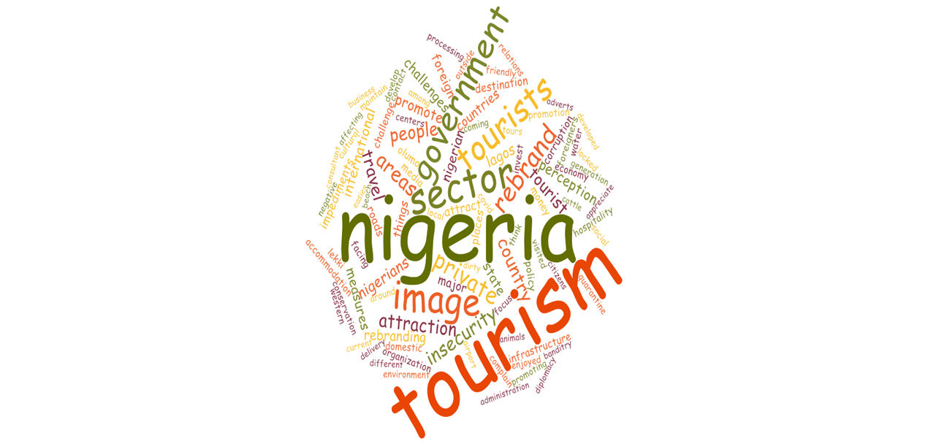

Figure 4.5 *Word Cloud presents the respondents’ responses to the Private sector tourism agencies****.***

From the word cloud presentation above, ‘tourism’ can be used to ‘rebrand’ ‘Nigeria’s image’ with the instrumentality of ‘hospitality’, ‘cultural’ heritage, attraction areas such as ‘beaches’, ‘Lekki’ ‘conservation’, ‘Olumo’ rock among others. However, the respondents identified the ‘impediments’ that are undermining tourism in Nigeria. They are ‘insecurity’, ‘corruption’, lack of ‘infrastructure’, lack of ‘money’ in the tourism sector, ‘Covid-19’ restriction policy, and ‘corruption’ among others. The respondents that have met with international tourists affirm that the ‘tourists’ ‘complained’ about ‘roads’, ‘insecurity’, and traffic among others, they enjoyed their ‘visit’ and wish to ‘visit’ again. The respondents also identified the following as the measures to put in place; government should ‘develop’ ‘tourism’ ‘centres’ and ‘advertise’ it on ‘media’, and the ‘government’ should also ‘maintain’ the ‘attraction’ ‘areas’.

**International Tourists**

**Tourists’ Experience in Nigeria**

Table 4.31 below shows the experiences of international tourists in Nigeria. The tourists expressed both negative and positive things about Nigeria. Respondent one affirmed *‘My experience as a tourist in Nigeria was exceptional. It left me with many lasting impressions.*

**Table 4.31: Informant’s experience in Nigeria**

|  |  |
| --- | --- |
| R1 | My experience as a tourist in Nigeria was exceptional. It left me with many lasting impressions this up-tight Brit had a ball. My sightseeing ranged from Fela Kuti’s shrine to the mosque in Abuja. I browsed the Jazzhole bookshop and braved the mad Lagos traffic, struck for hours, and soaked up the gap between the Haves and Have nots.  A woman let me pound yams with her and I was horrified by the slave departure point in Badagry. I took an internal flight from Abuja to Lagos and lost my luggage but it was returned to my hotel eventually. I was grateful for the air-con in cars and my hotel, the heat was hot. I was glad to have the use of a swimming pool in my accommodation and for the discreet but friendly staff there.  If you keep your wits about you and realize the shouts of Obinyo are friendly you will be fine.  Taxis and Ubers will wait for you while you visit Zuma rock or eat local food, sadly I used cutlery not my fingers but the food was delicious.  I was impressed by strong family values, such resilience and all the hustling going on. I was surprised by how many young people support Chelsea FC and the welcome I was given.  I would happily return, not everyone’s idea of a break but a real eye-opener and God bless Nigeria. |
| R2 | Nigeria is a world in itself. If you want your outlook on life changed permanently, visit Nigeria. Lagos especially. It’s the hustle and bustle of New York on steroids. It is a free-market enterprise circumventing restrictions resulting in black market operations on huge scales. It is religious zealotry intermingled with tribalism, occult, and tradition. It is the super-rich operating right next to the super poor, both taking advantage of the other. You meet great people and you meet the scum of the earth. |
| R3 | I have participated in several Marathon relay race across the middle East prior to Lagos. I have friend that been to Lagos for business purpose, he said Lagos is a “devil playground” because of fraudulent acts and people live in penury. Another friend warned me about the pretty theft in Lagos as a result of unemployment. I traveled to Lagos to participate in marathon race of six miles with about a hundred thousand Athletes. At first I was apprehended at the beginning of the race because of the young boys that was running towards my direction, I thought they want to steal my IPod but they didn’t. My impression about Lagos changed because the athletes were focused on winning the race in order to collect medal. We ran from Mainland to Island. I saw slave pens of the colonial masters in the colonial period, I saw fishermen at the canoe fishing. Athletes took selfies during the break, during the second half of the Marathon, we ran through industries where my eyes were burnt by black smoke from cooking fire and dried my esophagus. At the end of the race, Abraham Kprotich who is a Kenyan was given a check of eighteen million by Governor Ambode for winning the race. I was charmed in Lagos and I will like to participate in Lagos Marathon in some other time. |

|  |  |
| --- | --- |
| R4 | A few years ago, my daughter decided to start a new life in Lagos, I was familiar with the reputation of Lagos as an unsafe place. I was discouraged by Netherlanders not to travel to Lagos but I wanted to discover by myself about the things that were said about Lagos and the reason why my daughter made an odd move to Lagos. In 2015, I travelled to Nigeria, when we got to Surulere in Lagos, I was shocked to see run-down streets with large potholes and power cables knotted together among buildings. This was not a reassuring first impression. I am used to steady electricity supply and water supply in my country, but I experienced power and water shortage in Surulere. I was surprised to observe that no one seemed very concerned about the frequent power outages and water shortages. I noticed that Nigerians have the ability to adapt to any life situation and it is a big lesson for me. It’s an experience to drive through Lagos. All stereotypes appear to be more than true: never before have I seen so many noisy and aggressive people. The entire city is in shambles, people struggle to live daily and I just keep asking myself why my daughter choose to live here? But after a while, I got used to the traffic, noise and the fuzziness, it becomes background stuff and I begin to enjoy my stay. It is a great pleasure to meet many young, idealistic and energetic Nigerians, who became close friends with my daughter. Despite the fact that the government is not providing an enabling environment for youths to thrive, youths in Lagos are entrepreneurs with innovative ideas, Behind their directness! Nigerians are really hospitable and friendly, welcoming. I made new friends, Lagos turned out to be a blessing and it changed the way I perceived life. In Nigeria, people have a respectful attitude towards older people. It comes as a surprise that everybody calls me mum but apparently in the Nigerian culture this is a very friendly way to show respect to older people. I enjoyed it, it is so different from my own country where elderly people are treated with less respect. During my second trip to Lagos, almost two years later, I was surprised to see that the city had changed. It is still noisy and overwhelming, but this time we visited Balogun market, “XO bakery shop, I adore the delicious bread, Lekki craft market, and freedom park. |

In a corollary to this, they affirmed that Nigerians are friendly, the food is delicious, Nigerians have strong family values, Nigerians have great people, Nigerians are respectful attitude toward older people, and Nigerian youths in Lagos are idealistic, energetic and entrepreneurs.

           However, Respondent one complained that Nigeria is hot. Respondent two affirmed that *‘It is the super-rich operating right next to the super poor, both taking advantage of the others’*. This implies that the extremely rich and the extremely poor people take advantage of others in Nigeria. Respondent three complained that black smoke from the cooking fire burnt her eyes and dried her throat during the Lagos Marathon race. The fourth respondent also complained that Lagos is noisy with traffic, and there is a shortage of electricity and water supply.

           Despite all odds, tourists wish to visit Nigeria again. According to respondent one, ‘I *would happily return, not everyone’s idea of a break but a real eye-opener and God bless Nigeria’.*Respondent four also opined that ‘*My first stay in Lagos turned out to be a blessing and it changed the way I perceived life*.’ In the same vein, research conducted by (Akinyoade, 2013) shows that 78% of the respondents signified interest and that Nigeria is home and they would love to visit.

**Tourists’ Perception of Nigeria**

**Table 4.32 Informant’s Perception about Nigeria**

|  |  |
| --- | --- |
| R5 | What is perception before you came to Nigeria? |
|  | Before I came to Nigeria, I already have a lot of friends in Nigeria doing business  My friends told me good things about Nigeria, in Nigeria what is projected on Television stations is different from what I am seeing. |
|  | Do you feel comfortable in Nigeria? |
|  | Yes |
|  | Do you have challenges in processing your visa to Nigeria? |
|  | It is easy to process Nigeria’s visa |
|  | What was your first impression when you came to Nigeria? |
|  | Nigeria is very dirty |
|  | Have you visited any of the attraction areas before? |
|  | Yes, the beach in Lagos |
|  | Was your expectation met at the attraction area? |
|  | It was good, the food and hospitality were good but one has to be careful, there are thieves at the beach that steal phones, you can’t put a phone on the table, it will be stolen. |
|  | When you came to Nigeria, were you treated by the airport staff, and immigration officers? |
|  | No, they were working very slow, and sometimes they collect bribes, if I don’t bribe them, they will not process the documents that I need on time |

The table above shows the responses of a Chinese tourist that was interviewed. The tourists claimed to have a change of perception about Nigeria that what was projected on Television is different from his experience. Although he complained that Nigeria is dirty, there are thieves at the beach, and immigration officials collect bribes but he feels comfortable living in Nigeria and he likes our food and hospitality.

**Tourists’ Perception of Nigeria**

**Table 4.33 Informant’s view about Nigeria**

|  |  |
| --- | --- |
| R6 | I am from India, I have been in Nigeria for two months, |
|  | What was your perception before you came to Nigeria? |
|  | Before I came to Nigeria, I have friends in Nigeria, I don’t care about the negative things, I just wanted to come to Nigeria |
|  | Do you have any challenges in processing your visa?  I met the right person and we used the right channel, we don’t have any challenges in processing Nigerian visa |
|  | What was your first impression when you came to Nigeria when you arrived at the airport? |
|  | I arrived in Nigeria at Night, there is no first impression at night. |

Table 4.33 above shows the responses of an Indian tourist that was interviewed. He claimed to have friends in Nigeria before coming to Nigeria, he has an adventurous spirit and he doesn’t care about the negative things in Nigeria.

**Tourists’ Impression of Nigeria**

**Table 4.34 Informant’s Impression of Nigeria**

|  |  |
| --- | --- |
| R7 | What was your first impression when you came to Nigeria when you arrived at the airport? |
|  | I arrived in Nigeria at Night, there is no first impression at night. |
|  | Were you afraid that Nigeria is not secured? |
|  | No |
|  | Are you comfortable in Nigeria? |
|  | Yes |
|  | Do you have any challenges in processing your visa? |
|  | No, once I have a complete document, I can come |
|  | What is your impression of Nigeria? |
|  | Good |
|  | Do you have any complain about Nigeria? |
|  | There is too much traffic in Lagos |
|  | How were you treated by the airport staff and immigration? |
|  | Their process was fast |
|  | What can you say about our hospitality? |
|  | Nigerians are friendly |
|  | What about our food? |
|  | It is hot |

Table 4.34 above shows the responses of a German tourist that was interviewed, he claimed that he wasn’t afraid of insecurity in Nigeria, he was positive about his coming to Nigeria. He also feels comfortable coming to Nigeria because Nigerians are friendly but he complained about Lagos traffic and the hotness of Nigerian food.

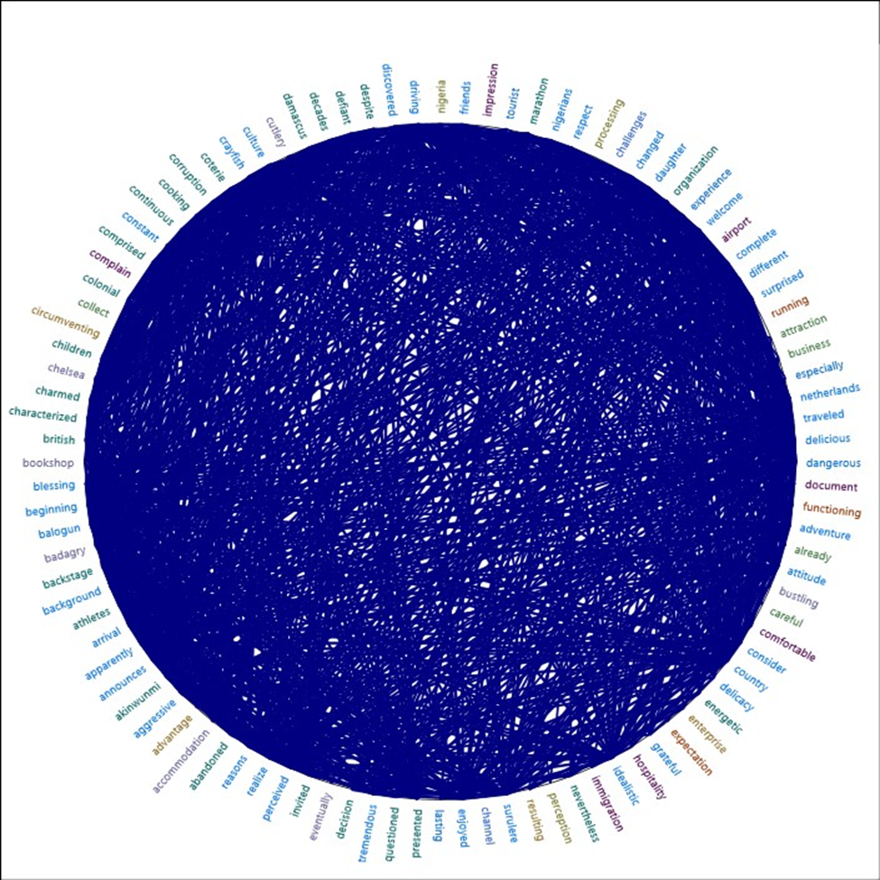

*Figure 4.6 Items clustered by word similarities of the International tourists*

The Prominent word similarities from figure 4.6 clustered diagram above present the tourists' experience in Nigeria. The ‘tourists’ were ‘comfortable’ staying in Nigeria, they had a good ‘impression’ because Nigerians are ‘welcoming’, and ‘hospitable’, they ate ‘delicious’ ‘delicacy’ among others. The Netherland woman opined that Nigeria was tagged ‘dangerous’ ‘place’ in their country, and she was ‘surprised’ when her ‘daughter’ relocated to Nigeria.

Although she was shocked when she saw road potholes, irregular water supply and electricity in ‘Surulere’ she adapted. She came to Lagos for her second trip and was ‘surprised’ that the city has changed, she had a wonderful experience in the ‘Balogun’ market. She affirmed that Nigerians are friendly and respectful. The tourists that participated in Lagos ‘Marathon’ race had a good ‘impression’ of Nigeria, she discovered that the ‘athletes’ are focused on winning the race rather than theft, she wishes to participate in the marathon race again.

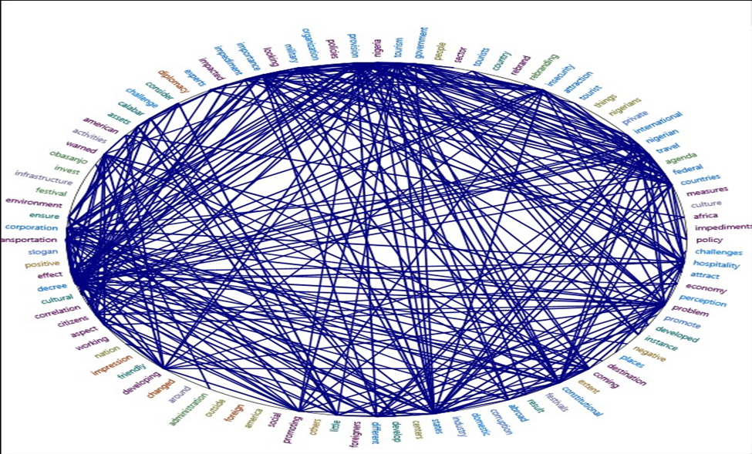

*Figure 4.7 Items clustered by word similarities of all the respondents*

The above-clustered diagram shows the prominent words of all the respondents. The respondents affirmed that ‘rebranding’ ‘agenda’ in Nigeria have not been effective in ‘rebranding’ Nigeria’s image. Although President Obasanjo’s administration’ tried through Heart of African slogan and shuttle ‘diplomacy’ but it has ‘impacted’ Nigeria’s image a ‘little’.

According to respondent 9 in Table 4.2:

‘The heart of Africa slogan was effective during Obasanjo’s administration because he embarked on shuttle diplomacy, he paid Nigeria’s debt, and he hired professionals that are Nigerians from abroad such as Dr Nkojo Iweala’. However, the use of slogans has not been working to rebrand the image of Nigeria because the people clamouring for power are not people of integrity and Nigerian leaders don’t have the interest of the people at hand.

However, all the respondents affirmed that tourism can be used as a mechanism to rebrand Nigeria’s image through the instrumentality of the ‘attraction’ ‘places’ such as Obudu cattle ranch in ‘Calabar’, ‘cultural’ ‘festivals’, and hospitality among others. This implies that tourists are informal diplomats, they will have practical experience with Nigerians through interpersonal interactions. The respondents also expressed their opinions about the impact of tourism in Nigeria.

Most of the respondents also agreed that tourism has ‘imparted’ Nigeria’s image to some ‘extent’, respondent one in Table 4.4 opined that there are tourism activities in Nigeria that attract ‘international’ ‘tourists’, ‘festivals’ such as Osun Osogbo, Calabar carnival among others. In addition to this, tourist respondents also attested that Nigerians are ‘friendly’ and ‘hospitable’.

Respondent one in Table 4.31 affirms that: ‘*My experience as a tourist in Nigeria was exceptional. It left me with many lasting impressions*. According to respondent one in Table 4.12, the Lagos State government is making progress in tourism development. He asserts that ‘*Lagos State Ministry of Tourism, Arts and Culture has a tourism master plan, one of the mission statements is to make Lagos the fifth tourist destination in Africa’.*

Furthermore, there are ‘impediments’ that are undermining ‘tourism’ in Nigeria such as lack of ‘infrastructures’, insecurity, lack of implementation of ‘tourism’ ‘policies’, lack of ‘tourism’ ‘experts’, ‘constitutional’ ‘challenges’, ‘corruption’ among others. Moreover, the respondents suggested the ‘measures’ to put in place to overcome the ‘impediments’, they opined that the government should provide ‘tourism’ ‘assets’ such as ‘infrastructures’, good ‘transportation’ system, implement favourable tourism ‘policies’, partner with ‘international’ ‘experts’, ‘develop’ tourism ‘destination’ ‘centers’, ‘promote’ ‘festivals’, amend the constitution, ‘promote’ ‘domestic’ ‘tourism’ and ‘ensure’ security among others. Respondent two in Table 4.23 opined that the ‘Federal’ government should ‘invest’ heavily in the tourism sector.

**4.2 THE THEMES**

**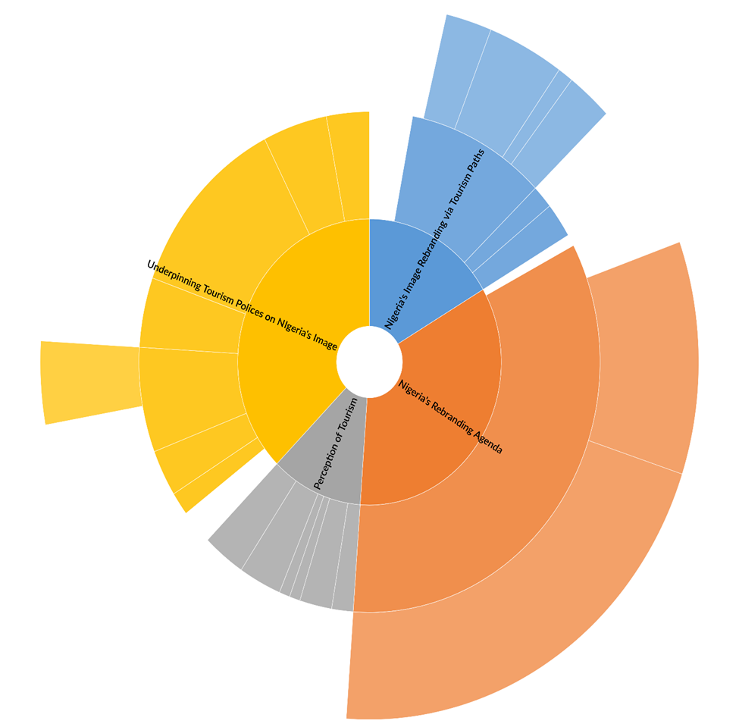***Figure 4.8The diagram above shows the major themes derived for the study*

**SUBTHEMES**

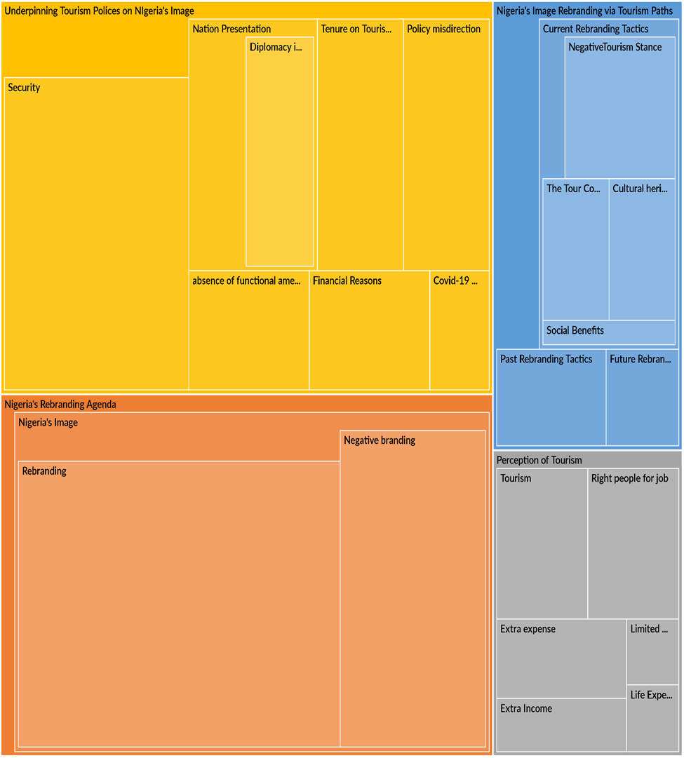

Figure 4.9 *The diagram above presents the sub-themes of the major theme*

**4.2.1 Theme One: Nigeria’s Rebranding Agenda**

**The Subthemes are Nigeria’s Image, Rebranding and Negative Branding**

The respondents demonstrated a broad understanding of Nigeria’s image. The key informants admitted that Nigeria’s image is negative as a result of negative posts by Nigerians on social media, international media posts, insecurity, and cybercrime.

According to respondent one in Table 4.18:

Journalists are pulling down the image of Nigeria which is a major impediment, although we are in the era of freedom of speech, Nigeria has not committed one-tenth of the crime committed by the United State or South Africa. Journalists in Nigeria overemphasize negative news.

The implication is that overemphasized negative news will continue to tarnish the image of Nigeria in the world.

           However, the Nigerian government has been making effort to rebrand Nigeria’s image through the use of slogans such as Heart of Africa, Good people, Great nation, and Change begins with me. The key informants expressed their opinions that Nigeria’s rebranding agenda have not been effective. According to respondent 3 in Table 4.2:

The past rebranding agenda has not been effective because there is no result to show to that effect. Security of lives and properties must be considered first before rebranding will take place. For instance, if a company wants to come up with the idea of rebranding, the security of the company, the company owner, and the company’s environment will be considered first.

This implies that domestic problems should be solved before rebranding can take place in Nigeria. Moreover, Respondent nine in Table 4.2 assert that the:

Heart of Africa' slogan was effective during Obasanjo’s administration because he embarked on shuttle diplomacy, paid Nigeria’s debt, and he hired professionals that are Nigerians from abroad such as Dr Nkojo Iweala.

Respondent seven in Table 4,2 also affirmed that: ‘Dora Akunuyi’s Slogan is the most effective because she took significant steps to drive it in the entertainment industry, the effect was seen in the music industry’. They concluded that the use of slogans cannot effectively rebrand Nigeria’s image. According to Respondent one in Table 4.19, Nigeria’s rebranding agenda lacks major ingredients such as hospitality, culture, and cuisine. These ingredients are tourism products and this can be linked to the second theme.

**4.2.2 Theme Two: Perception of Tourism**

**The Subthemes are Tourism, Right People for Job, Extra Expense, Extra Income, Life Experiences, and Limitation**

The key informants affirmed that tourism is an excellent tool to rebrand Nigeria’s image.

According to respondent three in Table 4.5: ‘Tourism is a very vital tool to rebrand our image because when tourists come to Nigeria, they will have a practical experience and have a true perception about Nigerians’.

This implies that tourists will be able to study and know Nigerians through interpersonal relationships. There is a need for tourism development so that it will be attractive to tourists. Respondent one in Table 4.5 opined that:

Tourism can be used as a tool to rebrand our image if tourism assets are well developed, marketable, affordable and reliable to the world. In essence, tourism can be used to rebuild our image by ensuring that our cultural heritage is promoted and advertised to the world. Tourism can build Nigeria’s image by improving its economic standard*.*

However, respondent two in Table 4.10 expressed his practical experience with tourists:

I have met with international tourists before, they were about three white people and five Americans, they were told that Nigeria is not a safe country but they were overwhelmed when they came to Nigeria. The way we were taking them around, nobody harasses them, we went to a night club, when we were ready to leave the club, the tourists were not ready to go because they were enjoying themselves. If it continues like that, many of them will want to visit Nigeria*.*

This implies that the practical experiences of the tourists changed their perception of Nigeria which is different from what they were told; they were willing to visit Nigeria again. Moreover, Respondent 9 in Table 4.28 also explained tourists' comments about Nigeria, he affirmed that:

Our team welcomed polish citizens recently, they wanted to tour Lagos, they had a nice time and it was fun for them, the hotel was good, they had good food, they visited Lekki conservation and other attraction areas in Lagos, they had a change of perception about insecurity in Nigeria, Nigeria is backward, people live in huts, people live in villages, there is no development in Nigeria when they came to their orientation changed*.*

This implies that the Polish citizens’ perception of Nigeria changed as a result of their life experience in Nigeria, they were able to see things by themselves. The tourist respondents also explained their life experiences and most of them are willing to revisit Nigeria. According to respondent 3 in Table 4.33, the tourists opined that: ‘Before I came to Nigeria, I have friends in Nigeria, I don’t care about the negative things, I just wanted to come to Nigeria’.

This implies that at times tourists do not consider the negativity they heard, they just want to explore and discover it by themselves. Furthermore, respondent one in Table 4.4 opined that tourism has impacted Nigeria’s image to some extent because it has attracted international tourists to festivals such as Osun Osogbo, and Calabar carnivals among others. In addition to this, respondent 4 in Table 4.4 assert that:

In the past, tourism impacted Nigeria's economic image because when tourists come to Nigeria, they spend their money on cuisine, hotels, transportation among others. The service providers will pay tax to the government, but Nigeria's structure has to be put in order first before we talk about tourism.

The economic benefit of tourism can be derived from his response; Nigeria has benefited from tourism in the past but tourism is limited by a lot of factors in recent times. According to respondent one in Table 4.6:

Religious strive, insecurity, lack of finance from the government, lack of interest of the government, lack of competent experts in the tourism sector, the private sector is not encouraging because they are not ready to invest in tourism*.*

Therefore, the Nigerian government's tourism perception must change and develop tourism. Insecurity issues must be tackled so that tourists will be safe in Nigeria. Respondent 8 in Table 4.8 also opined that: ‘The government should make favourable policies towards the development of tourism as its focus on crude oil. The citizens need to be educated on the importance of tourism. The issue of insecurity should be tackled’.

This implies that tourism can serve as a source of revenue generation for the government, and the government can have economic diversity rather than focusing on oil alone. The implication is that when tourists come to Nigeria, they will spend extra expenses on cuisine, accommodation, and transportation services among others and it will generate extra income for the government in terms of revenue generation.

**4.2.3 Theme Three: Underpinning Tourism Policies on Nigeria’s Image**

**The Subthemes are Security, Nation Presentation, Absence of Functional Amenities, Policy Misdirection, Covid-19, Financial Reasons and Diplomacy**

The respondents identified the absence of functional amenities as a major impediment to tourism development in Nigeria. Respondent seven in Table 4.6 opined that: ‘Attraction areas are underdeveloped and not well promoted, the poor road network. For example, the roads that lead to Owu fall are bad’.

This impediment is a result of policy misdirection by the Nigerian government. According to respondent three in Table 4.6:

Government focus more on crude oil than tourism. As a result, the government is not making policy towards the development of the attraction areas and tourism is hardly included in their budgetary plan*.*

This implies that the government needs to make tourism policies and implement them because this study discovers that tourism is an excellent tool to rebrand Nigeria’s image and generate revenue for the government. Apart from policy misdirection in Nigeria, Global policy also affected tourism, respondent 9 in Table 4.24 assert that the Covid-19 regulation policy is a major impediment to tourism because the policy is restricting the movement of people all over the world. Moreover, tourism in Nigeria is limited by financial reasons, respondent two in Table 4.22 affirm that:

Paucity of funds: the priority of the federal government is different; they don’t believe in investing money in the tourism sector. They don’t see tourism as a priority sector and they don’t fund it*.*

This implies that the government is not investing money in the government tourism sector. In the same vein, respondent eight in Table 4.24 affirm that ‘private sector travel and tour lack money to promote domestic tourism. The implication is that it will be difficult for the tourism sector to flourish to rebrand Nigeria’s image and generate revenue. Therefore, the Nigerian government needs to finance the tourism sector because is an excellent diplomatic tool to rebrand Nigeria’s image.

The implication is that if the Nigerian government develops tourism, it will attract more tourists because tourism has a multiplying effect, when tourists come to Nigeria, they will have interpersonal interaction with Nigerians which can change their perception of Nigerians and their practical experiences will make them present Nigeria better in the world.

**4.2.4 Theme Four: Nigeria’s Image Rebranding via Tourism Paths**

**The Subthemes are Past Rebranding Tactics, Current Rebranding Tactics, Negative Tourism Stance, Cultural Heritage, Social Benefits and Future Branding**

The respondents affirmed that the past rebranding tactics such as ‘Heart of Africa’, ‘Good people, Great Nation’, and ‘Change begins with me which is the current rebranding agenda have not been effective. According to respondent three in Table 4.2:

The past rebranding agenda have not been effective because there is no result to show to that effect. Security of lives and properties must be considered first before rebranding will take place. For instance, if a company wants to come up with the idea of rebranding, the security of the company, the company owner and the company’s environment will be considered first.

Most of the respondents affirm that security is the major impediment that is affecting Nigeria’s rebranding agenda. Respondent one in Table 4.19 opined that Nigeria’s rebranding agenda lacks major ingredients such as hospitality, cuisine and cultural heritage. These ingredients are tourism products that justify tourism as an excellent tool for rebranding Nigeria’s agenda.

However, tourism is not flourishing in Nigeria because of the negative tourism stance. According to respondent 10 in Table 4.6, the government lacks the political will to explore the attraction areas in the tourism sector. Respondent three in Table 4.6 also opined that: Government focuses more on crude oil than tourism. As a result, the government is not making policy towards the development of the attraction areas and tourism is hardly included in their budgetary plan.

This implies that the Nigerian government has a negative tourism stance. In the same vein, the majority of Nigerians do not embrace domestic tourism. According to Respondent eight in Table 4.28, ‘the tourist appreciates Nigeria but we Nigerians don't appreciate our country, they enjoyed their visit, and had a change of perception’. This implies that Nigerians must embrace and participate in domestic tourism, respondent one in Table 4.10 opined also that ‘Nigerians need a reorientation to embrace domestic tourism so that it will attract tourists and rebrand Nigeria’s image.

           Therefore, the government needs to create an enabling environment for tourism to thrive through the following measures; Respondent six in Table 4.8 opined that:

Government should make a deliberate effort to develop tourism and the revenue derived will be used for the maintenance of the attraction centres. The government should also build good roads to the rural attraction areas and improve security. The government should partner with the private sector and make policies that will regulate the activities of private sector tourism*.*

Respondent two in Table 4.12 also states the specific roles of the Federal government in tourism development, he opined that:

The federal government should address the electricity issue, the federal government should improve security, the process of obtaining visas for tourists coming from outside the country should be easier, If the federal government can do all of these things, more tourists will come to Nigeria and have ache-free stay in Nigeria*’.*

These measures imply that they can result in social benefits. Respondent two in Table 4.9 opined that tourism has a social benefit of promoting Nigeria’s culture and foreigners also get married to Nigerians.

**CHAPTER FIVE**

**SUMMARY, CONCLUSION AND RECOMMENDATION**

**5.1 Introduction**

The purpose of this study is to understand the importance of tourism as a mechanism to rebrand Nigeria’s image. Rebranding is important because Nigeria's image is critical to its international standing and nation-building (Aleyomi, 2020). The study researched preceding studies on the research objectives and inquired from 32 key informants through in-depth interviews. The findings from the key informants were discussed and analyzed with NVivo 12 software.

**5.1.1 Summary**

The study discovers that tourism is an excellent tool to rebrand Nigeria’s image. Tourism is a socially constructed reality that is culturally mediated by public relations to articulate symbolic systems of knowledge, experience, and satisfaction, which can only be understood in connection to expectations produced by the spread of ideas about the event-place (Jacquie and Lugo-Ocando, 2014). The study uses linkage theory to explain the nexus between Nigeria’s domestic environment and its international environment. The application of linkage theory establishes the fact that tourism can influence Nigeria’s external environment. In this regard, foreign tourists’ experiences in Nigeria’s domestic environment and their feedback in their home countries can influence Nigeria’s external environment.

On the first objective, the study discovered that the past rebranding agenda has been the use of slogans, but it has not been effective to a large extent because there is no result to show that effect. As a result, Nigeria’s image in the world is negative. According to respondent one in Table 4.19, Nigeria’s rebranding agenda lacks major ingredients such as hospitality, cuisine and culture, these ingredients are tourism products.

On the second objective, the study discovered that tourism has changed the perception of tourists to some extent because most of them are willing to visit Nigeria again. Although they complained about insecurity, traffic, absence of tourism pamphlets, theft, bad roads, lack of infrastructural facilities, and epileptic power supply among others. The study finds out that tourists are aware of the challenges before they come to Nigeria. Tourists have an adventurous spirit and they want to explore and learn new things and most of them don’t care about the negativity.

On the third objective, the study discovered that the following factors impede tourism; insecurity, bad roads, lack of infrastructure and social amenities, inadequate power supply, COVID-19 restriction policy, Religious strive, lack of competent experts in the tourism sector, religion rigidity, Lack of synergy between the federal government and the state government, paucity of funds, constitutional ambiguity among others.

On the fourth objective, the study suggested the measures to be put in place by the government, the private sector, and the citizens. The government should demonstrate Good leadership, appoint tourism experts to the tourism ministry, package unique festivals and sell it to the world, properly advertise and maintain the attraction areas, provide good access roads, amend the constitution on tourism, invest in the tourism sector, liaise with international tourism expert, provide electricity, ensure the security of lives and properties, provide infrastructures among others.

The private sector should bring tourism products to the doorstep of the tourists, be creative in tourism promotion, and partner with the government. The citizens should change their orientation and embrace domestic tourism. The expected outcome, if the measures are put in place, is that Nigeria will have huge patronage of tourism. As a result, Nigeria’s image will be rebranded through the influx of tourists because every tourist is an informal diplomat, the tourist will have practical life experience with Nigerians which can change their perception of Nigeria’s image. Tourism can also generate revenue for the government.

**5.2 Conclusion**

The main objective of the study is to explore tourism as a diplomatic tool to rebrand Nigeria’s image. In Chapter one, the study examines tourism impacts on tourism-driven countries. The study also identifies the tourism resources in Nigeria and its potential for rebranding Nigeria’s image. However, the Nigerian government has not focused on tourism as a major factor to rebrand its image, despite the ecotourism centers in Nigeria that can attract tourists, and the previous rebranding has been the use of slogans that have not been effective.

In chapter two, the literature reviews that the past rebranding has not been effective. As a result, Nigeria’s image is negative. Past research reviews that Tourists’ perception of Nigeria is both negative and positive. Infrastructural deficiency is a major factor that impedes tourism from rebranding Nigeria’s image. Tourism can be used to rebrand Nigeria’s image by implementing National Tourism Policy.

The study adopts linkage theory; linkage is a sequence of state behaviour reacted to by another state. This study uses the theory to explain the nexus between Nigeria’s domestic environment and its external environment. In chapter three, this study adopts a qualitative method, primary and secondary data source was utilized. Thirty-two key informants were interviewed from academia, tourists, the public sector tourism sector and private sector tourism agencies. Data collected were transcribed and analyzed with NVivo12 Software. This study used content analysis and thematic analytical techniques. The analysis result generated word cloud diagrams, clustered word similarity diagrams, themes and subthemes.

In chapter four, the first objective analysis result shows that Nigeria’s rebranding agenda has little impact on Nigeria’s image during Obasanjo’s administration while the other rebranding agenda did not have a significant impact. Thus, insecurity is a major impediment that is limiting the rebranding agenda from rebranding Nigeria’s image, the rebranding agenda also lacks major ingredients such as hospitality, culture, and heritage. The ingredients are tourism ingredients which can be linked with the second objective.

The second objective analysis result shows that tourism can be used as diplomacy intended to rebrand Nigeria’s image through the instrumentality of hospitality, culture, and heritage. Tourism has also changed the perception of tourists to some extent, most tourists are willing to visit Nigeria again because Nigerians are welcoming, friendly and hospitable.

The third objective analysis result identified the impediment to tourism such as inadequate security, Paucity of funds, policy misdirection, limited exposure of the citizens, absence of functional amenities, lack of synergy, religious rigidity, constitutional ambiguity, corruption, COVID 19 restrictions and bad roads

The fourth objective analysis shows that the government should demonstrate good leadership, ensure security, make Favourable tourism policies, promote tourism in the entertainment, advertising the attraction areas, and amend Nigeria’s constitution provision on tourism, make foreign travel easier for tourists among others. The analysis result of the expected outcome also shows that tourism will lead to social benefits for Nigerians and generate extra income for the government. In addition to this, the expected outcome can be realistic if the measures are put in place and if there will be continuity in the sustainability of tourism development in Nigeria’s government administration.

**5.3 Recommendation**

 Based on the findings of this study, the following recommendations were offered;

1. The federal government should adopt tourism as a mechanism for rebranding Nigeria’s image. In this regard, the government should invest in the tourism sector by developing the attraction areas to international standards, providing the infrastructures and social amenities, the government should also maintain the attraction areas.
2. The study recommends that the paramilitary forces in Nigeria should ensure adequate security because it is a major impediment that is limiting tourism from rebranding Nigeria’s image.
3. The National assembly should amend Nigeria’s constitution on tourism matters so that the Nigerian Tourism Development Corporation can have full control over all tourism matters in Nigeria.
4. There should be a synergy between the Federal Ministry of Tourism Arts and Culture and the State Ministry of Tourism, Arts and Culture, there should also be a synergy within all tourism Ministries in Nigeria. The private sector tourism agencies should partner with public sector tourism parastatals.
5. The Federal Ministry of Tourism, Arts and Culture should identify all the attractions areas and the festivals in Nigeria, both the tapped and untapped attraction areas, the government should create a tour pamphlet and distribute it to all the International airports in Nigeria so that airport staff can give it to every foreigner that arrives in Nigeria.
6. The Ministry of Information and Culture should advertise the attraction areas and festivals through the national media and international media, the government should also promote tourism in Nigeria through the entertainment industry and the ministry should also partner with tourism international experts to improve tourism in Nigeria.
7. The educational sector should promote tourism and give the citizens tourism education so that they can know the importance of tourism and change their orientation towards tourism.
8. This study recommends that the Federal Ministry of Tourism, Arts and Culture should establish exhibition centers in Nigeria and also participate in international exhibition programmes.

**5.4 Contribution to knowledge**

This study contributes to the body of knowledge because it provides new insight to Nigeria’s rebranding initiatives. The specific contributions of the study are stated below:

1. The study identifies tourism as a new mechanism for rebranding Nigeria’s image. Thus, Nigeria’s rebranding initiative requires tourism ingredients such as hospitality, cuisine, and culture to rebrand Nigeria’s image.
2. The study identifies the need for a synergy between the state government tourism ministry and the federal ministry of tourism, within ministry of tourism. The study also identifies the importance of partnership between the private sector tourism agencies and public sector tourism parastatals.
3. The study identifies the need for the amendment of Nigeria’s 1999 constitution because Section 4, part 60 (d) limits the responsibility of the Nigerian Tourism Corporation Development to regulate tourist traffic alone. The constitution must be amended so that the corporation can have total control of all tourism matters.
4. The study identifies tourism resources such as attraction areas, festivals, exhibitions of arts and crafts among others, that can generate revenue for the government and improve Nigeria’s economic image.
5. The study provides new insight to the application of linkage theory. The theory assumes that there is a nexus between the domestic environment and the external environment. This implies that tourism in Nigeria’s domestic environment can influence the external image of Nigeria.
6. The study discovers that good leadership and good governance are essential for long-term international relations and tourism because good international relations is a mechanism for quick tourism growth that international tourists take into consideration before visiting a destination (Fadipe,2007).
7. This study filled the methodology gap identified in the literature by adopting NVivo software for the thematic and content analysis of the interviews conducted.

**REFERENCES**

Abdul-Rasheed, S.L; Lateef, L; Yinusa, M.A; Abdullateef, R. (2016). Cybercrime and Nigeria’s external image: A critical assessment. *Africology: The journal of pan African Studies,* Vol.9, No.6.

Adegboyega, A. (2021) Insecurity: Minister blames media for Nigeria’s poor image. *Premium times.*https://www.premiumtimesng.com/news/top-news/485285-insecurity-minister-blames-media-for-nigerias-poor-image.html

Adelakun, A. (2016). Dear Lai, Change does not begin with me. *Punch news*. <https://punchng.com/dear-lai-change-not-begin/>

Adelusi, P.O. (2021). Linkage theory. *John & James Associates (Bilingual Policy Scientists).* https://www.researchgate.net/publication/350787358_LINKAGE_THEORY

Ademigbuji, A. (2013). Rise and Fall of Nigeria’s Image Branding. *national mirror online*.http://nationalmirroronline.net/new/rise-and-fall-of-nigerias-image-branding/ Jan 16,2013. Accessed 28 July, 2013

Ademigbuji, A. (2015). ‘Why Rebranding Nigeria project failed’. *The nation.*https://thenationonlineng.net/why-rebranding-nigeria-project-failed/.

Adujie, P. (2009), *Rebranding, teleprompting and managing Nigeria’s image or reputation*. Newswatch Magazine. May 25.

Agbese, D. (2009). *Rebranding Nigeria, an appraisal*. Newswatch Magazine.

Agency Report. (2018). Tourism contributes 34% to Nigeria’s GDP, generates 20% employment

Ajeluorou, A. (2018). Branding a nation requires more than global media campaign’. *Guardiannews*. https://guardian.ng/features/branding-a-nation-requires-more-than-global-media-campaign/

Akeregha, I and Onochie, B.C. (2018). Nigeria has invested heavily in tourism development. *TheGuardian.*https://guardian.ng/news/nigeria-has-invested-heavily-in-tourism-development-says-buhari/

Akhimien, P. (2013). “Rebuilding the Nigerian Image: A Strategic Approach”. *Research gate*. https://www.researchgate.net/publication/303880499

Akinyoade, A. I. (2013). Understanding Nigerian Immigrants Attitude towards Engaging in Tourism in Nigeria (Doctoral dissertation, Kent State University).

Akukwe, T and Chigozie, O.J. (2014). Designing and Developing a GIS Database for Tourism in Nigeria: The Case of Anambra State. *International Journal of Humanities and Social Science.*19(10):109-120.

Akunyili, D. (2009a). National re-branding campaign in Abuja. *Nigeria high commission information section.* London WCZN5BX.

Akunyili, D. (2009b). *We cannot grow in an atmosphere of corruption*. Tell Magazine, 13, 20.

Alade, B. (2021). ‘Insecurity undermining growth in tourism sector’. *TheGuardian.* https://guardian.ng/business-services/insecurity-undermining-growth-in-tourism-sector/

Aleyomi, M. B & Abu Bakar, M. Z. B. (2017). The challenges of citizen diplomacy in Nigeria project,2007-2010. *People: International Journal of Social Sciences*, 3(2), 1227–1250. https://dx.doi.org/ 10.20319/pijss.2017.32.12271250

Aleyomi, M. B. (2020). Nigeria’s image crisis: drivers, efforts and prospects. *African Identities*, 18(1–2), 217–232.https://doi.org/10.1080/14725843.2020.1775549

Alli, W. O. (2015). Corruption and national security: The imperative for stronger anti- corruption measures in Nigeria. *Studies in Politics and Society.* 3(1), 53–77.

Amadi and Nlemanya, R. (2017). *The Nigerian state re-branding and the people’s perception.* International Journal of Advanced Research in Management and Social Sciences. ISSN: 2278-6236

Ani, K. J. (2014). Mass media and re-branding Nigeria project: A historical evaluation of a failed government policy. *Africa's public service delivery and performance review*. Vol 2.

Aregbeshola, B. (2009). Re-branding Nigeria Project and Akunyili’s competence, accessed 25 February 2012. http://www.nigeriansinamerica.com/articles/3256/1/Re-branding-Nigeria-Project-and-Akunyilis-Competence/Page1.html>.

Aremu, M.A and Bamiduro, J.A (2012). *Assessment of the Need for and Effectiveness of Re-Branding in Nigeria*. International Journal of Management and Administrative Sciences (IJMAS). (ISSN: 2225-7225). Vol. 1, No. 4, (11-22)

Arogunmi, K. (2019). Government Should Invest in Tourism. *Nigerian Tribune*. https://tribuneonlineng.com/government-should-invest-in-tourism/

Asabor, I. (2021). Tackling Insecurity Challenge to Boost Nigerian Tourism Sector *Independent Newspapers Limited*. https://independent.ng/tackling-insecurity-challenge-to-boost-nigerian-tourism-sector/

Azeez, B. (2021). Esie: Inside Nigeria’s First Museum. *Nigerian Tribune.* https://tribuneonlineng.com/esie-inside-nigerias-first-museum/

Badiora, W and Bako, A.I. (2020). Foreign tourists' perceptions of safety and their future travel intentions to Nigerian cultural festivals.

*Research gate.*https://www.researchgate.net/publication/348018439.

Bassey, F. O and Egon, C. I. (2016). Nigerian tourism policy: A critical appraisal and reappraisal. *Journal of Tourism, Hospitality and Sports*. 20(1), 26-29.

Becker, B; Bronwyn; Dawson, P; Devine, K; Hannum, C; Hill, S; Leydens,J; Matuskevich, D; Traver,C and Palmquist, M. (2005). Case Studies. Writing@CSU. Colorado State University.

<https://writing.colostate.edu/guides/guide.cfm?guideid=60>

Bertram, M. G. (2018). *War Tourism: Second World War France from Defeat and Occupation to the Creation of Heritage* (Ithaca, NY: Cornell University Press), 144–5.

Briedenhann, J and Wickens, E. (2004). Tourism Routes as a Tool for the Economic Development of Rural Areas-Vibrant Hope or Impossible Dream? *Tourism Management*, 25, 71-79. http://dx.doi.org/10.1016/ S0261-5177(03)00063-3

Cabral, A.R. (2022). Dubai's international visitors up more than threefold in first five months of 2022. *Thenationalnews*.

Campbell, J. (2019). Five years after kidnapping, Nigeria’s Chibok School Girls fade from the International Scene. *Council on foreign relations*.

Chaziza, M. (2019). China’s Outbound Tourism as a Soft Power Tool in the Middle East. *Middle East Institute.* <https://www.mei.edu/publications/chinas-outbound-tourism-soft-power-tool-middle-east>

Chaziza, M. (2019). China’s Outbound Tourism as a Soft Power Tool in the Middle East. *Mei.edu.*https://www.mei.edu/publications/chinas-outbound-tourism-soft-power-tool-middle-east.

China daily (2016). Good tourists to improve China’s image abroad. *China daily.com*. http://usa.chinadaily.com.cn/china/2016-09/27/content_26910970.htm

Egobiambu, E. (2021) Insecurity: The Government Knows Sponsors of Boko Haram, Says Former Naval Officer. *ChannelsTV*.

<https://www.channelstv.com/2021/08/25/insecurity-the-govt-knows-sponsors-of-boko-haram-says-olawumi/>

Egwemi, V. (2010). Managing Nigeria's Image Crisis: Akunyili's Rebranding Programme to the Rescue (?)*Current Research Journal of Economic Theory* 2(3): 131–135.

Eke, O.A. (2009). *Globalization Challenges and Nigerian Foreign Policy*, Abakiliki: Willy Rose & Appleseed Publishing Coy.

Ekundayo, Y.O. (2014). Strategic Development and Sustainability of Tourism Industry in Nigeria. *Laurea University of Applied Sciences*.

<https://www.theseus.fi/bitstream/handle/10024/83702/Strategic%20Development%20and%20Sustainability%20of%20Tourism%20Industry%20in%20Nigeria.pdf?sequence=1>

Endong, F. P. C. (2018). Cinema globalization and nation branding: An exploration of the impact of Nollywood on the Nigerian Image Crisis. *Journal of Globalization Studies*. 7(2), 76–90.

Ezenagu, N. (2018). Challenges of Tourism promotion in Nigeria: The Case of Religion. *African Journal of Hospitality, Tourism and Leisure*, Volume 7 (1) - (2018) ISSN: 2223-814X

Fadipe, S. A. (2007). *Basic principles and practice of tourism*. Media Ace. ISBN:9783366076.

Fayose, A. (2016). His statement on Cameron’s characterization of Nigeria being “fantastically corrupt. *Sahara Rescue* 18 May. Online

Ferguson, R. (2001). *Brand-name government.* Elsevier.

Retrieved from http//www.knowledgemarketing group.com.Heinemann

Frankel, J. (1972). *Contemporary International Theory and Behaviour of State*. Free Press. New York.

Greener, S. (2008). *Business Research Methods*. London Ventus Publishing. - References - Scientific Research Publishing.

Hatemi, J (2015). On the tourism-led growth hypothesis in the UAE: a bootstrap approach with leveraged adjustments. *Applied Economics Letters*. 23(6):1-4

Igbokwe, P. (2009). *Introduction to Research and Research Methodology.* Research Methodology and Grant writing pg1-10 published by Rex Charles & Patrick Ltd. Anambra State, Nigeria ISBN:978-978-49233-0-9

Jacob, J. and Akintola, O. E. (2014). Foreign Policy and Terrorism in Nigeria: An Impact Assessment of the Activities of the Boko Haram Sect on Nigeria’s External Relations. In C. N. Nwoke, and O. Oche (Eds.), Contemporary Challenges in Nigeria, Africa and the World (pp. 201-216). Lagos: *The Nigerian Institute of International Affairs (NIIA).*

Jacquie, L. and Lugo-Ocando. J. (2013). *Tourism and public relations*, in The Routledge Handbook of Tourism Marketing ed. Scott McCabe. Routledge Handbooks Online. accessed 24 Jun 2022.

Johnson (2022). KTB Taps Key Personalities to Market Destination Kenya. *Radarr Africa.* https://radarr.africa/ktb-taps-key-personalities-to-market-destination-kenya/

Joseph, S. N. (2021). Soft power: the evolution of a concept. *Journal of Political Power.* DOI: 10.1080/2158379X.2021.1879572

Jun, J. W. and Lee, H. (2008). Impacts of Events on the Brand Germany: Perspectives from younger Korea customers. *Event Management.* 11(3), 145-153.

Kakabadse, N. K and Steane, P. (2010). Meaning and interpretation: Insights and discourse. *Journal of Management History.*

Kale, Y. (2018). Statistician-General of the Federation and Chief Executive Officer, NBS, made the disclosure at the 61st United Nations World Tourism Organisation Commission for Africa (UNWTO-CAF), Conference, in Abuja.

Kerr, G. M. (2006). From destination brand to location brand. *Journal of Brand Management*. 13 (4/5), 276-283.

Keshodkar, A. (2016). State-Directed Tourism Branding and Cultural Production In Dubai, UAE. *Urban Anthropology and Studies of Cultural Systems and World Economic Development,* 45(1/2), 93–151.

http://www.jstor.org/stable/26384881

Kimbu, A. N. and Ngoasong, M. Z. (2013). Centralized decentralization of tourism development: A network perspective. *Annals of Tourism Research,* 40, 235–259. doi: 10.1016/j.annals.2012.09.005 [Crossref], [Web of Science ®], [Google Scholar]

Koiki, O. (2021). Insecurity Bane of Tourism Growth in Nigeria – Tour Operators. *Independent*. https://independent.ng/insecurity-bane-of-tourism-growth-in-nigeria-tour-operators/

Lagos State Tourism Masterplan. (2018). Lagos State Tourism Master plan (2018- 2038). E-book.

Makinde, F. (2019). Nigerians groaning in the jaw of banditry, kidnapping, ethnic clashes after polls. *Punch news*. Retrieved from http://www.punchng.com/nigerians-groaning-in-the-jaw-of-banditry-kidnapping-ethnic-clashes-after-poll.

Mugo, M. A. and Misiani, M.P. (2017). Applying Anholt s National Branding Model: The Case of Kenya. *Business and Economics Journal.*

Muzellec, L. and Lambkin, M. (2006). Corporate rebranding: destroying, transferring or creating brand equity? *European Journal of Marketing,* Vol. 40 No. 7/8, pp. 803-824.

NBS.*Premiumtimes*.https://www.premiumtimesng.com/entertainment/naijafashion/271174-tourism-contributes-34-to-nigerias-gdp-generates-20-employment-nbs.html

Ngoasong, M. Z; Adeola O; Kimbu. A. N and Hinson. R.E. (2021). *New Frontiers in Hospitality and Tourism Management in Africa*. Springer.

Nicholas, G. O. (1989). *World of Our Making*. Columbia: University of South California Press. Nigerian Immigration Service. (2022). Visa on arrival process. *Government website.* <https://immigration.gov.ng/visa-on-arriva>

Novelli, M. (2015). *Tourism and development in Sub-Saharan Africa. Current issue and local realities*. London: Routledge. [Google Scholar]

Nworah, U. (2007). Rebranding Nigeria: Critical perspectives on the heart of Africa image project. *MRL Journal,* 1(1), 43–65.

Obeta, C. E and Fnipr, J.O.O. (2013). Assessing Tourism Potentials for Rebranding Nigeria. *IOSR Journal of Business and Management,* 8(6), 30–36. https://doi.org/10.9790/487x-0863036

Okeke, V.O.S and Aniche, E.T. (2015). Internal political environment of Nigerian foreign policy and implementation of citizen diplomacy under Yar’Adua/Johnathan administration 92007-2011): A linkage political approach. *America Journal of social issues and humanities*.

https://www.resaerchgate.net/publication/276059465.

Okupe, A; Ward, T and Adeola, O. (2018). Enhancing Hospitality and Tourism Industry Competitiveness in Sub Saharan Africa: Emerging Trends, Challenges and Strategies. *AIB Sub-Saharan Africa (SSA) Series*. <https://doi.org/10.1007/978-3-319-67014-0_6>

Olalekan, A. (2012). Boko Haram: Jonathan fires Azazi, Defence Minister. *Punch news.* June 23, p.7

Olapade, W. (2022). Tourism Collaboration: What Is Nigeria’s Private Sector Doing? *Nigerian Tribune*.https://tribuneonlineng.com/tourism-collaboration-what-is-nigerias-private-sector-doing/

Olasunkanmi, O. (2021). Lagos state government begins implementation of community-based tourism in pilot LGAS. *Lagos State Government Official Website*. https://lagosstate.gov.ng/blog/2021/09/26/lasg-begins-implementation-of-community-based-tourism-in-pilot-lgas/

Olawale, G. (2022). Ex-Minister says Nigeria shouldn’t bury FESTAC’s vision. *Vanguard news.*https://www.vanguardngr.com/2022/06/ex-minister-says-nigeria-shouldnt-bury-festacs-vision/

Olayinka, C. (2021). Nigeria recalls envoy over abuse in Indonesia. *Theguardian* https://guardian.ng/news/nigeria-recalls-envoy-over-abuse-in-indonesia/

Olins, W. (2002). Branding the nation – the historical context. *Brand Management.* 9(4-5)241-248.

Oloidi, A. (2019). *National Tourism Policy in Nigeria: issues and the way forward*. Published in the 4th Biennial Multidisciplinary Conference Proceedings of the Association for Tourism Development in Nigeria (ATDiN). ISBN: 978-978-57170-5-1.

Olufuye, J. (2009). *Rebranding Nigeria Through the Internet*. March 2009 edition of ICT Today magazine

Onochie, B. C. (2019). Tourism: Private sector operators task government on infrastructural development.*TheGuardian*.https://guardian.ng/saturday-magazine/travel-a-tourism/tourism-private-sector-operators-task-government-on-infrastructural-development/

Oshewolo, S. (2020). *Citizens in foreign policy theorizing: President Yar’Adua and Nigeria’s citizen diplomacy*. Routledge.

Polit, D. F. and Hungler, B.P. (1989). *Essentials of Nursing Research: Method, Appraisal and Utilisation,* 2nd edn. J.B. Lippincott Company, Philadelphia.

Putton, Q. (2002). *Qualitative Research and Evaluation Methods*. London: Sage.

Rezaei, N. (2014). Analysis of Public Diplomacy in Iranian Tourism Industry*. Geopolitics Quarterly,* 10(34), 160-188.

Rosenau, J. N (1969). *Towards the study of National –International linkages in J.N Rosenau (ed), Linkage Politics.* New York; The Free Press.p.ps35-15.

Sahara reporters (2021). Nigerian Media is to Blame for Country's Negative Image in The World-Buhari’s Minister. *Saharareporters*.

https://saharareporters.com/2021/09/16/nigerian-media-blame-countrys-negative-image-world%E2%80%94buhari%E2%80%99s-minister

Saliu, H. A (2018b). *Aspect of Nigerian Foreign policy in the fourth republic.* College Press. ISBN:978-978-54640-1-6.

Saliu, H. A. (2002a). Nigeria's external image. *Nigerian Journal of International Affairs*, 28, 222-240.

Saliu, H. A. (2010). Citizen diplomacy and the future of Nigeria’s foreign policy. In O.C. Eze (Ed.), *Beyond fifty years of Nigeria’s foreign policy: Issues, challenges and prospects* (PP.311-338). NIIA.

Scott, M. (2009). *Marginalized, negative or trivial?* Coverage of Africa in UK Press. Media, Culture and Society, 31(4): 533-557.

Seraphim, J., and Haq, F. (2020). Experiential heritage tourism designing in the United Arab Emirates. In Saurabh Dixit (Ed.), The Routledge Handbook of Tourism Experience Management and Marketing (Ch-17, pp.195-206). *NY: Routledge.*

Stein, A. A. (1980). *The politics of linkage*. World Politics. 33, No.1,62-81.

Stock, F. (2009). Identity, image and brand: A conceptual framework. *Place Branding and Public Diplomacy,* 5, 118-125.

Thomsopon (2017). Why Past Re-Branding Nigeria Efforts Failed-Experts. *Tribuneonline.* https://tribuneonlineng.com/past-re-branding-nigeria-efforts-failed-experts/

Tony, S. M. (2013). Chinese Outbound Tourism as a Form of Diplomacy. *Tourism Planning & Development,* Vol. 10, No. 2, pp. 149-158.

Tourism Economics. (2021). *Driving the tourism recovery in Kenya*. Tourism economics. https://s3.amazonaws.com/tourism-economics/craft/Google_Kenya_Final.pdf

Transparency International. (2021). Corruption Perceptions Index.

https://www.transparency.org/en/countries/nigeria

Tsakwo A. (2012). With Strong Political Will, Boko Haram can be dealt with. The *GuardianNewspaper*, Lagos. February 21, p.8

Uddoh, J. (2016). *Corruption and Nigerian foreign policy, 1999-2007*. Author House.

Ujara, E. C and Ibietan, J. (2014). Citizens diplomacy and Nigeria’s International image: The social constructivist explanation. *Covenant journal of Business and Social Science (CJBSS)* Vol.6, No.2.

Ujiagbedion, M. (2008). The heart of Africa project: A public relations disaster? *Marketing Edge Issue*, 16, 24.

Ukwayi, J. K; Okpa, J. T; and Akwaji, F (2019). *Trends in illicit drug trafficking in Nigeria: Highlighting the imperative of raising the red flag*. American Journal of Social Sciences and Humanities. Vol4, No.1,25-37. E-ISSN: 2520-5382.

Uzuegbu, J. O. (2012). Tourism as a Tool for Re-Branding Nigeria. *International Journal of Research in Arts and Social Sciences.* Vol 4.

Vanguard news. (2017). Five benefits of tourism to the host community. *Vanguard news*. https://www.vanguardngr.com/2017/10/five-benefits-tourism-host-community/

Vanguard news. (2018). Can Tourism Influence Nigeria’s International Image? *Vanguardnews*.https://www.vanguardngr.com/2018/04/can-tourism-influence-nigerias-international-image/

Wang, J. (2008). The power and limits of branding in national image communication in global society. *International Political Communication,* 14(2), 9-24.

Yanga, I.M; Frencha, J.A; Leeb, I.C and Watabea, M. (2020). The symbolism of international tourism in national identity. *Annals of Tourism Research*. 83 (2020) 102966.

Zeineddine, C. (2017). Nation branding in the Middle East - United Arab Emirates (UAE) vs. Qatar. ISSN 2558-9652. Proceedings of the 11th International Conference on Business Excellence. DOI: 10.1515/picbe-2017-0063.

Zhao. Y and Liu. B. (2020). The evolution and new trends of China’s tourism industry.

*National Accounting Review,* Vol 2, Issue4: 337-353.

Zimako, O.Z. (2009). *Face of a Nation Democracy in Nigeria, Foreign Relations and National Image. Lagos Modern Approach.* Scientific Research Publishing.

https://www.scirp.org/(S(351jmbntvnsjt1aadkposzje))/reference/ReferencesPapers.aspx?ReferenceID=1446163

**APPENDIX I**

**QUESTIONS FOR SEMI-STRUCTURED INTERVIEW**

**INTRODUCTION SECTION A: DEMOGRAPHY** Gender: Position in the Sector/Organisation: Sector/Organisation: Length of working experience: Marital status: **OBJECTIVE 1**: To examine the extent to which Nigeria’s rebranding agenda is effective in rebranding its image To what extent is Nigeria’s rebranding agenda effective? **SUB-SECTION A:**

1. What is the nature of Nigeria’s rebranding agenda?
2. What are the expectations of Nigerians in the rebranding agenda on its image?
3. How has Nigeria’s rebranding agenda rebranded its image?
4. How effective is Nigeria’s rebranding agenda?
5. What are the limitations of Nigeria’s rebranding agenda?

**OBJECTIVE 2:** To assess the extent to which tourism has changed the perception of tourists about Nigeria’s image To what extent has tourism changed the perception of tourists about Nigeria’s image? **SECTION B:**

1. What is the nature of Nigeria’s image?
2. What is the correlation between tourism and Nigeria’s image?
3. How has tourism impacted Nigeria’s image?
4. What is your perception of Nigeria before you visit Nigeria?
5. How have tourism areas in Lagos State changed your perception about Nigeria’s image?

**OBJECTIVE 3:** What impediments have undermined tourism from branding Nigeria’s image?

To evaluate the impediments that have undermined tourism from rebranding the image of Nigeria

**SECTION C:**

1. What is the nature of the tourism sector in Nigeria?
2. To what extent has tourism sector improved Nigeria’s image?
3. What are the factors impeding the tourism sector in Nigeria?
4. What is the correlation between tourism and the rebranding of Nigeria’s image?
5. How can tourism rebrand Nigeria’s image?

**OBJECTIVE 4:** What are the measures in place by the tourism sector to rebrand Nigeria’s image?

To suggest effective ways tourism could be used to rebrand Nigeria’s image

**SECTION D**

1. What have been the efforts of the Federal government in improving the tourism sector in Nigeria?
2. How effective are the efforts of the Federal government to improve the tourism sector in Nigeria?
3. How does tourism fit into Nigeria’s rebranding tool?
4. What ways can the tourism sector be improved upon to further help in rebranding Nigeria’s image?
5. What are the prospects of tourism in rebranding Nigeria’s image?

**APPENDIX 2**

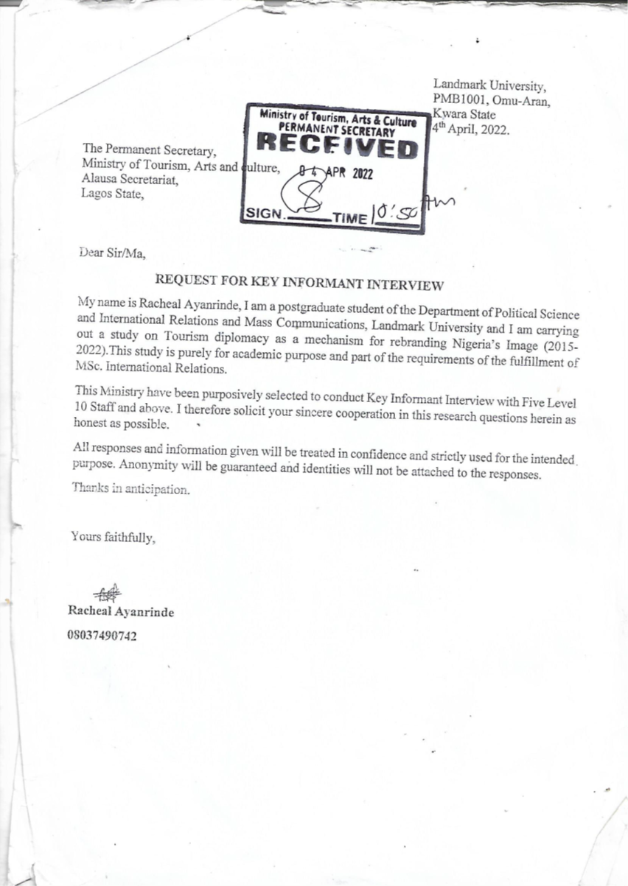

**APPENDIX 3**

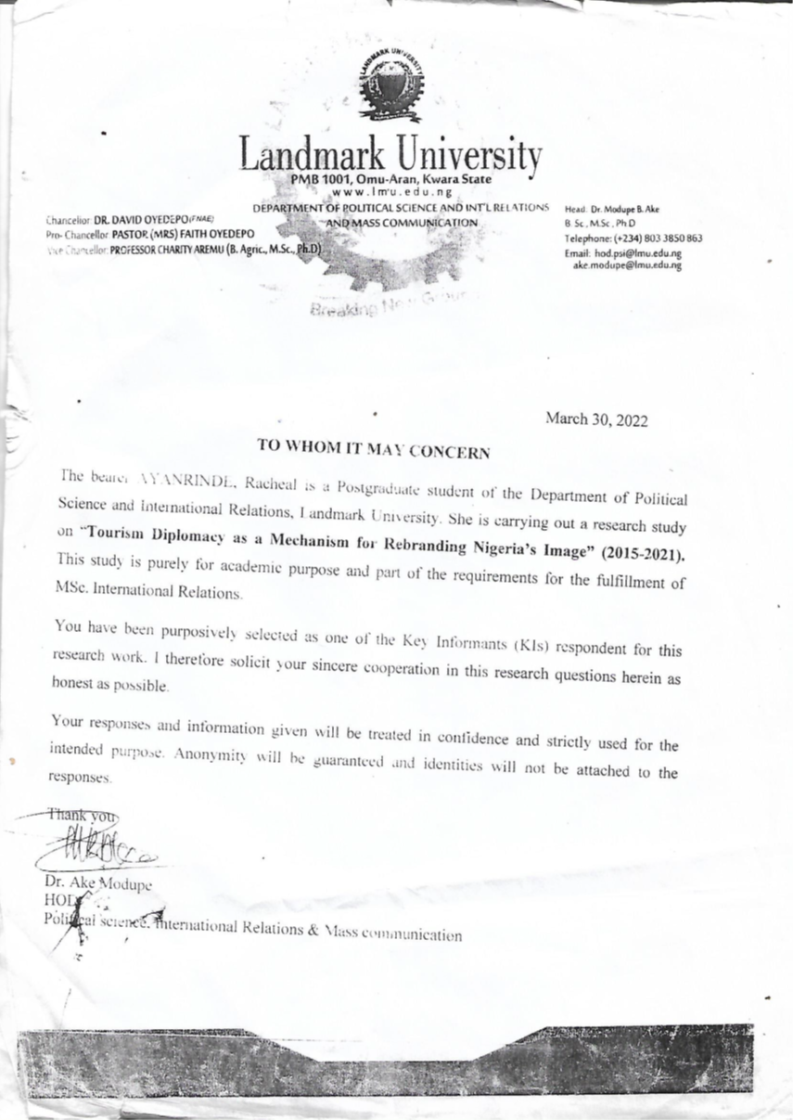

**APPENDIX 4**



