**CORROSION CONTROL OF Al6063/SiC COMPOSITE USING NOVEL HYBRID CONVERSION COATINGS**

**BY**

**ANYIM IKECHUKWU KINGSLEY**

**(20000239/20PGBE000147)**

**SUBMITTED TO**

**DEPARTMENT OF MECHANICAL ENGINEERING,**

**COLLEGE OF ENGINEERING,**

**LANDMARK UNIVERSITY, OMU-ARAN, KWARA STATE.**

**IN PARTIAL FULFILMENT OF REQUIREMENTS FOR THE AWARD OF MASTERS OF ENGINEERING (M. ENG.) IN MECHANICAL ENGINEERING**

**JULY, 2022**

**DECLARATION**

I, Ikechukwu Kingsley ANYIM, **M. Eng.** student in the **Department of Mechanical Engineering**, Landmark University, Omu-Aran, hereby declare that this thesis entitled “**CORROSION CONTROL OF Al6063/SiC COMPOSITE USING NOVEL CONVERSION COATINGS**”, submitted by me is based on my original work. Any material(s) obtained from other sources or work done by any other persons or institutions have been duly acknowledged.

------------------------------------------------------------------------

Student’s Full Name and Matriculation number

-----------------------------------------------

Signature and Date

**CERTIFICATION**

This is to certify that this thesis has been read and approved as meeting the requirements of the **Department of Mechanical Engineering**, Landmark University, Omu-Aran, Nigeria, for the Award of **M. Eng**.

|  |  |
| --- | --- |
| __________________________ | __________________________ |
| **Eng. Prof. M. Oki** | **Date** |
| **(Supervisor)** |  |
| __________________________ | __________________________ |
| **Eng. Dr. A.A. Adediran** | **Date** |
| **(Co-Supervisor)** |  |
| __________________________ | __________________________ |
| **Eng. Dr. A. O. BALOGUN** | **Date** |
| **(Head of Department)** |  |
| __________________________ | __________________________ |
|  | **Date** |
| **(External Examiner)** |  |

**DEDICATION**

This report is dedicated to Almighty God, who has provided supernatural provisions and direction throughout time.

**ACKNOWLEDGEMENT**

I am grateful to Almighty God for His wisdom, knowledge, and understanding thus far.

I wish to express my heartfelt appreciation to my supervisor Prof. M. Oki and co-supervisor Dr. A.A. Adediran, for their patience, valuable contributions, and words of encouragement all through this project work.

I want to also express a profound gratitude to all faculty and staff of Department of Mechanical Engineering for their contributions in my academic journey. Amongst them are; Head of Department, Dr. A. O. Balogun and Dean of Engineering, Prof. J.O. Ojediran respectively. I am genuinely grateful for their contributions towards my success and for the constructive criticism during this research. I also want to appreciate Dr. A. A Adeleke for his close guidance and tutorship all through my project work. I also say a big thank you to Mr. Peter and Mr. Taiwo for providing the basic necessities for the completion of this project. The Lord blesses you richly.

Much appreciation goes to my loving and supportive Parents and my always supportive siblings, I say thank you and God bless you.

To my loved ones, friends and colleagues; God bless you all and cause His face to shine and be gracious to you.

Table of Contents

|  |  |  |
| --- | --- | --- |
| **Section** | **Title** | **Page** |
| **1.0** | **Introduction** | 1 |
| 1.1 | Background to the Problem | 1 |
| 1.2 | Statement of the Problem | 3 |
| 1.3 | Justification for the Study | 4 |
| 1.4 | Aim and Objectives of the Study | 5 |
| 1.5 | Scope of the Study | 5 |
| 1.6 | Significance of the Study | 6 |
| **2.0** | **Review of Literatures** | 7 |
| 2.1 | Conceptual Issues | 7 |
| 2.2 | Review of Methodological Approaches | 8 |
| 2.3 | Gap Identified in the Literature | 13 |
| **3.0** | **Methodology** | 14 |
| 3.1 | Materials | 14 |
| 3.2 | Methods | 14 |
| 3.3 | Experimental Layout | 16 |
| 3.4 | Data Analysis | 22 |
| **4.0** | **Results and Discussions** | 23 |
| 4.1 | Coating Development | 23 |
| 4.2 | Scratched Specimens Exposed to the Atmosphere | 25 |
| 4.3 | Specimens Immersed in 3.5% NaCl | 28 |
| 4.4 | Adhesion Performance | 30 |
| 4.5 | Potentiodynamic Polarization Tests | 33 |
| 4.6 | Electrochemical Impedance Spectroscopy Measurements | 36 |
| 4.7 | Surface Morphology and EDS Analysis | 42 |
| **5.0** | **Conclusions and Recommendations** | 50 |
| **Section** | **Title** | **Page** |
| 5.1 | Summary | 50 |
| 5.2 | Conclusions | 50 |
| 5.3 | Recommendations | 51 |
| 5.4 | Contributions to Knowledge | 51 |
|  | **References** | 52 |

List of Tables

|  |  |
| --- | --- |
| **Table Title** | **Page** |
| 3.1 Compositional Constituents of Al 6063 - 10wt.% Silicon Carbide  Composite | 17 |
| 3.2 Experimental Design for the Research. | 20 |
| 4.1 Electrochemical Data After 24 Hours of Polarization Measurement. | 35 |
| 4.2 Electrochemical Data of Corresponding Nyquist Plots from EIS  Measurements | 41 |
| 4.3 Elemental Composition of Ferric Coating Obtained from EDS Analysis | 48 |
| 4.4 Elemental Composition of Hybrid Coating Obtained from EDS  Analysis | 49 |

List of Figures

|  |  |
| --- | --- |
| **Figure Title** | **Page** |
| 3.1 Schematic Diagram Showing the Process Flow Chat | 21 |
| 4.1 Graph Showing Coating Weight Versus Immersion Time in FCC and HCC  Coating Baths. | 24 |
| 4.2 Potentiodynamic Polarization Curves for Chromate, Ferric, and Hybrid  Coated Specimens. | 34 |
| 4.3 Nyquist Plots for Ferric Conversion Coatings Immersed In 3.5% NaCl at  24 Hours | 36 |
| 4.4 Nyquist Plots for Chromate Conversion Coatings Immersed in 3.5% NaCl  at 24 Hours | 37 |
| 4.5 Nyquist Plots of Hybrid Conversion Coatings Immersed in 3.5% NaCl at  24 Hours | 38 |
| 4.6 Equivalent Circuit Used for the Metal/Coating/Solution Interfaces. | 39 |
| 4.7 EDS Analysis of Al 6063 - 10 Wt.% Sic Specimen Treated for 180s in  Ferric Sulphate Coating | 45 |
| 4.8 EDS Analysis of Al 6063 - 10 Wt.% Sic Specimen Treated for 180s in  Hybrid Coating | 46 |

List of Plates

|  |  |
| --- | --- |
| **Plate Title** | **Page** |
| 4.1 Photographs of Scratched Specimens (a) Bare, (b) FCC, (c) CCC, (d)  HCC Before Exposure to the Atmosphere | 26 |
| 4.2 Photographs of Scratched Specimens After Day 1 of Atmospheric  Exposure (e) Bare, (f) FCC, (g) CCC, (h) HCC. | 26 |
| 4.3 Photographs of Scratched Specimens After Day 7 of Atmospheric  Exposure (i) Bare, (j) FCC, (k) CCC, (l) HCC. | 26 |
| 4.4 Photographs of Lacquer Coated and Scratched Specimens (a) Bare,  (b) FCC, (c) CCC, (d) HCC Before Exposure to the Atmosphere. | 27 |
| 4.5 Photographs of Lacquer Coated and Scratched Specimens After Day  1 of Atmospheric Exposure (e) Bare, (f) FCC, (g) CCC, (h) HCC | 27 |
| 4.6 Photographs of Lacquer Coated and Scratched Specimens After Day  7 of Atmospheric Exposure (i) Bare, (j) FCC, (k) CCC, (l) HCC | 27 |
| 4.7 Photographs of Specimens (a) Bare, (b) FCC, (c) CCC, (d) HCC  Before Immersion in 3.5% NaCl | 29 |
| 4.8 Photographs of Specimens After Day 1 of Immersion in 3.5% NaCl  (e) Bare, (f) FCC, (g) CCC, (h) HCC | 29 |
| 4.9 Photographs of Specimens After Day 7 of Immersion in 3.5% NaCl  (i) Bare, (j) FCC, (k) CCC, (l) HCC | 29 |
| 4.10 Photographs of Lacquer Coated Specimens (a) Bare, (b) FCC, (c)  CCC, (d) HCC Before Adhesion Performance | 31 |
| **Plate Title** | **Page** |
| 4.11 Photographs of Lacquer Coated Specimens (e) Bare, (f) FCC, (g)  CCC, (h) HCC After Adhesion Performance | 31 |
| 4.12 Photographs of Specimens (a) Bare, (b) FCC, (c) CCC, (d) HCC  Immersed in 3.5% NaCl Before Adhesion Performance | 32 |
| 4.13 Photographs of Specimens (e) bare, (f) FCC, (g) CCC, (h) HCC  Immersed in 3.5% NaCl After Adhesion Performance | 32 |
| 4.14 Scanning Electron Micrograph of Ferric Coated Al 6063 - 10 Wt.%  Sic Specimen for 180s | 42 |
| 4.15 Scanning Electron Micrograph of Hybrid Coated Al 6063 - 10  Wt.% Sic Specimen for 180s | 43 |

**Abstract**

Several organizations have limited their usage of chromate due to its high risks of carcinogenicity and environmental issues connected with chromium in +6 oxidation state, which has given rise to the numerous researches for chromate replacements in conversion coatings. This research focuses on developing a substitute using ferric sulphate and hybrid, ferric sulphate/chromate salts as relatively environmentally acceptable alternatives to chromate conversion coating. Aluminum composite 6063 - 10wt.% silicon carbide specimens were coated for 180s in ferric sulphate (Fe2(SO4)3) and hybrid ferric sulphate/chromate coating baths. The coated specimens were subjected to corrosion by natural atmospheric exposure and immersion in 3.5% sodium chloride (NaCl) solution combined with electrochemical analyses, electrochemical impedance spectroscopic (EIS) and potentiodynamic polarization (PDP) measurements. Adhesion tests using Japanese industrial test method was performed on exposed specimens. Similarly, conversion coated samples were inspected in scanning electron microscope with attached EDS facility (SEM/EDS). Results obtained from specimens subjected to immersion in 3.5% NaCl and paint adhesion tests revealed that hybrid conversion coating (HCC) and ferric conversion coating (FCC) were superior to chromate conversion coating (CCC). Also, EIS measurements showed superior corrosion resistance for both HCC and FCC over CCC. The charge transfer resistance, Rct, determined from the Nyquist plots were 9.89 × 104 Ω for HCC, 6.35 × 103 Ω for FCC and 3.75 × 103 Ω for CCC. Thus, the order of corrosion resistance is CCC < FCC < HCC from EIS measurements. However, CCC in EIS measurements performed relatively better under PDP measurements with a lower corrosion rate of 0.012 mm/year in comparism to 0.058 mm/year for FCC whereas the corrosion rate for HCC was 0.002 mm/year. Although chromate performed better than ferric under polarization measurements. However, hybrid conversion coating displayed superior corrosion resistance and showed less delamination in paint adhesion tests. Thus, it was established that the hybrid Ferric sulphate/chromate conversion coating on Al 6063/10%SiC composites performed better than chromate and ferric sulphate with respect the resistance to corrosion as well as its paint adhesion capabilities.

**CHAPTER ONE**

**INTRODUCTION**

**1.1** **Background to the Problem**

Corrosion refers to an irreversible chemical/electrochemical reaction of a material with its environment leading to deterioration of the material. Metals essentially corrode when they are exposed and react with substances like oxygen, hydrogen, electrical current or even bacteria. This results in reduction of the reliability and structural integrity of the material leading to an overall substantial decrease in performance while in service. The effect of corrosion cuts through most manufacturing and construction industries ranging from transport, agricultural, power plants, pipelines, bridges, offshore structures, etc. resulting into an increasing concern for safety, loss of life and an alarming cost of maintenance. According to Bharatiya *et al*. (2019), the all-out yearly expense of corrosion in the oil and gas, petroleum refining and the chemical and petrochemical industries in 2018 was estimated to be $6.772 billion.

Corrosion occurs in various forms with respect to the environmentally exposed surface. Uniform or generalized corrosion is the most recognized type of corrosion. It usually affects across the major surface region of the metal when exposed to a corrosive environment. Galvanic corrosion develops when two metals of different compositions make contact whether electrical or physical in a similar electrolyte like salt water. Upon immersion and contact of these two metals, the metal with the higher reactivity (the anode) gives off electrons faster than the more inert metal (the cathode) giving rise to corrosion.

Considering the various corrosion forms in Aluminum alloys, pitting corrosion is known to be the most damaging. It is the localized corrosion which appears in the form of cavities, occurring on the surface of a metal, usually restricted to a small area. Pitting corrosion which occurs in a defect free material is initiated by the composition of chemicals in the environment which may contain highly reactive components such as chlorides. Chlorides attack and damage the passive film oxide on the metal surface thereby causing pitting corrosion to erupt at the oxide breaks. In humid environments, water droplets which make contact with the metal surface also initiates pitting corrosion at the center of the water droplet known to be the anodic site. In an ideal climate condition, pitting is initiated due to inclusions present within the metal or even defects during production. Thus, the climate condition as well as the material itself can be responsible for the formation of pitting corrosion (Akpanyung and Loto, 2019).

Aluminum and its alloys are in high demands in the automobile, building and construction industries. This is due to their light weight, durability, high strength and stiffness amongst other mechanical properties which are responsible for their reliability and performance (Becker, 2019). Although aluminum is known for its low density, aluminum composites provide for even lower densities relative to a higher strength and stiffness. Some of the various benefits of aluminum composites compared to aluminum are their high efficiency in handling tensile stress, its compactable design in the distribution of weight on the composite resulting to equilibrium and its capability to remain flexible without causing a permanent deformation when bent. These are all achieved due to the presence of the fibers within the aluminum matrix which help in dissipating induced stress throughout the composite (Mavhungu *et al.,* 2017).

Metals such as freshly prepared aluminum when exposed to air, develop natural protective oxides. However, such films may be grown further through anodization in various media. These natural and electrically grown oxides prevent it from corroding in most environments. However, these oxide films may rupture to expose the substrate aluminum metal giving rise to corrosion at breached regions (Abbass *et al*., 2015; Dejun and Jinchun, 2015; Huang *et al*., 2019). The various metallic corrosion forms cause deterioration of the materials through electrochemical/chemical reactions causing the material to gradually return to its original state (Amani and Hjeij, 2015).

One of the most effective methods which have been implemented over the years for achieving an exceptional corrosion resistance in metals is through application of conversion coatings. Chemical conversion coating is preferred over other coating techniques like galvanization and electroplating because it provides a cost effective, durable and reliable coating on the metal surface. Amongst these various benefits, chemical conversion coating is also easy to operate. Conversion coating is a corrosion resistance technique performed on metals through chemical or electrochemical processes, where the metal is immersed in a chemical solution resulting in the growth of acoating layer upon the surface of the metal which protects the metal from corrosion, rust and probably wear (Becker, 2019). The use of chromate conversion coatings (CCCs) in corrosion protection have been predominant in the past. This has been as a result of its excellent corrosion resistance capabilities, fine bonding abilities which increases the paint adhesion capability, and its decorative purposes. The self-healing ability of CCCs in which they are able to stifle corrosion in the case of an exposure of the substrate metal has greatly increased its desirability. However, chromates are toxic to humans, the environment and even aquatic life. As consequences of their numerous applications in different components and parts, these carcinogenic compounds find their way into the soil and water bodies as wastes causing serious pollution. Various studies and researches have been conducted and are still ongoing to find a substitute to chromate conversion coatings (Gharbi *et al.,* 2018).

**1.2** **Statement of the Problem**

The hexagonal Cr (VI) in chromate conversion coating has faced a major setback in its application due to its toxicity. Several protocols from organizations such as the European union (EU) and the Occupational Safety and Health Administration (OSHA) have limited the application of chromates as a result of the high costs of their disposal coupled with their carcinogenicity and environmental pollution concerns when disposed into water bodies ( Oki *et al*., 2020; Proença *et al*., 2019; Qi *et al*., 2015; Whitman *et al.*, 2017).

Several researchers have made efforts in the introduction of environmentally friendly coatings with an aim of partially substituting or completely eliminating the use of chromium in conversion coating processes. Several substitutes such as Molybdate, Permanganate, Vanadate, Zirconate have been employed in experimental researches with various levels of successes. Thus, there is a large space for improvement which informed this research into using ferric sulphate as a partial/complete replacement for chromate in conversion coating baths ( Akulich *et al*., 2017; Liu *et al*., 2016; Oki *et al*., 2018; Zhang, 2017).

**1.3 Justification for the Study**

Conversion coating of metals is an important stage in preparation for a reliable corrosion resistant and an adequate paint adhesion material. CCCs have been greatly utilized in recent past for providing excellent surface finishing and adequate performance in corrosion resistance. However, due to the carcinogenic nature and environmental pollution posed by hexavalent chromium, the development of a substitute for chromate is investigated. Ferric sulphate’s ability to exist in more than one oxidation state is a possible substitute for chromate conversion coatings. A hybrid of ferric sulphate and chromate salts is expected to perform even better and reduce the quantity of Cr (VI) in effluents thus cutting down the cost of effluent treatment.

**1.4 Aim and Objectives of the Study**

The aim of this research is to develop and enhance the performance of ferric sulphate and chromate as a source of conversion coating on Al 6063 - 10 wt.% SiC composite.

The objectives of the research are to:

1. develop a ferric sulphate and hybrid chromate/ferric sulphate conversion coatings on Al 6063 - 10 wt.% SiC composite;
2. apply the corrosion and paint adhesion performances of the conversion coatings relative to standard chromate conversion coating using natural exposure/photography as well as electrochemical measurements;
3. examine the developed coatings with Scanning electron microscopy and energy dispersive spectroscopy (SEM/EDS).

**1.5 Scope of the Study**

The scope of the research covers;

1. Ferric sulphate, chromate and their hybrids were prepared and employed to coat on Al 6063 - 10 wt.% SiC composite;
2. Comparative corrosion resistance and paint adhesion capabilities were determined through natural exposure tests, electrochemical measurements and Japanese industrial test method with reference to standard chromate conversion coating.

**1.6 Significance of the Study**

1. This research led to viable, partial and/or complete replacement of Chromium +6 in conversion coating baths/processes, thus, reducing the carbon foot print of the coating industry, i.e. reduced environmental pollution associated with the metal finishing industry;
2. Efforts led to development of environmental and relatively cost friendly substitute for chromate conversion coating for corrosion protection of metals;
3. The research addressed the sustainable development goal (SDG 9- Innovation, Industry and Infrastructure)

**CHAPTER TWO**

**REVIEW OF LITERATURE**

**2.1. Conceptual Issues**

Chromium exists in more than one oxidation state. In particular, for its use as starting materials for conversion coatings, two of these oxidation states remain relevant which are the trivalent chromium (Cr (III)) and the hexavalent chromium (Cr (VI)). According to observations by Milošev and Frankel (2018); Ramezanzadeh *et al*. (2015) and several other researchers, these oxidation states of chromate form the backbone of chromate conversion coatings. Similarly, the existence of ferrous (Fe (II)) and ferric (Fe (III)) as oxidation states of iron are proposed to achieve reasonable reproducible conversion coatings. In the case of chromium conversion coatings (CCCs), the major constituents involved are the trivalent chromium (Cr (III)), hexavalent chromium (Cr (VI)), the parent metal, water, and other additional components such as oxides and fluorides. The degree of resistance achieved is dependent on various considerations such as; parent metal in use, the type of salt in use and quantity of coating formed on the metal may be important (Zarras and Stenger-Smith, 2015). The various parameters work excellently to provide the metal with good corrosion resistance, adequate paint adhesion and a decorative finish.

The main pressing issue these days with chromate conversion coating is its toxicity. An excessive inhalation of (Cr (VI)) compounds, broadens the chances of developing cancer in the respiratory organs and also causes ulcers and irritations in the stomach and intestine when ingested (Zarras and Stenger-Smith, 2015). (Cr (VI)) is carcinogenic and causes adverse health effects in humans, mammals and even aquatic life. Furthermore, chromates have also been identified to bring about genetic toxicity on plant life when the soil and water is contaminated which is caused by the improper waste management and disposal maintenance (Gharbi *et al*., 2018). The problem with disposing (Cr (VI)) wastes is that the compound sinks into underground water and runs into water bodies and contaminates the soil and aquatic life. The key to the disposal maintenance of toxic (Cr (VI)) is through a redox mechanism in which the toxic hexavalent chromium is reduced to a less toxic trivalent chromium. This was achieved using graphene oxide (GO) based polymer through electrostatic attractions (Bandara and Rodrigues, 2020). Similar approaches can also be conducted for ferric reducing it to a less toxic form. Although the poisonous compound is not fully eliminated, the toxic chemicals are cut down to a reasonable degree.

**2.2. Review of Methodological Approaches**

The effect of silicon carbide as a reinforcement on aluminum matrix composites was investigated by (Fenghong *et al.,* 2019). Results showed that there was a significant increase in hardness upon the addition of SiC, in which the hardness of the Al 6061 increased from 30 HB to 280 HB. Similarly, in the study of the mechanical properties of aluminum silicon carbide metal matrix composites, (Nuruzzaman and Kamaruzaman, 2016) observed that although there was an increase in the hardness of the composite, there was also a considerable increase on the density of the composite relative to the volume fraction of silicon carbide. Increase in density of aluminum composite minimizes its applicability in industry. Therefore, to maintain hardness as well as a relatively low density of the composite, 10% wt. of SiC is most satisfactory.

Shi *et al*. (2004) investigated the corrosion resistivity between ferric sulphate and ferric chloride on aluminum 6061. Observed results from the scanning electron microscope (SEM) showed less pitting corrosion on the aluminum composite by the ferric sulfate as compared to ferric chloride indicating a higher corrosion resistance to ferric sulfate. In an experiment on the effects of ferric ions on the corrosion of mild steel, Sisso *et al*. (2020) identified that ferrous ions quickly accumulated close to the surface of the metal until precipitates of ferrous sulfate, produced a dense, gray coating on the surface of the metal. The constituents of the oxide film were recognized to be ferrous sulfate heptahydrate which impedes further corrosion. This was also observed by Panossian *et al*. (2012) in the corrosion of carbon steel pipes and tanks by concentrated sulfuric acid in which carbon steel in sulfuric acid developed the forming of a resistive FeSO4 layer on the metallic surface. The layer acted as an impediment reducing the rate of corrosion.

In an experiment conducted by Geldien *et al*. (2019) for chromium conversion coatings on aluminum composites, ferric sulfate was used as a deoxidizing agent on Al which produced an oxide film and was converted into insoluble ferrous to continue the deoxidizing process. A similar application of ferric sulfate as a deoxidizing agent was recorded by Liu *et al*. (2015) in which an oxide layer was developed on a carbon steel surface. The development of these layers on the metal surface by ferric sulfate can be improvised not only as a deoxidizing agent but also for corrosion protection in chemical conversion coating.

The mixture of salts for the development of a more corrosion resistant and paint adhesive material is not also new. Verbruggen *et al*. (2019) observed in a molybdate-phosphate conversion coating, the formation of ferrimolybdite which developed on a steel surface. The coating formation was as a result of a combination of the mixture of ammonium heptamolybdate with ferric nitrate. This bonding attained by the ferric and molybdate mixture depicts a hybrid conversion coating which can be similarly replicated using ferric sulphate and chromium to obtain a more corrosion resistant material. Oki *et al*. (2017) studied the effect of hybrid conversion coating on aluminum alloys using manganate/fluoride/glycerol. It was observed that there was a notable corrosion resistance difference as compared to without glycerol when immersed in NaCl. Furthermore, it was also observed that the paint adhesion exhibition of the hybrid coating was far more superior to the standard chromate coatings.

Ferric sulphate in solution is brownish yellow having a pH of between 4.5 and 6; making it an acidic solution. Zai *et al*. (2019) studied the influence of different pH from 2.0 - 4.0 in the development of conversion coating on magnesium alloy. It was seen that at pH of 2.0, the highly acidic solution vigorously dissolved the coating formed thereby reducing the thickness and resistivity of the alloy to corrosion. Increasing the pH levels to between 3.5 to 4.0 obtained a more optimal coating modifying the corrosion resistivity of the magnesium alloy. Golru *et al*. (2015) also identified that the highly acidic solution lowered the levels of corrosion resistance of the coating. Additionally, the optimum immersion time was identified after 2, 3, 4 and 6 minutes using the open circuit potential measurements. The best coatings formed were observed at 3 to 4 minutes. Above 4 minutes, the coatings started deteriorating and became friable leading to reduced thickness and less corrosion resistance.

The effect of corrosion on metallic materials have given rise to the development of corrosion resistant materials. The most recognized and cost-effective methods of conversion coating are phosphate coating, anodic oxidation and chromate coating making them widely used methods in the modification and protection of metal surfaces (Asemani *et al*., 2016). Majorly, conversion coatings are utilized for the improvement of corrosion resistance of metals and modifying the adhesion of subsequently applied paints. During the conversion coating processes, the metals undergo a reformation of the surfaces of the substrates in which their corrosion resistance and adhesion capabilities are improved. This increases the bond strength of the paint on the surface, rather than merely sitting on the metal which could lead to delamination or chipping away of the paint particularly in instances of inadequate or no conversion (Saji, 2019). The enhancement of paint adhesion was observed in an experiment by Oki *et al*. (2018) on the improvement in corrosion resistance of Al 6061. The aluminum alloy was coated with permanganate-based conversion coating on which the Japanese industrial testing method Oki *et al.* (2017) was performed. It was observed that the untreated aluminum showed paint delamination whereas the conversion coated aluminum retained the applied paint after adhesion test.

Electroless nickel coating, which may be regarded as conversion coating also enhances the surface hardness of a metal as studied by Jian *et al*. (2020). An increase in surface hardness was observed from 66.23 Hv to 362.1 Hv for LZ91 magnesium alloy when Ni/P electroless nickel coating was applied and reinforced with V/Mn conversion coating on the alloy. Similar increase on surface hardness was observed whenRajabalizadeh *et al.* (2018)applied Zr coating on AM60B Mg alloy prior to deposition of Ni/P coating thereby increasing the hardness notably from 83 Hv to 996 Hv. Moreover, some conversion coatings do not only find a place in surface hardness enhancement but also as a decorative primer. Primers produce enhanced surface for proper adhesiveness between consecutively enforced coating with the base metal thus providing a durable and more protected coated surface ( Li *et al.,* 2015; De Nicolò *et al.,* 2016; Brunet *et al.,* 2020;).

In the mechanism of the chromate conversion coating (CCC) the central atom in the compound must occur in at least more than one oxidation state. In the case of CCC, it involves a cathodic deposition of insoluble hydrated (Cr (III)) oxide and a reducible soluble Cr (VI) oxide in solution. A metal activator sodium fluoride (NaF) activates the Al composite which allows for the deposition of hydrated Chromium III oxides and/or hydroxides on the metal surface (Fintová *et al*., 2018). As the coating grows, the chromate films will be composed of both trivalent and hexavalent chromium adsorbed and occluded in the coating formed. When there is a scratch to expose the substrate of the coated material, electrons are released by the base metal, which will react with Cr (VI) species present in that region (Oki *et al*., 2020). This causes reduction of Cr (VI) to occur, forming insoluble hydrated trivalent chromium compounds that stifle corrosion reactions adjacent to the breached coating.

As mentioned earlier, the hexavalent chromate conversion coating possesses self-healing properties making it very beneficial in the marine industries (Zarras and Stenger-Smith, 2015). The use of chromium in the metal finishing industry has produced excellent corrosion resistant materials. They have been vastly employed in improving metal brightness, paint adhesion to both ferrous and non-ferrous metals some of which include aluminum, zinc, copper, and magnesium surfaces (Harvey, 2013; Zhang *et al.,* 2017; Yang, *et al.,* 2020). CCC in general is close to an absolute corrosion protection technique having excellent electrical conductivity and ease of application (Abbass *et al*., 2015; Oki, 2015). CCCs provide adequate surfaces for strong paint adhesion on aluminum alloys. During the coating process, chromate neutralizes and replaces the alkali residual on the Al with a slightly acidic residue which improves its paint adhesion capability (Menke, 2020). CCCs exhibit self-healing properties which have been studied by several researchers. When corrosion attacks the bare aluminum, the coating layer which contains insoluble Cr+6 is reduced to insoluble Cr+3 terminating the corrosion process (Liu *et al*., 2016; Whitman *et al*., 2017). This excellent self-healing ability of CCCs have been extensively utilized by the aerospace industry increasing its durability. The corrosion resistance of CCCs have been unrivaled, providing exceptional anti-corrosion performance. Possible substitutes such as vanadate conversion coatings (VCC) and zirconate conversion coatings (ZCC) have been studied in which chromate displayed better corrosion resistance (Zhang, 2017; Oki *et al*., 2018). Due to these admirable performances of CCCs, there applications are still on-going in the aerospace, marine and military vehicle industries.

A drawback in the application of chromate conversion coating with its inherent mud cracking characteristics was resolved when Oki (2015) developed a hybrid of the chromate. A tannin/glycerol-chromate hybrid was prepared in which the crack morphology was obliterated and there was no observable pits formation and paint delamination on the coated material at exposure to high relative humidity. Other hybrid conversion coatings like zirconium-titanium (Milošev and Frankel, 2018) have also been employed to achieve better and more effective coating. However, in spite of chromates excellent performance in conversion coatings, hexavalent chromium poses a threat to both man and the environment. Its toxicity has limited its usage in recent past arising for the quest in developing alternatives. Consequently, in ferric sulphate/chromate hybridization, a more refined coating is envisioned as well as achieving a remarkable cut down in the proportion of the toxic chromate that are hitherto being used in chromate conversion coating baths.

**2.3. Gap Identified in the Literature**

Thus, from the above considerations, ferric sulphate produced films on the surfaces of the aluminum composite, are also able to combine easily with other salts to produce a hybrid, thereby increasing its resistance to corrosion and making it a potential candidate for the partial substitute or complete replacement for chromium in conversion coatings.

**CHAPTER THREE**

**METHODOLOGY**

**3.1****Materials**

The materials employed for this research include;

Aluminum alloy composite (Al 6063 - 10wt.% silicon carbide) was used due to its application in sign posts and roof tops and served as the coated base metal, ferric sulphate (Fe2(SO4)3) was used as the partial substitute or complete replacement for chromate, sodium fluoride (NaF) served as the metal activator in the coating bath (Genova *et al.,* 2021), chromium trioxide (CrO3) in solution being the standard conversion coating solution. Sodium hydroxide (NaOH) for degreasing (Romanovski *et al.,* 2020) and nitric acid (HNO3) for de-smutting (Marchezini *et al.,* 2019). Laboratory grade chemicals were used throughout this experiment. Emery paper for surface preparation of metals.

* 1. **Methods**

1. Following ASTM D1730-09 (2014), a coating solution of (Fe2(SO4)3 and NaF was prepared in ratio 8:1 in 1000 ml of water (Rai *et al.,* 2016). Adjustments to pH levels were made using either sodium hydroxide (NaOH) or nitric acid (HNO3) until a pH which was between 3.5 and 4 was attained.
2. A coating solution of Chromate Cr 8g: 1g NaF was also prepared in 1000 ml of water. Aluminum spade-like electrodes were formed using copper wires as support which were cleaned thoroughly in 10% NaOH to get rid of impurities from the surfaces. They were afterwards rinsed in water, thereafter in 50% nitric acid, rinsed in water again and were dried in air and finally stored in a desiccator. Specimens were immersed in coating solutions at different times between 60 seconds and 10 minutes and to dried in air for 30 minutes. The weight of the specimens was recorded before and after coating procedures.
3. A mixture of both salts was prepared under similar proportions to achieve a hybrid solution.
4. From the prepared solutions, groups A, B, C, D and E (ferric, chromate and hybrid coatings) were prepared respectively.
5. For Group A:

The specimens in group A were examined in the scanning electron microscope (SEM) supported with energy dispersive X-ray (EDS) facility. These are the specimens that were treated in the various coating baths for 3 minutes each.

1. For Group B: After 3 min of coating procedures

The specimens in group B were scratched and exposed to the atmosphere for 7 days while photographs were taken at intervals to monitor their interactions with the environment (Jian, *et al*., 2020)

1. For Group C:

The specimens in group C were coated with lacquer and allowed to dry in air for 24 hours. After which they were scratched and exposed to the atmosphere for a period of 7 days after which an adhesion test was carried out. Photographs were taken at intervals.

1. For Group D:

The specimens treated as in group C were submerged into a 3.5% NaCl solution for a period of 7 days (Shahzad *et al.,* 2020), after which an adhesion test was carried out on the specimens. Photographs were taken at intervals.

1. For Group E:

All specimens which were immersed for 3 min in the various coating baths were sent for electrochemical measurements in 3.5% NaCl solution.

In each of the various respective groups, untreated Al specimens served as control.

* 1. **Experimental Layout**

This research was conducted via a mixed method of quantitative and qualitative studies. The elemental analyzer was used to determine the compositional constituents of the aluminum (Al) alloy for the qualitative analysis. The representative compositional elements of the Al 6063 - 10wt.% silicon carbide used in this study are shown in Table 3.1. The elemental analyzer caused the sample to emit X-rays when it was roused by an X-ray source.The respective elements existing in the specimens produced a combination of distinct fluorescent X-rays that was exclusive for that particular element, with which their compositions were determined.

**Table 3.1:** Compositional Constituents of Al 6063 - 10wt.% Silicon Carbide Composite

|  |  |  |
| --- | --- | --- |
| Element Symbol | Element Name | % Composition |
| Fe | Iron | 0.20 |
| Si | Silicon | 0.90 |
| Cu | Copper | 0.01 |
| Zn | Zinc | 0.01 |
| Ti | Tin | 0.02 |
| C | Carbon | 0.18 |
| Mn | Manganese | 0.012 |
| Mg | Magnesium | 0.48 |
| Pb | Lead | <0.001 |
| Cr | Chromium | 0.01 |
| Al | Aluminum | 98.18 |

Similarly, the corrosion behavior was determined through potentiodynamic polarization (PDP) measurements and electrochemical impedance spectroscopy (EIS). Following ASTM G59-97 (2020), Potentiodynamic polarization measurements were carried out through three electrodes cell utilizing a computer regulated potentiostat/galvanostat (Autolab PGSTAT 302N) (Li *et al.,* 2015). The counter electrode (CE) which was used was the platinum electrode, the reference electrode (RE) which was used was Ag/AgCl in 3 M KCl (Vega *et al.,* 2018) and while the as working electrode (WE) used was Al 6063 - 10 wt.% SiC specimen. Approximately an area of 1cm2 of the working electrode was exposed to the medium. Prior to the potentiodynamic polarization (Tafel) study, the electrodes which were attached to the specimens were allowed to corrode freely and its open circuit potential (OCP) was recorded for 2 minutes, which was adequate in accomplishing a stable state. Furthermore, a steady-state of OCP which was equivalent to the corrosion potential (𝐸corr) of the working electrode was captured. The potentiodynamic polarization measurements were initiated from the cathodic to anodic direction (𝐸= 𝐸corr ±250 mV) at a scan rate of 10mVs-1. After every sweep, a new solution and untreated Al specimen was used. However, the EIS measurements were carried out using the same instruments prepared for the polarization measurements**.** In carrying out the EIS experiments, the specimens were superimposed with a sinusoidal potential of 5 mV amplitude and having a frequency ranging from 5×10-2 Hz - 105Hz.Electrochemical impedance spectroscopy reports were determined using FRA 32 software (Ziyatdinova *et al.,* 2018). The charge transfer resistance (Rct) and constant phase element (CPE) were obtained from Nyquist plots. The PDP and EIS data were used for quantitative analyses.

Also, the elemental composition and morphology of the coating was examined using SEM equipped with EDS, model JEOL 5800 LV (Boughoues *et al.,* 2020), for qualitative analyses.

The Al composites were abraded with various grades of emery papers to smoothen the surfaces and remove thick oxide skins that were formed on the composites during production. The specimens were cleaned with 10% NaOH to rid their surfaces of oils and grease and develop similar surfaces which aided in achieving a reproducible surface finish for all the specimens. The specimens were then rinsed in 50% HNO3 to de-smut silicon particles from the surface. Table 3.2 shows the experimental design, for each group, three repeat experiments were carried out to guarantee the repeatability and reproducibility of the results. The representative schematic diagram showing the process flow chat is as presented in Figure 3.1. The coated specimens were grouped into five groups A-E.

**3.4 Data Analysis**

The micrographs and microstructures, potentiodynamic polarization measurements and electrochemical impedance spectroscopy results obtained from the specimens were analyzed using the standard chromate conversion coating on Al composite as reference points for comparison.

**Table 3.2:** Experimental Design for the Research.

|  |  |  |  |  |  |
| --- | --- | --- | --- | --- | --- |
| Group | A | B | C | D | E |
| Test | SEM/EDS | Scratch and expose to atmosphere | Coat with lacquer then scratch and expose to atmosphere | Immerse in 3.5% NaCl solution | Potentiodynamic polarization measurement/ electrochemical impedance spectroscopy |
| Purpose for test | Determine the elemental content and coating morphology | Determine if the coating could impede corrosion from eating into the base metal from the scratch | Determine if the coating could impede corrosion from eating into the base metal from the scratch | Determine the duration and level of corrosion resistance achieved | Measured the corrosion rate with time electrochemically |

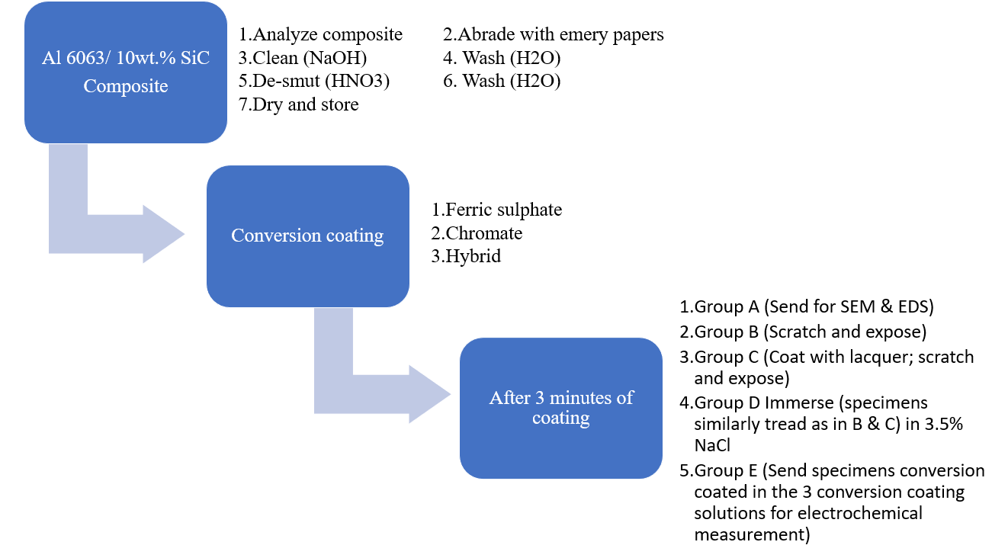

**Figure 3.1:** Schematic Diagram Showing the Process Flow Chat

**CHAPTER FOUR**

**RESULTS AND DISCUSSIONS**

**4.1 Coating Development**

The weights of the ferric and hybrid conversion coatings were obtained over a time period from 0 s to 600 s as shown in Figure 4.1. From an initial weight of 0 mg at 0 s immersion time, ferric conversion coating (FCC) gained 0.014 mg in 180 s. The increase in weight was as a result of the formation of ferric oxide films on the Al surface which served as the coating as observed by (Oki *et al.*, 2019). When observed at a more elongated period of immersion time, there was no significant increase in weight. Similarly, the hybrid conversion coating (HCC) gained 0.044 mg after an immersion time of 180 s and maintained the weight after longer immersion times (Liua *et al.,* 2020). A coating formation of 0.014 mg for FCC and 0.044 mg for HCC at similar time intervals show that hybrid conversion coating developed at a faster rate over the macroscopic composite surface which was attributed to the influence of chromate in the coating solution.

**4.2 Scratched Specimens Exposed to the Atmosphere**

Specimens with ferric, chromate and hybrid coatings developed for 180s, were cross scratched to expose the base aluminum composite, and were exposed to the atmosphere for 7 days. Following ASTM D4449 15, Plate 4.1 (a, b, c, d) shows the photographs of the various coatings before atmospheric exposure. Plate 4.2 (e, f, g, h) and Plate 4.3 (i, j, k, l) show days 1 and 7 of exposure respectively. Results show that there was no propagation of corrosion from the scratched regions in any of the conversion coated

**Figure 4.1:** Graph Showing Coating Weight Versus Immersion Time in FCC and HCC Coating Baths.

specimens. However, there were notable changes in the various coatings at seventh day of exposure. The hybrid conversion coating retained its initial color of brownish yellow to some extent while chromate and the ferric coated specimens faded substantially to lighter shades of their original colors. Similarly, using ASTM D3924 16 (2019), Plate 4.4 (a, b, c, d) displays the lacquer coated and scratched specimen before atmospheric exposure. Plate 4.5 (e, f, g, h) and Plate 4.6 (i, j, k, l) show days 1 and 7 of exposure respectively. Results show that there was no notable occurrence of corrosion activities on the lacquer coated specimens. There was no obvious coating delamination observable after the exposure time. The bare aluminum however, showed traces of pitting corrosion which were not observed on the various other conversion coated specimens.

**4.3 Specimens Immersed in 3.5% NaCl**

FCC, CCC and HCC specimens were immersed in 3.5% NaCl solution for 7 days with an untreated specimen used as control. Plate 4.7 (a, b, c, d) shows photographs before immersion in NaCl solution. It was observed that after 7 days, the chromate color of the coated specimen was completely removed leaving a reminiscent of an uncoated surface of the aluminum composite. The result from the ferric coated specimen as shown in Plate 4.8 (e, f, g, h) and Plate 4.9 (i, j, k, l) exhibited a somewhat better corrosion resistance performance than the CCCs in which the coating color faded exponentially however, leaving only traces of its initial color on the substrate. The hybrid coating showed the most resistance as patches of its initial color was still observable on the surface at the end of immersion for 7 days.

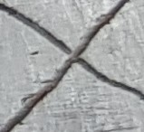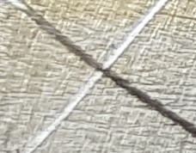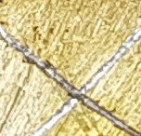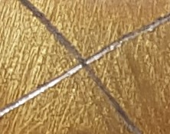

**a**

**d**

**c**

**b**

**Plate 4.1:** Photographs of Scratched Specimens (a) Bare, (b) FCC, (c) CCC, (d) HCC Before Exposure to the Atmosphere

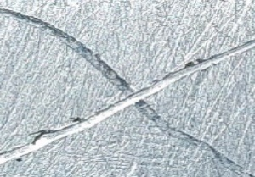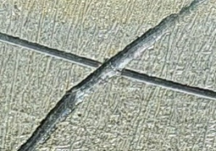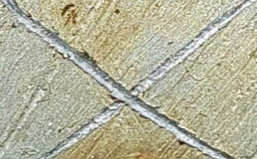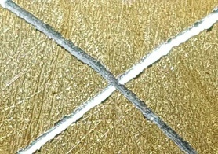

**e**

**h**

**g**

**f**

**Plate 4.2:** Photographs of Scratched Specimens After Day 1 of Atmospheric Exposure

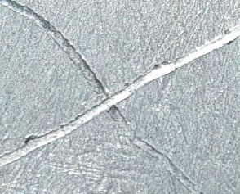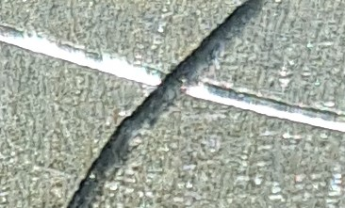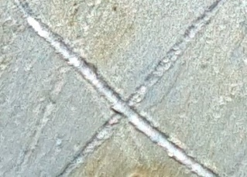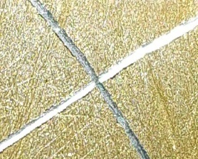

**i**

**j**

**k**

**l**

(e) Bare, (f) FCC, (g) CCC, (h) HCC.

**Plate 4.3:** Photographs of Scratched Specimens After Day 7 of Atmospheric Exposure

(i) Bare, (j) FCC, (k) CCC, (l) HCC.

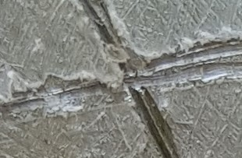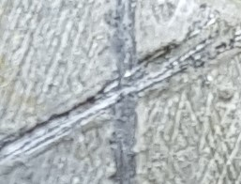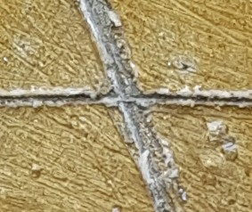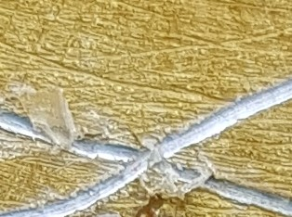

**a**

**b**

**c**

**d**

**Plate 4.4:** Photographs of Lacquer Coated and Scratched Specimens (a) Bare, (b) FCC, (c) CCC, (d) HCC Before Exposure to the Atmosphere.

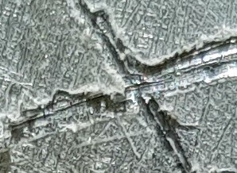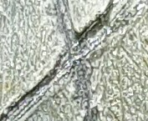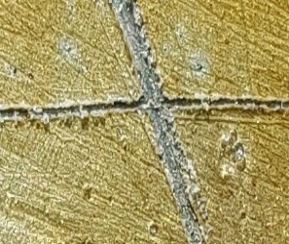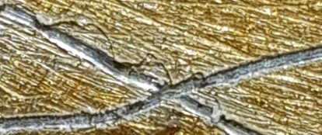

**e**

**f**

**g**

**h**

**Plate 4.5:** Photographs of Lacquer Coated and Scratched Specimens After Day 1 of Atmospheric Exposure (e) Bare, (f) FCC, (g) CCC, (h) HCC

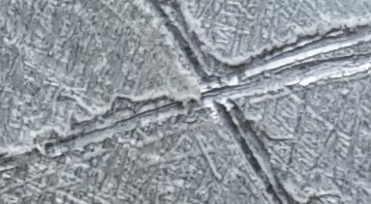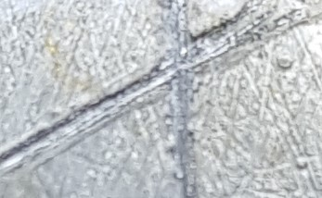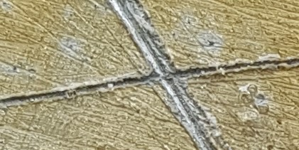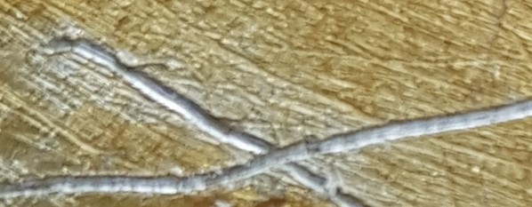

**i**

**j**

**k**

**l**

**Plate 4.6:** Photographs of Lacquer Coated and Scratched Specimens After Day 7 of Atmospheric Exposure (i) Bare, (j) FCC, (k) CCC, (l) HCC

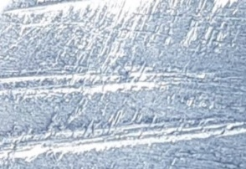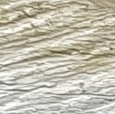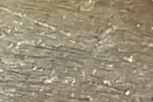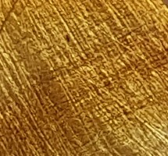

**a**

**d**

**c**

**b**

**Plate 4.7:** Photographs of Specimens (a) Bare, (b) FCC, (c) CCC, (d) HCC Before Immersion in 3.5% Nacl

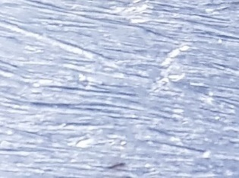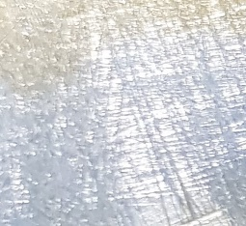

**h**

**e**

**g**

**f**

**Plate 4.8:** Photographs of Specimens After Day 1 of Immersion in 3.5% NaCl (e) Bare, (f) FCC, (g) CCC, (h) HCC

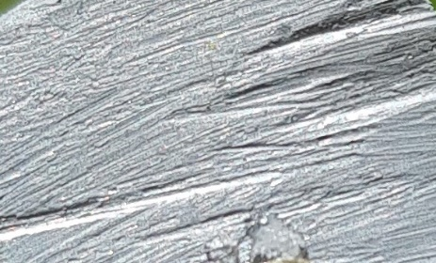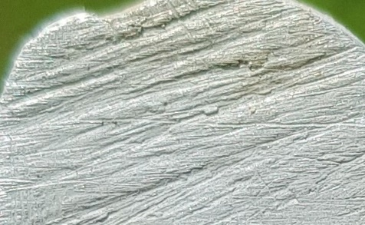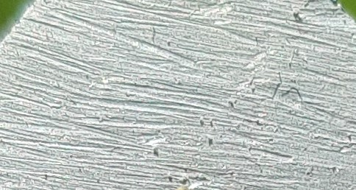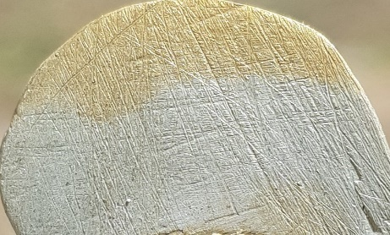

**i**

**l**

**k**

**j**

**Plate 4.9:** Photographs of Specimens After Day 7 of Immersion in 3.5% NaCl (i) Bare, (j) FCC, (k) CCC, (l) HCC

**4.4 Adhesion Performance**

Conversion coated specimens which were coated with lacquer were subjected to the Japanese industrial test. Plate 4.10 (a, b, c, d) shows the lacquer coated specimen before adhesion performance test. At the removal of the tape, there were no significant wear off of the coatings. The ferric conversion coating showed a minor coating delamination but the major proportion of the coating adhered to the composite. The bare aluminum composite which was coated with lacquer however, did not bond adequately with the lacquer. During the adhesion test, a good chunk of the lacquer was removed as shown in Plate 4.11 (e, f, g, h). Specimens which were immersed in 3.5% NaCl were also subjected to the tape peeling adhesion test. Plate 4.12 (a, b, c, d) and Plate 4.13 (e, f, g, h) show the specimens before and after the test respectively. The little remnant of ferric coating after immersion time was peeled off leaving a minute coating observable to the naked eye on the aluminum substrate. The hybrid conversion coating which had the most coating maintained an observable coating remnant after the removal of the tape being the most predominant of the other coatings.

**4.5 Potentiodynamic Polarization Tests**

The potentiodynamic polarization curves of Al 6063 - 10 wt.% SiC coated with ferric, chromate and hybrid conversion coatings are shown in Figure 4.2. The specimens coated for 180 s were immersed in 3.5% NaCl for 24 h. There equivalent electrochemical data are displayed in Table 4.1. The FCC showed to have the highest corrosion rate of 0.058 mm/y with a polarization resistance of 3 kΩ. The CCC outperformed the FCC having a lower corrosion rate of 0.012 mm/y while having a polarization resistance of 14 kΩ. HCC

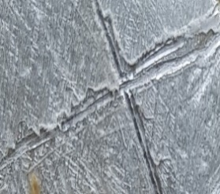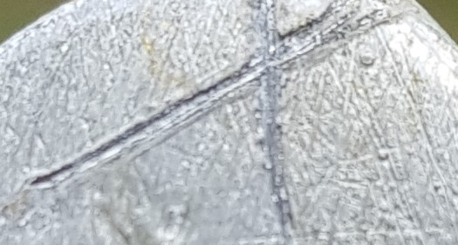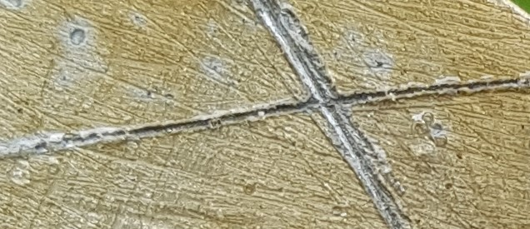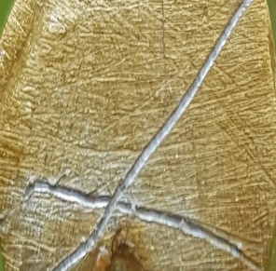

**a**

**d**

**b**

**c**

**Plate 4.10:** Photographs of Lacquer Coated Specimens (a) Bare, (b) FCC, (c) CCC, (d) HCC Before Adhesion Performance

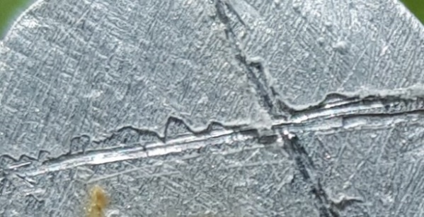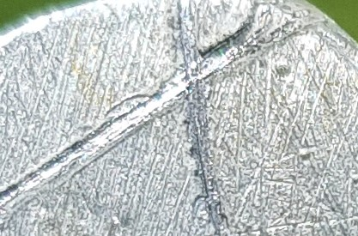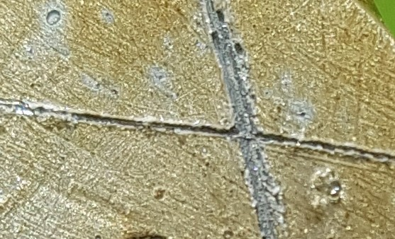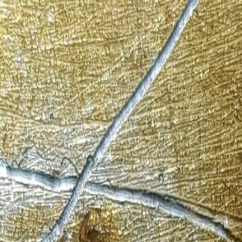

**e**

**h**

**g**

**f**

**Plate 4.11:** Photographs of Lacquer Coated Specimens (e) Bare, (f) FCC, (g) CCC, (h) HCC After Adhesion Performance



**a**

**d**

**c**

**b**

**Plate 4.12:** Photographs of Specimens (a) Bare, (b) FCC, (c) CCC, (d) HCC Immersed in 3.5% NaCl Before Adhesion Performance

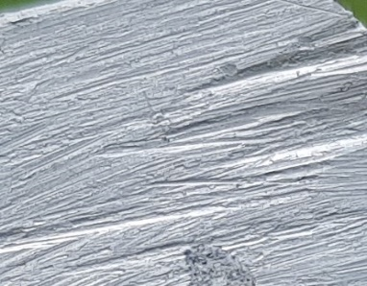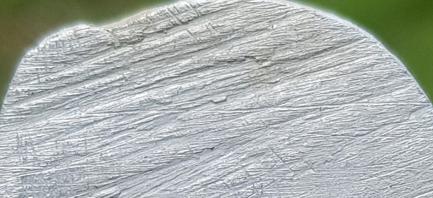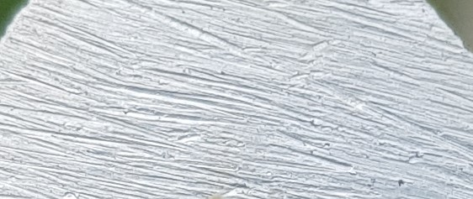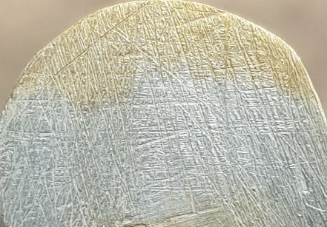

**e**

**h**

**f**

**g**

**Plate 4.13:** Photographs of Specimens (e) bare, (f) FCC, (g) CCC, (h) HCC Immersed in 3.5% NaCl After Adhesion Performance

showed the least rate of corrosion of 0.002 mm/y, harmonizing with the highest polarization resistance of approximately 107 kΩ. The high resistance obtained by HCC was as a result of the formation of ferric and chromate oxides on the Al composite which formed a more resistant film as observed by (Oki *et al.,* 2020). While the coating was being formed, ferric and chromate ions were in-cooperated into the coating, being a smart coating, when immersed in NaCl, these ions are removed to block locations of corrosion. Corrosion potential was observed to be -1.014 V, -0.839 V and -0.728 V for CCC, HCC and FCC respectively. The rapid changes in current density at some point for FCC indicated active/passive activities occurring on the surface of the metal. Ferric ions are readily reduced to ferrous compounds to stifle corrosion reactions in areas prone to pitting initiation (Motamedi *et al.,* 2019).

**4.6 Electrochemical Impedance Spectroscopy Measurements**

Results of the electrical resistance (impedance) of the metal/solution. Figures 4.3, 4.4, 4.5 and 4.6 respectively show the results of the EIS measurements after immersion in 3.5% NaCl while Table 4.2 shows their corresponding electrochemical data values. When the specimen was immersed into the NaCl solution, ions are transferred into the solution and back to the metal setting up a double layer. The potential is measured very close to the metal surface to avoid potential drop. The same occured for the solution resistance and the coating film resistance. The low corrosion rate of the HCC was as a result of the presence of ferric and chromium ions present in the coating. Ferric and chromium 6+ were reduced to ferrous and chromium 3+ to impede further propagation of corrosion. The electrochemical impedance spectroscopy (EIS) measurements of the FCC, CCC and HCC specimen which were coated for 180s were carried out. The values obtained from the

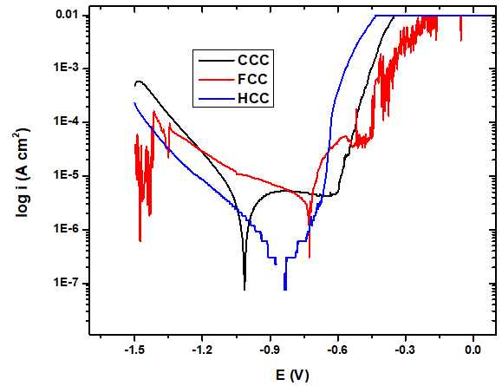

**Figure 4.2:** Potentiodynamic Polarization Curves for Chromate, Ferric, and Hybrid Coated Specimens.

**Table 4.1:** Electrochemical Data After 24 Hours of Polarization Measurement.

|  |  |  |  |  |  |  |  |
| --- | --- | --- | --- | --- | --- | --- | --- |
| **Specimen** | **Corrosion Rate (mm/y)** | **Corrosion Current (A)**  **×10-6** | **Corrosion Current Density (A/cm2)** | **Corrosion Potential (V)** | **Polarization Resistance, *R*p (Ω)** | **Cathodic Potential, Bc** | **Anodic Potential, Ba** |
| CCC | 0.012 | 1.82 | 1.14×10-6 | -1.014 | 14100.00 | -7.443 | 3.910 |
| FCC | 0.058 | 8.48 | 5.30×10-6 | -0.728 | 3028.00 | -2.049 | 5.625 |
| HCC | 0.002 | 2.41 | 1.50×10-7 | -0.839 | 106800.00 | -13.940 | 0.348 |



**Figure 4.3:** Nyquist Plots for Ferric Conversion Coatings Immersed In 3.5% Nacl at 24 Hours



**Figure 4.4:** Nyquist Plots for Chromate Conversion Coatings Immersed in 3.5% Nacl at 24 Hours



**Figure 4.5:** Nyquist Plots of Hybrid Conversion Coatings Immersed in 3.5% Nacl at 24 Hours

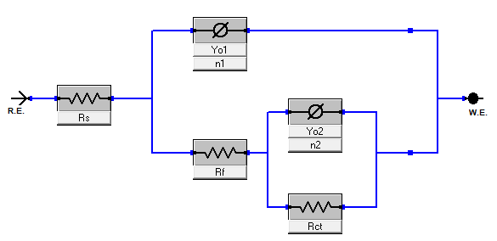

**Figure 4.6:** Equivalent Circuit Used for the Metal/Coating/Solution Interfaces.

charge transfer resistance of the ferric, chromate and hybrid conversion coatings showed the superiority of the HCC above CCC and FCC. Consequently, the charge transfer resistance obtained by FCC outperformed that of CCC. The EIS result obtained from the hybrid conversion coating corroborates with that which was obtained from the potentiodynamic polarization in which HCC showed highest level of corrosion resistance.

**4.7 Surface Morphology and EDS Analysis**

The scanning electron micrographs of specimens coated with ferric and hybrid conversion coatings for 180 s are displayed in Plate 4.14 and 4.15 respectively. The surface of the ferric coated composite showed patchy growth under the scanning electron microscope which highlighted and decorated the grain boundaries of the substrate. This could be as a result of the composition of the aluminum composite. According to Narayanan (2005), a metal having some proportions of other more noble reinforcements tend to have less difficulties in developing coatings. The aluminum composite used however, had a 10 wt.% silicon carbide composition which could have led to development of thin ferric conversion coating. It is usual for the grain boundaries to be anodic to the interior of grains hence the relatively more developed coatings at regions nearest to the boundaries. The morphology of the HCC appeared similar to that of FCC, however localized relatively thicker coatings with mud cracking morphology can be observed such as in the region marked, “H” in Plate 4.15. This was expected as the coating developed faster and gained more coating weight than for FCC at 180 s of immersion.

Results of EDS are depicted in Figure 4.7 and 4.8 showing the elemental composition of ferric and hybrid coated specimens.

**Table 4.2:** Electrochemical Data of Corresponding Nyquist Plots from EIS Measurements

|  |  |  |  |  |  |  |  |
| --- | --- | --- | --- | --- | --- | --- | --- |
| **Specimen** | **Rs (Ω)** | **Rf (Ω)** | **Rct (Ω)** | **Yo1** | **n1** | **Yo2** | **n2** |
| FCC | 5.505 | 3.595 | 6.35×103 | 3.15E-06 | 9.38E-01 | 7.46E-05 | 6.85E-01 |
| CCC | 7.015 | 1.50×103 | 3.75×103 | 3.90E-05 | 7.86E-01 | 5.91E-05 | 7.35E-01 |
| HCC | 2.62E-05 | 2.40×103 | 9.89×104 | 2.71E-05 | 3.64E-01 | 1.51E-05 | 6.23E-01 |

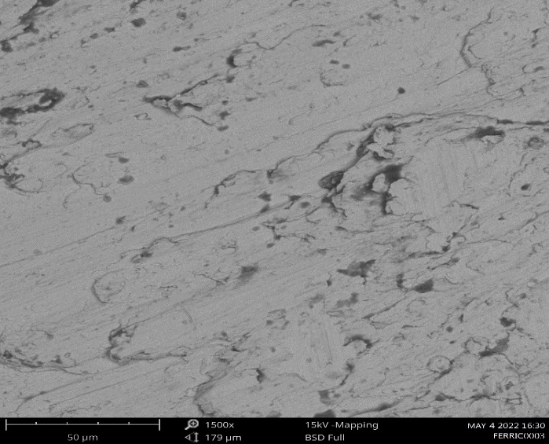

**Plate 4.14:** Scanning Electron Micrograph of Ferric Coated Al 6063 - 10 Wt.% Sic Specimen for 180s

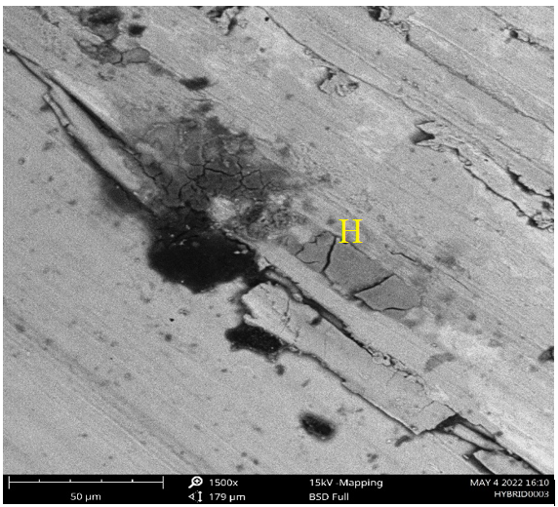

**Plate 4.15:** Scanning Electron Micrograph of Hybrid Coated Al 6063 - 10 Wt.% Sic Specimen for 180s

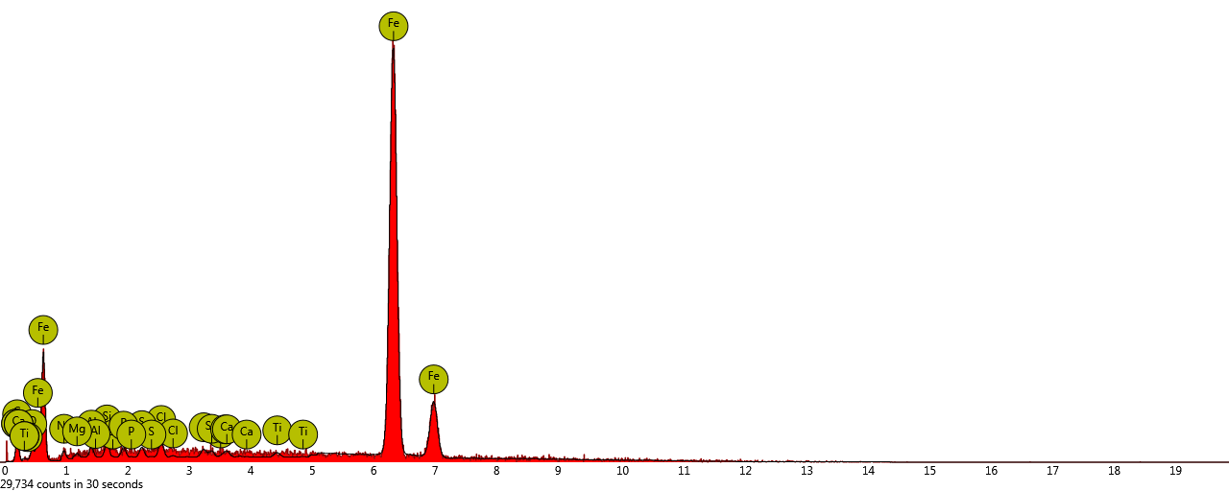

**Figure 4.7:** EDS Analysis of Al 6063 - 10 Wt.% Sic Specimen Treated for 180s in Ferric Sulphate Coating

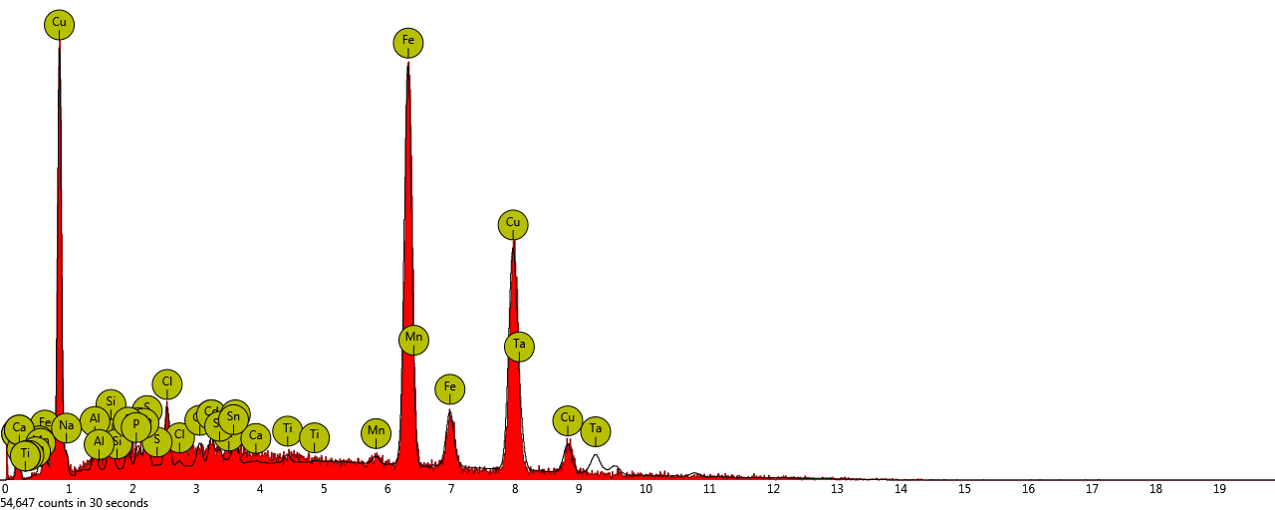

**Figure 4.8:** EDS Analysis of Al 6063 - 10 Wt.% Sic Specimen Treated for 180s in Hybrid Coating

Fe formed the bulk of the coating having an atomic and weight concentrations of 73.60% of 89.24% respectively. The hybrid coating however, interestingly do not account for the presence of chromium. This could be as a result of high voltage employed during analysis which caused the electrons to penetrate deep into the substrate neglecting the coating on the surface. Tables 4.3 and 4.4 display the corresponding EDS result for ferric and hybrid conversion coatings.

**Table 4.3:** Elemental Composition of Ferric Coating Obtained from EDS Analysis

|  |  |  |  |
| --- | --- | --- | --- |
| Element Symbol | Element Name | Atomic Concentration | Weight Concentration |
| Fe | Iron | 73.60 | 89.24 |
| C | Carbon | 17.40 | 4.54 |
| Sn | Tin | 0.46 | 1.18 |
| O | Oxygen | 2.08 | 0.72 |
| Cl | Chlorine | 0.84 | 0.64 |

**Table 4.4:** Elemental Composition of Hybrid Coating Obtained from EDS Analysis

|  |  |  |  |
| --- | --- | --- | --- |
| Element Symbol | Element Name | Atomic Concentration | Weight Concentration |
| Fe | Iron | 73.25 | 70.08 |
| Cu | Copper | 13.18 | 14.06 |
| Ta | Tantalum | 1.70 | 1.56 |
| Cd | Cadmium | 0.84 | 1.07 |
| Nb | Niobium | 0.75 | 0.79 |

**CHAPTER FIVE**

**CONCLUSIONS AND RECOMMENDATIONS**

**5.1 Summary**

Corrosion results in the degradation of metals through chemical and/or electrochemical reactions leading to decreased structural reliability of the metal thereby decreasing performance. Although chromate conversion coating provides metal surfaces with excellent corrosion resistance, its carcinogenic property has limited its usage in the industry. Ferric sulphate, an alternative to chromate, has been introduced as a partial substitute for chromate, cutting down the toxic output into the environment. A mixture of both salts produced a relatively more corrosion protective conversion coating on Al 6063 - 10 wt.% SiC composite. The performances of HCC with respect to corrosion resistance and paint adhesion potentials rivalled those of chromate conversion coatings.

**5.2 Conclusions**

1. Among the various coatings, the hybrid conversion coating had the most color retention and outperformed the ferric and chromate conversion coating both in corrosion resistance and paint adhesion capabilities.
2. Chromate based conversion coatings were superior to the ferric conversion coating in the lacquer coated scratch and paint adhesion tests. However, the results obtained for FCC after immersion in 3.5% NaCl showed a better performance than CCC.
3. HCC was superior in paint adhesion tests in which there was little or no delamination of lacquer coating from the substrate after immersion in 3.5% NaCl.

**5.3 Recommendations**

The following recommendations are suggested for further investigation on this research.

1. Although hybrid conversion coatings lost most of its coloration after immersion in 3.5% NaCl leaving very little of its initial color after 7 days, immersion time can be extended to determine the maximum tolerance of the coating.
2. Additional tests such as salt spray and SEM/EDS can also be carried out to study the effects of corrosion.

**5.4 Contributions to Knowledge**

From this research, the following outcomes were established:

1. Development of a hybrid conversion coating on Al 6063 - 10 wt.% SiC composite through the combination of ferric sulphate and chromium trioxide in a novel coating solution
2. A cut down in the level of chromate output into the environment through the reduction of the quantity of chromate in the coating solution; thus, cutting down on the cost of effluent treatment.
3. The hybrid coating, Fe3+/chromate outperformed the known chromate coating on aluminum composite with respect to corrosion resistance and paint adhesion capabilities as well as color retention after exposure episodes

**REFERENCES**

Abbass, M. K., Hassan, K. S., & Alwan, A. S. (2015). *Study of Corrosion Resistance of Aluminum Alloy 6061 / SiC Composites in 3 . 5 % NaCl Solution*. *3*(1), 31–35.

Akpanyung, K. V., & Loto, R. T. (2019). Pitting corrosion evaluation: A review. *Journal of Physics: Conference Series*, *1378*(2).

Akulich, N. E., Zharskii, I. M., & Ivanova, N. P. (2017). *A Study of Conversion Coatings on Vanadium / Galvanic Zinc*. *53*(3), 503–510.

Amani, M., & Hjeij, D. (2015). A comprehensive review of corrosion and its inhibition in the oil and gas industry. *Society of Petroleum Engineers - SPE Kuwait Oil and Gas Show and Conference*, 1–14.

Asemani, H. R., Ahmadi, P., Sarabi, A. A., & Eivaz Mohammadloo, H. (2016). Effect of zirconium conversion coating: Adhesion and anti-corrosion properties of epoxy organic coating containing zinc aluminum polyphosphate (ZAPP) pigment on carbon mild steel. *Progress in Organic Coatings*, *94*, 18–27.

Bandara, P. C., & Rodrigues, D. F. (2020). *Redox mechanisms of conversion of Cr ( VI ) to Cr ( III ) by graphene oxide- polymer composite*. *Vi*, 1–8.

Becker, M. (2019). *Chromate-free chemical conversion coatings for aluminum alloys*. *37*(4), 321–342.

Bharatiya, U., Gal, P., Agrawal, A., Shah, M., & Sircar, A. (2019). Effect of Corrosion on Crude Oil and Natural Gas Pipeline with Emphasis on Prevention by Ecofriendly Corrosion Inhibitors: A Comprehensive Review. *Journal of Bio- and Tribo-Corrosion*, *5*(2), 0.

Boughoues, Y., Benamira, M., Messaadia, L., Bouider, N., & Abdelaziz, S. (2020). Experimental and theoretical investigations of four amine derivatives as effective corrosion inhibitors for mild steel in HCl medium. *RSC Advances*, *10*(40), 24145–24158.

Brunet, M., Cochard, A., Deshayes, C., Brouca-Cabarrecq, C., Robbiola, L., Olivier, J. M., & Sciau, P. (2020). Study of Post-World War II French Aeronautical Aluminium Alloy and Coatings: Historical and Materials Science Approach. *Studies in Conservation*, *65*(2), 103–117.

De Nicolò, A., Paussa, L., Gobessi, A., Lanzutti, A., Cepek, C., Andreatta, F., & Fedrizzi, L. (2016). Cerium conversion coating and sol-gel multilayer system for corrosion protection of AA6060. *Surface and Coatings Technology*, *287*(3), 33–43.

Dejun, K., & Jinchun, W. (2015). Salt spray corrosion and electrochemical corrosion properties of anodic oxide film on 7475 aluminum alloy. *Journal of Alloys and Compounds*, *632*, 286–290.

Fenghong, C., Chang, C., Zhenyu, W., Muthuramalingam, T., & Anbuchezhiyan, G. (2019). Effects of Silicon Carbide and Tungsten Carbide in Aluminium Metal Matrix Composites. *Silicon*, *11*(6), 2625–2632.

Fintová, S., Drábiková, J., Pastorek, F., Kuběna, I., Trško, L., Hadzima, B., Doležal, P., Wasserbauer, J., & Ptáček, P. (2018). Improvement of electrochemical corrosion characteristics of AZ61 magnesium alloy with unconventional fluoride conversion coatings. *Surface & Coatings Technology*, #pagerange#.

Geldien, G. F. S., Fullen, W. J., & Company, T. B. (2019). *NASF SURFACE TECHNOLOGY WHITE PAPERS Troubleshooting Chromium Conversion Coatings on Aluminum*. *84*(October), 6–17.

Genova, V., Paglia, L., Pulci, G., Bartuli, C., & Marra, F. (2021). Diffusion aluminide coatings for hot corrosion and oxidation protection of nickel-based superalloys: Effect of fluoride-based activator salts. *Coatings*, *11*(4).

Gharbi, O., Thomas, S., Smith, C., & Birbilis, N. (2018). Chromate replacement : what does the future hold ? *Npj Materials Degradation*, *February*, 23–25.

Golru, S. S., Attar, M. M., & Ramezanzadeh, B. (2015). Morphological analysis and corrosion performance of zirconium based conversion coating on the aluminum alloy 1050. *Journal of Industrial and Engineering Chemistry*, *24*, 233–244.

Harvey, T. G. (2013). qian. *Corrosion Engineering Science and Technology*, *48*(4), 248–269.

Huang, Y., Mu, S., Guan, Q., & Du, J. (2019). Corrosion Resistance and Formation Analysis of a Molybdate Conversion Coating Prepared by Alkaline Treatment on Aluminum Alloy 6063. *Journal of The Electrochemical Society*, *166*(8), C224–C230.

Jian, S. Y., Chang, J. K., Lin, K. F., Chen, T. Y., Yuan, J. H., & Ger, M. Der. (2020). Characteristic V-Mn conversion coating in reinforcing corrosion resistance of electroless Ni-P coated LZ91 Mg alloy. *Surface and Coatings Technology*, *394*(November 2019), 125724.

Jian, S. Y., Yang, C. Y., & Chang, J. K. (2020). Robust corrosion resistance and self-healing characteristics of a novel Ce / Mn conversion coatings on EV31 magnesium alloys. *Applied Surface Science*, *510*(October 2019), 145385.

Li, L., Whitman, B. W., & Swain, G. M. (2015). Characterization and Performance of a Zr/Ti Pretreatment Conversion Coating on AA2024-T3. *Journal of The Electrochemical Society*, *162*(6), C279–C284.

Li, R., Liang, J., Hou, Y., & Chu, Q. (2015). Enhanced corrosion performance of Zn coating by incorporating graphene oxide electrodeposited from deep eutectic solvent. *RSC Advances*, *5*(75), 60698–60707.

Liu, H., Fu, C., Gu, T., Zhang, G., Lv, Y., Wang, H., & Liu, H. (2015). Corrosion behavior of carbon steel in the presence of sulfate reducing bacteria and iron oxidizing bacteria cultured in oilfield produced water. *Corrosion Science*, *100*, 484–495.

Liu, Y., Yang, Y., Zhang, C., Zhang, T., Yu, B., Meng, G., Shao, Y., Wang, F., & Liu, L. (2016). Protection of AA5083 by a Zirconium-Based Conversion Coating. *Journal of The Electrochemical Society*, *163*(9), C576–C586.

Liua, J., Zhang, B., Qi, W. H., Deng, Y. G., & Misra, R. D. K. (2020). Corrosion response of zinc phosphate conversion coating on steel fibers for concrete applications. *Journal of Materials Research and Technology*, *9*(3), 5912–5921.

Marchezini, E., Oliveira, F. P., Alloy, A., Curioni, M., Skeldon, P., Lin, H., & Liao, Y. (2019). *Corrosion Protection of Pure Titanium Implant by Electrochemical Deposition of Hydroxyapatite Corrosion Protection of Pure Titanium Implant by Electrochemical*.

Mavhungu, S. T., Akinlabi, E. T., Onitiri, M. A., & Varachia, F. M. (2017). Aluminum Matrix Composites for Industrial Use: Advances and Trends. *Procedia Manufacturing*, *7*, 178–182.

Milošev, I., & Frankel, G. S. (2018). Review—Conversion Coatings Based on Zirconium and/or Titanium. *Journal of The Electrochemical Society*, *165*(3), C127–C144.

Motamedi, M., Ramezanzadeh, M., Ramezanzadeh, B., & Saadatmandi, S. (2019). Enhancement of the active/passive anti-corrosion properties of epoxy coating via inclusion of histamine/zinc modified/reduced graphene oxide nanosheets. *Applied Surface Science*, *488*(February), 77–91.

Nuruzzaman, D. M., & Kamaruzaman, F. F. B. (2016). Processing and mechanical properties of aluminium-silicon carbide metal matrix composites. *IOP Conference Series: Materials Science and Engineering*, *114*(1).

Oki, M., Adediran, A. A., Ikubanni, P. P., Adesina, O. S., Adeleke, A. A., Akintola, S. A., Edoziuno, F., & Aleem, A. (2020a). Corrosion rates of green novel hybrid conversion coating on aluminium 6061. *Results in Engineering*, *7*(June), 100159.

Oki, M., Adediran, A. A., Ikubanni, P. P., Adesina, O. S., Adeleke, A. A., Akintola, S. A., Edoziuno, F., & Aleem, A. (2020b). Corrosion rates of green novel hybrid conversion coating on aluminium 6061. *Results in Engineering*, *7*(July), 100159.

Oki, Makanjuola. (2015). Performance of Tannin/Glycerol-Chromate Hybrid Conversion Coating on Aluminium. *Journal of Materials Science and Chemical Engineering*, *03*(07), 1–6.

Oki, Makanjuola, Adediran, A. A., Ogunsemi, B., Agboola, O. O., Olayinka, S., & Ogunsola, O. (2018). Improvement in corrosion resistance of aluminium alloy by permanganate-based conversion coating. *Journal of Physical Science*, *29*(2), 13–24.

Oki, Makanjuola, Adediran, A. A., Olayinka, S., & Ogunsola, O. (2017). Development and performance of hybrid coatings on aluminium alloy. *Journal of Electrochemical Science and Engineering*, *7*(3), 131–138.

Panossian, Z., Almeida, N. L. de, de Sousa, R. M. F., Pimenta, G. de S., & Marques, L. B. S. (2012). Corrosion of carbon steel pipes and tanks by concentrated sulfuric acid: A review. *Corrosion Science*, *58*, 1–11.

Proença, C. S., Pereira, A. M., Cabral, A. M., Pigliaru, L., Rohr, T., Araújo, M. E. M., & Correia, J. (2019). Trivalent chromium conversion coating on AA2024-T3 used in aeronautical and aerospace industry. *Surface and Interface Analysis*, *51*(12), 1298–1311.

Qi, J. T., Hashimoto, T., Walton, J. R., Zhou, X., Skeldon, P., & Thompson, G. E. (2015). Trivalent chromium conversion coating formation on aluminium. *Surface and Coatings Technology*, *280*, 317–329.

Rai, G., Yadav, A. K., Jain, N. K., & Agrawal, G. P. (2016). Eudragit-coated dextran microspheres of 5-fluorouracil for site-specific delivery to colon. *Drug Delivery*, *23*(1), 328–337.

Rajabalizadeh, Z., Seifzadeh, D., Habibi-Yangjeh, A., Mesri Gundoshmian, T., & Nezamdoust, S. (2018). Electrochemical noise analysis to examine the corrosion behavior of Ni-P deposit on AM60B alloy plated by Zr pretreatment. *Surface and Coatings Technology*, *346*(2017), 29–39.

Ramezanzadeh, B., Vakili, H., & Amini, R. (2015). Improved performance of cerium conversion coatings on steel with zinc phosphate post-treatment. *Journal of Industrial and Engineering Chemistry*, *30*, 225–233.

Romanovski, V., Frantskevich, V., Kazlouski, V., Kasach, A., Paspelau, A., Hedberg, Y., & Romanovskaia, E. (2020). Inappropriate cleaning treatments of stainless steel AISI 316L caused a corrosion failure of a liquid transporter truck. *Engineering Failure Analysis*, *117*(September), 104938.

Saji, V. S. (2019). Organic conversion coatings for magnesium and its alloys. *Journal of Industrial and Engineering Chemistry*, *75*, 20–37.

Shahzad, K., Sliem, M. H., Shakoor, R. A., Radwan, A. B., Kahraman, R., Umer, M. A., Manzoor, U., & Abdullah, A. M. (2020). Electrochemical and thermodynamic study on the corrosion performance of API X120 steel in 3.5% NaCl solution. *Scientific Reports*, *10*(1), 1–15.

Shi, Y., Fan, M., Brown, R. C., Sung, S., & Van Leeuwen, J. (2004). Comparison of corrosivity of polymeric sulfate ferric and ferric chloride as coagulants in water treatment. *Chemical Engineering and Processing: Process Intensification*, *43*(8), 955–964.

Sisso, O., Dor, S., Eliyahu, D., Sabatani, E., & Eliaz, N. (2020). Corrosion inhibition of copper in ferric chloride solutions with organic inhibitors. *Npj Materials Degradation*, *4*(1).

Menke, J. T. (2020). *Sandstrom Coating Technologies Joseph T. Menke Page 1 / 3 January 2020*. *January*, 1–3.

Vega, J., Scheerer, H., Andersohn, G., & Oechsner, M. (2018). Experimental studies of the effect of Ti interlayers on the corrosion resistance of TiN PVD coatings by using electrochemical methods. *Corrosion Science*, *133*(December 2017), 240–250.

Verbruggen, H., Baert, K., Terryn, H., & De Graeve, I. (2019). Molybdate-phosphate conversion coatings to protect steel in a simulated concrete pore solution. *Surface and Coatings Technology*, *361*, 280–291.

Whitman, B. W., Li, L., & Swain, G. M. (2017). Anti-Corrosion Properties of a TCP Pretreatment Conversion Coating on Aluminum Alloy 2024-T3 during Moist SO 2 Atmospheric Testing: Effects of Galvanic Coupling . *Journal of The Electrochemical Society*, *164*(4), C135–C147.

Zai, W., Su, Y., Man, H. C., Lian, J., & Li, G. (2019). Effect of pH value and preparation temperature on the formation of magnesium phosphate conversion coatings on AZ31 magnesium alloy. *Applied Surface Science*, *492*(May), 314–327.

Zarras, P., & Stenger-Smith, J. D. (2015). Smart Inorganic and Organic Pretreatment Coatings for the Inhibition of Corrosion on Metals/Alloys. In *Intelligent Coatings for Corrosion Control*. Elsevier Inc.

Zhang, C., Luo, X., Pan, X., Liao, L., Wu, X., & Liu, Y. (2017). Self-healing Li-Al layered double hydroxide conversion coating modified with aspartic acid for 6N01 Al alloy. *Applied Surface Science*, *394*, 275–281.

Zhang, S. (2017). *Electrochemical analysis of molybdate conversion coating on hot-dip galvanized steel in various growth stages*. *August 2016*.

Ziyatdinova, G., Kozlova, E., & Budnikov, H. (2018). Selective electrochemical sensor based on the electropolymerized p-coumaric acid for the direct determination of L-cysteine. *Electrochimica Acta*, *270*, 369–377.