**RELIABILITY ANALYSIS AND PREDICTION OF**

**OMU-ARAN 132/33kV SUBSTATION UNDER**

**STEADY-STATE**

BY

**ALABI AYODELE JOHN CHUKWUBUIKEM**

**19PGBD000061**

A THESIS SUBMITTED TO THE DEPARTMENT OF ELECTRICAL AND INFORMATION ENGINEERING, COLLEGE OF ENGINEERING. LANDMARK UNIVERSITY, OMU-ARAN

IN PARTIAL FULFILMENT OF THE REQUIREMENT FOR THE AWARD OF MASTER OF ENGINEERING (M Eng.) DEGREE IN THE ELECTRICAL AND INFORMATION ENGINEERING DEPARTMENT, LANDMARK UNIVERSITY, OMU-ARAN, KWARA STATE, NIGERIA

SEPTEMBER, 2022

# DECLARATION

I, ALABI AYODELE JOHN CHUKWUBUIKEM, a Master’s degree student in the Department of Electrical and Information Engineering, Landmark University, Omu-Aran, hereby declare that this thesis entitled “Reliability Analysis and Prediction of Omu-Aran 132/33kV Substation under Steady State”, submitted by me is based on my original work. Any material(s) obtained from other sources or work done by any other persons or institutions have been duly acknowledged.

**_________________________________ ___________________**

**Alabi Ayodele John Chukwubuikem Signature and Date**

(Student/Researcher)

# CERTIFICATION

This is to certify that this thesis has been read and approved as meeting the requirements of the Department of Electrical and Information Engineering, Landmark University, Omu-Aran, Nigeria, for the Award of Master of Engineering(M.Eng) in Electrical and Electronics Engineering (Power Option).

___________________ ___________________

**Dr P.K Olulope Signature and Date**

(Supervisor)

___________________ ___________________

**Dr P.K Olulope Signature and Date**

(Head of Department)

___________________ ___________________

**External Examiner Signature and Date**

# ABSTRACT

Reliability analysis and prediction of Omu-Aran 132/33kV Transmission Station, Omu-Aran Kwara State, and its associated 33kV feeders was investigated in this study. Analytical method was used to compute reliability indices, a multilayer feed-forward neural network (robotics) trained with the Levenberg-Marquardt (LM) feedforward technique was used to predict the reliability of station and outgoing 33kV feeders. Power flow was conducted using Power System Analysis Toolbox (PSAT) in MATLAB. Power flow result conducted on the 33kV feeders reveal that Otun 33kV feeder has the highest magnitude of power loss. It has real power (P) loss of 0.03906pu and reactive power (Q) loss 0.3622pu while Oro-Ago 33kV feeder has the least power loss with real power (P) value of 0.0006pu and reactive power (Q) of 0.00031pu. The station recorded an improvement in reliability with Mean Time Between Failure (MTBF) of 1219.43 hours in 2020 compared to 261.13hours recorded in 2016. It has the least failure rate of 0.00151 hours in 2019 with the least Mean Down Time (MDT) of 7.5625hours in 2015.The least number of interruptions were experienced in 2020 with System Average Interuption Index (SAIFI) of 0.0016 interruption/customer, highest System Average Interuption Duration Index (SAIDI) of 0.0122hours/customer(sustained interruption duration)in 2016, Customer Average Interuption Duration Index (CAIDI) of 35.4286 in 2020 and six years mean Average Service Availability Index (ASAI) of 0.9755. On the 33kV outgoing feeders, Otun 33kV feeder has the least average SAIFI and SAIDI values of 0.0963interruption/customer and 0.2291hours/customer respectively. Customers on this feeder experience the least number of interruptions and the least duration of the sustained interruption. Omu-Aran 33kV feeder has the least CAIDI of 1.7809 interruptions/customer. Customers on this feeder experience the least number of continuous interruptions. Omu-Aran 33kV feeder also recorded a mean ASAI of 0.8359 and Isanlu-Isin 33kV feeder recorded the least ASAI with a mean ASAI of 0.5943. The reliability prediction result is accurate with minimal error. There is a good agreement between Target, Training, and Testing results using Artificial Neural Network (ANN).

# DEDICATION

I dedicate this work to God who gave me the wisdom and strength to complete it, despite all odds.

# ACKNOWLEDGEMENT

I want to use this opportunity to thank God for the wisdom, strength and perseverance He has given me to get this work done despite all the odds.

My profound gratitude goes to my supervisor, Dr P.K Olulope for his continuous support, advice and contributions towards the success of this work. Indeed, the completion of this work could not have been possible without your consistent participation and assistance.

I acknowledge and appreciate the contributions of all the lecturers within the Department of Electrical and Information Engineering, Landmark University Omu-Aran. My deepest appreciation also goes to the Dean, School of Postgraduate Studies, Professor Charity Aremu, for her support and advice.

My sincere gratitude and appreciation goes to my wife, Temitope Aminat Alabi for her support and understanding when I was unavoidably absent during the course of this work.

My deepest appreciation goes to my colleague at work namely: Mr. Adesina D.I, Engr Aremu S.O and Mr Akereyeni S.B who stood in for me from time to time during the course of this work. God bless you all.

I am also thankful to Dr. Alabi Ibitoye for his professional advice and guidance. Not forgetting my course mates Kareem Babatunde, Julius Uwagboe, and several others who have supported the success of this work in various ways. I am indeed grateful. May God bless and reward you all. Amen!

# TABLE OF CONTENT

DECLARATION ii

CERTIFICATION iii

ABSTRACT iv

DEDICATION v

ACKNOWLEDGEMENT vi

TABLE OF CONTENT vii

CHAPTER ONE 1

INTRODUCTION 1

1.1 Background to the Problem 1

1.2 Statement of the Problem 3

1.3 Aims and Objectives 4

1.4 Research Questions 4

1.5 Scope of Research 4

1.6 Justification for the Study 5

1.7 Limitations of the Study 5

CHAPTER TWO 6

LITERATURE REVIEW 6

2.1 Power Systems Operations and Structure 6

2.1.1 Rationale for Interconnection 8

2.2 Reliability of Power Systems 9

2.3 Distribution System Reliability assesment 12

2.3.1 Distribution system Reliability Indices 13

2.3.2 Customer based indices 14

2.3.2.1a System Average Interruption Frequency Index (SAIFI) 14

2.3.2.2b Average Service Availability Index (ASAI) 14

2.3.2.3c System Average Interruption Duration Index (SAIDI) 14

2.3.2.4d Customer Average Interruption Duration Index (CAIDI) 15

2.3.3 System Based Indices 15

2.3.3.1a Mean Time Between Failure (MTBF) 15

2.3.3.2b Failure Rate (λ) 16

2.3.3.3c Mean down time (MDT) 17

2.3.3.4d Availability (A) 17

2.3.4 Distribution System reliability evaluation. 17

2.4 Reliability Prediction: An Overview 18

2.4.1 Computational intelligence in Power system Reliability Prediction 19

2.4.2 Artificial Neural Network (ANN) 20

2.4.3 Reliability Prediction Using Artifical Neural Network 23

2.5 Load Flow Studies 24

2.5.1 Load types 24

2.5.1.1 Domestic loads 25

2.5.1.2 Industrial loads 25

2.5.1.3 Commercial loads 25

2.5.1.4 Agriculture loads 25

2.5.2 Power Flow Analysis 25

2.5.2.1 Techniques of Load Flow Analysis 26

2.5.2.2 Newton-Raphson Power (Load) Flow Solution 27

2.5.3 Power System Stability Classification 29

2.5.3.1 Steady-State stability 29

2.5.3.2 Transient State Stability 29

2.6 Gaps Identified in literatures 30

CHAPTER THREE 35

METHODOLOGY 35

3.1 Study Area 35

3.2 Research Design Layout 36

3.3 Data Collection 37

3.4 Data Analysis Techniques 38

3.5 Modelling of Power System 39

3.5.1 Lines and Cables 40

3.5.2 Transformers 40

3.5.3 Shunt Elements 41

3.5.4 Loads 42

3.6 Reliability Prediction Using Artificial Neural Network. 42

3.7 ANN Prediction Equations for 33kV Bus and the outgoing 33kV Feeders ……………………………………………………………………………44

CHAPTER FOUR 46

RESULTS AND DISCUSSION OF FINDINGS 46

4.1 Results of Power Flow Analysis. 46

4.2 Results of reliability analysis 51

4.2.1 Feeders Outage Duration 52

4.2.2 Reliability Performance of the I32kV Transmission Station 59

4.2.3 Reliability Prediction Results 64

4.3 Discussions of Results 80

CHAPTER FIVE 84

CONCLUSION AND RECOMMENDATIONS 84

5.1 Conclusion 84

5.2 Recommendations 86

5.3 Research Contribution to Knowledge 86

REFERENCES 87

APPENDICES 95

APPENDIX A: TABLES SHOWING OTHER RESULTS FROM FEEDERS 95

Table A1: Omu-Aran132/33kV feeder network layout 95

Table A2: Omu-Aran 132/33kV Station Feeders Planned Outage Duration in Hours from Year 2015 – 2020 (January-December) 95

Table A3: Table ShowingForced Outages for 2015 in Hours 96

Table A4: Table Showing Forced Outages for 2016 in Hours 97

Table A5: Table Showing Forced Outages for 2017 in Hours 98

Table A6: Table Showing Forced Outages for 2018 in Hours 99

Table A7: Table Showing Forced Outages for 2019 in Hours 100

Table A8: Table Showing Forced Outages for 2020 in Hours 101

Table A9: Table Showing Annual Forced Outage Duration in Hours from 2015 – 2020 102

Table A10: Table Showing Supply Unavailability in Hours from 2015 - 2020 103

Table A11: Table Showing 33kV Feeders Route Length in Kilometers 104

Table A12: Table Showing Omu-Aran 132/33kV Station Customers Population 105

from Year 2015 - 2020 105

Table A13: Omu-Aran 132/33kv Station Feeders Forced Outage Duration in Hours from Year 2015– 2020 (January-December). 106

Table A14: Omu-Aran 132/33kV Station Feeders Total Duration of Outage in Hours (Forced and Planned) from Year 2015 -2020 (January-December). 106

Table A15: Omu-Aran 132/33kV Station Feeders Total Number of Interruptions (Frequency of Outage) from Year 2015 - 2020 (January-December) …………………………………………………………………...107

Table A16: Omu-Aran 132/33kV Station Feeders Total Number of System Operating Hours From Year 2015 - 2020 (January-December) 107

Table A17: Omu-Aran 132/33kV Station Feeders Mean Time Between Failures (MTBF) From Year 2015 - 2020 (January- December) 108

Table 18: Omu-Aran 132/33kV Station Feeders Failures Rate (λ) from Year 2015 – 2020 from (January-December) 108

Table A19: Omu-Aran 132/33kV Station Feeders Mean Down Time (MDT) From Year 2015 – 2020 (January-December). 109

Table A20: Omu-Aran 132/33kV Station Feeders System Average Interruption Frequency Index (SAIFI) from Fear 2015 - 2020 (January- December). 109

Table A21: Omu-Aran132/33kV Station Feeders System Average Interruption Duration Index (SAIDI) from Year 2015 - 2020 (January-December) 110

Table A22: Omu-Aran 132/33kV Station Feeders Customer Average Interruption Duration Index (CAIDI) From Year 2015 - 2020. (January-December) …………………………………………………………………..110

Table A23: Omu-Aran 132/33kV Station Feeders Average Service Availability Index (ASAI) from Year 2015 – 2020 (January – December) 111

Table A24: Frequency of Outage (January2015-December 2020) 111

Table A25: Duration of Outage January 2015 – December 2020 112

Table A26: Available Service Hour and Customer Hour Demanded 112

Table A27: Omu-Aran 132kV Station System Average Interruption Frequency Index (SAIFI) From Year 2015 - 2020 (January- December). 113

Table A28: Omu-Aran 132kv Station System Average Interruption Duration Index (SAIDI) fromYear 2015 – 2020 (January-December) 113

Table A29: Omu-Aran 132kV Station Customer Average Interruption Duration Index (CAIDI) fromYear 2015 – 2020 (January – December) 114

Table A30: Omu-Aran 132kV Station Average Service Availability Index (ASAI) From Year 2015 -2020 (January- December) 114

Table A31: Omu-Aran 132kV Station Mean Time Between Failures (MTBF) From Year 2015 – 2020(January –December) 115

Table A32: Omu-Aran 132kV Station Failure Rate (λ) From Year 2015 - 2020 (January-December). 115

Table A33: Omu-Aran 132kV Station Mean Down Time (MDT) From Year 2015 – 2020 (January-December) 116

APPENDIX B: POWER FLOW RESULTS 117

Table B1: The Result of Power Flow on the 33kV Bus 117

Table B2: The Result of Power Flow From Bus to Bus Across the Line 119

Table B3:Result of Power Flow from Bus to Bus on Omu – Aran 33kV Feeder Network …………………………………………………………………………….121

Table B4: Result of Power Flow on Omu-Aran 33kV Feeder Network from Line to Line …………………………………………………………………………….123

Table B5: showing the Power Flow Results on Isanlu-Isin 33kV Feeder Network 125

Table B6: Result of Power Flow on Isanlu-Isin 33kV Feeder Network from Bus to Bus …………………………………………………………………………….127

Table B7: Load Flow Result on Oro-Ago 33kV Feeder Network in Oro- Ago 33kV Feeder …………………………………………………………………………….129

Table B8: Result of Power Flow from Bus to Bus on Oro-Ago 33kV Feeder Across the Lines 131

Table B9: Load Flow Result on Otun 33kV Feeder Network 133

Table B10: Result of Power Flow from Bus to Bus on Otun 33kV Feeder Network 136

Table B11: Load Flow Result on Egbe 33kV Feeder Network 139

Table B12: Power Flow Result from Bus to Bus on Egbe 33kV Feeder Across Line Flows …………………………………………………………………………….142

APPENDIX C: OMU-ARAN 33KV FEEDER SINGLE LINE DIAGRAM 145

Appendix C1: Omu-Aran 33kv Feeder Single Line Diagram 145

Appendix C2: Isanlu-Isin 33kv Feeder Single Line Diagram 146

Appendix C3: Oro-Ago 33kv Feeder Single Line Diagram 147

Appendix C4: Ido-Otun 33 Network 148

Appendix C5: Egbe 33kv Feeder Single Line Diagram 149

**LIST OF TABLES**

Table 2.1: A typical representation of the statistics of the distribution system unavailability (per customer) 13

Table 3.1: Towns supplied by Omu-Aran Transmission station and the 33kVfeeders …………………………………………………………………………38

Table 3.2: Table showing the prediction model for the station 33kV Bus and outgoing 33kV Feeders 45

**LIST OF FIGURES**

Figure 2.1: Schematic representation of power supply system Source: Gupta (2013). …………………………………………………………………………..7

Figure 2.2: A simple One-line diagram of a power system Source: Gupta (2013). 8

Figure 2.3: A typical power network (or system) part Source: Gupta (2013). 8

Figure 2.4: Power system reliability classification **Error! Bookmark not defined.**

Figure 2.5: Single neuron structure. 21

Figure 2.6: Algorithmic flowchart for power flow analysis using Newton Raphson method (Source: Dung Vo Tien, et.al, 2020) 29

Figure 3.1: Map of Kwara State Showing Omu-Aran 132/33kV Transmission Substation source supply route. 35

Figure 3.2: Single line diagram of Omu-Aran 2×30 MVA, 132/33 kV transmission station Source: Adapted from Melodi and Aremu (2013) 36

Figure 3.2: Research design layout 37

Figure 3.3: Lumped-circuit model ($π$ model) of a transmission line 40

Fig 3.4: Two Winding Transformer Model 41

Figure 3.5: A shunt connected to bus k. 41

Figure 3.6: Model of Load Connected to Bus K 42

Figure 3.7: ANN Fitting view for data 43

Figure 3.8: Reliability prediction flow chart using Artifical Neural Network 44

Figure 4.1: Voltage Magnitude in Per Unit (P.U) from Bus to Bus on the 33kV Bus. ………………………………………………………………………46

Figure 4.2: Voltage magnitude in P.U. from bus to bus on Omu-Aran 33kV Feeder Network. 47

Figure 4.3: Voltage magnitude in P.U. from bus to bus on Isanlu-Isin 33kV Feeder Network. …………………………………………………………………………48

Figure 4.4: Voltage magnitude in P.U. from bus to bus on Oro-Ago 33kV Feeder Network ………………………………………………………………………49

Figure 4.5: Voltage magnitude in P.U from bus to bus on Otun 33kV Feeder Network. ………………………………………………………………………50

Figure 4:6: Voltage magnitude from bus to bus on Egbe 33kV Feeder Network. 51

Figure 4.7: Omu-Aran 132/33kV Station feeders Forced Outage Duration in Hours from January 2015 - December 2020. 52

Figure 4.8: Omu-Aran 132/33kV Station Feeders Total Duration of Outage in Hours (Forced and Planned) From Year 2015 – 2020. 53

Figure 4.9: Omu-Aran 132/33kV Station Feeders Total Number of Interruptions (Frequency of Outage) From 2015 – 2020 53

Figure 4.10: Omu-Aran 132/33kV Station Feeders Total Number of System Operating Hours From 2015 – 2020 54

Figure 4.11: Omu-Aran 132/33kV Station Feeders Mean Time between Failures (MTBF) From 2015 - 2020. 55

Figure 4.12: Omu-Aran 132/33kV Station Feeders Failures Rate (λ) From 55

Year 2015 – 2020. 55

Figure 4.13: Omu-Aran 132/33kV Station Feeders Mean down Time (MDT) From Year 2015 – 2020 56

Figure 4.14: Omu-Aran 132/33kV Station Feeders System Average Interruption Frequency Index (SAIFI) from 2015 – 2020 57

Figure 4.15: Omu-Aran 132/33kV Station Feeders System Average Interruption Duration Index (SAIDI) From 2015 – 2020 57

Figure 4.16: Omu-Aran 132/33kV Station Feeders Customer Average Interruption Duration Index (CAIDI) From 2015 – 2020 58

Figure 4.17: Omu-Aran 132/33kV Station Feeders Average Service Availability Index (ASAI) from 2015 – 2020 59

Figure 4.18: Frequency of Outage from 2015 – 2020. 59

Figure 4.19: Duration of Outage. 60

Figure 4.20: Duration of Availability. 60

Figure 4.20: Duration of Availability 60

Figure 4.21: Omu-Aran 132kV Station System Average Interruption Frequency Index (SAIFI) from2015 – 2020 61

Figure 4.22: Omu-Aran 132kV Station System Average Interruption Duration Index (SAIDI) from Year 2015 – 2020 61

Figure 4.23: Omu-Aran 132kv Station Customer Average Interruption Duration Index (CAIDI) FromYear 2015 – 2020 62

Figure 4.24: Omu-Aran 132kV Station Average Service Availability Index (ASAI) from 2015 – 2020 62

Figure 4.25: Omu-Aran132kV Station Mean Time between Failures (MTBF) from 2015 – December, 2020 63

Figure 4.26: Omu-Aran 132kV Station Failure Rate (λ) From 2015 - 2020. 63

Figure 4.27: Omu-Aran 132kV Station Mean Down Time (MDT) 64

From Year 2015 - 2020. 64

Figure 4.28: Predicted SAIFI for Omu-Aran 33kV Bus 65

Figure 4.29: Prediction of SAIDI for Omu-Aran 33kV Bus. 66

Figure 4.30: Predicted CAIDI for Omu-Aran 33kV Bus 66

Figure 4.31: Predicted ASAI for Omu-Aran 33kV Bus 67

Figure 4.32: Predicted SAIFI for Omu-Aran 33kV Feeder 67

Figure 4.33: Predicted SAIDI for Omu-Aran 33kV Feeder 68

Figure 4.34: Predicted CAIDI for Omu-Aran 33kV Feeder 69

Figure 4.35: ASAI Prediction for Omu-Aran 33kV Feeder. 69

Figure 4.36.: Predicted SAIFI for Isanlu-Isin 33kV Feeder 70

Figure 4.37: Predicted SAIDI for Isanlu-Isin 33kV Feeder 71

Figure 4.38: Predicited CAIDI for Isanlu-Isin 33kV Feeder.: 72

Figure 4.39: ASAI Prediction for Isanlu-Isin 33kV Feeder. 72

Figure 4.40: SAIFI Prediction of Oro-Ago 33kV Feeder. 73

Figure 4.41: Predicted SAIDI for Oro-Ago 33kV Feeder: 73

Figure 4.42: Predicted CAIDI for Oro-Ago 33kV Feeder. 74

Figure 4.43: Predicted ASAI for Oro-Ago 33kV Feeder. 74

Figure 4.44: SAIFI Prediction for Otun 33kV Feeder 75

Figure 4.45: SAIDI Prediction for Otun 33kV Feeder 76

Figure 4.46: Predicted CAIDI for Otun 33kV Feeder. 76

Figure 4.47: Predicted ASAI for Otun 33kV Feeder. 77

Figure 4.48: Predicted SAIFI for Egebe 33kV Feeder. 78

Figure 4.49: Predicted SAIDI for Egbe 33kV Feeder 78

Figure 4.50: Predicted CAIDI for Egbe 33kV Feeder 79

Figure 4.51: Predicted ASAI for Egbe 33kV Feeder. 79

**LIST OF ABREVIATIONS**

ANN: Artifical Neural Network

ASAI: Average Service Availability Index.

CAIDI: Customers Average Interuption Duration Index

kV: Killo-Volts

LM: Levenberg Marquardt

MDT: Mean Down Time

MM: millimetres

MTBF: Mean Time Between Failure

MW: Mega Watts

N-R: Newton Raphson

PSAT: Power System Analysis Toolbox

PU: Per Unit

SAIDI: System Average Interuption Duration Index

SAIFI: System Average Interupttion Freguency Index

TCN: Transmission Company of Nigeria.

# CHAPTER ONE

## INTRODUCTION

### 1.1 Background to the Problem

The value of, as well as the demand for, electric power supply in modern times cannot be overstressed as it forms one of the core of the normal functioning of human daily activities, both domestically and commercially. As such, in modern times, the society has come to heavily depend on the continuous supply of, and reliance on, electricity at high quality. It is empirically glaring today that computer gadgets and telecommunication networks, banks, manufacturing industries, offices, schools, hospitals are among few applications that run with a very serious dependence on reliable electric power source. Hence maintaining a continuous and steady electricity supply cannot be undermined (Jan et al., 2006; Gupta, 2013).

Over the years, the demand in Nigeria for a power system capable of guaranteeing adequate as well as reliable electricity supply has been a serious subject of concern. The accomplishment of independence as a country from the colonial masters plus economic development as well as population growth has led to increased demand for electricity.

Various reliability performance measures have been developed by electric utility companies to determine the performance of the system .These include

frequency of outages, outage duration, system availability, as well as response time (John and Suganthi, 2013). Most reliability studies deal only with systems under steady state (static) conditions (Adeoye and Okereke, 2018).’

Any power system's reliability is the chance (or probability) that it will work well in the long run. It also refers to the system's capacity to produce appropriate electric power continuously with minimum disruptions (Aibangbee and Chukwuemeka, 2017).

‘Reliability assessment plays an important role in planning of distribution system. It ensures the system is operated in an economical manner where interruption at the customer load will be minimum (Liu et al., 2019). Reliability is divided into security and adequacy (Aibangbee and Chukwuemeka, 2017). Securitys is the ability of an electric power system to withstand sudden disturbances such as short circuits as well as unanticipated losses of system elements. The security of a power system is the degree of risk associated with the system's capacity to withstand impending interruptions (or contingencies) without interrupting customer service. Adequacy, on the other hand, concerns the power system's ability to meet the consumer's total electrical energy demand, taking into account both scheduled and unscheduled outages (Xu et al., 2017). Distribution system reliability evaluation typically employs two methods which are: historical and predictive assessment. The collection and analysis of distribution system outages as well as customer interruption data are components of the historical evaluation (Liu et al., 2019). It is vital for electric utilities to monitor real-time distribution system reliability levels of performance and create performance indicators in order to evaluate the fundamental function of supplying all customer types” with a cost-effective and dependable (or reliable) power supply”. Generally speaking,” historical assessment is the process of assessing the previous performance (or functionality) of a system by tracking the frequency, duration, and reasons of component failures and client (or customer) disruptions”.” However, predictive reliability evaluation combines past component failure data with mathematical models to estimate the performance of specified configuratio”. To calculate service reliability, predictive approaches depend on two fundamental categories of data: component reliability characteristics (or parameters) and network physical configurations (Ghiasi et al., 2019). Reliability prediction is the process of utilising mathematical techniques and data to estimate the field reliability of a system prior to the availability of empirical data (observations) for such a system (Desson, 2008). Power outage has been a major source of concern in power distribution owing to incessant tripping of the distribution line recorded over the years. Several methods have been adopted in the past to determine the reliability of power systems. They include Artificial Neural Network (ANN), Monte Carlo and the analytical methods(Liu et al., 2019). ANN and Mont Carlo, are best suitable for complex network with several load buses. The analytical method requires extensive modelling which is subject to medelling reduction and could have great disadvantage on the output result (Ghiasi et al.,2019).’

Hence, the Analytical method andArtificial Neural Network (ANN) in MATLAB was used for the reliability analysis and prediction of Omu-Aran 132/33kV substation. Therefore, the focus of this study is on the reliability analysis and prediction of Omu-Aran 132/33 kV substation under steady-state.

### 1.2 Statement of the Problem

The negative effect of power outages to the social and economic livelihood of a people, and society at large can not be overemphazied. The problem of supply availability still remains a subject of concern for everyone. This study tends to create an awareness for system operator and the customers on availability of supply within Omu-Aran Transmission Network by considering certain indices to ascertain the reliability of power supply within the network and predict the behaviour of the network for future expansion.

### 1.3 Aims and Objectives

The aim of this study is to carry out reliability analysis and prediction of Omu-Aran 132/33kV Substation under steady state.

The specific objectives are to:

1. model the Omu-Aran 132/33 kV network;
2. carry out the load flow analysis of the network;
3. carry out consumer-based and network-based reliability performance of the 33kVfeeders in Omu-Aran Substation;
4. develop an artifical nueral network (ANN) model for reliability prediction.

### 1.4 Research Questions

The key research questions guiding the achievement of the objectives of this study towards proffering valuable pieces of information to the problem statements of this research are presented as follows.

1. What is the statutory composition of Omu-Aran transmission substation?
2. How many hour is supply available per day, month or year?
3. What constitute the outages within the network: forced or planned outages?
4. What is the future disposition of supply within the network?

### 1.5 Scope of Research

This study was conducted in Kwara state using 33kV feeders under Omu-Aran 132/33kV transmission sub-stations feeders. Whereas there are other power transmission stations located in Kwara state, this study only considered the Omu-Aran power transmission station. Also, the scope of this study covered the assessment of the general load dynamics, flow analysis and outages in order to determine and predict the reliability of Omu-Aran132/33kV power transmission network. The analysis contained in this study is strictly quantitative in nature from data generated from 2015- 2020.Five feeder stations were considered using time series data spanning from 2015 – 2020.

### 1.6 Justification for the Study

The importance of this study cannot be overemphasized as the results of this study could be of help in policy making by relevant authorities or bodies as regards improvement of the power distribution system. The findings from this work will contribute to body of existing knowledge, also further studies could be carried out based on this study as its critical analysis present more gaps to be covered for further studies towards ensuring better positioning of enhanced power distribution system in both rural and urban communities in Nigeria.

### 1.7 Limitations of the Study

The study is limited to the reliability analysis and prediction of only Omu-Aran power transmission station, without necessary capturing others present in Kwara state owing to difficulty in assessing the needed data, cost of visiting plus monitoring, and exigencies of time.

# CHAPTER TWO

# LITERATURE REVIEW

### 2.1 Power Systems Operations and Structure

The key components of a typical electric power system are generation, transmission, and distribution systems (Balasubbareddy et al., 2012). Power generating stations and distribution systems are linked through transmission lines. Usually, transmission lines indicate bulk power transfer via high-voltage connections and load centres. “ The distribution system is responsible for transporting power to the end consumers through lower voltage network”. Power generation voltage is between 11 – 25kV, and can be increased using step-up transformers down to main transmission voltage (Balasubbareddy et al., 2012). For instance, at the substations, according to Balasubbareddy and Kumar (2012), the links among various components such as lines plus transformers as well as switching of the components are done. Transmission voltage are within 66 – ‘400 kV or even higher. Hence, bulk power transmissions from the generation stations at 220 kV (or more), take place to the load centres. Thus, the network formed therefrom via these high-voltage lines is referred to as super grid sometimes.” This grid, supplies a sub-transmission system (or network) operating at 132 kV (or less).”

Power supply system or network as shown in figures 2.1 and 2.2, can be divided into three major components: generation, transmission and distribution systems Gupta (2013). Transmission system may be split into primary and secondary transmission or sub-transmission system, and the distribution system (or network) can be split into primary and secondary distribution system. A large number of distribution systems operate radially to ensure less short-circuit current as well as better protective coordination.

There are many differences that exist between distribution and transmission networks aside voltage magnitude. In the overall, the structure (or topology) of the distribution network varies and the quantity of sources or branches is much higher. Figure 2.1 is a typical representation of a portion of a power network (or system).’

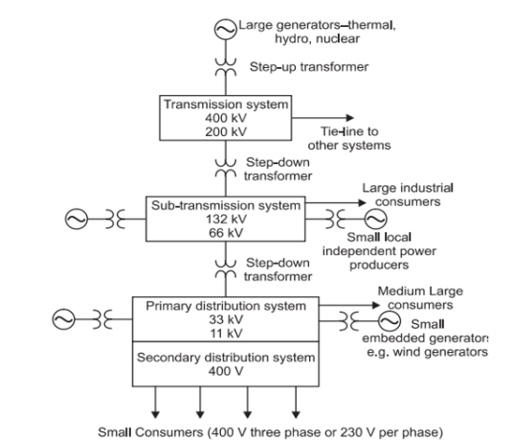Figure 2.1 is a typical representation of a portion of a power network (or system).

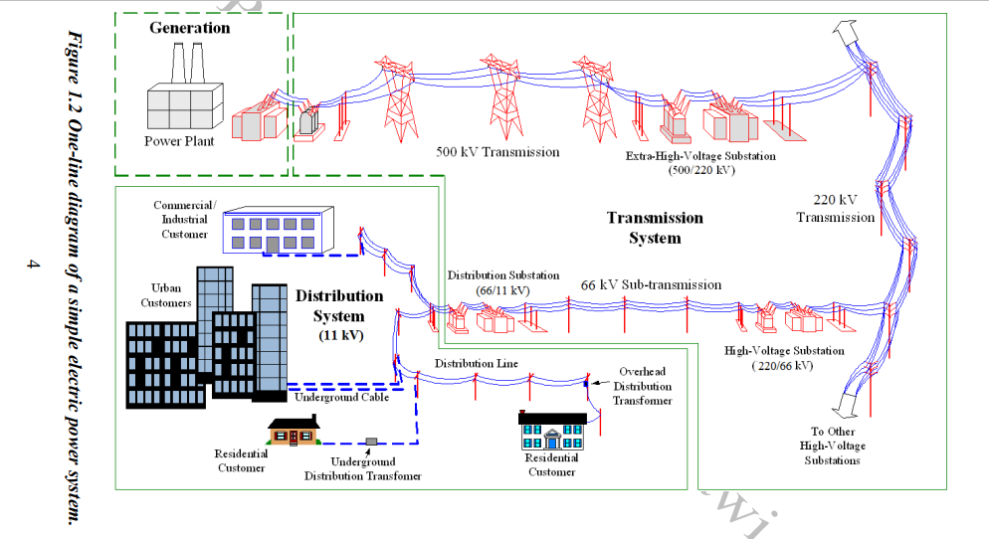

Figure 2.1: Schematic representation of power supply system Source: Gupta (2013).

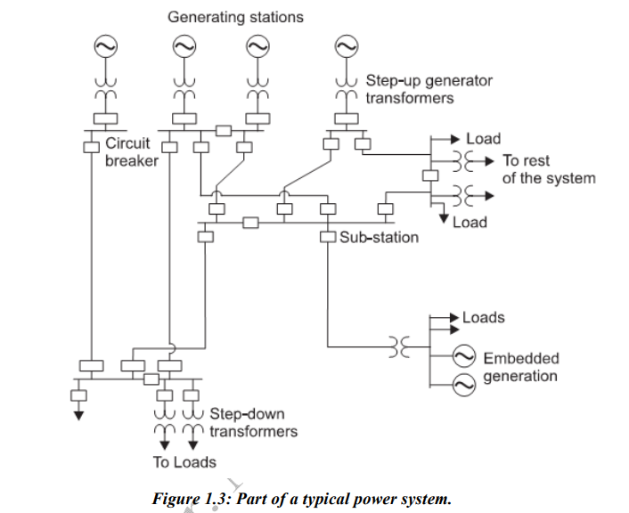Figure 2.2: A simple One-line diagram of a power system Source: Gupta (2013).

Figure 2.3: A typical power network (or system) part Source: Gupta (2013).

#### 2.1.1 Rationale for Interconnection

Power generating stations and distribution systems are connected through transmission lines. Every area has a transmission system known as grid. According to Gurunath (2010), Different power grids are interconnected using tie-lines to create a regional power grid (also known as power pools).” Numerous regional power grids are connected further to produce a national grid(Gurunath, 2010). Interconnected operation is usually economical as well as reliable (Gurunath, 2010). Therefore, Generating stations with large capacity of megawatt (MW) available for the provision of base load or intermediate load. With this link, generating stations can feed, not into a particular or specific load, but into a general system. The economic benefits of interconnection is reduction of the generation capacity of the reserve in every area. If suddenly there is load increase or generation loss in an area, there is possibility of borrowing power from adjoining areas that are interconnected. In order to meet up with sudden load increases, certain quantity of generating capacity in every area termed “spinning reserve” is needed. This comprises generators working (or running) at normal speed plus ready to supply electric power instantaneously.

Gas turbines as well as hydro generators could be kept as a “spinning reserve” as well. Gas turbines started as well as loaded in three (3) minutes or less (Gurunath, 2010).” It could be even quicker with hydro units”. It is comparatively more economical to have certain or particular generating stations serving this function than each station performing its own spinning reserve (Gurunath, 2010). Hence, interconnected operation gives the flexibility of meeting unexpected emergency loads.

### 2.2 Reliability of Power Systems

Reliability could be described as the ability of a system or component to perform its proposed function over a specified time period.

This is an important critera to consider in all phases of power system beginning from the planning to the design and then operation phases. Reliability criterion is highly needed or necessary to establishing target levels of reliability as well as engaging in consistent analysis plus comparism of the future levels of reliability with possible alternative plans for expansion (Al-Shaalan, 2019). The result of this need is the development of an all-inclusive assessment and modeling methods (Billinton, 2007; Grigsby, 2009; Al-Shaalan, 2017). Three (3) criteria are often chosen and used to assess power system reliability in generation development planning and energy production.” The first of them is the "loss of load expectation" (.LOLE), whie number of days the system will be offline each year when the load exceeds the available generating capacity.

The second indicator is the.expected.demand.not.supplied (.EDNS), which quantifies t They include: First, the .loss .of .load .expectation (.LOLE) – this denotes expected mean number of days in a year that the system has been on outage, meaning where the load surpasses the obtainable generating capacity. Second, is the .expected .demand .not .supplied (.EDNS) – this is a measure of the size of the load that has been lost owing to the severe occurrence of outages. The third factor is the "expected energy not supplied" (.EENS. ), which can be defined as the amount of energy that the system's generating unit(s) are expected to be unable to produce during the period under consideration due to a capacity shortage (or unanticipated, extremely severe power outages) (Al-Shaalan, 2012; Al-Shaalan, 2018).

The applications of these very indices are increasing today owing to their significance as regards physical as well as economic terms (Al-Shaalan, 2019). According to Al-Shaalan (2019), as compared with evaluation of generation reliability, there are reliability indices also related as well as important to network or system (i.e. transmission as well as distribution) reliability evaluation.

Two fundamental concepts are often put into consideration in network reliability, they include: violation of quality, as well as violation of continuity (Al-Shaalan, 2019). The first takes into account voltage limits violation plus carrying capacity or line rating violation, and the second assumes the infinite capacity of lines

“ Transmission system is a network of transmission lines and power equipment. “Using an appropriate reliability model, the average forced failure rate and outage duration of each component of a transmission system, such as a line section, transformer, or circuit breaker, can be computed.” As a result of the inherent redundancy in other parts of the transmission system, failure of one component does not necessarily result in the system failing. The weather conditions under which the transmission system operates are a major factor to consider in transmission system reliability.

Many outdoor equipments can fail due to lightning, snow, high winds, and In order to analyse transmission system reliability, different failure rates are assigned to different weather conditions(Chowdhury and Koval, 2009).

‘Transmission and distribution networks could be analysed in the same way as that employed in evaluation of generation reliability – which means the probability of dissatisfying power (Al-Shaalan, 2019). Thus, the result of this is that frequency plus duration in evaluation of network would have a simplified outlook. Granted that the correct constituent reliability indices necessary are known, expected failure rate of the system (i.e. λ), the average outage duration (r), as well as the unavailability (U) becomes relative easy or simple to calculate or compute. To achieve this, the values of earlier mentioned parameters for every component of the network or system are required (Brown, 2009).

Two fundamental components of power system reliability are system adequacy and system security. Adequacy refers to the availability of adequate facilities or energy to meet the load demand of customers. These include the infrastructure required to create sufficient energy and the accompanying transmission and distribution systems required to convey the energy to the load point of the customer (Aibangbee and Chukwuemeka, 2017). System security, on the other hand, is concerned with the capacity of the power system to survive abrupt disruptions, such as short circuits and unplanned element losses. In contrast, transmission reliability is only concerned with equipment failure and customer disruption.’

System reliability

System adequacy

System security

Figure 2.4: Power system reliability classification

### 2.3 Distribution System Reliability assesment

Distribution reliability refers to the distribution system's ability to operate normally under certain circumstances for a specified amount of time (Baggini, 2008). Distribution reliability is becoming more critical in today's competitive environment since the distribution system directly feeds the consumer. The distribution system is the utility's face to the public. It evaluates the system's reliability and client satisfaction (Zhang, 2017)

‘

To conduct a rigorous analytical examination of distribution reliability, well-defined units of measurement, referred to as metrics, are required. Numerous utilities across the globe now employ reliability indices to monitor the utilities, a region's, or a circuit's performance. Regulators compel the majority of publicly traded utilities to disclose their reliability indices. The regulatory trend is toward performance-based rates, which penalize or reward performance according to quantifiable reliability metrics. Additionally, the majority of utilities provide incentives to managers and other employees based in part on reliability successes. Even some commercial and industrial clients request reliability indices from utilities when considering a site for their businesses. Utilities and regulators use reliability indices to assess performance and prioritise investment in performance-enhancing initiatives.(Chowdhury and Koval, 2009)’

In distribution system, compared to generation and transmission systems, power outages have a considerably localized effect. According to Billinton et al. (2008), less work has been dedicated to distribution system and that makes it the biggest contributor to the unavailability of useful statics which shows that an average unavailability of 72.60% per customer take place in the 11 kV (or less) voltage level, which reinforces the necessity to be especially concerned with evaluation of the reliability of distribution systems. Table 2.1 is a typical representation of the statistics of the distribution system unavailability (per customer).

Table 2.1: A typical representation of the statistics of the distribution system unavailability (per customer)

|  |  |  |
| --- | --- | --- |
| **Average unavailability per customer per year** | | |
| **Contributor** | **Time (Minutes)** | **Percentage (%)** |
| Generation/Transmission | 0.50 | 0.50 |
| 132 kV | 2.30 | 2.40 |
| 66 kV and 32 kV | 8.00 | 8.30 |
| 11 kV and 6.6kV | 58.80 | 60.70 |
| Low voltage | 11.50 | 11.90 |
| Arrange Shut downs | 15.70 | 16.20 |
| **Total** | **96.80 Minutes** | **100.00** |

Source**:** Billinton et al. (2008)

#### 2.3.1 Distribution system Reliability Indices

These are statistical summaries of reliability information (or data) for a well-defined set of load components (or customers). This reliability evaluation may be separated into customer-based and system-based indices. Most reliability indices are calculated from the mean value of a certain reliability characteristic for a whole system, operational area, substation, or feeder (Melodi and Ogunboyo, 2013). The following categories of reliability indices were employed in this study.

#### 2.3.2 Customer based indices

Utilities employ two reliability indices for duration, and frequency each, to estimate the performance of their system, they include:

**Frequcency**

##### 2.3.2.1a System Average Interruption Frequency Index (SAIFI)

This is usually employed to give information about the average frequency of sustained interruption per customer within a predefined area. SAIFI estimates the number of sustained interruption an avaeage customer will experience over the course of a year. This equation is mathematically identified as equation (2.1). SAIFI can be improved by reducing the number of sustained interruption experienced by the customer. According to IEEE Standard 1366, the median value for North American utility is approximately 1.10 interruptions per customer (“IEEE Guide for Electric Power Distribution Reliability Indices,” 2012).

##### 2.3.2.2b Average Service Availability Index (ASAI)

This gives the ratio of the total hours that service was available over a specific duration of time to the total customer hour demanded.

##### 2.3.2.3c System Average Interruption Duration Index (SAIDI)

This commonly explains a customer’s duration of interruption or customer – hour. It is designed to give information on the average duration a customer is interrupted. It measures how many interruption hour an average customer will experience over the course of a year. This equation is mathematically identified as equation (2.2). SAIDI can be improved by reducing the number of interruption or by reducing the duration of these interruptions. A reduction in the value of SAIDI shows an enhancement in reliability. In line with IEEE standard 1336, North American’s utility median value is about 1.50 hours.

##### 2.3.2.4d Customer Average Interruption Duration Index (CAIDI)

This is the average time needed to restore service to the customer per sustained interruption. CAIDI measures the restoration time and it is employed to estimate the utility response to contingencies. It can be improved by reducing the length of the interruption. This equation is mathematically identified as equation (2.3). According to IEEE Standard 1366, the median value for North American utility is approximately 1.36 hours.

#### 2.3.3 System Based Indices

System based indices are used to check the overall performance of the system. Key performance indices like Mean Time between Failure (MTBF), Failure rate (λ), Mean down time (MDT) and availability could be calculated.

##### 2.3.3.1a Mean Time Between Failure (MTBF)

This expresses the average time which elapses between consecutive failure of the system or equipment.

Mathematically, MTBF is expressed as:

$MTBF=\frac{Total system operating hours}{Number of failures}$ (2.1)

Here, the Total system Operating hours = Total Number of hours available in the year – Total number of Outages in Hours.

Total number of outage = (forced outage + planned Outage). MTBF is the inverse of failure rate.

Therefore, the longer MTBF, the more reliable the system.

##### 2.3.3.2b Failure Rate (λ)

This is the frequency with which an engineering system or component fails. It is usually expressed in failure per unit time. Mathematically,

Failure Rate (λ) = $\frac{1}{MTBF}$ (2.2)

It is often used in reliability engineering.

The failure rate for non-repairable objects is expressed as a percentage in the following definition:

 (2.3)

The other definition relates to repairable items or systems and expresses failure rate as the number of failures, which occurs per unit-hour of operation. It is denoted by and given as:

 (2.4)

The unit of (N) therefore is failures per unit-hour but failures per thousand hours and failures per million hours are also used (Okorie et al., 2015).obviously, a high value of or is indicative of low reliability.

##### 2.3.3.3c Mean down time (MDT)

This is the average time that is needed to restore a system or an item to operational effectiveness once is fails. MDT is a function of the equipment design, the expertise of the personnel and the tool available. Clearly, a low value of MDT indicates good maintainability (Okorie et al., 2015).

Mathematically, MDT is given by: $\frac{Total duration of outage}{Frequency of outage}$ (2.5)

##### 2.3.3.4d Availability (A)

1. **Availability (A):** This is the most important of the basic indices of reliability. It is the probability that equipment will be available to perform as required or that it will be in a state of operational effectiveness within a given period.

Mathematically, Availability (A) as stated in okorie et al. (2015), is given as:

 (2.6)

#### 2.3.4 Distribution System reliability evaluation.

Evaluation and prediction methods can be used in assessing distribution system reliability. The evaluation method focouses more the analytical mothod to asses the realiability of the system while the predicition model involves the use of computational intelligence technique to predict the reliability of the distribution system.

Two key steps are essential for reliability evaluation (Billinton et al., 2008) and these include: data collection, and data analysis for creating statistical indices. The field data is first gotten by documenting the facts of failures occurrence and the different outage durations related to these failures. These field data are then analysed to generate statistical indices. The quality of these data depend on two (2) very important factors, which include: confidence and relevance. According to Billintonet al. (2008), the data quality, and the confidence placed in it is obviously reliant on the precision of the gathered information. Statistical indices quality is reliant on: first, the processing method of the data, the amount of pooling carried out, as well as the age of currently stored data. These factors obviously affect the significance of indices in their future usage. The quantity and varieties of collected data is reliant on the indices that need to be computed.

### 2.4 Reliability Prediction: An Overview

Reliability prediction is the process of projecting future reliability of a system based on historical data. Reliability Prediction for the future entails a lot of work and difficult issues due to many uncertainties (Volkan et al., 2001).

The standard evaluation approach for predicting the reliability of a power system involves historical data with precise network and reliable components. Several method have been deployed in the past for predicting reliability of power system. These include Monte carlo, neural network, linear regression model etc. (Zheng et al., 2013). Continuous research is being undertaken in the area of reliability prediction in order to develop new approaches. (Antonio et al., 2004; Fadare, 2010). (Musa, 2004; Ogbonnaya et al., 2006).

Each type of reliability prediction employs a unique model to accomplish the application's goals (Zaid et al., 2003). In the past, there have been a lot of different models and prediction parameters that have been used to make predictions. These include Regression Methods (Linear and Quadratic) and Artificial Neural Networks (ANN), as well as the Static State Estimation Method and Gaussian Process Models

(Douglas et al., 2004).

Two techniques were utilized to determine which model is most appropriate for prediction in this work: Analytical approaches and feed-forward neural networks trained using Levenburg Marquaratt (LM) backward propagation are represented.

#### 2.4.1 Computational intelligence in Power system Reliability Prediction

Computational intelligence is a new modern tool for solving complex problem which ordinary conventional technique will find difficult (Momoh,2000). Computational intelligence plays an important role by providing better solutions to new and existing problems in power system operations.Computational intelligence techniques can be applied to the following areas of power system:

1. Power system operation (including unit commitment, economic dispatch, hydro-thermal coordination, maintenance scheduling, congestion management, load/power flow, state estimation, etc.)
2. Power system planning (including generation expansion planning, transmission expansion planning, reactive power planning, power system reliability, etc.)
3. Power system control (such as voltage control, load frequency control, stability control, power flow control, dynamic security assessment, etc.)
4. Power plant control (including thermal power plant control, fuel cell power plant control, etc.)
5. Network control (location and sizing of facts devices, control of facts devices, etc.)
6. Electricity markets (including bidding strategies, market analysis and clearing, etc.)
7. Power system automation (such as restoration and management, fault diagnosis and reliability, network security, etc.)
8. Distribution system application (such as operation and planning of distribution system, demand side management & demand response, network reconfiguration, operation and control of smart grid, etc.)
9. Distributed generation application (such as distributed generation planning, operation with distributed generation, wind turbine plant control, solar photovoltaic power plant control, renewable energy sources, etc.)
10. Forecasting application and reliability prediction (such as short term load forecasting, electricity market forecasting, long term load forecasting, wind Predicting outages power forecasting, solar power forecasting, etc.) (D. Saxena et al,2010)

Computational intelligence methods include Expert System (ES), Artificial Neural Network (ANN), Genetic Algorithim (GA), Evolutionary Computation (EC), Fuzzy Logic etc. In this study, ANN was adopted for reliability prediction due to its numerous advantages which include speed , robustness and ability to learn and adapt.

#### 2.4.2 Artificial Neural Network (ANN)

Artificial neural networks are made up of basic neurons that are connected and built in a way that is similar to how they are in nature. An ANN is modelled as biological neurons that receive an environmental signal and transfer information to all linked ANNs. They utilise computer modelling methods frequently used in science and engineering to simulate complicated issues in the real world. In making judgments and generating conclusions when faced with complicated, loud, irrelevant, and incomplete information, they mimic human intuition. A neuron is the basic processing unit in a neural network. All neurons throughout time have this fundamental structural component.

Figure 2.5 illustrates the core structure of ANN (Olulope et al., 2010). It is composed of input vectors (X1, X2, X3, and X4), hidden neurons, weights (w), transfer functions, and outputs. The transfer net employs the weighted input in order to generate the output. Transfer functions may be linear sigmoid, bipolar sigmoid, hyperbolic tangent, and so on (Mellit and Kalogirou, 2008). The weight and bias are not constant, but change and can be modified or adjusted according to the intended behaviour. In most instances, however, it is assumed that the bias (b) employed is 1.

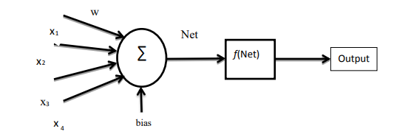

Figure 2.5: Single neuron structure.

Source: Olulope et al. (2010)

Where x represents the input data and y can be any signal or quantity of interest.

ANNs are trained with specific datasets until they understand patterns that can be utilised as task-specific inputs. There are two techniques to implement learning in Artificial Neural Networks: batch mode and online mode. Online learning indicates that learning can be performed concurrently with the normal operation of the system, changing the model at each step, i.e., the weights and biases are updated every time an input is supplied to the model (Engelbrecht, 2007).

Notable ANN properties include:

1. They can automatically recognise patterns in data derived from actual systems, computer programmes, physical models, and other sources.
2. They can process several inputs and provide solutions that are acceptable to designers.
3. In addition, they can handle numerical or analogue data that would be difficult to manage with conventional methods.
4. They are resilient even when the input data contains noise. They are thus suitable for online evaluation as well as control systems.
5. Their high parallelism means rapid processing and tolerance for hardware breakdown.
6. They can learn and adaptively allow the system to modify its internal structure in response to a changing environment.

Added to the aforementioned traits, neural networks also possess the following:

**Non-linearity: -** Neurons that are non-linear and linked are dispersed across neural networks. The majority of actual systems, such as power system networks, are nonlinear. This attribute increases its use for real-time applications.

**Adaptivity:** Whenever artificial neural networks are correctly trained in a certain environment, they can function in a different environment and adapt to tiny changes in the environment. Using the training process, the synaptic weight adaptation determines the neuron's adaptability (Xiao et al., 2010).

**Fault-tolerance:** By design, Artificial Neural Networks are resilient to errors. Distributed information in a neural network makes it more resistant to errors caused by missing input or incorrect data. Before catastrophic failure, the mistake must be monumental (Engelbrecht, 2007). Included in feed-forward neural networks are radial basis networks, Kohohen self-organizing Neural Networks, Recurrent Neural Networks, Convolutional Neural Networks, and Modular Neural Networks, among others. On the basis of their architectures, Artificial Neural Networks may typically be categorised into two groups: feed-forward Neural Networks and Recurrent Neural Networks (or systems). Feed-forward Neural Networks are static because they generate a single set of output values as opposed to a stream of values beginning at a specific point. There are also multilayer perceptrons, radial basis function nets, Kohonen's self-organized map, etc. Recurrent Networks, on the other hand, are dynamic networks since their outputs rely not only on the current inputs but also on those from the past. They include the Hopfield network, ART models, Discrete-Time Recurrent Neural Networks, Elman Recurrent Neural Networks, and Simultaneous Recurrent Neural Networks (SRNs). Everyone has both strengths and limitations.

#### 2.4.3 Reliability Prediction Using Artifical Neural Network

The neural network model needs only failure history as input to predict future failure more accurately than the analytic model(Karunanithi et al, 1992). Recent advancement in neural network showed that they can be used in applications involving predictions, an application in time series predictions which predicts a complex sequential process like reliability growth. With failure history as input(no assumption), nueral network model automatically develops its own model of the failure and predict the future failure. Reliability prediction problem can be stated in terms of neural network mappings.

Given

P: $\{I_{K}\left(t\right),O_{K}\left(t\right)\}$ → $T_{K(t)}$ (2.7)

Where IK(t),Ok(t) represent the failure history of the system at time ,t used in training the network and $T_{K(t)}$ is the network prediction(Yiyo Kuo and Lin 2010).

Difficulties in detecting and predicting failures can be overcomed using ANN model with parmarnently updated intelligent algorithim (Bermejo et al,2019).

Neural Networks are used for functions approximation or mapping problems, pattern matching task, classification, Noise reduction(recorgnisepattern input and produce noiseless out put), Prediction(exploration based on historical data). (Haykin,1999). Nonetheless, a Feed-Forward Neural Network trained using LM backward propagation was used in this study.

### 2.5 Load Flow Studies

#### 2.5.1 Load types

The total load demand in an area is dependent on its population as well as living standards of the individuals. Generally, the nature of load could be characterized using the load factor, diversity factor, demand factor, power factor, as well as utilization factor. According to Balasubbareddy et al. (2012), generally speaking, load types consists of the following classes: (i) Domestic, (ii) Industrial, (iii) Commercial, and (iv) Agriculture.

##### 2.5.1.1 Domestic loads

These chiefly comprise lights, refrigerators, fans, mixer, air-conditioners, grinders, ovens, heaters, small pumping motors, and a host of others.

##### 2.5.1.2 Industrial loads

These comprise small-scale, medium-scale, large-scale, heavy, as well as cottage industries.

##### 2.5.1.3 Commercial loads

These mainly comprise lighting for offices, shops, advertisements, as well as fans, air-conditioning, heating, and several other electrical appliances operated in commercial establishments like restaurants, market places, and so on.

##### 2.5.1.4 Agriculture loads

These load types is chiefly load of motor pump-sets. The load factor for this is usually very small, for instance, within the range of 0.15 – 0.20.

#### 2.5.2 Power Flow Analysis

A power system is modelled as a set of nodes (buses) interconnected by impedances (transmission lines). At different nodes, generators and loads are connected, which inject and absorb complex powers. Power flow studies, commonly known as load flow, forms an important part of power system analysis. They are required for scheduling, planning, economic and control of an existing system. Four quantities are associated with each bus, these are real power P, reactive power Q, voltage magnitude /V/ and phase angle $δ$.

The connectivity of all the producing stations, or the creation of a grid system, is the current approach to power networks. Throughout the day, there are significant fluctuations in load demand. Power should always be generated at a rate equal to its demand. One of the benefits of a grid system's ability to constantly generate enough electricity to satisfy demand is its ability to constantly generate enough electricity to satisfy demand. The burden must be distributed equally for the majority of economic activity. It is essential that none of the stations that are linked become overburdened. The transmission line's stability limit should not be approached; it must be ensured.

The steady-state solution of a network is given by the load flow solution, as long as certain inequality limits are met.

1. The load flow solution gives the voltages and phase angles at each node, as well as the amount of power going into each bus and the flow of power between power channels that are connected.
2. Designing a new power system necessitates a solution for load flow.
3. A load (or power) flow solution is required for the expansion of the current system to accommodate increasing load demand. Characteristics of equations for load flow.
4. The equations for load flow are algebraic and nonlinear.

##### 2.5.2.1 Techniques of Load Flow Analysis

Load flow solutions according to Sen et al. (2013), are done using certain leading techniques of power flow, which include:

1. Gauss-Seidal method;
2. Newton-Raphson method; and
3. Fast decoupled method.

##### 2.5.2.2 Newton-Raphson Power (Load) Flow Solution

In this work the power (or load) flow is expressed in polar form. For any typical bus of a power system, the current entering bus i is related to the voltage and admittance by equation (2.8)

$I_{i}=\sum_{j=i}^{n}{Y_{ij}V_{j}}$ (2.8)

Expressing this equation in polar form, we have

$I_{i}=\sum_{j=i}^{n}{\left|Y_{ij}\right|\left|V_{j}\right|}∠θ_{ij}+δ_{j}$ (2.9)

the complex (or composite) power at bus i is

$P_{i}-Q_{i}=V_{i}^{*}I_{i}$ (2.10)

Substituting for $I_{i}$ in (2.22) we have

$P_{i}-Q_{i}=\left|V_{i}\right|∠-δ_{i}\sum_{j=i}^{n}{\left|Y_{ij}\right|\left|V_{j}\right|}∠θ_{ij}+δ_{j}$ (2.11)

Separating the real and imaginary part,

$P_{i}=\sum_{j=i}^{n}{\left|V_{i}\right|\left|Y_{ij}\right|\left|V_{j}\right|}cos⁡(θ_{ij}-δ_{i}+δ_{j})$ 2.25 (2.12)

$Q_{i}=-\sum_{j=i}^{n}{\left|V_{i}\right|\left|Y_{ij}\right|\left|V_{j}\right|}sin⁡(θ_{ij}-δ_{i}+δ_{j})$ (2.13)

Equations (2.12) and (2.13) constitute (or form) a set of non-linear algebraic equations in respect of (in terms of) voltage magnitude in per unit, independent variables, and phase angle radians.

Expanding (2.12) and (2.13) in Taylor series about the initial estimate and ignoring or neglecting all higher terms outcomes (or results) in the following set of linear equations.

$\left|\begin{aligned}∆P \\ ∆Q\end{aligned}\right|=\left|\begin{aligned}J_{1}J_{2} \\ J_{3}J_{4}\end{aligned}\right|\left|\begin{aligned}∆δ \\ ∆\left|V\right|\end{aligned}\right|$ (2.14)

The matrix J constitutes the element of the Jacobian matrix.

Equation (2.14) is solved iteratively in Mat power software platform to obtain the values of bus voltage V and the voltage angle $δ$.

Among these techniques mentioned above, the Gauss Sidel method is simple and easy to execute, but it consumes more time (more iterations) as the number of buses increases. The Newton-Raphson (NR) method is more accurate than all the other methods and provides better results in fewer iterations. Also, Owing to the quadratic convergence, the NR method is mathematically superior to Gauss siedel method (Vijayvargia et al., 2016). The fast decoupled method is the fastest of all the methods, but it is less accurate since assumptions are made for fast calculation.

In this work, the NR approach was employed and the load flow analysis done iteratively using Power System Analysis Toolbox (PSAT) analytical software.

Figure 2.6 below shows the algorithmetic flow chart for power flow analysis

Figure 2.6: Algorithmic flowchart for power flow analysis using Newton Raphson method (Source: Dung Vo Tien, et.al, 2020)

#### 2.5.3 Power System Stability Classification

Power system stability, according to Sen et al. (2013), can be basically classified into two major categories: Steady-State Stability, as well as Transient State Stability, as detailed in the following sub-sections.

##### 2.5.3.1 Steady-State stability

A moderate or relatively modest shift in load is what is referred to as steady state stability for the power system. The pace at which the load is delivered is supposed to be sluggish relative to either the natural frequency of oscillation of the system's principal components or the rate at which the rotating machine's field flux changes in response to the change in loading. The system runs on a single power angle curve in the steady state stability zone, and the regulators move slowly to get the terminal voltage to the desired level.

##### 2.5.3.2 Transient State Stability

The transient state factors relate to the greatest amount of power that may flow through a location without losing stability under unexpected, substantial changes in network circumstances, such as those caused by faults or abrupt, high load increases. The transitory stability is brought on by significant disturbances and a lack of synchronising torque. The following factors influence transitory stability:

1. Higher system voltage enables the machine to spin over a larger angle before reaching the critical clearing, resulting in a longer critical clearing time and a better chance of retaining stability.
2. Parallel lines are used to minimise series reactance.
3. Use of high-speed and auto-reclosing circuit breakers.

### 

### 2.6 Gaps Identified in literatures

|  |  |  |  |  |  |
| --- | --- | --- | --- | --- | --- |
| Authors | Year | Title of work | Applied Method | Summary | Limitation |
| Melodi A.O  Aremu S.O | 2013 | Functional efficacy of Radial 132/33kV Electricity Transmission substation arrangement: A case study of Omu-Aran 132/33kV substation arrangement | Network parameters was evaluated using standard formula | For load flow computation studies, the substation layout was mathematically modelled using the bus admittance matrix approach. Using primarily voltage and thermal capacity parameters, the power delivery efficiency was analysed. Voltage and power losses between the substation and load communities on the current 33kV network line are large and unacceptable. | Reliability indices like mean time between failure, mean down time, outage rate, reliability and supply availability to the station was not worked on. |
| D.A Daramola  P.K Olulope | 2017 | Analysis of power supply in a typical Nigerian Transmission Substation: A case study of Ota 132/33kV substation. | Performance and Operations problem of the substation was investigated using numerical statistical techniques. MATLAB- Newton Raphson method was applied in the load flow computation. | Power supply to the substation was evaluated using numerical and statistical techniques. Records of outages, basic reliability indices like mean time between failures, mean down-time, outage rate, reliability and supply availability to the station was carried out. | The fault analysis was not carried out. |

|  |  |  |  |  |  |
| --- | --- | --- | --- | --- | --- |
| P.T Ogunboyo,  R. Taiko  I.E Davidson | 2017 | Voltage Profile Enhancement in low voltage 11/0.4kV Electric Power distribution network using Dynamic voltage restorer (DVR) under three phase unbalanced load. | This work tends to proffer solution to the problem of low power quality using power Electronics device such as dynamic voltage restorer. (DVR). DVR is installed between the source voltage and the load to correct voltage disturbances affecting the load voltage. This was modelled using MATLAB/Simu link sim power tool | Result from simulation show that with distribution length 0.5km-5km for three phase unbalanced load, permissible nominal voltage tolerance of ±5% was obtained when DVR is connected to the network, but it is not the case when DVR is not connected. | DVR Compensation is cost effective when the injection voltage is limited to a fraction of rated supply voltages (usually 50%) |
| P.T Ogunboyo  R. Taiko  I.E Davidson | 2017 | Investigation of voltage unbalance in low voltage Electric distribution network under steady state mode. | Using MATLAB/Simulink as well as the power system tool box, conventional network characteristics (or attributes) for a typical low voltage distribution network were used to simulate the network. | Simulation results indicate that, for an unbalanced three-phase load across a length of 0.5KM, the voltage is within the allowed nominal voltage tolerance range of 5%, whereas consumers at the distribution end of the network length of 0.8KM–5KM experience unacceptable voltage. The observed voltages were below the standard permissible limit of 0.95pu of nominal voltage. | The work was limited to distribution network with short distance network |

|  |  |  |  |  |  |
| --- | --- | --- | --- | --- | --- |
| O.P Taiwo  M O Adegoke | 2018 | Electrical Industry long term load forecast on Ilesha road 11kv feeder, Akure, Ondo State. | Power distribution problem on 11kV was evaluated using Trend and growths Function in Excel work sheet. | The result shows that peak network load of 8MW is expected to go up to 14.5MW by the year 2021 and the need to deploy power quality enhancement in secondary distribution | This work was only limited to 11kV secondary voltage. |
| Ogunboyo P.T.,  Davidson I.E. | 2019 | Assessment and analysis of typical ESKOM secondary distribution network under steady state. | A typical ESKOM secondary 11/0.4Kv distribution network was modelled using MATLAB/Simulink sim power tool box | This work evaluates the performance of secondary distribution network as a result of voltage losses, voltage deviation and voltage variations using MATLAB software. Voltage quality was identified as one of the major power quality disturbances. | This study was limited to 11/0.4kV distribution voltage. |
| Mohmeedfuzail Bilagi,  S.G. Ankaliki | 2019 | Performance Analysis of 33/11kV Substation and its feeders. | The simulation of 33/11kV substation was done using Electrical Transient Analyser Program (ETAP) and MI Power solution | Faults analysis was carried out manually using symmetrical component method and the results obtained were compared with software solutions obtained from ETAP and MI Power to validate hand calculation. Error was between acceptable limit of 3.2% for all type fault. In this paper analysis of 33/11kV substation using ETAP and MI power software is carried out with an approach to overcome the problem an under voltage, line losses and voltage | The reliability of the station was not looked into |

|  |  |  |  |  |  |
| --- | --- | --- | --- | --- | --- |
| Jesus Ferrero Bermejo,  Juan F Gomez Fernandez,  Fernando Olivencia Polo,  Adolf Crespo Marquez. | 2019 | A review of artificial neural network model for Energy and reliability prediction. A study of Solar PV, Hydraulic, and wind Energy sources. | ANN was used to estimate the real-time reliability of energy generation from different sources of energy. | This work provided a precise review of literature related to the use of ANN when predicting the behaviour in energy production for referred renewable energy sources | The work focused more on adequacy reliability. The system security reliability was not worked on |
| Okachi Cheta  Emmanuel,  S.L. Braide,  D.C. Idoniboyeobu | 2020 | Electrical load evaluation in Igwuruta, Port Harcourt for improved distribution | Electrical load was evaluated using Electrical Transient Analyser program (ETAP) Simulation tool. | Potential problem in the distribution network such as energy usage harmonics interference and low voltage was discovered. Optimal capacitor bank of 4800kVR was introduced to enhance the voltage profile | The work was restricted to a single feeder and line faults were not considered |

Relevant works have been carried out on load flow analysis of transmission stations feeders (Daramola and Olulope, 2017; Mohammed, 2019; Okachi et al., 2020; Okerafor et al., n.d), however, this work specifically is on reliability analysis and prediction of Omu-Aran 132/33 kV transmission station under steady state. According to Melodi and Aremu (2013), the effectiveness of the 132/133 kV radial arrangement of the substation network was ascertained and established the overstretched nature of some service areas – which has caused critical voltage losses, and with a recommendation for an effectual reconstruction work on the substation network so that it is capable of facilitating normal supply of power to consumers. However, their study did not consider the reliability of the Omu-Aran 132/33 kV Substation-system. Therefore, this study is focused on the reliability analysis and prediction of Omu-Aran 132/33 kV transmission station feeder under steady-state condition.

# 

# CHAPTER THREE

## METHODOLOGY

### 3.1 Study Area

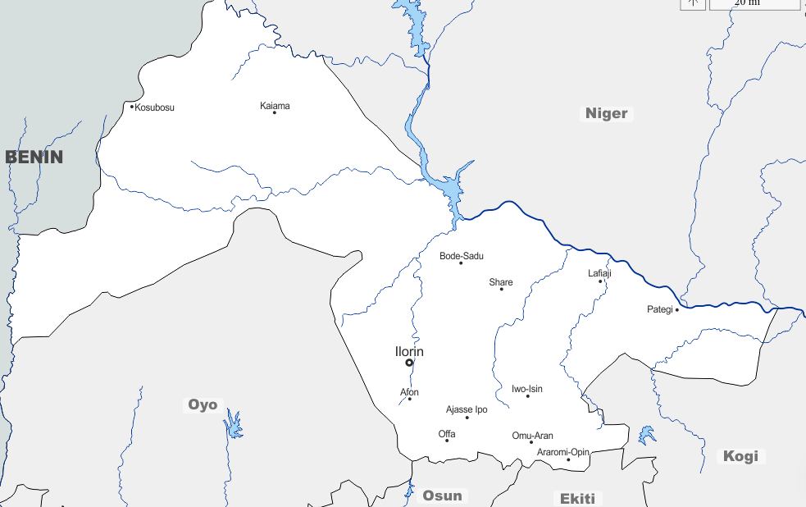Omu-Aran 132/33kV transmission substation is located in Omu-Aran Kwara State on ${8.15}^{0}N,{5.09}^{0}E.$ The transmission station was formerly fed at 132kV from Osogbo 330kV transmission station but now it receives its supply through Ganmo 330kV transmission station. This implies that the station can be fed either through Osogbo or Ganmo 330kV transmission station. The station is made up of 2 $×30MVA132/33KV$ Transformers (T1 and T2), an incoming 132kV line (IL), Five Outgoing 33kV feeders namely Omu-Aran 33kV outgoing line (OL), Oroago 33kV OL, Isanlu-isin 33kV OL, Egbe 33kV OL and Otun 33kV OL (Melodi and Aremu, 2013). Figure 3.1 represent the Map of Kwara State showing Omu-Aran and figure 3.2 shows the station single line diagram.

Figure 3.1: Map of Kwara State Showing Omu-Aran 132/33kV Transmission Substation source supply route.

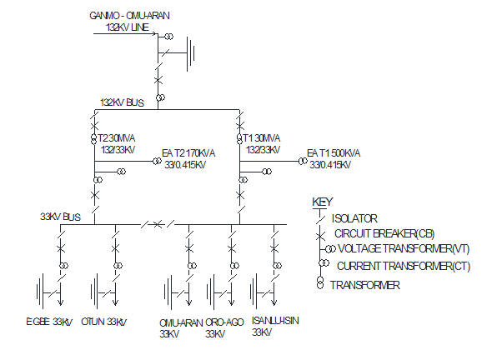

Figure 3.2: Single line diagram of Omu-Aran 2×30 MVA, 132/33 kV transmission station Source: Adapted from Melodi and Aremu (2013)

### 3.2 Research Design Layout

This study adopts the use of data mining (process used to extract usable data from a larger set of any raw data) from existing datasets those variables that are related and relevant to the stated research questions and objectives. The research layout is represented in the figure 3.2 below.

Data Collection

Data Collection

Load flow analysis using N-R method in PSAT

Determination of voltage level

Reliability analysis

Customer based reliability analysis

System based reliability analysis

Reliability prediction using Artifical Nueral Network

Analysis of result, summary, conclusion and recommendation

Figure 3.2: Research design layout

### 3.3 Data Collection

Data of outages and load was collected from 2015 –2020, January to December, from transmission company of Nigeria, Omu-Aran 132/33KV substation. Extract of the relevant and usable data on identified research focus variables were mined and made ready for analysis.

The various towns supplied by the substation can be summarized in Table 3.1.

Table 3.1: Towns supplied by Omu-Aran Transmission station and the 33kVfeeders

|  |  |  |
| --- | --- | --- |
| **S/No** | **33kV Feeder** | **Local Government Area Supplied.** |
| 1 | Omu-Aran | Irepodun, Kwara State, Oke-illa, Osun State. |
| 2 | Isanlu-Isin | Irepodun, Isin and Ifelodun all in Kwara state. |
| 3 | Oroago | Irepodun, oke-Ero, and Ifelodun all in Kwara state. |
| 4 | Egbe | Oke-Ero, Ekiti, Irele in Kwara state, Yagba East and Yagba west in Kogi State. |
| 5 | Otun | Moba, Oye, Ifaki, Ijereo, Ikole and Ido/Isin all in Ekiti state. |

**Source:** Melodi and Aremu (2013)

### 3.4 Data Analysis Techniques

The method used in this research is solely dependent on data obtained from the Transmission Company of Nigeria (TCN) log book to calculate parameters needed for the reliability analysis. Operational data from January 2015 –December 2020 comprising of forced outages, planned outages, supply availability, number of customers and feeder route length was collected. Using the analytical method, reliability indices was calculated using equations 2.1 – 2.10, reliability prediction was done using Feed-Forward Nueral Network trained with LM backward propagation algorithm and power flow was conducted using PSAT in MATLAB on the station 132kV bus and the 33kV feeders. Reliability indices determined was categorized into customer and system based indices. The customer based indices include: System Average Interruption Frequency Index (SAIFI), System Average Interruption Duration Index (SAIDI), Customers Average Interruption Duration Index (CAIDI) and Average Service Availability Index (ASAI). ), while the system based indices includes: failure rate ( ), mean time between failure (MTBF) and mean down time (MDT).These sets of indices considers the amount of customers involved. According to Okorie et al. (2015), the mathematical definition of these indices is shown as follows.



System average interruption frequency index, SAIFI: .

SAIFI = $\frac{Total Number of Customer Interruption}{Total Number ofCustomer Serverd.}$ = $\frac{\sum{N_{i}}}{N_{T}}$ (3.1)



System average interruption duration index, SAIDI:

SAIDI= $\frac{ Sum ofCustomer Interruption Duration}{Total Number ofCustomer Serverd.}$ = $\frac{\sum{N_{i×R_{i}}}}{N_{T}}$ (hr/yr.) (3.2)

Customer average interruption duration index, CAIDI:

CAIDI = $\frac{Sum of Customer interruption Duration}{Total Number of Customer interruption}=\frac{\sum{N_{i×R_{I}}}}{\sum{N_{i}}}$ (3.3)

Average service availability index, ASAI:

ASAI = $\frac{Customer hours of available service}{Customer hours demanded}$ = $\frac{\sum{N_{T}×8760-\sum{N_{T}×R_{i}}}}{\sum{N_{T}×8760}}×100$ (3.4)

From Equations 3.1-3.4

$N_{i}$– Total (or overall) number of customer interrupted

$R_{i }$– Outage (or overall) duration or restoration time

$N_{T}$– Total number of customer severed

$T- Time period (or duration) under study (in hour)$

### 3.5 Modelling of Power System

The traditional power system model, in its simplest form, is made up of some basic components as listed; the electrical machines, the prime mover system, and the network structure which couples the individual machines to the loads. This is an impedance model relating machine voltages to machine currents. In subsequent sections, the modelling equations for the various subsystems are presented.

#### 3.5.1 Lines and Cables

Figure 3.3 depicts a transmission line's equivalent model. A collection of parameters distinguishes the generic distributed model.

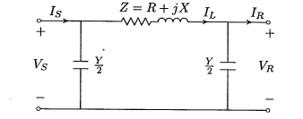

Figure 3.3: Lumped-circuit model ($π$ model) of a transmission line

Where VS is the voltage at the sending (or distribution) end, VR is the voltage at the receiving (or delivery) end. IS is the current at the distribution or sending end, IR is the current at the receiving (or delivery) end.

#### 3.5.2 Transformers

The simplified model of a transformer is obtained by neglecting the magnetising current and the no-load losses. In this case the transformer can be modelled by an ideal transformer with turns ratio tkm in series with a series impedance zkm which represents resistive (load-dependent) losses and the leakage reactance, as shown in Figure 3.3. Depending on if tkm is real or non-real (complex) the transformer is in-phase or phase-shifting.

Often the magnetizing current and no-load losses are modelled by shunt impedance, with much higher impedance than the leakage impedance. The inductive part of this impedance is then determined by the value of the magnetizing current and the 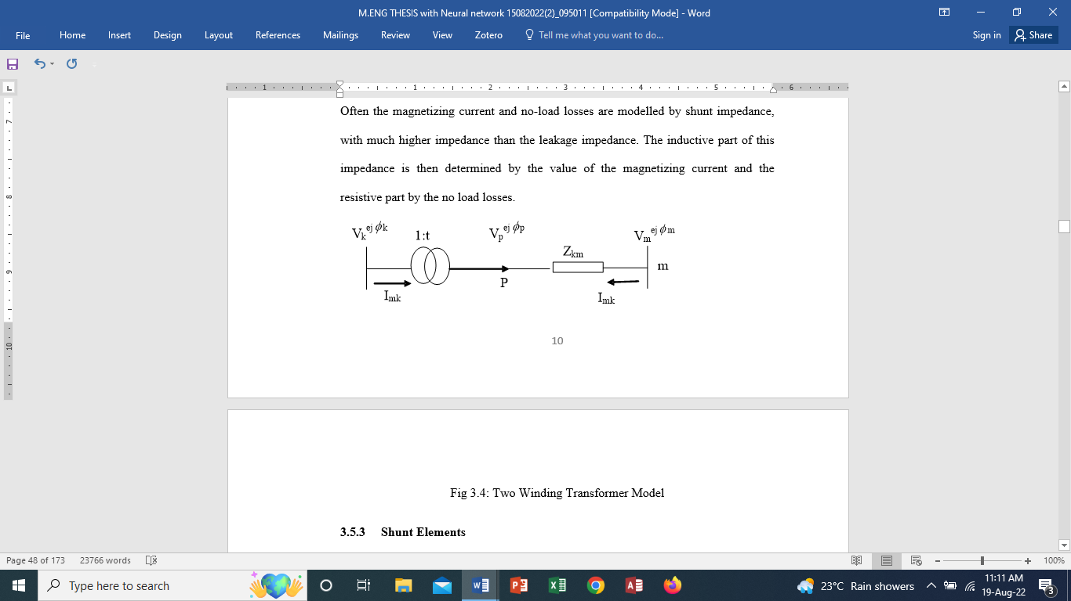resistive part by the no load losses.

Fig 3.4: Two Winding Transformer Model

#### 3.5.3 Shunt Elements

The modelling of shunt components (or elements) in the network equations is simple, and the goal of this section is to teach the notation and sign convention to be utilised while constructing the network equations. From Figure 3.4 the current from a shunt is defined as positive when injected into the bus. This means that:

 (3.5)

WithEkbeing the complex voltage at node k. Shunts are in all practical cases either shunt capacitors or reactor. The injected complex power is:

 (3.6)



Figure 3.5: A shunt connected to bus k.

#### 3.5.4 Loads

Power system modelling requires the use of load modelling. Often the voltage in the distribution systems is kept constant by controlling the tap-positions of the distribution transformers which means that power, active and reactive, in most cases can be regarded as independent of the voltage on the high voltage side. This means that the complex power Ek (Ikload)* is constant, i.e. independent, of the voltage mag­nitude.



Figure 3.6: Model of Load Connected to Bus K

### 3.6 Reliability Prediction Using Artificial Neural Network.

Reliability prediction was done using Feed-Forward Neural Network trained with Levenberg Marquardt (LM) backward propagation.

The Artifical Nueral Network view for fitting data is presented in the figure below:

X1

X2

X3

X4

A1

A2

A3

A4

Y

Input

Hidden Layer

Output

Figure 3.7: ANN Fitting view for data

Where

X1 is outage duration in hours

X2 number of interuptions

X3 system operating hours

X4 customer population

Y is the predicted SAIFI, SAIDI, CAIDI and ASAI

Using ANN, the network was trained to give rise to Predicted value(training) and Predicted value (testing) for the 33kV bus and the five outgoing 33kV feeders using failure and availability data from Januay 2015- December 2020.

Start

Data gathering

ANN model

Taining

Testing

R > 0.7

Training Ok

No

Yes

Output Result

Stop

Figure 3.8: Reliability prediction flow chart using Artifical Neural Network

### 3.7 ANN Prediction Equations for 33kV Bus and the outgoing 33kV Feeders

Feed-forward neural network trained with LM backward propagation was used for reliability prediction for the station 33kV bus and 33kV feeders. The prediction model is presented in the table below:

Table 3.2: Table showing the prediction model for the station 33kV Bus and outgoing 33kV Feeders

|  |  |  |
| --- | --- | --- |
| **OMU-ARAN 33kV Bus/33kV feeders** | **Training** | **Testing** |
| **Omu-Aran 33kV Bus**  SAIFI  SAIDI  CAIDI  ASAI  **Omu-Aran 33kV Feeder**  SAIFI  SAIDI  CAIDI  ASAI  **Isanlu-Isin 33kV Feeder**  SAIFI  SAIDI  CAIDI  ASAI  **Oro-Ago 33kV Feeder**  SAIFI  SAIDI  CAIDI  ASAI  **Otun 33kV Feeder**  SAIFI  SAIDI  CAIDI  ASAI  **Egbe 33kV Feeder**  SAIFI  SAIDI  CAIDI  ASAI | $$y=1T+3.1 e^{-11}$$ $$y=1T-5.4 e^{-12}$$ $$y=1T-6.2 e^{-15}$$ $$y=1T+4.3 e^{-10}$$ $$y=0.76T+0.028$$ $$y=0.44T+0.12$$ $$y=0.61T+0.68$$ $$y=1T+1.5 e^{-15}$$ $$y=0.51T+0.085$$ $$y=0.6T+0.24$$ $$y=0.96T+0.13$$ $$y=1T -1.4 e^{-10}$$ $$y=0.63T+0.26$$ $$y=0.9T+0.18$$ $$y=0.69T+0.52$$ $$y=1T- 9 e^{-11}$$ $$y=0.24T+0.073$$ $$y=0.74T+0.071$$ $$y=0.4T+1.2$$ $$y=1T -2.9 e^{-12}$$ $$y=0.62T+0.056$$ $$y=0.44T+0.15$$ $$y=0.91T+0.18$$ $$y=1T+3.3 e^{-12}$$ | $$y=1T+6.3 e^{-12}$$ $$y=1T-3.7 e^{-11}$$ $$y=1T-7.4 e^{-15}$$ $$y=1T+2.6 e^{-10 }$$ $$y=0.58T+0.051$$ $$y=0.52T+0.093$$ $$y=0.88T+0.62$$ $$y=1T+1.6 e^{-14}$$ $$y=0.35T+0.11$$ $$y=0.44T+0.25$$ $$y=0.84T+0.33$$ $$y=1T-9.1 e^{-11}$$ $$y=0.54T+0.37$$ $$y=0.65T+0.66$$ $$y=0.92T-0.44$$ $$y=1T-13 e^{-10}$$ $$y=0.3T+0.071$$ $$y=0.54T+0.12$$ $$y=0.5T+0.97$$ $$y=1T-8.6 e^{-12}$$ $$y=0.097T+ 0.15$$ $$y=0.6T+0.11$$ $$y=0.58T+0.82$$ $$y=1T+2.1 e^{-11}$$ |

Where T represent the target.

The target is gotten using the analytical method.

# CHAPTER FOUR

## RESULTS AND DISCUSSION OF FINDINGS

This chapter presents in detail the results and discussion of findings of the reliability analysis and prediction of Omu-Aran132/33kV substation and load flow studies conducted on each of the feeders of the sub-station.

## 4.1 Results of Power Flow Analysis.

Load flow was conducted on the station 33kV feeders and the results presented in tables (in appendix B, specifically B1 to B11) and figures 4.1 – 4.6 as follows.

Figure 4.1 shows the voltage magnitude profile of the 33kV Bus. From the profile minimum line voltage occurred in Bus 18. The value of the voltage is 0.95313pu. this section of the line is overloaded, however, the value of the voltage still falls within the acceptable standard voltage profile of 0.95pu – 1.05pu and the grid code value of 0.94pu – 1.06pu.

Figure 4.1: Voltage Magnitude in Per Unit (P.U) from Bus to Bus on the 33kV Bus.

Figure 4.2 shows the voltage magnitude profile from Bus to Bus on Omu-Aran 33kV Feeder. Minimum line voltage occurred in Bus 29 with value of 0.90837pu. This section of the line is overloaded and this value falls below the standard voltage profile of 0.95pu – 1.05pu and the grid code value of 0.94pu – 1.06pu. The result shows a drop in the value of voltage magnitude from bus to bus.



Figure 4.2: Voltage magnitude in P.U. from bus to bus on Omu-Aran 33kV Feeder Network.

Figure 4.3 shows the voltage magnitude profile of Isanlu-Isin 33kV Feeder from bus to bus. The result of the load flow shows that there are voltage drops along the line as we move from one bus to another bus. The minimum voltage occurred in bus 29 with a value of 0.5585pu.This section of the line is overloaded and the value falls below the standard 0.95pu – 1.05pu and the grid code value of 0.94pu – 1.06pu.

Figure 4.3: Voltage magnitude in P.U. from bus to bus on Isanlu-Isin 33kV Feeder Network.

Figure 4.4 shows valotage magnitude profile of Oro-Ago 33kV Feeder from bus to bus. The minimum line voltage occurred in bus 26 with the value of 0.88025pu. this section of the line is overloaded and falls below the standard 0.95 – 1.05pu and the gride code value of 0.94 – 1.06pu.



Figure 4.4: Voltage magnitude in P.U. from bus to bus on Oro-Ago 33kV Feeder Network

Figure 4.5 shows the voltage magnitude profile of Otun 33kV Feeder from bus to bus. The figure clearly shows voltage drop from bus to bus with the minimum line voltage of 0.888025pu occurring in bus 43. This section of the line is overloaded and falls below the standard value of 0.95 – 1.05pu and gride code value 0.94 – 1.6pu.

Figure 4.5: Voltage magnitude in P.U from bus to bus on Otun 33kV Feeder Network.

Figure 4.6 shows voltage magnitude profile of Egbe 33kV Feeder from bus to bus. The minimum voltage occurred in bus 48. It has the value 0.83619pu. this section of the line is overloaded and falls below the standard 0.95 – 1.05pu and grid code value of 0.94 – 1.06pu.

Figure 4:6: Voltage magnitude from bus to bus on Egbe 33kV Feeder Network.

## 4.2 Results of reliability analysis

The computation of reliability indices on customer –, and system – based indices, was computed from January 2015 – December 2020 and the results are shown in Tables 4.1 – 4.21. This was done using Equations 2.1 – 2.6 and 3.1-3.4 and their corresponding charts presented in Figures 4.1 – 4.21 respectively. The single line diagrams for each of the feeders are also clearly represented in Appendix C (Figures C1 – C5).

### 4.2.1 Feeders Outage Duration

The following tables and figures are representations of the results and their corresponding trends shown in figures as well.

Figure 4.7 shows there is a decline in the number of forced outage from 2015 – 2020 on the 33kV feeders. However, Isanlu-Isin 33kV feeder experienced more forced outage with a sharp decline from 2019 to 2020. From the graph, Omu-Aran 33kV feeder appears to be relatively stable but experienced a spike in 2019 and a sharp decline in 2020.This feeder has the least number of forced outage. This can be due to the network structure which has 150mm conductor size and medium load compared to others. The robust network with higher number of concrete poles makes it fire proof during bush burning which usually occur during the dry season.

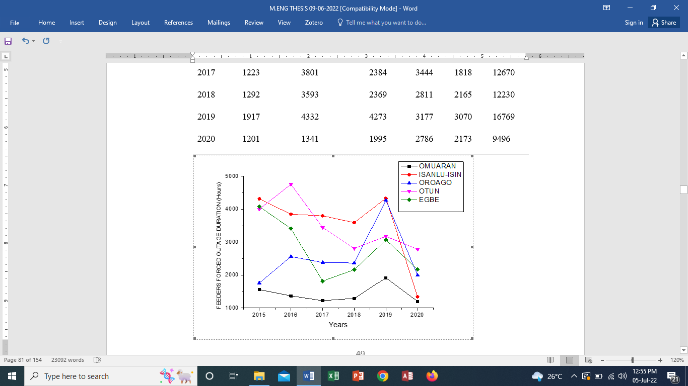

Figure 4.7: Omu-Aran 132/33kV Station feeders Forced Outage Duration in Hours from January 2015 - December 2020.

Figure 4.8 represents the sum of all the outages on the feeders. The 33kV feeders show a decline in the number of outage with more outage occurring on Isanlu-isin 33kV feeder. The sharp decline is due to investment made to improve on the network structure leading to a decrease in the number tripping of the feeder thus the decline from 2019 to 2020.

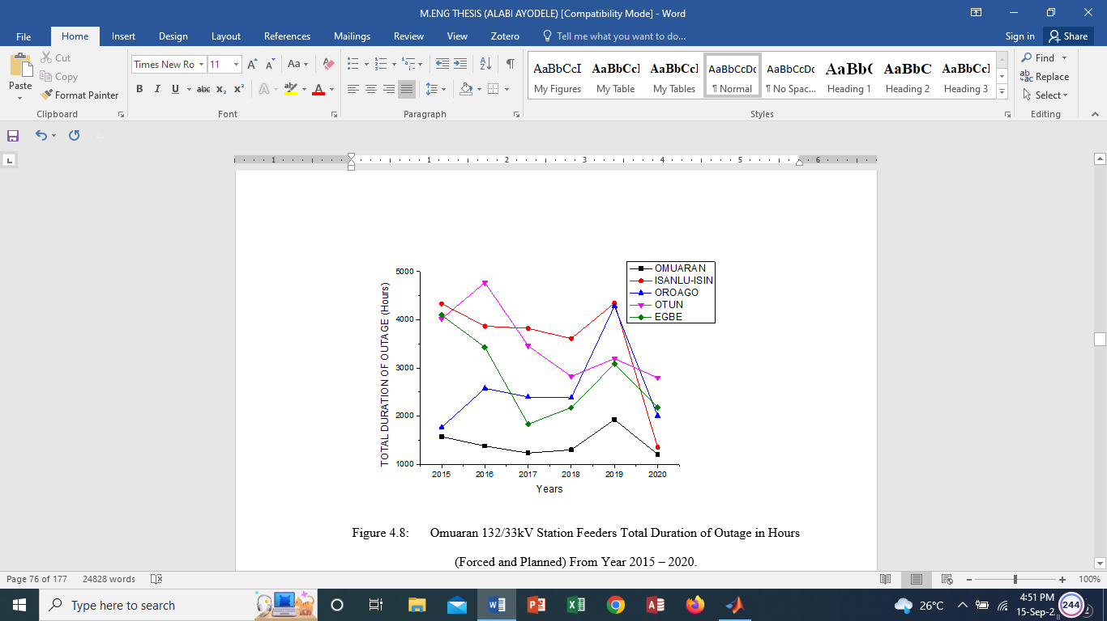

Figure 4.8: Omu-Aran 132/33kV Station Feeders Total Duration of Outage in Hours (Forced and Planned) From Year 2015 – 2020.

Figure 4.9 shows a decline in the number of outage between 2015 -2016 for all the 33kV feeders. Omu-Aran 33kV feeder showed a steady decline in the number of interruption from 2015-2020. The steady decline in the number of outages is due to investment made on the network. Worthy of Note is Omu-Aran 33kV feeder where the number declined from 2019 to 2020.

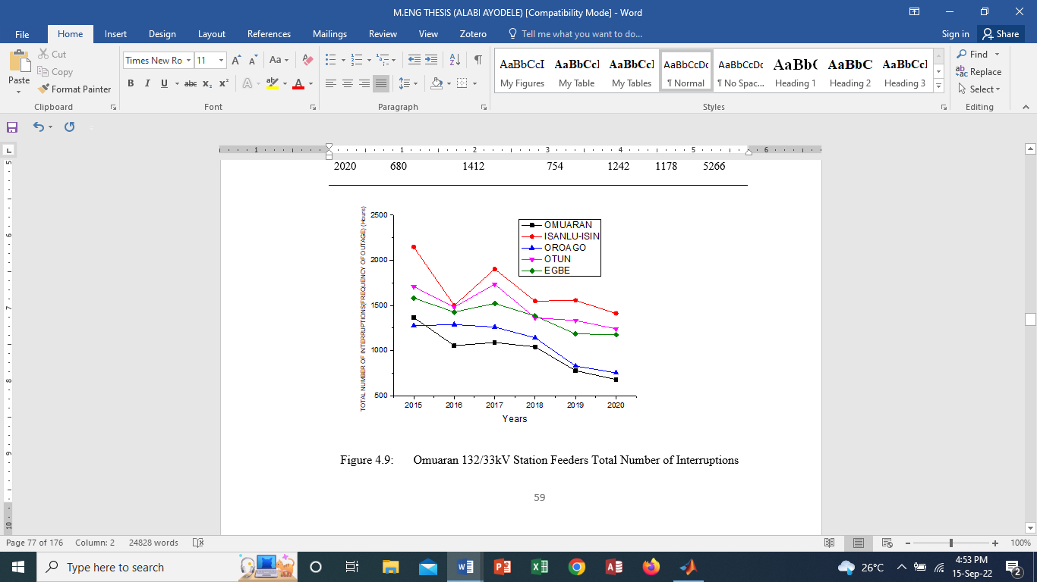

Figure 4.9: Omu-Aran 132/33kV Station Feeders Total Number of Interruptions (Frequency of Outage) From 2015 – 2020

Figure 4.10 shows that the 33kV feeders experience a sharp decline in number of operating hours in 2019, this was largely due to load shedding resulting from low power generation from the grid. Otun 33kV feeder recorded the least operating hour in 2016. This was largely due to line faults resulting from poor network structure.



Figure 4.10: Omu-Aran 132/33kV Station Feeders Total Number of System Operating Hours From 2015 – 2020

According to Figure 4.11, Omu-Aranand Oroago 33kV feeders recorded an improvement MTBF in 2020. This is due to investment made to improve on the existing network structure leading to decrease in the number of tripping recorded.While Isanlu-isin recorded the least MTBF in 2015.The result shows that more tripping occurred on this feeder due to poor network structure, however it showed an improvement in 2020 where it recorded less tripping compared to other years.

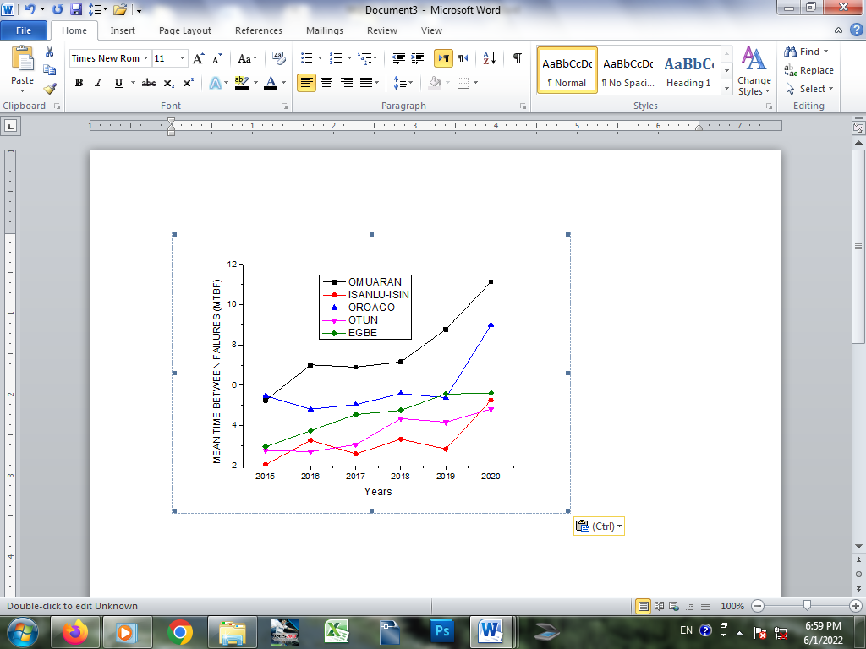

Figure 4.11: Omu-Aran 132/33kV Station Feeders Mean Time between Failures (MTBF) From 2015 - 2020.

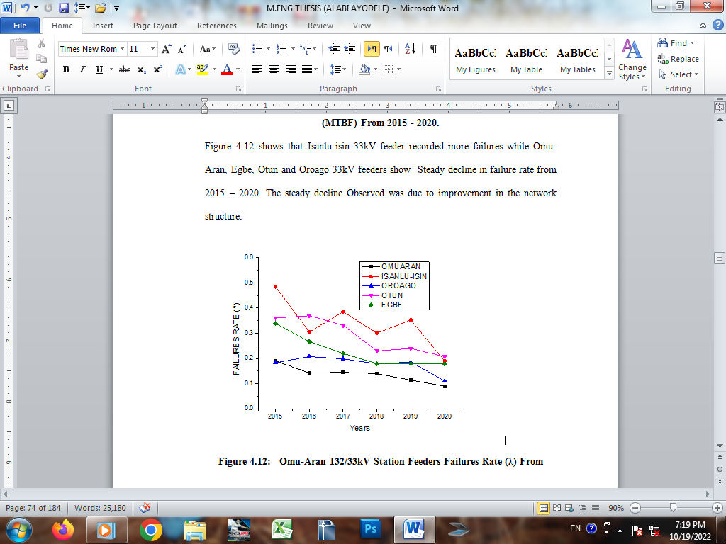Figure 4.12 shows that Isanlu-isin 33kV feeder recorded more failures while Omu-Aran, Egbe, Otun and Oroago 33kV feeders show Steady decline in failure rate from 2015 – 2020. The steady decline Observed was due to improvement in the network structure.

Figure 4.12: Omu-Aran 132/33kV Station Feeders Failures Rate (λ) From

Year 2015 – 2020.

Figure 4.13 shows that Oroago 33kV experienced the highest MDT from 2018 – 2019 and a sharp a decline from 2019 – 2020. The high mean down time recorded by Oroago 33kV feeder in 2019 was due to breaker fault, which kept the feeder out of service for a longer period. In 2016, all the feeders experienced an increase in down time. This was due to numerous system collapse that occurred in that year. The National grid experienced the highest number of system collapse that year.

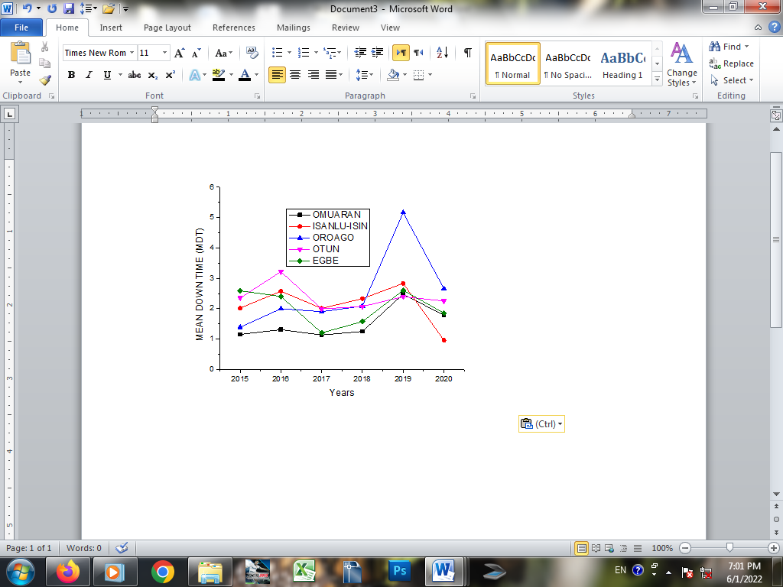

Figure 4.13: Omu-Aran 132/33kV Station Feeders Mean down Time (MDT) From Year 2015 – 2020

Figure 4.14 shows a steady decline in SAIFI for the 33kV feeders from 2015-2020. Oroago 33kV recorded highest SAIFI in 2017 and steadily declined from 2017 -2020.The decline recorded is as a result of decrease in the number of outages on the feeder. Customers on this feeder recorded the highest number of interruption owing to poor nature of the distribution network. It declined from 2019- 2020 due to some improvement made to improve on the network.

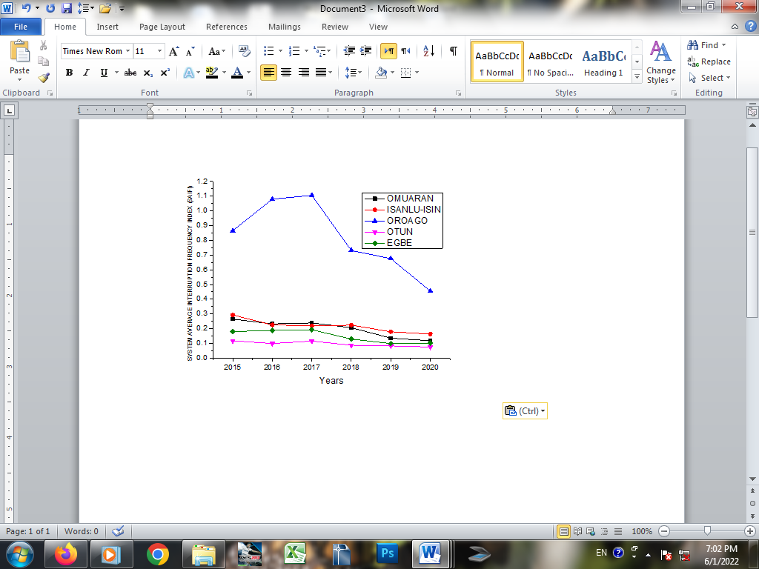

Figure 4.14: Omu-Aran 132/33kV Station Feeders System Average Interruption Frequency Index (SAIFI) from 2015 – 2020

Figure 4.15 shows that the 33kV feeders experience a decline in SAIDI for the period under review, of note is Oroago 33kV feeder that was erratic. This is due to the numerous line faults and adverse weather condition. Increased from 2015-2016, declined in 2016-2018, experienced a spike in 2019 and a sharp drop in 2020.

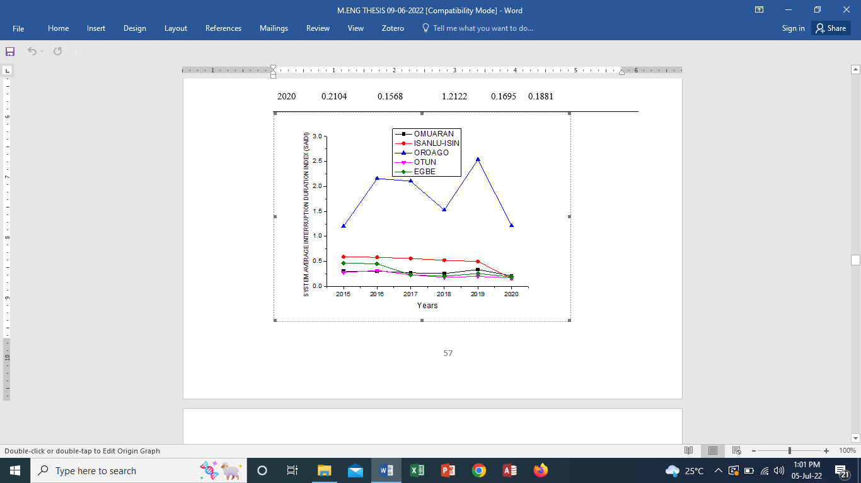

Figure 4.15: Omu-Aran 132/33kV Station Feeders System Average Interruption Duration Index (SAIDI) From 2015 – 2020

From Figure 4.16 it can be seen that the 33kV feeders showed a decline in CAIDI. Worthy of note is Isanlu-Isin and Oroago 33kV feeders. While Isanlu-Isin 33kV CAIDI increased in 2016, declined 2017-2018.it increased in 2019 and decreased in 2020. The high CAIDI value recorded in 2019 was due to breaker fault that prolonged the outage duration for customers on this feeder. The CAIDI values for the 33kV feeders appeared to be stable from 2017-2018, owing to less tripping, investment on the 33kV network and availability of supply from the grid.

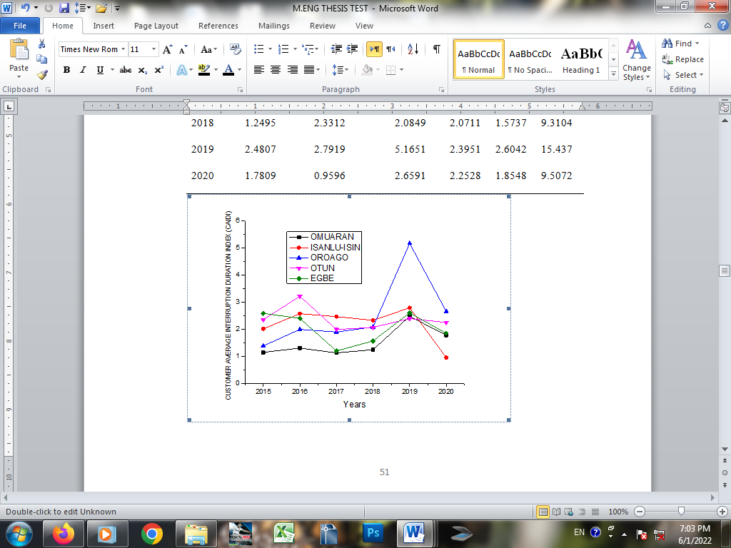

Figure 4.16: Omu-Aran 132/33kV Station Feeders Customer Average Interruption Duration Index (CAIDI) From 2015 – 2020

From Figure 4.17, Omu-Aran 33kV feeder showed a steady rise in ASAI from 2016-2018, a sharp decline in 2019 and increase in 2020. Otun 33kV feeder recorded the least ASAI in 2016 of all the five feeders. In general 2019 shows a decline in ASAI for all the feeders. This is largely due to increase in load demand, poor distribution network and a decline in the load generation from the grid.

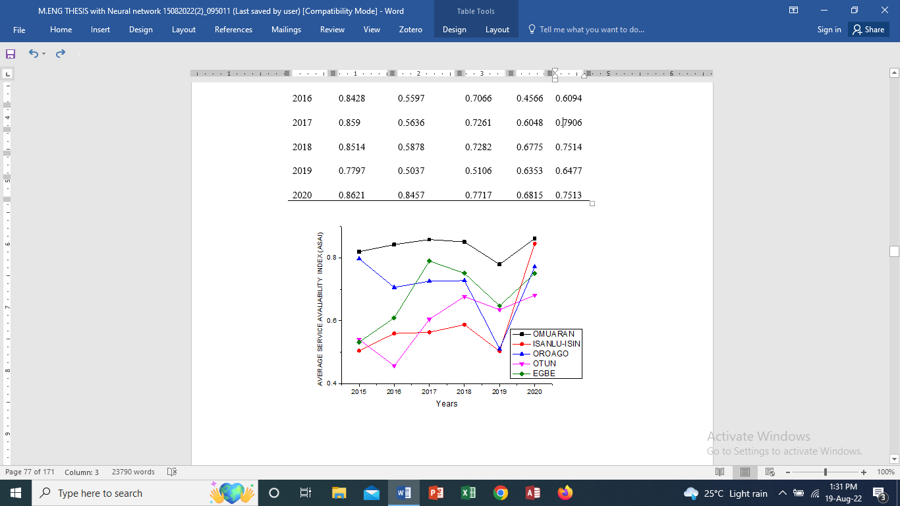

Figure 4.17: Omu-Aran 132/33kV Station Feeders Average Service Availability Index (ASAI) from 2015 – 2020

### 4.2.2 Reliability Performance of the I32kV Transmission Station

The results obtained are shown in the following tables and figures.

Figure 4.18 shows that the station experienced an increase in system collapse from 2015 – 2016, the highest number of system collapse occurred in 2016 and a steadily decline from 2016 – 2020. It recorded the least number of system collapse in 2020.

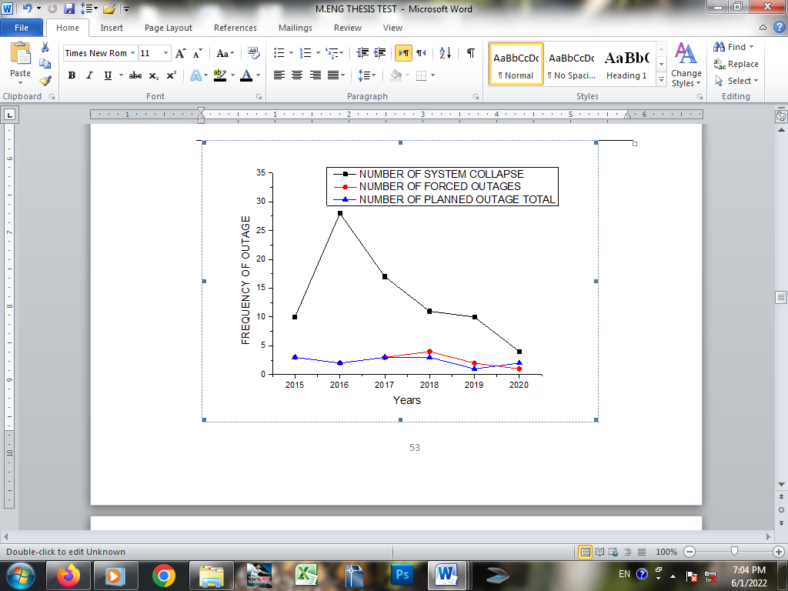

Figure 4.18: Frequency of Outage from 2015 – 2020.

Figure 4.19 shows the duration of forced outage to planned outage. Number of planned outage tend to be same. While forced outage was at its peak in 2016. This was due to the numerous system collapse that occurred that year and declined from 2016 – 2018. According to the graph, least outage occurred in 2018.The decline was due to the investment made on improving the national grid from where the substation receives supply.

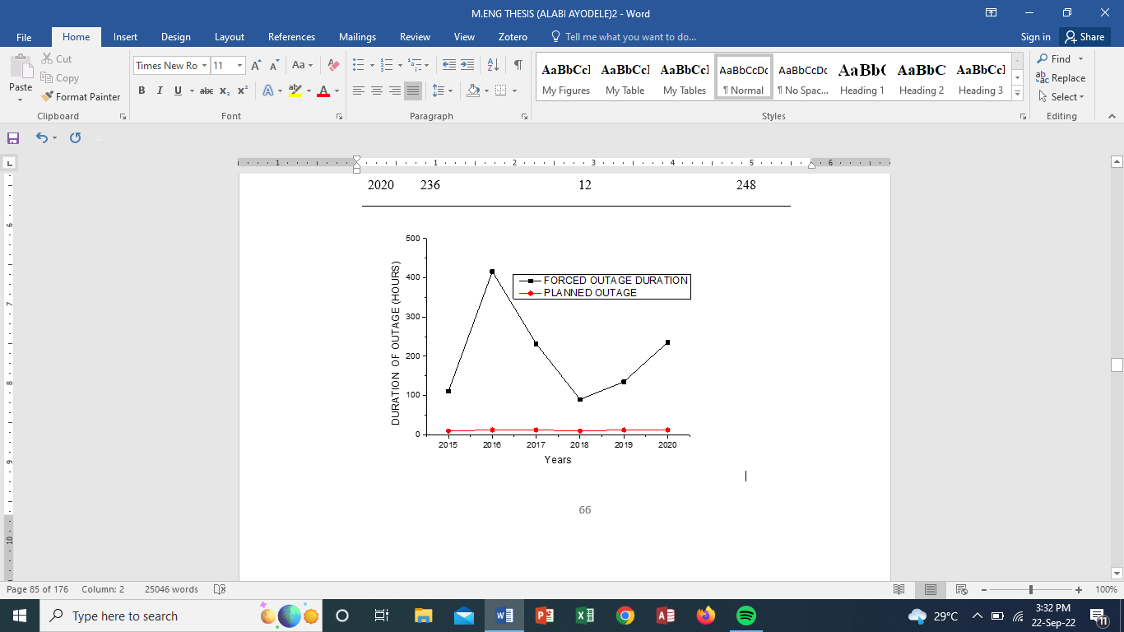

Figure 4.19: Duration of Outage.

Figure 4.20 shows a decline in availability from 2015 – 2016 this was due to the frequent system collapse that occurred between 2015-2016. Then a gradual increase from 2017, reaching a peak value in 2018.

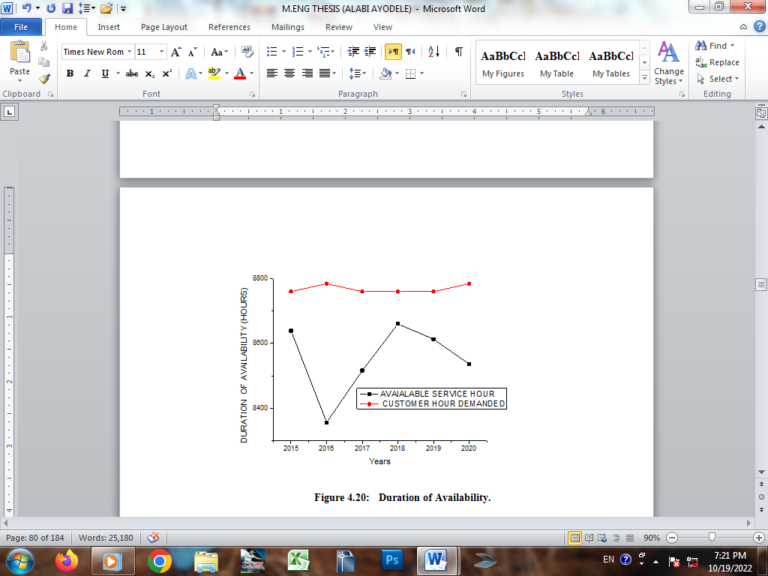

Figure 4.20: Duration of Availability.

Figure 4.20: Duration of Availability

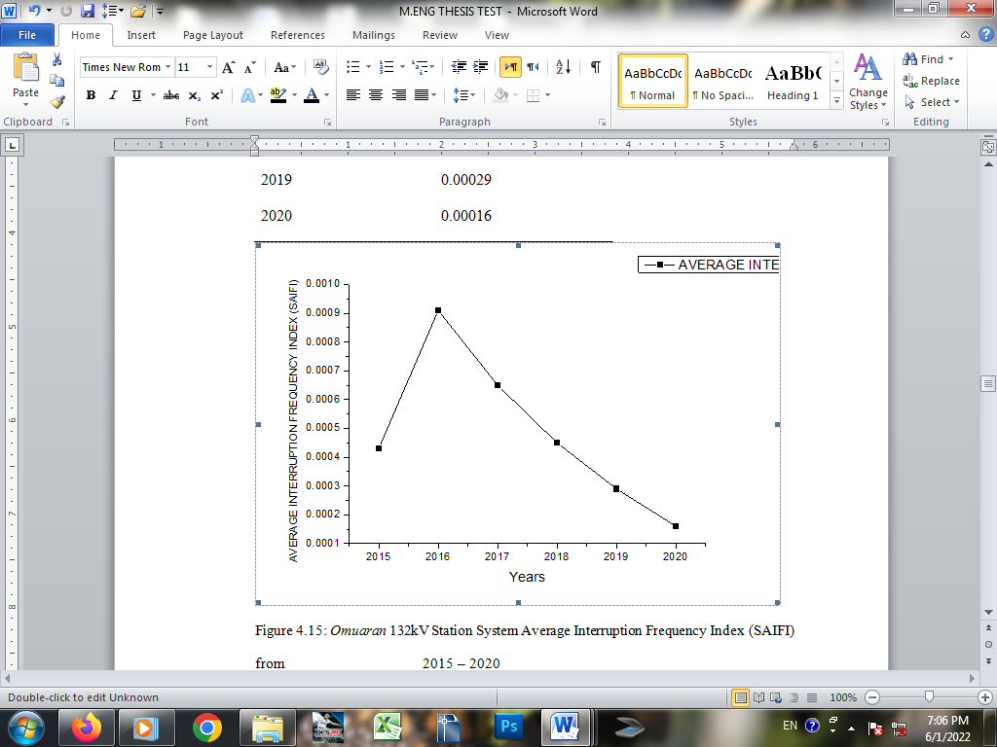Figure 4.21 shows a peak SAIFI Value in 2016, before experiencing a steady decline from 2017 – 2020. 2020 recorded the lowest amount of system collapse.

Figure 4.21: Omu-Aran 132kV Station System Average Interruption Frequency Index (SAIFI) from2015 – 2020

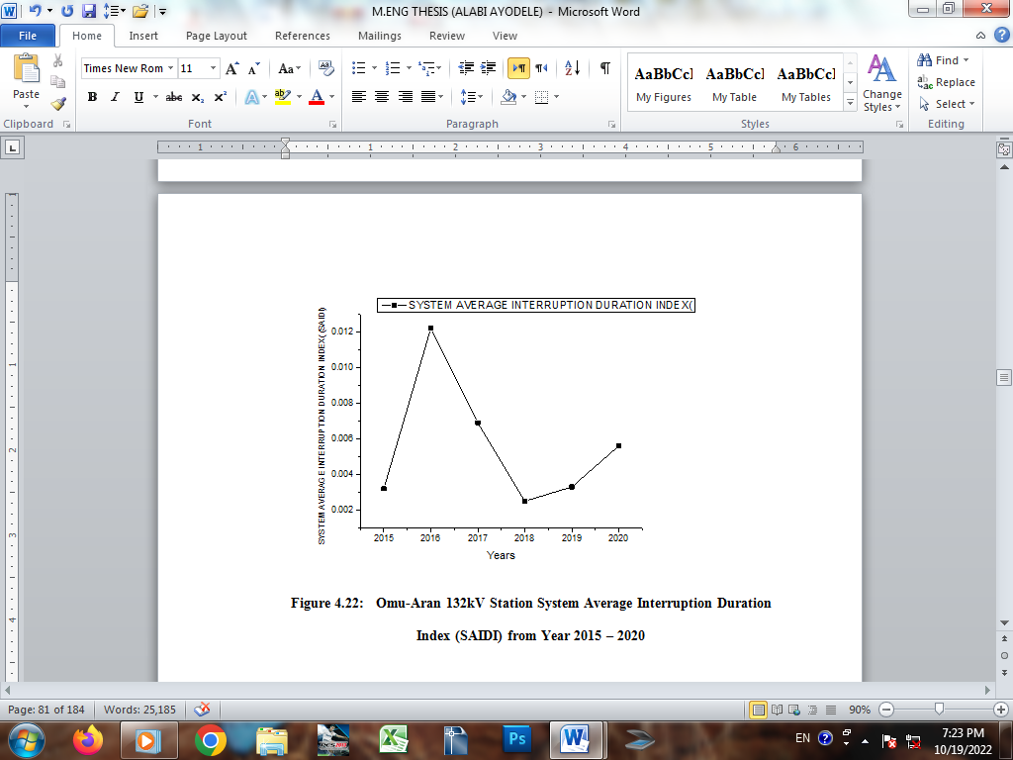From Figure 4.22, the station recorded the highest SAIDI value in 2016, then declined steadily and was lowest in 2018 before experiencing a slight increase in 2019 – 2020.

Figure 4.22: Omu-Aran 132kV Station System Average Interruption Duration Index (SAIDI) from Year 2015 – 2020

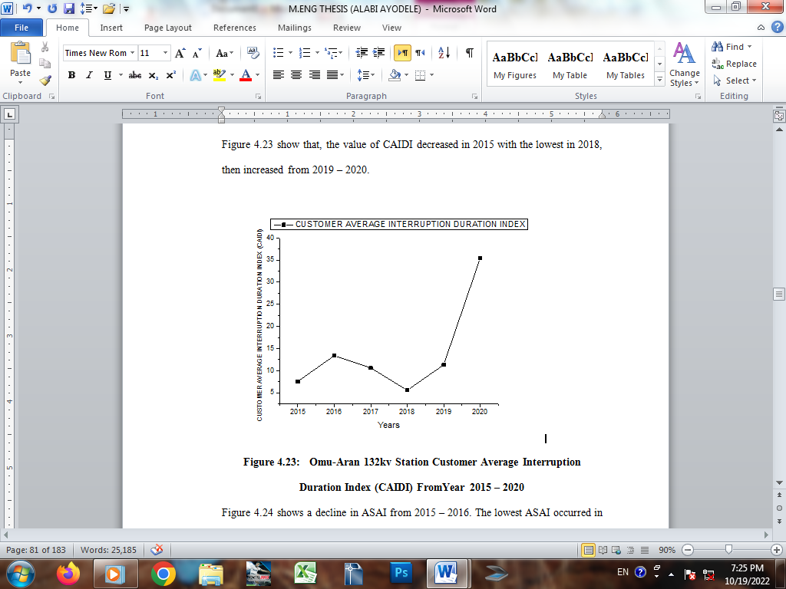Figure 4.23 show that, the value of CAIDI decreased in 2015 with the lowest in 2018, then increased from 2019 – 2020.

Figure 4.23: Omu-Aran 132kv Station Customer Average Interruption Duration Index (CAIDI) FromYear 2015 – 2020

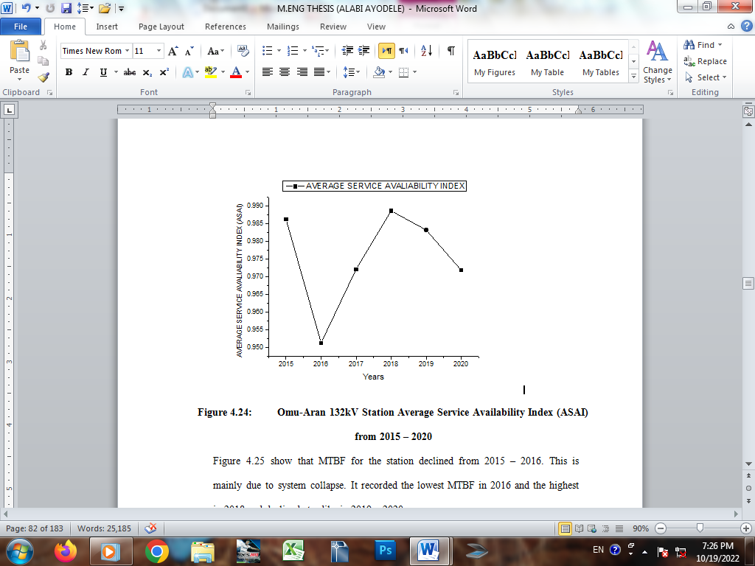Figure 4.24 shows a decline in ASAI from 2015 – 2016. The lowest ASAI occurred in 2016. This is due to the numerous system collapse recorded. The station recorded the highest ASAI in 2018 due to improvement in supply availability from the grid.

Figure 4.24: Omu-Aran 132kV Station Average Service Availability Index (ASAI) from 2015 – 2020

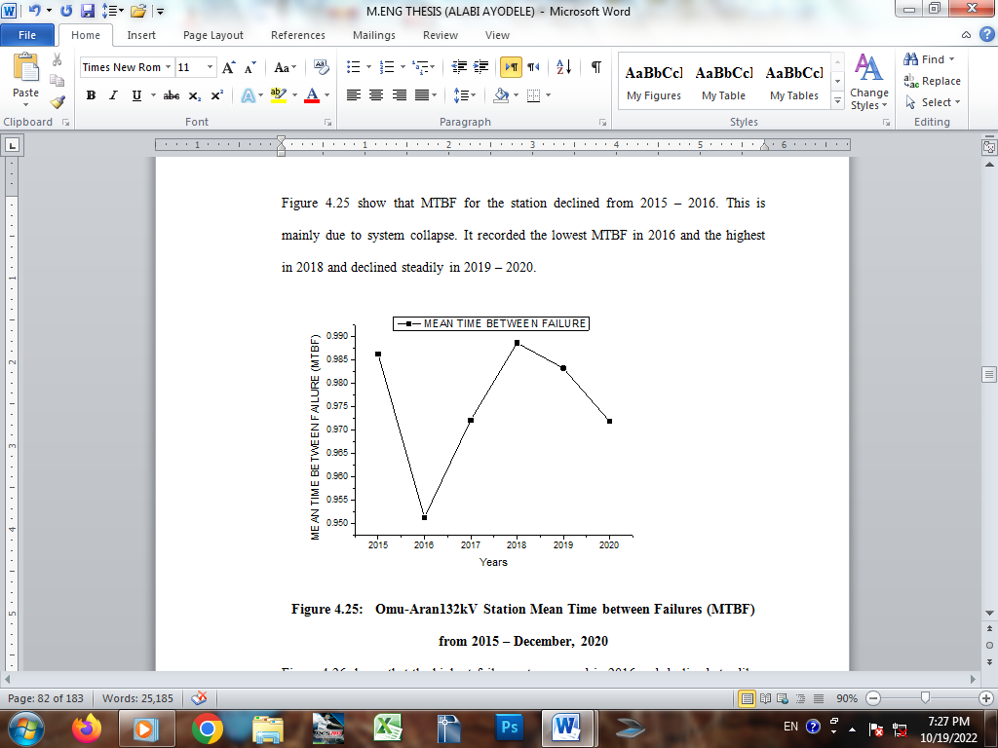Figure 4.25 show that MTBF for the station declined from 2015 – 2016. This is mainly due to system collapse. It recorded the lowest MTBF in 2016 and the highest in 2018 and declined steadily in 2019 – 2020.

Figure 4.25: Omu-Aran132kV Station Mean Time between Failures (MTBF) from 2015 – December, 2020

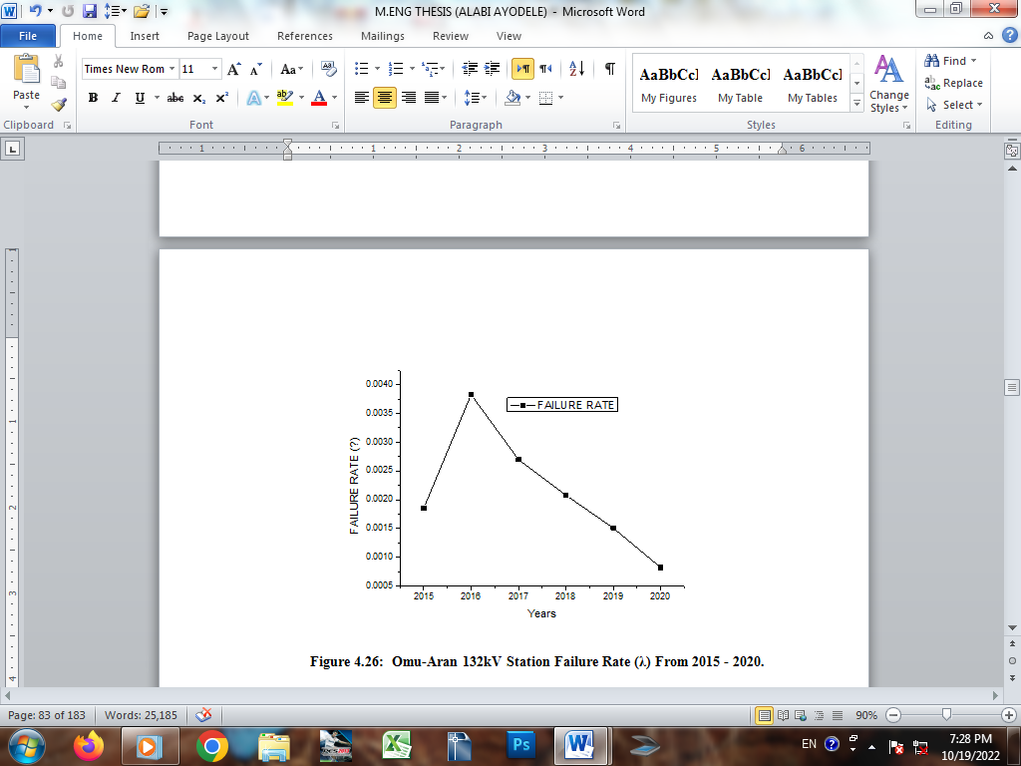Figure 4.26 shows that the highest failure rate occurred in 2016 and declined steadily from 2017-2020 with 2020 experiencing the least failure.

Figure 4.26: Omu-Aran 132kV Station Failure Rate (λ) From 2015 - 2020.

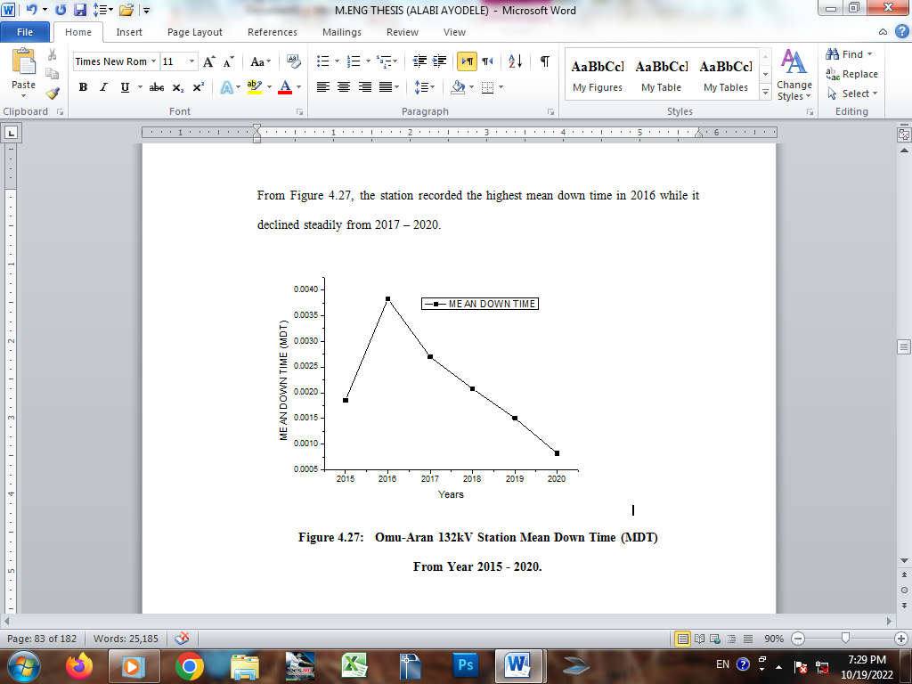From Figure 4.27, the station recorded the highest mean down time in 2016 while it declined steadily from 2017 – 2020.

Figure 4.27: Omu-Aran 132kV Station Mean Down Time (MDT)

From Year 2015 - 2020.

### 4.2.3 Reliability Prediction Results

The results of the reliability prediction for the 33kV bus and the outgoing 33kV feeders are presented in Figures 4.28. to Figure 4.51. The reliability prediction includes target, training and testing. There is a good agreement between the Target, Training and Testing. The prediction is accurate and precise with minimal error as shown in the figures below.

 **RELIABILITY PREDICTION RESULT FOR OMU-ARAN 33KV BUS**

Figure 4.28: Predicted SAIFI for Omu-Aran 33kV Bus

Figure 4.28 shows SAIFI result for Omu-Aran 33kV Bus for target, training and testing using ANN. The result is accurate with minimal error and the regression coefficient (R) of 0.8933.



Figure 4.29: Prediction of SAIDI for Omu-Aran 33kV Bus.

Figures 4.29 shows SAIDI result reliability prediction for target, training and testing using ANN. Result is accurate and error is minimal The regression result is 0.8335.



S

Figure 4.30: Predicted CAIDI for Omu-Aran 33kV Bus

Figure 4.30 shows the CAIDI result for Target, Training and Testing for the 33kV bus using ANN. The result is accurate with minmal error and a regression of 0.9124.

Figure 4.31: Predicted ASAI for Omu-Aran 33kV Bus

Figure 4.31 shows ASAI for Omu-Aran 33kV bus using ANN. Target, Training and Testing results are accurate with minimal error.The regression result is 1.0000.

 **RELIABILITY PREDICTION RESULT FOR OMU-ARAN 33KV FEEDER**

Figure 4.32: Predicted SAIFI for Omu-Aran 33kV Feeder

Figure 4.32 shows the SAIFI result for target, training and testing using ANN. The result is accurte enough even though the error is a little big. It can still be accommodated. The error of 0.06 is small and it can be accommodated. The regression result is 0.8148



Figure 4.33: Predicted SAIDI for Omu-Aran 33kV Feeder

Figure 4.33 showns SAIDI result for Taget, Training andTesting using ANN. The result is accurate with minimal error between 0.05 and 0.06. The result of the regression is 0.8397.



Figure 4.34: Predicted CAIDI for Omu-Aran 33kV Feeder

 Figure 4.34 shows CAIDI result for target, training and testing for Omu-Aran 33kV feeder using ANN.Prediction is accurate and precise with a regression result of 0.8601

Figure 4.35: ASAI Prediction for Omu-Aran 33kV Feeder.

Figure 4.35 shows the ASAI result of reliability prediction for target, training and testing for Omu-Aran 33kV feeder using ANN.The prediction is accurate and error is minimal. The result of the regression is 1.0000. sThe regression(R) value measures the correlation between output and Taget. An R value of 1 means a close relationship and 0 a random relationship

**RELIABILITY PREDICTION RESULT FOR ISANLU-ISIN 33KV FEEDER**

Figure 4.36.: Predicted SAIFI for Isanlu-Isin 33kV Feeder

Figure 4.36 shows the SAIFI target, training and testing for Isanlu-Isin 33kV feeder using ANN .It has a minimal error of 0.08, which effect can be negligible.The regression result is 0.9136.



Figure 4.37: Predicted SAIDI for Isanlu-Isin 33kV Feeder

Figure 4.37 shows SAIDI result for target,training training and testing for Isanlu-Isin 33kV feeder. The result is accurate with minimal error of 0.09. The result of the regression is 0.8843.

Figure 4.38: Predicited CAIDI for Isanlu-Isin 33kV Feeder.:

Figure 4.38shows CAIDI result for Target, Training and Testing for Isanlu-Isin 33kV feeder.The prediction is accurate with minimal error. The value of the regression is 0.8167.



Figure 4.39: ASAI Prediction for Isanlu-Isin 33kV Feeder.

Figure 4.39shows ASAI result for Target, Training and Testing for Isanlu-Isin 33kV feeder using ANN. The value of the prediction ranges between 0.55 to 0.58. The result of the regression is 1.0000

The regression(R) value measures the correlation between output and Taget. An R value of 1 means a close relationship and 0 a random relationship.

**RELIABILITY PREDICTION RESULT FOR ORO-AGO 33KV FEEDER**

Figure 4.40: SAIFI Prediction of Oro-Ago 33kV Feeder.

Figure 4.40 shows SAIFI result for Target, Training and Testing for Oroago 33kV feeder using ANN.The result is accurate though with an error of 0.1. The result of the regression is 0.7689.

Figure 4.41: Predicted SAIDI for Oro-Ago 33kV Feeder:

Figure 4.41 shows SAIDI result for target, training and testing, The result is accurate with minimal error of 0.05. The result of the regression is 0.8108.

Figure 4.42: Predicted CAIDI for Oro-Ago 33kV Feeder.

****Figure 4.42shows CAIDI result for target, training and testing using ANN for oroago 33kV feeder. The error is minimal and negligible with the result of the regression as 0.8832

Figure 4.43: Predicted ASAI for Oro-Ago 33kV Feeder.

Figure 4.43 shows ASAI result for target, training and testing for Oroago33kV feeder using ANN. There is a good agreement between target, training and testing predictions.The result of the regression is 1.0000

The regression(R) value measures the correlation between output and Taget. An R value of 1 means a close relationship and 0 a random relationship.

**RELIABILITY PREDICTION RESULT FOR OTUN 33KV FEEDER**

Figure 4.44: SAIFI Prediction for Otun 33kV Feeder

Figure 4.44 shows SAIFI result for target, training and testing for Otun 33kV feeder using ANN.The result is accurate with minimal error of 0.015 and regression of 0.7465.



Figure 4.45: SAIDI Prediction for Otun 33kV Feeder

Figure 4.45 shows SAID result for Target, Training and Testing using ANN. The prediction is accurate and precise with a minimal error. The result of the regression is 0.9051.

Figure 4.46: Predicted CAIDI for Otun 33kV Feeder.

Figure 4.46 shows CAIDI result for Target, Training and Testing for Otun 33kV feeder using ANN. The prediction is precise and accurate with regression of 0.8837

Figure 4.47: Predicted ASAI for Otun 33kV Feeder.

Figure 4.47 shows ASAI result for Target, Training and Testing for Otun 33kV feeder using ANN. There is a good agreement between target, training and testing predictions.The regression result is 1.0000

The regression(R) value measures the correlation between output and Taget. An R value of 1 means a close relationship and 0 a random relationship.

**RELIABILITY PREDICTION RESULT FOR EGBE 33KV FEEDER**

Figure 4.48: Predicted SAIFI for Egebe 33kV Feeder.

Figure 4.48 shows SAIFI result for Target, Training and Testing for Egbe 33kV feeder using ANN. The result is accurate with minimal error of 0.02. The regression result is 0.8601

Figure 4.49: Predicted SAIDI for Egbe 33kV Feeder

Figure 4.49 show SAIDI result for Target, Training and Testing for Egbe 33kV feeder using ANN. The result is accurate with minmal error. The result of the regression is 0.8075.

Figure 4.50: Predicted CAIDI for Egbe 33kV Feeder

****Figure 4.50 shows CAIDI result for Target, Training and Testing for Egbe 33kV feeder using ANN.The result of the prediction is accurate with minimal error. The result of the regression is 0.9706

Figure 4.51: Predicted ASAI for Egbe 33kV Feeder.

Figure 4.51 shows ASAI result for Target, Training and Testing for Egbe 33kV feeder using ANN. There is a good agreement between target, training and testing.  The result of the regression(R) is 1.0000.

The regression(R) value measures the correlation between output and Taget. An R value of 1 means a close relationship and 0 a random relationship.

## 4.3 Discussions of Results

The result of load flow conducted on the station 33kV feeders is presented in Tables in appendix B1 – B11. From the results, on the 33kV bus, the Minimum line voltage occurred in Bus 18 with the value of 0.95313pu.This section of the line is overloaded. On Omu-Aran 33kV feeder, the minimum voltage on the line occurred in bus 29(Imoji) with a value of 0.90837pu, for Isanlu-Isin 33kV feeder, minimum line voltage occurred in bus 29 with the value of 0.55856pu, similarly on Oroago 33kVfeeder, minimum line voltage occurred in bus 26 with a value of 0.88025pu, On Otun 33kV feeder, the minimum line voltage occurred in bus 43 (Iyamero) with a value of 0.888025pu and

Egbe 33kV feeder, minimum line voltage occurred in bus48 (Okoloke) with value of 0.83619pu. These sections of the line for the feeders are overloaded. as presented in figures 4.22 – 4.27. In summary, Otun 33kV feeder has the highest load with total real power (P) of 15.725MVA and reactive power (Q) of 11.814MVA. The feeder also have the highest magnitude of power loss. The real power loss (P) is 0.03906 pu and reactive power loss of 0.3622pu, its followed by Egbe 33kV feeder with the value of P as 0.1022pu and Q as 0.00913pu, Isanlu-isin 33kV feeder with values of P as 0.00418pu and Q as 0.00367pu, Omu-Aran 33kV feeder with P value of 0.00059pu and Q value of 0.00021pu while Oroago 33kV feeder have the least value of Power loss with value of P as 0.0006pu and the value of Q as 0.00031pu respectively.

Tables 4.4, 4.5, and 4.6 show Mean Time between Failure (MTBF), Failure Rate and Mean down Time (MDT) for the feeders from January 2015 – December 2020. Omu-Aran 33kV feeder has high MTBF, low MDT and failure rate which makes it relatively stable and reliable. However, Isanlu-Isin and Otun 33kV feeders have low MTBF, high MDT Failure rate. This can be due to unfortified network structure, network length and Load (as shown in figure 4.12) While Oroago and Egbe 33kV feeders are averagely reliable.

Otun 33kV feeder has the smallest SAIFI. The average SAIFI for the feeder between January 2015- December 2020 is 0.0963 interruption/customer(Apedix: Table A20). The highest SAIFI value of 0.1178 interruption/customer in 2015 and least SAIFI value of 0.0752 interruption/customer in 2020 as shown in Figure 4.14. Customers on this feeder experience the least occurrence of sustained interruptions. On the other hand, Oroago, Isanlu-Isin, Omu-Aran and Egbe Feeders have Average SAIFI values of 0.8190, 0.2173, 0.1995, and 0.1483 respectively. While Oroago 33kv Feeder have the highest average SAIFI of 0.8190 interruption/customer, it recorded the highest SAIFI of 1.1061 in 2017 and the least SAIFI of 0.4557 in 2020. Customers on this feeder (Oroago) experience the highest occurrence of sustained interruptions.

Otun 33kV feeder has the smallest SAIDI value. The mean SAIDI for the feeder between January 2015 – December 2020 is 0.2291 hours/customer(Apedix Table A21). It recorded the highest SAIDI of 0.3179 hours/interruption in 2016 and least SAIDI of 0.1695hours/interruption in 2020 as shown in Figure 4.15. Customers on this feeder experience the least duration of sustained interruptions. On the other hand Omu-Aran, Egbe, Isanlu-Isin and Oroago 33kV feeders have average SAIDI of 0.2805, 0.29978, 0.4847 and 1.7898 hours/interruption. Customers on Oroago feeder experience the maximum duration of sustained interruption. This feeder requires a special attention because the value is quite high compared to the other feeders.

Omu-Aran 33kV feeder has the least average CAIDI of 1.5176 interruption/customer. With the highest CAIDI value of 1.7809 interruption/customer in 2020 and the least CAIDI of 1.1330 in 2017 as shown in Figure 4.16. Customers on this feeder experience least continuous interruption. On the other hand, Egbe, Isanlu-Isin, Otun and Oroago 33kV feeders have average CAIDI of 2.0382, 2.1910, 2.3808 and 2.5331 interruption/customer. Oroago 33kV feeder has the highest CAIDI of 5.1651 interruption/customer in 2019 and least CAIDI of 0.9596 interruption/customer in 2020. Customers on this feeder experience the highest number of continuous interruptions.

Omu-Aran 33kV feeder has mean ASAI of 0.8359. It recorded highest ASAI of 0.8621 in 2020 and least (0.7797) in 2019. Oroago, Egbe, Otun and Isanlu-Isin 33kV feeders have mean ASAI of 0.7068, 0.6805, 0.5994 and 0.5943 respectively. The analysis shows Omu-Aran 33kV feeder is relatively stable, as Otun 33kV feeder recorded least ASAI and requires special attention

Customer based indices and system based indices for the 132/33kV bus section from where the feeders receive supply reveal that station experienced the least interruption in 2020 as shown in figure 4.21 with SAIFI of 0.0016 interruption/customer. It recorded the highest number of sustained interruption in 2016. It has a SAIDI value of 0.0122hours/customer, CAIDI of 35.4286 in 2020, ASAI of 0.9886 in 2018 and least ASAI of 0.9513 in 2016. As shown in Figures 4.22 – 4.24.

The station showed an improvement in reliability with mean time between failures (MTBF) of 1219.43 hours in 2020 compared to 2016 where it recorded a MTBF of 261.13 hours according to Table 4.20. It recorded the least failure rate of 0.00151hours in 2019 and the least mean down time (MDT) of 7.5625hours in 2015 as shown in figures 4.25 – 4.27.

While the station shows a high level of reliability based on reliability indices evaluated, this high reliability has not been translated to the average customer as a result of frequent tripping due to poor distribution network. Hence more should be done to strengthen the distribution network in order to improve on supply availability to the customer.

Figures 4.28- 4.51 shows reliability prediction for the Station 33kV bus and the outgoing 33kV feeders .The indices was divided into Target values, Predicted value (training) and Predicted Value (testing). The testing values represent the performance of the neural network after training.

# CHAPTER FIVE

## CONCLUSION AND RECOMMENDATIONS

### 5.1 Conclusion

This work carried the reliability analysis and prediction of Omu-Aran 132/33kV station, the 33kV feeders feeding from the station and load flow studies on the 33kV outgoing feeders. The reliability analysis carried out on the station shows high level of reliability. The System based indices and customer based indices analysed confirmed this claim. Reliability indices evaluated include the following: MDT, failure rate, MTBF, SAIFI, SAIDI, CAIDI and ASAI for the station and the five outgoing feeders from January 2015 – December 2020. Results obtained showed high reliability for the station with mean ASAI of 0.9755, with the highest ASAI of 0.9886 in 2018 and the least ASAI of 0.9513 in 2016. For the outgoing 33kV feeders, Omu-Aran 33kV is more reliable in terms of supply availability, than the other 33kV feeders in the station going by the result of the reliability analysis. It recorded a six-year mean ASAI of 0.8359, with the highest ASAI of 0.8621 in 2020 and the least ASAI of 0.7797 in 2019. Isanlu- Isin 33kV feeder recorded the least ASAI, with a six-year mean ASAI of 0.5943, with the highest ASAI of 0.8457 in 2020, and the least ASAI of 0.5050 in 2015.

The reliability Prediction result for target, training and testing using ANN are accurate and precise with minimal error as shown in figures 4.28-4.51. With the prediction result in place, the state of the system can be known ahead of time to prevent loss in supply availability resulting from outages. The feed-forward neural network using LM backward propagation was used in the training . The neurons were able to memorize the dynamics of the system used during training, with little data presented during testing it was able to give the required prediction with minimal error.

The load flow studies conducted on the outgoing feeders shows that Otun 33kV feeder recorded the highest number of power loss while Oroago 33kV feeder has the least. With the increasing demand and growing dependence on electricity supplies nation-wide, it is necessary to analyze the behaviour of the system based on frequency of outage, outage duration, system availability and response time, and also put a mechanisim in place that can predict the state of the system ahead of time in order to guaranty an acceptable level of reliability in meet rising load demand by the customers.

The significant contribution of this work is that it was able to reveal the operational status of Omu-Aran 132/33kV substation and the outgoing 33kV feeders in terms of supply availability, outages(forced and planned) , duration of outages and restoration time. While the station shows a high level of reliability, this reliability has not been translated into high supply avaialaibility going by the indices. This is largely due to poor network structure which has resulted in frequent trippings( forced outages).

The reliability status of each outgoing 33kV feeder can be clearly seen from the results obtained. . Omu-Aran, Egbe, Otun and Isanlu-isin 33kV feeders all show a slight improvement in reliability values. However Oroago 33kV feeder showed a steady decline in reliability from the reliability prediction. This feeder requires special attention in order to improve supply availability. Also the result of power flow conducted on the 33kV feeders shows voltage drops as we move from bus to bus. This is largely due to the poor nature of the network which can be improved upon by network reinforcement using standard sized conductors and introducing capacitor banks to improve the magnitude of the voltage profile.

### 5.2 Recommendations

The following are recommended for future works that can be considered as an extension of this research work:

1. Reliability assessment and prediction of active distribution network.
2. Optimization analysis on network considering reliability using intelligent techniques.
3. Optimization and economic cost reduction.

### 5.3 Research Contribution to Knowledge

i. The research work developed an Artifical Neural Network (ANN) situation awareness model for reliability analysis and prediction for the Omu-Aran 132/33kV substation Steady-state condition.

ii. The research work developed customer reliability model for decision making in power system operation.

# 

# REFERENCES

Adeoye, O.S., and Okereke C.O. (2018). Investigation and analysis of reliability of power supply in Ado-Ekiti metropolis, Ekiti state, Nigeria. Research Journal of Energy and Power Engineering, 1(1), 1 – 3.

Aibangbee, J.O., and Chukwuemeka, I. (2017). Reliability assessment of APO 132/33kV electric transmission substation, Abuja. American Journal of Engineering, Research, 6, 170 – 176.

Ali, A. Chowdhury, Don .O, Koval, Power Distribution System Reliability: practical methods and application (2009), New Jersey, John Wiley and Sons Inc.

Al-Shaalan A. (2012). Reliability evaluation in generation expansion planning based on the expected energy not supplied. Journal of King Saud University– Engineering Sciences, 24(1):11-18

Al-Shaalan A. (2017). Reliability/cost tradeoff evaluation for interconnected electric power systems. International Journal of Computing and Digital Systems, 6(6):371 – 374. ISSN 2210-142X

Al-Shaalan A. (2018). Fast Fourier Transform (FFT) for Reliability Evaluation of Smart Unit Energy Production. IEEE Xplore Publications. IEEE Xplore.

Al-Shaalan, A.M. (2019). Reliability evaluation of power systems. Online Intech Open. Book Chapter, 1 – 25.

Antonio J.C., Javier, C., Rosa, E., and Miguel A.P. (2004). Forecasting electricity prices for a day-ahead pool-based electric energy market. International Journal of Forecasting, 21, 435 – 462.

Badran , L. (2008). Reliability of load generation, transmission, distribution and usage in Nigeria. American Journal of Applied Sciences, 5 (7), 763 – 768.

Baggini, A. (2008). Handbook of Power Quality. John Wiley and Sons, Ltd.

Balasubbareddy, M., Murthy, G.V.K., and Kumar, K.S. (2012). Performance evaluation of different structures of power system stabilizers. International Journal of Electrical and Computer Engineering, 11(1): 114 – 123.

Bermejo, J. F., Fernandez, J. F., Polo, F. O., and Marquez., A. C. (2019). A Review of the Use of Artificial Neural Network Models for Energy and Reliability Prediction. A Study of the Solar PV, Hydraulic and Wind Energy sources. Applied Sciences.

Billinton R. (2007). Reliability Assessment of Bulk Electric Systems. Publications No. 148. Canada: Power System Research Group, University of Saskatchewan, 75.

Billinton, R and Allan, R.N (2008): Reliability Evaluation of Power Systems Second Edition Springer, New Delhi: 514.

Brown, R.E. (2009). Electric Power Distribution Reliability. 2nd ed. (Chapter 7). Taylor and Francis Group, LLC.

Chen, G., Zhang, F., You, D., Wang, Y., Lu, G., Zou, Q., Liu, H., Quian, J., and Xu, H. (2017). Reliability evaluation of distribution system with distributed generation. IOP Conf. Series: Materials Science and Engineering 224, 012035. doi:10.1088/1757-899X/224/1/012035.

Daramola, D.A., and Olulope, P.K. (2017). Analysis of Power Supply in a Typical Nigerian Transmission Substation: A Case Study of Ota132/33KV substation. International Journal of Scientific and Engineering Research, 35(1): 56 – 67.

Demuth H., Neural network toolbox for use with MATLAB: User’s guide. MathWorks, Inc, 1992

Denson, W. (1998). The history of reliability prediction. IEEE Transactions on Reliability, 47(3), SP321–SP328.

Deware, K. (2016). Basics of electrical power transmission system. Retrieved from online via: <https://www.electricaleasy-basics-of-electrical-power-transmission.html>. Accessed on 30/11/2020.

Douglas, J.L., Martin, H., and John, V.R. (2004). Gaussian Process Prior Models for Electrical Load Forecasting, 8th International Conference on Probabilistic Methods Applied to Power Systems (September 12 – 16). Iowa State University, Ames, Iowa, USA.

Eneje, I.S., and Fadare, D.A. (2012). Modelling and forecasting periodic electric load for a metropolitan city in Nigeria. African Research Review, 6(1), 101 – 115.

Engelbrecht A. P., Computational Intelligence: An Introduction, 2nd ed. Wiley, 2007

Escalera, A., Hayes, B., and Prodanovic, M. (2018). A survey of reliability assessment techniques for modern networks. Renewable and Sustainable Energy Reviews, 91, 344 – 357.

Fadare, D. A. (2010). Energy Modeling and Forecasting. University of Ibadan, Ibadan, Nigeria.

Ghiasi, M., Ghadimi, N., and Ahmadinia, E. (2019). An analytical methodology for reliability assessment and failure analysis in distributed power system. SN Applied Sciences, 1(14). https://doi.org/10.1007/s42452-018-0049-0.

Gomes, S., Guimarães, C.H.C., Martins, N., and Taranto, G.N. (2018). Damped Nyquist Plot for a pole placement design of power system stabilizers. Electric Power Systems Research, 158, 158-169.

Grigsby, L. (2008): Electric Power Distribution Handbook. New York: Taylor and Francis Group, 650.

Grigsby, L.L. (2009). Power Systems, Power System Planning Taylor and Francis Group, LLC (Reliability Part 3)..

Gupta, J.B. (2013). A course in electrical power. New Delhi: S.K. Kataria and Sons.

Gurunath, G. (2010). Power System Stabilizer Design for Interconnected power System. IEEE Trans. on Power Systems, 25(2): 1042 – 1051.

Haykin.S (1999). Neural Network and learning Machines. Third Edition, New York: Prentice Hall

Hu, C., Si, X., and Yang, J. (2010). System reliability prediction model based on evidential reasoning algorithm with nonlinear optimization. Expert systems with applications Journal, 37, 2550 – 2562.

IEEE Guide for Electric Power Distribution Reliability Indices (2012). IEEE Std 1366 – 2012 (Revision of IEEE Std 1366 – 2003, 1 – 43). <https://doi.org/10.1109/IEEESTD.2012.6209381>.

James A. Momoh and Mohamed E. El-hawary(2000): Electric Systems dynamics and stability with artificial intelligence application. New York, Marcel Dekker Inc.

Jan, M., Janusz, W.b., and Bumby, J. (2006). Power system dynamics and stability. Chichester – New York: John Wiley and Sons.

John, J.S., and Suganthi, S.T. (2013). Enhancing reliability by reconfiguration of power distribution systems considering loss. International Electrical Engineering Journal (IEEJ), 4(1), 987 –991.

Karunanithi, N., Whitley, D., and Malaiya, Y. .. (1992). Reliability Prediction using Neural Network. IEEE software, 53-59.

Kifle, Y., Khan, B., and Singh, P. (2018). Assessment and enhancement of distribution system reliability by renewable energy sources and energy storage. Journal of Green Engineering, 8(3), 219 – 262.

Kumar, S., and Saket, R.K., Dheer, D.K., Holm-Nielsen, J.B., and Sanjeevikumar, P. (2020). Reliability enhancement of electrical power system including impacts of renewable energy sources: A comprehensive review. IET Generation, transmission, and distribution, 14, 1799 – 1815.

Liu, Y., Li, Y., Sheng, M., and Wang, S. (2019). Reliability prediction method and application in distribution system based on genetic algorithm–back-propagation neural network. The Institution of Engineering and Technology, 13(7), 984 – 988. doi: 10.1049/iet-gtd.2018.6422.

Li, W. et al. (2013). Reliability assessment of electric power systems using Monte Carlo methods. Springer Science and Business Media.

Mellit A. and S. A. Kalogirou, ―Artificial intelligence techniques for photovoltaic applications: A review,‖ Prog. Energy Combust. Sci., vol. 34, no. 5, pp. 574–632, Oct. 2008.

Melodi, A.O., and Aremu, S.O. (2013). Functional efficacy of Omu-Aran 132/33KV electricity transmission substation-network arrangement. Advanced materials research, 824: 100 – 107.

Melodi, A.O., and Ogunboyo, P.T. (2013). Power distribution problems on 11kV feeder networks in Akure, Nigeria. 2013 IEEE International Conference on Emerging and Sustainable Technologies for Power and ICT in a Developing Society (NIGERCON), 292 – 300.

Mohammed, D.S. (2019). Performance Analysis of 33/11KV Substation and its Feeders. International Journal of Scientific and Engineering Research, 45(8): 30 – 41.

Musa, A. (2004). Essentials of Electrical power engineering (1st editon). IGA Publishers, Kano, Nigeria.

Nagsarkar, T., and Sukhija, M. S. (2017). Power System Analysis. New Delhi: Oxford University Press.

Ogbonnaya, I.O., Chikuni, E., Peter, O.O., and Govender, P. (2006). Conventional Energy Sources in Nigeria: A statistical approach. University of Ibadan, Ibadan, Nigeria.

Olulope P.K., Folly K.A., Chowdhury S., Chowdhury S.P. (2010). Transient stability Assessment using Artificial Neural Network Considering Fault Location. Iraq J. Electrical and Electronic Engineering. Vol.6 No.1, 67 – 72

Olulope P. K., Folly K. A., Chowdhury S., and Chowdhury S. P., ―Computational intelligence techniques applied to real-time and off-line power system stability assessment with distributed generation -A review in 2010 Joint International Conference on Power Electronics, Drives and Energy Systems (PEDES) 2010 Power India, 2010, 1 –10

Okachi, C.E., Braide, S.L., and Idoniboyeobu, D. (2020). Electrical and Load Evaluation in Igwuruta Port-Harcourt for Improved Distribution. Global Journal for Research in Engineering: Electrical and Electronics Engineering, 20(5): 49 – 66.

Okorie, P.U., Aliyu, U.O., Jimoh, B., and Sani, S.M. (2015). Reliablity of indices of electric distribution network system assessment. Journal of Electronics and Communication Engineering Research, 3(1), 1 – 6.

Pregelj, A., Begovic, M., and Rohatgi, A. (2006). Recloser allocation for improved reliability of DG-Enhanced Distribution Networks. IEEE Transactions on Power Systems, 21(3), 1442 – 1449.

Saab, S., Elie, B., and George, N. (2000). Univariate modeling and forecasting of energy consumption: The case of electricity in Lebanon. Lebanese American University, Byblos, Lebanon.

Saxena,D. S. N . Singh and K.S Verma (2010). Application of computational intelligence in emerging power systems. *International Journal of Engineering, Science and Technology*, 1-7.

Sen, S., Banerjee, A., and Samanta, S. (2013). Voltage stability and security analysis. International Journal of Scientific and Engineering Research, 4(8), 2160 – 2170.

Stephen O. Ekolu and Harry Quainoo (2019): Reliability of assessments in engineering education using Cronbach’s alpha, KR and split-half methods. Global Journal of Engineering Education vol 21, 24-29

Taiwo, O. P., and M . O Adegoke. (2018). Electrical Distribution Industry- long term load forcast on Ilesha road 11kV feeder Akure, Ondo State. International Journal of Engineering Research in Africa vol 37, 52-61.

Tur, M.R. (2020). Reliability assessment of distribution power system when considering energy storage configuration technique. IEEE access, 8, 77962 – 77971.

Vijayvargia, A., Jain, S., Meena, S., Gupta, V., and Lalwani, M. (2016). Comparison between Different Load Flow Methodologies by Analyzing Various Bus Systems. International Journal of Electrical Engineering, 9(2), 127 – 138.

Volkan S.E., and Huseyin, T. (2001). Forecasting the primary energy demand in Turkey and analysis of cyclic patterns. Hacettepe University, Ankara, Turkey.

Xiao P., Venayagamoorthy G. K., Corzine K. A., and Huang J., ―Recurrent Neural Networks Based Impedance Measurement Technique for Power Electronic Systems,‖ IEEE Trans. Power Electron., vol. 25, no. 2, 382 –390, Feb. 2010

Yiyo, Kuo-Ping, K. a., and Lin. (2010). Using neural network and decision tree for machine. *International Journal of Advanced Manufacturing Technology*, 1243-1251.

Zaid, M., and Pat, B. (2003). Forecasting electricity consumption in New Zealand using economic and demographic variables. Christ church, New Zealand.

Zheng, Y., Sun, G., Wei, Z., Zhao, F., and Sun, Y. (2013). A Novel Power System Reliability Predicting Model Based on PCA and RVM. Mathematical Problems in Engineering, 2013, 1–6. https://doi.org/10.1155/2013/648250

# APPENDICES

## APPENDIX A: TABLES SHOWING OTHER RESULTS FROM FEEDERS

### Table A1: Omu-Aran132/33kV feeder network layout

|  |  |  |  |  |  |  |
| --- | --- | --- | --- | --- | --- | --- |
| **S/N** | **FEEDER** | **MAX LOAD (MW)** | **CONDUCTOR SIZE (MM)** | **POLE TYPE** | | **POLE CONNECTION** |
| CONCRETE | WOODEN |
| **1** | Omu-Aran | 7.0 | 150 | 90% | 10% | **H-Connection** |
| **2** | Isanlu-Isin | 8.4 | 150/100 | 60% | 40% | **H-Connection** |
| **3** | Oroago | 3.2 | 100 | 40% | 60% | **H-Connection** |
| **4** | Otun | 17.0 | 150/100 | 70% | 30% | **H-Connection** |
| **5** | Egbe | 9.5 | 150/100 | 60% | 40% | **H-Connection** |

### Table A2: Omu-Aran 132/33kV Station Feeders Planned Outage Duration in Hours from Year 2015 – 2020 (January-December)

|  |  |  |  |  |  |  |
| --- | --- | --- | --- | --- | --- | --- |
| FEEDER | OMU-ARAN | ISANLU-ISIN | OROAGO | OTUN | EGBE | TOTAL |
| 2015 | 15 | 20 | 12 | 18 | 16 | 81 |
| 2016 | 12 | 21 | 14 | 16 | 18 | 81 |
| 2017 | 12 | 22 | 15 | 18 | 16 | 83 |
| 2018 | 10 | 18 | 12 | 14 | 13 | 67 |
| 2019 | 13 | 15 | 14 | 18 | 16 | 76 |
| 2020 | 10 | 14 | 10 | 12 | 12 | 58 |

### Table A3: Table ShowingForced Outages for 2015 in Hours

|  |  |  |  |  |  |
| --- | --- | --- | --- | --- | --- |
| **FORCED OUTAGES FOR 2015 IN HOURS** | | | | | |
| **PERIOD**  **(IN MONTH)** | **OMU-ARAN** | **ISANLU-ISIN** | **OROAGO** | **OTUN** | **EGBE** |
| **33KV FEEDER**  **(HOURS)** | **33KV FEEDER**  **(HOURS)** | **33KV FEEDER**  **(HOURS)** | **33KV FEEDER**  **(HOURS)** | **33KV FEEDER**  **(HOURS)** |
| JANUARY | 60 | 350 | 118 | 288 | 365 |
| FEBRUARY | 65 | 318 | 95 | 280 | 275 |
| MARCH | 60 | 320 | 100 | 310 | 300 |
| APRIL | 188 | 400 | 178 | 420 | 418 |
| MAY | 184 | 404 | 174 | 398 | 400 |
| JUNE | 180 | 390 | 170 | 388 | 390 |
| JULY | 172 | 382 | 160 | 378 | 380 |
| AUGUST | 168 | 359 | 150 | 328 | 340 |
| SEPTEMBER | 162 | 339 | 135 | 192 | 318 |
| OCTOBER | 108 | 306 | 142 | 296 | 277 |
| NOVEMBER | 149 | 378 | 216 | 320 | 243 |
| DECEMBER | 64 | 370 | 121 | 405 | 375 |
| **TOTAL** | **1560** | **4316** | **1759** | **4003** | **4081** |

### Table A4: Table Showing Forced Outages for 2016 in Hours

|  |  |  |  |  |  |
| --- | --- | --- | --- | --- | --- |
| **FORCED OUTAGES FOR 2016 IN HOURS** | | | | | |
| **PERIOD**  **(IN MONTH)** | **OMU-ARAN** | **ISANLU-ISIN** | **OROAGO** | **OTUN** | **EGBE** |
| **33KV FEEDER**  **(HOURS)** | **33KV FEEDER**  **(HOURS)** | **33KV FEEDER**  **(HOURS)** | **33KV FEEDER**  **(HOURS)** | **33KV FEEDER**  **(HOURS)** |
| JANUARY | 112 | 309 | 137 | 284 | 327 |
| FEBRUARY | 52 | 204 | 128 | 420 | 210 |
| MARCH | 90 | 230 | 220 | 338 | 184 |
| APRIL | 129 | 323 | 149 | 378 | 282 |
| MAY | 188 | 502 | 337 | 513 | 478 |
| JUNE | 259 | 452 | 307 | 456 | 488 |
| JULY | 105 | 421 | 290 | 360 | 389 |
| AUGUST | 46 | 313 | 228 | 453 | 231 |
| SEPTEMBER | 87 | 331 | 339 | 414 | 281 |
| OCTOBER | 149 | 342 | 201 | 441 | 267 |
| NOVEMBER | 87 | 256 | 167 | 323 | 126 |
| DECEMBER | 65 | 164 | 60 | 377 | 150 |
| **TOTAL** | **1369** | **3847** | **2563** | **4757** | **3413** |

### Table A5: Table Showing Forced Outages for 2017 in Hours

|  |  |  |  |  |  |
| --- | --- | --- | --- | --- | --- |
| **FORCED OUTAGES FOR 2017 IN HOURS** | | | | | |
| **PERIOD**  **(IN MONTH)** | **OMU-ARAN** | **ISANLU-ISIN** | **OROAGO** | **OTUN** | **EGBE** |
| **33KV FEEDER**  **(HOURS)** | **33KV FEEDER**  **(HOURS)** | **33KV FEEDER**  **(HOURS)** | **33KV FEEDER**  **(HOURS)** | **33KV FEEDER**  **(HOURS)** |
| JANUARY | 109 | 242 | 152 | 398 | 162 |
| FEBRUARY | 71 | 260 | 130 | 292 | 102 |
| MARCH | 125 | 310 | 217 | 304 | 240 |
| APRIL | 69 | 275 | 210 | 320 | 248 |
| MAY | 113 | 404 | 222 | 222 | 155 |
| JUNE | 128 | 400 | 228 | 250 | 180 |
| JULY | 166 | 365 | 378 | 327 | 193 |
| AUGUST | 99 | 289 | 175 | 266 | 88 |
| SEPTEMBER | 116 | 316 | 240 | 198 | 123 |
| OCTOBER | 76 | 317 | 147 | 313 | 177 |
| NOVEMBER | 75 | 314 | 145 | 300 | 70 |
| DECEMBER | 76 | 310 | 140 | 254 | 80 |
| **TOTAL** | **1223** | **3802** | **2384** | **3444** | **1818** |

### Table A6: Table Showing Forced Outages for 2018 in Hours

|  |  |  |  |  |  |
| --- | --- | --- | --- | --- | --- |
| **FORCED OUTAGES FOR 2018 IN HOURS** | | | | | |
| **PERIOD**  **(IN MONTH)** | **OMU-ARAN** | **ISANLU-ISIN** | **OROAGO** | **OTUN** | **EGBE** |
| **33KV FEEDER**  **(HOURS)** | **33KV FEEDER**  **(HOURS)** | **33KV FEEDER**  **(HOURS)** | **33KV FEEDER**  **(HOURS)** | **33KV FEEDER**  **(HOURS)** |
| JANUARY | 78 | 289 | 157 | 250 | 78 |
| FEBRUARY | 114 | 258 | 187 | 253 | 105 |
| MARCH | 110 | 224 | 120 | 285 | 158 |
| APRIL | 90 | 271 | 128 | 300 | 160 |
| MAY | 100 | 300 | 140 | 310 | 180 |
| JUNE | 120 | 325 | 160 | 330 | 204 |
| JULY | 77 | 350 | 349 | 250 | 314 |
| AUGUST | 89 | 394 | 270 | 249 | 265 |
| SEPTEMBER | 118 | 308 | 224 | 183 | 222 |
| OCTOBER | 109 | 365 | 239 | 221 | 186 |
| NOVEMBER | 170 | 293 | 226 | 87 | 197 |
| DECEMBER | 117 | 216 | 169 | 93 | 96 |
| **TOTAL** | **1292** | **3593** | **2369** | **2811** | **2165** |

### Table A7: Table Showing Forced Outages for 2019 in Hours

|  |  |  |  |  |  |
| --- | --- | --- | --- | --- | --- |
| **FORCED OUTAGES FOR 2019 IN HOURS** | | | | | |
| **PERIOD**  **(IN MONTH)** | **OMU-ARAN** | **ISANLU-ISIN** | **OROAGO** | **OTUN** | **EGBE** |
| **33KV FEEDER**  **(HOURS)** | **33KV FEEDER**  **(HOURS)** | **33KV FEEDER**  **(HOURS)** | **33KV FEEDER**  **(HOURS)** | **33KV FEEDER**  **(HOURS)** |
| JANUARY | 214 | 289 | 277 | 203 | 195 |
| FEBRUARY | 134 | 383 | 214 | 206 | 143 |
| MARCH | 175 | 358 | 235 | 309 | 245 |
| APRIL | 189 | 382 | 256 | 330 | 255 |
| MAY | 125 | 461 | 301 | 289 | 243 |
| JUNE | 150 | 472 | 280 | 300 | 280 |
| JULY | 160 | 480 | 292 | 312 | 300 |
| AUGUST | 170 | 349 | 427 | 302 | 298 |
| SEPTEMBER | 163 | 230 | 720 | 280 | 272 |
| OCTOBER | 181 | 408 | 744 | 241 | 280 |
| NOVEMBER | 129 | 260 | 317 | 168 | 266 |
| DECEMBER | 127 | 260 | 210 | 237 | 293 |
| **TOTAL** | **1917** | **4332** | **4273** | **3177** | **3070** |

### Table A8: Table Showing Forced Outages for 2020 in Hours

|  |  |  |  |  |  |
| --- | --- | --- | --- | --- | --- |
| **FORCED OUTAGES FOR 2020 IN HOURS** | | | | | |
| **PERIOD**  **(IN MONTH)** | **OMU-ARAN** | **ISANLU-ISIN** | **OROAGO** | **OTUN** | **EGBE** |
| **33KV FEEDER**  **(HOURS)** | **33KV FEEDER**  **(HOURS)** | **33KV FEEDER**  **(HOURS)** | **33KV FEEDER**  **(HOURS)** | **33KV FEEDER**  **(HOURS)** |
| JANUARY | 72 | 189 | 156 | 270 | 241 |
| FEBRUARY | 125 | 202 | 148 | 174 | 133 |
| MARCH | 127 | 282 | 217 | 261 | 217 |
| APRIL | 151 | 292 | 220 | 282 | 242 |
| MAY | 86 | 336 | 230 | 333 | 238 |
| JUNE | 128 | 369 | 200 | 223 | 146 |
| JULY | 82 | 268 | 155 | 189 | 134 |
| AUGUST | 74 | 241 | 147 | 180 | 164 |
| SEPTEMBER | 95 | 317 | 180 | 208 | 209 |
| OCTOBER | 95 | 251 | 118 | 250 | 138 |
| NOVEMBER | 51 | 164 | 140 | 184 | 169 |
| DECEMBER | 115 | 230 | 84 | 232 | 142 |
| **TOTAL** | **1201** | **3141** | **1995** | **2786** | **2173** |

### Table A9: Table Showing Annual Forced Outage Duration in Hours from 2015 – 2020

|  |  |  |  |  |  |  |
| --- | --- | --- | --- | --- | --- | --- |
| **ANNUAL FORCED OUTAGE DURATION IN HOURS FROM 2015 – 2020** | | | | | | |
| **YEAR** | **NUMBER OF HOURS IN THE YEAR** | **OMU-ARAN 33KV FEEDER** | **ISANLU-ISIN 33KV FEEDER** | **OROAGO 33KV FEEDER** | **OTUN 33KV FEEDER** | **EGBE 33KV FEEDER** |
| 2015 | 8760 | 1560 | 4316 | 1759 | 4003 | 4081 |
| 2016 | 8784 | 1369 | 3847 | 2563 | 4757 | 3413 |
| 2017 | 8760 | 1223 | 3801 | 2384 | 3444 | 1818 |
| 2018 | 8760 | 1292 | 3593 | 2369 | 2811 | 2165 |
| 2019 | 8760 | 1917 | 4332 | 4273 | 3177 | 3070 |
| 2020 | 8784 | 1201 | 3141 | 1995 | 2786 | 2173 |

### Table A10: Table Showing Supply Unavailability in Hours from 2015 - 2020

|  |  |
| --- | --- |
| **SUPPLY UNAVAILIABILITY IN HOURS FROM 2015 - 2020** | |
| **YEAR** | **NO OF HOURS** |
| 2015 | 121 |
| 2016 | 428 |
| 2017 | 244 |
| 2018 | 100 |
| 2019 | 147 |
| 2020 | 248 |

### Table A11: Table Showing 33kV Feeders Route Length in Kilometers

|  |  |  |
| --- | --- | --- |
| **33KV FEEDERS ROUTE LENGTH IN KILOMETERS** | | |
| **FEEDER** | **ROUTE LENGTH (KM)** | |
| OMU-ARAN | | 142.2 |
| ISANLU-ISIN | | 286.2 |
| OROAGO | | 65.0 |
| OTUN | | 330.0 |
| EGBE | | 232.1 |

### Table A12: Table Showing Omu-Aran 132/33kV Station Customers Population

### from Year 2015 - 2020

|  |  |  |  |  |  |  |
| --- | --- | --- | --- | --- | --- | --- |
| **OMU-ARAN 132/33KV STATION CUSTOMERS POPULATION FROM YEAR 2015 - 2020** | | | | | | |
| **FEEDER** | **2015** | **2016** | **2017** | **2018** | **2019** | **2020** |
| OMU-ARAN | 5156 | 4542 | 4559 | 5083 | 5744 | 5755 |
| ISANLU-ISIN | 7328 | 6660 | 6848 | 6918 | 8717 | 8641 |
| OROAGO | 1475 | 1194 | 1140 | 1561 | 1689 | 1654 |
| OTUN | 14510 | 15010 | 15043 | 15610 | 16073 | 16507 |
| EGBE | 8769 | 7606 | 7910 | 10701 | 12014 | 11616 |
| **TOTAL** | **37238** | **35012** | **35500** | **39873** | **44237** | **44173** |

### Table A13: Omu-Aran 132/33kv Station Feeders Forced Outage Duration in Hours from Year 2015– 2020 (January-December).

|  |  |  |  |  |  |  |
| --- | --- | --- | --- | --- | --- | --- |
| FEEDER | OMU-ARAN | ISANLU-ISIN | OROAGO | OTUN | EGBE | TOTAL |
| 2015 | 1560 | 4316 | 1759 | 4003 | 4081 | 15719 |
| 2016 | 1369 | 3847 | 2563 | 4757 | 3413 | 15949 |
| 2017 | 1223 | 3801 | 2384 | 3444 | 1818 | 12670 |
| 2018 | 1292 | 3593 | 2369 | 2811 | 2165 | 12230 |
| 2019 | 1917 | 4332 | 4273 | 3177 | 3070 | 16769 |
| 2020 | 1201 | 1341 | 1995 | 2786 | 2173 | 9496 |

### Table A14: Omu-Aran 132/33kV Station Feeders Total Duration of Outage in Hours (Forced and Planned) from Year 2015 -2020 (January-December).

|  |  |  |  |  |  |  |
| --- | --- | --- | --- | --- | --- | --- |
| FEEDER | OMU-ARAN | ISANLU-ISIN | OROAGO | OTUN | EGBE | TOTAL |
| 2015 | 1575 | 4336 | 1771 | 4021 | 4097 | 15800 |
| 2016 | 1381 | 3868 | 2577 | 4773 | 3431 | 16030 |
| 2017 | 1235 | 3823 | 2399 | 3462 | 1834 | 12753 |
| 2018 | 1302 | 3611 | 2381 | 2825 | 2178 | 12297 |
| 2019 | 1930 | 4347 | 4287 | 3195 | 3086 | 16845 |
| 2020 | 1211 | 1355 | 2005 | 2798 | 2185 | 9554 |

### Table A15: Omu-Aran 132/33kV Station Feeders Total Number of Interruptions (Frequency of Outage) from Year 2015 - 2020 (January-December)

|  |  |  |  |  |  |  |
| --- | --- | --- | --- | --- | --- | --- |
| FEEDER | OMU-ARAN | ISANLU-ISIN | OROAGO | OTUN | EGBE | TOTAL |
| 2015 | 1367 | 2148 | 1276 | 1709 | 1582 | 8082 |
| 2016 | 1055 | 1501 | 1289 | 1483 | 1428 | 6756 |
| 2017 | 1090 | 1903 | 1261 | 1736 | 1523 | 7513 |
| 2018 | 1042 | 1549 | 1142 | 1364 | 1384 | 6481 |
| 2019 | 778 | 1557 | 830 | 1334 | 1185 | 5684 |
| 2020 | 680 | 1412 | 754 | 1242 | 1178 | 5266 |

### Table A16: Omu-Aran 132/33kV Station Feeders Total Number of System Operating Hours From Year 2015 - 2020 (January-December)

|  |  |  |  |  |  |  |
| --- | --- | --- | --- | --- | --- | --- |
| FEEDER | OMU-ARAN | ISANLU-ISIN | OROAGO | OTUN | EGBE | TOTAL |
| 2015 | 7185 | 4424 | 6989 | 4739 | 4663 | 28000 |
| 2016 | 7403 | 4916 | 6207 | 4011 | 5353 | 27890 |
| 2017 | 7525 | 4937 | 6361 | 5298 | 6926 | 31047 |
| 2018 | 7458 | 5149 | 6379 | 5935 | 6582 | 31503 |
| 2019 | 6830 | 4413 | 4473 | 5565 | 5674 | 26955 |
| 2020 | 7573 | 7429 | 6779 | 5986 | 6599 | 34366 |

### Table A17: Omu-Aran 132/33kV Station Feeders Mean Time Between Failures (MTBF) From Year 2015 - 2020 (January- December)

|  |  |  |  |  |  |
| --- | --- | --- | --- | --- | --- |
| FEEDER | OMU-ARAN | ISANLU-ISIN | OROAGO | OTUN | EGBE |
| 2015 | 5.256 | 2.0596 | 5.4773 | 2.7729 | 2.9475 |
| 2016 | 7.0171 | 3.2751 | 4.8154 | 2.7047 | 3.7486 |
| 2017 | 6.9037 | 2.5943 | 5.0444 | 3.0518 | 4.5476 |
| 2018 | 7.1574 | 3.3241 | 5.5858 | 4.3512 | 4.7558 |
| 2019 | 8.7789 | 2.8343 | 5.3892 | 4.1717 | 5.5688 |
| 2020 | 11.1368 | 5.2613 | 8.9907 | 4.8196 | 5.6019 |

### Table 18: Omu-Aran 132/33kV Station Feeders Failures Rate (λ) from Year 2015 – 2020 from (January-December)

|  |  |  |  |  |  |
| --- | --- | --- | --- | --- | --- |
| FEEDER | OMU-ARAN | ISANLU-ISIN | OROAGO | OTUN | EGBE |
| 2015 | 0.1903 | 0.4855 | 0.1826 | 0.3606 | 0.3393 |
| 2016 | 0.1425 | 0.3053 | 0.2077 | 0.3697 | 0.2668 |
| 2017 | 0.1448 | 0.3855 | 0.1982 | 0.3316 | 0.2199 |
| 2018 | 0.1397 | 0.3008 | 0.179 | 0.2298 | 0.1796 |
| 2019 | 0.1139 | 0.3528 | 0.1856 | 0.2397 | 0.1796 |
| 2020 | 0.0898 | 0.1901 | 0.1112 | 0.2075 | 0.1785 |

### Table A19: Omu-Aran 132/33kV Station Feeders Mean Down Time (MDT) From Year 2015 – 2020 (January-December).

|  |  |  |  |  |  |
| --- | --- | --- | --- | --- | --- |
| FEEDER | OMU-ARAN | ISANLU-ISIN | OROAGO | OTUN | EGBE |
| 2015 | 1.1521 | 2.0186 | 1.3879 | 2.3528 | 2.5896 |
| 2016 | 1.309 | 2.5769 | 1.9992 | 3.2185 | 2.4027 |
| 2017 | 1.133 | 2.0089 | 1.9025 | 1.9942 | 1.2042 |
| 2018 | 1.2495 | 2.3312 | 2.0849 | 2.0711 | 1.5737 |
| 2019 | 2.4807 | 2.8343 | 5.1651 | 2.3951 | 2.6042 |
| 2020 | 1.7809 | 0.9596 | 2.6592 | 2.2528 | 1.8548 |

### Table A20: Omu-Aran 132/33kV Station Feeders System Average Interruption Frequency Index (SAIFI) from Fear 2015 - 2020 (January- December).

|  |  |  |  |  |  |
| --- | --- | --- | --- | --- | --- |
| FEEDER | OMU-ARAN | ISANLU-ISIN | OROAGO | OTUN | EGBE |
| 2015 | 0.2651 | 0.2931 | 0.8651 | 0.1178 | 0.1804 |
| 2016 | 0.2323 | 0.2254 | 1.0796 | 0.0988 | 0.1877 |
| 2017 | 0.2391 | 0.2192 | 1.1061 | 0.1154 | 0.1925 |
| 2018 | 0.2066 | 0.2239 | 0.7316 | 0.0874 | 0.1293 |
| 2019 | 0.1354 | 0.1786 | 0.6761 | 0.0829 | 0.0986 |
| 2020 | 0.1182 | 0.1634 | 0.4557 | 0.0752 | 0.1014 |

### Table A21: Omu-Aran132/33kV Station Feeders System Average Interruption Duration Index (SAIDI) from Year 2015 - 2020 (January-December)

|  |  |  |  |  |  |
| --- | --- | --- | --- | --- | --- |
| FEEDER | OMU-ARAN | ISANLU-ISIN | OROAGO | OTUN | EGBE |
| 2015 | 0.3055 | 0.5917 | 1.2007 | 0.2771 | 0.4672 |
| 2016 | 0.3041 | 0.5808 | 2.1583 | 0.3179 | 0.4511 |
| 2017 | 0.2709 | 0.5583 | 2.1043 | 0.2301 | 0.2319 |
| 2018 | 0.2561 | 0.5219 | 1.5253 | 0.1809 | 0.2035 |
| 2019 | 0.336 | 0.4987 | 2.5382 | 0.1988 | 0.2569 |
| 2020 | 0.2104 | 0.1568 | 1.2122 | 0.1695 | 0.1881 |

### Table A22: Omu-Aran 132/33kV Station Feeders Customer Average Interruption Duration Index (CAIDI) From Year 2015 - 2020. (January-December)

|  |  |  |  |  |  |
| --- | --- | --- | --- | --- | --- |
| FEEDER | OMU-ARAN | ISANLU-ISIN | OROAGO | OTUN | EGBE |
| 2015 | 1.1522 | 2.0186 | 1.3879 | 2.3528 | 2.5897 |
| 2016 | 1.309 | 2.5769 | 1.9992 | 3.2185 | 2.4027 |
| 2017 | 1.133 | 2.468 | 1.9025 | 1.9942 | 1.2042 |
| 2018 | 1.2495 | 2.3312 | 2.0849 | 2.0711 | 1.5737 |
| 2019 | 2.4807 | 2.7919 | 5.1651 | 2.3951 | 2.6042 |
| 2020 | 1.7809 | 0.9596 | 2.6591 | 2.2528 | 1.8548 |

### Table A23: Omu-Aran 132/33kV Station Feeders Average Service Availability Index (ASAI) from Year 2015 – 2020 (January – December)

|  |  |  |  |  |  |
| --- | --- | --- | --- | --- | --- |
| FEEDER | OMU-ARAN | ISANLU-ISIN | OROAGO | OTUN | EGBE |
| 2015 | 0.8202 | 0.5050 | 0.7978 | 0.5409 | 0.5323 |
| 2016 | 0.8428 | 0.5597 | 0.7066 | 0.4566 | 0.6094 |
| 2017 | 0.859 | 0.5636 | 0.7261 | 0.6048 | 0.7906 |
| 2018 | 0.8514 | 0.5878 | 0.7282 | 0.6775 | 0.7514 |
| 2019 | 0.7797 | 0.5037 | 0.5106 | 0.6353 | 0.6477 |
| 2020 | 0.8621 | 0.8457 | 0.7717 | 0.6815 | 0.7513 |

### Table A24: Frequency of Outage (January2015-December 2020)

|  |  |  |  |  |  |
| --- | --- | --- | --- | --- | --- |
| YEAR | NUMBER OF  SYSTEM COLLAPSE | | NUMBER OF  FORCED OUTAGES | NUMBER OF PLANNED OUTAGES | TOTAL |
| 2015 | 10 | 3 | | 3 | 16 |
| 2016 | 28 | 2 | | 2 | 32 |
| 2017 | 17 | 3 | | 3 | 23 |
| 2018 | 11 | 4 | | 3 | 18 |
| 2019 | 10 | 2 | | 1 | 13 |
| 2020 | 4 | 1 | | 2 | 7 |

### Table A25: Duration of Outage January 2015 – December 2020

|  |  |  |  |  |  |  |
| --- | --- | --- | --- | --- | --- | --- |
| YEAR | FORCED OUTAGE DURATION (HOURS) | PLANNED OUTAGE (HOURS) | T0TAL |  | |  |
| 2015 | 111 | 10 | 121 | |
| 2016 | 416 | 12 | 428 | |
| 2017 | 232 | 12 | 244 | |
| 2018 | 90 | 10 | 100 | |
| 2019 | 135 | 12 | 147 | |
| 2020 | 236 | 12 | 248 | |

### Table A26: Available Service Hour and Customer Hour Demanded

|  |  |  |
| --- | --- | --- |
| YEAR | AVAIALABLE SERVICE HOUR | CUSTOMER HOUR DEMANDED |
| 2015 | 8639 | 8760 |
| 2016 | 8356 | 8784 |
| 2017 | 8516 | 8760 |
| 2018 | 8660 | 8760 |
| 2019 | 8613 | 8760 |
| 2020 | 8536 | 8784 |

### Table A27: Omu-Aran 132kV Station System Average Interruption Frequency Index (SAIFI) From Year 2015 - 2020 (January- December).

|  |  |
| --- | --- |
| YEAR | SAIFI |
| 2015 | 0.00043 |
| 2016 | 0.00091 |
| 2017 | 0.00065 |
| 2018 | 0.00045 |
| 2019 | 0.00029 |
| 2020 | 0.00016 |

### Table A28: Omu-Aran 132kv Station System Average Interruption Duration Index (SAIDI) fromYear 2015 – 2020 (January-December)

|  |  |
| --- | --- |
| YEAR | SAIDI |
| 2015 | 0.0032 |
| 2016 | 0.0122 |
| 2017 | 0.0069 |
| 2018 | 0.0025 |
| 2019 | 0.0033 |
| 2020 | 0.0056 |

### Table A29: Omu-Aran 132kV Station Customer Average Interruption Duration Index (CAIDI) fromYear 2015 – 2020 (January – December)

|  |  |
| --- | --- |
| YEAR | CAIDI |
| 2015 | 7.5625 |
| 2016 | 13.375 |
| 2017 | 10.6086 |
| 2018 | 5.5555 |
| 2019 | 11.3076 |
| 2020 | 35.4286 |

### Table A30: Omu-Aran 132kV Station Average Service Availability Index (ASAI) From Year 2015 -2020 (January- December)

|  |  |
| --- | --- |
| YEAR | ASAI |
| 2015 | 0.9862 |
| 2016 | 0.9513 |
| 2017 | 0.9721 |
| 2018 | 0.9886 |
| 2019 | 0.9832 |
| 2020 | 0.9718 |

### Table A31: Omu-Aran 132kV Station Mean Time Between Failures (MTBF) From Year 2015 – 2020(January –December)

|  |  |
| --- | --- |
| YEAR | MTBF |
| 2015 | 539.94 |
| 2016 | 261.13 |
| 2017 | 370.26 |
| 2018 | 481.11 |
| 2019 | 662.54 |
| 2020 | 1219.43 |

### Table A32: Omu-Aran 132kV Station Failure Rate (λ) From Year 2015 - 2020 (January-December).

|  |  |  |
| --- | --- | --- |
| YEAR | FAILURE RATE (λ) | |
| 2015 | 0.00185 |  |
| 2016 | 0.00383 |  |
| 2017 | 0.0027 |  |
| 2018 | 0.00208 |  |
| 2019 | 0.00151 |  |
| 2020 | 0.00082 |  |

### Table A33: Omu-Aran 132kV Station Mean Down Time (MDT) From Year 2015 – 2020 (January-December)

|  |  |
| --- | --- |
| YEAR | MDT |
| 2015 | 7.5625 |
| 2016 | 13.375 |
| 2017 | 10.6086 |
| 2018 | 5.5555 |
| 2019 | 11.3077 |
| 2020 | 35.4286 |

# APPENDIX B: POWER FLOW RESULTS

## Table B1: The Result of Power Flow on the 33kV Bus

Bus V phase P gen Q gen P load Q load

[p.u.] [rad] [p.u.] [p.u.] [p.u.] [p.u.]

Bus1 1 0 0.00083 9e-005 0 0

Bus10 0.97159 -0.01357 0 0 1e-005 1e-005

Bus11 0.97068 -0.01362 0 0 1e-005 0

Bus12 0.96896 -0.01367 0 0 1e-005 0

Bus13 0.96142 -0.01662 0 0 6e-005 2e-005

Bus14 0.95866 -0.01858 0 0 9e-005 4e-005

Bus15 0.9566 -0.0195 0 0 9e-005 4e-005

Bus16 0.95492 -0.02008 0 0 9e-005 4e-005

Bus17 0.95319 -0.0214 0 0 9e-005 4e-005

Bus18 0.95313 -0.02146 0 0 1e-005 0

Bus19 0.99909 -0.0004 0 0 1e-005 1e-005

Bus2 0.99925 -0.00028 0 0 0 0

Bus20 0.99761 -0.00127 0 0 4e-005 2e-005

Bus21 0.9974 -0.00146 0 0 4e-005 2e-005

Bus22 0.99737 -0.00152 0 0 1e-005 0

Bus23 0.99503 -0.00171 0 0 1e-005 0

Bus24 0.99361 -0.00206 0 0 1e-005 0

Bus25 0.99219 -0.0023 0 0 0.00012 7e-005

Bus26 0.9871 -0.00657 0 0 2e-005 1e-005

Bus27 0.98705 -0.00674 0 0 2e-005 1e-005

Bus28 0.98713 -0.00737 0 0 2e-005 1e-005

Bus29 0.98734 -0.00771 0 0 1e-005 0

Bus3 0.99573 -0.00154 0 0 2e-005 1e-005

Bus30 0.98742 -0.00788 0 0 0 0

Bus31 0.98764 -0.0081 0 0 0 0

Bus32 0.98769 -0.00814 0 0 0 0

Bus33 0.98771 -0.00816 0 0 0 0

Bus4 0.99371 -0.00238 0 0 2e-005 1e-005

Bus5 0.99167 -0.00321 0 0 1e-005 0

Bus6 0.98718 -0.00643 0 0 0 0

Bus7 0.98572 -0.00905 0 0 1e-005 0

Bus8 0.98231 -0.00935 0 0 1e-005 0

Bus9 0.97697 -0.01151 0 0 1e-005 0

## Table B2: The Result of Power Flow From Bus to Bus Across the Line

From Bus To Bus Line P Flow Q Flow P Loss Q Loss

[p.u.] [p.u.] p.u.] [p.u.]

Bus1 Bus2 1 0.00083 9e-005 0 -1e-005

Bus2 Bus3 2 0.00073 9e-005 0 -1e-005

Bus3 Bus4 3 0.00058 4e-005 0 -1e-005

Bus4 Bus5 4 0.00055 4e-005 0 -1e-005

Bus5 Bus6 5 0.00055 5e-005 0 -1e-005

Bus6 Bus7 6 0.00048 0.0001 0 -1e-005

Bus7 Bus8 7 0.00048 0.00011 0 -1e-005

Bus8 Bus9 8 0.00047 0.00011 0 -1e-005

Bus9 Bus10 9 0.00046 0.00012 0 -1e-005

Bus10 Bus11 10 0.00045 0.00012 0 -1e-005

Bus11 Bus12 11 0.00044 0.00013 0 -1e-005

Bus12 Bus13 12 0.00043 0.00013 0 -1e-005

Bus13 Bus14 13 0.00037 0.00012 0 -1e-005

Bus14 Bus15 14 0.00028 9e-005 0 -1e-005

Bus15 Bus16 15 0.00019 6e-005 0 -1e-005

Bus16 Bus17 16 0.0001 3e-005 0 -1e-005

Bus17 Bus18 17 1e-005 -1e-005 0 -1e-005

Bus2 Bus19 18 0.0001 1e-005 0 -1e-005

Bus19 Bus20 19 9e-005 1e-005 0 -1e-005

Bus20 Bus21 20 5e-005 0 0 -1e-005

Bus21 Bus22 21 1e-005 -1e-005 0 -1e-005

Bus3 Bus23 22 0.00013 5e-005 0 -1e-005

Bus23 Bus24 23 0.00013 5e-005 0 -1e-005

Bus24 Bus25 24 0.00012 6e-005 0 -1e-005

Bus6 Bus26 25 6e-005 -5e-005 0 -1e-005

Bus26 Bus27 26 4e-005 -5e-005 0 -1e-005

Bus27 Bus28 27 3e-005 -4e-005 0 -1e-005

Bus28 Bus29 28 1e-005 -4e-005 0 -1e-005

Bus29 Bus30 29 0 -4e-005 0 -1e-005

Bus30 Bus31 30 0 -3e-005 0 -1e-005

Bus31 Bus32 31 0 -2e-005 0 -1e-005

Bus32 Bus33 32 0 -1e-005 0 -1e-005

TOTAL LOAD

REAL POWER [p.u.] 0.00081

REACTIVE POWER [p.u.] 0.00038

TOTAL LOSSES

REAL POWER [p.u.] 2e-005

REACTIVE POWER [p.u.] -0.00029

## Table B3:Result of Power Flow from Bus to Bus on Omu – Aran 33kV Feeder Network

Bus V phase P gen Q gen P load Q load

[p.u.] [rad] [p.u.] [p.u.] [p.u.] [p.u.]

BUS 14 Eh 0.97216 -0.00359 0 0 0.00024 0.00018

BUS 16 J1 0.97586 -0.00312 0 0 0 0

BUS 1 Sou 1 0 0.01035 0.00753 0 0

BUS 10 J10 0.91858 -0.01099 0 0 0 0

BUS 11 Ipe 0.91336 -0.01174 0 0 0.00024 0.00018

BUS 12 J12 0.91221 -0.01191 0 0 0 0

BUS 13 Ara 0.9102 -0.01218 0 0 0.00024 0.00018

BUS 15 GGS 0.97613 -0.00307 0 0 0.00016 0.00012

BUS 17 Oke 0.97558 -0.00316 0 0 0.00016 0.00012

BUS 18 Ele 0.97542 -0.00318 0 0 0.00016 0.00012

BUS 19 Lan 0.96395 -0.00452 0 0 0.0008 0.0006

BUS 2 _J2 0.97633 -0.00304 0 0 0 0

BUS 20 Tai 0.95585 -0.00578 0 0 0.00024 0.00018

BUS 21 Tow 0.93703 -0.00835 0 0 0.0004 0.0003

BUS 22 Omo 0.91718 -0.01118 0 0 0.00024 0.00018

BUS 23 Omo 0.91625 -0.01131 0 0 0.0004 0.0003

BUS 24 Tai 0.91562 -0.0114 0 0 0.0004 0.0003

BUS 25 MTN 0.91559 -0.01141 0 0 4e-005 3e-005

BUS 26 Lan 0.9128 -0.01181 0 0 0.0004 0.0003

BUS 27 Aiy 0.91031 -0.01218 0 0 0.00016 0.00012

BUS 28 Ila 0.90895 -0.01238 0 0 0.00032 0.00024

BUS 29 Imo 0.90837 -0.01246 0 0 0.00016 0.00012

BUS 30 Ror 0.90968 -0.01224 0 0 0.00036 0.00027

BUS 31 J31 0.92552 -0.00998 0 0 0 0

BUS 32 FGC 0.92367 -0.01021 0 0 0.0004 0.0003

BUS 33 GRA 0.92394 -0.01019 0 0 0.0004 0.0003

BUS 34 Kin 0.92293 -0.01032 0 0 0.0004 0.0003

BUS 35 GRA 0.92341 -0.01026 0 0 0.00024 0.00018

BUS 36 Amu 0.93729 -0.00833 0 0 0.0004 0.0003

BUS 37 Iga 0.93707 -0.00835 0 0 0.00024 0.00018

BUS 38 Sec 0.94513 -0.00724 0 0 0.0004 0.0003

BUS 39 Lan 0.9704 -0.00375 0 0 0.0008 0.0006

BUS 4 Unio 0.96533 -0.0045 0 0 8e-005 6e-005

BUS 40 Lan 0.96537 -0.00436 0 0 0.0008 0.0006

BUS 5 Ocea 0.95636 -0.00571 0 0 8e-005 6e-005

BUS 6 J6 0.94582 -0.00715 0 0 0 0

BUS 7 J7 0.93807 -0.00822 0 0 0 0

BUS 8 J8 0.92881 -0.00952 0 0 0 0

BUS 9 Iraw 0.92417 -0.01018 0 0 0.0004 0.0003

BUS3 J3 0.97258 -0.00354 0 0 0 0

## Table B4: Result of Power Flow on Omu-Aran 33kV Feeder Network from Line to Line

From Bus To Bus Line P Flow Q Flow P Loss Q Loss

[p.u.] [p.u.] [p.u.] [p.u.]

BUS 1_Sour BUS 2 _J2 1 0.01035 0.00753 0.00022 0.0002

BUS 2 _J2 BUS3 J3 2 0.00722 0.00521 3e-005 1e-005

BUS3 J3 BUS 4 Unio 3 0.00696 0.00503 5e-005 3e-005

BUS 4 Union BUS 5 Ocea 4 0.00683 0.00493 6e-005 4e-005

BUS3 J3 BUS 14 Eh 5 0.00024 0.00017 0 -1e-005

BUS 5 Ocean BUS 20 Tai 6 0.00024 0.00017 0 -1e-005

BUS 2 _J2 BUS 39 Lan 7 0.00242 0.00179 1e-005 0

BUS 39 Land BUS 40 Lan 8 0.00161 0.00119 1e-005 0

BUS 40 Land BUS 19 Lan 9 0.0008 0.00059 0 -1e-005

BUS 2 _J2 BUS 15 GGS 10 0.00048 0.00032 0 -1e-005

BUS 15 GGS BUS 16 J1 11 0.00032 0.00021 0 -1e-005

BUS 16 J16 BUS 18 Ele 12 0.00016 0.00011 0 -1e-005

BUS 16 J16 BUS 17 Oke 13 0.00016 0.00011 0 -1e-005

BUS 5 Ocean BUS 6 J6 14 0.00645 0.00466 6e-005 5e-005

BUS 6 J6 BUS 38 Sec 15 0.0004 0.00029 0 -1e-005

BUS 6 J6 BUS 7 J7 16 0.00599 0.00431 4e-005 3e-005

BUS 7 J7 BUS 21 Tow 17 0.0004 0.00029 0 -1e-005

BUS 7 J7 BUS 36 Amu 18 0.00064 0.00046 0 -1e-005

BUS 36 Amun BUS 37 Iga 19 0.00024 0.00017 0 -1e-005

BUS 7 J7 BUS 8 J8 20 0.0049 0.00353 4e-005 3e-005

BUS 8 J8 BUS 9 Iraw 21 0.00341 0.00245 2e-005 1e-005

BUS 9 Irawo BUS 10 J10 22 0.00299 0.00214 2e-005 1e-005

BUS 8 J8 BUS 31 J31 23 0.00145 0.00104 0 0

BUS 31 J31 BUS 32 FGC 24 0.0004 0.00029 0 -1e-005

BUS 31 J31 BUS 33 GRA 25 0.00104 0.00076 0 -1e-005

BUS 33 GRA BUS 34 Kin 26 0.0004 0.00029 0 -1e-005

BUS 33 GRA BUS 35 GRA 27 0.00024 0.00017 0 -1e-005

BUS 10 J10 BUS 11 Ipe 28 0.00189 0.00136 1e-005 0

BUS 11 Ipej BUS 26 Lan 29 0.0004 0.00029 0 -1e-005

BUS 11 Ipej BUS 12 J12 30 0.00124 0.00088 0 -1e-005

BUS 12 J12 BUS 13 Ara 31 0.00024 0.00017 0 -1e-005

BUS 12 J12 BUS 27 Aiy 32 0.00064 0.00046 0 -1e-005

BUS 27 Aiye BUS 28 Ila 33 0.00048 0.00034 0 -1e-005

BUS 28 Ilal BUS 29 Imo 34 0.00016 0.00011 0 -1e-005

BUS 12 J12 BUS 30 Ror 35 0.00036 0.00026 0 -1e-005

BUS 10 J10 BUS 22 Omo 36 0.00108 0.00078 0 -1e-005

BUS 22 Omon BUS 23 Omo 37 0.00084 0.00061 0 -1e-005

BUS 23 Omon BUS 24 Tai 38 0.00044 0.00031 0 -1e-005

BUS 24 Taiw BUS 25 MTN 39 4e-005 2e-005 0 -1e-005

TOTAL LOAD

REAL POWER [p.u.] 0.00976

REACTIVE POWER [p.u.] 0.00732

TOTAL LOSSES

REAL POWER [p.u.] 0.00059

REACTIVE POWER [p.u.] 0.00021

## Table B5: showing the Power Flow Results on Isanlu-Isin 33kV Feeder Network

Bus V phase P gen Q gen P load Q load

[p.u.] [rad] [p.u.] [p.u.] [p.u.] [p.u.]

BUS 13 Ok 0.86183 -0.01482 0 0 8e-005 6e-005

BUS 15 Iw 0.86039 -0.01505 0 0 0.00016 0.00012

BUS 2 Isi 0.9199 -0.00771 0 0 0.00016 0.00012

BUS 24 J2 0.84977 -0.01517 0 0 0 0

BUS 5 Oke 0.91889 -0.00786 0 0 0.00024 0.00018

BUS 1 Sour 10 0.01527 0.01198 0 0

BUS 10 Olu 0.86677 -0.01399 0 0 0.00016 0.00012

BUS 11 J11 0.86409 -0.01444 0 0 0 0

BUS 12 Iwo 0.86317 -0.0146 0 0 0.00016 0.00012

BUS 14 J14 0.86069 -0.01501 0 0 0 0

BUS 16 Owo 0.85994 -0.01513 0 0 0.00016 0.00012

BUS 17 Ala 0.85916 -0.01526 0 0 0.00016 0.00012

BUS 18 Oke 0.85875 -0.01532 0 0 0.00016 0.00012

BUS 19 Ore 0.85866 -0.01534 0 0 0.00016 0.00012

BUS 20 Bab 0.8584 -0.01538 0 0 0.00016 0.00012

BUS 21 Olo 0.85825 -0.0154 0 0 0.00016 0.00012

BUS 22 Oba 0.86347 -0.01454 0 0 0.00016 0.00012

BUS 23 Pam 0.86323 -0.01457 0 0 0.00016 0.00012

BUS 25 J25 0.82956 -0.01737 0 0 0 0

BUS 26 J26 0.81528 -0.01897 0 0 0 0

BUS 27 Edi 0.77845 -0.02329 0 0 0.00015 0.00011

BUS 28 NIP 0.6173 -0.0454 0 0 0.00179 0.00134

BUS 29 NIP 0.55856 -0.05601 0 0 0.00146 0.0011

BUS 3 J3 0.91936 -0.0078 0 0 0 0

BUS 30 Agb 0.75446 -0.02662 0 0 0.00014 0.00011

BUS 31 J31 0.7344 -0.02954 0 0 0 0

BUS 32 Ora 0.73284 -0.02979 0 0 0.00034 0.00025

BUS 33 Oke 0.73186 -0.02995 0 0 0.00033 0.00025

BUS 34 Agu 0.71526 -0.0324 0 0 0.00032 0.00024

BUS 35 Aba 0.69659 -0.03531 0 0 0.00303 0.00227

BUS 36 Oke 0.8485 -0.01535 0 0 0.00024 0.00018

BUS 37 Ok 0.82898 -0.01746 0 0 0.00016 0.00012

BUS 38 Oke 0.81443 -0.01909 0 0 0.00024 0.00018

BUS 4 CAC 0.91908 -0.00784 0 0 0.00016 0.00012

BUS 6 J6 0.87626 -0.01241 0 0 0 0

BUS 7 Ijar 0.87167 -0.01316 0 0 0.00016 0.00012

BUS 8 Iji 0.8701 -0.01343 0 0 0.00016 0.00012

BUS 9 Kudu 0.86846 -0.0137 0 0 0.00016 0.00012

## Table B6: Result of Power Flow on Isanlu-Isin 33kV Feeder Network from Bus to Bus

LINE FLOWS

From Bus To Bus Line P Flow Q Flow P Loss Q Loss

[p.u.] [p.u.] [p.u.] [p.u.]

BUS 1 Sourc BUS 2 Isi 1 0.01527 0.01198 0.00114 0.00106

BUS 2 Isin BUS 3 J3 2 0.0004 0.00027 0 -1e-005

BUS 3 J3 BUS 4 CAC 3 0.00016 0.00011 0 -1e-005

BUS 3 J3 BUS 5 Oke 4 0.00024 0.00017 0 -1e-005

BUS 2 Isin BUS 6 J6 5 0.01357 0.01053 0.0006 0.00055

BUS 6 J6 BUS 7 Ijar 6 0.00235 0.00164 1e-005 0

BUS 7 Ijara BUS 8 Iji 7 0.00218 0.00152 0 0

BUS 8 Iji I BUS 9 Kudu 8 0.00202 0.00141 0 0

BUS 9 Kudu BUS 10 Olu 9 0.00185 0.00129 0 0

BUS 10 Olu BUS 11 J11 10 0.00169 0.00117 0 0

BUS 11 J11 BUS 12 Iwo 11 0.00137 0.00095 0 -1e-005

BUS 12 Iwo BUS 13 Ok 12 0.0012 0.00084 0 -1e-005

BUS 13 Oke BUS 14 J14 13 0.00112 0.00078 0 -1e-005

BUS 14 J14 BUS 15 Iw 14 0.00016 0.00011 0 -1e-005

BUS 11 J11 BUS 22 Oba 15 0.00032 0.00023 0 -1e-005

BUS 22 Oba BUS 23 Pam 16 0.00016 0.00011 0 -1e-005

BUS 14 J14 BUS 16 Owo 17 0.00096 0.00068 0 -1e-005

BUS 16 Owod BUS 17 Ala 18 0.0008 0.00056 0 -1e-005

BUS 17 Alab BUS 18 Oke 19 0.00016 0.00011 0 -1e-005

BUS 17 Alab BUS 19 Ore 20 0.00048 0.00034 0 -1e-005

BUS 19 Orek BUS 20 Bab 21 0.00032 0.00023 0 -1e-005

BUS 20 Baba BUS 21 Olo 22 0.00016 0.00011 0 -1e-005

BUS 6 J6 BUS 24 J2 23 0.01062 0.00833 0.0003 0.00027

BUS 24 J24 BUS 36 Oke 24 0.00024 0.00017 0 -1e-005

BUS 24 J24 BUS 25 J25 25 0.01008 0.00789 0.00022 0.0002

BUS 25 J25 BUS 37 Ok 26 0.00016 0.00011 0 -1e-005

BUS 25 J25 BUS 26 J26 27 0.0097 0.00757 0.00016 0.00014

BUS 26 J26 BUS 38 Oke 28 0.00024 0.00017 0 -1e-005

BUS 26 J26 BUS 27 Edi 29 0.0093 0.00726 0.00039 0.00036

BUS 27 Edid BUS 28 NIP 30 0.0042 0.00332 0.00081 0.00076

BUS 28 NIPP BUS 29 NIP 31 0.0016 0.00123 0.00014 0.00013

BUS 27 Edid BUS 30 Agb 32 0.00456 0.00346 0.00013 0.00012

BUS 30 Agbe BUS 31 J31 33 0.00429 0.00324 0.0001 9e-005

BUS 31 J31 BUS 34 Agu 34 0.00351 0.00265 8e-005 7e-005

BUS 34 Agun BUS 35 Aba 35 0.00311 0.00234 7e-005 6e-005

BUS 31 J31 BUS 32 Ora 36 0.00067 0.00049 0 0

BUS 32 Ora BUS 33 Oke 37 0.00034 0.00025 0 0

TOTAL LOAD

REAL POWER [p.u.] 0.01109

REACTIVE POWER [p.u.] 0.00831

TOTAL LOSSES

REAL POWER [p.u.] 0.00418

REACTIVE POWER [p.u.] 0.00367

## Table B7: Load Flow Result on Oro-Ago 33kV Feeder Network in Oro- Ago 33kV Feeder

Bus V phase P gen Q gen P load Q load

[p.u.] [rad] [p.u.] [p.u.] [p.u.] [p.u.]

BUS 30_ 0.91509 -0.01148 0 0 4e-005 3e-005

BUS 18_J 0.89185 -0.0149 0 0 0 0

BUS 19_I 0.89105 -0.015010 0 0.00024 0.00018

BUS 20_A 0.8902 -0.01513 0 0 0.0004 0.0003

BUS 21-G 0.88984 -0.01518 0 0 0.00024 0.00018

BUS 22_O 0.8898 -0.0152 0 0 0.00024 0.00018

BUS 24_O 0.88793 -0.01546 0 0 0.00024 0.00018

BUS 25_A 0.88132 -0.01646 0 0 0.0004 0.0003

BUS 26_F 0.88025 -0.01661 0 0 0.00056 0.00042

BUS 28_O 0.87996 -0.01666 0 0 8e-005 6e-005

BUS 29 _ 0.91917 -0.01087 0 0 0.00016 0.00012

BUS 31_O 0.90859 -0.01243 0 0 0.00016 0.00012

BUS 32_E 0.92234 -0.01039 0 0 0.0004 0.0003

BUS12_AJ 0.88872 -0.01537 0 0 0.00024 0.00018

BUS13 _I 0.88723 -0.01559 0 0 0.00024 0.00018

BUS15_OR 0.882 -0.01636 0 0 0.00024 0.00018

BUS16_MA 0.88152 -0.01643 0 0 0.00024 0.00018

BUS 10 _O 0.89323 -0.0147 0 0 8e-005 6e-005

BUS 11_OK 0.89105 -0.01503 0 0 8e-005 6e-005

BUS 14_J1 0.88283 -0.01624 0 0 0 0

BUS 23_OL 0.88847 -0.01539 0 0 0.00024 0.00018

BUS 27 _A 0.88009 -0.01664 0 0 8e-005 6e-005

BUS 6_OKO 0.91998 -0.01076 0 0 0.00024 0.00018

BUS17_AHU 0.88117 -0.01648 0 0 0.00024 0.00018

BUS5_J5 0.92395 -0.01018 0 0 0 0

BUS7_J7 0.91513 -0.01147 0 0 0 0

BUS 4_WATE 0.95546 -0.00573 0 0 0.0008 0.0006

BUS 8_J8 0.90911 -0.01236 0 0 0 0

BUS 9_J9 0.89594 -0.0143 0 0 0 0

BUS1_SOURC 1 0 0.00728 0.00532 0 0

BUS2_GRA1 0.98763 -0.00154 0 0 0.0004 0.0003

BUS3_GRAII 0.97303 -0.00341 0 0 0.0004 0.0003

## Table B8: Result of Power Flow from Bus to Bus on Oro-Ago 33kV Feeder Across the Lines

From Bus To Bus Line P Flow Q Flow P Loss Q Loss

[p.u.] [p.u.] [p.u.] [p.u.]

BUS1_SOURCE BUS2_GRA1 1 0.00728 0.00532 8e-005 7e-005

BUS2_GRA1 BUS3_GRAII 2 0.0068 0.00496 9e-005 8e-005

BUS3_GRAII BUS 4_WATE 3 0.00631 0.00458 0.0001 9e-005

BUS 4_WATER BUS5_J5 4 0.00541 0.00389 0.00016 0.00014

BUS5_J5 BUS 6_OKO 5 0.00484 0.00346 2e-005 1e-005

BUS 6_OKO BUS 29 _ 6 0.00016 0.00011 0 -1e-005

BUS 6_OKO BUS7_J7 7 0.00443 0.00316 2e-005 1e-005

BUS7_J7 BUS 30_ 8 4e-005 2e-005 0 -1e-005

BUS7_J7 BUS 8_J8 9 0.00436 0.00312 3e-005 2e-005

BUS 8_J8 BUS 9_J9 10 0.00418 0.00299 5e-005 4e-005

BUS 8_J8 BUS 31_O 11 0.00016 0.00011 0 -1e-005

BUS 9_J9 BUS 18_J 12 0.00161 0.00115 1e-005 0

BUS5_J5 BUS 32_E 13 0.0004 0.00029 0 -1e-005

BUS 18_J1 BUS 19_I 14 0.00088 0.00064 0 -1e-005

BUS 19_ID BUS 20_A 15 0.00064 0.00046 0 -1e-005

BUS 20_AY BUS 21-G 16 0.00024 0.00017 0 -1e-005

BUS 18_J1 BUS 22_O 17 0.00072 0.00052 0 -1e-005

BUS 22_OL BUS 23_OL 18 0.00048 0.00034 0 -1e-005

BUS 23_OLL BUS 24_O 19 0.00024 0.00017 0 -1e-005

BUS 9_J9 BUS 10 _O 20 0.00251 0.0018 1e-005 0

BUS 10 _OM BUS 11_OK 21 0.00243 0.00174 1e-005 0

BUS 11_OKE BUS12_AJ 22 0.00234 0.00168 1e-005 0

BUS12_AJE BUS13 _I 23 0.0021 0.0015 0 0

BUS13 _IR BUS 14_J1 24 0.00185 0.00133 1e-005 0

BUS 14_J14 BUS15_OR 25 0.00072 0.00052 0 -1e-005

BUS15_ORO BUS16_MA 26 0.00048 0.00034 0 -1e-005

BUS16_MAL BUS17_AHU 27 0.00024 0.00017 0 -1e-005

BUS 14_J14 BUS 25_A 28 0.00112 0.00081 0 -1e-005

BUS 25_AR BUS 26_F 29 0.00072 0.00052 0 -1e-005

BUS 26_FE BUS 27 _A 30 0.00016 0.0001 0 -1e-005

BUS 27 _AW BUS 28_O 31 8e-005 5e-005 0 -1e-005

TOTAL LOAD

REAL POWER [p.u.] 0.00668

REACTIVE POWER [p.u.] 0.00501

TOTAL LOSSES

REAL POWER [p.u.] 0.0006

REACTIVE POWER [p.u.] 0.00031

## Table B9: Load Flow Result on Otun 33kV Feeder Network

Bus V phase P gen Q gen P load Q load

[p.u.] [rad] [p.u.] [p.u.] [p.u.] [p.u.]

Igogo2 0.85701 -0.01459 0 0 0.0048 0.0036

Airtel Oke 0.83493 -0.01751 0 0 0.002 0.0015

Aiye Airte 0.71309 -0.03356 0 0 0.00191 0.00143

Aiye Gram 0.71361 -0.03348 0 0 0.00191 0.00143

Aiyegbaju 0.69455 -0.03647 0 0 0.00121 0.0009

Aiyetoro 0.84894 -0.01564 0 0 0.0016 0.0012

Aiyetoro S 0.83893 -0.01696 0 0 0.0016 0.0012

Aiyetoro W 0.84056 -0.01674 0 0 0.012 0.009

Ajonibode 0.84687 -0.01591 0 0 0.0016 0.0012

Araromi 0.77246 -0.02503 0 0 0.00149 0.00112

Araromi 0.74475 -0.02888 0 0 0.00139 0.00104

Ayo Ajayi 0.71267 -0.03363 0 0 0.0019 0.00143

BEDC 0.94473 -0.00517 0 0 0.0024 0.0018

Eda oniyo 0.74869 -0.02831 0 0 0.0014 0.00105

Eko eko 0.87841 -0.01212 0 0 0.0024 0.0018

Elo High S 0.85208 -0.01523 0 0 0.0016 0.0012

Erinmope 0.95391 -0.00427 0 0 0.0024 0.0018

Ero dam 0.80912 -0.02029 0 0 0.008 0.006

Esukun 0.69149 -0.03696 0 0 0.0012 0.0009

General ho 0.87304 -0.01272 0 0 0.0024 0.0018

Igogo 1 0.85709 -0.01458 0 0 0.0048 0.0036

Ijaro 1 0.75419 -0.02755 0 0 0.00213 0.0016

Ijaro 2 0.75421 -0.02755 0 0 0.00213 0.0016

Ijelu 0.68743 -0.03762 0 0 0.00177 0.00133

Ijesa mod 0.79834 -0.02163 0 0 0.00159 0.0012

Ijesamodu 0.79543 -0.022 0 0 0.00198 0.00148

Ijukun 0.83663 -0.01728 0 0 0.0008 0.0006

Ikole Rd 0.68807 -0.03752 0 0 0.00296 0.00222

Ikosun 0.83137 -0.01754 0 0 0.0016 0.0012

Ikun 0.80215 -0.02115 0 0 0.0024 0.0018

Ilafon 0.72619 -0.03158 0 0 0.00198 0.00148

Ilefori iy 0.76438 -0.02613 0 0 0.00219 0.00164

Ilemeso 0.73176 -0.03076 0 0 0.00201 0.00151

Imojo 0.70781 -0.03438 0 0 0.00188 0.00141

Inisa 0.93743 -0.00589 0 0 0.0016 0.0012

Ipere/MTN 0.75456 -0.0275 0 0 0.00249 0.00187

Irare 0.97335 -0.00242 0 0 0.0032 0.0024

Ire 0.69006 -0.0372 0 0 0.00238 0.00179

Itaji Pala 0.71182 -0.03376 0 0 0.0019 0.00143

Itapa road 0.68951 -0.03729 0 0 0.00059 0.00045

Itapaji 0.68703 -0.03769 0 0 0.0059 0.00443

Iwaro Ipot 0.83616 -0.01734 0 0 0.0016 0.0012

Iyamero 0.68684 -0.03772 0 0 0.00118 0.00088

Iye LGA 0.78022 -0.024 0 0 0.00228 0.00171

Iye MTN 0.77848 -0.02423 0 0 0.00227 0.0017

Iye palace 0.78505 -0.02336 0 0 0.00231 0.00173

J12 0.85862 -0.01438 0 0 0 0

J14 0.81086 -0.02005 0 0 0 0

J25 0.75504 -0.02742 0 0 0 0

J31 0.73208 -0.03071 0 0 0 0

J41 0.69468 -0.03645 0 0 0 0

J46 0.68861 -0.03743 0 0 0 0

MKT Aiyede 0.71772 -0.03285 0 0 0.00193 0.00145

MOBA 0.86745 -0.01336 0 0 0.004 0.003

MTN 0.73637 -0.03008 0 0 0.00034 0.00025

Market Squ 0.73526 -0.03025 0 0 0.00135 0.00101

Odo owa 0.83498 -0.0175 0 0 0.0008 0.0006

OgunladI 0.70439 -0.03491 0 0 0.00124 0.00093

Oja 0.93996 -0.00564 0 0 0.0016 0.0012

Ojiololo 0.73909 -0.02969 0 0 0.00137 0.00102

Oke Iludun 0.77711 -0.02441 0 0 0.00226 0.0017

Oke Oja Il 0.83858 -0.01701 0 0 0.0024 0.0018

Oke Okin 0.77631 -0.02452 0 0 0.00151 0.00113

Okebola 0.83995 -0.01683 0 0 0.0016 0.0012

Onigari 0.93249 -0.00638 0 0 0.0024 0.0018

Osasuyi 0.69081 -0.03708 0 0 0.00179 0.00134

Osin 0.68783 -0.03756 0 0 0.00118 0.00089

Osue otun 0.91813 -0.00784 0 0 0.004 0.003

Oye 11kV 0.69842 -0.03585 0 0 0.0061 0.00457

Red Block 0.69037 -0.03715 0 0 0.00298 0.00223

Sajuku 0.83738 -0.01718 0 0 0.0024 0.0018

Source 1 0 0.19658 0.15436 0 0

St John 0.69232 -0.03683 0 0 0.0018 0.00135

Water Boos 0.73186 -0.03075 0 0 0.00134 0.001

## Table B10: Result of Power Flow from Bus to Bus on Otun 33kV Feeder Network

From Bus To Bus Line P Flow Q Flow P Loss Q Loss [p.u.] [p.u.] [p.u.] [p.u.]

Source Irare 1 0.19658 0.15436 0.00487 0.00457

Irare Erinmope 2 0.1885 0.1474 0.0035 0.00328

Erinmope BEDC 3 0.18261 0.14232 0.00163 0.00152

BEDC Oja 4 0.17857 0.139 0.00084 0.00078

Oja Inisa 5 0.17614 0.13702 0.00044 0.0004

Inisa Onigari 6 0.1741 0.13542 0.00085 0.00079

Onigari Osue otun 7 0.17085 0.13283 0.00244 0.00228

Osue otun Eko eko 8 0.16441 0.12754 0.00659 0.00618

Eko eko General ho 9 0.15541 0.11956 0.00088 0.00082

General hos MOBA 10 0.15214 0.11694 0.0009 0.00084

MOBA J12 11 0.14724 0.11311 0.00138 0.00129

J12 Ikosun 12 0.10565 0.08164 0.0031 0.00291

Ikosun J14 13 0.10094 0.07754 0.0023 0.00215

J14 Ikun 14 0.09062 0.06937 0.0009 0.00084

Ikun Ijesa mod 15 0.08733 0.06674 0.00038 0.00035

Ijesa modu Ijesamodu 16 0.08535 0.06519 0.00029 0.00026

Ijesamodu 2 Iye palace 17 0.08309 0.06344 0.001 0.00093

Iye palace Iye LGA 18 0.07978 0.06078 0.00045 0.00042

Iye LGA Iye MTN 19 0.07704 0.05865 0.00016 0.00014

Iye MTN Oke Iludun 20 0.07461 0.0568 0.00012 0.00011

Oke Iludun Oke Okin 21 0.07222 0.05499 7e-005 6e-005

Oke Okin Araromi 22 0.07065 0.0538 0.00032 0.0003

Araromi Ilefori iy 23 0.06883 0.05239 0.00066 0.00062

Ilefori iye J25 24 0.06598 0.05013 0.00074 0.00069

J25 Eda oniyo 25 0.05848 0.04438 0.00045 0.00042

Eda oniyo Araromi 26 0.05662 0.04291 0.00027 0.00025

Araromi Ojiololo 27 0.05496 0.04162 0.00038 0.00036

Ojiololo MTN 28 0.05321 0.04024 0.00018 0.00016

MTN Market Squ 29 0.05269 0.03982 7e-005 6e-005

Market Squa J31 30 0.05127 0.03874 0.0002 0.00019

J31 Ilafon 31 0.04772 0.03606 0.00035 0.00033

Ilafon MKT Aiyede 32 0.04538 0.03425 0.00049 0.00045

MKT Aiyede Aiye Gram 33 0.04297 0.03235 0.00023 0.00021

Aiye Gram S Aiye Airte 34 0.04083 0.03071 3e-005 2e-005

Aiye Airtel Ayo Ajayi 35 0.0389 0.02926 2e-005 1e-005

Ayo Ajayi Itaji Pala 36 0.03697 0.02782 4e-005 3e-005

Itaji Palac Imojo 37 0.03503 0.02636 0.00018 0.00017

Imojo OgunladI 38 0.03297 0.02478 0.00015 0.00013

OgunladI Oye 11kV 39 0.03158 0.02372 0.00025 0.00023

Oye 11kV J41 40 0.02524 0.01892 0.00012 0.00011

J41 St John 41 0.02391 0.01791 7e-005 7e-005

St John Esukun 42 0.02204 0.0165 2e-005 2e-005

Esukun Osasuyi 43 0.02082 0.01558 2e-005 1e-005

Osasuyi Itapa road 44 0.01365 0.01021 2e-005 2e-005

Itapa road J46 45 0.01303 0.00975 2e-005 1e-005

J46 Ikole Rd 46 0.00415 0.0031 0 0

Ikole Rd Osin 47 0.00118 0.00088 0 0

J46 Ijelu 48 0.00887 0.00664 1e-005 1e-005

Ijelu Itapaji 49 0.00708 0.0053 0 0

Itapaji Iyamero 50 0.00118 0.00088 0 0

Osasuyi Red Block 51 0.00536 0.00401 0 0

Red Block Ire 52 0.00238 0.00178 0 0

J41 Aiyegbaju 53 0.00121 0.0009 0 0

J31 Water Boos 54 0.00335 0.0025 0 0

Water Boost Ilemeso 55 0.00201 0.0015 0 -1e-005

J25 Ipere/MTN 56 0.00249 0.00186 0 0

J25 Ijaro 2 57 0.00427 0.00319 0 0

Ijaro 2 Ijaro 1 58 0.00213 0.00159 0 -1e-005

J14 Ero dam 59 0.00802 0.00601 2e-005 1e-005

J12 Igogo 1 60 0.00962 0.0072 2e-005 1e-005

Igogo 1 Igogo 2 61 0.0048 0.00359 0 -1e-005

J12 Elo High S 62 0.03059 0.02297 0.00021 0.00019

Elo High Sc Aiyetoro 63 0.02878 0.02158 0.0001 8e-005

Aiyetoro Ajonibode 64 0.02708 0.02029 6e-005 5e-005

Ajonibode Aiyetoro W 65 0.02542 0.01904 0.00017 0.00016

Aiyetoro W. Okebola 66 0.01325 0.00989 1e-005 0

Okebola Aiyetoro S 67 0.01164 0.00869 1e-005 1e-005

Aiyetoro Sc Oke Oja Il 68 0.01002 0.00748 0 0

Oke Oja Ilo Sajuku 69 0.00762 0.00568 1e-005 0

Sajuku Ijukun 70 0.00521 0.00388 0 0

Ijukun Iwaro Ipot 71 0.00441 0.00328 0 0

Iwaro Ipoti Odo owa 72 0.0028 0.00209 0 0

Odo owa Airtel Oke 73 0.002 0.00149 0 -1e-005

TOTAL LOAD

REAL POWER [p.u.] 0.15752

REACTIVE POWER [p.u.] 0.11814

TOTAL LOSSES

REAL POWER [p.u.] 0.03906

REACTIVE POWER [p.u.] 0.03622

## Table B11: Load Flow Result on Egbe 33kV Feeder Network

Bus V phase P gen Q gen P load Q load

[p.u.] [rad] [p.u.] [p.u.] [p.u.] [p.u.]

AINA 0.87419 -0.01429 0 0 0.0016 0.0012

ARAROMI 0.92999 -0.00757 0 0 0.0024 0.0018

IDOFIN I 0.91193 -0.0097 0 0 0.0032 0.0024

IDOFIN I 0.91161 -0.00974 0 0 0.0016 0.0012

IGBEDE 0.95691 -0.00455 0 0 0.0024 0.0018

IJOWA 0.84219 -0.01846 0 0 0.0016 0.0012

IRELE 0.84185 -0.01851 0 0 0.0016 0.0012

ISALE OP 0.91417 -0.00943 0 0 0.0032 0.0024

ISAPA S/ 0.86462 -0.01552 0 0 0.0016 0.0012

JEGE 0.84072 -0.01866 0 0 0.0016 0.0012

KORO 0.84364 -0.01827 0 0 0.0008 0.0006

MTN 0.86495 -0.01547 0 0 0.0004 0.0003

OGA 0.84142 -0.01857 0 0 0.0016 0.0012

OGBE 0.84279 -0.01838 0 0 0.0016 0.0012

OMI 0.84218 -0.01846 0 0 0.0016 0.0012

ADMIRAL F 0.8646 -0.01552 0 0 0.004 0.003

BMG ODO O 0.9446 -0.00591 0 0 0.0016 0.0012

ECWA STAR 0.87317 -0.01443 0 0 0.0024 0.0018

EGBE RADI 0.8377 -0.01906 0 0 0.0024 0.0018

EGOSI 0.98275 -0.00178 0 0 0.0024 0.0018

EJIBA 0.84302 -0.01835 0 0 0.0016 0.0012

EJIU 0.89092 -0.0122 0 0 0.0016 0.0012

ERUKU AIR 0.85861 -0.01629 0 0 0.0024 0.0018

ERUKU POL 0.87323 -0.01443 0 0 0.0016 0.0012

ERUKU S/S 0.87333 -0.01441 0 0 0.00027 0.0002

ETAN 0.90633 -0.01034 0 0 0.0016 0.0012

HONEYMOON 0.99068 -0.00096 0 0 0.0024 0.0018

IDOFIN 0.84247 -0.01843 0 0 0.0016 0.0012

IDOFIN IG 0.91148 -0.00976 0 0 0.0016 0.0012

IGARUKU 0.84343 -0.0183 0 0 0.0016 0.0012

ISANLU ES 0.83594 -0.0193 0 0 0.0016 0.0012

ISOLO 0.8832 -0.01316 0 0 0.0016 0.0012

J10 0.95696 -0.00454 0 0 0 0

J13 0.93035 -0.00752 0 0 0 0

J16 0.90667 -0.0103 0 0 0 0

J17 0.89158 -0.01212 0 0 0 0

J18 0.88342 -0.01313 0 0 0 0

J19 0.87693 -0.01395 0 0 0 0

J2 0.99073 -0.00095 0 0 0 0

J21 ISAPA 0.86518 -0.01544 0 0 0 0

J23 ODO E 0.84492 -0.0181 0 0 0 0

J3 0.98297 -0.00176 0 0 0 0

J4 0.97204 -0.00291 0 0 0 0

OBBO AIYE 0.90614 -0.01036 0 0 0.0016 0.0012

OBBO ILE 0.97172 -0.00295 0 0 0.0024 0.0018

OBBO ILE 0.87541 -0.01414 0 0 0.0016 0.0012

ODO OWA 0.96216 -0.00398 0 0 0.008 0.006

OKOLOKE 0.83619 -0.01927 0 0 0.0016 0.0012

OKUNRAN 0.83671 -0.0192 0 0 0.0016 0.0012

ORA OBBO 0.86449 -0.01553 0 0 0.0016 0.0012

OSI 0.91723 -0.00905 0 0 0.004 0.003

RICE MILL 0.84275 -0.01839 0 0 0.0016 0.0012

SEC SCH I 0.86465 -0.01551 0 0 0.0016 0.0012

SEMINARY 0.8734 -0.0144 0 0 0.0016 0.0012

SOURCE 1 0 0.10209 0.07804 0 0

AJUBA 0.91241 -0.00964 0 0 0.0024 0.0018

IKERIN 0.91295 -0.00958 0 0 0.0016 0.0012

ISAPA S/S 0.86475 -0.0155 0 0 0.0016 0.0012

J8 0.9622 -0.00397 0 0 0 0

## Table B12: Power Flow Result from Bus to Bus on Egbe 33kV Feeder Across Line Flows

From Bus To Bus Line P Flow Q Flow P Loss Q Loss

[p.u.] [p.u.] [p.u.] [p.u.]

SOURCE J2 1 0.10209 0.07804 0.00087 0.00081

J2 J3 2 0.09882 0.07544 0.00071 0.00066

J3 J4 3 0.09571 0.07299 0.00098 0.00091

J4 J8 4 0.09232 0.07028 0.00086 0.0008

J8 J10 5 0.08346 0.06349 0.00042 0.00038

J8 ODO OWA 6 0.008 0.00599 0 -1e-005

J2 HONEYMOON 7 0.0024 0.00179 0 -1e-005

J3 EGOSI 8 0.0024 0.00179 0 -1e-005

J4 OBBO ILE 9 0.0024 0.00179 0 -1e-005

J10 IGBEDE 10 0.0024 0.00179 0 -1e-005

J10 BMG ODO O 11 0.08064 0.06132 0.00096 0.00089

BMG ODO OW J13 12 0.07808 0.05923 0.00108 0.00101

J13 ARAROMI 13 0.0024 0.00179 0 -1e-005

J13 OSI 14 0.0746 0.05643 0.00097 0.0009

OSI J16 15 0.05597 0.04232 0.00059 0.00055

J16 J17 16 0.05218 0.03938 0.0008 0.00074

J17 J18 17 0.04978 0.03745 0.00042 0.00038

J18 J19 18 0.04776 0.03587 0.00032 0.00029

J19 AINA 19 0.03994 0.02999 0.00011 0.0001

AINA J21 ISAPA 20 0.03822 0.02869 0.00036 0.00033

J21 ISAPA ERUKU AIR 21 0.02706 0.0203 0.00019 0.00017

ERUKU AIRT J23 ODO E 22 0.02447 0.01833 0.00036 0.00033

J23 ODO ER KORO23 0.00561 0.00419 1e-005 0

KORO OGBE 24 0.00481 0.00359 0 0

OGBE IJOWA 25 0.0032 0.00239 0 -1e-005

IJOWA IRELE 26 0.0016 0.00119 0 -1e-005

J16 ETAN 27 0.0032 0.00238 0 -1e-005

OBBO AIYE 28 0.0016 0.00119 0 -1e-005

J17 EJIU 29 0.0016 0.00119 0 -1e-005

J18 ISOLO 30 0.0016 0.00119 0 -1e-005

J19 OBBO ILE 31 0.0075 0.00559 1e-005 0

OBBO ILE SEMINARY 32 0.00589 0.00439 1e-005 0

SEMINARY ERUKU S/S 33 0.00427 0.00318 0 -1e-005

ERUKU S/S ERUKU POL 34 0.004 0.00299 0 -1e-005

ERUKU POL ECWA STAR 35 0.0024 0.00179 0 -1e-005

J21 ISAPA ADMIRAL F 36 0.0056 0.00419 0 0

ADMIRAL FA ORA OBBO 37 0.0016 0.00119 0 -1e-005

ISALE OPI IKERIN 38 0.01042 0.00778 1e-005 0

IKERIN AJUBA 39 0.00881 0.00658 0 0

AJUBA IDOFIN I 40 0.0064 0.00478 0 -1e-005

IDOFIN IG IDOFIN I 41 0.0032 0.00238 0 -1e-005

IDOFIN IG IDOFIN IG 42 0.0016 0.00119 0 -1e-005

MTN ISAPA S/S 43 0.0048 0.00358 0 -1e-005

J21 ISAPA MTN 44 0.0052 0.00387 0 -1e-005

OSI ISALE OP 45 0.01366 0.01021 4e-005 3e-005

ISAPA S/S SEC SCH I 46 0.0032 0.00239 0 -1e-005

SEC SCH IS ISAPA S/ 47 0.0016 0.00119 0 -1e-005

J23 ODO ER IGARUKU 48 0.00642 0.00479 1e-005 0

IGARUKU OMI 49 0.00481 0.00359 1e-005 0

OMI OGA 50 0.0032 0.00239 0 0

OGA JEGE 51 0.0016 0.00119 0 -1e-005

J23 ODO ER EJIBA 52 0.00481 0.00359 1e-005 0

EJIBA RICE MILL 53 0.0032 0.00239 0 -1e-005

RICE MILL IDOFIN 54 0.0016 0.00119 0 -1e-005

J23 ODO ER EGBE RADI 55 0.00726 0.00543 6e-005 5e-005

EGBE RADIO OKUNRAN 56 0.00481 0.00359 1e-005 0

OKUNRAN S OKOLOKE 57 0.0032 0.00239 0 -1e-005

OKOLOKE ISANLU ES 58 0.0016 0.00119 0 -1e-005

TOTAL LOAD

REAL POWER [p.u.] 0.09187

REACTIVE POWER [p.u.] 0.0689

TOTAL LOSSES

REAL POWER [p.u.] 0.01022

REACTIVE POWER [p.u.] 0.00913

# APPENDIX C: OMU-ARAN 33KV FEEDER SINGLE LINE DIAGRAM

## Appendix C1: Omu-Aran 33kv Feeder Single Line Diagram

## Appendix C2: Isanlu-Isin 33kv Feeder Single Line Diagram

## Appendix C3: Oro-Ago 33kv Feeder Single Line Diagram

## Appendix C4: Ido-Otun 33 Network

## Appendix C5: Egbe 33kv Feeder Single Line Diagram