**PERFORMANCE ANALYSIS OF CASSAVA PEEL ASH IN MITIGATING THE OCCURRENCE OF ALKALI- SILICA REACTION IN CONCRETE**

**BY**

**AJAYI, JOSEPH ADENIYI**

**[20PGBC000137]**

**BEING A THESIS SUBMITTED IN PARTIAL FULFILLMENT OF THE REQUIREMENTS FOR THE AWARD OF MASTER OF ENGINEERING DEGREE [M.ENG] IN CIVIL ENGINEERING.**

**TO THE**

**DEPARTMENT OF CIVIL ENGINEERING,**

**COLLEGE OF ENGINEERING, LANDMARK UNIVERSITY, OMU-ARAN, KWARA STATE, NIGERIA**

**JULY, 2022.**

# DECLARATION

I, (Joseph Adeniyi AJAYI), a (Master's Degree) student in the **Department of Civil Engineering,** Landmark University, Omu-Aran, hereby declare that this thesis, titled "**Performance analysis of Cassava Peel Ash in mitigating the occurrence of Alkali Silica reaction in Concrete**," is premised on my original work. Any and all materials taken from other sources, as well as all work done by other people or institutions, have been properly acknowledged.

----------------------------------------

AJAYI, Joseph Adeniyi [20PGBC000137]

----------------------

Signature & Date

# CERTIFICATION

This is to confirm that this thesis has been examined and accepted as meeting the standards of Landmark University's Department of Civil Engineering in Omu-Aran, Nigeria, for the award of a Master degree in Civil Engineering).

|  |  |
| --- | --- |
| \_\_\_\_\_\_\_\_\_\_\_\_\_\_\_\_\_\_\_ | \_\_\_\_\_\_\_\_\_\_\_\_\_\_\_ |
| **Dr. Gana A. J.** | Date |
| (Supervisor) |  |
| \_\_\_\_\_\_\_\_\_\_\_\_\_\_\_\_\_\_\_\_\_\_ | \_\_\_\_\_\_\_\_\_\_\_\_\_\_\_\_ |
| **Prof. Ayinninuola** | Date |
| (Co-Supervisor) |  |
| \_\_\_\_\_\_\_\_\_\_\_\_\_\_\_\_\_\_\_ | \_\_\_\_\_\_\_\_\_\_\_\_\_\_ |
| **Dr. Gana A. J.** | Date |
| (Head of Department) |  |
| \_\_\_\_\_\_\_\_\_\_\_\_\_\_\_\_\_\_\_\_\_\_ | \_\_\_\_\_\_\_\_\_\_\_\_\_\_\_\_ |
| **Name:** | Date |
| (External Examiner) |  |

**DEDICATION**

This project is dedicated to God and my Parents. I also wish to dedicate it to the loving memory of my late brother (Oluwatomisin Ajayi).

# ACKNOWLEDGEMENT

I thank Almighty God, The Most Beneficent, The Most Merciful, for guiding me through this endeavor, my academic difficulties, and my entire life. May his name alone be revered, I say. Amen.

I would want to convey my heartfelt gratitude to my parents for their prayers, moral and financial support during my academic career and in other aspects of my life. I hope that God provide my mother a long and healthy life so that she can enjoy the fruits of her labor on us, the children. Amen, I hope that God grants my late father eternal rest as well.

My heartfelt gratitude goes out to my siblings, Mrs. Bisi Ajayi Asaolu and Yemi Ajayi Shittu, for their contributions to my academic accomplishment, as well as to all of my family members, Mr. Tommy Adu, Mr. Akintunde Ibosiola, and the families of my late uncle (Hon. Oluropo Oni). May God richly bless you all in this life and in the next. Amen.

I'd like to thank Dr. Gana A.J. and Prof. Ayinnuola for their constructive feedback and humorous attitude, as well as the excellent supervision and direction they offered during this project. Thank you very much, sir. May the Almighty God continue to bless you and your loved ones. Amen. Engr. Aladegboye provided significant and helpful information. May God generously bless you for your help. Amen.

Dr. Ariyo Adanikin's valuable insight and experience in identifying the problem and providing focus for this effort, as well as the assistance he provided financially, morally and spiritually, are also gratefully acknowledged. Engr. Adeniji A.A deserves a special mentioning too and other members of Elizade University's Civil Engineering Department for their assistance and encouragement. Also, I'd like to express my gratitude to the staff of Civil Engineering Department, Landmark University Omuaran.

I want to express my gratitude to my charming pastor (Pastor Adeyemi Segun) and Dr. Bukky Abraham for their moral support, and I pray that God continues to bless you in all your endeavors. Amen.

# ABSTRACT

Concrete is a composite material created by humans that has mechanical properties similar to naturally occurring limestone pebbles. Researchers have become interested in the sustainability of concrete as a result of the increasing harm being done to the environment. As a result, they are looking for partial substitutes for Portland cement in concrete to lessen the alkali-silica reaction. In this investigation, the potential use of cassava peel ash (CPA) to stop ASR in concrete structures is explored. Cassava peels were gathered as waste, sun-dried, and then heated to 850°C in an electric furnace for 90 minutes. Using a mix ratio of 1:1:2 and replacement rates for CPA in the cement of 0, 5, 10, 15, 20, and 30% by weight, concrete samples having water-cement ratios of 0.65 and 0.7 were created. For the test, four distinct set sizes of samples—100 x 150 mm cylindrical sample, 150 x 150 x 150 mm cubic sample, 30 x 30 x 150 mm, and 100 x 100 x 1000 mm—were made and cured in water. X-ray fluorescence (XRF) spectroscopy was used to analyze the elemental makeup of CPA. Workability, compressive strength, split tensile, thermal conductivity, water and acid solubility, and electrical resistivity tests were carried out on accelerated mortar bars at 7, 14, 21, and 28 days. The results demonstrated that using cassava peel ash as a cement substitute in concrete at acceptable concentrations reduced the development of ASR (5, 10, and 15 percent). Because CPA had the greatest effect on alkali-silica reactivity, it can be used to manage alkali-silica reactions in concrete by substituting it for 10% of the cement.

# ABBREVIATION

AASHTO Association of America State of Highway and Transportation Officials

ASTM American Standard of Testing Material

BS British Standard

CPA Cassava Peel Ash

Table of Contents

[DECLARATION ii](#_Toc104589207)

[CERTIFICATION iii](#_Toc104589208)

[ACKNOWLEDGEMENT v](#_Toc104589209)

[ABSTRACT vii](#_Toc104589210)

[ABBREVIATION viii](#_Toc104589211)

[CHAPTER ONE 1](#_Toc104589212)

[1.0 INTRODUCTION 1](#_Toc104589213)

[1.1 Background of the study 1](#_Toc104589214)

[1.2 Statement of the Problem 2](#_Toc104589215)

[1.3 Aim and Objectives of the research 3](#_Toc104589216)

[1.4 Justification of Research 3](#_Toc104589217)

[1.5 Scope of Study 3](#_Toc104589218)

[1.6 Expected Contribution of Research to Knowledge 4](#_Toc104589219)

[CHAPTER TWO 5](#_Toc104589220)

[2.0 LITERATURE REVIEW 5](#_Toc104589221)

[2.1. Cement 5](#_Toc104589222)

[2.1.1 Types of cement 5](#_Toc104589223)

[2.1.2 Cement in Nigeria 6](#_Toc104589224)

[2.1.3 Constituents of cement 6](#_Toc104589225)

[2.1.4 Chemical composition of cement 7](#_Toc104589226)

[2.1.5 Functions of the compounds present in Cement 7](#_Toc104589227)

[2.1.6 Setting and Hardening of cement 8](#_Toc104589228)

[2.1.7 Testing of cement 8](#_Toc104589229)

[2.2 Concrete 9](#_Toc104589230)

[2.2.1 Water-cement ratio 9](#_Toc104589231)

[2.2.2 Grades of Concrete 10](#_Toc104589232)

[2.2.3 Batching of concrete 11](#_Toc104589233)

[2.2.4 Strength of concrete 11](#_Toc104589234)

[2.2.5 Factors affecting the compressive strength of concrete 12](#_Toc104589235)

[2.3 Pozzolans: Meaning, Origin and Classifications 12](#_Toc104589236)

[2.4 Mechanism of Pozzolanic Activity 12](#_Toc104589237)

[2.5 Cassava Production in Nigeria and Uses of Cassava Peels 12](#_Toc104589238)

[2.6 Cassava Peel and Cassava Peel Ash (CPA) 13](#_Toc104589239)

[2.7 Typical Dosage Requirements of SCM for Effective ASR Mitigation **Error! Bookmark not defined.**](#_Toc104589240)

[2.8 Review of Related Literature **Error! Bookmark not defined.**](#_Toc104589241)

[2.8.1 Review of Literature on SCMs 16](#_Toc104589242)

[2.8.2 Review of Literature on Concrete Structures **Error! Bookmark not defined.**](#_Toc104589243)

[2.8.2.1 Durability Properties **Error! Bookmark not defined.**](#_Toc104589244)

[2.8.2.2 Shrinkage and Creep **Error! Bookmark not defined.**](#_Toc104589245)

[2.8.2.3 Chloride Resistance **Error! Bookmark not defined.**](#_Toc104589246)

[2.8.2.4 Sulphate Resistance **Error! Bookmark not defined.**](#_Toc104589247)

[2.8.3 Review of Literature on Cassava Peel Ash (CPA) **Error! Bookmark not defined.**](#_Toc104589248)

[2.8.4 Review of Literature on Alkali-Silica Reaction (ASR) **Error! Bookmark not defined.**](#_Toc104589249)

[2.9 Summary of Existing Literature 18](#_Toc104589250)

[CHAPTER THREE 20](#_Toc104589251)

[3.0 METHODOLOGY 20](#_Toc104589252)

[3.1 Description of the study area 20](#_Toc104589253)

[3.2 Collection of Materials 20](#_Toc104589254)

[3.3 Experimental Design 22](#_Toc104589255)

[3.4 Experimental Methods 23](#_Toc104589256)

[3.4.1 Sieve Analysis Test **Error! Bookmark not defined.**](#_Toc104589257)

[3.4.2 Specific Gravity Test **Error! Bookmark not defined.**](#_Toc104589258)

[3.4.3 Consistency Test **Error! Bookmark not defined.**](#_Toc104589259)

[3.4.4 Initial and Final Setting Time of Cement **Error! Bookmark not defined.**](#_Toc104589260)

[3.4.5 Fineness Test **Error! Bookmark not defined.**](#_Toc104589261)

[3.4.6 Silt Content Test on Fine Aggregate **Error! Bookmark not defined.**](#_Toc104589262)

[3.4.7 Moisture Content Test **Error! Bookmark not defined.**](#_Toc104589263)

[3.5 Sample Production 25](#_Toc104589264)

[3.6 Chemical Analysis 26](#_Toc104589265)

[3.7 Determination of the effect of Cassava Peel Ash (CPA) on the Mechanical and Chemical Properties of the concrete 26](#_Toc104589266)

[3.7.1 Workability (Slump) Test 26](#_Toc104589267)

[3.7.2 Determination of water Absorption test 26](#_Toc104589268)

[3.7.3 Determination of bulk density 27](#_Toc104589269)

[The bulk density was calculated using ASTM C29 / C29M – 07 as a guideline. **Error! Bookmark not defined.**](#_Toc104589270)

[3.7.4 Split Tensile Strength 27](#_Toc104589271)

[3.7.5 Compressive Strength - Cube Test 27](#_Toc104589272)

[3.7.6 Water and Acid Solubility Test 29](#_Toc104589273)

[3.8 Thermal Conductivity 31](#_Toc104589274)

[3.8.1 Thermal diffusivity 33](#_Toc104589275)

[3.8.2 Specific Heat Capacity 33](#_Toc104589276)

[3.9 Accelerated Mortar Bar Test (ASTM C1260) 33](#_Toc104589277)

[3.10 Electrical Resistivity 36](#_Toc104589278)

[3.11 Scanning Electron Microscopy – Secondary Electrons (SEM-SE) Analysis 38](#_Toc104589279)

[3.12 Statistical Analysis 42](#_Toc104589280)

[CHAPTER FOUR **Error! Bookmark not defined.**](#_Toc104589281)

[4.0 RESULTS AND DISCUSSION **Error! Bookmark not defined.**](#_Toc104589282)

[4.1 Result of various tests on Cement **Error! Bookmark not defined.**](#_Toc104589283)

[4.1.1 Result of Elemental Oxide Composition 43](#_Toc104589284)

[4.1.2 Setting Time of Cement 44](#_Toc104589285)

[4.1.3 Fineness Test 44](#_Toc104589286)

[4.2 Test on Cassava Peel Ash (CPA) 45](#_Toc104589287)

[4.3 Result of various tests on Fine aggregate Used 46](#_Toc104589288)

[4.3.1 Silt Content Test for the Fine Aggregate 46](#_Toc104589289)

[4.3.2 Moisture Content Test for the Fine Aggregate 47](#_Toc104589290)

[4.3.3 Sieve Analysis Result for Fine Aggregate 48](#_Toc104589291)

[4.4 Test on Coarse aggregate 49](#_Toc104589292)

[4.4.1 Specific Gravity **Error! Bookmark not defined.**](#_Toc104589293)

[4.5 Test on Concrete 51](#_Toc104589294)

[4.5.1 Slump test result 51](#_Toc104589295)

[4.5.2 Water absorption result 52](#_Toc104589296)

[4.5.3 Bulk Density 53](#_Toc104589297)

[4.5.4 Split Tensile Result 55](#_Toc104589298)

[4.5.5 Compressive Strength 57](#_Toc104589299)

[4.5.6 Acid Solubility Test Result 59](#_Toc104589300)

[4.6 Thermal conductivity, Thermal diffusivity, Bulk Density and Specific heat capacity Test Results. 60](#_Toc104589301)

[4.7 Electrical Resistivity Test Using Schlumberger Array Probe Method 63](#_Toc104589302)

[4.7.1 Resistivity and Concrete Corrosion 65](#_Toc104589303)

[4.8 Scanning Electron Microscopy (SEM) Test 66](#_Toc104589304)

[4.9 Empirical Modelling of Concrete Admixed With CPA 75](#_Toc104589305)

[Final Equation in Terms of Actual Factors equation 13 **Error! Bookmark not defined.**](#_Toc104589306)

[CHAPTER FIVE 86](#_Toc104589307)

[5.0 CONCLUSION AND RECOMMENDATION 86](#_Toc104589308)

[5.1 Conclusion 86](#_Toc104589309)

[5.2 Recommendation 87](#_Toc104589310)

[5.3 Contribution to the knowledge 87](#_Toc104589311)

[REFERENCES 88](#_Toc104589312)

[APPENDICES 105](#_Toc104589313)

**LIST OF TABLES**

[Table 2. 1: Proportions of different ingredients in a concrete mix 10](#_Toc104561686)

[Table 2. 2: Production of Cassava and its Peels by Geo-Political Zones in Nigeria in 2002 14](#_Toc104561687)

[Table 2. 3: Common causes of concrete deterioration **Error! Bookmark not defined.**](#_Toc104561688)

[Table 3. 1: Properties of Materials used.….……………………………………………...21](#_Toc104561678)

[Table 3. 2: Properties of Dangote 3x 42.5R Portland cement 21](#_Toc104561679)

[Table 3. 3: Chemical Composition of Dangote 3x 42.5R Portland cement 22](#_Toc104561680)

[Table 3. 4: Experimental Design (1:1:2 Mix Ratio) 23](#_Toc104561681)

[Table 3. 5: Laboratory Tests Conducted on materials used 23](#_Toc104561682)

[Table 3. 6: Mix Proportion of Constituent Materials (Compressive Cube Test) 40](#_Toc104561683)

[Table 3. 7: Mix Proportion of Constituent Materials (Accelerated Mortar Bar Test) 41](#_Toc104561684)

[Table 3. 8: Mix Proportion of Constituent Materials (Electrical Resistivity Test) 42](#_Toc104561685)

[Table 4. 1: Elemental Oxide Composition of Selected Cement Sample ……………43](#_Toc104561645)

[Table 4. 2: Setting time result for cement 44](#_Toc104561646)

[Table 4. 3: Result of fineness test on cement 45](#_Toc104561647)

[Table 4. 4: Geochemical Analysis Result (Elemental Oxide Composition) of CPA Sample 45](#_Toc104561648)

[Table 4. 5: Silt Content Test for the Fine Aggregate 46](#_Toc104561649)

[Table 4. 6: Moisture Content Test for the Fine Aggregate 47](#_Toc104561650)

[Table 4. 7: Sieve Analysis Result for Fine Aggregate 48](#_Toc104561651)

[Table 4. 8: Specific Gravity Test for Coarse Aggregate **Error! Bookmark not defined.**](#_Toc104561652)

[Table 4. 9: Specific Gravity Test for Fine Aggregate **Error! Bookmark not defined.**](#_Toc104561653)

[Table 4. 10: Specific Gravity Test for Cassava peel Ash **Error! Bookmark not defined.**](#_Toc104561654)

[Table 4. 11: Specific Gravity Test for Cement 49](#_Toc104561655)

[Table 4. 12: Results of slump test 51](#_Toc104561656)

[Table 4. 13: Water Absorption Result 52](#_Toc104561657)

[Table 4. 14: Bulk Density Test Results at Varying CPA Percentages and Days 54](#_Toc104561658)

[Table 4. 15: Split Tensile Result 56](#_Toc104561659)

[Table 4. 16: Compressive Strength Test Results 57](#_Toc104561660)

[Table 4. 17: Percentage solubility of samples in acid 59](#_Toc104561661)

[Table 4. 18: Thermal conductivity, thermal diffusivity, specific heat capacity result at 28 days 61](#_Toc104561662)

[Table 4. 19: Thermal conductivity, thermal diffusivity, specific heat capacity result at 28 days 61](#_Toc104561663)

[Table 4. 20: Average Resistance Values obtained from the Concrete Cubes 63](#_Toc104561664)

[Table 4. 21: Average Resistivity Values obtained from the Concrete Cubes 64](#_Toc104561665)

[Table 4. 22 : Backscatter electron detector (BSD) of 0% CPA Sample 68](#_Toc104561666)

[Table 4. 23: Backscatter electron detector (BSD) of 10% CPA Sample 70](#_Toc104561667)

[Table 4. 24: Backscatter electron detector (BSD) of 30% CPA Sample 72](#_Toc104561668)

[Table 4. 25: Accelerated Mortar Bar Test Result Readings 73](#_Toc104561669)

[Table 4. 26: Concrete Cubes Expansion Result 73](#_Toc104561670)

[Table 4. 27: Standard Concrete Reactivity Classification 74](#_Toc104561671)

[Table 4. 28: ANOVA for Response Surface Model for Compressive Strength 76](#_Toc104561672)

[Table 4. 29: Fit Statistics 77](#_Toc104561673)

[Table 4. 30: ANOVA for Response Surface Reduced Quartic Model for Split Tensile 80](#_Toc104561674)

[Table 4. 31: Fit Statistics 81](#_Toc104561675)

[Table 4. 32: ANOVA for Response Surface Model for Compressive Strength 83](#_Toc104561676)

[Table 4. 33: Fit Statistics 84](#_Toc104561677)

**TABLE OF FIGURES**

[Figure 2. 1: Cassava Production in Nigeria 15](#_Toc104562855)

[Figure 3. 1: Procedure for Scanning Electron Microscopy (SEM) analysis of samples………………………………………………………………………………...…39](#_Toc104562864)

[Figure 4. 1:Particle Size Distribution Curve..……………………………………………49](#_Toc104562878)

[Figure 4. 2: Summary Graph for Specific Gravity of Concrete Constituents 50](#_Toc104562879)

[Figure 4. 3: graph of slump test against percentage replacement of CPA 52](#_Toc104562880)

[Figure 4. 4: graph of water absorption result 53](#_Toc104562881)

[Figure 4. 5: Variation of Bulk Density of Concrete Cubes (Kg/m3) 55](#_Toc104562882)

[Figure 4. 6: graph showing result of split tensile test 56](#_Toc104562883)

[Figure 4. 7: Graph showing compressive strength results 58](#_Toc104562884)

[Figure 4. 8: Graph showing the result of the water and acid solubility test 60](#_Toc104562885)

[Figure 4. 9: Graph showing the thermal properties of the concrete at different temperatures 62](#_Toc104562886)

[Figure 4. 10: Graph showing electrical resistivity values obtained from the Concrete Cubes 64](#_Toc104562887)

[Figure 4. 11: graph showing the average resistivity of the concrete cube 65](#_Toc104562888)

[Figure 4. 12: Image of 0% CPA Sample 67](#_Toc104562889)

[Figure 4. 13: Energy Dispersive Spectroscopy (EDS) of 0% CPA Sample 68](#_Toc104562890)

[Figure 4. 14: SEM Image of 10% CPA Sample 69](#_Toc104562891)

[Figure 4. 15 : Energy Dispersive Spectroscopy (EDS) of 0% CPA Sample 70](#_Toc104562892)

[Figure 4. 16: SEM Image of 30% CPA Sample 71](#_Toc104562893)

[Figure 4. 17: Energy Dispersive Spectroscopy (EDS) of 0% CPA Sample 72](#_Toc104562894)

[Figure 4. 18: Variation of concrete cube expansion with CPA replacement (%) 74](#_Toc104562895)

[Figure 4. 19: Variation of the Observed (Actual) Response Values Versus the Predicted Response Values for Compressive Strength 78](#_Toc104562896)

[Figure 4. 20: 3D Model of Compressive Strength Test 79](#_Toc104562897)

[Figure 4. 21: Variation of the Observed (Actual) Response Values Versus the Predicted Response Values for Split Tensile 81](#_Toc104562898)

[Figure 4. 22: 3D Model of Cube Expansion Test 85](#_Toc104562899)

**LIST OF PLATES**

[Plate 3. 1: cassava peels, Plate 3. 2: Cassava peel ash 20](#_Toc104564014)

[Plate 3. 3: Coarse aggregate, Plate 3. 4: Bag of cement & Plate 3. 5: Fine aggregate 21](#_Toc104564015)

[Plate 3. 6: Cylindrical sample before failure. Plate 3. 7: Split Tensile Test of cylinder sample……………………………………………………………………………………27](#_Toc104564016)

[Plate 3. 8: Universal Testing Machine Used for Testing Concrete Strength 28](#_Toc104564017)

[Plate 3. 9: Crushing of Concrete Samples 29](#_Toc104564018)

[Plate 3. 10: Dissolution of Concrete Samples in Acid 30](#_Toc104564019)

[Plate 3. 11: Filtering of Samples 30](#_Toc104564020)

[Plate 3. 12: Weighing of Samples 30](#_Toc104564021)

[Plate 3. 13: Weighing of Samples 30](#_Toc104564022)

[Plate 3. 14: Arrangement of sample into the guarded hot plate plugged with the stabilizer 32](#_Toc104564023)

[Plate 3. 15: Guarded hot plate set up 32](#_Toc104564024)

[Plate 3. 16: Batching of materials for AMBT test at varying % of CPA Addition 34](#_Toc104564025)

[Plate 3. 17: Measurement of the Length of Concrete Samples for AMBT 34](#_Toc104564026)

[Plate 3. 18: Weighing of Concrete Samples Before Immersion in 100g of NaOH 35](#_Toc104564027)

[Plate 3. 19: Immersion of Concrete Cubes in 100g of NaOH 35](#_Toc104564028)

[Plate 3. 20: Samples in Oven at 800C for days 35](#_Toc104564029)

[Plate 3. 21: oven used for the experiment 35](#_Toc104564030)

[Plate 3. 22: Concrete cast with electrodes inserted for electrical resistivity test 36](#_Toc104564031)

[Plate 3. 23: Experimental setup for electrical resistivity 37](#_Toc104564032)

[Plate 3. 24: Experimental setup for Electrical Resistivity showing the Anode and Cathode 38](#_Toc104564033)

# CHAPTER ONE

# 1.0 INTRODUCTION

## 1.1 Background of the study

Concrete is a composite manmade material that possesses similar mechanical properties to the naturally derived lime stone rocks. Its major ingredients are fine aggregate, coarse aggregate, water, and cement; and it also developed the required mechanical strength through cement hydration reaction (Shafigh *et al.,* 2014). Concrete’s utilization in the infrastructural development sector is on the increase, especially in developing countries which causes a relative increase in its demand and also results in more consumption of the ingredients. For concrete structures to satisfy their design life, their durability should be optimal and cost implications minimal. The incorporation of waste materials in concrete production helps to solve satisfactorily environmental and waste management challenges (Chimmaobi *et al.*, (2020). This becomes essential because, during the process of production of cement which is an essential ingredient in concrete, a large quantity of CO2 emissions occurs as a result of the fuel combustion and industrial processes which are major drivers of global warming. To tackle these challenges, the use of supplementary cementitious materials to substitute cement use reduces the total construction cost and also achieves environment efficient, environment friendly, and sustainable development in terms of infrastructure (Lothenbach *et al.,* 2011; Onyelowe*,* 2019).

The durability of concrete structures is however impeded by a reaction known as Alkali-Silica Reaction (Santos *et al.,* 2020; Adanikin *et al.,* 2019;Chatterji, 2005**)**.The acidic silanol (Si-OH) groups of the weakly crystalline hydrous silica react with the surrounding hydroxyl ions in the strong alkaline solution in an acid-base reaction. Thomas (2011) claims that some of the siloxane connections (SiO-SI) are also attacked as the reaction progresses and hydroxyl ions progressively penetrate the silicate structure.

Cassava peel is a refuse of the processing of cassava, and these materials are produced on either a home (household) or industrial scale. Particularly when manually peeling, the cassava peel makes up between 20 and 35 percent of the weight of the tuber (Olanbiwoninu & Odunfa 2012). To thermally degrade this agricultural waste into ash with pozzolanic properties, it is heated using a control incinerating system (Salau *et al.,* 2012). The cementitious substances calcium silicates hydrates, calcium sulfo-aluminate hydrates, and calcium aluminate hydrates are thought to be produced when calcium hydroxide and finely split silica and alumina react in the presence of water (Thomas, 2013). Pozzolanic materials have been utilized as building construction ingredients for almost as long as there have been civilizations. They are utilized to improve the properties of lime, and many of these constructions are still standing today as proof of the longevity of pozzolanic-lime concrete mixtures (Ololade & Mohammed, 2019).

## 1.2 Statement of the Problem

Recycling agricultural waste is a huge issue for municipalities all over the world, including Nigeria, where the agricultural waste management is a major difficulty and poses a serious threat to humanity's health (Ezechi *et al,* 2017; Ferronato and Torretta, 2019). The role of Cassava Peel Ash (CPA) during the accelerated ASR performance test is one area where there is a knowledge gap (Rajabipour *et al.,* 2015) and not much has been done. However, this study will examine the effectiveness of agricultural waste (specifically cassava peels) in reducing the impacts of Alkaline Silica Reactions (ASR) in Nigerian concrete structures. Additionally, the study will address the environmental issue brought on by the trash's careless disposal.

## 1.3 Aim and Objectives of the research

The thesis investigates the applicability of cassava peel ash (CPA) as a pozzolan to reduce ASR in concrete. The following precise objectives were established to fulfill this purpose:

1. to estimate composition of cassava peel ash
2. examine how cassava peel ash (CPA) affects the chemical and mechanical characteristics of the final concrete
3. to identify the thermal characteristics of the final concrete
4. to ascertain how Cassava Peel Ash (CPA) affects the ASR of the resulting concrete.

## 1.4 Justification of Research

Cassava peel (CP) is a leftover from the processing of cassava that can be used in both domestic and commercial settings. Adesanya, *et al.,* (2008) claim that when cassava is manually peeled, it might make up 20–35 percent of the weight of the tuber. Approximately 6.8 million tonnes of cassava peel are produced annually, with 12 million tonnes expected to be produced by 2020, according to a 20 percent estimate. Due to blatant underuse and a lack of machinery to recycle them, cassava peels are tossed carelessly, creating a significant problem and a tragedy for the environment. Therefore, finding fresh approaches to reuse them is necessary. Salau and Olonade (2011) examined the pozzolanic potential of CPA and discovered that it showed pozzolanic reactivity following calcination at 7000C for 90 minutes and came to the conclusion that CPA contained more than 70% combined silica, alumina, and ferric oxide at these conditions.

## 1.5 Scope of Study

The study scope consists of three independent examinations, each of which is self-contained in and of itself, but which are intimately intertwined, one complementing the other while providing useful information. These are: (a) determining the chemical properties of cassava peel ash and evaluating the mechanical properties of concrete comprising various percentages of cassava peel ash and cement; (b) assessment of the cassava peel ash's ability to reduce ASR in concrete (c) determining the optimal CPA replacement percentage that will have the most beneficial effect on the concrete using the Electrical Resistivity approach.

## 1.6 Expected Contribution of Research to Knowledge

The CPA has been demonstrated to be pozzolanic in previous research and has been recommended for use in concrete as Supplemental Cementitious Materials (SCM) / natural pozzolan to control ASR. However, it is unknown how CPA reduces ASR (i.e., what mechanisms are involved) and which features of cassava peel ash (CPA) are most important in determining its effectiveness against ASR. To prevent ASR in concrete, more efficient and less expensive SCMs must be developed. According to previous studies on CPA, the chemical composition of CPA should be capable of decreasing ASR. This research will therefore explain the mechanism and optimal percentage replacement required for the use of CPA in reducing ASR in concrete. This study will also be valuable in solving environmental problems associated with cassava peel indiscriminate dumping.

# 

# CHAPTER TWO

# 2.0 LITERATURE REVIEW

## 2.1. Cement

A cementing substance possesses the cohesive and adhesive properties necessary to assemble inert particles into a solid mass with enough tensile and compressive strength. Cement is a key component of concrete that is used all over the world. Although various types of cement are available for specialized applications, the term "cement" normally refers to ordinary Portland Cement (OPC). Various forms of cement have been employed in the construction business in recent years. The selection of correct cement is important based on the requirements of the project site and the grade of concrete. This decision is based on both physical and chemical cement analyses. Cement is primarily made by grinding clinker with gypsum to the proper consistency. Only when cement is combined with water does it gain sticky properties. After blending, cement and water undergo a process known as cement hydration in which chemical reactions take place. The main reason why cement gets stronger is because the silicates in the cement hydrate (Joel & Mpadun, 2016). According to research, temperature has an impact on how quickly concrete strengthens (Soutsos et al., 2018).

### 2.1.1 Types of cement

Around the world, Kalpana and Sudharson (2021) submitted that Portland Cement is the most widely used type of cement as a key component of concrete. Gana *et al*., (2020). Here is a list of the numerous cement varieties that are employed in construction projects.

1. Rapid Hardening Cement is a speedily hardening variety of Portland cement (OPC). The C3S content is greater, and the grinding is finer. As a result, compared to OPC, it promotes early strength development. The strength of this cement over 3 days is virtually comparable to that of OPC after seven days at almost the same water-cement ratio, according to Vengadesh & Soundarya's (2019) research.
2. Low Heat Cement: It is created by increasing the concentration of C2S and decreasing the amounts of C3S and C3A, Jadhav (2021). This cement has a lower reactivity, and it takes longer to build up than OPC. This cement is primarily utilized in the construction of mass concrete structures.
3. Sulphate Resisting Cement: It's manufactured by lowering the content of C3A and C4AF in cement. Cement with this composition is very resistant to sulphate attack. AlSadig and Khalifa (2017). This cement is used to build foundations on soils with significant subsurface sulphate concentrations.

### 2.1.2 Cement in Nigeria

Concrete is the most commonly utilized building material, obute *et al.,* (2021). Nigeria's problem is not unique, as much of the country's infrastructure, such as buildings, bridges, and concrete highways, is made of concrete. In Nigeria, buildings and other concrete constructions frequently fail. The quality of the concrete used for building determines the safety, strength, and structural integrity of the structure.

### 2.1.3 Constituents of cement

Gaharwar *et al.,* (2016) claim that the following components are crushed, ground, and proportioned to create Portland cement:

* 1. Lime
  2. Silica (SiO2).
  3. Alumina, Al2O3
  4. Iron, Fe2O3
  5. Gypsum, CaSO4.2H20: found together with limestone

### 2.1.4 Chemical composition of cement

Silica, lime, alumina, and iron oxide are the primary raw ingredients used in the manufacture of Portland cement (Gaharwar *et al.,* 2016). Within the kiln, a sequence of reactions occurs between each of these raw ingredients, resulting in compounds that are significantly more complicated than the parent components, eventually reaching a state of chemical equilibrium (Gaharwar *et al.,* 2016). The characteristics of cement are affected by the proportions of various oxides.

### Functions of the compounds present in Cement

1. **Tricalcium Silicate**

Due to a higher percentage of this chemical releasing a huge quantity of heat as a result of hydration, it accounts for a faster improvement in strength (Gaharwar *et al.,* 2016). A higher percentage of this compound causes Portland cement's early strength to be stronger. This substance immediately becomes hard and has a significant role in initial setting and early strength.

1. **Dicalcium Silicate**

The process of hardening is slowed. The strength of concrete rises with concrete's age.

1. **Tricalcium Aluminate**

Because it is the first chemical to hydrate, it contributes significantly to the development of concrete strength in the first few days. Contributes to faster growth in strength by allowing the body to expel more heat as a result of hydration. Due to its weak sulfate resistance, it will reduce in bulk when dried.

1. **Tetracalcium Aluminoferrite**

It assists “in the manufacturing of Portland cement” (Sabbie *et al.,* 2019) in the first place. Although it hydrates quickly, it does not contribute to significant levels of strength. Is to responsible for Ordinary Portland Cement's greyish colour. It acts as a filler.

Calcium silicates (3CaO.SiO2 and 2CaO.SiO2) account for at least two-thirds of the mass of Portland cement (Ige, 2013).

### 2.1.6 Setting and Hardening of cement

The mixture of cement and water produces a stiff but sticky paste that, depending on its properties, remains plastic for a certain period (Raheem & Bamigboye, 2013). The plastic nature or plasticity of the cement paste gradually deteriorates over time, causing it to stiffen due to hydration. The setting of cement is a gradual yet fascinating occurrence.

### Testing of cement

Laboratory testing and field testing are the two categories into which cement testing may be separated.

1. **Field testing**

Putting cement through a variety of field testing is a crucial step in ensuring its validity (Aryal, 2019). More frequently than not, field testing is done on cement samples that will be utilized for small-scale projects. The following tests should be carried out when in the field:

1. Visually inspect and evaluate the cement by opening the bag. There should be no lumps evident. The cement should be a greenish-gray colour.
2. Place your hand into the bag of cement. The cement should feel cold to the touch and be free of lumps.
3. Feel the cement between your fingers or in your palm with a pinch or a hand full of it. The cement should be smooth, not gritty or harsh to the touch.
4. **Laboratory testing**

Cement that will be utilized for medium and large-scale projects undergoes laboratory testing. An endless number of factors can compromise the integrity of cement used in a building. Improper storage, poor manner or mode of transportation, and so forth are some of them. A series of laboratory tests can be run to evaluate which cement is suitable for construction (Aryal, 2019).

## 2.2 Concrete

The construction industry is vital to a country's economic and social development, and it is regarded as the backbone of the economy (Sohu *et al.,* 2018). Because it is accessible and long-lasting, concrete has become more popular. Residential homes, skyscrapers, bridges, pavements, and dams are just a few of the buildings made with concrete. But by the early 1800s, it had been demonstrated that concrete exhibited a remarkable strength in compression but a weakness in tension, depriving it of tensile strength, ductility, and crack resistance (Agarwal *et al.,* 2014; Behbahani *et al.,* 2012). When a component fails, it may lose nearly all of its loading capacity, reducing its usability and application. Steel bars were used to strengthen concrete and increase its tensile strength in order to address this weakness. Tensile strength and crack resistance are improved with steel reinforcing bars, but at a price. Because it contains coarse particles, concrete, which is made of cement, sand, coarse aggregates, and water, gives a building its own weight. It has an advantage over other materials because of its growing compressive strength and low cost. Concrete is utilized in the construction of load-bearing elements of buildings, such as staircases, Gana *et al.,* (2020)

### 2.2.1 Water-cement ratio

Although adding water improves workability, it also diminishes the strength of the concrete and raises the risk of segregation during compaction.

### 2.2.2 Grades of Concrete

Ordinary concrete and regulated concrete are the two primary classes or classifications of concrete (Rehan *et al.,* 2016). Ordinary concretes are ones that haven't had any initial testing done to them.

The mix ratios of different grades of concrete mix are all different. These proportions describe how the components (sand, gravel, cement, and water) are blended and are as shown in Tables 2.1.

**Table 2. 1:** **Proportions of different ingredients in a concrete mix**

|  |  |  |  |
| --- | --- | --- | --- |
| **S/No.** | **Grade** | **Concrete Mix** | **Uses** |
| 1 | M10 | 1:3:6 | Piers, abutments, and large reinforced concrete members are all made of mass concrete. |
| 2 | M15 | 1:2:4 | Slabs, columns, beams, walls, and narrow span arches are typical R.C.C. works. |
| 3 | M20 | 1:11/2:3 | Reservoirs, columns, and piles are examples of water-retaining structures. |
| 4 | M25 | 1:1:2 | Arches with long spans and heavily weighted columns. |
| 5 | M30 | Design mix | Foundations made of mass concrete. |
| 6 | M35 | Design mix | Pre-stressed concrete that has been post-tensioned. |
| 7 | M40 | Design mix | Pre-tensioned pre-stressed concrete. |

Source: Khurmi & Gupta, 2008

### 2.2.3 Batching of concrete

Batching is the act of weighing out and mixing the necessary concrete components by volume or weight in accordance with the mix design to produce a homogeneous concrete quality (Opeyemi, *et al*., 2018). To ensure consistency of proportions in subsequent batches, a careful and exact measurement of all materials used in concrete production is required. Until the concrete has a consistent appearance and all of the components are distributed evenly, all of the components should be gently mixed. In addition to being operated at the manufacturer's advised mixing speed, mixers should not be filled above their rated capacities. The additional production should be accomplished with a larger mixer or more mixers rather than speeding up or overloading the current machinery. A mixer's ability to mix will be less effective if its blades become dull or coated in hardened concrete. We should deal with these problems. The density, air content, slump, and coarse-aggregate content of concrete samples taken from different batches should be almost same if the concrete has been correctly mixed. ASTM C 94 specifies the maximum permissible variations for evaluating mixing homogeneity within a batch of ready-mixed concrete (AASHTO M 157).

### 2.2.4 Strength of concrete

The major shortcoming of concrete, which every engineer is aware of, is that, despite its high compressive strength, it is very weak in tension. Because of this lack of tensile strength, reinforcing is required to carry any tensile force present in the structure. Typically, only the behaviour of the material under uniaxial stress is investigated, while the uncertainty introduced into the analysis by the assumption allows it to be examined under different stress circumstances. The rate of increasing strength in concrete is rapid in its early life but slows as it ages, but some concrete continues to grow stronger for many years. For design reasons, the concrete strength at 28 days is usually used, which is around 80% of the strength after one year. Any strength obtained after 28 days can be regarded as an additional contribution to the factor of safety.

### 2.2.5 Factors affecting the compressive strength of concrete

Variations in concrete design strength can be attributable to a variety of factors. Natural (intrinsic) and/or production-related factors may have an impact on design strength (Ebenezer, 2019). These factors include natural influences include basic material qualities, mixed proportions, and age, Compaction, the external environment, curing, and placement are all elements that affect production.

## 2.3 Pozzolans: Meaning, Origin and Classifications

Pozzolans alone don't have much, if any, cementitious value. However, when combined with finely split alkalis and moisture, they will chemically react to produce cementing chemicals.

## 2.4 Mechanism of Pozzolanic Activity

The silica content of pozzolans can range from 22 to 42 percent and from 55 to 22 percent, depending on where they were formed. As a result, the ratio Ca/Si and the quantity of water molecules can change, and the stoichiometry may not be accurate (Chatterji, 2005).

## 2.5 Cassava Production in Nigeria and Uses of Cassava Peels

The South American plant known as cassava is also known as Manihot esculenta, manioc, yucca, and tapioca. A common preparation and high-carbohydrate dietary item is tubers (parts of the root system). It serves as a staple food in numerous impoverished nations throughout the world, including South and Central America, India, and Southeast Asia. Wherever there is uncertain rainfall, cassava can be grown (Food Safety Network, 2005).

South American plants produce cassava. Nigeria produces more cassava than any other country in the world, nearly doubling that of Indonesia and Thailand and accounting for a third of Brazil's production. Other African countries like the Democratic Republic of the Congo, Ghana, Madagascar, Mozambique, Tanzania, and Uganda appear to produce less cassava than Nigeria, which has a sizable output. Sanni *et al.,* (2005) state that the Food and Agriculture Organization of the United Nations (FAO) in Rome calculated that Nigeria produced over 34 million tonnes of cassava in 2002.

In 2002, the Projects Coordinating Unit (PCU) estimated production at 28 million tonnes, which was the most conservative projection. PCU data gathers state-level data from each state's Agricultural Development Program (ADP) offices. The most abundant crop produced in Nigeria is cassava, which is followed by yams (27 million tonnes in 2002), sorghum (7 million tonnes), millet (6 million tonnes), and rice (5 million tonnes). Figure 2.1 shows that practically all of the states in the Federation—aside from those in the northeast—grow cassava.

Currently, annual production is estimated to be 51 million metric tons (Aro *et al.,* 2010). However, according to the International Institute of Tropical Agriculture (IITA, 2004), production will reach 60 million tonnes by 2020.

## 2.6 Cassava Peel and Cassava Peel Ash (CPA)

A by-product of the processing of cassava, cassava peel is used for both domestic and commercial applications. Between 10 and 13 percent of cassava tubers are thought to contain peels, according to Calvosa and Amorriggi's (2009) estimate. From 5% to 15% of the root might be made up of cassava peels (Aro *et al.,* 2010; Olanbiwoninu and Odunfa 2012). The tubers are bought after being mechanically peeled and washed (Aro *et al.,* 2010). According to Tewe (2004) and Adesanya *et al.* (2008), cassava peels make up 20–35 percent of the weight of the tuber, especially when hand peeling is utilized, which is the most popular method in Nigeria. They also contain more cyanogenic glycosides and protein than other tuber sections. Cassava peel production is estimated at over 13 million tonnes per year, with 15 million tonnes anticipated by 2020. Less than 40% of this is used again as ethanol production, animal feed, and other purposes; the remainder is dumped in landfills and burned. There must be recycling because this is such a large amount.

Cassava peels have a dry matter content of 27.9%, a crude protein content of 5.3 percent, and an ether extract content of 1.2 percent. It has a high crude fibre content (20.97%) and ash content (5.93 percent). It has a nitrogen-free extract content of 66.6 percent. It does, however, contain more hydrogen cyanide (HCN) than the pulp (Adesanya *et al.,* 2008). Cassava peel is used as a feed for ruminant animals, pigs, and rabbits, as well as a livestock feed alternative (Iyayi and Tewe, 2009). One disadvantage of utilizing cassava peel only as animal feed is its low protein content, which necessitates supplementing the pellets with other protein sources to suit the nutritional needs of the animals. Another stumbling block is cassava's high cyanogenic glycoside content. Cassava peel is also difficult to digest for all animal species (Calvosa and Amorriggi, 2009).

Cassava peels are also used as a carbon source for Aspergillus niveus to produce Amylolytic enzymes, and efforts have been made to utilise them in the production of ethanol and microbial protein enrichment (Adesanya *et al.,* 2008). However, due to a lack of technology needed to process cassava peels in these numerous ways, as well as the other factors mentioned above, cassava peels are woefully underutilized. As a result, mounds of cassava peel end up in landfills near cassava processing plants. An example of a cassava peel waste site is shown below.

Table 2.2 shows the Production of Cassava and its Peels by Geo-Political Zones in Nigeria in 2002 while the Figure 2.1shows Cassava Production in Nigeria.

Table 2. 2: Production of Cassava and its Peels by Geo-Political Zones in Nigeria in 2002

|  |  |  |  |
| --- | --- | --- | --- |
| **S/N** | **Region** | **a Quantity of Cassava Tubers Produced (Tonnes)** | **b Quantity of Cassava Peels Produced (Tonnes)** |
| 1 | South West | 5 883 805 | 1 470 951 |
| 2 | South South | 6 321 674 | 1 580 419 |
| 3 | South West | 5 846 310 | 1 461 578 |
| 4 | North West | 2 340 000 | 585 000 |
| 5 | North Central | 7 405 640 | 1 851 410 |
| 6 | North East | 140 620 | 35 155 |
| **Total** |  | **27 938 049** | **6 984 512** |

a = (PCU 2003)

b = Cassava peels are 25% by weight of Cassava tubers (Adesanya et. Al, 2008).

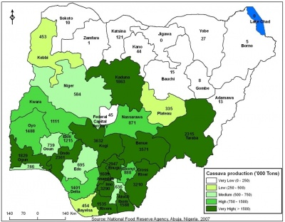

Figure 2. 1: Cassava Production in Nigeria

Source: National Food Research Agency, Abuja, Nigeria. 2007

### 2.8. Review of Literature on SCMs

Some examples of Natural pozzolans that utilized in Portland cement concrete are rice husk ash (RHA), cow bone ash (CBA), cassava peel ash (CPA), sugarcane bagasse ash (SBA), bamboo leaf ash (BLA), and sawdust. The research findings on supplemental cementitious materials (SCMs) utilized in cement concrete are summarized in the following paragraphs.

Falade, *et al.,* (2012) showed that bones that are pulverized have some pozzolanic properties. The

Through his examination, the researcher proved that crushed bones are pozzolanic. The study found that as long as the replacement level doesn't go above 20%, they are perfect for use as a partial replacement for cement in concrete without sacrificing strength.

An experimental examination on the usage of Bamboo Leaf Ash (BLA) as a cement substitute in concrete was conducted by Umoh and Ujene (2014). According to the study, the inclusion of BLA reduced voids and decreased permeability in the concrete. The compressive strength of the concrete was decreased by the addition of BLA, while the tensile splitting strength of BLA mixed cement concrete cubes increased with curing time but decreased as BLA percentage increased.

Abdulfatai and Lawal (2014) worked on “Partial replacement of cement with rice husk ash (RHA) as filler in asphalt concrete design”. Through experimental tests, the researcher was able to prove that the Rice husk ash used in the study is pozzolanic and of class C, with a total concentration of silica, aluminum, and iron oxides of 69.96 percent. According to the Marshall Stability test, a replacement rate of 10% is ideal. The Asphalt Institute's standards were met by this.

According to Arabani *et al.,* (2016), rice husk ash (RHA), a waste byproduct of rice milling, has significant advantages when used in bituminous highways and pavement, including lowering construction costs and conserving natural resources. There isn’t many research on the usage of this component in asphalt mixtures, though.

Olutoge and Oladunmoye (2017) studied “Bamboo Leaf Ash (BLA) as Supplementary Cementitious Material”. The study demonstrated that BLA had pozzolanic qualities and showed that using BLA as a substitute material for OPC at a percentage of 10–20% enhanced the concrete's workability. However, the researcher observed an increase in the concrete's setting time as the amount of BLA used increased. According to the researcher, BLA might be used to reduce the price of concrete and alleviate environmental concerns that could result from the improper disposal of bamboo leaves.

Okeyinka *et al.,* (2018) investigation on the "durability performance of cow bone ash blended cement (CBABC) concrete in a hostile environment." The researcher comes to the conclusion that CBABC, or cow bone ash blended cement, has the most capability for usage in hostile conditions, particularly those that are subject to hydrochloric acid. CBABC has a 10 percent replacement of cow bone ash content. The findings of this study imply that in regions where hydrochloric acid (HCl) is available, the novel 10 percent CBABC concrete mix could be employed as a long-lasting substitute for conventional Grade C25 Concrete mixes.

Ikumapayi and Arum (2019) demonstrated that adding sugarcane bagasse ash to substitute some of the conventional Portland cement produced concrete with better compressive strength and little changes to shrinkage after curing. A 12% mix substitution of sugarcane bagasse ash for ordinary Portland cement was reported to be ideal.

According to Ashraf and Doh (2020), the mixtures with the highest compressive strengths were those containing 5 percent egg shell ponder and 30 percent or 40 percent fly ash, respectively. The study's findings suggest that using green elements in place of cement can produce concrete with great strength while using up to 45 percent less cement overall.

Mohiey *et al* (2020) have produced a report on "The Performance of Hot Asphalt Mixes and the Effect of Rice Husk Ash." The researchers came to the conclusion that adding RHA decreased the amount of rutting that was created in the asphaltic concrete, with a 50% RHA replacement being deemed the best because it developed the highest Marshall Test value. The results showed that RHA addiction improved the dynamic modulus and flow values.

Balogun and Otunola, (2021) worked on using yam peel ash to replace traditional cement in concrete and came to the conclusion that the best compressive strength of the blended concrete was witnessed for a mix ratio of 1:3:6 at 5% yam peel ash (YPA) replacement while the best flexural strength discovered was at a mix ratio of 1:2:4. The outcome also showed that the density of the test specimens of the blended concrete did not significantly change as the percentage of YPA substitution of cement increased.

## 2.9 Summary of Existing Literature

Due to the (Atoyebi *et al.,* 2020) increasing destruction of the present and future environment, academics and engineers have grown interested in concrete sustainability. Various studies have recently been undertaken to improve concrete in order to make it safer and more capable of performing more particular tasks Atoyebi *et al.,* (2020). Cassava peel ash is pozzolanic, and the longevity of concrete structures is always impaired by a reaction known as alkaline silica reaction, according to a study (Santos, *et at.,* 2020; Adanikin *et al*, 2019; Chatterji, 2005). To reduce the likelihood of alkaline silica reactions in concrete, many supplementary cementitious materials have been utilized, including rice husk ash, wood ash, sugar cane bagasse ash, cow bone ash, sawdust ash, egg shell ash, and others. It has also been suggested to use cassava peel ash as SCM in concrete. Foroughi *et al.,* (2012) proposed that replacing a proportion of Portland cement with natural pozzolan in concretes should be explored in minimizing expansion potentials and therefore addressing the occurrence of alkaline silica reactions. More research is needed on ways to avoid Alkaline Silica reactions in concrete utilizing cassava peel ash, as well as the thermal and mechanical qualities of the final concrete. As a result, the current researcher thinks it is crucial to look at how well using cassava peel ash in concrete works to lessen alkaline silica interactions.

# CHAPTER THREE

# 3.0 METHODOLOGY

## 3.1 Description of the study area

Research area is Omu-Aran in Kwara State, which is located in the country's North Central geopolitical zone.

## 3.2 Collection of Materials

Th peel used was sourced as waste from a local processing company in Omuaran, Kwara State, Nigeria, where a variety of conventional cassava food varieties are currently created for consumption (such as gari, fufu, starch, Abacha, and so on). The peels subsequently air dried before being burned at 750°C to ashes. As shown in Plates 3.1 to 3.5, the clinker was grinded and sieved in the lab using a sieve number 200 (0.075mm).

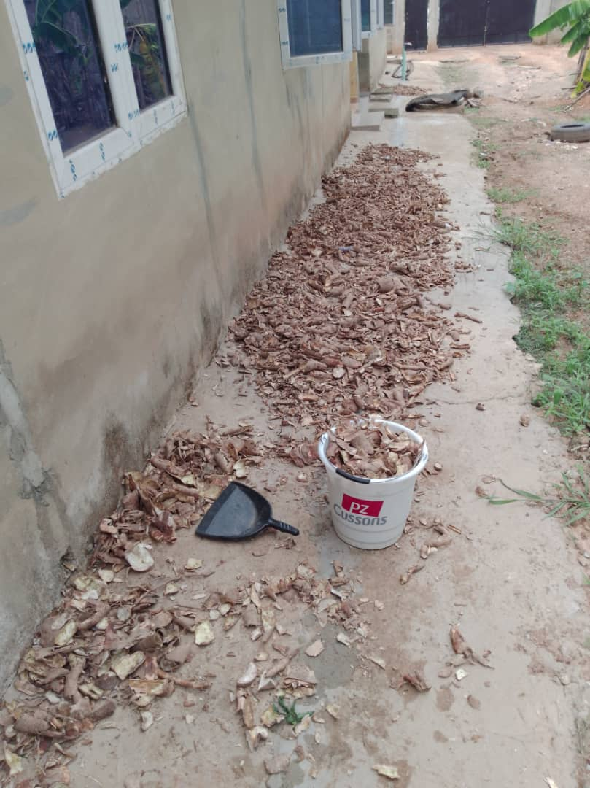 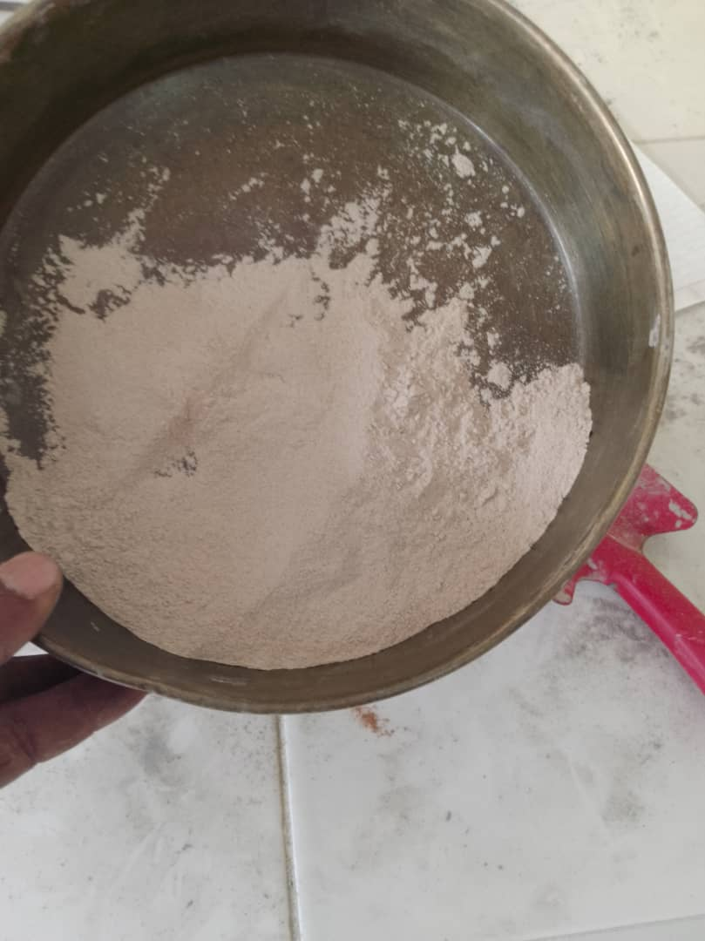

Plate 3. 1: cassava peels Plate 3. 2: Cassava peel ash

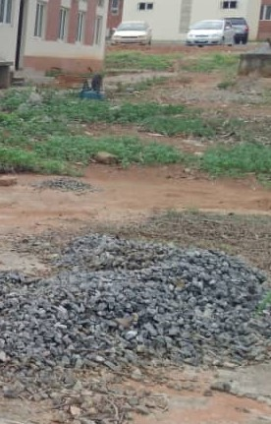 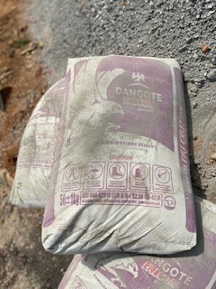 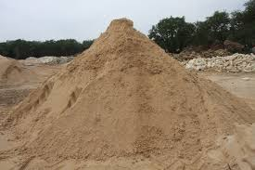

Plate 3. 3: Coarse aggregate Plate 3. 4: Bag of cement Plate 3. 5: Fine aggregate

Table 3. 1: Properties of Materials used

|  |  |
| --- | --- |
| **Material** | **Size (mm)** |
| Fine aggregate | <4.75 |
| Coarse aggregate | 5-20 |
| Cement | <0.075 |
| Cassava Peel Ash | <0.075 |
| Water cement ratio | 0.65 & 0.7 |

Table 3. 2: Properties of Dangote 3x 42.5R Portland cement

|  |  |  |
| --- | --- | --- |
| **S/N** | **Properties** | **Characteristic Value** |
| a. | Slump test | 40 mm |
| b. | Compressive Strength:   1. 7 days 2. 14 days 3. 21 days 4. 28 days | 16.89 N/mm2  18.14 N/mm2  21.78 N/mm2  22.06 N/mm2 |

**Source: Bamigboye *et al*. (2015).**

The typical chemical composition of Dangote 3X 42.5R Portland cement which makes it suitable for use in this study is displayed in Table 3.3.

Table 3. 3: Chemical Composition of Dangote 3x 42.5R Portland cement

|  |  |  |
| --- | --- | --- |
| **S/N** | **Chemical Composition** | **Characteristic Value (%)** |
| a. | K2O | - |
| b. | Na2O | - |
| c. | TiO2 | - |
| d. | P2O5 | - |
| e. | MnO | 1.0 |

**Source: Bamigboye *et al.,* (2015)**

## 3.3 Experimental Design

Table 3.4 below provides the study's experiment design.

**Table 3. 4**: Experimental Design (1:1:2 Mix Ratio)

**CODE CPA CEMENT FINE SAND GRAVEL REPLICATES**

**(%) (%)**

B0 0 100 1 2 3

B5 5 95 1 2 3

B10 10 90 1 2 3

B15 15 85 1 2 3

B20 20 80 1 2 3

B30 30 70 1 2 3

## 3.4 **Experimental Methods**

Water and other concrete ingredients were weighed out in accordance with the 1:1:2 mix ratio. The tests on the concrete control samples were then done. The concrete was then amended by simply substituting some of the cement with Cassava Peel Ash, ranging from 0% to 30% at a 5% interval (CPA). The amended concrete underwent workability (slump), water and acid solubility testing, split tensile tests, compressive strength - cube tests, and thermal property tests. Table 3.5 lists the numerous laboratory tests performed as well as the standards used in this investigation.

Table 3. 5: Laboratory Tests Conducted on materials used

|  |  |
| --- | --- |
| **Material/ Combination** | **Laboratory Test – Standard** |
| Materials used | * Sieve Analysis (Sand only) - BS 812 (1985) * Fineness test (Cement and CPA) * Initial and final setting time (Cement only) * Chemical Analysis (CPA and Cement) * Specific Gravity (Cement, CPA, sand, and coarse aggregate) * Moisture content test (fine aggregate only) * Silt content test (fine aggregate only) |
| Control Sample | * Workability (Slump test) * Water absorption test * Compressive Strength, cube tests (7th, 14th, 21st, and 28thdays) – BS 1881 (2016) * Thermal properties test, (28th days) - ASTM C78M (2018) * Electrical Resistivity - ASTM C1760 (2012) * Water and Acid Solubility - ASTM C1152 (2012) * Accelerated Mortar Bar Test (AMBT) - ASTM C1260 (2009) * Scanning Electron Microscopy (SEM) – ASTM C1723 (2016) |

**Table 3.5: Laboratory Tests Conducted on materials used Continues**

|  |  |
| --- | --- |
| Resulting concrete | * Workability (Slump test) * Compressive Strength, cube tests (7th, 14th, 21st, and 28th days) – BS 1881 (2016) * Thermal properties test, (28th days) - ASTM C78M (2018) * Electrical Resistivity - ASTM C1760 (2012) * Water and Acid Solubility - ASTM C1152 (2012) * Accelerated Mortar Bar Test (AMBT) - ASTM C1260 (2009) * Scanning Electron Microscopy (SEM) – ASTM C1723 (2016) |

## 3.5 Sample Production

The coarse aggregate was then introduced and mixed using manual method until a thoroughly dispersed mixture with the fine sand and cement in the mixing pan were obtained. Finding the weights of 5%, 10%, 15%, 20%, and 30% and combining them appropriately to produce concrete samples. A specific amount of water added to the item that had already been blended. In total, 180 samples with labels were created. Three samples were tested from each mix design after 7, 14, 21, and 28 days of curing. Cassava Peel Ash was not used in the control group (0%). (CPA). The water-cement ratio is 0.65, which was raised to 0.7 as the percentage of CPA increased, and the mix ratio is 1:1:2. For easy de-moulding, two sets of molds were lightly treated with used motor oil before the slurry was put into them. The initial mould was 150 x 150 x 150mm in size, and It was tested for split tensile strength and compressive strength. A second mould was used to create 18 samples, each measuring 100mm in diameter and 150mm in length, for the thermal conductivity test. With a steel trowel, the concrete was leveled to the top of the molds after the slurry had been compacted with a tamping rod until no air bubbles were visible on its surface.

## 3.6 Chemical Analysis

Chemical research reveals the principal chemical components found in cassava peel ash and cement, along with their percentage abundance. The chemical study demonstrates how the cassava peel ash's elemental composition can turn it into a pozzolana in the presence of water.

## 3.7 Determination of the effect of Cassava Peel Ash (CPA) on the Mechanical and Chemical Properties of the concrete

Samples put through the following tests.

### 3.7.1 Workability using Slump Test

Cleansing the molds inside surface is followed by four equal levels of fresh concrete being poured over a horizontal, non-absorbent surface while the mold is firmly kept in place. Each one is about a quarter of the mold's height. Each layer tampers 25 times with a tamping rod that evenly distributes the strokes across the mold's cross-section. The tamping rod penetrates the underlying layer for the second and succeeding layers. The excess concrete is brushed out above the concrete cone with a tampering rod or a trowel. The vertical height of the cone (h1) is measured, and the cone is removed vertically slowly, and cautiously. As soon as the cone is removed, the concrete starts to sink vertically. The height of the cone (h2) is measured by placing the steel scale horizontally above the top of the settled concrete. The value of slump is calculated as the difference between two heights (h1-h2).

### 3.7.2 Determination of water Absorption test

The samples were shook to eliminate excess water, and then immediately dried with a cloth until no free water was left on the surface. Following that, the specimens were reweighed, and Equation 3.4 was used to calculate the percent water absorption for each specimen.

Percentage water absorption = $\frac{wet weigth \left(W2\right)-dry weight (W3)}{dry weight (W1)}X 100$………………………3.4

### 3.7.3 Determination of bulk density

### The ASTM C29 / C29M - 07 standard was used as a reference when calculating the bulk density.

### 3.7.4 Split Tensile Strength

Three samples were tested in each category, and the average result was recorded. The split tension test was carried out utilizing a digital compression machine with a 2000kN capacity, as shown in Plates 3.6 and 3.7. We used the standard formula in equation 3.5 to get split tensile strength:

Split Tensile strength (MPa) = 2P / π DL …………………………… 3.5

Where, P = Load at failure (kN): D = Diameter of the Sample: L = Length of Sample.

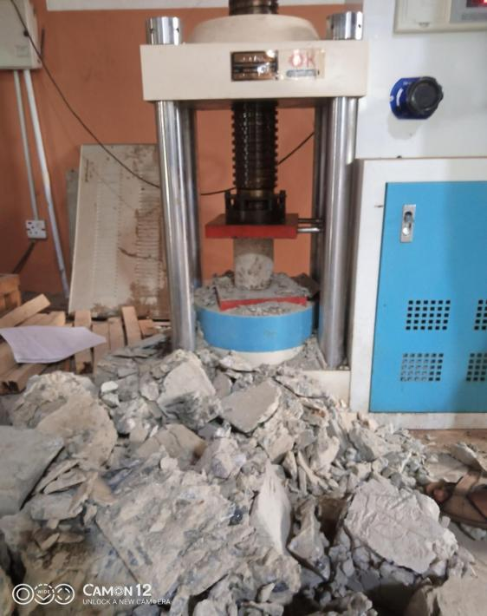 **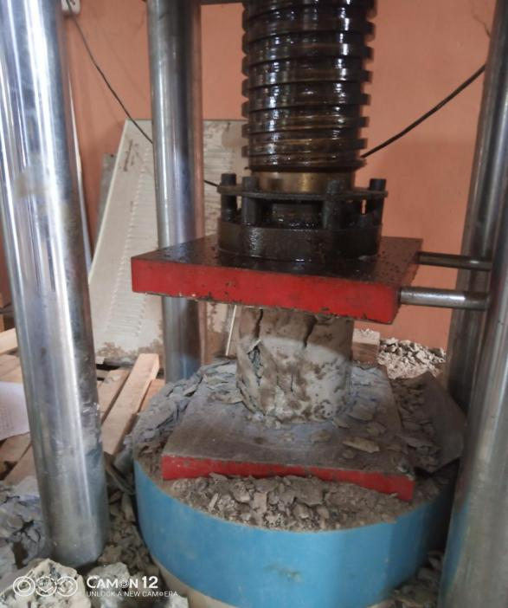**

Plate 3. 6: Cylindrical sample before failure. Plate 3. 7: Split Tensile Test of cylinder sample

### 3.7.5 Compressive Strength - Cube Test

Concrete's compressive strength gauges how well the substance can endure compressive loads (such as traffic). The compressive strength measurements are generally used to assess whether the concrete mixture delivered on-site complies with the task specifications stated in the project's planning. The compressive strength of 150mm concrete cubes was evaluated by applying a 3.0 KN/s compression force following BS 1881: Part 111. (1983). The concrete samples' weight (kg), density (kg/m3), and crushing load (KN) were determined, and the compressive strength (N/mm2) was calculated. Before evaluating the density of each concrete cube, the weight of each cube was determined. This was completed following BS 1881: Part 114: 1983.

Cubic test specimens with dimensions of 150mm x 150mm x 150mm are used. The test specimens were built so that the concrete was completely compressed after mixing, without segregation or undue laitance. Plates 3.8 and 3.9 show the compressive testing machine and the procedure.

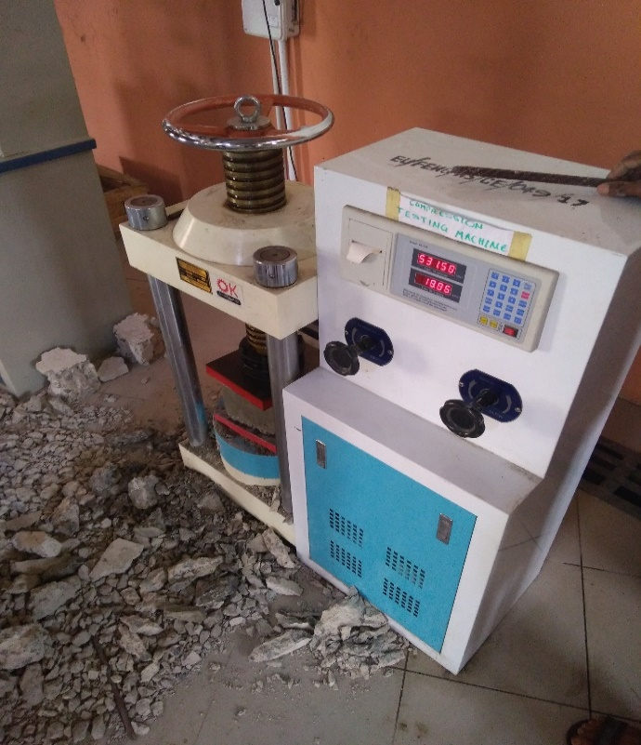

Plate 3. 8: Universal Testing Machine (Digital Okhard 2000kN) Used for Testing Concrete Strength

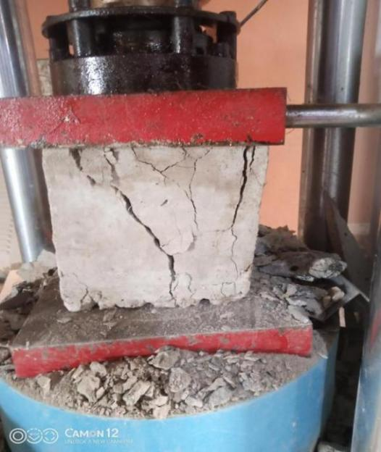

Plate 3. 9: Crushing of Concrete Samples

### 3.7.6 Water and Acid Solubility Test

The test primarily aids in determining how chlorides present in aggregates and cement might be lowered, resulting in structural weakness and concrete's life expectancy being shortened. Additionally, it will assess the conductivity of a concrete sample to evaluate how impermeable the concrete is to chloride ions and how the inclusion of CPA inhibits chloride attacks on the concrete, hence reducing ASR (ASTM C1152). The samples' percentage solubility (the percentage of solute dissolved in the solvent) was calculated using the formula in equation 3.5.

$$Percentage Solubility \left(\%\right)=\frac{\left(Wdb – Wda\right)}{ Wda} equation 3.5$$

The equipment utilized for the test, as well as the process for performing the water and acid solubility test, are shown in Plates 3.10 to 3.13.

|  |  |  |
| --- | --- | --- |
|  | |  |
| **Plate 3. 10: Dissolution of Concrete Samples in Acid** | | Plate 3. 11: Filtering of Samples |
|  |  | |
| **Plate 3. 12: Weighing of Samples** | Plate 3. 13: Weighing of Samples | |

## 3.8 Thermal Conductivity

The k-value, or thermal conductivity (W/m°C), is among the crucial properties to consider when determining whether a substance may be used as a thermal insulator. Using the guarded hot plate technique, the thermal conductivity of cylindrical block samples was assessed. This technique requires that the guarded hot-plate equipment be used in a steady-state setting (controlled environment).

The test was conducted on the 28th day of curing by vertically stacking the cylindrical block samples (see Plate 3.14), which resulted in a thin wall that could pass through the hot-plate chamber's entrance using the general equation shown in equation 3.6 provided by Fourier's law.

Qo = -kA ----------- 3.6

Qo = Rate of heat transfer

T1 = Temperature of the heating chamber

T2 = Temperature of the sample after 1 hour

K = Thermal conductivity (w/mk)

P = Power supplied to the heating chamber = (watts)

dx = Thickness of sample (m)

A = Cross sectional Area (m2) = 7.85 10-3m2

dT = T1 - T2

R = radius of the cylindrical specimen = 50mm

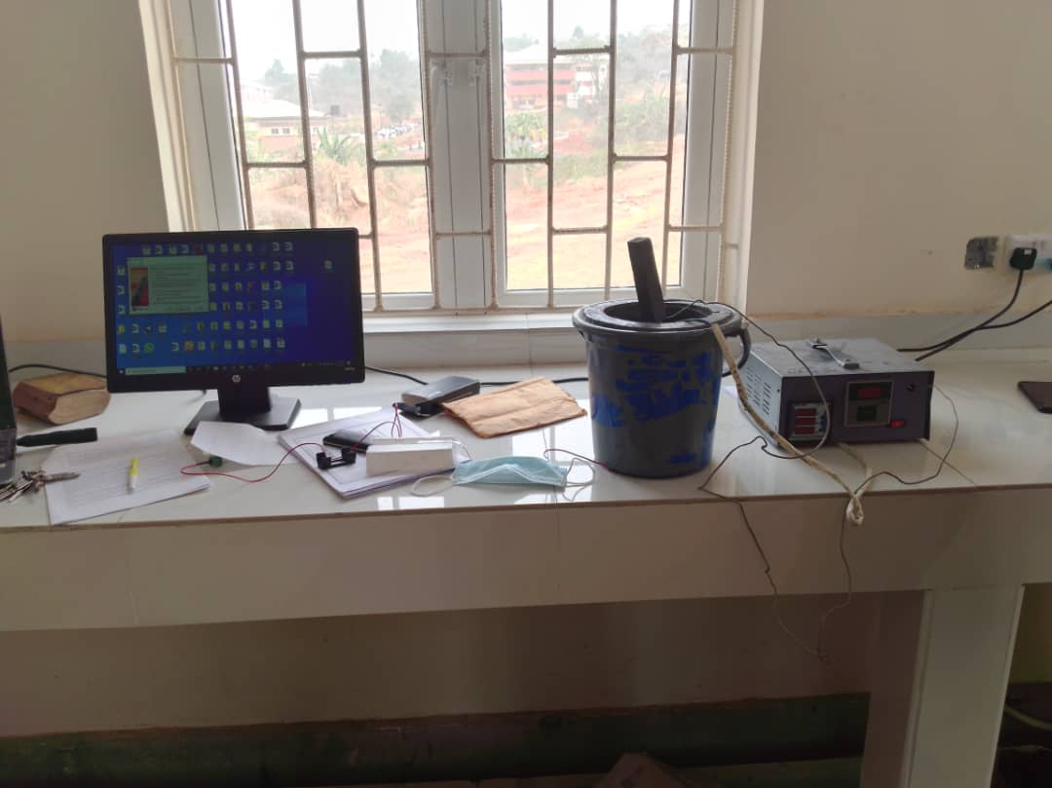

Plate 3. 14: Arrangement of sample into the guarded hot plate plugged with the stabilizer

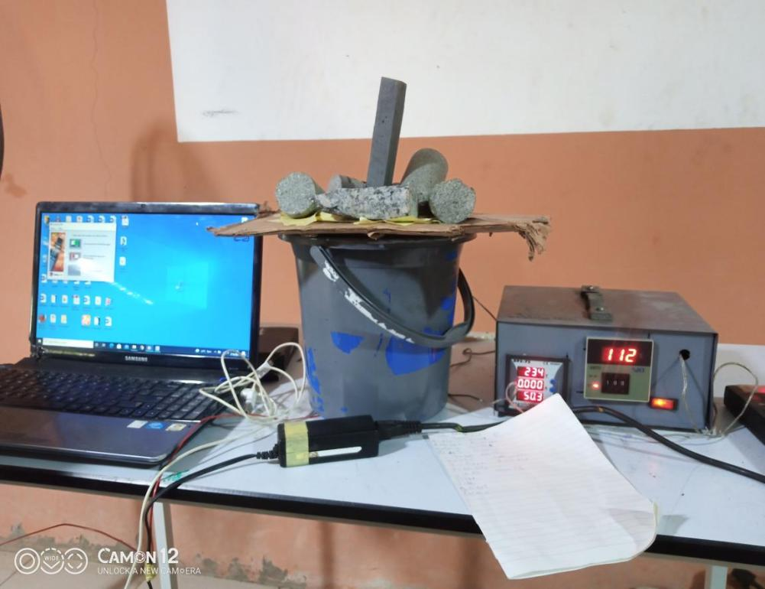

Plate 3. 15: Guarded hot plate set up

### 3.8.1 Thermal diffusivity

The quantity of heat that moves over a unit area of a layer with a unit thickness and a unit temperature difference between its faces in a unit amount of time generates a change in temperature in the material's unit volume, which is measured by thermal diffusivity.

A = $\frac{k}{ρc_{p}}$……………………… 3.7

### 3.8.2 Specific Heat Capacity

Equation 3.8 was used to estimate the specific heat capacity

Q = mCpT 3.8

Q = Energy (J)

m = mass (kg)

$∆$ T = Temperature difference

Qo = Rate of heat transfer

Because of this, the specific heat describes how much energy must be delivered to a unit mass in order to boost the temperature by a unit. Thus, it evaluates a material's capability for internal energy storage (thermal energy).

### 3.9 Accelerated Mortar Bar Test (ASTM C1260)

The experiment was conducted by creating three samples for each of the CPA replacement percentages. On the 7th, 14th, and 28th days, dial readings of the elongation were collected and compared to the permitted standards for concrete expansion. Plates 3.15 to 3.20 depict the AMBT test's equipment, experimental setup, and procedure.

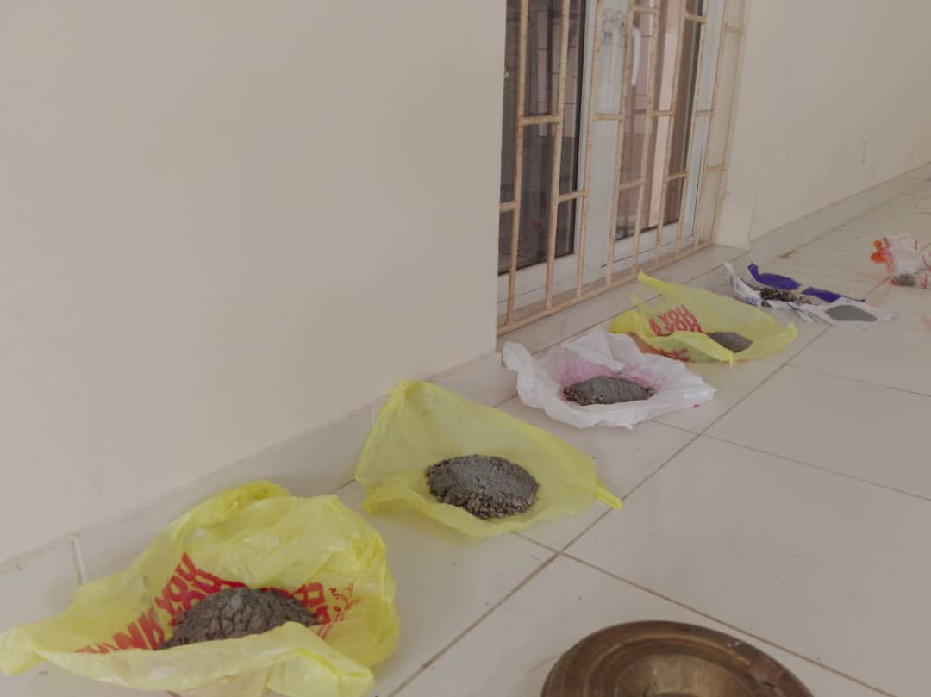

Plate 3. 16: Batching of materials for AMBT test at varying % of CPA Addition

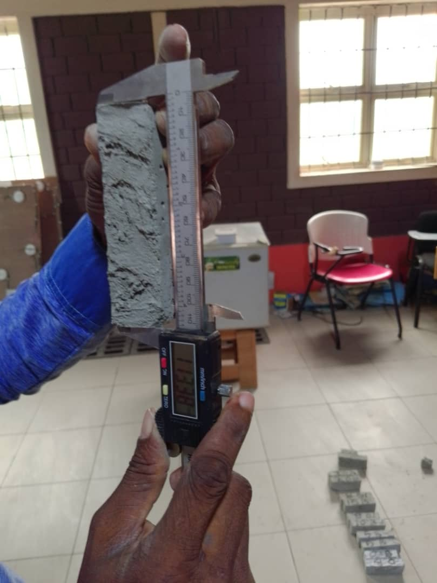

Plate 3. 17: Measurement of the Length of Concrete Samples for AMBT

|  |  |  |  |
| --- | --- | --- | --- |
| C:\Users\user\Desktop\20190119_110400.jpg | |  | |
| Plate 3. 18: Weighing of Concrete Samples Before Immersion in 100g of NaOH | | Plate 3. 19: Immersion of Concrete Cubes in 100g of NaOH | |
|  |  | |
| **Plate 3. 20: Samples in Oven at 800C for days** | Plate 3. 21: oven used for the experiment | |

## 3.10 Electrical Resistivity

Concrete's long-term durability can be affected by how quickly pore structures form in it. Additionally, the tensile strength of cementitious materials is weak during a young age, and the substance is vulnerable to cracking. As a result of this initial breach, dangerous substances can enter the matrix. This cracking can be identified using resistivity tests, which helps determine how long concrete will last. Additionally, the concrete's moisture content and the connection of its micropores can be assessed using electrical resistance. This test will employ the Vertical Electrical Sounding (VES) technique and an electrical resistivity meter.

The equipment, experimental setup, and process for the electrical resistivity test are shown in Plates 3.21 to 3.23.

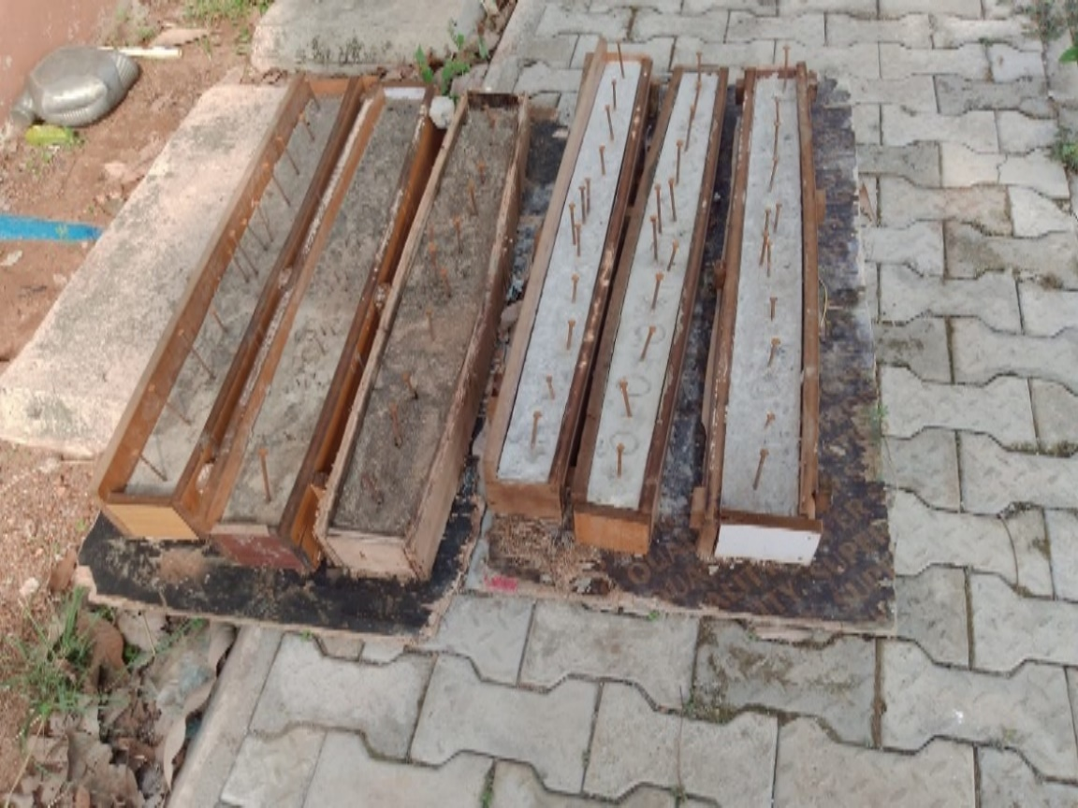

Plate 3. 22: Cast Concrete with electrodes

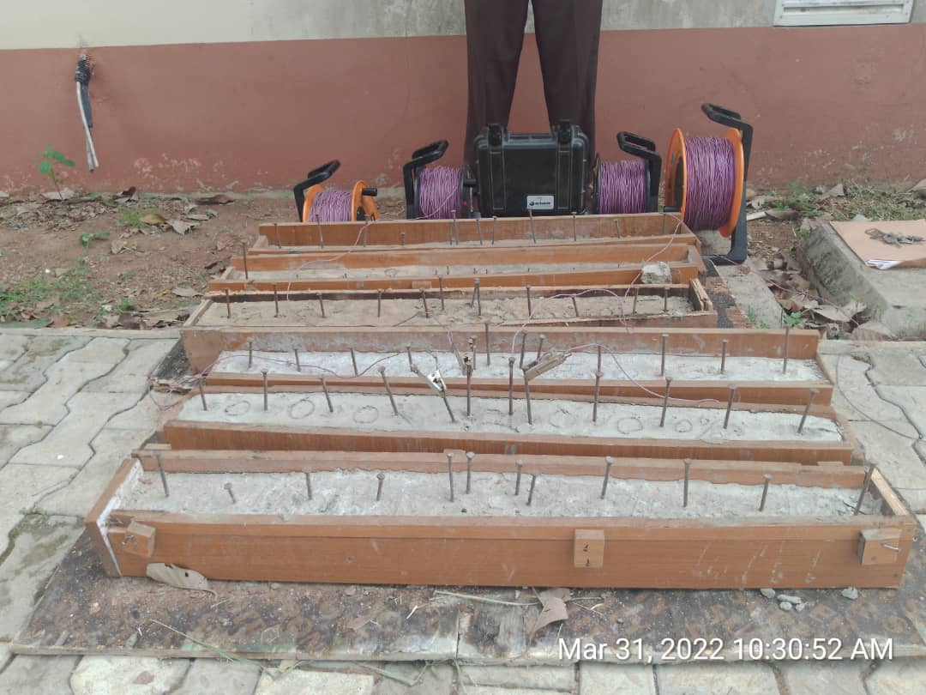

Plate 3. 23: Experimental setup for electrical resistivity

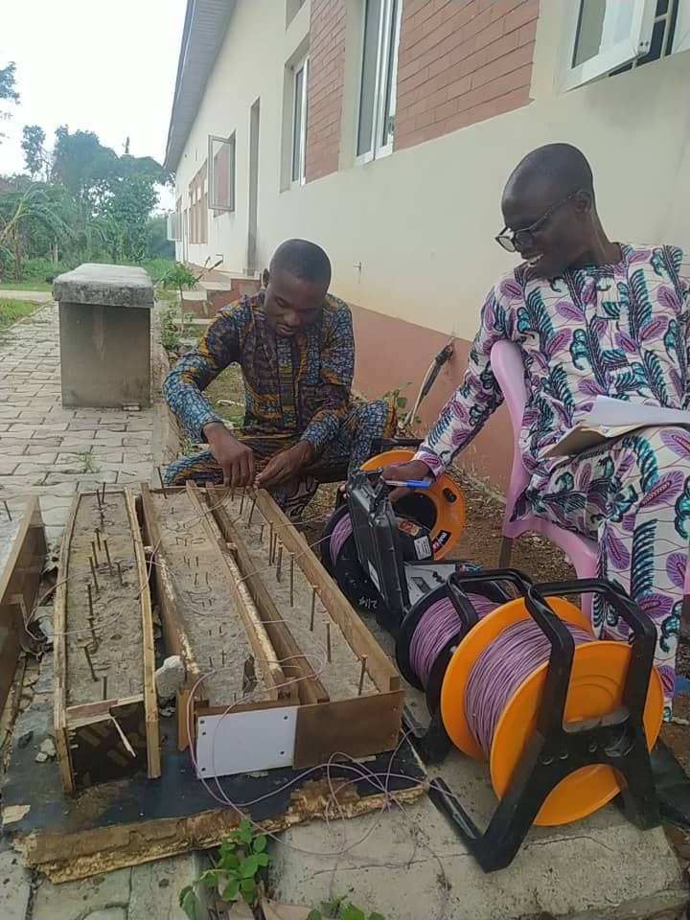

Plate-3. 24: Experimental setup for Electrical Resistivity

## 3.11 Scanning Electron Microscopy – Secondary Electrons (SEM-SE) Analysis

The SEM-SE is used to identify and image submicroscopic characteristics, as well as to determine the causes of concrete failure that could be attributed to ASR. SEM-SE examination is also utilized to identify unknown materials/deposits, evaluate corrosion products, and examine surface contamination and staining. The test method is shown in Figure 3.1.

**Figure 3. 1: Procedure for Scanning Electron Microscopy (SEM) analysis of concrete samples**

**Table 3. 6**: **Mix Proportion of Constituent Materials for Each Sample (Compressive Cube Test)**

|  |  |  |  |  |  |
| --- | --- | --- | --- | --- | --- |
| **Constituent Materials** | | | | | |
| **Mix ID** | **Water**  **(Kg)** | **Cement**  **(Kg)** | **CPA**  **(Kg)** | **Sand**  **(kg)** | **Coarse Aggregate (Kg)** |
| B0 | 10.80 | 18 | 0 | 18 | 36 |
| B5 | 10.80 | 17.10 | 0.9 | 18 | 36 |
| B10 | 10.80 | 16.20 | 1.8 | 18 | 36 |
| B15 | 10.80 | 15.30 | 2.7 | 18 | 36 |
| B20 | 13.30 | 14.40 | 3.6 | 18 | 36 |
| B30 | 13.30 | 12.60 | 5.4 | 18 | 36 |
| **Total** | **69.80** | **93.60** | **14.40** | **108.00** | **216.00** |

Cube mould size = 15cm × 15cm × 15cm

Volume of mould = 0.15m × 0.15m × 0.15m = 3.375 X 10-3 m3

Total number of cubes per sample = 90 samples

**Table 3. 7:** **Mix Proportion of Constituent Materials for Each Sample (Accelerated Mortar Bar Test)**

|  |  |  |  |  |  |
| --- | --- | --- | --- | --- | --- |
| **Constituent Materials** | | | | | |
| **Mix ID** | **Water**  **(Kg)** | **Cement**  **(Kg)** | **CPA**  **(Kg)** | **Sand**  **(kg)** | **Coarse Aggregate (Kg)** |
| B0 | 0.09 | 0.15 | 0 | 0.15 | 0.3 |
| B5 | 0.09 | 0.143 | 0.007 | 0.15 | 0.3 |
| B10 | 0.09 | 0.135 | 0.015 | 0.15 | 0.3 |
| B15 | 0.09 | 0.128 | 0.023 | 0.15 | 0.3 |
| B20 | 0.11 | 0.120 | 0.030 | 0.15 | 0.3 |
| B30 | 0.11 | 0.105 | 0.045 | 0.15 | 0.3 |
| **Total** | **0.580** | **0.780** | **0.120** | **0.900** | **1.800** |

The mix proportion for the constituent materials for each mixed sample for the electrical resistivity test is presented in Table 3.8.

**Table 3. 8:** **Mix Proportion of Constituent Materials for Each Sample (Electrical Resistivity Test)**

|  |  |  |  |  |  |
| --- | --- | --- | --- | --- | --- |
| **Constituent Materials** | | | | | |
| **Mix ID** | **Water**  **(Kg)** | **Cement**  **(Kg)** | **CPA**  **(Kg)** | **Sand**  **(kg)** | **Coarse Aggregate (Kg)** |
| M1 | 4.80 | 8.00 | 0 | 8 | 16 |
| M2 | 4.80 | 7.60 | 0.4 | 8 | 16 |
| M3 | 4.80 | 7.20 | 0.8 | 8 | 16 |
| M4 | 4.80 | 6.80 | 1.2 | 8 | 16 |
| M5 | 5.60 | 6.40 | 1.6 | 8 | 16 |
| M6 | 5.60 | 5.60 | 2.4 | 8 | 16 |
| **Total** | **30.40** | **41.60** | **6.40** | **48** | **96** |

## 3.12 Statistical Analysis

The experiment for this study was made using Design-Expert software, version 10.0.8. The response surface methodology's Central Composite Designs (CCD) were employed for this investigation since their designs accommodated and suited the experimental technique required to accomplish a 2-level experiment with a sufficient array.

# CHAPTER FOUR

# 4.0 RESULTS AND DISCUSSION

## 4.1 Result of various tests on Cement

The following are the findings of several tests performed on the cement used.

### 4.1.1 Result of Elemental Oxide Composition

Table 4.1 shows the elemental oxide content of the typical Portland cement utilized in the investigation.

Table 4. 1: Elemental Oxide Composition of Selected Cement Sample

|  |  |
| --- | --- |
| Elemental Oxide | Weight Detected (%) |
| SiO₂ | 20.76 |
| Fe₂O₃ | 4.35 |
| Al₂O₃ | 5.83 |
| CaO | 62.89 |
| MgO | 1.42 |
| SO₃ | 2.00 |
| K₂O | 1.61 |
| Na₂O | 1.03 |
| Al₂O₃ + Fe₂O₃ | 10.18 |
| SiO₂ + Fe₂O₃ + Al₂O₃ | 30.94 |
| SiO₂ + Fe₂O₃ + Al₂O₃ + CaO | 93.83 |

### 4.1.2 Setting Time of Cement

Table 4.2 below summarizes the findings of the initial and final cement setting times.

Table 4. 2: Setting time result for cement

|  |  |  |  |  |  |
| --- | --- | --- | --- | --- | --- |
| **S/N** | **Determination No:** | **1st trial** | **2nd trial** | |  |
| 1 | Time when water is introduced to the cement | 5 min | 5 min |  |  |
| 2 | Time at the initial setting | 50 min | 40min |  |  |
| 3 | Total time is taken for the initial setting | 55 min | 45 min |  |  |
| 4 | **Initial Setting Time** | **50 min** | |  |  |
| 5 | Time at final setting time | 450min | 480min |  |  |
| 6 | Total time is taken for the final setting | 455min | 485 min |  |  |
| 7 | **Final setting time** | **470 min (7hrs, 50 min)** | | |  |
| 8 | Expected results | Min. 5hrs and Max. 10hrs | | |  |
| 9 | Comment | It is okay since it is less than 10hrs | | | |

Because the cement's initial and final setting times were less than 10 hours, the setting time was satisfactory**.**

### 4.1.3 Fineness Test

Table 4.3 below displays the results of the fineness test.

Table 4. 3: Result of fineness test on cement

|  |  |  |
| --- | --- | --- |
| **Observation** | **First Trial** | **Second Trial** |
| Weight of sample before the experiment (g) | 100 | 100 |
| Weight of sample before the experiment (g) | 4.5 | 4.2 |
| fineness (%) | 4.5 | 4.2 |
| **Average fineness (%)** | **4.35** |  |
| Expected values | It must be less than 10% | |
| Comment | Passed |  |

The result was less than 10%, indicating that the cement fineness test was successful.

## 4.2 Test on Cassava Peel Ash (CPA)

The elemental oxide makeup of the cassava peel ash used in the experiment is displayed in Table 4.4. Silica, Aluminum Oxide (Al2O3), and Iron Oxide (Fe2O3) have a combined percent composition of more than 70. This demonstrates that it is an excellent pozzolan that can aid in the synthesis of cementitious compounds from cement hydration reaction products.

Table 4. 4: Geochemical Analysis Result (Elemental Oxide Composition) of CPA Sample

|  |  |
| --- | --- |
| **Elemental Oxide** | **Weight Detected (%)** |
| SiO₂ | 54.86 |
| Fe₂O₃ | 11.14 |
| Al₂O₃ | 11.42 |
| CaO | 9.30 |
| MgO | 4.74 |
| SO₃ | 1.00 |
| K₂O | 3.56 |
| Na₂O | 2.18 |
| SiO₂ + Fe₂O₃ + Al₂O₃ | 77.42 |

## 4.3 Result of various tests on Fine aggregate Used

### 4.3.1 Silt Content Test for the Fine Aggregate

Table 4.5 displays the findings of the fine aggregate silt content test. The outcome reveals that the fine aggregate contains 3.5 percent silt, which is below the 6 percent maximum limit advised by BS 812-103.2 (1985) and hence suitable for the study. As a result, silt cannot be a source of concrete faults. The formula in equation 4.1 is used to calculate the silt content.

Table 4. 5: Silt Content Test for the Fine Aggregate

|  |  |  |
| --- | --- | --- |
|  | **First Trial** | **Second Trial** |
| Height of sand in the 250ml cylinder (mm) | 100 | 100 |
| Height of silt (mm) | 3.00 | 4 |
| Silt/clay content (%) | 3.0 | 4 |
| **Silt/clay content (%)** | **3.5** | |

Silt Content = $\frac{Height of silt }{Height of sand}$\* 100 equation 4.1

First trial = $\frac{3.0}{100}$\* 100 = 3%

Second trial = $\frac{4}{100}$\* 100 = 4%

$\frac{Trial 1 + Trial 2 }{2}$ = $\frac{3.0+4 }{2}$ = 3.5%

### 4.3.2 Moisture Content Test for the Fine Aggregate

Table 4.6 displays the findings of the fine aggregate moisture content test. The outcome demonstrates that 18% moisture is present in the fine aggregate. The formula in equation 4.2 is used to compute the moisture content.

**Table 4. 6:** **Moisture Content Test for the Fine Aggregate**

|  |  |  |
| --- | --- | --- |
| Sample | A (g) | B (g) |
| M1 | 34 | 34 |
| M2 | 184 | 184 |
| M3 | 160 | 162 |
| Ms | 126 | 128 |
| Mw | 24 | 22 |
| Water content (%) | 19% | 17% |

### 4.3.3 Sieve Analysis Result for Fine Aggregate

Table 4.7 displays the result for fine aggregate. The 950 grams of dry soil used in the experiment was sampled. According to AASHTO, the sand is categorized as A-1-b, meaning that, when properly drained, it can be used as a subgrade or subbase material. Particle size uniformity is essential to prevent voids and keep concrete workable. Equations 4.3 and 4.4's formulas are used to calculate the Cu and the CC respectively.

Cu = equation 4.3

Cc = equation 4.4

Table 4. 7: Sieve Analysis Result for Fine Aggregate

|  |  |  |  |
| --- | --- | --- | --- |
| Sieve Diameter (mm) | Soil Weight Retained (g) | Soil Retained (%) | Soil Passing (%) |
| 4.75 | 90.0 | 9.5 | 90.5 |
| 2.00 | 162.0 | 17.1 | 73.5 |
| 0.85 | 250.7 | 26.4 | 47.1 |
| 0.43 | 285.0 | 30.0 | 17.1 |
| 0.25 | 89.0 | 9.4 | 7.7 |
| 0.75 | 60.0 | 6.3 | 1.4 |
| Pan | 13.3 | 1.4 | 0.0 |
| Total | 950 | 100 |  |

Figure 9 depicts the particle size distribution curve for the study's fine aggregates.

Figure 4. 1: Particle Size Distribution Curve.

## 4.4 Test on Coarse aggregate

Table 4. 8: Specific Gravity Test for Cement

|  |  |  |
| --- | --- | --- |
| Description | 1st Trial (g) | 2nd Trial (g) |
| Mass of bottle + stopper (M1) | 295 | 295 |
| Mass of bottle + dry cement (M2) | 305 | 305 |
| Mass of bottle + cement + water (M3) | 536.71 | 536.78 |
| Mass of bottle filled with water (M4) | 530 | 530 |

Result: Calculation for the specific gravity

G = $\frac{M2-M1}{\left(M2-M1\right) -(M3-M4)}$

For 1st test: G1 = = 3.04

For 2nd test: G2 = = 3.11

Actual Specific Gravity = $\frac{3.04+3.11}{2}$

Actual Specific Gravity = 3.08

**The specific gravity for the Cement = 3.08**

The summary graph for the specific gravity of the concrete constituents is shown in Figure 4.2.

Figure 4. 2: Summary Graph for Specific Gravity of Concrete Constituents

The results for the different constituent materials' specific gravities showed that when water is added to concrete, the moisture content of the resulting concrete won't affect its workability and mechanical strength because the constituents of concrete are all heavier than the specific gravity of water, with cement being 3.08 times heavier, as shown in figure 4.2.

## 4.5 Test on Concrete

Compressive strength testing, electrical resistivity testing, accelerated mortar bar testing, and scanning electron microscope (SEM) analysis are among the concrete tests performed.

### 4.5.1 Slump test result

Table 4.12 and figure 4. 3 show the results of the w/c ratio at various CPA content levels. Cassava peel ash has a larger water absorption potential, which could explain this behavior. As a result, additional water may be required, depending on the amount of CPA used, to produce concrete containing CPA.

Table 4. 9: Results of slump test

|  |  |  |
| --- | --- | --- |
| **CPA Replacement (%)** | **Slump (mm)** | **Comment** |
| 0 | 200 | Collapse slump |
| 5 | 130 | Shear slump |
| 10 | 30 | True slump |
| 15 | 10 | True slump |
| 20 | 1 | True slump |
| 30 | 0 | True slump |

**Figure 4. 3: graph of slump test against percentage replacement of CPA**

The discovered workability feature of the concrete matrix shows that as the amount of cassava peel ash in the concrete mixture rises, the slump test value falls, requiring more water to make the mixture more workable. The high-water need is due to the presence of silica and the ash sample's higher surface area. This is because the silica-lime reaction requires more water than the water used in the cement hydration reaction process (Salau *et al.,* 2012).

### 4.5.2 Water absorption result

As can be seen in Figure 4.4 and Table 4.13, the amount of cement that CPA replaces increases the concrete sample's ability to absorb water.

Table 4. 10: Water Absorption Result

|  |  |  |
| --- | --- | --- |
| **CPA Replacement (%)** | **Water Absorption Result (%)** | |
| **7 days** | **28 days** |
| 0 | 0.51 | 2.60 |
| 5 | 0.54 | 2.89 |
| 10 | 0.60 | 3.35 |
| 15 | 0.73 | 3.62 |
| 20 | 0.75 | 4.01 |
| 30 | 1.10 | 4.95 |

**Figure 4. 4: graph of water absorption result**

The findings of the water absorption test shown in figure 4.4 above indicated that adding CPA to the finished concrete increased the water absorption rate because of the pozzolanic nature of cassava peel ash. It was also discovered that as the percentage rises, so does the amount of water absorbed. For both 7 and 28 days, according to the measured amounts of absorbed water, 5 percent CPA cement replacement had the least quantity and 30 percent CPA cement replacement had the most. This corresponds to the findings of (Olatokunbo *et al.,* 2018). With each passing year of cure, the amount of water absorbed increases.

### 4.5.3 Bulk Density

The findings for densities of concrete made with 0 to 30% CPA replacement at intervals of 5% are depicted in table 4.14 and figure 4.5. The densities vary between 2400.10 and 2574.55 kg/m3, indicating normal concretes. Concrete is defined as normal concrete if its density value is not less than 2400 Kg/m3.

**Table 4. 11: Bulk Density Test Results at Varying CPA Percentages and Days**

|  |  |  |  |  |  |  |
| --- | --- | --- | --- | --- | --- | --- |
| **Bulk Density (Kg/m3)** | | | | | | |
|  | **0%** | **5%** | **10%** | **15%** | **20%** | **30%** |
| 7th Day | 2483 | 2400.1 | 2414.19 | 2403.39 | 2480.35 | 2402.2 |
| 14th Day | 2510.05 | 2618.9 | 2419.15 | 2426.12 | 2430.01 | 2409.77 |
| 21st Day | 2522 | 2421.11 | 2500.2 | 2441.65 | 2421.11 | 2405.05 |
| 28th Day | 2574.55 | 2444.03 | 2542.59 | 2409.72 | 2477.78 | 2409.23 |
|  |
|  |

**Figure 4. 5: Variation of Bulk Density of Concrete Cubes (Kg/m3)**

Table 4.14 and Plate 4.5 indicate bulk densities that are all higher than the minimum criteria for ordinary concrete. This further indicates that the aggregate size, the quantity of air captured or purposely absorbed, the density of the aggregate, and not only the amount of binder, control the concrete density.

### 4.5.4 Split Tensile Result

Table 4.15 and Figure 4.6 below show the tensile splitting strength data. Additionally, it was revealed that between 7 and 28 days of curing, 0 percent CPA substitution had the highest tensile splitting strength range, 2.02N/mm2 to 3.31N/mm2, and 30 percent CPA replacement had the lowest, 1.01N/mm2 to 1.48N/mm2. The results of Olatokunbo *et al.,* (2018) likewise revealed this declining tendency in the split tensile strength of CPA-admixed concrete.

Table 4. 12: Split Tensile Result

|  |  |  |  |  |  |  |
| --- | --- | --- | --- | --- | --- | --- |
| **Split Tensile (N/mm2)** | | | | | | |
|  | **0%** | **5%** | **10%** | **15%** | **20%** | **30%** |
| 7th Day | 2.02 | 1.72 | 1.79 | 1.66 | 1.37 | 1.01 |
| 14th Day | 2.16 | 2.03 | 2.29 | 1.61 | 1.52 | 1.31 |
| 21st Day | 2.64 | 2.49 | 2.31 | 2.02 | 1.59 | 1.34 |
| 28th Day | 3.31 | 3.25 | 2.80 | 2.46 | 2.09 | 1.48 |

Figure 4. 6: graph showing result of split tensile test

Based on this performance, a 5–10% cement replacement for CPA can be regarded as the ideal cement replacement for CPA that will increase the serviceability of cement concrete containing cassava peel ash. Concrete's tensile strength is typically regarded as negligible because it is not frequently built to carry loads under tension. Tensile strength is crucial in concrete buildings, however, particularly when it comes to preventing fractures, as Jagadeesh (2017) notes. In many cases, compressive strength is less important for serviceability Limit states than tensile strength.

### 4.5.5 Compressive Strength

The compressive strength of cement-CPA concrete increases over time, regardless of the amount of CPA in the mix. On the other hand, as the CPA concentration increases, the compressive strength decreases. Table 4.16 and Figure 4.6 display the compressive strength findings.

Table 4. 13: Compressive Strength Test Results

|  |  |  |  |  |  |  |
| --- | --- | --- | --- | --- | --- | --- |
| **Compressive Strength (N/mm2)** | | | | | | |
|  | **0%** | **5%** | **10%** | **15%** | **20%** | **30%** |
| 7th Day | 21.27 | 19.23 | 18.86 | 16.61 | 13.54 | 12.01 |
| 14th Day | 23.56 | 21.30 | 20.89 | 18.40 | 15.00 | 13.31 |
| 21st Day | 27.16 | 24.55 | 24.08 | 21.21 | 17.29 | 15.34 |
| 28th Day | 32.72 | 31.50 | 29.01 | 25.55 | 20.83 | 15.48 |

Figure 4. 7: Graph showing compressive strength results

The study's findings, as shown in Figure 4.7, show that all of the concrete cube samples for 0%, 5%, 10%, and 15% CPA replacement passed the necessary compressive strength for grade 25 concrete (M25). The results show that useful strength can be achieved with only a little amount of OPC replaced with CPA. This is further demonstrated by the fact that all compressive strengths obtained with varying degrees of replacement were lower than those produced with 100% OPC. This study also suggests that when less than 15% by weight of cement is employed, CPA can contribute to late strength development. This behavior indicates that CPA has pozzolanic properties.

Furthermore, these data show that up to 15% is adequate, exceeding the ASTM C311-98 standard of 75%. Because the strength values are within acceptable bounds, the study's findings also imply that substituting cement with CPA up to 15% is permissible, which is consistent with those of Salau *et al.,* (2012).

The strength durability performance outcomes degrade as the CPA replacement ratio rises, claim Ogbonna *et al.,* (2020). The findings show that a 5 percent CPA replacement blend gave concrete with a 90-day curing time the best durability. The findings of this study also showed that a CPA replacement rate of 5% is a safe bet.

### 4.5.6 Acid Solubility Test Result

Table 4.17 and Figure 4.8 display the outcomes of water and acid solubility tests on samples of hardened concrete.

Table 4. 14: Percentage solubility of samples in acid

|  |  |  |  |
| --- | --- | --- | --- |
| **Sample** | **Solubility**  **in HNO3 (%)** | **Solubility**  **in HCL (%)** | **Solubility in**  **H2O (%)** |
| 0% | 8.01 | 4.90 | 3.45 |
| 5% | 8.70 | 6.95 | 6.57 |
| 10% | 9.79 | 14.72 | 9.38 |
| 15%  20%  30% | 14.61  15.27  18.93 | 17.30  14.39  12.58 | 9.39  11.84  13.10 |

**Figure 4. 8: Graph showing the result of the water and acid solubility test**

As shown in Figure 4.8, the solubility rate of hardened samples in water and HNO3 differed from that of HCL. Solubility in water and HNO3 increases as CPA quantity increases from 8.01% to 18.93% and 3.45% to 13.10% at 24hours respectively. Solubility in HCL also increased from 0-15% CPA replacement but started declining in value as the replacement level was put above 15% CPA replacement. The rate of solubility is lowest in 0% CPA replacement and experiences high values as CPA replacement was above 10% replacement. The findings reveal that CPA replacement of less than 15% fell within the permissible range and therefore will perform better when expose to acidic conditions or in the event of acidic rain.

## 4.6 Thermal conductivity, Thermal diffusivity, Bulk Density and Specific heat capacity Test Results.

Tables 4.18 and 4.19, and Figure 4.9 show the results of the thermal conductivity test when the samples were exposed to temperatures of 1000C and 3000C.

Table 4. 15: Thermal conductivity, thermal diffusivity, specific heat capacity result at 28 days.

|  |  |  |  |  |  |  |
| --- | --- | --- | --- | --- | --- | --- |
| **Thermal conductivity at 1000c** | | | | | | |
|  | 0% | 5% | 10% | 15% | 20% | 30% |
| I (A) | 0.613 | 0.612 | 0.650 | 0.648 | 0.561 | 0.421 |
| V (v) | 272 | 268 | 240 | 233 | 234 | 227 |
| P (w) | 166.74 | 164.02 | 156 | 150.98 | 131.27 | 95.55 |
| T1 (oC)  T2 (oC)  K (w/m°C) | 100  33  48.21 | 100  31.5  45.75 | 100  32.5  44.16 | 100  30.5  41.51 | 100  27.5  34.60 | 100  36.5  28.75 |
| Cp (kJ/kgK)  (kg/m3)  A (kJ/kg) | 2768  2832  6.25 | 2618  2794.57  6.25 | 2552  2767.40  6.25 | 2406  2758.91  6.25 | 2056  2691  6.25 | 1583  2903.23  6.25 |

Table 4. 16: Thermal conductivity, thermal diffusivity, specific heat capacity result at 28 days.

|  |  |  |  |  |  |  |
| --- | --- | --- | --- | --- | --- | --- |
| **Thermal conductivity at 3000c** | | | | | | |
|  | **0%** | **5%** | **10%** | **15%** | **20%** | **30%** |
| I (A) | 0.608 | 0.624 | 0.589 | 0.550 | 0.489 | 0.556 |
| V (v) | 237 | 231 | 218 | 240 | 238 | 232 |
| P (w) | 150.18 | 144.14 | 128.4 | 132 | 116.38 | 113.99 |
| T1 (oC)  T2 (oC)  K (w/m°C) | 300  38  15.61 | 300  36  10.43 | 300  46  9.66 | 300  41.5  9.76 | 300  47.5  8.81 | 300  41  8.41 |
| Cp (kJ/kgK)  (kg/m3)  A (kJ/kg) | 621  2832  6.25 | 597  2794.57  6.25 | 558  2767.40  6.25 | 566  2758.91  6.25 | 523  2691  6.25 | 463.28  2903.23  6.25 |

Figure 4. 9: Graph showing the thermal properties of the concrete at different temperatures

When compared to the control sample with thermal conductivity of 45.75 w/moC with cassava peel ash incorporation at a temperature rate of 100°C, the average thermal conductivity values conducted for concrete samples with CPA varied from 0% to 30%, as shown in Tables 4.18 and 4.19, and Figure 4.9, improved thermal conductivity performance by gradually lowering the thermal conductivity value from 44.16w/moC (5%) to 28.75w/moC (30 percent). When the sample is heated to 300°C and the thermal conductivity value is gradually reduced from 10.43w/moC to 8.41w/moC, a similar pattern emerges. Higher CPA inclusions, on the other hand, led to lower heat conductivity values. Lower thermal conductivity materials are typically regarded as superior thermal insulators and provide greater building insulation.

## 4.7 Electrical Resistivity Test Using Schlumberger Array Probe Method

As the core voids that allow for gel development and cracking are eliminated, the higher the resistivity of a concrete sample, the higher its strength. The electrical resistivity nodes are depicted in Plate 4.1.

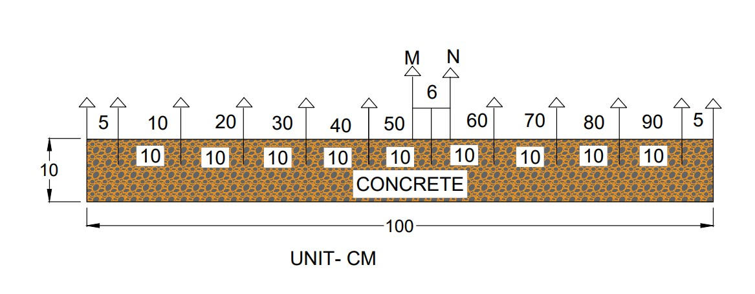

**Plate 4.1: Setup Showing Positioning of Electrodes in the Concrete**

Table 4. 17: Average Resistance Values obtained from the Concrete Cubes

|  |  |  |  |  |  |  |
| --- | --- | --- | --- | --- | --- | --- |
| **Average Resistance (Ohm)** | | | | | | |
|  | 0% | 5% | 10% | 15% | 20% | 30% |
| 1st Day | 15.45 | 36.69 | 81.21 | 48.51 | 26 | 18 |
| 7th Day | 131.48 | 299.14 | 508.8 | 248.74 | 17.02 | 11.99 |
| 14th Day | 91.96 | 143.98 | 246.5 | 84.99 | 15 | 12.02 |
| 21st Day | 69.92 | 131.41 | 235.91 | 65.86 | 13 | 11 |
| 28th Day | 209.35 | 253.45 | 265.50 | 70.43 | 10 | 8 |

**Figure 4. 10: Graph showing electrical resistivity values obtained from the Concrete Cubes**

**Table 4. 18**: **Average Resistivity Values obtained from the Concrete Cubes**

|  |  |  |  |  |  |  |
| --- | --- | --- | --- | --- | --- | --- |
| **Resistivity (ρ) (Ώm)** | | | | | | |
|  | **0% CPA** | **5% CPA** | **10% CPA** | **15% CPA** | **20% CPA** | **30% CPA** |
| 1st Day | 148 | 157 | 310 | 157 | 44 | 39 |
| 7th Day | 174 | 243 | 322 | 169 | 54 | 45 |
| 14th Day | 176 | 280 | 486 | 181 | 63 | 55 |
| 21st Day | 265 | 289 | 518 | 187 | 74 | 56 |
| 28th Day | 321 | 372 | 617 | 281 | 99 | 72 |

Figure 4. 11: graph showing the average resistivity of the concrete cube

After 28 days, concrete cube samples' average resistivity for 0% CPA replacement is 321Ώm, however at 5% CPA replacement, the resistivity rose to 372Ώm, and at 10% CPA replacement, it reached an optimum value of 617Ώm, indicating that CPA addiction at 10% replacement increased the concrete's resistivity, thereby improving mechanical strength and durability. When the percentage rise in CPA exceeds 10% replacement, there is a decrease in resistivity values. Resistivity values for 15%, 20%, and 30% CPA replacements were 281Ώm, 99Ώm, and 72Ώm, respectively. It has been established that as the percentage of CPA replacement goes beyond 10%, the resistivity values decrease, with the lowest value reported at 30% replacement (see table 4.20).

### 4.7.1 Resistivity and Concrete Corrosion

Adniikin et al (2019) states that corrosion is rare when resistivity is more or equivalent to 120Ώm, plausible when it is between 80Ώm and 120Ώm, and practically unavoidable when it is less than 80Ώm. The investigation demonstrates that the concrete samples with various CPA additions will be corrosion-free on the first day excluding 20 and 30 percent CPA replacement. This same pattern was observed for days 7, 14, and 21 since they all had higher resistivity values that exceeded 120Ώm. At 28 days, % CPA substitution had a resistivity value of 99Ώm, which falls between 80Ώm and 120Ώm, indicating that corrosion is conceivable or feasible, whereas 30 percent CPA replacement had a resistivity value of 72Ώm, indicating that corrosion is unavoidable. Other CPA replacements have values larger than 120Ώm, reducing the likelihood of corrosion when applied.

## 4.8 Scanning Electron Microscopy (SEM) Test

The early strength of the concrete is significantly influenced by the calcium concentration. The high carbon content in concrete samples, according to Chen, Fu, and Chun (2006), both lessens drying shrinkage and boosts flexural toughness. The compressive strength and crack resistance of concrete are enhanced by its high carbon content, claim Liu *et al.,* (2018). Oxygen is another crucial component found in concrete samples. According to Kotaro, Sachiko, Hideki, and Eiji (2018), oxygen serves as a critical binder in concrete buildings and is necessary for the structures to be stiff. The properties of the concrete have undergone several effects as a result.

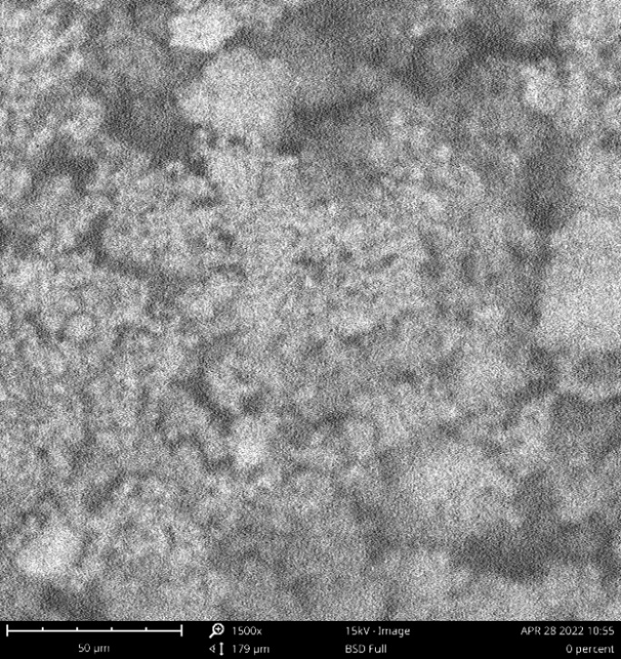 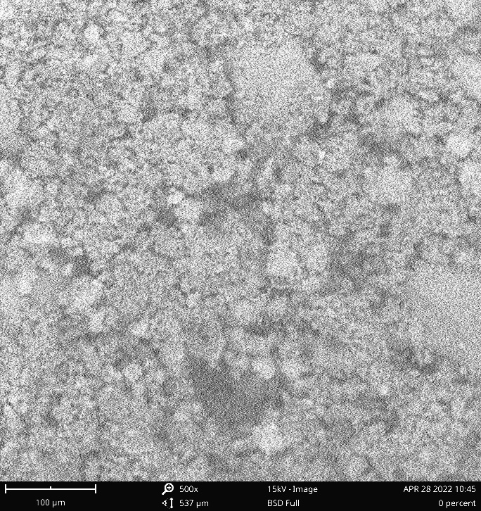

Figure 4. 12: Image of 0% CPA Sample

|  |  |  |  |  |  |  |  |  |  |  |  |  |  |  |  |  |  |  |  |  |  |  |  |  |  |  |  |  |  |  |  |  |  |  |  |  |  |  |  |  |
| --- | --- | --- | --- | --- | --- | --- | --- | --- | --- | --- | --- | --- | --- | --- | --- | --- | --- | --- | --- | --- | --- | --- | --- | --- | --- | --- | --- | --- | --- | --- | --- | --- | --- | --- | --- | --- | --- | --- | --- | --- |
| Table 4. 19 : Backscatter electron detector (BSD) of 0% CPA Sample   |  |  |  |  |  | | --- | --- | --- | --- | --- | | **Element Number** | **Element Symbol** | **Element Name** | **Atomic Conc.** | **Weight Conc.** | | 20 | Ca | Calcium | 59.76 | 61.93 | | 14 | Si | Silicon | 22.00 | 15.98 | | 26 | Fe | Iron | 5.62 | 8.12 | | 28 | Ni | Nickel | 4.83 | 7.33 | | 24 | Cr | Chromium | 1.79 | 2.41 | | 12 | Mg | Magnesium | 3.63 | 2.28 | | 16 | S | Sulfur | 2.36 | 1.95 | |

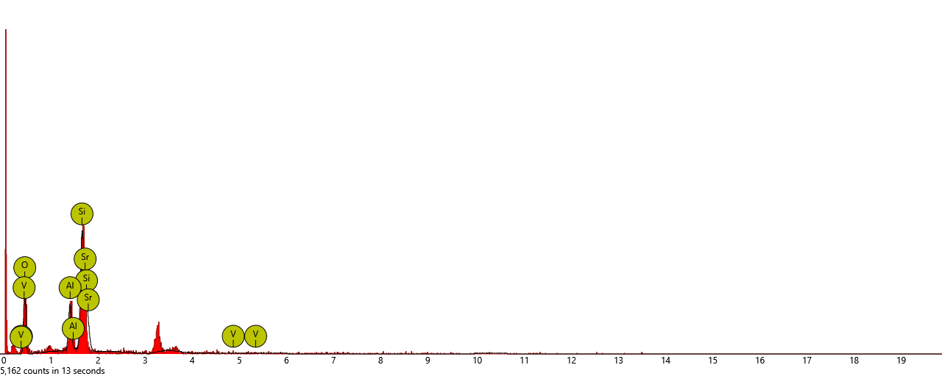

Figure 4. 13: Energy Dispersive Spectroscopy (EDS) of 0% CPA Sample

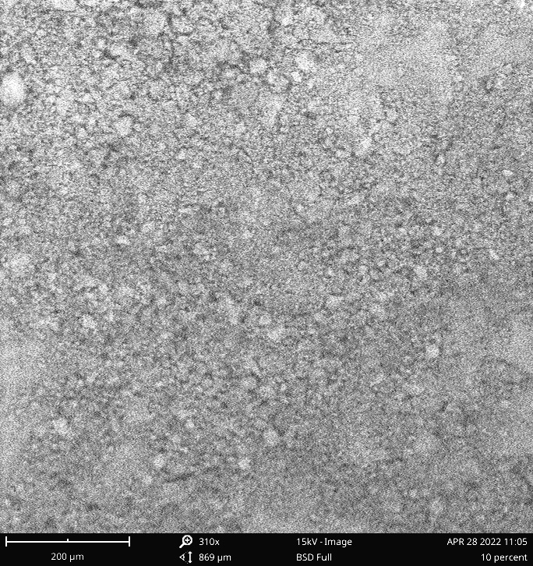 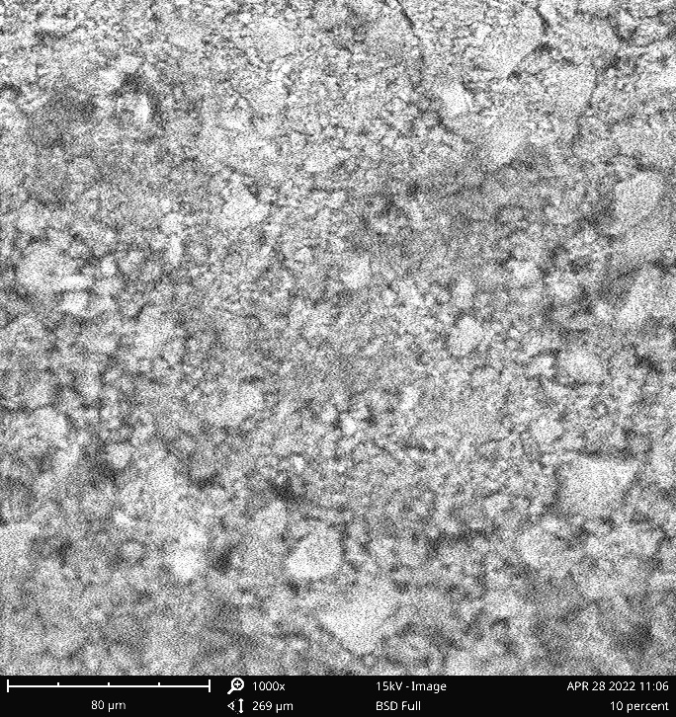

**Figure 4. 14: SEM Image of 10% CPA Sample**

**Table 4. 20**: **Backscatter electron detector (BSD) of 10% CPA Sample**

|  |  |  |  |  |
| --- | --- | --- | --- | --- |
| **Element Number** | **Element Symbol** | **Element Name** | **Atomic Conc.** | **Weight Conc.** |
| 52 | Te | Tellurium | 27.59 | 53.28 |
| 20 | Ca | Calcium | 40.34 | 24.47 |
| 14 | Si | Silicon | 19.10 | 8.12 |
| 35 | Br | Bromine | 5.94 | 7.19 |
| 26 | Fe | Iron | 4.98 | 4.21 |
| 38 | Sr | Strontium | 2.06 | 2.74 |

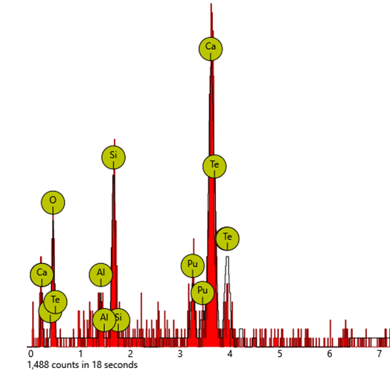

Figure 4. 15 : Energy Dispersive Spectroscopy (EDS) of 10% CPA Sample

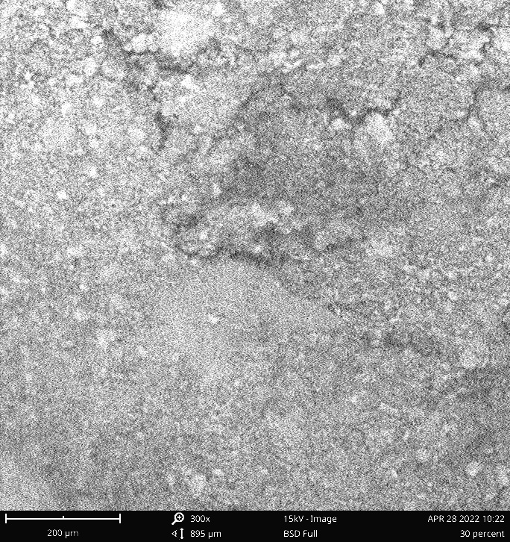 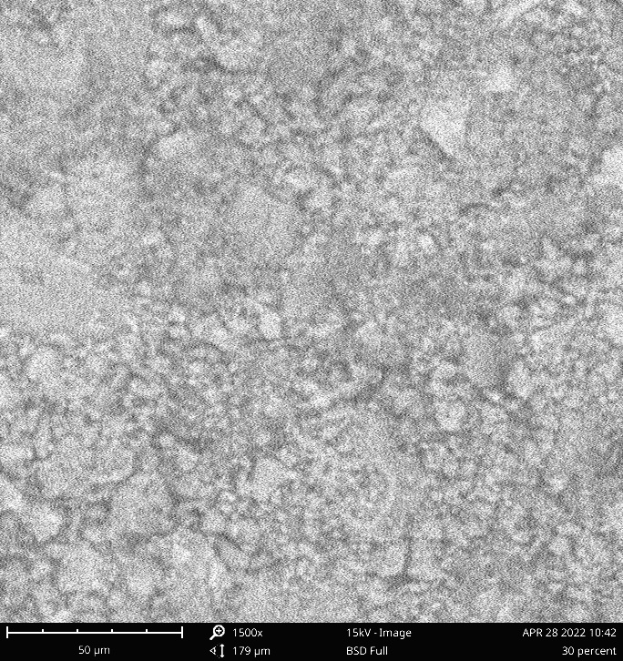

Figure 4. 16: SEM Image of 30% CPA Sample

**Table 4. 21**: **Backscatter electron detector (BSD) of 30% CPA Sample**

|  |  |  |  |  |
| --- | --- | --- | --- | --- |
| **Element Number** | **Element Symbol** | **Element Name** | **Atomic Conc.** | **Weight Conc.** |
| 52 | Te | Tellurium | 16.56 | 35.39 |
| 94 | Pu | Plutonium | 7.40 | 30.24 |
| 20 | Ca | Calcium | 25.50 | 17.12 |
| 8 | O | Oxygen | 31.82 | 8.53 |
| 14 | Si | Silicon | 14.39 | 6.77 |
| 13 | Al | Aluminum | 4.33 | 1.96 |



Figure 4. 17: Energy Dispersive Spectroscopy (EDS) of 30% CPA Sample

**4.8 Accelerated Mortar Bar Test**

The immersion solution for concrete is made using sodium hydroxide (NaOH). Sodium chloride is used to enhance the ASR reaction in concrete during the accelerated aging process since it is an alkali activator. ASR-free concrete bars have expansion values that are fewer than the expansion values. By measuring the length increase of typical concrete bars with and without CPA after storage under high-temperature test circumstances, the outcome is achieved. Table 4.25 displays the mass of the cubes.

Table 4. 22: Accelerated Mortar Bar Test Result Readings

|  |  |  |
| --- | --- | --- |
| **CPA Substitution (%)** | **Sample Weight Before Immersion (g)** | **Sample Weight after Immersion (g)** |
| 0 | 400 | 444 |
| 5 | 500 | 520 |
| 10 | 404 | 414 |
| 15 | 448 | 478 |
| 20 | 408 | 480 |
| 30 | 372 | 402 |

Tables 4.26 and 4.27 display the acquired and specified requirements as well as the classification for ASR growth in concrete. Figure 4.16 shows the concrete cube samples' expansion before and after being submerged in 100g of NaOH at 80oC for 7, 14, and 28 days.

Table 4. 23: Concrete Cubes Expansion Result

|  |  |  |  |
| --- | --- | --- | --- |
| **CPA Substitution (%)** | **Expansion of Concrete Cubes** | | |
| **7th Day** | **14th Day** | **28th Day** |
| 0 | 0.009 | 0.020 | 0.039 |
| 5 | 0.003 | 0.005 | 0.025 |
| 10 | 0.001 | 0.002 | 0.013 |
| 15 | 0.006 | 0.007 | 0.027 |
| 20 | 0.014 | 0.027 | 0.040 |
| 30 | 0.028 | 0.034 | 0.056 |

Figure 4. 18: Variation of concrete cube expansion with CPA replacement (%)

Table 4. 24: Standard Concrete Reactivity Classification

|  |  |  |  |  |  |  |
| --- | --- | --- | --- | --- | --- | --- |
| Mortar Bar Expansion (%) in 1M NaOH (80%) | | | | | | Classification |
| VicRoads Standard Specification Section 610 | | ASTM C1260 | | | ASTM C1293 |
| 10 Days | 21 Days | | 14 Days | 28 Days | |
| < 0.010\* | < 0.010\* | | < 0.020 | < 0.040 | | Non-reactive |
| = 0.010\* | = 0.010\* | | = 0.020 | = 0.040 | | Slowly reactive |
| > 0.010\* | > 0.010\* | | > 0.020 | > 0.040 | | Reactive |
| \*0.015% for naturally occurring fine aggregate | | | | | | |

According to the VicRoads standard, 0% CPA replacement is minimally reactive, however, 20% and 30% CPA replacement are too prone to alkaline assaults and should be avoided. Alkaline attacks are not a problem for concrete with a CPA content of 5%, 10%, or 15%. The optimum replacement is 10%.

According to the study, concrete bars with CPA replacement levels of 5%, 10%, 15%, and 20% are non-reactive/non-delirious on day 7, but concrete bars with CPA replacement levels of 30% exhibit substantial levels of ASR. The 28th-day data reveal that the 0% CPA replacement is slow to react to alkaline attacks, whereas the 20% and 30% CPA replacements are extremely vulnerable to alkaline attacks. According to the studies, 5 percent, 10%, and 15% of CPA replacements are non-reactive to ASR attacks. The optimum value is 10% replacement

## 4.9 Empirical Modelling of Concrete Admixed With CPA

Empirical models developed from input-output data for the concrete pavement admixed with CPA using Central Composite Design. Equations 11 to 13 illustrate the predictive model equations for the compressive strength (CS), split tensile strength (ST), and concrete cube expansion (CCE) of the concrete where cement is partially substituted with variable percentages of CPA.

**Table 4. 25: ANOVA for Response Surface Reduced Quartic Model for Compressive Strength**

|  |  |  |  |  |  |  |
| --- | --- | --- | --- | --- | --- | --- |
| **Source** | **Sum of Squares** | **Df** | **Mean Square** | **F-value** | **p-value** |  |
| **Model** | 493.85 | 7 | 70.55 | 263.21 | < 0.0001 | Significant |
| A-DAYS | 61.62 | 1 | 61.62 | 229.91 | < 0.0001 |  |
| B-Cassava Peel Ash (%) | 90.14 | 1 | 90.14 | 336.31 | < 0.0001 |  |
| AB | 17.29 | 1 | 17.29 | 64.49 | 0.0005 |  |
| A² | 2.42 | 1 | 2.42 | 9.01 | 0.0300 |  |
| B² | 0.6037 | 1 | 0.6037 | 2.25 | 0.1937 |  |
| A²B | 2.70 | 1 | 2.70 | 10.07 | 0.0247 |  |
| AB² | 1.33 | 1 | 1.33 | 4.95 | 0.0766 |  |
| **Residual** | 1.34 | 5 | 0.2680 |  |  |  |
| **Cor Total** | 495.19 | 12 |  |  |  |  |

Model significance is suggested by the model's Model F-value of 263.21. An F-value this large could only happen owing to noise in 0.01 percent of cases.

Table 4. 26: Fit Statistics

|  |  |  |  |  |
| --- | --- | --- | --- | --- |
| **Std. Dev.** | | 0.5177 | **R²** | 0.9973 |
| **Mean** | | 20.89 | **Adjusted R²** | 0.9935 |
| **C.V. %** | | 2.48 | **Predicted R²** | 0.9601 |
|  |  | | **Adeq Precision** | 51.5505 |

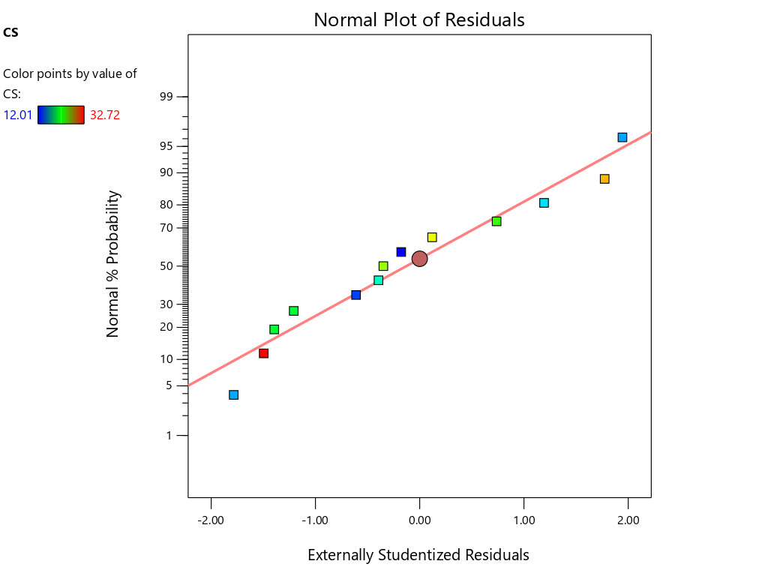

Figure 4. 19: Variation of the Observed (Actual) Response Values Versus the Predicted Response Values for Compressive Strength

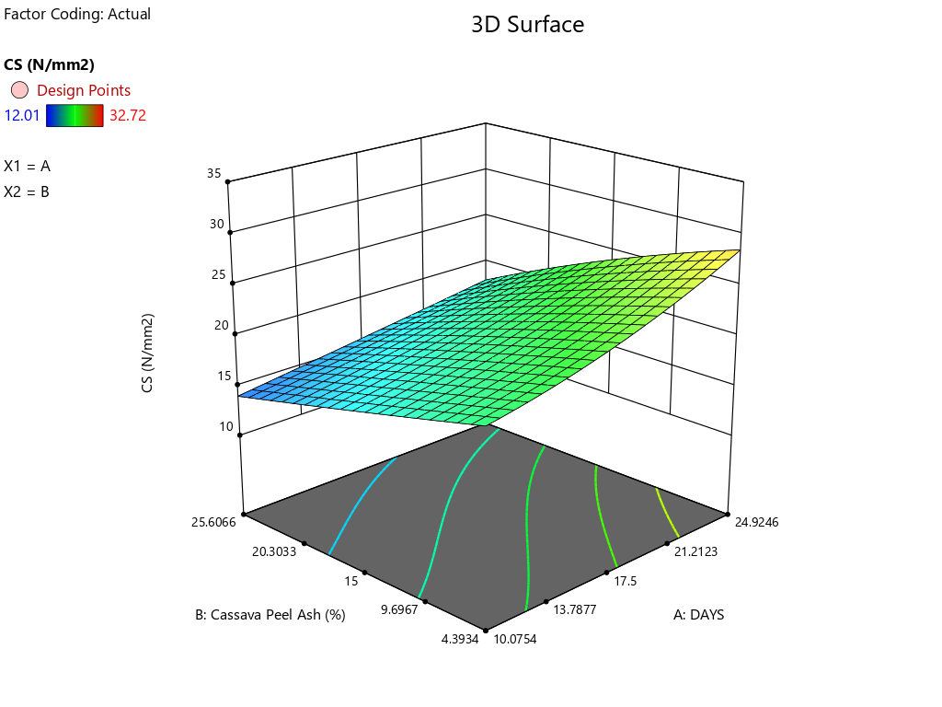

Figure 4. 20: 3D Model of Compressive Strength Test

Table 4. 27: ANOVA for Response Surface Reduced Quartic Model for Split Tensile

|  |  |  |  |  |  |  |
| --- | --- | --- | --- | --- | --- | --- |
| **Source** | **Sum of Squares** | **Df** | **Mean Square** | **F-value** | **p-value** |  |
| **Model** | 4.71 | 7 | 0.6725 | 100.05 | < 0.0001 | significant |
| A-DAYS | 0.4834 | 1 | 0.4834 | 71.91 | 0.0004 |  |
| B-Cassava Peel Ash (%) | 0.8306 | 1 | 0.8306 | 123.58 | 0.0001 |  |
| AB | 0.2175 | 1 | 0.2175 | 32.35 | 0.0023 |  |
| A² | 0.0622 | 1 | 0.0622 | 9.26 | 0.0287 |  |
| B² | 0.0018 | 1 | 0.0018 | 0.2688 | 0.6263 |  |
| A²B | 0.0610 | 1 | 0.0610 | 9.08 | 0.0297 |  |
| AB² | 0.0006 | 1 | 0.0006 | 0.0934 | 0.7722 |  |
| **Residual** | 0.0336 | 5 | 0.0067 |  |  |  |
| **Cor Total** | 4.74 | 12 |  |  |  |  |

Model significance is suggested by the model's Model F-value of 100.05. An F-value this large might be caused by noise only 0.01 percent of the time.

Table 4. 28: Fit Statistics

|  |  |  |  |
| --- | --- | --- | --- |
| **Std. Dev.** | 0.0820 | **R²** | 0.9929 |
| **Mean** | 1.93 | **Adjusted R²** | 0.9830 |
| **C.V. %** | 4.24 | **Predicted R²** | 0.8839 |
|  |  | **Adeq Precision** | 35.6150 |

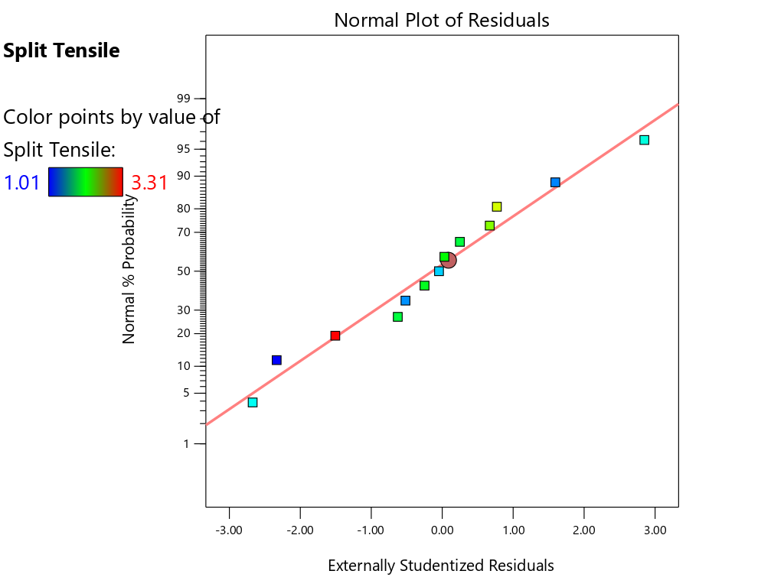

Figure 4. 21: Variation of the Observed (Actual) Response Values Versus the Predicted Response Values for Split Tensile

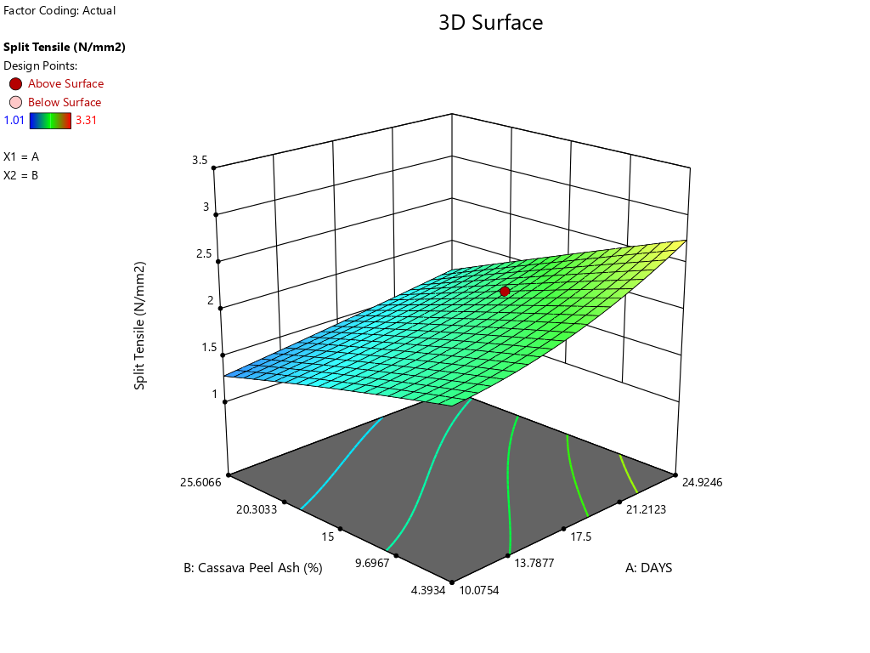

**Figure 4.20:** **3D Model of Split Tensile Test**

**Table 4.29:** **ANOVA for Response Surface Reduced Quartic Model for Compressive Strength**

|  |  |  |  |  |  |  |
| --- | --- | --- | --- | --- | --- | --- |
| **Source** | **Sum of Squares** | **Df** | **Mean Square** | **F-value** | **p-value** |  |
| **Model** | 0.0033 | 7 | 0.0005 | 9.57 | 0.0122 | significant |
| A-DAYS | 0.0005 | 1 | 0.0005 | 10.08 | 0.0247 |  |
| B-Cassava Peel Ash (%) | 0.0001 | 1 | 0.0001 | 1.86 | 0.2311 |  |
| AB | 4.581E-06 | 1 | 4.581E-06 | 0.0929 | 0.7728 |  |
| A² | 0.0000 | 1 | 0.0000 | 0.7500 | 0.4261 |  |
| B² | 0.0011 | 1 | 0.0011 | 22.32 | 0.0052 |  |
| A²B | 9.402E-06 | 1 | 9.402E-06 | 0.1907 | 0.6806 |  |
| AB² | 0.0000 | 1 | 0.0000 | 0.4985 | 0.5117 |  |
| **Residual** | 0.0002 | 5 | 0.0000 |  |  |  |
| **Cor Total** | 0.0035 | 12 |  |  |  |  |

The Model F-value of 9.57 suggests that the model is significant. An F-value of this size can occur randomly only 1.22 percent of the time.

Table 4. 30: Fit Statistics

|  |  |  |  |
| --- | --- | --- | --- |
| **Std. Dev.** | 0.0070 | **R²** | 0.9305 |
| **Mean** | 0.0217 | **Adjusted R²** | 0.8333 |
| **C.V. %** | 32.37 | **Predicted R²** | -0.4985 |
|  |  | **Adeq Precision** | 10.5023 |

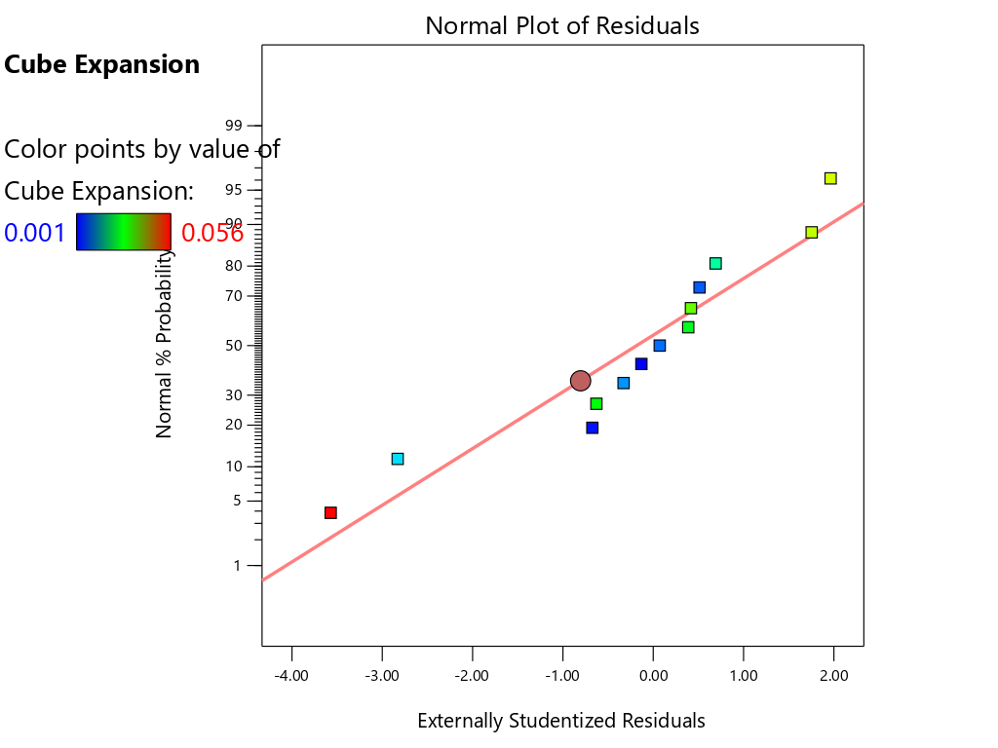

**Figure 4.21:** **Variation of the Observed (Actual) Response Values Versus the Predicted Response Values for Cube Expansion**

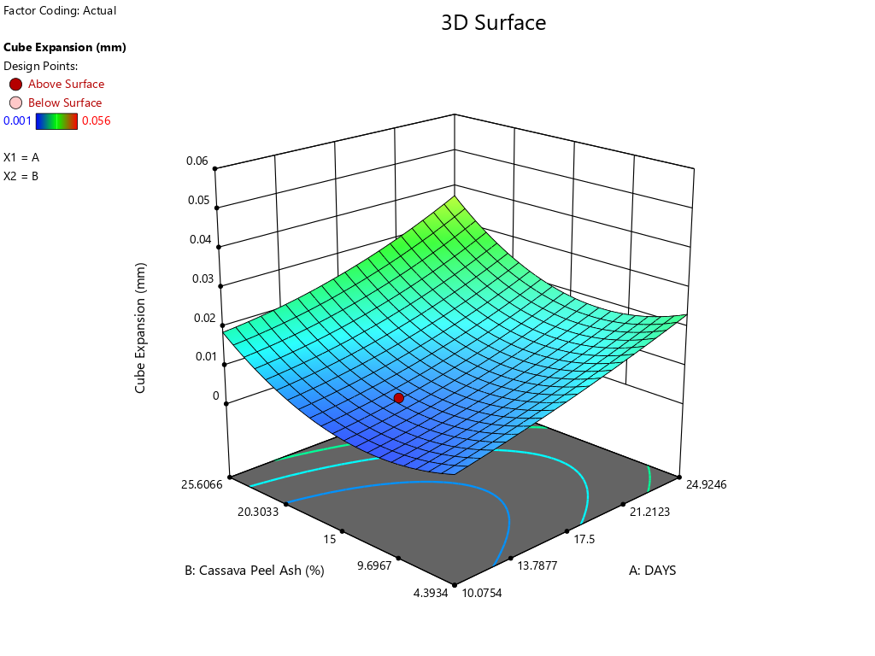

Figure 4. 22: 3D Model of Cube Expansion Test

# CHAPTER FIVE

# 5.0 CONCLUSION AND RECOMMENDATION

## 5.1 Conclusion

The fundamental aim of the thesis is to determine how efficiently cassava peel ash inhibits alkaline silica reactions in concrete. This chapter provides a summary of the findings that address that purpose. The test results gathered during the study can be used to draw the following conclusions:

* CPA has a chemical composition of 77.42% silica, Aluminum Oxide (Al2O3), and Iron Oxide (Fe2O3), it is therefore considered an excellent pozzolan for stimulating the synthesis of cementitious compounds during the cement hydration reaction.
* The investigation discovered that all concrete cube samples for CPA replacement of 5%, 10%, and 15% met the necessary compressive strength for grade 25 concrete (M25). The results reveal that with only a little amount of OPC replaced with CPA, acceptable strength can be obtained.
* The statistics indicate that CPA replacement of less than 15% fell within the acceptable range, indicating that the concrete will function better when exposed to acidic circumstances or if acidic rain occurs.
* The concrete's thermal properties were improved by the inclusion of cassava peel ash (CPA).
* The 28th-day analysis revealed that the 0% CPA replacement is slow to react to alkaline attacks, whereas the 20% and 30% CPA replacements are extremely vulnerable to alkaline attacks. According to the studies, 5%, 10%, and 15% of CPA replacements are non-reactive to ASR attacks, respectively. The findings reveal that cassava peel ash at appropriate doses (5%, 10%, and 15%) significantly reduces ASR development even in types of cement with adequate alkali content. Utilizing portlandite, releasing silicon and aluminum into solution, and lowering the alkali content of the pore solution are all SCM capabilities that are associated with reduced ASR growth. It was also discovered that the 10% substitution was more effective at reducing alkaline silica reactivity.

## 5.2 Recommendation

1. As a result, it is suggested that the effect of superplasticizer be explored on concrete enhanced with CPA at a percentage substitution of cement of no more than 15% by weight.
2. More research should be done on partial cement substitution with CPA utilizing various mix ratios.

## 5.3 Contribution to the knowledge

1. This study closes a knowledge gap on the efficiency of cassava peel ash (CPA) as a pozzolanic material to prevent the ASR in concrete. This study's Accelerated Mortar Bar Test (AMBT) technique more closely resembled the mix of ASR and environmental-caused deterioration observed in the field.

2. Never before has an electrical resistivity test been used to evaluate the mechanical properties of concrete that partially substitutes CPA for cement. The advancement of non-destructive testing (NDT) in the testing of building materials is a fruit of this research.

3. The study contributes to sustainable and cost-effective building by promoting the use of CPA, which reduces CO2 emissions caused by the production of cement.

4. The research establishes a valuable method of transforming waste (cassava peel) into money, thereby reducing ASR in concrete, addressing environmental issues, and offering economic benefits to society.

# REFERENCES

Abdulfatai A M. and Lawal S. (2014). Partial replacement of cement with rice husk ash (RHA) as filler in asphalt concrete design. *Journal of Engineering and Applied Sciences* *10(1), 30 – 40*.

Abdulwahab M.T, Uche O.A. (2021). Durability Properties of Self-Compacting Concrete (SCC) Incorporating Cassava Peel Ash (CPA). *Nigerian Journal of Technology (NIJOTECH), Vol. 40, (4), 584 – 590*

Abdulwahab M.T, Uche O.A. (2021). Modelling Fresh Properties of Self-Compacting Concrete (SCC) Incorporating Cassava Peel Ash (CPA). *Platform- a journal of Engineering. VOL. 5 (3). 1-10*

ACI Committee (2000). Use of Raw or Processed Natural Pozzolans in Concrete. *ACI 232.1 R-00, Farmington Hills.*

Adajar M.A., De Mesa C. J, Dizon M., Molas K. and Quintana A.J (2019). Assessing the Effectiveness of Fly-Ash in Mitigating the Alkali-Silica Reaction in Concrete with Soda-Lime Glass. *DLSU Research Congress 2019, De La Salle University, Manila, Philippines, 1-12.*

Adanikin A., Falade F.**,** Olutaiwo A., (2020). Microstructural Analysis of Concrete Using Cow Bone Ash for Alkali-Silica Reaction (ASR) Suppression. *Journal of Casting & Materials Engineering Vol. 4(2), 34–40.*

Adanikin A., Falade F., Olutaiwo A.O, Faleye E.T and Ajayi A.J (2019). Investigation of the effect of alkali-silica reaction (ASR) on properties of concrete pavement admixed with cow bone ash (CBA) by electrical resistivity test. *Materials Science and Engineering, 640, 1-10*

Adanikin, A., Falade, F., Olutaiwo, A. O., Faleye, E. T., and Ajayi, A. J. (2019). Investigation of the effect of Alkali-Silica Reaction (ASR) on Properties of Concrete Pavement Admixed with Cow Bone Ash (CBA) by Electrical Resistivity Method. *International Conference on Sustainable Infrastructural Development (ICSID),* 1-8.

Adesanya, O.A, Oluyemi, K.A., Josiah, S.J., Adesanya, R.A., Shittu, L.A.J., Ofusori, D.A., Bankole, M.A. and Babalola, G.B. (2008). Ethanol Production by Saccharomyces Cereviasiae from cassava peel hydrolysate. *The Internet Journal of Microbiology,* 5(1), 25-35.

Adetoye O. A, Afolayan T.J., Asekunowo T. (2022). Compressive Strength Properties of Cassava Peel Ash and Wood Ash in Concrete Production. *International Journal of New Practices in Management and Engineering Volume 11, (01), 1-10.*

Agarwal A, Nanda B, Maity D (2014) Experimental investigation on chemically treated bamboo reinforced concrete beams and columns. Constr Build Mater 71:610–617.

Amar, D. S., & Sandhya, M. (2014). Relation between compressive strength and electrical resistivity of microsilica concrete. *International Journal on Mechanical Engineering and Robotics (IJMER)*, 2(4), 15-18.

Amir, M. (2017). *Investigation of concrete electrical resistivity as a performance-based test.* *All Graduate Theses and Dissertations*. Retrieved from: Https://Digitalcommons.Usu.Edu/Etd/6858

Arabani.M, Tahami.A.S, Taghipoor.M (2016). Laboratory investigation of hot mix asphalt containing waste materials. *Road materials and pavement Design*, *1-11.*

Aro, S. O., Aletor, V. A., Tewe, O. O., Agbede, J. O., (2010). Nutritional potentials of cassava tuber wastes: *A case study of a cassava starch processing factory in south-western Nigeria. Livest. Res. Rural Dev., 22 (11)*

Aryal E. B. (2019). Field-Based Quality Assessment of Cement*. Saudi J Civ Eng, 3(5), 135-140*

Asatov N. (2021).Concrete structure with complex additives. *Materials Science and Engineering, 1030, 1-10*

Ashraf T. and Doh S. I., (2020). Mechanical properties of high-strength concrete replace cement partly by using fly ash and eggshell powder. *Chapter in Physics and Chemistry of the Earth, Parts A/B/C. 1-10*

ASTM C1152M. (2012). Standard test method for acid-soluble chloride in mortar and concrete. ASTM International.

ASTM C1157 (2006). Performance Specification for Hydraulic Cements, V. 4.01.

ASTM C1260 (2009). *Stan*dard Test Method for Potential Alkali Reactivity of Aggregates (Mortar-Bar Method), *ASTM Annual Book of Standards*, Vol. 4(2), *Concrete and Aggregates*, *ASTM International, West Conshohocken, Pennsylvania.*

ASTM C1293 (2018). Standard Test Method for Determination of Length Change of Concrete Due to Alkali-Silica Reaction, *Books of Standard Volume*, 4(2).

ASTM C1293-20a (2020). Standard test method for determination of length change of concrete due to alkali-silica reaction. ASTM International, West Conshohocken, PA.

ASTM C595 (2006). Specification for Blended Hydraulic types of cement, V. 4.01.

ASTM D 422, (2006). Standard Test Method for Particle-Size Analysis of Soils.

ASTM D854-02 (2002). Standard Test methods for specific gravity of soil solids by water pycnometer. ASTM International, West Conshohocken, PA.

ASTM International (2014). *Standard Test Method for Potential Alkali Reactivity of Aggregates (Mortar-Bar Method)*, ASTM C1260, *West Conshohocken, United States.*

ASTM International (2015). *Standard Specification for Coal Fly Ash and Raw or Calcined Natural Pozzolan for Use in Concrete*, ASTM C618 West Conshohocken, United States.

ASTM, C1260. (2009). *Standard test method for potential alkali reactivity of aggregates (Mortar-Bar Method), 2009* ASTM *Annual Book of Standards, Volume 04.02, Concrete and Aggregates. ASTM International, West Conshohocken, Pennsylvania.*

ASTM, C1760. (2012). *Standard test method for bulk electrical conductivity of hardened concrete.* ASTM International.

ASTM, C78M (2018). *Standard test method for flexural strength of concrete (Using simple beam with third-point loading).* ASTM International, *West Conshohocken, PA*

Atoyebi O.D., Gana A.J., and Longe J.E. (2020). *Strength assessment of concrete with waste glass and bankoro (MorindaCitrifolia) as partial replacement for fine and coarse aggregate*. Results in Engineering 6, 100124, 1-3.

Balogun W. O., and Otunola O.O., (2021). The Use of Yam Peel Ash as Partial Replacement of Cement Towards Achieving Low-Cost Housing*. American Journal of Construction and Building Materials, 5(1), 15-21*

Bamigboye, G., Ede, A., Umana, U., & Olowu, O.O. (2015). Assessment of strength characteristics of concrete made from locally sourced gravel aggregate from South-South *Nigeria. British Journal of Applied Science & Technology,* 12(5), 1-10.

Behbahani H.P, Nematollahi B., Sam M.A.R, Lai F.C. (2012). Flexural behavior of steel-fiber-added-Rc (SFARC) beams with C30 And C50 classes of concrete. *Int. J. Sustainable Construction Engineering & Technology, 3 (1), 54-64*

Bello A. A., Ige J.A., and Ayodele H., (2015). Stabilization of Lateritic Soil with Cassava Peels Ash. *British Journal of Applied Science & Technology, 7(6): 642-650.*

Bello A.A., Ojelade A.E., Oriaje A.T. (2015). Stabilization of Soil with Cassava Peel Ash – Lime Admixture*. Civil and Environmental Research, Vol.7, (11), 17-23.*

Bert-Okonkwor, K. C. (2019). Comparative Analysis of Concrete Strength Made from Selected Brands of Cement in Anambra State, Nigeria. *Archives of Current Research International, 19,* (4), 1-8.

Boddy, A.M., Hooton, R.D. & Thomas, M.D.A. (2003). The effect of the silica content of silica fume on its ability to control alkali-silica reaction', *Cement and Concrete Research*, *33, 1263–1268.*

Borges A.L., Soares S.M., Freitas T. O, Júnior A.D., Ferreira E.B., Ferreira F.G (2021). Evaluation of the Pozzolanic Activity of Glass Powder in Three Maximum Grain Sizes. *Materials Research, 24(4), 1-11.*

BS 1377 (1990). Methods of Test for Soils for Civil Engineering Purposes; BSI: London, UK, 1990*; Part 1 and 2.*

BS 812 (1985). *Testing aggregates-* Part 103*: Methods for determination of particle size distribution* (British Standard).

BS EN 12390-6:2009 Testing hardened concrete. Tensile splitting strength of test specimens, British Standards Institution.

BS EN 12390-6:2009. Testing hardened concrete. Tensile Splitting Strength Test, BSI: London, UK

BS EN 196-3:2005. Methods of Testing Cement. Determination of Setting time and soundness, BSI: London, UK

BS EN 196-3:2018. Methods of Testing Cement. Determination of fineness of cement, BSI: London, UK.

BS, 1881-211 (2016). *Testing concrete. procedure and terminology for the petrographic examination of hardened concrete* (British Standard).

Calvosa, C. and Amoriggi, G. (2009). The feasibility study to put in place an animal feed plant in Ogun State (Abeokuta), making use of cassava peel, Sponsored: *International Fund for Agricultural Development (IFAD), Rome. 1-10*

Carslaw H.S., & Jaeger J.C (1959). *Condition of Heat in Solids.*

Chandio S.A., Memon B. A., Mahboob O., Faraz A. C., and Muhammad U. M., (2020). Effect of Fly Ash on the Compressive Strength of Green Concrete. *Engineering, Technology & Applied Science Research Vol. 10, (3), 5728-5731.*

Chatterji, S. (2005). Chemistry of alkali-silica reaction and testing of aggregates', *Cement & Concrete Composites*, 27, 788–795.

Chen, P. W., Fu, X., & Chung, D. D. L. (2006). Microstructural and mechanical effects of latex, methylcellulose and silica fume on carbon fiber reinforced cement. *ACI Materials Journal,* 94(2), 147-155

Chimmaobi, O., Mbadike, E. M. and Alaneme, G. U. (2020). Experimental Investigation OF Cassava Peel Ash in the Production of Concrete and Mortar. *Umudike Journal of Engineering and Technology (UJET); Vol. 6, (2), 10 – 21.*

Corral-Higuera, R., Arredondo Rea, S. P., Neri Flores, M. A., Gómez Soberón, J. M., Almeraya Calderón, F., Castorena González, J. H. and Almaral Sánchez, J. L. (2011). Sulfate attack and reinforcement corrosion in concrete with recycled concrete aggregates and supplementary cementing materials*. Int. J. Electrochem. Sci,* 6: 613 – 621.

Diamond, S., S. Nishibayashi, and M. Kawamura. (1989). *ASR-another looks at mechanism, in K. Okada (Ed.)*. in *Proceedings of the 8th International Conference on Alkali-Aggregate Reaction*”. Kyoto.

Duchesne, J. & Berube, M.-A. (2001). Long-term effectiveness of supplementary cementing materials against alkali-silica reaction. *Cement and Concrete Research,* 31, *1057–1063.*

Ebenezer, C. M. (2019). Quality Assurance of Available Portland Cements in Nigeria. *International Journal of World Policy and Development Studies, 5*(6), 53-63.

Esperanza M., Miguel A.S., Ricardo G. R, Cristina A. & Hairon R. (2020). Sustainable and Durable Performance of Pozzolanic Additions to Prevent Alkali-Silica Reaction (ASR) Promoted by Aggregates with Different Reaction Rates. *Appl. Science journal, vol 10, (4), 1-24*

Ettu L. O., N. N. Osadebe, M. S. W. Mbajiorgu (2013). Suitability of Nigerian Agricultural By-Products as Cement Replacement for Concrete Making. *International Journal of Modern Engineering Research (IJMER),* 3(2), 1180-11085.

Ezechi E.H, Nwabuko C.G, Enyinnaya O.C, Babington C.J (2017). Municipal solid waste management in Aba, Nigeria: Challenges and prospects. *Environmental Engineering Research,* 22(3), 231-236

Falade, F., Ikponmwosa, E., &Fapohunda, C. (2012). Potential of Pulverized Bone as Pozzolanic material. *International Journal of Scientific & Engineering Research*, 3(7), 1-6.

Familusi A. O., Mujedu K. O., Adewumi B. E., Ogundare D. A., OlusamiJ. O. (2019)*. School of Engineering Technology Annual International Conference, Federal Polytechnic Ede, 1-12.*

FAO (2013). Save and Grow: Cassava, A guide to sustainable production intensification, Food, and Agriculture Organization of the United Nations, Rome. 1 – 129.

Fapohunda C., Akinbile, B. & Shittu A., (2017). “Structure and properties of mortar and concrete with rice husk ash as partial replacement of ordinary Portland cement – A review*,” Int. J. Sustain. Built Environ., vol. 6, no. 2, pp. 675–692.*

Ferronato N and Torretta V (2019). Waste Mismanagement in Developing Countries: A Review of Global Issues. *International Journal of Environmental Research and Public health,* 16(6), 1-10

Folliard, K.J., Thomas, M.D.A., and Kurtis, K.E. (2003). Guidelines for the Use of Lithium to Mitigate or Prevent ASR. a*A FHWA Research Report, FHWA-RD-03-047, The Transtec Group, Austin, TX.*

Food Safety Network (2005). What is Cassava? Retrieved from <http://foodsafety.ksu.edu/articles/533/cassava_factsheet.pdf>.

Foroughi, M., Tabatabaei R., and Shamsadeini, M. (2012). Effect of Natural Pozzolans on the Alkali-Silica Reaction of Aggregates in Real Concrete Specimens. *Journal of Basic and Applied Scientific Research, 2(5)5248-5254.*

Gaharwar A.S., Naveen Gaurav, Singh A.P., Gariya H.S., Bhoora, (2016).A Review Article on Manufacturing Process of Cement, Environmental Attributes, Topography and Climatological Data Station: IMD, Sidhi M.P. *Journal of Medicinal Plants Studies 2016; 4(4): 47-53.*

Gana A. J, Atoyebi O. D and Ichagba R.B (2020). Effect of different brands of Nigerian cement on the properties of pervious concrete. IOP Conf. Series: Earth and Environmental Science 445, 1-8.

Gana A.J, Amodu M.F, Orogbade B.O, and Ashinetiang U.J (2020). Strength evaluation of different cement brands in theproduction of inter locking paving stones. IOP Conf. Series: Earth and Environmental Science 445, 1-9.

Gopu G. N., and Edukondalu K., (2020). Mechanical Properties of Concrete by Replacing Cement with Eggshell powder and Fly ash. *International Journal of Innovative Technology and Exploring Engineering (IJITEE), Vol. 9 (4), 2278-3075.*

Hansen, W.C., (1944). Studies Relating to the Mechanism by Which the Alkali-Silica Reaction Proceeds in Concrete*. Journal of the American Concrete Institute, vol. 15 (2), 213-227.*

Hirschfelder J.O., Curtis C.F., & Bird R.B. (1964). *Molecular Theory of Gases and Liquids.*

Hobbs, D.W. (1986). Deleterious expansion of concrete due to the alkali-silica reaction: influence of PFA and slag. *Magazine of Concrete Research,* 38, 191-205.

Ibrahim A. S, Nahla N., Qays K. (2015). An overview on the Influence of Pozzolanic Materials on Properties of Concrete. *International Journal of Enhanced Research in Science Technology & Engineering, Vol. 4 (3), 81-92*

Ige, O. A. (2013). Comparative Analysis Of Portland Cements In Nigeria. *International journal of engineering research & technology (ijert), 02,* (03), 1-10.

Ikotun, B. D. and Ikotun, A. G. (2014). Effect of a Modified Pozzolan on the Sulphate Attack Resistant of Mortar, *IACSIT International Journal of Engineering and Technology*, 6(1): 55 – 59.

Ikumapayi C.M., and Arum C., (2019). Pozzolanic influence of bagasse ash on the Compressive Strength and drying shrinkage of Concrete. *FUTAJEET 13 (2), 143-149.*

Islam, M.S., Alam, M.S., Ghafoori, N. & Sadiq, R. (2016). Role of Solution Concentration, cement alkali, and test duration on the expansion of accelerated mortar bar test. *Materials and Structures*, *49, 1955-1965.*

Iyayi. E. A. & Tewe, O.O (2009). Effect of protein deficiency on utilization of cassava peel by growing pigs. *Retrieved from: http://www.ilri.org/InfoServ/Webpub/Fulldocs on 22nd 0ct. 2021.*

Jadhav S.B. (2021). Study and Review of Properties & Applications of Low Heat Cement*. International Journal of Regional Planning (INJURPLAN), Vol. 1. (1), 1-10.*

Jagadeesh, K. C. (2017). Experimental Study on Tensile Strength of Concrete by Partial Replacement of Coarse Aggregate by Ceramic Aggregate. *International Journal of Civil Engineering and Technology (IJCIET), 08*(04), 73–77.

Khalifa S. A. & AlSadig D.H. (2017). Adjustment of Clinker Raw Mix Design to Produce Sulfate Resisting Cement. *International Journal of Trend in Research and Development, Volume 4(5), 1-3.*

Ki-Bong P. & Takafumi N. (2017). Effects of Mixing and Curing Temperature on the Strength Development and Pore Structure of Fly Ash Blended Mass Concrete. *Advances in Materials Science and Engineering*, *Volume 20, (3), 1- 11.*

Kotaro, D. Sachiko, H., Hideki, K., & Eiji, A. (2018). Effects of oxygen pressure and chloride ion concentration on corrosion of iron in mortar exposed to pressurized humid oxygen gas. *Journal of Electrochemical Society,* 165(9), 582-589.

Lakhiar MT, Sohu S, Bhatti IA, Bhatti N, Abbasi SA, and Tarique M (2018). Flexural performance of concrete reinforced by plastic fibers. *Engineering, Technology and Applied Science Research, 8(3): 3041-3043.*

Li, Z., Afshinnia, K. & Rangaraju, P.R. (2016). Effect of alkali content of cement on properties of high-performance cementitious mortar. *Construction and Building Materials,* 102, 631–639.

Lindgard, J., Andiç-Çakır, O., Fernandes, I., Rønning, T. & Thomas, M. (2012). Alkali–silica reactions (ASR): Literature review on parameters influencing laboratory performance testing. *Cement and Concrete Research*, *42, 223–243.*

Liu, D. J., Chen, M. J., Xue, L., & He, F. (2018). The effect of carbon fiber on concrete compressive strength. *Advanced Materials Research*, *1145, 106-111*

Lothenbach B., Scrivener K. L., and Hooton D., (2011). Supplementary Cementitious Materials. *Cement and Concrete Research 41(3), 217-229*

Mbadike E.M., Ogbonna C., and Nwokeke K., (2016). Effect of Cassava Peel Ash on Lateric Soil Stabilised with Bitumen. *Elixir Civil Engineering. (95) 41109-41112.*

Miller S. A., Cunningham P. R., & Harvey J. T., (2019). “Rice-based ash in concrete: A review of past work and potential environmental sustainability*. Resour. Conserv. Recycle., vol. 146, (4), 416–430.*

Mohiey M, *Hassan A. Mahdy*and Mokhtar F. Ibrahim (2020) “Effect of Rice Husk Ash on the Performance of Hot Asphalt Mixes” *Mansoura Engineering Journal, (MEJ),* *45(2),1-12.*

Nelson B. and Yu-wei C. (2015). Tellurium in the environment: A critical review focused on natural waters, soils, sediments and airborne particles. *Applied Geochemistry 63, 83-92*

Obla, K., *Alkali-Silica Reactions* in *Concrete in Focus*. 2005, *Naylor Publications, Inc.: Silver Spring, Maryland. 3-7.*

Obute J. O., Oluwatobi O. A., Amartey Y. D., Ejeh S. P. (2021). Effects of the Partial Replacement of Cement with Cassava Peel Ash and Rice Husk Ash on Concrete. *Covenant Journal of Engineering Technology (CJET) Vol.5 (1), 2682-531.*

Obute J.O, Oluwatobi O. A., Yusuf D. A., Stephen P. E. (2021). Effects of the Partial Replacement of Cement with Cassava Peel Ash and Rice Husk Ash on Concrete*. Covenant Journal of Engineering Technology (CJET) Vol.5, (1), 20-20.*

Odewumi, G. O. (2015). Assessment of Compressive Strength of Concrete Produced from Different Brands of Portland Cement. *Civil and Environmental Research, 7*(8), 1-12.

Ogbonna, C., Mbadike, E.M. & Alaneme, G.U. (2020). Effects of cassava-peel-ash on mechanical properties of concrete. *Umudike Journal of Engineering and Technology (UJET) 6(2), 61 – 75.*

Okeyinka O.M., Olutoge F. A., and Okunlola L.O., (2018). Durability Performance of Cow-Bone Ash (CBA) Blended Cement Concrete in Aggressive Environment. *International Journal of Scientific and Research Publications (IJSRP) 8(12), 1-10.*

Olanbiwoninu A. A. & Odunfa S. A. (2012). Enhancing the Production of Reducing Sugars from Cassava Peels by Pretreatment Methods*. International Journal of Science and Technology,* 2(9), 650 – 652.

Olanbiwoninu. A. A., & Odunfa S.A (2012). Enhancing the Production of Reducing Sugars from Cassava Peels by Pretreatment Methods. *International Journal of Science and Technology, Vol. 2, (9), 1-8.*

Olatokunbo O., Anthony E., Olofinnade R., Oyebisi S., Alayande T., and Ogundipe J. (2018). Assessment of Strength properties of Cassava Peel Ash-Concrete. *International Journal of Civil Engineering and Technology (IJCIET), Vol. 9, (1), 965–974.*

Olatokunbo O., Anthony E., Olofinnade R., Solomon O., Alayande T. and Ogundipe J. (2018). Assessment of Strength Properties of Cassava Peel Ash-Concrete*. International Journal of Civil Engineering and Technology (IJCIET) Vol. 9, (1), 965–974.*

Olonade, K. A. & Mohammed, H. (2019). Review of Selected Bio-Wastes as Potential Materials for Alkali-Activation for Cement-Based Products. *Nigerian Journal of Technological Development,* 16(3), *1-11.*

Olutaiwo A.O., Adanikin Ariyo (2016). Evaluation of the Structural Performance of Lateritic Soil Stabilized with Cassava Peel Ash (CPA) and Cement. *International Journal of Constructive Research in Civil Engineering (IJCRCE) Volume 2, (2), 18-26.*

Olutoge F.A. & Oladunmoye O.M (2017). Bamboo Leaf Ash as Supplementary Cementitious Material. *American Journal of Engineering Research*, 6(6), 1-8.

Onyelowe K., (2019). Review on the role of solid waste materials in soft soils reengineering. *Materials science for Energy Technologies 2(1), 45-51*

Opeyemi J., Olabosipo I., Fagbenle, Kolapo O. O., Shunanum J. Shamaki., Joyce A. Abuka-J., Ayodeji O. O., Lekan M. A., & Ignatius O. O. (2018).A Comparative Analysis of Batching by Weight and Volume towards Improved Concrete Production. *Construction Research Congress, vol 10, (2), 1-8.*

Osuide E. E., Ukeme U., & Osuide, M. O (2021). An Assessment of the Compressive Strength of Concrete made with Cement Partially Replaced with Cassava Peel. *SAU Sci-Tech. J., vol. 6, (1), 64-73.*

Qureshi, M., & Barbhuiya, S. (2016). Effects of silica fume on the strength and durability properties of concrete. *1st International Conference on Civil Engineering for Sustainable Development – Opportunities and Challenges,* 117-120.

Raheem, A.A. and Bamigboye, G.O. (2013). Establishing Threshold Level for Gravel Inclusion in Concrete Production. *Innovative System Design and Engineering. Vol.4 (9), 25-30.*

Raheem, S. B., Arubike, E. D., Awogboro, O. S. (2015). Effects of Cassava Peel Ash (CPA) as Alternative Binder in Concrete. *International Journal of Constructive Research in Civil Engineering (IJCRCE) Vol. 1, (2), 27-32.*

Rajabipour, F., Giannini, E., Dunant, C., Ideker, J. & Thomas, M. (2015). Alkali–silica reaction: Current understanding of the reaction mechanisms and the knowledge gaps. *Cement and Concrete Research*, *(76), 130 - 146.*

Ramlochan, T., Thomas, M. & Gruber, K.A. (2000). The effect of metakaolin on alkali-silica reaction in concrete. *Cement and Concrete Research,* 30, 339-344.

Rasheeduzzafar & Hussain, S.E. (1991). Effect of micro silica and blast furnace slag on pore solution composition and alkali-silica reaction. *Cement and Concrete Composites*, *13(3), 219-225.*

Rehan A. K., Moizuddin S, & Shahbaz A. (2016). Overview of Concepts of Ordinary Concrete and its properties*. International journal of advance research in science and Engineering, Vol. 5, (2), 1-7.*

Safeer A., Syed M. k., and Muhammad J. M., (2017). Potential of rice husk ash for mitigating the alkali-silica reaction in mortar bars incorporating reactive aggregates. *Construction and Building Materials 132, 61–70.*

Salau M A and Olonade K A (2011). Pozzolanic Potentials of Cassava Peel Ash. *Journal of Engineering Research, 16(1), 10-21.*

Salau M.A, E.E Ikponmwosa, K.A Olonade, (2012). Structural Strength Characteristics of Cement-Cassava Peel Ash Blended Concrete. *Civil and Environmental Research, 2(10), 1-10.*

Salau M.A., Ikponmwosa E.E., Olonode K.A (2012). Structural Strength Characteristics of Cement-Cassava Peel Ash Blended Concrete. *Civil and Environmental Research, Vol 2, (10), 68-77.*

Sanni, L., B. Maziya-Dixon, J. Akanya, C.I. Okoro, Y. Alaya, C.V. Egwuonwu, R. Okechukwu, C. Ezedinma, M. Akoroda, J. Lemchi, E. Okoro, and A. Dixon. (2005). *Standards for cassava products and guidelines for export. IITA, Ibadan, Nigeria, 93, 1-10.*

Santos M.B, Brito J.D, and Silva A.S (2020). A Review on Alkali-Silica Reaction Evolution in Recycled Aggregate Concrete. *Materials,* *13(2625), 1-20.*

Shafaatian, S.M.H., Akhavan, A., Maraghechi, H. & Rajabipour, F. (2013). How does fly ash mitigate alkali-silica reaction (ASR) in accelerated mortar bar test *(ASTM C1567). Cement & Concrete Composites,* 37, 143–153*.*

Shafigh P., Mahmud H. B., and Zargar M. (2014). Agricultural wastes as aggregate in concrete mixtures – A review. *Construction and Building Materials (53), 110-117*

Shehata, M.H. & Thomas, M.D.A. (2000). The effect of fly ash composition on the expansion of concrete due to alkali-silica reaction. *Cement and Concrete Research*, vol. 30, *pp. 1063-1072.*

Sirivivatnanon, V., Mohammadi, J. & South, W. (2016). Reliability of new Australian test methods in predicting the alkali-silica reaction of field concrete. *Construction and Building Materials*, *126, 868–874.*

Smith A.S., Xu G., Garba M. J., and Aliyu M. Y., (2020). Pozzolanic and Mechanical Properties of Date Palm Seed Ash (DPSA) Concrete. *Nigerian Journal of Technology (NIJOTECH) Vol. 39, (3), 680 – 686.*

Sohu S., Abdullah A.H, Nagapan S. Memon N. A. Yunus R. Hasmori M. F. (2018). Causative Factors of Cost Overrun in Building Projects of Pakistan. *International Journal of Integrated Engineering, Special Issue in Innovations in Civil Engineering, Vol. 10 (9), 122-126.*

Soutsos M., Kanavaris F. and Hatzitheodorou A. (2018). Critical analysis of strength estimates from maturity Functions. Case studies in construction materials, Vol. 9, 1-20.

Standards Australia (2015). *Alkali Aggregate Reaction - Guidelines on Minimizing the Risk of Damage to Concrete Structures in Australia.* *SA HB 79:2015, SAI Global Limited, Sydney, Australia.*

Stanton, Thomas E. (1940). Expansion of Concrete through Reaction between Cement and Aggregate. Proceedings, *American Society of Civil Engineers*, *V.66, New York, 1781-1811.*

Takemoto K & Uchikawa H., (1980). Hydration of Pozzolanic Cement. *Proceedings of the 7th International Congress on the Chemistry of Cement, Vol. 1, Sub-Theme IV-2 1980*.

Tewe, O. O., (2004). The global cassava development strategy: cassava for livestock feed in Sub-Saharan Africa. IFAD and FAO.

Thomas, B. S., (2018). “Green concrete partially comprised of rice husk ash as a supplementary cementitious material – A comprehensive review,” *Renew. Sustain. Energy Rev., vol. 82, no. March 2017, 3913– 3923.*

Thomas, M (2011). The effect of supplementary cementing materials on alkali-silica reaction: A review. *Cement and Concrete Research,* *41, 1224-1231.*

Thomas, M., Fournier, B., Folliard, K., Ideker, J. & Shehata, M. (2006). Test methods for evaluating preventive measures for controlling expansion due to alkali-silica reaction in concrete. *Cement and Concrete Research, 36, 1842–1856.*

Thomas, M.D.A. (2013). *Supplementary Cementing Materials in Concrete, Taylor & Francis Group, LLC, Boca Raton, Florida. 1-10*

Umoh A. A. & Ujene, A. O. (2014). An empirical study on the effect of bamboo leaf ash in concrete”, *Journal of Engineering and Technology, 5(2), 1-12.*

Vengadesh M. R., & Soundarya P. (2019). An Experimental Study on Rapid Hardening Cement Concrete Paver Blocks by Using Corundum as A Mineral Admixture. *IOSR Journal of Mechanical and Civil Engineering (IOSR-JMCE),* *Vol. 16, (3), 01-09.*

VicRoads Test Method - Revision Summary RC 376.03 – Accelerated Mortar Bar Test - Alkali-silica reactivity of aggregate.

Whittaker, M., Zajac, M., Ben, H.M., Bullerjahn, F. and Black, L. (2014). The role of the alumina content of slag, plus the presence of additional sulfate on the hydration and microstructure of Portland cement-slag blends. *Cement and Concrete Research*, *66: 91–101.*

Wikipedia (2018). *Alkali silica reaction.* *Retrieved from: https://en.wikipedia.org/wiki/ Alkali%E2%80%93silica\_reaction.*

Wikipedia (2018). *Electrical resistivity measurement of concrete.* *Retrieved from:* *https://en.wikipedia.org/wiki/Electrical\_resistivity\_measurement\_of\_concrete.*

Zhutovsky S. and Kovler (2012). Effect of internal curing on durability related properties of high-performance concrete, cement and concrete research, 42, (1), 20-26.

# APPENDICES

**Appendix I:** **USCS definition of particle sizes**



**Appendix II: AASHTO classification of soils and soil aggregate mixtures**

