SEVERITY OF SOME FOLIAR DISEASES ON SELECTED TOMATO VARIETIES AND ASSOCIATED PATHOGENS IN A DERIVED SAVANNAH AGROECOLOGY

BY

ADEWUMI ADEBUKOLA ELIZABETH (20PGDC000115)

DEPARTMENT OF CROP AND SOIL SCIENCE,
LANDMARK UNIVERSITY, OMU-ARAN, KWARA STATE.
JULY, 2022

DECLARATION
I, (ADEBUKOLA, ELIZABETH ADEWUMI), an MSc student in the Department of Crop and Soil Science, Landmark University, Omu-Aran, hereby declare that this thesis entitled “Severity of Some Foliar Diseases on Selected Tomato Varieties and Associated Pathogens in a Typical Derived Savannah Agro-Ecology”, submitted by me is based on my original work. Any material(s) obtained from other sources or work done by any other persons or institutions have been duly acknowledged.

----------------------------------------
Student’s Full Name and Matriculation number
----------------------
Signature & Date

CERTIFICATION
This is to certify that this thesis has been read and approved as meeting the requirements of the Department of (Crop Science), Landmark University, Omu-Aran, Nigeria, for the Award of (Masters of Science).

___________________ | _______________
Dr. Joseph Abiodun | Date
(Supervisor)
______________________ | ________________
Prof. S.A Abolusoro | Date
(Co-Supervisor)
_______________________  Dr. A. O. Adekiya | Date
(Head of Department)
Name | Date
(External Examiner)

ABSTRACT

Tomato leaf diseases can be severe, causing defoliation and eventually killing the plant if not properly managed. Estimating disease severity is crucial for disease management and yield loss prediction. Detection and identification of pathogens enable selection of pathogen-free planting materials that are essential for improved yield and quality. The present study identified the pathogens associated with foliar diseases of four tomato varieties, assessed the incidence and severity of these diseases and determined the effect of these foliar diseases on some growth parameters.
Four tomato varieties (Tropimech, Tima, Roma VF and Omu-Aran local) were raised in the nursery and transplanted to Sites A and B on the field. The experimental design was a randomized complete block design with three replicates. Leaves of the tomato plants were observed for foliar disease symptoms. The pathogens associated with the diseases were identified. Data were collected on observed incidence and severity of foliar diseases, plant height, number of leaves and branches at 2, 4 and 6 weeks after transplanting (WAT). Data collected were subjected to analysis of variance using statistical package for social sciences (SPSS) package and means were separated using Duncan multiple range test at 5% probability level.
The identified foliar diseases were early blight (Alternaria solani), bacterial wilt (Ralstonia solanacearum) and curly top (curly top virus). Roma Vf had the highest incidence of early blight (83.4%) at 6 WAT in Site A. At 4 WAT in Site A, Tima had the highest severity of bacterial wilt (3.5), followed by Tropimech (2.5). AT 6 WAT in Site B, the tallest plants was recorded on Roma Vf (28.5cm), followed by Omu-Aran local (27.3cm) and Tropimech (19.5cm) and the lowest number of leaves was recorded on Tima (9.8) in Site A. At 6 WAT in Site B, Roma Vf had the highest number of branches (13.5).
Bacterial wilt was the most severe foliar disease encountered in the study area. Roma VF and Omu-Aran local are recommended for planting in areas where bacterial wilt is widespread while Tima is suitable where early blight is prevalent. Findings from this study can serve as bedrock for breeding and selection of foliar disease resistant tomato varieties.

Keywords: Tomato, foliar diseases, pathogens, disease incidence, disease severity, growth parameters
DEDICATION
This project is dedicated to God Almighty, my ever-supportive mother, Mrs. Omolara Adewumi and my siblings (Adejoke Adewumi and Adebimpe Adewumi).

ACKNOWLEDGEMENT
I am thankful to God for providing me with strength, endurance and discipline during the course of this program. Special appreciation to my supervisor, Dr. Abiodun Joseph, for his constant mentoring, advice, discipline, and support. Sir, may the Lord continue to bless you. My sincere gratitude also goes to Professor S.A Abolusoro, many thanks to Dr. A.O. Adekiya, for inspiring me. A very special acknowledgement goes to all the lecturers and staff in the Department of Crop and Soil Science, Landmark University, for their interest, love and concern. May God bless you.
My appreciation also goes to my sweet mother, Mrs. Omolara Adewumi, for her unwavering support, love, and care, as well as for always believing in me and motivating me to achieve more. I would want to appreciate my siblings, Adejoke and Adebimpe for their unflinching support throughout the duration of this program. Special thanks to my friends Miss Ejue Wutem, Miss Faith Okunlola, and my fellow M.Sc. colleagues in the Department of Crop and Soil Science for their support.
I thank myself for putting in the necessary time, work, and resources to ensure the success of this project, just a little reminder that being diligent pays.
Contents
CHAPTER ONE 1
1.0 INTRODUCTION 1
1.1Background of the study………………………………………………………....1
1.2 Statement of the problem 1
1.3 Justification for the study 2-3
1.4 Objectives of the study 3
CHAPTER TWO 4
2.0 LITERATURE REVIEW 4
2.1 Origin and distribution of tomato…………………………………………....4
2.2 Plant and fruit description……………….………………………………..…5
2.3 Uses of tomato and nutritional value…………………………..………….5-6
2.4 Botany………………………………………………………………………7
2.5 Agronomy…………………………………………………...........................7
2.5.1 Soil, pH and Climatic Requirements………………………...………...…..7-8
2.6 Harvesting………………………………………………………….………..9
2.6.1 Post-harvest management…………………………………………………….9
2.7 Tomato Production in Nigeria……………..…………………………….9-10
2.8 Constraints to production.……………………………………………….... 10
2.9 Foliar Diseases of Tomato……………………………………….……..11-20
2.10 Review of Methodological Approach 21
2.11 Features of Roma Vf, Tropimech and Tima tomato varieties…….………..22
2.12 Gap Identified……………………….……………………………..……….22
CHAPTER THREE 23
3.0 MATERIALS AND METHODS 23
3.1 Description of the experimental site 23
3.2 Source of materials, curing of poultry manure and soil sterilization 23
3.3 Nursery Operation……………………………………..…………………….23
3.4 Land Preparation, transplanting and experimental design…………….....23-24
3.5 Field layout…………………………………………………………………24
3.6 Data Collection………………………………………..…………………26-28
3.7 Data Analysis………………………………………………………………28
CHAPTER FOUR……………………………………………………..……………..29
4.0 RESULT AND DISCUSSION……………………………………………….29
4.1 Identified pathogens…………………………………………………….,,,29-32
4.2 Disease Incidence…………………………………………………………33-35
4.3 Disease Severity………………………..…………………………………36-38
4.4 Response of four tomato varieties to some growth parameters…………..39-42
4.5 Meteorological data ……………………………………………...………….43
4.6 Discussion…………………………………………………………….….44-46
CHAPTER FIVE
5.0 CONCLUSION, AND RECOMMENDATIONS……….……………….….47
REFERENCES…………………………………………………………………...48-63

LIST OF TABLES

- Table 1: Nutritional Value of tomato per 100g (3.5 oz) …………………………………............6
- Table 2: Growth Stages and Temperature Requirement…………………………..………..……8
- Table 3: Plant height (cm) of four tomato varieties as influenced by foliar diseases…………....40
- Table 4: Number of leaves of four tomato varieties as influenced by foliar diseases…………...41
- Table 5: Number of branches of four tomato varieties as influenced by foliar diseases……..….42
- Table 6: Meteorological data recorded for the research area…………………………………..43

LIST OF FIGURES

- Figure 1: Healthy Tomato plant/fruit ………………………………………………………......4
- Figure 2: Symptom of early blight on tomato leaf ………………………………………..…...11
- Figure 3: Symptom of septoria leaf spot………………………………………………………..13
- Figure 4: Symptom of late blight on tomato leaf …………………………………………….....15
- Figure 5: Symptom of Fusarium wilt on tomato leaf ………………………………..................16
- Figure 6: Symptom of Verticillium wilt on tomato leaf ……………………………..................17
- Figure 7: symptom of bacterial wilt on tomato leaf …………………………………………...18
- Figure 8: symptom of tomato leaf curl virus on tomato leaf …………………………………..19
- Figure 9: symptom of curly top virus on tomato leaf ………………………………………….20
- Figure 10: Symptoms of early blight observed on the experimental field ………….................29
- Figure 11: Symptoms of bacterial wilt observed on the experimental field……………………31
- Figure 12: Symptoms of curly top observed on the experimental field……………………….32
- Figure 13: Early blight Disease incidence at Site A and Site B ………………………………..33
- Figure 14: Bacterial wilt Disease incidence at Site A and Site B………………………………34
- Figure 15: Curly top incidence at SiteA and Site B…………………………………………....35
- Figure 16: Early Blight Severity at Site A and B ……………………………………………..36
- Figure 15: Bacterial wilt Severity at Site A and Site B ………………………………………..37
- Figure 18: Curly top severity at Site A and Site B …………………………………………….38

CHAPTER ONE
1.0 INTRODUCTION
1.1 Background of the Study
Tomato (Solanum lycopersicum L.) is a commonly cultivated vegetable in the world and belongs to the Solanaceae family (Srinivas et al., 2019). Tomato ranks second after potato both in production and consumption (Singh et al., 2017), and is popularly grown in Nigeria. (Nwosu et al., 2014).
Tomato can be consumed in a variety of ways and are an essential component of a large selection of raw, cooked, and processed foods, as well as various dishes, sauces, salads, and beverages. It is high in vitamins A and C, minerals, dietary fibres, and proteins (Tilahun et al., 2017). Lycopene, a powerful antioxidant present in tomato aids in the prevention of cancer and other cardiovascular diseases such as hypertension (Tilahun et al., 2017, Cheng et al., 2017).
The global production of tomato is estimated at 177 million tonnes, with 120 million tonnes is produced for fresh markets and 57 million tonnes processed (FAO, 2016). Asia produces 60% of the world's tomato, followed by Europe (13.3 %), Africa (11.1 %), North America (8.7%), Central America and South America (6.6%) (FAOSTAT, 2017).

1.2 Statement of the problem
In Sub-Sahara Africa, Nigeria is one of the largest tomato producers (Ugonna, Jolaoso, & Onwualu, 2015). Despite its high ranking in global and regional production to meet its needs, the country continues to import tomato (Edeh 2017, Okojie, 2018). Nigeria cultivates tomato on 541,800 hectares of land, yet the average yield is rather low (4 N/T/ha), as opposed to Egypt (38.7 N/T/ha) and South Africa (78.7 N/T/ha), respectively (Latha et al., 2009).
It is stated that due to a shortage of vegetables including tomato during the dry season, it is said that vegetable consumption in developing countries is lower than the Food and Agriculture Organization's recommendation of 206g per day (75kg per year) (Yekinni & Oguntade, 2015; Oyediran, Omoare, Shobowale, & Onabajo, 2020). With an increase in population, tomato demand is up while supply is declining (Tsegay, 2010). To close the supply-demand gap of tomato, Nigeria purchased 105,000 metric tonnes of tomato paste which costs over 16 billion naira. (FAO, 2013). Optimum tomato growth is limited by abiotic and biotic factors. Weeds, pests, and diseases constitute the biotic factors limiting tomato production. Diseases and insects are important factors that greatly limit tomato production (Soro et al., 2009). Tomato is susceptible to several phytopathogenic organisms and insects (Ramyabharathi, Meena, & Raguchander, 2012; Yadeta & Thomma, 2013). There have been reports of more than 20 diseases affecting tomato (Ashqar, Belal, & Abu-Naser, 2018).
Fungi, bacteria, viruses, and nematodes cause tomato diseases. These pathogens are responsible for considerable yield losses, both in quantity and quality (Adhikari, Oh, & Panthee, 2017). The major diseases of tomato include bacterial wilt, root-knot nematodes, early and late mildew, Fusarium wilt, and early blight (Adhikari, Oh, & Panthee, 2017). The major bacterial diseases affecting tomato foliage are speck (Pseudomonas syringae), canker (Clavibacter michiganensis), spot (Xanthomonas campestris), and wilt (Ralstonia solanacearum) (Allen, Prior & Hayward, 2005).
Septoria leaf spot (Septoria lycopersici), early blight (Alternaria solani), Fusarium wilt (Fusarium oxysporum), late blight (Phytophthora infestans), and Verticillium wilt (Verticillium dahlia) are the common fungal diseases of tomato foliage (Sanoubar & Barbanti, 2017). Torrado virus, cucumber mosaic virus, yellow leaf curl virus, curly top virus, pepino mosaic virus, marchitez virus, necrotic spot virus, and chlorosis virus are the most common viral diseases of tomato leaves (Hanssen, Lapidot & Thomma, 2010; Singh, Pan, Bhavana, Srivastava & Seth, 2017).

1.3 Justification for the study
Leaves are an important organ in plants by virtue of their position as the site of photosynthesis, guttation, transportation, transpiration, respiration, and, in some cases, storage and defense (Kumar, Naeem, & Kumar, 2015). Any damage to plant leaf will invariably result in decreased yield, both in quantity and quality (Byjus, 2022). Tomato leaf diseases can be severe, causing irregular growth, discolouration, defoliation and eventually killing the plant if not properly managed (Shijie, Peiyi, & Siping, 2017; Ewekeye & Odebode, 2021). It is therefore vital to prevent plant foliage from infection and infestation.
Correct identification and characterization of a plant pathogen is a critical step in disease management (Ashqar, Belal, & Abu-Naser., 2018). The ability to detect and identify pathogens enable the selection of pathogen-free plant material that are essential for improved productivity and quality (Ayo-John & Odedara, 2017). Rapid and precise identification is also an important part of any pathogen inspection and survey program (Yerasu et al., 2019).
Data on disease assessment is crucial to many plant pathology investigations, as quantifying disease incidence and severity are required for characterizing disease dynamics, monitoring epidemics during surveys, understanding and estimating yield losses, comparing phenotypes for disease resistance or susceptibility, and evaluating management strategies such as chemical use and resistant cultivars (Bock, Chiang, & Del Ponte, 2021).
The incidence and severity of plant disease must be assessed in order to determine the diseases geographic distribution and status in a specific location or region. (Gashaw, Alemu, & Tesfaye, 2014). Rapid and precise detection of disease severity will aid in reducing yield losses (Bock, Poole, Parker, & Gottwald, 2010). Leaf spot disease intensity can be evaluated by measuring disease severity, and this criterion can be used to classify varieties into various susceptibility groups. Therefore, estimating disease severity is therefore crucial for disease management, yield loss prediction, and hence, achieving food security (Wang, Sun, & Wang, 2017).

1.4 Objectives of the study
The main aim of this study was to quantify the severity of foliar diseases of tomato and investigate the effect of these diseases on some of its growth parameters in the study sites.
The specific objectives were to:
- identify the pathogens associated with foliar diseases on four tomato varieties;
- assess the incidence and severity of foliar diseases on four tomato varieties; and
- determine the effect of foliar diseases on some growth parameters of these tomato varieties in the study site.

CHAPTER TWO

2.0 LITERATURE REVIEW
2.1 Origin and Distribution of Tomato
Tomato (Solanum lycopersicum) originally came from western South America and was domesticated in Central America (Ugonna, Jolaoso, & Onwualu, 2015), because of its relevance and worth, this crop has become widely cultivated. After pepper and onion, tomato is the third most consumed vegetable in Nigeria (Oke, Osilaechuu, Aremu, & Ojediran, 2020). Nigeria is Africa's leading tomato-producing country. (FAO, 2016).
Tomato are one of the most consumed crops and are grown both in gardens and commercially (Tsado, 2016); yet, biotic and abiotic stress limits tomato productivity (Dhaliwal, Jindal, Dhaliwal, Gaikwad, & Sharma 2017).
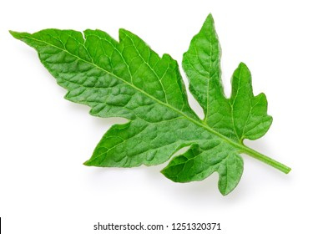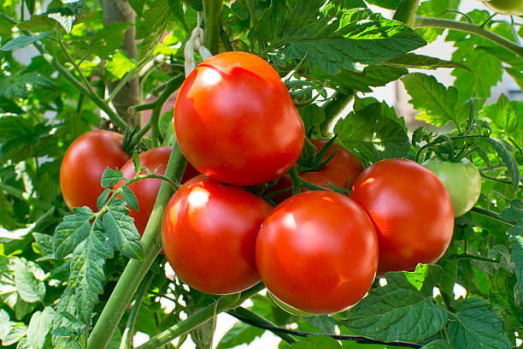
- Healthy plant (b) Healthy fruit
Figure 1- Tomato Plant

2.2 Plant and Fruit Description
Tomato belongs to the Solanaceae family, which includes over 3000 species with origins in both the old and new world (Bai & Lindhout, 2007). The growth habit can be either determinate or indeterminate. Determinate tomato plant grows a particular amount of leaves before transitioning its growth to fruit production while indeterminate tomato throughout the growing season, continues to produce new stems and leaves, as well as fruit (Jensen, & Shock, 2009).
2.3 Uses of Tomato and Nutritional Value
Tomato is produced for its fruit which can be consumed in diverse ways. It is a basic ingredient used in the manufacture of puree pastes, juices, and canned fruit, as well as being combined into chili (Tsado, 2016). The essential nutrients found in tomato are important for human diets and are an excellent source of energy (Mailafiya et al., 2014).
Minerals, essential amino acids, carbohydrates, dietary fibres, and phosphorus are present in tomato fruit (Table 1). Tomatoes are rich in bioactive components such as carotenoids, flavonoids, tannins, and vitamins (A, C, E, and B) (Martí et al., 2016). It contains lycopene, an essential antioxidant that helps in the prevention of many forms of cancer (Tilahun et al., 2017) and also lowers the risk of cardiovascular conditions like hypertension (Cheng et al., 2017). Vitamin A present in Tomato helps improve vision and prevent night blindness (Ganesan, Rajesh, Solairaj, & Senthilkumar, 2012).
Table 1: Nutritional Value of tomato per 100g

Phytochemicals | Value/100 g (unit)
Energy | 74kJ(18kcal)
Carbohydrates  Sugars  Dietary fibre | 3.9g  2.6g
Fat | 0.2g
Protein | 0.9g
Water | 94.5g
Magnesium | 11mg (3 %)
Manganese | 0.114mg (5%)
Phosphorus | 24mg (3%)
Potassium | 273mg (5%)
Lycopene | 2,573µg
Vitamin A equiv. | 42 µg (5%)
B carotene | 449 µg (4%)
Lutein/zeaxanthin | 123mg
Thiamine | 0.037 mg
Niacin | 0.594 mg
Vitamin B6 | 0.08 mg
Vitamin C | 14 mg (17 %)
Vitamin E | 0.54 mg (4 %)
Vitamin k | 7.9µg (8%)

Source: Butnariu & Butu (2015)
2.4 Botany
Self-pollination is the most common method of pollination for tomato plants, even then, there is a potential of cross-pollination (Shankara et al., 2005). The inflorescences of tomato plants typically contain six to twelve bisexual blooms with yellow petals (Ochar, 2015).
A tomato plant with tap roots can grow to a height of approximately 50 cm (Akinfasoye, Dotun, & Ajayi, 2011). The glandular stems of tomato plants typically reach a height of 2 to 4 metres (Shankara et al., 2005).
The primary root of a tomato develops dense lateral and adventitious roots, and it has a strong tap root system that penetrates to a depth of at least 50 cm. It has a robust, uneven, hairy, and smooth stem and can reach heights of up to 2-4 meters. The leaves are oblong and slender, ovate to glandular hair coated. Small pinnate appear between the greater leaves, Spiral arranged in length 15 to 50 cm and in width 10 to 30 cm.
The bisexual, typical, 1.5–2 cm-diameter blooms are arranged in opposing or between the leaves. The six golden, reflexed sepals of the calyx tube are tiny, persistently hairy, and have a length of up to one cm. When fully developed, the 6 stamens' anthers have a bright yellow colour and have a protruding sterile point surrounding the style. The ovary is exceptional, having 2–9 compartments.
Self-pollinated in most cases, but cross-pollinated in certain cases, bees and bumblebees are the most significant pollinators. Fruit is a fleshy berry with a diameter of 2-15 cm and a globular to oblate shape; immature fruit is green and hairy. The colour of the fruit can be red or yellow. Usually it is round and smooth. Seeds are kidneys and pears shaped, light brown hairy and the weight of approx. 1000 seeds is between 2.5 and 3.5 g (Dam, Goffau, Jeude, & Naika, 2005).

2.5 Agronomy

2.5.1 Soil, pH and Climatic Requirements
A variety of soil types can be used to grow tomato, they thrive in productive, deep, medium-textured, sandy loam or loamy soils that have good drainage (UNH, 2018). The ideal soil pH for tomato cultivation is 6.0-7.0 (Hanson, et al., 2001). The table below shows the temperature range for the various tomato stages (Dam, Goffau, Jeude, & Naika, 2005).

Table 2: Tomato Growth Stages and Temperature Requirement
Phases | Temperature (° C)
 | Minimum | Optimum | Maximum
sprouting of seeds | 11 | 16-19 | 34
growing of seeds | 18 | 21-24 | 32
Fruit set | 18 | 20-24 | 30
colour development | 10 | 20-24 | 30
Source: Butnariu & Butu (2015)

Soil Sterilization and Sowing
Solarization is done to kill soil-borne pathogens and insect pests (Lin, Luther & Hanson 2015). It is a simple, safe, and economical means of sterilizing the soil to produce healthy seedlings. To solarize the soil, water is applied to soften the seedbed. The soil is then covered with plastic sheets for 3 to 4 weeks, and thereafter removed. Seeds are then sown 2-3 days later. After germination, seedlings are regularly sprinkled with water to ensure sufficient moisture for growth (Lin, Luther & Hanson 2015).

Fertilization
Tomato plants require both micro and macronutrients for growth and development (Rikky, 2011). The nutrients can be supplied as inorganic or organic fertilizer in a balanced composition. Excessive fertilization leads to waste of resources and can contribute to plants being susceptible to pests and diseases (Nosa & Elfarisna, 2013). Tomato crop nutrient requirements are determined by variety, yield, and cultural techniques (Sainju, Dris &Singh 2003).
Compost, farmyard manure, and poultry dung are just a few of the several types of organic waste. Typically, poultry manure is more effective than farmyard manure, because it enables plants to quickly absorb nutrients, it is a sort of manure that is especially advantageous. Mixing poultry manure with equal amounts of crumbly soil or sand is a nice way to apply it, after sprinkling between the rows, lightly rake or hoe this mixture. It also contains a lot of calcium, which is good for acidic soil (alkaline) (Dam, Goffau, Jeude, & Naika, 2005).

Irrigation
Watering is most important during transplanting, flowering, and fruit development. Irrigation prevents terrible crop losses caused by severe drought. Lack of sufficient water causes stress in tomato which leads to shedding of flowers in young fruit, sun scalding, and fruit dry rot (Georgia, 2009).

2.6 Harvesting
One of the most perishable fruits is the tomato, which keeps changing even after harvest. Depending on moisture and temperature, it matures quickly, which eventually results in reduced value since the fruit is mushy and wholly unpalatable (Ullah, 2009). Tomato for the market are normally selected at the mature green stage in order to prevent the fruit from turning overripe during shipping and handling, the optimal times to begin to harvest tomato are 90 to 120 days after planting or 45 to 55 days after flowering (Ullah, 2009, Penn, 2019).
2.6.1 Post-harvest management
Farmers aiming for faraway markets, according to Orzolek et al (2006), should harvest their tomato in a matured green stage. This would provide farmers adequate time to get their produce ready for market and reduce harvest-related mechanical injuries. The best temperature ranges for mature green tomatoes to ripen is between 63 and 70 ℉; they will not normally ripen at temperatures above 80 ℉ or below 55 (Penn, 2019).
Overloading during harvesting might result in the buildup of excessive compressive stresses, fruits found near the bottom of the containers are crushed. (Hurst, 2010). Mechanical injuries as well as the crushing of harvested fruits could be reduced by using smooth-surfaced and shallow containers that avoid overflowing.

2.7 Tomato Production in Nigeria
As at 2017, Nigeria was the fourteenth (14th) largest tomato grower in the world, with approximately 48 million tomato farmers around the country with 1.8 million tonnes of tomato. Nigeria produces 65% of the tomato grown in West Africa (Sunday, Akinfenwa, Falaju, and Alabi, 2018).
The savannah agro-channel zone in Nigeria is the ideal region for growing tomato since it has less pests and diseases that affect them, between the latitudes of 7.5⁰N and 13⁰N, with temperatures ranging from 25°^{c} to 34ºC. This includes northern states such as Katsina, Jigawa, Sokoto, Zamfara, Bauchi, Kaduna, Taraba, Gombe, and Kano, as well as southern states such as Kwara, Delta, and Oyo (Agronews, 2016).

2.8 Constraints to production
In Nigeria, tomato cultivation is mostly rain fed, meaning that production takes place primarily during the rainy season and that, as a result of inadequate irrigation infrastructure, production is limited during the dry season (Adenuga, Muhammad-Lawal, & Rotimi, 2013). Some of the factors limiting tomato production in Africa are pests and diseases, and foreign imports pose competition (Robinson and Kolavalli 2010).

Insect pests of tomato
Tomato production is constrained by insect pests, which attack the crop at all phases of development, resulting in lower yields (Kharia, Kumar, & Kumar, 2019). Several insect pests limiting tomato production in Nigeria includes, fruit borer (Helicoverpa armigera), the grasshopper (Zonocerus variegatus), cutworms, horn worms, whiteflies (Bemisia tabaci), leaf hoppers (Amrasca devastans), leaf miners (Liriomyza trifolii), mole crickets (Gryllotalpa spp.), tomato aphids (Myzus persicae), mole crickets, mole crickets, and mole crickets, cotton leafworm (Spodopter Epilachna dedecastigma) (Mailafiya, Degri, Maina, Gadzama, & Galadima, 2014). One of the most destructive tomato pests is Tuta absoluta and, due to its significant crop loss, is regarded as an emerging and dangerous pest (Sylla et al., 2017).

2.9. Foliar Diseases of Tomato
2.9.1 Early Blight
Early blight (EB) is a fungal disease caused by Alternaria solani, a deuteromycetous fungus (Ellis and Martin). The necrotrophic fungi (Alternaria solani) was first described by Ellis & Martin. A. brassicicola, A. solani, and A. alternata are the economically important plant pathogens that belong to the genus Alternaria (Agrios, 2005). The thick conidia wall adjusts the fungus to unfavorable environmental conditions (Foolad, Merk, & Ashrafi, 2008). Early blight control has shown to be quite difficult due to the large variety of isolates, the phase of the disease cycle is prolonged, and the wide host range (Chohan, Perveen, Mehmood, Naz, & Akram, 2015).
Infection symptoms are distinguished by lesions in black and brown (Wolter, Schindele, & Puchta, 2019). It is one of the most damaging diseases, reducing the quality of fruit that may be produced in regions (Adhikari, Oh, & Panthee, 2017). In favorable climates that encourage the spread of disease, the pathogen can affect all parts of a tomato, including the stems, fruits and leaves. By generating sunken lesions and black blotches close to the stem base, the disease also promotes girdling and stunting of the stem (Narendra Babu, Jogaiah, Ito, Kestur Nagaraj, & Tran, 2015).
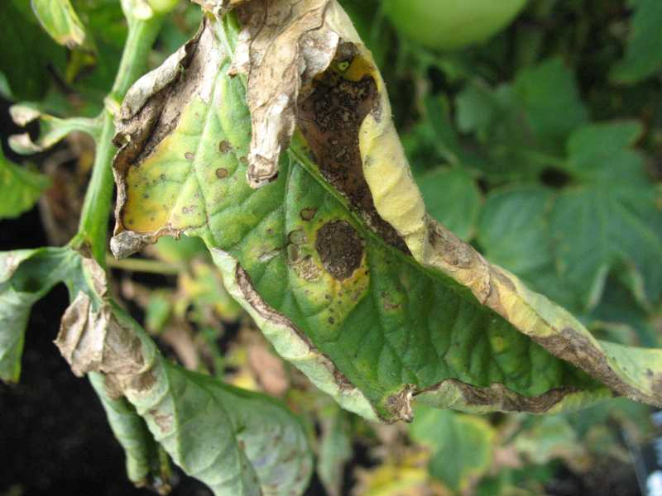
Figure 2: Symptom of early blight on tomato leaf
Leaf blight, or EB, is a disease that can severely damage sensitive varieties, resulting in losses of 50–80% when the disease is severe and there is a lot of moisture around (Ravikumar and Garampalli, 2013). Foliage (leaf blight), stems (collar rot), and fruit are all affected by the fungus, with the leaf blight phase being the most devastating.
Early Blight, which leads to an excessive fall in the value of the fruit profit is found predominantly in wet and sub-tropical areas, is the most detrimental fungal disease of tomato crop (Abdel-Sayed, 2006, Abada, Mostafa, & Hillal, 2008). Sometimes, a yearly loss in tomato production was estimated at 79% because of early blight (Adhikari, Oh, & Panthee, 2017).
Management of Early Blight
Planting resistant varieties, rotating crops, maintaining good hygiene, managing nutrition, and, most critically, using chemical fungicides are used to manage early blight disease because of their quick impacts (Aslam, Mukhtar, Hussain, & Raheel, 2017; Sarfraz et al., 2018). The use of fungicides is considered to be the most successful technique in early distress reduction, as various works have indicated (Sarfraz et al., 2018). Protective fungicides having a multisite mode of action, such as Mancozeb, and systemic fungicides, such as azoxystrobin are generally utilized worldwide. During the tomato growing season, several rounds of treatment are often needed to obtain a suitable disease management level (Abu-El Samen, Goussous, Jendi, & Makhadmeh, 2015).
Fungicide, however, is expensive, has health hazards, and harms the environment due to concerns about toxicity risks and dangers of its residues, the use of fungicides cannot be seen as a long-term solution. In addition, the production of pathogenic fungi resistance to synthetic pesticides is a major problem that can have a notable impact on the efficacy of chemical fungicides (Chohan, Perveen, Anees, Azeem, & Abid, 2019). By combining with other rather safer alternative processes, the usage of fungicides can be changed into a safer control method (Sarfraz et al., 2018).
The use of a bio-control agent provides an efficient and ecological approach to early blight disease management. Trichoderma species due to their potent mycoparasitic fungal infections, are regarded as efficient control agents and quick development capacity (Chanthini et al., 2018). A Biocontrol agent is an effective and ecological alternative approach for managing early blight.

2.9.2 Septoria Leaf Spot
Septoria leaf spot (Septoria lycopersici) is a fungal disease which causes diseased leaves on a variety of horticultural plants (Verkley, Quaedvlieg, Shin, & Crous, 2013). Septoria leaf spot spreads quickly, defoliating and damaging plants and making them unable to produce fruit (Iannotti, 2021).
Although petioles, stems, and the calyx can also show symptoms, leaves typically do. Early symptoms on elder leaves include little, circular patches (Douglas, 2008). Symptoms develop on the undersides of older leaves towards the plant's base as fairly circular spots, with a dark brown edge and light gray or tan centers, the patches get larger as the disease progresses. If you examine them closely using a microscope, you may see the fungus's fruiting bodies, which resemble dark brown pimple which is one of the signs that distinguishes septoria disease (Iannotti, 2021).
​ 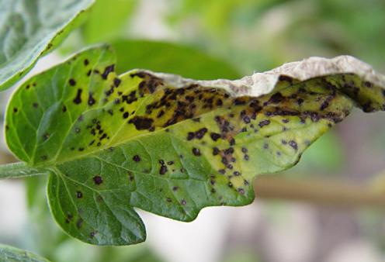
Figure 3: symptom of septoria leaf spot on tomato leaf
The frequency of disease on tomato plants can be considerably increased by the confluence of ideal temperatures and significant precipitation, particularly in the summer. Tomato yields may be reduced by more than half when temperatures are higher than 25 °C and leaf wetness lasts longer than 6 hours (Sanoubar & Barbanti, 2017). Symptoms of disease can arise at during the growth of a tomato plant.
Management of Septoria Leaf Spot
Septoria leaf spot can be minimized by combining sanitation, cultural, and chemical actions in an integrated disease management program. (Douglas, 2008). Fungicides, crop rotation, plant debris removal, weed control, drip irrigation are some of the disease management approaches. (Cabral, Marouelli, Lage, & Café-Filho, 2013; Becker, 2019).
Remove weeds from tomato fields and rotate crops that can act as alternate hosts for the disease. Avoid dense plantings, stake plants, and to enhance rapid leaf drying, plant rows parallel to the prevailing wind direction. If practical, avoid overhead irrigation and time irrigations to cease before sunset to avoid prolonged periods of leaf moisture, reduce the amount of leaves that comes into touch with the soil. Avoid working in tomato fields when the foliage is damp to prevent the fungus from spreading from plant to plant (Schwartz & Gent, 2016).
Chemical control by treating the seeds can help prevent seed-borne disease in the field, 0.2% Mancozeb spraying effectively controls the disease. (Pavan Kumar, Raja, & Srinivasulu, 2018). However, it is unsustainable and is being questioned by the public and governmental sectors because to the harm to the environment and human health. There is a possibility of S. lycopersici isolates becoming fungicide resistant (Alves, Fernandes, & Marin, 2008).
2.9.3 Late Blight
One of the most detrimental tomato diseases, late blight (Phytophthora infestans), resulting in substantial loss (20–70%) in economic output of tomato (Foolad, Merk, & Ashrafi, 2008; Nowicki, Foolad, Nowakowska, & Kozik, 2012). P. infestans can reproduce both asexually and sexually, which leads to quick growth, quick outbreaks, and increased genetic variety and survival (Fry 2008).
On tomato leaves, disease symptoms and indicators begin as vague, water-soaked patches that swiftly progress to light green to brownish-black lesions that c can cover a large portion of the leaf. The disease worsens, causing the foliage to turn yellow, then brown, curl, shrivel, and eventually die (Pavan, Kumar, Raja, & Srinivasulu, 2018).
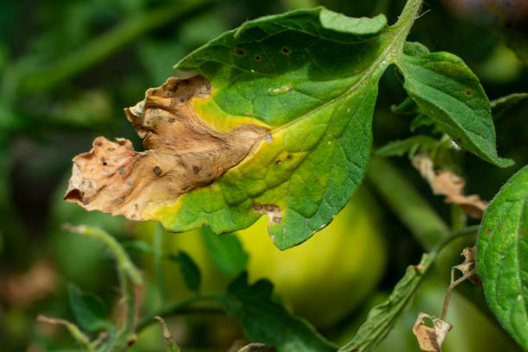
Figure 4: symptom of late blight on tomato leaf
Management of Late Blight Disease
Use of resistant cultivars, crop rotation, fallowing, removal of weeds from fields, destruction of diseased residues from any previous tomato crop, use of pathogen-free seeds, and use of fungicides are all used to control these diseases (Mizubuti, Junior, & Forbes, 2007; Maerere, et al., 2010).
Complete late blight control is challenging to accomplish, particularly during heavy wet seasons. Conversely, significant amounts of disease reduction could be attained by combining tomato resistant cultivars with foliar fungicide applications (Mengesha, Dejene, Hussien, & Biazin, 2018).

2.9.4 Fusarium Wilt
Fusarium wilt (Fusarium oxysporum) is a soil-borne fungus, yellow patches, and withering, are observed on the lower leaves are signs of the disease (Shankara, 2005). It causes wilting of the oldest leaves, followed by wilting of entire plants that eventually dries out, is especially noticeable during dry and hot weather (Worku & Sahe, 2018).
Due to the pathogen's particular vascular tissue, leaves on the side of the plant sometimes display significant disease symptoms that differ from those on the opposite side of the plant during the blooming and fruiting stages (Domsch, Gams, & Anderson, 1980). The pathogen enters the plant through the tips of the roots (Sally, Randal, & Richard, 2006).

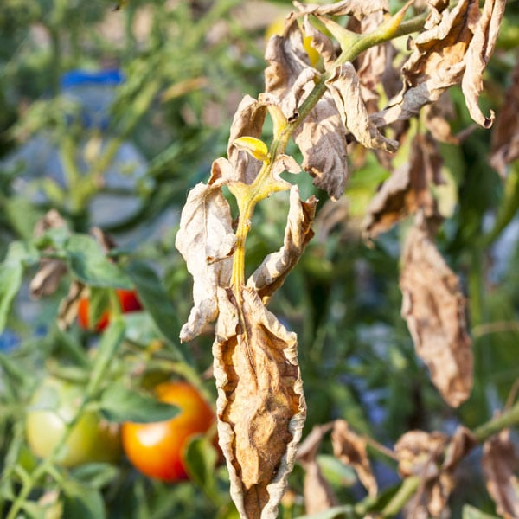
Figure 5: symptom of Fusarium wilt on tomato leaf
Management of Fusarium Wilt
Fusarium wilt disease is usually treated with chemical fungicides; however, this strategy is frequently ineffective because of pathogen tolerance to harsh environmental conditions, as well as the effects of synthetic pesticides on the environment and people. In recent decades, plant produce or allelochemicals have been proposed as a unique alternative source for combating fungal diseases in metal-stressed environments, as well as having metal remediation potential (Farooq, Bajwa, Cheema, & Cheema, 2013). The use of bioagents shows prospects to be highly efficient in controlling Fusarium wilt disease (Freeman, Zveibil, Vintal, & Maymon, 2002).

2.9.5 Verticillium Wilt
Verticillium wilt disease (Verticillium dahliae) is a soil-borne fungal pathogen. Desiccation extends from the tip to the petiole and first appears on older leaves before spreading to younger leaves. Verticillium wilt causes lower leaves to yellow uniformly and wilt. Younger leaves wilt and die as the disease worsens, leaving only a few healthy leaves at the top of the plant. They're slim and stunted, with little fruits. Younger leaves wilt and die as the disease develops until only a few stable leaves remain at the plant's top. They are stunted and slender, with little fruits (Khaire, Mane, & Pawar, 2021).
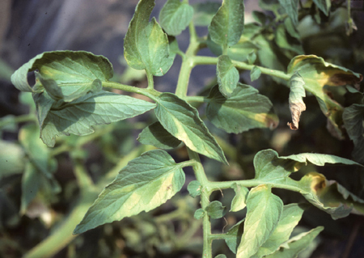
Figure 6: symptom of Verticillium wilt on tomato leaf
Management of Verticillium Wilt
Survival of fungus resting structures (microsclerotia) over a long period of time in soil and the wide variety of plants that host this disease make management of Verticillium wilt difficult (Klosterman, Atallah, Vallad, & Subbarao, 2009). Chemicals are commonly used, to improve disease management, minimize chemical use, and improve the soil ecology, fumigants have been employed in combination with non-chemical methods like the use of resistance planting material and bio fumigants (Pecchia, Franceschini, Santori, Vannacci, & Myrta, 2017, Shennan et al., 2017).
Bio-control agents or extracts, as well as organic amendments, can be used in combination, thus improving the biological activity of bacteria and/or their extracts, has resulted in better management of Vertillicium dahliae (Ruano-Rosa & Mercado-Blanco, 2015; Cheng, Li, Peng, Wang, & Zhu, 2020). Anaerobic soil sterilization is a method for preventing the spread of soil-borne diseases before planting, based on organic amendments that can be used to reduce the incidence of Verticillium wilt (Poret-Peterson, Albu, McClean, & Kluepfel, 2019).
2.9.6 Bacteria Spot
Tomato plants are particularly vulnerable when they are seedlings, as well as right prior to and throughout fruiting (Bliss et al. 1973). Lesions can coalesce under the right environmental conditions, generating big blighted regions on the leaves that cause them to fall out too soon (Schlub et al. 2007).
Although heavy infection might result in defoliation, the main effect of these diseases is a loss in fruit quality. The bacteria can potentially enter a field through contaminated seed or infected transplants. The severity of these diseases is worsened by driving rain and mechanical damage to plants caused by high winds (Kennelly, 2009)
2.9.7 Bacterial Wilt
Bacterial wilt (Ralstonia solanacearum) is among the most serious diseases, limiting tomato productivity (Huang et al. 2013). Bacterial wilt is a damaging bacterial disease affecting tomato all over the world. This bacterium can live for years in the soil. Bacterial wilt is characterized by a rapid drooping of the tomato plant, which occurs frequently while the plant is still green, wilted plants eventually die. (Georgia, 2009).
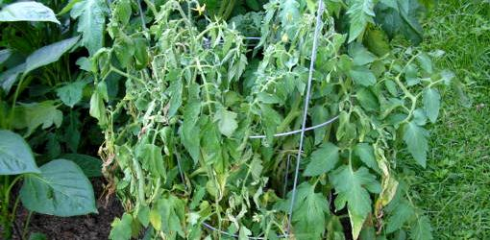
Figure 7: symptom of bacterial wilt on tomato leaf

2.9.8 Tomato yellow leaf curl virus (TYLCV)
Tomato yellow leaf curl virus (TYLCV) is spread by whiteflies, which can transmit the disease into the field from affected plants in the surrounding area. The symptoms of tomato plants include leaf curling, smaller-than-normal leaves, yellow leaf margins and plant stunting (Blake, 2018).
Symptoms include stunted growth, and little to no yield can be obtained from tomato plan. Plant symptoms manifest as severely stunted individual plants with significantly decreased leaves that resemble mouse ears. Tomato leaves from infected plants may also show signs of marginal chlorosis. Because this disease is frequently carried in on infected transplants and disseminated by whiteflies, transplant inspection is essential (George, 2009).
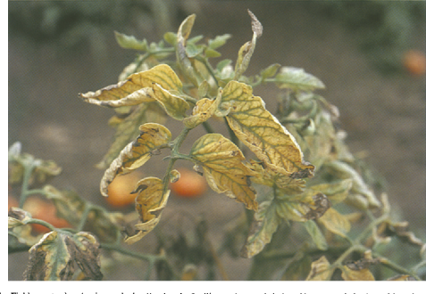
Figure 8: symptom of tomato leaf curl virus on tomato leaf
However, leaf disease is primarily treated with chemical fungicides but due to the rising risk to the environment caused by fungicides, the globe is moving toward more efficient, safe, sustainable, and environmentally friendly plant disease management techniques (Lamichhane et al., 2017).

2.9.9 Curly top virus of tomato
Curly top viruses affect over 300 plant species from 44 families, causing the disease, including tomato. Curly top symptoms begin with light green leaves, up-curling, and vein purpling atop the leaves' undersides. Curly Top disease (CT), a curtovirus family, affects several different types of agricultural crops. CT has historically caused major damage to tomato crops, resulting in significant economic loss (Frantz, Gordillo, Nischwitz, & Compton, 2019).
When plants are infected early in their development, they stop growing and die, typically standing out amid healthy plants nearby. Curly top stunts and causes plant growth to be deformed, leading to phloem necrosis and hyperplasia as well as crumpling, yellowing, and vein swelling in leaves and distortion (Chen, Brannigan, Clark, & Gilbertson, 2010).

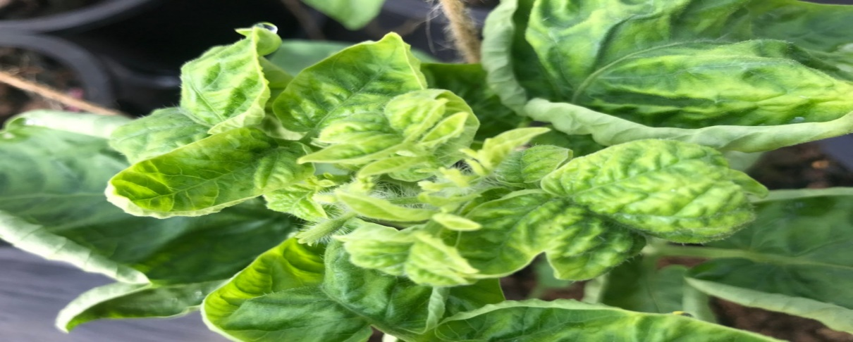

Figure 9: symptom of curly top virus on tomato leaf
Curly top is a spontaneous and unpredictably occurring; the Curly Top Virus Control Program depends on monitoring leafhopper populations, spray insecticides that specifically target the vector; There are no commercially available tomato varieties that can withstand curly tops, however cultural practices such avoiding planting near foothills or dense plant populations can help (Gilbertson, 2014).
The greatest way to control CTV is through an integrated strategy. The Beet Leaf Hopper (BLH), which spreads from infected weeds to healthy plants each year, should be removed from host plants in nearby areas (Rudig, 2009).

2.10 Review of Methodological Approach
Abbasi, Al-Dahmani, Sahin, Hoitink, & Miller (2002) investigated on the Effect of Compost Amendments on Disease Severity and Yield of Tomato in Conventional and Organic Production System. The findings of this study back up an earlier possibility that soil amendments with manures can reduce the severity of some plant diseases that occur above ground, despite the fact that compost amendments raised foliar disease symptoms, disease incidence on fruit was minimized in this study.
Arogundade, Balogun, & Fawole (2009) carried out an experiment on In a southern Guinea savannah agro-ecology, the incidence and severity of common viral and fungal diseases of dry season tomato plants were investigated, and it was discovered showed tomato plants grown in the dry season were exposed to fungi and viruses at all stages of development. Stage 1 had the highest rate of viral disease infection (i.e., the seedling/vegetative stage from day 1 to 28 days after transplantation). This may be because leaf curl, the most severe viral disease affecting tomatoes during the dry season when they are being irrigated, is the prevalent viral disease.

Amuji et al., (2012) carried out screening of seven tomato genotypes/lines for fungal disease in the field during the 2011 and 2012 rainy seasons. The findings of this experiment showed that the most common fungal pathogens identified from tomato lines were Fusarium oxysporum and Rhizopus stolonifera as a result, they were considered the localized fungal pathogen limiting tomato production in Nsukka, Nigeria's south-eastern region.

Terna, Okoro, Bem, Okogbaa, & Waya, (2016) carried out a survey during the wet seasons of 2012 and 2013, the incidence and severity of tomato diseases on farmers' farms in Benue State were investigated. Using the quadrat method to assess the disease incidence, the survey discovered that the disease peaked in July and that symptoms advanced more quickly in 2012. Leaf spots, blights, stem rots, fruit rot, plant wilt, seedling damping-off, yellowing leaves, fungal substance growth on plant bodies, and stunted growth are among the symptoms noticed. In the research location, the severity of tomato disease is very high.

2.11 Features of tomato varieties evaluated
Roma Vf
The Roma tomato is a hybrid species created by crossing the Pan American tomato with the San Marzano paste tomato to the US by Italian immigrants. Roma Tomato are generally disease resistant and have long shelf life. The plants of Roma Vf are determinate and have great leaf cover The fruits are large, plum-shaped and bright red. It is commonly used for paste. It is a cross between 'Roma' variety and 'California Red Top VR 9'. Fusarium wilt and Verticillium wilt resistance is present in Roma (https://www.victoryseeds.com/tomato_roma-vf.html).

Tropimech
Tropimech tomato varieties exhibit determinate growth habits. The fruit is elongated (egg-shaped) in shape, has slightly green shoulder, weighs 90-100g and are firm. The firmness enhances good preservation during transportation. The plants mature in 65 to 70 days after transplanting. The fruits are uniform colour. Fusarium wilt, stem canker, nematodes, and the tomato yellow leaf curl virus are all resistant to this variety.

Tima
Tima variety is well adapted to the tropics and has a determinate growth habit (https://greenseeds.net/product/tomato-tima/). The plant height varies from 45-90cm (https://davesgarden.com/guides/pf/go/115458/#b). The plant parts are poisonous if ingested. The fruits are elongated, cylindrical and weighs 90-100g. The fruit is red in colour, firm and has a good shelf life. It is used fresh or for salad. It can also be preserved in cans. Fruits mature in 70-75 days after transplanting.

2.12 Gap Identified
There is a paucity of data on disease incidence and severity on commonly cultivated tomato varieties, particularly in Nigeria.

CHAPTER THREE

3.0 MATERIALS AND METHODS

3.1 Description of the experimental site
The research was carried at Landmark University's Teaching and Research Farm Omu-Aran, Kwara State, Nigeria. Omu-Aran is located at latitude of 80.9'N and longitude of 50'61 E, in the derived savanna ecological zone. Experiment was conducted in two locations (Sites A and B) between December and February, the area’s annual rainfall ranges from 600 -1,500mm, with peaks in June. The humidity varies from 50% in the dry season to around 85% in the rainy season.
3.2 Source of materials, curing of poultry manure and soil sterilization
Four varieties of tomato were used for this study: two (Tropimech and Tima) were sourced from Technisem (a certified seed company in Ilorin) and Omu-Aran local from the open market in Omu-Aran, and Roma VF from National Horticultural Research Institute (NIHORT), Ibadan, Nigeria.
Poultry manure was collected from Landmark University's Teaching and Research Farm's Animal Section, Omu-Aran. The manure was cured by keeping under shade exposing it to the air and incorporated into the soil for two weeks to allow mineralization. The soil was sterilized in the soil sterilizer for 30 minutes at 120°C and 15psi, and then air-dried for 72 hours (Kolawole, Haastrup & Olabiyi, 2018) to kill soil-borne pathogens and insect pests that may be present in the soil.
3.3 Nursery Operation
Seeds of the four varieties of tomato were raised in polythene bags in the screen-house for 3 weeks. The seedling was watered the early hours of the day and late at night to ensure appropriate moisture for growth.
3.4 Land Preparation, transplanting and experimental design
A land area of 22 m² was cleared manually, and partitioned into 12 beds at each site, with each bed measuring 1m x 1m with 0.5m alley in between beds, tomato seedlings were transplanted at spacing of 0.5 x 0.75m.
The cured poultry manure was applied to the soil during site preparation at 20t/ha (Adekiya et al., 2017). The experiment was laid in a randomized complete block design (RCBD) with 4 replications.
After three weeks, seedlings were transplanted to the field. The seedlings were hardened a week before transplanting by reducing water application, but 12-14 hours before being removed, they were thoroughly watered again to minimize excessive root damage. Transplanting was done during the cool hours of the day, and each seedling was planted with a ball of earth to protect the roots. The plants were watered immediately after transplanting. Weeding and staking manually were carried out as required. Watering was done twice a day, in the morning and in the evening, under natural infection conditions, the plants were exposed to foliar pathogens.

3.5 Field layout:
^{Rep 1} | ^{Rep 2} | ^{Rep 3}
^{V1} | ^{V3} | ^{V4}
^{V2} | ^{V1} | ^{V3}
^{V3} | ^{V4} | ^{V2}
^{V4} | ^{V3} | ^{V1}

V1: Roma VF
V2: Tima
V3: Tropimech
V4: Omu-Aran Local

3.6 Data Collection
Starting from one week after transplanting, the leaves of the plants were observed for symptoms of foliar diseases. Using visual observation the data collected was deployed to calculate disease incidence (DI) and severity (DS). Brown paper envelopes were used to collect infected leaf samples, labelled accordingly and taken to Nigeria Agricultural Quarantine Service, Ibadan (NAQS) and the International Institute of Tropical Agriculture (IITA), Ibadan, Nigeria, for pathogen identification.
3.6.1 Disease incidence assessment
Percentage disease incidence was calculated using the formula:
% Disease Incidence = $\frac{Number of infected plants}{Total plants observed }*100$
3.6.2 Disease severity assessment
For early blight disease, severity was assessed on a scale of 0-5 according to Rahmatzai et al., (2017):
0 = | No symptom on the leaf
1 = | < 10% of leaf surface area
2 = | 11-25% of foliage of plants covered with symptom
3 = | Symptoms coalesced on the leaves, covering 25-50% surface area
4 = | 51-75% area of the plant’s leaves, fruits and stems with the symptom.
5 = | <75% area of plant part with disease symptom.

The severity of bacterial wilt was evaluated using a 5 rating scale (Tiwari, Mehta, Singh, & Tiwari, 2012) as below:

Score | Infection (%) | Reaction
0 = | 0 | Highly resistant
1 = | 1-10 | Resistant
2 = | 11-25 | Moderately resistant
3 = | 26-50 | Moderately susceptible
4 = | 51-75 | Susceptible
5 = | 76-100 | Highly susceptible

For curly top virus, severity was assessed based on the rating scale of (Montazeri, Shams-Bakhsh, Mahmoudi, & Rajabi, 2016) as tabulated below:

Score | Symptoms on leaf
1 = | No visible symptoms
2 = | The leaf thickens and the veins clear.
3 = | 2–3 leaves margins are curling, and there is a mild vein swelling and crumpling..
4 = | 4–5 leaves margins are curling, and there is a minor vein swelling and crumpling..
5 = | Majority of leaves exhibit mild vein swelling, crumpling, and curling..
6 = | Most leaves have slight vein swelling, crumpling, and curling.
7 = | Most leaves have moderate vein swelling and crumpling, as well as severe leaf curling.
8 = | Severe stunting, swollen and crumpled veins on most leaves, and curled leaf margins

3.6.3 Plant growth parameters

Data were collected on the following growth parameters of tomato at two, four, and six weeks after transplanting:
(i) Plant height: Plant height (cm) was measured from the ground to the tip of the growth point using a meter rule.
(ii) Number of leaves: The number of leaves was counted and recorded.
(iii) Number of branches: The number of branches was counted and recorded.
3.6.4 Pathogen Isolation and Identification
Fungal and bacterial isolations were carried out according to Rashid, Sijam, Awla, Saud, & Kadir (2016): The infected parts of leaves were cut into little 3 mm diameter pieces, along with some healthy-looking parts. The small pieces were rinsed with sterile water and surface sterilized with 10% NaOCl for 30 to 60 seconds before being blotted to dry on sterile paper. Three pieces were placed aseptically on Petri dishes with Potato Dextrose Agar (PDA) medium after drying. After that, the inoculated Petri dishes were labeled and incubated at 25°C for 5 days to allow the fungus to multiply. Fungal identifications were based primarily on colony characterization and examination using a compound microscope with a magnification of 40X (Aneja, 2004).
For bacterial isolation, infected plant samples were placed in tiny test tubes and soaked in 2 mL of sterilized distilled water for an hour. The tubes were agitated in a vortex mixer to obtain turbid bacterial suspensions. Loopfuls of the aqueous solution were streaked over Nutrient Agar (NA) and cultured at 30 ° C for two days, on NA plates, different colonies were streaked. This procedure was repeated until pure bacterial cultures with uniform colony morphology were formed. The colony was observed on a stereomicroscope.

3.7 Data Analysis
Data collected were subjected to analysis of variance (ANOVA) using the SPSS package, and means were separated using Duncan multiple range (DMRT) at a probability level of 5%.

CHAPTER FOUR
4.0 RESULT AND DISCUSSION
4.1 Identified pathogens
The foliar diseases observed in this study are early blight, bacterial wilt and curly top virus and the identified pathogens attributable are Alternaria solani, Ralstonia solanacearum and curly top virus, respectively.
4.1.0 Characteristic symptoms of early blight as noticed on the field
Early blight symptoms were visible on the leaves, appearing as irregular brown leaf lesions with dark edges on the affected leaves. Concentric rings with lesions were noticed on the field, as well as necrosis of the damaged leaf part. These symptoms are synonymous with the biology of A. solani (Adhikari, Oh, & Panthee, 2017).
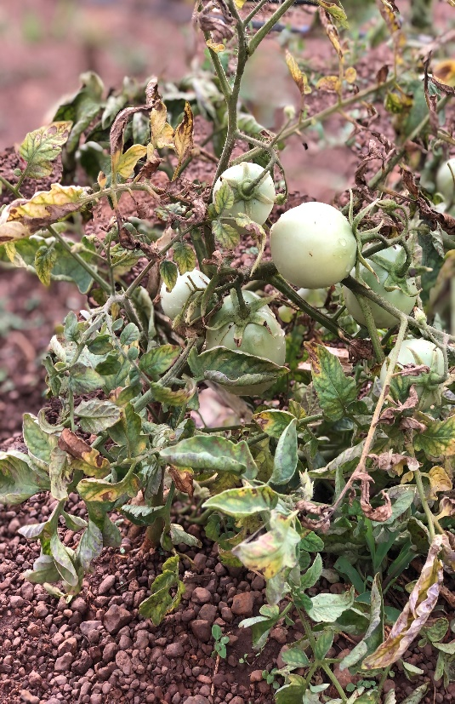 | 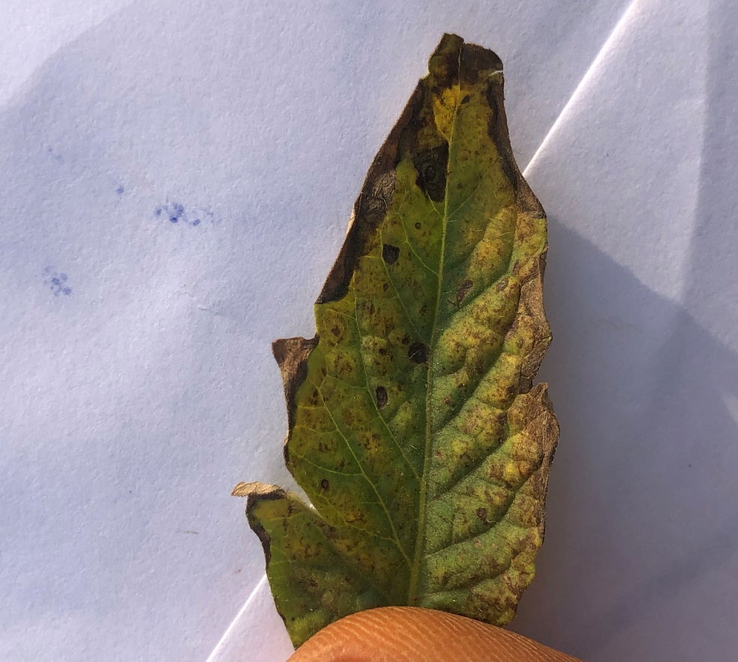
(a): Infected tomato plant (b) Infected tomato leaf
Fig 10: Symptoms of early blight observed on the field
4.1.1 Early blight Disease Identification and Morphological Characterization

On potato dextrose agar (PDA) the fungus (Alternaria solani) produced profuse mycelial growth. The mycelium was initially hyaline, became grey-brownish, multi-celled, septate, and irregularly branching. Hyphae were thin (2.84 m in diameter), narrow, and hyaline in the early stages of growth, but they thickened slightly (4.42 m in diameter) as they matured.
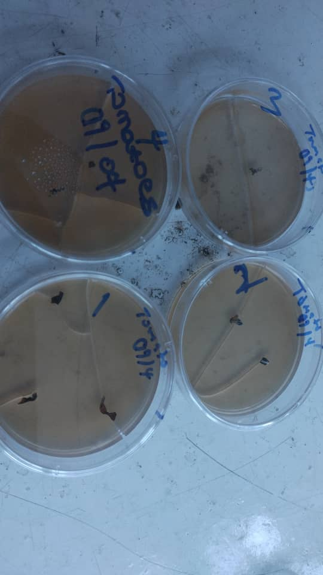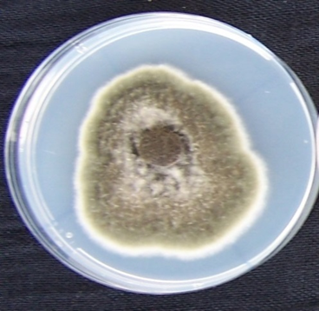
(a): fungus culture (b): fungus profuse mycelial growth
Plate1: Alternaria solani culture at plating and after growth
Microscopic description
Conidiophores can appear alone or in groups of two to six, and can be long or short, they were pale olivaceous to olivaceous-brown in color, straight or curved, geniculate, swollen at the apex, and had terminal scars indicating the place of conidia attachment. On conidiophores, conidia were born in chains of ten or more, they were obclavate to fully ellipsoidal, muriform with a tapering apex and 1 to 3 longitudinal and 2-10 transverse septa, and varied in color from light olivaceous to dark brown and varied in shape from obclavate to largely ellipsoidal, muriform with a tapering apex and 1 to 3 longitudinal and 2-10 transverse septa.
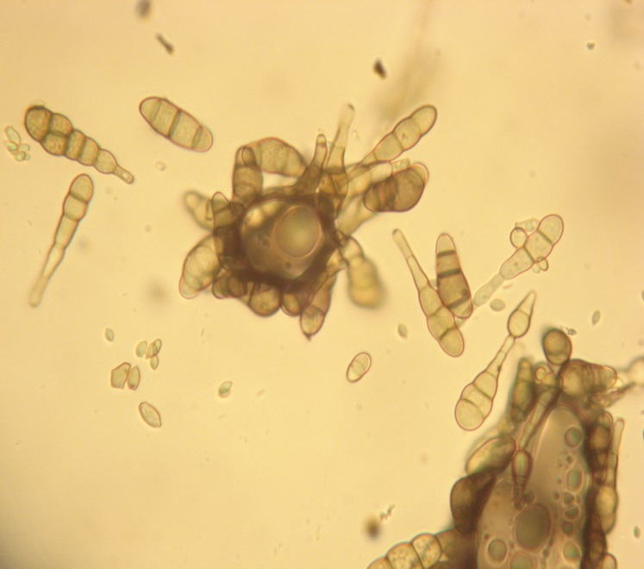
Plate 2: microscopic description of the fungus

4.1.2 Characteristic symptoms of bacterial wilt as observed on the field
Symptoms observed on infected plants on the field showed wilting even while the plants were still green (Figure 11a).
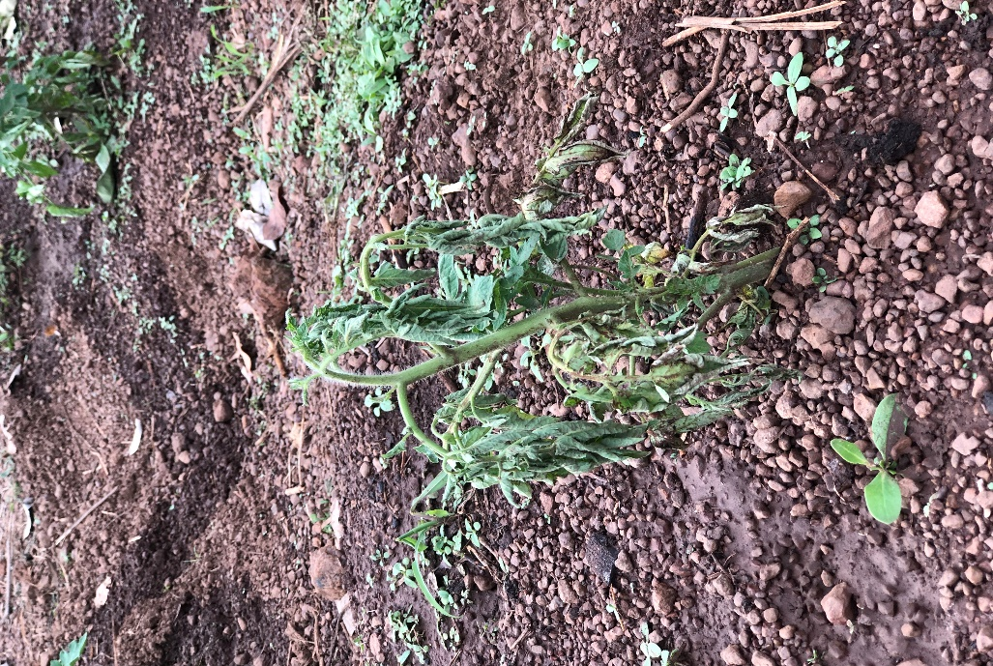
- Wilted plant
Figure 11: Symptoms of bacterial wilt observed in the field
A cross section of an affected stem revealed brown vascular tissue discolouration (Figure 13b). The freshly cut stem at the plant base immersed in water also showed a stream of white slimy substance, which is a strong indicator of the presence of Ralstonia solanacearum (causative organism of tomato bacterial wilt) in the vascular tissue.
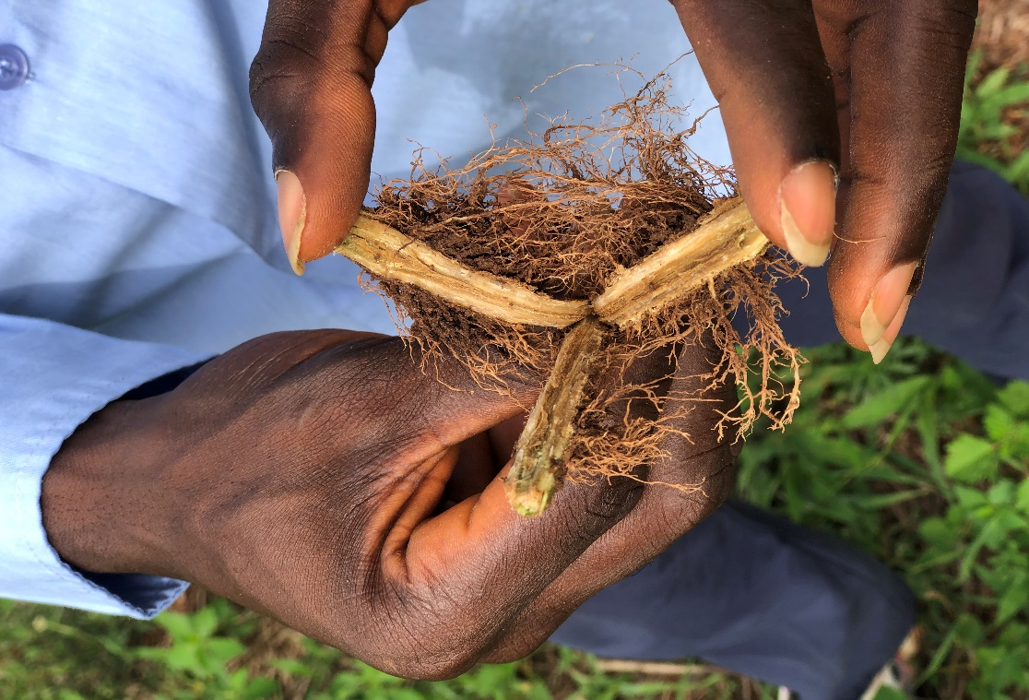
(b) cross-section of infected stem
Figure 11: Symptoms of bacterial wilt observed on the field
4.1.3 Characteristic symptoms of curly top virus as observed on the field
Infected tomato plants on the field had a bumpy feel, showed stunted and deformed growth, leaves were curled and deformed, and showed light green to yellow discolouration.
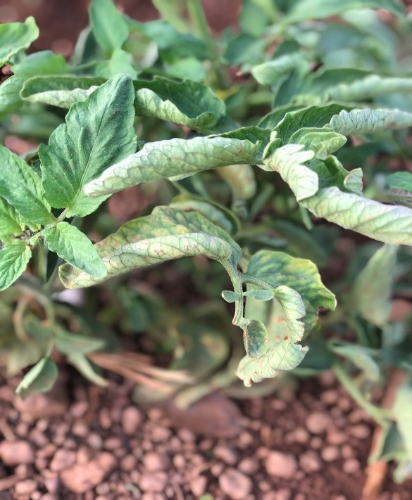 | 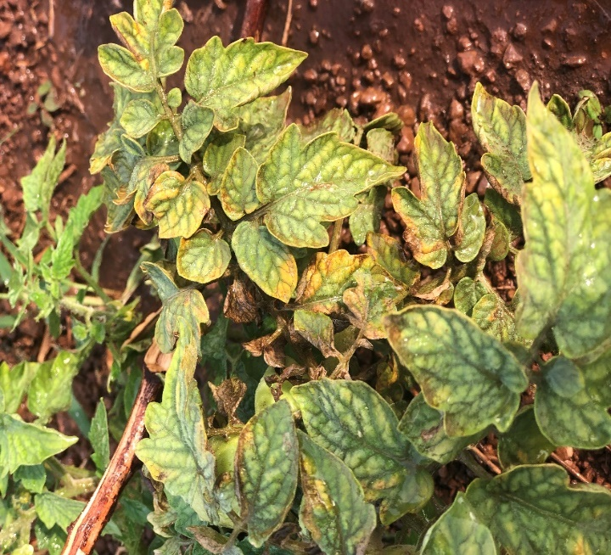
Figure 12: Symptoms of curly top observed on the experimental field

4.2 Disease Incidence
4.2.1 Early blight Incidence
The incidence of early blight on the four tomato varieties is presented in Figure 13. In Site A at 2 and 4 WAT, there was no significant difference in the disease incidence among the four tomato varieties. At 6WAT, Roma Vf (83.4%) had the highest incidence of early blight; however, this was not statistically different from Tropimech (58.4%). The lowest incidence was recorded on Omu-Aran Local (41.7%) and Roma Vf (41.7%).
The results in Site B shows that at 2 WAT, the highest disease incidence was observed in Roma Vf (50%), followed by Tima (25.0%) and Tropimech (16.7%), all of which were not significantly (P<0.05) different. The lowest incidence (8.3%) of early blight was recorded in Omu-Aran Local. At 4WAT, the highest disease incidence was observed in Roma Vf (75.0%), followed by Tropimech (41.6%), both of which were not significantly (P<0.05) different. The lowest incidence was observed on Tima (25.0%) and Omu Aran Local (25.0%). At 6WAT, the highest disease incidence was observed in Roma Vf (100.0%) and Omu-Aran Local (100.0%), followed by Tropimech (58.3%), all of which were not significantly (P<0.05) different. The lowest early blight incidence was recorded in Tima (50.0%).
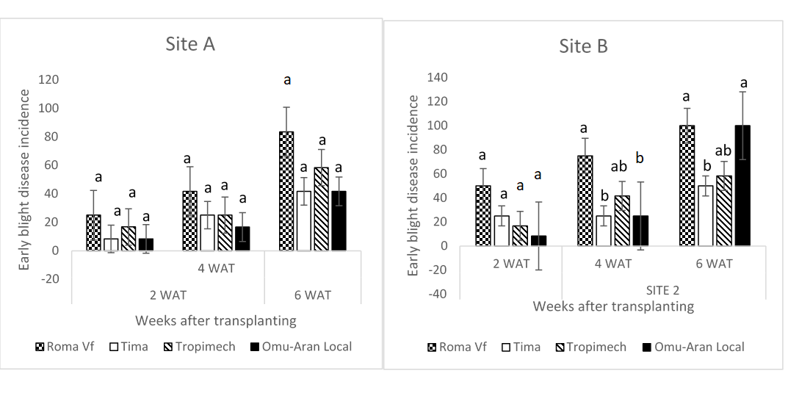
b
a
a
Bars marked with different letters shows means are significantly different at 0.05 level of probability using DMRT. Vertical bars show standard error.
Fig 13: Early blight Disease incidence at Site A and Site B

4.2.2 Bacterial Wilt Incidence

The incidence of bacterial wilt on the four tomato varieties is presented in Figure 14. 1 At 2WAT in Site A, the highest disease incidence was recorded on Tima (66.7%) and was significantly (P<0.05) higher than Tropimech (33.3%), Roma Vf (8.3%) and Omu-Aran Local (8.3%), all of which were statistically similar. At 4 WAT, Tima had the highest bacterial wilt incidence (91.7%), followed by Tropimech (58.4%). The lowest disease incidence was recorded on Omu-Aran Local (16.7%) and Roma Vf (8.3%). At 6WAT, the highest disease incidence was observed in Tima and Tropimech (100.0) both of which were not significantly (P<0.05) different. The lowest disease incidence (41.6%) was recorded on Roma Vf and Omu-Aran Local.
In Site B at 2 WAT, there was no significant (P<0.05) difference in the disease incidence of the varieties. At 4WAT, the highest disease incidence was recorded on Tima (75.0%) which was significantly (P<0.05) higher than Omu-Aran Local (58.3%) and Tropimech (50.0%). Roma Vf had the lowest incidence (16.7%). At 6WAT the highest disease incidence was recorded on Tima (91.7%), followed by Omu-aran Local (83.3%) and Tropimech (75.0%) which were not significantly (P<0.05) different. The lowest disease incidence score was recorded on Roma Vf (41.7%).
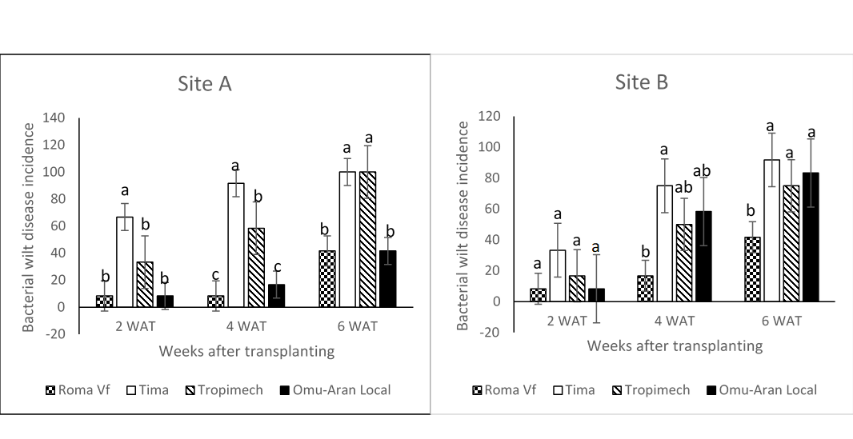
Bars marked with different letters shows means are significantly different at 0.05 level of probability using DMRT. Vertical bars show standard error.
Fig 14: Bacterial wilt incidence at Site A and Site B

4.2.3 Curly top virus Incidence
The incidence of curly top virus is presented in Figure 15 below. There was no significant difference (P<0.05) in disease incidence among all the tomato varieties at 2,4, and 6 WAT in both Site A and B.
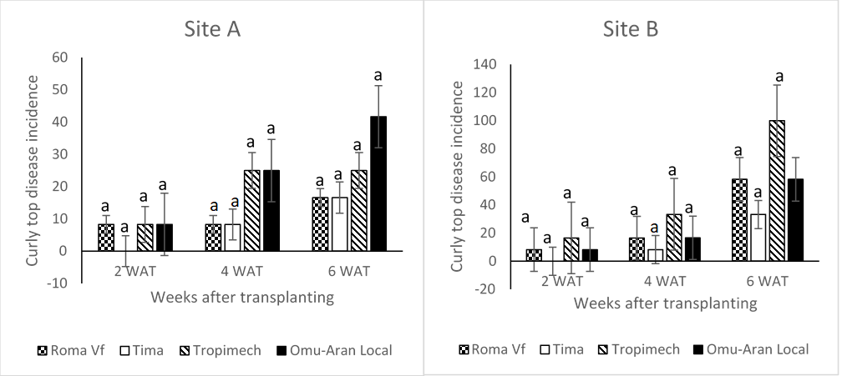

Bars marked with different letters shows means are significantly different at 0.05 level of probability using DMRT. Vertical bars show standard error.
Figure 15: Curly top incidence at Site A and Site B

4.3 Disease Severity

4.3.1 Early blight severity

The severity of early blight on the four tomato varieties is presented in Figure 16. In Site A at 2WAT, there was no significant (P<0.05) difference in disease severity among the four varieties with Roma having the highest value (1.3) and Omu-Aran local the lowest (0.3. At 4WAT, Roma Vf had the highest severity (2.5) which was not significantly (P<0.05) different from Tima (1.3) and Tropimech (1.3). The lowest early blight severity (0.5) was recorded on Omu-Aran Local. At 6WAT, the highest disease severity (3.0) was recorded on Roma Vf and was significantly (P<0.05) higher than Tropimech (1.8), Tima (1.5) and Omu-Aran Local (1.5), all of which were not significantly (P<0.05) different.
In Site B at 2 WAT, there was no significant difference (P<0.05) in early blight severity among the four tomato varieties. At 4WAT, the highest disease severity (1.8) was recorded on Roma Vf and was significantly higher than Tropimech (0.8), Tima (0.8) and Omu-Aran Local (0.5), all of which were not significantly (P<0.05) different. AT 6WAT, the highest disease severity was observed in Roma Vf (3.0) and was significantly (P<0.05) higher than Tropimech (1.3), Omu-Aran Local (1.3) and Tima (1.0).

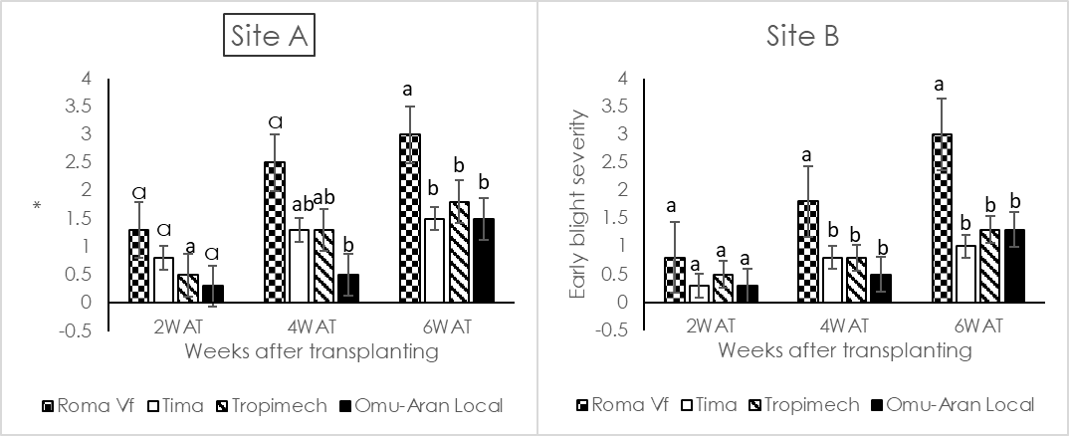
Bars marked with different letters shows means are significantly different at 0.05 level of probability using DMRT. Vertical bars show standard error
a
Figure 16: Early Blight Severity at Site A and

4.3.2 Bacterial wilt severity
The severity of bacterial wilt on the four tomato varieties is presented in Figure 17. At 2 WAT in Site A, the highest disease severity (2.8) was recorded in Tima and was not significantly (P<0.05) different from Tropimech (2.0). The lowest severity was observed in Omu-Aran Local and Roma Vf, both of which were not significantly (P<0.05) different. At 4 WAT, Tima had the highest severity of bacterial wilt (3.5), followed Tropimech (2.5), both of which were not significantly (P<0.05) different. The lowest disease severity was recorded in Omu-Aran Local (1.3) and Roma Vf (0.5), both of which were not significantly (P<0.05) different. At 6 WAT, Tima had a significantly (P<0.05) higher severity (4.8) than the other varieties. There was no significant difference in bacterial wilt severity among Tropimech (2.8), Omu-Aran Local (2.5) and Roma Vf (2.0).
In Site B at 2 WAT, there was no significant (P<0.05) difference in disease severity among the four tomato varieties. At 4 WAT, Tima had a significantly (P<0.05) higher severity (3.8) than the other varieties. There was no significant difference in bacterial wilt severity among Tropimech (1.8), Omu-Aran Local (1.5) and Roma Vf (0.8). At 6 WAT, Tima had the highest severity (5.0), followed by Tropimech (3.3), both of which were not significantly (P<0.05) different. Omu-Aran Local (2.3) and Roma Vf (2.0) had the lowest severity of bacterial wilt, both of which were not significantly (P<0.05) different.

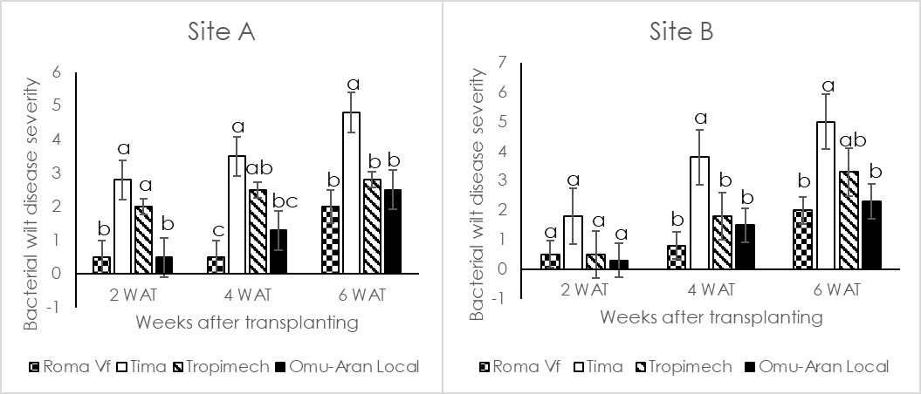
Bars marked with different letters shows means are significantly different at 0.05 level of probability using DMRT. Vertical bars show standard error

Figure 17: Bacterial wilt Severity at Site A and Site

4.3.3 Curly top virus Severity
The severity of curly top virus is presented in Figure 18 below. There was no significant difference (P<0.05) in disease severity among all the tomato varieties at 2,4, and 6 WAT in both Site A and B.
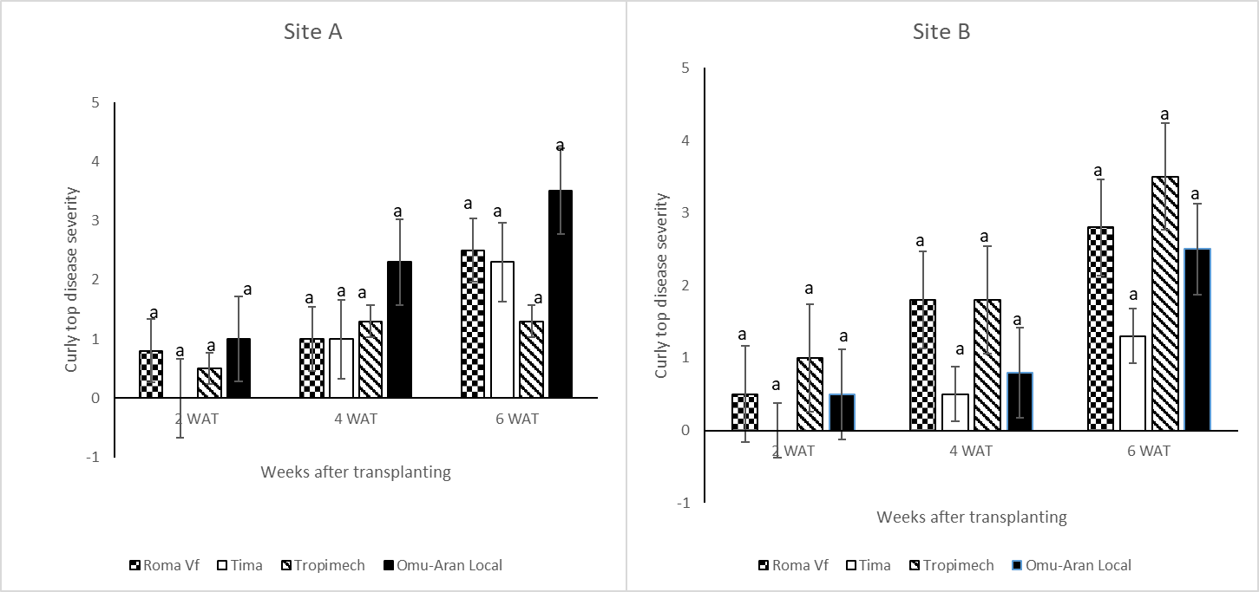
Bars marked with different letters shows means are significantly different at 0.05 level of probability using DMRT. Vertical bars show standard error
Figure 18: Curly top severity at Site A and Site B

4.4 Response of four tomato varieties to some growth parameters
4.4.1 Plant height of four tomato varieties as influenced by foliar diseases
The effect of foliar diseases on the four tomato varieties is presented in Table 3. In Site A at 2 WAT, the tallest tomato plants were observed in Tropimech (16.8cm), Omu-Aran Local (16.0cm) and Roma Vf (13.3cm), all of which were not significantly (P<0.05) different. The shortest plant (9.8cm) were recorded in Tima. At 4 WAT, the highest plant height was observed in Omu-Aran Local (21.9cm), followed by Tropimech (21.5cm) and Roma Vf (19.4cm), all of which were not significantly (P<0.05) different. The lowest plant height (14cm) was recorded in Tima. Similar result trend was recorded at 6 WAT.
The results in Site B shows that at 2 WAT, the highest plant height was observed in Omu-Aran Local (15.4 cm), followed by Roma Vf (15.3 cm) and Tropimech (11.9 cm), all of which were not significantly (P < 0.05) different. The lowest plant height (9.0cm) was recorded on Tima. A similar result was recorded at 4 WAT. AT 6 WAT, the highest plant height was recorded in Roma Vf (28.5cm), followed by Omu-Aran Local (27.3cm) and Tropimech (19.5cm), all of which were statistically similar. The lowest plant height (18.5cm) was recorded on Tima.

Table 3: Plant height (cm) of four tomato varieties as influenced by foliar diseases
Treatment | 2 WAT | SITE A  4 WAT | 6 WAT | 2 WAT | SITE B  4 WAT | 6 WAT
Roma Vf | 13.3ª | 19.4^{ab} | 28.0^{ab} | 15.3ª | 18.0ª | 28.5ª
Tima | 9.8^{b} | 14.0^{b} | 18.6^{b} | 9.0^{b} | 12.9^{b} | 18.5^{b}
Tropimech | 16.8ª | 21.5ª | 31.1ª | 11.9^{ab} | 16.5^{ab} | 19.5^{b}
Omu-Aran Local | 16.0ª | 21.9ª | 35.3ª | 15.4ª | 18.6ª | 27.3ª

Means in a column followed by the same letter(s) do not differ significantly at 0.05 level of probability according to Duncan Multiple Range Test (DMRT)

4.4.2 Number of leaves of four tomato varieties as influenced by foliar diseases
The effect of foliar diseases on the number of leaves is presented in Table 4 below. In Site A, at 2 WAT, Roma Vf had the highest number of leaves (23.8) of tomato, and was statistically similar to the Omu-Aran Local (22.3) and Tropimech (17.8). The lowest number of leaves was recorded om Tima (9.8). At 4 WAT, Omu-Aran Local had the highest number of leaves (34.5) followed by Roma Vf (32.8) and Tropimech (29.3) all of which were not significantly (P < 0.05) different. The lowest number (14.8) of leaves was recorded on Tima. A similar result trend was observed at 6WAT.
In Site B at 2 WAT, the highest number of leaves was recorded on Roma Vf (23.8) and was not significantly (P<0.05) different to Omu-Aran Local (22.3) and Tropimech (17.8). Tima (9.8) had the lowest number of leaves according to the table below. At 4 WAT and 6 WAT, Omu-Aran Local had the highest number of leaves and was statistically similar to Tropimech and Roma VF. The lowest number of leaves was recorded in Tima.

Table 4: Number of leaves of four tomato varieties as influenced by foliar diseases
Treatment |  | SITE A |  |  | SITE B
 | 2 WAT | 4 WAT | 6 WAT | 2 WAT | 4 WAT | 6 WAT
Roma Vf | 23.8ª | 32.8ª | 71.8ª | 23.8ª | 32.8ª | 71.8ª
Tima | 9.8^{b} | 14.8^{b} | 22.0^{b} | 9.8^{b} | 14.8^{b} | 22.0^{b}
Tropimech | 17.8^{ab} | 29.3^{ab} | 51.3^{ab} | 17.8^{ab} | 29.3^{ab} | 51.3^{ab}
Omu-Aran Local | 22.3ª | 34.5ª | 78.8ª | 22.3ª | 34.5ª | 78.8ª
Means in a column followed by the same letter(s) do not differ significantly at 0.05% level of probability according to Duncan Multiple Range Test (DMRT)

4.4.3 Number of branches of four tomato varieties as influenced by foliar diseases
At Site A, the number of branches of four tomato varieties is shown in table 5 below. At 2WAT the highest number of branches was recorded in Omu-Aran Local (6.5) and was not significantly (P<0.05) different to Tropimech (5.8) and Roma VF (5.5). The lowest number of branches was recorded in Tima (3.5). At 2 WAT, the highest number of branches was observed in Omu-Aran Local and was statistically (P<0.05) similar to Roma Vf (9.0) and Tropimech (8.8). The lowest number of branches was recorded in Tima (6.5). Similar results trend observed in 2WAT was recorded at 6WAT.
In Site B at 2 WAT in the table 6 below, Roma Vf (5.3) had the highest number of branches and was statistically similar to Tropimech (4.3) and Omu-Aran Local (4.3). The lowest number of branches was recorded in Tima (3.0). At 4 WAT Omu-Aran Local (6.8) and Roma Vf (6.8) had the same number of branches which was recorded to be the highest and was not significantly (P<0.05) different to both Tima (5.0) and Tropimech (5.5). At 6 WAT, Roma Vf (13.5) had the highest number of branches and was not significantly (P<0.05) different to Omu-Aran Local (10.8). The lowest number of branches was recorded in Tima (8.0) and Tropimech (7.3), both of which were not significantly (P<0.05) different.

Table 5: Number of branches of four tomato varieties as influenced by foliar diseases
 |  | SITE A |  |  | SITE B
Treatment | 2 WAT | 4 WAT | 6 WAT | 2 WAT | 4WAT | 6 WAT
Roma Vf | 5.5ª | 9.0^{ab} | 13.5ª | 5.3ª | 6.8ª | 13.5ª
Tima | 3.5^{b} | 6.5^{b} | 8.3^{b} | 3.0^{b} | 5.0ª | 8.0^{b}
Tropimech | 5.8ª | 8.8^{ab} | 14.3ª | 4.3^{ab} | 5.5ª | 7.3^{b}
Omu-Aran Local | 6.5ª | 10.3ª | 16.5ª | 4.3^{ab} | 6.8ª | 10.8^{ab}
Means in a column followed by the same letter(s) do not differ significantly at 0.05 level of probability according to Duncan Multiple Range Test (DMRT).
4.5 Meteorological data

Table 6: Meteorological data recorded for the research area

 | Wind-speed  (km/hr) | Temperature (°C) | Relative humidity (%) | Rainfall (mm) | Solar radiation (hrs/day)
December | 1.5 | 25.2 | 52.5 | 0 | 185.2
January | 2.4 | 24.9 | 37.6 | 0 | 175.4
February | 2.5 | 26.7 | 44.7 | 0 | 196.8

4.6 Discussion
Tomato is susceptible to several devastating diseases that affects the crop at various stages of development. The current study examined the incidence and severity of tomato foliar diseases as well as the influence of these foliar diseases on some growth parameters. The study also identified the pathogens associated with these foliar diseases. A sound understanding of the impact of meteorological parameters on disease progression is a prerequisite for developing an effective disease management strategy.
The foliar diseases observed in this study are early blight, bacterial wilt and curly top virus and the identified pathogens attributable are Alternaria solani, Ralstonia solanacearum and curly top virus, respectively. Fusarium wilt caused by Fusarium oxysporum and soft rot incited by Rhizopus stolonifera were identified in a study conducted by Amuji et al (2012), the authors affirmed that this were the most endemic pathogens limiting tomato production in Nsukka, south-eastern Nigeria. A related research carried out by Ewekeye & Odebode (2021), identified leaf spots, chlorosis, and wilting as symptoms of foliar diseases of tomato in Ogun State, Nigeria. Previous research carried out by Opoku, Kwoseh, Gyasi, & Moses (2021) also documented early blight on tomato plants.
Findings from this study showed that the four tomato varieties (Roma Vf, Tima, Tropimech and Omu-Aran Local) are susceptible to foliar diseases. However, the varieties varied in the degree of susceptibility to these diseases. Roma Vf had the highest incidence and severity of early blight; Tima had the highest incidence and severity of bacterial wilt while Omu-Aran Local had the highest incidence and severity of curly top virus. Variations in pedigree of cultivars, varieties, genotypes or accessions could have influence on resistance or susceptibility to pathogens. Our result corroborates the findings of Mtui, Maerere, Sibuga, & Bennett, (2015) that varying tomato varieties to differ in susceptibility infection by pathogens.
The incidence and severity of these foliar diseases increased with tomato growth stages among the varieties evaluated. This observation supports previous research that reported a positive correlation between early blight disease and tomato plant age (Mailem & Singh, 2018). Similar findings were observed by Yerasu et al. (2019), that disease expression in seedlings and older plants varied.
Adhikari et al. (2017) reported that majority of cultivated tomato are susceptible to early blight whereas a few are resistant. This demonstrates varietal differences to early blight pathogen. Roma Vf was moderately susceptible to early blight in accordance with the classification table of Rahmatzai et al. (2017).
Temperature and humidity have been proven to influence early blight development (He, Yang, Huang, Qing, & Sun Xc, 2012; Riaz, Chohan, & Abid, 2021). Devi, Singh, Tombisana Devi, & Tampakleima Chanu, (2017), identified a strong positive relation between tomato early blight disease severity and some abiotic factors (temperature and relative humidity), the authors established temperature range of 28-30°C and relative humidity of 68- 94% as optimum for A. solani.
The temperature of the Teaching and Research Farm during the period of study varied from 25.2 -26.7ºC while A. solani is known to thrive best from 28-30°C (Roy et al., 2019). This could have therefore accounted for the low severity of early blight recorded. Observation from the current study disagrees with the findings of Saha and Das (2013), that no significant correlation existed between A. solani and temperature in four tomato varieties (BSS 494, Patharkuchi, EG 294and ARTH 128). However, our result is in agreement with the work of Chothani, Kapadiya, Acharya, & Bhaliya (2017) which reported the effect of temperature on disease severity.
The relative humidity of the Teaching and Research Farm during the research ranged between 45- 53%. Watering during the growth of tomato could have triggered the dissemination of the spores of A. solani pathogen to the lower leaves, thereby initiating and spreading the disease. Moisture promotes A. solani sporulation, thereby aggravating disease severity, (van der Waals et al., 2003), found that A. solani was spread by rain splash.
Ralstonia solanacearum (bacterial wilt pathogen) has an extremely wide host range, with tomato being highly susceptible. Tima had the lowest number of functional leaves as a result of the high incidence and severity of bacterial wilt. The severity of bacterial wilt disease increased because R. solanacearum is a soil-borne pathogen and the regular watering during the growing season favoured disease development and symptom expression. This is consistent with the result of Garrity, Bell, & Lilburn (2004) who reported that favourable environmental factors promote disease manifestation and has a major impact on pathogen survival and proliferation. The temperature of the experimental site appears to favour the survival of R. solanacearum. This is in agreement with the observation of Singh, Yadav, Sinha, & Choudhary (2014) that bacterial wilt incidence increased within temperature range of 25 to 35 °C.
Curly top virus disease incidence and severity on four tomato varieties were low at the two experimental locations. Curly top virus is transmitted by the beet leafhoppers as insect vector and plants in the Amaranthaceae family are the preferred hosts (Koike & Gilbertson, 2010), as opposed to Solanaceae to which tomato belongs. In addition, the population of this insect was low during the growing season since the environmental condition was not favourable for the reproduction of the insect. Thus, the low relative humidity that prevailed during the experiment could have accounted for the reduced incidence of curly top virus. Agrilife, (2020) identified a link between curly top incidence and relative humidity; the incidence of curly top decreases with relative humidity above 50%, and severe under relative humidity below 35%. Furthermore, beet leafhopper visits are likely to be limited by high humidity (Agrilife, 2020).
Tomato height, number of leaves and branches were affected by the disease complex. According to this study, Roma VF and Omu-Aran Local produced the best growth in terms of height, number of leaves, and branches. Tima tomato plants had the shortest heights, number of leaves, and number of branches, which can explain by the high incidence and severity of bacterial wilt recorded on this variety.
4.7 Findings
Under natural field conditions, bacteria wilt, early blight, and curly top virus were reported in the study area. The diseases were identified in the field based on the symptoms that were observed on the leaves. For correct identification, infected leaf samples were collected, and the % disease incidence and severity for each disease were calculated. Roma Vf had the highest early blight disease incidence and severity, Tima had the highest Bacterial wilt incidence and severity, and Omu-Aran Local had the highest Curly top virus incidence and severity.

.

CHAPTER FIVE

SUMMARY, CONCLUSIONS AND RECOMMENDATIONS

5.1 SUMMARY
The present study examined the incidence and severity of foliar diseases on four tomato varieties and identified the pathogens associated with these foliar diseases. The study also investigated the influence of the foliar diseases on some growth parameters of tomato varieties namely Tropimech, Tima, Roma VF and Omu-Aran local. The experiment was laid in a randomized complete block design with three replicates. One week after transplanting, leaves of the tomato plants were observed for symptoms of foliar diseases. The pathogens associated with the diseases were identified. Data were collected on incidence and severity of foliar diseases observed, plant height, number of leaves and number of branches of tomato at 2, 4 and 6 weeks after transplanting (WAT).
The foliar diseases identified were early blight (Alternaria solani), bacterial wilt (Ralstonia solanacearum) and curly top (curly top virus). Results show that Roma Vf had the highest incidence of early blight (83.4%) at 6 WAT in Site A. At 6 WAT, the highest disease incidence was observed in Roma Vf (100.0%) and Omu-Aran Local (100.0%), followed by Tropimech (58.3%), all of which were not significantly (P<0.05) differ amongst the varieties. The lowest early blight incidence was recorded in Tima (50.0%).
At 4 WAT in Site A, Tima had the highest severity of bacterial wilt (3.5), followed by Tropimech (2.5). AT 6 WAT in Site B, the highest plant height was recorded on Roma Vf (28.5cm), followed by Omu-Aran local (27.3cm) and Tropimech (19.5cm). The lowest number of leaves was recorded on Tima (9.8) in Site A. At 6 WAT in Site B, Roma Vf had the highest number of branches (13.5).

5.2 CONCLUSIONS
Early blight (Alternaria solani), bacterial wilt (Ralstonia solanacearum) and curly top (curly top virus) were the identified foliar diseases of tomato in the study location. Bacterial wilt was however, the most severe, causing considerable damage to tomato foliage.

5.2 RECOMMENDATIONS
Roma Vf and Omu-Aran local tomato varieties are recommended for planting in areas where bacterial wilt is prevalent while Tima is suitable where early blight epidemic occurs. Roma Vf and Tima are recommended for planting in areas with outbreak of curly top virus disease. Findings from this study can serve as foundation for breeding and selection of foliar disease resistant tomato varieties.

‌REFERENCES
Abada, K., Mostafa, S., & Hillal, M. (2008). Effect of some chemical salts on suppressing the infection by early blight disease of tomato E. Journal of Applied Science, 23(20), 47–58.
Abbasi, P. A., Al-Dahmani, J., Sahin, F., Hoitink, H. A. J., & Miller, S. A. (2002). Effect of Compost Amendments on Disease Severity and Yield of Tomato in Conventional and Organic Production Systems. Plant Disease, 86(2), 156–161. https://doi.org/10.1094/pdis.2002.86.2.156.
Abdel-Sayed. (2006). Pathological, physiological and molecular variations among isolates of Alternaria solani the causal of tomato early blight (p. 181). Faculty of Agriculture Cairo University.
Abu-El Samen, F. M., Goussous, S. J., Jendi, A. A., & Makhadmeh, I. M. (2015). Evaluation of tomato early blight management using reduced application rates and frequencies of fungicide applications. International Journal of Pest Management, 61(4), 320–328. https://doi.org/10.1080/09670874.2015.1059969.
Adekiya, A. O., & Agbede, T. M. (2017). Effect of methods and time of poultry manure application on soil and leaf nutrient concentrations, growth and fruit yield of tomato (Lycopersicon esculentum Mill). Journal of the Saudi Society of Agricultural Sciences, 16(4), 383–388. https://doi.org/10.1016/j.jssas.2016.01.006.
Adenuga, A. H., Muhammad-Lawal, A., & Rotimi, O. A. (2013). Economics and Technical Efficiency of Dry Season Tomato Production in Selected Areas in Kwara State, Nigeria. Agris On-Line Papers in Economics and Informatics 5(1), 11-19.
Adhikari, P., Oh, Y., & Panthee, D. (2017). Current Status of Early Blight Resistance in Tomato: An Update. International Journal of Molecular Sciences, 18(10), 2019. https://doi.org/10.3390/ijms18102019.
Agrilife. (2020). Curly Top Virus. Retrieved from Texas Plant Disease Handbook website: https://plantdiseasehandbook.tamu.edu/problems-treatments/problems-affecting-multiple-crops/curly-top-virus.
Agrios, G. (2005). Plant Pathology 5th Edition (PDF) by George N. Agrios. Retrieved September 13, 2022, from https://www.e-libraryme.com/2018/10/plant-pathology-by-Agrios.html.
Agronews. (2016). Nigerian states and their agricultural produce. Retrieved from https://www.agronewsng.com/nigerian- states-and-their-agricultural- products, 101(4), 1159–1170. https://doi.org/10.1007/s42161-019-00304-8.
Akinfasoye, J. A., Dotun, J. O., & Ajayi, E. O. (2011). Phenotypic relationship among Agronomic Characters of Commercial Tomato (Lycopersicum esculentum) Hybrids. American Eurasian Journal of Agronomy, 4(1), 17–22.
Allen, C., Prior, P., & Hayward, A. C. (2005). Bacterial wilt disease and the Ralstonia solanacearum species complex. Saint Paul: APS Press. Retrieved from http://publications.cirad.fr/une_notice.php?dk=524964.
Alves, S. M. F., Fernandes, P. M., & Marin, J. O. B. (2008). Condições de trabalho associadas ao uso de agrotóxicos na cultura de tomate de mesa em Goiás. Ciência E Agrotecnologia, 32(6), 1737–1742. https://doi.org/10.1590/s1413-70542008000600009.
Amuji, C. F. A., M. I. Uguru, M. I. U., P. E. Ogbonna, P. E. O., K. I. Ugwuoke, K. I. U., I. E. Eze, I. E. E., & J. I. Mbadianya, J. I. M. (2012). Isolation and Identification of Fungal Pathogens Associated with Tomato Genotypes/Lines in Nsukka South-Eastern Nigeria. International Journal of Scientific Research, 2(6), 5–8. https://doi.org/10.15373/22778179/june2013/2.
Arogundade, O., Balogun, O., & Fawole, O. (2009). Incidence and Severity of Common Viral and Fungal Diseases of Dry Season Tomato Crop in a Southern Guinea Savannah Agro-Ecology. Agrosearch, 9(1-2). https://doi.org/10.4314/agrosh.v9i1-2.46297.
Ashqar, Belal, A., & Abu-Naser., S. S. (2018). Image-Based Tomato Leaves Diseases Detection Using Deep Learning.
Aslam, S., Tahir, A., Aslam, M. F., Alam, M. W., Shedayi, A. A., & Sadia, S. (2017). Recent advances in molecular techniques for the identification of phytopathogenic fungi – a mini review. Journal of Plant Interactions, 12(1), 493–504. https://doi.org/10.1080/17429145.2017.1397205.
Ayo-John, E. I., & Odedara, O. O. (2017). Serological detection of viruses infecting tomato and pepper in Southwest Nigeria and their distribution. Nigerian Journal of Biotechnology, 33(1), 78-80. https://doi.org/10.4314/njb.v33i1.11.
Bai, Y., & Lindhout, P. (2007). Domestication and Breeding of Tomatoes: What have We Gained and What Can We Gain in the Future? Annals of Botany, 100(5), 1085–1094. https://doi.org/10.1093/aob/mcm150.
Becker, W. F. (2019). Avaliação de sistemas de previsão para a septoriose do tomateiro tutorado em Caçador, SC, Brasil. Agropecuária Catarinense, 32(3), 62–67. https://doi.org/10.22491/rac.2019.v32n3.8.
Blake, J. H. (2018). Tomato Diseases & Disorders. Retrieved from Home & Garden Information Center | Clemson University, South Carolina website: https://hgic.clemson.edu/factsheet/tomato-diseases-disorders.
Blanca, J., Cañizares, J., Cordero, L., Pascual, L., Diez, M. J., & Nuez, F. (2012). Variation Revealed by SNP Genotyping and Morphology Provides Insight into the Origin of the Tomato. PLoS ONE, 7(10), e48198. https://doi.org/10.1371/journal.pone.0048198.
Bliss, F. A. (1973). Inheritance of Resistance in Tomato to Target Leaf Spot. Phytopathology, 63(7), 837. https://doi.org/10.1094/phyto-63-837.
Bock, C. H., Chiang, K.-S., & Del Ponte, E. M. (2021). Plant disease severity estimated visually: a century of research, best practices, and opportunities for improving methods and practices to maximize accuracy. Tropical Plant Pathology. https://doi.org/10.1007/s40858-021-00439-z.
Bock, C. H., Poole, G. H., Parker, P. E., & Gottwald, T. R. (2010). Plant Disease Severity Estimated Visually, by Digital Photography and Image Analysis, and by Hyperspectral Imaging. Critical Reviews in Plant Sciences, 29(2), 59–107. https://doi.org/10.1080/07352681003617285.
Butnariu M, & Butu A. (2015). Chemical Composition of Vegetables and Their Products. Springer Berlin Heidelberg.
Butnariu, M., & Butu, A. (2015). Chemical Composition of Vegetables and Their Products. Handbook of Food Chemistry, 627–692. https://doi.org/10.1007/978-3-642-36605-5_17.
Byjus. (2022). Morphology of Leaf - Structure, Types, Parts & Modifications. Retrieved May 4, 2022, from BYJUS website: https://byjus.com/biology/leaves-morphology-types-modification/).
Cabral, R. N., Marouelli, W. A., Lage, D. A., & Café-Filho, A. C. (2013). Septoria leaf spot in organic tomatoes under diverse irrigation systems and water management strategies. Horticultura Brasileira, 31(3), 392–400. https://doi.org/10.1590/s0102-05362013000300009.
Chanthini, K.P., Senthil-Nathan, S., Soranam, R., Thanigaivel, A., Karthi, S., Sreenath Kumar, C., Kanagaraj Murali-Baskaran, R. (2018). Bacterial compounds, as biocontrol agent against early blight (Alternaria solani) and tobacco cut worm of tomato (Lycopersicon esculentum Mill.). Archives of Phytopathology and Plant Protection, 51(13-14), 729–753. https://doi.org/10.1080/03235408.2018.1496525.
Chen, L.-F., Brannigan, K., Clark, R., & Gilbertson, R. L. (2010). Characterization of Curtoviruses Associated with Curly Top Disease of Tomato in California and Monitoring for These Viruses in Beet Leafhoppers. Plant Disease, 94(1), 99–108. https://doi.org/10.1094/pdis-94-1-0099.
Cheng, F., Li, G., Peng, Y., Wang, A., & Zhu, J. (2020). Mixed bacterial fermentation can control the growth and development of Verticillium dahliae. Biotechnology & Biotechnological Equipment, 34(1), 58–69. https://doi.org/10.1080/13102818.2020.1713023.
Cheng, H. M., Koutsidis, G., Lodge, J. K., Ashor, A., Siervo, M., & Lara, J. (2017). Tomato and lycopene supplementation and cardiovascular risk factors: A systematic review and meta-analysis. Atherosclerosis, 257, 100–108. https://doi.org/10.1016/j.atherosclerosis.2017.01.009.
Chohan, S., Perveen, R., Anees, M., Azeem, M., & Abid, M. (2019). Estimation of secondary metabolites of indigenous medicinal plant extracts and their in vitro and in vivo efficacy against tomato early blight disease in Pakistan. Journal of Plant Diseases and Protection, 126(6), 553–563. https://doi.org/10.1007/s41348-019-00252-6.
Chohan, S., Perveen, R., Mehmood, M., Naz, S., & Akram, N. (2015). Morpho-physiological studies, management and screening of tomato germplasm against Alternaria solani. Int. J. Agric. Biol., 17, 111–118.
Chothani, E., Kapadiya, H. J., Acharya, M. F., & Bhaliya, C. M. (2017). Impact of Weather Parameter on Early Blight Epidemiology in Tomato Crop. International Journal of Current Microbiology and Applied Sciences, 6(11), 3160–3166. https://doi.org/10.20546/ijcmas.2017.611.370.
Dam, B. V., Goffau, M. de, Jeude, J. van L. de, & Naika, S. (2005). Cultivation of tomato: production, processing and marketing. Undefined. Retrieved from https://www.semanticscholar.org/paper/Cultivation-of-tomato%3A-production%2C-processing-and-Dam-Goffau/c830ef3e317d0a30cd1a2ec9194dc5acfb589fc2.
Devi, N. O., Singh, N. I., Tombisana Devi, R. K., & Tampakleima Chanu, W. (2017). In Vitro Evaluation of Alternaria solani (Ellis and Mart.) Jones and Grout Causing Fruit Rot of Tomato by Plant Extracts and Bio-Control Agents. International Journal of Current Microbiology and Applied Sciences, 6(11), 652–661. https://doi.org/10.20546/ijcmas.2017.611.078.
Dhaliwal, M. S., & Jindal, S. K. (2017). Development of cherry tomato variety from interspecific cross (Solanum esculentum and S. pimpinellifolium) for protected cultivation. Agricultural Research Journal, 54(2), 182. https://doi.org/10.5958/2395-146x.2017.00035.7.
Domsch, K. H., Gams, W., & Anderson, T. (1980). The pathogens are soil-borne and spread across most tomato producing areas, causing diseased leaves to droop, curl downward, and turn yellow. New York USA: Academic Press.
Douglas, S. (2008). Septoria Leaf Spot of Tomato. Retrieved from https://portal.ct.gov/-/media/caes/documents/Publications/Fact_Sheets/Plant_Pathology_and_Ecology/septoria leaf spot of tomato063008Rpdf.pdf?la=en.
Edeh, Harisson. (2017). FG announces new tomato policy to protect over $180m market. In: Businessday. In http://www.businessdayonline.com/exclusives/article/fg-announces-new-tomato-policy- protect-180m-market.
Ewekeye, T. S., & Odebode, A. C. (2021). Isolation and Identification of Fungi Associated with Solanum lycopersicum L. (Tomato) Leaves in Alapoti, Ogun State Nigeria. International Journal of Pathogen Research, 1–11. https://doi.org/10.9734/ijpr/2021/v6i430166.
FAO. (2016). Food and Agriculture Organization of the United Nations [Online]. Rome-Italy: Food and Agriculture oorganization of the United States. Retrieved from faostat3.fao.org/search/tomato%20/E.
FAOSTAT. (2017). Production Crops – Area harvested/ Production quantity – Tomatoes – 2014”, FAO Statistics online database, Food and Agriculture Organization, Rome.
Farooq, M., Bajwa, A. A., Cheema, S. A., & Cheema, Z. A. (2013). Application of allelopathy in crop production. Int. J. Agric. Biol., 15, 1367–1378.
Foolad, M. R., Merk, H. L., & Ashrafi, H. (2008). Genetics, Genomics and Breeding of Late Blight and Early Blight Resistance in Tomato. Critical Reviews in Plant Sciences, 27(2), 75–107. https://doi.org/10.1080/07352680802147353.
Frantz, R., Gordillo, L., Nischwitz, C., & Compton, T. (2019). Modelling the Spread of Curly Top Disease in Tomato Crops. Retrieved from https://ir.library.illinoisstate.edu/cgi/viewcontent.cgi?article=1559&context=beer.
Fry, W. (2008). Phytophthora infestans: the plant (and R gene) destroyer. Molecular Plant Pathology, 9(3), 385–402. https://doi.org/10.1111/j.1364-3703.2007.00465.x.
Ganesan, M., Rajesh, P., Solairaj, P., & Senthilkumar, T. (2012). Tomato as a pioneer in health management. IJPCBS. 2, 3, 210–217.
Garrity, G. M., Bell, J. A., & Lilburn, T. G. (2004). Taxonomic outline of the Prokaryotes: Bergeys manual of Systematic Bacteriology. Second Edition, Release 5.0. Springer, New York Incorporated. P401.https://doi.org/10.4314/jab.v74i1.2.
Gashaw, G., Alemu, T., & Tesfaye, K. (2014). Morphological, physiological and biochemical studies on Pyricularia grisea isolates causing blast disease on finger millet in Ethiopia. Journal of Applied Biosciences, 74(1), 6059. https://doi.org/10.4314/jab.v74i1.2.
Georgia (2009, April). Commercial Tomato Production Handbook | UGA Cooperative Extension. Retrieved from Uga.edu website: https://extension.uga.edu/publications/detail.html?number=B1312&title=Commercial%20Tomato%20Production%20Handbook.
Gilbertson, R. (2014). The 2013 Outbreak of Beet curly top virus in tomato and other crops: What we know and what we don’t know. Retrieved from https://ucanr.edu/sites/veg_crop_sjc/files/182170.pdf.
Hanson, P., Chen, J. T., Kuo, C. G., Morris, R., & Opena, R. T. (2001). Tomato Production. Retrieved from http://www.avrdc.org/ /tomato/production/0LC 4climate.htm.
Hanssen, I. M., Lapidot, M., & Thomma, B. P. H. J. (2010). Emerging Viral Diseases of Tomato Crops. Molecular Plant-Microbe Interactions®, 23(5), 539–548. https://doi.org/10.1094/mpmi-23-5-0539.
He, K., Yang, S., Huang, Z., Qing, L., & Sun Xc, L. Zl. (2012). Identiﬁcation and biological characteristics of potato early blight. : 72-77.
Huang, J., Wei, Z., Tan, S., Mei, X., Yin, S., Shen, Q., & Xu, Y. (2013). The rhizosphere soil of diseased tomato plants as a source for novel microorganisms to control bacterial wilt. Applied Soil Ecology, 72, 79–84. https://doi.org/10.1016/j.apsoil.2013.05.017.
Hurst, W. C. (2010). Publications | UGA Cooperative Extension. Retrieved from extension.uga.edu website: http://www.caes.uga.edu/publications/pubDetail.cfm?pk_id=7470.
Iannotti, M. (2021). Save Your Tomatoes From Septoria Leaf Spot. Retrieved February 25, 2022, from The Spruce website: https://www.thespruce.com/identifying-and-controlling-septoria-leaf-spot-of-tomato-1402974.
Jensen, L., & Shock, C. (2009). Common Tomato Varieties. US Dept. of Agric & Oregon State Ext. Serv. Oregon State Univ. Retrieved from http://www.cropinfo.net/CommonTomatoVarietiesApril20.
Jones, J. B., Zitter, T. A., Momol, M. T., & Miller, S. A. (2014). Compendium of tomato diseases and pests. In The Open Library (Second edition.). St. Paul, Minnesota: APS Press/The American Phytopathological Society. Retrieved from https://openlibrary.org/books/OL31011939M/Compendium_of_tomato_diseases_and_pests.
Kennelly, M. (2009). Tomato Leaf and Fruit Diseases and Disorders Plant Pathology L721 Septoria Leaf Spot and Early Blight. Retrieved from https://bookstore.ksre.ksu.edu/pubs/L721.pdf.
Khaire, P. B., Mane, S. S., & Pawar, S. V. (2021). Review of Identification and Management of Fungal Diseases of Tomato-A Review.
Kharia, P. M., Kumar, R., & Kumar, V. (2019). Evaluation of Different Management Schedules against Fruit Borer, Helicoverpa armigera on Tomato. International Journal of Current Microbiology and Applied Sciences, 8(04), 477–484. https://doi.org/10.20546/ijcmas.2019.804.051.
Klosterman, S. J., Atallah, Z. K., Vallad, G. E., & Subbarao, K. V. (2009). Diversity, Pathogenicity, and Management of Verticillium Species. Annual Review of Phytopathology, 47(1), 39–62. https://doi.org/10.1146/annurev-phyto-080508-081748.
Koike, S. T., & Gilbertson, R. L. (2010). Curly Top Disease Occurring on Coastal Tomato and Pepper. Retrieved May 17, 2022, from ANR Blogs website: https://ucanr.edu/blogs/blogcore/postdetail.cfm?postnum=3352.
Kolawole, G. O., Haastrup, T. M., & Olabiyi, T. I. (2018). Can arbuscular mycorrhiza fungi and NPK fertilizer suppress nematodes and improve tuber yield of yam (Dioscorea rotundata “cv” ewuru). Eurasian Journal of Soil Science (EJSS), 7(2), 181–186. https://doi.org/10.18393/ejss.384515.
Kumar, V., Naeem, F., & Kumar, A. (2015). Evaluation of Different Germplasms/Cultivars of Tomato against Early Blight (Alternaria solani) in Field Conditions and by Artificial Inoculation Method: A Review Article. OALib, 02(06), 1–8. https://doi.org/10.4236/oalib.1101548.
Lamichhane, J., Ghimire, Y. N., Timsina, K., & Thapa Magar, D. B. (2017). Profitability Assessment of Tomato Cultivation under Plastic House in Western Hills of Nepa.
Latha, P., Anand, T., Ragupathi, N., Prakasam, V., & Samiyappan, R. (2009). Antimicrobial activity of plant extracts and induction of systemic resistance in tomato plants by mixtures of PGPR strains and Zimmu leaf extract against Alternaria solani. Biological Control, 50(2), 85–93. https://doi.org/10.1016/j.biocontrol.2009.03.002.
Lin, L., Luther, G. C., & Hanson, P. (2015). Raising healthy tomato seedlings. AVRDC – The World Vegetable Center.
Maerere, A. P., Sibuga, K. P., Bulali, J. E., Mwatawala, M., Kovach, J., Kamanywa, S.Erbaugh, M. (2010). Deriving appropriate pest management technologies for smallholder tomato (Solanum lycoperscum Mill.) gr. Journal of Animal and Plant Sciences, 6(3). https://doi.org/663-676.
Mailafiya, D. M., Degri, M. M., Maina, Y. T., Gadzama, U. N., & Galadima, I. B. (2014). Preliminary Studies on Insect Pest Incidence on Tomato in Bama, Borno State, Nigeria. International Letters of Natural Sciences, 10, 45–54. https://doi.org/10.18052/www.scipress.com/ilns.10.45.
Mailem, Y. S., & Singh, P. J. (2018). Effect of plant age and spore load of Alternaria tagetica on development of blight of marigold. Agricultural Research Journal, 55(4), 711. https://doi.org/10.5958/2395-146x.2018.00129.1.
Marja De Goffau, Shankara Naika, & Lidt, V. (2005). Cultivation of tomato: production, processing and marketing. Wageningen: Agromisa Foundation and Cta.
Martí, R., Roselló, S., & Cebolla-Cornejo, J. (2016). Tomato as a Source of Carotenoids and Polyphenols Targeted to Cancer Prevention. Cancers, 8(6), 58. https://doi.org/10.3390/cancers8060058.
Mengesha, G. G., Dejene, W. M., Hussien, T., & Biazin, B. (2018). Integrated Management of Tomato Late Blight (Phytophthora infestans (Mont.) de Bary) Through Host Plant Resistance and Reduced Frequency of Fungicide in Arbaminch Areas, Southern Ethiopia.
Mizubuti, E. S., Junior, V. L., & Forbes, G. A. (2007). Management of Late Blight with Alternative Products. Pest Technology. 1(2), 106–116.
Moneruzzaman, K. M., Hossain, A. B., Sani, M. S., Saifuddin, W., & Alenazi, M. (2009). Effect of harvesting and storage conditions on the post-harvest quality of tomato (Lycopersicon esculentum mill) cv. roma VF. Australian Journal of Crop Science, 3(2), 113–121.
Montazeri, R., Shams-Bakhsh, M., Mahmoudi, S. B., & Rajabi, A. (2016). Evaluation of sugar beet lines for resistance to beet curly top viruses. Euphytica, 210(1), 31–40. https://doi.org/10.1007/s10681-016-1693-3.
Mtui, H., Maerere, A., Sibuga, K., & Bennett, M. (2015). Effect of mulch and different fungicide spray regimes on yield of tomato (Solanum lycopersicum L.) in Tanzania. African Journal of Food, Agriculture, Nutrition and Development, 15(68), 9607–9619. https://doi.org/10.18697/ajfand.68.13720.
Narendra Babu, A., Jogaiah, S., Ito, S., Kestur Nagaraj, A., & Tran, L.-S. P. (2015). Improvement of growth, fruit weight and early blight disease protection of tomato plants by rhizosphere bacteria is correlated with their beneficial traits and induced biosynthesis of antioxidant peroxidase and polyphenol oxidase. Plant Science, 231, 62–73. https://doi.org/10.1016/j.plantsci.2014.11.006.
Nosa, T. P., & Elfarisna, D.R. (2013). spon Pertumbuhan dan ProduksiTanaman Tomat (Licopersicon esculentum Mill. Terhadap Dosis Pupuk Kandang Ayamdan Dosis Pupuk NPK.Fakultas Pertanian, Universitas Muhammadiyah Jakarta.
Nowicki, M., Foolad, M. R., Nowakowska, M., & Kozik, E. U. (2012). Potato and Tomato Late Blight Caused by Phytophthora infestans: An Overview of Pathology and Resistance Breeding. Plant Disease, 96(1), 4–17. https://doi.org/10.1094/pdis-05-11-0458.
Nwosu, D. J., Onakoya, O. A., Babatunde, A. O., & Popoola, A. F. (2014). Genetic Variability and Correlations in Rainfed Tomato (Solanum spps.) Accessions in Ibadan, Nigeria. Greener Journal of Agricultural Sciences, 4(5), 211–219. https://doi.org/10.15580/gjas.2014.5.031014141.
Ochar. K. (2015). Studies on genetic variability in agronomic and fruit quality traits among some tomato (Solanum lycopersicum L.) genotypes.
Oke, A. M., Osilaechuu, A. P., Aremu, T. E., & Ojediran, J. O. (2020). Effect of drip irrigation regime on plant height and stem girth of tomato (Lycopersicon esculentum Mill). IOP Conference Series: Earth and Environmental Science, 445, 012016. https://doi.org/10.1088/1755-1315/445/1/012016.
Okojie, J. (2018). Absence of HS Code for greenhouses shows tomato policy weakness. In http://www.businessdayonline.com/companies/agriculture/article/absence-hs- codegreenhouses. Businessday Online.
Opoku, B. A., Kwoseh, C., Gyasi, E., & Moses, E. (2021). Incidence and severity of major fungal diseases on tomato in three districts within the forest and forest-savannah agro-ecological zones of Ghana. Ghana Journal of Agricultural Science, 56(2), 46–60. https://doi.org/10.4314/gjas.v56i2.5.
Orzolek, M. D., Bogash, M. S., Harsh, M. R., Lynn, F., Kime, L. F., Jayson, K., & Harper, J. K. (2006). Tomato Production. Agricultural Alternatives Pub. Code # UA291.
Oyediran, W., Omoare, A. M., Shobowale, A. A., & Onabajo, A. O. (2020). Effect of socio-economic characteristics of greenhouse farmers on vegetable production in Ogun state, Nigeria. Sustainability, Agri, Food and Environmental Research, 8(1). https://doi.org/10.7770/safer-v0n0-art1593.
Pavan Kumar, S., Raja, K., & Srinivasulu, A. (2018). Symptomology of major fungal diseases on tomato and its management. ~ 1817 ~ Journal of Pharmacognosy and Phytochemistry, 7(6), 1817–1821. Retrieved from https://www.phytojournal.com/archives/2018/vol7issue6/PartAF/7-6-389-309.pdf.
Pecchia, S., Franceschini, A., Santori, A., Vannacci, G., & Myrta, A. (2017). Efficacy of dimethyl disulfide (DMDS) for the control of chrysanthemum Verticillium wilt in Italy. Crop Protection, 93, 28–32. https://doi.org/10.1016/j.cropro.2016.11.019.
Penn State Extension. (2019, May 22). Tomato Production. Retrieved September 13, 2022, from Penn State Extension website: https://extension.psu.edu/tomato-production.
Poret-Peterson, A. T., Albu, S., McClean, A. E., & Kluepfel, D. A. (2019). Shifts in Soil Bacterial Communities as a Function of Carbon Source Used During Anaerobic Soil Disinfestation. Frontiers in Environmental Science, 6. https://doi.org/10.3389/fenvs.2018.00160.
Rahmatzai, N., Zaitoun, A. A., Madkour, M. H., Ahmady, A., Hazim, Z., Magdi, A., & Mousa, A. (2017). Morphological, Pathogenic, Cultural and Physiological Variability of The Isolates Of Alternaria Solani Causing Early Blight Of Tomato. Int. J. Adv. Res., 4(11), 808–817.
Ramyabharathi, S., Meena, B., & Raguchander, T. (2012). Induction of chitinase and b-1,3- glucanase PR proteins in tomato through liquid formulated Bacillus subtilis EPCO 16 against Fusarium wilt. J. J Today’s Biol Sci Res Rev JTBSRR., 1(1), 50–60.
Rashid, T. S., Sijam, K., Awla, H. K., Saud, H. M., & Kadir, J. (2016). Pathogenicity Assay and Molecular Identification of Fungi and Bacteria Associated with Diseases of Tomato in Malaysia. American Journal of Plant Sciences, 07(06), 949–957. https://doi.org/10.4236/ajps.2016.76090.
Ravikumar, M. C., & Garampalli, R. H. (2013). Antifungal activity of plants extracts againstAlternaria solani, the causal agent of early blight of tomato. Archives of Phytopathology and Plant Protection, 46(16), 1897–1903. https://doi.org/10.1080/03235408.2013.780350.
Riaz, H., Chohan, S., & Abid, M. (2021). Occurrence of tomato early blight disease and associated Alternaria species in Punjab, Pakistan. The Journal of Animal and Plant Sciences, 31, 1352–1365. https://doi.org/10.36899/japs.2021.5.0337.
Rikky, T. (2011). The Effect of The Use of Compound Fertilizer on The Growth and Yield of Tomato Crops (Lycopersicon esculentum). Padjadjaran University.
Robinson, E. J. Z., & Kolavalli, S. L. (2010). The Case of Tomato in Ghana: Marketing. GSSP Working Paper 20. Ghana Strategy Support Program (GSSP). GSSP Working Paper No. 20. Accra, Ghana: International Food Program.
Roy, C. K., Akter, N., Sarkar, M. K. I., Pk, M. U., Begum, N., Zenat, E. A., & Jahan, M. A. A. (2019). Control of Early Blight of Tomato Caused by Alternaria Solani and Screening of Tomato Varieties against the Pathogen. The Open Microbiology Journal, 13(1), 41–50. https://doi.org/10.2174/1874285801913010041.
Ruano-Rosa, D., & Mercado-Blanco, J. (2015). Combining biocontrol agents and organics amendments to manage soil-borne phytopathogens. In: Organic Amendments and Soil Suppressiveness in Plant Disease Management (pp. 457–478.). Cham, Switzerland: Springer International Publishing.
Rudig, J. (2009). Curly top virus controls permitted for 2009. Retrieved from http://westernfarmpress.com/management/curly-top- virus-controls-permitted-2009.
Saha, P., & Das, S. (2013). Assessment of losses due to early blight (Alternaria solani) and influence of weather factors on disease development in tomato. Journal of Agrometeorology, 15(1), 82–85. https://doi.org/10.54386/jam.v15i1.1449.
Sainju, U. M., Ramdane Dris, & Bharat Singh. (2003). Mineral nutrition of tomato. Retrieved from ResearchGate website: https://www.researchgate.net/publication/228960277_Mineral_nutrition_of_tomato.
Sally, A. M., Randal, C. R., & Richard, M. R. (2006). Fusarium verticillium wilts of Tomato, Potato, Pepper and Eggplant. The Ohio State University Extension.
Sanoubar, R., & Barbanti, L. (2017). Fungal diseases on tomato plants under greenhouse condition. European Journal of Biological Research, 7(4), 299–308. Retrieved from https://doi.org/10.5281/zenodo.1011161.
Sarfraz, M., Khan, S. A., Moosa, A., Farzand, A., Ishaq, U., Naeem, I., & Khan, W. A. (2018). Promising Antifungal Potential of Selective Botanical Extracts, Fungicides and Trichoderma Isolates against Alternaria solani. Cercetari Agronomice in Moldova, 51(1). https://doi.org/10.2478/cerce-2018-0006.
Schlub, R. L., Smith, L. J., Datnoff, L. E., & Pernezny, K. (2009). An Overview 0f Target Spot of Tomato Caused by Corynespora cassiicola. Horticulturae, (808), 25–28. https://doi.org/10.17660/actahortic.2009.808.1.
Schwartz, H. F., & Gent, D. H. (2016). Septoria Leaf Spot - Bugwoodwiki. Retrieved February 26, 2022, from wiki.bugwood.org website: https://wiki.bugwood.org/HPIPM:Septoria_Leaf_Spot.
Shankara Naika. (2005). Cultivation of tomato: production, processing and marketing. Wageningen, the Netherlands: Agromisa Foundation And Cta.
Shankara, N., Joep, V. L., Marja, D. J., Hilmi, D. G., Barbara, M., & Van dam. (2005). Prota - Plant Resources of Tropical Africa. Retrieved from Prota.org website: http://www.prota.org.
Shankara, N., Maijade, G., Matin, H., & Van Dam, B. (2005). Cultivation of Tomato, Production, Processing and Marketing. Agromisa Foundation, Wageningen, 63–64.
Shennan, C., Muramoto, J., Koike, S., Baird, G., Fennimore, S., Samtani, J. Mazzola, M. (2017). Anaerobic soil disinfestation is an alternative to soil fumigation for control of some soilborne pathogens in strawberry production. Plant Pathology, 67(1), 51–66. https://doi.org/10.1111/ppa.12721.
Shijie, J., Peiyi, J., & Siping, H. (2017). Automatic detection of tomato diseases and pests based on leaf images. In 2017 Chinese automation congress (CAC). 2537–2510.
Singh, D., Yadav, D. K., Sinha, S., & Choudhary, G. (2014). Effect of temperature, cultivars, injury of root and inoculums load of Ralstonia solanacearum to cause bacterial wilt of tomato. Archives of Phytopathology and Plant Protection, 47(13), 1574–1583. https://doi.org/10.1080/03235408.2013.851332.
Singh, V. K., Singh, A. K., & Kumar, A. (2017). Disease management of tomato through PGPB: current trends and future perspective. 3 Biotech, 7(4). https://doi.org/10.1007/s13205-017-0896-1.
Soro, S., Doumbia, M., Dao, D., Bile N’da, A., Kouakou, A., Girardin, O. Tano (2009). Evaluation de la sensibilité à Bemisia tabaci (Gen) de 13 variétés de tomate (Lycopersicon esculentum Mill.) et expression des symptômes de la jaunisse en cuillère des feuilles (TYLCV) en Côte d\'Ivoire. Agronomie Africaine, 19(3). https://doi.org/10.4314/aga.v19i3.1722.
Srinivas, C., Nirmala, D., Narasimha Murthy, K., Mohan,, C. D., Lakshmeesha, T. R., Singh, B. ;, & Kalagatur, N. K. (2019). Fusarium oxysporum f. sp. lycopersici causal agent of vascular wilt disease of tomato: Biology to diversity– A review. Saudi Journal of Biological Sciences, 26(7), 1315–1324. https://doi.org/10.1016/j.sjbs.2019.06.002.
Sunday, E.-A., Akinfenwa, G., Falaju, J., & Alabi, A. (2018, January 21). Still a long way to self-sufficiency in tomato production. Retrieved May 16, 2022, from The Guardian Nigeria News - Nigeria and World News website: https://guardian.ng/saturday-magazine/cover/still-a-long-way-to-self-sufficiency.
Sylla, S., Brévault, T., Bal, A. B., Chailleux, A., Diatte, M., Desneux, N., & Diarra, K. (2017). Rapid spread of the tomato leafminer, Tuta absoluta (Lepidoptera: Gelechiidae), an invasive pest in Sub-Saharan Africa. Entomologia Generalis, 36(3), 269–283. https://doi.org/10.1127/entomologia/2017/0453.
Terna, T. P., Okoro, J. K., Bem, A. A., Okogbaa, J. I., & Waya, J. I. (2016). Incidence and Severity of Diseases Associated with Rain-Fed Tomatoes in Benue State, Nigeria. Journal of Agriculture and Veterinary Science (IOSR-JAVS), 9(4), 59–65. https://doi.org/10.9790/2380-0904015965.
Tilahun, S., Park, D. S., Taye, A. M., & Jeong, C. S. (2017). Effect of ripening conditions on the physicochemical and antioxidant properties of tomato (Lycopersicon esculentum Mill.). Food Science and Biotechnology, 26(2), 473–479. https://doi.org/10.1007/s10068-017-0065-7.
Tiwari, J. K., Mehta, N., Singh, M. K., & Tiwari, P. S. (2012). Screening of tomato genotypes against bacterial wilt (Ralstonia solanacearum) under ﬁeld condition for Chhattisgarh. Global Journal of Biosciences and Biotechnology, 1(2), 168–170.
Tsado, E. K. (2016). The Best Source of Compost for Tomato Production: A Study of Tomato Production in Niger State, Nigeria. European Journal of Agriculture and Forestry Research, 4(5), 24–34.
Tsegay, L. (2010). High Value Agriculture in Eastern and Southern Africa: Increased Regional Trade: Opportunities and Issue. Ethiopian Horticulture Development Agency.
Ugonna, C., Jolaoso, M., & Onwualu, A. (2015). Tomato Value Chain in Nigeria: Issues, Challenges and Strategies. Journal of Scientific Research and Reports, 7(7), 501–515. https://doi.org/10.9734/jsrr/2015/16921.
Ullah J. (2009, October). Storage of fresh Tomatoes to determine the level of CaCl2 coating and optimum temperature for extended shelf. A post-Doctoral Fellowship report submitted to the Department of Food Science and Technology, pp. 85-113. Asian Institute of Technology Bangkok, Thailand.
UNH. (2018, August 13). Powdery mildew of greenhouse & high tunnel tomato. Retrieved May 16, 2022, from Extension website: https://extension.unh.edu/blog/2018/08/powdery-mildew-greenhouse-high-tunnel-tomato.
Usman, J., & Bakar, U. (2013). Profitability of Small Scale Dry Season Tomato (Lycopersicon esculentum Mill.) production in Adamawa States, Nigeria. ARPN Journal of Science and Technology. Vol.3. No. 6. IS S N 2225 -7217.
Van der Hoeven, R., Ronning, C., Giovannoni, J., Martin, G., & Tanksley, S. (2002). Deductions about the Number, Organization, and Evolution of Genes in the Tomato Genome Based on Analysis of a Large Expressed Sequence Tag Collection and Selective Genomic Sequencing. The Plant Cell, 14(7), 1441–1456. https://doi.org/10.1105/tpc.010478.
Verkley, G. J. M., Quaedvlieg, W., Shin, H.-D., & Crous, P. W. (2013). A new approach to species delimitation in Septoria. Studies in Mycology, 75, 213–305. https://doi.org/10.3114/sim0018.
Wang, G., Sun, Y., & Wang, J. (2017). Automatic Image-Based Plant Disease Severity Estimation Using Deep Learning. Computational Intelligence and Neuroscience, 2017, 1–8. https://doi.org/10.1155/2017/2917536.
Wolter, F., Schindele, P., & Puchta, H. (2019). Plant breeding at the speed of light: the power of CRISPR/Cas to generate directed genetic diversity at multiple sites. BMC Plant Biology, 19(1). https://doi.org/10.1186/s12870-019-1775-1.
Worku, M., & Sahe, S. (2018). Review on Disease Management Practice of Tomato Wilt Caused Fusarium oxysporum in Case of Ethiopia. Journal of Plant Pathology & Microbiology, 9(11). https://doi.org/10.4172/2157-7471.1000460.
Yadeta, K. A., & J. Thomma, B. P. H. (2013). The xylem as battleground for plant hosts and vascular wilt pathogens. Frontiers in Plant Science, 4. https://doi.org/10.3389/fpls.2013.00097.
Yekinni, O. T., & Oguntade, M. I. (2015). Training needs of women vegetable farmers in Akinyele local government area of Oyo state, Nigeria. Tropical Agricultural Research and Extension, 17(1), 38. https://doi.org/10.4038/tare.v17i1.5296.
Yerasu, S. R., Murugan, L., Halder, J., Prasanna, H. C., Singh, A., & Singh, B. (2019). Screening tomato genotypes for resistance to early blight and American serpentine leafminer. Horticulture, Environment, and Biotechnology, 60(3), 427–433. https://doi.org/10.1007/s13580-019-00130-y.

