BIOASSAY-GUIDED ISOLATION AND CHARACTERIZATION OF ANTIPLASMODIAL COMPOUNDS FROM THE LEAVES AND BARK OF LANDOLPHIA DULCIS AND MORINDA LUCIDA

PH.D. RESEARCH THESIS

BY

OLADEJI, SOLOMON OLUWOLE
B.TECH. (HONS) CHEMISTRY; M.TECH. CHEMISTRY (LAUTECH)
(MAT. NO. 19PGCE000074)

SUBMITTED IN PARTIAL FULFILMENT OF THE REQUIREMENTS FOR THE AWARD OF THE DEGREE OF DOCTOR OF PHILOSOPHY IN CHEMISTRY IN
THE DEPARTMENT OF PHYSICAL SCIENCES
(INDUSTRIAL CHEMISTRY PROGRAMME),
COLLEGE OF PURE AND APPLIED SCIENCES,
LANDMARK UNIVERSITY,
OMU-ARAN, KWARA STATE, NIGERIA.

APRIL, 2023.
Declaration
I declare that the work in this thesis entitled “Bioassay-guided isolation and characterization of antiplasmodial compounds from the leaves and bark of Landolphia dulcis and Morinda lucida” was carried out by Oladeji, Solomon Oluwole in the Department of Physical Sciences (Industrial Chemistry Programme), College of Pure and Applied Sciences, Landmark University, Omu-Aran, Nigeria under the guidance of Dr A.P. Oluyori and Dr A.O. Dada.

OLADEJI, Solomon Oluwole  (19PGCE000020) | _________________ | _____________________
 | Signature | Date

Certification
This is to certify that the work reported in this thesis was an original work carried out by Oladeji, Oluwole Solomon. It has been read and certified as meeting the requirements for the award of the Degree of Doctor of Philosophy in Chemistry, Landmark University, Omu-Aran, Nigeria.

Dr Abimbola P., OLUYORI  (Project Supervisor) | _________________ | _____________________
 | Signature | Date
Dr Adewumi O., DADA  (Project Co-Supervisor) | _________________ | _____________________
 | Signature | Date

Dr Stephen, IKUBANNI  (Head of Department) | _________________ | _____________________
 | Signature | Date

(SPS Representative) | ______________ | _____________________
 | Signature | Date
(External Examiner) | ______________ | ________________
 | Signature | Date

Dedication
This research is dedicated to Almighty God, the Alpha and Omega, who graciously enriched medicinal plants with several therapeutic properties. May His name be praised forever. It is also dedicated to the less privileged in the world, who are challenged with life threatening infections and are financially ridden to afford the price of conventional drugs.

Acknowledgement
To begin with, I appreciate God Almighty, my creator and savior, the sustainer of my life for His unwavering grace, mercy and protection through the period of this work. For protecting my going out and coming in especially during my trip to Ibadan, God mysteriously delivered me from a ghastly motor accident. To Him alone be all the glory!
My wholehearted appreciation goes to my vibrant and outstanding supervisors, Dr A.P. Oluyori and Dr A.O. Dada. Their incessant inspiration and obvious passionate drive for excellence significantly contributed to the success of this work. My supervisors are supportive and approachable mentors. They are academically, spiritually and morally equipped with indisputably integrity. His passionate and intelligent approach to work will carry on to inspire me along this career line.
I want to sincerely appreciate the Chancellor, Dr David Oyedepo and Pastor (Mrs) Faith Oyedepo, for the opportunity and enabling environment. I appreciate the Dean of the College of Pure and Applied Sciences, Landmark University, Omu-Aran, Professor Adebiyi, A.A., for his constructive contributions. I acknowledge the Head of Department, Physical Sciences, Landmark University, Dr Ikubanni, S., for providing outstanding leadership and drive for excellence. I deeply appreciate the Head of Programme, Industrial Chemistry, Landmark University, Dr T.O. Abodunrin for her valuable words of encouragement which I enjoyed during the course of this work.
I also appreciate all the academic and technical staff of the Industrial Chemistry Programme, Department of Physical Sciences, Landmark University for their moral and technical supports during the period of this work. Specifically, I appreciate Dr A.A. Inyinbor who encouraged me when all seems to be lost. I also, appreciate Dr G.O. Egharevba, Dr A.C. Oladipo, Mrs D.T. Bankole and Miss T. Afolabi for timely encouragements and support at various levels.
I also thank Dr Oladimeji of the University of Medical Sciences, Ondo, Ondo State for helping with some analysis.
I equally appreciate Komal (India) and Miss T. Ogunnupebi (Covenant University) for helping with the NMR and MS studies. I deeply appreciate Mrs Thomas of the Institute of Medical Research and Advanced Training, University College Hospital, Ibadan for assisting in the antiplasmodial screenings.
I would like to express my immense appreciation to my parents, Pa and Mrs Amos Ojo, Oladeji and Pastor and Mrs Timothy Oyebode for their understanding, motivation and constant prayer towards the success of this programme.
I sincerely express my gratitude to my darling wife Elizabeth Aanuoluwa, Oladeji who stood by me through thick and thin. Thank you for supporting me. Many thanks to, Hephzibah Iroyin-Ayo, Oladeji for being a good child. You are the expression of God’s grace and I love you.
Finally, I appreciate everyone who contributed to the success of this work. Thank you and God bless you.

TABLE OF CONTENTS
Title page  Declaration  Certification  Dedication  Acknowledgement  Table of content  List of tables  List of figures  List of schemes  List of plates  List of Appendixes  Abstract  CHAPTER ONE  1.0 INTRODUCTION  1.1 Natural Products  1.2 Historical Background of Natural Products  1.3 Secondary metabolites of Medicinal Importance  1.4 Statement of the problem of the Study  1.5 Justification of the study  1.6 Aim and objectives of the study  1.6.1 Aim of the study  1.6.2 Objectives of the study  1.7 Significance of the study  1.8 Scope of the study  CHAPTER TWO  2.0 LITERATURE REVIEW  2.1 Malaria  2.2 Antimalarial therapy  2.3. Antimalarial drugs and drug resistance  2.3.1 . Quinine  2.3.2. Chloroquine  2.3.3. Artemisinin  2.4 Search for promising Antiplasmodial Therapy  2.4.1 Combinatory therapy  2.4.1.1 Artefenomel–ferroquine  2.4.1.2 Cipargamin  2.4.1.3 Lumefantrine-KAF156  2.4.1.4 DSM-265  2.3.1.5 Fosmidomycin  2.3.1.6 (+)-SJ733  2.3.1.7 MMV 390048  2.4.1.8 AQ-13  2.4.2 Drug repurposing  2.4.2.1 Repurposing conventional drugs for malaria  2.4.3 Herbal therapy for malaria  2.5. Antimalarial compounds  2.5.1 Ozonides and Artemisinin derivatives  2.5.2 Terpenoids  2.5.3 Alkaloids  2.5.4 Heterocyclic compounds  2.5.4.1 Aminoquinolines  2.5.4.2 Indole  2.5.4.3 Pyrimidine  2.5.4.4 Triazole and Tetrazole  2.5.4.5 Imidazole and benzimidazole  2.5.4.6 Isoquinoline  2.5.4.7 Pyrazole  2.6 Literature review of selected medicinal plants  2.6.1 Morinda lucida  2.6.1.2 Plant description  2.6.1.2 Taxonomical classification  2.6.1.3 Geographical distribution  2.6.1.4 Antimalarial activity  2.6.2 Landolphia dulcis  2.6.2.1 Plant Description  2.6.2.2 Morphological characterizations  2.6.2.3 Geographical distribution  2.6.2.4 Antiplasmodial activity  2.7 Antiplasmodial drug discovery protocols from medicinal plants  2.7.1 Collection and Preparation of Plant materials  2.7.2 Extraction  2.7.3 Antiplasmodial Assays  2.7.3.1 In vivo Antiplasmodial Assays  2.7.3.1a Prophylactic Assays (Respiratory)  2.7.3.2b Suppressive Assay  2.7.3.2c Curative Assay  2.7.4. Fractionation and Isolation of secondary metabolites.  2.7.4.1 Bio-Assay guided Isolation  2.7.4.2 Secondary metabolites guided isolation  2.7.5. Structural Characterization of Isolated Metabolites  2.7.5.1 Infrared Spectroscopy  2.7.5.2 UV-Visible Absorption Spectroscopy  2.7.5.3 High Performance Liquid Chromatography  2.7.5.4 Nuclear Magnetic Resonance  2.7.5.5. Mass Spectrometry  2.8 Use of molecular docking computational tools in drug discovery  2.8.1 Molecular docking  2.8.2 Theory of docking  2.8.3 Scoring functions  2.8.4 Practical aspects in molecular docking  2.8.4.1 Protein preparation  2.8.4.2 Ligand preparation  CHAPTER THREE  3.0 EXPERIMENTALS  3.1 Materials  3.1.1 Reagents and Solvents  3.1.2 Collection and Identification of Plant Materials  3.1.3 Experimental animals  3.2 Experimental Procedures  3.2.1 Preparation, Extraction and Concentration Procedures  3.2.2 Preliminary Screenings of the extracts for secondary metabolites  3.2.2.1 Test for Flavonoids  3.2.2.2 Test for Tannins  3.2.2.3 Test for Steroids  3.2.2.4 Test for Saponins  3.2.2.5 Test for Alkaloids  3.2.2.6 Test for Terpenoids  3.2.2.7 Test for Anthraquinones  3.2.2.8 Test for Phenols  3.2.3 Quantitative secondary metabolites analysis  3.2.3.1 Total Phenolics Content  3.2.3.2 Total Flavonoids Content  3.2.3.3 Total Tannins Content  3.2.3.4 Total Alkaloids Content  3.2.3.5 Total Terpenoids Content  3.2.4 Antiplasmodial assay of crude extracts  3.2.4.1 Acute toxicity test  3.2.4.2 Animal grouping and treatment  3.2.4.3 Parasite Inoculation  3.2.4.4 Curative test  3.2.4.4.1 Parasitaemia Assessment  3.2.4.4.2 Body weight Assessment  3.2.4.4.3 Packed cell volume Assessment  3.2.5 Column Chromatographic Fractionation  3.2.5.1 Fractionation of EtLDB  3.2.5.2 Fractionation of EtMLB  3.2.6 Antiplasmodial Screenings of Fractions  3.2.6.1 Grouping and Dosing  3.2.6.2 Parasite Inoculation  3.2.6.3 Curative Test  3.2.6.3.1 Determination of level of parasitaemia  3.2.6.3.2 Determination of changes in body weight  3.2.6.3.3 Determination of packed cell volume  3.2.7 Isolation of compounds from OL-N  3.2.8 Fractionation of EtLDB  3.2.9 Isolation of compounds from OL-N  3.2.10 Isolation of EtLDB-65-oil  3.2.11 Characterization of compounds  3.2.11.1 Gas chromatography-mass spectrometry (GC–MS)  3.2.11.2 Structural Characterization/ Elucidation  3.2.11.2a Infrared Spectrometry  3.2.11.2b NMR Spectroscopy  3.2.11.2c Mass Spectroscopy  3.2.12 In silico Molecular Docking Studies  3.2.12.1 Selection of Ligands for Docking Studies  3.2.12.2 Ligand Preparation and Molecular Docking  CHAPTER FOUR  4.0 RESULTS  4.1 Qualitative phytochemical screening  4.2 Quantitative phytochemical screening  4.3 Antiplasmodial assays of L. dulcis and M. lucida crude extracts  4.3.1 Effects of L. dulcis and M. lucida crude extracts on body weight of test animals  4.3.2 Effects of L. dulcis and M. lucida crude extracts on packed cell volume  4.3.3 Effects of L. dulcis and M. lucida crude extracts on level of parasitaemia  4.3.4 Inhibitory activities of L. dulcis and M. lucida crude extracts  4.4 Antiplasmodial assays of L. dulcis and M. lucida fractions  4.4.1 Body weight assessment of fractions  4.4.2 Packed cell volume assessment of fractions  4.4.3 Effect of fractions on level of parasitaemia  4.4.4 Inhibitory activities of L. dulcis and M. lucida fractions  4.5 Identification/ Characterization of Compounds  4.5.1 Identification of Phytoconstituents in ML-K  4.5.2 Identification of Phytoconstituents in OL-N  4.5.3 Identification of compounds in EtLDB-65-oil  4.5.4 Structure Elucidation of Compounds Isolated from the Bark of Landolphia dulcis  4.6 In Silico Molecular Docking  4.6.1 Molecular docking against P. falciparum Enoyl ACP Reductase with Triclosan Reductase (2OP0)  4.6.2 Molecular docking calculations against P. falciparum thymidylate kinase (2YOG).  CHAPTER FIVE  5.0 Discussion  5.1 Phytochemical Screenings  5.2 Antiplasmodial Assay  5.3 Phytochemical Characterization  5.4 Molecular Docking  CHAPTER SIX  6.0 CONCLUSION AND RECOMMENDATIONS  6.1 Conclusion  6.2 Recommendations  References  Appendix | i  ii  iii  iv  v  vii  xv  xviii  xii  xxii  xxiii  xxiv  1  1  2  6  8  9  10  10  11  12  12  13  13  14  17  17  18  19  20  21  22  23  24  25  25  25  26  26  27  27  29  31  32  33  34  36  37  37  38  39  41  41  42  42  42  42  43  43  45  46  46  48  48  48  49  50  51  52  52  52  53  53  53  54  54  54  55  56  56  57  58  62  62  63  63  65  66  67  69  69  69  69  69  70  70  74  74  74  74  74  74  75  75  75  75  75  76  76  77  77  78  78  78  79  79  80  81  81  82  82  84  85  85  86  86  86  86  86  87  90  91  91  91  91  92  92  92  92  93  93  93  94  96  102  102  107  111  114  117  117  119  121  123  125  125  129  132  136  128  144  146  169  192  192  195  200  206  210  210  212  214  1
List of Tables
Table 1.1: Drugs discovered between 1981 and 2014.  Table 2.1: Year of introduction and first report of resistance  Table 3.1: Crude extracts obtained from M. lucida and L. dulcis  Table 3.2: CC of EtLDB  Table 3.3: CC of EtMLB  Table 3.4: CC of OL-N  Table 4.1: Preliminary Secondary metabolites screening of L. dulcis and M. lucida extracts  Table 4.2: Quantitative phytochemical screenings of leaves and bark extracts of L. dulcis and M. lucida.  Table 4.3: The variation in body weight (g) of L. dulcis treated experimental Swiss Albino mice.  Table 4.4: The variation in body weight (g) of M. lucida treated experimental Swiss Albino mice.  Table 4.5: Effect of L. dulcis extracts on packed cell volume in Swiss Albino mice  Table 4.6: Effect of M. lucida extracts on packed cell volume in Swiss Albino mice  Table 4.7: The effects of crude extracts (L. dulcis and M. lucida) on level of parasitaemia in experimental Swiss Albino mice.  Table 4.8: The percentage inhibitory activity of chloroquine, M. lucida and L. dulcis extracts  Table 4.9: Body weight assessments of fractions in parasitized mice  Table 4.10: PCV assessments of fractions in parasitized mice  Table 4.11: Effects of fractions on level of parasitaemia | 5  18  72  83  85  88  95  101  105  106  109  110  113  116  118  120
Table 4.12: The percentage inhibitory activity of chloroquine, M. lucida and L. dulcis fractions.  Table 4.13: Chemical composition (GCMS) of M. lucida fraction (ML-7)  Table 4.14: Chemical composition (GCMS) of L. dulcis fraction (OL-N)  Table 4.15: Phytocompounds identified in oil isolated from EtLDB-65-oil  Table 4.16: Selected Secondary metabolites for In silico molecular docking against targeted Plasmodium protease.  Table 4.17: Binding scores or scoring functions of selected ligands against 2OP0  Table 4.18. Calculated binding affinity, types of interaction and amino acid residues involved in the interaction.  Table 4.19: Binding scores or scoring functions of selected ligands against 2YOG  Table 4.20. Calculated binding affinity, types of interaction and amino acid residues involved in the interaction.  Table 4.21: Comparison of ligands docking scores | 124  127  130  133  145  147  168  170  187  189

List of Figures
Fig 1.1: Chemical structures of some drugs discovered between 1981 and 2019.  Fig. 2.1: Quinine structure  Fig 2.2: Chloroquine structure  Fig 2.3: Artemisinin structure  Fig 2.4: Ferroquine structure  Fig 2.5: Cipargamin structure  Fig 2.6: Lumenfantrine structure  Fig 2.7: MMV 390048 structure  Fig 2.8: Schematic representation of the processes in classical drug discovery in comparison to drug repurposing approaches.  Fig 2.9: Heterocyclic compounds with antiplasmodial properties.  Fig 2.10: Pictures of M. lucida: (i). Leaves, (ii). Tree with leaves, (iii). Dried leaves and bark (iv). Trunk or stem bark  Fig 2.11: Some anthraquinones isolated from Morinda lucida  Fig 2.12: Secondary metabolites isolated from Landolphia  Fig. 2.13. Scoring functions in docking.  Fig. 2.14. A typical docking workflow.  Fig. 2.15. 1D to 3D workflow for a small molecule.  Fig. 3.1: TLC plates showing spots under UV lamp  Fig 4.1: Gallic acid calibration curve for total phenolic content  Fig 4.2: Quercetin calibration curve for total flavonoid content  Fig 4.3: Gallic acid calibration curve for total tannins content. | 4  18  19  20  23  24  24  26  28  36  45  47  61  65  66  68  84  98  99  100
Fig 4.4: Structural moiety of selected compounds from GC-MS of ML-7.  Fig 4.5: Structural moiety of selected compounds from GC-MS of OL-N.  Fig. 4.6: Structure of 3-Chloro-2-oxo-3-(2-phenylphenyl) propanamide (showing sites available for hydrogen bonding)  Fig 4.7: Structural moiety of selected compounds from GC-MS of EtLDB-65-oil.  Fig. 4.8: Structure of cyclooctyl N,N-diisopropylphosphoramidocyanidate (showing sites available for hydrogen bonding)  Fig. 4.9: Structure of Phthalic acid, isobutyl tridec-2-yn-1-yl ester (showing sites available for hydrogen bonding).  Fig. 4.10: Compound OL-1 (Proposed)  Fig 4.11: Compound A-3 (Proposed)  Fig 4.12: 2D structures of interaction between OL-1 and P. falciparum Enoyl ACP Reductase (PDB ID 2OP0)  Fig. 4.13: 3D structure of OL-1 interaction with P. falciparum Enoyl ACP Reductase (PDB ID 2OP0)  Fig 4.14: 2D structures of interaction between A-3 and P. falciparum Enoyl ACP Reductase (PDB ID 2OP0)  Fig. 4.15: 3D structure of A-3 interaction with P. falciparum Enoyl ACP Reductase (PDB ID 2OP0)  Fig 4.16: 2D structures of interaction between chloroquine (2719) and P. falciparum Enoyl ACP Reductase (PDB ID 2OP0)  Fig. 4.17: 3D structure of A-3 interaction with P. falciparum Enoyl ACP Reductase (PDB ID 2OP0)  Fig 4.18: 2D structures of interaction between3-Chloro-2-oxo-3-(2-phenylphenyl) propanamide (163209274) and P. falciparum Enoyl ACP Reductase (PDB ID 2OP0)  Fig. 4.19: 3D network of 3-Chloro-2-oxo-3-(2-phenylphenyl) propanamide interaction with P. falciparum Enoyl ACP Reductase (PDB ID 2OP0)  Fig 4.20: 2D structures of interaction between Artemether (68911) and P. falciparum Enoyl ACP Reductase (PDB ID 2OP0)  Fig. 4.21: 3D network of Artemether (68911) and P. falciparum Enoyl ACP Reductase (PDB ID 2OP0)  Fig 4.22: 2D structures of interaction between Phthalic acid, isobutyl tridec-2-yn-1-yl ester (6423518) and P. falciparum Enoyl ACP Reductase (PDB ID 2OP0)  Fig. 4.22: 3D network of Phthalic acid, isobutyl tridec-2-yn-1-yl ester (6423518) and P. falciparum Enoyl ACP Reductase (PDB ID 2OP0)  Fig 4.23: 2D structures of interaction between OL-1 and P. falciparum thymidylate kinase (PDB ID 2OP0)  Fig. 4.24: 3D network between OL-1 and P. falciparum thymidylate kinase (PDB ID 2OP0)  Fig 4.25: 2D structures of interaction between A-3 and P. falciparum thymidylate kinase (PDB ID 2OP0)  Fig. 4.26: 3D network between A-3 and P. falciparum thymidylate kinase (PDB ID 2OP0)  Fig 4.27: 2D structures of interaction between 68911 and P. falciparum thymidylate kinase (PDB ID 2OP0)  Fig. 4.28: 3D network between 68911 and P. falciparum thymidylate kinase (PDB ID 2OP0)  Fig 4.29: 2D structures of interaction between 163209274 and P. falciparum thymidylate kinase (PDB ID 2OP0)  Fig. 4.30: 3D network between 163209274 and P. falciparum thymidylate kinase (PDB ID 2OP0)  Fig 4.31: Secondary metabolites with significant in silico antiplasmodial potentials against the selected proteases (2YOG and 2OP0). | 128  131  135  136  135  149  150  152  153  155  156  158  159  161  162  164  165  164  170  171  173  174  176  177  179  180  182  183  187

List of Schemes
Scheme 3.1: Successive Extraction of the Leaves and Bark of M. lucida and
L. dulcis with n-Hexane, Ethyl Acetate and 50% hydroethanol. 73
Scheme 3.2: Successive fractionation and isolation of OL-1 (from EtLDB). 89
Scheme 3.3: Isolation of A-3 91
Scheme 4.1: Fragments in the ESI-MS spectra of OL-1. 139
Scheme 4.2: Proposed fragmentation pattern for A-3. 142

List of Plates
Plate 2.1 | Pictures of M. lucida: (i). Leaves, (ii). Tree with leaves, (iii). Dried leaves and bark (iv). Trunk or stem bark | 44
Plate 3.1  Plate 3.2 | TLC plates showing distance travelled by fractions or eluate from EtLDB  TLC plates showing spots under UV lamp | 84  90

List of Appendices
Appendix I: Demographic details of the respondents (N= 90)
Appendix II: The common symptoms of malaria and the health effects of antimalarial herbal drugs (N= 90)
Appendix III: Common symptoms of malaria
Appendix IV: Common health effects of antimalarial herbal drugs
Appendix V: Common health effects of antimalarial herbal drugs
Appendix VI: Plants part used for herbal preparation
Appendix VII: Forms of herbal preparation
Appendix VIII: GC-MS of ML-K
Appendix IX: GC-MS of OL-N
Appendix X: GC-MS of EtLDB-65-oil
Appendix XI: HNMR Spectrum of OL-1
Appendix XII: COSY Spectrum of OL-1
Appendix XIII: ESI-HRMS Spectrum of OL-1
Appendix XIV: FTIR Spectrum of OL-1
Appendix XV: HNMR of compound A-3
Appendix XVI: ESI-MS spectra of A3
Appendix XVII: FTIR Spectra of A3
Appendix XVIII: 1HNMR of AI/B1
Appendix XIX: 13CNMR of AI/B1

ABSTRACT
Adverse side effects and drug resistance often associated with some of the current antimalarial drugs are partly responsible for the intensive search for safer natural antimalarial remedies from diverse plant genetic resources. Preliminary ethnopharmacological survey revealed that Morinda lucida (L.) Benth. and Landolphia dulcis (Sabine) Pichon require investigations as sources of novel antiplasmodial molecules. Hence, this work isolated and characterized novel antiplasmodial compounds from the leaves and bark of M. lucida and L. dulcis.
The leaves and bark were respectively dried, pulverized and successively extracted with solvents of increasing polarity: n-hexane, ethyl acetate and hydroethanol (50%). Qualitative phytochemical methods were used to identify the inherent Secondary metabolites while different standard quantitative procedures were used to quantify the different secondary metabolites present in the different extracts. Furthermore, the extracts were subjected to in vivo antiplasmodial investigations (animal models) using the four-day curative assay. The most active extract from each plant was chromatographically fractionated using solvents of increasing polarity and the resulting fractions were subjected to further antiplasmodial assays (in vivo). Pure and semi-pure compounds were obtained from the most active fraction in L. dulcis (OL-N) via column and preparative thin layer chromatography. The pure compounds were characterized using infrared spectroscopy, 1D and 2D- nuclear magnetic resonance and mass spectrometry. However, the constituents of semi-pure compounds were identified using the gas chromatography-mass spectrometry technique. The identified compounds were subjected to molecular docking against Plasmodium protease of P. falciparum thymidylate kinase (2YOG) and P. falciparum Enoyl ACP Reductase with Triclosan Reductase (2OP0) to understand the mechanism by which the compounds induce antiplasmodial activity.
The cold extractions were successful, yielding n-hexane extracts [(L. dulcis leaves (HLDL) and bark (HLDB), M. lucida leaves (HMLL) and bark (HMLB)], ethyl acetate extracts [(L. dulcis leaves (ELDL) and bark (ELDB), M. lucida leaves (EMLL) and bark (EMLB)] and 50% hydroethanol extracts [(L. dulcis leaves (EtLDL) and bark (EtLDB), M. lucida leaves (EtMLL) and bark (EtMLB)]. The preliminary phytochemical screenings revealed varying presence of steroids, terpenoids, tannins, flavonoids, alkaloids, phenols, saponins and anthraquinones in the extracts. The extracts and fractions significantly reduced the level of parasitaemia, and increased packed cell volume as well as body weight of Swiss albino mice infected with P. berghei. Three compounds (OL-1, A1B1 and A3) were successfully isolated from OL-N. Based on spectroscopic data, OL-1 was elucidated as a bianthraquinone, A-3 was characterized as a steroidal glycoside while A1B1 as an ester. OL-1, A-3 and the identified compounds from selected chromatographic fractions inhibited 2OP0 and 2YOG with impressive docking scores, indicating the inhibition of fatty acids in cell wall biosynthesis and enzymatic activity in pyrimidine nucleotide biosynthesis as part of the mechanism by which the compounds effect their antiplasmodial activities.
Antimalarial compounds were isolated and identified for the first time from the bark of Landolphia dulcis. The underexplored plant is a sustainable source of therapeutic compounds with high potential for development into novel antiplasmodial drugs.

CHAPTER ONE
1.0 INTRODUCTION
1.1 Natural Products
Metabolites are natural products from bioresources such as plants and microbes. Secondary metabolites are active components found in widespread medicinal plants, and have been established to exhibit diverse health benefits, such as antimicrobial, antioxidant, anticancer, antiplasmodial and anti-inflammatory. Generally, these metabolites have played a fundamental role in the discovery of some contemporary drugs like morphine from Papaver somniferum and quinine from Cinchona tree. This was documented as the first purified pharmacophore from nature and was thereafter developed as a modern drug (Nahar and Sarker, 2020). These plant products are considered as vital structural frameworks for medicinal chemists and drug discovery scheme (Cragg, 1998; Koehn and Carter, 2005; Tan, 2013). They are specialized constituents or metabolites, generated by microorganisms and plants, with distinct biological activities and structural moieties (Smanski et al., 2016). Plant based products are the most viable source of various chemical compounds with novel pharmacological or pharmacotherapeutic reaction pathways and sustained effectiveness against several drug (biological) targets. Secondary metabolites constitute a noteworthy portion of the universal pharmaceutical resources. These compounds or secondary metabolites are active constituents in medicinal plants and functions in the plant’s defense system (Muheen et al., 2021).
In general, natural products include products or substances derived from nature or life (Samuelson, 1999). They are biologically synthesized via clear semi or total biosynthetic pathways and play significant roles in the advancement of drug discovery by providing candidates that are challenging synthetic targets. The term natural product is connected to commercial or industrial products such as cosmetics, dietary or food supplements derived from natural sources with little or no additives (Hanson, 2003). In a broad sense, these products are typically constrained to organic compounds isolated majorly from natural sources that are derived by the primary and secondary metabolic pathways (Hanson, 2003). In medicinal chemistry, it is often constrained to secondary metabolites or Secondary metabolites (Williams and Lemke, 2002). However, they offer plants that synthesize them survival and resilience route (Maplestone et al., 1992). Primary metabolites are widely distributed in plants and play considerable roles in plants` survival, reproduction, growth and development. The therapeutic or pharmacological activities exhibited by plants depend on the secondary metabolites present in them. Some of these metabolites are known to be abundant in some plant species, hence, the pharmacological activities they exhibited is clearly justified (Li and Vederas, 2009). They are also characterized by chemical or structural complexity which informs their pharmacological activities. These could also generate preliminary studies on potential bioactive constituents valuable for industrial development as principal pharmacophores in drug discovery (Li and Vederas, 2009). Although natural products have instigated the development of several drugs, drug discoveries and development from biological sources, it has been on the decline in the 21st century. This may be due to difficult access and supply, limitations, lack of technical know-how, and commercial prospects, seasonal or environmental inconsistency, and loss of bioresources genetic pool due to overgrazing, deforestation and other human activities (Rutz et al., 2022).
1.2 Historical Background of Natural Products
In the history of humans, medicinal plants have been established for millennia as major sources of health promoting products. The knowledge or information about various therapeutic properties of the plants is transferred from ages to ages through pragmatic culture. Over the years, man has been inquisitive about the health promoting factors present in plants. The discovery of these factors have led to the development and postulation of several techniques for elucidating the structural moieties or framework of compounds responsible for the healing and improving health. This approach pave way for phytochemistry, that is, the scientific study of compounds present in plants. It was reported that over 10,000 secondary metabolites have facilitated the development of commercial drug products (Dreyfuss and Chapela, 1994). Natural bioresources especially plants have conventionally been an abundant source of chemical substance used to develop or process novel or potent therapeutics. Vascular plants are particularly rich in biosynthesized natural compounds. Nevertheless, after many years of exceptional bioactivity-based research, created knowledge gaps that form the basis for the increase in further research. This suggest that natural products discovery might be complex and seemingly less promising (Newman and Cragg, 2020).
In the past, natural products have long been a source of novel potent or active biomolecules. Precisely, between 1981 and 2019 (Table 1.1)(Fig 1.1), about 50% of all newly registered small biomolecules or pharmaceuticals were natural products or their derivatives (Newman and Cragg, 2020). Some of these natural products were obtained from microbes such as bacteria, particularly the genus Streptomyces (Katz and Baltz, 2016). In the promising era, often called “golden era” of drug discovery, novel metabolites were discovered through phenotypic screening of established media or underutilized extracts. These approaches led to the discovery of most conventional drugs used today (Newman and Cragg, 2020). Several factors such as capital, lack of equipment and non-functional laboratories have massively affected the search for novel secondary metabolites. In addition, the costs required in drug discovery pathways has provoked many pharmaceutical industries to discontinue their pursuit in natural drug discovery business (Dougan et al., 2019). However, the genomics revolution has facilitated interest in the discovery of natural products, given small quota of established compounds compared to the hugely underexplored natural biosynthetic prospects (Kautsar et al., 2021). Several factors could be responsible for expiration of patents, these include non-payment of renewal or maintenance fee, rigid law enforcements or laws, non-reproducible mechanisms for production, and decline in the novelty of drugs patented. New procedures targeting the discovery of novel natural products could help to overcome the long-lasting problem of drug resistant strains (Ahmad and Khan, 2019).
Table 1.1: Trends of drugs discovered and approved between 1981 and 2014.
Year of discovery | Name of the drug | Year when the synthesis mechanism was developed | Government approval | Patented expired
1981 | Verapamil (I) | 1981 | 1981 | 1997
1984 | Sumatriptan (II) | 1984, | 1984 | 2006
1989 | Ketorolac (III) | 1989 | 1989 | 2009
1993 | Celecoxib (IV) | 1993 | 1993 | 2003
1998 | Leflunomide (V) | 1998 | 1998 | 1998
2000 | Bevacizumab (VI) |  | 2004 | 2024
2001 | Valdecoxib (VII) |  | 2016 | -
2003 | Alirocumab (VIII) |  | 2015 | 2035
2006 | Linagliptin (IX) |  | 2011 | 2031
2007 | Apixabam (X) |  | 2012 | 2032
2012 | Ivacaptor (XI) |  | 2012 | 2032
2013 | Vilanterol (XII) |  | 2013 | 2033
2014 | Evolucumab (XIII) |  | 2015 | 2035

Fig 1.1: Chemical structures of some drugs discovered between 1981 and 2014.
Verapamil (I), Sumatriptan (II), Ketorolac (III), Celecoxib (IV), Leflunomide (V), Bevacizumab (VI), Valdecoxib (VII), Alirocumab (VIII), Linagliptin (IX), Apixabam (X), Ivacaptor (XI), Vilanterol (XII)

In contemporary times, several schemes have been proposed to aid the discovery of novel secondary metabolites. These include considerable efforts to screen new or underexplored sources of biological assortments for bioactive compounds (Cahn and Piel, 2021). It equally results in the emergence of new techniques like genomics-guided structural prediction, ordered screenings (Blin et al., 2021) and generation of open-access mass spectrometry databases for rapid reassessment of established compounds (Kersten et al., 2011). Procedures to activate natural products biosynthetic gene clusters that are inactive during laboratory cultivation (Wang et al., 2020), and enhancements in heterologous expression of natural products in adopted hosts were processed that advanced the protocols for drug discoveries (Wang et al., 2020).
1.3 Secondary metabolites of Medicinal Importance
The use of herbal drugs in primary health care is viewed as the oldest therapeutic system since human creation. According to the World Health Organization (WHO), herbal medicine is an alternative means of combating diseases and infections (WHO, 2016). Nature has provided massive therapeutic substances from bioresources such as Landolphia dulcis and Morinda lucida for the treatment of a wide range of diseases and infections (Kayser et al., 2003). Traditional medicine involves the use of plants, finished medicinal plant products, which are initiated on intuitive ideas acquired from predecessors, which were adopted by their offspring before the invention of conventional or western medicine (Cardini et al., 2006; Ekor, 2013; Verpoorte, 2015; WHO, 2015).
Traditional medicine has gained global recognition in Africa, Asia, Europe and the Latin America as the innocuous therapeutic medium. These achievements propelled “Traditional Medicine Programme” organised by WHO in 1976. Some of the contributions of herbal drugs were declared in Alma Ata in 1978. Traditional medicine was described as the overall knowledge and practices of diagnosis and treatment of psychological, social or physical inequality which completely depend on practical knowledge inherited and transferred from parents to offspring. This means of transmission could be in written or oral form. The medicinal beliefs and ideas adopted by different cultures or societies are termed complementary or alternative medicine. The different beliefs or applications of phytotherapeutic ideas in different cultures prompted the invention of recognized bodies like African Traditional Medicine, Chinese medicine, Indian Traditional Medicine, Australian Traditional Medicine and others (Guub-Fakim, 2006; WHO, 2008).
In Africa and Asia, the use of herbal drugs could be linked to environmental and economic factors such as accessibility, affordability, cheap and lower negative health side effects. Generally, herbs contains assortment of bioactive metabolites which are responsible for the pharmacological activities displayed by the herbs (Oladeji et al., 2019). The metabolic pathways of secondary metabolites in human body indicated arrays of secondary metabolites in herbs could metabolize singly, reacts with other metabolites or acts as antagonists, thus leading to some physiological or psychological responses (Guub-Fakim, 2006). It is postulated that colossal diversity in structural pattern of bioactive compounds in plants cannot be deemed as waste. These metabolites significantly facilitated effective communication of plants with the immediate environment, attract pollinator, release signals, defense against parasites and predators, or exert resistance against pests and diseases (Guub-Fakim, 2006).
Secondary metabolites present in medicinal plants such as steroids, carotenoids, saponins, phenols, tannins, alkaloids and terpenoids have a wide range of disease prevention properties (Bardoza et al., 2013). These plant secondary metabolites play lifesaving functions such as antimicrobial, antiplasmodial, antioxidant, antidiabetic, antidepressant, anti-inflammatory, antiaging and wound healing activities (Bahramsoltani et al., 2014; Bardoza et al., 2013).
1.4 Statement of the problem of the Study
Malaria, is one of the most lethal and earliest diseases of humans that spread through bites of female Anopheles mosquito. According to the reports published by the WHO in 2014, about 300–500 million new malaria cases and 1.5 million deaths, in which children and pregnant women are the most affected, were recorded (Guinovart et al., 2006). In 2017, about 219 million cases of malaria infections were reported, with about 200 million deaths recorded from sub-Saharan Africa (WHO, 2018). Malaria is a major risk to global well-being and has contributed to high morbidity and mortality rates in tropical and subtropical regions. This overwhelming mortality rate in Africa could be associated with parasitic infections especially the one caused by Plasmodium. According to the WHO, malaria is classified as a global disease contributing to the stern malfunctioning of the body system and eventual death (Fentahun et al., 2017; Orabueze et al., 2020). Generally, untreated malaria could be lethal, especially when combined with other infections such as typhoid and cholera.
The morphological evolution and occurrence of multidrug-resistant strains of P. falciparum are the major causes of irrepressible increase in malaria incidence. Hence, prompting the desire for the development of novel, cost-effective and potent anti-malarial agents. In the past, quinine, a quinoline-type alkaloid isolated from Cinchona bark, has been a dominant anti-malarial medicine and still play a lifesaving role in disease management today. Nevertheless, search for new anti-malarial compounds from plant or animal sources became more pressing (Beaufay et al., 2018). In reality, the urge to isolate more antiplasmodial compounds increased on daily basis after the successful discovery of artemisinin, sesquiterpene lactone, and their derivatives (Mishra et al., 2017).
Several drugs such as chloroquine and artemisinin combination therapies have widely been used for the treatment Plasmodium infections (WHO, 2018). Despite recent breakthroughs recorded by these drugs against malaria infections, the insurgence of drug-resistant Plasmodium infections have propelled a search for more novel and safer antimalarial drugs than the commonly used drugs such as chloroquine, quinine and artemisinin combinatory therapy.. At the moment, many documented antimalarial drugs are becoming ineffective in treating malaria infections. The search for active antiplasmodial compounds from medicinal plants could be linked to the parasitic resistance of plasmodium strains to available antimalarial drugs, side effects of some antimalarial drugs and the developmental stage of the parasites in infected person prior to treatment (Fentahun et al., 2017; Orabueze, et al., 2020). This prompts the exploration for economical, innocuous and potent drugs with better therapeutic potentials in treating malaria infection.
1.5 Justification of the study
Medicinal plants are widely distributed all over the biosphere, and their therapeutic potency on several ailments have been appraised in traditional medicine and several scientific fields (Bhalodia and Shukla, 2011). For centuries, the curative potentials of plants for the treatment of ulcer, hypoglycemia, microbial infections, diabetes, sexually transmitted diseases (STDs), cancer, malaria, typhoid, measles, cholera, tuberculosis and other infectious diseases have been appraised and documented (Amjad et al. 2015). In Africa and Asia, leaves, root, stembark and flower of Morinda lucida are generally used in folk medicine as curative substance in the treatment of a number of diseases such as malaria and typhoid (Mireku et al., 2017). Till date, the therapeutic potentials of some plants such as Landolphia dulcis have not been fully explored or documented. The ethnobotanical and ethnopharmacological studies of L. dulcis revealed that different parts of the plant have been used to boost sexual performance, reduce abdominal cramps, treat ulcer and skin infections. Despite these folkloric uses, reports of the antiplasmodial activity of L. dulcis is not documented.
Herbal medicines have efficiently improve primary health care in many parts of the world, and contributed to the discovery of novel therapeutic drugs. In tropical regions, most people use herbal drugs for their primary health care due to its availability, affordability, economic value and sociocultural acceptability (Truter, 2007; Maroyi, 2013). In contemporary times, a noteworthy increase in the credence placed on plant-based drugs in tropical and subtropical regions is well documented (Ekor, 2014; Garcia-Alvarez et al., 2014; Low et al., 2017). In view of this, herbal drugs are now widely distributed in pharmaceutical stores, shops and hospitals under the label “health products”. Many people still use herbal products despite the fact that most of them have not been scientifically tested, standardized, regulated and licensed. The high demand for herbal products could be due to consumer preference for natural products, concern over the side-effects of conventional medicine, the belief that herbal medicines are safe, self-medication practice, high cost of conventional medicines, and belief that herbal medicines are more potent than western medicines (Calixto, 2005).
The contemporary innovation in herbal medicine suggests the applications of scientific methods to substantially modulate their therapeutic potencies and mode of action. This could reduce accompanying toxicological and health concerns ((Ekor, 2014; Garcia-Alvarez et al., 2014). Several active components or drugs have exhibited significant therapeutic potentials in the treatment of malaria, however, the emerging threats of drug-resistant Plasmodium species against these drugs call for the discovery of new pharmacophores or compounds with novel antiplasmodial mechanisms. Hence, this study seeks to investigate the leaves and bark of M. lucida and L. dulcis for potent antiplasmodial compounds.
1.6 Aim and objectives of the study
1.6.1 Aim of the study
An ethnopharmacology/literature survey revealed M. lucida and L. dulcis (Appendix I-VII) as candidates for novel antiplasmodial molecules. Hence, the aim of this research is to isolate antiplasmodial compounds from the leaves and bark of L. dulcis and M. lucida, screen them for antiplasmodial property and establish their structural moiety using spectroscopic techniques.
1.6.2 Objectives of the study
The specific objectives of the study were to:
i. prepare crude extracts of leaves and bark of L. dulcis and M. lucida using serial extraction technique with solvents of increasing polarity (n-hexane, ethyl acetate and 50% ethanol);
ii. determine the secondary metabolite constituents of L. dulcis and M. lucida leaf and bark crude extracts;
iii. investigate the antiplasmodial property (in vivo) of the crude extracts of leaves and bark of L. dulcis and M. lucida using Swiss albino mice;
iv. fractionate the crude extracts of L. dulcis and M. lucida with the highest antiplasmodial activity using column chromatography;
v. investigate the antiplasmodial property of the fractions via a 4-day curative test using an animal model (Swiss albino mice);
vi. isolate pure compounds from the most active fraction and characterize them via spectroscopic techniques; and
vii. subject the characterized compounds to molecular docking to identify the Secondary metabolites that inhibit P. falciparum (2YOG and 2OP0).
1.7 Significance of the study
The findings from this research titled “Bioassay-guided isolation and characterization of antiplasmodial compounds from the leaves and bark of L. dulcis and M. lucidaˮ have:
i. contributed to the existing knowledge on the antiplasmodial effects of plant resources of M. lucida and L. dulcis;
ii. discovered the secondary metabolites of the plants with antiplasmodial property;
iii. provided fresh insights that could encourage pharmacists, natural products researchers and health practitioners on the potentials of L. dulcis and M. lucida in the formulation of new drugs;
iv. enlightened people on the safety of folkloric applications of medicinal plants, particularly in antimalarial therapy.
v. identified secondary metabolites in different parts of the plants, and the part with the best reserve of metabolites, and
vi. established research study towards the identification/characterization of active compounds that could serve as pharmacophores in the synthesis of novel antiplasmodial drugs.
1.8 Scope of the study
This research study covers:
i. the serial extraction of leaves and bark of L. dulcis and M. lucida using n-hexane, ethyl acetate and ethanol (50%).
ii. the screening for secondary metabolites in crude extracts of leaves and bark of L. dulcis and M. lucida using standard qualitative and quantitative phytochemical techniques.
iii. the antiplasmodial screenings of crude extracts of leaves and bark of L. dulcis and M. lucida and fractions in Swiss albino mice infected with Plasmodium berghei using four-day curative technique.
iv. the structural elucidation of isolated compounds from active fractions showing promising antiplasmodial activity by means of spectroscopic and chromatographic techniques.
v. the molecular docking or in silico study of characterized compounds against two identified protein targets (P. falciparum) responsible for malaria infections.

CHAPTER TWO
2.0 LITERATURE REVIEW
2.1 Malaria
Malaria is a lethal parasitic disease of major global health concern since ancient times, especially in the tropic and sub-tropic regions (Andrews et al., 2013; Elshemy et al., 2020). According to WHO, malaria, tuberculosis and human immunodeficiency virus are the most dominant infections contributing to more than 70,000 deaths (Fentahun et al., 2017). About 50% of the world's population is presumed to have contracted this parasitic infection (Snow et al., 2005). The most affected region in the tropics is Africa and countries by the equator that are economically challenged (Greenwood and Mutabingwa, 2002). The global outbreak of malaria is could be linked to Plasmodium malariae, Plasmodium falciparum, Plasmodium vivax, Plasmodium ovale and Plasmodium knowlesi from the genus Plasmodium (Cowman et al., 2012). The most common species is West Africa is P. falciparum, transmitted by bite of female Anopheles mosquito, which introduces the sporozoites into humans during probing for a blood meal. The infection may be expressed by symptoms such as high body temperature, loss of body weight, anemia, enlarged spleen, damage to the brain, and if not properly managed, could lead to death. Malaria is described as the major cause of death in early childhood (under the age of 5) and pregnant women in Nigeria (Adesegun et al., 2008). The parasite stimulates immune-responsive genes during the life-threatening transition stage of the Plasmodium life’s cycle. Among the Plasmodium species, P. falciparum is the most virulent and is responsible for a significant malaria deaths (Snow et al., 2005). According to a report, almost 50% Africans close to the equator are presumed to have been at the risk of malaria infection (Snow et al., 2005).
The malaria epidemic has contributed to global socio-economic decline, especially in many underdeveloped nations. According to reports, published by health organizations, in the last ten years, nearly 70,000,000 infections and 430,000 to 618,700 deaths have been reported in Africa (Singh et al., 2004). The global mortality report estimated that over 228,000,000 infections and 405,000 death were associated with malaria parasite (WHO, 2015). The WHO estimated in 2013 that 3,200,000,000 people are at risk of malaria while 584,000 deaths were attributed to malaria (WHO, 2014). In a similar report published in 2015, approximately 214,000,000 cases of malaria with over 438,000 deaths were linked to Plasmodium infections (WHO, 2015). Malaria is a key world-wide health concern due to lack of potent antimalarial vaccines, and the emergence of drug resistant Plasmodium strains which increase mortality rate due to the infection (Oladeji et al., 2020; WHO, 2014). Furthermore, unpredictable seasonal change in relation to temperature and precipitation have been found to influence the pattern of malarial occurrence in Northern Nigeria. Similarly, climatic irregularities experienced in the Southern region of the country, also contribute to the high occurrence of malaria infection (Adebayo and Krettli, 2011).
Several programme, policies and campaigns have been deployed to eradicating the spread of malaria, despite challenges such as ineffective monitoring and regulatory schemes. Other factors include the occurrence of resistance to available insecticides, cost of acquiring effective chemically synthesized drugs, resistance to available drugs, and uncontrolled human movement (Fentahun et al., 2017). Therefore, search for novel, effective and cost-effective drugs with promising resistance to Plasmodium parasites is inevitable.
2.2 Antimalarial therapy
In the twentieth century, the crave to combat global outbreak of infectious diseases by researchers was voracious. Most of these research studies targeted the discovery of safe and potent pharmacophores for eradicating pathogens or causative agents of diseases. The approach has prompted the discovery of chemotherapeutic substances which have effectively inhibited Plasmodium development, targeting the parasites at the blood stage of their life cycle. Some pharmacophores such as quinine (QN) exhibited strong inhibitory activities against Plasmodium species. QN is the first documented antimalarial drug which was synthesized by Joseph Caventou and Pierre Pelletier. This pharmacophore was effective against all Plasmodium species until the 1920s when quinine-resistant Plasmodium strains were reported. Hence, the search for more effective pharmacophore with outstanding antiplasmodial potentials (Fidock et al., 2004). For more than a decade, chloroquine (CQ) served as the most effective antimalarial drugs because of its efficacy, low toxicity, affordability and effectiveness (Fidock et al., 2004). However, the emergence of CQ- resistant Plasmodium species resulted in further studies to develop new antimalarial drugs. The discovery of new pharmacophores such as 4-aminoquinoline, isoquine, tebuquine and amodiaquine have effectively inhibited most CQ-resistant Plasmodium strains. Despite these achievements, certain constraints such as agranulocytosis and hepatotoxic effects of available drugs which were investigated in blood sample of infected person have significantly restrained subjects from using these antimalarial drugs (Pradines et al., 1998).
It is well documented that over 50 pharmacophores have marked antiplasmodial potency against all Plasmodium species (Ghaffarifar et al., 2010). Despite these landmark achievements, the emergence of anti-therapeutic Plasmodium strains increase leading to high mortality and morbidity rate (Ghaffarifar et al., 2010). Of late, vitamin D3 (calcitriol), the active form of vitamin D has been used to combat drug resistance Plasmodium parasites. Calcitriol considerably inhibited parasitic growth of Plasmodium (acute phase) and led to moderate inhibitory peak of Parasitemia growth. The antiplasmodial activities displayed by calcitriol could be due to the concentrations or levels of nitric oxide and their inhibitory effects on microbial growth (Ghaffarifar et al., 2010; Molinari et al., 2013; Morris and Seivaraj, 2014).
In folk medicine, different regions use medicinal plants for the treatment of several diseases, and the knowledge is passed from generation to generation. Expectedly malaria endemic regions have medicinal plants and herbal products used alone or as recipes in polyherbal preparations to suppress, prevent or cure malaria infection. This is premised on cultural belief, economic status, and crave to investigate a substitute treatment method (Orabueze et al., 2020). Several health organizations recommended some measures or approaches to combating malaria infections. These approaches include combinatory therapy, drug repurposing or repositioning and herbal therapy. It is documented that drug resistant Plasmodium strains could emerge after monotherapy treatment, however, this predicament has been rescinded with the approach of combinatory therapy. Several combination therapy have been proposed, the commonest is the use of artemisinin-based combination treatments (ACT). In the 20th century, several ART derivatives such as hydroartemisinin, artesunate and artemether are preferred as therapeutic substance in the treatment of severe malaria (Norsten and White, 2007; WHO, 2015). Another development is the boost in the efficacy of chloroquine by combining it with other pharmacophores such as sulfadoxine/pyrimethamine and amodiaquine (Zongo et al., 2005).
In spite of this systematic approach, commonly used antimalarial therapies still need further clarification. This will reduce its toxicity level and enhance its efficacy. The search for potent and cost-effective antimalarial drugs has recently taken a twist. Plants have been explored and established as reservoirs for potent, accessible, cheap, eco-friendly and safe antimalarial pharmacophores (Oladeji et al., 2020).
2.3. Antimalarial drugs and drug resistance
The challenge of drug resistance build-up has rendered most antimalarials drugs ineffective, hence the increase in the rate of mortality and morbidity (Newton et al., 2016). Most of the available antimalarial therapies have now lost their efficiency. This has escalated effort to search for new therapy with novel mechanism or mode of action against this life threatening infection (Bero et al., 2009; Biagini et al., 2003). The control of this parasitic infection has proven to be a huge task due to the propagation of drug resistance (Antoine et al., 2013; Travassos and Laufer, 2009). Antimalarial drugs activate the immune system to annihilate or inhibit Plasmodium parasites at all stages. As a result, several researchers have focused on developing a vaccine that would prohibit the parasite from infecting normal erythrocytes. This would therefore prevent malaria-related deaths. These individuals' blood samples taken in tropical areas constrained minute amounts of chloroquine. The main reason for the inability to manage or eradicate this fatal disease completely is the extensive use of antimalarial medications (White, 2004). The drug's introduction year and the first year that resistance was noted are both shown in Table 2.1.
2.3.1. Quinine
Quinine (QN) (Fig 2.1), an antimalarial drug was first discovered in the 17th century from Cinchona tree (bark) which was called “the sacred bark”, “cardinal’s bark” or “Jesuits’ bark (Achan et al., 2011). Quinine, which was a common antimalarial drug during the 1600s. In the last 50 years, mefloquine and quinoline derived drugs are the most used antimalarial drugs around the world. The drug inhibits the level of parasitaemia by bringing about swelling of food vacuole, hence increasing the granularity of the parasitic cell and finally results in cell lyses (Jacobs, 1988).
Table 2.1: Year of introduction and first report of resistance
Drug | Introduced in the year | First year resistance reported | References
Quinine | 1632 | 1910 | Wongsrichanlai et al., (2002)
Chloroquine | 1945 | 1957 | Wongsrichanlai et al., (2002)
Proguanil | 1948 | 1949 | Wongsrichanlai et al., (2002)
Sulfadoxine-pyrimethamine | 1967 | 1967 | Wongsrichanlai et al., (2002)
Mefloquine | 1977 | 1982 | Wongsrichanlai et al., (2002)
Atovaquone | 1996 | 1996 | Carter et al., (2015)
Artemisinim | 1971 | 1998 | WHO (2014)

Fig. 2.1: Quinine structure

2.3.2. Chloroquine
Chloroquine (CQ) (fig 2.2.) inhibits the growth of hematin (a therapeutic product produced during the proteolysis of haemoglobin) and release toxins that detoxify in the digestive vacuole of the Plasmodium, hence causing toxic effect to it, and resulting to the end of its cycle . The resistance of Plasmodium to CQ is due to mutation initiated within P. falciparum CQ resistance (PfCRT) at location 76 (K76T) (Djimde et al., 2003). CQ is one of the most popular antimalarial drugs and its global acceptance could be due to its clinical efficacy, low toxicity level, simple applications and inexpensive synthesis as well as production. Despite the global acceptance of CQ, its value has dropped massively over the years due to high emergence of Plasmodium resistance (Winstanley et al., 2002). Sulfadoxinepyrimethamine drug target the PfDHFR (dihydrofolate reductase) and PfDHPS (dihydropteroate synthase) in the folate biosynthetic pathway (Plowe et al., 1995).
Fig 2.2: Chloroquine structure
2.3.3. Artemisinin
Artemisinin (AR) is a common antimalarial drug (Fig 2.3), for the treatment of P. falciparum infections, however, its efficacy has also been muted due to resistance build-up by some Plasmodium strains (Dondorp et al., 2009). AR, with structural moiety of tetracyclic 1,2,4-trioxane and an endoperoxide linkage, that serve as the active component or pharmacophore (Antoine et al., 2013). This antimalarial drug is widely obtained from a herb, known as sweet wormwood (Artemisia annua). The resistance buildup in P. falciparum occur in Kelch protein, which is located on the chromosome 13. At this location, it undergoes mutation, and this create resistance to artemisinin. Furthermore, the secondary loci was also reported to influence the assumed resistance (Mbengue et al., 2015). The mode of reaction of AR is not well documented, however, two mechanistic pathways have been proposed. To start with, artemisinin contains an atypical linkage which interacts with haemoglobin (iron). This sequentially interferes with the detoxification process and generates reactive oxygen species, which combat the parasites protein. Furthermore, it may directly combat the mitochondria (Cragg and Newman, 2013). The diminutive half-life of AR restricts the likelihood of resistance. Nevertheless, contemporary use or dependency of AR has made the Plasmodium parasite to build-up resistance to this drug (Rosenthal, et al., 2008).
Fig 2.3: Artemisinin structure
2.4 Search for promising Antiplasmodial Therapy
In tropical and subtropical regions, several pharmacophores have played significant roles in the management of Plasmodium infections (Tse et al., 2019). However, the efficacy of these drugs have significantly dropped due to mutational factors such as parasitic mutability (genome) and high resistance build-up by the Plasmodium species (White, 2004). Although, several chemotherapeutic agents such as artemisinin and its semisynthetic derivatives are well documented for their strong inhibitory effects against Plasmodium species in all developmental stages (White, 2008).
The occurrence of Plasmodium resistant to available antimalarial therapeutic drugs necessitates the search for potent pharmacophores with low toxicity, lesser side effects and therapeutic benefits. At this moment in time, reports of resistance build-up by Plasmodium species against common drugs created a series of research especially studies focusing on the discovery of active or efficacious pharmacophores. These pharmacophores will help combat or eradicate malaria in cases where the Plasmodium species have developed resistance to available antimalarial drugs. However, there are some sustainable procedures or guidelines showing promising results in the management of malaria in all regions of the world. The most documented strategies include combinatory therapy, drug repurposing or repositioning and herbal therapy.
2.4.1 Combinatory therapy
In present-day management of malaria, combinatory therapy is an highly acknowledged strategy in overcoming Plasmodium resistance to pharmacophores. The administration of artemisinin derivatives and other antimalarial drugs have compensated for the low inhibitory activities (in vivo) of artemisinins, and overcome the occurence of resistance by Plasmodium species (Pryce and Hine, 2019). The aim of this technique is the synergy exhibited by the pharmacophores. The artemisinins are acknowledged for the rapid inhibitory activity on Plasmodium species, however, untreated species could be eradicated by slow acting drugs administered with artemisinins, hence, exterminating all Plasmodium in the blood stream (White et al., 1999). On the whole, co-administered drugs in ACTs include sulfadoxine/pyrimethamine, amodiaquine, piperaquine, pyronaridine, lumefantrine and mefloquine (Pryce and Hine, 2019; WHO, 2015). These pharmacophores, that is, ACTs are well acknowledged as target drugs and have considerably lowered the emergence of resistance and mortality caused by Plasmodium species (van der Pluijm et al., 2020).
Several ACTs drugs currently in use have significantly inhibit the growth of Plasmodium species at different developmental stages. However, combination of two or more ACTs with common antimalarial drugs have improved their antimalarial efficacies, safety and are generally accepted. Some of the common combinations include (a) piperaquine + dihydroartemisinin + mefloquine, (b) lumefantrine + artemether + amodiaquine, (c) lumefantrine + artemether, (d) piperaquine + dihydroartemisinim, (e) amodiaquine + artesunate, (f) mefloquine + artesunate, and (g) sulfadoxine + pyrimethamine + artesunate (van der Pluijm et al., 2020). Some of the pharmacophores combined with ACTs are extensively explained below.
2.4.1.1 Artefenomel–ferroquine
Artefenomel–ferroquine (Ar-F) (Fig 2.4) involves the synergy of three pharmacophores of synthetic ozonide with a fast and prolong activity ranging from 48 to 72 hours (Phyo et al., 2016). It consist of ferroquine (FQ), artefenomel (OZ439) and 4-aminoquinoline (4-AQ) which are a group of pharmacophore (piperaquine and chloroquine) with exceptional inhibitory activities against drug-resistant Plasmodium parasites. The drugs are characterised by low dose frequency, hence overcoming the obstacles caused by drug-resistant Plasmodium strains with activity that may span 16 days (half-life). The efficacy of arteferolane (OZ377) is boosted by the replacement of alkyl group (CH₃) with a phenyl (C₆H₅) which piloted the synthesis of ozonide artefenomel (OZ439), leading to increase in activity time (half-life) from 24 hours to 46 – 62 hours. The prominent activities exhibited by Ar-F and FQ could be attributed to the fact that the two pharmacophores are novel compounds with no history of cross resistance and has never been positioned as monotherapy in malaria treatment (Allman et al., 2016).
Fig 2.4: Artefenomel–ferroquine structure
2.4.1.2 Cipargamin
Cipargamin (CP) (Fig 2.5) is a potent, fast, long-term antimalarial pharmacophore of the spiroindolone class. The activity is based on inhibitory action of a P-type Na⁺ -ATPase known as PfATP4, leading to interference in the Na⁺ homeostasis in the Plasmodium parasite (Ashley and Phyo, 2018; Kumar et al., 2018). The inhibitory activity exhibited by CP is close to the activity exhibited by artesunate against all drug resistant strains of P. vivax and P. falciparum. Equipotent activity is also documented against erythrocytic stages of Plasmodium parasite (White et al., 2014).

Fig 2.5: Cipargamin structure
2.4.1.3 Lumefantrine-KAF156
Lumefantrine-KAF156 (LU) (Fig 2.6) is a safe and potent imidazolopiperazine KAF156 which has a multi-phase activity and long-lasting elimination time of 48.7 ± 7.9 h (White et al., 2016). This pharmacophore combines lumefantrine (aryl-amino alcohol) with the highly active KAF156 (imidazolopiperazine) which is generally use in the form of artemether–lumefantrine (ARM-LUM) (White et al., 2016). The KAF156-LU activity is fast and long-lasting over ARM-LUM since LUM is dose- and fat-dependent, and their curative potency is increasing on daily basis especially in treatment of multi-drug resistant Plasmodium strains (Ashley et al., 2007).
Fig 2.6: Lumenfantrine structure
2.4.1.4 DSM-265
DSM265 known as (2-(1,1-Difluoroethyl)-5-Methyl-N- [4-(Pentafluoro-lambda~6~-sulfanyl) phenyl]- [1,2,4] triazolo[1,5-a] pyrimidin-7-amine) is a safe and long-lasting dihydroorotate dehydrogenase (DHD) plasmodial inhibitor with strong blood and liver stage activity. The pharmacophore is safe but its activity is lesser than most new ACTs. Thus, it may possibly not function as monotherapeutic substance. Conversely, the activity could be enhanced by combining with a more effective and efficient pharmacophore (McCarthy et al., 2017). The two important parameters considered in matching DSM265 with other drugs include safety profile of the combination and pharmacokinetic elimination between the combined drugs (McCarthy et al., 2020; Phillips et al., 2015).
2.3.1.5 Fosmidomycin

Fosmidomycin (FMD) is a well-known antibacterial agents developed in the 1980s. The pharmacophore is safe and inhibit the parasites isoprenoid biosynthetic pathway (Fernadez et al., 2015). In recent times, it has exhibited variable efficacy as monotherapeutic agent or in synergy with clindamycin (Fernades et al., 2015), and piperaquine which exhibit strong activity with dihydroartemisinin (Davis et al., 2005). Plasmodium resistant to piperaquine has been reported in the Asian continent. Because of this, combination of piperaquine with FMD is nullified as substitute for drug resistance ACTs (Wirkoskwi et al., 2017).
2.3.1.6 (+)-SJ733
(+)- SJ733, like CP is a dihydroisoquinolone and an inhibitor of the PfATP4 which exhibits significant antiplasmodial activity (in vivo). The pharmacophore functions both as schizonticide and inhibitor for P. vivax and P. falciparum (blood stage) and gametocytogenesis respectively (Spillman and Kirk, 2015).
2.3.1.7 MMV 390048
MMV 390048 (Fig 2.7), also known as 390048 (3-(2-(Trifluoromethyl) pyridin-5-yl)-5-(4-(methylsulfonyl)-phenyl) pyridin-2-amine) is a multiphase antiplasmodial pharmacophore known for its inhibitory activity against P. falciparum phosphatidylinositol 4-kinase (Paquet et al., 2017). This aminopyridine inhibitor possesses outstanding prophylactic activity against P. cynomolgi (in vivo), blood and pre-erythrocytic stages, along with mature gametocytes (both sexes) (Baragana et al., 2015; Paquet et al., 2017).

Fig 2.7: MMV 390048 structure
2.4.1.8 AQ-13
AQ-13 is a CQ derivative (or a substituted 4-with unique pharmacokinetic properties (Drake et al., 1946). The major difference between AQ-13 and CQ is the diversity in their structural moiety. AQ-13 has a unique 3-carbon dimethyl linkage, CQ has a methyl link to 4-carbon chain with equipotent inhibition against CQ- sensitive (CQ-S) and CQ- resistant (CQ-R) Plasmodium strains (Ramanathan-Girish et al., 2004). The phase II clinical trials reported in 2017 indicated it to be non-inferior to artemether-lumefantrine in adult male in North Africa. It has elimination period with half-life of 3.9 days and an equivalent activity to FQ (Koita et al., 2017; Mzayek et al., 2007).
2.4.2 Drug repurposing
Drug repurposing has intensified in the last decade. This phrase also means drug redirecting, reconditioning, or reprofiling. These terms depict a drug discovery scheme, with specific goal of unfolding new applications for present day drugs (Pushpakom et al., 2018). In drug repurposing, pharmacophores intended for a specific diseases is augmented or refunctionalized to act on another disease for efficacy (Hernandez et al., 2018). Several factors have contributed to drug repurposing, these include economic influence, drug resistance and time frame for clinical trials of new pharmacophores or compounds are the main purpose or driving force behind repositioning of drugs (Fig 2.8). This approach is a rapid, cost-effective and smooth pathway to drug discovery and development taking into consideration the risk-reward quid pro quo factors of repurposed drugs have been taken care of (Dinić et al., 2020; Pushpakom et al., 2018).
2.4.2.1 Repurposing conventional drugs for malaria
Several pharmacophores or drugs including ACTs and CQ are extensively used in the treatment of malaria in endemic regions (WHO, 2013b). In some regions in Africa and South America, quinine, artemether and artesunate are recommended for alleviating severe malaria infections. Generally, drugs such as primaquine (PQ) are well documented for treatment of P. vivax, however, its efficacy has been compromised after reports of health effects in patients with glucose-6-phosphate dehydrogenase deficiency (Howes et al., 2013; WHO, 2013b). Unfortunately, most accessible antimalarial drugs have been linked with drug resistance and reduced potency or efficacy. Hence, it is highly recommended to search and develop new antimalarial pharmacophores with promising efficacy against multi-drug resistant species.
Step 6: Registration and marketing
Step 5: Preclinical and clinical studies
Step 4: ADMET
Step 3: Optimization
Step 2: Drug acquisition and discovery
Step 1: Target discovery

De novo drug discovery (10 – 17 years)

Market
Registration
Clinical trials
Drug target validation and preclinical studies
Compound identification

Drug repurposing (3 – 12 years)
Reduced time and cost, quicker to enter clinical trials compared to de novo drug discovery

Fig 2.8: Schematic illustration procedures in conventional drug discovery and drug repurposing methods.
In recent times, several antimalarial drugs or pharmacophores are repositioned or redesigned for treatment of diseases or infections aside Plasmodium infections (De Castro et al., 2018; Andrade et al., 2019; Antoszczak et al., 2020; Masuda et al., 2020). Moreover, some conventional anticancer, antimicrobial, antidiabetic, antiviral, antipyretic, anti-COVID-19 and antioxidant pharmacophores are currently used or repurposed for the therapy of drug resistant parasitic infections. According to documented reports, these repurposed drugs exhibited pronounced inhibitory activities against acute or severe Plasmodium infections. Several antibiotics are repurposed and exhibited strong antiplasmodial activities. Tetracyclines such as doxycycline has exhibited strong inhibitory activity against malaria. The synergy of doxycycline and ACTs such as quinidine and quinine were effective against liver stages of Plasmodium species. Another antibiotic repurposed for malaria treatment is clindamycin. This lincosamide was designed for acne treatment in 1950s, but is currently used in treatment of Plasmodium infections (Christain and Krueger, 1975).
The sulphonamide group is a fundamental component of many drugs used for the treatment of epilepsy, obesity, glaucoma, kidney disorder and cancer. Currently, about 100 sulphonamide are widely documented and their toxicological profiles indicated that they are innocuous and potent antiparasitic drugs. Antibiotics such as sulphadoxime, sulphonamides and sulphadiazine in combination with ACTs have considerably exhibited pronounced inhibitory activities against Plasmodium species (Guerina et al., 1994). Furthermore, a combination of sulfamethoxazole and trimethoprim synthesized for treatment of Otitis media, Pneumocystis carinii pneumonia, chronic urinary-tract infection and shigellosis are widely used as inhibitors for toxoplasmosis and malaria in pregnant woman (Gleckman et al., 1979).
2.4.3 Herbal therapy for malaria
In contemporary time, interest in the search for secondary metabolites from natural products purposely to treat malaria is increasing on daily basis. This unrelenting search have contributed enormously to the discovery of many compounds with potential inhibitory property. The antiplasmodial activities of more than 10,000 medicinal plants have been reported. Of late, crude extracts, fractions or isolated metabolites from plant resources have exhibited pronounced inhibitory activities against drug resistance Plasmodium species (Oladeji et al., 2020). In tropical regions, medicinal plants are considered principal therapeutic substances majorly in primary health care system. According to WHO, malaria endemic regions of Africa and Asia depends majorly on plant materials which can be singly used or as recipes in treatment or management of malaria infection (Olasehinde et al., 2014). The universal acceptance of herbs in primary health care system could be attributed to factors such as socio-cultural belief, economic status and availability of bioresource (Olasehinde et al., 2014).
Secondary metabolites consist of an assortment of structural complexities which exhibit significant role in discovery of therapeutic macromolecules (Olasehinde et al., 2014). The recent breakthrough of therapeutic substances from nature or naturally occurring bioresources have stimulated the search for potent antimalarial drugs through several biochemical processes. Many therapeutic substances are linked to plant species even though thousands of medicinal plants still remained unexplored or have undocumented or unestablished phytochemical information (Olasehinde et al., 2014).
According to documented facts, therapeutic potentials of medicinal plants were inscribed on Assyrian clay tablets by the Egyptians, Chinese and Indians progenitors (Patwardhan, 2005). Conventional drugs are believed to originate from traditional medicine (herbal medicine). The pharmacological reports of medicinal plants documented between 1981 and 2006, is almost 62% of bioresource or biomolecular drugs. These drugs are produced from natural products, semi-synthetic natural molecules or natural products` analogs (Newman and Cragg, 2007). The phytochemical and pharmacological studies of bioactive metabolites has contributed immensely to the discovery of novel natural and semi-synthetic antimalarial pharmacophores such as erythromycin, doxycycline, artemisinin, tetracycline, atovaquone, oxytetracycline, asclindamycin, chlortetracycline and azithromycin (Ginsburg and Deharo, 2011). These pharmacophores exhibited marked inhibitory activities against chloroquine- resistant (CQ-R) and chloroquine- sensitive (CQ-S) Plasmodium species. Despite the breakthrough of herbal drugs in primary health care, several factors such as poor documentations, standardization, regulations and safety of these pharmacophores have severely contributed to disapproval of herbal medicines (Corson and Crews, 2007). Despite the challenges faced by herbal users, several pharmacophores of prominent therapeutic activity have been documented (Keith et al., 2005; Li and Zhang, 2008). In Asia, Africa, Europe and Latin America, compounds isolated from plants are well documented for their roles in primary health care. In-depth phytochemical and pharmacological studies of natural pharmacophores have shown the efficacy and molecular diversity of compounds from medicinal plants, herbal formulations and plant extracts as prospective antimalarial therapy. These studies could be regarded as the scaffold guiding the isolation of antimalarial metabolites from plants (Keith et al., 2005; Li and Zhang, 2008).
Herbal medicines are comprehensively used for the thearapy of malaria in spite of the increased global production of quality-assured ACTs (WHO, 2014). Artemisinin and chloroquine are two generally accepted antiplasmodial pharmacophores isolated from plant (Artemisia annua and Cinchona respectively). These pharmacophores in combinatory therapy with slow acting drugs were proposed by WHO for the therapy of severe malaria (Batista et al., 2009). The systematic isolation and characterization of secondary metabolites from plants have steered the discovery of new antimalarial scaffolds. Most of the isolated compounds provide valuable therapeutic properties that were not established or patented due to scientific annulment and substandard information. In overcoming this, innovative approaches have been hypothesized through semi-synthetic techniques and these contributed significantly to the phytochemical and pharmacological studies of these compounds (Batista et al., 2009; Keith et al., 2005).
2.5. Antimalarial compounds
In the last decade, several scientifically proven compounds were identified and appraised for efficiency in combating malarial parasites. Several synthetic and semisynthetic derivatives compounds are incorporated as active ingredients in most herbal and conventional antimalarial recipes. Such derivatives are heterocyclic, ozonides, quinoline and triazole compounds. In this segment, natural and synthesized compounds with strong antimalarial activity will be explored.
2.5.1 Ozonides and Artemisinin derivatives
Ozonides and artemisinin derivatives are efficacious antimalarial therapeutic substances which are semi-synthetic derivatives of natural products. These compounds are reported as active ingredients or constituents in most traditional herbal recipes (Giannangelo et al., 2019). Studies have shown the antimalarial potency of artemisinin could be due to the structural skeleton consisting of sesquiterpene lactone backbone covalently linked by peroxide bond (Tilley et al., 2016; Giannangelo et al., 2019). In recent time, several derivatives have been synthesized from artemisinim with promising antimalarial potentials. These include artesunate, dihydroartemisinin and artemether (Tilley et al., 2016).
Ozonides are primarily synthesized to boost the antimalarial potency of artemisinin. Several ozonides synthesized and their derivatives are universally recognized, with the most potent known as OZ277 (or arterolane) (Wang et al., 2015). The artemisinin mechanism results in the production of derived drug radicals activated by peroxide bond. This mechanism is initiated by a slight reduction in iron supply which induced extensive oxidative damage on the parasites (Wang et al., 2015; Ismail et al., 2016). The cellular stress response of malaria parasite is determined by the accumulation of damaged protein and inhibitory activity shown by artemisinin on parasitic protein function, thereby leading to parasite asphyxiation (Bridgford et al., 2018; Dogovski et al., 2015). Ozonides are alleged to be stimulated by an intraparasitic iron-based to cytotoxic species leading to induced reductive cleavage of peroxide bond covalently interacting with susceptible intracellular parasitic species (Wang et al., 2015; Tilley et al., 2016).
Arterolane displayed pronounced in vitro and in vivo inhibitory activities against clinical P. falciparum strains and P. bergheri-infected mice (Firn, 2010; Dogovski et al., 2015). The elimination half-life of arterolane was about twofold prolonged than that of dihydroartemisinin when examined on clinical isolates. This formed the basis of its approval in India as a recommended synthetic antimalarial drug (Dogovski et al., 2015). Recently, potent synthetic ozonide, artefenomel was reported to display pronounced elimination of malaria parasite in clinical samples (Phyo et al., 2016).
2.5.2 Terpenoids
Terpenoids are naturally occurring organic therapeutic compounds synthesized from terpenes. These compounds occasionally called isoprenoids contain multicyclic structures with oxygen- containing functional groups (Firn, 2010). Mostly, they are categorized into sesquiterpenoids, polyterpenoids, hemiterpenoids, sesterpenoids, triterpenoids, diterpenoids, and monoterpenoids established on the isoprene units present in the parent terpenes. Most antimalarial plants synthesized four isoprene units with a lathyrane-diterpenoid skeleton and have been analyzed to displayed pronounced antiplasmodial activity (Ayoola, 2008; Jing et al., 2019).
Of late, successive inventions and investigations of new terpenoids in medicinal plants have made significant impacts to several herbal drugs used in the therapy of malaria. Two diterpenoids, 14-deoxy-1β-hydroxy-4(4E)-jatrogrossidentadione (1ΒhJ) and 15-deoxy-(1ΒhJ) from Jathropha multifida stem bark displayed significant in vitro inhibitory activities with IC₅₀ values of 1485 to 47600 µg/mL (Falodun et al., 2010). Novel sesquiterpenes β-bisabolene and β-Caryophyllene from C. reticulata oleorosin displayed exceptional antiplasmodial activity of 50% inhibitory concentration (IC₅₀) (8.25 µg/ml) against P. falciparum 3D7 infected mice (Kamaraj et al., 2014). Ergostane steroids and terpenoids isolated from Antrocaryon klaineanum trunk bark were assessed in vitro against P. falciparum. Entilin C, antrocarine A, betulinic acid, entilin A and β- sitosterol exhibited strong IC₅₀ of 0.44 and 4.34 µg/mL compared to chloroquine (IC₅₀= 0.009 µM) (Fouokeng et al., 2019). Terpenoids from Diospyros conocarpa leaves and trunk exhibited a low antiplasmodial activity with viability percentages constantly higher than 90%. IC₅₀ of 1 µg/mL of ethyl acetate extracts displayed pronounced resistance against malaria parasite more than aridarin, lupeol, mangiferolic acid, bergenin, D-quercitol and betunilic acid (Albernaz et al., 2010).
2.5.3 Alkaloids
Alkaloids are natural organic phytochemical compounds containing basic nitrogen atoms. Most natural alkaloid-containing compounds are categorized by the occurrence of pyridine and pyrrolidine rings with great structural diversity. The poisonous features or bitter taste of most plants are linked to the availability of alkaloid. About 10 to 25% plants contain alkaloids (Chea et al., 2007). Plants synthesized alkaloids from tyrosine, aspartic acid, histidine, anthranilic acid, ornithine and lysine which are biosynthesized through Mannich and Schiff bases reactions. The roles of alkaloids in plants are not well known; however, it is described as the final product of nitrogen metabolism in plant and could also regulate plant growth (Chea et al., 2007). Many alkaloids isolated from plants displayed vast pharmacological activities. Benzylisoquinoline derivatives such as tetrahydropalmatine, cepharanthine, xylopine, and dehydroemetine isolated from Stephania rotunda tuber exhibited remarkable in vitro activity against P. falciparum W2. The compounds inhibit Plasmodium growth (IC₅₀ values of 0.36 and 0.61 µM) and thus could be attributed to actions of dehydro and basic functional groups (Chea et al., 2007).
The appraisals of febrifugine derivatives of quinazoline alkaloids significantly inhibited the growth of drug resistant malaria parasite (Kikuchi et al., 2014). Several amaryllidaceae alkaloids such as haemanthamine and ungeremine are potent antimalarial substances against chloroquine sensitive (CS) and chloroquine resistant (CR) clinical Plasmodium strains. Semi-synthesized lycorenine derivatives such as pancratinine A and hippeastrine isolated from Pancratium maritimum bulbs were modified to enhance their antiplasmodial activity. The hydroxyl group on hippeastrine (C-2) was modified by replacing the methylenedioxy moiety (Cedron et al., 2010). The tetrahydroquinazoline derivative of 3-(3-((2R,3S)-3-hydroxypiperidin-2-yl)-2-oxopropyl)quinazolin-4(3H)-one displayed a pronounced in vitro and in vivo antiplasmodial activity of high therapeutic index (ED₅₀ = 12.8 mg/kg, TI = 94). The antimalarial potential of the derivatives were displayed against CS FCR-3 strain ((EC₅₀= 79 nM) and CR K1 strain (EC₅₀= 85.7nM) (Waterman et al., 2014).
Indole alkaloids have a special monoterpene skeletal structure. They significantly contributed to drug discovery due to the diverse pharmacological activities reported. Synthetic cryptolepine analogs, olivacine and ellipticine exhibited pronounced inhibition of Plasmodium species (de Almeida et al., 2019). Two alkaloids, julifloridine and juliprosopine isolated from Proposopis juliflora leaves were investigated using male adult Swiss Webster mice that were intraperitonially infected with CR P. falciparum W2 strain. The compounds displayed pronounced in vivo and in vitro antiplasmodial activities of 2 mg/kg compared to 50 mg/kg of chloroquine (Batista et al., 2018).

2.5.4 Heterocyclic compounds
Most contemporary studies have revealed diverse heterocyclic derivatives with pronounced antimalarial properties (Kalaria et al. 2018a). Some of the remarkable heterocyclic compounds are shown in Fig 2.9.
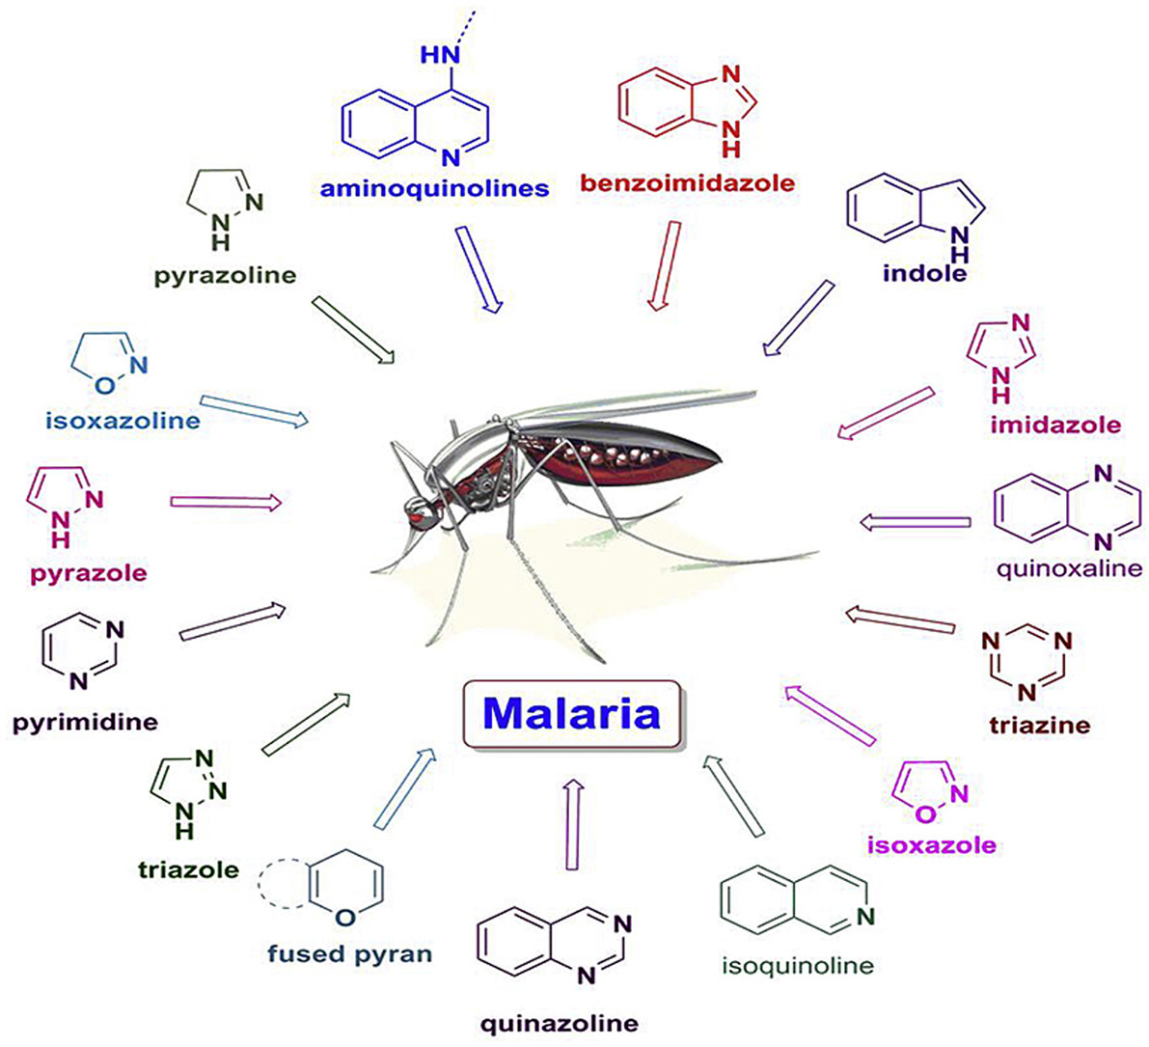
Fig 2.9: Heterocyclic compounds with antiplasmodial property (Kalaria et al., 2018a).

2.5.4.1 Aminoquinolines
Aminoquinolines are quinoline derivatives. The compound occurs in two forms: 4-aminoquinoline and 8- aminoquinoline with significant antimalarial potency. In recent studies, the antiplasmodial potential of aminoquinolines is explored. Several 4-aminoquinoline-1,3,5-triazine derivatives displayed significant in vitro antiplasmodial activity against CR-RKL-2 and CS-3D-7 strains (Bhat et al., 2013). Several synthesised pyrimidine-primaquine hybrids displayed strong inhibition against liver and blood stages of Plasmodium parasites (Kaur et al., 2015). Arylpyrrolyl derivatives of 7-chloro-4-aminoquinoline displayed pronounced inhibition against CS-D-10 and CR-W2 P. falciparum clinical strains (Casagrande et al., 2008). Antimalarial substance was synthesized by coupling 1,10-carbonyldiimidazole to condensed carboxylic acid-functionalized chalcone and aminoquinolines. The compound displayed strong activities against CR-W2 and CS-3D7 (Smith and Nda, 2014). 3-[(2-Chloroquinolin-3-yl) methylene]-5-phenylfuran-2(3H)-one derivatives displayed strong IC₅₀ of 0.50 nM against P. falciparum. Dehydroxy isoquine derivatives strongly inhibited P. berghei with IC₅₀ of 1.66 mM (Valverde et al., 2018).
2.5.4.2 Indole
Several heterocyclic phytochemical constituents are reported for their diverse pharmacological activities. Indole and derivatives possess a characteristic skeleton which significantly enhances their antimalarial potentials. 3-piperidin-4-yl-1H-indoles synthesised compounds displayed significant in vitro antiplasmodial activity for CS strains (EC₅₀ = 3 mM). However, no significant inhibitory activities were observed on CR strains (Santos et al., 2015). Spiroindolones exhibited strong in vivo inhibition against K1 and NF54 P. falciparum strain (Yeung et al., 2010). Recently, 3-pyrimidylindole derivatives were appraised for their antiplasmodial activities. The compounds showed promising antiplasmodial potentials (Lebar et al., 2011).
A promising antimalarial compound was synthesised from 4-aminoquinoline. Its pronounced activity against P. falciparum could be linked to indol-3-yl (C-2 of 4-aminoquinoline) and quaternary nitrogen on quinoline. Alkylation of 4-aminoquinoline enhanced its inhibitory activities against CS-3D7 and CR-K1 strain (Teguh et al., 2013). Chemical modification of indole ring on the skeletal structure of melatonin derivatives was fundamental for the observed antiplasmodial activity displayed by indole related compounds. The attachment of carboxamide group on the C-3 position of indole compounds exhibited strong activity at low micromolar against the growth of P. falciparum (IC₅₀ = 2.93 mM) (Schuck et al., 2014).
Novel indoloisoquinolines with an allyl substituent displayed strong antimalarial activity (IC₅₀ = 1.5 mM). Several N-alkyl derivatives of calothrixins A and B exhibited pronounced inhibitory activity against P. falciparum FCR-3 clinical strain (Matsumoto et al., 2012).
2.5.4.3 Pyrimidine
One of the most important aromatic heterocyclic natural compounds with vast pharmacological activities is pyrimidine. It has a distinctive structure similar to pyridine, however, bounded by the presence of nitrogen atoms. Several pyrimidines have been reported for their pronounced antiplasmodial activity. Quinazoline-2,4,6-triamine derivatives synthesized displayed significant in vivo antiplasmodial activity stronger than pyrimethamine and chloroquine, respectively (Hernandez-Luis et al., 2017). Pyrimidines derivatives displayed significant activity of IC₅₀ of 67 $µ$M against aeAZT strain of P. falciparum. Distinctive pyrimidine derivative of 2,4-diamino-thienopyrimidines displayed an outstanding in vivo activity after oral administration of 50 mg/kg of the synthesized compound (Cabrera et al., 2015). Synthesised pyrido [1,2-a]pyrimidin-4-ones also displayed a significant in vitro antiplasmodial activity against FP-2 inhibitors (Mane et al., 2012).
2.5.4.4 Triazole and Tetrazole
These are poly-nitrogen containing five-membered rings that are commonly used as bioisosteric substitute of carboxylic acid group in drug discovery and development. These compounds are reported to raise the bioavailabilty and lipophilicity and also, have low side effects. Tetrazoles moieties commonly interact with the enzymes and receptors by means of non-covalent connections that could enhance the therapeutic response. Due to its exceptional pharmacokinetic profile with compounds such as carboxylic acids, tetrazoles possess an array of biological activities, such as antiviral, antimicrobial, antiprotozoal, anti-tuberculosis, anti-inflammatory, and anticancer (Wittenberger, 1994). Several triazole derivatives are reported for their pronounced antimalarial activity. 7-chloroquinolinotriazole substituted with triazole moiety through copper-catalyzed cycloaddition between alkyne and 4-azido-7-chloroquinoline was investigated for antiplasmodial activities against clinical strains. The synthesised compounds exhibited a moderate inhibitory activity against the clinical strain of P. falciparum (IC₅₀ = 9.6 nM) (Guilherme et al., 2019). Flavones and chalcones through copper catalyzed click chemistry synthesised 1,4-disubstituted-1,2,3-triazole, the synthesised triazole derivatives displayed significant in vitro antiplasmodial activities of IC₅₀ = 502.74 mg/mL against the erythrocytic phases of P. falciparum (3D7 strain) (Kant et al., 2016). Triazole based fluoroquinolone synthesised via simple alkylation and click chemistry were appraised for their in vitro antiplasmodial activity. The synthesized quinolone displayed strong inhibitory activities against CS strain of P. falciparum with IC₅₀ of 1.33mg/mL (Dixit et al., 2012). The C-5 substituent of isatin ring and the alkyl chain length on the 7-chloroquinoline moieties of 1H-1,2,3-triazole tethered 7-chloroquinolineisatin was investigated for antiplasmodial activity. Activity of IC₅₀ of 1.21 mM was observed against cultured W2-strain of P. falciparum. The nanomolar concentration of triazolium and imidazolium synthesised salts produced electron deficient core which interact with negatively charged moiety on the Plasmodium merozoite, thus, displayed outstanding inhibitory activity against Plasmodium strains (Vlahakis et al., 2010).
The pharmacological activities of triazole have been boosted by incorporating two or more chemical entities or auxochromes. Thus reducing the resistance build-up of triazoles, while improving the efficacy and affinity to parent drugs (Chu et al., 2019). Several triazole hybrids displayed strong antiplasmodial activity against Plasmodium species. Triazole-quinoline and quinolone hybrids such as mefloquine (MQ), chloroquine (CQ) and quinine (QN) are cores malaria therapeutic agents and played a vital role in novel antimalarial drugs development (Kaur et al., 2010; Vandekerchtrove and Dhoogbe, 2015). Quinoline-triazole amides and hybrids displayed pronounced in vitro plasmodial inhibition against CR-K1 (IC₅₀: 17.4 and 354.7 nM) and CS-D10 (IC₅₀: 18.2 mM) of β-haematin and P. falciparum strains (Joshi et al., 2013).
The in vitro antiplasmodial activities of chloroquine and artesunate displayed strong inhibition against CQS NF54 strain (IC₅₀: 12.1 and <5.2 nM) than quinoline-triazole amines. However, a significant activity was observed for the synthesized triazole hybrids against CQR Dd2 strains (IC₅₀ = 8.9 to 5330 nM) (27). Quinoline-triazole hybrids of propylene (IC₅₀: 0.59 - 4.71mM) and ethylene (IC₅₀: 0.90 - 11.52mM) displayed moderate inhibition against clinical strains of P. falciparum CQR W2 and CQS D6 (Manohar et al., 2011). The berberine-triazole hybrids displayed strong antiplasmodial activities (IC₅₀:0.142 - 28.006 mM) against P. falciparum strain (CQD 3D7) (Batra et al., 2018).
2.5.4.5 Imidazole and benzimidazole
Imidazole and benzimidazole and its derivatives are essential classes of bioactive compounds. Benzimidazole is a fused heterocyclic with a benzene and imidazole ring. This bioresource has wide range of therapeutic activities such as antiinflammatory, antimicrobial, antiparasitic, antiviral, and anticancer (Spasov et al., 1999). Several N-alkoxy and N-akyl- imidazolidine diones have been shown to significantly inhibit the prophylactic and radical Plasmodium species in monkey and mouse models. The synthesized diones were metabolically stable and displayed weak in vitro activities against P. berghei infected mice and P. falciparum clones (W2 and D6) (Zhang et al., 2019). Polyhydroquinoline derivatives with imidazole and pyrazole which were nucleus synthesised by cyclocondensation mechanism of 5-(1H-imidazole-1-yl)-3-methyl-1-phenyl-1H-pyrazole-4-carbaldehyde and enaminones in absolute ethanol reasonably inhibit Plasmodium species (Kalaria et al., 2018b).
2.5.4.6 Isoquinoline
Series of natural and synthesised isoquinoline exhibited strong antiplasmodial activity. The synthesised derivatives of 1,7-diaminoisoquinolinamines inhibited the activity of Plasmodium species. However, 7-benzylamino-1-isoquinolinamine exhibited pronounced inhibitory activity against CS P. falciparum (Kalaria et al., 2018). Similarly, novel indoloisoquinolines show strong activity relative to dihydrousambarensine (Horrocks et al., 2016).

2.5.4.7 Pyrazole
Pyrazole is a heterocyclic compound with diverse therapeutic applications such as antitrypanosomal, antileishmanial and antimalarial properties. Pyrazole synthesised by combining substituted fluoro pyrazole nucleus and 1,3,4-oxadiazole skeleton displayed strong in vitro activity against Plasmodium species (0.826 mM) (Karad et al., 2014). Similarly, caffeine-based pyrazolines, pyrazolo [3,4-b] [1,4] diazepines and pyrazolines derivatives are found to display strong activity against Plasmodium species (Cobo et al., 2017).
2.6 Literature review on plants of study
2.6.1 Morinda lucida
2.6.1.1 Plant description
Plants have been used since primordial times as therapeutics for different kinds of diseases (Enemchukwu et al., 2015; Ogundare and Onifade, 2009). The secondary metabolites of medicinal plants contribute to their therapeutic applications in treating diverse diseases (Ruwali et al., 2013; Nasri et al., 2015). Herbs which are plant preparation in the form of decoction, tincture, infusion are universally used for the treatment of diseases. This is due to their affordability, accessibility, zero side effect, economical and intense therapeutic benefits (Taiwo et al., 2005).
The genus Morinda comprise 102 species, and is evenly distributed in the tropics, subtropics and temperate region (Zhang et al., 2018). Morinda lucida Benth (Rubiaceae) is a tree consisting of about 90 varieties (Mabberley, 2008). It is mostly found in the rainforest region, measuring up to about 9 – 18 m in height and 20 – 30 m in diameter with short, dense crown of crooked and slender branches (Plate 1). The leaves are simple and opposite, stipulates triangular or ovate, about 1 – 7 mm long; petiole is almost 1.5 m long with blade elliptical about 6 – 18 cm × 2 – 9 cm. The leaf base rounded to cuneate bounded with acute apex, shiny above, occasionally finely pubescent and some hairs on the midribs (Zimudzi and Cardon, 2005; Adeleye et al., 2018). It is known as Brimstone tree owing to its yellow wood. The plant has many local names and is commonly found on grassland, rainforest, exposed hillsides and sometimes in flooded areas with elevations from sea-level of about 1, 300 m (Kouamé et al., 2019). Traditionally, it is used to treat diabetes, gonorrhea, dysentery, abdominal colic, fever and hypertension. The leaves, bark and root decoction or infusion have been reported in treating malaria, yellow fever and trypanosomiasis (Adejo et al., 2015; Igwilo et al., 2018). All these pharmacological activities could be linked to the presence of secondary metabolites in different parts of the plant (Fig 2.10).
2.6.1.2 Taxonomical classification
Kingdom: Plantae
Phylum: Tracheophytes
Order: Gentianales
Family: Rubiaceae
Genus: Morinda
Species: lucida
2.6.1.3 Geographical distribution
The plant is broadly dispersed in Africa, predominantly in Central and West Africa (Lawal et al., 2012). In West African countries, it is widely found in the coastal nations including Togo, Nigeria, Ghana and Ivory Coast (Zimudi and Cardon, 2005). It is also widely distributed from Sudan to Senegal, Angola and Zambia (Lawal et al., 2012).
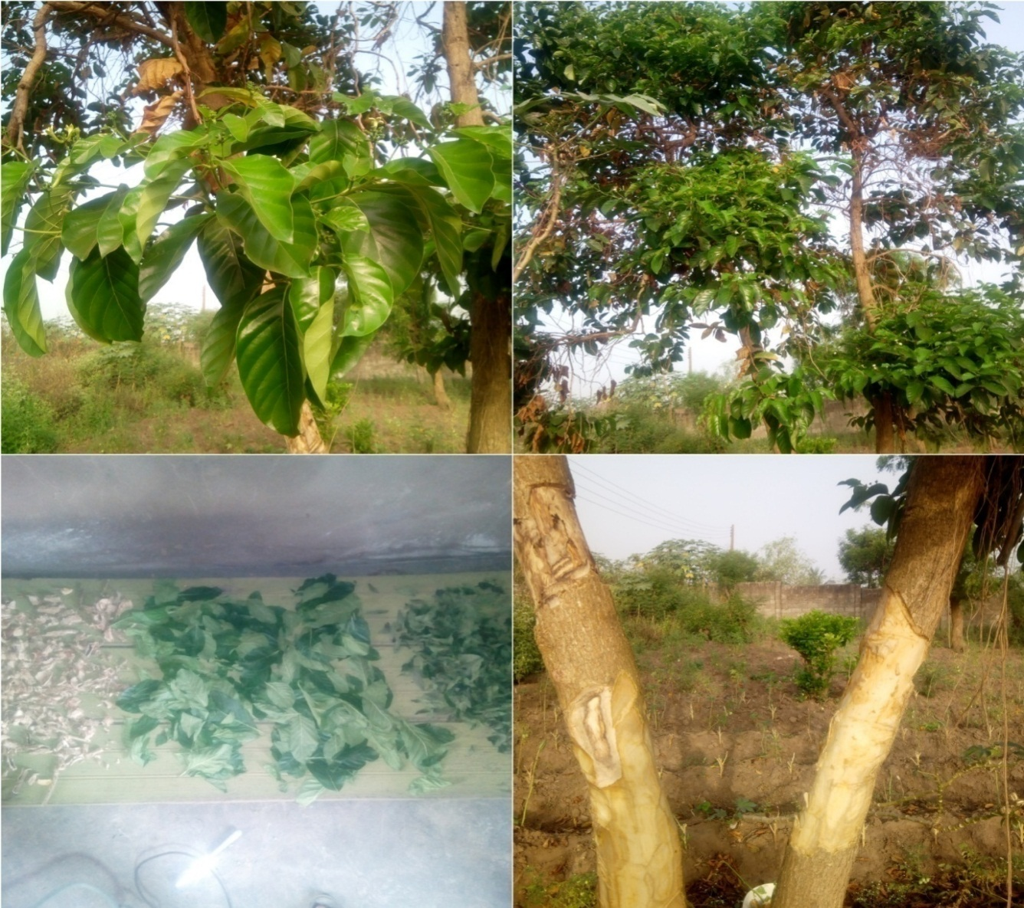
Plate 2.1: Pictures of M. lucida: (a). Leaves, (b). Tree with leaves, (c). Dried leaves and bark (d). Trunk or stem bark

(2S,3R)-1,2,3,4-tetrahydro-2,3,6-trihydroxy-2-methylanthracene-9,10-dione (1),

3,6-dihydroxy-1,2-dimethoxyanthraquinone (2)

1,6-dihydroxy-2-hydroxymethyl-
5-methoxyanthraquinone (3)
Morinda lucida
stem barks

2-hydroxy-1- methoxyanthraquinone (4)  2,5-dihydroxy-1-methoxy-6-methoxymethylanthraquinone (5)  Morinda lucida  stem barks | R₁ R₂  4 H H  5 C₁₅H₂OC₁₆H₃ OH

Fig 2.10: Some anthraquinones isolated from Morinda lucida
2.6.1.4 Antimalarial activity of M. lucida
According to WHO, malaria is classified as one of the lethal diseases of humans (WHO, 2016). Traditional records in many malaria endemic regions demonstrated the common use of M. lucida in malaria therapy. Scientific and ethnobotanical literature indicated that all plant parts displayed pronounced resistance towards Plasmodium in humans (Umar et al., 2012; Ayinla and Oseni, 2013; Ayoade et al., 2014). The ethanolic bark and leaf extracts of M. lucida was investigated on P. berghei infected mice at body weights of 100 to 400 mg/kg after three days of administration of plant extracts. The extracts successfully suppressed the parasitaemia effect, but however, increase in the pack cell volume (PCV) was observed which was due to the hematonic nature of the plant extracts (Ukpanukpong et al., 2019). M. lucida root extracts displayed 50% inhibition at a concentration of 6.25µg ml^{–1} against Plasmodium parasite. The petroleum ether and dichloromethane extracts of the plants also exhibited inhibitory activities at concentrations above 6.3µg ml^{–1} (Chukwujekwu et al., 2005). Four- day’s malaria test was employed to assess the antimalarial activity of M. lucida (12.5–400 mg kg⁻¹) and Morinda lucida- sulphadoxine-pyrimethamine (ML-SP) on P. berghei–infected mice (PB-IM). The ML-SP displayed 1.8- to 2.5-fold chemosuppression which was found to be higher than M. lucida extract (39.8–90.5) (Agbedahunsi et al., 2016).
2.6.2 Landolphia dulcis
2.6.2.1 Plant Description
The genus Landolphia (P. Beauv.) belongs to the Apocynaceae family, which is broadly dispersed across tropical Africa. It represents one of the therapeutically significant genera in folk medicine, with over 40 genera, 60 species and almost 113 documented varieties (Aliyu et al., 2010). Landolphia species displayed immense adaptability and habits ranging from shrubs, perennial herbs, evergreen to deciduous. In recent years, Landolphia have been exploited due to its significant roles in rubber production and medicinal applications (Aliyu et al., 2010).
The significance of Landolphia in traditional medicine is justified in the treatment of several diseases (Mitsuo, 2001). Different parts of the plant have shown immeasurable therapeutic potentials. In Ghana, the root is used in treatment of gastric ulcers, stomach cramps and vermifuge (Mireku et al., 2017). In Nigeria, the leaves are used to treat gastrointestinal disorders, typhoid fever, bacterial aetiology, constipation, diarrhea, food poisoning, malaria, ulcer and dermal infections (Okeke et al., 2001, Nwogu et al., 2008; Aliyu et al., 2010). All these pharmacological uses could be linked to the secondary metabolites in different parts of the plant. Some of these metabolites are represented in Fig 2.11.
Fig 2.11: Structures of some secondary metabolites isolated from the genus Landolphia
Gallic acid (1), vanillic acid (2), caffeic acid (3), p-coumaric acid (4), catechin (5), apigenin (6), quercetin (7), protocatechinic acid (8), cortisone (9), isofistularin (10), septicine (11), asteoside (12), quercetin-3-0-galactopyranoside (13) and hydroxyanthanilic acid (14)

2.6.2.2 Morphological characterizations

According to the botanical classification, Landolphia belongs to Gentianales (order), Rauvolfioideae (subfamily) and Apocynaceae (family). The genus has distinctive corolla tube thickened directly above the glabrous fruits, anthers and typically dense inflorescences (Persoon et al., 1992). Most Landolphia species are huge lianas with large curled terminal tendrils. There are two auxiliary branches with one of it partially forming the extension, thus resulting to sympodial growth. Auxiliary buds besides the tendril concurrently open, leaflets sprout, branch formed and grows slowly while the other produced inflorescences. The second branch shapes the next apical tendril subsequently producing leaf pairs and the process is repeated. Hence, these plants grow in the prototypical of Koriba (Halle and Oldeman, 1970).

2.6.2.3 Geographical distribution

Landolphia consist of about 75 accepted species which are widely dispersed in tropical and Saharan Africa, from Guinea to Cameroon, including Central Africa, Uganda, Southern Tanganyika and Sudan (Table 1). L. owarrensis (vine rubber) is found in Madagascar, South Africa, and Nigeria (Ilesanmi et al., 2011), L. dulcis in tropical forest of Nigeria, Guinea and spreading to Congo (Ilodigwe et al., 2013), L. buchananiiin Cameroun, Sudan, Ethiopia, Mozambique, Angola, Nigeria, Zambia, and Democratic Republic of Congo, and L. heudelotti is widely dispersed in Western tropical Africa (Kini et al., 2012).
2.6.2.4 Antiplasmodial activity
The in vitro and in vivo antiplasmodial activity of different species of Landolphia revealed that different parts possess antiplasmodial properties. The antiplasmodial study of different parts of L. dulcis, L. owariensis and L. heudelotii showed that these plants displayed high inhibitory activity against Plasmodium strains. The early, established literature studied residual parasitaemia infections in P. Berghei infected albino rats using different dose concentrations (200, 400, 800 mg/kg) of ethanolic extract (LOEE), ethyl acetate (LOEF), methanolic (LOMF) and n-hexane (LOHF) fractions of L. owariensis. After treatment for 14 days, the fractions significantly suppressed the parasitemia infections, with suppressive activities of 29 to 86% (early), 18 to 95% (established) and 75 to 96% (residual). The 50% effective dose for suppressive activities is 514.93 mg/kg (LOHF), 392.95 mg/kg (LOEF), 266.56 mg/kg (LOE) and 165.70 mg/kg (LOMF). The post 30- days’ survival index of the treated rats appraised is 50–83.3% (LOMF), 16.7–66.7% (LOEF), 16.7–50% (LOE) and 16.7% (LOHF). The extract significantly reverse weight loss and reduced the mortality rate of treated rats (Ezike et al., 2016).
The antiplasmodial appraisal of L. heudelotii leaves was explored in human blood infected by chloroquine sensitive- NF54 and chloroquine resistant K1 strains. Appraisals of aqueous extract at trophozoïtes stage exhibited strong IC₅₀ activities against K1 (8.11 ± 0.65 µg/ml) and NF54 (7 ± 0.14 µg/ml). However, ethanolic extracts significantly inhibited the Plasmodium strain with IC₅₀ activities of K1 (18 ± 0.51µg/ml) and NF54 (5 ± 1.77 µg/ml) (Kipré et al., 2018).
2.7 Antiplasmodial drug discovery pathways from medicinal plants
Several approaches have been used to control the outbreak of malaria, nevertheless, of all the proposed or documented protocols, drug discovery from natural sources is highly regarded because of its cost effectiveness and efficiency. More than ten thousand structural moieties or pharmacophores have been isolated from natural sources and screened for their antiplasmodial activity. A good number of these metabolites showed significant activity (Hughes et al., 2011). This progress led to advanced scientific procedures aiming at the discovery of novel pharmacophores with potentials to subjugate overcoming resistance build-up by Plasmodium species (Noedl et al., 2008; Phyo et al., 2012). Similarly, quite a number of antimalarial pharmacophores are under clinical trials, most of these pharmacophores go through the conventional drug discovery scheme (Gelb, 2007). Different drug discovery schemes have been employed by researchers with the primary focus of unearthing compounds from a plethora of medicinal plants. The common approach involves collection, preparation, extraction, biological assay, fractionation (or purification), isolation and characterization of metabolites obtained from plant materials (Fig. 2.12). These approaches has led to the discovery of novel antimalarial scaffolds (Fidocket et al., 2004).
2.7.1 Collection and Preparation of Plant materials
The collection of plant samples is essential to natural product research because it provides an important connection between scientific information and traditional knowledge (Cotton, 1996). Furthermore, sample collection, preparation of voucher specimens, identification, and storage of specimens in herbarium are vital because it disseminate logistic or information to other researchers working on the same plant material (Santos et al., 2014). In collection of plant materials, care must be taken in selecting suitable containers used for transporting plant samples from collection site. Samples should be placed in blotting paper bags, polythene bags or wrap in blotting paper. The use of printed papers such as newspaper is not acceptable because prints on the paper could interfere or contaminate the sample. The preparation of plant samples from washing to drying should be carried out without being treated with a preservative. Generally, steps involved in collection and preparation of plant samples for specific or general phytochemical study are important and could significantly contribute to the outcome of a study (Santos et al., 2014).

2.7.2 Extraction
In drug discovery, extraction entails separation of therapeutically active parts of plant tissues from inactive constituents by solvents gradients mostly of different polarities. The constituents obtained are comparatively impure solids or slurry proposed for in vitro or in vivo therapeutic assays. The tinctures and fluid crude extracts obtained may be processed and integrated in any prescribed amount (dosage) or fractionated to isolate discrete secondary metabolites. Selection of extraction methods is vital because it plays a part on the final quality of herbal drugs or pharmacophores.
Common extraction techniques of medicinal plants include maceration. This involves soaking a preweighed pulverized plant material in a stoppered container filled with solvent for a period of time (mostly, at room temperature) with frequent agitation. Infusion is macerating a preweighed crude extract in cold or boiling aqueous solution for a period of time while decoction is for extracting thermostable and water soluble constituents of plant material by applying heat for a particular period of time, cooling and filtering. Hot continuous extraction (Soxhlet) requires finely grounded plant sample in a thimble or porous bag placed in a chamber of the soxhlet apparatus. The solvent in the flask is heated based on the boiling point of solvent and its vapour condenses into the extracting thimble which siphon into the boiling flask. This process continues until the solvent (drop) from the siphon tube does not leave residue when evaporated.
Other extraction methods include digestion, phytonic process, counter-current, ultra-sound, fermentation and supercritical fluid extraction. Some of the parameters to be considered in choosing a suitable extraction method include conditions used for drying, particle size, polarity of sample, thermal capacity (thermolabile or thermostable) and degradation potential of plant materials.
2.7.3 Antiplasmodial Assays
Antiplasmodial assays of plant extracts, fractions or isolated compounds are to a great extent used in the assessment of therapeutic potency of medicinal plants against Plasmodium species (via curative or suppressive assays). Basically, plants contain secondary metabolites or compounds which are responsible for the pronounced therapeutic activities displayed (Fetahun et al., 2017). A number of methods are used in the determination of antiplasmodial drug efficacy, these include in vivo studies, molecular marker analyses, drug concentrations measurement and in vitro tests.
2.7.3.1 In vivo Antiplasmodial Assays
The assessments of in vivo therapeutic efficacy of natural products remains as the best method or protocol for investigating antimalarial drug efficacy. This study is the bedrock in formulating antimalarial drug policy as published by National Malaria Control Programmes (Maji, 2018; WHO, 2015). These studies give detailed information on parasitological and clinical responses of natural products either with single or combined therapy (Maji et al., 2018). Fundamentally, there are three common documented in vivo antiplasmodial assays, these are prophylactic, suppressive and curative tests.
2.7.3.1a Prophylactic Assays (Respiratory)
The prophylactic assay is aimed at investigating the preventive potentials of plant extracts before Plasmodium inoculation or infections. The procedure for respiratory assay involves administration of drugs as single dose in 24 h for three days before inoculation or infection (day 0 – 2). On the fourth day (day 3), inoculation is done and blood samples collected after 72 h of inoculation monitored and compared to results obtained before inoculation (Alaribe et al., 2021).
2.7.3.2b Suppressive Assay
This presents comprehensive therapeutic information on the inhibitory potency of plant extracts or drugs in an organism (experimental animals). This assay is widely documented in in vivo antiplasmodial assays whereby treatment commence after inoculation of Plasmodium species take place (day 0). Generally, treatment of Plasmodium infections in experimental animals takes minimum of four days, therefore, it is widely regarded as a four-day suppressive test and percentage chemosuppression will be calculated (Alaribe et al., 2021; Dibessa et al., 2018).
2.7.3.2c Curative Assay
This assay is well documented because it gives detailed information on prevention, suppressive and curative potentials of drugs or pharmacophores, thus, it serves as the bedrock to drug discovery. The experimental animals are grouped, inoculated and treated with different dose concentrations of drugs or extracts. The administration of drugs as single dose per 24 h for five consecutive days commences after 72 h of inoculation for establishment of Plasmodium infection. The curative potency is evaluated via blood samples taken from tail snips of mice before treatment and every 24 h during period of treatment (Alaribe et al., 2021).
2.7.4. Fractionation and Isolation of secondary metabolites.
The goal of drug discovery from natural products is to isolate secondary metabolites or Secondary metabolites responsible for therapeutic activities (Oladeji et al., 2021). This approach has led to the discovery of alkaloids, terpenoids, saponins and flavonoids which are fundamental antiplasmodial metabolites (Nwali et al., 2018). These secondary metabolites could have displayed the observed antiplasmodial potency singly, synergically or multi-factorially, thus, isolation of individual metabolites is inevitable (Gilbert and Alves, 2003). There are two techniques in drug discovery for isolating secondary metabolites from plant extracts: bio-assay guided and secondary metabolites guided isolation.
2.7.4.1 Bio-Assay guided Isolation
The main focus of drug discovery is to investigate curative potentials of extracts or drugs and investigate or isolate metabolites present. This technique is guided by potency of investigated extracts and selected based on the drugs or extracts that with the promising activity. It is well documented in natural products research because it revealed precise secondary metabolite responsible for marked pharmacological activity displayed in fractions or extracts.
2.7.4.2 Secondary metabolites guided isolation
Secondary metabolites isolation is mostly guided by qualitative and/or quantitative phytochemical screenings of extracts or fractions. Different methods have been developed for isolating different classes of secondary metabolites, thereby masking out the possibility of detecting other compounds which could synergically be responsible for the said pharmacological activities.
2.7.5. Structural Characterization of Isolated Metabolites
Several analytical techniques have been used for structural characterization of chemical constituents derived from medicinal plants. These include nuclear magnetic resonance (NMR), mass spectrometry (MS), infrared spectroscopy (IR), high resolution mass spectrometry (HR-MS), Ultra-violet visible spectroscopy and gas chromatography. Generally, molecular spectroscopy emanating from the emission or absorption of electromagnetic (EM) radiation when quantized photon or energy of molecules undergoes transition, is a documented technique for the elucidation of structural moieties of secondary metabolites (Derrien et al., 2019).
Secondary metabolites from medicinal plants consists of a wide range of characteristic constituents that absorbs or emit electromagnetic radiation and are susceptive to ambient physiochemical and biological transitions (Derrien et al., 2019). The variation in chemical constituents could provide detailed information on molecular weight, aromaticity, diversity, distribution, functionality, pharmacology, toxicology and reactivity of metabolites (Derrien et al., 2019). The recent advancement on the applications of analytical techniques for the characterization and elucidation of structural moieties of metabolites necessitate the summary of their principle and applications.
2.7.5.1 Infrared Spectroscopy
Infrared radiation (IR) is located between the visible and microwave regions in the electromagnetic spectrum. The excitation of molecules in secondary metabolites is achieved in a wavelength range of 750 to 2500 nm (4,000 and 600 cm⁻¹) (Herschel, 1800). The natural products or samples absorb quota of incoming infrared radiation at a predefined and quantified wavelength leading to a spectrum or fingerprint. Secondary metabolites possessing certain functional groups such as carbonyl (C=O), hydroxyl (O-H), amino (N-H), alkane (C-H) and ketone (−C(=O)−) functional groups are excited to perform deformation, stretching and scissor vibrations. Likewise, some secondary metabolites absorbs in the mid-infrared (4000 to 400 cm⁻¹) region widely known as signatures. The near infrared overtones and variations contains detailed information compared to mid-infrared with overlapping peaks (Huck et al., 2016).
On the whole, aside information on the functional groups in the metabolites, IR spectroscopy also give instant and non-destructive quantitative and qualitative analyses of fundamental constituents of many secondary metabolites (De Benedictis and Huck, 2016; Eisenstecken, 2015; Schönbichler et al., 2014).
2.7.5.2 UV-Visible Absorption Spectroscopy
UV-Visible (UV-Vis) absorption spectroscopy is an analytical technique widely used in natural products research to identify or detect abundance or quality, trace the source or chemical reactivity, and elucidate structural variations in metabolites. It is simple to operate, rapid in response, economical and highly sensitive (Li and Hur, 2017). Due to a variety of light-absorbing fractions in secondary metabolites, it’s original UV-Vis absorption spectra are usually undistinguished, which decrease approximately exponentially with increasing wavelength. Some specific parameters such as spectra slopes, absorption ratio and coefficient can be analyzed from UV-Vis spectra of metabolites, thus providing substantial information on chemical environment of the compounds (Roccaro et al., 2015).
Spectral slopes gotten from UV-Vis spectra of secondary metabolites are analyzed from particular bands of log-transformed spectra via exponential or linear fitting which can give substantial information about structural variations in secondary metabolites. Similarly, this could also reflect aromaticity and molecular weight of metabolites (Helms et al., 2008; Roccaro et al., 2015). Several factors such as pH, turbidity, coexistent ions and temperature could obstruct with the calculation, measurement and interpretation of spectra (McKay et al., 2018).
2.7.5.3 High Performance Liquid Chromatography
High-Performance Liquid Chromatography (HPLC) is one of the most extensively used analytical equipment for detecting wide range of organic compounds or secondary metabolites. It can be used to analyze complex constituents or mixtures, without derivatization or sample (complex) preparation. In recent times, HPLC is hyphenated with spectroscopic techniques or detectors such as mass spectrometer which present spectra holding structural information (molecular weight and UV-Vis absorption bands) after separation of analyte (Wolfender, 2009). This technique proffer an accurate and sensitive identification of known phytoconstituents especially for compounds with available database or standard (Jaroszewski, 2005).
For rapid de novo identification of unidentified secondary metabolites, advanced spectroscopic detectors are coupled with HPLC for detection of NMR-active nucleus (e.g., ¹H, ¹³C, ¹⁵N, ³¹P) in the eluate. This coupling give detailed structural elucidation, compound identification, quantification and stereochemical information (via two-dimensional nuclear magnetic resonance) (Wolfender, 2010).
2.7.5.4 Nuclear Magnetic Resonance
Nuclear magnetic resonance (NMR) is an analytical system which give absolute information on the qualitative or quantitative chemical nature of isolates from secondary metabolites. The signal response obtained from NMR spectrum is nonaligned of chemical nature of analyte or sample, thus, no accurate reference or standard is required for structural elucidation. The NMR signal of isolated metabolite is proportional to the number of nuclei responsible provided all experimental conditions are define. To achieve reliable and accurate quantitative measurements, the nuclei under study must be relaxed and pulse recycle delay should be adopted (Claridge, 2009; Wilson and Brinkman, 2003).
In determination of bioactive metabolites in natural products, crude extracts from plants are screened for pharmacological activities, followed by bioassay guided isolation. Absolute sample concentrations of isolates cannot be achieved by NMR, however, a calibrant or internal standard which is economical, soluble in NMR solvent, presented in high purity, non-volatile, chemically inert and stable can be used to overcome this barrier (Pauli et al., 2004). Isolate is spiked with internal standard of predetermined concentration. From NMR signals, the concentration can be calculated through comparison with accuracy of 0.5% (Pauli et al., 2004). This assay has been used in structural elucidation of several biological samples with unconvincing therapeutic potentials. Some of these include characterization of steroidal compounds from fireflies (Eldrigde et al., 2002), identification of Caenorhabditis elegans mating pheromone (Srinivasan et al., 2008), induced plant defense hormones (Glauser et al., 2008) and metabolites from heat-shocked C. elegans (Clendinen et al., 2015).
In recent times, elucidation of structural moiety of isolates has taken a new dimension, prompting new technologies in the assignment of structural information of a given analyte in a mixture. Analytical techniques such as HPLC, liquid chromatography (LC), two dimensional NMR (2D- NMR) have provided reliable information on chemical nature of metabolites (Pierens et al., 2008). Thus, on-line or at-line LC-NMR have widely been applied to solve exigent issues of quick identification of secondary metabolites in various complex crude extracts. Nowadays, on-flow LC-NMR is widely used for the characterization of metabolites that are unstable in their pure form, while majority of at-line techniques are documented for obtaining standard spectra (Bohni et al., 2013).
2.7.5.5. Mass Spectrometry
Mass spectrometry is an analytical technique widely used in structural elucidation studies of target compounds or isolates from biological samples or materials. This analytical technique is versatile and its ability to analyze is based on the application of several physical phenomena required to ionize the molecules, generate fragments and separate fragmented ions by their mass-to-charge ratio (Alvarez-Rivera et al., 2019). In recent times, the applications of several mass spectrometric units bounded with varying ionization systems, positive and negative ions of analytes from natural compounds and fragmentation. These could enhance structural elucidation of organic molecules (Zhang et al., 2017).
One of the latest advancement in mass spectrometry is unearthing of high resolution mass spectrometry (HR-MS). This analytical technique is highly sensitive with a wide detection range, excellent resolution, and easy to couple with other chromatographic techniques for structural identification of peaks shown in the spectrum. Furthermore, it is a widely used equipment in chemical profiling and quality control of secondary metabolites. In elucidation of structural moieties of complex compounds, mass spectrometers have recently been hyphenated with chromatographic techniques such as gas chromatography (GC-MS), capillary electrophoresis (CE-MS) and liquid chromatography (LC-MS) (Lima et al., 2017). HR-MS presents analytical characterization of complex secondary metabolites and compounds with diverse physicochemical attributes such as volatility, molecular weight and polarity by giving detailed information on their structural moiety, composition and concentration (Zhang et al., 2017; Zhang et al., 2008; Zhu et al., 2018).
A wide range of secondary metabolites in plant samples such as coumarins, terpenoids, flavonoids, saponins, flavonoids and phenolics have been analyzed using different mass spectrometer coupled with equipment such as time of flight (Wang et al., 2018), matrix-assisted laser desorption/ionization, quantum time of flight (Gonzalez and Aguilera, 2017; Tong et al., 2018; Zhu et al., 2018) or Fourier-transform ion cyclotron resonance (Park et al., 2017).
Time of flight-mass spectrometer (TOF-MS) analyser is widely used in HR-MS for structural elucidation of complex secondary metabolites due its accurate structural and mass information from fragmentation pattern of metabolites (Zhang et al., 2017; Zhu et al., 2018). HPLC coupled with quantum time of flight (Q-TOF) is well documented for the characterization of complex or high molecular weight metabolites. The combination also give high separation efficiency and accurate structural elucidation. For further peak annotation, Q-TOF-MS coupled with LC has contributed to efficient structural elucidation or analysis of antioxidant compounds. It also give reliable information on actual mass, retention time, fragmentation ions and UV spectra of metabolites. These spectroscopic techniques are well documented in drug discovery or unearthing of novel pharmacophores (Ballesteros-Vivas et al., 2019).
Electrospray MS is one of the most documented spectroscopic techniques for structural elucidation and chemical characterization of crude extracts, purified fractions or isolated metabolites from plant materials. It evaluates stereochemistry and regiochemistry of organic molecules and gives reliable mass determination and structural elucidation of metabolites. Recently, electrospray are combined with 1D-, 2D- NMR, X-ray crystallography, FTIR, circular dichroism and UV-Vis, and also with the aid of ESI-Q-TOF and ESI-TOF, several classes of known or novel compounds have been identified. These include daphnane diterpenoid orthoesters, nortriterpenoids, bisbibenzyls, unsaturated cyclic ketones and sesquiterpenes (Natarajan et al., 2015; Yang et al., 2018).

MS, FTIR, UV, HR-MS, ESI-MS, NMR, GC-MS, LC-MS
STRUCTURAL CHARACTERIZATION
BIO-ASSAY GUIDED
SECONDARY METABOLITES GUIDED

IN VIVO
PROPHYLATIC
SUPPRESSIVE
CURATIVE
MACERATION
INFUSION
SOXHLET
DECOCTION
Digestion, Phytonic process, Counter-current, ultra-sound, supercritical fluid
FRACTIONATION AND ISOLATION
IDENTIFICATION AND AUTHENTICATION
ANTIPLASMODIAL ASSAYS
EXTRACTION
COLLECTION
AND PREPRATION

Fig. 2.12: Stages in exploiting novel drugs from natural plant sources.
2.8 Use of molecular docking computational tools in drug discovery
Drug discovery is a complex and well-structured procedure. In recent times, some organizations such as the Tufts Center for the Study of Drug Development published the total cost associated with developing a new drug. From their reports, they concluded that the cost has increased by nearly 145% and average time for clinical trials has dropped, and also, drugs approval by obtaining the US Food and Drug Administration (FDA) approval has dropped to 12% (Di Masi et al., 2016). The Computer-aided drug design (CADD) such as molecular docking has significantly helped to reduce the costs and time frame necessary for the drug discovery by directing experimental research towards active compounds more rapidly. Large libraries of compounds can be computationally screened for similarity to known inhibitors (ligand-based) or conformity to target structures (structure-based) in order to discover highly targeted subsets from which the actives can subsequently be experimentally verified (Ripphausen et al., 2010). Thus far, this approach has generated many lead compounds and numerous clinical substances are reported to have been unearthed or optimized via computational assays (Talele et al., 2010; Kitchen et al., 2004; Clark, 2006).
2.8.1 Molecular docking
The most popular computational approach for structure-based drug design (SBDD), known as molecular docking, has been in use since the early 1980s (Kuntz et al., 1982). It is the primary tool where the protein target's three-dimensional (3D) structure is known. The surge in popularity of molecular docking has been greatly aided by the huge advancement in computer power and accessibility, as well as the emergence of the quantity of small molecule and protein structures. Finding potential binding modes and understanding and predicting molecular recognition are the two fundamental objectives of molecular docking (i.e. predicting binding affinity). Nevertheless, in the recent times, there is an unprecedented increase in the study of nucleic acid (DNA and RNA)-ligand, protein-protein and nucleic acid-protein-ligand docking. Applications of molecular docking in drug discovery are numerous and include structure-activity studies, lead optimization, finding potential leads through virtual screening, providing binding hypotheses to aid in predictions for mutagenesis studies, as well as helping X-ray and cryogenic electron microscopy, inhibitors to electron density and crystallography in fitting substrates (Stanzione et al., 2021).
2.8.2 Theory of docking
The molecular docking procedure entails two basic steps: prediction of the ligand's conformation as well as its position and orientation within the protein binding site (generally referred to as pose) and evaluation of the pose's quality using a scoring function. The ligand (typically a small molecule) is then used to perform the molecular docking. The scoring method should place the experimental binding mode first among all formulated configurations, and the sampling procedure should be able to reproduce it. The docking process also has the additional task of scoring active compounds higher than established inactive compounds. This degree of precision is difficult to achieve, though, as it is typically influenced by a wide range of non-protein-related factors. Therefore, the primary goals of a docking algorithm are to accurately forecast the ligand pose and evaluate the pose's quality (although various scoring algorithms have also taken active/inactive ranking into account) (Stanzione et al., 2021).
2.8.3 Scoring functions
Scoring functions are fast estimated scientific or mathematical techniques used to predict or estimate the binding affinity or strength of the interaction between two or more molecules (organic or inorganic). The reliability of any scoring function depends on the ability to produce scores or data which linearly show a relationship with experimentally obtained binding affinity (scoring power), ability to accurately categorize a set of ligands that combine or bind to a protein target by their binding sites or pockets when their binding poses are predetermined (ranking power), the capability to categorize the binding pose of a ligand as the one with the best score, and when screening or evaluating a large set of generated decoy poses (docking power) and the ability to determine the true binders to a targeted protein among a library or arrays of molecules (screening power) (Fig 2.13).
Generally, there are four basic categories of scoring functions: those based on physics, empirical data, human understanding, and machine learning (Li et al., 2019). It can be broadly divided into classical (physics-based, empirical and knowledge-based) and machine learning scoring functions. Machine learning-based scoring functions use more sophisticated or automated machine learning systems, such as support vector machines, random forests and deep learning to estimate non-linear problems.

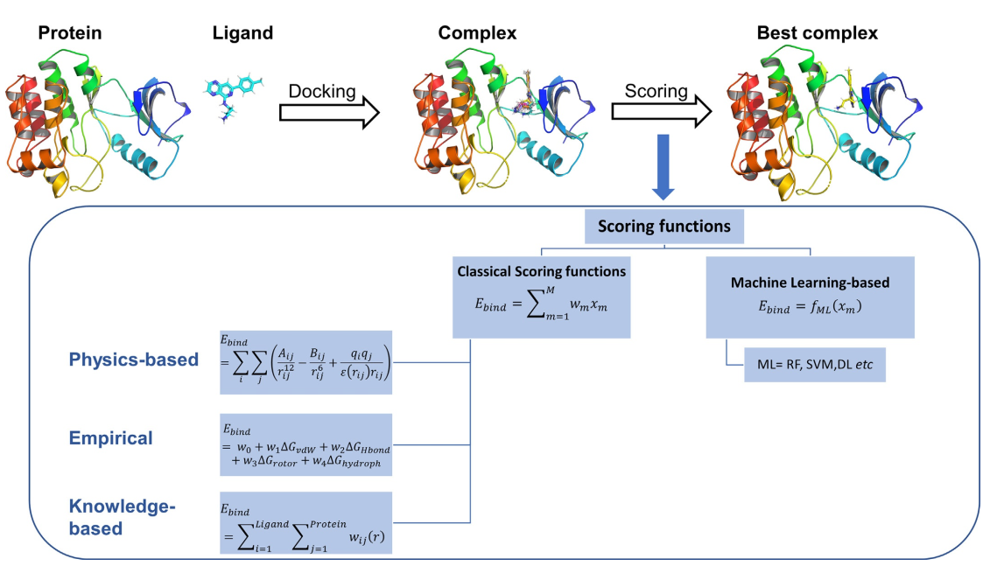
Fig. 2.13. Illustration of docking process and sccoring functions (Stanzione et al., 2021).

2.8.4 Practical aspects in molecular docking
The key procedures or protocols common to all molecular docking is presented in Fig 2.14. A molecular docking assessment requires a 3D structural framework of the target (protein and ligand) molecules. The structural elucidation of the protein target is typically determined by experimental methods such as NMR or X-ray crystallography, or can be obtained from the Protein Data Bank (PDB) (https://www.rcsb.org/) (Berman et al., 2000).
There are some significant factors to be considered when evaluating the quality of the protein target (Warren et al., 2012). The main factor is the study of crystal-structure resolution of protein or nucleic acid, which is the degree of quantifiable diffraction evident in the crystallographic experiment. This depends on the degree of crystallinity, intensity or strenght and coherence of the diffraction beam used in the experiment. An ordered crystal and atoms in the crystal will scatter the radiations from X-rays in the same manner, and the diffraction pattern will display the fine details of the crystal.
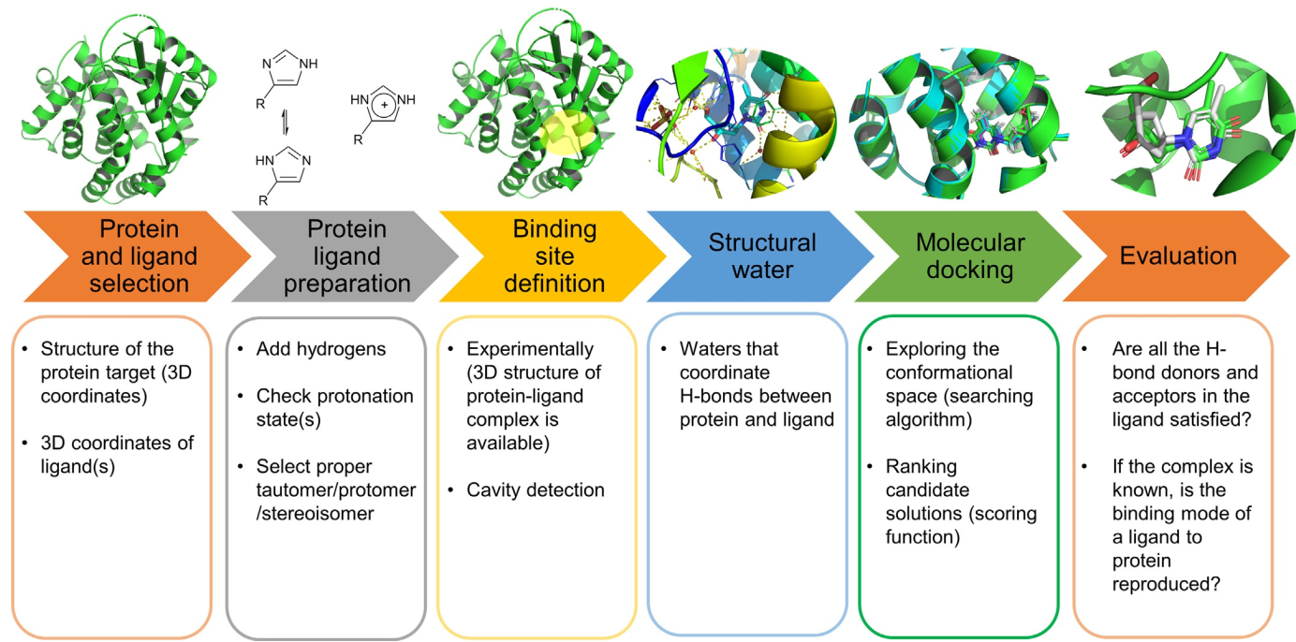
Fig. 2.14. A schematic of typical docking workflow (Stanzione et al., 2021).
2.8.4.1 Protein preparation
Prior to molecular docking analysis, some procedures such as protein and ligand preparation steps would follow procurement of protein target either from protein database or generated using protein prediction methods. Most of the molecules in the PDB contain coordinates of non-hydrogen atoms. To overcome this, the missing hydrogen atom(s) will be replaced. Furthermore, missing chains (or linkages), bonds are replaced or fixed, bond orders are assigned, locations are carefully studied and atoms with high frequencies are preferentially ranked. Other more complex, techniques include prediction of protonation states and identification and screening of water molecules (if any) to ascertain the molecules to be removed or retained in the protein target structure (Stanzione et al., 2021).
2.8.4.2 Ligand preparation
Ligand preparation involves the generation, optimisation, and authentication of its 3D structure. These structures can be obtained via experimental approach or generated using software such as SMARTS, SMILES to convert 1D or 2D structures into 3D molecular structures (Fig. 2.15). The 3D structure of the ligand must possess bond angles and lengths. Several computational programs exist to generate and optimize the 3D structure of a ligand (e.g. CSD Conformer Generator) (Cole et al., 2018; Taylor et al., 2014), Omega (Ebejer et al., 2012; O’Boyle et al., 2011), Confab, Confect, RDKit (Sch€arfer et al., 2013).
In the protein ligand, hydrogen atoms and formal charges must be implicated in the 3D structure. The protonation state should be set according to the tautomeric state, physiological pH and the pH of the simulation (Stanzione et al., 2021).
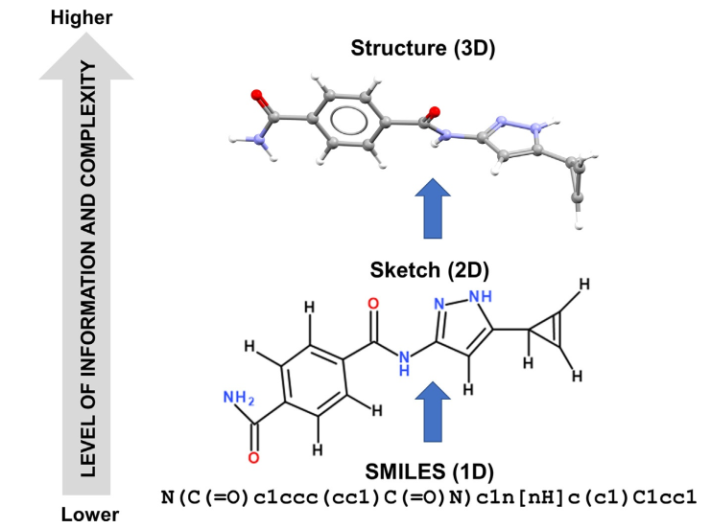
Fig. 2.15. 1D to 3D workflow for a small molecule (Stanzione et al., 2021).

CHAPTER THREE
3.0 EXPERIMENTALS
3.1 Materials
3.1.1 Reagents and Solvents
Solvents used for extractions, phytochemical screenings, fractionation and isolation include methanol, n-hexane, ethyl acetate, chloroform, ethanol, formic acid, toluene, dichloromethane, acetone and chloroform. Some of these solvents were redistilled using rotary evaporator. Reagents such as 2, 2-diphenyl−1-picrylhydrazyl hydrate, Folin-Ciocalteu phenol reagent, ascorbic acid, quercetin and gallic acid were used for this research. Some of these reagents were sigma Aldrich (analytical grade) products.
3.1.2 Collection and Identification of Plant Materials
Leaves and barks of Landolphia dulcis were obtained from a farm in Oko Town, Ogbomoso, Oyo State, Nigeria (Latitude 8° 08′ N, Longitude 4° 15′ E) between September and December, 2020. The plant sample (L. dulcis leaves) was taxonomically authenticated at the Herbarium of the Department of Pure and Applied Biology, Ladoke Akintola University of Technology, Ogbomoso, Nigeria with voucher specimen number (LHO/639). The bark and leaves of Morinda lucida were collected in Ogbomoso, Oyo State, Nigeria (Latitude 8° 08′ N, Longitude 4° 15′ E) in July, 2020. The plant (M. lucida leaves) was taxonomically authenticated at the Herbarium of the Department of Botany, University of Ilorin, Nigeria with voucher specimen number (UIH/001/913/2021).
3.1.3 Experimental animals
One hundred and thirty healthy Swiss albino mice (male: female (1:3), 6 to 8 weeks old) with body weight between 24 ± 3.0 g were obtained from the Institute of Medical Research and Advanced Training (IMRAT), University College Hospital, University of Ibadan, Ibadan, Oyo State, Nigeria. The experimental mice were nurtured in sanitized plastic cages and kept for eight days for acclimatization. They were carefully handled according to international guidelines. Ethical approval was obtained from the Department of Biochemistry, Landmark University, Omu-Aran, Nigeria (LMAC/BCH/2022/006A).
Chloroquine sensitive (CQ-S) P. berghei ANKA was obtained from the Institute of Medical Research and Advanced Training (IMRAT), College of Medicine, University of Ibadan, Nigeria.
3.2 Experimental Procedures
3.2.1 Preparation, Extraction and Concentration Procedures
The bark and leaves of M. lucida and L. dulcis were rinsed (in separate containers) with clean water to remove extraneous materials, air dried at room temperature for 5 weeks. The dried plant materials were grounded with mortar and pestle and sieved using sieve with mesh size of 20 mm. The extraction was done according to the method of Goswami et al., (2020) with slight modification. Accurately weighed 1.5 kg of pulverized leaves of M. lucida was macerated in n-hexane (3 × 4.5 L) at room temperature (26 ± 1°C) for 48 hours with continuous stirring on a mechanical shaker. The crude extract solution was filtered and the filtrate concentrated under reduced pressure (26.00 ± 2°C) using a rotary evaporator (Stuart Rotary Evaporator, Model RE300BD, BIBBY Scientific Limited, Stone) to obtain n-hexane leaves extract of M. lucida (HMLL). The residue obtained was macerated in ethyl acetate (3 × 4.5 L), filtered and the filtrate concentrated using rotary evaporator to obtain ethyl acetate leaves extract of M. lucida (EMLL). The residue obtained was macerated in ethanol:water (50:50) (3 × 4.5 L) for 48 hours at room temperature. The crude extract solution was filtered and filtrate concentrated using rotary evaporator to obtain aqueous ethanolic extracts (EtMLL). These procedures were repeated to obtain other crude extracts, (that is, ethyl acetate and 50% ethanol in water) (Table 3.1). The crude extracts obtained from serial extraction were transferred into clean containers and stored at 4°C for further phytochemical appraisals (Scheme 3.1).

Table 3.1: Crude extracts obtained from M. lucida and L. dulcis
s/n | Solvent | Code and extract
1 | n-hexane | HMLL (hexane M. lucida leaves)  HMLB (hexane M. lucida bark)  HLDL (hexane L. dulcis leaves)  HLDB (hexane L. dulcis bark)
2 | Ethyl acetate | EMLL (Ethyl acetate M. lucida leaves)  EMLB (Ethyl acetate M. lucida bark)  ELDL (Ethyl acetate L. dulcis leaves)  ELDB (Ethyl acetate L. dulcis bark)
3 | Aqueous ethanol (50%) | EtMLL (Ethanolic M. lucida leaves)  EtMLB (Ethanolic M. lucida bark)  EtLDL (Ethanolic L. dulcis leaves)  EtLDB (Ethanolic L. dulcis bark)

Extraction with
Powdered
M. lucida/
L. dulcis Bark/Leaves
(1.5 kg)

Extraction with Hexane
N-Hexane Extracts HMLL
HMLB
HLDL
HLDB

Residual Plant Material

Extraction with Ethyl Acetate
Ethyl Acetate Extracts
EMLL
EMLB
ELDL
ELDB

Residual Plant Material

Extraction with 50% Ethanol in water

Residual Plant Material

Ethanol Extracts
EtMLL
EtMLB
EtLDL
EtLDB

Scheme 3.1: A flow chart depicting successive extraction of leaves and bark of M. lucida and L. dulcis with n-hexane, ethyl Acetate and 50% hydroethanol.

3.2.2 Preliminary Screenings of the extracts for secondary metabolites
The extracts were subjected to qualitative secondary metabolites assessment for identification of their constituents or secondary metabolites such as flavonoids, tannins, coumarins, steroids, saponins, glycosides, alkaloids and terpenoids (Zimudzi et al., 2012).
3.2.2.1 Test for Flavonoids
About 1 mL portion of crude extract was treated with four drops of lead acetate solution. The appearance of yellow coloration revealed the presence of flavonoids.
3.2.2.2 Test for Tannins
To an aliquot of each extracts, about 4 mL of distilled water was added, and the mixture warmed in water bath for 15 minutes and filtered. Two drops of ferric chloride was added to the filtrate and a dark-green precipitate revealed the presence of tannins.
3.2.2.3 Test for Steroids
To 5 mg of each crude extract, 2 mL each of acetic anhydride and tetraoxosulphate (VI) acid were added. The colour change from violet to blue indicated the presence of steroids.
3.2.2.4 Test for Saponins
Distilled water (5 mL) was added to each aliquot of crude extract and the mixture shaken vigorously. Formation of frothing or creamy surface gave an indication of the presence of saponins.
3.2.2.5 Test for Alkaloids
To 5 mg of crude extract, 20 mL dilute hydrochloric acid was added. The resulting mixture was filtered and 2 mL of Mayer´s reagent was added to the filtrate, the yellow coloration indicated the presence of alkaloids.

3.2.2.6 Test for Terpenoids
To 5 mg of each crude extract, chloroform (2 mL) and concentrated tetraoxosulphate (VI) acid (3 mL) were sequentially added. A reddish brown precipitate at interface of two layers indicated the presence of terpenoids.
3.2.2.7 Test for Anthraquinones
Each crude extract (5 mg) was boiled in hydrochloric acid (5 mL) for 8 minutes in a water bath, filtered and cooled. To the filtrate, chloroform (5 mL) and ammonia (3 drops) were added and the mixture boiled. A pink colour indicated the presence of anthraquinones.
3.2.2.8 Test for Phenols
To 5 mg of each crude extract, 2 drops of ferric chloride solution was added. A formation of blue-black colouration indicated the presence of phenol.
3.2.3 Quantitative secondary metabolites analysis
3.2.3.1 Total Phenolics Content
Total phenolic content (TPC) of each crude extract was assessed via Folin-Ciocalteu technique according to the protocol of Singleton et al., (1999) with slight modifications. The extract (5 mg) was dissolved in 10 mL of distilled water and 50 μL was taken into a clean beaker. Deionized water (3 mL) and 250 μL Folin-Ciocalteu reagent were mixed and allowed to stand for 5 minutes. After the addition of 20% Na₂CO₃ (750 μL), the mixture was agitated and incubated at room temperature (26 ± 1°C) for 4 and 30 minutes respectively. The absorbance for the solution was measured at 760 nm (Libra UV-Visible Spectrophotometer). The absorbance reading for each sample solution was taken in triplicate. The gallic acid calibration curve was plotted using concentrations of 0.2, 0.4, 0.6, 0.8 and 1 mg mL⁻¹ (Fig 4.1). The TPC of each crude extract was extrapolated from the calibration curve and expressed as mg mL⁻¹ dry material.
3.2.3.2 Total Flavonoids Content
Total flavonoid content (TFC) of each crude extract was evaluated using the aluminum chloride colorimetric assay. To 500 μL of each crude extract, ethanol (1.5 mL, 99%), potassium acetate (100 μL, 1M), aluminium chloride (100 μL, 10%) and distilled water (3 mL) were sequentially added. The mixture was agitated for 10 minutes, left to stand and incubated at 28°C room temperature for 30 minutes. The absorbance was measured using (Libra (BioChrom) UV-Visible Spectrophotometer) at 415 nm. The absorbance reading for each sample solution was taken in triplicate. The quercetin calibration curve was plotted using concentrations of 20, 40, 60, 80, 100 and 120 μg·mL⁻¹ (Fig 4.2). For each crude extract, TFC was extrapolated from calibration curve and expressed as mg mg mL⁻¹ dry material (Zhishen et al., 1999).
3.2.3.3 Total Tannins Content
Total tannin content (TTC) of each crude extracts was assessed via Folin-Ciocalteu technique according to the protocol of Singleton et al., (1999) with slight modifications. To 5 μL of crude extract, 500 μL Folin-Ciocalteu reagent, 5 mL deionized water, 5 mL Na₂CO₃ (35%) was added, agitated and kept at 28°C for 30 minutes. The absorbance of gallic acid of concentrations ranging from 0.2, 0.4, 0.6, 0.8 and 1.0 mg·mL⁻¹was measured at 725 nm (Libra UV-Visible Spectrophotometer). A calibration curve of absorbance against concentration was plotted (gallic acid calibration curve) (Fig 4.3). The TTC for each extract was evaluated from the calibration curve and expressed as mg mL⁻¹ dry material (Singleton et al., 1999).

3.2.3.4 Total Alkaloids Content
Each crude extract (0.5 mg) was transferred into a beaker containing 200 mL of 10% v/v acetic acid in ethanol. The mixture was covered and allowed to stand for 4 hours at 28 ± 1°C. The mixture was filtered and the resulting filtrate was placed in a water bath until a quarter of its original volume was obtained. Three drops of concentrated ammonium hydroxide were added until precipitation was completed. The mixture was filtered and the residue collected on a preweighed filter paper and washed with dilute ammonium hydroxide. The precipitate obtained was dried and weighed (Ifemeje et al., 2014).
The percentage alkaloids was calculated via:
$$Alkaloids (\%)=\frac{W_{2 }- W_{1}}{W_{t} }×100$$
Where: W₁=weight of empty filter paper
W₂= weight of filter paper + alkaloid
W_{t} = weight of sample or extract
3.2.3.5 Total Terpenoids Content
Approximately 0.5 g of the extract was weighed and macerated in 50 mL ethanol (95%) for 24 hours. The extract was filtered and extracted with petroleum ether (65ºC). The filtrate was concentrated to dryness in water bath and dried ether extract was estimated as total terpenoids content (Chined et al., 2014).
$$Terpenoids \left(\%\right)= \frac{{W_{bde}-W}_{b } ×100}{W_{t}}$$
Where
W_{bde} = Weight of beaker + dried ether extract
W_{b} = weight of empty beaker
W_{t} = weight of the sample
3.2.4 Antiplasmodial assay of crude extracts
3.2.4.1 Acute toxicity test
The acute toxicity test was carried out using Lorke’s method as described by Chinedu et al., (2013) with little modifications. For this assay, thirty-two female Swiss albino mice obtained from IMRAT, Ibadan, were cultured in plastic cages. The mice were grouped into four each containing four mice. The top-down approach was adopted for this assay. Four albino female mice each was administered 1000 mg/kg body weight hydroethanolic (50%) extract of M. lucida bark which was dissolved in distilled water. Each mice was administered 1000 mg/kg body weight extract using a canula (oral administration). The mice were placed under continuous observation for three days to observe any behavioural or physiological changes along with mortality rate. Other behavioural variations such as salivating, body itching, restlessness, sleepiness, eye colour and skin irritation were recorded. The same procedure was adopted for mice administered with 800 and 1000 mg/kg body weight hydroethanolic (50%) extracts of bark and leaves of L. dulcis and M. lucida.
3.2.4.2 Animal grouping and treatment
One hundred and thirty Swiss albino mice were systematically grouped into twenty-six (each containing five mice). These groups were categorized as follows: infected-extract treated groups (groups 1 to 24), and two control groups, viz., infected-chloroquine (CQ) treated (25) and infected-untreated (26) group. Each experimental animal in group 1 to 24 were administered either 200 or 400 mg/kg dose of HMLL, HMLB, HLDL, HLDB, EMLL, EMLB, ELDL, ELDB, EtMLL, EtMLB, EtLDL and EtLDB. Furthermore, group 25 was administered with chloroquine (CQ, 25 mg/kg) while group 26 was administered with distilled water (1 mL) (infected untreated group). All administrations were carried out through oral method using oral gavage by giving each mice 1 mL of either the extracts, CQ or distilled water (Dibessa et al., 2020).
3.2.4.3 Parasite Inoculation
The infected red blood cells was administered into Swiss Albino mice with a rising parasitaemia of >30%, by weekly inoculation of 1×10⁷ infected Red Blood Cells (RBCs) in donor mice. A portion of infected blood sample was taken from donor (host) mouse. It was then mixed with normal saline and treated with trisodium citrate so that each 0.2 mL of aliquot contain about 1×10⁷ infected RBCs. All the experimental mice were inoculated with parasitaemia intraperitonially (Dibessa et al., 2020).
3.2.4.4 Curative test
The curative potency of HMLL, HMLB, HLDL, HLDB, EMLL, EMLB, ELDL, ELDB, EtMLL, EtMLB, EtLDL, EtLDB extracts and CQ were investigated against P. berghei infection using the procedure described by Dibessa et al., (2020). The parasite was injected into the body of each experimental mice and were allowed to establish by feeding the mice with animal feed and water for 72 hours. During inoculation, 0.2 mL of infected blood (1×10⁷ P. berghei) was taken from the donor mice and inoculated intraperitonially into each experimental mice. Prior to this, experimental mice were grouped into twenty-six and administration or treatment was done for four days (D₅ to D₈) according to dosage (200 mg/kg and 400 mg/kg body weight). Parameters such as change in body weight, level of parasitaemia and packed cell volume of each experimental mice were assessed before inoculation, before treatment (post four-day inoculation) and after four-day treatment period (Dibessa et al., 2020).

3.2.4.4.1 Parasitaemia Assessment
The changes in parasitaemia level in experimental mice were evaluated using the procedure described by Eyasu et al., (2013). An aliquot of blood sample was taken from the tail snip of each mice and thin smear was developed on sterilized microscopic slide. On each slide, parasitized blood sample from each experimental mice was fixed with methanol for about 30 seconds followed by 10% Giesma for 15 minutes. The infected and treated RBCs were observed and counted on each slide under a light microscopy with an oil immersion objective (×100 magnification). In each microscopic slide, ten fields of vision along the tail (lower) part of each stained film was evaluated for each experimental mice. The number of infected RBCs and uninfected RBCs were counted and recorded for each mice (experimental groups) and percentage curation was calculated by comparing percentage parasitaemia in the control group to that of treated groups according to the formulae presented below:
$$\% Parasitaemia = \frac{N_{IRBC} }{N_{IRBC} +N_{URBC}} ×100$$
Where
N_{IRBC} = Number of infected red blood cells
N_{URBC} = Number of uninfected red blood cells
$$\% Parasite inhibitory activity = \frac{{\%P}_{CG}-{\%P}_{TG} }{{\%P}_{CG}} ×100$$
Where
%P_{CG} = % parasite in control group (CQ treated)
%P_{TG} = % parasite in extract-treated group

3.2.4.4.2 Body weight Assessment
The body weight (g) of each Swiss albino mice per treatment was taken using an electronic weighing balance (Ohius Parsippany, New Jersey, USA) and recorded before inoculation (D₀), before treatment (D₄) and during treatment (D₅ to D₈).
3.2.4.4.3 Packed cell volume Assessment
Clean heparinized microhaematocrit capillary tubes were filled with aliquot of blood sample collected from tail snip of each mice to about two-third of their original height. Each capillary tube contained freshly taken blood sample from each mice and was sealed at one end with plasticizer. Sealed capillary tubes were placed in microhaematocrit centrifuge and centrifuged at 11,000 rpm for 5 minutes. Packed cell volume (PCV) of each extract-treated mice was obtained using the equation below and compared with that from the chloroquine-treated group.
$$PCV= \frac{V_{ERY}}{V_{TB}} × 100\%$$
Where
V_{ERY} = Volume of erythrocytes in a given blood
V_{TB} = Total blood volume

3.2.5 Column Chromatographic Fractionation
Column chromatography was done on silica gel (100-200 and 250-400 mesh size). Thin layer chromatography (TLC) was performed on Merck precoated silica gel G F₂₅₄ on aluminum foil to establish the number and purity of isolates. The spots on the TLC and preparative TLC plates were visualized with the aid of a UV lamp operating at wavelengths (220 to 370 nm) (fluorescent and fluorescent quenching spots). Non UV active spots were detected by using iodine chamber.
The most active extracts from each plant, viz., hydroethanolic (50%) leaves extract of M. lucida (EtMLB) and hydroethanolic (50%) leaves extract of L. dulcis (EtLDB) were subjected to silica gel column chromatography and some fractions were further subjected to repeated chromatography. The open columns were packed wet with silica gel of several mesh sizes. The elution was carried out using n-hexane, n-hexane with increasing gradient of ethyl acetate, ethyl acetate with increasing gradient of methanol, dichloromethane with increasing gradient of methanol and methanol. Thin layer chromatography (TLC) was used to monitor the progress of column chromatography in all cases.
3.2.5.1 Fractionation of EtLDB
Accurately weighed 60 g of EtLDB was mixed with 70 mL n-hexane and 80 g of silica gel (100-200 mesh). The mixture was continuously stirred and solvent was evaporated. The slurry was loaded onto a column packed with 500 g silica gel in n-hexane. Approximately measured 1000 mL each of n-hexane: ethyl acetate (9:1, 5:5, 1:9 v/v), ethyl acetate: methanol (9:1, 5:5, 1:9, 50 mL v/v) was used to elute the loaded EtLDB and washed with methanol (100%). One hundred and twenty fractions were eluted into clean beakers each containing eluents of 50 mL. Some fractions such as 1 to 30, 31 to 40, 41 to 50, 51 to 67, 68 to 72 and 73 to 120 were combined based on TLC evidence and subjected to a repeated column chromatography (plate 3.1). The summary of the column chromatography which was monitored by TLC is shown in Table 3.2.

Table 3.2: Column fractionation of EtLDB
Eluant | Fraction no | Combined fraction | Code for combined fractions
n-Hexane: Ethyl acetate 9:1  n-Hexane: Ethyl acetate 5:5 | 1-30 | I | OL-J
n-Hexane: Ethyl acetate 5:5 | 31-40 | II | OL-K
n-Hexane: Ethyl acetate 1:9 | 41-50 | III | OL-L
n-Ethyl acetate: Methanol 9:1 | 51-67 | IV | OL-M
n-Ethyl acetate: Methanol 8:2 | 68-72 | VI | OL-N
n-Ethyl acetate: Methanol 7:3 | 73-120 | VII | OL-O

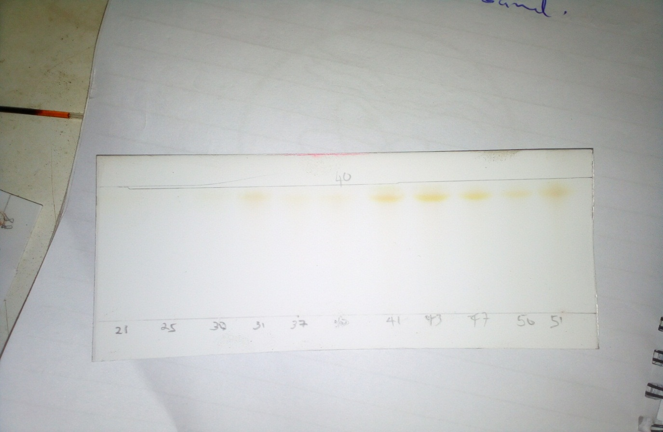Plate 3.1: TLC plates showing distance travelled by fractions or eluate from EtLDB
3.2.5.2 Fractionation of EtMLB
Accurately weighed 30 g of EtMLB was mixed with 60 mL of hexane-ethyl acetate (1:3) and 70 g silica gel (100-200 mesh). The mixture was stirred and the solvent removed in vacuo. The sample was then introduced onto a silica gel packed column and eluted with n-hexane, ethyl acetate and dichloromethane of different proportion. Fractions were collected at equal intervals of 50 mL each until a total of 45 fractions were collected. Each of the fractions collected was concentrated in vacuo. Fractions 1 to 7, 8 to 12, 13 to 17, 18 to 21 and 22 to 45 were pooled together based on TLC evidence and subjected to a repeated column chromatography. The summary of the column chromatography which was monitored by TLC is shown in Table 3.3.

Table 3.3: Column fractionation of EtMLB
Eluant | Fraction no | Combined fraction | Code for combined fractions
n-Hexane: Ethyl acetate 9:1 | 1-7 | I | ML-J
n-Hexane: Ethyl acetate 8:2 | 8-12 | II | ML-K
n-Hexane: Ethyl acetate 7:3 | 13-17 | III | ML-L
n-Hexane: Ethyl acetate 6:4 | 18-21 | IV | ML-M
n-Hexane: Ethyl acetate 5:5 | 22-45 | VI | ML-N

3.2.6 Antiplasmodial Screenings of Fractions
The antiplasmodial potency of chromatographic fractions obtained from the most active extracts (section 3.2.6), that is, EtLDB and EtMLB was done using the method of Dibessa et al., (2020) with slight modifications (in the number and sex of experimental mice and dose concentrations).
3.2.6.1 Grouping and Dosing
For this assay, thirty male Swiss albino mice (16 ± 2.0 g) were obtained from IMRAT, Ibadan, Oyo State, Nigeria. The animals were divided into ten groups, each containing three mice, viz. groups I-IV (M. lucida fractions), V-IX (L. dulcis fractions) and X (CQ (25 mg/kg body weight) treated groups. The animals were house in sanitized polyvinyl cages for eight days and maintained under standard laboratory conditions (room temperature 25 ± 1°C) and 12 hour light -12 hour dark cycles. These animals were fed on a standard laboratory animal diet and water ad libitum. To keep the hydration rate in constant flow, feed and water were stopped 12 hour before the treatment experiments, that is, before treatment commences. For the treatment, all animals were administered 1 mL of fractions (100 mg/kg) or CQ through oral medium using oral gavage (Dibessa et al., 2020).
3.2.6.2 Parasite Inoculation
Chloroquine- sensitive P. berghei ANKA infected animals (donor) were obtained from IMRAT, Ibadan, Oyo State, Nigeria. The parasite inoculation was carried out according to the method of Dibessa et al., (2020) as explained in section 3.2.4.3.
3.2.6.3 Curative Test
The curative potency of purified fractions obtained from EtLDB and EtMLB extracts and CQ, were investigated in early P. berghei infection using the procedure described by Dibessa et al., (2020) as explained in section 3.2.4.4.
3.2.6.3.1 Determination of level of parasitaemia
The changes in parasitaemia level in experimental mice were evaluated using the procedure described by Eyasu et al., (2013) as explained in section 3.2.4.4.1.
3.2.6.3.2 Determination of changes in body weight
The body weight (g) of each Swiss Albino mice was obtained using an electronic weighing balance (Ohius Parsippany, New Jersey, USA). Body weight of each mice was recorded before inoculation (D₀), before treatment (D₄), during (D₅ to D₇) and after treatment period (D₈) as explained in section 3.2.4.4.2.
3.2.6.3.3 Determination of packed cell volume
Clean heparinized microhaematocrit capillary tubes were filled with aliquot of blood sample collected from tail snip of each mice to about two-third of their original height. The packed cell volume of fractions and CQ treated groups were assessed using the method described in section 3.2.4.4.3.
3.2.7 Isolation of compounds from OL-N
The most active fraction was further subjected to column chromatography for purification and isolation of antiplasmodial compounds. Thus, OL-N was fractionated over silica gel into 40 fractions of 100 mL each. The dark brown crystalline fraction, OL-N (20 g) was dissolved in a mixture of n-hexane and dichloromethane (DCM) (4:1, 30 mL) and silica gel (45 g) was added. The mixture was stirred and n-hexane: DCM was driven off under vacuum and the powder gotten was transferred to a silica gel column (100-200 mesh, 500 g) set in n-hexane (100%). The open column was eluted with n-Hexane: DCM (9:1; 5:5; 1:9) and DCM: ethyl acetate (9:1; 8:2; 7:3; 6:4; 5:5; 4:6; 3:7). The column was monitored using TLC and combined fractions were concentrated appropriately in line with TLC results (Table 3.4) (Scheme 3.2).

Table 3.4: Column purification and isolation of fraction OL-N
Eluant | Fraction no | Combined fraction | Isolated compounds
Hexane: DCM (9:1) | 1-6 | FR-6 | OL-1
Hexane: DCM (5:5) | 7-11 | I | -
Hexane: DCM (1:9) | 12-15 | II | -
DCM: ethyl acetate (9:1) | 16-18 | III | -
DCM: ethyl acetate (8:2) | 19-21 | IV | -
DCM: ethyl acetate (7:3) | 22-25 | V | -
DCM: ethyl acetate (6:4) | 26-30 | VI | -
DCM: ethyl acetate (5:5) | 31-34 | VII | -
DCM: ethyl acetate (4:6) | 34-37 | VIII | -
DCM: ethyl acetate (3:7) | 37-40 | IX | -

FR-6, brown amorphous solid was subjected to preparative TLC. It was developed with n-hexane: ethyl acetate: ethanol (2:2.5: 3) to give three distinctive bands: OL-N1, OL-N2, OL-N3. OL-N2 under UV lamp gave broad pale green (plate 3.2) (both short and long wavelength). The band was scrapped, dissolved in DCM: 5% ethanol (19:1), filtered and concentrated under vacuum to give OL-1 (8 mg) (Scheme 3.2).

EtLDB
(60 g)

Column Chromatography

OL-M

OL-O

OL-N

OL-L

OL-K

OL-J

Column chromatography

FR-6

OL-1 (6 mg)
Preparative TLC
Scheme 3.2: Graphic representation of the process involved in the successive fractionation and isolation of OL-1 (from EtLDB).

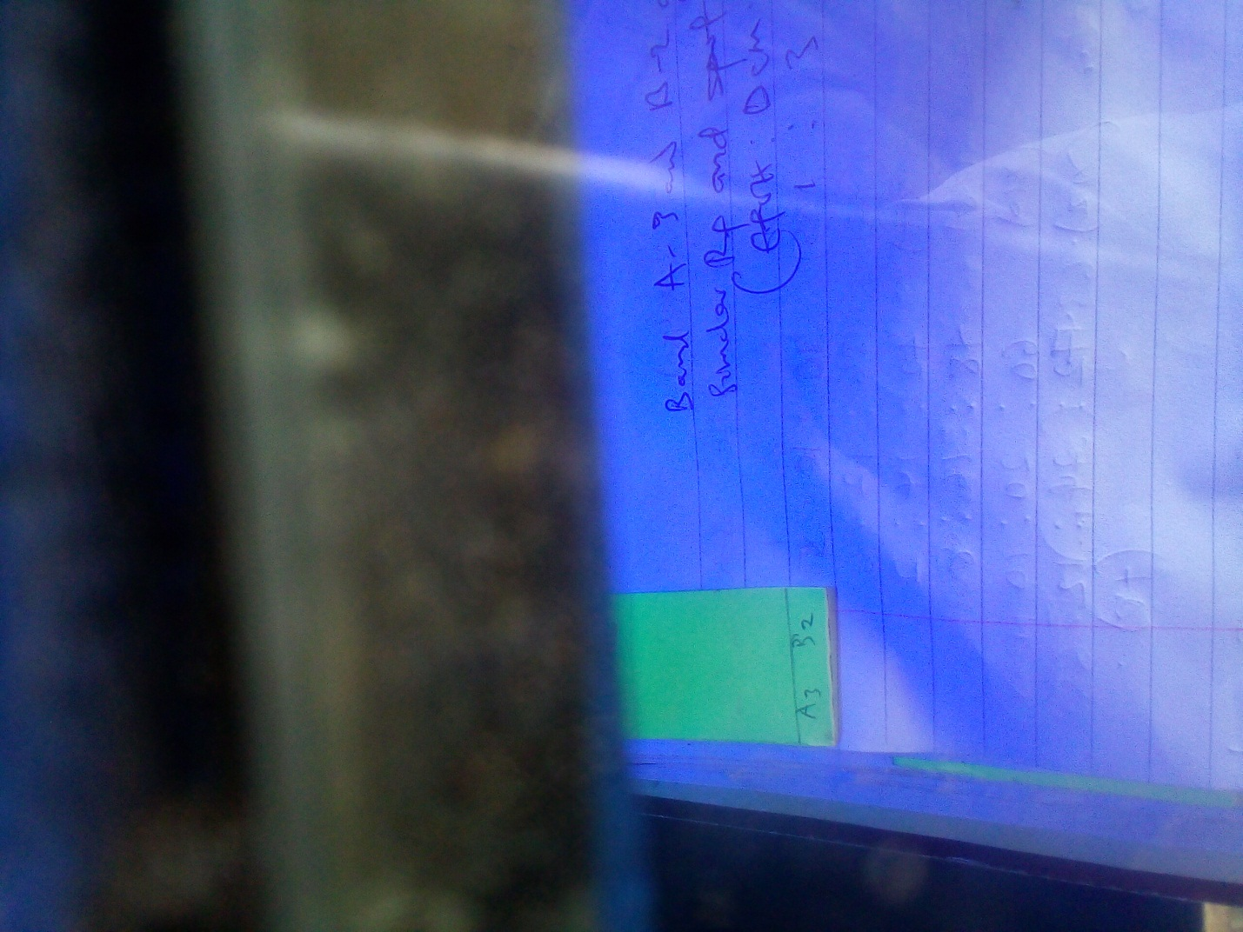
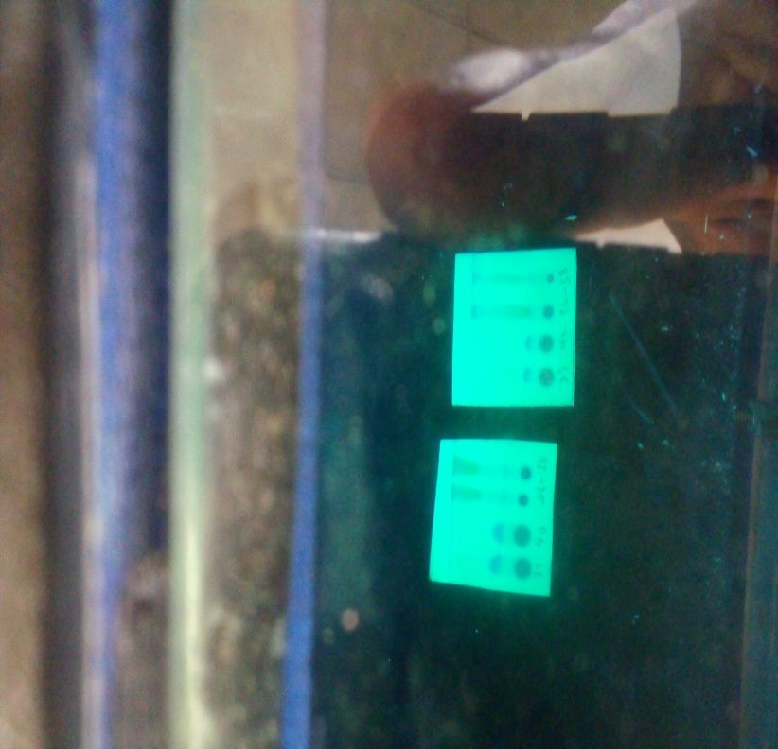

Plate 3.2: TLC plates showing spots depicting fractions under UV lamp (EtLDB)

3.2.8 Fractionation of EtLDB
The dark brown crystalline extract EtLDB (10.081 g) was dissolved in n-hexane and DCM (4:1, 30 mL) and silica gel (30 g) was added. The mixture was stirred until homogenous. The n-hexane: DCM was driven off under vacuum and the resulting powder was loaded onto a column (100 - 200 mesh, 350 g) set in n-hexane (100%). The open column was eluted with n-Hexane: ethyl acetate (9:1), DCM (100%), DCM: Methanol (99:1), DCM: Methanol (98:2) and DCM: Methanol (96:4). A total of 67 fractions of 100 mL each were collected. Fractions 36-38 yielded a greenish-yellow oily compound which showed a deep yellowish colour under UV lamp (short and long wavelength). Also, fractions 39 - 40 yielded a deep brown powdery compound which showed a glowing brown spot when viewed under UV-lamp (short wavelength). Its R_{f} value was 0.38 in n-hexane: DCM: ethanol (1:3:1) and it was assigned A-N (Plate 3.2).

3.2.9 Isolation of compounds from OL-N
Fraction A-N (0.90 g) was dissolved in DCM (100%) and purified on preparative TLC developed with hexane: DCM: ethanol (1:3:1) to give three distinct spots (compounds) labelled A-3 (5 mg), B-2 (6 mg) and C-3 (7 mg) (Scheme 3.3).
A-N

Preparative TLC

A1/B1 (7 mg)

B-2 (6 mg)

A-3 (5 mg)

Scheme 3.3: Isolation of A-3
3.2.10 Isolation of EtLDB-65-oil
Fr-65 obtained from section 3.2.5.1 (Table 3.2) has an oily surface. This layer was separated into EtLDB-65 and EtLDB-65-oil. EtLDB-65-oil was placed in waterbath at 35-45°C to remove left-over solvent.
3.2.11 Characterization of compounds
3.2.11.1 Gas chromatography-mass spectrometry (GC–MS)
The analysis was carried out in Mass spectrometry and Chromatography unit, Department of Analytical and Structural Chemistry, Council of Scientific and Industrial Research, Indian Institute of Chemical Technology, Hyderabad, India (7890B GC with 5977A MSD, Agilent Technologies, USA). A Hewlett Packard 5890 gas chromatograph coupled with a Hewlett Packard 5989B mass spectrometer was used. The sample was separated on a fused silica capillary column (HP5MS) (5% phenyl methyl siloxane), 30 m × 0.32 mm, 0.25 mm film thickness, in a temperature program from 50 (kept 2 min) to 250°C (kept 10 min), with a rate of 8°C min⁻¹ . The injector temperature was 250°C, and the flow rate of the carrier gas, helium, was 1 ml min⁻¹. The interface keeping the capillary column end into the ion source block, was kept at 280°C. The Hewlett Packard quadrupolar mass spectrometer model 5989B had an electron energy of 70 eV, electron emission of 300 mA, ion source temperature of 200°C, and analyzer temperature of 100°C.
3.2.11.2 Structural Characterization/ Elucidation
The structural elucidation of the isolated compounds was based on the spectra obtained from infrared (IR), NMR (HNMR and H-H COSY), and MS (ESI-MS).
3.2.11.2a Infrared Spectrometry
Infrared studies of isolated compounds were carried out at Covenant University Centre for Research Innovation and Discovery (CUCRID) and CSIR, Indian Institute of Chemical Technology, India (CSIR-IICT).
3.2.11.2b NMR Spectroscopy
NMR spectra were recorded on Nanalysis benchtop NMR 60 MHz and 400 MHz Spectrometers. The chemical shift were given in δ (ppm) with TMS as reference. The homonuclear bond 1H-1H connectiveness was determined by using H-H COSY experiment. The NMR experiments were carried out at Covenant University Center for Research Innovation and Discovery (CUCRID) and CSIR, Indian Institute of Chemical Technology, India (CSIR-IICT).
3.2.11.2c Mass Spectroscopy
Mass spectrometric analysis was carried out in Mass spectrometry and Chromatography unit, Department of Analytical and Structural Chemistry, Council of Scientific and Industrial Research, Indian Institute of Chemical Technology, Hyderabad, India (7890B GC with 5977A MSD, Agilent Technologies, USA).
3.2.12 In silico Molecular Docking Studies
3.2.12.1 Selection of Ligands for Docking Studies
The secondary metabolites obtained from GC-MS of ML-7, LD-5 and EtLDB-65-oil as elucidated from the National Institute of Standards and Technology library were selected for molecular docking. The Secondary metabolites were downloaded from PubChem using their PubChem identification code and others without identification code were drawn using ChemDraw software. Also, smiley of some compounds were generated from ChemDraw softwares.
3.2.12.2 Ligand Preparation and Molecular Docking
The 3D structures of Plasmodium falciparum thymidylate kinase (2OYO), P. falciparum Enoyl ACP Reductase with Triclosan Reductase (2OP0)) were downloaded from protein data bank which are two important proteins in antimalarial therapy. The proteins were subjected to molecular docking software in order to achieve non-bonding interactions and binding affinity. The optimization was done in order to determine the best binding pose of a ligand against a protein target which could maximize reliability, efficiency, longevity, productivity, strength and utilization. The optimized compounds were converted from .Spartan format using Spartan software to pdb format. The selected phytochemical compounds were optimized via density functional theory (6.31-G∗) using Autodock Vina software. The optimization was achieved in water so as to represent the factual activities of drug-like compounds in human body before docking calculation using Autodock vina, Chimera and Discovery studio software (Oluyori et al., 2023).
CHAPTER FOUR
4.0 RESULTS
4.1 Qualitative phytochemical screening
The results of the preliminary phytochemical screenings of HMLL, HMLB, HLDL, HLDB, EMLL, EMLB, ELDL, ELDB, EtMLL, EtMLB, EtLDL and EtLDB are shown in Table 4.1. The results of qualitative phytochemical screenings of leaves and bark extracts of L. dulcis and M. lucida presented in Table 4.1 revealed the presence of steroids, terpenoids, tannins, flavonoids, alkaloids, phenols and saponins. These results are based on the colour changes or reactions that occurred after the addition of each reagent. In all Secondary metabolites analyzed, colour changes was used to ascertain the presence of these metabolites except in saponins that the presence was ascertained by the formation of lather or frothing. Secondary metabolites such as saponins, tannins, terpenoids, steroids, phenols, flavonoids, alkaloids and anthraquinones were detected in EtLDL and EtMLL. From these extracts, that is EtLDL and EtMLL, saponins, terpenoids, phenols and anthraquinones were detected in moderate amount. Flavonoid is present in all the crude extracts, though, it was moderately present in HMLL. The abundance in the plant extracts could be linked to the colour intensity observed. Similarly, steroid is present in all the crude extracts except in EtMLB and EtLDB. In HMLL, terpenoids, steroids and flavonoids were present while saponins, tannins, phenol, alkaloids and anthraquinone were undetected. Similar results obtained in HMLL were observed in HMLB. Generally, the phytochemical screening results of n-hexane leaves and bark extracts of L. dulcis and M. lucida is quite different from that of 50% hydroethanolic extracts. For example, all Secondary metabolites analyzed were present in the 50% hydroethanolic leaves extracts of L. dulcis and M. lucida.
Table 4.1: Secondary metabolites constituents of L. dulcis and M. lucida extracts
Extract/ | SN | TN | TP | ST | PH | FL | AK | AN
HMLL | - | - | + | + | - | ++ | - | -
EMLL | + | + | - | + | + | + | - | +
EtMLL | ++ | ++ | + | + | ++ | + | ++ | ++
HMLB | - | - | ++ | + | - | + | - | -
EMLB | - | + | ++ | + | + | + | - | +
EtMLB | + | ++ | + | - | ++ | + | + | ++
HLDL | - | - | + | + | - | + | - | -
ELDL | + | + | - | + | + | + | - | +
EtLDL | ++ | ++ | + | + | ++ | + | ++ | ++
HLDB | - | - | ++ | + | - | + | - | -
ELDB | - | + | ++ | + | - | + | - | -
EtLDB | + | ++ | + | - | ++ | + | + | ++

Keys: (-) Negative, (+) Present, (++) Moderately present

SN- Saponins, TP- Terpenoids, TN- Tannins, ST- Steroids, PH-Phenols, FL- Flavonoids,
AK- Alkaloids, AN- Anthraquinone

4.2 Quantitative phytochemical screening
The total concentrations or amounts of alkaloids, terpenoids, flavonoids, tannins and phenols in HMLL, HMLB, HLDL, HLDB, EMLL, EMLB, ELDL, ELDB, EtMLL, EtMLB, EtLDL and EtLDB extracts were assayed in Table 4.2. The amount or concentrations of total flavonoids, tannins and phenols were obtained via spectrophotometric techniques from quercetin (Fig 4.1) and gallic acid (Fig 4.2 and 4.3) calibration curves respectively. The total alkaloids, terpenoids and saponins were determined gravimetrically (Table 4.2).
The total phenolic contents (TPC) in HMLL, HMLB, HLDL, HLDB, EMLL, EMLB, ELDL, ELDB, EtMLL, EtMLB, EtLDL and EtLDB extracts was obtained through extrapolation of the gallic acid calibration curve (mg/g). The highest phenolic content was assayed in EtLDB (165.93 mg/g) followed by EtLML (67.905 mg/g), EtLDL (45.828 mg/g) and EtMLB (26.802 mg/g). Similarly, the lowest TPC were assayed in HBML (14.700 mg/g), HLML (10.648 mg/g), HLDB (8.675 mg/-g) and HLDL (8.418 mg/g). From the TPC results obtained for all the crude extracts, ethanolic extracts contain high phenolic contents compared to ethyl acetate and n-hexane extracts of L. dulcis and M. lucida bark and leaves. The total flavonoid contents (TFC) in HMLL, HMLB, HLDL, HLDB, EMLL, EMLB, ELDL, ELDB, EtMLL, EtMLB, EtLDL and EtLDB extracts was obtained through extrapolation of the quercetin calibration curve (mg/g). The highest flavonoid content was assayed in EtMLL (1348.966 mg/g) followed by EtLDB (935.172 mg/g), EtLDL (920.059 mg/g) and EtMLB (919.541 mg/g). Similarly, low TFC of 515.748 mg/g (HMLL), 492.872 mg/g (HMLB), 467.586 mg/g (HLDL) and 408.734 mg/g (HLDB) were obtained in n-hexane extracts of leaves and bark of M. lucida and L. dulcis. This trend agree with the results (concentrations) of TPC, with ethanolic extracts exhibiting high amount of TFC. The total tannin contents (TTC) in the crude extracts was assayed via extrapolation of gallic acid calibration curve (mg/g). The TPC of 195.427 mg/g was found to be the highest which was assayed in EtLDB. Other notable TPC include EtMLL (76.933 mg/g) and EtLDL (49.945 mg/g). Similar to the results obtained in TPC and TFC, n-hexane extracts of M. lucida and L. dulcis leaves and bark exhibited low tannin contents. The TTC of 4.593, 2.926 and 2.029 mg/g were assayed in HMLL, HLDL and HLDB respectively. The TTC in HMLL, HMLB, HLDL, HLDB, EMLL, EMLB, ELDL, ELDB, EtMLL, EtMLB, EtLDL and EtLDB extracts is significantly lower than the concentration assayed in TPC and TFC assayed. The TPC, TFC and TTC in all crude extracts followed increasing solvent polarity order with ethanolic extracts exhibiting higher concentrations than ethyl acetate and n-hexane extracts.
The total alkaloids contents (TAC) of leaves and bark of L. dulcis and M. lucida extracts obtained from gravimetric assay indicated that ethanolic extracts exhibited the highest concentrations. Notable concentrations such as 92.95, 86.76, 66.80 and 62.82% were assayed in EtMLB, EtLDB, EtMLL and EtLDL respectively. Similarly, lowest TAC were assayed in n-hexane extracts of leaves and bark of L. dulcis and M. lucida extracts. In n-hexane extract, concentrations of 25.38, 12.10, 11.47 and 7.11% were assayed in HMLL, HMLB, HLDB and HLDL respectively. The total terpenoids content (TTpC) of leaves and bark of L. dulcis and M. lucida extracts obtained from gravimetric assay indicated that ethanolic extracts exhibited the highest concentrations. Noteworthy TTpC such as 75.40, 56.15 and 50.20% were assayed in EtLDL, EtLDB and EtMLL respectively. The trend observed in TTpC did not agree with that observed in TAC, TPC, TTC and TFC. In TTpC assays, some ethyl acetate and n-hexane extracts such as HLDL (54.00%), EMLB (52.20%), HLDB (31.80%) and ELDL (23.40%) exhibited higher amount of terpenoids compared to more polar extracts, that is, ethanolic extracts.

Fig 4.1: Gallic acid calibration curve for total phenolics content

Fig 4.2: Quercetin calibration curve for total flavonoids content

Fig 4.3: Gallic acid calibration curve for total tannins content.

Table 4.2: Concentrations of secondary metabolites in leaves and bark extracts of L. dulcis and M. lucida.
E | TPC (mg/g) | TFC (mg/g) | TTC (mg/g) | TAC (%) | TTpC (%)
1 | 10.648 ± 0.0006 | 515.748 ± 0.0071 | 4.593 ± 0.0006 | 25.38 ± 0.0071 | 36.00 ± 00020
2 | 26.341 ± 0.0016 | 684.369 ± 0.0040 | 24.817 ± 0.0010 | 7.77 ± 0.0065 | 23.40 ± 0.080
3 | 67.905 ± 0.0153 | 1348.966 ± 0.006 | 76.933 ± 0.0000 | 66.80 ± 0.0016 | 50.20 ± 0.0007
4 | 14.700 ± 0.0010 | 492.872 ± 0.0025 | 18.183 ± 0.0010 | 12.10 ± 0.0008 | 26.60 ± 0.0005
5 | 24.469 ± 0.0020 | 653.103 ± 1.0935 | 19.978 ± 0.0047 | 44.37 ± 0.0078 | 52.20 ± 0.0025
6 | 26.802 ± 0.0006 | 919.541 ± 0.0110 | 22.959 ± 0.0023 | 92.95 ± 0.0005 | 48.60 ± 0.0018
7 | 8.418 ± 0.0006 | 467.586 ± 0.0026 | 2.926 ± 0.0012 | 7.11 ± 0.0008 | 54.00 ± 0.0021
8 | 21.777 ± 0.0010 | 558.734 ± 0.0021 | 35.266 ± 0.0021 | 12.10 ± 0.0017 | 47.80 ± 0.0005
9 | 45.828 ± 0.0006 | 920.059 ± 0.0063 | 49.945 ± 0.0006 | 62.82 ± 0.0019 | 75.40 ± 0.0020
10 | 8.675 ± 0.00058 | 408.734 ± 0.00252 | 2.029 ± 0.001 | 11.47 ± 0.0001 | 31.80 ± 0.0001
11 | 13.725 ± 0.00058 | 464.94 ± 0.0085 | 8.632 ± 0.0005 | 26.00 ± 0.0016 | 54.20 ± 0.0052
12 | 165.931 ± 0.01039 | 935.172 ± 0.0053 | 195.427 ± 0.003 | 86.76 ± 0.0076 | 56.15 ± 0.0065

n=3, {TPC (total phenolics content), TFC (total flavonoids content), TTC (total tannins content), TAC (total alkaloids content), TTpC (total terpenoids content, E (extract)}.
HMLL (1), EMLL (2), EtMLL (3), HMLB (4), EMLB (5), EtMLB (6), HLDL (7), ELDL (8), EtLDL (9), HLDB (10), ELDB (11) and EtLDB (12).

4.3 Antiplasmodial assays of L. dulcis and M. lucida crude extracts
4.3.1 Effects of L. dulcis and M. lucida crude extracts on body weight
Prior to the antiplasmodial study of the crude extracts of M. lucida and L. dulcis, the acute toxicity test showed that the extracts administered were not toxic or harmful to the experimental mice. The extracts administered, that is, 800 and 1000 mg/kg of 50% hydroethanolic bark and leaves extracts of M. lucida and L. dulcis did not have behavioural or physiological effects on the mice. Behavioural changes such as salivating, body itching, restlessness, sleepiness, eye colour and skin irritation were not observed in the experimental mice.
The antiplasmodial screenings of HMLL, HMLB, HLDL, HLDB, EMLL, EMLB, ELDL, ELDB, EtMLL, EtMLB, EtLDL and EtLDB crude extracts studied in Plasmodium infected Swiss albino mice showed that L. dulcis and M. lucida plants extracts have promising antiplasmodial (Table 4.3 and 4.4). The effects of crude extracts on the common symptoms of malaria infections such as weight loss and erythrocytic levels were studied.
The effect of changes in body weight in P. berghei infected animals (mice) after administration or treatment with HMLL, HMLB, HLDL, HLDB, EMLL, EMLB, ELDL, ELDB, EtMLL, EtMLB, EtLDL and EtLDB crude extracts (200 and 400 mg/kg) and CQ were presented in Table 4.3 and 4.4 for L. dulcis and M. lucida extracts respectively. According to Table 4.3, all extracts (200 and 400 mg/kg) and CQ significantly increased the body weight of infected mice after four-day treatment period. From the results, it was evident that 400 mg/kg HLDB treated group (4.3500 g) exhibited pronounced weight gain compared to CQ treated group (3.6000 g). Similarly, ELDB (200 mg/kg) treated group significantly exhibited body weight changes from 22.00 ± 2.6458 g to 25.00 ± 1.0000 g with body weight gain of +3.00 g. Similar body weight gain of 2.60 g were exhibited in EtLDL and HLDB (200 mg/kg) treated groups while HLDB (400 mg/kg) caused an increase in body weight from 23.20 ± 2.1697 to 25.75 ± 0.9574 g. Likewise, reasonable body changes was exhibited in EtLDB (200 mg/kg) treated group (23.80 ± 3.0332 to 24.00 ± 1.2247 g). ELDL (400 mg/kg) administered groups exhibited low body weight variation of 0.40 g (24.00 ± 2.2361 to 24.40 ± 3.2094 g) while body weight variation of 1.00 g was shown in HLDL (400 mg/kg) and ELDB (400 mg/kg) extracts treated groups. The weight gained presented in Table 4.3 is not dependent on the polarities of crude extracts with less polar extracts such as ethyl acetate and n-hexane extracts exhibiting pronounced weight gain compared to ethanolic extracts of leaves and stem bark of L. dulcis and M. lucida.
According to Table 4.4, all extracts (200 and 400 mg/kg) and CQ significantly increased the body weight of infected mice after four-day treatment period. The effects of oral administration of 200 and 400 mg/kg dose concentrations of HMLL, HMLB, HLDL, HLDB, EMLL and EMLB in infected mice were investigated before inoculation (D₀) and after treatment (D₈) (Table 4.4). In extract treated groups, significant body weight gain from 20.80 ± 1.6432 to 23.90 ± 1.5275 g (3.10 g) and 21.60 ± 1.1402 to 24.60 ± 2.1909 g (3.00 g) corresponding to 400 mg/kg and 200 mg/kg EtMLL treated groups respectively. In EtMLB (400 mg/kg) treated group, a considerable rise in body weight of 2.75 g (21.00 ± 0.7071 to 23.75 ± 1.5166 g) was observed after treatment. Similar trend was assayed in EtMLB (200 mg/kg) treated group with weight gain of 2.60 g (20.00 ± 1.2247 to 22.60 ± 1.1402 g. A close proximity in weight gain was evaluated in 200 and 400 mg/kg HMLL and HMLB treated groups. A body weight difference of 1.25 g (20.00 ± 2.5495 to 21.25 ± 2.0615 g), 1.20 g (20.80 ± 1.9235 to 22.00 ± 2.1213) and 1.00 g (20.00 ± 1.4142 to 21.00 ± 2.1602 g) were exhibited in HMLL (400 mg/kg) and HMLL (200 mg/kg) extracts respectively. CQ treated group significantly exhibited marked body weight gain of 3.60 g. CQ significantly increased body weight of experimental mice from 19.20 ± 1.6432 to 22.80 ± 1.1402 g while parasitaemia significantly contributed to severe reduction in body weight (-3.00 g) in groups infected but untreated (20.00 ± 1.5811 to 17.00 ± 0.0000 g).
I- 200 HMLL, II- 400 HMLL, III- 200 EMLL, IV- 400 EMLL, V- 200 EtLDL, VI- 400 EtLDL, VII-200 HMLB, VIII- 400 HMLB, IX-200 EMLB, X- 400 EMLB, XI- 200 EtMLB, XII- 400 EtMLB.

Table 4.3: Body weight (g) in P. berghei- infected mice administered L. dulcis extracts
E | D₀ | D₄ | D₅ | D₇ | D₈ | ∆D(D₈-D₄)
I | 25.80 ± 1.7889 | 24.00 ± 1.5811 | 26.00 ± 1.000 | 26.80 ± 1.3038 | 26.00 ± 2.1213 | 2.0000
II | 26.00 ± 1.2247 | 24.60 ± 0.8944 | 28.00 ± 1.000 | 26.20 ± 1.643 | 27.00 ± 0.7071 | 2.4000
III | 26.40 ± 0.8943 | 24.80 ± 0.8367 | 28.40 ± 1.5166 | 29.00 ± 0.5080 | 27.00 ± 0.5000 | 2.2000
IV | 24.00 ± 2.2361 | 23.40 ± 2.4083 | 25.40 ± 1.5166 | 24.40 ± 2.1909 | 24.40 ± 3.2094 | 1.0000
V | 22.00 ± 1.2247 | 21.60 ± 1.3416 | 26.00 ± 1.5811 | 25.80 ± 2.5884 | 24.60 ± 2.9665 | 3.0000
VI | 23.80 ± 2.4899 | 22.40 ± 2.8809 | 26.80 ± 1.6432 | 26.80 ± 2.8636 | 25.80 ± 2.7749 | 3.4000
VII | 23.40 ± 1.1402 | 21.60 ± 0.5477 | 25.60 ± 1.3416 | 25.00 ± 4.3589 | 24.00 ± 3.2146 | 2.4000
VIII | 23.20 ± 2.1679 | 21.40 ± 1.6733 | 24.80 ± 0.4472 | 25.20 ± 1.7889 | 25.75 ± 0.9574 | 4.3500
IX | 22.00 ± 2.6458 | 20.80 ± 1.9235 | 26.00 ± 3.0822 | 26.00 ± 1.0000 | 25.00 ± 1.0000 | 2.2000
X | 24.00 ± 1.8708 | 22.80 ± 1.3038 | 25.20 ± 1.9235 | 21.50 ± 2.1213 | 25.00 ± 0.5774 | 2.2000
XI | 23.80 ± 3.0332 | 22.60 ± 2.8809 | 23.00 ± 2.8284 | 23.40 ± 1.1402 | 24.00 ± 1.2247 | 1.4000
XII | 24.20 ± 2.1679 | 22.20 ± 1.4832 | 25.60 ± 3.4351 | 23.80 ± 1.9235 | 25.40 ± 2.2449 | 3.2000
CQ | 20.60 ± 2.1909 | 19.20 ± 1.6432 | 21.40 ± 1.3416 | 22.60 ± 1.1402 | 22.80 ± 1.1402 | 3.6000^{b}
NT | 23.40 ± 2.3022 | 20.00 ± 1.5811 | 19.25 ± 1.5000 | 17.50 ± 0.7071 | 17.00 ± 0.0000 | -3.0000ª
{Values given as mean ± SEM. n = 5}
E- Extract (mg), D₀ – Before inoculation, D₄ –four-day post inoculation, D₄₋D₈₋ Treatment period
Table 4.4: Body weight (g) in P. berghei- infected mice administered M. lucida extracts
E | D₀ | D₄ | D₅ | D₇ | D₈ | ∆D(D₈-D₄)
200 HMLL | 22.80 ± 2.5884 | 20.80 ± 1.9235 | 21.00 ± 0.8165 | 21.50 ± 0.1213 | 22.00 ± 2.1213 | 1.2000
400 HMLL | 21.20 ± 2.3875 | 20.00 ± 2.5495 | 20.40 ± 1.1408 | 20.50 ± 1.2910 | 21.25 ± 2.0615 | 1.2500
200 EMLL | 21.80 ± 2.3877 | 20.00 ± 2.1213 | 21.80 ± 3.0332 | 21.75 ± 1.2583 | 22.00 ± 1.4142 | 2.0000
400 EMLL | 21.00 ± 2.000 | 19.80 ± 1.4832 | 20.60 ± 2.6077 | 21.56 ± 1.1547 | 22.00 ± 1.0000 | 2.2000
200 EtMLL | 23.40 ± 2.1909 | 21.60 ± 1.1402 | 23.80 ± 1.9235 | 24.20 ± 1.9235 | 24.60 ± 2.1909 | 3.0000
400 EtMLL | 22.00 ± 1.8908 | 20.80 ± 1.6432 | 22.00 ± 1.4142 | 23.33 ± 1.5275 | 23.90 ± 1.5275 | 3.1000
200 HMLB | 21.40 ± 1.1402 | 20.00 ± 1.4142 | 20.00 ± 1.4142 | 20.40 ± 2.1909 | 21.00 ± 2.1602 | 1.0000
400 HMLB | 23.00 ± 1.8708 | 20.80 ± 0.8367 | 21.75 ± 2.2174 | 22.00 ± 1.0000 | 22.67 ± 1.1547 | 1.8700
200 EMLB | 21.80 ± 1.9235 | 20.20 ± 1.3038 | 22.80 ± 1.0954 | 23.00 ± 1.0000 | 23.00 ± 1.0000 | 1.8000
400 EMLB | 22.00 ± 2.8284 | 19.80 ± 2.0494 | 21.40 ± 2.3022 | 21.60 ± 2.4083 | 21.60 ± 2.4083 | 1.8000
200 EtMLB | 21.80 ± 1.7889 | 20.00 ± 1.2247 | 22.20 ± 1.6432 | 22.40 ± 1.0954 | 22.60 ± 1.1402 | 2.6000
400 EtMLB | 23.00 ± 1.2247 | 21.00 ± 0.7071 | 23.40 ± 1.5166 | 23.60 ± 2.0736 | 23.75 ± 1.5166 | 2.7500
CQ | 20.60 ± 2.1909 | 19.20 ± 1.6432 | 21.40 ± 1.3416 | 22.60 ± 1.1402 | 22.80 ± 1.1402 | 3.6000
NT | 23.40 ± 2.3022 | 20.00 ± 1.5811 | 19.25 ± 1.5000 | 17.50 ± 0.7071 | 17.00 ± 0.0000 | -3.0000

{Values given as mean ± SEM. n = 5}E- Extract (mg), D₀ – Before inoculation, D₄ – four-day post inoculation,, D₄₋D₈₋ Treatment period

4.3.2 Effects of L. dulcis and M. lucida crude extracts on packed cell volume
The effects of HMLL, HMLB, HLDL, HLDB, EMLL, EMLB, ELDL, ELDB, EtMLL, EtMLB, EtLDL and EtLDB crude extracts on the packed cell volume of P. berghei infected mice were assayed in Table 4.5 and 4.6. The packed cell volume was assayed before, during and after treatment.
The effects of L. dulcis extracts and CQ assayed in Table 4.5 presented that CQ treated group significantly exhibited increase in PCV compared to L. dulcis treated groups. In L. dulcis treated groups, an increase of +0.400% was assayed in 400 mg/kg treated group while 200 mg/kg restored the PCV of infected mice to the initial level before inoculation (+0.00%). Similar activities were demonstrated in 200 mg/kg EtLDB and 400 mg/kg ELDB with a reduction of -0.020% in the PCV. The CQ treated groups exhibited pronounced increase in PCV of about +3.60% (42.80 ± 1.6432 to 46.40 ± 0.5477%) while infected untreated (NT) group displayed a strong reduction of -5.93%. In L. dulcis treated groups, the pronounced reduction in PCV was assayed in ELDL and HLDL (both 200 mg/kg) with activity of -1.67 and -1.10% respectively.
The effects of M. lucida extracts and CQ presented in Table 4.6 revealed that CQ treated group significantly exhibited increase in PCV compared to M. lucida treated groups. The effects of PCV observed in M. lucida treated groups showed that there is a significant reduction in extracts treated groups with reduction of -4.00%, -3.85%, -3.56%, -3.35%, -3.43%, -2.60% and 2.40% assayed in 200 mg/kg EMLB, 200 mg/kg HMLB, 400 mg/kg HMLB, 400 mg/kg EtMLL, 300 mg/kg HMLL, 400 mg/kg EtMLB and 200 mg/kg EtMLB respectively. When comparing the activities exhibited by M. lucida and L. dulcis (Table 4.5 and 4.6), L. dulcis treated groups significantly increase the PCV in parasitized mice compared to activities exhibited by M. lucida treated groups. In spite of these activities, none of the extracts could measure up to the activity exhibited by CQ treated groups. Similarly, there is no correlation between the polarity of crude extracts and the activities exhibited with some ethanolic crude extracts exhibiting low activity compared to ethyl acetate and n-hexane extracts.

Table 4.5: Packed cell volume in P. berghei –infected mice administered L. dulcis extracts
Extract (mg) | D₀ | D₄ | D₈ | ∆D (D₈-D₄)
200 HLDL | 53.60 ± 4.0373 | 47.60 ± 6.6182 | 52.50 ± 4.7258 | -1.1000
400 HLDL | 54.00 ± 4.7958 | 49.00 ± 2.9155 | 53.20 ± 3.5637 | -0.8000
200 ELDL | 54.00 ± 2.0000 | 47.80 ± 3.0332 | 52.33 ± 1.5275 | -1.6700
400 ELDL | 53.60 ± 3.7148 | 45.20 ± 3.1145 | 52.80 ± 2.4899 | -0.8000
200 EtLDL | 48.60 ± 1.7436 | 43.00 ± 1.0955 | 48.00 ± 1.000 | -0.6000
400 EtLDL | 49.20 ± 2.1679 | 41.40 ± 3.0496 | 49.00 ± 2.000 | -0.2000
200 HLDB | 47.80 ± 2.5884 | 42.40 ± 2.4083 | 46.80 ± 2.000 | -1.0000
400 HLDB | 50.00 ± 3.9370 | 43.60 ± 2.7019 | 49.10 ± 5.4130 | -0.9000
200 ELDB | 53.00 ± 3.4641 | 47.60 ± 2.5099 | 53.000 ± 1.000 | 0.0000
400 ELDB | 51.00 ± 2.2361 | 46.60 ± 1.3416 | 51.20 ± 1.0955 | 0.2000
200 EtLDB | 54.20 ± 1.4832 | 43.80 ± 0.8367 | 54.40 ± 0.8944 | 0.2000
400 EtLDB | 49.40 ± 2.7018 | 46.00 ± 2.0000 | 49.80 ± 0.8367 | 0.4000
CQ | 51.00 ± 0.0000 | 42.80 ± 1.6432 | 46.40 ± 0.5477 | 3.6000
NT | 49.60 ± 3.6469 | 44.33 ± 2.3094 | 43.67 ± 3.7859 | -5.9300
{Values given as mean ± SEM. n = 5}
E- Extract (mg), D₀ – Before inoculation, D₄ – post four-day inoculation, D₄₋D₈₋ Treatment period

Table 4.6: Packed cell volume in P. berghei –infected mice administered M. lucida extracts
Extract (mg) |  | D₀ | D₄ | D₈ | ∆D (D₈-D₄)
200 HMLL | 48.6 ± 2.8809 |  | 44.00 ± 1.5275 | 45.17 ± 1.5275 | -3.4300
400 HMLL | 49.00 ± 2.8284 |  | 42.40 ± 2.3022 | 46.00 ± 1.4142 | -3.0000
200 EMLL | 50.60 ± 2.9665 |  | 45.5 ± 2.3805 | 47.50 ± 1.7321 | -3.1000
400 EMLL | 50.8 ± 4.2071 |  | 45.40 ± 2.4083 | 47.67 ± 0.5774 | -3.1300
200 EtMLL | 48.60 ± 2.7019 |  | 44.80 ± 1.7889 | 46.40 ± 0.5477 | -2.2000
400 EtMLL | 53.60 ± 2.1909 |  | 48.00 ± 1.6329 | 50.25 ± 1.7078 | -3.3500
200 HMLB | 51.60 ± 2.8809 |  | 46.25 ± 1.5000 | 47.75 ± 2.0616 | -3.8500
400 HMLB | 49.06 ± 3.6469 |  | 42.75 ± 2.2174 | 46.10 ± 2.8868 | -3.5600
200 EMLB | 54.20 ± 1.7889 |  | 47.4 ± 2.3022 | 50.20 ± 1.3038 | -4.0000
400 EMLB | 49.80 ± 2.5884 |  | 45.60 ± 2.9665 | 47.00 ± 1.2247 | -2.8000
200 EtMLB | 49.80 ± 2.5884 |  | 45.60 ± 2.9665 | 47.40 ± 2.0736 | -2.4000
400 EtMLB | 50.00 ± 3.0822 |  | 42.80 ± 1.6432 | 47.40 ± 0.5477 | -2.6000
CQ | 51.00 ± 0.0000 |  | 42.80 ± 1.6432 | 46.40 ± 0.5477 | 3.6000
NT | 49.60 ± 3.6469 |  | 44.33 ± 2.3094 | 43.67 ± 3.7859 | -5.9300
{Values given as mean ± SEM. n = 5}
E- Extract (mg), D₀ – Before inoculation, D₄ – post four-day inoculation, D₄₋D₈₋ Treatment period

4.3.3 Effects of L. dulcis and M. lucida crude extracts on level of parasitaemia
The effects of crude extracts of L. dulcis and M. lucida (HMLL, HMLB, HLDL, HLDB, EMLL, EMLB, ELDL, ELDB, EtMLL, EtMLB, EtLDL and EtLDB) on the level of parasitaemia in parasitized mice were assayed in Table 4.7. The level of parasitaemia, that is, amount of infected red blood cells in CQ and extracts treated groups after inoculation (D0) and post four-day treatment (D4) were assayed and compared in Table 4.7. The reductions from 1.1953 ± 0.2364 to 0.4983 ± 0.2419, 0.3683 ± 0.0915 to 0.0917 ± 0.0006, 0.8327 ± 0.3350 to 0.2927 ± 0.0015, 0.8123 ± 0.2794 to 0.1847 ± 0.1596, 1.2293 ± 0.2093 to 0.5703 ± 0.3342 and 1.7237 ± 0.1485 to 0.6660 ± 0.24721 were exhibited by 200 mg/kg HL, 400 mg/kg HL, 200 mg/kg EL, 400 mg/kg EL, 200 mg/kg EtL and 400 mg/kg EtL of leaves extracts of L. dulcis respectively.
Similarly, bark extracts of L. dulcis reduce the amount of parasitized cells with activity of 1.4730 ± 0.0902 to 0.6003 ± 0.0542, 1.4343 ± 0.1088 to 0.1923 ± 0.0006, 0.6820 ± 0.0312 to 0.0923 ± 0.0006, 1.2900 ± 0.0060 to 0.1733 ± 0.1054, 0.6883 ± 0.1399 to 0.0927 ± 0.0006 and 1.2620 ± 0.1039 to 0.1543 ± 0.1071 exhibited by 200 mg/kg HB, 400 mg/k HB, 200 mg/kg EB, 400 mg/kg EB, 200 mg/kg EtB and 400 mg/kg EtB respectively. Similar trends were exhibited by leaves and bark extracts of M. lucida at 200 and 400 mg/kg after post four-day treatment. There is a significant reduction in the level of parasitaemia in CQ treated group with activity of 0.5230 ± 0.2659 to 0.0000 ± 0.0000 after post-four day treatment. In contrast, a significant increase in level of parasitaemia or parasitized cells was assayed in infected but untreated group with activity of 1.2073 ± 0.0006 to 2.5000 ± 1.0629. The crude extracts (HMLL, HMLB, HLDL, HLDB, EMLL, EMLB, ELDL, ELDB, EtMLL, EtMLB, EtLDL and EtLDB) were able to reduce or inhibit the growth of parasitaemia after four-day post treatment periods, that is, all extracts-treated mice significantly had a reduction in the level of parasitaemia after four-day treatment period. The reduction caused by oral administration of extracts were not dose nor solvent polarity dependent with some non-polar (n-hexane) extracts and 200 mg/kg extracts showing significant reduction compared to polar (ethyl acetate and ethanolic) and 400 mg/kg extracts.

Table 4.7: Percentage parasitaemia in P. berghei- infected mice administered L. dulcis and M. lucida extracts
 | L. dulcis |  | M. lucida
Extract (mg/kg) | D₄ (%) | D₈ (%) | D₄ (%) | D₈ (%)
200 HL | 1.1953 ± 0.2364 | 0.4983 ± 0.2419 | 0.7377 ± 0.1631 | 0.0923 ± 0.0006
400 HL | 0.3683 ± 0.0915 | 0.0917 ± 0.0006 | 1.8453 ± 0.3986 | 0.1543 ± 0.1071
200 EL | 0.8327 ± 0.3350 | 0.2927 ± 0.0015 | 2.1257 ± 0.0906 | 0.0943 ± 0.0035
400 EL | 0.8123 ± 0.2794 | 0.1847 ± 0.1596 | 1.4180 ± 0.2113 | 0.0927 ± 0.0006
200 EtL | 1.2293 ± 0.2093 | 0.5703 ± 0.3342 | 1.4760 ± 0.1611 | 0.0927 ± 0.0006
400 EtL | 1.7237 ± 0.1485 | 0.6660 ± 0.24721 | 1.4727 ± 0.1582 | 0.1940 ± 0.1058
200 HB | 1.4730 ± 0.0902 | 0.6003 ± 0.0542 | 1.1986 ± 0.4899 | 0.3950 ± 0.2193
400 HB | 1.4343 ± 0.1088 | 0.1923 ± 0.0006 | 0.3697 ± 0.0006 | 0.3380 ± 0.1417
200 EB | 0.6820 ± 0.0312 | 0.0923 ± 0.0006 | 0.3080 ± 0.1065 | 0.0923 ± 0.0006
400 EB | 1.2900 ± 0.0060 | 0.1733 ± 0.1054 | 1.5697 ± 0.0015 | 0.1580 ± 0.0572
200 EtB | 0.6883 ± 0.1399 | 0.0927 ± 0.0006 | 1.2887 ± 0.0042 | 0.6960 ± 0.0676
400 EtB | 1.2620 ± 0.1039 | 0.1543 ± 0.1071 | 2.1543 ± 0.0982 | 0.0903 ± 0.0046
CQ | 0.5230 ± 0.2659 | 0.0000 ± 0.0000 | 0.5230 ± 0.2659 | 0.0000 ± 0.0000
NT | 1.2073 ± 0.0006 | 2.5000 ± 1.0629 | 1.2073 ± 0.0006 | 2.5000 ± 1.0629

{Values given as mean ± SEM. n = 5}
E- Extract (mg), D₀ – Before inoculation, D₄ – post four-day inoculation, D₄₋D₈₋ Treatment period.
{HL- n-hexane leaves, EL- Ethyl acetate leaves, EtL-Ethanolic (50%) leaves, HB- n-hexane bark, EB- Ethyl acetate bark, EtB-Ethanolic (50%) bark}.
4.3.4 Inhibitory activities of L. dulcis and M. lucida crude extracts
The inhibitory (%) effects of CQ, leaves and bark extracts of L. dulcis and M. lucida at different dosage (or body weight) were assayed in Table 4.8. The inhibitory activity of crude extracts (HMLL, HMLB, HLDL, HLDB, EMLL, EMLB, ELDL, ELDB, EtMLL, EtMLB, EtLDL and EtLDB) and CQ in parasitized mice showed that all extracts inhibited the growth of parasitaemia after post-four day treatment period (Table 4.8). In M. lucida, significant inhibitory activity of 93.68%, 96.43% and 96.31% were exhibited in 400 mg/kg EMLB, 400 mg/kg EtMLB and 200 mg/kg EMLB treated groups respectively. Other inhibitory activities exhibited by M. lucida include 86.48% (400 mg/kg HMLL), 84.20% (200 mg/kg HMLL), 72.16% (200 mg/kg EtMLL) and 69.29% (200 mg/kg EtMLB). These activities were comparatively low compared to 100% inhibitory activity exhibited by CQ treated group.
The inhibitory activity assayed in L. dulcis treated groups showed activities that span from 87.77% to 58.31% corresponding to 400 mg/kg EtLDB and 200 mg/kg HLDL respectively. Other notable activities in L. dulcis treated groups include 87.77%, 86.59%, 86.56%, 86.53% and 67.16% corresponding to 400 mg/kg EtLDB, 400 mg/kg HLDB, 400 mg/kg ELDB, 200 mg/kg EtLDB and 200 mg/kg EtLDB respectively. The percentage inhibitory activities instigated by oral administration of 200 mg/kg and 400 mg/kg dose concentrations of the crude extracts were not dose nor solvent polarity dependent with some non-polar (n-hexane) extracts and 200 mg/kg extracts showing significant inhibitory activities compared to polar (ethyl acetate and ethanolic) and 400 mg/kg extracts. From the results assayed in Table 4.8, all extracts exhibited pronounced inhibitory activities against P. berghei infected or parasitized mice. In comparison, M. lucida treated groups have higher inhibitory activities when compared to that exhibited by L. dulcis extracts. Furthermore, ethanolic bark extracts (200 mg/kg and 400 mg/kg treated groups) of L. dulcis and M. lucida exhibited pronounced inhibitory activities in parasitized mice compared to ethyl acetate and n-hexane extracts.

Table 4.8: The percentage inhibitory activity of chloroquine, M. lucida and L. dulcis extracts
Group  mg/kg | 200 HL | 400 HL | 200 EL | 400 EL | 200 EtL | 400 EtL | CQ
LD (%) | 58.31 | 75.10 | 64.85 | 77.26 | 53.61 | 67.16 | 100.00
ML (%) | 96.31 | 94.00 | 96.24 | 96.29 | 96.29 | 96.24
Group  mg/kg | 200 HB | 400 HB | 200 EB | 400 EB | 200 EtB | 400 EtB
LD (%) | 59.24 | 86.59 | 54.66 | 86.56 | 86.53 | 87.77
ML (%) | 84.20 | 86.48 | 96.31 | 93.68 | 72.16 | 96.43 | 100.00

HMLL (n-hexane M. lucida leaves), EMLL (ethyl acetate M. lucida leaves), EtMLL (50% hydroethanolic M. lucida leaves), HMLB (n-hexane M. lucida bark), EMLB (ethyl actate M. lucida bark), EtMLB (50% hydroethanolic M. lucida bark), HLDL (n-hexane L. dulcis leaves), ELDL (ethyl acetate L. dulcis leaves), EtLDL (50% hydroethanolic L. dulcis leaves), HLDB (n-hexane L. dulcis bark), ELDB (ethyl acetate L. dulcis bark) and EtLDB (50% hydroethanolic L. dulcis bark), CQ- Chloroquine.

4.4 Antiplasmodial assays of L. dulcis and M. lucida fractions
The most promising extract from L. dulcis and M. lucida extracts subjected to open column fractionation yielded fractions ML-J to ML-M and OL-J to OL-N corresponding to EtMLL and EtLDB respectively. The results of antiplasmodial assays of ML-J to ML-M and OL-J to OL-N assayed in Plasmodium infected Swiss albino mice or parasitized mice were assayed and compared with that of CQ treated group (Table 4.9 – 4.12). The body weight, packed cell volume, level of parasitaemia and percentage inhibitory activities of the fractions were compared with standard antiplasmodial drug, that is, CQ.
4.4.1 Body weight assessment of fractions
The effects of fractions ML-J to ML-M and OL-J to OL-N on the body weight of parasitized mice were assayed in Table 4.9. The weight before inoculation (D₀), post-four day infection (D₄) and post four day treatment period (D₈).
The effect of changes in body weight of P. berghei infected animals (mice) after administration or treatment with fractions ML-J to ML-M (M. lucida) and OL-J to OL-N (L. dulcis) and CQ were assayed in Table 4.9. According to Table 4.9, all fractions and CQ significantly increased the body weight of infected mice after four-day treatment period except OL-L (-0.33 g). From the results, it was evident that ML-M treated group (+2.00 g) exhibited pronounced weight gain compared to CQ treated group (+1.33 g). Similarly, fractions ML-K, OL-M, ML-J and ML-L exhibited body weight gain of +1.67 g, 1.33 g, +1.00 g and +1.00 g respectively. Likewise, similar body weight increment was observed in OL-J and OL-K with body weight gain of +0.67 g.

Table 4.9: Body weight in P. berghei- infected mice administered fractions of M. lucida and L. dulcis.
Group | D₀ | D₄ | D₈ | D(D₈ – D₄)
ML-J | 16.3333 ± 2.0817 | 12.0000 ± 1.7321 | 13.0000 ± 1.0000 | 1.0000
ML-K | 16.6667 ± 1.1547 | 10.3333 ± 2.0817 | 12.0000 ± 1.0000 | 1.6700
ML-L | 15.3333 ± 1.5275 | 13.0000 ± 2.6458 | 14.0000 ± 1.0000 | 1.0000
ML-M | 15.3333 ± 1.5275 | 12.0000 ± 3.6056 | 14.0000 ± 1.0000 | 2.0000
OL-J | 14.6667 ± 1.1547 | 12.6667 ± 3.05505 | 13.3333 ± 1.5275 | 0.6667
OL-K | 15.6667 ± 2.0817 | 15.0000 ± 3.0000 | 15.6667 ± 0.57735 | 0.6667
OL-L | 15.6667 ± 1.5275 | 15.0000 ± 3.6055 | 14.6667 ± 1.5275 | -0.3333
OL-M | 15.3333 ± 1.5275 | 12.6667 ± 1.5272 | 14.0000 ± 1.0000 | 1.3333
OL-N | 16.3333 ± 1.5275 | 14.6667 ± 2.5166 | 15.0000 ± 1.732051 | 0.3333
CQ | 16.6667 ± 1.5275 | 14.6667 ± 2.0817 | 16.0000 ± 1.0000 | 1.3333

{Values given as mean ± SEM. n = 3}
E- Extract (mg), D₀ – Before inoculation, D₄ – post four-day inoculation, D₄₋D₈₋ Treatment period.

4.4.2 Packed cell volume assessment of fractions
The effects of fractions ML-J to ML-M and OL-J to OL-N on packed cell volume in parasitized mice were assayed in Table 4.10. The packed cell volume before inoculation (D₀), post-four day infection (D₄) and post four day treatment period (D₈) were also presented. The effects of fractions ML-J to ML-M and OL-J to OL-N on packed cell volume in parasitized mice showed that all fractions treated groups exhibited negative percentage packed cell volume with activities of 9.23%, -7.10%, -5.10%, -4.10%, -1.87%, -0.47% and -0.10% corresponding to fractions ML-K, ML-J, OL-K, OL-L, ML-L and OL-J respectively. However, fractions OL-M (+3.53%) and OL-N (+2.67%) increase the level of parasitaemia with activity demonstrated higher than that of CQ treated group (+2.40%).

Table 4.10: Packed cell volume (%) in P. berghei- infected mice administered fractions of M. lucida and L. dulcis
Group | D₀ | D₄ | D₈ | D(D₈ – D₄)
ML-J | 44.5000 ± 1.8520 | 43.4333 ± 1.4742 | 38.3333 ± 1.4843 | -5.1000
ML-K | 43.2667 ± 1.3317 | 38.4667 ± 1.4640 | 31.3667 ± 1.6442 | -7.1000
ML-L | 43.7000 ± 0.7810 | 39.3667 ± 1.1150 | 38.9000 ± 1.8358 | -0.4667
ML-M | 44.8000 ± 0.7211 | 38.6667 ± 1.5275 | 29.4333 ± 1.6010 | -9.2334
OL-J | 42.4667 ± 0.7211 | 39.6333 ± 1.1015 | 39.5333 ± 1.3650 | -0.1000
OL-K | 44.6667 ± 1.1547 | 42.3333 ± 1.0066 | 38.2333 ± 1.3576 | -4.1000
OL-L | 42.2333 ± 2.0503 | 41.3000 ± 0.9849 | 39.4333 ± 1.4422 | -1.8667
OL-M | 44.3667 ± 1.5821 | 41.3000 ± 0.7549 | 44.8333 ± 0.9074 | 3.5333
OL-N | 44.3333 ± 1.5275 | 41.3000 ± 0.8889 | 43.9667 ± 1.7616 | 2.6667
CQ | 42.9000 ± 0.8544 | 40.9667 ± 0.8387 | 43.3667 ± 1.0005 | 2.4000
{Values given as mean ± SEM. n = 3}
D₀ – Before inoculation, D₄ – post four-day inoculation, D₄₋D₈₋ Treatment period.

4.4.3 Effect of fractions on level of parasitaemia
The curative potency of fractions ML-J to ML-M and OL-J to OL-N investigated in parasitized Swiss albino mice before and after post four-day treatment was presented in Table 4.11. The level of parasitaemia, that is, amount of infected red blood cells in CQ and fractions treated groups after inoculation (D₀) and post four-day treatment (D₄) were assayed and compared in Table 4.7. The reductions from 2.1748 ± 0.5556 to 0.2770 ± 0.3917, 1.2871 ± 0.1831 to 0.2145 ± 0.053, 0.8292 ± 0.2445 to 0.3975 ± 0.1414, 1.1386 ± 0.1432 to 0.5209 ± 0.1908 and 1.104 ± 0.1807 to 0.6451 ± 0.1846 were exhibited by ML-J, ML-K, ML-L and ML-M fractions respectively. Similar trends were exhibited by OL-J, OL-K, OL-L, OL-M and OL-N fractions after post four-day treatment. There is a slight reduction in the level of parasitaemia in CQ treated group with activity of 0.919 ± 0.0003 to 0.9177 ± 0.0002 after post-four day treatment. All fractions treated groups reduce the level of infected red blood cells or parasitized cells in mice after post-four day treatment period.

Table 4.11: Level of parasitaemia in P. berghei- infected mice administered fractions of M. lucida and L. dulcis
Group | D₀ | D₄ | D₈
ML-J | 5.1521 ± 2.9759 | 2.1748 ± 0.5556 | 0.2770 ± 0.0917
ML-K | 6.5192 ± 0.1989 | 1.2871 ± 0.1831 | 0.2145 ± 0.053
ML-L | 3.3683 ± 0.6667 | 0.8292 ± 0.2445 | 0.3975 ± 0.1414
ML-M | 2.3071 ± 0.2349 | 1.1386 ± 0.1432 | 0.5209 ± 0.1908
OL-J | 1.5996 ± 0.6028 | 1.104 ± 0.1807 | 0.6451 ± 0.1846
OL-K | 1.2016 ± 0.2431 | 0.2465 ± 0.1412 | 0.2108 ± 0.1065
OL-L | 1.2587 ± 0.7827 | 0.9246 ± 0.0938 | 0.2455 ± 0.1910
OL-M | 2.4734 ± 0.7604 | 0.7362 ± 0.1842 | 0.3989 ± 0.2817
OL-N | 1.4774 ± 0.4893 | 0.7969 ± 0.1900 | 0.1998 ± 0.0002
CQ | 1.6907 ± 0.8892 | 0.919 ± 0.0003 | 0.9177 ± 0.0002

{Values given as mean ± SEM. n = 3}
D₀ – Before inoculation, D₄ – post four-day inoculation, D₄₋D₈₋ Treatment period.

4.4.4 Inhibitory activities of L. dulcis and M. lucida fractions
The inhibitory (%) effects of CQ and fractions ML-J to ML-M and OL-J to OL-N fractions in parasitized mice were assayed in Table 4.12. The percentage inhibitory activity of CQ and fractions ML-J to ML-M and OL-J to OL-N from M. lucida and L. dulcis were assayed in Table 4.12. In M. lucida fractions treated groups, inhibitory activity of 69.81, 76.63, 56.69 and 43.24% were exhibited in ML-J, ML-K, ML-L and ML-M respectively. The lowest inhibitory activity of 29.70% was reported in OL-J. In L. dulcis fraction treated groups, inhibitory activity exhibited were 29.70, 77.03, 67.22, 56.53 and 78.23% corresponding to OL-J, OL-K, OL-L, OL-M and OL-N respectively. Also, a moderate inhibitory activity of 78.23% was exhibited by OL-N. Despite these activities, CQ treated group completely inhibited growth of parasitaemia with activity of 100%. There is close proximity between percentage inhibitory activity of fractions of M. lucida and L. dulcis.

Table 4.12: The percentage inhibitory activity of chloroquine, M. lucida and L. dulcis fractions.
ML-J | ML-K | ML-M | ML-N | OL-J | OL-K | OL-L | OL-M | OL-N | CQ
69.81 | 76.63 | 56.69 | 43.24 | 29.70 | 77.03 | 67.22 | 56.53 | 78.23 | 100.00

4.5 Identification/ Characterization of Compounds
Secondary metabolites are classes of metabolites in plants known to contain biomolecules or bioresources which are known to be responsible for numerous pharmacological activities reported in plants. Some specific pharmacological activities could linked to the presence of certain Secondary metabolites such as alkaloids, terpenoids, saponins, flavonoids, glycosides, and polyphenols, amongst others. In this present study, the EtLDB and EtMLB exhibited exceptional inhibitory activities against P. berghei in mice. Hence, these extracts were successfully fractionated using solvents of different polarities. The fractions ML-J, ML-K, ML-L, ML-M, OL-J, OL-K, OL-L, OL-M and OL-N were subjected to further antiplasmodial screening using curative approach, however, OL-N (78.23%) and ML-K (76.63%) gave the highest inhibitory activities. Therefore, the two most active fractions were subjected to further screenings to investigate the active phytoconstituents.
4.5.1 Identification of Phytoconstituents in ML-K
The phytoconstituents in ML-K assayed via gas chromatography coupled with mass spectrometer (GCMS) are given in appendix VIII (Table 4.13). From the GCMS spectrum of ML-7, about fifteen peaks analogous to signals of fifteen compounds were identified as active compounds ML-K fractionated from ethanolic bark extract of M. lucida (Appendix I) (Table 4.13). From the chromatogram, the compounds or peaks with their intensity are isopropylcarbinol (90.26%), formic acid, butyl ester (2.28%), 1,3,5-Cycloheptatriene (0.12%), 1,1-Diisobutoxy-butane (4.57%), Tetradecamethylcyclohepta- siloxane (0.06%), Benzoic acid, 2,5-bis(trimethylsiloxy)-trimethylsilyl ester (0.23%), Tetracosamethyl-cyclododecasiloxane (0.29%), Tricontamethylcyclopentadecasiloxane (0.31%), 3-Isopropoxy-1,1,1,7,7,7-hexamethyl-3,5,5-tris(trimethylsiloxy)tetrasiloxane (0.21%), 4-[[4-(4-bromo-phenyl)-thiazol-2-yl]-methyl-amino]-butyric acid (0.16%) and 1,1-Dibutoxybutane (0.10%). These compounds belongs to different classes of Secondary metabolites. Each phytoconstituents elute at different retention time, this retention time gave rise to peaks observed in the GCMS spectrum. The structural moieties of the identified compounds are presented in Figure 4.4.

Table 4.13: Chemical composition (GCMS) of M. lucida fraction (ML-7)
s/n | Retention time | Compound name | Peak area | Molecular weight (g/mol)
1 | 2.159 | Isopropylcarbinol | 90.26 | 60.16
2 | 2.346 | Formic acid, butyl ester | 2.28 | 102.13
3 | 3.362 | 1,3,5-Cycloheptatriene | 0.12 | 92.14
4 | 9.143 | 1,1-Diisobutoxy-butane | 4.57 | 202.33
5 | 9.970 | 1,1-Dibutoxybutane | 0.10 | 202.33
6 | 14.353 | Tetradecamethylcycloheptasiloxane | 0.06 | 519.07
7 | 13.367 | Hexadecamethylcyclooctasiloxane | 0.16 | 593.20
8 | 18.108 | Octadeamethyl-cyclononasiloxane | 0.21 | 667.40
9 | 19.668 | Eicosamethylcyclodecasiloxane | 0.21 | 741.50
10 | 21.098 | Benzoic acid, 2,5-bis(trimethylsiloxy)-, trimethylsilyl ester | 0.23 | 370.66
11 | 22.393 | Tetracosamethylcyclododecasiloxane | 0.26 | 889.80
12 | 24.723 | Tetracosamethyl-cyclododecasiloxane | 0.31 | 889.80
13 | 25.856 | Decamethylcyclopentadecasiloxane | 0.31 | 370.77
14 | 28.892 | 3-Isopropoxy-1,1,1,7,7,7-hexamethyl-3,5,5-tris(trimethylsiloxy)tetrasiloxane | 0.21 | 576.21
15 | 31.067 | 4-[[4-(4-bromo-phenyl)-thiazol-2-yl]-methyl-amino]-butyric acid | 0.16 | 255.14

Fig 4.4: Structural moiety of selected compounds from GC-MS of ML-7.

4.5.2 Identification of Phytoconstituents in OL-N
The phytoconstituents in OL-N assayed via gas chromatography coupled with mass spectrometer (GCMS) are given in appendix IX (Table 4.14). From the GCMS spectrum of OL-N, about twelve peaks analogous to signals of twelve compounds were identified as active compounds OL-N fractionated from ethanolic bark extract of L. dulcis (Appendix II) (Table 4.14). From the chromatogram, the major peaks identified with their intensity are sulfinylbismethane (98.12%), 3-Chloro-2-oxo-3-(2 phenylphenyl)propanamide (0.16%), Tetracosamethyl-cyclododecasiloxane (0.16%), Hexadecamethylcyclooctasiloxane (0.14%), Octadecamethylcyclononasiloxane (0.14%), Hexadecamethyl-cyclooctasioxane (0.10%), Fumaronitrile (0.03%), Tetradecamethylcycloheptasiloxane (0.03%), 1-Chloro-2-nitroethane (0.01%) and 2,3-dichlorobutane (0.01%). These compounds identified belongs to different classes of Secondary metabolites. The structural moieties of the identified compounds are presented in Figure 4.5.

Table 4.14: Chemical composition (GCMS) of L. dulcis fraction (OL-N)
s/n | Retention time | Compound name | Peak area  (%) | Molecular weight (g/mol)
1 | 3.363 | Methylbenzol | 0.06 | 108.14
2 | 4.761 | Sulfinylbismethane | 98.12 | 94.13
3 | 5.369 | 3-Chloro-2-oxo-3-(2-phenylphenyl)propanamide | 0.16 | 273.71
4 | 5.550 | Fumaronitrile | 0.03 | 78.07
5 | 5.609 | 2,3-dichlorobutane | 0.01 | 127.01
6 | 5.628 | 1-Chloro-2-nitroethane | 0.01 | 109.51
7 | 14.347 | Tetradecamethylcycloheptasiloxane | 0.03 | 519.07
8 | 16.360 | Hexadecamethyl-cyclooctasioxane | 0.10 | 593.20
9 | 18.108 | Octadecamethylcyclononasiloxane | 0.14 | 667.40
10 | 22.393 | Tricontamethylcyclopentadecasiloxane | 0.15 | 370.77
11 | 23.597 | Tetracosamethyl-cyclododecasiloxane | 0.16 | 889.80
12 | 31.079 | Tetradecamethylhexasiloxane | 0.07 | 458.99

Fig 4.5: Structural moiety of selected compounds from GC-MS of OL-N.

4.5.3 Identification of compounds in EtLDB-65-oil
The phytoconstituents in EtLDB-65-oil assayed via gas chromatography coupled with mass spectrometer (GCMS) are given in appendix X (Table 4.15). About twenty-four phytoconstituents (Fig 4.6) were identified in the oil sample isolated from fraction 65 of L. dulcis ethanolic bark extract (Appendix III) (Table 4.15). The most abundance compounds are butanoic acid, butyl ester, Propanoic acid, 2-methyl-, 2,2-dimethyl-1-(2-hydroxy-1-methylethyl)propyl ester, Propanoic acid, 2-methyl-, 1-(1,1-dimethylethyl)-2-methyl-1,3-propanediyl ester, Undecane, 4,7-dimethyl-, Tridecanoic acid, methyl ester, Dodecane, Heptadecane, 2-Bromododecane, Cyclooctyl N,N-diisopropylphosphoramidocyanidate, Undecane, Undecane, 4,7-dimethyl-, 1,11-Dibromoundecane, 17-Pentatriacontene, 2-Propyn-1-amine, N,N-di-2-propynyl-, Chloro-methyl-methoxy-amine, Phthalic acid, isobutyl tridec-2-yn-1-yl ester, 1,4-Bis(trimethylsilyl)-1,3-butadiyne and S-Ethyl methylphosphonothiofluoridate.

Table 4.15: Phytocompounds identified in oil isolated from EtLDB-65-oil
S/N | RT (min) | Area (%) | Compound Name | Mol Weight (amu) | Nature of compound
1 | 3.948 | 61607 | Undecane | 156.19 | Alkane
2 | 4.746 | 162609 | Undecane, 4,7-dimethyl- | 184.22 | Alkane
3 | 4.962 | 30466 | Nonadecane | 268.31 | Alkane
4 | 5.09 | 33483 | Decane | 142.17 | Alkane
5 | 5.286 | 51947 | Undecane, 4,7-dimethyl- | 184.22 | Alkane
6 | 5.39 | 40418 | 17-Pentatriacontene | 490.55
7 | 5.593 | 13902 | 11-Methyldodecanol | 200.21
8 | 5.889 | 154067 | Dodecane | 170.2 | Alkane
9 | 6.082 | 94834 | Heptadecane | 240.28 | Alkane
10 | 6.247 | 258956 | Propanoic acid, 2-methyl-, 2,2-dimethyl-1-(2-hydroxy-1-methylethyl)propyl ester | 216.17 | Ester
11 | 6.718 | 429854 | Butanoic acid, butyl ester | 144.12 | Ester
12 | 7.174 | 15791 | N-Dichlorophosphinodimethylhydroxylamine | 160.96 | Amine
13 | 8.299 | 24275 | 1,11-Dibromoundecane | 312.01 | Alkane
14 | 8.775 | 76324 | 2-Bromo dodecane | 248.11 | Haloalkane
15 | 9.238 | 62459 | Cyclooctyl N,N-diisopropylphosphoramidocyanidate | 300.2
16 | 9.387 | 67962 | Heptadecane | 240.28 | Alkane
17 | 10.109 | 245379 | Propanoic acid, 2-methyl-, 1-(1,1-dimethylethyl)-2-methyl-1,3-propanediyl ester | 286.21 | Ester
18 | 10.606 | 21015 | 2-Propyn-1-amine, N,N-di-2-propynyl- | 131.07 | Amine
19 | 12.796 | 111419 | Tridecanoic acid, methyl ester | 228.21 | Ester
20 | 12.889 | 12956 | S-Ethyl methylphosphonothiofluoridate | 142
21 | 12.982 | 22587 | Phthalic acid, isobutyl tridec-2-yn-1-yl ester | 400.26 | Ester
22 | 13.47 | 14132 | Chloro-methyl-methoxy-amine | 95.014 | Amine
23 | 13.625 | 26793 | Tridecanoic acid, 12-methyl-, methyl ester | 242.23 | Ester
24 | 14.154 | 14569 | 1,4-Bis(trimethylsilyl)-1,3-butadiyne | 194.1

Fig 4.6: Structural moiety of selected compounds from GC-MS of EtLDB-65-oil.

4.5.4 Structure Elucidation of Compounds Isolated from the Bark of Landolphia dulcis
The phytochemical investigations of the ethanolic bark extract of Landolphia dulcis (EtLDB) led to the isolation and identification/characterization of two pure compounds (isolates) whose structural elucidation are discussed below.
Compound OL-1:
Fig. 4.7: Compound OL-1 (Proposed)
Compound OL-1:
1-butyl-8-(6-(9,10-dioxo-8-propyl-9,10-dihydroanthracen-1-yl)hexyl)anthracene-9,10-dione, was obtained from the repeated column chromatography of EtLDB. (Sections 3.8.1 and 3.8.3).
Physical Appearance: Light brown sticky soild
HNMR 400 MHZ, CDCl₃ + CD₃OD (Appendix XI): The HNMR spectra of OL-1 show significant peaks at δH 6.4 and 7.3 which are peculiar to aromatic compounds. The signals suggest the presence of a para-substituted benzene ring. The two (a) and four (b) protons at the aromatic region, indicates the presence of an anthraquinone in which the proton at (a) splitting (b) into doublet. These signals exhibit similar splitting patterns and number of protons at each sides, that is, the protons at (a) and (b) (4:2), suggest the presence of two anthraquinones. The peaks between 0.86 and 1.25 ppm suggests the presence of methylene groups. Furthermore, the alkyl groups at 1.80 ppm suggests the effects of deshielding of aromatic rings. The multiplicity and coupling constants in OL-1 are given below:
¹H NMR (400 MHz, CDCl₃) δ 7.08 (s, 1H), 7.04 (s, 1H), 1.83 (s, 1H), 1.57 (s, 4H), 1.36 (dd, J = 31.5, 16.3 Hz, 2H), 1.25 (s, 2H), 0.92 – 0.77 (m, 1H).
COSY (Appendix XII): The ¹H-¹H Correlation Spectroscopy (COSY) of OL-1 spectrum show that proton a correlates with b as shown in the HNMR spectrum is clearly confirmed by the contours in the aromatic region of the COSY spectrum.
Key COSY correlations for OL-1
ESI-MS (Appendix XIII): The ESIMS data shows a peak, [M+ H] peak at 597.25. Other significant peaks appeared at 596, 407, 318, 96 and 64. The [M+ H] peak corresponds to the molecular formula C₄₁H₃₈O₄. According to the combined spectroscopic data, OL-1 is identified as 1-butyl-8-(6-(9,10-dioxo-8-propyl-9,10-dihydroanthracen-1-yl)hexyl)anthracene-9,10-dione. To the best of our knowledge, the compound is hereby identified for the very first time from this plant, Landolphia dulcis. Considering the ESI-MS data, the integration in the 1HNMR and COSY data of OL-1, the proposed structure is 1-butyl-8-(6-(9,10-dioxo-8-propyl-9,10-dihydroanthracen-1-yl)hexyl)anthracene-9,10-dione. The principal ions or fragments in OL-1 are presented in Scheme 4.1.

Scheme 4.1: Prominent fragments in the ESI-MS spectra of OL-1.
IR (cm⁻¹) (Appendix XIV) KBr: V_{max} 2922, 2854, 1737, 1631, 1457, 1249 and 1064 cm⁻¹.

Compound A-3 (PROPOSED):

Compound A-3: (2R,3S,5R,6S)-3,4-dihydroxy-6-(hydroxymethyl)tetrahydro-2H-pyran-2,5-diyl dioctanoate.
Physical Appearance: Transparent or creamy-like semi-solid compound.
HNMR 60 MHz (CDCl₃, TMS) (Appendix XV): The HNMR spectrum of A-3 exhibited a hump between 0.8 and 2.2 ppm which is a distinctive characteristic of terpenoids and steroidal compounds. Similarly, the peaks between 3.9 and 4.7 ppm suggests the presence of a sugar molecule. The methyl singlet at 0.8 ppm suggests the presence of the methyl group of saturated alkanes. Furthermore, the peaks between 1.2 and 2.1 ppm indicates the methylene group of saturated alkanes.
¹H NMR (60 MHz, Chloroform-d) δ 7.24 (s, 1H), 5.34 – 3.80 (m, 2H), 2.14 (s, 1H), 1.42 (d, J = 22.5 Hz, 16H), 0.86 (s, 7H).
ESI-MS (Appendix XVI): The mass spectra and fragmentation pattern of compound A3 are given in appendix XVIII and Scheme 4.2 respectively.
Based on the available spectra data and comparison with literature (Anjoo and Ajay, 2011; Permender et al., 2012), the proposed structure for A-3 is Sitosterol glycoside. The proposed fragmentation pattern of A-3 is presented in scheme 4.2.
FTIR (Appendix XVII): V_{max} 3380, 1609, 1519, 1443, 1283 and 1109 cm⁻¹.

Scheme 4.2: Prominent fragments in the ESI-MS spectra of A3.

Compound A1/B1 (Proposed):
Compound A1/B1: 15-methylhexadecyl 2-(4-hydroxyphenyl)acetate
Physical Appearance: Transparent or creamy-like semi-solid compound.
HNMR 60 MHz (CDCl₃, TMS) (Appendix XVI): The HNMR spectrum of A1/B2 showed three distinct humps between 1.0 and 1.5 ppm which are indicative of methyl protons. The peaks between 2.0 and 2.5 ppm suggest the methylene protons. Similarly, the peak at 3.60 ppm indicate the presence of a proton attached next to a carbonyl carbon. The two doublet at 7.52 and 7.53 ppm indicate a symmetrical para- substituted benzene ring. In the benzyl ring, the CH proton split the neighboring CH proton into a doublet. The methyl singlet at 5.0 to 5.5 ppm suggests the presence of the methylene proton of a hydroxyl group.
The summary or assignments are as follows: δ 0.94 (t, CH₂-CH₃), δ 1.28 (m, -CH₂-CH₂-), δ 2.22 (m, O-CH₂-CH₂-), δ 3.65 (t, ph-CH₂-C=O), δ 5.35 (s, aromatic OH proton), δ 7.53 (d, ortho aromatic protons) and δ 7.70 (d, ortho aromatic protons).
Proton assignment of A1B1
The proton assignment shown above indicated that the two aromatic protons (a,a) splits the proton on d to a singlet. Similar occurrence was observed in protons (b,b) where they splitted e to a s singlet. Proton c shows the aromatic hydroxyl proton (singlrt).
13CNMR 400 MHZ (CDCl₃ + CD₃OD) (Appendix XVII): The 13C NMR reveals the presence of 24 carbon atoms. The 13C assignments of A1B1 as shown in the spectra are given below (Table 4.16).
Carbon atoms assignment of A1B1
Table 4.16: 13 C assignments in AIBI
Carbon | Δ
C-1 | 180.28
C-2 | 163.25
C-3, -4 | 161.57
C-5 | 144.22
C-6, -7 | 116.51
C-8 | 68.19
C9 – C22 | 22.72 – 52.51
C-23 | 19.77
C-24 | 14.15

Considering the integration in the HNMR and 13C NMR spectra obtained in this study and the spectra reported by Stevenson et al., (2009), the proposed structure of AIB1 is undecyl 2-(4-hydroxyphenyl)acetate. This compound belong to the group of coumaric acid esters with the only difference in the length of the carboxylic acid and presence of pi- bond (Stevenson et al., 2009).
4.6 In Silico Molecular Docking
The phytochemical analysis of M. lucida [ML_{b} (ML₈ to ML₁₂)], L. dulcis [LF_{e} (LF₆₈ to LF₇₂)] and L. dulcis (EtLDB-65-oil) via GCMS analysis (7890B GC with 5977A MSD, Agilent Technologies, USA) afforded fifty-one compounds. The PubChem identification codes were obtained and downloaded from database (sdf format) (Table 4.16). The compounds containing silicon were removed from the lists of compounds selected for docking. After this, about nineteen compounds were successfully added with eleven compounds from EtLDB-65-oil, four from ML-7 and three from OL-N. Common antiplasmodial drugs (chloroquine and artemether), OL-1 and A-3 were also selected. The ligands or Secondary metabolites and standard drugs were docked against two Plasmodium falciparum enzymes namely P. falciparum thymidylate kinase (2YOG) and P. falciparum Enoyl ACP Reductase (2OP0). The binding affinity or energies, intermolecular or intramolecular linkages or connections that play fundamental or significant roles in drug discovery and development were fully assayed.

.

Table 4.16: Selected secondary metabolites for in silico molecular docking against targeted Plasmodium protease.
PubChem CID | Compound Name | Source
163209274 | 3-Chloro-2-oxo-3-(2-phenylphenyl)propanamide | EtLDB-65-oil
91751399 | Propanoic acid, 2-methyl-, 2,2-dimethyl-1-(2-hydroxy-1-methylethyl)propyl ester | EtLDB-65-oil
16554 | Cyclooctyl N,N-diisopropylphosphoramidocyanidate | EtLDB-65-oil
11000 | 1,3,5-Cycloheptatriene | ML-7
1140 | Methylbenzene | OL-N
11614 | Formic Acid, Butyl Ester | ML-7
136442 | 2-Chloronitroethane | OL-N
22210 | 1,1-Dibutoxybutane | ML-7
548183 | N-Chloro-N-Methoxymethylamine | EtLDB-65-oil
551303 | Propanoic acid, 2-methyl-, 1-(1,1-dimethylethyl)-2-methyl-1,3-propanediyl ester | EtLDB-65-oil
138724 | N,N-di-2-propynyl-2-Propyn-1-amine | EtLDB-65-oil
6423518 | Phthalic acid, isobutyl tridec-2-yn-1-yl ester | EtLDB-65-oil
21204 | Methyl 12-methyltridecanoate | EtLDB-65-oil
637930 | Fumaronitrile | OL-N
548263 | N-Dichlorophosphinodimethylhydroxylamine | EtLDB-65-oil
7004977 | Isopropylcarbinol | ML-7
6213 | Methylsulfonylmethane | LD
27969 | N-Dichlorophosphinodimethylhydroxylamine | EtLDB-65-oil
548182 | S-Ethyl methylphosphonothiofluoridate | EtLDB-65-oil
A-3, A1B1 |  | *
OL-1 |  | *
2719 | Chloroquine | **
68911 | Artemether | **
* Isolated compounds ** Standard antimalarial drugs

4.6.1 Molecular docking against P. falciparum Enoyl ACP Reductase with Triclosan Reductase (2OP0)
The binding scores or scoring functions of selected ligands against 2OP0 and calculated binding affinity, types of interaction and amino acid residues involved in the interaction are presented in Tables 4.17. In addition, the 2D structures of interaction between the ligands and P. falciparum Enoyl ACP Reductase (PDB ID 2OP0) and likewise, the 3D structures of 2OP0-ligands interaction are presented in figures 4.10 to 4.20.

Table 4.17: Binding scores or scoring functions of selected ligands against 2OP0
Ligand | Binding Affinity | rmsd/ub | rmsd/lb
2OP0_Prep_11000 | -5.0 | 2.305 | 0.222
2OP0_Prep_1140 | -5.1 | 1.826 | 0.004
2OP0_Prep_11614 | -3.9 | 2.418 | 1.508
2OP0_Prep_138724 | -4.8 | 4.145 | 1.282
2OP0_Prep_163209274 | -7.3 | 4.524 | 2.931
2OP0_Prep_16554 | -6.3 | 0.000 | 0.000
2OP0_Prep_22210 | -5.0 | 0.000 | 0.000
2OP0_Prep_2719 | -7.3 | 0.000 | 0.000
2OP0_Prep_548182 | -4.0 | 0.000 | 0.000
2OP0_Prep_548183 | -3.0 | 10.836 | 10.784
2OP0_Prep_548263 | -3.8 | 2.646 | 2.285
2OP0_Prep_551303 | -5.3 | 4.561 | 1.806
2OP0_Prep_6213 | -3.0 | 2.375 | 0.003
2OP0_Prep_637930 | -4.0 | 4.136 | 0.354
2OP0_Prep_6423518 | -7.4 | 0.000 | 0.000
2OP0_Prep_68911 | -8.1 | 0.000 | 0.000
2OP0_Prep_7004977 | -6.5 | 1.340 | 0.016
2OP0_Prep_91751399 | -5.6 | 3.485 | 1.826
2OP0_Prep_A3 | -7.3 | 0.000 | 0.000
2OP0_Prep_OL | -12.4 | 0.000 | 0.000
2OP0_Prep_A1B1 | -6.5 | 0.000 | 0.000
The binding energy or scores assayed from the interaction between selected ligands (Table 4.16) and Plasmodium protein (2OP0) was found to be between -3.0 to -12.4. The binding energy of the favorable reaction or interaction is found to be negative. Thus, low binding energy or scoring functions suggest stronger binding or interaction between the ligands and protein. A strong interaction or binding affinity was assayed in OL-1 and A3 with binding scores of -12.4 and -9.3 respectively. Other notable interactions with high binding scores include 68911 (-8.1), 6423518 (-7.4), 2719 and 163209274 (both -7.3), 7004977 (-6.5) and 16554 (-6.3). Similarly, about eight ligands have binding scores below -5.0, these ligands include 138724 (-4.8), 637930 and 548182 (both -4.0), 11614 (-3.9), 548263 (-3.8), 13644 (-3.3) and 548183 and 6213 (both -3.0). Out of the docked Secondary metabolites, thirteen Secondary metabolites have binding scores higher than -5.0 indicating the strong affinity between the 2OP0 and Secondary metabolites.
The major interactions or binding linkages between the Secondary metabolites and amino acid residues binding pockets on the protein (2OP0) are presented using the 2D and spatial representation (3D) (Figure 4.9 to 4.20). The high binding affinity or score in ligand-protein complex (OL-1-2OP0) could be linked to the interactions such as Vander Waals (ALA: 312, THR: 266, PRO: 314, PHE: 368), pi-cations electrostatic (LYS: 285), pi-pi T-shaped (TYR: 111, 267, 277) and Pi-Alkyl (LEU: 265, ILE: 369, VAL: 134, ALA: 217) at different binding pockets or sites. Compound OL-1, a bianthraquinone successfully docked in the active sites of tyrosine, alanine, valine and leucine in the 2OP0 through bonding interactions with pi-electrons in the two phenyl rings of each anthraquinone unit (Fig 4.9 and 4.10).

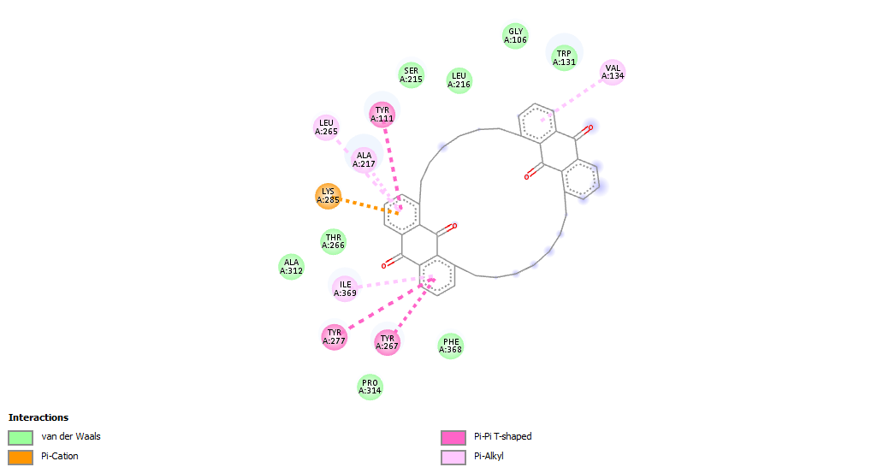

Figure 4.9: 2D structures of interaction between OL-1 and P. falciparum Enoyl ACP Reductase (PDB ID 2OP0)

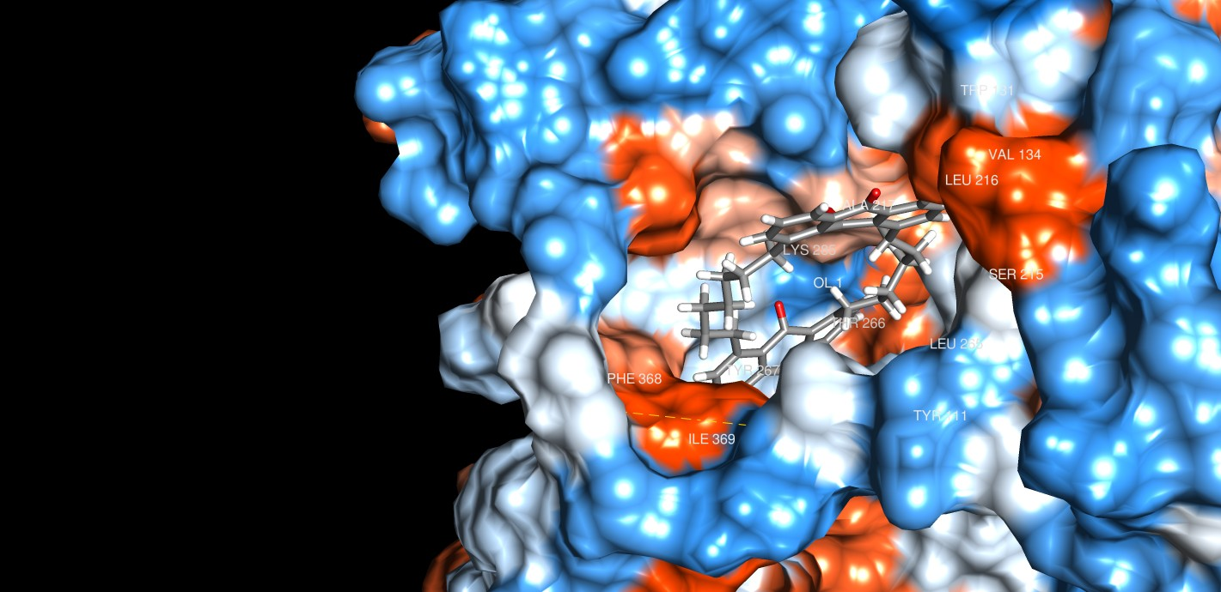
Figure 4.10: 3D structure of OL-1 interaction with P. falciparum Enoyl ACP Reductase (PDB ID 2OP0)

In Figure 4.11, the binding score of -9.3 could be attributed to five major chemical interactions such as Vander Waals (ALA: 169, THR: 266, LEU: 216 PHE: 3167), conventional hydrogen bonding (ILE: 105), alkyl (ALA: 217, VAL: 134), pi sigma (ALA: 217, VAL: 134) and unfavourable Donor-Donor (TRP: 131) interactions at different amino acid binding pockets or sites. The presence of conventional hydrogen bond interaction and unfavourable donor-donor interaction could also contribute to the high binding score. Compound A-3, a stigmasterol effectively docked in the active binding pocket or sites of alanine, valine, tryptophan and isoleucine in the 2OP0 through bonding interactions with glucosidic hydroxyl group and amino side chain of amino acid via conventional hydrogen bonding. The high binding score and interaction between A-3 and 2OP0 could also be linked to unfavourable exchange of electrons between hydroxyl group on glycoside and nitrogen atom on the heterocyclic ring of tryptophan (Figure 4.11 and 4.12).

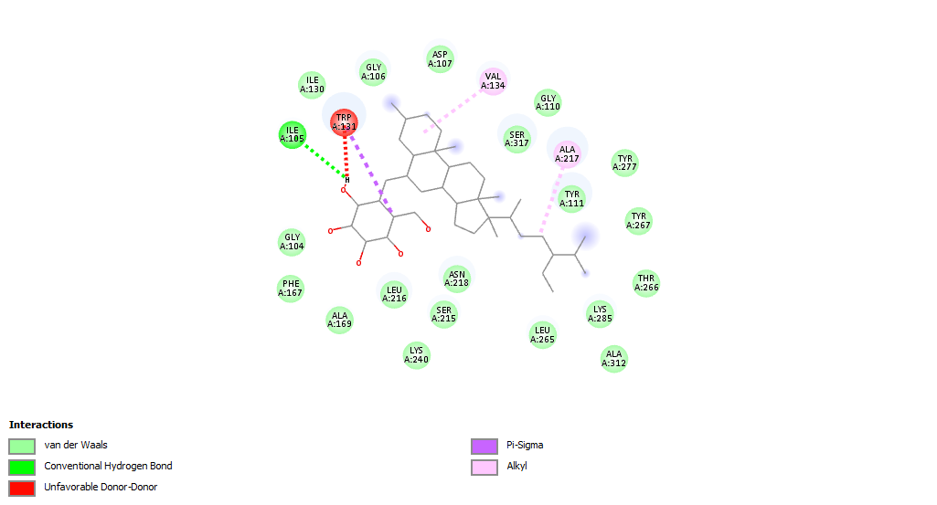

Figure 4.11: 2D structures of interaction between A-3 and P. falciparum Enoyl ACP Reductase (PDB ID 2OP0)

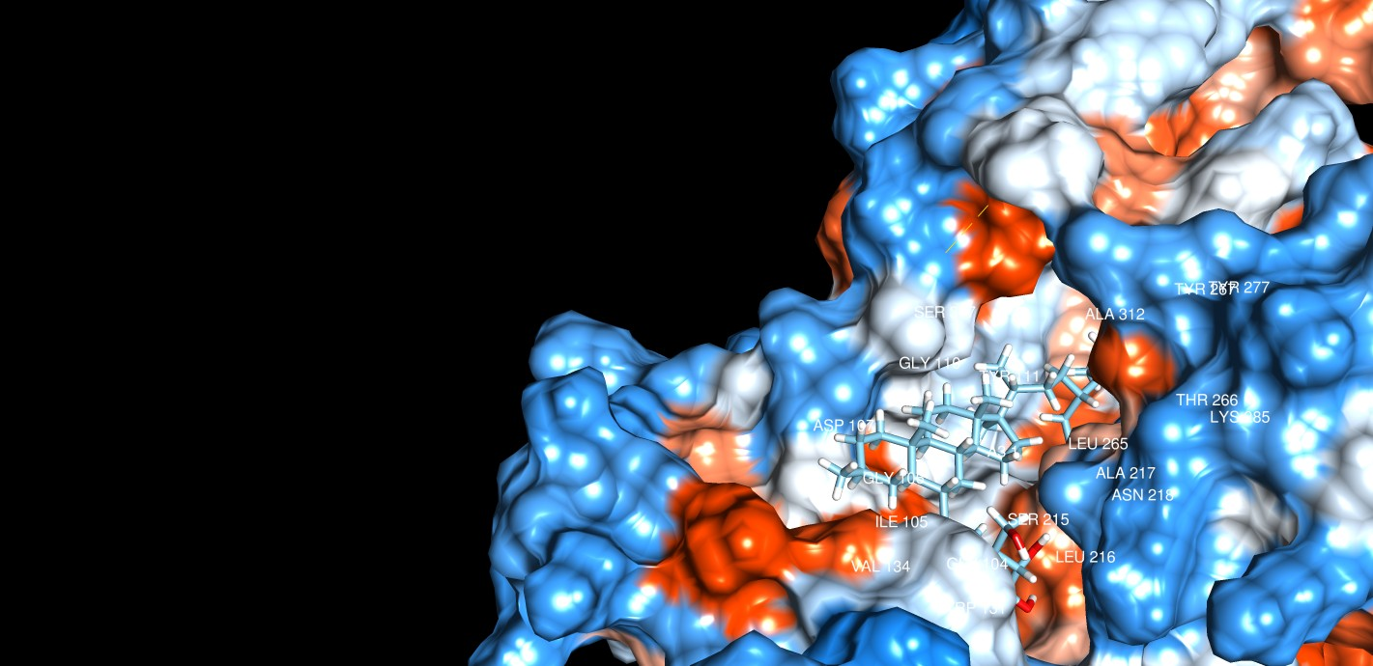
Figure 4.12: 3D structure of A-3 interaction with P. falciparum Enoyl ACP Reductase (PDB ID 2OP0)

In Figure 4.13, the high binding affinity or score in ligand-protein complex (2719-2OP0) could be linked to the interactions such as Vander Waals (ASP:168), conventional hydrogen bond (PHE:167, SER:215), carbon-hydrogen bond (SER:170), unfavourable donor-donor (ALA:169), pi-pi stacked (TRP:131), alkyl (LEU:216) and pi-Alkyl (LYS:240) interactions at different binding pockets or sites of 2OP0. Similar interactions such as unfavourable donor-donor, conventional hydrogen bond, alkyl and Vander Waals were assayed in A-3 complex with 2OP0 (Figure 4.13 and 4.14).

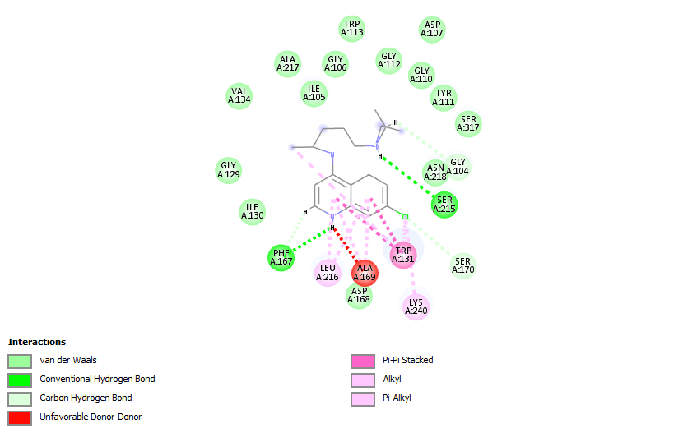
Figure 4.13: 2D structures of interaction between chloroquine (2719) and P. falciparum Enoyl ACP Reductase (PDB ID 2OP0)

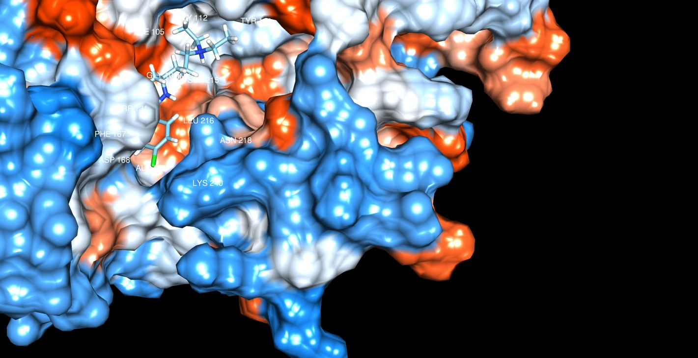
Figure 4.14: 3D structure of 2719 interaction with P. falciparum Enoyl ACP Reductase (PDB ID 2OP0)

In Figure 4.15, the high binding energy score (-7.3) when ligand 3-Chloro-2-oxo-3-(2-phenylphenyl)propanamide (163209274) complex with 2OP0 could be linked to some interactions such as Vander Waals (GLY:129, ILE:130, ALA:217, ASP:168), conventional hydrogen bond (PHE:167, ALA:169), carbon-hydrogen bond (TRP:131), pi-pi stacked (LEU:216) and pi-alkyl (LYS:240) at different amino acid binding pockets. The high binding score of 163209274 could be linked to the conventional hydrogen bonding between halogenated atom (chlorine) in the structural moiety of 3-Chloro-2-oxo-3-(2-phenylphenyl)propanamide and binding pockets of amino acid residues in 2OP0. One of the phenyl rings in the ligand (163209274) undergo C-H bond and pi-alkyl interaction. The hydrogen bond between ALA (169) and carbonyl oxygen on the ligand, and also, the binding between nitrogen atom on the amino acid residue with the hydrogen atom on the amine of the ligand at PHE (169) could be linked to the binding energy score of the complex 163209274-2OP0 (Figure 4.15 and 4.16).

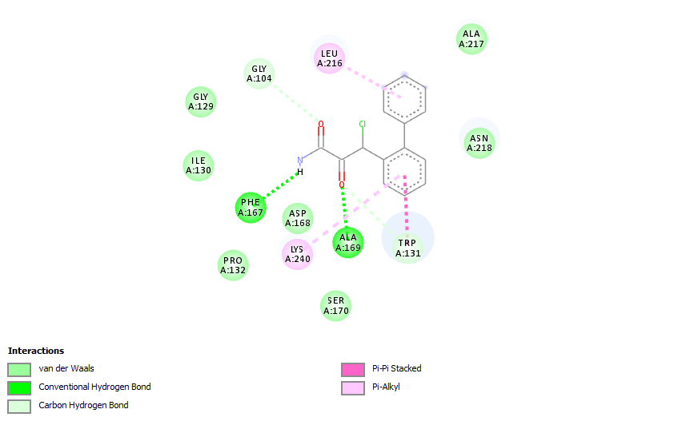 Figure 4.15: 2D structures of interaction between 3-Chloro-2-oxo-3-(2-phenylphenyl)propanamide (163209274) and P. falciparum Enoyl ACP Reductase (PDB ID 2OP0)
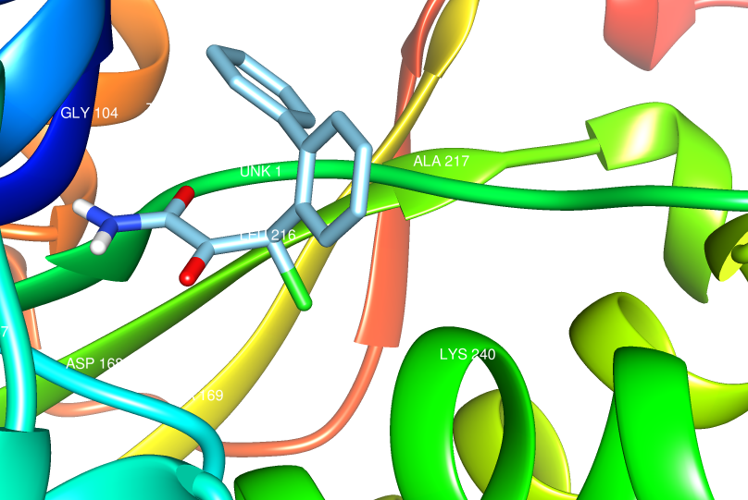
Figure 4.16: 3D network of 3-Chloro-2-oxo-3-(2-phenylphenyl)propanamide interaction with P. falciparum Enoyl ACP Reductase (PDB ID 2OP0)

In Figure 4.17, the high binding energy score (-8.1) when artemether (68911) complex with 2OP0 could be linked to some interactions such as conventional hydrogen bonding (LYS:285), PI-Akyl (TYR:267, TYR:277) and Vander Waals (ALA:217, LEU:265, TYR:111, VAL:222, ILE:369, PRO:314) at different amino acid binding pockets. The high binding score could be linked to strong hydrogen bonding between hydrogen atom in 68911 and nitrogen atom on lysine (LYS) at binding site of 285 (Figure 4.17 and 4.18)

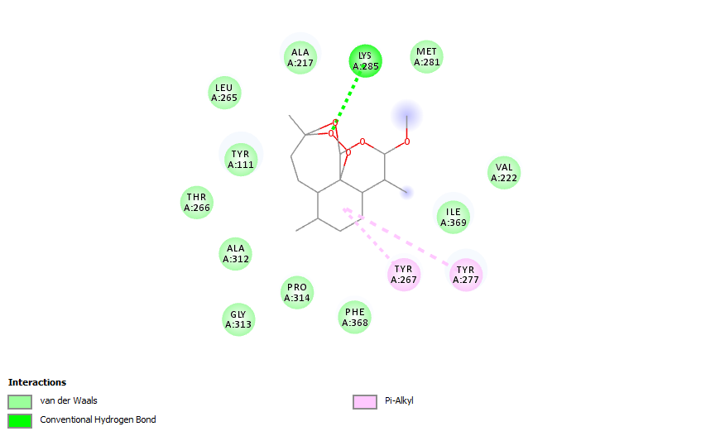
Figure 4.17: 2D structures of interaction between Artemether (68911) and P. falciparum Enoyl ACP Reductase (PDB ID 2OP0)
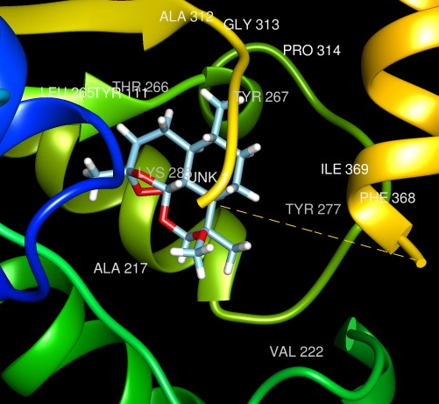
Figure 4.18: 3D network of Artemether (68911) and P. falciparum Enoyl ACP Reductase (PDB ID 2OP0)

In Figure 4.19, the binding score of -7.4 could be attributed to five major chemical interactions such as Vander Waals (ALA: 312, THR: 216, PHE: 167, PRO:314), conventional hydrogen bonding (ALA:217), alkyl (ALA: 169, LEU:265, THR:267, LEU:216), pi sigma (THR:131) and pi-alkyl (ALA: 169, LEU:265, THR:267, LEU:216) and carbon-hydrogen bond (THR:111, TRP:131) interactions at different amino acid binding pockets or sites. The presence of conventional hydrogen bond interaction could also contribute to the high binding score. The high binding score and interaction between 6423518 and compound A1B1 against 2OP0 could also be linked to alkyl and pi-alkyl linkages between the ligand and amino acid residues pocket sides (Figure 4.19- 4.22).
The summary of calculated binding energy scores, types of interaction and amino acid residues involved in the interaction were assayed in Table 4.18.

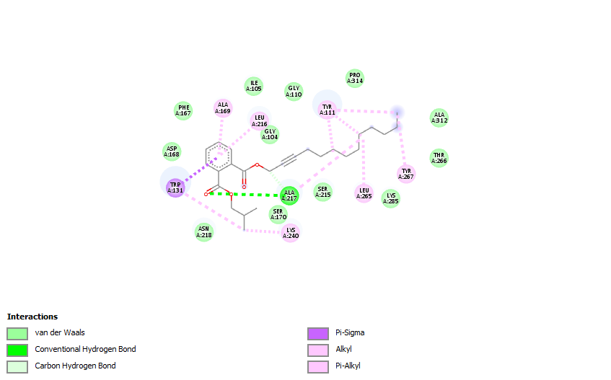Figure 4.19: 2D structures of interaction between Phthalic acid, isobutyl tridec-2-yn-1-yl ester (6423518) and P. falciparum Enoyl ACP Reductase (PDB ID 2OP0)
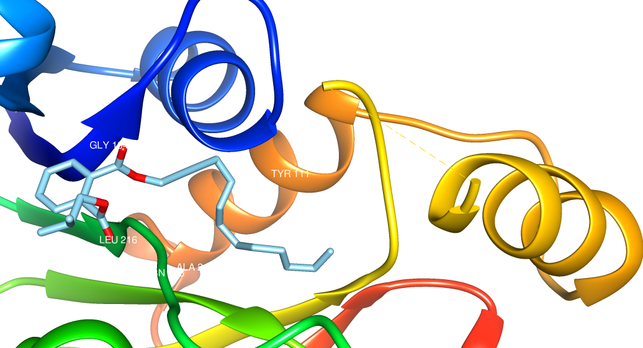
Figure 4.20: 3D network of Phthalic acid, isobutyl tridec-2-yn-1-yl ester (6423518) and P. falciparum Enoyl ACP Reductase (PDB ID 2OP0)

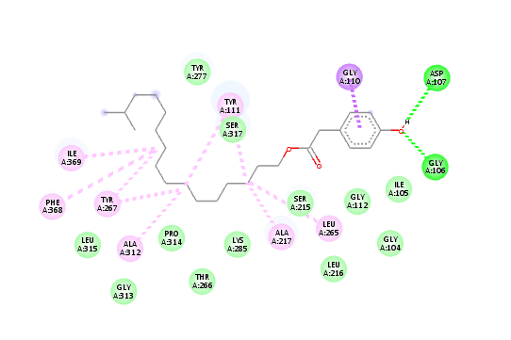

Figure 4.21: 2D structures of interaction between A1B1 and P. falciparum Enoyl ACP Reductase (PDB ID 2OP0)

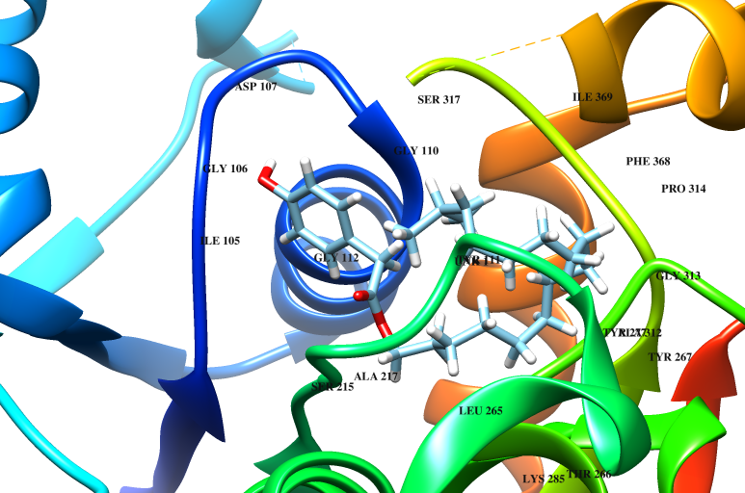
Figure 4.22: 3D network of A1B1 and P. falciparum Enoyl ACP Reductase (PDB ID 2OP0)

Table 4.18. Calculated binding affinity, types of interaction and amino acid residues involved in the interaction.
Compound (Ligands) | Binding Affinity  (kcal/mol) | Types of Non-bonding interaction involved (Residues involved in the interactions)
OL-1 | -12.4 | Vander Waals (ALA: 312, THR: 266, PRO: 314, PHE: 368), Pi-cations electrostatic (LYS: 285),  Pi-pi T-shaped (TYR: 111, 267, 277)  Pi-Alkyl (LEU: 265, ILE: 369, VAL: 134, ALA: 217)
A-3 | -9.3 | Vander Waals (ALA: 169, THR: 266, LEU: 216 PHE: 3167), Conventional hydrogen bonding (ILE: 105),  Alkyl (ALA: 217, VAL: 134),  Pi sigma (ALA: 217, VAL: 134)  Unfavourable Donor-Donor (TRP: 131)
2719 | -7.3 | Vander Waals (GLY: 129, VAL: 134, TYR: 111, TRP: 113),  Conventional hydrogen bonding (SER: 215, PHE: 127)  Carbon-hydrogen bond (ASP: 168, SER: 170),  Unfavourable donor-donor (ALA: 169),  Pi-pi stacked (TRP: 131),  Alkyl (LYS: 240, LEU: 216)  Pi-Alkyl (LYS: 240, LEU: 216)
163209274 | -7.3 | Vander Waals (GLY: 129, PRO: 132, SER: 170, ASP: 168),  Conventional hydrogen bonding (ALA: 169, PHE: 167)  Carbon-hydrogen bond (ASN: 218, ALA: 217),  Pi-Alkyl (LYS: 240)  Pi-Pi stacked (LEU: 216)
68911 | -8.1 | Vander Waals (ALA: 312, GLY: 313, VAL: 222, THR: 266, ILE: 369),  Conventional hydrogen bonding (LYS: 285)  Pi-Alkyl (TYR: 267, TYR: 277)
6423518 | -7.4 | Vander Waals (GLY: 104, PHE: 167, SER: 215, ASP: 168),  Conventional hydrogen bonding (ALA: 217)  Carbon-hydrogen bond (ASN: 217, SER: 170; LYS: 215),  Pi-sigma (TRP: 131),  Alkyl (ALA: 169, LEU: 216, LYS: 240)  Pi-Alkyl (LYS: 240, LEU: 265)

The correctness of docking geometry of ligands from its reference position in the 2OP0 was estimated using the Root Mean Square Deviation (RMSD) after the optimal superimposition of the receptor molecules. The correctness of distance (orientation) between atoms rmsd/lb (RMSD lower bound) and how atoms matched in one conformation to their orientation in another (rmsd/ub (RMSD upper bound) were presented in Table 4.17. Some of the ligands such as OL-1, A-3, 2719, 68911 and 6423518 with high docking scores have low RMSD values of approximately 0.00, except in 163209274 (-7.3) with 4.524 and 2.931 for high and low RMSD values respectively. The higher the RMSD, the more deviation between the ligands and P. falciparum Enoyl ACP Reductase. The high RMSD values recorded in ligands 548183 (-3.0) and 6213 (-3.0) could be responsible for low binding scores or affinity.
4.6.2 Molecular docking calculations against Plasmodium falciparum thymidylate kinase (2YOG).
About nineteen ligands (Table 4.16), two isolated compounds (OL-1 and A-3), artemether and chloroquine were docked against Plasmodium falciparum thymidylate kinase with PDB ID 2yog for investigating the non-bonding interactions and binding affinity between the studied complexes. The prediction of binding modes of selected ligands or Secondary metabolites with P. falciparum thymidylate kinase in complex with a (thio)urea- alpha-deoxythymidine inhibitor, root mean square deviation, rmsd/lb (RMSD lower bound) and rmsd/ub (RMSD upper bound), are presented in Table 4.19. During docking, ligands undergo either hydrophobic interactions or hydrogen bonding with active site residues of receptor (protease) that influences the affinity or linkages of ligand(s) with receptor.

Table 4.19: Binding scores or scoring functions of selected ligands against 2YOG
Ligand | Binding Affinity | rmsd/ub | rmsd/lb
2YOG__Prep3_11000 | -3.6 | 0 | 0
2YOG__Prep3_1140 | -3.6 | 0 | 0
2YOG__Prep3_A1B1 | -4.7 | 0 | 0
2YOG__Prep3_136442 | -3.2 | 0 | 0
2YOG__Prep3_138724 | -3.2 | 0 | 0
2YOG__Prep3_163209274 | -5.4 | 0 | 0
2YOG__Prep3_16554 | -4.3 | 0 | 0
2YOG__Prep3_21204 | -3.8 | 0 | 0
2YOG__Prep3_22210 | -3.3 | 0 | 0
2YOG__Prep3_2719 | -3.7 | 0 | 0
2YOG__Prep3_27970 | -3 | 0 | 0
2YOG__Prep3_548182 | -2.7 | 0 | 0
2YOG__Prep3_548183 | -3.2 | 0 | 0
2YOG__Prep3_548263 | -2.9 | 0 | 0
2YOG__Prep3_551303 | -3.7 | 0 | 0
2YOG__Prep3_6213 | -2.9 | 0 | 0
2YOG__Prep3_637930 | -3.3 | 0 | 0
2YOG__Prep3_6423518 | -4.3 | 0 | 0
2YOG__Prep3_68911 | -5.1 | 0 | 0
2YOG__Prep3_7004977 | -4.5 | 0 | 0
2YOG__Prep3_91751399 | -3.8 | 0 | 0
2YOG__Prep3_A3 | -5.2 | 0 | 0
2YOG__Prep3_OL | -6.7 | 0 | 0

The binding energy or scores assayed from the interaction between selected ligands (Table 4.16) and Plasmodium falciparum thymidylate kinase (2YOG) range from -6.7 to -2.7. A strong interaction or binding affinity was assayed in OL-1 and 163209274 with binding scores of -6.7 and -5.4 respectively. Other notable interactions with high binding scores include 68911 (-5.1), 6423518 (-4.3), and A3 (both -5.2), 7004977 (-4.5) and 16554 (-4.3). Similarly, about eighteen ligands have binding scores below -4.5. Out of the docked Secondary metabolites, five Secondary metabolites have binding scores higher than -4.5 indicating the strong affinity between the 2YOG and Secondary metabolites. The major interactions or binding linkages between the Secondary metabolites and amino acid residues binding pockets on the protein (2YOG) are presented using the 2D and spatial representation (3D) (Figure 4.23 to 4.32). The high binding affinity or score in ligand-protein complex (OL-1-2YOG) could be linked to the interactions such as Vander Waals, pi-cations electrostatic, pi-pi T-shaped and Pi-Alkyl at different binding pockets or sites. Compound OL-1, a bianthraquinone successfully docked in the active sites of tyrosine, alanine, valine and leucine in the 2YOG through bonding interactions with pi-electrons in the two phenyl rings of each anthraquinone unit. In Figure 4.23, the binding score of -6.7 could be attributed to four major chemical interactions such as Vander Waals (PRO: 139, ARG:182, LYS: 183), conventional hydrogen bonding (ASN:140), Pi-Alkyl (ARG:18) and pi sigma (ILE:184, VAL: 137) interactions at different amino acid binding pockets or sites. The presence of conventional hydrogen bond interaction and unfavourable donor-donor interaction could also contribute to the high binding score. Compound OL-1, effectively docked in the active binding pocket or sites of alanine, valine, tryptophan and isoleucine in the 2YOG through bonding interactions with glucosidic hydroxyl group and amino side chain of amino acid via conventional hydrogen bonding (Figure 4.23 and 4.24).

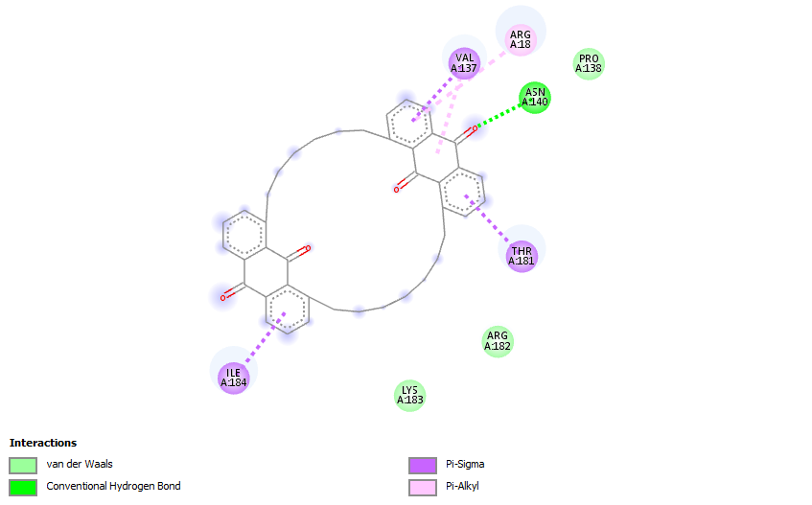
Figure 4.23: 2D structures of interaction between OL-1 and Plasmodium falciparum thymidylate kinase (PDB ID 2YOG)

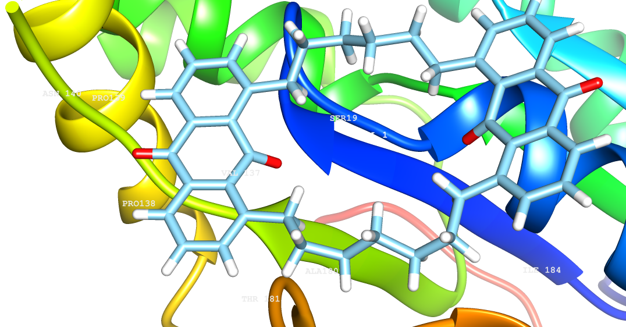
Figure 4.24: 3D network between OL-1 and Plasmodium falciparum thymidylate kinase (PDB ID 2YOG)

In Figure 4.25, the binding score of -5.2 could be attributed to three major chemical interactions such as Vander Waals (VAL:137, THR:23, SER:22, ILE:184, GLY:20), conventional hydrogen bonding (ASP:17, LYS:21) and unfavourable Donor-Donor (ARG:99) interactions at different amino acid binding pockets or sites (Figure 4.25 and 4.26).

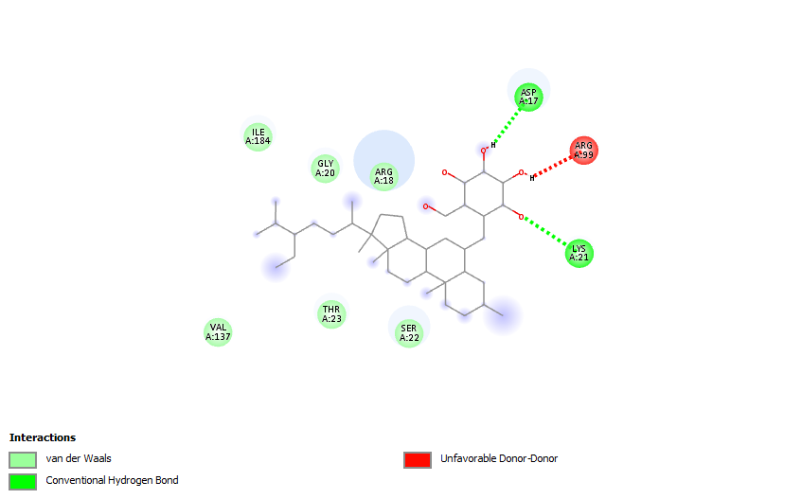
Figure 4.25: 2D structures of interaction between A-3 and Plasmodium falciparum thymidylate kinase (PDB ID 2YOG)
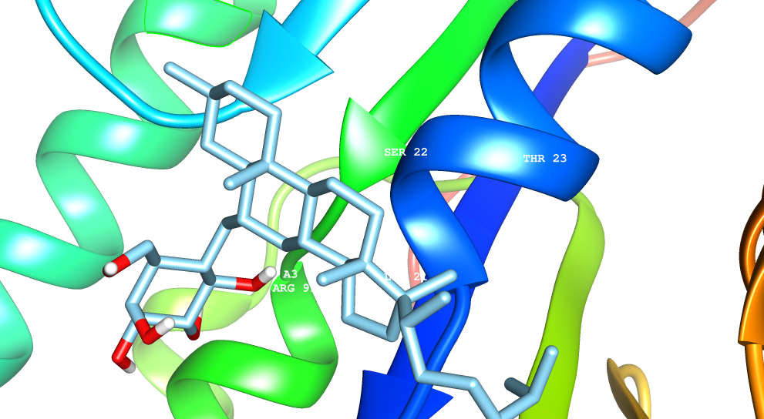
Figure 4.26: 3D network between A-3 and Plasmodium falciparum thymidylate kinase (PDB ID 2YOG)

In Figure 4.27, the binding score of -5.1 could be attributed to four major chemical interactions such as Vander Waals (THT:23, ARG:182, LYS: 183), conventional hydrogen bonding (ARG:18, ILE:187, ILE:184, VAL:134), Carbon Hydrogen (ARG:182) and Alkyl (ILE:184, ILE:187, VAL: 137) interactions at different amino acid binding pockets or sites. The presence of conventional hydrogen bond interaction could also contribute to the high binding score. Compound 68911 effectively docked in the active binding pocket or sites of valine, arginine and isoleucine in the 2YOG through bonding interactions with glucosidic hydroxyl group and amino side chain of amino acid via conventional hydrogen bonding (Figure 4.27 and 4.28).

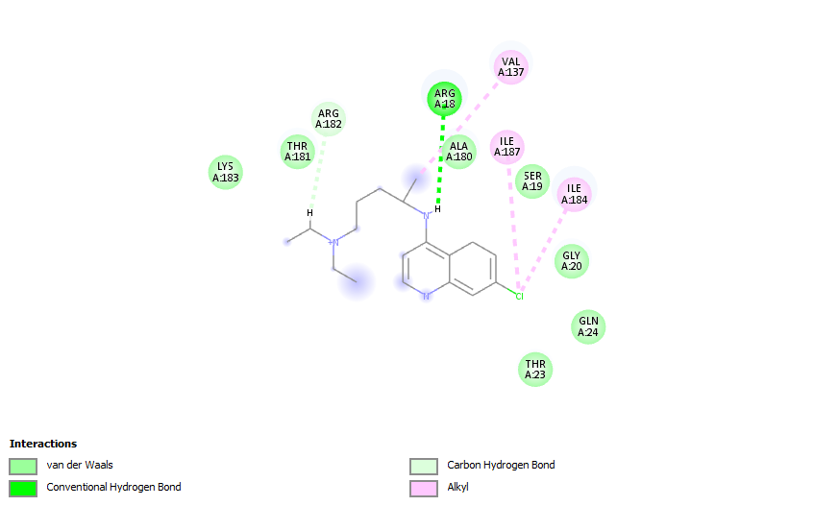
Figure 4.27: 2D structures of interaction between 68911 and Plasmodium falciparum thymidylate kinase (PDB ID 2YOG)
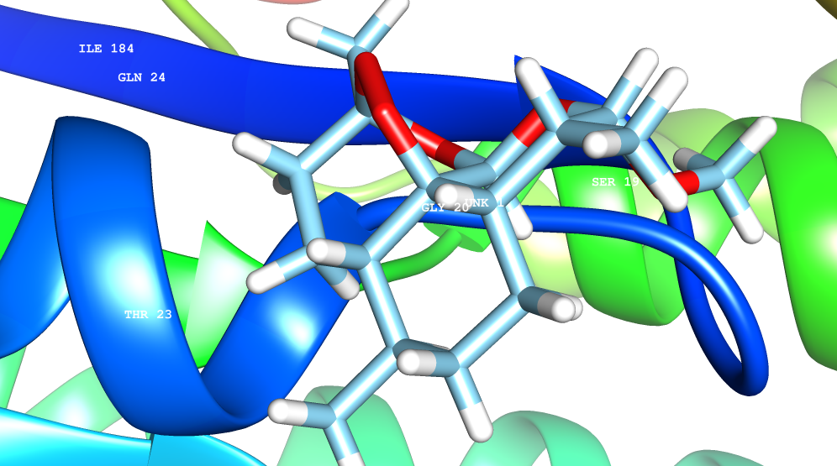
Figure 4.28: 3D network between 68911 and Plasmodium falciparum thymidylate kinase (PDB ID 2YOG)

In Figure 4.29, the binding score of -5.4 could be attributed to three major chemical interactions such as Vander Waals (ILE:187, ALA:180, SER:19, THR:181, GLY:20), conventional hydrogen bonding (ARG:18, THR:23) and Pi-Alkyl (VAL:137, ILE:184) interactions at different amino acid binding pockets or sites. The presence of conventional hydrogen bond interaction and unfavourable donor-donor interaction could also contribute to the high binding score. Compound 163209274 effectively docked in the active binding pocket or sites of alanine, valine, tryptophan and isoleucine in the 2YOG through bonding interactions with glucosidic hydroxyl group and amino side chain of amino acid via conventional hydrogen bonding (Figure 4.29 and 4.30).

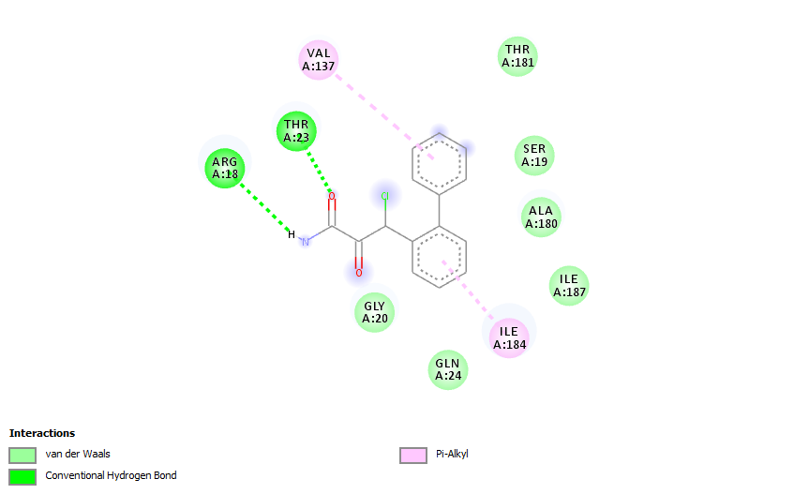
Figure 4.29: 2D structures of interaction between 163209274 and Plasmodium falciparum thymidylate kinase (PDB ID 2OP0)
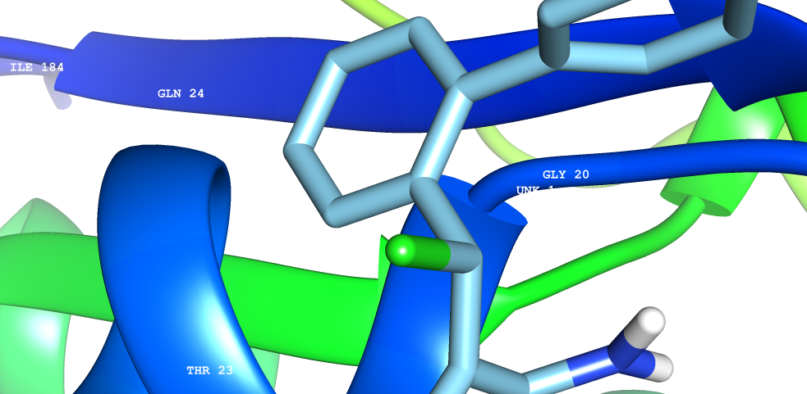
Figure 4.30: 3D network between 163209274 and Plasmodium falciparum thymidylate kinase (PDB ID 2YOG)

In Figure 4.31, the binding score of -4.3 could be attributed to four major chemical interactions such as Vander Waals (ARG:182, ILE:187, GLN:24, THR:23, SER:19), conventional hydrogen bonding (ASN:140), Pi-Alkyl (ARG:18, VAL:137) and Alkyl (ILE:184) interactions at different amino acid binding pockets or sites. The presence of conventional hydrogen bond interaction and unfavourable donor-donor interaction could also contribute to the high binding score. Compound 6423518 effectively docked in the active binding pocket or sites of alanine, valine, tryptophan and isoleucine in the 2YOG through bonding interactions with glucosidic hydroxyl group and amino side chain of amino acid via conventional hydrogen bonding (Figure 4.32). The binding interactions between compound A1B1 against 2YOG is given in Figure 33.

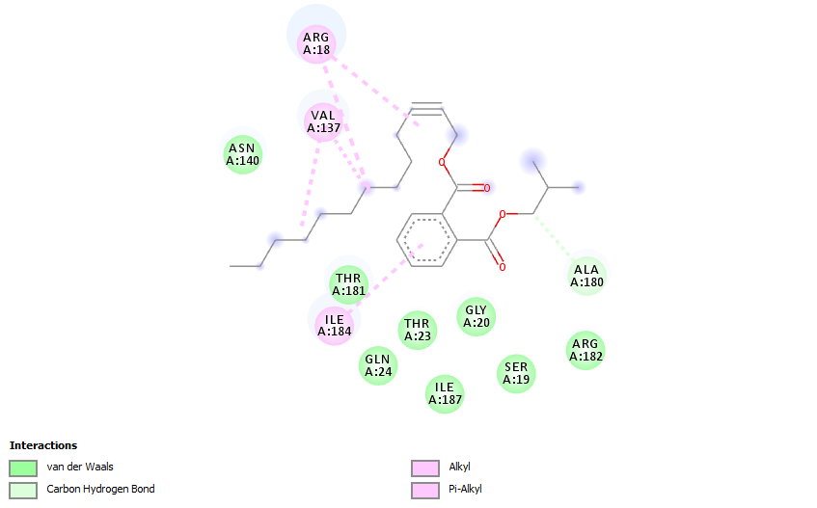
Figure 4.31: 2D structures of interaction between 6423518 and Plasmodium falciparum thymidylate kinase (PDB ID 2YOG)
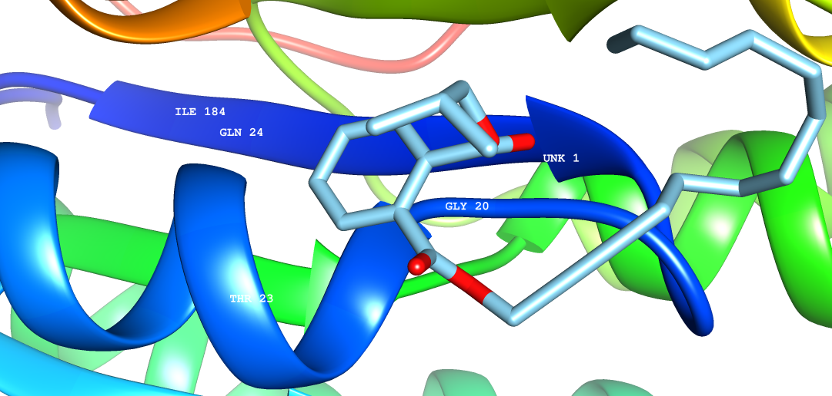

Fig. 4.32: 3D network between 163209274 and Plasmodium falciparum thymidylate kinase (PDB ID 2YOG)

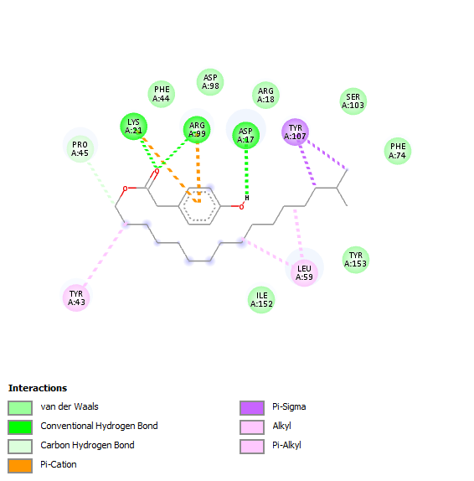
Figure 4.33: 2D structures of interaction between AIBI and Plasmodium falciparum thymidylate kinase (PDB ID 2YOG)

The summary of calculated binding energy scores, types of interaction and amino acid residues involved in the interaction were assayed in Table 4.20.
Table 4.20. Calculated binding affinity, types of interaction and amino acid residues involved in the interaction.
Compound (Ligands) | Binding Affinity  (kcal/mol) | Types of Non-bonding interaction involved (Residues involved in the interactions)
OL-1 | -6.7 | Vander Waals (ARG: 182, LYS: 183, PRO: 138),  Conventional hydrogen bonding (ASN: 140),  Pi-sigma (ILE: 184, VAL: 137)  Pi-Alkyl (ALG: 18)
A-3 | -5.2 | Vander Waals (ILE: 184, GLY: 20, ARG: 18, VAL: 137),  Conventional hydrogen bonding (ASP: 17, LYS: 21),  Unfavourable Donor-Donor (ARG: 99)
2719 | -3.7 | Vander Waals (LYS: 183, THR: 181, ALA: 180, SER: 18, GLY: 20),  Conventional hydrogen bonding (ARG: 18)  Alkyl (VAL: 137, ILE: 184, ILE: 187)  Carbon-Hydrogen bond (ARG: 182)
163209274 | -5.4 | Vander Waals (GLY: 20, GLN: 24, SER: 19, ALA: 180, ILE: 187),  Conventional hydrogen bonding (ARG: 18, THR: 23)  Pi-Alkyl (VAL: 137, ILE: 184)
6423518 | -4.3 | Vander Waals (ASN: 140, THR: 181, GLY: 20, SER: 19, ARG: 182),  Conventional hydrogen bonding (ALA: 180),  Akyl (ILE: 184)  Pi-Alkyl (ARG: 18, VAL: 137)

The correctness of docking geometry of ligands from its reference position in the Plasmodium falciparum thymidylate kinase was estimated using the Root Mean Square Deviation (RMSD) after the optimal superimposition of the receptor molecules. The correctness of orientation between atoms rmsd/lb (RMSD lower bound) and how atoms matched in one conformation to their orientation in another (rmsd/ub (RMSD upper bound) were presented in Table 4.19. According to Table 4.23, all selected ligands such as OL-1, A-3, 2719, 163209274, 68911 and 6423518 with high docking scores have low RMSD values of approximately 0.00. The higher the RMSD, the more deviation between the ligands and P. falciparum Enoyl ACP Reductase. The high RMSD values recorded in ligands OL-1 and 163209274 could be responsible for low binding scores or affinity.
According to the docking scores, selected ligands have high docking scores against 2OP0 compared to that obtained in 2YOG (Table 4.21). Ligand OL has good docking scores against both proteins followed by scores obtained by A3. Surprisingly, the isolated compounds exhibited better scores compared to chloroquine (2719) and artemether (68911) (Fig 4.31).

Table 4.21: Comparison between docking scores of 2YOG and 2OP0
 | 2YOG | 2OP0
Ligand | Binding Affinity
11000 | -3.6 | -5
1140 | -3.6 | -5.1
138724 | -3.2 | -4.8
163209274 | -5.4 | -7.3
16554 | -4.3 | -6.3
22210 | -3.3 | -5
2719 | -3.7 | -7.3
551303 | -3.7 | -5.3
6423518 | -4.3 | -7.4
68911 | -5.1 | -8.1
7004977 | -4.5 | -6.5
91751399 | -3.8 | -5.6
A3 | -5.2 | -9.3
OL | -6.7 | -12.4
A1B1 | -4.7 | -6.5

Fig 4.34: Secondary metabolites with significant in silico antiplasmodial potentials against the selected proteases (2YOG and 2OP0).

The ligands with outstanding binding scores against the selected proteases are presented in Figure 4.34. The ligands belong to the glycosides, esters, anthraquinone, amide and alcohols or alkanols with characteristic functional groups such as hydroxyl, carbonyl (ketone and esters), carbon-carbon and carbon-hydrogen. All the ligands possess five and six membered cyclic hydrocarbon chains.

CHAPTER FIVE
5.0 DISCUSSION
5.1 Secondary metabolites in M. lucida and L. dulcis
The qualitative phytochemical screening of solvent extracts of the leaves and stem-bark of L. dulcis and M. lucida led to the identification of certain classes of secondary metabolites of biological significance. Generally, plant secondary metabolites have been reported to immensely contribute to the pharmacological or therapeutic effects exhibited by different parts of the plants (Oladeji et al., 2019). The phytochemical screening results obtained in this study is in conformity with the phytochemical screenings of aqueous extract of M. lucida leaf reported by Anifowoshe et al., (2019) (Table 4.1). Their results showed that steroids and alkaloids were undetected in the aqueous extract, in contrast to the present study which detected alkaloids. This contrast could be as a result of the different extraction approaches. Secondary metabolites such as saponins, terpenoids, steroids, phenol and flavonoids were detected while tannins was undetected in crude peptide extract of ML leaf which is similar to the results obtained from the phytochemical screenings in this study (Adebayo et al., 2017). The phytochemical profile of ML leaves is in agreement with the reports of Addy et al., (2013) and Adomi and Umukoro (2010) noted the presence of saponins, anthraquinones and alkaloids. The presence of secondary metabolites such as alkaloids, steroids, tannins and saponins were detected in the root, bark and leaf of M. lucida (Osuntokun et al., 2016).
Phenolic compounds are extensively distributed Secondary metabolites in most plants and are synthesized via the Shikimic acid and phenylpropanoid pathways (De la Rosa et al., 2019). They have been well-known to exhibit anti-inflammatory, antioxidant, antimicrobial and antiplasmodial properties (Oladeji et al., 2016). The antiplasmodial activity of the roots of Ochna schweinfurthiana was linked to the presence of phenolic compounds (Messi et al., 2016). Several reports have explored and reported the antiplasmodial effects of phenolic compounds. Flavonoids identified as dehydrolupinifolinol, sericetin and lupinifolin isolated from the leaves of Mundulea sericea were potent against drug-sensitive chloroquine-resistant W2 (Chepkirui et al., 2021). Flavonoids are bioactive compounds present in most medicinal plants. Flavonoids are major group of polyphenolic compounds found in plants, and therefore commonly consumed in the human diet. The structural framework of flavonoids is made up of 15-carbon skeleton, with two unique phenyl rings and a heterocyclic ring. The therapeutic properties such as antioxidant, anti-inflammatory, anticancer, antidiabetic, antimicrobial and antiobesity of flavonoids are well documented (Qin et al., 2020). Wairata et al., (2022) reported that the total phenolic and flavonoid contents of solvent extracts of Garcinia forbesii King could be responsible for the antiplasmodial activities exhibited against chloroquine sensitive P. falciparum strain 3D7. Their biological properties depend on the degree of hydroxylation, nature, magnitude of conjugation and pattern of substitution (Kelly et al., 2002). The presence of terpenoids in plant is of high pharmacological significance (Kaur et al., 2009). Terpenoids form the largest group of secondary metabolites (Croteau et al., 2000). These primarily act as deterrents to herbivore. A few of them, such as gibberellic acid, abscisic acid, phytol, and carotenoids, also work in plant growth and metabolism (Croteau et al., 2000). Terpenes such as diterpenes, triterpenes, sesquiterpenes and miscellaneous terpenes have exhibited strong antiplasmodial properties against established or early Plasmodium infections (Kaur et al., 2009).
The presence of alkaloids in EtLDB, EtMLB, EtLDL and EtMLL could be responsible for the marked antiplasmodial properties exhibited by these extracts. Among the natural products, alkaloids represent a remarkable class of compounds with pronounced antiplasmodial properties (Frederich et al., 2008). Till date, studies have revealed that alkaloids are active substances via in vitro or in vivo analyses in the micromolar assortment and have good selectivity index. Alkaloids are the main secondary metabolites that were primarily unearthed and have been in use as early as 4000 years ago. They are and highly documented for their various therapeutic potential (Amirkia and Heinrich, 2014).
Alkaloids have a wide range of pharmacological activities including antimalarial (quinine), analgesic (morphine), anticancer (homoharringtonine), antibacterial (chelerythrine), cholinomimetic (galantamine), antiarrhythmic (quinidine), antiasthma (ephedrine) and antihyperglycemic (piperine) activities which serve as basic reference for the development of drugs (Kittakoop et al., 2014; Russo et al., 2013; Raymond et al., 2010; Cushole et al., 2014). Several antiplasmodial alkaloids have been classified based on their heterocyclic ring system and biosynthetic precursor. They are classified into various categories, viz. purine, indole, isoquinoline, quinoline, imidazole and tropane (Roy, 2017). The aphrodisiac properties of L. dulcis could be linked to the presence of steroidal compounds in the leaves and stem-bark. Steroids possess a wide range of prospective anticancer, antiplasmodial and anti-inflammatory potentials which have been identified as new microtubule-stabilizing and life-saving agents (Peng et al., 2011; Tinley et al., 2003). The antiplasmodial activity of some steroids such as stigmast-4-en-3-one, Fusidic acid, 6-hydroxystigmast-4-en-3-one, exemestane, dutasteride and 3-hydroxystigmast-5-en-7-one are documented (Indriani et al., 2020; Pavadi et al., 2017). Other important Secondary metabolites in M. lucida and L. dulcis include tannins, saponins and phenols. These compounds are linked to diverse pharmacological applications or therapeutic potency of the plants. This results of the present study shows that the under-utilized L. dulcis and M. lucida possess some secondary metabolites that could be studied for the development (or synthesis) of novel antiplasmodial, antidiabetic, antiflammatory and aphrodisiac drugs.
The hybridization of two or more phytochemical compounds entails covalent linking of two pharmacophores or active substances to form compounds with outstanding therapeutic potential. Although, a single hybrid molecule such as alkaloid, tannin, saponins, flavonoid may reacts independently to exhibit dual mode of action (Gupta et al., 2019). The activities exhibited by solvent extracts of L. dulcis and M. lucida bark and leaf extracts could be linked to the mode of action or mechanism described above.
5.2 Antiplasmodial Assay
The antiplasmodial activities of leaves and bark extracts of L. dulcis and M. lucida were tested against the P. berghei infected mice and the body weight, PCV, level of parasitaemia and percentage inhibitory activity were estimated. The antiplasmodial screenings of the studied plants showed a dose dependent antiplasmodial efficacy which agree with antiplasmodial screenings of medicinal plants (Nureye et al., 2021; Tadege et al., 2022). Similarly, this study present the antiplasmodial screenings of known antiplasmodial plants (M. lucida) and underexplored antiplasmodial plant (L. dulcis). The bite of infected female Anopheles mosquito on erythrocytic levels in humans a huge concern. At this point, Plasmodium strains causes a broad modification in the host red blood cells (RBCs) and could lead to cell rupturing. Other effects include increase adhesiveness, stringency of the membrane, loss of typical discoid shape of blood cells and increased permeability to a wide range of ions and other species. This lowers the amount of RBCs which could lead to anemia (Fowkes et al., 2008; Kotepui et al., 2015). The CQ treated groups exhibited a strong increase in RBCs in parasitized mice, with an increase of 3.60% (42.80 ± 1.6432 to 46.40 ± 0.5477%) while infected untreated group demonstrated a strong decline in erythrocytic level in their blood serum with a sharp reduction of -0.66% (44.33 ± 2.3094 to 43.67 ± 3.7859%). The result of this agree with the report of Afolabi and Abejide, (2020). They reported that 400 mg/kg of ethanolic M. lucida leaves extract treated group showed a significant increase in red blood cell counts compared to the untreated group. Although, the activity shown by the extract is higher than what was observed in the CQ treated group, which is not in agreement with this study. The significant reduction in the percentage of PCV in all extracts treated groups could be due to the antiplasmodial activities of the crude extracts which only suppressed the parasites and not potent to totally cleared the erythrocytic stage of the parasite after four days of treatment. Hence, the recurrence of the Plasmodium parasites and subsequent destruction of the red blood cells leading to a notable reduction in PCV values after 4 days post infection (Afolabi and Abejide, 2020).
The antiplasmodial results reported by Ejembi and Sanni, (2012) is quite higher than the results of this study. They reported that ethanolic leaves extracts of M. lucida increased PCV level by 5% while combinations of M. lucida and A. indica leaves gave 29% increment. The increase in percentage PCV could be due to synergic effects of active Secondary metabolites in the two plant extracts. Although, they did not disclose or give detailed report on the phytochemical responsible for the marked activities. The reduction in PCV of untreated groups and increase in PCV of CQ treated group of this study agrees with that of Idih et al., (2017). It was also reported that there was a significant increase in PCV of ethanolic extract treated group. The in vivo antiplasmodial screenings of medicinal plants is viewed as a framework for scientific research in unearthing new antimalarial drugs. One of the factors of utmost important is to search for new pharmacophores with great inhibitory effects against Plasmodium strains or have effects on parasitaemia level in parasitized organisms. The findings of this study revealed that crude extracts of L. dulcis and M. lucida (HMLL, HMLB, HLDL, HLDB, EMLL, EMLB, ELDL, ELDB, EtMLL, EtMLB, EtLDL and EtLDB) were able to reduce or inhibit the growth of parasitaemia after four-day post treatment periods. The Plasmodium infest red blood serum, thereby creating high level of parasitaemia (infected blood cells) in human body (Oladeji et al., 2020). The percentage parasitaemia gives a comprehensive description on the level of parasitic infection in the host blood, which is calculated by the number of infected RBCs compared to that of normal RBCs. The surge in percentage parasitaemia in infected untreated mice is in agreement with the reports of Adewole et al., (2017), Adepiti et al., (2016) and Adewole et al., (2018). The low inhibitory activities reported in available literatures in some of the plant extracts could be due to the dose concentration used, level of parasitaemia or resistance build-up by the chloroquine sensitive Plasmodium strains against the extracts. The noteworthy antiplasmodial activities exhibited by leaves extracts of M. lucida could be due to the presence of saponins, alkaloids, flavonoid, phytate, oxalate, glycosides, tannin and terpenoids (Ugbeni and Osubor, 2017). Similarly, partially purified cysteine-stabilised peptide extract of M. lucida leaves moderately reduced parasitaemia at body weight of 31.25 mg/kg with activity of 51.52%. This activity is lower than the inhibitory activities reported in this study. This could be due to factors such as the low dose concentration, extraction method (percolation) or extraction solvent (DCM: Methanol, 50:50) used (Adebayo et al., 2017). The results of antiplasmodial screenings of this study agree with the report of Kipre et al., (2018). They found that aqueous leaves extract of L. heudelotii exhibited strong inhibitory effects against NF54 and K1 P. falciparum strain (5 ≤ IC50 ≤ 15 µg/mL). They linked the activities to the presence of sterols, polyphenols, alkaloids, flavonoids and polyterpenes in the extracts. A similar report was published by Ezike et al., (2016). They reported that leaves extracts of Landolphia owariensis caused 29–86, 18–95 and 75–96% suppression of parasitaemia in early, established and residual infections stages respectively (Ezike et al., 2016).
The synergic effects of medicinal plants have been viewed as a major framework in enhancing its efficacy. The results of curative potency of leaves and bark extracts of M. lucida note in this study is comparatively higher compared to the activity reported by Adepiti et al., (2013). The combination of freeze-dried extracts of M. lucida, Azadirachta indica, Alstonia boonei and Mangifera indica (MAMA) and amodiaquinne administered in CQ sensitive P. berghei infected mice exhibited a dose-dependent parasitaemia reduction. The percentage reduction at 60, 120 and 240 mg/kg body weight had mean percentage parasitaemia of 11.33, 10.54 and 10.24 % respectively. At concentration of 240 mg/kg, curative potency or effect was not evident. These effects could be enhanced if dose concentration is increased (Adepiti et al., 2013). The results of this study agreed with that of Adepiti et al., (2016). They reported that parasitaemia level in P. berghei ANKA (CQ-resistant)-infected mice in the negative control group increased from 5.3 to 20.9% on day to 7. Also, combination of MAMA (120 mg/kg) showed no curative effect while at 240 mg/kg exhibited parasite clearance of 17.1 to 60.1% on day 3 and 6 (Adepiti et al., 2016).
The results of this study showed that crude extracts of M. lucida and L. dulcis bark and leaves, significantly inhibit the formation of β-haematin, causing >70% inhibition at a high concentration of 400 mg/kg. It is believed that Plasmodium species digest haemoglobin to release haem. This haem is known to be very toxic to Plasmodium species, therefore, this product is converted to hemozoin (safe) by Plasmodium activities. To inhibit the Plasmodium activities, chloroquine and crude extracts tested, inhibited the production of β-haematin. Therefore, this suggests that inhibition of hemozoin formation could be the principal mechanism of action of M. lucida and L. dulcis extracts (Egan et al., 2002; Ginsburg et al., 1999; Adebayo et al., 2017). The bark extract of M. lucida gave parasite clearance of 93.3 ± 0.05% compared to 100% shown by Dihydroartemisinin-piperaquine. This result is in agreement with that obtained for bark extracts of M .lucida in this study (Alaribe et al., 2021). Largely, herbal plants are frequently taken separately or in combinations with other plants instead of pure or isolated compounds. Several chemical interactions between these compounds in crude extract matrix often exert remarkable effects against targeted organisms. The high activity exhibited by crude extracts in this study supports the facts that they contain compounds that could be acting in synergy. According to the findings of Wagner and Ulrich-Merzenich (2009), single compound seldom have the same amount of therapeutic activity as the unpurified or unfractionated extract at same concentrations or doses. This occurrence could be accredited to the heterogeneous nature of crude extracts in comparison to single compounds. Similarly, Rasoanaivo et al., (2011) identified that unpurifed plant extracts could enhance positive pharmacodynamic and/or pharmacokinetic synergies between separate phtoconstituents contributing to their activity at various receptor targets and enhanced the pharmacokinetic profile of the pharmacophore(s) or active compound(s). These enhanced interactions could consist of modulation of adverse effects, reversal of resistance and other complementary mechanisms of action (Rasoanaivo et al., 2011). These occurrences could rationalise the significant activities of CQ compared to its single constituent in curative antiplasmodial assays. Similar studies have also shown that combining different medicinal plants or conventional drugs through herbal formulations could bring about exceptional therapeutic effects (Anagu et al., 2014; Adepiti et al., 2016). However, such herbal combinations could also produce subtractive or antagonistic effect or produce no significant difference, as hitherto reported (Idowu et al., 2014). Our findings indicate that the extracts of M. lucida and L. dulcis possessed antimalarial property and could be useful as treatment or curative agent for malaria.

5.3 Phytochemical Characterization
The GCMS analysis has been shown to be a reliable analytical technique for the determination of phytochemical constituents in plant extracts or fractions (Kaur et al., 2017). The Secondary metabolites presented in Table 4.13 are compounds with wide range of therapeutic properties. One of these compounds, benzoic acid, 2,5-bis(trimethylsiloxy)-, trimethylsilyl ester was reported in ethyl acetate and petroleum ether fractions from crude ethanolic extract of Pericampylus glaucus with peak area of 3.37% (Muhammad et al., 2016). The antifungal and antibacterial activities of this compound have been reported (Suprayitno, 2015). The compound was also identified in garlic (Allium sativum) with an exceptional anti-Bacillus anthracis activity (Kaur et al., 2017). The antimicrobial and antioxidant activities of benzoic acid, 2,5-bis(trimethylsiloxy)-, trimethylsilyl ester identified in Propolis from a Rize Province of Turkey was also reported (Ertürk et al., 2016). This compound was obtained from essential oil extracted from the fruits of Lonicera macckii. It demonstrated strong anticancer, blood sugar reducing and anti-cardiovascular potential (Yang et al., 2018).
The phytochemical constituents of Callistemon viminalis flower gave 1,1-dibutoxybutane (4.2%). The compound gave a strong inhibition against Ralstonia solanacearum, Agrobacterium tumefaciens, Pectobacterium carotovorum and Dickeya spp. (EL-Hefny et al., 2017). Similarly, leaves and leaves-peel of Beta vulgaris exhibited noticeable antiobesity and antioxidant potentials. These activities were linked to the presence of 1,1-dibutoxybutane (Chaturvedi and Gupta, 2021). There is no phytochemical or pharmacological reports on isopropylcarbinol at the time of this study. 1,3,5-Cycloheptatriene was identified as a bioactive compounds of Skimmia anquetlia (methanolic leaf extract). This compound enhanced the antibacterial activity of the crude extract (Nabi et al., 2022). Furthermore, 1,3,5-Cycloheptatriene was also identified as the major phytoconstituent in n-hexane seed extract of Sinapis alba. The strong antioxidant exhibited by the plant extract could be due to the high amount of the compound analysed (Karthika et al., 2014). The compound was also identified in ethanolic extract of Prosopis cineraria pod (Sharma et al., 2021).
3-isopropoxy-1,1,1,7,7,7-hexamethyl-3,5,5-tris(trimethylsiloxy) tetrasiloxane was identified as a major constituent in oil extracted from seed of Crataegus azarolus L. The compound displayed strong antioxidant and antimicrobial activities (Bechkri et al., 2017). Kowti et al., (2020) also reported that identification of 3-isopropoxy-1,1,1,7,7,7-hexamethyl-3,5,5-tris(trimethylsiloxy) tetrasiloxane from the flower of Hibiscus cannabinus and Hibiscus sabdariffa. Similarly, the phytoconstituents was identified in the leaves extract of Schefflera vinosa leaves. The similarity between the results from past studies and that of present study is that the metabolite was reported as a minor constituent (Singh et al., 2021). Tetracosamethyl-cyclododecasiloxane was identified as one of the major constituent in the fruit of Salvadora persica L. The phytoconstituent was found to exhibit strong cytotoxic and antimicrobial activities (Al Bratty et al., 2020). Furthermore, the compound was also identified in n-hexane extract of Amburana cearensis seed (Aguiar et al., 2020), Aegle marmelos leaf extract (Ahmad et al., 2021), essential oils of Trigonella monantha (Esmaeili et al., 2012) and leaves and stem-bark of Grewia lasiocarpa E. Mey. ex Harv. (Akwu et al., 2019).
The presence of siloxanes and sulfinyl justified the antibacterial and antioxidant activities exhibited by different parts of L. dulcis (Wang et al., 2015). According to 4.5.2, the existence of siloxanes in medicinal plants has not been well documented, however, their roles have been broadly reported. They enhances proper growth in plants, stimulates upright growth and favourable exposure to sunlight, and offers resistance to fungal and bacterial attack. The speciﬁc features of siloxanes which influence their therapeutic properties include strong Si-O and Si-C bonds in their structural moiety, free rotation of the chain, and moderately ionic nature of the bond (siloxane). In contact with any surface such as body system, the function is controlled by densely packed methyl groups, which causes low energy and chemically inert surface which is invariably affected by strong Si-C and Si-O bonds. These determine the safety of siloxanes and polysiloxanes in direct contact with the human system (De Buyl, 2001; Mojsiewicz-Pie´nkowska, 2015).
The amide phytoconstituent identified as 3-Chloro-2-oxo-3-(2-phenylphenyl) propanamide could be responsible for the marked antiplasmodial activity exhibited by OL-N. Some pharmacological studies have shown that a number of phytoconstituents containing chloroquine analogs undergo strong intramolecular hydrogen bonding, this interaction tend to enhance their inhibitory activity against multidrug-resistant (MDR) P. falciparum. The antiplasmodial activity could be improved by the addition of alkyl linkers, aromatic substitutions, increasing the intermolecular hydrogen bonding and changing the pKa (Madrid et al., 2006). Despite the promising antiplasmodial structural moiety of 3-Chloro-2-oxo-3-(2-phenylphenyl) propanamide, there are no documented reports of its antiplasmodial activity.
One of the identified phytoconstituent in OL-N, that is, tetradecamethylcycloheptasiloxane was reported as a major component in methanolic leaf extract of Toddalia asiatica (L.) (Patil and Jadav, 2014). Similarly, this constituent was obtained as volatile compound in oolong, red and green tea from blueberry leaves (Chai et al., 2020). Octadecamethylcyclononasiloxane was also reported in the essential oil extracted from the leaves of Thaumatococcus danielli (Benn.) Benth. The compound displayed strong antioxidant activities (in vitro) (Ojekale et al., 2013). It was also reported among alkaloids in the ethanolic leaves extract of Nerium oleander via GCMS assay (Imad et al., 2015). Tetradecamethylcycloheptasiloxane was found in volatile oil extracted from the aerial parts of Pterocephalus canus. The compound exhibited strong inhibitory activities against Eschericia coli and Staphylococcus saprophyticus (Vahedi et al., 2011). The aerial parts of Leucas zeylanica also showed traces of the compound and exhibited a strong activity against SARS-CoV-2 (Dutta et al., 2021).
One of the major constituent in EtLDB-65-oil is cyclooctyl N,N-diisopropylphosphoramidocyanidate (Fig 4.33). As earlier discussed, antiplasmodial activities of secondary metabolites increases as the strength of hydrogen bonding increase with amino acid residues in Plasmodium strains. There are two major sites available for hydrogen bonding with amino-acid residues of Plasmodium protease that are responsible for acute or chronic malaria infections. The phosphate and amine groups undergo strong hydrogen bonding with amino acid residues responsible for the development of Plasmodium strains. Due to the electronegativity of oxygen in the phosphate functional group, more electrons are withdrawn, therefore, making the oxygen more electropositive and available for bonding or interactions.
The phytoconstituents, cyclooctyl N,N-diisopropylphosphoramidocyanidate and Phthalic acid, isobutyl tridec-2-yn-1-yl ester have two binding sites available for hydrogen bonding (Fig 4.34). Considering the structure in Fig 4.34, there is conjugation between the phenyl ring and the two carbonyl groups. This conjugation might facilitate stronger bonds, which invariably enhances its antiplasmodial activity of the compound.
The results of this study agree with that of Karimiam et al. (2013). In this study, butanoic acid, butyl ester was identified as the major constituent which was also reported as major constituent in the aerial parts of both Verbascum songaricum and Verbascum cheirantifolium. The result also agree with that of Feirouz et al., (2014). They identified butanoic acid, butyl ester in the essential oil of fresh aerial parts of Ammi visnaga L. Hydrogen-bonding interactions play a key role in most chemical and biochemical systems or processes. In S-Ethyl methylphosphonothiofluoridate, the fluorine (most electronegative element) acts as a hydrogen-bond acceptor in both intermolecular and intramolecular interactions. Phthalic acid, isobutyl tridec-2-yn-1-yl ester, have polar bonds in its ester functional group. Considering the structure, the two >C=O functional groups possibly contributed to the antiplasmodial inhibitory effects of phthalic acid, isobutyl tridec-2-yn-1-yl ester. The identification of phytoconstituents in ML-7, LD-65 and EtLDB-65-oil afforded about fifty-one compounds of biological significance. Despite the arrays of pharmacological activities exhibited by these compounds, reports on their antiplasmodial activities are scarce. To this effect, these compounds could help unearth new antiplasmodial biomolecules with strong inhibitory activity against drug resistant chloroquine resistant Plasmodium strains. The health impacts or side effects of ester-containing compounds in human body is not well documented, however, some study linked this compound to some reproductive and developmental toxicities (Mariko et al., 2008).
In section 4.5.4, the assignment of OL-1 is in agreement with the report of Shao et al., (2008). They reported that there are two meta-coupled aromatic proton signals at δH 6.77 and 7.45, which is closer to the 6.4 and 7.3 obtained from this study. Furthermore, their methylene groups at δH 1.88(1H, m), 2.10 (1H, m); 1.53 (1H, m), 1.65 (1H, m); and 1.84 (1H, m), 2.04 (1H, m) agree with δH 1.23 (1H, m), 2.04 (1H, m); 1.40 (1H, m) and 2.59 (1H, m) methylene groups in this study. Similarly, the anthraquinone 1HNMR assignments reported by Mahdieh et al., (2020) is in agreement with this study. The assignments of δH 7.82 and 7.28 (the doublet of doublets) is in agreement with δH 7.06 and 7.01 in this study. According to Dong et al., (2016), 1HNMR spectra has unique characteristics peaks at δH 7.6390, 7.2053 and three δH 6.8201, 6.6860 and 6.6860 indicating protons of aromatic or phenyl rings. Also, a sharp peak at δH 4.8090 indicate the presence of carbonyl oxygen (ketone). Furthermore, a long peak (methylene) at δH 2.65 is an indicative of methylene attached to anthraquinone (Dong et al., 2016). All these δH signals are similar to signals obtained for OL-1HNMR. According to the combined spectroscopic data, OL-1 is identified as 1-butyl-8-(6-(9,10-dioxo-8-propyl-9,10-dihydroanthracen-1-yl)hexyl)anthracene-9,10-dione. Based on literature search, the compound rarely identified from this plant except in this study. From the ESI-MS, 1HNMR, IR and COSY spectra obtained for OL-1, the structure could be deduced as 1-butyl-8-(6-(9,10-dioxo-8-propyl-9,10-dihydroanthracen-1-yl)hexyl)anthracene-9,10-dione.
Generally, plants synthesize a wide range of secondary metabolites, however, synthetic pathway for some metabolites remains unknown. Two proposed biosynthetic pathways for anthraquinones in plants include: (1) a polyketide pathway and (2) a combination of mevalonate/methyl-D-erythritol 4-phosphate and shikimate pathways. About thirty-five years ago, radiolabeled feeding experiments revealed that the A and B anthraquinones rings were derivative of α-ketoglutarate and shikimate via O-succinylbenzoate. They further indicated that C ring was derived from mevalonate pathway via dimethylallyl pyrophosphate (DMAPP) and isopentenyl pyrophosphate (IPP) or 2-C-methyl-D-erythritol 4-phosphate (MEP) pathway. In contrast, recent studies hypothesized that the biosynthesis of anthraquinones in plants occurs via a polyketide pathway (Scheme 4.2) (Van Den Berg and Labadie, 1989; Leistner, 1985; Furumoto and Hoshikuma, 2011; Han et al., 2002). For compound A-3, based on the available spectra data and comparison with literature the proposed structure for structure A-3 is Sitosterol glycoside (Anjoo and Ajay, 2011; Permender et al., 2012). The proposed fragmentation pattern of A-3 is presented in scheme 4.2.

5.4 Molecular Docking
The assay or modeling program was also used to visualize, calculate the binding sites and predict the docking scores of ligand-protein complex. From the results obtained, the Secondary metabolites bind to the proteins through conventional hydrogen bonding, Vander Waals, Pi-stacked, Pi-Alkyl, Pi-Pi T-shaped, Pi-Cation, Carbon Hydrogen bond and unfavourable Donor-Donor to form ligand-protein complex. In this study, molecular docking was used to analyze sizeable databases in order to identify potential hit candidates. The most common virtual screening methods include ligand-based and structure-based (Alakanse et al., 2022). In this study, ligand-based virtual screening of twenty-one compounds led to the successful prediction of ligand-protein complex and also, suggest the chemical linkages using AutoDock Vina tools.
The interactions such as conventional hydrogen bonding and hydrophobic bonding with the essential amino acid residues of the targeted binding pockets based on the binding scores stabilized the ligand-protein complex of the target receptor. Generally, all the docked orientation or conformation with the least binding scores or energy has the highest affinity, therefore, is considered as ligand-protein complex with the best conformation (Pantsar and Poso, 2018; Boittier et al., 2020).
From figures 4.9 to 4.30, the 2D and 3D representations of ligand-protein complex indicated that there are strong affinity between the ligands and targeted proteins. The 2D and 3D chemical interactions between the pocket sites of amino acid residues in P. falciparum thymidylate kinase and 3-Chloro-2-oxo-3-(2-phenylphenyl)propanamide) in Figures 4.25 and 4.26 showed that at binding site (A: 17), strong hydrogen bonding occur between asparagine side-chain and peptide backbone of the protease. Asparagine bind to the N-terminal active site of 163209274 making it a strong inhibitor against P. falciparum activity (-5.4). Lysine (LYS) form hydrogen bonding between its positively charged amino group with negatively charged atoms such as the carbonyl oxygen in the ligand (A: 21). Similarly, serine (SER) possess hydroxyl groups in their chains which can bond to carbonyl oxygen of 3-Chloro-2-oxo-3-(2-phenylphenyl)propanamide to form hydrogen bonding (A: 22). Serine and lysine are polar molecules, however, serine is uncharged while lysine is positively charged. The hydroxyl group in serine binds to carbonyl carbon in the ligands by displacing protein-bound water molecules into the bulk solvent. This interaction could also promote ligand binding affinity. The high binding or docking score between target protein and 3-Chloro-2-oxo-3-(2-phenylphenyl)propanamide could also be attributed to the intermolecular hydrogen bonds, which contributed to the formation of a strong complex and inhibitory effects. Also, it contributed to strong geometric restraints and hence, makes the displacement of 3-Chloro-2-oxo-3-(2-phenylphenyl)propanamide more efficient. The pi-alkyl interactions occurred between pi-electron cloud of two phenyl groups in 3-Chloro-2-oxo-3-(2-phenylphenyl)propanamide and arginine (ARG) and tyrosine (TYR). At phenyl ring 1 and 2, interactions occurred between the pi-electrons in each rings and electron group in the saturated hydrocarbons (-CH₂- alkyl groups) in arginine and tyrosine respectively. This non-covalent interactions contribute to the stabilization of the complexes between the protein (target) and ligand. The carbon-hydrogen (C-H) interactions occurred between amino acid residues (proline (PRO), histidine (HIS), arginine (ARG) and phenylalanine (PHE)) and 3-Chloro-2-oxo-3-(2-phenylphenyl)propanamide. The ligand-protein interaction is stabilized by C-H non-covalent binding between these macromolecules and ligand. The binding energy of the favorable reaction is negative and inhibitory activity of drug-like compounds could be linked to their pose or orientation within the complex with is measure using binding scores or functions (Oyewole et al., 2020; Oyebamiji et al., 2021).
In this study, the lead compounds, OL-1, A-3, 2719, 68911 and 163209274 are within the limit of allowed number of hydrogen bounds in terms of acceptors and donors; therefore, there is high possibility that they possess significant absorption or permeation attributes. In addition, all twenty-one Secondary metabolites docked against the proteins are within the range of accepted number of hydrogen, however, the aforementioned Secondary metabolites with the highest binding affinity could be interpreted to contain higher number of hydrogen bonds; hence, their complexes are said to be more stable than that of others of low binding affinities (Brenk et al., 2008; Magboub, 2017; Alakanse et al., 2022). Previous studies have shown that synergistic receptor-ligand Hydrogen-bond pairings contribute to high-affinity binding, which relate to an intensification in binding affinity (Maher and Johnson, 2008; Eldehna et al., 2016; Diana et al., 2017; Freitas and Schapna, 2017). Furthermore, conventional hydrogen bonding and augmented hydrophobic interactions contributed to the stabilization of the ligands at the target site or binding pockets of amino acid residues, alter binding affinity or conformation and drug efficacy (Schoichet, 2007; Patil et al., 2010; Magboub, 2017). The recorded increase in binding affinities of ligands A-3 and 2719 in contrast to OL-1 may be due to the observed increase in the unfavourable donor-donor, hydrogen bond and hydrophobic interactions, in addition to electrostatic interaction (Nishio, 2011; Eldehna et al., 2016; Alakanse et al., 2022).
In this study, all ligand-protein complex undergo hydrogen bonding interaction. The interaction is said to be the predominant directional intermolecular interactions in biological complexes, and the major influence to the specificity of molecular recognition due to their close distance and geometric constraints. Several studies showed the contributions of hydrogen bond to free energy is dependent on its conformation or complex environment. For instance, a solvent-exposed hydrogen-bond (hydrophilic) have insignificant net interaction or binding energy than the hydrogen-bond in a buried hydrophobic pocket (Schoichet, 2007; Magboub, 2017; Alakanse et al., 2022). The strength or energy of hydrogen bonds is optimal with conformity or alignment of the atoms involved in bond formation. This occur mostly when the hydrogen donor points directly at the electron acceptor pair. Nevertheless, the strength of hydrogen bonds is weaker than that of electrovalent or covalent bonds, hence promoting the specificity of molecular recognition (Schaeffer, 2008; Nishio, 2011). In this study, the bond distances for most of the ligand-protein complexes are within the expected threshold of median distance 3.0 A˚ except for ligands 136442, 138724, 548183, 551303, 637930 and 91751399 (Freitas and Schapra, 2017). The bond distance in these complexes could be responsible for the low binding energy scores with the targeted proteins (Alakanse et al., 2022; Oyebamiji et al., 2022). Thus, hydrophobic linkages are one of the most important interactions in protein-ligand complexes, accounting for many bindings at a distance of 4.0 between an atom-atom such as carbon-carbon, carbon-halogen, or carbon-sulfur (Diana et al., 2017). The Pi-Sigma bonding formed by the interaction between an aliphatic carbon in the receptor and an aromatic carbon in the ligand account for most interactions in virtual screenings which was evident in the molecular docking study of ligand-protein complex in this study (Diana et al., 2017; Maher and Johnson, 2008). This facts substantiate that phenyl or aromatic rings in small molecules or biomolecules are also present in marketed or conventional drugs and play significant roles in the interaction or binding between ligand-protein complexes (Brenk et al., 2008). Not surprisingly, the side chain interactions discovered in this study agree with several reports that leucine, valine, alanine and isoleucine side-chains are common in hydrophobic interactions (Freitas and Schapra, 2017).

CHAPTER SIX
6.0 CONCLUSION AND RECOMMENDATIONS
6.1 Conclusion
The ethnopharmacological survey of medicinal plants used for the treatment of malaria in some areas in Oyo, Kwara, Ogun and Ekiti States, Southwest Nigeria revealed M. lucida and L. dulcis as candidates that could be explored for novel antiplasmodial molecules. The antiplasmodial effects of aforementioned plants were assayed via bioassay-guided isolation and in vivo antiplasmodial screenings. The preliminary phytochemical screenings of n-hexane, ethyl acetate and 50% ethanolic extracts of leaves and bark from each plants revealed the presence of selected secondary metabolites such as terpenoids, flavonoids, tannins, anthraquinones, saponins, alkaloids and tannins in different concentrations. The extracts were observed to cause significant inhibitory effects against Plasmodium strains in infected mice. The body weight and packed cell volume in infected mice increased after post four-day treatment. The activities exhibited by these extracts could be linked to the synergetic effects of secondary metabolites analyzed in the extracts. The fractions obtained from EtLDB and EtMLB, significantly inhibited the growth of Plasmodium strains in infected mice, as well as, restoring their body weights and packed cell volume in P. berghei infected mice. The antiplasmodial effects exhibited by these fractions were relatively low compared to the activities displayed by the extracts. The phytoconstituents identified from the semi-pure compounds/ fractions via GC-MS could be linked to the pronounced antiplasmodial effects exhibited. The pure compounds obtained from fraction OL-N were characterized using infrared spectroscopy, 1D and 2D- nuclear magnetic resonance and mass spectrometry. Based on spectroscopic data, OL-1 was elucidated as a bianthraquinone, A-3 was characterized as a steroidal glycoside (proposed) while A1B1 as an ester. The isolated and identified compounds gave impressive binding or docking scores against Plasmodium proteases such as Plasmodium falciparum thymidylate kinase (2YOG) and Plasmodium falciparum Enoyl ACP Reductase with Triclosan Reductase (2OP0) which are important drug targets in antimalarial therapy. Hence, it could be inferred that these compounds exert their antiplasmodial effects by binding to the active sites of the aforementioned proteases via conventional hydrogen bonding, hydrophobic, Vander Waal forces, pi-pi stacking and pi-sigma interaction amongst others. These interactions are responsible for the remarkable binding scores observed in the ligand-protein complexes that were formed.
The results obtained from this study established M. lucida (a recognized natural antimalarial therapeutic plant) and L. dulcis (underexplored antimalarial plant) as promising sources of accessible and affordable therapeutic substances. Considering the current spread of malaria infections in the tropical and subtropical regions of Asia and Africa, leaves and stem-bark of M. lucida and L. dulcis could provide the human body with phytochemical constituents capable of inhibiting the spread of malaria and providing treatment for chronic malaria infections. The extracts, fractions and characterized compounds obtained from the bark of Landolphia dulcis could serve as sustainable sources of therapeutic compounds or templates for the development of novel antiplasmodial drugs. Therefore, the result obtained in this work substantiate the ethnobotanical usage of various parts of these plants in antimalarial therapy and could serve as reliable basis for further antiplasmodial investigations.
6.2 Recommendations for further study
Based on the outcome of this study, I hereby make the following recommendations:
1. The constituents of OL-J, OL-K, OL-L, OL-M and OL-O were not assayed in this study since the antiplasmodial guided isolation did not lead in their direction. These fractions should therefore be subjected to silica gel column chromatography for isolation of pure compounds in further studies.
2. Further in vivo antiplasmodial studies should be carried out on n-hexane and ethyl acetate leaves and bark extracts.
3. The roots, flowers, seeds and fruits of M. lucida and L. dulcis should be investigated for relative therapeutic potentials and their efficacy compared with data from this study. This would cover the ethnopharmacological activities of whole plants of M. lucida and L. dulcis as potent antiplasmodial agents.
4. Toxicology studies should be carried out on the leaves and bark extracts from M. lucida and L. dulcis so as to assure those who would use the plant parts for the treatment of malaria or other parasitic infections.
5. Histological and hematological studies of the harvested organs and blood samples of tested organisms could enlighten or present systematic information regarding possible adverse or health effects of extracts and fractions of M. lucida and L. dulcis.
6. To further substantiate the curative potency of M. lucida and L. dulcis, preventive or prophylactic and suppressive antiplasmodial assays of leaves and stem-bark should be carried out.
7. More compounds with pronounced antiplasmodial inhibitory effects against multi-drug resistant Plasmodium strains could be isolated from other extracts/fractions. Hence, compounds with unique structural moiety could be obtained from extracts/fractions with promising antiplasmodial activities.
8. More structural characterization should be carried out on the three isolates obtained in this study. The isolates displayed exceptional antiplasmodial activities as established via in silico and in vivo studies. Hence, these plants could be explored for more novel chemical structures of commercial value and clinical significance in primary health care systems.
9. Although, the bark and leaves of L. dulcis and M. lucida showed promising antiplasmodial potency in the experimental mice (in vivo) and against Plasmodium proteases (in silico), further studies such as in vitro antiplasmodial activity of the isolated compounds should be carried out in order to further establish their inhibitory effects against other Plasmodium strains.
10. The isolated compounds obtained from the bark of L. dulcis showed strong inhibitory activity against Plasmodium proteases, therefore, further studies should be directed towards isolating more compounds which could serve as templates or lead drugs in the eradication of malaria.

References
Achan, J., Talisuna, A. O., Erhart, A., Yeka, A., Tibenderana, J. K., Baliraine, F. N., & D’Alessandro, U. (2011). Quinine, an old anti-malarial drug in a modern world: role in the treatment of malaria. Malaria Journal, 10(1), 144.
Achouri, A., Derbre, S., Medjroubi, K., Laouer, H., Seraphin, D., & Akkal, S. (2017). Two new triterpenoid saponins from the leaves of Bupleurum lancifolium (Apiaceae). Natural Product Research, 31(19), 2286–2293
Addy, B.S., Owodo, H.T., Gyapong, R.N., Umeji, C.O., & Mintah, D.N. (2013). Phytochemical Screening and Antimicrobial Study on the Leaves of Morinda lucida (Rubiaceae). Journal of Natural Sciences Research, 3, 14.
Adebayo, J.O., & Krettli, A.U. (2011). Potential antimalarials from Nigerian plants: a review. Journal of Ethnopharmacology, 133 (2), 289–302.
Adebayo, J.O., Adewole, K.E., & Krettli, A.U. (2017). Cysteine-stabilised peptide extract of Morinda lucida (Benth) leaf exhibits antimalarial activity and augments antioxidant defense system in P. berghei-infected mice. Journal of Ethnopharmacology, 207, 118–128.
Adejo, G.O., Akintayo, C.O., & Obinna, M. (2015). Morinda lucida leaf and fruit extracts may attenuate diarrhea arising from Ebola. Basic Research Journal of Medical and Clinical Sciences, 4 (3), 95-100.
Adeleye, O.O., Ayeni, O.J., & Ajamu, M.A. (2018). Traditional and medicinal uses of Morinda lucida. Journal of Medicinal Plants Studies, 6 (2), 249-254.
Adesegun, S., Ayoola, G., Coker, H., Adepoju-Bello, A., Obaweya, K., Ezennia, E., & Atangbayila, T. (2008). Phytochemical Screening and Antioxidant Activities of Some Selected Medicinal Plants Used for Malaria Therapy in Southwestern Nigeria. Tropical Journal of Pharmaceutical Research, 7(3).
Adomi, O.P., & Umukoro, E.G. (2010). Antibacterial activity of aqueous and ethanol crude extracts of the root barks of Alstonia boonei and preliminary phytochemical test of Morinda lucida. Journal of Medicinal Plants Research, 4(8), 644-648.
Agbedahunsi, J.M., Adepiti, A., Adedini, A.A., Akinsomisoye, A., & Adepitan, O. (2016). Antimalarial Properties of Morinda lucida and Alstonia boonei on Sulphadoxine Pyrimethamine and Curcuma longa on Quinine in Mice. Journal of Herbs, Spices & Medicinal Plants, 22, 1–10.
Aguiar, A.A., Bastos, E.G., Soares, I.M., Grivicich, I., Miri, J.M., Ascêncio, S.D., & Aguiar, R.W. (2020). Antiproliferative effect of Amburana cearensis seed extracts on human cancer cell lines. African Journal of Biotechnology, 19(1), 56-64.
Ahmad, W., Amir, M., Ahmad, A., Ali, A., Ali, A., Wahab, S., Barkat, H.A., Ansari, M.A., Sarafroz, M., Ahmad, A. (2021). Aegle marmelos leaf extract: Phytochemical analysis, cytotoxicity, in vitro antioxidant and antidiabetic activities. Plants, 10, 2573.
Ahmad, M., & Khan, A.U. (2019). Global economic impact of antibiotic resistance: A review. Journal of Global Antimicrobial Resistance, 19, 313-316.
Akharaiyi, F.C., & Boboye, B. (2010). Antibacterial and phytochemical evaluation of three medicinal plants. Journal of Natural Products, 3, 27-34.
Akwu, N. A., Naidoo, Y., Singh, M., Nundkumar, N., & Lin, J. (2019). Phytochemical screening, in vitro evaluation of the antimicrobial, antioxidant and cytotoxicity potentials of Grewia lasiocarpa E. Mey. ex Harv. South African Journal of Botany, 123, 180–192.
Al Bratty, M., Makeen, H. A., Alhazmi, H. A., Syame, S. M., Abdalla, A. N., Homeida, H. E., Khalid, A. (2020). Phytochemical, cytotoxic, and antimicrobial evaluation of the fruits of Miswak plant, Salvadora persica L. Journal of Chemistry, 21–11.
Alakanse, S.O., Joel, I.Y., George, O.A., Adigun, T.O., Sulaiman, F.A., Ohanaka, J.N., Idris, M., Yekeen, A.A., & Olarewaju, A.D. (2022). Identification of lead inhibitors of TMPRSS2 isoform. Data Science for COVID-19 B.K. Shoichet. No free energy lunch. Nature Biotechnology, 25 (10), 1109-1110.
Alaribe, S.C., Oladipupo, A.R., Uche, G.C., Onumba, M.U., Awodele, O., & Oyibo, W.A. (2021). Suppressive, curative, and prophylactic potentials of an antimalarial polyherbal mixture and its individual components in Plasmodium berghei-Infected mice. Journal of Ethnopharmacology, 277, 114105.
Alaribe, S.C., Oladipupo, A.R., Uche, G.C., Onumba, M.U., Ota, D., Awodele, O., & Oyibo, W.A. (2021). Suppressive, curative band prophylactic potentials of an antimalarial polyherbal mixture and its individual components in Plasmodium berghei-Infected mice. Journal of Ethnopharmacology, 277, 114105.
Albernaz, L.C., de Paula, J.E., Romero, G.A., Silva Mdo, R., Grellier, P., Mambu, L., & Espindola, L.S. (2010). Investigation of plant extracts in traditional medicine of the Brazilian Cerrado against protozoans and yeasts. Journal of Ethnopharmacology,10, 131, 116–121.
Albert K. (2002). On-line LC-NMR and related techniques. Chichester: John Wiley & Sons.
Aliyu, A.,Kuhiyop, E., & Hamza, A. (2010). Extraction and characterization of Landolphia seed oil. Advanced Applied Scientific Research, 1(3), 265-268.
Allman, E.L., Painter, H.J., & Samra, J. (2016). Metabolomic profiling of the Malaria Box reveals antimalarial target pathways. Antimicrobial Agents Chemotherapy, 60, 6635–6643.
Alvarez-Rivera, G., Ballesteros-Vivas, D., Parada-Alfonso, F., Ibanez, E., & Cifuentes, A. (2019). Recent applications of high resolution mass spectrometry for the characterization of plant natural products. TrAC trends in analytical chemistry, 112, 87-101.
Amjad, M.S., Arshad, M., & Qureshi, R. (2015). Ethnobotanical inventory and folk uses of indigenous plants from Pir Nasoora National Park, Azad Jammu and Kashmir. Asian Pacific Journal of Tropical Biomedicine, 5, 3, 234–241.
Anagu, O.L., Attama, A.A., Okore, V.C., Gugu, H.T., Ngene, A.A., & Esimone, C.O. (2014).
Azadirachta indica extract-artesunic acid combination produces an increased cure
rate of Plasmodium berghei-infected mice. Pharmaceutical Biology, 52, 883–889.
Andrade, C.H., Neves, B.J., Melo-Filho, C.C., Rodrigues, J., Silva, D.C., Braga, R.C., & Cravo,
P.V.L. (2019). In silico chemogenomics drug repositioning strategies for neglected
tropical diseases. Current Medicinal Chemistry, 26, 4355–4379.
Andrews, K.T., Fisher, G.M., Sumanadasa, S.D., Skinner-Adams, T., Moeker, J., Lopez, M., & Poulsen, G.A. (2013). Antimalarial activity of compounds comprising a primary benzene sulfonamide fragment. Bioorganic Medicinal Chemistry Letters, 23, 6114-6117.
Anifowoshe, A.T., Abdulkareem, A.O., Opeyemi, O.A., Aina, O.M., Makanjuola, D.E., Abel, J.O., Majolagbe, J.O., & Babamale, O.M. (2019). Evaluation of cytogenotoxic potential of Morinda lucida leaf extract on Swiss albino male mice using two bioassays. Journal of Basic and Clinical Physiology and Pharmacology, 0079.
Antoine, T., Fisher, N., Amewu, R., O’Neill, P. M., Ward, S. A., & Biagini, G. A. (2013). Rapid kill of malaria parasites by artemisinin and semi-synthetic endoperoxides involves ROS-dependent depolarization of the membrane potential. Journal of Antimicrobial Chemotherapy, 69(4), 1005–1016.
Antoszczak, M., Markowska, A., Markowska, J., & Huczyński, A. (2020). Old wine in new
bottles: drug repurposing in oncology. European Journal of Pharmacology, 866, 172784.
Archer, N. K., Mazaitis, M. J., Costerton, J. W., Leid, J. G., Powers, M. E., & Shirtliff, M. E. (2011). Staphylococcus aureus biofilms. Virulence, 2(5), 445–459.
Aronimo, B. S., Okoro, U. C., Ali, R., Ibeji, C. U., Ezugwu, J. A., & Ugwu, D. I. (2021). Synthesis, molecular docking and antimalarial activity of phenylalanine-glycine dipeptide bearing sulphonamide moiety. Journal of Molecular Structure, 1246, 131201.
Ashburn, T.T., & Thor, K.B. (2004). Drug repositioning: Identifying and developing new uses
for existing drugs. Natural Reviews on Drug Discovery, 3, 673–683.
Ashley, E., Stepniewska, K., Lindegardh, N., McGready, R., Annerberg, A., & Hutagalung, R. (2007). Pharmacokinetic study of artemether–lumefantrine given once daily for the treatment of uncomplicated multidrug-resistant falciparum malaria. Tropical Medicine and International Health, 12(2), 201–8.
Ashley, E.A., & Phyo, A.P. (2018). Drugs in Development for Malaria. Drugs, 78, 861-879.
Atawodi, S.E., & Alafiatayo, A.A. (2007). Assessment of the phytochemical and antitrypanosomal properties of some extracts of leaves, stem and root bark of Landolphia sp. P. Beauv. Journal of Ethnopharmacology, 114(2), 207-211.
Athanasia, O.M., Durotoye, A., Hlengilizwe, N., Ladislaus, M., Papiso, T., Bhekie, M., & Msagati, T. (2017). Fatty acid composition of dried fruits of Sclero caryabirrea, Diospyros blancoi and Landolphia kirkii. International Journal of Environmental Research in Public Health, 14, 1401.
Ayinla, K.I., & Oseni, T.O., (2013). Antiplasmodial efficacy of methanolic extract of leaf of Morinda lucida. Science Focus, 18 (1), 57-62.
Ayoade, G.W., Olusi, T.O., Amoo, I.A., & Gbolahan-Ayoade, E.E., (2014). Composition of some traditional malaria remedies and their antiplasmodial effects on (Plasmodium berghei). International Journal of Scientific and Research Publications, 4 (3), 1-8.
Ayoola, G.A., Coker, H.A.B., Adesegun, S.A., Adepoju-Bello, A.A., Obaweya, K., & Ezennia, E.C. (2008). Phytochemical screening and antioxidant activities of some selected medicinal plants used for malaria therapy in southwestern Nigeria. Tropical Journal of Pharmaceutical Research, 7, 1019–1024.
Bahramsoltani, R., Farzaei, M.H., & Rahimi, R. (2014). Medicinal plants and their natural components as future drugs for the treatment of burn wounds: An integrative review. Archives of Dermatological Research, 306, 601-617.
Ballesteros-Vivas, D., Álvarez-Rivera, G., Morantes, S.J., Sánchez-Camargo, A., Ibáñez, E., Parada-Alfonso, F., & Cifuentes, A. (2019). An integrated approach for the valorization of mango seed kernel: Efficient extraction solvent selection, phytochemical profiling and antiproliferative activity assessment. Food Research International, 126(21), 108616–24.
Baltz, R.H. (2005). Antibiotic discovery from actinomycetes: will a renaissance follow the decline and fall? SIM News, 55(5), 186-196.
Baragaña, B., Hallyburton, I., & Lee, M. (2015). A novel multiple-stage antimalarial agent that inhibits protein synthesis. Nature, 522, 315-320.
Barbosa, A., Silveira, G.D., de Menezes, I., Neto, J., Bitencurt, J., & Estavam, C.D. (2013). Antidiabetic effect of the Chrysobalanus icaco L. aqueous extract in rats. Journal of Medicinal Food, 16, 538-543.
Barnes, K.A., Ball, L., Desbrow, B., Alsharairi, N., & Ahmed, F., (2016). Consumption and reasons for use of dietary supplements in an Australian university population. Nutrition, 32, 524–530
Basco, L.K. (2007). Field Application of in vitro Assays for the Sensitivity of Human Malaria Parasites to Antimalarial Drugs. Geneva: World Health Organization.
Bassey, M.E. (2012). Common wild fruits from Akwa Ibom State, Nigeria and nutritional analyses of Landolphia membranacea (Stapf) Pichon. Central European Journal of Experimental Biology, 1(2), 49-52.
Batista, R., De Jesus Silva, Junior, A., & De Oliveira, A.B. (2009). Plant-derived antimalarial agents: new lea/3ds and efficient phytomedicines. Part II. non-alkaloidal natural products. Molecules, 14: 3037–3072.
Batista-dos-Santos, S. A., Freitas, D. R. C., Raiol, M., Cabral, G. F., Feio, A. C., Póvoa, M. M., & Ribeiro-dos-Santos, Â. (2018). Strategy to improve malaria surveillance system preventing transfusion-transmitted malaria in blood banks using molecular diagnostic. Malaria Journal, 17(1), 236-46.
Batra, N., Agarwal, D., Wadi, I., Tekuri, C.S., Gupta, R.D. & Nath, M. (2022). Synthesis and antimalarial activity of 7-chloroquinoline-tethered sulfonamides and their [1,2,3]-triazole hybrids. Future Medicinal Chemistry, 14(23), 54.
Beaufay, C., Bero, J., & Quetin-Leclercq, J. (2018). Antimalarial terpenic compounds isolated from plants used in traditional medicine. Natural Antimicrobial Agents, 247–268.
Bechkri, S., Berrehal, D., Semra, Z., Bachari, K., Kabouche, A., & Kabouche, Z. (2017). Composition and biological activities of seeds oils of two Crataegus species growing in Algeria. JMES, 8(5), 1526-1531.
Berman, H.M., Westbrook, J., Feng, Z., Gilliland, G., Bhat, T.N., & Weissig, H, (2000). The protein data bank. Nucleic Acids Research, 28:235–42.
Bero, J., Frederich, M., & Quetin-Leclercq, J. (2009). Antimalarial compounds isolated from plants used in traditional medicine. Journal of Pharmacy and Pharmacology, 61, 1401–1433.
Bero, J., Ganfon, H., Jonville, M.C., Frédérich, M., Gbaguidi, F., DeMol, P., & Quetin-Leclercq,
J. (2009). In vitro antiplasmodial activity of plants used in Benin in traditional medicine to treat malaria. Journal of Ethnopharmacology, 122(3), 439-444.
Bhalodia, N., & Shukla, V. (2011). Antibacterial and antifungal activities from leaf extracts of Cassia fistula l.: an ethnomedicinal plant. Journal of Advanced Pharmaceutical Technology and Research, 2, 2, 104.
Bhat, H.R., Singh, U.P., Gahtori, P., Ghosh, S.K., Gogoi, K., Prakash, A., & Singh, R.K. (2013). Chemistry of antiplasmodial compounds in plants. New Journal of Chemistry. 37, 2654-2662.
Bhat, S.V., Nagasampagi, B.A., & Sivakumar, M. (2005). Chemistry of Natural Products. Berlin; New York: Springer.
Biagini, R. E., Schlottmann, S. A., Sammons, D. L., Smith, J. P., Snawder, J. C., Striley, C. A. F., MacKenzie, B. A., & Weissman, D. N. (2003). Method for Simultaneous Measurement of Antibodies to Pneumococcal Capsular Polysaccharides. Clinical and Vaccine Immunology, 10(5), 744–750.
Blin, K., Shaw, S., Kloosterman, A.M., Charlop-Powers, Z., van Wezel, G.P., & Medema, M.H. (2021). Antismash 6.0: Improving cluster detection and comparison capabilities. Nucleic Acids Research, 49, 29-35.
Bohni N, Cordero-Maldonado ML, Maes J, Siverio-Mota D, Marcourt L, & Munck S,
(2013). Integration of microfractionation, qNMR and zebrafish screening for the in vivo
bioassay-guided isolation and quantitative bioactivity analysis of natural products.
PLoS ONE, 8, e64006.
Boittier, E.D., Tang, Y.Y., Buckley, M.E., Schuurs, Z.P., Richard, D.J., & Gandhi, N.S., (2020).
Assessing molecular docking tools to guide targeted drug discovery of CD38
inhibitors. International Journal of Molecular Science, 21 (15), 5183.
Bokosi, F. R. B., Beteck, R. M., Mbaba, M., Mtshare, T. E., Laming, D., Hoppe, H. C., & Khanye, S. D. (2021). Design, synthesis and biological evaluation of mono- and bisquinoline methanamine derivatives as potential antiplasmodial agents. Bioorganic and Medicinal Chemistry Letters, 38, 127855.
Brenk, R., Schipani, A., James, D., Krasowski, A., Gilbert, I.H., Frearson, J., & Wyatt, P.G. (2008). Lessons learnt from assembling screening libraries for drug discovery for neglected diseases. ChemMedChem, 3(3), 435-444.
Bridgford, J. L., Xie, S. C., Cobbold, S. A., Pasaje, C. F. A., Herrmann, S., Yang, T., & Tilley, L. (2018). Artemisinin kills malaria parasites by damaging proteins and inhibiting the proteasome. Nature Communications, 9(1), 35-48.
Burkill, H.M. (2000). Useful plants of West Tropical Africa 2nd ed., London: Royal Botanic Gardens, Kew.
Cabrera, D., Douelle, F., Le Manach, C., Han, Z., Paquet, T., Taylor, D., Njoroge, M., Lawrence, N., Wiesner, L., Waterson, D., Witty, M., Wittlin, S., Street, L. & Chibale, K. (2015). Structure activity relationship studies of orally active antimalarial 2,4-Diamino-thienopyrimidines. Journal of Medicinal Chemistry, 58, 18, 7572–7579.
Cahn, J.K.B., & Piel J. (2021). Opening up the single-cell toolbox for microbial natural products research. Angewandte Chemie International Edition, 60 (34), 18412-18428.
Calixto, S.J.B. (2005). “Twenty-five years of research on medicinal plants in Latin America,” Journal of Ethnopharmacology, 100(1-2), 131–134.
Cardini, F., Wade, C., Regalia, A.L., Gui, S., Li, W., Raschetti, R., & Kronenberg, F. (2006). Clinical research in traditional medicine: priorities and methods. Complementary Therapeutic Medicine, 14(4): 282-7.
Casagrande, M., Basilico, N., Parapini, S., Romeo, S., Taramelli, D., & Sparatore, A. (2008). Antiplasmodial compounds. Bioorganic & Medicinal Chemistry, 16, 6813-6823.
Cedrón, J. C., Gutiérrez, D., Flores, N., Ravelo, Á. G., & Estévez-Braun, A. (2010). Synthesis and antiplasmodial activity of lycorine derivatives. Bioorganic & Medicinal Chemistry, 18(13), 4694–4701.
Chai, Z., Tian, L., Yu, H., Zhang, L., Zeng, Q., Wu, H., & Huang, W. (2020). Comparison on chemical compositions and antioxidant capacities of the green, oolong, and red tea from blueberry leaves. Food Science & Nutrition, 15, 45-58.
Chaturvedi, S., & Gupta, P. (2021). Functional components in extracts of Beta vulgaris (Chukandar) parts for antioxidant effect and antiobesity potential with lipase inhibition. Food Bioscience, 41, 100983.
Chea, A., Hout, S., Bun, S., Tabatadze, N., Gasquet, M., Azas, N., Elias, R., & Balansard, G. (2007). Antimalarial activity of alkaloids isolated from Stephania rotunda. South African Journal of Botany, 112(1), 130–137.
Chen, D., Oezguen, N., Urvil, P., Ferguson, C., Dann, S.M., & Savidge, T.C. (2016). Regulation of protein-ligand binding affinity by hydrogen bond pairing. Scientific Advances, 2 (3), 1501240.
Chepkirui, C., Ochieng, P.J., Sarkar, B., Hussain, A., Pal, C., Yang, L.J., Coghi, P., Akala, H.M., Derese, S., Ndakala, A., Heydenreich, M., Wong, V.K., Erd´elyi, M., & Yenesew, A. (2021). Antiplasmodial and antileishmanial flavonoids from Mundulea sericea. Fitoterapia 149, 104796.
Chinedu, E., Arome, D., & Ameh, F.S. (2013). A new method for determining acute toxicity in animal models. Toxicology International, 20(3), 224–32.
Chokki, M., Cudălbeanu, M., Zongo, C., Dah-Nouvlessounon, D., Ghinea, I. O., Furdui, B., & Baba-Moussa, F. (2020). Exploring Antioxidant and Enzymes (A-Amylase and B-Glucosidase) Inhibitory Activity of Morinda lucida and Momordica charantia leaves from Benin. Foods, 9(4), 434.
Christian, G.L., & Krueger, G.G. (1975). Clindamycin vs placebo as adjunctive therapy in
moderately severe acne. Archive on Dermatology, 111(8), 997–1000.
Chu, X., Wang, C., Wang, W., Liang, L., Liu, W., Gong, K., Sun, K. (2019). Triazole derivatives and their antiplasmodial and antimalarial activities. European Journal of Medicinal Chemistry, S0223523419300595.
Chukwujekwu, J.C., van Staden, J., & Smith, P. (2005). Antibacterial, anti-inflammatory and antimalarial activities of some Nigerian medicinal plants. South African Journal of Botany, 71 (3&4), 316–325.
Clara, D., (2016). Comparison of near-infrared diffuse reflectance (NIR) and attenuated-total-reflectance mid-infrared (ATR-IR) spectroscopic determination of the antioxidant capacity of Sambuci flos with classic wet chemical methods (assays). Analytical Methods, 8 (1), 97–104.
Claridge, TDW. (2009). One-dimensional techniques. In: Timothy DWC, editor. High-resolution
NMR techniques in organic chemistry. Oxford: Elsevier, 99–128.
Clark, D.E. (2006). What has computer-aided molecular design ever done for drug discovery?
Expert Opinions on Drug Discovery, 1(2), 103–10.
Clendinen CS, Pasquel C, Ajredini R, & Edison AS. (2015). ¹³C NMR metabolomics:
inadequate network analysis. Analytical Chemistry, 87, 5698–706.
Clendinen, C.S, Stupp, G.S., Wang, B., Garrett, T.J., & Edison, A.S. (2016). ¹³C Metabolomics: NMR and IROA for unknown identification. Current Metabolomics, 4,116–20.
Cobo, J. L., Abbate, F., de Vicente, J. C., Cobo, J., & Vega, J. A. (2017). Searching for proprioceptors in human facial muscles. Neuroscience Letters, 640, 1–5.
Cole, J.C., Korb, O., McCabe, P., Read, M.G., & Taylor, R. (2018). Knowledge-based conformer
generation using the Cambridge structural database. Journal of Chemistry Information and Model, 58 (3), 615–29.
Corson, T.W., & Crews, C.M. (2007). Molecular understanding and modern application of traditional medicines: triumphs and trials. Cell, 130, 769-774.
Cotton, C. M. (1996). Ethnobotany: Principles and applications. Chichester, England: John Wiley and Sons.
Cowman, A. F., Berry, D., & Baum, J. (2012). The cellular and molecular basis for malaria parasite invasion of the human red blood cell. The Journal of Cell Biology, 198(6), 961–971.
Cragg GM. (1998). Paclitaxel (Taxol): a success story with valuable lessons for natural product drug discovery and development. Medicinal Research and Reviews, 18(5), 315–31.
Cragg, G. M., & Newman, D. J. (2013). Natural products: A continuing source of novel drug leads. Biochimica et Biophysica Acta (BBA) - General Subjects, 1830(6), 3670–3695.
Cragg, M., Newman, N., & David, J. (2013). Natural products: A continuing source of novel drug leads. Biochimica et Biophysica Acta (BBA) - General Subjects, 1830(6), 3670–3695.
Cushnie, T.P., Cushnie, B., & Lamb, A.J. (2014). Alkaloids: An overview of their antibacterial, antibiotic-enhancing and antivirulence activities. International Journal of Antimicrobial Agents, 44 (5), 377–386.
d’Almeida, T.C., Sadissou, I., Sagbohan, M., Milet, J., Avokpaho, E., Gineau, L., Sabbagh, A., Moutairou, K., Donadi, E., Favier, B., Pennetier, C., Baldet, T., Moiroux, N., Carosella, E., Moreau, P., Rouas-Freiss, N., Cottrell, G., Courtin, D., & Garcia, A. (2019). High level of soluble human leukocyte antigen (HLA)-G at beginning of pregnancy as predictor of risk of malaria during infancy. Scientific Reports, 9(1), 9160.
Dai, Y., Harinantenaina, L., Bowman, J. D., Da Fonseca, I. O., Brodie, P. J., Goetz, M., & Kingston, D. G. I. (2014). Isolation of antiplasmodial anthraquinones from Kniphofia ensifolia, and synthesis and structure–activity relationships of related compounds. Bioorganic & Medicinal Chemistry, 22(1), 269–276.
Daina, A., Michielin, O., & Zoete, V. (2017). SwissADME: a free web tool to evaluate pharmacokinetics, drug-likeness and medicinal chemistry friendliness of small molecules. Scientific Reports, 7, 42717.
Davis, T.M., Hung, T.Y., Sim, I.K., Karunajeewa, H.A., & Ilett, K.F. (2005). Piperaquine: a resurgent antimalarial drug. Drugs, 65(1), 75–87.
De Benedictis, L., & Huck, C., (2016). New approach to optimize near-infrared spectra with design of experiments and determination of milk compounds as influence factors for changing milk over time. Food Chemistry, 212, 552–560.
De Buyl, F. (2001). Silicone sealants and structural adhesives. International Journal of Adhesives, 21, 411–422.
De Castro, A.A., Da Cunha, E.F., Pereira, A.F., Soares, F.V., Leal, D.H., Kuca, K.,
& Ramalho, T.C. (2018). Insights into the drug repositioning applied to the Alzheimer’s
disease treatment and future perspectives. Current Alzheimer Research, 15, 1161–1178.
De Freitas, R.F., & Schapira, M. (2017). A systematic analysis of atomic protein ligand interactions in the PDB. Medicinal Chemistry Communications, 8 (10), 1970-1981.
De la Rosa, L.A., Moreno-Escamilla, J.O., Rodrigo-García, J., & Alvarez-Parrilla, E. (2019). Phenolic Compounds. Postharvest Physiology and Biochemistry of Fruits and Vegetables. Food chemistry, 53, 253–271.
Derrien, M., Alvarez, A.S., & de Vos, W.M. (2019). The Gut Microbiota in the First Decade of Life. Trends in Microbiology, 45, 67-80.
Dibessa, T.T., Engidawork, E., Nedi, T., & Teklehaymanot, T. (2020). Antimalarial activity of the aqueous extract of the latex of Aloe pirottae Berger. (Aloaceae) against Plasmodium berghei in mice. Journal of Ethnopharmacology, doi: https://doi.org/10.1016/j.jep.2020.112763.
DiMasi, J.A., Grabowski, H.G., & Hansen, R.W. (2016). Innovation in the pharmaceutical industry: new estimates of R and D costs. Journal of Health Economics, 47:20–33.
Dinića, J., Efferth, T., Alfonso, T., García-Sosac, J., Padróne, J.M., Pajevaf, I., Rizzoliog, F., Saponarai, S., Spenglerj, G., & Tsakovska, I. (2020). Repurposing old drugs to fight multidrug resistant cancers. Drug Resistance Updates, 52, 100713.
Dixit, S.K., Mishra, N., Sharma, M., Singh, S., Agarwal, A., Awasthi, S.K., &.
Bhasin, L. (2012). The antiplasmodial compounds from nature. European Journal of Medicinal Chemistry, 51, 52-59.
Djimde A.A., Doumbo O.K., Traore O., Guindo A.B., Kayentao K., Diourte Y., Niare-Doumbo S., Coulibaly D., Kone A.K., Cissoko Y., Tekete M., Fofana B., Dicko A., Diallo D.A., Wellems T.E., Kwiatkowski, D. & Plowe, C.V. (2003). Clearance of drug-resistant parasites as a model for protective immunity in Plasmodium falciparum malaria. American Journal of Tropical Medicine and Hygiene, 69, 558-563.
Dogovski, C., Xie, S. C., Burgio, G., Bridgford, J., Mok, S., McCaw, J. M., & Tilley, L. (2015). Targeting the Cell Stress Response of Plasmodium falciparum to Overcome Artemisinin Resistance. PLOS Biology, 13(4), e1002132.
Dondorp, A.M., Nosten, F., Yi, P., Das, D., Phyo, A.P., Tarning, J., & White, N.J. (2009). Artemisinin Resistance in Plasmodium falciparum Malaria. New England Journal of Medicine, 361(5), 455–467.
Dong, J.W., Cai, L., Fang, Y.S., Duan, W.-H., Li, Z.J., & Ding, Z.T. (2016). Simultaneous, Simple and Rapid Determination of Five Bioactive Free Anthraquinones in Radix et Rhizoma Rhei by Quantitative1H NMR. Journal of the Brazilian Chemical Society. doi:10.5935/0103-5053.20160103
Dougan, G., Dowson, C., & Overington, J. (2019). Meeting the discovery challenge of drug-resistant infections: Progress and focusing resources. Drug Discovery Today, 24 (2), 452-461.
Drake, L., Creech, H.J., & Carman, J.A. (1946). Synthetic Antimalarials. The Preparation of Certain 4-Aminoquinolines. Journal of American Chemical Society, 68: 1208–1213.
Dreyfuss, M.M., & Chapela, I.H. (1994). Potential of fungi in the discovery of novel, low-molecular weight pharmaceuticals. In: Gullo VP, editor. The Discovery of Natural Products with Therapeutic Potential. Stoneham, MA: Butterworth-Heineman, 456.
Dutta, M., Tareq, A.M., Rakib, A., Mahmud, S., Sami, S.A., Mallick, J., Islam, M.N., Majumder, M., Uddin, M.Z., & Alsubaie, A. (2021). Secondary metabolites from Leucas zeylanica targeting main protease of SARS-CoV-2: Chemical profiles, molecular docking, and molecular dynamics simulations. Biology, 10, 789.
Ebejer, J.P., Morris, G.M., & Deane, C.M. (2012). Freely available conformer generation methods:
how good are they? Journal of Chemistry Information and Model, 52(5), 1146–58.
Egan, T.J., Combrinck, J.M., Egan, J., Hearne, G.R., Marques, H.M., Ntenteni, S., Sewell, B.T., Smith, P.J., Taylor, D., van Schalkwyk, D.A., & Walden, J.C., (2002). Fate of haem iron in the malaria parasite Plasmodium falciparum . Biochemistry Journal, 365, 343–347.
Eisenstecken, D., (2015). A near infrared spectroscopy (NIRS) and chemometric approach to improve apple fruit quality management: a case study on the cultivars “cripps pink” and “braeburn”. Molecules, 20 (8), 13603–13619.
Ejembi, D., & Sanni, M. (2012). "Studies on the consequences of the administration of aqueous extracts of Azadiracta indica and Morinda lucida on the heamatological parameter and the activities of phosphatases in rats cellular tissue. International Journal of Asian Social Science, Asian Economic and Social Society, 2(8), 1222-1230.
Ekor, M., Adeyemi, O.S., & Otuechere, C. (2013). Management of anxiety and sleep disorders: role of complementary and alternative medicine and challenges of integration with conventional orthodox care. Chinese Journal of Integrative Medicine, 19(1):5-14.
Ekor, M., (2014). The growing use of herbal medicines: issues relating to adverse reactions and challenges in monitoring safety. Frontiers in Pharmacology, 1–23.
Eldehna, W.M., Abou-Seri, S.M., El Kerdawy, A.M., Ayyad, R., Hamdy, A.M., Ghabbour, H.A., Ali, M.M., & El Ella, D.A. (2016). Increasing the binding affinity of VEGFR-2 inhibitors by extending their hydrophobic interaction with the active site: design, synthesis and biological evaluation of 1-substituted-4-(4-methoxybenzyl) phthalazine derivatives. European Journal of Medicinal Chemistry, 113, 50-62.
Eldridge GR, Vervoort HC, Lee CM, Cremin PA, Williams CT, & Hart SM, (2002). High throughput method for the production and analysis of large natural product libraries for drug discovery. Analytical Chemistry, 74, 3963–71.
EL-Hefny, M., Ashmawy, N.A., Salem, M.Z, Salem, A.Z. (2017). Antibacterial activities of the Secondary metabolites-characterized extracts of Callistemon viminalis, Eucalyptus camaldulensis and Conyza dioscoridis against the growth of some phytopathogenic bacteria. Microbial Pathogenesis, 113, 348-356.
El-Magboub, A.S. (2017). Computational Models for Drug Design and Delivery (Doctoral dissertation, University of Southern California), 35, 67-828.
Elshemy, H.A.H., Zaki, M.A., Mohamed, E.I., Khan, S.I., & Lamie, P.F. (2020). A multicomponent reaction to design antimalarial pyridyl-indole derivatives: Synthesis, biological activities and molecular docking. Bioorganic Chemistry, doi.org/10.1016/j.bioorg.2020.103673
Enemchukwu, B. N., Uchenna, N., Udedi, S. C., Ubaoji, K.I., & Akalonu, X.C. (2015). Nutritional and Antinutritional Evaluation and Phytochemical Composition of Aqueous leaf extract of Mucuna pruriens. The Bioscientist, 3 (1), 93-100.
Ertürk, O., Çil, E., Yoloğlu, N., & Yavuz, C. (2016). An in vitro Study on antimicrobial and antioxidant activity of Propolis from Rize Province of Turkey. Mellifera, 16(1):4–18.
Esmaeili, A., Rashidi, B., & Rezazadeh, S. (2012). .Biological Activities of Various Extracts and Chemical Composition of Trigonella monantha C. A. Mey. subsp. monantha Grown in Iran. Iran Journal of Pharmaceutical Research, 11(4), 1127–1136.
Eyasu, M., Shibeshi, W., & Giday, M. (2013). In vivo antimalarial activity of hydromethanolic leaf extract of Calpurnia aurea (Fabaceae) in mice infected with chloroquine sensitive Plasmodium berghei. International Journal of Pharmacy and Pharmacology, 2(9), 131-142.
Ezike, A.C., Okonkwo, C.H.,Akah, P.A., Okoye, T.C., Nworu, C.S., Mbaoji, F.N., Nwabunike, A., & Onyeto, C.A. (2016). Landolphia owariensis leaf extracts reduce parasitaemia in Plasmodium berghei-infected mice. Pharmaceutical Biology, 54(10), 2017-2025.
Falodun, A., Imieje, V., Erharuyi, O., Ahomafor, J., Melissa, R, Khan, S.I., & Hamann, M.T. (2014). Evaluation of three medicinal plant extracts against Plasmodium falciparum and selected micro-organisms. African Journal of Traditional, Complementary and Alternative Medicine, 11(4):142-146.
Feirouz, B., & Salima, K.G. (2014). Antibacterial activity and chemical composition of Ammi visnaga L. essential oil collected from Boumerdes (Algeria) during three periods of the plant growth. Journal of Essential Oil Bearing Plants, 17(6), 1317–1328.
Fentahun, S., Makonnen, E., Awas, T., & Giday, M. (2017). In vivo antimalarial activity of
crude extracts and solvent fractions of leaves of Strychnos mitis in Plasmodium berghei
infected mice. BMC Complementary and Alternative Medicine, 17, 13.
Fernandes, J.F., Lell, B., Agnandji, S.T., Obiang, R.M., Bassat, Q,, & Kremsner, P.G. (2015). Fosmidomycin as an antimalarial drug: A meta-analysis of clinical trials. Future Microbiology, 10(8),1375–90.
Fidock, D.A., Rosenthal, P.J., Croft, S.L., Brun, R., & Nwaka, S. (2004). Antimalarial drug discovery: efficacy models for compound screening. Natural Reviews on Drug Discovery, 3(6), 509-520.
Firn, R. (2010). Nature’s Chemicals. Oxford University Press, Oxford, 74-75.
Foley, M. (1998). Quinoline Antimalarial Mechanisms of Action and Resistance and Prospects for New Agents. Pharmacology & Therapeutics, 79(1), 55–87.
Fouokeng, Y., Feumo Feusso, H.M., & Mbosso Teinkela, J.E. (2019). In vitro antimalarial, antitrypanosomal and HIV-1 integrase inhibitory activities of two Cameroonian medicinal plants: Antrocaryon klaineanum (Anacardiaceae) and Diospyros conocarpa (Ebenaceae). South African Journal of Botany, 122, 510–517.
Fowkes, F., Michon, P., Pilling, L., & Ripley, R.M. (2008). Host erythrocyte polymorphisms and exposure to Plasmodium falciparum in Papua New Guinea. , 7(1), 1.
Furumoto, T. & Hoshikuma, A. (2011). Biosynthetic origin of 2-geranyl-1,4-naphthoquinone and its related anthraquinone in a Sesamum indicum hairy root culture. Phytochemistry 72, 871–874.
Garba, S., & Garba, I. (2017). Anti-diarrhoeal properties of cis-9-octadecenoic acid isolated from Landolphia owariensis plant. Organic and Medicinal Chemistry, 3, 4.
Garcia-Alvarez, A., Egan, B., De Klein, S., Dima, L., Maggi, F.M., Isoniemi, M., Ribas-Barba, L., Raats, M.M., Meissner, E.M., Badea, M., Knaze, V., Hodgkins, C., Bruno, F., Salmenhaara, M., Mila-Villarroel, R., Marculescu, A., Uusitalo, L., Restani, P., & Serra-Majem, L., (2014). Usage of plant food supplements across six European countries: findings from the PlantLIBRA consumer survey. PLoS One, 9, 1–18.
Gelb, M.H. (2007). Drug discovery for malaria: a very challenging and timely endeavor. Current Opinion in Chemical Biology, 11, 440–445.
Ghaffarifar, F., Pour, M.A., Sharifi, Z., Asl, A.D., & Al-Kawaz, E. (2010). The effect of vitamin
D3 alone and mixed with IFN-γ on tachyzoites of Toxoplasma gondii (RH strain) proliferation and nitric oxide (NO) production in infected macrophages of BALB/C mice. Iranian Journal of Parasitology, 5, 48–56.
Giannangelo, C., Fowkes, F. J. I., Simpson, J. A., Charman, S. A., & Creek, D. J. (2019). Ozonide Antimalarial Activity in the Context of Artemisinin-Resistant Malaria. Trends in Parasitology, 35(7), 529–543.
Gilbert, B., & Alves, L.F. (2003). Synergy in plant medicines. Current medicinal chemistry, 10(1), 13-20.
Ginsburg, D., & Deharo, H. (2011). A call for using natural compounds in the development of new antimalarial treatments– an introduction. Malaria Journal, 10(Suppl 1): S1.
Ginsburg, H., Ward, S., Bray, P., (1999). An integrated model of chloroquine action. Parasitology Today, 15, 357–360.
Glauser, G., Guillarme, D., Grata, E., Boccard, J., Thiocone, A., & Carrupt, P.A, (2008). Optimized liquid chromatography–mass spectrometry approach for the isolation of minor stress biomarkers in plant extracts and their identification by capillary nuclear magnetic resonance. Journal of Chromatography A, 1180, 90–8.
Gleckman, R., Alvarez, S., & Joubert, D.W. (1979). Drug therapy reviews: trimethoprim–
sulfamethoxazole. American Journal of Hospitality and Pharmacy, 36 (7): 893–906.
Gonzàlez Cabrera, D., Douelle, F., Le Manach, C., Han, Z., Paquet, T., Taylor, D.,
Njoroge, M., Lawrence, N., Wiesner, L., & Waterson, D. (2015). Journal of Medicinal chemistry, 58, 7572-7579.
Gonzalez, c., &Aguilera, F. (2017). Preliminary assessment of the volatiles control in the central Andean volcanic zones, northern Chile, 13th Gas workshop, Ecuador.
Goswami, S., Das, R., Ghosh, P., Chakraborty, T., Barman, A., & Ray, S. (2020). Comparative antioxidant and antimicrobial potentials of leaf successive extract fractions of poison bulb, Crinum asiaticum L.. Industrial Crops and Products, 154, 112667–79.
Greenwood, B., & Mutabingwa, T. (2002). Malaria in 2002. Nature, 415(6872), 670–672.
Guerina, N.G., Hsu, H.W., Meissner, H.C., Maguire, J.H., Lynfield, R., Stechenberg, B.,
Abroms, I., Pasternack, M.S., Hoff, R., & Eaton, R.B. (1994). Neonatal serologic screening and early treatment for congenital Toxoplasma gondii infection. The New England regional Toxoplasma working group. New England Journal of Medicine, 330 (26), 1858–1863.
Guilherme, E., Renata, V.B., Juliana, O.S., Camil, L.Z., Fábio, C.C., Glauciu, O., Rafael, V.C., & Aguiar, A.C. (2019). Antiplasmodial profile of selected compounds from Malaria Box: in vitro evaluation, speed of action and drug combination studies. Malaria Journal, 18, 447
Guinovart, C., Navia, M., Tanner, M., & Alonso, P., (2006). Malaria: burden of disease. Current Molecular Medicines, 6 (2), 137–140.
Gupta, P., Singh, L., & Singh, K. (2019). The hybrid antimalarial approach. Annual Reports in Medicinal Chemistry, 15, 45-67.
Gurib-Fakim, A. (2006) Medicinal Plants: Traditions of Yesterday and Drugs of Tomorrow. Molecular Aspects of Medicine, 27, 1-93.
Han, Y.-S., Heijden, R. V. D., Lefeber, A. W. M., Erkelens, C. & Verpoorte, R. (2002). Biosynthesis of anthraquinones in cell cultures of Cinchona ‘Robusta’ proceeds via the methylerythritol 4-phosphate pathway. Phytochemistry, 59, 45–55.
Hanson, J.R. (2003). Natural Products: the Secondary Metabolite. Cambridge: Royal Society of Chemistry.
Helms, J.R., Stubbins, A., Ritchie, J.D., Minor, E., Kieber, D.J., & Mopper, K. (2008). Absorption spectra slopes and slope ratios as indicators of molecular weight, source, and photobleaching of chromophoric dissolved organic matter. Limnology and Oceanography, 53, 955-969.
Hernandez, H.W., Soeung, M., Zorn, K.M., Ashoura, N., Mottin, M., Andrade, C.H.,
Caffrey, C.R., de Siqueira-Neto, J.L., & Ekins, S. (2018). High throughput and
computational repurposing for neglected diseases. Pharmaceutical Research (N.Y.), 36, 27.
Hernández-Vázquez, E., Salgado-Barrera, S., Ramírez-Espinosa, J. J., Estrada-Soto, S., & Hernández-Luis, F. (2016). Synthesis and molecular docking of N′-arylidene-5-(4-chlorophenyl)-1-(3,4-dichlorophenyl)-4-methyl-1H-pyrazole-3-carbohydrazides as novel hypoglycemic and antioxidant dual agents. Bioorganic and Medicinal Chemistry, 24(10), 2298–2306.
Herschel, W. (1800). Experiments on the refrangibility of the invisible rays of the sun. Philosophy Transactions of the Royal Society London, 90, 284–292.
Horrocks, D. E., McKenna, J., Whitehead, A. E., Taylor, P. J., Morley, A. M., & Lawrence, I. (2016). Preparation, structured deliberate practice and decision making in elite level football: The case study of Gary Neville (Manchester United FC and England). International Journal of Sports Science and Coaching, 11(5), 673–682.
Howes, R.E., Battle, K.E., Satyagraha, A.W., Baird, J.K, & Hay, S.I. (2013).
G6PD deficiency: global distribution, genetic variants and primaquine therapy.
Advanced Parasitology, 81, 133-201.
Huck, C., (2016). Recent developments in solid-phase extraction for near and attenuated total reflection infrared spectroscopic analysis. Molecules, 21, (5), 633.
Hughes, J.P., Rees, S., Kalindjian, S.B., & Philpott, K.L. (2011). Principles of early drug discovery. British Journal of Pharmacology, 162: 1239–1249.
Idih, F.M., Ighorodje-Monago, C.C., & Ezim, O.E. (2017). Antiplasmodial effect of ethanol extract of Morinda lucida and Mucuna pruriens Leaves on NK65 Chloroquine Resistant Strain of Plasmodium berghei in Mice. Clinical and Experimental Pharmacology, 7, 234.
Idowu, O.A., Babalola, A.S., Adenubi, O.T., & Olukunle, J.O., (2014). Antiplasmodial
activities of combined extracts of Morinda morindiodes, Morinda lucida and Vernonia
amygdalina in Plasmodium berghei infected mice. Zoology, 11, 40–45.
Ifemeje, J.C., Egbuna, C., Eziokwudiaso, J.O., & Ezebuo, F.C. (2014). Determination of the anti-nutrient composition of Ocimum gratissimum, Corchorus olitorius, Murraya koenigii Spreng and Cucurbita maxima. International Journal of Innovation and Scientific Research, 3, 127–133.
Igwilo, I.O., Iwualla, L.C., Igwilo, S.N., Agbara, A.C., Okpala, C.O., & Ezeigwe, C.O. (2018). Proximate Analysis and Phytochemical Composition of Fresh and Dried Fruit of Morinda lucida. The Bioscientist, 6 (1), 31-39.
Ilesanmi, F.F, Balogun, B.E., Ilesanmi, O.S., Odusola, K.B., & Onunkwor, O.B. (2011). Effect of Chronic administration of Landolphia owariensis extract on the activities of rat enzymes. Research Opinions in Animal and Veterinary Science, 1(5), 266-268.
Ilodigwe, E.E., Akah, P.A., & Nworu, C.S. (2010). Evaluation of the acute and subchronic toxicities of ethanol leaf extract of Spathodeacamp anulata P. Beauv. International Journal of Research in Natural Products, 3(2), 17-21.
Ilodigwe, E.E., Igbokwe, E.N., Ajaghaku, D.L., & Ihekwereme, C.P. (2013). Aphrodisiac activity of ethanol root extract and fractions of Landolphia dulcis (Sabine) Pichon. International Journal of Pharmaceutical Science and Research, 4(2), 813-818.
Imad, H. H., Huda, J., Muhanned, A. K., & Ameera, O. H. (2015). Alkaloid constitution of Nerium oleander using gas chromatography-mass spectroscopy (GC-MS). Journal of Medicinal Plants Research, 9(9), 326–334.
Indriani, I., Nanik, S.A., & NiNyoman, T. P. (2020). Antiplasmodial Activity of Stigmastane Steroids from Dryobalanops oblongifolia Stem Bark. Open Chemistry, doi:10.1515/chem-2020-0027.
Iqbal, J.; Al-Awadhi, M.; Ahmad, S. (2020). Decreasing trend of imported malaria cases but increasing influx of mixed P. falciparum and P. vivax infections in malaria-free Kuwait. PLoS one, 15, e0243617.
Ismail, H. M., Barton, V., Phanchana, M., Charoensutthivarakul, S., Wong, M. H. L., Hemingway, J., & Ward, S. A. (2016). Artemisinin activity-based probes identify multiple molecular targets within the asexual stage of the malaria parasites Plasmodium falciparum 3D7. Proceedings of the National Academy of Sciences, 113(8), 2080–2085.
Jacobs, C. W. (1988). Functions of microtubules in the Saccharomyces cerevisiae cell cycle. The Journal of Cell Biology, 107(4), 1409–1426.
Jaroszewski JW. (2005). Hyphenated NMR, methods in natural products research, part 1: direct
hyphenation. Planta Medica, 71, 691–700.
Jing, X., Yang, F., & Shao, C. (2019). Role of hypoxia in cancer therapy by regulating the tumor microenvironment. Molecular Cancer, 18, 157.
Joppa, K.M., Métowogo, K., Missebukpo, A., Agbèrè, S., Vovor, A., & Aklikokou, K. (2019). Preventive and Curative Effect of Morinda lucida extract on the Anemia and its Toxicological Evaluation. Research Journal of Medicinal Plants, 13, 89-95.
Joshi, M. C., Wicht, K. J., Taylor, D., Hunter, R., Smith, P. J., & Egan, T. J. (2013). In vitro antimalarial activity, β-haematin inhibition and structure–activity relationships in a series of quinoline triazoles. European Journal of Medicinal Chemistry, 69, 338–347.
Kalaria, P.N., Karad, S.C., & Raval, D.K. (2018). A review on diverse heterocyclic compounds as the privileged scaffolds in antimalarial drug discovery. European Journal of Medicinal Chemistry, 158, 917-936.
Kamaraj, C., & Rahuman, A.A (2010). Larvacidal and adulticide potential of medicinal plant extracts from south India against vectors. Asian Pacific Journal of Tropical Medicine, 3, 948-953.
Kant, R., Kumar, D., Agarwal, D., Gupta, R.D., Tilak, R., Awasthi, S.K., &
Agarwal, A. (2016). European journal of medicinal chemistry, 113, 34-49.
Karad, S. C., Purohit, V. B., & Raval, D. K. (2014). Design, synthesis and characterization of fluoro substituted novel pyrazolylpyrazolines scaffold and their pharmacological screening. European Journal of Medicinal Chemistry, 84, 51–58.
Kareru, P.G., Kenji, G.M., Gachanja, A.N., Keriko, J.M., & Mungai, G. (2007). Traditional medicines among the Embu and Meru peoples of Kenya. African Journal of Traditional Complementary and Alternative Medicine, 4, 75-86.
Karimian, V., Vahabi, M.R, Fazilati, M., & Soleimani, F. (2013). Chemical composition in two species of Verbascum collected from natural habitats, southern Iran. Journal of Herbal Drugs, 4(3), 127-132.
Karthika, S., Mariajancyrani, S., & Chandramohan. (2014). GC-MS analysis of phytocomponents and total antioxidant activity of hexane extract of Sinapis alba. International Journal of Plants Chemical and Biological Sciences, 4(1), 112-117.
Katz, L., & Baltz, R.H. (2016). Natural product discovery: Past, present, and future. Journal of Industrial Microbiology and Biotechnology, 43 (2–3), 155-176.
Kaur, H., Machado, M., de Kock, C., Smith, P., Chibale, K., Prudêncio, M., & Singh, K. (2015). Antiplasmodial molecules. European journal of medicinal chemistry, 101, 266-273.
Kaur, K., Jain, M., Kaur, T., & Jain, R. (2009). Antimalarials from nature. Bioorganic & Medicinal Chemistry, 17(9), 3229–3256.
Kaur, K., Jain, M., Reddy, R., & Jain, R. (2010). Quinolines and structurally related heterocycles as antimalarials. European Journal of Medicinal Chemistry, 3245-3264.
Kautsar, S.A., vander Hooft, J.J., de Ridder, D., & Medema, M.H. (2021). BiG-SLiCE: A highly scalable tool maps the diversity of 1.2 million biosynthetic gene clusters. GigaScience, 10, 1.
Kayser, O., Kiderlen, A.F., & Croft, S.L. (2003). Natural products as antiparasitic drugs. Parasitology Research, 90(Suppl 2), S55–62.
Keith, C.T., Borisy, A.A., & Stockwell, B.R. (2005). Multicomponent therapeutics for networked systems. Natural Reviews of Drug Discovery, 4, 71-78.
Kersten, S.A., Yang, Y.L., Xu, Y., Cimermancic, P., Nam, S.J., & Fenical, W. (2011). A mass spectrometry-guided genome mining approach for natural product peptidogenomics. Nature Chemical Biology, 7 (11), 794-802.
Kikuchi, R., Nakamura, K., MacLauchlan, S., Ngo, D. T.-M., Shimizu, I., Fuster, J. J., Walsh, K. (2014). An antiangiogenic isoform of VEGF-A contributes to impaired vascularization in peripheral artery disease. Nature Medicine, 20(12), 1464–1471.
Kini, F., Saba, A., Parkouda, C., Ouedraogo, S., & Guissou, P. (2012). Partial phytochemical characterization of the fruits of Sabasen egalensis (Apocynaceae) and Landolphia heudolotii (Apocynaceae). Pharmacopee et medicine traditionnelle africaine, 16, 45.
Kipré, G.R., Offoumou, R.M., Silué, K.D., Bouablé, G.M., Zirihi, G.N., & Djaman, A.J. (2018). Antiplasmodial activity and phytochemical screening of Landolphia heudelotii, Mitragynale dermannii and Spathodea campanulata, three traditional plants. Journal of Pharmacognosy and Phytochemistry, 7 (1), 358-360.
Kitchen, D.B., Decornez, H., Furr, J.R., & Bajorath, J. (2004). Docking and scoring in virtual screening for drug discovery: methods and applications. Natural Reviews on Drug Discovery, 3 (11), 935–49.
Kittakoop, P., Mahidol, C., & Ruchirawat, S. (2014). Alkaloids as important scaffolds in therapeutic drugs for the treatments of cancer, tuberculosis, and smoking cessation. Current Topics in Medicinal Chemistry, 14 (2), 239–252.
Koehn, F., & Carter, G. (2005). The evolving role of natural products in drug discovery. Natural Reviews on Drug Discovery, 4, 206–20.
Koita, O.A., Sangaré, L., & Miller, H.D. (2017). AQ-13, an investigational antimalarial, versus artemether plus lumefantrine for the treatment of uncomplicated Plasmodium falciparum malaria: a randomised, phase 2, non-inferiority clinical trial. Lancet Infectious Diseases, 17, 1266–1275.
Konan, K. V., Le, T. C., & Mateescu, M. A. (2020). Antiplasmodial combined formulation of Artemisinin with Peschiera fuchsiaefolia bis-indole alkaloids. Journal of Pharmaceutical Sciences. doi:10.1016/j.xphs.2020.09.033
Kopa, T. K., Tchinda, A. T., Tala, M. F., Zofou, D., Jumbam, R., Wabo, H. K., & Tane, P. (2014). Antiplasmodial anthraquinones and hemisynthetic derivatives from the leaves of Tectona grandis (Verbenaceae). Phytochemistry Letters, 8, 41–45.
Kotepui, M., Piwkham, D., PhunPhuech, B., Phiwklam, N., Chupeerach, C., & Duangmano, S. (2015). Effects of malaria parasite density on blood cell parameters. Plos One, 10(3), e0121057.
Kouame, B.F., Kablan, L., Kabran, A.F., Adiko, N.M., Akoubet, O.A., Diomande, G.D., Akpa, S.J., Bedi, G., Tea, I., Robins, R., Adjou, A., & Tonzibo, F.Z. (2019). A novel anthraquinone from Morinda lucida Benth (Rubiaceae). Journal of Pharmacognosy and Pharmacy, 8(4), 11-14.
Kumar, S., Bhardwaj, T.R., & Prasad, D.N. (2018). Drug targets for resistant malaria: Historic to future perspectives. Biomedicine and Pharmacotherapy, 104, 8–27.
Kuntz, I.D., Blaney, J.M., Oatley, S.J., Langridge, R., & Ferrin, T.E. (1982). A geometric approach to macromolecule-ligand interactions. Journal of Molecular Biology, 161(2), 269–88.
Kyu, H.H., Stein, C.E., Pinto, C.B., Rakovac, I., Weber, M.W., Purnat, T.D., Amuah, J.E., Glenn, S.D., Cercy, K., Biryukov, K., Gold, A.L., Chew, L., Mooney, M.D., O'Rourke, M.F., Sligar, A., Murray, C.J., Mokdad, A.H., & Naghavi, M. (2018). Causes of death among children aged 5-14 years in the WHO European Region: a systematic analysis for the Global Burden of Disease Study 2016. Lancet Child Adolescence Health, 2(5), 321-337.
Ladan, Z., Amupitan,J.O., Oyewale, O.A., Ayo, R.G., Temple, E., & Ladan, E.O. (2014). Phytochemical screening of the leaf extracts of Hyptis spicigera plant. Plant Advances, 8(5), 83-88.
Lawal H., Etatuvie, S.O., & Fawehinmi, A.B., (2012). Ethnomedicinal and pharmacological properties of Morinda lucida. Journal of Natural Products, 5, 93-99.
Lebar, M.D., Hahn, K.N., Mutka, T., Maignan, P., McClintock, J.B., Amsler, C.D.,
van Olphen, A., Kyle, D.E., & Baker, B.J. (2011). Bioorganic & Medicinal Chemistry, 19, 5756-5762.
Leistner, E. (1985). In Biosynthesis of Chorismate-Derived Quinones in Plant Cell Cultures (eds Neumann, K. H., Barz, W. & Reinhard, E.) 215–224 (Springer, 1985).
Li, J., Tenenbaum, P., Twicken, J.D., Burke, C.J., Jenkins, J.M., & Quintana, E.V. (2019). Kepler Data Validation II–Transit Model Fitting and Multiple-planet Search. Publications of the Astronomical Society of the Pacific, 131, 024506, 28.
Li, J.W., & Vederas, J.C. (2009). "Drug discovery and natural products: end of an era or an endless frontier?". Science, 325 (5937), 161–5.
Li, P., & Hur, T. (2017). Utilization of UV-Vis spectroscopy and related data analyses for dissolved organic matter (DOM) studies: A review. Critical reviews in environmental science and technology, 47, 131-154.
Li, X.J., & Zhang, H.Y. (2008). Synergy in natural medicines: implications for drug discovery. Trends in Pharmacological Science, 29, 331-332.
Li, Y., Shen, J., Sun, X., Li, W., Liu, G., & Tang, Y. (2010). Accuracy assessment of protein-based
docking programs against RNA targets. Journal of Chemistry and Information Model, 50(6), 1134–46.
Lima, L.V., Abner, T.S., & Sluka, K.A. (2017). Does exercise increase or decrease pain? Central mechanisms underlying these tow phenomena. Journal of physiology, 595, 4141-4150.
Low, T.Y., Wong, K.O., Yap, A.L.L., DeHaan, L.H.J., & Rietjens, I.M.C.M., (2017). The regulatory framework across international jurisdictions for risks associated with consumption of botanical food supplements. Comprehensive Reviews in Food Science and Food Safety, 16, 821–834.
Mabberley, D.J., (2008). A Portable Dictionary of Plants, their Classifications and Uses (3rd edition). Reference Reviews, 23, 35-36.
Madrid, P. B., Liou, A. P., DeRisi, J. L., & Guy, R. K. (2006). Incorporation of an Intramolecular Hydrogen-Bonding Motif in the Side Chain of 4-Aminoquinolines Enhances Activity against Drug-ResistantP.falciparum. Journal of Medicinal Chemistry, 49(15), 4535–4543.
Maher, T.J., & Johnson, D.A. (2008). Receptors and drug action, in: Foye’s Principles of Medicinal Chemistry, 85, 45.
Maji, A.M. (2018). Drug susceptibility testing methods of antimalarial agents. Tropical Parasitology, 8(2), 70–76.
Mane, U.R., Li, H., Huang, J., Gupta, R.C., Nadkarni, S.S., Giridhar, R., Naik, P., & Yadav, M.R. (2012). Bioorganic and Medicinal Chemistry, 20, 6296-6304.
Manohar, S., Khan, S. I., & Rawat, D. S. (2011). Synthesis of 4-aminoquinoline-1,2,3-triazole and 4-aminoquinoline-1,2,3-triazole-1,3,5-triazine Hybrids as Potential Antimalarial Agents. Chemical Biology & Drug Design, 78(1), 124–136.
Maplestone, R.A., Stone, M.J., & Williams, D.H. (June 1992). "The evolutionary role of secondary metabolites—a review". Gene. 115 (1–2): 151–7.
Maroyi, A., (2013). Traditional use of medicinal plants in south-central Zimbabwe. Review and perspectives. Journal of Ethnobiology and Ethnomedicine, 9 (31), 1–18.
Masuda, T., Tsuruda, Y., Matsumoto, Y., Uchida, H., Nakayama, K.I., & Mimori, K. (2020).
Drug repositioning in cancer: the current situation in Japan. Cancer Science, 111:
1039–1046.
Matías-Hernández, L., Jiang, W., Yang, K., Tang, K., Brodelius, P.E., & Pelaz, S. (2017). AaMYB1 and its orthologue AtMYB61 affect terpene metabolism and trichome development in Artemisia annua and Arabidopsis thaliana. The Plant Journal, 90(3), 520–534
Matsumoto, K., Choshi, T., Hourai, M., Zamami, Y., Sasaki, K., Abe, T., Ishikura, M.,
Hatae, N., Iwamura, T., Tohyama, S., Nobuhiro, J., & Hibino, S. (2012). Bioorganic and Medicinal Chemistry Letters, 22, 4762-4764.
Mbengue, A., Bhattacharjee, S., Pandharkar, T., Liu, H., Estiu, G., Stahelin, R. V., & Haldar, K. (2015). A molecular mechanism of artemisinin resistance in Plasmodium falciparum malaria. Nature, 520(7549), 683–687.
McCarthy, J., Lotharius, J., Ruckle, T., Chalon, S., Phillips, M., & Elliott, S. (2017). Safety, tolerability, pharmacokinetics, and activity of the novel long-acting antimalarial DSM265: a two-part first-in-human phase 1a/1b randomised study. Lancet Infectious Diseases, 17(6), 626–35.
McCarthy, S., Rückle, T., & Elliott, S.L. (2020). A single-dose combination study with the experimental antimalarials artefenomel and DSM265 to determine safety and antimalarial activity against blood-stage Plasmodium falciparum in Healthy volunteers. Antimicrobial Agents and Chemotherapy, 64, 01371-19.
Mckay, P., Leach, M., Jackson, B., Robinson, S., & Rule, S. (2018). Guidelines for the management of mantle cell lymphoma. British journal of heamatology, 182, 46-62.
Messi, A.N., Ngo, M.J., Ndongo, J.T., Nyegue, M.A., Tchinda, A.T., Yemeda, F.L., Frédérich, M., & Pegnyemb, D.E. (2016). Phenolic compounds from the roots of Ochna schweinfurthiana and their antioxidant and antiplasmodial activities. Phytochemistry Letters, 17, 119–125.
Mireku, E.A., Mensah, A., Mensah, M.L., Amponsah, I.K., & Mintah, D.N. (2017). Phytochemical constituents and anti-oxidative properties of Landolphia heudelotti roots. International Journal of Pharmaceutical Science Research, 7, 2862-66.
Mireku, E.A., Mensah, A.Y., Mensah, M.L., Amponsah, I.K., & Mintah, D.N. (2017). Phytochemical constituents and anti-oxidative properties of Landolphia heudelotti roots. International Journal of Pharmaceutical Science and Research, 8(7), 2862-66.
Mishra, M., Mishra, V.K., Kashaw, V., Iyer, A.K., Kashaw, S.K., (2017). Comprehensive review on various strategies for antimalarial drug discovery. European Journal of Medicinal Chemistry, 125, 1300–1320.
Mishra, M., Mishra, V.K., Senger, P., Pathak, A.K., & Kashaw, S.K. (2014). Medicinal
Chemistry Research, 23, 1397-1405.
Moghaddam, M. S., Safaie, N., Soltani, J., & Pasdaran, A. (2019). Endophytic association of bioactive and halotolerant Humicola fuscoatra with halophytic plants, and its capability of producing anthraquinone and anthranol derivatives. Antonie van Leeuwenhoek. doi:10.1007/s10482-019-01336-x
Mojsiewicz-Pie´nkowska, K., Szymkowska, K., Glamowska, D., Cal, K., Jankowski, Z., Jamrógiewicz, M. (2015). Consequences of overcoming the skin barrier by low molecular cyclic and linear methyl siloxanes (silicones). 5th International Conference on Clinical & Experimental Dermatology, New Orleans, USA, July 13-15. Journal of Clinical and Experimental Dermatological Research, 6, 60.
Molinari, C., Rizzi, M., Squarzanti, D.F., Pittarella, P., Vacca, G., & Renò, F. (2013). 1α,25-
Dihydroxycholecalciferol (Vitamin D3) induces NO-dependent endothelial cell proliferation and migration in a three-dimensional matrix. Cellular Physiology and Biochemistry, 37–65.
Morris, A., & Seivaraj, R.K. (2014). In vitro 25-hydroxycholecalciferol treatment of lipopolysaccharide-stimulated chicken macrophages increases nitric oxide production and
mRNA of interleukin-1 beta and 10. Vertenary Immunology and Immunopathology, 161: 265–270.
Muhammad, K., Moklesur, R.S., & Mohd, S.M. (2016). Phytochemical investigation of ethanolic extract of Pericampylus glaucus leaves from Malaysia by GC-MS analytical technique. International Journal of PharmTech Research, 9(12), 410-416.
Muhseen, Z. T., Hameed, A. R., Al-Bhadly, O., Ahmad, S., & Li, G. (2021). Natural products for treatment of Plasmodium falciparum malaria: An integrated computational approach. Computers in Biology and Medicine, 134, 104415.
Mzayek, F., Deng, H., Mather, F.J., Wasilevich, E.C., Liu, H., & Hadi, C.M. (2007). Randomized dose-ranging controlled trial of AQ-13, a candidate antimalarial, and chloroquine in healthy volunteers. PLoS Clinical Trials, 2(1), 6.
Nabi, M., Zargar, M.I., Tabassum, N., Ganai, B.A., Wani, S.U.D., Alshehri, S., Alam, P., & Shakeel, F. (2022). Phytochemical profiling and antibacterial activity of methanol leaf extract of Skimmia anquetilia. Plants, 11, 1667.
Nahar, L., & Sarker, S. D. (2020). Medicinal natural products—An introduction. Annual Reports in Medicinal Chemistry.
Nasir, T., Tarryn, S., Heinrich, C.H., Fanie R., & van Heerden, R. (2021). Phytochemical and antiplasmodial investigation of Gardenia thunbergia L. f. leaves . Natural Product Research, doi:10.1080/14786419.2021.1958808
Nasri, H., Shirzad, H., Baradaran, A., & Rafieian-Kopaei, M., (2015). Antioxidant plants and diabetes mellitus. Journal of Research in Medical Sciences, 20, 491–502.
Nataraja, S.G., Yu, H.N., & Palmer, S.S. (2015). Discovery and development of small molecule allosteric modulators of glycoprotein hormone receptors. Frontier in Endocrinology, 6, 142.
Newman, D. J., & Cragg, G. M. (2020). Natural Products as Sources of New Drugs over the Nearly Four Decades from 01/1981 to 09/2019. Journal of Natural Products, 83(3), 770–803.
Newman, D.J., & Cragg, G.M. (2007). Natural products as sources of new drugs over the last 25 years. Journal of Natural Products, 70, 461-477.
Newton, N. C., Conrod, P. J., Slade, T., Carragher, N., Champion, K. E., Barrett, E. L., & Teesson, M. (2016). The long-term effectiveness of a selective, personality-targeted prevention program in reducing alcohol use and related harms: a cluster randomized controlled trial. Journal of Child Psychology and Psychiatry, 57(9), 1056–1065.
Nishio, M. (2011). The CH/p hydrogen bond in chemistry. Conformation, supramolecules, optical resolution and interactions involving carbohydrate., Physical Chemistry, 13 (31), 13873-13900.
Noedl, H., Se, Y., Schaecher, K., Smith, B. L., Socheat, D., & Fukuda, M. M. (2008). Evidence of artemisinin-resistant malaria in western Cambodia. National England Journal of Medicine, 359, 2619–2620.
Nosten, F., & White, N.J. (2007). Artemisinin-based combination treatment of falciparum malaria. American Journal of Tropical Medicine and Hygiene, 77, 181-92.
Nwaji, N.N., Ojo, O.O., Ayinla, Z.A., Ajayi-Smith, A.F., Mgbenka, U.R., Nkwor, A.N., & Onuoha, M.O. (2016). Antioxidant and angiotensin converting enzyme inhibition activity of Landophia owariensis. International Journal of Pharmacognosy and Phytochemical Research, 6, 871-880.
Nwaogu, L.A., Alisi, C.S., Igwe, C.U., & Ujowundu, C.O. (2008). A comparative study of the antimicrobial properties of the ethanolic extracts of Landolphia owariensis leaf and root. African Journal of Biotechnology, 7, 368-372.
O’Boyle, N.M., Vandermeersch, T., Flynn, C.J., Maguire, A.R., & Hutchison, G.R. (2011). Confabsystematic generation of diverse low-energy conformers. Journal of Cheminformation, 3(1), 8.
Ochora, D. O., Kakudidi, E., Namukobe, J., Heydenreich, M., Coghi, P., Yang, L. J., Yenesew, A. (2021). A new benzophenone, and the antiplasmodial activities of the constituents of Securidaca longipedunculata fresen (Polygalaceae). Natural Product Research, 1–9.
Ogunrade, A.O., & Onifade, A.K., (2009). The antimicrobial activity of Morinda lucida leaf extract on Escherichia coli. Journal of Medicinal Plants Research, 34, 319-323.
Ojekale, A.B., Oladipupo, A.L., Adeola, A.S., Folorunso, O.S., Azeez, I.I., & Opoku, A.R. (2013). Volatile Constituents, Antioxidant and Insecticidal Activities of Essential Oil from the Leaves of Thaumatococcus Danielli (Benn.) Benth. From Nigeria. Iosr Journal of Pharmacy, 3(3), 01-05.
Okeke, M.I., Iroegbu, C., Eze, E.N., Okoli, A.S., & Esimone, C. (2001). Evaluation of extracts of the root of Landolphia owerrience for antibacterial activity. Journal of Ethnopharmacology, 78, 119– 127.
Oladeji, O.S., Adelowo, F.E., & Oluyori, A.P. (2021). The genus Senna (Fabaceae): A review on its traditional uses, botany, phytochemistry, pharmacology and toxicology. South African Journal of Botany, 138, 1–32.
Oladeji, O.S., Adelowo, F.E., Ayodele, D.T., & Odelade, K.A., (2019). Phytochemistry and pharmacological activities of Cymbopogon citratus: A review. Scientific African. https://doi.org/10.1016/j.sciaf.2019.e00137
Oladeji, O.S., Oluyori, A.P., Bankole, D.T., Afolabi, T.Y. (2020). Natural Products as Sources of Antimalarial Drugs: Ethnobotanical and Ethnopharmacological Studies. Scientifica, 076139
Olasehinde, G.I., Ojurongbe, O., & Adeyeba, A.O. (2014). In vitro studies on the sensitivity pattern of Plasmodium falciparum to anti-malarial drugs and local herbal extracts. Malaria Journal, 13, 63.
Oluyemi, W. M., Samuel, B. B., Kaehlig, H., Zehl, M., Parapini, S., D’Alessandro, S., & Krenn, L. (2019). Antiplasmodial activity of triterpenes isolated from the methanolic leaf extract of Combretum racemosum P. Beauv. Journal of Ethnopharmacology, 112203.

Oluyori, A.P., Olanipekun, B.E., Adeyemi, O.S., Adegboyega, A.E., & Oladeji, O.S. (2023). Molecular docking, pharmacophore modelling, MD simulation and in silico ADMET study reveals bitter cola constituents as potential inhibitors of SARS-CoV-2 main protease and RNA dependent-RNA polymerase, Journal of Biomolecular Structure and Dynamics, 41(4), 1510–1525.
Onegi, B., Kraft, C., Köhler, I., Freund, M., Jenett-Siems, K., Siems, K., & Eich, E. (2002). Antiplasmodial activity of naphthoquinones and one anthraquinone from Stereospermum kunthianum. Phytochemistry, 60(1), 39–44.
Orabueze, C.I., Ota, D.A., & Coker, H.A. (2020). Antimalarial potentials of Stemonocoleus micranthus Harms (leguminoseae) stem bark in Plasmodium berghei infected mice,” Journal of Traditional and Complementary Medicine, 10(1), 70–78.
Osuntokun, O.T., Yusuf-Babatunde, O., Ige, O., & Odufuwa, A.E. (2016). Phytochemical Screening and Evaluation of Antioxidant and Proximate Properties of Morinda lucida Ethanolic Extract. Journal of Advances in Medical and Pharmaceutical Sciences, 11(2) 54-66.
Pantsar, T., & Poso, A., (2018). Binding affinity via docking: Fact and fiction. Molecules,
23(8), 1899.
Paquet, T., Le Manach, C., & Cabrera, D.G. (2017). Antimalarial efficacy of MMV390048, an inhibitor of Plasmodium phosphatidylinositol 4-kinase. Science and Translational Medicine, 9: 1-14.
Park, C.S., Helmbrecht, A., Htoo, J.K., & Adeola, O. (2017). Comparison of amino acid digestibility in full-fat soyabean, two soyabean meals, and peanut flour betwee broiler chickens and growing pigs. Journal of Animal Science, 95, 3110-3119.
Patil, A., & Jadhav, V. (2014). GC-MS Analysis of Bioactive Components from Methanol Leaf Extract of Toddalia asiatica (L.). International Journal of Pharmaceutical Science and Revolution Research, 29(1), 4, 18-20.
Patil, R., Das, S., Stanley, A., Yadav, L., Sudhakar, A., & Varma, A.K., (2010). Optimized hydrophobic interactions and hydrogen bonding at the target-ligand interface leads the pathways of drug-designing, PLoS One, 5(8), 345.
Patwardhan, B. (2005). Ethnopharmacology and drug discovery. Journal of Ethnopharmacology, 100, 50-52.
Pauli, G.F., Jaki, B.U., & Lankin, D.C. (2004). Quantitative 1H NMR: development and potential of a method for natural products analysis. Journal of Natural Products, 68, 133–49.
Pavadai, E., Kaur, G., Wittlin, S., & Chibale, K. (2017). Identification of steroid-like natural products as antiplasmodial agents by 2D and 3D similarity-based virtual screening. Medicinal Chemistry Communications, doi. 10.1039.C7MD00063D.
Peng, J., Risinger, A.L., Fest, G.A., Jackson, E.M., Helms, G., Polin, L.A., & Mooberry, S.L. (2011). Identification and biological activities of new taccalonolide microtubule stabilizers, Journal of Medicinal Chemistry, 54, 6117–6124.
Persoon, J.G.M., van Dilst, F.J., Kuijpers, R., Leeuwenberg, A.J., & Vonk, G.J. (1992). The African species of Landolphia P. Beauv.Series of revisions of Apocynaceae XXXIV. First edition. Kluwer Academic Publishers, Dordrecht/Boston/London.
Phillips, M.A., Lotharius, J., Marsh, K., White, J., Dayan, A., & White, K.L. (2015). A long-duration dihydroorotate dehydrogenase inhibitor (DSM265) for prevention and treatment of malaria. Science and Translational Medicine, 7(296), 6645.
Phyo, A.P., Jittamala, P., & Nosten, F.H. (2016). Antimalarial activity of artefenomel (OZ439), a novel synthetic antimalarial endoperoxide, in patients with Plasmodium falciparum and Plasmodium vivax malaria: an open-label phase 2 trial, Lancet Infectious Diseases, 16, 61–69.
Phyo, A.P., Nkhoma, S., Stepniewska, K., Ashley, E.A., Nair, S., & McGready, R. (2012). Emergence of artemisinin-resistant malaria on the western border of Thailand: a longitudinal study. Lancet, 379, 1960–1966.
Pierens, G.K., Carroll, A.R., Davis, R.A, Palframan, M.E., & Quinn, R.J. (2008). Determination of analyte concentration using the residual solvent resonance in 1H NMR spectroscopy. Journal of Natural Products, 71, 810–3.
Plowe, C.V., Djimde, A., Bouare, M., Doumbo, O., & Wellems, T.E. (1995). Pyrimethamine and proguanil resistance-conferring mutations in Plasmodium falciparum dihydrofolate reductase: polymerase chain reaction methods for surveillance in Africa. American Journal of Tropical Medicine and Hygiene, 52(6), 565-8.
Pradines, A., Tall, D., Prazzy, A., Spiegel, T., Fusai, R., Hienne, J.F., Trape, J.C., & Doury, J. (1998). Antimicrobial Chemotherapy, 42, 333-339.
Pryce, J., & Hine, P. (2019). Pyronaridine-artesunate for treating uncomplicated Plasmodium falciparum malaria. Cochrane Database Systematic Reviews, 6, 1-137.
Pushpakom, S., Iorio, F., Eyers, P.A., Escott, K.J., Hopper, S., Wells, A., Doig, A.,
Guilliams, T., Latimer, J., McNamee, C., Norris, A., Sanseau, P., Cavalla, D.,
& Pirmohamed, M. (2018). Drug repurposing: progress, challenges and recommendations. Natural Reviews of Drug Discovery, 18, 41–58.
Qin, H., Zhang, Z., Lekkala, R., Alsulami, H., & Rakesh, K.P. (2020). Chalcone hybrids as privileged scaffolds in antimalarial drug discovery: A key review. European Journal of Medicinal Chemistry, 193, 112215.
Ramanathan-Girish, P., Catz, M.R., & Creek, P. (2004). Pharmacokinetics of the antimalarial drug, AQ-13, in rats and cynomolgus macaques. International Journal of Toxicology, 23, 179–189.
Rasoanaivo, P., Wright, C.W., Willcox, M.L., & Gilbert, B., (2011). Whole plant extracts
versus single compounds for the treatment of malaria: synergy and positive
interactions. Malaria Journal, 10 (Suppl. 1), S4.
Raymond, S.S., Jonathan, S.J., & Michael, J.W. (2010). The Essence of Analgesia and Analgesics. Cambridge University Press, 82–90.
Ripphausen, P., Nisius, B., Peltason, L., & Bajorath, J. (2010). Quo vadis, virtual screening? A comprehensive survey of prospective applications. Journal of Medicinal Chemistry, 53(24), 8461–7.
Roccaro, A. M., Mishima, Y., Sacco, A., Moschetta, M., Tai, Y.-T., Shi, J., Ghobrial, I. M. (2015). CXCR4 Regulates Extra-Medullary Myeloma through Epithelial-Mesenchymal-Transition-like Transcriptional Activation. Cell Reports, 12(4), 622–635.
Rosenthal, V.D., Maki, D.G., Mehta, A., Álvarez-Moreno, C., Leblebicioglu, H., Higuera, F., Navoa-Ng, J.A., Garcell, H.G., Raka, L., Hidalgo, F., Medeiros, E.A., Kanj, S.S., & Pratesi, R.D. (2008). International Nosocomial Infection Control Consortium report, data summary for 2002-2007, issued January 2008, 36(9), 0–637.
Roy, A. (2017). A Review on the Alkaloids an Important Therapeutic Compound from Plants. International Journal of Plant Biotechnology, 3(2), 1-9.
Russo, P., Frustaci, A., Del Bufalo, A., Fini, M., & Cesario, A. (2013). Multitarget drugs of plants origin acting on Alzheimer's disease. Current Topics in Medicinal Chemistry, 20 (13), 1686–93.
Rutz, A., Sorokina, M., Galgonek, J., Mietchen, D., Willighagen, E., & Gaudry, A. (May 2022). "The LOTUS initiative for open knowledge management in natural products research". eLife. 11, e70780.
Ruwali, P., Rai, N., Kumar, N., & Gautam, P., (2013). Antiviral potential of medicinal plants: an overview. International Research Journal of Pharmacy, 4, 8–16.
Samuelson, G. (1999). Drugs of Natural Origin: A Textbook of Pharmacognosy. Taylor & Francis Ltd.
Santos, G.T., Marchi, F.E., Damasceno, J.C., Alcalde, C.R., Branco, A.F., Jobim, C.C., Cecato, U., & Santos, F.S. (2014). Digestibility of canola seeds treated by autoclaving and/or condensed tannins. Revolution of Colombiana Cienciano Peculiarity, 27 (1), 29-36.
Santos, S.A., Lukens, A.K., Coelho, L., Nogueira, F., Wirth, D.F., Mazitschek, R.,
Moreira, R., & Paulo, A. (2015). Antiplasmodial molecules from plants. European journal of medicinal chemistry, 102, 320-333.
Sch€arfer, C., Schulz-Gasch, T., Hert, J., Heinzerling, L., Schulz, B., Inhester, T. (2013).
CONFECT: conformations from an expert collection of torsion patterns. ChemMed
Chemistry, 8(10), 1690–700.
Schaeffer, L. (2008). The role of functional groups in drugereceptor interactions, in: The Practice of Medicinal Chemistry, Academic Press, 464-480.
Schönbichler, S.A., (2014). Comparison of NIR and ATR-IR spectroscopy for the determination of the antioxidant capacity of Primulae flos cum calycibus. Analytical Methods, 6, 6343–6351.
Schuck, D.C., Jordão, A.K., Nakabashi, M., Cunha, A.C., Ferreira, V., & Garcia, C.R. (2014). Synthetic antiplasmodial compounds. European Journal of Medicinal Chemistry, 78, 375-382.
Shao, C., Wang, C., Wei, M., Li, S., She, Z., Gu, Y., & Lin, Y. (2008). Structural and spectral assignments of six anthraquinone derivatives from the mangrove fungus (ZSUH-36). Magnetic Resonance in Chemistry, 46(9), 886–889.
Sharma, G., Vyas, D.R., & Sisodia, R. (2021). Phytochemical analysis of ethanolic extract OF Prosopis cineraria pods by GC-MS. International Journal of Plant Science Research, 12(1), 418-431.
Singh, B., Sung, L. K., Matusop, A., Radhakrishnan, A., Shamsul, S. S., Cox-Singh, J., & Conway, D. J. (2004). A large focus of naturally acquired Plasmodium knowlesi infections in human beings. The Lancet, 363(9414), 1017–1024.
Singh, N., Mansoori, A., Jiwani, G., Solanke, A., Thakur, T.K., Kumar, R., Chaurasiya, M. (2021). Antioxidant and antimicrobial study of Schefflera vinosa leaves crude extracts against rice pathogens. Arabian Journal of Chemistry, 14(7), 103243.
Singleton, V.L., Orthofer, R., & Lamuela-Raventos, R.M. (1999). Analysis of total phenols and other oxidation substrates and antioxidants by means of Folin–Ciocalteu reagent. Methods in Enzymology, 299, 152–178.
Smanski, M., Zhou, H., & Claesen, J. (2016). Synthetic biology to access and expand nature’s chemical diversity. Nature Reviews on Microbiology, 14, 135–49.
Smit, F.J., & N’Da, D.D. (2014). Malaria and drug resistance. Bioorganic and Medicinal Chemistry, 22, 1128-1138.
Snow, R. W., Guerra, C. A., Noor, A. M., Myint, H. Y., & Hay, S. I. (2005). The global distribution of clinical episodes of Plasmodium falciparum malaria. Nature, 434(7030), 214–217.
Spasov, A.A., Yozhitsa, I.N., & Bugaeva, L.I. (1999). Benzimidazole derivatives: Spectrum of pharmacological activity and toxicological properties (a review). Pharmaceutical Chemistry Journal, 33, 232–243.
Spillman, N.J., & Kirk, K. (2015). The malaria parasite cation ATPase PfATP4 and its role in the mechanism of action of a new arsenal of antimalarial drugs. International Journal for Parasitology: Drugs and Drug Resistance, 5(3), 149–162.
Spillman, N.J., Allen, R.J., & McNamara, C.W. (2013). Na⁺ regulation in the malaria parasite Plasmodium falciparum involves the cation ATPase PfATP4 and is a target of the spiroindolone antimalarials. Cell Host Microbe, 13, 227–237.
Srinivasan, J, Kaplan F, Ajredini R, Zachariah C, Alborn HT, Teal PEA, (2008). A blend
of small molecules regulates both mating and development in Caenorhabditis elegans.
Nature, 454, 1115-46.
Stanzione, F., Giangreco, I., & Cole, J. C. (2021). Use of molecular docking computational tools in drug discovery. Progress in Medicinal Chemistry, 273–343.
Stanzione, F., Giangreco, I., & Cole, J.C. (2021). Progress in Medicinal Chemistry, 60, ISSN 0079-6468.
Steven J. Wittenberger (1994): Recent developments in tetrazole chemistry. A review, Organic Preparations and Procedures International: The New Journal for Organic Synthesis, 26, 5, 499-531.
Suprayitno, E. (2015). Isolation and identification structure antioxidant active compounds of ethyl acetate fraction hypokotil Bruguiera gymnorhiza (L) Lamk. International Journal of ChemTech Research, 8, 1858-1867.
Taiwo, V.O., Olukunle, O.A., Ozor, I.C., & Oyejobi, A.T., (2005). Consumption of aqueous extract of raw Aloe vera leaves: histopathological and biochemical studies in rat and tilapia. Group 8, 169–178
Tajuddeen, N., Swart, T., Hoppe, H. C., & van Heerden, F. R. (2021). Phytochemical and antiplasmodial investigation of Gardenia thunbergia L. f. leaves. Natural Product Research, 1–9.
Talele, T., Khedkar, S., & Rigby, A (2010). Successful applications of computer aided drug discovery: moving drugs from concept to the clinic. Current Topics in Medicinal Chemistry, 10, (1), 127–41.
Tan, L.T. (2013). Marine cyanobacteria: a prolific source of bioactive natural products as drug leads. Marine Microbiology, 59–81.
Taylor, R., Cole, J., Korb, O., & McCabe, P. (2014). Knowledge-based libraries for predicting
the geometric preferences of drug like molecules. Journal of Chemistry Information and Model, 54(9), 2500–14.
Teguh, S.C., Klonis, N., Duffy, S., Lucantoni, L., Avery, V.M., Hutton, C.A., Baell, J.B., & Tilley, L. (2013). Ozonosides antiplasmodial compounds. Journal of medicinal chemistry, 56, 6200-6215.
Tilley, L., Straimer, J., Gnädig, N. F., Ralph, S. A., & Fidock, D. A. (2016). Artemisinin Action and Resistance in Plasmodium falciparum. Trends in Parasitology, 32(9), 682–696.
Tinley, T.L., Leal, R.M., Hlubek, D.A., Jessac, G.W.,. Wilkens, L.R., Rao, P.N., & Mooberry, S.L. (2003). Novel 2-methoxyestradiol analogues with antitumor activity, Cancer Research, 63, 3211–3220.
Tong, C.W., Wu, M., Cho, W.C., & To, K. (2018). Recent advances in the treatment of breast cancer. Frontiers in oncology, 14, 8, 227.
Travassos, M. A., & Laufer, M. K. (2009). Resistance to Antimalarial Drugs: Molecular, Pharmacologic, and Clinical Considerations. Pediatric Research, 65(5 Part 2), 64R–70R.
Truter, I., (2007). African Traditional health practitioners: Cultural and Religious Beliefs Intertwined in a Holistic Way. South African Health Review, 74 (8), 56–60.
Tse, E.G., Korsik, M., & Todd, M.H. (2019). The past, present and future of antimalarial medicines, Malaria Journal, 18, 1–21.
Ukpanukpong, R.U., Out, D., Fafioye, R., Yusuff, A., & Eteng, M., (2019). Hepato-protective and haematological assessment of Morinda lucida ethanolic leaf extract on Plasmodium berghei parasitized mice. International Journal of Current Research in Bioscience and Plant Biology, 6 (4), 9-16.
Vahedi, H., Nasrabadi, M., Lari, J., & Halimi, M. (2011). Volatile constituents and antimicrobial activities of Pterocephalus canus. Phytochemistry, 5(23), 5646-5648.
Valverde, E.A., Romero, A.H., Acosta, M.E., Gamboa, C., Henriques, G,, Rodrigues, J.R., Ciangherotti, C., & López, S.E. (2018). European Journal of Medicinal Chemistry, 148, 498-506.
Van Den Berg, A.J.J. & Labadie, R. P. (1989). In Methods in Plant Biochemistry. Vol. 1 (ed. Harborne, J. B.) 451–491.
Van der Pluijm, R.W., Tripura, R., & Hoglund, R.M. (2020). Triple artemisinin-based combination therapies versus artemisinin-based combination therapies for uncomplicated Plasmodium falciparum malaria: a multicentre, open-label, randomised clinical trial. Lancet, 395: 1–16.
Vandekerckhove, S. & D’hooghe, M. (2015) Quinoline-Based antimalarial hybrid compounds. Bioorganic and Medicinal Chemistry, 23, 5098-5119.
Verpoorte R. From traditional use to clinical trials and meta-analyses. Journal of Ethnopharmacology, 22, 164.
Vlahakis, J.Z., Lazar, C., Crandall, I.E., & Szarek, W.A. (2010). Bioorganic and Medicinal
Chemistry, 18, 6184-6196.
Wagner, H., & Ulrich-Merzenich, G., (2009). Synergy research: approaching a new generation of phytopharmaceuticals. Phytomedicine, 16, 97–110.
Wairata, J., Fadlan, A., Purnomo, A.S., Taher, M., & Ersam, T. (2022). Total phenolic and flavonoid contents, antioxidant, antidiabetic and antiplasmodial activities of Garcinia forbesii King: A correlation study. Arabian Journal of Chemistry, 15, 103541.
Wang, J., Xu, C., Wong, Y.K., Li, Y., Liao, F., Jiang, T., & Tu, Y.Y. (2018). Artemisinin, the Magic Drug Discovered from Traditional Chinese Medicine, Engineering. doi: https://doi.org/10.1016/j.eng.2018.11.011
Wang, J., Zhang, C.-J., Chia, W. N., Loh, C. C. Y., Li, Z., Lee, Y. M., & Lin, Q. (2015). Haem-activated promiscuous targeting of artemisinin in Plasmodium falciparum. Nature Communications, 6(1), 68-79.
Wang, B., Ren, H., Tian, Q., & Zhao, H. (2020). Activation of silent natural product biosynthetic gene clusters using synthetic biology tools H.W.B. Liu, T.P. Begley (Eds.), Comprehensive natural products III, Elsevier, 113-135.
Warren, G.L, Do, T.D, Kelley, B.P., Nicholls, A., & Warren, S.D. (2012). Essential considerations for using protein–ligand structures in drug discovery. Drug Discovery Today, 17(23–24),
1270–81.
Waterman, C., Cheng, D.M., Rojas-Silva, P., Poulev, A., Dreifus, J., Lila, M.A., Raskin, I. (2014). Stable, water extractable isothiocyanates from Moringa oleifera leaves attenuate inflammation in vitro. Phytochemistry, 103, 114–122.
White, N., Duong, T., Uthaisil, C., Nosten, F., Phyo, A., & Han-boonkunupakarn, B. (2016). Antimalarial activity of KAF156 in falciparum and vivax malaria. New England Journal of Medicine, 375(12), 1152–60.
White, N.J. (2004). Antimalarial drug resistance. Journal of Clinical Investment, 113, 1084-1092.
White, N.J. (2008). Qinghaosu (artemisinin): The price of success. Science, 320, 330–334.
White, N.J., Pukrittayakamee, S., & Phyo, A.P. (2014). Spiroindolone KAE609 for falciparum and vivax malaria. New England Journal of Medicine, 371, 403-410.
White, N.J., Van Vugt, M., & Ezzet, F.D. (1999). Clinical pharmacokinetics and pharmacodynamics of artemether-lumefantrine. Clinical Pharmacokinetics, 37, 105–125.
WHO, (2018). World Health Organization, Geneva, 2018. World Malaria Report 2018. Licence: CC BY-NC-SA 3.0 IGO.
WHO, (2014). World Malaria Report, World Health Organization, Geneva, Switzerland.
Williams, D.A., & Lemke, T.L. (2002). "Chapter 1: Natural Products". Foye's Principles of Medicinal Chemistry (5th ed.). Philadelphia: Lippincott Williams Wilkins. p. 25.
Wilson, I.D., & Brinkman, U.A.T. (2003). Hyphenation and hypernation—the practice and prospects of multiple hyphenation. Journal of Chromatography A, 1000, 325–56.
Winstanley, P.A., Ward, S.A., & Snow, R.W. (2002). Clinical status and implications of antimalarial drug resistance. Microbes and Infection, 4(2), 157–164.
Witkowski, B., Duru, V., Khim, N., Ross, L.S., Saintpierre, B., & Beghain, J. (2017). A surrogate marker of piperaquine-resistant Plasmodium falciparum malaria: a phenotype-genotype association study. Lancet Infectious Diseases, 17(2):174–83.
Wittenberger, Steven J. (1994). Recent developments in tetrazole chemistry. A review. Journal of Medicinal Chemistry, 26(5), 499–531.
Wolfender J-L. (2009). HPLC in natural product analysis, the detection issue. Planta Medica, 75,719–34.
Wolfender J-L. (2010). LC-NMR and related techniques for the rapid identification of plant metabolites. In: Waksmundzka-Hajnos M, Sherma J, editors. High performance liquid chromatography in phytochemical analysis. Boca Raton, FL: CRC Press, 287–330.
Wongsrichanalai C., Pickard A.L, Wernsdorfer W.H, & Meshnick S.R. (2002). Epidemiology of drug-resistant malaria. Lancet Infectious Diseases, 2, 209–218.
World Health Organization, (2008). World Malaria Report 2008. World Health Organization, Geneva, 7–15: 99–101.
World Health Organization, (2013). Emergency response to artemisinin resistance in the Greater Mekong subregion: regional framework for action (2013-2015), World Health Organization.
World Health Organization, (2014). Malarial Fact Sheet Number 94, retrieved 28 August, 2014. 32-42.
World Health Organization, (2016). World malaria report 2016. Geneva: WHO Retrieved
from http://apps.who.int/iris/bitstream/10665/252038/1/9789241511711-eng.pdf?ua=1.
World Health Organization. Facts on ACTs. January 2006 Update.
World Health Organization. World Malaria Report 2009. Geneva: World Health Organization.
World Health Organization. World malaria report 2015. Geneva: World Health Organization; 2015.
Xia,J., Wu, D., Wu, K., Zhu, H., Lin,W., Li, K., Zhang, J., Zhang, L., & Si, L. (2020). Epidemiology of Plasmodium falciparum malaria and risk factors for Severe Disease in Hubei Province, China. American Journal of Tropical Medicine and Hygiene, 103(4), 1534–1539.
Yang, H., Wang, W., Romano, K.A., Gu, M., Sanidad, K.Z., Kim, D., Yand, J., Schmidt, B., Panigrahy, D., Pei, R.,Martin, D.A., Ozay, E., Wang, Y., Song, M, Bolling, B.W., Xiao, H., Minter, I.M., Yang, G.Y., Liu, Z., Rey, F.E., & Zhang, G. (2018). A common antimicrobial additive increases colonic inflammation and colitis associated colon tumorigenesis in mice. Trasnslational medicine, 30, 10, 443.
Yang, Y., Olatunde, O.Z., Yong, J., & Lu, C. (2018). Progress of Chemical Components and Biological Activities of Lonicera Maackii. Malaysian Journal of Cancer, 3(1), 016.
Yeung, B.K., Zou, B., Rottmann, M., Lakshminarayana, S.B., Ang, S.H., Leong, S.Y.,
Tan, J., Wong, J., Keller-Maerki, S., & Fischli, C. (2010). Journal of medicinal chemistry, 53, 5155-5164.
Zhang, F., Peng, W., Yang, Y., Dai, W., & Song, J. (2019). A novel method for identifiying essential genes by fusing dynamic protein interactive networks. Genes, 10,1,31.
Zhang, J., Xin, H., Xu, Y., Shen, Y., He, Y., Bing Lin, H., Song, H., Yang, H., Qin, L., Zhang,Q., & Du, J., (2018). Morinda officinalis How.–A comprehensive review of traditional uses, phytochemistry and pharmacology. Journal of Ethnopharmacology, 213, 230–255.
Zhang, W., Wang, L., Fang, L., Ma, J., Xu, Y., Jiang, J., Cao, W. (2008). Spatial analysis of malaria in Anhui province, China. Malaria Journal, 7(1), 206.
Zhang, Y.K., Plattner, J.J., Easom, E.E., Jacobs, R.T., Guo, D., Freund, Y.R., Berry, P., Ciaravino, J., Rosenthal, P.J., Campo, B., Gamo, F.J., Sanz, L.M., & Cao, J. (2017). Journal of Medicinal Chemistry, 60, 5889-5908
Zhishen, J., Mengcheng, T., & Jianming, W. (1999). The determination of flavonoid contents in mulberry and their scavenging effects on superoxide radicals. Phytochemistry, 64(4), 555–559.
Zhu, L., Tripathi, J., Rocamora, F.M., Miotto, O., van der Pluijm, R., Voss, T .S., Mok, S., Kwiatkowski, D.P., Nosten, F., White, N.J., Dondorp, A.M., & Bozdech, Z. (2018). The origins of malaria artemisinin resistance defined by a genetic and transcriptomic background. Nature Communications, 9(1), 5158.
Zimudi, C., & Cardon, D., (2005). Morinda lucida Benth. In: Jansen, P.C.M. & Cardon, D. (Eds). PROTA 3: Dyes and Tannins/colarants et tannins. Prota database, Wageningen, Netherlands.
Zimudzi, C., Gwenhure, L.F., Kunonga, N., Kativu, S., & Jere, J. (2012). Phytochemical screening, cytotoxicity and anti-inflammatory activities of the Zimbabwean endemic plant Phyllanthus serpentinicola Radcl.-Sm. (Phyllanthaceae). Journal of Applied Pharmaceutical Sciences, 2 (10), 050-053.
Zongo, I., Dorsey, G., Rouamba, N., Dokomajilar, C., Lankoande, M., Ouedraogo, J. B. & Rosenthal, P. J. (2005) Amodiaquine, sulfadoxine-pyrimethamine, and combination therapy for uncomplicated falciparum malaria: a randomized controlled trial from Burkina Faso. American Journal of Tropical Medicine and Hygiene, 73, 826-32.
APPENDIX I (DEMOGRAPHIC DETAILS OF THE RESPONDENTS (N= 90)
Biodata | Group of informants | Number of informants (%)
Age | 20 – 39 years old  40 – 59 years old  60 – 79 years old  >80 years old | 49 (54.44)  22 (24.44)  15 (16.67)  04 (4.44)
Sex | Male  Female | 44 (48.88)  46 (51.11)
Education | Illiterate (none)  Primary level  Secondary level  Tertiary level | 16 (17.78)  07 (7.78)  23 (25.56)  44 (48.89)
Location | Urban  Rural | 54 (60.00)  36 (40.00)

APPENDIX II (THE COMMON SYMPTOMS OF MALARIA AND THE HEALTH EFFECTS OF ANTIMALARIAL HERBAL DRUGS (N= 90)
Common symptoms of malaria | No of respondents, n (%) | Health effects of antimalarial herbal drugs | No of respondents, n (%)
Fever | 25 (28) | Dizziness | 16 (18)
Fatigue | 33 (37) | Sweating | 44 (49)
Body pain | 58 (64) | Weakness | 22 (6)
Vomiting | 6 (7) | Frequent urination | 24 (5)
Sweating | 26 (29) | Itching | 5 (6)
Headache | 65 (72) | No side effects | 36 (40)

APPENDIX III (COMMON SYMPTOMS OF MALARIA)
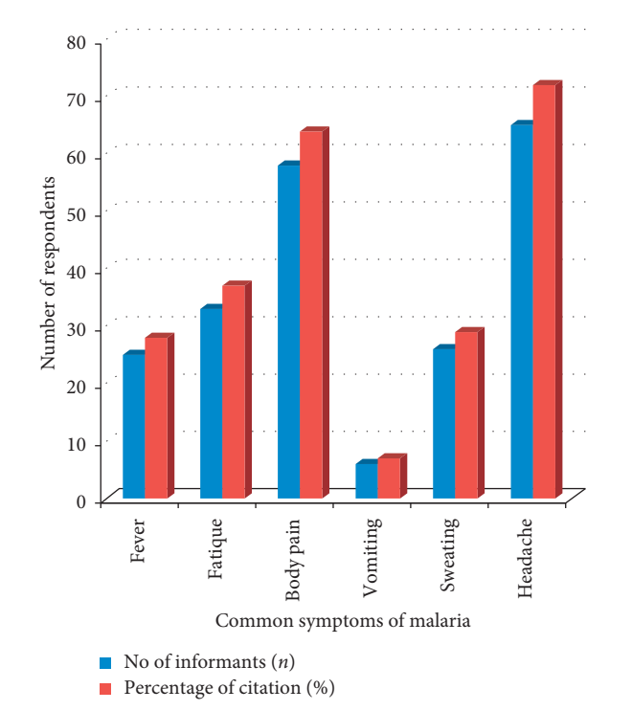

APPENDIX IV (COMMON HEALTH EFFECTS OF ANTIMALARIAL HERBAL DRUGS)
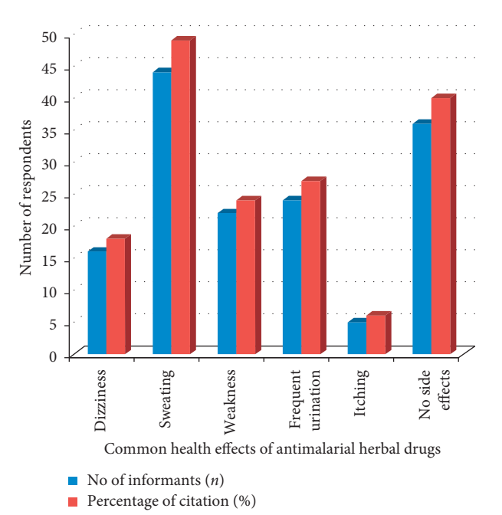

APPENDIX V (COMMON HEALTH EFFECTS OF ANTIMALARIAL HERBAL DRUGS)
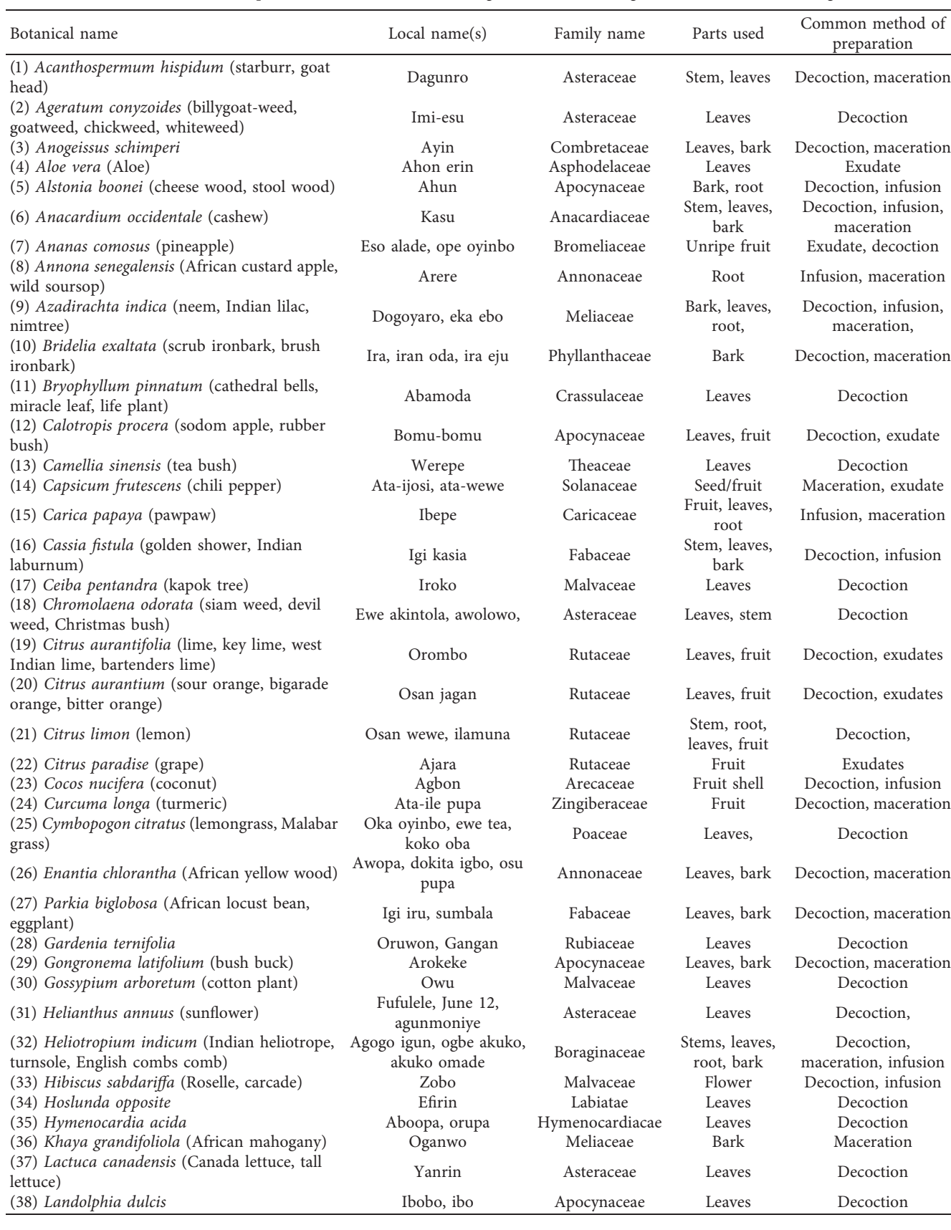
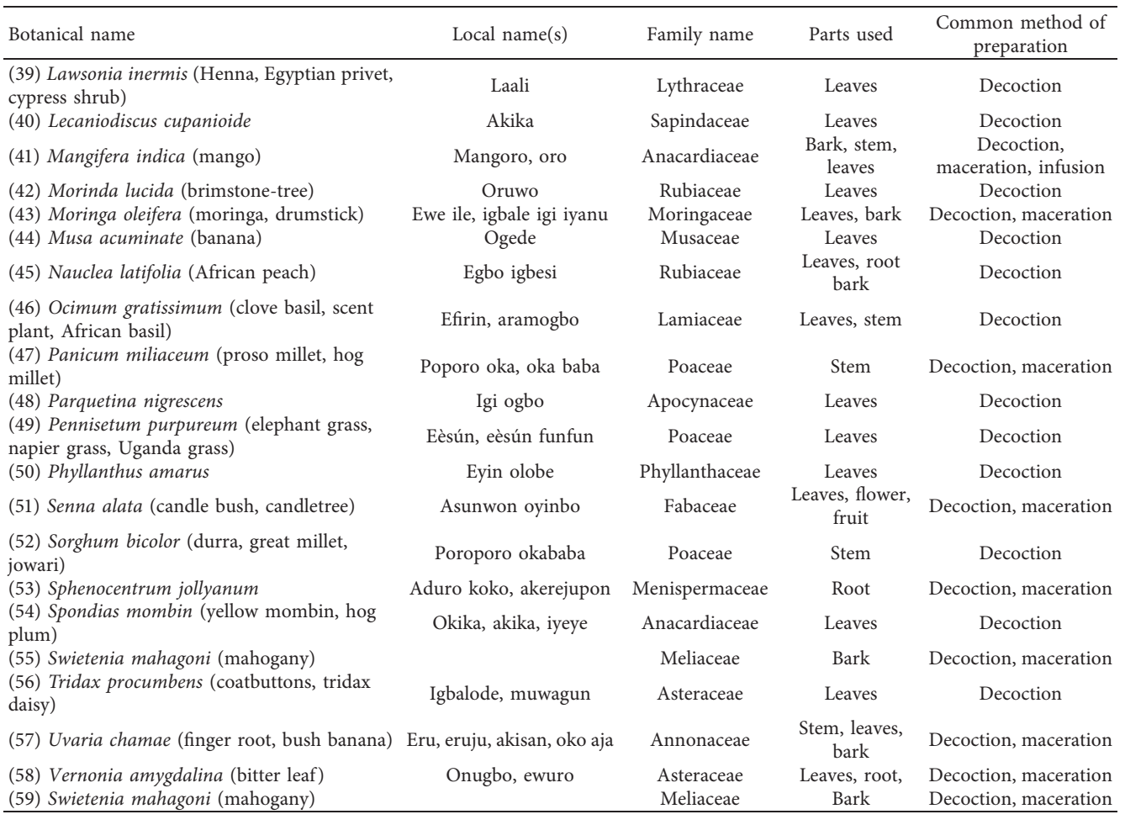

APPENDIX VI (PLANTS PART USED FOR HERBAL PREPARATION)

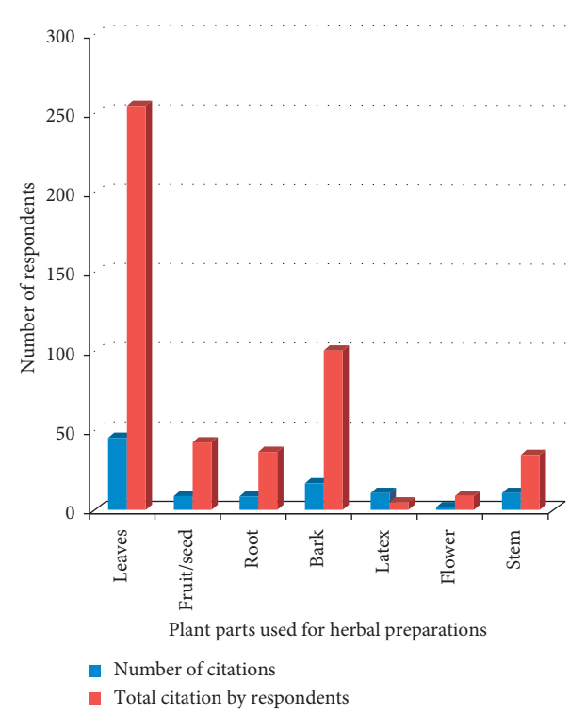

APPENDIX VII (FORMS OF HERBAL PREPARATION)
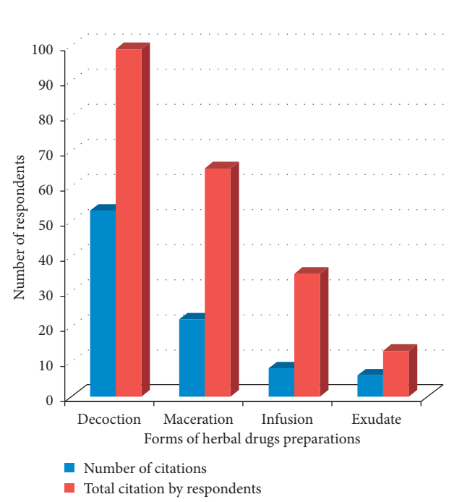

Appendix VIII: GC-MS of ML-K
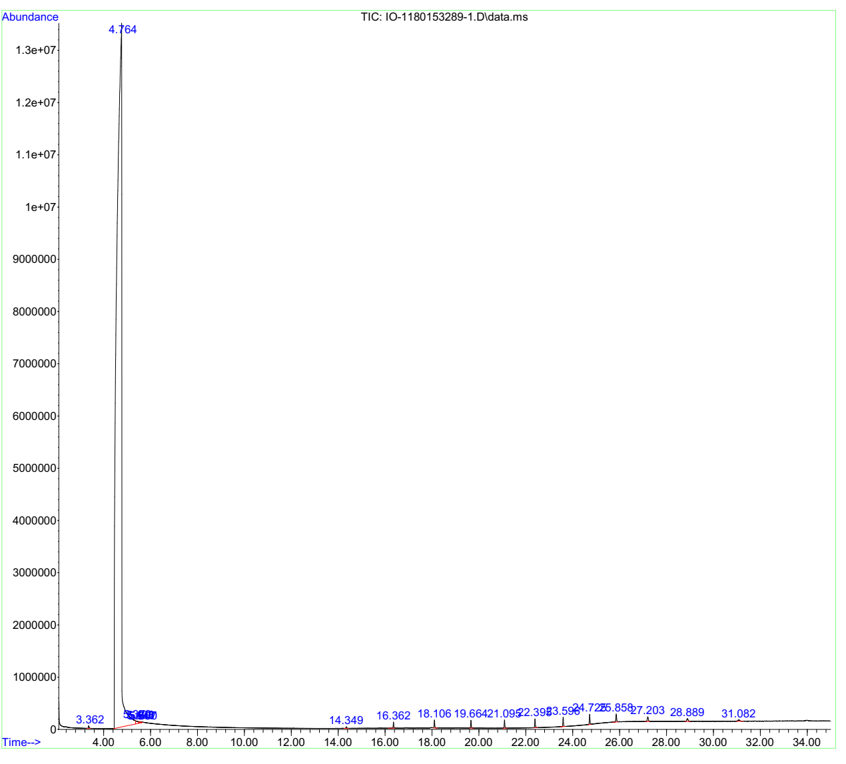

Appendix IX: GC-MS of OL-N
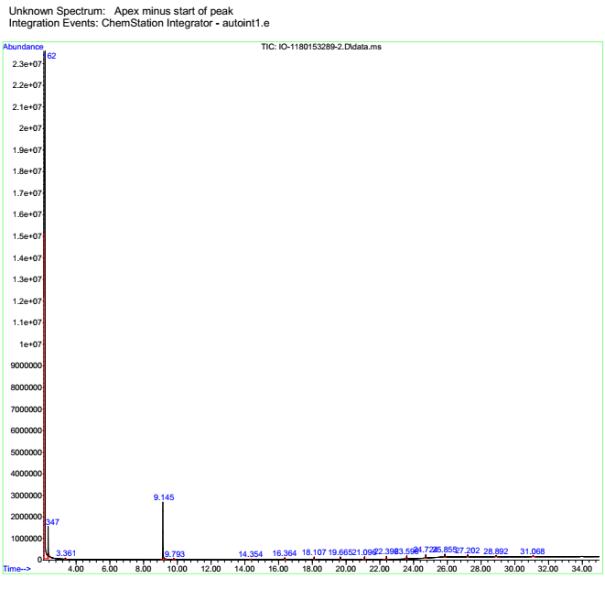

Appendix X: GC-MS of EtLDB-65-oil
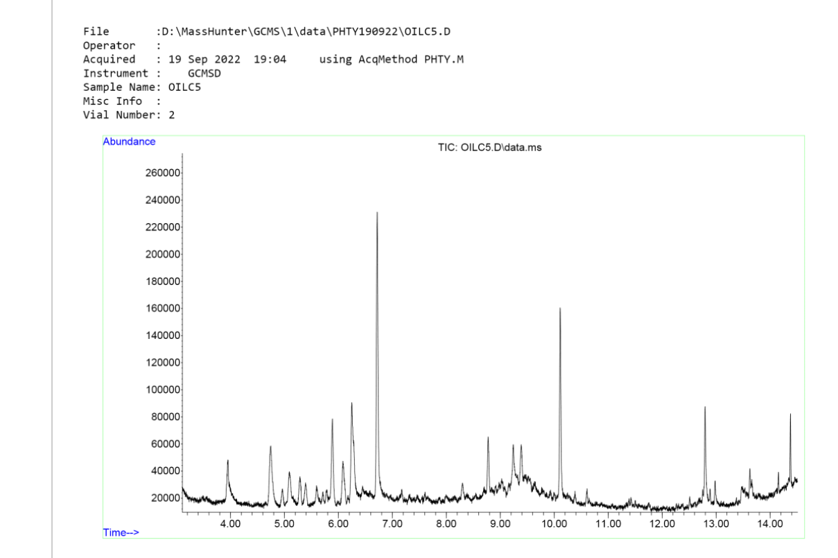

Appendix XI: HNMR Spectrum of OL-1

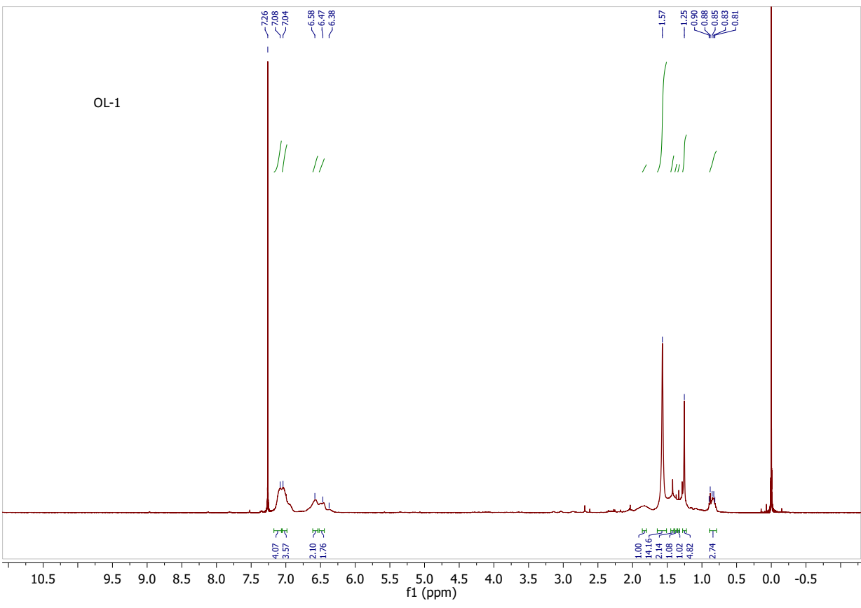

Appendix XII: COSY Spectrum of OL-1

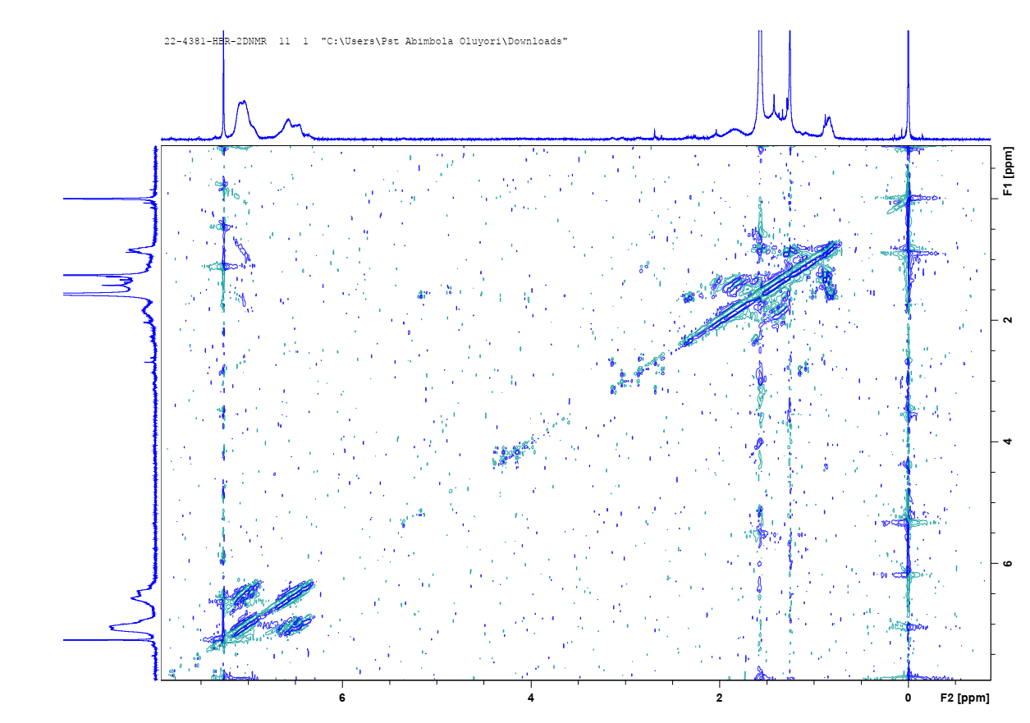

Appendix XIII: ESI-HRMS Spectrum of OL-1

Appendix XIV: FTIR Spectrum of OL-1
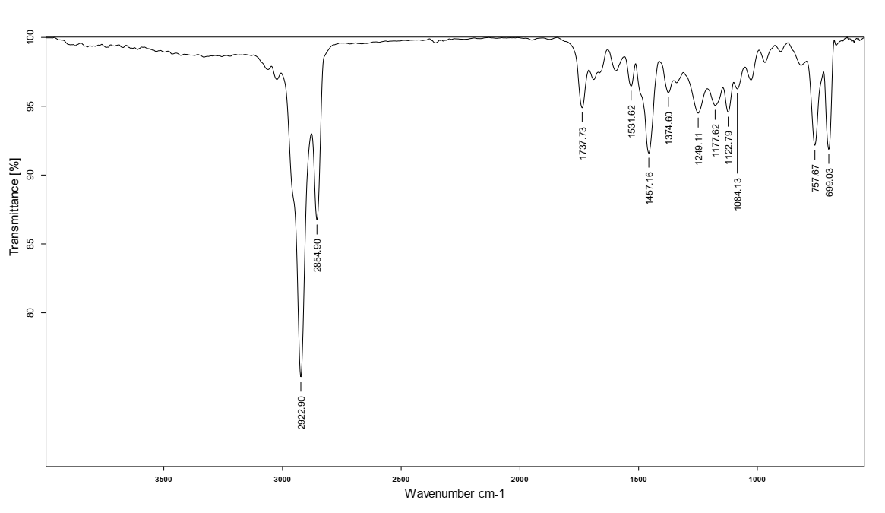

Appendix XV: HNMR of compound A-3

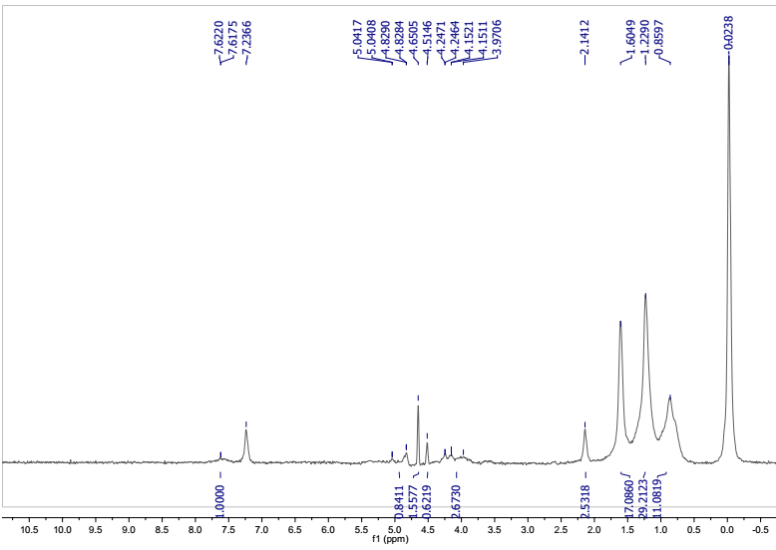

Appendix XVI: ESI-MS spectra of A3
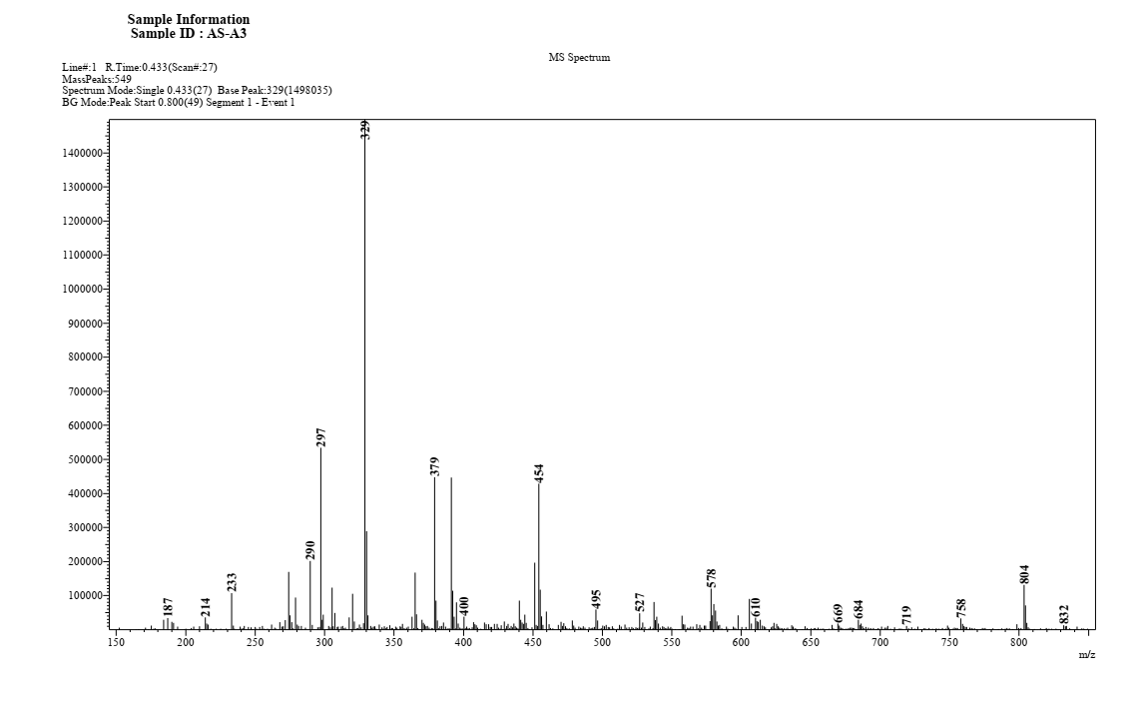

Appendix XVII: FTIR Spectra of A3
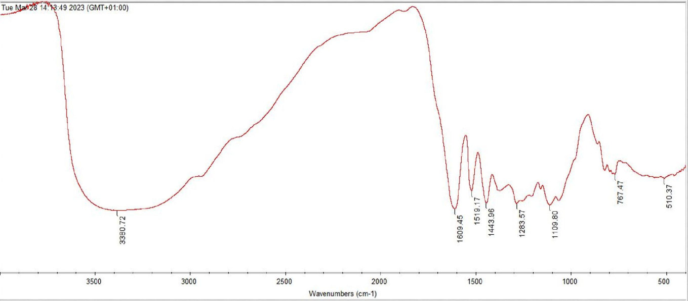

Appendix XVIII: 1HNMR of AI/B1
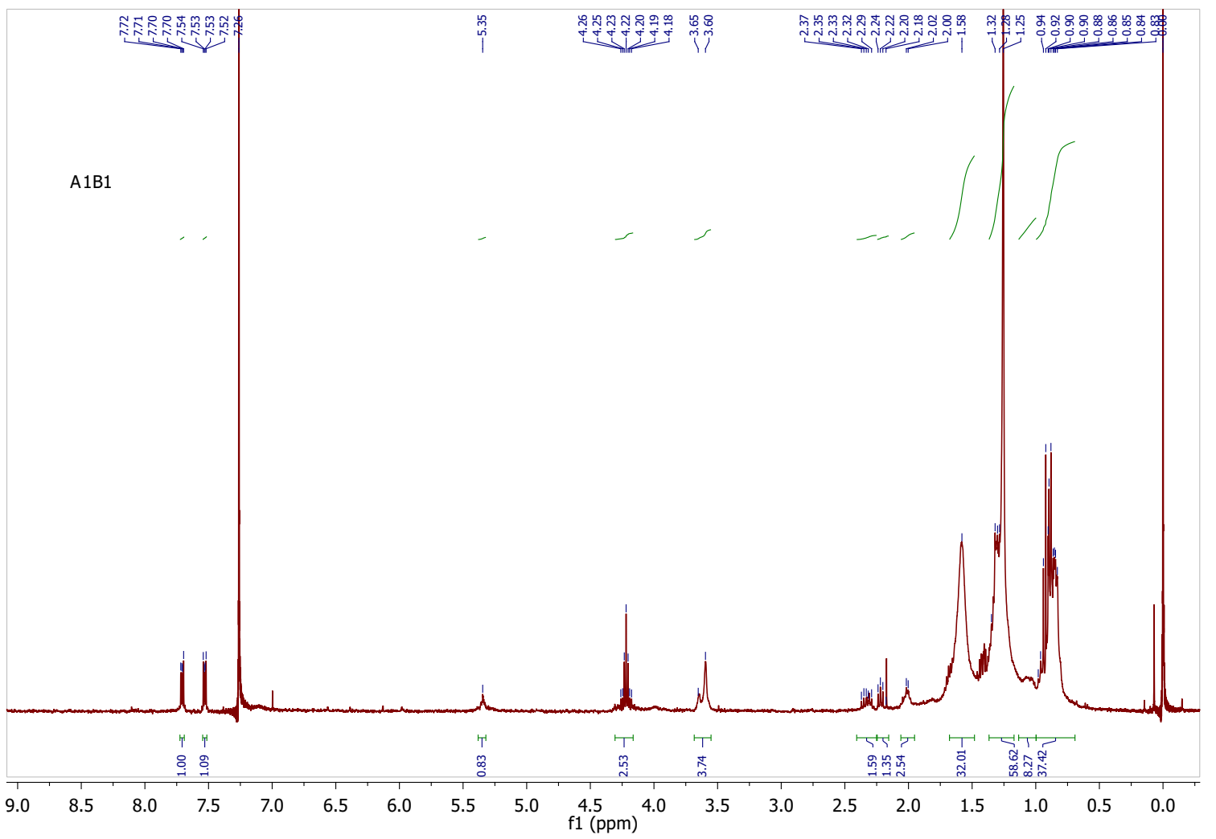

Appendix XIX: 13CNMR of AI/B1

