Automating the University Library using Alexandria Library Management Software: The Landmark University Experience

By

Yusuf Felicia ¹ Aregbesola Ayooluwa ² Owolabi Sola Emmanuel ³

Centre for Learning Resources
Landmark University, Omu-Aran
Kwara State, Nigeria
- yusuf.felicia@lmu.edu.ng
- aregbesola.ayooluwa@lmu.edu.ng
- owolabi.sola@lmu.edu.ng

Abstract
The paper examined the automation of Landmark University Library using Alexandria Library Management Software. Specific objectives of the study include: to highlight the various features of Alexandria LMS, examine reasons for the successful deployment of the software in Landmark University Library, and to consider the strengths and limitations of the software. Regular power supply, adequate funding, engagement of ICT proficient librarians were identified as some of the reasons for the successful deployment of Alexandria LMS in Landmark University Library. The strengths and limitations of the software were also discussed. The paper concluded by enjoining librarians yet to automate their operations to consider deploying Alexandria Library Management Software.

Keywords: Library automation, Alexandria, Library Management Software, Landmark University Library

Introduction
Information and Communication Technologies have triggered a paradigm shift in the process of information acquisition, processing, storage and dissemination. Cursory observation shows that the use of computer and other information technologies have become almost fully integrated into all aspects of the university system. The library as an integral and active part of this system has undergone various stages as well as experienced a phenomenal development in the use of information technology for creating, processing, storing, retrieving and disseminating information. These technological advancements have enabled the library to carry out its routine tasks efficiently and effectively. The Changing trend in the digital age has made it imperative for Nigerian libraries to develop ways to manage and access library resources in electronic format and effectively share them, since digital age has provided a platform on which they have to share their resources (Nkanu, 2010).
According to Nok (2006), automation reduces the stress encountered in the traditional system which is predominantly manual. Library automation involves the full application of computer technology in routine activities such as acquisition, cataloguing, users’ registration, circulation etc. hitherto manually performed (Nwalo 2003). Taylor (2004) opines that library automation is a fully integrated computer system that includes various modules to perform different functions. Integrating these modules will eliminate duplication of data and waste of resources.
The 21st century information processing and dissemination terrain has been influenced positively by the internet and other information and communication technologies. This has introduced a more efficient way of implementing Ranganathan’s law. Quick access to information takes premium in user satisfaction and has been the main essence of library services that informs users’ preference of the automated over the traditional system of information handling. Manual or traditional processing of information has lots of limitations which take its toll on user satisfaction thereby negating the five laws of librarianship as propounded by Ranganathan (1957).
The Library, which is pivotal to the teaching and learning process, is dynamic and evolving. Described as a growing organism by Ranganathan (1957), the library has to be transformed not only in collections but also in meeting the changing nature of users’ demands and needs. There is a clarion call on libraries in the modern society to embrace new ways of doing things as their role, especially in higher institutions of learning, is cardinal in providing support for teaching, learning and research.
Automation is very essential for proper management of information resources in the 21st century library. Mohammed (2006) affirmed that automation enhances proper management of large collections and the changing nature of library users, thereby deviating from the traditional system of handling information which is cumbersome. He further observed that the inadequacy of traditional library services and tools in coping with the detailed requirements of identifying information pertinent to a given problem has forced libraries to automate their functional service areas. It is also worthy to note that greater expectation of users, change in library usage patterns, information seeking strategy and more sophistication in the new interfaces of knowledge delivery underscore the importance of automation in the 21st century library. Abubakar (2006) believes that automation in libraries permits decentralized access to records and information. Dan-Isa (2004) also observed that library automation helps in cost reduction in running the library. He further argued that library services are very labour intensive where two thirds of library's budget usually goes for labour and reasoned that since machines can be made more cost effective in a way that human beings cannot, it appears inexorable that the cost of labour will tend to increase relative to other costs.
Several literature (Fatoki, 2004; Breeding, 2009; Utpat-Digrajkar, 2011; Yakubu, 2013) enumerate the advantages of automation. These include the following:
- It increases productivity in terms of works as well as service
- Professional staff need not spend much time to do routine library work
- Eliminates human errors while performing routine library work
- Improved Computer awareness among users
- Cataloguing is faster
- Excellent control over circulation
Historical Background of Landmark University Library (LMUL)
Landmark University, Omu-Aran owned by World Mission Agency - an outreach arm of the Living Faith Church Worldwide was founded on a Christian mission ethos committed to raising global leaders equipped with skills and character to lead the world in meeting the needs of humanity. It was established on the 21st of March 2011 and commenced her academic activities almost immediately. The University academic programmes are meant to raise graduates with sound professional expertise, spiritual, mental and entrepreneurial initiatives that will revolutionize the different sectors of our nation.
Landmark University, Omu-Aran commenced with a University Library known as Centre for Learning Resources (CLR). The vision of the Library is ‘to become a world class library committed to acquiring, organizing, storing and disseminating information in diverse formats in support of teaching, learning and research geared towards raising solution thinkers in all areas of human endeavor’. The library complex is a magnificent glass edifice, which portrays teaching, learning and research as the major activities in the University. It is strategically located within the academic area with a seating capacity of 2000. The major objective of the Library is to make available and accessible diverse information resources and services to enhance the quality of teaching, learning and research. It acquires, organizes, stores and disseminates information in various formats. These include print and electronic formats. The resources available in the centre include:
- Reference materials
- Online databases
- Books
- Periodicals: Journals, Newspapers, Magazines
- CD-ROMS
- Internet Resources/Services
Currently the library has over 24,600 volumes of books (print), over 700,000 titles (e-books) and over 50,000 electronic journals made available on the platform of various online databases such as EBSCO and Sciencedirect among others. These resources provide an enhanced and robust resource-base for teaching, learning and research in the University. It also serves a considerable number of occasional users from other educational institutions, corporate organizations as well as the host community and its environs. The library was automated since inception using a library management software (LMS) called Alexandria. It is an integrated web-based library management software developed by Companion Corporation, United States in 1987. Apart from managing all library routines, it is a fully integrated computer system that includes various modules. These modules include; acquisitions, cataloguing, indexing, patrons’ registration, circulation, report generation, Online Public Access Catalogue (OPAC) and Web Public Access Catalogue (WebPAC). The integration of these modules eliminates duplication of data and waste of effort.
Objectives of the Study
The study examined the automation of university library using Alexandria LMS, with the following specific objectives:
- Highlight the various features of Alexandria LMS.
- Examine reasons for successful deployment of the software in Landmark University Library.
- Consider the strengths and limitations of the software.
Methodology
Documentary evidences were adopted as methodology in this paper. Several literature on library automation were consulted and used as basis for the discussion of this paper.
Features of Alexandria Library Management Software
Orders and Acquisitions Module
This module contains the names and addresses of booksellers/vendors used by the library. It also serves to specify the full details of the bookseller with each order, so that a code number can be used on the order record. Items can easily be ordered for and the received items can automatically be added to the library inventory.

Cataloguing Module
Alexandria, through Item Management Window helps in locating and importing complete and up-to-standard MARC records of all items (books, periodicals, e-resources) by searching across hundreds of Z39.50 servers, or by specifying favourite sources, thus simplifying and standardizing cataloguing practices. The imported data are thereafter edited, bearing a customized barcode label before they are saved into the library catalogue. Alexandria creates, stores, and updates MARC records with the information entered on the Items Management window, thereby enabling library information management.
The Items Management window consists of two distinct areas:
- The left-hand side of the Item Management window is the Item Title List and associated tools.
- The larger, right-hand portion of the Item Management window is the Current Item Record pane where the selected item/title record is displayed, in full, along with related tools that help perform operations on said record.

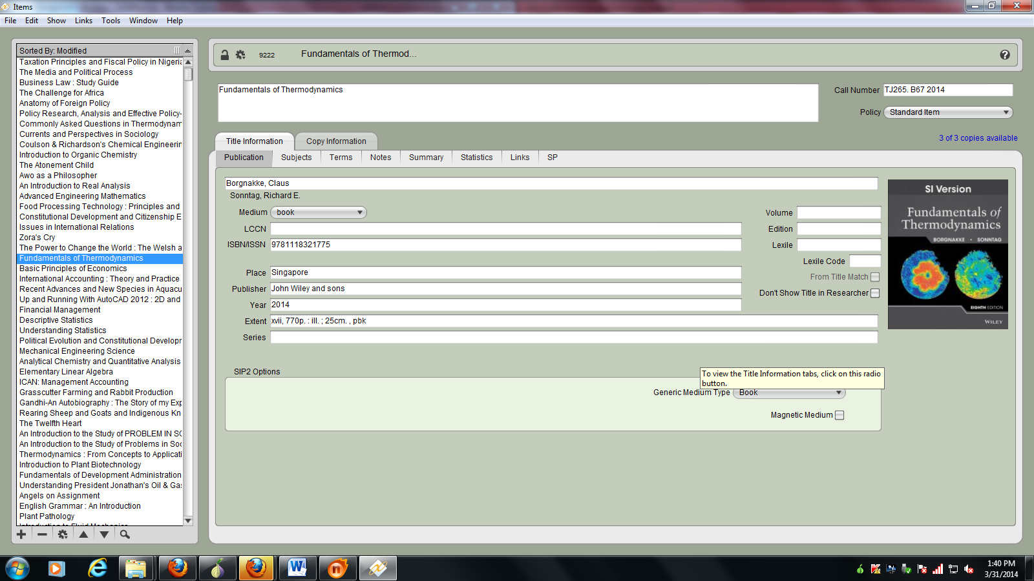
Figure 1: Landmark University Library Items Management Window

Patron Management Window
The Patrons window contains information about the library users including their respective photographs. Information about each user can be created, viewed, modified and removed.
The Patrons management window consists of two distinct areas:
- The left hand side of the Patrons management window belongs to the Patron Records List which is basically a list that contains the names of library users (i.e. patrons and librarians) that have been created and assigned a security group. It is also used for browsing patron and operator records and other related tools. Any of the users displayed within this field may be selected in order to modify their information or remove them completely.
- The larger, right-hand portion of the Patron Management window consists of the Current Patron Record pane where the selected patron or librarian record is displayed, in full, along with associated tools that help perform operations on said record.
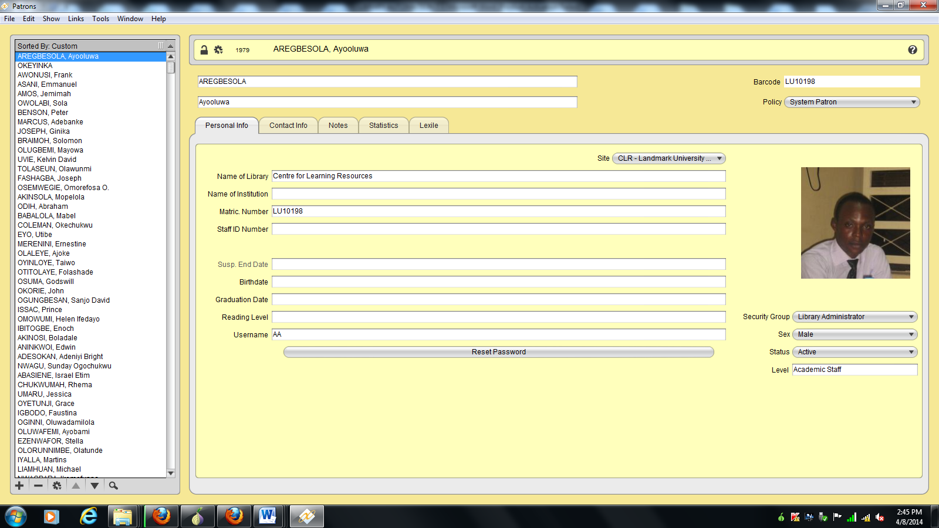
Figure 2: Landmark University Library Patrons Management Window

Circulation Module
The circulation module of Alexandria performs all tasks involved in the circulation of library materials. These include check-in, check-out, inventory, overdue notices, holds, and reserves, processing fees, fines, payments, fine receipt and books renewals.
Alexandria has powerful patron tools and utilities for registering patrons in simple steps, using easy import wizard, or auto import features. It can also automatically email overdue notices to patrons, hold fulfillment, and item renewal notices. The use of technological devices such as computers, barcode labels, scanners and its software in circulation helps in performing these routine operations easily and quickly.

Online Public Access Catalogue (OPAC) - Researcher Workstation

The Online Public Access Catalogue which serves as bibliographic control tool is an electronic catalogue which provides access to library collections from the networked computer workstations within the library complex or through remote login by staff and students to the catalogue from their offices and hostels respectively. The system allows cataloguing details to be accessible through the internet anywhere around the world at any time (WebPAC).
Researcher is Alexandria's default search interface for this purpose. Once a search has been performed, it provides the results of latest search in variety of changeable views along with an explanation of why no search results were returned.
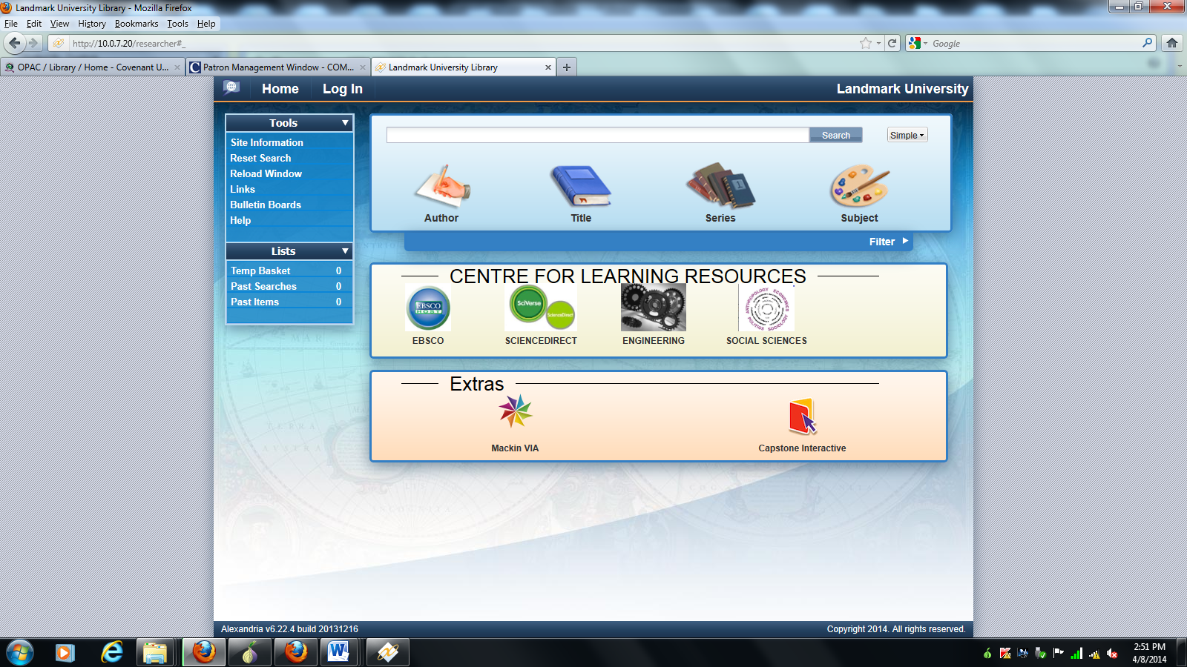
Figure 3: Landmark University Library search interface
Reports and Statistics Module
Alexandria through the Report Writer window allows generation of nearly endless variety of reports and statistics in cataloguing, acquisitions, serials, and circulation. Essentially, this window provides general templates that help build reports that meet the form, content, and organizational requirements. It also performs a comprehensive analysis of library’s collection status, and usage reports in multiple and various formats.
Reasons for Successful Deployment of Alexandria in LMUL
Landmark University Library is the first academic library in Nigeria to adopt Alexandria LMS. The Library has fully automated all its routine activities and can boast of a functional virtual library service, which gives faculty, staff and students remote access to its Web Public Access Catalogue (WebPAC) and other electronic resources from the convenience of their offices, departments or residence via any web browser at any-time. Since its adoption, there has not been any major challenge regarding its use, or need to consider any other software as it has been the case with many other university libraries in Nigeria. The deployment of Alexandria was a huge success in LMUL for the following reasons:
- Adequate Funding - The peculiarity of Landmark University as a well-funded mission-based institution created a good pivot for deployment of Alexandria software. As against the usually cited challenge of lack of funds in literature on automation of libraries, the library enjoys good financial backing from its proprietor base.
- Regular Power Supply – The University does not solely depend on public power source. There is a dedicated 500Kva generator attached to the library which serves as a back-up in the event of power outage.
- Necessary Infrastructure – The library building, ICT infrastructures, furniture, electrical appliances and other modern working tools needed for successful deployment of Alexandria and continuity of operations were adequately provided for.
- Engagement of ICT Proficient Librarians – ICT proficiency forms one of the major factors considered in the engagement of librarians and other library support staff. There is a policy in LMUL on engaging the services of librarians who are highly proficient in the use of modern technologies. The library therefore commenced its operations with ICT inclined librarians which explains the successful take-off of a fully automated library.
Strengths of Alexandria LMS
The following are the strengths of Alexandria LMS:
Technical Support and Developers’ Reputation - The first thing the library considered was institutional support and secondly the reputation of the company that developed the software. One has to be skeptical about the software developed by individuals and newly established companies as there may be no continuity. Alexandria was developed by a reputable company and has been sustained for over 20years. Technical support is made available through various media and their response is in real-time. The developers also take suggestions from clients, which result in the introduction of additional features that constitute a regular upgrade of the software.
Cost - Alexandria is a cheap, cross-platform library automation software considering the functions it performs. Also, the software is upgraded regularly without attracting extra costs.
Flexible and User Friendly - Alexandria's default search interface is intuitive, simple, fast and easy to use. This interface also allows you to search your collection using the advanced Boolean modifiers (And, Or, Not, and Through). It also allows customization of interface in terms of design and content to suit the user institution’s peculiarities.
MARC and Z39.50 Compliant – The software is capable of producing, locating and retrieving complete and up-to-standard MARC records by searching across hundreds of Z39.50 servers, or by specifying favourite sources, thus simplifying and standardizing cataloguing practices. For easy migration in future it is important to adopt softwares that allow searching, retrieval and exchange of records across platforms. This is fully embedded in Alexandria.
Concurrent Authentication – Unlike some Library Management Softwares where licenses have to be purchased for each user in order to have access to the workstation, Alexandria allows simultaneous logins at different times and places with or without the same authentication details by several users.
Compatible with Self-service kiosks and Security Devices - Alexandria provides self-service kiosks that allow patrons to perform check-in and checkout transactions unassisted. This helps to reduce manpower and by implication the cost of hiring them. It also supports Library Security Devices such as Electromagnetic and Radio-Frequency Identification which are used to identify and track tags attached to materials from the library as well as other peripherals like printers, barcode scanners (wireless and wired), bluetooth etc.
Limitations of Alexandria LMS
No matter the sophistication of any software, some limitations will still be inevitable. For Alexandria LMS, the following are some of the observed limitations:
- Indexing of Periodicals - The software lacks the capacity to adequately capture articles and other details in periodicals.
- Report Generation – the software has the capacity to generate reports on the total number of collections (Including titles and copies). It is however difficult to generate reports based on specific subject areas.
Conclusion and Recommendations
The importance of automation in a 21st century library cannot be overemphasized as it conforms to best practices around the world. The hitherto herculean routine task of librarians becomes highly simplified when relevant technologies are deployed. In order to successfully maintain a fully automated library system, certain parameters must be put in place. These include adequate funding, uninterrupted power supply, necessary ICT infrastructures, and the engagement of ICT savvy librarians among others. Proper engagement of these parameters has been responsible for the success story of Landmark University Library in the deployment of Alexandria Library Management Software. In order to successfully run and maintain a fully automated library system the paper recommends the following:
- Libraries should consider alternative sources of power supply and not rely solely on public power generation. This is because automation thrives on constant supply of power.
- Before libraries embark on automation, it may be needful to consider the sustainability of the project putting into consideration factors such as funding.
- Libraries who intend to maintain an automated system should do so from inception as retrospective conversion of data becomes an herculean task.
- Regular back-up of data should be of utmost importance.
- The services of at least one systems librarian is advised. He/she will serve as an interface between the library and the ICT unit of the organization.

References
Abubakar, Abiduna. (2006). Lifelong education in the age of information technology: the need for a review of library study courses in the NCCE minimum standards. International journal of Research in Education, Vol. 3, No. 1, pp. 20-28.
Breeding, M. (2009). Open source for library automation and resource discovery: trends in library automation”, available at http://www.librarytechnology.org/docs/14309.ppt. Accessed on 16th October, 2013
Dan-Isa, Ado. (2004). The information and communication technology at BUK: Plan and
Development. In Attahiru M.Jega, Isa Alkali Abba and Haruna Wakili (Eds.),
Consolidating the Citadel: Kano; Bayero University, Kano, pp.366-374.

Fatoki, O. (2004). Library automation in Nigeria: The Kenneth Dike library experience. Lagos
Journal of Library and Information Science, Vol. 2 No. 2
Mohammed, Ahmed. (2006). Automation in Nigerian university libraries: Problems and
prospect. Journal of Educational Services, Vol. 2, No. 1, pp. 55-63.
Nkanu, W. O. (2010). Digital Divide: Bridging the gap through ICT in Nigerian Libraries. Library Philosophy and Practice. At http://webcashe.gorgleusercontent.com/search?pp.2of16,3of16,4of16. Accessed on 16th October, 2013
Nok, G. (2006). The challenges of computerizing a university library in Nigeria: The Kashim Ibrahim library, Ahamadu Bello University, Zaria. Library Philosophy and Practice, Vol. 8, No. 2. Available: http://unllib.unl.edu/LPP/nok.htm. Accessed on 16th October, 2013
Nwalo, K.I.N. (2002). Fundamentals of library routines. Ibadan: Stirling Horden Publishers.
Ranganathan, S. R. (1957). The Five Laws of Library Science, 2nd ed., Bombay: Asia House.
Taylor, A.G. (2004). The Organization of Information. Westport,CT: Libraries Unlimited, Inc.
Utpat-Digrajkar, S. (2011), “Library automation using Koha: an experience of IndSearch library”, available at: http://units.sla.org/chapter/cas/Seema.pdf. Accessed on 16th October, 2013
Yakubu, Hajara (2013) Library Automation in the Federal University Dutsima library, Nigeria. Compendium of Nigerian Library Association 2013 Conference Papers.

