**DESIGN OF BICYCLE LANE - A CASE STUDY OF UNILORIN**

**Braimoh S.O.**

Civil Engineering Department, Landmark University, Omuaran Kwara state

**Adeleke O.O.**

Civil Engineering Department, university of Ilorin, Ilorin, Kwara state.

C. A. Ezugwu

Mechanical Engineering Department, Landmark University, Omu-Aran Kwara State

**ABSTRACT**

*The study helps to improve on an existing arterial road on the permanent site of the University of Ilorin, Ilorin, Nigeria to carter for bicycling.* The design was done by carrying out manual measurement using tape on the road. The width of the University road is found to be wide enough to accommodate bicycle lane on both sides of the road. The use of bicycling facilities is vital to the advancement and development of any locality. By placing emphasis on cycling, the problem of acceptance will be over along the road of Unilorin. It is recommended that the design of bicycle facility should no longer be ignored in current transportation planning practices and in formulating, implementing and refining policies. In this light, Unilorin road is designed for the bicycling and bicycle park facilities.

**Keywords: Bicycle lane, non-motorized transportation and cycling.**

Cite this Article: Braimoh S.O., Adeleke A.A.**,** Ezugwu, C. A.,Design of Bicycle Lane - a case study of Unilorin**.** *International Journal of Civil Engineering and Technology*, 12(9), 2018, pp. http://www.iaeme.com/IJCIET/issues.asp?JTypeIJCIET&VType=6&IType=7

1. **INTRODUCTION**

Bicycling is a major aspect of Non-motorized transportation. It is one of the oldest means of transportation and still has a lot of relevance today in our transportation system. Non-motorized transportation includes every mode of transportation that is not powered by any external source such as electrical or mechanical motors, instead powered by the physical energy of the user. It can sometimes be referred to as human powered mobility (FRSC, 2014).

Walking is the most familiar form of non-motorized transportation (NMT). Other common form of NMT include: human porter age; handcarts/wheelbarrows; animal drawn carts; and other human powered vehicles. In fact, the definition of NMT includes any form of transportation that provides personal or goods mobility by methods other than the combustion motor.

In medium-sized cities in Japan, Germany and the Netherlands, 40-60 percent of all trips are made by walking and cycling, while in similarly sized cities in India this share is as high as 80 percent (Heierli, 1993). Almost all rural transport in Sub-Saharan Africa is non-motorized and dominated by head- and back-carrying by women and children. In many Asian countries, non-motorized two- and three-wheelers are common sights, employing special adaptations to the vehicle for goods transport, hawking or passenger hire.

Though NMT users are the majority in many places, they are often neglected in the design and modernization of transportation infrastructure. For example, new construction and upgrading often does not provide physical infrastructure (e.g., overpasses or shoulders) for existing NMT users, sometimes resulting in higher NMT-automobile accident rates, longer travel times for NMT users, or even a complete elimination of NMT traffic. The result of this neglect is a transportation system that in many ways favors cars and other motorized traffic to the detriment of poorer segments of the population; thus consideration of NMT during infrastructure design is an essential element to providing equitable transportation opportunities.

One of the advantages of NMT is that it provides a very flexible solution to accessibility, especially where resources are scarce. This is true not only from the user's perspective; but local level service providers, policy-makers and opinion-leaders are also becoming increasingly aware of the viability of NMT. The following sections discuss issues related to the integration of NMT in the design of developing country infrastructure projects.

The planning, designing and construction of bicycle lane facility is so vital to a nation development and advancement. In the realm of transportation planning, a city or nationwide plan for transport is incomplete without the incorporation of Non-motorized transportation facilities (bicycle lane), as it is also an important component of the transportation system (Owolabi, 2011). Previous researches have documented a lot of literature on travel by various modes of transport with facilities provided for their operation. However, very little information has been provided on non-motorized trips. With regard to walking in particular, past local and international commuter surveys have found that this mode account for only 5-15% of main mode splits, creating a perception that travel by foot and bicycle is relatively unimportant (Behrens 2001).

Furthermore, through the incorporation of NMT a lot of benefits will be enjoyed. Some of these benefits includes: Congestion-easing, Fuel savings, reduced dependency on fossil fuels, Reduced CO2 emissions, reduced air pollution, reduced noise pollution. Increased quality of life, Improved quality of the public environment, Increased interaction between residents, A boost to the vitality of city centre’s: livability, Increased accessibility to jobs (and schools), Boost for the tourism, Boost for the bicycle industry (bike-sharing systems, contractors and bicycle producers) (UNEP, Baufeldt, 2008)

NMT is being encouraged globally thus the need to provide infrastructure (well planned, designed and constructed) to facilitate NMT in Nigeria. Yet due to a lack of attention to the needs of pedestrians, and a tendency to favor motorized transport, pedestrians and bicyclist who constitute a high percentage of non-motorized transport are hardly considered or catered for in the design of roadways in Nigeria which put them at risk of accidents in Nigeria cities.

1.1 AIM/OBJECTIVES

The study examines how adequately Bicycle lane is addressed in University of Ilorin, Nigeria.

1. The examination of provisions made for non-motorized transportation worldwide as obtained in the design manual of Nigeria.

ii. Design of non-motorized transportation facilities (Bicycle lane) for an existing arterial road.

1.2 THE UNTAPPED POTENTIALS OF NMT

**Empowerment**

Many people in the developing world underestimate the potentials of non-motorized transportation Attempts at advocacy for cyclic have always been met with negative reactions as people tend not to appreciate the benefits of cycling beyond being good for exercise. This probably may have been responsible for the lack of attention to NMT. There are several untapped potentials in NMT. These can be appreciated from the lessons from a study on cost benefit analysis of untapped potentials of the Bicycle ownership in Uganda reported by Gauravsinghal Blog (2009). In this study, 300 households from different regions of Uganda were given subsidized bicycles and a one – time guidance on how to utilize the time saved in doing any allied productive work. The impacts of the bicycle on the household social and economic life were examined. The highlights of the findings are presented as follows:

• Saving of almost 2 hours per day of transport time per household was achieved

• Substantially more frequent visits to market and facilities were attained

• 23% fewer journeys to carry out domestic tasks achieved

• Regional destination up to 40km away was within reach

• Relieving the housewife of 46% of all her transport loads was attained

• A 35% higher income from selling harvest products on external markets with higher prices were achieved

• Benefit to cost quotient of 4 for the operative years of the bicycle was recorded.



**Before After Before After**

**Male-led Households Female-led Households**

+39%

+36%

**Figure 1: Increase in Household Income due to bicycle**

Sources: Institute for Transportation policy (2005).

It can be seen that bicycle, in this study resulted in significant changes in the lives of surveyed poor as they were able to overcome poverty. The bicycle had improved both their sphere of activity and there transport capacity. This made a virtuous cycle, the effect of which was their significantly higher ability to growth and development. This example demonstrates that cycling can generate empowerment, better life while being a sustainable mode of transport.

**Improved quality of life**

An examination of the ten most liveable cities across the globe elicits some critical attributes which include having successful planned bicycled and pedestrian programmes (off/on road bicycle lanes pedestrian walkways, integration of public transport with cycling, etc.). This is at variance with the fact that it is only in Africa that cycling and walking is almost an exclusive preserve of those who cannot afford cars and those who use it for athletics and exercising.

The 2012 global livability report produced by Economist Intelligence Unit’s (EIU), An arm of the Economist Group is presented in Table 2.

**Table 1: Global liveability Report 2012**

|  |
| --- |
| **The EIU’s Global Liveability report** |

|  |  |  |  |
| --- | --- | --- | --- |
|  | **City** | **Country** | **Rating** |
| **1** | **Melbourne** | **Australia** | **97.5** |
| **2** | **Vienna** | **Austra** | **97.4** |
| **3** | **Vancouver** | **Canada** | **97.3** |
| **4** | **Toronto** | **Canada** | **97.2** |
| **5** | **Calgary** | **Canada** | **96.6** |
| **6** | **Adelaide** | **Australia** | **96.6** |
| **7** | **Syndney** | **Australia** | **96.1** |
| **8** | **Helsinki** | **Finland** | **96.0** |
| **9** | **Perth** | **Australia** | **95.9** |
| **10** | **Auckland** | **New Zealand** | **95.7** |
| **138** | **Lagos** | **Nigeria** | **39.0** |

*Source: Economist Intelligence Unit’s (EIU), 2012*

Of the 140 world cities studied each year, the bottom six for 2012 include Lagos at 138. Others at the bottom of the ladder are Karachi, Algiers, Harare, Moresby and Dhaka. (Economic Intelligence Unit, 2012).

**Reduced road crashes and traffic conditions**

The FRSC began the campaign for the use of bicycles as a means of urban transportation in 2011. The campaign was hinged on five cardinal benefits. Key among these is road transportation safety. At that time, Nigeria occupied the 91 position in the World`s Safest Roads Ranking and had a vision of climbing to become one of the 20 nations with the safest road by year 2020. Twenty nations with the safest roads at that time were studied. It was observed that all of them had as their primary urban transportation focus, cycling and walking. They all had made huge investments in the provision of infrastructure for NMT and were still investing. It became common sense to tow this trend. It was observed that any city with strong investment in cycling and walking across the world enjoy traffic orderliness, low level of day light crime, high sense of neighborliness, a sense of community and reduced road traffic crashes in urban centres. Laws, infrastructures and policies that promote cycling and walking naturally inject order into the overall traffic.

**Improve personal, family and national economy**

The Centre for housing policy, a non-profit research affiliate of the National Housing Conference [NHC] in the United States conducted a study of working families in 28 major metropolitan areas. The study found that families spend about 57% of their incomes on housing and transportation, 28% on housing and 29% on transportation [Centre for Housing policy, 2006]. In a similarly research conducted by FRSC [2006] an average Nigeria salary earner who owns a car spends about 35% of his income on fuelling and maintaining their vehicles for transportation. This is apart from other unquantifiable effects of using a car such as health.

It has been noted that the about 10 million registered vehicle partly consume over 40 million liters of petrol daily. An average daily consumption of 43.55 million liters of PMS, 7.76 million litres of AGO was recorded in 2013 (NNPC, 2013).

ATTITUDES TOWARD THE BICYCLE

Some insight into attitudes toward cycling can be obtained from a survey carried out in five different cities across the world (Accra, Delhi, Gangzhou, León, and Lima) in 1996.Most bicycle users in these cities preferred bicycle to bus primarily because it was less expensive, but the majority also found it more flexible in routing, faster, and more reliable. The survey did suggest, however, that many would change to motorcycles except for the cost. In Ouagadougou, a city almost exclusively dependent on two-wheeled transport, bicycles were still clearly viewed as an inferior mode to be abandoned as soon as the household could afford a motorcycle. In two of the cities, public transport users were also asked about the relative merits of bicycle and public transport. Interestingly, most of the perceived benefits of cycling were the same as those perceived by the cyclists, namely, cost, speed, and flexibility. The main disadvantages that this group perceived (which by definition were clinching in their decision to use public transport) were the danger of cycling, the risk of thefts and assaults, the lack of bicycle paths, and the motorists’ lack of respect for traffic laws (also by implication safety concerns). Only a minority quoted excessive trip distance or topography as clinching factors. One implication is that if these factors could be overcome, the use of NMT might be even greater. Another, less-comfortable implication is that if private motorized transport could be afforded and were to have the same flexibility as NMT, it would be preferred. Certainly that would seem to be consistent with the recent rapid increases in motorcycling in the richer developing countries.

THE POLICY PACKAGE

In most countries NMT has developed spontaneously and remains largely outside the normal processes of transport planning. Provision for NMT, if made at all, tends to be “retrofitted” to existing infrastructure, and to concentrate on minimizing the disturbance that it causes to the flow of motorized traffic. The consequence is that the provisions are not only expensive but often inconvenient for NMT (for example, open pedestrian footbridges for crossing busy roads). Even where it is necessary to retrofit, the chances of designing an attractive NMT package are much greater when there is a willingness to modify elements of the system not originally designed for NMT. For example, measures of traffic calming to reduce speed differentials between motorized and non-motorized traffic may be an essential requirement if bicycle traffic is to be attracted to unsegregated roads.

The more successful schemes, whether providing for NMT as a feeder mode or a main mode, have been incorporated in initial urban system design. For example, the plan for Tama New Town in Tokyo provides for pedestrian and bicycle access to town centers and railway stations completely segregated from vehicular road traffic.

The basis for such comprehensive attention to NMT is a combination of national strategy and local implementation planning.

SOME RECENT EXPERIENCE WITH FACILITIES FOR CYCLING IN CHINA

In *Shanghai,* the development of NMT routes has been slow; the pace of development has superseded many proposals. But such problems did not affect the rapid development of motorized vehicle routes. In retrospect, it would appear that the Shanghai agencies saw the creation of NMT routes as a way of increasing the capacity and facilitating the operation of motorized vehicle routes, rather than providing safer and easier passage for NMT on a network of routes. The NMT routes suffered from problems of motorized vehicle access and parking (Interface for Cycling Expertise 1997).

In *Guangzhou,* the piecemeal development of elevated city-center routes has severed NMT and pedestrian routes, and again, the development of segregated NMT routes was seen by the Guangzhou agencies as a way of improving capacity for motorized vehicles (De Langen, 2000).

In *Urumqi,* NMT volumes have decreased dramatically since 1992 with the introduction of minibuses, particularly in the central area. Weather and geography also result in NMT volumes lower than in other Chinese cities. Consequently, existing and previously physically segregated NMT lanes in the city have been converted into service roads and footways. Cycle lanes on central area roads are being converted to bus lanes

In *Beijing,* NMTs are increasingly being squeezed by motorized vehicle parking in physically segregated NMT lanes and by the reallocation of space in wide NMT lanes to through motorized vehicle traffic. On the Second Ring Road, the outside half of the NMT lane has been reassigned motorized vehicles, and the inside half is used by buses and taxis. NMT parking at work units is increasingly being moved to distant, inconvenient locations to provide more convenient space for motorized vehicle parking. A recent high-profile closure to NMTs of a commercial street atXidan in Beijingepitomizes current practice (Interface for Cycling Expertise 1997).

SAFETY EDUCATION AND TRAINING

An important requirement of a strategy to promote NMT is to establish and make known to the general public the rights and responsibilities of pedestrians and cyclists, as well as the traffic rules that deal with safety. In many Organizations for Economic Co-operation and Development (OECD) countries, these rights and rules are clear.

In contrast, in many developing countries cyclists and pedestrians are often mentioned in legislation only for definition purposes and have no specified legal rights in the use of road space. Traffic law should clearly define the rights and Responsibilities of non-motorized users of roads, as well as those of motorized users. Establishing rules is only one part of the solution to the problem. The second part is to get them known and applied. Training and educating children to understand more about traffic rules can be addressed both by incorporation of such training in the school curriculum and by campaigns outside school. In the longer term, knowledge of the rights of pedestrians and cyclists should be incorporated in driver license testing. In the shorter term, the problems are twofold: many existing drivers are unlicensed, and few police have been educated to think of the safety of pedestrians and cyclists as a responsibility of drivers of motorized vehicles. Treatment of NMT should thus be a central part of comprehensive road-safety programs.

Figure 2.3 shows the picture of a pedestrian activated red light to ensure the safety of the pedestrians as well as the other road users. A pedestrian uses the crossing by pressing the button to activate the first signal. When the light turns red a ‘walk’ signal prompts them to proceed to the median. The pedestrian then walks a short distance along the median to activate the second signal. A second walk indication appears when the traffic signal turns red. This uses a Red-Yellow-Green signal for motorists and remains green unless activated by a pedestrian. Bicyclist should yield to pedestrians, dismounting if necessary.

**THE FUTURE OF URBAN MOBILITY**

Nigeria has been making huge investments in transport infrastructures. This involved investment in road construction, reconstruction, expansion and maintenance all with a view to reducing existing mobility challenges and improving them. But there are so many contending issues that have to be considered to achieve effective urban mobility and reduce infrastructural deficit. There is paucity of funds and dwindling government resources as can be observed in annual budgets, which puts limitation on the extent of infrastructure development. The rate of urbanization is increasing at an astronomical rate and characterized by high uncontrolled rural – urban migration, unemployment, slum development, high poverty level and dwindling car ownership potential. In the light of the above, there is need to diversify urban transportation investments to address future sustainable issues that incorporate Non- Motorized transportation as a critical component of future urban mobility. To achieve this, strategies must be evolved to encourage mutual participation of Nigerians at all levels in NMT, provide dedicated lanes for NMT, promote programmes that will facilitate and ensure effective management of NMT and its incorporation into national socio- economic consciousness.

**The cycle-to-school program proposed by FRSC**

A strategy that could be beneficial is the Cycle-to School programme which the Federal Road Safety Commission (FRSC) initiated. Under the program, cycling is designed to be the major mode of transportation to schools and on the campuses of institutions of higher learning. This program could also be extended to enclosed premises such as Offices, Military/ Para-Military Barracks, estates, corporations with large premises, etc. to give better effect, car movements will be restricted while incentives will be provided to schools that embrace the program. The south Australian Government reduced taxes for schools which embraced such program on realizing that the cumulative tangible and intangible benefits accruing to students cycling to school outweigh the taxes being paid by the school authorities. FRSC has consulted campuses for a pilot scheme. Bolder community in the US voted to clear away cars and bus for conveyance of children to school to encourage children walk or cycle to schools. The community is said to have one of the healthiest children in the US.

Deliberate efforts to invest in this area would ensure cycling becomes a culture for school age people and by implication would lead to building the future of people who will be less dependent on cars but more dependent on NMT.

**KEY FACTORS TO SUCCESFUL NMT IN CITIES**

**Urban planning and infrastructure policies**

The characteristics pattern and processes of urban settlements play fundamental roles on whether city dwellers will accept and enjoy NMT. This is because the interplay of the 3 will determine where people live and the distances to service delivery centers to meet daily needs. The greater the distance the higher the limitation in the use of NMT mobility option. This does not however preclude conducting journeys that are within cycling or walking distance. Relevant professionals such as town and urban planners, engineers, etc. should design cities, settlements and communities to incorporate all modes of transport in existing settlements such as in the Federal Capital Territory, Nigeria.

FRSC and FCT Administration (FCTA) agencies of the Nigerian government conducted a study to examine the reason why the cycle lanes provided in the Abuja roads master plan were not implemented and to determine what can be done about it. The outcome of the study showed that provision was made for bicycle lane on virtually all roads in the design of Abuja roads but were not implemented at the construction stage, except for the Yakubu Gowon Road in Asokoro where the bicycle lanes and pedestrian walkway were clearly provided. 10 major arterial roads and streets were studied (FRSC, 2012 and 2013) and the summary of observations and recommendations are as follows:

1. Spaces provided for bike lanes on the roads still exist and are recoverable except in few negligible cases.
2. In most cases, the bike lanes were either merged with walkways making some of the walkways excessively wide or are merged with green areas. Only in few cases were there encroachments in form of building of fences.
3. Yakubu Gowon Way where the bike lanes was implemented had issues of truncation, non-consideration of cyclist at junctions, planting of bill boards, which make the lane unusable by cyclists who may want to do so.
4. The recovery of the lanes alone are not sufficient to make cycling safe and attractive as traffic facilities need to be provided; and intersections, junctions and roundabouts need to be re-engineered to be cycle-friendly, as global cycling crash data shows that over 60% of cycling crashes happen at intersections.
5. The recovery of the lanes and installation of traffic facilities may cost the FCTA reasonable funds but the cumulative tangible and intangible benefits of investing the resources would far out way the investment.
6. The FCTA should embark on the process of recovery of the dedicated lanes.

There is the need for a deliberate reform of the present urban infrastructure policy to give NMT prominence. Such reforms may include making it mandatory to include bike lanes on road design and road development in new city layouts, re-engineering of existing roads where possible to accommodate cycle lanes, and urban vehicle speed reduction. Such policies should also include strategies that would mandate the provision of bike storage facilities at clearly marked bus and rail terminals as wells as in the premises of public buildings such as malls, offices complexes, etc. This is a critical component for making the adoption of cycling as a national programme effective.

It is important however, to mention that making cycling and walking safe and attractive alone has not succeeded in making a city totally an NMT city. This is going by experiences in Paris, France where bicycles were provided free with payment of refundable fee and attractive bike lanes were provided, yet usage was minimal until steps were taken to discourage the use of individual cars through stringent policies.

Promoting bike infrastructure as a matter of policy was not enough even in Europe to discourage car use and make cars a less attractive form of transportation. The European Commission had noted that Denmark and the Netherlands have implemented a range of taxes and restrictions on car ownership, parking and use, which have made driving both expensive and inconvenient. It was reported that in Denmark 2-3% of parking spaces are removed each year to make it increasingly inconvenient to drive to the city. Even though car ownership remains high in these countries, such policies have encouraged more people to use their bicycles when they can. Cars are often used for the weekend especially long distance journeys. The cost of parking cars is very high not just for income generation but primarily to discourage individual car use. In most cities in Europe, car owners’ pay tax on pollutants they emit from the vehicle tail pipe based on the fuel consumed. Governments in Nigeria may take a cue from these if commitment to NMT is to be taken seriously.

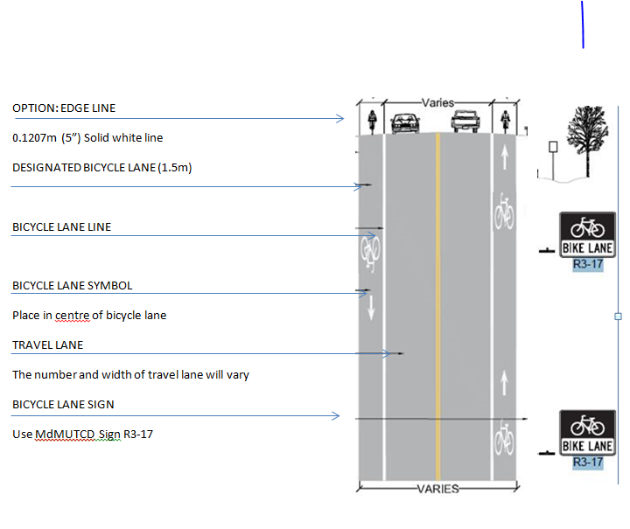Figure 2 Designated Bicycle Lane- No parking

1. **METHODOLOGY**

The map of the existing arterial road was obtained from Google map, while the cross section parameters were measured manually using a tape. The bicycle parking lot was equally measured with a tape to be able to design the number of bicycle it can accommodate.

1. **RESULTS AND DISCUSIONS**

**Description of the University of Ilorin primary road**

The Unilorin primary arterial road leading from the gate to the Civil Engineering Department building (block 8) opposite UBA is as shown in figure 4.2. From the gate there are two lanes leading into the campus and terminated at Jalala housing estate junction (segment A).The lane widths of Segment A are 6m (exit) and 4.2m (entry) having a length of 1.28km. The lane width of segment B is 9m while its length is 3.2km. The lane width of segment C is 6m while its length is 0.72km.The road lane widths will require the addition of extra 1.5m expansion on both sides of the road in order to accommodate the bike lane that is been designed. Hence, an additional 3m will be added to the original road width of 6m to make it 9m while the road segment C that is 9m (just after the intersection that leads to the park) will be left unexpanded. The bike lane is only marked out with 0.127m (5inches) thick white lines to demarcate the vehicle lane from the bicycle lane with bicycle sign well placed and positioned. This is not a cycle track that requires the inclusion of kerbs, rails and ramps. It is simply a bike lane that can sometimes serve as a temporary parking space for emergency motor vehicles or disabled motor vehicles for a short period of time.

The cross section of the roadway segments A, B and C of 4.5m, 9m and 6m width respectively, have cross slopes of the carriageway as 2.5% while the cross slope of the bicycle lane is 3.5%. Hence, Figure 4.3, 4.4 and 4.5 have the fore mentioned slopes.

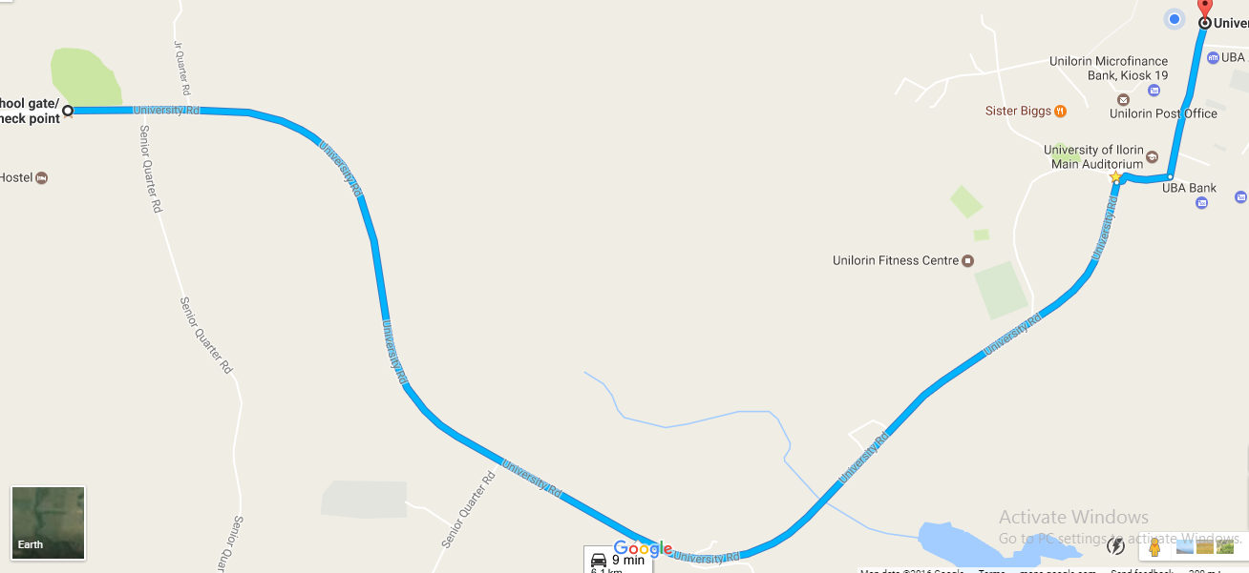

**C**

**B**

**A**

Figure 3 Google Map Imagery of the University road

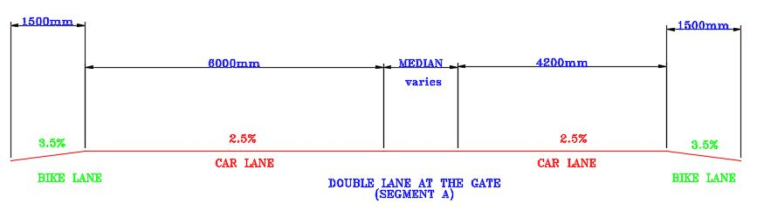

Figure 4 Proposed Cross section of the dualised segment of the road (segment A)

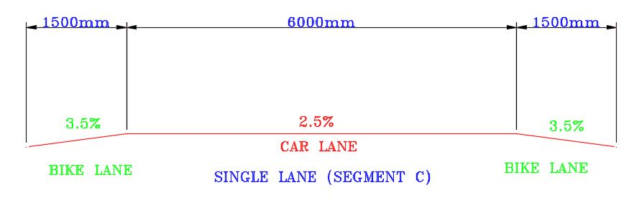

Figure 5 Proposed Cross section of the 2- lane carriage way segment (segment C)

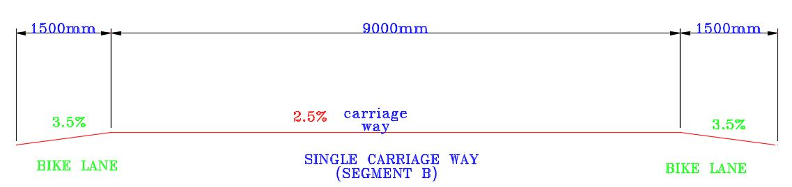

Figure 6 Proposed Cross section of the road segment as 3-lane non dualised road (segment B).

**CONCLUSION AND RECOMMENDATION**

**CONCLUSION**

The study shows that the road that leads to the university, does not have cyclist lane. Bicycling will benefit our nation in the following ways: Congestion-easing, Fuel savings, reduced dependency on fossil fuels, Reduced CO2 emissions, reduced air pollution, reduced noise pollution. Increased quality of life, Improved quality of the public environment, Increased interaction between residents, A boost to the vitality of city centre’s: livability, Increased accessibility to jobs (and schools), Boost for the bicycle industry (bike-sharing systems, contactors and bicycle producers) (UNEP, Baufeldt, 2008).This greater emphasis will spur and enable the engineer and designer to better advice the government to incorporate the NMT facilities whenever road is to be designed and constructed especially on arterial roads in urban centres.

In the twenty first century, much premium has been placed on the culture of car ownership and use, which has made it a dominant mode of road transportation. This however is not without its challenges. There is much dependency in motorized mobility. Transiting to non-motorized transportation such as promoting the use of bicycle as a means of urban mobility will naturally meet acceptance problem.

In African setting especially Nigeria, car journeys can be transferred to cycling which has shown to have health, environmental and other benefits. To do this, stakeholders including Governments need to evolve strategies that can effectively incorporate NMT into national mobility programs. The need for advocacy, education, enlightenment, designing of roads to accommodate cycling lanes and furniture, evolving strategic measures to enforce and manage cyclig, etc. cannot be over-emphasized. Car journeys can also be transferred to journeys where a bicycle is combined with public transport. This requires the cooperation of all stakeholders.

**RECOMMENDATION**

Non-motorised transportation facilities (especially bicycling), if put into consideration for new constructions, renovations, rehabilitation of existing roads, then Nigeria will have less than 20% mortality of pedestrians and cyclist which was usually about 50% as suggested by FRSC (2015). When cycling facilities are increased across the nation, bicycling will be encouraged and enhanced thereby helping Nigerians to take pleasure in bicycling which helps in bodily exercise that gives some physical benefits.

In line with the above, the following are recommended:

1. The on-going efforts of the Federal Ministry of Transport to have a formidable national urban Transportation Policy should be re-focused to include bicycling as prominent modes of road transportation.
2. State Governments and the Federal Capital Territory (FCT) should set up agencies that will develop and coordinate bicycling as a focal point of urban transportation.
3. School authorities at Basic, post-basic and tertiary levels should develop initiatives and programs that will see cycling reduce individual vehicle use on the campus.
4. Employers of labor and owners of businesses should take full advantage of the enormous potentials of cycling to make it a viable option for daily commuting by their employees.

**REFERENCE**

Marshal and Chief Executive, Federal Road Safety Corps at Australian Cycling Conference Gadd, p. (1976).The Ecology of Urbanization and Industrialization. Macmillan, London pp. 12-21

Gould, W.T.S. (1990). Migration and basic needs in Africa. Liverpool papers in human geography. N.S. no. 1, Liverpool: University of Liverpool, inc, pp. 3-14

Ajaegbu, H.I (1976). Urban and Rural Development in Nigeria Heinmen Education Books, London. Pp. 27 – 28

Jaeger R.J., (2003). Guidelines for the investigation and remediation of potentially hazardous bicycle and pedestrian locations, Traffic Engineering and Safety Management Branch, North

Carolina Department of Transportation.

Adedeji, A & Rowland, L. (1973). Management problem of Rapid Urbanization in Nigeria.Unifepress. Transportation and Land Development, Institute of Transportation Engineers, (2002).

Adelugbe, M.O.A (1999) Industrialization and Development in Nigeria (1950-1999) Concept publications Limited.

Austine Troy (2012) can America Embrace Biking the way Denmark Has? Slates Magazine, 1stNovember, 2012 edition edition

Bonat, Z.A & Abdulahi, Y.A (1989).World Bank, I.MF and Nigeria’s Agriculture and Rural Economy.Zed Books London.

Centre for Housing Policy (2006). A Heavy Load: The Combined Housing and Transportation- Burdens of Working Families, The Library of Congress, United State. Pp. 1

Cyclist Touring Club,(1996). Cycle – friendly infrastructure: Guideline for planning and Design.Chattered Institute of Highways and Transport, UK. Pp8-17

Deskoster J. and Schollaert U. (1999).Cycling: the way ahead for towns and cities. European Commission. Pp 11-19, 22-29

Emmanuel O.O. (2012). Five decades of development aid to Nigeria: the impact on human development Journal of Economics and Sustainable Development. ISSN 2222-1700 ISSN 2222 – 2855 (online) vol. 1.3, No. 1. <http://iiste.org/journal/index/JEDS/article/viewfile/1167/1088>

European Commision (2013). Study to support an impact Assesment of the Urban mobility package. Pp 5-21

Federal Road Safety Commission, FRSC. (2014). FRSC Annual Report 2014

Federal Road Safety Commission, FRSC. (2013). Nigeria Road Safety Strategy (NRSS) 2014-2018.

FRSC, (2012) Study on the state of bicycle transportation in Nigeria. Paper presented by the corps

International Bicycle Fund (2015). Bicycle Statistic: Usage, production, Sales, Import, Export.

<http://www.ibike.org/library/statistic-data.htm>

John, E.O. (2015). Non-motorized Transportation in Developing Countries.Peniel prints publishers.Pp16-35, 95-114, 219-228. ISBN 978-978-945-836-3

JurgenHeyen – perschon. (2006). Non-motorized Transport and its socio-economic impact on poor Households in Africa. Presentation at the Velomondial Conference, Cape Town

Department for Transport. (1991). *Traffic advisory leaflet 03/91: Speed control humps*.

United Kingdom: Department for Transport.