**S4.1 Characterization of nZVMn**

**S4.1.1. Functional group Analysis**

Shown in Fig. S1 is the FTIR spectrum of nZVMn indicating the various functional groups and other elements such as 3288 (O–H broad of alcohol), 1636 (H-O-H stretching), 1307(C─O stretching of alcohol), and 504 cm-1 (Manganese nanoparticles). The band from alcohol originated from the isopropyl alcohol used during the synthesis (Sinha et al.2011, Li et al.2009). EDX and XRF results further confirmed the presence of nZVMn.

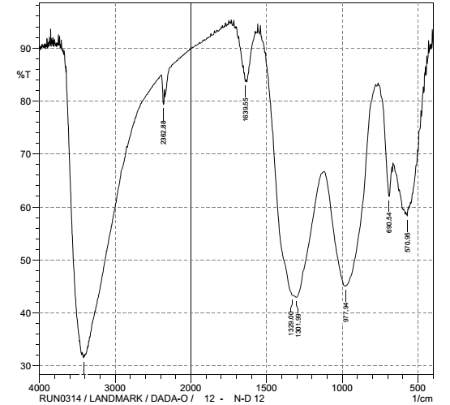

Fig S1: FTIR spectrum of Nanoscale Zerovalent Manganese (nZVMn)

**S4.1.2 Surface Morphology**

The size, shape and nature of nZVMn are vividly seen from the TEM and SEM micrographs before adsorption. The TEM micrograph in Fig S2 shows the micro-image of nZVMn of size range 6.120 nm – 99.428 nm. Special attribute of nZVMn is displaced in the traces of dispersions and whiskers supporting the lamina flow that enhanced heavy metal ions adsorption

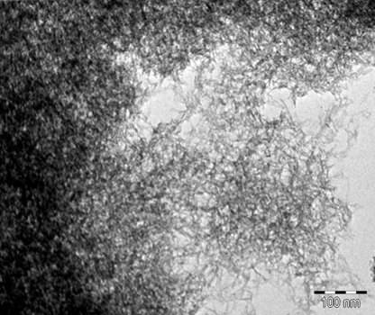

Fig S2: TEM of nZVMn

Fig S3 depicts the SEM micrograph of zerovalent manganese nanoparticle. The micrograph reveals trapezoidal coarse, rough and crake surface of nZVMn particles before adsorption. The presence of crake surface enhanced free and dynamic flow of the solution of adsorbate (Cu2+, Cd2+ ) into the pores of nZVMn adsorbent. Also, the rough and coarseness of the surface indicates a higher BET surface area of 131.3490 m²/g, pore width 170.4736 Å, pore diameter 185.147 Åwhich facilitated strong adsorption of heavy metal ions to the pores and external surface of nZVMn nanoadsorbent (Morsali *et al*., 2011).

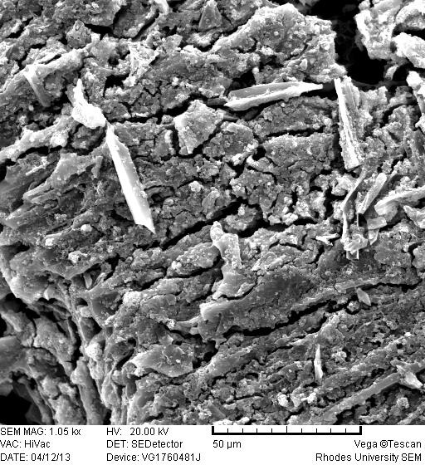

Fig S3: SEM micrograph of nZVMn before adsorption.

**S4.1.3 Energy Dispersive X-ray (EDX)**

Qualitative as well as quantitative evidence of nZVMn is provided from the result of EDX analysis (Shahwan *et al.,* 2011; Xi *et al.,* 2011; Photiphitak *et al.*,2010). The EDX spectrum of nZVMn (Fig S4) which gives the characteristics intense peaks of the nanoparticles, the information on the surface atomic distribution and the chemical elemental composition couple with the percentage composition which was supported by the XRF. Other elements present could be traceable to the additives during the course of the analysis. The elemental composition is provided in Table S1

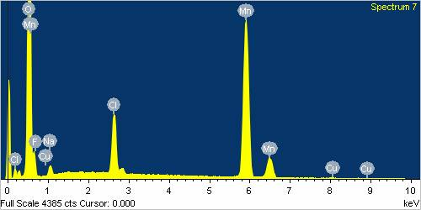

Fig. S4: EDX spectrum of nZVMn

Table S1: EDX Elemental percentage composition of nZVMn

|  |  |  |
| --- | --- | --- |
| Element | Weight% | Atomic% |
| Mn K | 65.94 | 16.40 |
| O K | 82.29 | 70.29 |
| C K | 4.00 | 4.55 |
| F K | 5.17 | 3.72 |
| Na K | 3.81 | 2.26 |
| Si K | 0.59 | 0.29 |
| Cl K | 6.17 | 2.38 |
| Cu K | 0.49 | 0.11 |
| Totals | 168.46 | 100 |

**S4.1.4. XRF for Nanoscale Zerovalent Manganese (nZVMn)**

The elemental percentage composition of Nanoscale manganese nanoparticle (nZVMn) was determined by XRF and presented in Table S2. The following elements are presents: MnO (94.09%), Cl (3.52%), CaO (0.21%), Co3O4 (0.02%), NiO (0.052%), SeO2 (0.084%), Er2O3(0.1%). Core shell manganese nanoparticle remains the dominant element among the constituent present.

Table S2: XRF for Nanoscale Zerovalent Manganese (nZVMn)

|  |  |
| --- | --- |
| Compound | Wt (Unit) % |
| MnO | 94.09 |
| Cl | 3.52 |
| CaO | 0.21 |
| Co3O4 | 0.02 |
| NiO | 0.052 |
| SeO2 | 0.084 |
| Er2O3 | 0.1 |
| LOI | 1.924 |
| Total | 98.076 |

**S4.2. Adsorption Isotherm Models for Sorption of Cd2+ onto Nanoscale Zerovalent Manganese**

**(nZVMn)**

The experimental equilibrium data for the adsorption of Cd2+ and Cu2+ onto nZVMn were tested using Langmuir, Freundlich, Temkin, Dubinin–Kaganer–Raduskevich (DKR) and Halsey isotherm models in order to determine the isotherm model that could best describe the sorption process and mechanism of solid-liquid system. The corresponding various plots are presented in FigS4.2(a-j) and the plot of the Langmuir dimensionless separation factors (Fig S4.2k). The error bars are indicated on the plots showing that statistical models were used. The summary of the values of calculated data and the correlation coefficient (*R2*), sum of square error (SSE), chi-square (χ2) are stated on Table

Fig S4.2(a-b): Langmuir linear plots for adsorption of (a) Cd2+ and (b) Cu2+ onto nZVMn

Fig S4.2(c-d): Freundlich linear plots for adsorption of (c) Cd2+ and (d) Cu2+ onto nZVMn

Fig S4.2(e-f): Temkin linear plots for adsorption of (e) Cd2+ and (f) Cu2+ onto nZVMn

Fig S4.2(g-h): DKR linear plots for adsorption of (g) Cd2+ and (h) Cu2+ onto nZVMn

Fig S4.2(i-j): Halsey linear plots for adsorption of (i) Cd2+ and (j) Cu2+ onto nZVMn

Fig. S4.2(k): Dimensionless separation factor from Langmuir for sorption of Cd2+ and Cu2+ onto nZVMn

**Supplementary References**

Dada, A.O., Adekola, F.A., Odebunmi, E.O. 2015b. A novel zerovalent manganese for removal of copper ions: synthesis,

characterization and adsorption studies. *Appl Water Sci (Springer). Doi:10.1007/s13201-015-0360-5*

Li, E., Zeng, X., Fan, Y, 2009. Removal of chromium ion (III) from aqueous solution by manganese oxide and microemulsion modified

diatomite. *Desalin* 238: 158–165

Sinha, A., Singh, V.N., Mehta, B.R., Khare, S.K. 2011. Synthesis and characterization of monodispersed orthorhombic manganese oxide

nanoparticles produced by Bacillus sp. cells simultaneous to its bioremediation. *J Hazard Mater*, *192:* 620 – 627.

Shahwan, T., Sirriah, A.S., Nairat, M., Boyacı, E., Eroglu, A.E., Scott, T.B., Hallam. K.R., 2011. Green synthesis of iron nanoparticles and

their application as a Fenton-like catalyst for the degradation of aqueous cationic and anionic dyes. *Chem Engg J,*

172, 258– 266